Targeted latent tuberculosis infection screening in the APY Lands
Working health-economic analysis for SA Health planning and refinement
Analysis date: 02 September 2026
Code commit: 12f697aa7caccad9a9290a7c7eef2dad54257e46
Important use note
This working analysis supports programme planning and refinement. It is not final policy evidence, does not prove cost-effectiveness, and must not be used to deny clinically indicated screening, treatment or care.

Executive summary
This report extends the earlier APY targeted LTBI screening analysis with a health-economic working analysis. The reference strategy screens 30% of the eligible population over two years using IGRA and offers 3HP preventive treatment.
Across 2,000 simulations, the compatibility anchor estimates 12.0 direct active-TB cases averted over 20 years. This is a direct individual-level result and excludes secondary transmission effects.
Included intervention delivery expenditure is AUD 95,052. Avoided active-TB care contributes an offset of AUD 187,422, giving a net included health-system saving of AUD 92,370 under the working assumptions.
That apparent saving is conditional on the current costing scope. Programme setup, programme running, travel, outreach and staffing costs are not yet locally costed and must not be interpreted as truly zero.
Measure | Value | Interpretation
Eligible population | 1,500 | people
People screened | 450 | people
Active TB cases averted | 12 | cases over 20 years
Included gross delivery expenditure | AUD 95,052 | AUD 2019, 3% discounted
Active-TB care cost offset | AUD 187,422 | AUD 2019, 3% discounted
Net included health-system result | AUD 92,370 net saving | AUD 2019, 3% discounted
Provisional DALYs averted | 16.2 | secondary, provisional
Willingness-to-pay threshold | Not supplied | NMB not calculated

Background and policy question
Targeted LTBI screening can prevent future active TB, but it shifts resources into earlier testing, review and preventive treatment.
The policy question is whether those up-front health-system costs are justified by the expected reduction in active TB and later active-TB care.
An editable economic model is useful because local programme delivery costs, bundling and implementation resources can materially change the net result.
Decision problem and reference strategy
Comparator: current practice, including ordinary background TB diagnosis and care, without an additional systematic LTBI screening programme.
Intervention: targeted systematic LTBI screening with IGRA and 3HP preventive treatment, prioritising people most likely to avoid active TB.
Population: all 1500 APY demonstration residents eligible; 30.0% screened over 2 years with 20 years of follow-up.
Economic perspective: Australian health-care system; currency and price year: AUD 2019; primary discounting: 3% for costs and DALYs, with 0% retained for comparison.
Methods
The primary epidemiological anchor is a stochastic individual-level compatibility run reproducing the frozen earlier APY reference analysis.
The model simulates the population, prioritises screening using the active-TB-prevention targeting rule, applies test performance, treatment initiation, completion, adverse-event stopping and treatment efficacy, and records events in a shared ledger.
Costs are calculated from event-ledger quantities: screening tests per person screened, pathway costs per screened person or treatment start, regimen costs per treatment start, ADR management per ADR-related stop, and active-TB care per active-TB case.
Annual costs and DALYs are discounted by model year. Quantities such as people screened and TB cases are not discounted.
DALYs use acute active-TB disability and mortality assumptions. Treatment, ADR and post-TB health losses are excluded from the primary analysis through explicit reviewed-exclusion records.
Simulation percentiles describe finite-population variation under fixed parameter assumptions. They are not confidence intervals, credible intervals or a probabilistic sensitivity analysis.
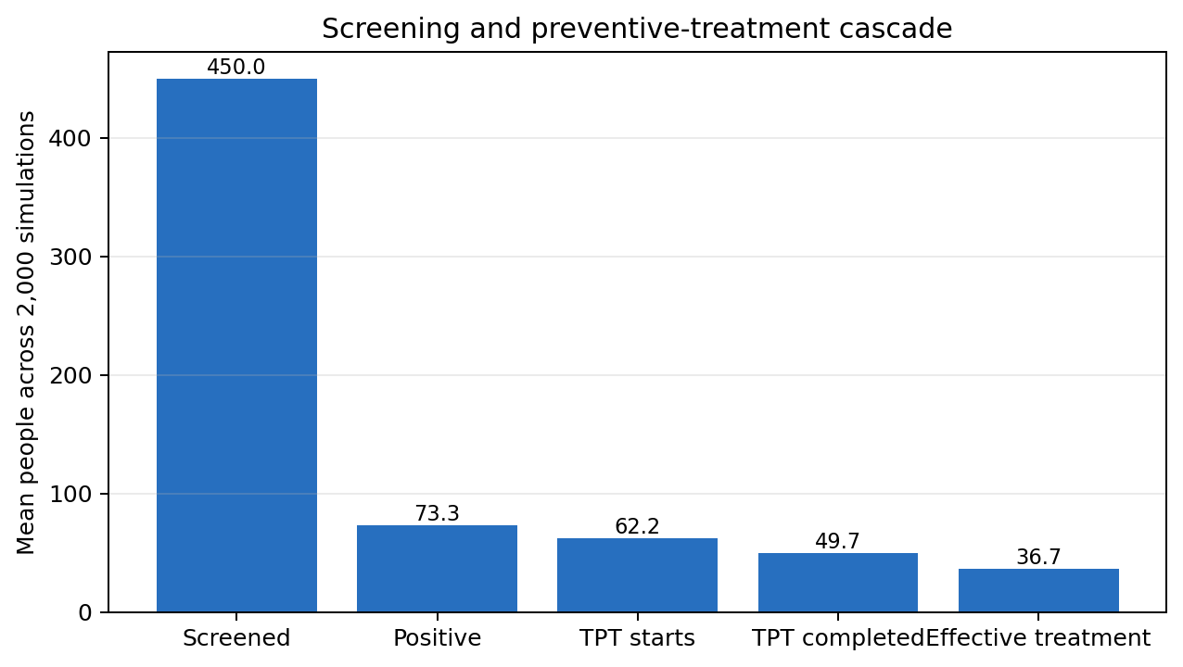
Figure 1. Screening and preventive-treatment cascade.
Economic inputs
Costs are reported in AUD 2019. A displayed zero is not treated as proof that a resource has no cost: unresolved local programme resources are labelled separately.
Cost item | Value | Unit | Status | Caveat
IGRA screening test per person | AUD 113 | cost per person screened | Reviewed working numerical assumption | Supports current cost-consequence calculation.
3HP preventive regimen per started course | AUD 166 | cost per started course | Reviewed working numerical assumption | Supports current cost-consequence calculation.
Active-TB disease care per case | AUD 19,080 | cost per active TB case | Reviewed working numerical assumption | Supports current cost-consequence calculation.
TPT ADR management per ADR stop | AUD 39 | cost per ADR stop | Reviewed working numerical assumption | Supports current cost-consequence calculation.
Return/results pathway cost per screened person | AUD 50 | AUD per person screened | Reviewed working numerical assumption | Supports current cost-consequence calculation.
Clinical-review pathway cost per TPT start | AUD 50 | AUD per TPT start | Reviewed working numerical assumption | Supports current cost-consequence calculation.
Active-TB exclusion / CXR / laboratory work-up per TPT start | AUD 150 | AUD per TPT start | Reviewed working numerical assumption | Supports current cost-consequence calculation.
False-positive incremental care per false-positive TPT start | Reviewed as bundled/no additional cost | cost per false-positive TPT started | Reviewed as bundled/no additional cost | Supports current cost-consequence calculation.
Programme setup total cost | Reviewed exclusion | total once at programme start | Reviewed exclusion | Not yet locally costed; zero compatibility value in the primary working reference.
Programme running cost | Reviewed exclusion | annual or total over screening programme | Reviewed exclusion | Not yet locally costed; zero compatibility value in the primary working reference.
Travel, outreach and staff-support cost per screened person | AUD 0 | AUD per person screened | Reviewed working numerical assumption | Not yet locally costed; zero compatibility value in the primary working reference.

Health outcomes and DALY assumptions
Assumption | Value | Unit | Status | Caveat
Active-TB disability weight | 0.333 | disability weight | Reviewed working numerical assumption | Supports secondary provisional DALY/ICER outputs.
daly.active_tb_duration_years | Excluded in primary analysis |  | Unresolved
TB case-fatality risk | 0.074 | probability | Reviewed working numerical assumption | Supports secondary provisional DALY/ICER outputs.
YLL per TB death | 20.0 | years | Reviewed working numerical assumption | Supports secondary provisional DALY/ICER outputs.
TPT health loss inclusion or exclusion | Excluded in primary analysis | DALYs per TPT start | Reviewed exclusion | Supports secondary provisional DALY/ICER outputs.
ADR health loss inclusion or exclusion | Excluded in primary analysis | DALYs per ADR stop | Reviewed exclusion | Supports secondary provisional DALY/ICER outputs.
Post-TB sequelae inclusion or exclusion | Excluded in primary analysis | DALYs | Reviewed exclusion | Supports secondary provisional DALY/ICER outputs.

Epidemiological results
Measure | Value | Interpretation
Eligible population | 1,500 | people
Screened | 450 | people
True-positive latent results | 65.9 | people
False-positive results | 7.4 | people
Preventive treatments initiated | 62.2 | people
Preventive treatments completed | 49.7 | people
ADR-related treatment stops | 3.1 | people
Infections effectively treated | 36.7 | people
Comparator active TB | 37.3 | cases
Intervention active TB | 25.3 | cases
Active TB cases averted | 12.0 | cases
Relative reduction | 32.1% | direct active-TB outcomes

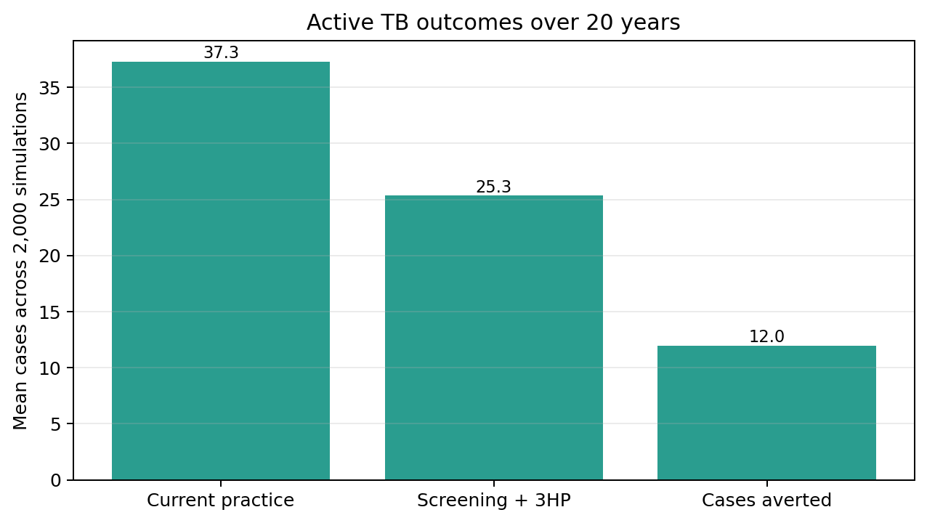
Figure 2. Comparator and intervention active-TB outcomes.
Cost-consequence results
Under the primary working assumptions, comparator active-TB care costs are AUD 626,261; intervention total costs are AUD 533,891.
The signed incremental cost is AUD -92,370. Because this is negative, the included health-system costs are lower with screening and preventive treatment in the model. This should be read as a net included health-system saving, not as proof that programme delivery is costless.
Category | Comparator | Intervention | Incremental | Interpretation
Screening test | AUD 0 | AUD 50,323 | AUD 50,323 | Included mapped event cost.
Return/results | AUD 0 | AUD 22,173 | AUD 22,173 | SA Health pathway working cost; possible bundle overlap should be reviewed.
Clinical review | AUD 0 | AUD 3,069 | AUD 3,069 | SA Health pathway working cost; possible bundle overlap should be reviewed.
Active-TB exclusion/work-up | AUD 0 | AUD 9,208 | AUD 9,208 | SA Health pathway working cost; possible bundle overlap should be reviewed.
Preventive regimen | AUD 0 | AUD 10,159 | AUD 10,159 | Included mapped event cost.
ADR management | AUD 0 | AUD 120 | AUD 120 | Included mapped event cost.
Programme setup | AUD 0 | AUD 0 | AUD 0 | Not yet locally costed in primary reference.
Programme running | AUD 0 | AUD 0 | AUD 0 | Not yet locally costed in primary reference.
Travel/outreach/staff | AUD 0 | AUD 0 | AUD 0 | Not yet locally costed in primary reference.
Active-TB care | AUD 626,261 | AUD 438,839 | AUD -187,422 | Offset from fewer modelled active-TB cases.
Total | AUD 626,261 | AUD 533,891 | AUD -92,370 | Included mapped event cost.

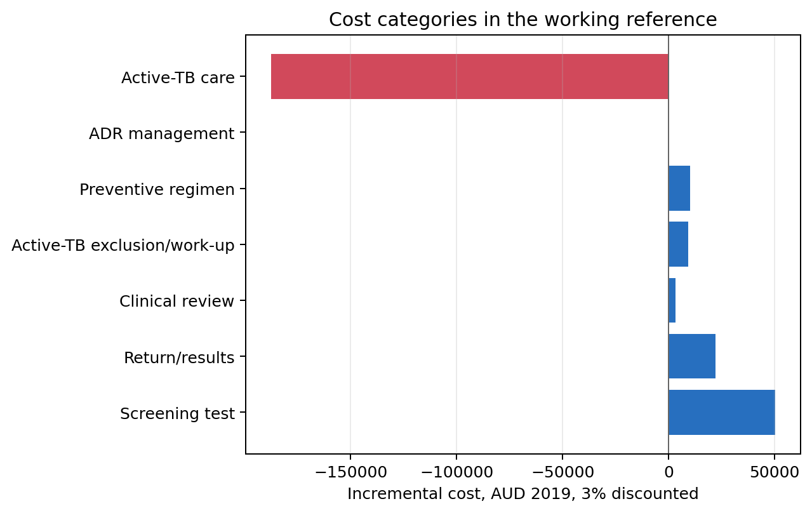
Figure 3. Cost-category comparison by arm.
Gross and net ratios
Gross delivery measures use intervention delivery expenditure before active-TB care offsets.
Measure | Numerator | Denominator | Result
Intervention delivery expenditure per person screened | AUD 95,052 | 450.0 | AUD 211
Intervention delivery expenditure per TPT start | AUD 95,052 | 62.2 | AUD 1,527
Intervention delivery expenditure per TPT completion | AUD 95,052 | 49.7 | AUD 1,912
Intervention delivery expenditure per infection effectively treated | AUD 95,052 | 36.7 | AUD 2,589
Intervention delivery expenditure per active TB case averted | AUD 95,052 | 12.0 | AUD 7,943

Net health-system measures use incremental health-system cost after active-TB care offsets.
Measure | Numerator | Denominator | Result
Net health-system saving per person screened | AUD 92,370 net saving | 450.0 | AUD 205 saving
Net health-system saving per TPT completion | AUD 92,370 net saving | 49.7 | AUD 1,858 saving
Net health-system saving per active TB case averted | AUD 92,370 net saving | 12.0 | AUD 7,719 saving

Budget impact over time
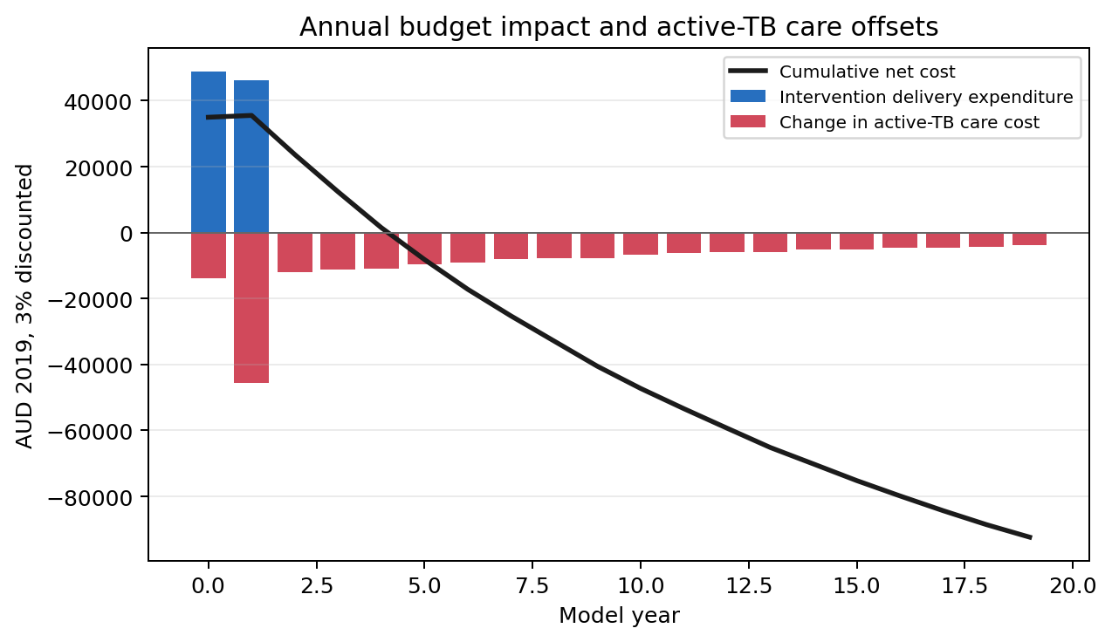
Figure 4. Annual budget impact and later active-TB care offsets.
Year | Delivery expenditure | Comparator TB care | Intervention TB care | Annual incremental | Cumulative incremental
0 | AUD 48,938 | AUD 220,675 | AUD 206,727 | AUD 34,990 | AUD 34,990
1 | AUD 46,111 | AUD 146,691 | AUD 101,140 | AUD 560 | AUD 35,551
2 | AUD 4 | AUD 23,946 | AUD 12,076 | AUD -11,866 | AUD 23,685
3 | AUD 0 | AUD 22,402 | AUD 11,105 | AUD -11,297 | AUD 12,388
4 | AUD 0 | AUD 21,292 | AUD 10,417 | AUD -10,875 | AUD 1,513
5 | AUD 0 | AUD 19,075 | AUD 9,398 | AUD -9,677 | AUD -8,164
6 | AUD 0 | AUD 17,888 | AUD 8,868 | AUD -9,020 | AUD -17,184
7 | AUD 0 | AUD 16,289 | AUD 8,214 | AUD -8,075 | AUD -25,259
8 | AUD 0 | AUD 15,416 | AUD 7,779 | AUD -7,636 | AUD -32,895
9 | AUD 0 | AUD 15,062 | AUD 7,421 | AUD -7,640 | AUD -40,536

The complete annual table is included in the report-ready CSV outputs.
Scenario and sensitivity analysis
Scenario | Incremental cost | Active TB cases averted | DALYs averted | Interpretation
Primary working reference | AUD 92,370 net saving | 11.97 | 16.2 | Primary working reference; local programme resources remain not locally costed.
Illustrative AUD 500,000 setup | AUD 407,630 net cost | 11.97 | 16.2 | Adds illustrative setup cost; epidemiological outcomes unchanged.
Bundled/excluded pathway costs | AUD 126,819 net saving | 11.97 | 16.2 | Excludes selected pathway components to test possible overlap with bundled costs.
Higher post-TB DALY burden | AUD 92,370 net saving | 11.97 | 73.1 | Costs unchanged; DALY gain increases under secondary post-TB burden assumption.

Question | Value | Interpretation
One-off additional setup cost before net saving is exhausted | AUD 92,370 | Arithmetic break-even only; not a willingness-to-pay threshold.
Equivalent annual running cost over two screening years | AUD 46,867 | Assumes equal payments in years 0 and 1 with 3% cost discounting.

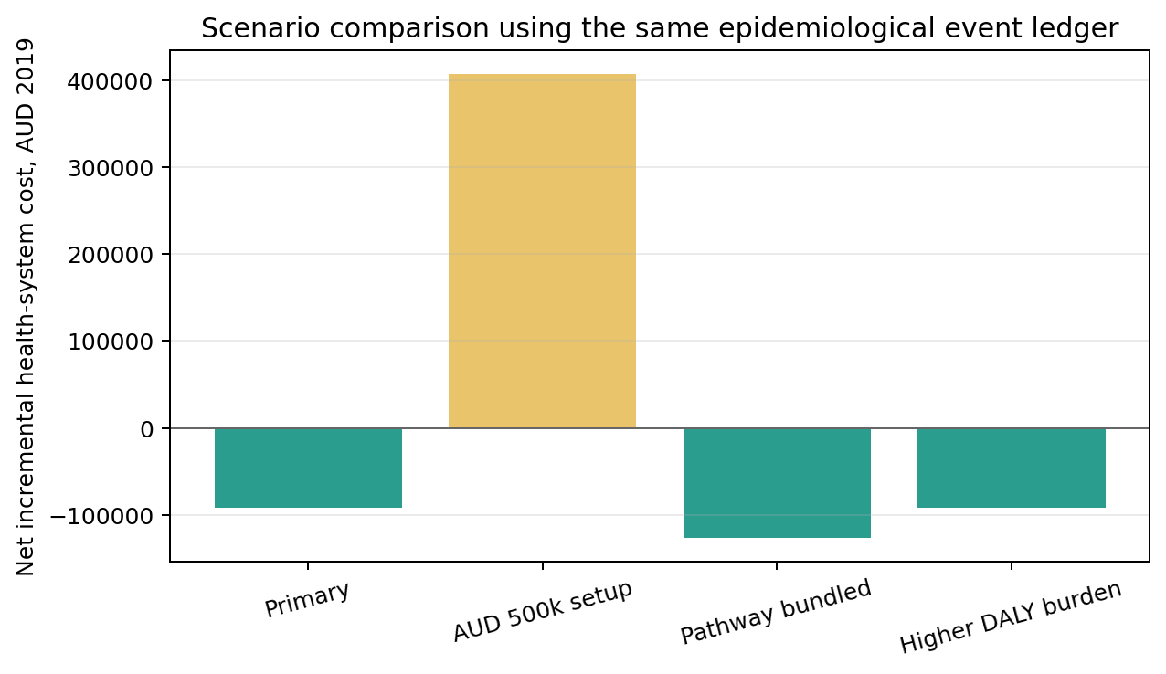
Figure 5. Scenario comparison using one epidemiological event ledger.
Cost-utility results
The primary acute-DALY calculation estimates 16.2 discounted DALYs averted. Because the aggregate result has lower included costs and greater health gain, the diagnostic classification is dominant under the working assumptions.
In the higher-burden post-TB scenario, discounted DALYs averted increase to 73.1 while costs and epidemiological events are unchanged.
No willingness-to-pay threshold is supplied; NMB and probability cost-effective are therefore not calculated.
Interactive analysis
A Streamlit interface is available for reviewing the model workflow. The public site link should be checked against the reviewed branch before using it as the live health-economic tool.
Open the LTBI Screening Decision Tool
Readable URL: https://tb-community-risk.streamlit.app
Limitations
The inherited 10/770 active-TB calibration target has unresolved provenance and interpretation.
The implicit early phase is retained for compatibility with the earlier analysis, not interpreted as measured recent LTBI.
Disease-risk odds ratios are used as multiplicative hazard multipliers for compatibility and remain scientifically provisional.
Active or near-baseline TB is not fully separated from future incident, preventable TB in the compatibility model.
Programme setup, programme running, travel, outreach and staffing costs are not yet locally costed.
Some pathway costs may overlap with bundled test or treatment costs and require review.
DALY assumptions are working assumptions and the ICER result is secondary and provisional.
No reviewed willingness-to-pay threshold is supplied, so NMB and probability cost-effective are unavailable.
Transmission and indirect community effects are excluded.
Interpretation and next information required
The compatibility model expects targeted IGRA/3HP screening to reduce direct active-TB outcomes in the simulated APY cohort.
Included delivery costs are offset by avoided active-TB care under the working assumptions, but this depends materially on unresolved local programme resources and inherited epidemiological calibration semantics.
The immediate next step is for SA Health to enter local setup, running, travel, outreach and workforce costs in the Streamlit Health Economics workspace and review possible bundling with test and regimen costs.
References
Dale KD, Abayawardana MJ, McBryde ES, Trauer JM, Carvalho N. Modeling the Cost-Effectiveness of Latent Tuberculosis Screening and Treatment Strategies in Recent Migrants to a Low-Incidence Setting. Am J Epidemiol. 2022;191(2):255-270. doi:10.1093/aje/kwab150.
Repository evidence registry snapshot: data/apy_assumption_evidence_registry.csv, hash recorded in the report manifest.
Frozen APY reference validation artifacts: validation/matlab_reference/prevent_igra_3hp_N1500_seed1.

Appendix A. Reproducibility manifest
Field | Value
Repository | github.com/emmamcbryde/tb-community-risk
Branch | codex/apy-sa-health-matlab-compatible-anchor
Commit | 12f697aa7caccad9a9290a7c7eef2dad54257e46
Model type | Stochastic individual-based compatibility anchor
Simulations | 2000
Seed | 1
Population | 1500
Coverage | 30.0%
Screening window | 2 years
Follow-up | 20 years
Event-ledger contract | ltbi_screening_event_ledger_v3
Economics contract | ltbi_health_economics_results_v3
Configuration hash | a84f98039b269502d17f9c6e4b1e97fb6e9d35a211294bb8bccb637f7af7c9f1
Economics hash | 57ce96656c71ac1d2e1a4e8fbc77578d9e292ed02737e926529ed97c80e4ce67
Evidence-registry hash | 72a9410cff2f41b7b252e28a87527d3c9683cfa810b2a83179fa460635f14e43

Appendix B. Validation against frozen epidemiological reference
Metric | Compatibility mean | Compatibility median | Frozen median | Frozen 2.5-97.5%
nScreened | 450.00 | 450.0 | 450.0 | 450.0 to 450.0
nTestPositive | 83.29 | 83.0 | 84.0 | 68.0 to 100.0
nTestPositiveNonActive | 73.28 | 73.0 | 73.0 | 59.0 to 89.0
nFalsePositiveTests | 7.40 | 7.0 | 7.0 | 3.0 to 13.0
nStartTPT | 62.24 | 62.0 | 62.0 | 48.0 to 77.0
nCompleteTPT | 49.72 | 50.0 | 50.0 | 37.0 to 63.0
nADRstop | 3.08 | 3.0 | 3.0 | 0.0 to 7.0
nCuredInfection | 36.71 | 36.0 | 37.0 | 26.0 to 49.0
nPreventedActiveTB | 11.97 | 12.0 | 12.0 | 6.0 to 19.0
nActiveBy20y | 37.30 | 37.0 | 37.0 | 26.0 to 49.0

Appendix C. Reproduction command
python scripts/build_sa_health_reference_package.py
python scripts/build_sa_health_word_report.py

