 University of the Philippines

 Microelectronics and Microprocessors Laboratory

Lab Module 05 – Answer Sheet

Name: Estallo, Emmanuel

Student #: 2018-02355

Class: SATURDAY AM

SCORE: XX/40

Instructions:

This is answer sheet is a format only. You may answer using any word processor (i.e. Microsoft Word, Libre Office, Latek, Google docs … etc.) but you need to submit either a pdf or docx file so we can comment on it. Make sure to put your name, student number, and indicate what lab class you are in. This is given in the format above. Name your file “coe197_class_lastname_studentnumber”. For the class write “satam” or “satpm” if you’re in the morning or afternoon class, respectively. For example: “coe197_satam_antonio_201101474”.

When you make your document please maintain the order of the main sections (PART I, PART II, PART III, and PART IV) and stick to the numbering provided in this answer sheet. You may use this word document if you like.

Answer with clear and concise solutions. Indicate your final answer (box it, bold it, change its color but please do not use red font color). For problems that require explanations, elaborate your thoughts. Any unclear answers will be marked wrong. There will be partial points.

**Have fun and learn by heart!**

Part I: Review

1. What are the small-signal parameters $g_{m}$, $r_{o}$, and $g_{m}r_{o}$? Mathematically, how do we get these?

Use long-channel equations.

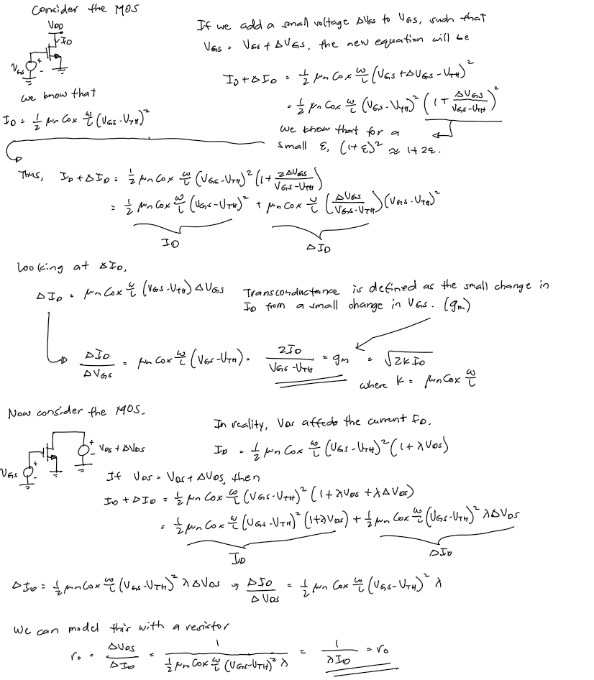

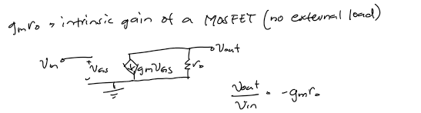

Part II: Training

## Question Q2.1:

Just to make sure you know how to read plots. What $V_{GS}$ would give us $g_{m}≈250 uS$? What about $g_{m}≈300 uS$? What’s $g_{m}$ at $0.35$ V?

Based on the plot, for $g_{m}=250μS$ $→V_{GS}=316mV$. For $g_{m}=300μS$ $→V_{GS}=344 mV$

The value of $g_{m}$ at $V_{GS}=0.35V is$ $≈310 mS$

## Question Q2.2:

Complete the statements with increase, decrease, no change, or makes no sense and be sure to indicate why?

1. As $W$ increases, $g_{m}$ increases since $g_{m}$ is directly proportional to W.
2. As $L$ increases, $g_{m}$ decreases since $g_{m}$ is inversely proportional to L.
3. As $W$ and $L$ increases, $g_{m}$ remains the same if both W and L are multiplied by the same factor.
4. As $V_{GS}$ increases, $g_{m}$ increases since $I_{D}$ increases.

## Bonus Question Q2.3:

Give an intelligent guess as to why the transconductance starts to decrease as we approach $V_{DS}=1.2 V$?

* As we approach $V_{DS}=1.2V,$ The transistor exits the saturation region.

## Question Q2.4:

Roughly what is $r_{o}$ for the entire saturation region?

* Approximately $120 kΩ$

## Question Q2.5:

Complete the statements with increase, decrease, no change, or makes no sense and be sure to indicate why?

1. As $W$ increases, $r_{o}$ decreases since $I_{D}$ increases.
2. As $L$ increases, $r_{o}$ increases since $I_{D}$ decreases.
3. As $W$ and $L$ increases, $r_{o}$ remains the same given that W and L are multiplied by the same factor.
4. As $V_{DS}$ increases, $r_{o}$ increases because of stronger channel length modulation.

## Question Q2.6:

Fill the blanks with increase, decrease, or no change. When we increase the width, $g_{m}$ increases and/but $r_{o}$ decreases. When we increase the length, $g_{m}$ decreases and/but $r_{o}$ increases What kind of engineering problem do we have? Trade-off

Part III: Exercise

## A. Reinforcement Learning

Let’s make sure you understood this lab module.

1. How would you differentiate large-signal (DC) vs. small-signal (AC) analysis?

- Large – signal analysis is used to compute the operating voltages of the transistor. In a sense, those operating voltages are where the small signals “sit”.

1. How would you define transconductance $g_{m}$?

* $g_{m}$ is the small change in $I_{D}$ due to a small change in $V_{GS}$.
* How a small increase in gate voltage affects the drain current.

1. How would you define output impedance $r_{o}$?

* It is the resistance seen by the load when looking at the output terminal of the transistor.

1. How would you define small-signal gain ?

- It is the gain when no load is connected to the output terminal.

5. Why is the input impedance infinite?

- The input impedance is only infinite when DC is connected. The transistor has parasitic capacitances. Since capacitors block DC, the input impedance is infinite as far as DC signals are concerned.

6. What is the importance of the inductor in Figure 2.11?

- Inductors act as short circuits at low frequencies. Since it has a high inductance, for non-DC signals, it acts as an open circuit. This way, we can find the gain better.

7. Why do we need to set AC = 1V for our AC analysis?

- This is the voltage source used for the small signal model. In essence, we tell the circuit to use 1V AC for the small-signal computation.

8. In Figure 2.11, how is $v_{out}$ indicative of $g_{m}r_{o}$? In other words, why is measuring $v_{out}$ equal to ?

- . Since we set , .

9. How would you define ?

- is defined as the frequency at which the short circuit current gain of the device drops to 1.

10. How do we increase ?

- is dominantly influenced by $C_{GS}$. To increase $f_{T}$, we can try to decrease $C_{GS}$ as much as possible.

- Increasing $g_{m}$ also increases $f_{T}$

## B. Current here, and current there!

Let’s see if you know how to use the pre-made schematics for you. You are given the following schematics:

* “lab05_pmos_char”
* “lab05_pmos_gmro_extract”
* “lab05_pmos_ft_extract”

With $W=10 um$ and $L=1$ um, Extract the following:

1. Reproduce the PMOS equivalent of Figure 2.8. Use $V_{SD}=0.6 V$. Show your plot and place a cursor showing $g_{m}$ at $V_{SG}=0.35 V$.

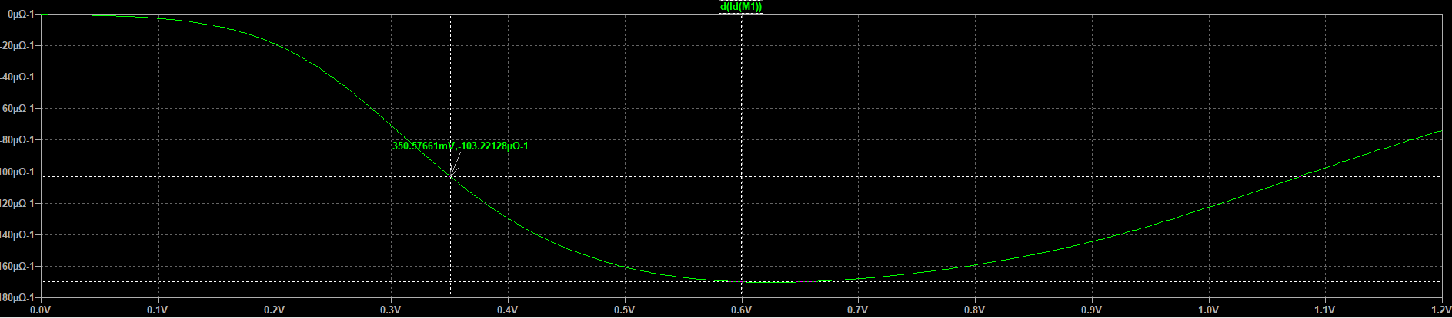

1. Reproduce the PMOS equivalent of Figure 2.10. Use $V_{SG}=0.35 V$. Show your plot and place a cursor showing $r_{o}$ at $V_{SD}=0.6 V$.

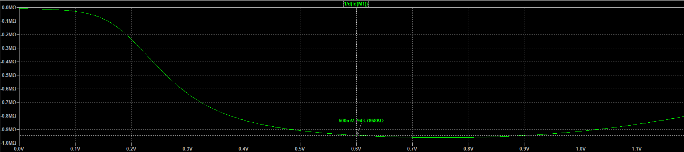

1. Reproduce the PMOS equivalent of Figure 2.15. Use $V_{SD}=0.6 V$. Show your plot and place a cursor showing $g_{m}r_{o}$ at $V_{SG}=0.35 V$.

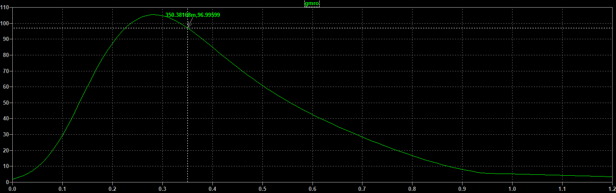

1. Reproduce the PMOS equivalent of Figure 2.19. Use $V_{SD}=0.6 V$. Show your plot and place a cursor showing $f_{T}$ at $V_{SG}=0.35 V$.

