 University of the Philippines

 Microelectronics and Microprocessors Laboratory

Lab Module 08 – Answer Sheet

Name: Lastname, Firstname

Student #: 20XX-XXXXX

Class: SATURDAY AM / SATURDAY PM

SCORE: XX/40

Instructions:

This is answer sheet is a format only. You may answer using any word processor (i.e. Microsoft Word, Libre Office, Latek, Google docs … etc.) but you need to submit either a pdf or docx file so we can comment on it. Make sure to put your name, student number, and indicate what lab class you are in. This is given in the format above. Name your file “coe197_class_lastname_studentnumber”. For the class write “satam” or “satpm” if you’re in the morning or afternoon class, respectively. For example: “coe197_satam_antonio_201101474”.

When you make your document please maintain the order of the main sections (PART I, PART II, PART III, and PART IV) and stick to the numbering provided in this answer sheet. You may use this word document if you like.

Answer with clear and concise solutions. Indicate your final answer (box it, bold it, change its color but please do not use red font color). For problems that require explanations, elaborate your thoughts. Any unclear answers will be marked wrong. There will be partial points.

**Have fun and learn by heart!**

Part I: Review (3 pts)

1. What does a cascode current mirror do? (1 pt.)

2. What is a differential circuit? (1 pt.)

3. Concisely, describe differential mode and commode mode. (1 pt.)

Part II: Training (29 pts)

## Question Q2.1: (11 pts)

Let’s see if you understood what really happens in a cascode. Answer with *increase(s)* or *decrease(s)* only. Following the same discussion in Figure 2.15.

1. As $V_{OUT}$ decreases, $V_{DS2}$__________. This $I_{DS2}$__________ or $I_{OUT}$.
2. As $I_{OUT}$__________, $V_{DS1}$ needs to __________. Hence $V_{D1}=V_{S2}$__________.
3. Take note that $V_{G2}$ is fixed, and since $V_{S2}$__________, $V_{GS2}$__________.
4. Take note also that $V_{DS2}=V_{D2}-V_{S2}$ therefore, $V_{DS2}$__________.
5. Because $V_{GS2}$ and $V_{DS2}$__________, then it follows that $I_{DS2}$__________.
6. In the end, $I_{OUT}$ should __________ but a relatively “slower” rate.

## Question Q2.2: (8 pts)

Let’s see if you’re paying attention. Fill in the blanks, and refer to Figure 2.9. Assume $V_{IN}=V_{IC}$ is fixed but $V_{IP}$ is free to move. Answer with increase, decrease, or no change.

1. When $V_{IP}$ decreases, $V_{GS,M1}$____________.
2. When $V_{GS,M1}$____________, $I_{DS,M1}$____________.
3. When $I_{DS,M1}$____________, $V_{ON}$____________, and $I_{DS,M2}$____________.
4. When $I_{DS,M2}$____________, $V_{OP}$____________.

## Question Q2.3: (2 pts)

Let’s put on your thinking cap. When $V_{IP}$ increases, the $I_{DS,M1}$ increases. How high can $I_{DS,M1}$ be until all the current in $I_{DS,M2}$ is “stolen”? Assume that the DP is biased by some $I_{TAIL}$ current. Elaborate and prove your answer.

## Question Q2.4: (7 pts)

Let’s see if you’re paying attention. Fill in the blanks, and refer to Figure 2.9. Assume $V_{ID}=0$ and $V_{IC}$ is free to move. Answer with increase, decrease, or no change.

1. When $V_{IC}$ decreases, $V_{GS,M1}$____________, and $V_{GS,M2}$____________.
2. When $V_{IC}$ decreases, $I_{DS,M1}$____________, and $I_{DS,M2}$____________.
3. When $V_{IC}$ decreases, $V_{ON}$____________, and $V_{OP}$____________.
4. When $V_{IC}$ decreases, $V_{TAIL}$____________.

## Question Q2.5: (1 pts)

What’s the CMRR assuming $A_{dm}≈5$ and $A_{cm}≈600u$?

Part III: Exercise (20 pts)

## A. Miller Operational Amplifier (10 pts)

Figure 3.1 is a simple Miller Amplifier. Answer the following questions.

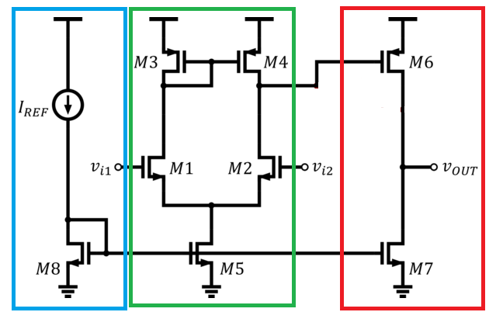

Figure 3.1 Simple Two-Stage Miller Amplifier

1. Describe what do the electrical elements in the blue section do? (1 pt)

2. What kind of circuit is in the green section? (1 pt)

3. What kind of circuit is in the red section? (1 pt)

4. In relation to #2, what is M5 for? (1 pt)

5. Do we want M5’s output impedance to be higher or lower? Why? (1 pt)

6. List at least 2 ways to increase the output impedance of M5. (1 pt)

7. What does M3 and M4 do? (1 pt)

8. What does M6 and M7 do? (1 pt)

9. If you were to design this Miller Amplifier, who would you tackle first, the red, green, or blue section? Elaborate your answer. (2 pt)

## B. Summarize! (10 pts)

You will be graded how well you write/summarize your answers.

In a maximum of 3 paragraphs, can you summarize what you have learned about analog design? Be sure to include things like:

* Design philosophies
* Trade-offs to watch out for
* Design methodologies
* Ideas you think that can improve your design strategies
* Add things that may not be included in the lab discussion but you may have discovered along the way



## C. (BONUS) Finish Strong! (5 pts)

Sometimes it’s great to not just finish a course, but to finish “strong”! What we mean by that is that, let’s try to expand ourselves and do better than what was recommended in this course. With that, consider Figure 3.2 which shows an amplifier with higher complexity. Then, answer the following questions.

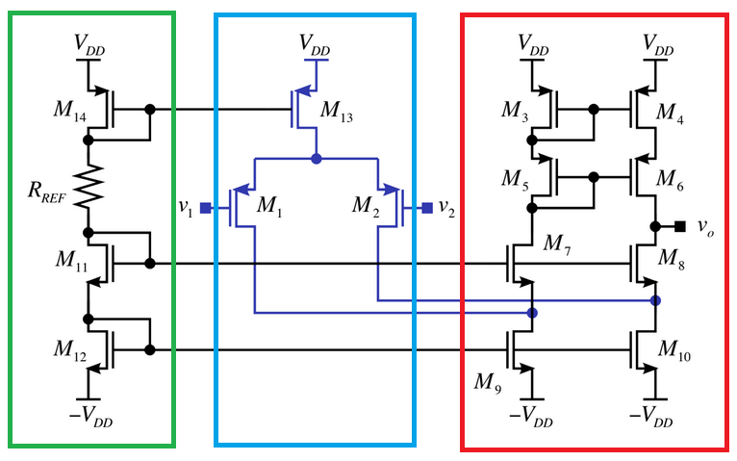

Figure 3.2 Super cool amplifier

1. What do you call this amplifier? (1 pt)

2. What circuit is the green section? (1 pt)

3. What circuit is the blue section? (1 pt)

4. What circuit is the red section? (1 pt)

5. This amplifier has very high gain. Why? Estimate to a first-order what that gain would be? (i.e. $A_{v}= ?$) (1 pt)