Engineering Probability and Statistics Project

Emmanuel Gonzalez

University of Texas at Arlington

11/18/2018

Dr. Jenny Tejeda

1. Data Set 1 – The Iris flower data set is a widely observed and used data set in statistics. It can be found on many places on the internet but I got it from a machine learning repository provided by the University of California, Irvine. The data set contains a few recorded attributes of 3 species of 150 Iris flowers. These attributes include sepal length and width, as well as pedal length and width.  
   **Descriptive Statistics:**
   * 1. Sample mean – 5.84333333
     2. Sample standard deviation – 0.82806613
     3. Quartile 1 – 4.3 to 5.1
     4. Quartile 2 – 5.2 to 5.8
     5. Quartile 3 – 5.9 to 6.4
     6. Box and Whisker Plot:

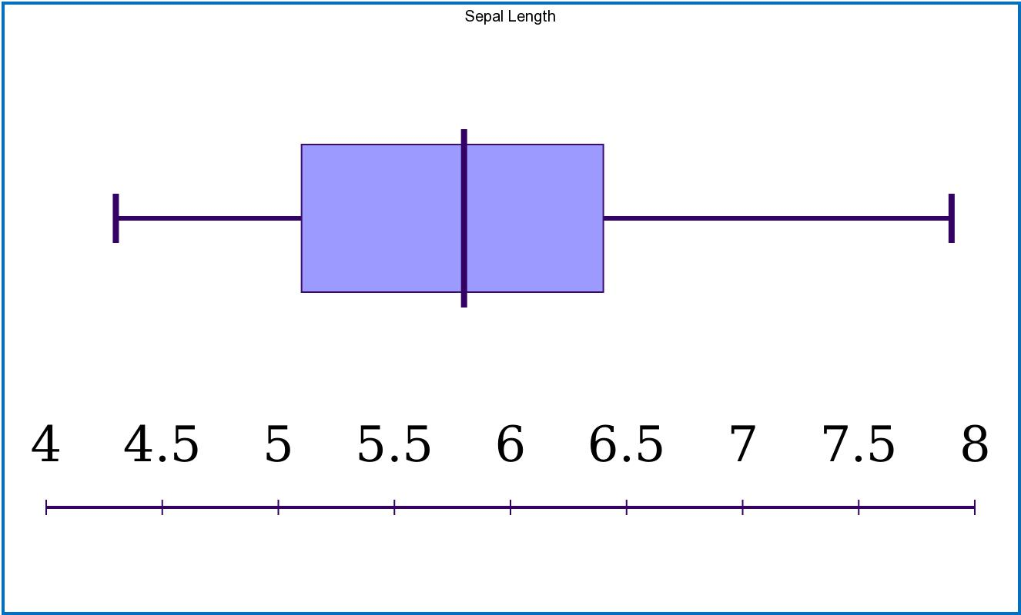

* + 1. Frequency Table:

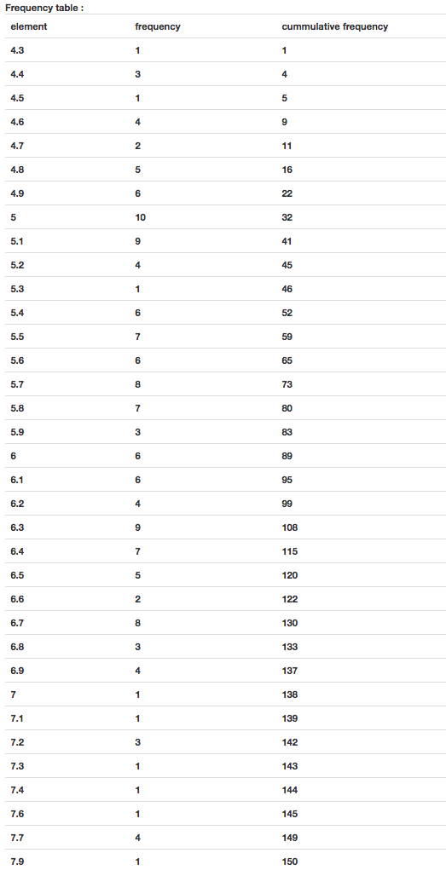

* + 1. Frequency Histogram:

