**Report on ERD creation**

Purpose: Create an ERD and initial table design for a e-news website.

1. Enitites description:

* Writer: aka reporter., person that writes one or several articles.
  + writerID: unique sequence for each writer
  + writerName: name of the writer
* Editor: person who is in charge of reviewing article written by one or several writers.
  + editorID: unique sequence for each editor
  + editorName: name of each editor
* Review: Since the relationship between writer and editor is M-N, a new entity named “Review” should be created to connect between these 2 entities.
  + reviewID: unique sequence for each review
  + reviewDate: the day that the review session is conducted
* Article: an article
  + articleID: unique sequence of each article
  + fullContent: whole content of each article
  + publishedDate: the day that the article is published
  + headerName: summary of the article
  + articleNam: name of the article
* ArticleWriter: Since the relationship between writer and article is M-N, a new entity named “ArticleWriter” should be created to connect between these 2 entities.
* InCategory: Since the relationship between article and category is M-N, a new entity named “InCategory” should be created to connect between these 2 entities.
* Picture: pictures used in all articles
  + picID: unique sequence of each picture
  + picName: name of each picture
* Category:
  + categoryID: unique sequence of each category
  + categoryName: name of each category

1. ERD

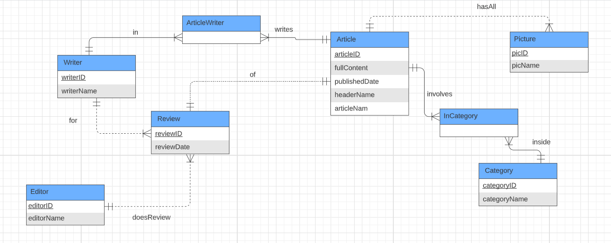

1. Entities relationship:

* Editor – Writer: M-N, many editors can give reviews to many writers and several writers can have their drafts reviewed by several editors. Since this is a M-N relationship, an entity “Review” is created to connect these 2 entities.
* Writer-Article: M-N, one writer can write several articles and 1 article can be written by several writers. Since this is a M-N relationship, an entity “ArticleWriter” is created to connect these 2 entities.
* Article-Picture: 1-M, meaning 1 article can have several pictures.
* Article-Category: M-N, one article can have several categories and 1 category can contain several articles. Since this is a M-N relationship, an entity “InCategory” is created to connect these 2 entities.

1. Initial Table design

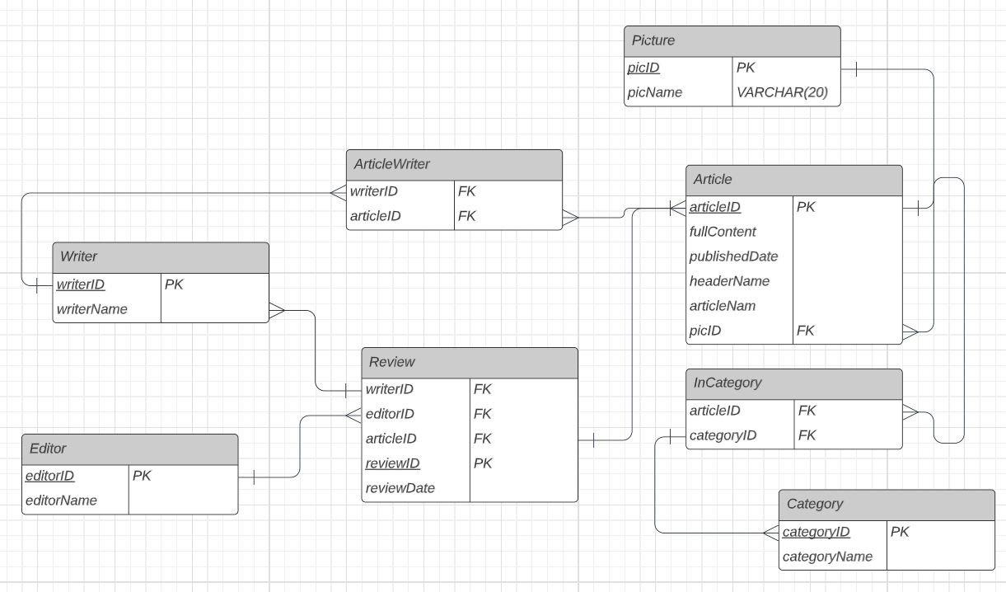

1. BCNF

* 1 NF: No multiple values for each attribute in entity by assigning each unique ID sequence to writer, editor, review session, article, picture and category so that every single row contain unique information of an individual.
* 2NF: Breaking into a new entity named ArticleWriter from Writer entity since the information articleID in Writer entity depends on key attribute “writerID”.
* 3NF: Breaking into a new entity named Writer from Review entity.

I think I have conducted the initial table design already following BCNF principles so that there isn’t need for modification.