THE ULTIMATE

THE

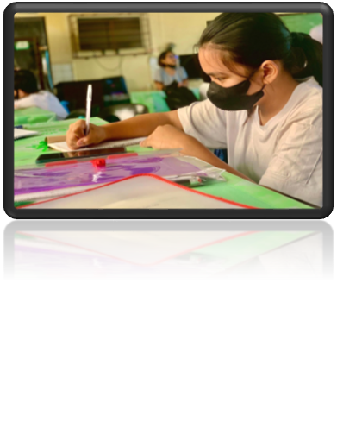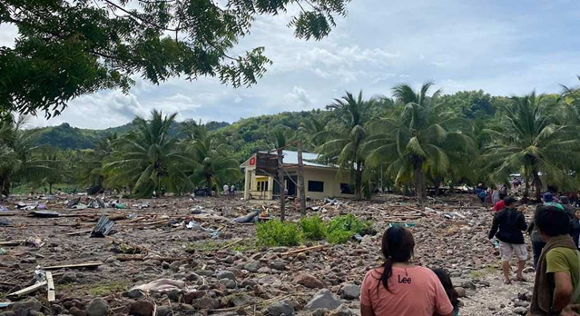Typhoon Paeng (Nalgae) washed out the Eastern Samar

Page. 5

Hidilyn Diaz takes her 1st ever Sea Games weightlifting gold medal

Page. 3

Page. 4

Face to face with a twist

An Endless Love Beyond Eternity

FULL BLAST FACE TO FACE

THE FIRST, THE VOICE, BEYOND WORDS

NEWS ARTICLE

https://www.bing.com/images/search?view=detailV2&ccid=g2Z8g%2bu%2f&id=C939A6BC5C5E1D1E9CC0C182AF5A2D4E5F0A1775&thid=OIF.1CiWgvqTXx7uhsK4%2fyk0gQ&mediaurl=https%3a%2f%2fxrc.bomboradyo.com%2fnewscenter%2f2022%2f10%2fmaguindanao-flashfloods-paeng.jpg&exph=542&expw=916&q=bagyong+paeng&simid=7059409041961&FORM=IRPRST&ck=D4289682FA935F1EEE86C2B8FF293481&selectedIndex=12&mode=overlay

By: JONA MAE FRIAS

Typhoon Paeng (international name: Nalgae), intensively moving to Borongan City, Eastern Samar with the maximum wind ranging to 65km/h and gustlines up to 80km/h last October 28,2022.

According to DSWD, about 3million individuals are already affected by this typhoon. More than 100 people

have been died and some got injured due to the recent Severe Trophical Storm Paeng from Luzon,Visayas and Mindanao.

Most of the affected are in the agricultural industry, P1.33 billion worth of damaged has been recorded by the Department of Agriculture (DA). many crops are destroyed and farmers are voicing for help.

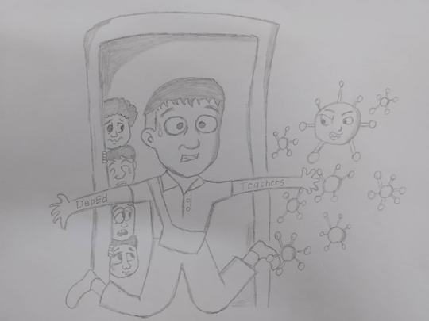Face to face with a twist

EDITORIAL NEWS

By: MARY JOYCE TAMAYO

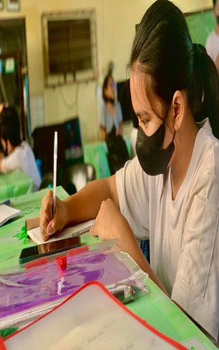

To learn, To teach, To evaluate. Are the things that comes to our mind when it comes to the world “face to face’. But in this new normal, are we sure that we are already capable to do the full blast thing?

In having a full blast face to face learning;students will see their classmates personally clearly. We all know that in the time of the pandemic most of the students don’t find the modular learning as a alternative. They don’t find it easy due to some reason including;some of them have their household chores; or sometimes they don’t understand what is in the module.

We know that we are still in the hands of pandemic, we still uses mask, and still practicing social distancing . Meaning our face to face is having a twist, new challenges for the teachers and students. New beginning, new normal.

Parents are having a difficulties in letting their children go to school, they are afraid in the question “what if mt child will get infected?” Pandemic ruin the quality of education by just spreading the virus, and in just a click of a hand the world stops

So are we ready for face to face with a twist?

An Endless Love Beyond Eternity

FEATURE STORY

By: MARIA PAULA TAMONDONG

We remember, We pray, We visit”. All soul’s day looks too creepy and scary yet it is a wonderful period to commemorate our love ones who already past away ,the time of reminiscence and visualization to them. Souls do not stick with a mark of fear and desolation but with endless love and care.

Every year at every 2nd day of November, all soul’s day is being conducted. it is a process of visiting and pricking candles as we go to cemetery for us to connect and assume that we are with them also it is the day were children starts to get scared because they see it as the time where the ghosts explodes.

https://www.bing.com/images/search?view=detailV2&ccid=va5EAySr&id=F01821257C0D15FD849816E1928FB1E883EC6FA6&thid=OIP.va5EAySrDk-gx4rl_MfKfQHaE8&mediaurl=https%3A%2F%2Fassets2.rappler.com%2FF6B98496F1794C84ACD9083749BC70CB%2Fimg%2FC6BBCC2AE9404CD5AD5627D6A120014D%2Fundas-ng-kababaihan-oct242017-013.jpg&exph=1280&expw=1920&q=undas&form=IRPRST&ck=4014628DA1E48AA7240322CFCD776D8D&selectedindex=0&mode=overlay&vt=2

ASD must not be the period of fear whereas the day of affection and focus to those we miss specially to the unforgettable members of us.

Be good, Be fair and Be kind. We cannot bring our money ,jewelries or any other expensive things we have when the time comes, because next moment, what the small day cannot hold must spill into eternity.

https://www.bing.com/images/search?view=detailV2&ccid=BT3tOTHi&id=FDE69D8690D4A2B1198CF1F98D18CA4D704B156C&thid=OIP.BT3tOTHiJiGMExWiKgBG3wHaEK&mediaurl=https%3a%2f%2fassets2.rappler.com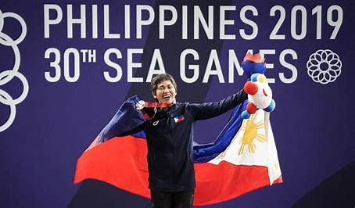

SPORTS NEWS

Hidilyn Diaz takes her 1st ever Sea Games weightlifting gold medal

By:CHERINE ALBINO

Hidilyn Diaz a 31 years old strong lady male a history by grabbing the thrown in the 30th Southeast Asian Games weightlifting competition at December 11,2019, it was held in World Trade Center in Pasay City. After a 30 long consecutive years, the Philippines bring home the gold medal.

Hidilyn acquired 88kg in first, 91kg in second, 110kg in fourth and 115 in her last attempt resulting a 404kg in total. Nguyen Thi Thuy was her nearest opponent having a score of 197kg.

“I’m really confident with my strength in teenager and we’ve been study my opponent so we know she’s strong in snatch but in clean and joke no, but of course I cannot play competition, I always want to do my best”, said Hidilyn.

News- Jona Mae Frias

Sports- Cherine Albino

Layout Artist- Lloyd Alexis Camacho

Editorial Writing and Cartooning- Mary Joyce Tamayo

Feature- Maria Paula Tamondong