**CHAPTER 4**

**RESULTS AND DISCUSSION**

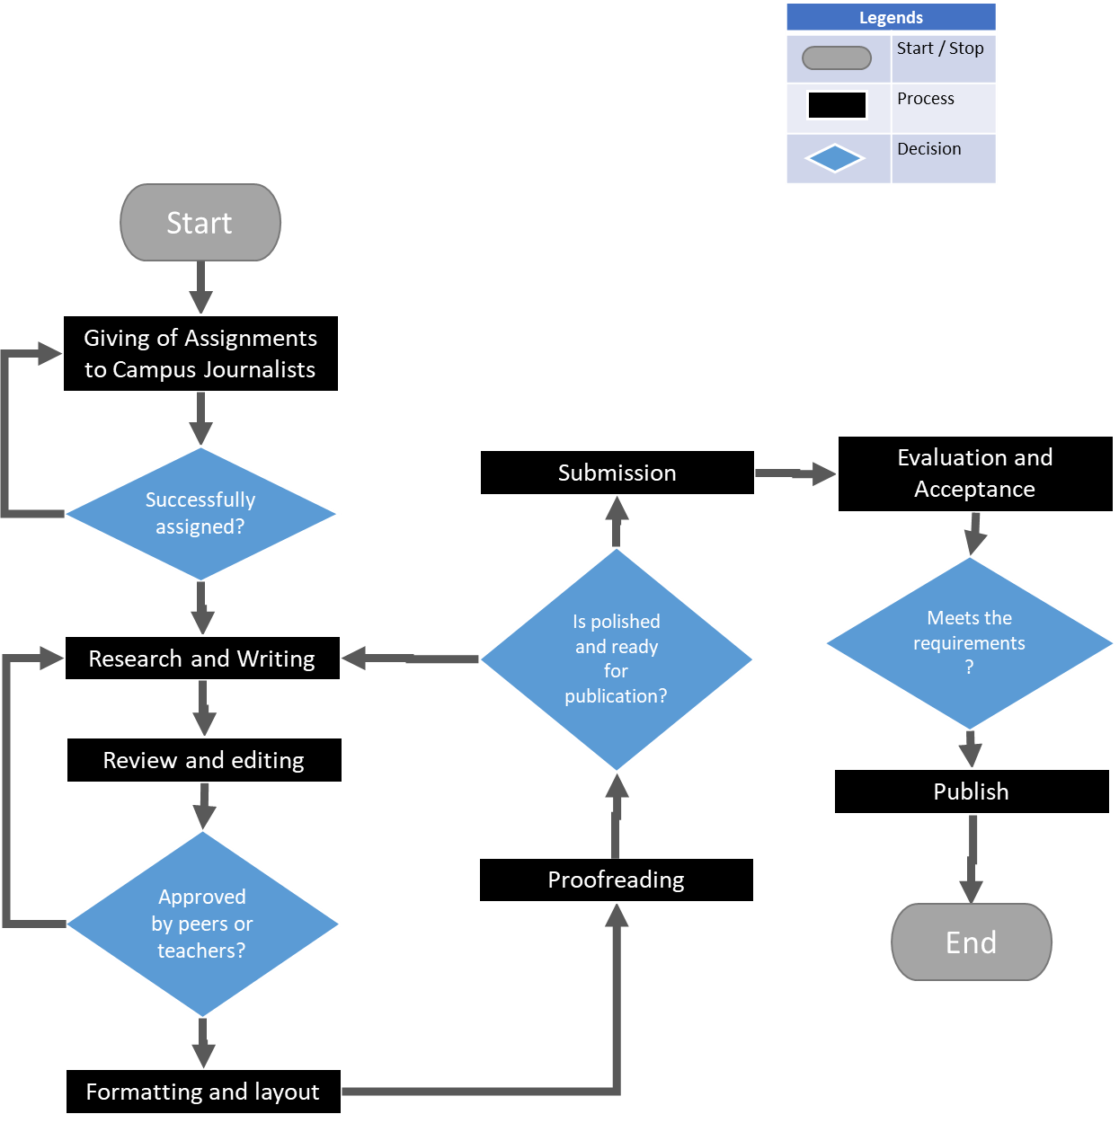**4.1 – The Current Manual Services and Processes of the Speaker Eugenio Perez National Agricultural School**

**Figure 7** – School Paper Publication Flowchart

Figure 7 shows the manual processes of school paper publication practiced in Speaker Eugenio Perez National Agricultural School. The school paper comes only once every school year – in it are details regarding the results of the Intramurals, the awards garnered by the school and its students from various competitions, and other matters that are related to the school.

**Giving of Assignments:** The publication of the school paper starts with the School Paper Adviser assigning topics to the campus journalists.

**Research and Writing:** After receiving their assignment, the campus journalists gather and analyze data and start writing the paper.

**Review and Editing:** After the paper is written, it will be reviewed by the author, their peers, or their teacher to ensure that the paper is well-written, well-researched, and free of errors.

**Formatting and layout:** After the paper has been reviewed and edited, it is formatted and laid out according to the guidelines set by the school.

**Proofreading:** Before the paper is submitted, proofreading is done to check for any remaining errors or inconsistencies.

**Submission:** After the paper has been reviewed, edited, formatted, and proofread, it is submitted to the school for publication.

**Evaluation and Acceptance:** The paper is evaluated by the school, if it meets the requirements it will be accepted for publication.

**4.2 – The Functional and Non-Functional Requirements of the System**

|  |  |
| --- | --- |
| **Functional Requirements** | **Non-Functional Requirements** |
| User authentication: the ability for users to log in and out of the system using a unique username and password. | Performance: the system's response time, throughput, and overall speed. |
| Data storage: the ability for the system to store and retrieve data in an organized and efficient manner. | Security: the system's ability to protect sensitive data and prevent unauthorized access. |
| Reporting: the ability for the system to generate reports on different aspects of the data. | Usability: the system's ease of use, learnability, and overall user experience. |
| Scalability: the ability for the system to handle an increasing number of users or transactions. | Reliability: the system's ability to operate without failure and meet its functional requirements consistently. |
| User-friendly interface: the ability for the system to be easy to use and understand for users. | Scalability: the system's ability to handle an increasing number of users, transactions, or data. |
|  | Availability: the system's ability to be accessible and operational during agreed upon times. |

**4.3 – Acceptability Test of the System**