VARYS
PRODUCT
DOCUMENTATION
Drone Operations and Aerial Intelligence Platform
From mission planning to actionable intelligence
DOCUMENT PURPOSE
To define the problem Varys addresses, the solution it provides, its product vision and goals, its current scope, and the recommended next phases of development.
Version 1.0 | July 2026

Executive Summary
Varys is a role-based drone operations and aerial intelligence platform. It connects mission planning, equipment management, aerial-data collection, specialist analysis, reporting, and client delivery within one coordinated environment.
The platform is designed around four principal users: clients or viewers, drone operators, agriculture analysts, and security analysts. Each user receives access to the information and tools required for their work, while sensitive operational functions remain protected.
Varys is not intended to stop at collecting images from the air. Its purpose is to convert aerial data into clear, traceable, and useful intelligence that supports agricultural management, security monitoring, and operational decision-making.

Product at a glance
Product type | Drone operations and aerial intelligence platform
Primary users | Clients, drone operators, agriculture analysts and security analysts
Core value | One controlled workflow from mission planning to insight delivery
Initial focus | Agricultural intelligence, security monitoring and client reporting

1.0 Introduction
The growing use of drones has created new opportunities in agriculture, security surveillance, land monitoring, infrastructure inspection, and environmental management. Drones can cover large areas quickly and collect detailed aerial images and location-based information. The value of this technology, however, depends on how effectively the collected data is processed, analysed, presented, and used for decision-making.
In many organisations, mission planning, drone maintenance, aerial-image storage, analysis, and report preparation are handled through separate applications or manual records. This weakens coordination and slows the delivery of useful information to clients and decision-makers.
Varys addresses this challenge by providing a single digital platform for managing drone operations and transforming aerial data into practical intelligence. Through Varys, authorised users can plan missions, monitor flights, manage drones and payloads, upload captured data, perform agricultural or security analysis, generate reports, and share approved results with clients.
Varys is therefore more than a drone management application. It is an aerial intelligence platform that supports the complete process from data collection to analysis, reporting, and decision-making.

2.0 Problem at Hand
Collecting aerial images is only one part of a drone operation. The information must also be organised, interpreted, stored securely, connected to the correct project, and presented in a form that decision-makers can understand. Many organisations lack one system that manages this complete process.

2.1 Fragmented operational workflow
Mission planning, flight execution, data uploads, analysis, reporting, and client communication are frequently performed through different tools. This creates gaps in the workflow and makes it difficult to follow a mission from initial request to final delivery.

2.2 Limited equipment visibility
Drone operators need reliable information about aircraft availability, battery condition, payload compatibility, maintenance history, and flight time. When these records are dispersed or manually maintained, equipment may be assigned incorrectly and important maintenance activities may be delayed.

2.3 Raw data without clear interpretation
Agricultural and security users do not simply need aerial images. Farmers need understandable information about vegetation, crop condition, planting suitability, and possible areas of concern. Security teams require structured observations, mapped incidents, alerts, and traceable reports.

2.4 Poor client visibility
Clients may depend on calls, email messages, and manually shared files to receive project updates. This makes it difficult to monitor work, view mapped locations, obtain reports, and access approved deliverables from one secure location.

2.5 Key problems summarised
- Disconnected planning, flight, analysis, and reporting processes.
- Poor organisation and traceability of aerial data.
- Limited monitoring of drones, batteries, payloads, and maintenance.
- Difficulty converting raw imagery into useful agricultural or security intelligence.
- Slow report preparation and delivery.
- Limited collaboration and client visibility.
- Dependence on manual records and communication channels.

3.0 The Varys Solution
Varys provides a central, role-based environment for managing drone operations and converting collected aerial data into useful information. It connects all major participants in a drone project and gives each one a dashboard designed around their responsibilities.
The platform begins with secure access. After sign-in, a user is directed to the appropriate dashboard based on the assigned role. This protects sensitive information and prevents users from accessing functions outside their responsibilities.
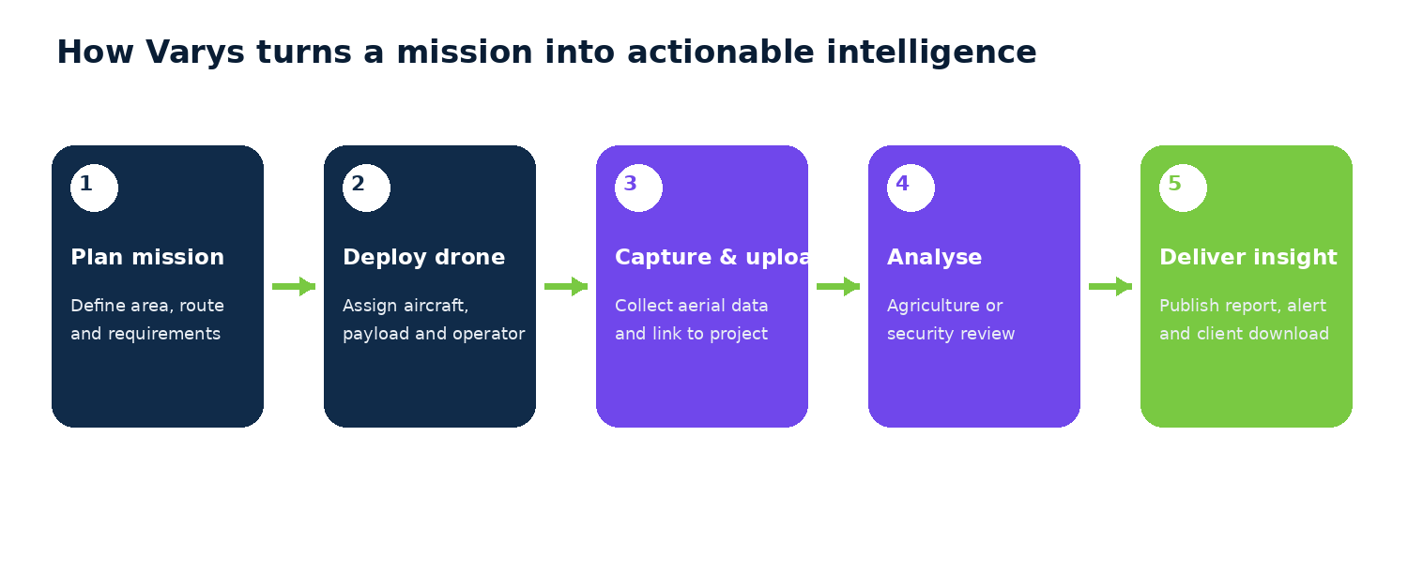
Figure 1. Varys end-to-end operational workflow

3.1 How the solution works
- A project requirement or mission is created.
- The mission area, route, objectives, and flight parameters are prepared.
- A suitable drone, payload, battery, and operator are assigned.
- The drone carries out the mission and captures aerial data.
- Captured data is uploaded and linked to the correct project.
- An authorised agriculture or security analyst interprets the data.
- A report, alert, map, or other deliverable is produced.
- The client is notified and accesses the approved result.

4.0 Product Vision
To become a trusted aerial intelligence platform that enables organisations to plan drone operations, understand aerial data, and make faster, better-informed decisions from one secure environment.
Varys aims to make drone technology more useful and accessible by moving beyond basic image collection. The platform will transform aerial data into clear insights that support agricultural productivity, security monitoring, resource management, and other location-based operations.

4.1 Long-term direction
The long-term product should remain modular and flexible enough to support new drone types, sensors, analytical models, industries, and operational environments as the platform grows.

5.0 Goal and Objectives
The main goal of Varys is to create an integrated platform that manages the complete drone-data lifecycle, from mission preparation and aerial-data collection to analysis, reporting, and client delivery.

5.1 Specific objectives
- Provide secure role-based access for operators, analysts, clients, and administrators.
- Centralise missions, projects, aerial data, reports, and user activities.
- Simplify mission planning and active-flight monitoring.
- Maintain reliable records of drones, payloads, batteries, maintenance, and flight history.
- Support agricultural analysis with maps, vegetation indices, crop records, and field observations.
- Support structured security monitoring, incident reporting, and alerts.
- Reduce the time required to prepare and deliver reports.
- Give clients controlled access to project progress and downloadable results.
- Create a scalable foundation for advanced analytics and artificial intelligence.

6.0 User Roles

Client / Viewer
Views assigned projects, mapped locations, mission reports, notifications, and authorised downloads. This role does not control internal flight or analytical operations.

Drone Operator
Plans missions, manages drones and payloads, checks maintenance, monitors active missions, uploads data, and reviews flight logs.

Agriculture Analyst
Examines farm imagery, NDVI and vegetation conditions, planting suitability, crop information, possible disease observations, field notes, and agricultural reports.

Security Analyst
Reviews authorised aerial surveillance data, mapped observations, incidents, alerts, and intelligence reports.

Administrator
Manages users, organisations, permissions, reference data, audit records, and platform-wide settings. This role should be added explicitly during development.

7.0 Current Product Scope

7.1 Authentication and access control
Secure login, password recovery, session management, account verification, and permission-based access.

7.2 Client dashboard
Project monitoring, map view, mission reports, downloads, notifications, and profile settings.

7.3 Drone operations
Dashboard summaries, drone records, payloads, maintenance, mission planning, active missions, uploads, and flight logs.

7.4 Agricultural intelligence
Farm overview, NDVI and vegetation analysis, planting suitability, crop data, disease observations, field notes, and reports.

7.5 Security intelligence
Surveillance review, location-based observations, incident classification, alerts, reporting, and controlled evidence access.

7.6 Projects and reports
Project records that connect missions, maps, uploads, analysis, reports, and client deliverables.

7.7 Notifications and settings
Role-relevant alerts, account preferences, notification controls, and authorised system configuration.

8.0 Recommended Next Phase of Development
The next phase should move Varys from a complete interface design into a functional minimum viable product. Development should proceed in controlled stages so that the main workflow is validated before advanced integrations and automation are introduced.
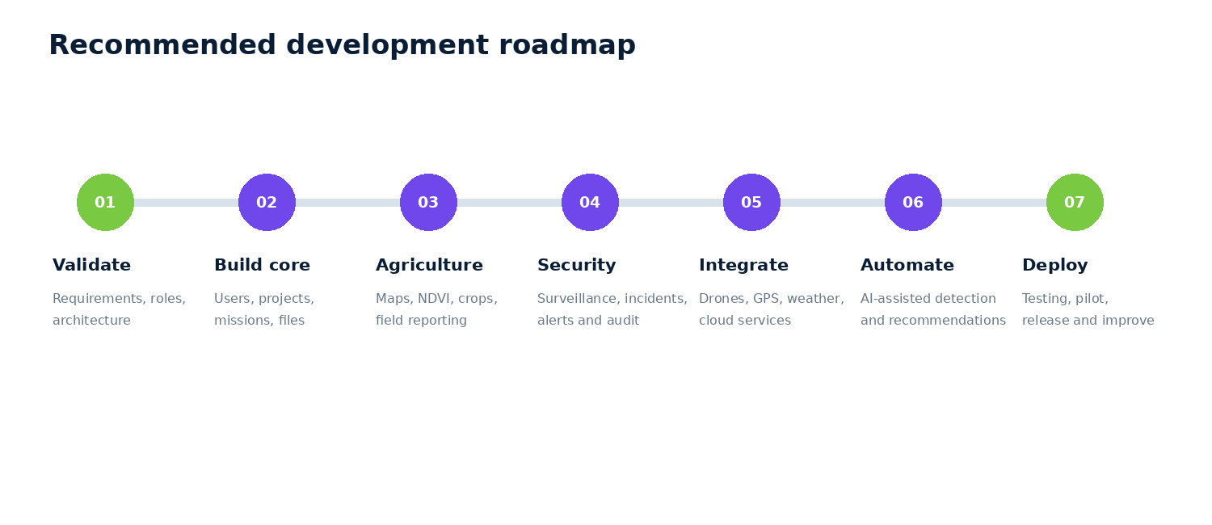
Figure 2. Recommended phased development roadmap

Phase 1: Product validation and technical planning
- Confirm roles, permissions, requirements, and workflows.
- Define user stories, acceptance criteria, database structure, APIs, security requirements, and system architecture.
- Prioritise features for the minimum viable product.

Phase 2: Core platform development
- Build authentication and role-based access.
- Implement organisations, clients, projects, missions, drone and payload records, flight logs, file uploads, maps, reports, notifications, and downloads.
- Prove one complete workflow from project creation to client delivery.

Phase 3: Agricultural intelligence
- Connect farm boundaries and georeferenced imagery.
- Implement NDVI, vegetation analysis, crop and field records, planting suitability, date comparisons, maps, and reports.
- Validate results with agriculture and remote-sensing specialists.

Phase 4: Security intelligence
- Implement monitoring areas, surveillance review, incidents, alerts, evidence management, escalation, reporting, and audit logs.
- Apply strong privacy controls and documented authorisation procedures.

Phase 5: External integrations
- Integrate approved drone platforms, GPS and maps, weather services, satellite imagery, cloud storage, and communication services.
- Reduce manual entry and improve operational speed.

Phase 6: Artificial intelligence and automation
- Introduce AI only after reliable, properly labelled data is available.
- Support vegetation-stress detection, imagery comparison, object detection in approved operations, predictive maintenance, report summaries, and analyst recommendations.
- Keep human review in the loop for important findings.

Phase 7: Testing, pilot deployment, and improvement
- Complete functional, security, performance, recovery, permission, browser, map, and upload testing.
- Run pilot projects with real users and improve the product using verified feedback.

9.0 Minimum Viable Product Success Criteria
The first functional release should be considered successful when the platform can complete one entire operational cycle reliably.
- An administrator can create users and assign roles.
- A project can be created for a client.
- A drone operator can plan and complete a mission.
- Equipment and flight information can be recorded.
- Captured data can be uploaded and attached to the project.
- An analyst can review the information and attach a report.
- The client receives a notification and downloads the approved deliverable.
- Every important action is recorded for accountability.

10.0 Expected Outcome
When fully developed, Varys will provide a coordinated environment for managing drones, missions, aerial data, analysis, and client reporting. It will reduce dependence on disconnected tools and manual processes while improving the visibility and traceability of every project.
Drone operators will have a structured way to manage equipment and missions. Analysts will have organised data and specialised tools for producing useful findings. Clients will be able to monitor projects and access results from one location. Management will have clearer records of resources, activities, performance, and completed work.
The overall result will be a platform that transforms drone operations from a collection of separate technical activities into a complete aerial intelligence service.

