Loan Management System
Independent Assessment

A technical and product review of the Jasiri Lending Software platform

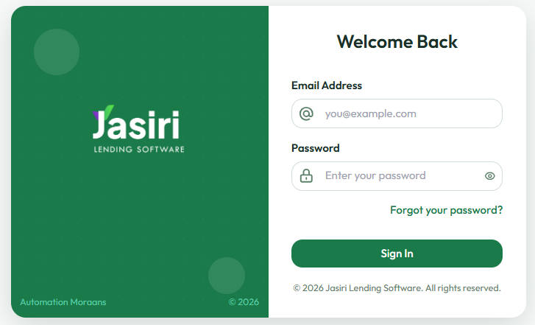
PREPARED FOR

Prepared by Emmanuel Birgen
IT Consultant · Serve Well Co.
24 July 2026
CONFIDENTIAL — prepared solely for Mular Credit. Contains security-sensitive findings; handle accordingly.

Contents
Contents 2
1 Executive summary 3
2 Scope and method 4
3 What Jasiri does well 4
4 The core opportunity — origination and turnaround 5
5 Registry and onboarding 6
6 Loan products and credit settings 9
7 Reports and finance 10
8 Security findings — responsible disclosure 12
9 Integration and single sign-on 14
10 Recommended priorities 14
11 In closing 15
A Appendix — findings register 16

1 Executive summary
Jasiri is a capable lending platform with a genuinely strong analytical core and a well-shaped product model. This review — conducted live on the production tenant — finds it held back by three things: onboarding friction that inflates the time from application to disbursement; a handful of unfinished areas presented as finished; and, most urgently, security exposures on the live system that warrant immediate attention. None of these is fatal. All are fixable, and the same fixes are the roadmap to a fast, identity-first origination engine.
THE HEADLINE
Mular’s greatest opportunity is turnaround. Two capabilities collapse the time from application to disbursement without loosening control: IPRS-first identity (an ID number returns verified particulars — the very thing that impressed the CEO when he handed over only his own ID) and internal statement scoring that assigns a starting limit and matches the customer to the right product — with reason codes. Together they move expensive human judgement to the few cases that need it, instead of every case.

Findings at a glance
16 findings across 11 module groups and 60+ screens: 1 Critical · 6 High · 7 Medium · 2 Low

Module maturity
Module group | Standing | In a line
Dashboards & Analytics | Strong | The platform’s best asset — broad, well-organised analytics.
Leads | Strong | Lead management, aging, converted and insight views all present.
Audit & Logs | Adequate | Data-change and user-activity logs exist — a good foundation.
Loan Products & Credit | Adequate | Sensible tiered products; penalty configuration is broken (F-08).
Loaning & Approvals | Adequate | Workable, but gated behind a long manual approval chain.
Reports & Finance | Adequate | Content is right; presentation and access model are dated.
Registry & Onboarding | Needs work | Friction, weak validation, and a hard dead-lock (F-01…F-06).
Administration & Security | At risk | Privilege self-escalation and non-expiring sessions (S-01, S-02).
System Settings | At risk | Placeholder — every item redirects to the dashboard (S-03).

2 Scope and method
What was reviewed. The live Jasiri Lending Software tenant operated for Mular Credit, exercised end-to-end on 24 July 2026 by Emmanuel Birgen as a provisioned Administrator. The review covered all eleven module groups — Dashboard, Leads, Registry, Loaning, Credit Settings, Accounts & Finance, Reports, Drafts, Administration, System Settings, and Audit & Logs — across more than sixty screens, working the real customer-onboarding and loan journeys rather than inspecting screens in isolation.
How severity is rated. Each finding is rated by business impact and likelihood: Critical (control-defeating, act now), High (blocks users or exposes the business), Medium (friction or quality), and Low (polish).
On the security findings. Section 8 was found and confirmed in the course of normal testing and is disclosed here responsibly and privately. No customer data was exfiltrated or altered; the only action taken was the minimum needed to demonstrate that a role could be self-assigned. We recommend the items in Section 8 be treated as time-sensitive.

3 What Jasiri does well
A fair critique begins with credit where it is due — and Jasiri earns it in several places.

3.1 A comprehensive analytics core
The Analytics Dashboard is the platform’s strongest asset. Beyond Regional and Branch performance, it carries Loan Product Overview, Customer Retention, Repayment Trends, Customer Age Distribution, Business Sector Distribution, Guarantor Age Analysis, Payer Type Analysis, Customer Distribution by County, Marital Status Breakdown, and NPL Analysis. That is a genuinely complete analytical surface, and it sets the bar to meet — and then exceed — with a more cinematic, presentation-grade analysis studio.
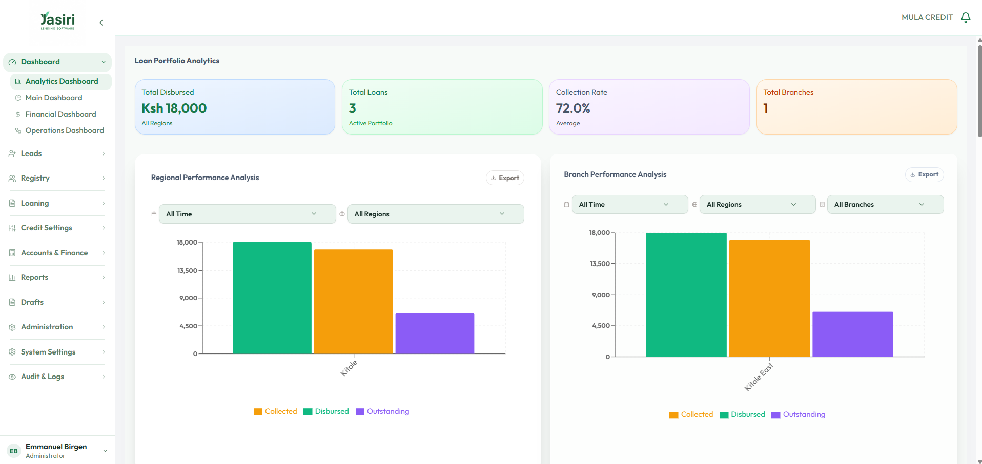
Figure 1 — The Analytics Dashboard: broad, well-organised, and the platform’s clear high point.

3.2 Input validation done right, in the right places
- Business age. A business under six months old is rejected at the business-info step — exactly the guardrail a micro-lender wants at the door.
- Phone formats. Both the primary and alternative mobile numbers are format-checked (“10–15 digits”), catching a common data-quality problem early.

3.3 Institutional memory of every customer touch
The customer record carries interactions and dispositions saved by call-centre agents, alongside approval history, limit-adjustment history, and scored-amount history. This is a real strength and worth replicating well — it is the institution’s memory of every conversation and decision about a customer.
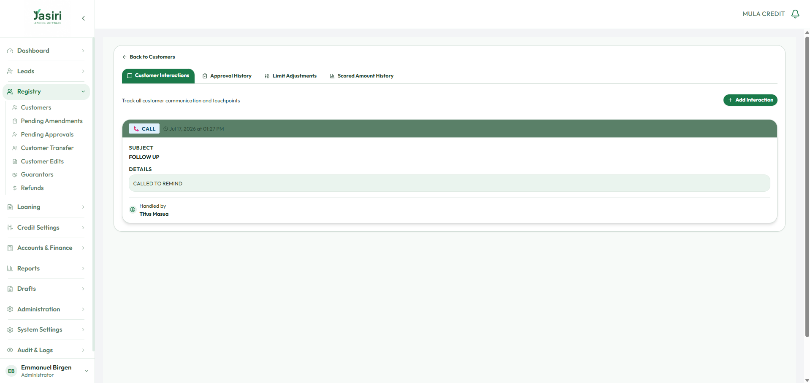
Figure 2 — Customer interactions, approval history, limit adjustments, and scored-amount history on the customer record.

3.4 A workable approval workflow, and a real finance module
- Configurable workflow statuses and approval messages run across the loan chain — a good catch and a sound idea.
- A fuller finance surface than many peers ship: chart of accounts, journal vouchers, bank and manual reconciliation, a financial-transactions ledger, and promise-to-pay reports.
- Report access codes show the right security instinct — reports should be gated (we refine how, in F-10).

4 The core opportunity — origination and turnaround
Mular’s operating reality is a long runway from lead to disbursement: leads are captured, converted, and then passed through multiple approval stages — much of it before a loan application even exists. It is thorough, and it is slow. The single largest opportunity is to collapse that turnaround without losing an ounce of control. Two capabilities do most of the work.
① IPRS-FIRST IDENTITY
Instead of hand-keying a customer’s particulars and validating them after the fact, the officer enters an ID number and the system returns the verified names and details — the same principle that let the CEO hand over only his ID number and watch his own record return. Applied to the borrower, the guarantor, and the next-of-kin, it removes the single largest source of both friction and fabricated data at once — and closes F-03 and F-04 by construction.

② INTERNAL SCORE → STARTING LIMIT → PRODUCT MATCH
Rather than pushing every applicant through the full manual chain to discover their standing, an M-Pesa statement is analysed into an internal score; from that score the customer is given a starting loan limit and matched to the product bucket and term that fit — FADHILI, KUZA, or INUKA — each recommendation carrying its reason codes (why this limit, why this product). The officer sees, on one screen, exactly what the customer qualifies for and why, before the approval chain begins.

Together, these move the expensive human judgement to the end — on the handful of cases that genuinely need it — instead of the front, on every case. That is how the time from application to disbursement falls, and it is exactly where Serve Well Co. and the BirgenAI engine suite are built to help.

5 Registry and onboarding
Onboarding is where a lending platform earns or loses its operators, and it is where Jasiri needs the most work. The journey is functional but brittle: validation fires too late, drafts are lost, and one failure surfaces the raw database. Each finding below is small on its own; together they inflate turnaround and, in one case, strand the user entirely.
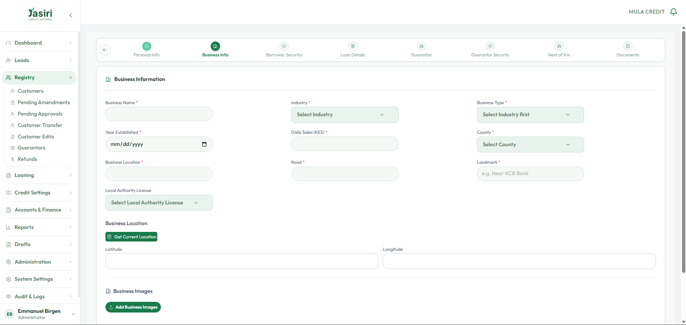
Figure 3 — The new-customer business-info step, where several of the findings below first appear.
F-01 Save-as-draft fails and loses earlier steps | HIGH

WHAT HAPPENS | On the multi-step new-customer form, “Save as draft” at Stage 2 returns “Failed to save draft.” After a refresh, every entry — including the completed Stage 1 — is gone.
IMPACT | An officer who is interrupted loses all captured data and must re-key from scratch. In the field, on intermittent mobile data, this all but guarantees abandoned registrations and inflated turnaround. It also implies steps are not persisted server-side as they are completed.
RECOMMENDATION | Persist each step to a draft record the moment it is completed (autosave), so a draft is always recoverable and the form resumes where it stopped. Never advance a wizard whose previous step was not saved.

F-06 A raw database error is shown to the user — and dead-locks them | HIGH

WHAT HAPPENS | After every step was completed correctly, submission failed with a raw database message: “null value in column “branch_id” of relation … violates not-null constraint.” The screen showed the database’s words, with no plain-language reason and no way forward.
IMPACT | A real officer dead-locks precisely here: everything looks complete, yet an internal constraint (no branch attached) blocks the submission with no guidance. This single class of error strands users, generates support calls, and leaks internal schema details to the outside.
RECOMMENDATION | Never surface raw exceptions. Catch them, translate to plain language (“This application isn’t linked to a branch — choose the customer’s branch to continue”), and point to the fix. An embedded assistant should let a stuck user simply ask “why did this fail?” and get a human answer.

F-03 Next-of-kin accepts anything — even the borrower’s own details | HIGH

WHAT HAPPENS | The next-of-kin step performs no validation. The borrower’s own name and phone number were entered as the next-of-kin and the form advanced without objection.
IMPACT | Next-of-kin is a recovery and tracing safeguard. If it can equal the borrower, it is worthless, and the customer record is polluted at the source. The same absence of checks would let guarantor details be fabricated.
RECOMMENDATION | Validate that next-of-kin differs from the borrower (name, phone, ID) and require a stated relationship. Better still, capture next-of-kin and guarantor by ID and auto-populate verified identity — removing the very opportunity to invent the data.

F-02 Town is asked before County, and starts empty | MEDIUM

WHAT HAPPENS | The Town / City selector sits to the left of County and is empty, because its options depend on a County that has not yet been chosen. Users click Town first, find nothing, and stall.
IMPACT | Predictable confusion at the very first data-entry screen — the worst place to lose the operator’s confidence.
RECOMMENDATION | Order County first; reveal or enable Town only once a County is set, and populate it from that county. A control that is disabled-until-ready reads far more clearly than one that is simply empty.

F-04 Date of birth is not enforced until the final submit | MEDIUM

WHAT HAPPENS | The wizard allows the operator to proceed past the identity step without a date of birth, then rejects the final submission with “Please fix missing fields (first: dateOfBirth).”
IMPACT | The user is told at the end about a field they passed at the beginning — the least helpful moment possible. Combined with the draft-loss issue (F-01), it can cost the entire entry.
RECOMMENDATION | Enforce mandatory fields at their own step and block “Next” until they are satisfied. Fail early and in context, never at the finish line.

F-05 Verification photos are silently mandatory | MEDIUM

WHAT HAPPENS | Officer / client verification photos (first officer + client, second officer + client, both officers + client) are required, but the requirement only appears as a submit-time error after everything else is complete.
IMPACT | The same late-failure pattern, and it is unclear whether the requirement is configurable per lender or hard-coded for all.
RECOMMENDATION | Surface the requirement at the photo step itself, and make each photo’s necessity a visible, per-lender configurable rule.

F-13 Transfer screens have no way back | MEDIUM

WHAT HAPPENS | In Customer Transfers, “Create Transfer” opens the transfer-details page, but “Cancel” does not return to the previous list. “Review” opens the “Execute Transfer Now” page with no back button at all — the only way out is to re-click the sidebar.
IMPACT | Broken spatial navigation: users lose their place and their trust in the flow, and re-entering from the sidebar risks losing context.
RECOMMENDATION | Give every secondary screen an explicit Back / Cancel that returns to the originating list with its state intact.

F-07 Business-location map is slow to appear | LOW

WHAT HAPPENS | On the Business Location step, the map (and two dependent required fields) takes a long time to render.
IMPACT | Perceived slowness at a required step; officers may wait unnecessarily or mis-enter while it loads.
RECOMMENDATION | Lazy-load the map behind a lightweight placeholder and capture coordinates with a fast “use current location” that does not block on a full map render.

SERVE WELL RECOMMENDS
An ID-first onboarding flow with step-level validation, true autosave drafts, and plain-language errors backed by an embedded assistant. Most of the findings above disappear not by patching each one, but by changing the shape of the journey: verify identity up front, save as you go, and never let a user reach a wall they cannot read.

6 Loan products and credit settings
Mular’s catalogue is well-conceived: three tiers by ticket size — INUKA (KES 1,000–5,000), KUZA (6,000–10,000), and FADHILI (11,000 and above) — each with weekly terms from four to eight weeks, interest scaling with tenor (25% at four weeks up to 50% at eight), and processing charged either as a percentage (FADHILI, 5%) or a flat fee (KES 500 on INUKA and KUZA). A global joining fee of KES 300 is applied once per new customer. The tiering is exactly the right shape for a graduating micro-borrower.
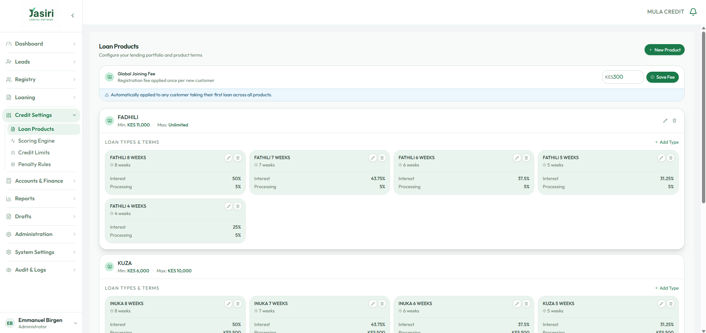
Figure 4 — The FADHILI / KUZA / INUKA product tiers, with per-term interest and processing charges.
F-08 Penalty Rules settings fail to load | HIGH

WHAT HAPPENS | Opening Credit Settings → Penalty Rules shows “Error Loading Penalty Settings / Failed to load penalty settings / Retry Connection.” The page does not recover.
IMPACT | Penalties are core credit configuration. A lender cannot review or change how arrears are charged. For a micro-lender whose margin depends on repayment discipline, an inaccessible penalty engine is material.
RECOMMENDATION | Fix the endpoint, and treat the availability of credit configuration as a monitored health check — not something a user discovers is broken.

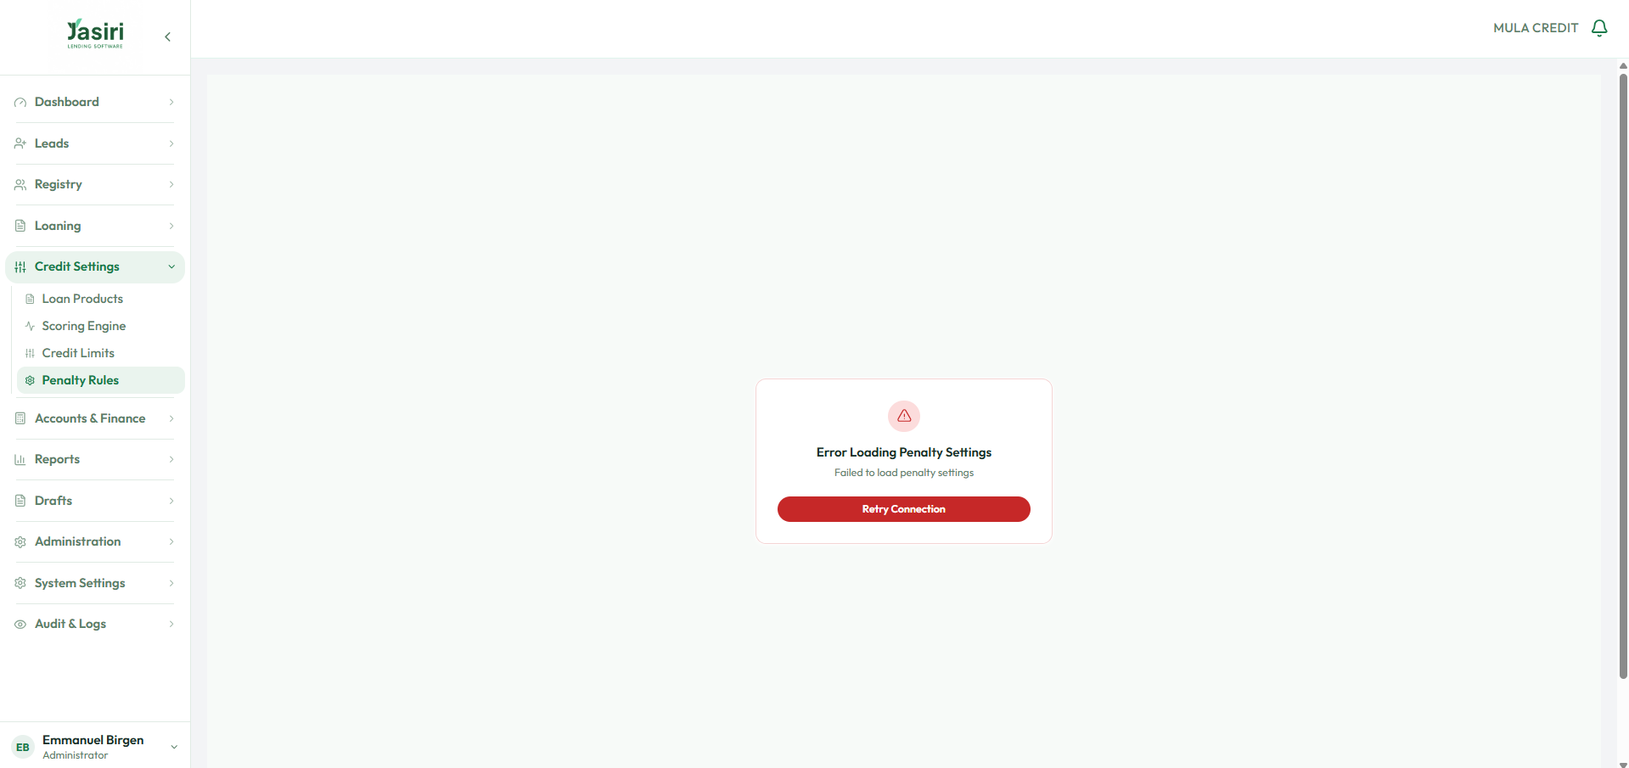
Figure 5 — Credit Settings → Penalty Rules fails to load.
SERVE WELL RECOMMENDS — SEPARATE CHARGES FROM PRODUCTS
In the strongest design, charges are decoupled from products. The joining fee belongs to borrower-level rules (alongside eligibility such as age limits), and processing fees attach to each product as distinct, individually-priced charges — so pricing flexes per product and per lender without ever editing the product itself. This is also what makes reason-coded, limit-driven product matching (Section 4) clean to implement.

7 Reports and finance
F-09 Income statement is sound but visually dated | MEDIUM

WHAT HAPPENS | The income statement is numerically correct — revenue by product, processing and joining fees, penalties, and totals — but the presentation is a plain generic table with no branding, no visual hierarchy, and no period framing beyond a header line.
IMPACT | This is a document a lender shows owners, auditors, and funding partners. Its appearance is the institution’s brand, and “correct but plain” undersells a serious business.
RECOMMENDATION | A branded, properly typeset statement in Mular’s identity — period comparatives, clear sub-totals, share-of-revenue — exporting cleanly to PDF and Excel.

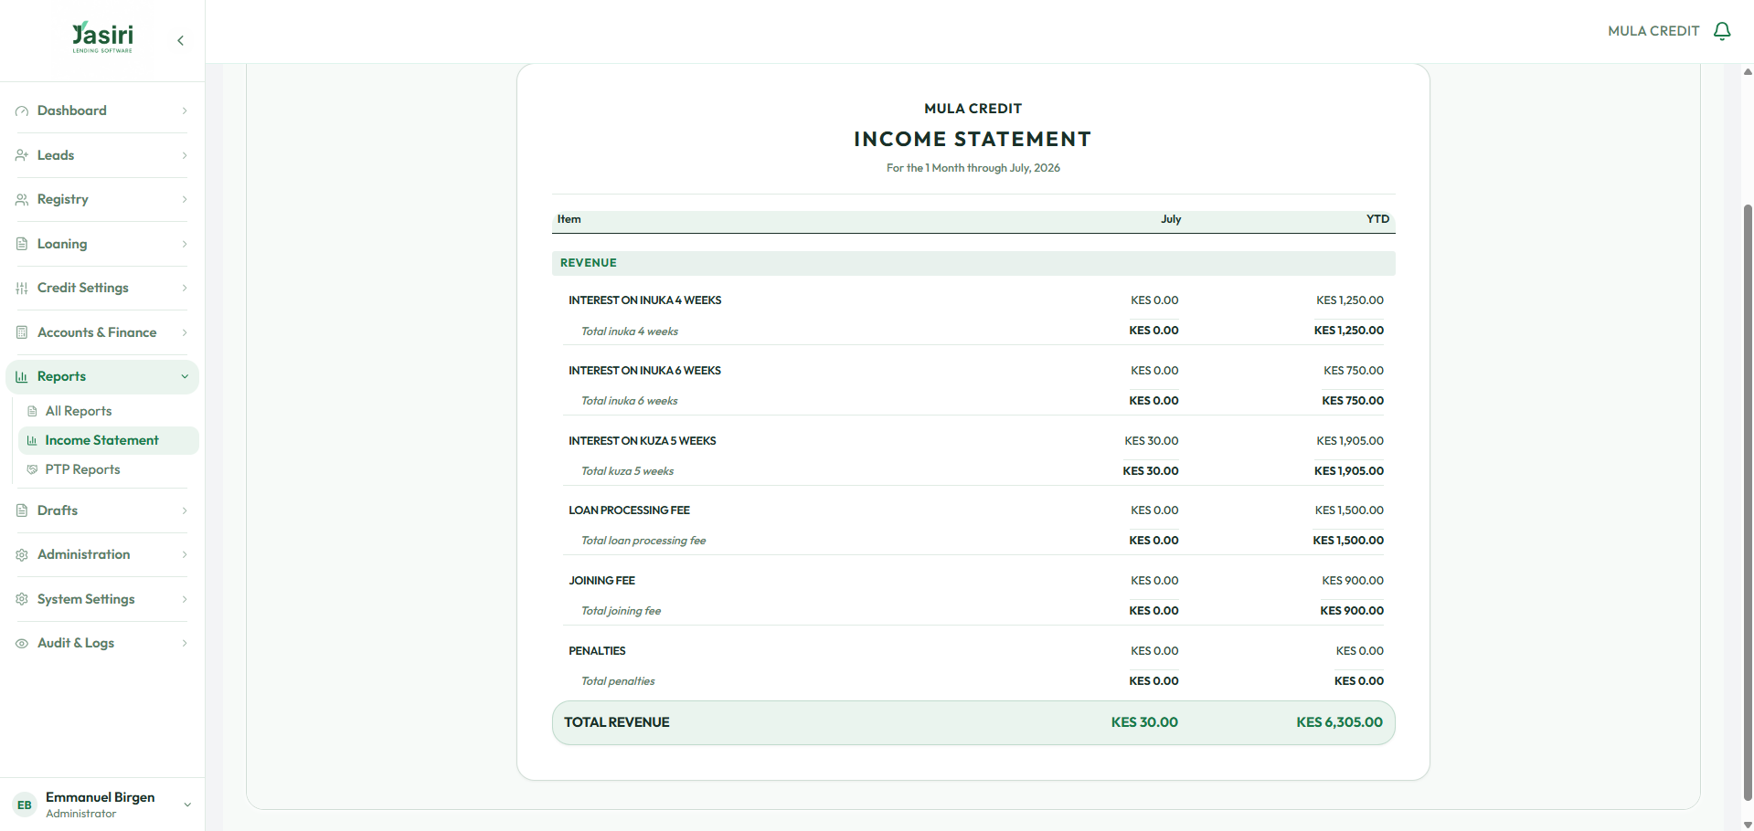
Figure 6 — The income statement: numerically sound, visually plain.
F-10 Report access is by shared code, not by user | MEDIUM

WHAT HAPPENS | Reports are gated behind access codes — a good security instinct — but access is granted by code rather than by identity, and is not scoped per report per user.
IMPACT | Codes are shareable and coarse. They do not answer the question a regulator or owner will ask: who, specifically, can open which report?
RECOMMENDATION | A Report Access Manager that binds report visibility to the user at creation — choose exactly which reports each user may open and how they are scoped (branch, region, own-book). Auditable and revocable.

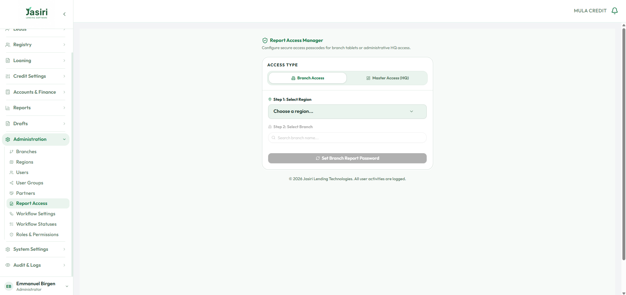
Figure 7 — The current report-access approach.
F-11 Manual reconciliation is not clearly guided | MEDIUM

WHAT HAPPENS | Manual reconciliation exists, but the path — see an unmatched payment, understand where it came from, then attach it to the right customer — is not clearly led.
IMPACT | Reconciliation mistakes are money mistakes, and an unclear flow makes them more likely and harder to trace.
RECOMMENDATION | A clear three-beat flow — show the money and its source → search the customer → reconcile to that account — with a visible audit trail on every match.

8 Security findings — responsible disclosure
These findings were confirmed during ordinary testing and are shared privately so they can be fixed quickly. They are the most important items in this document. We recommend they be treated as time-sensitive, and we would be glad to help remediate them.
S-01 An Administrator can promote itself to Super Admin | CRITICAL

WHAT HAPPENS | An account provisioned only as Administrator was able to assign itself the Super Admin role from the role dropdown and obtain full access. The reviewer’s own account — provisioned as Administrator (see the account badge) — now appears in the “Superadmin · Full access” group alongside the CEO.
IMPACT | The most serious finding in this review. Any admin-tier user can silently seize total control of the tenant — customer data, credit settings, finance, and other users, including the CEO’s own account. It defeats every other control in the system.
RECOMMENDATION | Authorise role changes server-side against the actor’s own authority (a user may never grant a role above their own); remove Super Admin from the assignable options in both UI and API; require four-eyes approval for any elevation; and log and alert on every role change. This was tested responsibly — no data was accessed or altered beyond demonstrating the assignment.

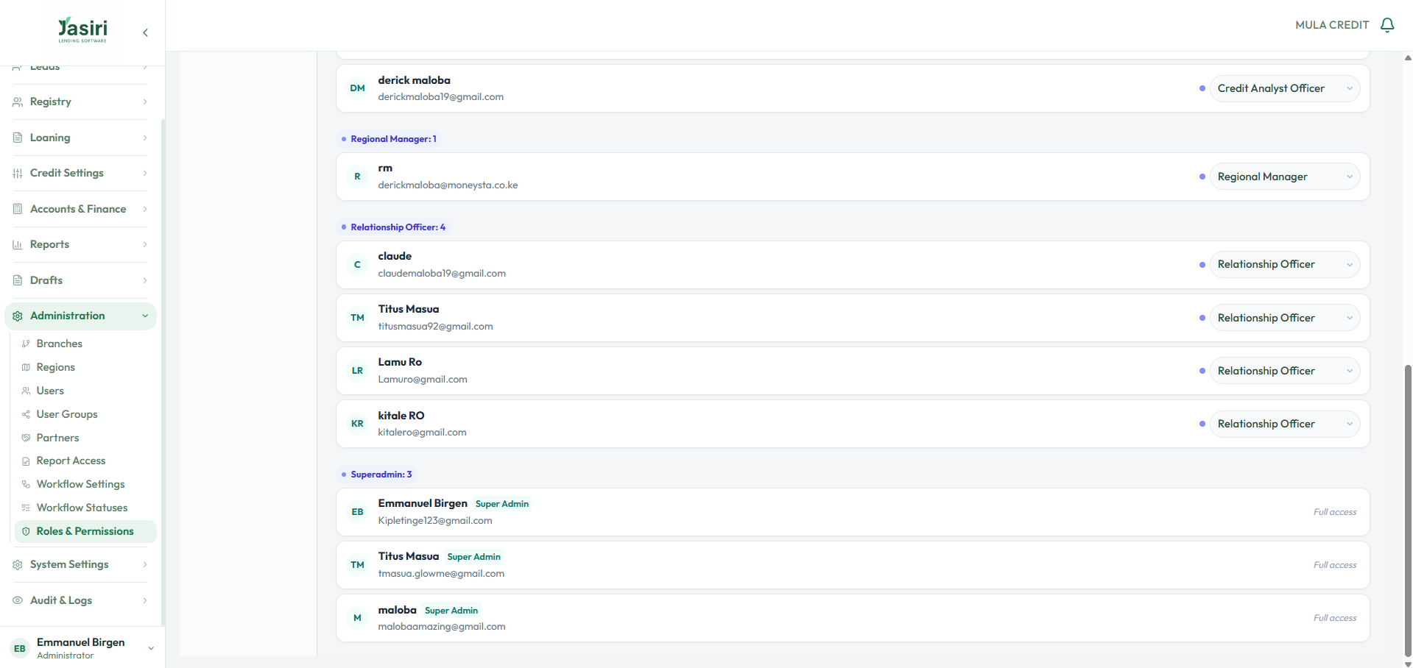
Figure 8 — The reviewer’s account, provisioned as Administrator, now listed under “Superadmin · Full access.” (Staff details can be cropped before this report is shared onward.)
S-02 Sessions never expire | HIGH

WHAT HAPPENS | Sessions do not time out. The reviewer remained logged in for roughly two days across closing the laptop and the browser, without ever being asked to re-authenticate.
IMPACT | A shared or stolen device stays authenticated indefinitely, and no sensitive action asks for re-authentication. Combined with S-01, a walk-up attacker inherits full control.
RECOMMENDATION | Introduce an idle timeout and an absolute session lifetime; require re-authentication (or a step-up one-time code) for sensitive actions such as role changes, disbursement, and settings; and consider daily reusable one-time codes for staff sign-in.

S-03 System Settings are placeholders presented as live | HIGH

WHAT HAPPENS | The entire System Settings section — General, Email, SMS, and the rest — is non-functional: every item redirects to the dashboard.
IMPACT | A live product is presenting configuration surfaces that do not exist. An operator may believe they have configured something (an SMS sender, an email template) that was never applied — a silent-failure risk with real operational consequences.
RECOMMENDATION | Either build these settings or clearly mark them “coming soon” and hide the dead links. Never present a control that does nothing.

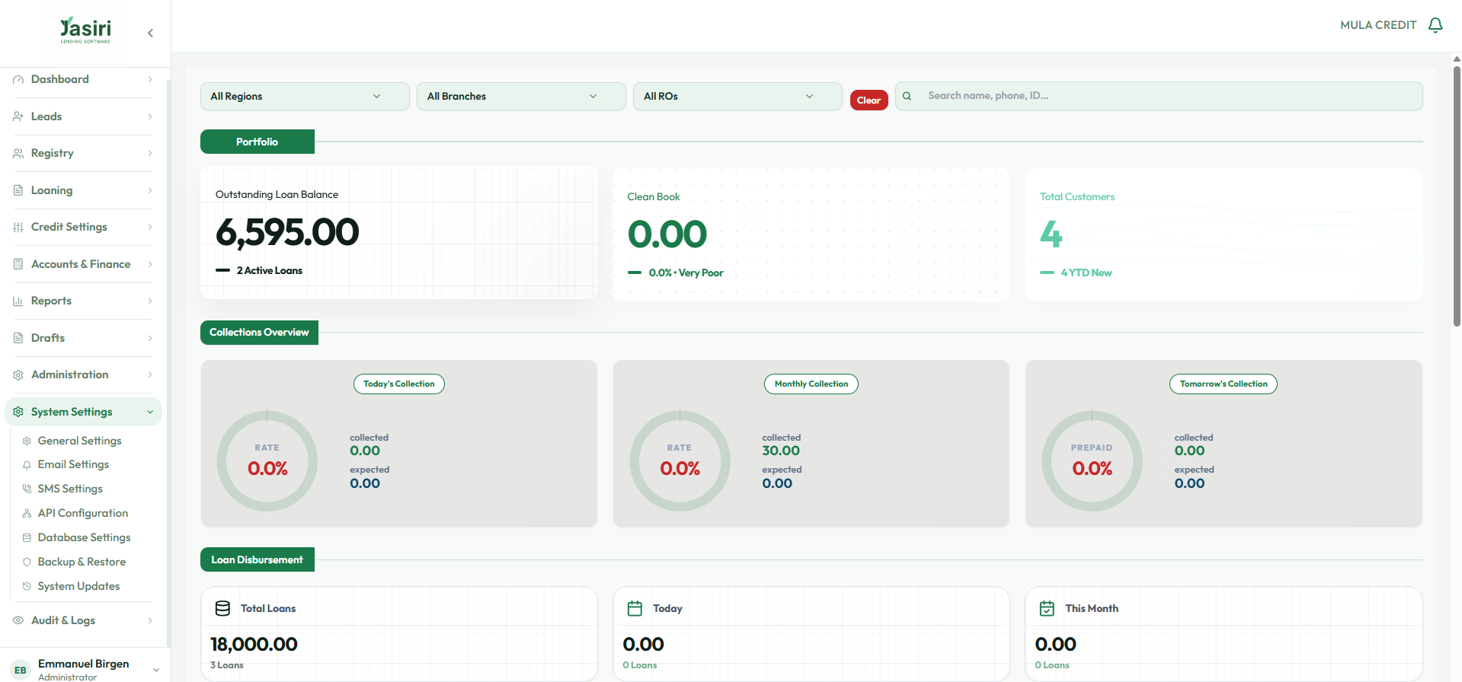
Figure 9 — Every System Settings item redirects to the dashboard.

9 Integration and single sign-on
A specific request from Mular’s leadership: the platform should work seamlessly alongside separate systems — a HR system, an accounting system, a call-centre system — each with its own front door, but with the user authenticated once. This is a single-sign-on and identity problem, and it is very solvable.
- One identity layer. A user signs in once and that identity is honoured across every connected system. Each system may keep its own login page as an entry point, but all defer to the shared session — no repeated logins, no divergent user lists.
- Engines as APIs. The differentiating capabilities — IPRS identity, statement analysis, credit scoring, and M-Pesa Ratiba auto-repayments — are exposed as clean APIs, so they can be embedded into whichever system needs them (including systems Mular already runs) rather than trapped inside one screen.
This is the point at which a platform stops being “an LMS” and becomes the spine the rest of the business plugs into — and it is precisely the shape Serve Well Co. and the BirgenAI engines are built to deliver.

10 Recommended priorities
A pragmatic order of work — stabilise first, then differentiate.
Horizon | Focus | Items
NOW | Stabilise & secure | Lock down role self-escalation and session expiry (S-01, S-02); stop showing raw DB errors and fix branch attachment (F-06); restore penalty configuration (F-08); make drafts persist (F-01).
NEXT | Collapse turnaround | IPRS-first onboarding for borrower, guarantor and next-of-kin; internal-score → starting limit → product match with reason codes; step-level validation (F-02, F-04, F-05); transfer navigation (F-13).
LATER | Differentiate & polish | A cinematic Analysis Studio; branded income statement and a per-user Report Access Manager (F-09, F-10); guided reconciliation (F-11); unified SSO and engine APIs; step-up one-time codes; retire placeholder settings (S-03).

11 In closing
Jasiri is a capable platform with a strong analytical core and a sensible product model. It is held back by onboarding friction that inflates turnaround, by a few unfinished areas presented as finished, and — most urgently — by security exposures on the live system that need prompt attention. None of this is fatal; all of it is fixable, and the fixes double as the roadmap to a genuinely fast, identity-first origination engine.
Serve Well Co., with the BirgenAI engine suite, is positioned to deliver exactly that: identity-first onboarding, score-driven limits and reason-coded product matching, M-Pesa auto-repayment rails, and the integration spine that lets Mular’s systems act as one. We would welcome the opportunity to take the priorities in Section 10 forward with you.

Emmanuel Birgen
IT Consultant · Serve Well Co.
[ email · phone · Nairobi, Kenya ]

A Appendix — findings register
ID | Severity | Finding
S-01 | CRITICAL | An Administrator can promote itself to Super Admin
S-02 | HIGH | Sessions never expire
S-03 | HIGH | System Settings are placeholders presented as live
F-01 | HIGH | Save-as-draft fails and loses earlier steps
F-06 | HIGH | A raw database error is shown to the user — and dead-locks them
F-03 | HIGH | Next-of-kin accepts anything — even the borrower’s own details
F-08 | HIGH | Penalty Rules settings fail to load
F-13 | MEDIUM | Transfer screens have no way back
F-02 | MEDIUM | Town is asked before County, and starts empty
F-04 | MEDIUM | Date of birth is not enforced until the final submit
F-05 | MEDIUM | Verification photos are silently mandatory
F-09 | MEDIUM | Income statement is sound but visually dated
F-10 | MEDIUM | Report access is by shared code, not by user
F-11 | MEDIUM | Manual reconciliation is not clearly guided
F-07 | LOW | Business-location map is slow to appear
F-12 | LOW | Scroll position carries across module switches (minor)

Prepared by Emmanuel Birgen, IT Consultant, Serve Well Co. · Confidential to Mular Credit · 24 July 2026

