**THE DEVELOPMENT OF A BRAIN COMPUTER CONTROLLED HAND ORTHOSIS**

BY

**EEE401 GROUP 8**

A GROUP DESIGN PROJECT REPORT SUBMITTED TO THE DEPARTMENT OF ELECTRONIC AND ELECTRICAL ENGINEERING, FACULTY OF TECHNOLOGY, OBAFEMI AWOLOWO UNIVERSITY, ILE-IFE, OSUN STATE.

IN PARTIAL FULFILLMENT OF THE REQUIREMENTS FOR THE AWARD OF A BACHELOR OF SCIENCE (B.Sc) DEGREE IN ELECTRONIC AND ELECTRICAL ENGINEERING.

SUPERVISED BY DR. K.P. AYODELE

**JUNE 2021**

# GROUP MEMBERS

|  |  |  |
| --- | --- | --- |
| S/N | NAME | REG. NO. |
| 1. | OLATEJU EMMANUEL OLUWASEGUN | EEG/2016/054 |
| 2. | ODUOLA FAWAZ AYOOLA | EEG/2016/044 |
| 3. | LAWSON OLUWAFEMI JULIUS | EEG/2017/121 |
| 4. | ELUDIORA MICHAEL OLUWASEUN | PHY/2016/026 |
| 5. | AJAYI PRAISE INIOLUWA | EEG/2016/009 |
| 6. | ODEYEMI TEMILOLUWA STEPHEN | EEG/2016/043 |
| 7. | ADEKUNLE ADEWALE OLUWADAMILARE | EEG/2016/082 |
| 8. | OGBIDI EBOSETALESE DUNJOYIN | EEG/2016/094 |
| 9. | OKUNOWO SIMILOLUWA ADETOYOSI | EEG/2016/095 |

# CERTIFICATION

This is to affirm that the content of this report is the group design project report submitted by EEE401 GROUP 8 supervised by me. They have successfully completed the group design project work titled “The Development of a Brain Computer Controlled Hand Orthosis”.

-----------------------------                                              ----------------------------

Dr. K.P. Ayodele                                                                                                          Date

Supervisor

# ACKNOWLEDGEMENT

Our utmost gratitude goes to God Almighty, the bringer of all Knowledge and Ideas and also to the Department of Electronic and Electrical Engineering, OAU, Ile-Ife for the positive impact the EEE401 Group design project course has made in our lives.

We also appreciate our supervisor, Dr. K.P. Ayodele for his guidance, constructive criticism and invaluable suggestions during the course of this group design project.

# ABSTRACT

The development of Brain-computer interfaces (BCIs) is an emerging field, with diverse applications in medical rehabilitation, control of prosthetics etc. This paper reports on the design and implementation of an electroencephalography-based brain computer control system for hand orthosis. A brain computer control system typically involves signal acquisition from subjects, feature extraction, feature selection, classification, and a control system for the hand orthosis. The signal acquisition hardware consists of a Ultra-cortex Mark IV EEG headset connected to an 8-channel Cyton bio-sensing board used to acquire EEG data from multiple subjects via motor imagery for two classes (grasp and release). The OpenBCI GUI was used for visualizing, streaming, and recording data from the Cyton board.

An open-source visual pipeline designer, Neuropype was utilized for signal processing and feature extraction. Several feature extraction and selection techniques i.e. Common Spatial Patterns, Principal Component Analysis, Wavelet transform techniques were applied on the acquired data. The extracted feature vectors were trained and classified using a hybrid deep neural network architecture, consisting of convolutional and long-short term memory layers.

Results obtained show that the combination of CSP features and the hybrid deep neural network classifier yielded an accuracy of 82% on data from twelve (12) subjects after cross-validation. The 3D model of the Hand orthosis was designed using the Autodesk Inventor 2021 software, and printed using the Prusa 3D-printer. Linear actuators were mounted on the Hand Orthosis, and controlled using an Arduino uno board based on commands from the BCI system.

**KEYWORDS: -** *Brain Computer Interface, Electroencephalography, Motor-Imagery, Feature-extraction, OpenBCI, Neuropype, Deep neural network, Hand Orthosis.*

TABLE OF CONTENTS

GROUP MEMBERS ii

CERTIFICATION iii

ACKNOWLEDGEMENT iv

ABSTRACT v

LIST OF TABLES viii

LIST OF FIGURES ix

CHAPTER ONE

INTRODUCTION 1

1.1 Background of the Study 1

1.1.1 Brain-computer Interface 1

1.1.2 Overview of Electroencephalography-based BCIs 3

1.1.3 EEG Signal Processing 8

1.1.4 Machine learning for EEG Signal classification 9

1.2 Problem Statement 10

1.3 Scope of the Study 10

1.4 Aims and Objectives of the Study 11

1.5 Justification 12

CHAPTER TWO

LITERATURE REVIEW 13

2.1 History of BCI Systems 13

2.2 Signal Processing Techniques 14

2.2.1 Artefact Reduction 15

2.2.2 Feature Extraction and Selection 15

2.3 Machine learning Techniques for EEG Signal Classification 18

2.3.1 Conventional Machine Learning Approaches 19

2.3.2 Deep Learning Approaches 20

2.4 Construction of a Hand Orthosis 21

CHAPTER THREE

METHODOLOGY 24

3.1 Block Diagram of the System 24

3.2 EEG Signal Acquisition 26

3.2.1 Hardware Setup 26

3.2.2 EEG Dataset 31

3.3 EEG Signal Processing 32

3.3.1 Channel Selection 32

3.3.2 Marker Assignment 32

3.3.3 Band-pass filtering, Noise and Artefacts reduction 32

3.4 Feature Extraction 33

3.4.1 Common Spatial Pattern (CSP) filtering 35

3.4.2 Filter Bank Common Spatial Pattern (FBCSP) 35

3.4.3 Wavelet Transform 35

3.5.4 Principal Component Analysis (PCA) 38

3.6 Classification 38

3.7 Construction of the Hand Orthosis 41

CHAPTER FOUR

RESULTS AND DISCUSSION 44

4.1 Feature Extraction 44

4.1.1 Common Spatial Patterns (CSP) 44

4.1.2 Principal component analysis (PCA) 46

CHAPTER FIVE

CONCLUSIONS AND RECOMMENDATIONS 48

5.1 Conclusions 48

5.2 Challenges Faced 48

REFERENCES 49

# 

# LIST OF TABLES

|  |  |
| --- | --- |
| **TABLE NAME** | **Pg. No** |
| Table 1: Ultracortex headset and Cyton board connection | 30 |
| Table 2: Comparison of Classification Performance for Different Principal Components | 46 |

# 

# 

# LIST OF FIGURES

|  |  |
| --- | --- |
| **FIGURE NAME** | **Pg. No** |
| Figure 1: Electrode locations for 10-20 Electrode Placement System | 5 |
| Figure 2: Brain Wave Description Chart  Figure 3: Model of the Hand Orthosis | 7  23 |
| Figure 4: Functional Block diagram of the System | 25 |
| Figure 5: Assembled Ultracortex Mark-IV headset | 27 |
| Figure 6: The 8-channel OpenBCI Cyton board | 28 |
| Figure 7: Complete Pipeline implemented in Neuropype pipeline designer | 34 |
| Figure 8: Wavelet Transforms Representation | 37 |
| Figure 9: Generated summary of model architecture and parameters  Figure 10: Design of The Hand Orthosis  Figure 11: 3D Design of Hand Orthosis | 40  42  43 |
| Figure 12: Training curve of the CNN+LSTM network over 100 epochs | 45 |
| Figure 13: Plot of the Receiver Operating Characteristics curve for 2 and 3 principal components | 47 |
|  |  |
|  |  |
|  |  |

**CHAPTER ONE**

# INTRODUCTION

## 1.1 Background of the Study

### 1.1.1 Brain-computer Interface

Over the past few decades, Brain-computer Interfaces (BCIs) have gained significant interest from researchers in computational neuroscience, bio-signal processing, neural engineering etc. With recent advances in this research effort, brain computer interfaces have evolved from being a mere human fantasy to a possible commonplace reality.

A brain-computer interface is a device that measures the neurological activities of the brain, processes the detected signals, and translates them into commands that can be used to control external devices such as computers, prosthetic organs, wheelchairs, robotic arms etc. This can ultimately help humans establish direct communication with the environment by means of brain activity. For example, a brain-computer interface can be used to read and interpret brain activity signals from a subject imagining lifting a cup, and translate the signals into an appropriate command that controls a robotic arm to perform the desired motor function.

A typical brain-computer interface involves four main stages which include: signal acquisition, signal processing, machine learning, and control of the desired actuator device. The signal processing stage involves processing the raw acquired signals into a format suitable for classification, the processing stages include: artefact reduction, band-pass filtering, segmentation(epoching), and feature-extraction. The machine learning stage involves classifying the signals into external commands used for controlling the external effector applying several techniques. The recent surge in the development of brain-computer interfaces over the past few decades has been influenced by advances in computational neuroscience, availability of low-cost brain-computer interfacing hardware, and improved signal processing and machine learning algorithms.

Brain activity can be measured from subjects using a variety of techniques which are broadly classified into: invasive, semi-invasive, and non-invasive techniques. Invasive techniques involve the implant of electrodes into the human brain via a surgical procedure, and recording from or stimulating neurons in the brain. Invasive approaches to brain-computer interfacing typically rely on recording spikes from an array of microelectrodes (Rao, 2013). Invasive techniques are usually used in advanced medical settings due to the potential adverse consequences of the surgical procedure required for implantation of electrodes in the brain. Semi-Invasive techniques involve recording from or stimulating from the surface of the brain or nerves. Non-Invasive techniques involve recording brain activity from electrodes placed directly on the scalp, without penetrating the skin or skull.

Non-Invasive techniques are the most common however, due to the safety considerations and low-cost setup. Non-Invasive techniques are usually characterized by weaker and less accurate signals due to obstruction of the skull, and resistance from the hair strands of subjects. Electroencephalography (EEG) is the most common non-invasive BCI technique, with others being Magnetoencephalography (MEG), Functional Magnetic Resonance Imaging (fMRI), Functional Near Infrared Imaging (fNIR), Magnetic Resonance Tomography (MRT) etc.

Today, BCIs have found significant applications in the domain of neuro-rehabilitation, through the control of neuro-prostheses, which aims to either restore or replace lost motor and cognitive functions in individuals suffering from stroke, paralysis (i.e., quadriplegics), severe spinal cord injuries, or provide devices to assist them, such as interfaces with computers, wheel-chairs or robotic arms. Brain-computer interfaces can also be adopted by healthy users, with potential applications in the field of video gaming, virtual reality, and neuro-enhancement (Lotte, et al., 2018).

### 1.1.2 Overview of Electroencephalography-based BCIs

Electroencephalography-based BCIs involve a non-invasive technique of recording brain activity from the brain by placing electrodes directly on the scalp of the subject. EEG signals are generated due to the synchronous activity of cortical neurons in the brain. A neuron, also known as a *nerve cell* represents a fundamental information processing unit of the brain that is responsible for receiving information from the external world, processing the information, and transforming and relaying the output to thousands of other neurons, muscle cells etc.

EEG signals only represent the summation of postsynaptic potentials from thousands of neurons oriented radially to the scalp, and not currents tangential to the scalp. Thus, EEG predominantly captures electrical activity in the cerebral cortex due to proximity to the skull (Rao, 2013). EEG signals are characterized by low spatial resolution, high temporal resolution, and weak signal amplitudes (in order of µV). The low spatial resolution is due to obstructions caused by the hair on the scalp, the skull, and different layers of tissues between the main source of the signal and the electrodes on the scalp. The weak signal amplitudes of the desired EEG signal also make it susceptible to interference, noise, and artefacts. Artefacts, usually generated from unwanted physiological or non-physiological activity can contaminate the desired EEG signal recordings. Artefacts induced from unwanted physiological activity such as eye movements, eye blinks, head movement, pulse, clenching of jaw muscles etc. are the most common types. Subjects are hence advised to avoid such movements for improved performance of the EEG signals, and artefact reduction algorithms such as IIR filtering, wavelet methods, independent component analysis (ICA), Empirical-mode Decomposition (EMD) can be used to reduce different kinds of artefacts in EEG signals (Jiang et al., 2019).

The EEG recording process involves placing the electrodes on the subject’s scalp, by means of a headset or electrode cap. The electrodes are applied using a conductive gel or paste to prevent electrode-cap impedance. The passive electrodes used are usually made of silver-silver chloride (Ag-Agcl). The placement of the electrodes is standardized based on the international 10-20 system.

#### 1.1.2.1 The 10-20 Electrode Placement System

The 10-20 Electrode placement system maintains a standard inter-electrode placement and labelling scheme across all laboratories. The “10” and “20” implies that the distance between actual electrodes are either 10% or 20% of the total front-to-back or left-to-right distance. The reference electrode locations are the nasion, in front of the skull; and the inion, at the back of the skull. Each electrode is labelled with a name that specifies the area of the brain where it is measuring activity from. The five cross-sectional areas are the pre-frontal (Fp), frontal (F), temporal (T), parietal (P), occipital (O), and central (C) lobes (Rao, 2013). The number of electrodes used may vary depending on the application, and number of signals we want to analyse (Avid, 2012).

Figure 1 shows the electrode locations for the 10-20 Electrode placement system below: -

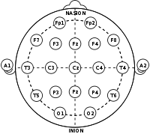

Figure 1: Electrode locations for 10-20 Electrode placement system

#### 1.1.2.2 Brain Waves Classification

The Brain Waves which arise from synchronization of neurons are characterized by their frequency ranges, and functional states in the brain. Brain waves are broadly classified into: Delta, Theta, Alpha, Beta, Gamma waves.

Delta waves, with a frequency range of 0.5-4 Hz, and are recorded during deep, dreamless sleep or unconsciousness. They are not very useful for BCI systems due to the low frequency range. Theta waves, with a frequency range of 4-8 Hz are detected during light sleep, deep meditation, recall, or fantasy. Theta waves are associated with drowsiness or “idling” in adults (Rao, 2013).

Alpha waves, with frequency range of 8-13 Hz are detected in a relaxed mental state, or during light meditation. A particular type of Alpha wave is the mu rhythm (Rao, 2013). Beta waves, with frequency range of 13-22 Hz are recorded during the normal waking state, or concentration while solving logical or analytical problems. The highest frequencies are visible in the Gamma waves, with frequencies ranging from 22-30 Hz. Gamma waves are recorded during higher mental activity, or motor functions.

A chart showing the classification of brain waves, and a concise description of the functional states is shown in Figure 2 below: -

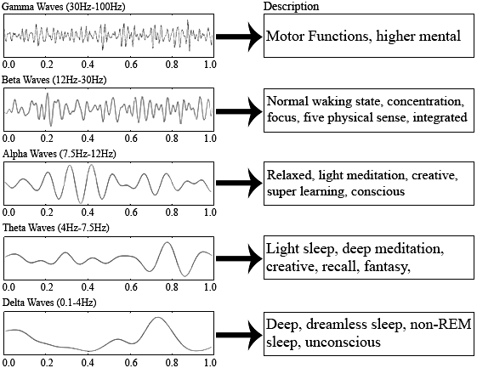

Figure 2: Brain Waves Description Chart (https://www.researchgate.net/profile/Phakkharawat-Sittiprapaporn/publication/325701712/figure/fig1/Brain-waves-charts-description_Q640.jpg)

#### 1.1.2.3 Motor Imagery

Motor Imagery involves generating brain activity from the cortex which is induced by imagination, rather than movement of limbs or external stimulus. Motor imagery (MI) signals recorded via electroencephalography are the most convenient method for designing Brain-computer interfaces (Sreeja et al., 2017).

Subjects simulate motor imagery tasks such as lifting a cup via imagination to generate the required motor imagery based EEG data, which generates oscillations in the brain known as sensorimotor rhythms. The data is pre-processed for noise and artefact reduction before relevant features are extracted. These features are then classified using supervised machine learning techniques (i.e. SVM, LDA, k-Nearest Neighbor, adaptive classifiers, or deep neural networks).

### 1.1.3 EEG Signal Processing

Signal processing is a subfield of electrical engineering that focuses on the analysis and synthesizing of waveforms and signals. It is a foundational area important in other fields of study some of which are: audio processing, image processing, video processing, seismology, geospatial studies, control systems, wireless communications and as in our case: feature extraction and biological signals processing among others. It is a field of study that functions largely on mathematical relations and definitions.

Biological signals are space-time recordings of biological events. There are various classes of biological signals, the biological event being recorded against time determines the class of the biological signal. Electrocardiograph (ECG) signals are recordings of the electrical activity of the heart, electromyogram (EMG) record muscle activity and electroencephalogram (EEG) signals record brain activity.

EEG signals are non-stationary signals, i.e., they are signals whose frequency content changes with time. The non-stationary nature of EEG signals makes it difficult to analyse using the traditional signal processing techniques such as Fourier transform which works on the assumption that signals are stationary. The non-stationary nature of EEG signals is also beneficial in that the changes in frequency content with time carries information on the type of brain activity occurring at an instance in time.

Useful information in EEG signals could be contained in the time-domain, frequency-domain and spatial-domain depending on the application of EEG data in use. Each domain has methods of processing EEG signals. The domain of interest and whichever of its associated methods applied to processing of EEG signals depends on the EEG application being built and its time, frequency and spatial resolution needs.

### 1.1.4 Machine learning for EEG Signal classification

Machine learning is a subset of artificial intelligence which involves the ability of computers to learn from data, applying statistical and algorithmic techniques, make predictions, and improve from experience without being explicitly programmed. Machine learning has facilitated diverse applications in computer vision, predictive modelling, medical diagnosis, speech recognition, language modelling, automated stock trading etc.

Algorithms for machine learning can be broadly classified into: - supervised learning, unsupervised learning. Supervised learning involves learning the underlying mapping function between independent variables (input) and the corresponding dependent variable (output) in labelled data. Supervised learning algorithms can be broadly classified into: - classification and regression. Classification deals with discrete or categorical labels while regression deals with continuous labels. Supervised learning can be applied in Fraud detection, Image classification, Speech recognition. Unsupervised learning involves learning the hidden statistical patterns in unlabelled data. Unsupervised learning algorithms include clustering, apriori algorithms, and dimensionality reduction algorithms such as principal component analysis and singular value decomposition. Unsupervised learning can be applied in customer segmentation, recommendation systems, anomaly detection. Other notable Machine learning techniques include semi-supervised learning, reinforcement learning, graph representation learning etc.

The field of Machine learning has played a significant role in the development of improved brain-computer interfaces by providing techniques for signal classification. Supervised machine learning algorithms are usually used for classification of EEG signals into two (binary classification) or more tasks (multi-class classification. Deep learning approaches are currently being adopted to learn higher-level representations in EEG data.

## 1.2 Problem Statement

Patients of stroke and physically disabled people where possible, have different recovery periods, it can take weeks, months or years. Some stroke patients have lifelong or long-term disabilities and some recover fully. During the period of recovery, some body parts become immobile. This is not because the part is damaged but rather the link between the brain and that part has been severed. The ability of the human head to give off signals that indicate cognitive and motor activities on its cortex area has been explored using signal-processing and machine learning methods to classify specific intended motor actions.

The brain-computer controlled orthosis developed in this study has the potential to aid the development of neuro-prostheses, assistive devices for patients suffering from stroke, paralysis etc. hence reducing the number of affected patients seeking medical attention, and consequently improving the quality of life. This can also reduce the number of potential workforce members put out of service due to stroke or some other form of physical disability by restoring their normal motor functions.

## 1.3 Scope of the Study

EEG data is to be acquired from multiple subjects, pre-processed, passed through four different feature extraction techniques and then tested with machine learning classifiers to evaluate the performance of each feature extraction method with the machine learning classifiers. The feature extraction methods and classifiers that produce the best accuracy are to be implemented in real-time classification as opposed to classification from recorded data. The combination of feature-extraction method and classifier with highest number of accurate classifications during real-time classification is to be focused on and improved for better accuracy.

This study will explore just four feature-extraction methods, namely common spatial patterns (CSP), filter bank common spatial patterns (FBCSP), principal component analysis (PCA) and wavelet-transform. The Morlet wavelet will be used based on literature findings. This study will not criticize the mathematics of the feature extraction methods or classifiers used. This study will evaluate the performance measures obtained by combining the four feature extraction methods with the classifiers and select which is best for real-time classification. This study will assume the EEG acquisition hardware used as almost perfect, neglecting its inadequacies which do not affect the whole system being developed to a large extent.

## 1.4 Aims and Objectives of the Study

The primary aims and objectives of this study include: -

1. Determining the best generic feature-extraction method and machine-learning classifier to be used in implementing a brain-computer controlled hand orthosis system. The best combination of feature-extraction methods and machine-learning classifiers will be obtained by evaluating the performance of four feature-extraction methods with machine-learning classifiers using the same acquired dataset.
2. Secondly, this project aims to design and fabricate a 3D-printed hand orthosis to be controlled by the output of the BCI system.

## 1.5 Justification

The thought of limited capacity, whether in terms of finances, mental ability, or movement should be eliminated by eliminating limited capacity itself.  Of various forms of limited capacity, one immediately noticed in the human environment is limited movement in disabled people or persons with impaired motor functions. It is imperative to support advances in the development of brain-computer interfaces in low-resource continents like Africa, leveraging better techniques to improve the quality of life for affected persons via neuro-rehabilitation, and restoration of lost motor or cognitive functions.

**CHAPTER TWO**

# LITERATURE REVIEW

## 2.1 History of BCI Systems

Research on Brain-computer Interfaces dates back to the 1970s. Hans Berger’s discovery of the electrical activity of the human brain, and electroencephalography in 1924 highly influenced research in the field of Brain-computer Interfaces. Berger was the first person to record brain activity by means of EEG, and identify the alpha wave (8-13 Hz) by analysing EEG traces (Wikipedia, 2018). Berger’s recording devices including silver wires and foils placed on the scalp of patients to acquire alternating EEG waves, and analysed how they related to brain diseases. This signified a major breakthrough for advances in BCI and EEG research.

Professor Jacques Vidal, from the University of California, Los Angeles (UCLA) coined the term "BCI" and produced the first peer-reviewed publications on this topic. Vidal is widely recognized as the inventor of BCIs in the BCI community, as reflected in numerous peer-reviewed articles reviewing and discussing the field. The 1977 experiment Vidal described was the first application of BCI after his 1973 BCI challenge. It was a non-invasive EEG (actually Visual Evoked Potentials (VEP)) control of a cursor-like graphical object on a computer screen (Wikipedia, 2018).

In 1988, a report was given on a non-invasive EEG control of a physical object, a robot. The experiment described was EEG control of multiple start-stop-restart of the robot movement, along an arbitrary trajectory defined by a line drawn on a floor. The line-following behaviour was the default robot behaviour, utilizing autonomous intelligence and autonomous source of energy.

In 1998, A researcher Philip Kennedy implanted the first brain computer interface object into a human being. The BCI was limited in function, however it marked a significant milestone in BCI development by enhancing the possibilities.

In 2004, the Cybernetics’ BrainGate implanted an EEG recording device in a human, and successful clinical trials were undertaken. In December 2004, researchers at New York State Department of Health demonstrated the ability to control a computer using non-invasive techniques, by placing an electrode cap on a patient’s head.

Clinical trials have been widely performed on humans and animals such as monkeys, rats, and pigs. In May 2008, A monkey was shown operating a robotic arm by thinking about the task and generating neuro-feedback at the University of Pittsburgh medical centre (Wikipedia, 2018). Recently, Elon Musk, the co-founder of Neuralink, a neurotechnology company developing ultra-high bandwidth and implantable brain-machine interfaces reported that a chip was successfully implanted in a monkey, which enabled it to control video games via brain-computer interfacing.

In the next few decades, it is predicted that brain-computer interfaces will become a commonplace reality in medical and social applications. This is due to rapid research advances, and the availability of open-source tools democratizing neuroscience applications, and aiding developers to build brain-computer interfaces more easily.

## 2.2 Signal Processing Techniques

The goal of signal processing is to extract spikes from the EEG data that are emitted by a single neuron in a recording electrode (Rao, 2013), eliminate artefacts, and extract relevant features for classification. Signal processing usually employs frequency domain, time domain, and wavelet analysis on the EEG signals to understand the spatial and temporal features. It also involves filtering methods such as band-pass filtering, Laplacian averaging, common spatial filtering to ensure distinguishability between different EEG task recordings, and dimensionality reduction algorithms such as Principal component analysis (PCA) and Independent component analysis (ICA) to reduce the feature space from multiple electrode channels.

### 2.2.1 Artefact Reduction

Different approaches have been used in recent literature to eliminate artefacts in EEG data, with an objective of improving the accuracy and overall performance of brain-computer interfaces. There are different kinds of artefacts which include: electro-oculographic artefacts, muscle artefacts (electromyographic artefacts), rhythmic and cardiac artefacts, extrinsic artefacts (Jiang et al., 2019; Rao, 2013). External artefacts i.e. from electromagnetic interference could also affect the EEG recordings.

Algorithms such as regression methods, thresholding, filtering, wavelet transforms, principal component analysis, and independent component analysis are widely used in artefact removal. Hybrid methods which combine two or more existing approaches by exploiting their advantages are also being used (Jiang et al., 2019).

### 2.2.2 Feature Extraction and Selection

Feature Extraction involves extracting distinguishable and useful feature vectors from the raw or pre-processed EEG signals for classification. Feature selection ensures that only non-redundant features are selected to reduce time consumption for processing and improve performance (PadField et al., 2019). The quality of the feature vectors usually determines the performance of the classifier.

Several feature extraction and selection such as CSP, FBCSP, continuous and discrete wavelet transforms, power spectrum density, PCA, ICA have been widely used in literature (Craik et al., 2019; Rao, 2013; PadField et al., 2019).

Some other novel algorithms have been discussed recently to extract features from motor imagery based EEG data. Kim et al. proposed a data-driven method for strong uncorrelating transform complex common spatial patterns (SUTCCSP), which reduces the correlation and maximises the inter-class pseudovariance between mu and beta rhythms obtained via multivariate empirical mode decomposition (Kim, et al., 2016). This algorithm was tested on left and right hand movement motor imagery data, and yielded positive results than conventional spatial filtering methods.

Yahya et al. also introduced a method which combines common spatial filtering and wavelet transforms. In this method, continuous wavelet transform is used to convert band-pass filtered and common spatial filtered EEG signals from selected electrodes into scalograms. The 2D scalograms are then fed as RGB images into a pre-trained deep neural network (Google LeNet) for binary classification of grasp-and-lift events. This method yielded a performance of 98.5% from the receiver operating characteristic (ROC) curve (Yahya et al., 2019).

Zhou et al. proposed a hybrid method combining discrete wavelet transforms (DWT) and hilbert transforms (HT) for feature extraction. The MI-EEG signal is decomposed using DWT, and hilbert transform is then utilized to compute the wavelet enveloped of the decomposed sub-bands. This ensures that the amplitude and time-series envelope are captured (Zhou et al., 2018). The features were trained with an long-short term memory (LSTM) network in that study and yielded improved performance.

Some common feature extraction methods have been discussed in detail in the sub-sections below.

#### 2.2.2.1 Wavelet Transforms

Wavelet transforms are generally used to convert the time-domain representation of an EEG signal to a time-frequency-domain representation. The advantage of wavelet transforms over Fourier transforms and Fast-Fourier transforms is that the wavelets retain both local spectral and temporal information which is beneficial for EEG signal classification. Wavelet transforms decomposes the EEG signal into simpler oscillating functions called wavelets which belong to a family derived from a specific mother wavelet (Fiscon, et al., 2018). The wavelets are simply scaled or time-shifted representations of the mother wavelet. Examples of commonly used mother wavelets are belonging to the: Daubechies, Symlet, Morlet, or Coiflet families.

The two types of wavelet transforms are: Discrete Wavelet Transform (DWT) and Continuous Wavelet Transform (CWT). DWT is typically applied when dealing with signals that are frequency band-limited, and only a finite set of wavelets are used while CWT uses all the possible wavelets over a range of scales and location. Wavelet analysis can also be applied in image compression, electrocardiogram (ECG) analysis, edge and corner detection etc.

#### 2.2.2.2 Common Spatial Filtering

Common Spatial Filtering is a common feature extraction method, which applies a mathematical method to separate multi-channel EEG data into a unique space of separate sub-components, where the difference in variance between the sub-components is maximized. This variance ratio optimization implies that it can be used to distinguish between which feature vectors correctly represent one class of brain activity i.e., grasping or releasing.

There are various alterations to the CSP method which help to improve its feature extraction capabilities (PadField et al., 2019). The pure CSP method does not achieve high performance due to issues with selection of subject-specific optimal frequency band, and the time it takes to select the optimal frequency band. The Common spatio-spectral pattern (CSSP) approach combines a finite impulse response (FIR) filter with the CSP algorithm, which improves the overall performance. The Common sparse spatio-spectral patterns techniques is more advanced than the CSSP techniques, and finds the spectral patterns which are common among multiple channels (PadField et al., 2019; Rashid, et al., 2020). In sub-band CSP, the EEG signals are filtered into different sub-bands, and then the CSP features are computed for each band.

Other variations include the filter bank CSP (FBCSP), wavelet CSP (WCSP) and regularized CSP (RCSP) method (Rashid, et al., 2020).

#### 2.2.2.3 Principal Component Analysis

A key issue in BCI development is the high-dimensionality of multi-channel EEG data, which introduces the ‘curse of dimensionality’ during classification of feature vectors. Principal Component Analysis (PCA) is a dimensionality-reduction algorithm that reduces the dimensionality of datasets generally, by projecting the data points in the higher dimensional data to only a few principal components to compute a lower-dimensional basis, without losing important information. A key characteristic of the first few principal components is that they are in a direction that maximizes variance in the projected data.

The obtained principal components are eigenvectors of the projected higher-dimensional data. The principal components can be obtained by computing the Eigen-value decomposition of the covariance matrix or the single value decomposition of the data matrix. Each obtained principal component is orthogonal, hence statistically-independent of each other.

Dimensionality reduction algorithms such as principal component analysis and independent component analysis (ICA) have been applied in EEG signal processing, feature extraction, and feature selection with improve classification accuracies (PadField et al., 2019).

## 2.3 Machine learning Techniques for EEG Signal Classification

The extracted feature vectors can be classified using machine learning techniques to translate the intended brain activity to a command that is used to control an actuator. EEG Signal classification is usually achieved using supervised machine learning algorithms: regression and classification. However, classification algorithms are more utilized to achieve this objective in existing literature (Lotte, et al., 2018).

The Machine learning techniques being used have evolved from conventional techniques like logistic regression, support vector machine (SVM) to deep learning-based approaches such as convolutional neural networks, recurrent neural networks, auto-encoders etc.

The performance of the Machine learning classifiers can be evaluated using several performance evaluation metrics such as accuracy score, receiver operating characteristic (ROC) score, F1-score, sensitivity, specificity, and other appropriate loss metrics.

### 2.3.1 Conventional Machine Learning Approaches

Conventional Machine learning approaches employed in EEG signal classification includes support vector machines (SVM), linear discriminant analysis (LDA), k-nearest neighbour (k-NN), decision trees, and ensemble networks.

SVM is a discriminative classifier which utilizes decision hyperplanes to separate the feature vectors into the desired number of classes using linear or non-linear decision boundaries to maximize the margins. Non-linear decision boundaries can be achieved by using kernels such as the Gaussian kernel or radial basis function (RBF) kernel. SVMs are suitable for small sample space, and also suitable for high-dimensional data. However, support vector machines do not perform well with large data. Linear discriminant analysis is very similar to SVM, however linear discriminant analysis assumes that all data points have the same covariance and the probability density is assumed to be normally distributed.

The k-NN algorithm works by classifying features close to each other as ‘neighbours’ in the same feature space, hence grouped together. It utilizes distance metrics such as minkowski and Euclidean distance to measure the distance between two or more feature vectors. k-NN algorithms are not very common in EEG signal classification due to their sensitivity to the dimensionality of feature vectors. Nonetheless, it yields good performance when it is used with low-dimensional feature vectors.

Reviewing published results in existing literature, SVM classifiers produce better results than LDA, and k-NN using feature vectors trained from CSP, FBCSP, and wavelet transforms (PadField, 2019). Conventional machine learning algorithms such as SVM and LDA are very prone to overfitting, hence regularization techniques and hyperparameter tuning can be used to reduce overfitting.

### 2.3.2 Deep Learning Approaches

The most notable deep learning approaches in EEG signal classification involves the use of deep neural networks: convolutional neural networks, and recurrent neural networks.

#### 2.3.2.1 Convolutional Neural Networks

A Convolution Neural Network (CNN) is a class of deep neural network that are usually applied to images, and video data. A CNN consists of convolutional layers, pooling layers, and fully connected layers. The convolutional layers apply mathematical convolutions on the input data using a specific number of kernels or filters. The output is then transformed using a non-linear activation function i.e., ReLU, tanh, Elu etc. The Pooling layer is used to down-sample the feature space. The output is then flattened, and passed to a fully-connected neural network which determines the optimal sets of learnable weights and biases relating the input and output, which minimizes the error metric or objective function.

Rashid et al. discusses the performance of CNN architectures with benchmark datasets (Rashid, et al., 2020). Notably, 2D Convolutional Neural Networks are used to train spectrograms of scalograms generated from EEG data. These spectrograms or scalograms can be fed into the network as 2D RGB or grayscale images (Craik et al., 2019; Yahya et al., 2019).

Existing literature also discusses the CNN learning from signal values using 1D CNNs, some of the signal values can also be converted to Fourier feature maps and 3D mesh grids. CNN studies had the greatest proportion of studies using signal values as inputs and the majority of those studies did not limit the number of channels, indicating that CNNs are more capable of handling the high dimensionality of EEG signal datasets when compared to other deep learning algorithms (Craik et al., 2019).

#### 2.3.2.2 Recurrent Neural Networks

Recurrent Neural Networks (RNNs) are special kinds of deep neural networks suitable for learning sequence data. Sequence data includes speech data, time series, text etc. RNNs are suitable for EEG signals due to its temporal nature. The key characteristic of the recurrent neural network, is that a preceding layer of the network will retain previous information which is used by the next layer. Long-short term memory (LSTM) networks are the most common recurrent neural networks in practice.

A study distinguished visual and non-visual learners by considering the wavelet features of EEG alpha and beta bands. The LSTM-based RNN framework was also used for classification purposes, and the mean training accuracy was 87.5 and 86% for beta and alpha bands, respectively. In relation to EEG MI classification, Ma et al. (2018) proposed a pure RNN-based parallel method for encoding spatial and temporal raw data with bidirectional LSTM and standard LSTM, respectively, reporting an average accuracy of 68.20%

## 2.4 Construction of a Hand Orthosis

There are many methods for creating assistive orthosis but the one we would focus on in this project is to employ a soft cable and a linearly operated electric motor. These devices don't use hard kinematic constraints; instead, they use tensioned wires to impart forces to the segments of the fingers. The way these wires deliver forces to the fingers is broadly comparable in previous designs, with Kang et al glove's serving as an example.

In flexion, cables are routed along the palmar surface of the finger, whereas in extension, cables are routed along the dorsal surface of the finger. Torque is generated at each joint as a result of the cable's tension and the fact that it does not travel through the joint axis.

A semi-rigid cable is used to assist with flexion and extension by pushing and pulling on the fingers. Although it's uncertain how effective this simple strategy is based on their research, for a commercial rehab glove, (Baronio et al., 2016) employs a similar strategy. Tendon-based systems have some disadvantages over rigid systems. For example, because they use a single cable to generate an applied torque, unsupported translational loads are applied on the joints.

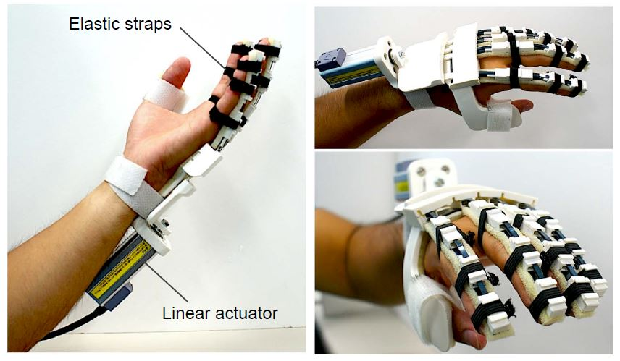

Figure 3: Model of the Hand Orthosis

**CHAPTER 3**

# METHODOLOGY

Signals from the surface of the brain (cortex area) known as electroencephalogram (EEG) signals were acquired from eight electrode positions for four events namely: imagine-grasp, grasp, imagine-release, from 12 test-subjects. Imagine-grasp and Imagine-release events were re-mapped to grasp and release events respectively. The acquired EEG signals were band-pass filtered to remove interference noise and artefacts. The filtered signals were then broken into equal time segments around events of interest, a process called EEG epoching. The epochal signals were then fed to appropriate signal processing blocks for the purpose of feature extraction. The extracted features were sent to a machine-learning classifier for feature learning and binary task classification.

## 3.1 Block Diagram of the System

The main functional blocks of this system are utilized for: -

1. Signal Acquisition from the subject using the Ultracortex Mark-IV headset and 8-channel Cyton board,
2. EEG Signal processing,
3. Feature Extraction and Selection,
4. Control of the fabricated Hand Orthosis

The Block diagram of the system is shown in Figure 3 below: -

EEG Signal Processing

Feature Extraction using Neuropype software/ Python

Classification of the generated feature vectors

EEG Signals acquired from multiple subjects

Translated command (grasp or release) to Fabricated Hand Orthosis

Control unit for the Hand Orthosis

Figure 4: Functional Block Diagram of the System

## 3.2 EEG Signal Acquisition

### 3.2.1 Hardware Setup

The Hardware setup consists of: -

1. One (1) 3D-printed Ultracortex Mark-IV EEG headset,
2. One (1) 8-channel OpenBCI Cyton board,
3. Bluetooth dongle,
4. Computer with Neuropype, and OpenBCI GUI installed.

The assembled 3D-printed Ultracortex headset is required to acquire EEG signals from multiple subjects. The electrode locations in the Ultracortex headset are based on the standard 10-20 system. The spiky electrodes are inserted carefully into the electrode locations. The assembled Ultracortex headset is shown in Figure 4 below.

The OpenBCI Cyton board consists of 8 channels with a 32-bit processor, which can be used to sample EEG, EMG, and ECG signals. The Cyton board is shown in Figure 5 below. The Cyton board has the following specifications: -

* Power with 3-6V DC Battery only
* PIC32MX250F128B Microcontroller with chip KIT UDB32-MX2-DIP bootloader
* ADS1299 Analog Front End
* LIS3DH 3 axis Accelerometer
* RFduino BLE radio
* Micro SD card slot
* Voltage Regulation (3.3V, +2.5V, -2.5V)
* Board Dimensions 2.41" x 2.41" (octagon has 1" edges)
* Mount holes are 1/16" ID, 0.8" x 2.166" on centre

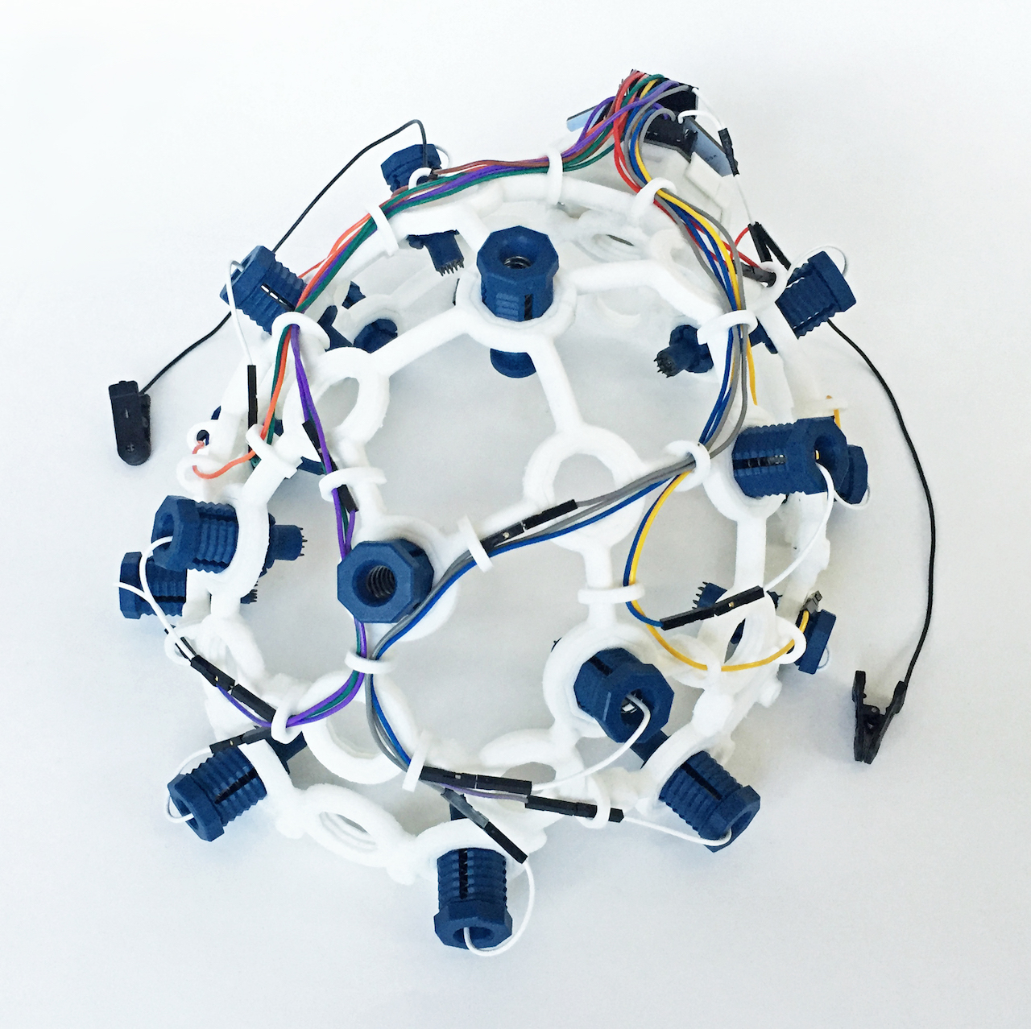

Figure 5: Assembled Ultra-cortex Mark-IV headset

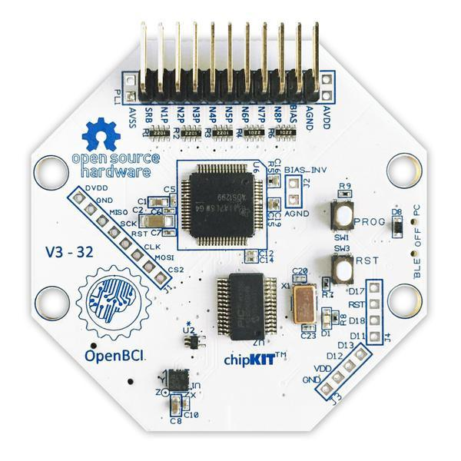

Figure 6: The Open-BCI 8-channel Cyton Board

The pins of the Cyton board are connected to the Ultracortex headset via jumper wires. Different colours are used to identify the wires for connection. The connections between the Cyton board and Ultracortex electrodes made are shown in Table 1 below.

The Bluetooth dongle is connected to the computer to communicate real-time recordings from the headset to the computer. Two open-source software: The OpenBCI GUI, and Neuropype pipeline designer are installed on the computer. The OpenBCI GUI is used for visualizing and streaming the EEG recordings, and useful plots of the brain activity through each channel. The Neuropype pipeline designer provides a drag-and-drop interface for building complete BCI pipelines, with a suite of tools for signal processing, feature extraction, machine learning, file system manipulation, LSL communication etc.

Table 1: Ultracortex headset and Cyton board connection

|  |  |  |
| --- | --- | --- |
| S/N | ELECTRODE | CYTON BOARD PIN |
| 1 | Ear Clip | Bottom SRB pin (SRB2) |
| 2 | C3 | Bottom N1P pin |
| 3 | Cz | Bottom N1P pin |
| 4 | C4 | Bottom N1P pin |
| 5 | P3 | Bottom N1P pin |
| 6 | Pz | Bottom N1P pin |
| 7 | P4 | Bottom N1P pin |
| 8 | O1 | Bottom N1P pin |
| 9 | O2 | Bottom N1P pin |
| 10 | Fpz | Bottom BIAS pin |

### 3.2.2 EEG Dataset

The EEG dataset are primary(self-acquired) and were acquired for the purpose of understanding how EEG data indicated specific intended hand movements (grasp and release) and therefore develop a hand orthosis system for grasp rehabilitation. The EEG data-acquisition device used was the OpenBCI setup consisting of: The Ultra-cortex Mark IV headset, Cyton board, Bluetooth-dongle and the OpenBCI GUI software. Eight electrodes out of 16 electrodes were used at a sampling frequency of 250Hz.

The EEG dataset is made up of the training dataset and the test dataset each consisting of recordings of imagine-grasp, imagine-release, grasp, and release events from 12 subjects. Each subject performed 22 trials each for grasp and release events for both the training dataset and the test dataset. The electrode position on the head was chosen based on the 10/20 electrode placement system. The Ultracortex Mark IV headset allows for easy location of the nasion and inion.

A bottle of water was placed in front of the test-subjects and the subjects were instructed to either hold the bottle or release it, for grasp and release events respectively for equal duration of time. The instructions were given to the subject and labels of events recorded alongside the data using the software, lab-recorder. The storing format of the acquired dataset was XDF.

Only data acquired from test-subjects with low level hair-cut or skin-cut were recorded as valid data. A timespan of seconds was adopted for each event during data-acquisition so as to avoid patients being mentally fatigued. All test-subjects filled a consent form where they indicated their interest in being volunteer test-subjects. Also, data on mental history of test-subjects was collected as brain response to similar situations in subjects with history of mental defects and those without might be different.

## 3.3 EEG Signal Processing

### 3.3.1 Channel Selection

Eight channels were selected from 16 namely, Fp1, Fp2, C3, C4, P7, P8, O1, O2. These channels were selected based on their location on the cortex of the brain and mapping to areas of the cortex associated with hand movement. These locations were chosen because the parietal area of the cortex, the prefrontal cortex, the primary motor area of the cortex and the supplementary motor area play important roles in generating voluntary movements. We also considered taking readings from the occipital area of the cortex to detect electrooculography artefacts so as to be subtracted from the EEG data.

### 3.3.2 Marker Assignment

Imagine-grasp and imagine-release event markers were reassigned as grasp and release events markers. This was done as our classification is a binary classification and because machine-learning nodes for classification require just two event labels. After the marker reassignment, the grasp and release events were assigned target values of one (1) and zero (0) respectively as required by supervised learning nodes. This marker reassignment was permissible and could act to improve performance of the classification model because the waveform of EEG signal generated during motor-imagery of a specific movement is similar to that generated during the actual movement.

### 3.3.3 Band-pass filtering, Noise and Artefacts reduction

The EEG signals after reassigning the markers were passed through a band-pass FIR filter of low and high cut-off frequencies, 8Hz and 30Hz respectively and with stop band attenuation frequencies of 5Hz and 32Hz. This was done so as to eliminate ocular artefacts, electromyography artefacts, and electrocardiograph artefacts. 60HZ power line interference noise was also reduced. Ocular artefacts are found at frequencies below 4Hz, electromyography artefacts are found at frequencies above 30Hz and electrocardiograph artefacts are found usually at frequencies not more than 1.2Hz. frequencies below 4Hz and above 30Hz are not found within the µ and β frequency range which are of interest for motor-imagery task classification. This filtering does not eliminate useful information or data.

## 3.4 Feature Extraction

Six feature extraction techniques were tested on the dataset and the classifier. The classifier performance measures were recorded for each technique of which the technique with best performance for online and/or offline testing was then selected of the six to be employed in the development of the hand orthosis. The entire pipeline for signal processing and feature extraction with CSP and FBCSP were implemented in the Neuropype pipeline designer is shown in Figure 6 below.

The raw acquired EEG signals stored in XDF file format are imported using the ‘Import XDF’ node. This is used to inject calibration data for training the CSP or FBCSP nodes. The ‘FIR Filter’ node is a band-pass filter with frequency bands [5 8 30 32] for signal processing. The ‘Segmentation’ node is used for the epoching process. The epoching is performed using the segment window limits [-1,1] which implies 1 second before and after the marker was obtained. The CSP and FBCSP nodes are then applies, and the required variance is computed. The output can be recorded to a .csv file, or sent in real-time via LSL (Lab streaming layer) or Open Sound Control (OSC) for classification on the computer. The Streaming data is acquired via LSL input from the desired subject.

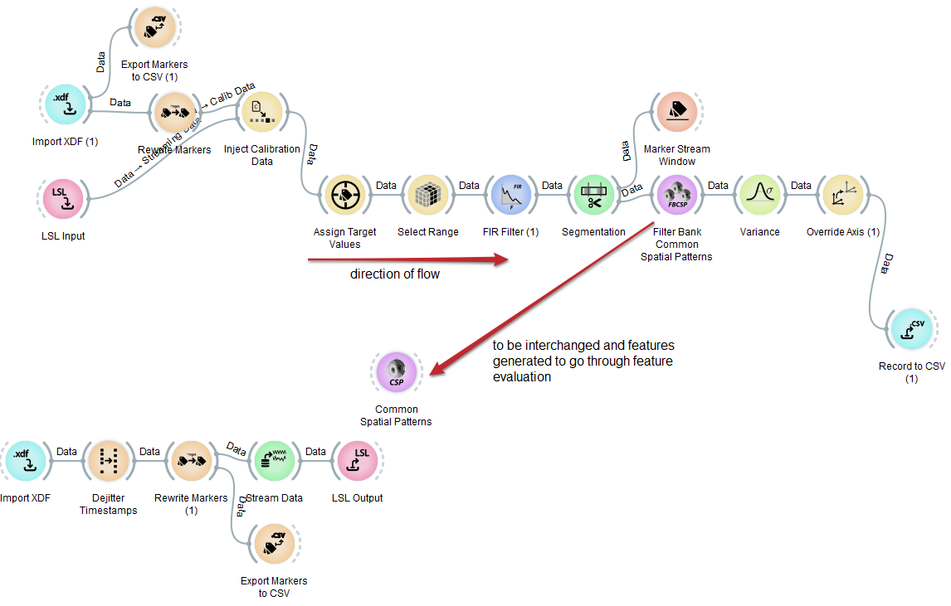

Figure 7: Complete pipeline implemented in Neuropype pipeline designer

### 3.4.1 Common Spatial Pattern (CSP) filtering

This is a supervised learning based spatial filtering method. It is well suited for binary task classification. It works by maximizing the variance of one event while minimizing the variance of the other using a train dataset. Based on the train dataset, it creates a filter that fits the test data to a pair of new axes that are orthogonal to one another, thereby maximizing variance of once class in one direction and minimizing the variance of the other in the other direction orthogonal to the first. This new pair of axes improves the discriminative power between the two classes in the EEG signals and results in better classification. The Neuropype software has a node for common spatial patterns and can produce multiple pairs of orthogonal axes, up to the number of electrodes used divided by two, that improves discriminative power between the two classes in the EEG signals. Since eight electrode positions were used, our common spatial pattern node produces four pattern pairs, therefore eight new axes. The classifier was trained with each pair independently.

### 3.4.2 Filter Bank Common Spatial Pattern (FBCSP)

This is a modified form of the common spatial pattern filtering technique, optimized for better class discrimination and optimal distinctive features for classifier inputs. This works by splitting the EEG signal into frequency bands of interest and then applying the common spatial patterns technique on the various frequency bands independently. In our case, the EEG signals into two frequency bands namely, the µ-band and β-band with frequency bands 8Hz to 12Hz and 13Hz to 30Hz respectively. Using four pattern pairs just as in CSP, rather one pattern having two axes, one pattern had four axes, one pair each for the µ-band and β-band.

### 3.4.3 Wavelet Transform

Due to the non-stationary nature of signals, Fourier transform fails to provide efficient results, wavelet transforms can be potentially used, which decomposes a function into a set of wavelets.

A wavelet is a wave-like oscillation that is localized in time, wavelets have two basic properties: scale and location. Scale defines how stretched or how compact the wavelet is. Location describes what position in time the wavelet is positioned. A typical example of a wavelet is the Morlet wavelet (morl), a Gaussian-windowed complex sinusoid whose wave function is given below.

In the above equation, t is a non-dimensional time parameter, is the wave number.

In wavelet transform, the basic idea is to compute how much of a wavelet is in a signal for a particular scale and location. A wavelet with a particular scale is convolved across the entire signal in time. The result of this convolution or signal multiplication gives the coefficient for that wavelet scale at that time step, the process is then repeated with increase in the wavelet scale.

#### 3.5.3.1 Continuous Wavelet Transform (CWT)

Continuous wavelet transform can be used to obtain a simultaneous time frequency analysis of a signal. The output of CWT are coefficients which are functions of scale or frequency and time. Each scaled wavelet is shifted in time along the entire length of the signal compared with the original signal. This process is repeated for all the scales, resulting in coefficients that are functions of the wavelet’s scale and shift parameter. To put in perspective, a signal with 1500 samples analysed with 20 scales results in 30,000 coefficients.

Where is the mother wavelet, a is the scaling factor (dilation or compression), and b is the translation factor (time shift)?

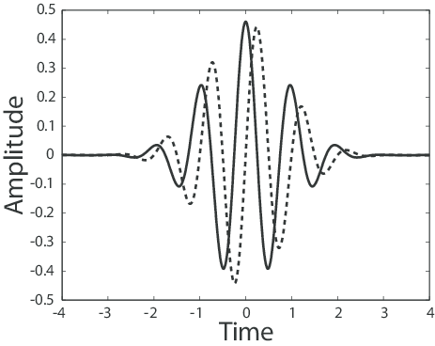

Figure 8: Wavelet transforms representation

#### 3.5.3.2 Scalograms

Scalograms are scaled representations of a continuous wavelet transformation (CWT) performed on the original signal. Scalograms are a way of transforming CWT into a 3-d tensor, with a predetermined number of layers, in which each layer corresponds to the convolutions of the signal data with a different scale mother wavelet for each layer. The CSP features were converted to scalograms using the continuous wavelet transform algorithm. The 2D RGB images generated from the scalograms are trained using a convolutional neural network with 2D convolutional layers which is suitable for multi-channel images.

### 3.5.4 Principal Component Analysis (PCA)

This is a dimensionality reduction technique which can also be used as a spatial filter. It acts as a spatial filter by reducing the dimension of space or reducing the number of electrodes from which EEG signal is to be fed to other feature extraction techniques. A major advantage of PCA is its ability to decorrelate the inputs. In our case, PCA acted to eliminate correlations between the various electrodes; these correlations are no longer present in the transformed and dimension-reduced output of PCA. The output of PCA is a linear combination of vectors of directions of maximum variance of the input data. The PCA Algorithm was implemented in the Python programming language.

## 3.6 Classification

Several deep learning architectures were trained on the extracted CSP and FBCSP feature vectors. Some of these deep learning architectures include Shallow ConvNets, Deep ConvNets with 2D convolutional layers, and hybrid networks combining convolutional layers and LSTM layers. The hybrid classifier consisting of convolutional layers and LSTM layers was ultimately selected due to its performance and increased generalization on the dataset. The classifier was implemented using Python programming language, TensorFlow, and Keras. The CSP feature vectors have a dimension of (8 x 1) from four (4) pattern pairs, while the FBCSP features have a dimension of (16 x 1).

Five (5) 1-D convolutional layers were stacked together for learning more spatial features from the CSP features. Each convolutional layer contains 64 kernels/filters for performing the convolution operation on the feature vectors. The ReLU activation function was used between the convolutional layers, it was selected after hyper-parameter tuning for the network. The output of the convolutional layers was passed to the LSTM layers for learning temporal based features from the EEG data. Three (3) LSTM layers were used to achieve this purpose with 32 memory units and the tanh activation function. The final output dense layer contained two units, because this is a binary classification task. Each neuron represents each class: grasp and release. The sigmoid activation function was used in the output dense layer. The sigmoid activation is represented by the formula: -

The output of the sigmoid activation is bounded between (0,1), which represents the predicted probabilities. The class with the maximum probability is the correctly predicted class. Dropout and batch normalization layers were also used to reduce overfitting in the network.

A summary of the hierarchical arrangement of layers, and model parameters is shown in Figure 8 below. The model was compiled using the categorical cross-entropy loss function and accuracy metric. The model was trained with the feature vectors split into: 85% for training and 15% for validation; for 100 epochs. The results obtained are discussed in the results and discussion section. Other classification methods used are stated in the results and discussions section of this work.

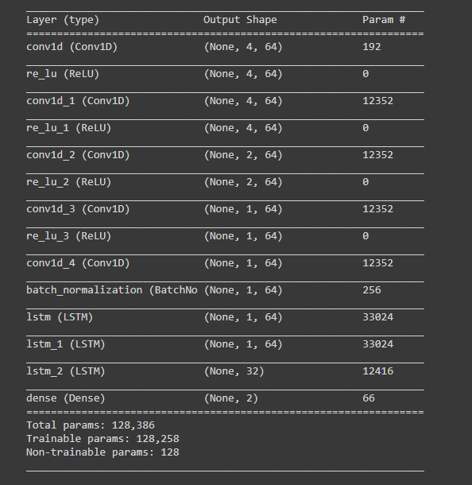

Figure 9: Generated summary of the model architecture and parameters

## 3.7 Construction of the Hand Orthosis

Before printing the hand orthosis, thorough analysis was carried out on the human hand so as to have an overview of what to design and picking the right measurement for each finger. the next issue was how to design and print. Autodesk Inventor (2021) was used to design the hand orthosis and the design was constructed into different sections and parts, it helps to ease the stress while using a 3-D printer to print the hand orthosis and its ease to assemble the parts together after printing.  The design was constructed to be a left hand since majority of humans are right-handed, so the left hand has limited functions it could perform, especially at old ages for humans, although a right-hand design can also be constructed for left hand users that find it difficult to use their right hand very well.

After the design has been completed using Autodesk Inventor (2021), the file is exported from Autodesk inventor (IPT File) to STL file, it was later sliced using Ultimaker Cura, which converts the STL file to the language the 3-D printer understands, that is Geometric code (G-code). The G-code is uploaded to the machine with the use of a memory card.

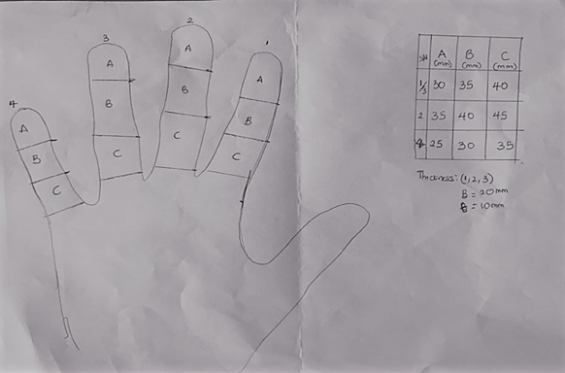

Figure 10: Design Of The Hand Orthosis

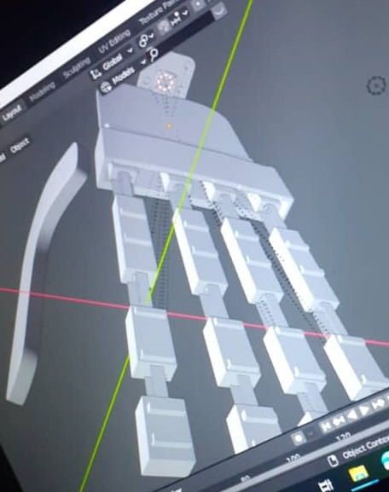

Figure 11: 3D Design of Hand Orthosis

**CHAPTER FOUR**

# RESULTS AND DISCUSSION

## 4.1 Feature Extraction

### 4.1.1 Common Spatial Patterns (CSP)

The Common Spatial patterns were computed using Neuropype as demonstrated in the methodology section. The patterns were successfully extracted using four (4) pattern pairs for the 12 subjects. The extracted features were recorded to a CSV file for training. The hybrid deep neural network consisting of convolutional layers and LSTM layers was trained on the extracted CSP feature vectors for 100 epochs as explained in the methodology section. The best classifier achieved an accuracy of 82.13% on the train set and 59.06% on the validation set, after 10-fold validation to prevent over-fitting. Figure 9 shows the accuracy training curve for the classifier over 100 epochs.

The results of the deep learning approaches were limited by insufficient data available. This can be mitigated by applying augmentation methods, adaptive transfer learning etc or acquiring more data from subjects. The model was thus serialized, and used to classify CSP feature vectors sent via Open Sound Control (OSC) protocol from Neuropype to generate real-time commands.

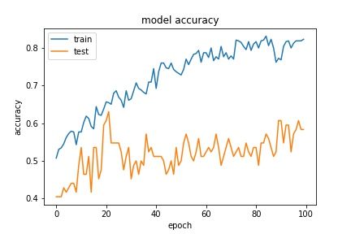

Figure 12: Training curve of the CNN+LSTM network over 100 epochs

### 4.1.2 Principal component analysis (PCA)

Classifiers explored with features extracted using PCA are, Linear Support Vector Classifier, Support Vector Classifier, Logistic Regression, Random Forest Classifier, AdaBoost Classifier and Gradient Boosting Classifier. Their performance measures are given below for two to eight components (directions) of maximum variance. Only the classifier giving best performance metrics (accuracy and ROC-AUC score) for each component is stated in Table 2 below: -

Table 2: Comparison of Classification Performance for Different Principal Components

|  |  |  |  |  |  |
| --- | --- | --- | --- | --- | --- |
| Number of components | Classifier | Train Accuracy | Test Accuracy | Train AUC | Test AUC |
| 2 | Logistic Regression | 0.51 | 0.51 | 0.51 | 0.49 |
| 3 | Random Forest | 1.00 | 0.57 | 1.00 | 0.53 |
| 4 | Logistic Regression | 0.48 | 0.47 | 0.50 | 0.50 |
| 5 | Logistic Regression | 0.50 | 0.47 | 0.51 | 0.50 |
| 6 | Logistic Regression | 0.50 | 0.51 | 0.52 | 0.49 |
| 7 | Logistic Regression | 0.51 | 0.49 | 0.53 | 0.50 |
| 8 | Logistic Regression | 0.50 | 0.49 | 0.53 | 0.50 |

Hence, the Random Forest classifier combined with 2 principal components yielded the best average performance. The plot of the Receiver-Operating Characteristics for the best score is shown in Figure 10 below: -

|  |  |
| --- | --- |
|  |  |

Figure 13: Plot of Receiver Operating Characteristics for 2 and 3 principal components

### 

**CHAPTER FIVE**

# CONCLUSIONS AND RECOMMENDATIONS

## 5.1 Conclusions

It was concluded that CSP Feature-extraction method alongside CNN+LSTM classifier gave the best performance for the development of the Brain Computer Controlled Hand Orthosis system in this work.

CSP is a good feature extraction method for EEG signals and binary task classification in terms of motor-imagery.

Results gotten from classifiers used with features extracted using PCA in this work show the logistics-regression classifier, to be promising in future works if explored further.

The performance measures exhibited by classifiers getting their features from PCA, indicate that PCA might be a poor feature-extraction method for EEG signals and motor-imagery applications.

## 5.2 Challenges Faced

The following challenges were encountered during the development of this brain-computer controlled hand orthosis: -

* Poor documentation for the Neuropype software and Hardware compatibility issues
* Lack of voluntary subjects for acquiring training data due to COVID-19 restrictions, hence leading to insufficient EEG data, and reduced classification accuracy,
* Keeping subjects focused on motor imagery tasks,
* Presence of electromyography (EMG) artefacts due to unwanted muscle movements,
* Power supply hindrances during printing the fabricated hand orthosis.

# REFERENCES

Avid, R.-G. (2012). EEG Signal Processing for BCI Applications. *Advances in Intelligent and Soft Computing, 98*(1), 51-591.

Baronio, G., Harran, S., & Signoroni, A. (2016). A Critical Analysis of a Hand Orthosis Reverse Engineering and 3D Printing Process. *Applied Bionics and Biomechanics*.

Craik, A., He, Y., & Contreras-Vidal, J. L. (2019, April 9). Deep learning for electroencephalogram (EEG) classification tasks: a review. *Journal Of Neural Engineering, 16*. Retrieved April 24, 2021, from https://iopscience.iop.org/article/10.1088/1741-2552/ab0ab5

Daly, Janis J.; Huggings, Jane E. (2015). Brain-Computer Interface: Current and Emerging Rehabilitation Applications. *Archives of Physical Medicine and Rehabilitation, 96*(3), S1-S7. Retrieved from https://doi.org/10.1016/j.apmr.2015.01.007

Fiscon, G., Weitscheck, E., Cialini, A., Felici, G., Bertolazzi, P., & Bramanti, A. (2018). Combining EEG signal processing with supervised methods for Alzheimer’s patients classification. *BMC Medical Informatics and Decision Making*.

Jiang, X., Gui-Bin, B., & Zean, T. (2019). Removal of Artifacts from EEG Signals: A Review. *Sensors (Basel), 19*, 5. Retrieved May 14, 2021, from https://doi.org/10.3390/s19050987

Kim, Y., Ryu, J., Kim, K. K., Took, C. C., Mandic, D. P., & Park, C. (2016). Motor Imagery Classification Using Mu and Beta Rhythms of EEG with Strong Uncorrelating Transform Based Complex Common Spatial Patterns. *Computational Intelligence and Neuroscience, 2016*.

Lotte, F., Bougrain, L., Chichocki, A., Clerc, M., Congedo, M., & Yger, F. (2018). A Review of Classification Algorithms for EEG-based Brain-Computer Interfaces: A 10-year update. *Journal of Neural Engineering, 3*(15), 55.

OpenBCI. (2020). *UltraCortex Mark IV Documentation*. Retrieved from Official OpenBCI Documentation: https://docs.openbci.com/docs/04AddOns/01-Headwear/MarkIV

PadField, N., Zabalza, J., Zhao, H., Masero, V., & Ren, J. (2019). EEG-Based Brain-Computer Interfaces Using Motor Imagery: Techniques and Challenges. *Sensors (Basel)*.

Rao, R. P. (2013). *Brain-Computer Interfacing: An Introduction.* New York: Cambridge Press.

Rashid, M., Sulaiman, N., AbdulMajeed, A. P., Musa, R. M., Bari, B. S., & Khatun, S. (2020). Current Status, Challenges, and Possible Solutions of EEG-Based Brain-Computer Interface: A Comprehensive Review. *Neurorobot*. doi: https://doi.org/10.3389/fnbot.2020.00025

Sreeja, S., Rahba, J., Nagarjuna, K. S., Mitra, P., & Sarma, M. (2017). Motor Imagery EEG Signal Processing and Classification Using Machine Learning Approach. *2017 International Conference on New Trends in Computing Sciences (ICTCS).* Amman, Jordan: IEEE.

Wikipedia. (2018, March). *Brain-computer Interfaces*. Retrieved from Wikipedia: https://en.wikipedia.org/wiki/Brain%E2%80%93computer_interface

Xygonakis, I., Athanasiou, A., Pandria, N., & Kugiumtzis, D. (2018). Decoding Motor Imagery through Common Spatial Pattern Filters at the EEG Source Space. *Recent Advances in Brain Signal Analysis: Methods and Applications*. doi:10.1155/2018/7957408

Yahya, N., Musa, H., Ong, Z. Y., & Elamvazhuti, I. (2019). Classification of Motor Functions from Electroencephalogram (EEG) Signals Based on an Integrated Method Comprised of Common Spatial Pattern and Wavelet Transform Framework. *Sensors (Basel)*.

Zhang, K., Robinson, N., Lee, S.-W., & Guan, C. (2020, December). Adaptive transfer learning for EEG motor imagery classification with Deep Convolutional Neural Network. *Neural Networks, 136*(8). doi:10.1016/j.neunet.2020.12.013

Zhou, J., Meng, M., Gao, Y., Ma, Y., & Zhang, Q. (2018). Classification of motor imagery EEG using wavelet envelope analysis and LSTM networks. *Chinese Control and Decision Conference, CCDC 2018*, (pp. 5600-5605). China. doi:10.1109/CCDC.2018.8408108