**A** **TECHNICAL REPORT**

ON

**STUDENTS INDUSTRIAL WORK EXPERIENCE SCHEME (SIWES II)**

**EEE400**

UNDERTAKEN AT

**EGBIN POWER PLC**

EGBIN, IJEDE ROAD, IKORODU, LAGOS STATE.



BY

**ADARIJO, RASHEED ALADE**

**MATRIC NO.: EEG/2016/004**

SUBMITTED TO

**THE SIWES COORDINATOR**

**DEPARTMENT OF ELECTRONIC AND ELECTRICAL ENGINEERING**

**OBAFEMI AWOLOWO UNIVERSITY, ILE-IFE, OSUN STATE**

**IN PARTIAL FULFILMENT OF THE REQUIREMENT FOR THE AWARD OF**

**BACHELOR OF SCIENCE (B.Sc.) DEGREE IN**

**ELECTRONIC AND ELECTRICAL ENGINEERING**

**JANUARY 2022**

Department of Electronic and Electrical Engineering,

Obafemi Awolowo University,

Ile-Ife,

Osun State.

24th January, 2022.

Department of Electronic and Electrical Engineering,

Obafemi Awolowo University,

Ile-Ife.

Dear Sir,

# LETTER OF TRANSMITTAL

In partial fulfilment of the requirement for the award of Bachelor of Science degree in Electronic and Electrical Engineering. I, ADARIJO Rasheed Alade with matriculation number, (EEE/2016/004), hereby Submit for grading, the report for the Students’ Industrial Work Experience Scheme II (SIWES II) – EEE400 undertaken at Egbin Power Plc, from 12th July, 2021 to 17th December, 2021.

Yours faithfully,

-----------------------------------

ADARIJO Rasheed Alade

**EEE/2016/004**

# DEDICATION

I dedicate this report to Almighty God, the creator of universe, who has conferred on me His mercy, blessing, perseverance, wisdom and favour before, during and after my Industrial training. Also, to my mother and siblings for their constant support and prayers.

# ACKNOWLEDGEMENT

My utmost gratitude goes to Almighty Allah for his infinite mercy and guidance which I have always benefitted from. In Him, I rely upon.

My profound gratitude also goes to my parents who have contributed immensely towards my education.

I would like to acknowledge all the staff at the maintenance department Egbin power plc, who gave me extensive training and provided a conducive environment for the scheme.

I would also like to acknowledge Dr F.K. Ariyo who is the departmental SIWES coordinator for his fatherly orientation before we embark on the training. Also, my unfathomed gratitude goes to all my lecturers in the department for the knowledge they have impacted.

# ABSTRACT

This technical report gives a detailed account of the process of power generation as a whole. The processes involved in production of electricity from the water treatment and demineralization plant down to the synchronization of electric power to the grid. Machines peculiar to each production process were stated.

Moving forward, mode of operation of major equipment were described ranging from steam boilers, turbines, hydrogen cooled generator, air compressor, transformers and switchgears. Functions of these equipment in the power generation process were also included in this report.

Furthermore, types of maintenance activity carried out in maintenance department were stated. Maintenance such as corrective, preventive and predictive maintenance. Technical experiences garnered in accordance to the activities carried out in each unit of attachment were elaborated.

# TABLE OF CONTENTS

LETTER OF TRANSMITTAL ii

DEDICATION iii

ACKNOWLEDGEMENT iv

ABSTRACT v

TABLE OF CONTENTS vi

CHAPTER ONE x

INTRODUCTION x

1.1 Historical Background of Students’ Industrial Work Experience Scheme x

1.2 Aims and Objectives of SIWES xi

1.3 About Egbin Power Plc xi

1.4 Egbin’s Mission xiii

1.5 Egbin’s Vision xiii

1.6 Egbin’s Core Value System xiii

1.7 Company’s Objectives xiv

1.8 Organizational Structure of Egbin xiv

CHAPTER TWO xvi

EGBIN POWER GENERATION xvi

2.1 Power System in Nigeria xvi

2.2 Plant Overview Principles xix

2.2.1 RANKINE CYCLE xix

2.3 Power Generation Process in Egbin xxi

2.3.1 Water Production and Treatment Process xxi

2.3.2 Demineralization Process xxiv

2.3.3 Steam Generation Process (Boiler System) xxvi

2.3.4 Steam Work Process (Turbine System) xxxii

2.4 Common Service Equipment xxxiv

CHAPTER THREE xxxvi

MAJOR UTILITY EQUIPMENT AND TOOLS xxxvi

3.1 BOILER xxxvi

3.1.1 WATER TUBE BOILER xxxvi

3.1.2 IGNITION xxxvii

3.1.3 BURNER xxxvii

3.1.4 BOILER EFFICIENCY xxxvii

3.1.5 BOILER DRUM xxxviii

3.1.6 SAFETY VALVE xxxviii

3.2 GENERATORS xl

3.2.1 A.C. Generator Components xli

3.2.2 EXCITER xlii

3.2.3 GOVERNOR CONTROL xlii

3.2.4 Synchronous Generators Construction xlii

3.2.5 Parallel Operation of AC Generators xliii

3.2.6 GENERATOR PROTECTION xlvii

3.3 TRANSFORMERS xlvii

3.3.1 Principles of Transformer: Ideal Transformer xlvii

3.3.2 Ideal transformer and Induction Law xlviii

3.3.3 Real Transformer xlviii

3.3.4 Transformer Cooling System l

3.4 CIRCUIT BREAKERS lii

3.4.1 Operation of Circuit Breakers lii

3.4.2 Types of Circuit Breakers liii

3.5 UNINTERRUPTIBLE POWER SUPPLY UPS lv

3.5.1 UPS STRUCTURE lv

CHAPTER FOUR lvii

TECHNICAL EXPERIENCE lvii

4.1 Health, Safety and Environment (HSE) Department lvii

4.1.1 Roles of HSE Department lvii

4.1.2 My Safety Journey in Egbin Power Plc lviii

4.2 Maintenance lix

4.2.1 Types of maintenance lix

4.3 MAINTENANCE DEPARTMENT lxii

4.3.1 ELECTRICAL MAINTENANCE DEPARTMENT lxii

4.3.2 MECHANICAL DEPARTMENT lxxii

4.3.3 INSTRMENTATION AND CONTROL (I & C) DEPARTMENT lxxvii

4.3.4 MECHANICAL WORKSHOP MAINTENANCE DEPARTMENT lxxxiv

CHAPTER FIVE xc

SUMMARY, CONCLUSION AND RECOMMENDATION xc

5.1 SUMMARY OF WORK DONE xc

5.2 RELEVANCE OF EXPERIENCE TO COURSE OF STUDY xci

5.3 CONCLUSION xciii

5.4 RECOMMENDATION xciii

# CHAPTER ONE

# INTRODUCTION

## 1.1 Historical Background of Students’ Industrial Work Experience Scheme

The Student Industrial Work Experience Scheme (SIWES) was established by Industrial Training Fund (ITF) in 1973 by decree No. 47 of 1973 due to the identified need in graduates of tertiary institutions in Nigeria. SIWES was introduced as a planned and structured program based on stated and specific career objectives, geared towards developing the occupational competences of participant. SIWES commenced in 1974 with Seven hundred and forty-eight (748) students from eleven institutions. In 1978, Federal Ministry of Education made it compulsory for all students of Polytechnic, College of Technology to undergo one (1) year Industrial Training program. The ITF solely funded the scheme during its formative years, but as the financial involvement became unbearable to the fund, it withdrew from the scheme in1978. The Federal Government handed over the scheme in 1979 to both the National Universities Council (NUC) and National Board for Technical Education. They were managing the activities of SIWES until 1984. During this period of their management, NBTE renamed SIWES to Compulsory Supervised Industrial Training Attachment (COSITA). In November, 1984 Federal Government reverted the management and implementation of SIWES to ITF and it was effectively taken by the Industrial Training Fund in 1985 in collaboration with the supervising agencies (NUC, NBTE). In 1985, Federal Government legally backed the scheme by decree No. 16 of 1985 which says ―all students enrolled in specialized engineering, technical, business, applied arts should have supervised industrial attachment as part of their studies‖. As at 2017, the number of institutions has increased to 311 to 360,341students.

## 1.2 Aims and Objectives of SIWES

The Industrial Training Funds Policy Document No. 1 of 1973 which established SIWES

1. Provide an avenue for students in higher institutions of learning to acquire industrial skills and experience during their course of study.
2. Prepare students for industrial work situations that they are likely to meet after graduation.
3. Expose students to work methods and techniques in handling equipment and machinery that may not be available in their institutions.
4. Make the transition from school to the world of work easier and enhance students’ contacts for later job placement.
5. Provide students with the opportunities to apply their educational knowledge in real work situations, thereby bridging the gap between theory and practice.
6. Enlist and strengthen employers’ involvement in the entire educational process and prepare

Students for employment in industry and commerce.

## 1.3 About Egbin Power Plc

Egbin Power Plc is the largest thermal power plant in Nigeria with an installed capacity of 1,320MW consisting of 6 Units of 220MW steam turbines. The station is located at Ijede/Egbin, in Ikorodu. It is about 40 km north east of the city of Lagos, and is situated on low land in Ijede and bounded by the Lagoon to the south, Agura/Gberigbe to the north and situated in Ijede Local Council Development Area. The land acquired extends from east of Ijede to Ipakan extends approximately 100m inland from the lagoon shoreline. Its situation by the lagoon is one of the basic logistic needs as well as water supply requirements of the power plant, such that the maintenance and operating supplies could most easily be transported to the dredged lagoon waterway.

The construction work of Egbin Power Plant started in 1982 by the Marubeni Consortium which used Hitachi Company of Japan for Electric/Mechanical works and Bouygues of France for civil works. The first unit (Unit 3) was completed and commissioned on the 13th May, 1985 and the other five units were commissioned at six-monthly intervals. Upon completion of the ramp-structured edifice, the commissioning was carried out under the auspice of the then Head of States and commander-in-chief of the Armed Forces, General Ibrahim Badamasi Babangida.

After a series of negotiations and payment of $407.3 million, The [Federal Government of Nigeria](https://en.wikipedia.org/wiki/Federal_Government_of_Nigeria) handed over Egbin Thermal Power Plant to the core investor, a joint venture between Sahara Power Group and KEPCO, on 1 November 2013. The privatization was overseen by the National Council on Privatization who approved the transaction, and the Bureau of Public Enterprises who handled the sale process. The asset has been optimally managed with international best practices since November 2013 till date.

The Egbin Thermal Power Plantis a gas-fired plant with six 220MW independent boiler turbine units. It can alternatively run-on High Pour Fuel Oil, commonly called HPFO. The plant also has provision of one gas turbine generator (GTG) with a capacity of 24.5MW and two emergency diesel generators (1.5MW) during **black start**. Egbin supplies about 16% share of electricity to the National Grid consumed by residential, commercial and industrial electricity consumers in Nigeria, making it one of the largest providers of electricity generated for consumption across Nigeria.

Power generated at the Plant is sent to the national grid by three main transmission lines, namely:

1. Ikeja West (330 kV) line;
2. Ajah (330 kV) line and;
3. Ikorodu (132 kV) lines.

## 1.4 Egbin’s Mission

To transform through sustainable and reliable innovation in energy generation, connecting lives and positively impacting livelihoods.

## 1.5 Egbin’s Vision

To be the provider of choice where energy is consumed.

## 1.6 Egbin’s Core Value System

Egbin Power Plc are guided by values and principles which are not only needed to engage better with the economy, society and environment, but are required to create a vibrant power industry in Nigeria where operation is in line with international best practice. These core value systems are as follow;

1. **Safety**: To ensure safety in all our areas of operations.
2. **Sustainability**: To remain committed to building a sustainable business.
3. **Environmental Consciousness**: To ensure all our operation are environmentally friendly
4. **Professionalism**: To deliver on all our endeavors with the highest level of professionalism.
5. **Integrity and Discipline**: To maintain integrity through discipline in all our actions.
6. **Commitment to Stakeholders**: To maintain our commitment to deliver quality service to all our stakeholders.

## 1.7 Company’s Objectives

Following its goal to becoming the best generating power plant in Africa while maintaining the highest safety standard with zero downtime and injuries, the Egbin Power Plc. focuses on:

1. Making developments that will inspire a new direction of excellence, world-class performance and best health/safety/environmental standards for the company.
2. Providing an additional projected capacity of 5000MW with the aim of achieving a total generating capacity of over 10 000MW in the next decade if demand permits.
3. Investing in new technology and robust human capacity in order to deliver world class services in electric power generation and supply throughout Nigeria and ultimately, to other parts of Africa.

## 1.8 Organizational Structure of Egbin

The organogram of Egbin Power Plc is structured as shown in fig 1.1 below:

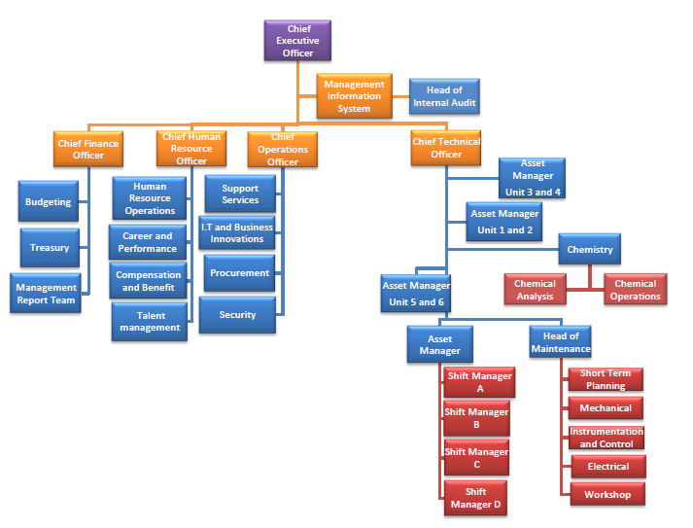

Figure 1.1. Organizational Structure of Egbin Power Plc.

# CHAPTER TWO

# EGBIN POWER GENERATION

## 2.1 Power System in Nigeria

The electricity we are able to use in the comfort of our homes, schools, offices and industries to power light bulbs, fans, printers and lathe machines, just to mention a few, has undergone certain processes to be available for our use. These processes are shown in Figure 2.1.

For electrical power to be supplied, three companies need to be in place and they are the Generation Company, Transmission Company and Distribution Company.

1. **GENERATION:** In Nigeria, Electricity production over the last 40years has varied from gas-fired, oil fired, hydroelectric power stations to coal fired stations with hydroelectric power systems and gas fired systems taking precedence. Some of Nigeria’s power generating companies are Kainji Plc, Jebba Power Plc, Ughelli Power Plc, Shiroro Power Plc and Egbin Power Plc (which this report is centered on). Electricity is generated at between 11.5–16kV and stepped up by a step-up transformer to 330kV at the Power stations. This is done so as to take care of power losses (I2R losses) along the line of transmission since the electricity generated is to be transmitted over long distances. Power generated at various generating stations in the Nation is connected to the National Grid and then transmitted.
2. **TRANSMISSION:** The next phase of getting power to the consumer is Transmission. Transmission begins with the transportation of voltage, 330kV along transmission lines (otherwise referred to as conductors) and is stepped down by a transformer to 132kV at the Transmission substation, this voltage is further transported along transmission lines to Injection substations and stepped down to 33kv.
3. **DISTRIBUTION:** Distribution of electricity starts at this point. The voltage is stepped down by a distribution transformer to 11 kV and 33Kv. The former which in turn is stepped down to 0. 415kV and further stepped down to 240V before it gets to our homes or offices while the latter, is used consumed by industries and high scale ventures.

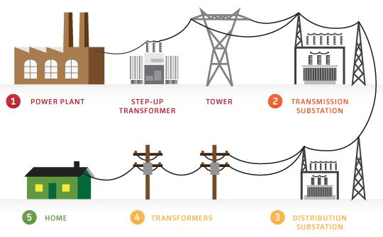

## 2.2 Plant Overview Principles

Electrical power generation is based on Michael faraday’s law of electromagnetic induction which states that ‘the *magnitude of the electromotive force induced in a circuit is proportional to the rate of change of the magnetic flux that cuts across the circuit.”*

Mathematically, the electromotive force (e.m.f) is expressed as:

Where

From faraday’s law it can be concluded that three provisions must be met for there to be induced electromotive force and thus electricity. These are: magnetic field, conductor, and relative motion between the other two. To obtain this relative motion which in Egbin Power Plc is a rotating shaft of a steam turbine that operates on the principle of a modified Rankine cycle.

### 2.2.1 RANKINE CYCLE

The Rankine cycle is an idealized thermodynamic cycle that describes the process by which certain heat engines, such as steam turbines or reciprocating steam engines, allow mechanical work to be extracted from a fluid (water) as it moves between a heat source and a heat sink.

Heat energy is supplied to the system through (typically water) is converted to a high-pressure gaseous state (steam) in order to turn the shaft of a turbine. After passing over the turbine the fluid is allowed to condense back into a liquid state as waste heat energy is rejected before being returned to boiler, completing the cycle. Friction losses throughout the system are often neglected for the purpose of simplifying calculations as such losses are usually much less significant than thermodynamic losses, especially in larger systems. The ability of a Rankine engine to harness energy depends on the relative temperature difference between the heat source and heat sink. The greater the differential, the more mechanical power can be efficiently extracted out of heat energy, as per Carnot's theorem.

The modifications to the Ideal Rankine Cycle adopted in Egbin Power Plc are;

1. Superheat: This is the process of heating the water to dry steam. In an Ideal Rankine cycle, the efficiency of the steam turbine will be limited by water-droplet formation. As the water condenses, water droplets hit the turbine blades at high speed, causing pitting and erosion, gradually decreasing the life of turbine blades and efficiency of the turbine. The easiest way to overcome this problem is by superheating the steam.
2. Reheat: Reheating is the process of heating up the steam after the first stage of expansion has been done in the turbine. The advantages are that it prevents the vapor from condensing during its expansion in the second stage of the turbine and thereby reducing the damage in the turbine blades, and improves the efficiency of the cycle.
3. Regeneration: By regeneration it means the working fluid is heated by steam tapped from the hot portion of the cycle. Regeneration increases the cycle heat input temperature by eliminating the addition of heat from the boiler/fuel source at the relatively low feed water temperatures that would exist without regenerative feed water heating. This improves the efficiency of the cycle, as more of the heat flow into the cycle occurs at higher temperature.

## 2.3 Power Generation Process in Egbin

The power generation process in Egbin Power Plc is a closed and continuous process which utilizes many engineering applications, equipment, unit operations and maintenance so as to efficiently and effectively produce the required output. Steam being the working fluid of the power generation process, it is been produced by the treatment of water from deep wells, demineralization of the water and heating up the water to get a dry steam of temperature, 541℃ and pressure, 12.5MPa to drive the turbine and generator at a speed of 3000rpm.

The generation process in Egbin Power Plc spans across the following stages:

1. Water Production and Treatment Process.
2. Demineralization Process.
3. Steam Generation Process (Boiler).
4. Steam Work Process (Turbine & Generator).

### 2.3.1 Water Production and Treatment Process

Egbin Power plant requires steam as the prime mover for the steam turbines, thus water is required for the process operations. There are two main sources of water in the plant namely:

1. The lagoon water ­– used mainly for cooling,
2. The deep well water – used for the power generation.

There are six Deep-wells in total which are all situated about 14km away from the plant. These wells are alphabetically indicated thereby making their names Well A, B, C, D, E, & F for easy identification. Four of these well are in service while the other two are on standby during operation. Each deep well consist of a submersible pump which pumps water at the rate of 75m3/hr. Water from the deep well contain debris, impurity, low pH of about 4.0 – 4.2. The Deep-well water is preferably used for power generation over the Lagoon water because it requires less modification, purification, and process cost in order to achieve optimum condition.

To achieve the demineralized water, the water from the deep well goes through the following processing units:

1. **Bleaching Tank:** This is an open tank where **water disinfection** and **pH modification** take place. Water from the deep-well are transferred through pipeline to the bleaching tank. A pH probe is firstly used in measuring the acidity of the incoming water, thereby regulating the addition of *Calcium Hydroxide* (Milk of Lime) which facilitates the modification of the water pH into one (about 7.4) which is best for corrosion prevention and suitable for domestic use. *Calcium Hypochlorite* is also added for disinfection so as to prevent the growth of algae in the tank.

The Bleaching Tank is also equipped with a stirrer so as to aid the agitation of the entire tank volume thereby producing a homogenous mixture. After the homogenous mixture of the reagents and the water, the water is then transferred to the Clarifier.

1. **Clarifier:** This is an open settling tank built with the mechanical means for the removal of solids which is done by the action of **flocculation, coagulation and sedimentation** so as to produce clear water.

After the addition of the flocculation reagent such as polyelectrolytes which increases the rate at which finely particles form larger particles, the finely suspended particles clump together and form larger particles by the action of coagulation that settle more quickly and stably by the action of sedimentation. Therefore, the separation is done efficiently and easily. The deposits accumulate at the bottom of the Clarifier and then pushed to the centre by the scrapper required to be removed and disposed.

1. **Sand Filter:** This is a unit operation in which the water from the Clarifier is transferred to so as to rid it of residual particulates. The Sand Filters are arranged in four beds of different grain sizes each so as to remove suspended matter, as well as floating and sinkable particles. The particles are removed by way of absorption or physical encapsulation.

In addition, the Sand Filters are also equipped with Air Blowers and Wash Pumps so as to aid an operation which is termed *Backwashing* – an act of using compressed air and water to differentially clean the clogged pores of the filter beds which tends to reduce filtration efficiency.

1. **Clear Well:** It is an underground storage tank which is used for temporal storage of processed water from the previous processing units before being sent to the Fresh Water Tanks.
2. **Fresh Water Tanks:** These are storage tanks of 3000m3 in volume and 10.8m in height, it receives water from the clear well to be channeled into three places, namely:
3. to the Firefighting tank for firefighting System,
4. to the Water Treatment plant through the Carbon Filter Vessel which removes odour, colour and taste from water in order to make the water consumable for the plant and the housing colony hence, the water is stored in the Portable Water Tanks,
5. To the Demineralization Plant.

### 2.3.2 Demineralization Process

The Demineralization Process in Egbin Power Plc is carried out so as strip from the feedwater impurities such as acids, salts, bases and ions which are detrimental to the efficiency of the boiler and the turbine system. The process is carried out in the Demineralization Plant which consists of two separate trains, A & B, equipped with the same process operation of which one train is always in service during production while the other is on standby. Each train is specifically made to deliver a net service flow of 200m3/h.

From the Fresh Water tank, the water is been transferred to the Demineralized plant by the action of the Demineralized Water Supply Pump. Between the Fresh Water tank and the Demineralized tank, there are some processing units that the water needs to pass through in other to get a demineralized water. The processing units are listed below:

1. **Carbon Filter Vessel:** Feed water from the Fresh Water tanks is first channeled to this vessel which employs *activated carbon* as filter media. As a result, it makes the water colourless, odourless and tasteless which becomes consumable for human. After this process, the water leaves through the bottom to the cation vessel.
2. **Cation Vessel:** In this vessel, *resins* in the bead form are employed. As the feedwater travels through this vessel, the resins remove every positive ion present in the water making the water an acid softened water. After this process, the acid softened water leaves to the anion vessel.
3. **Anion Vessel:** In this vessel, resin beads are also employed. The resin beads remove the negatively charged ions such as Chloride ion (Cl-), Sulphate ion (SO42-), Bicarbonate ion (CO32-) as well as Silica from water. After this process, the water is further transferred to the mixed bed vessel.
4. **Mixed Bed Vessel:** This vessel is a polisher that contains both anion and cation resin to polish the ions that escaped from the previous processing units. By the action of gravity, the anion resins float above the cation resin in the vessel because cation resins are heavier that anion resins. After this process, it is assumed that the water has been completely deionized which completes the production of **Demineralized Water.** Therefore, the water is been transferred into the demineralized tank for storage before usage.
5. **Demineralization Tanks:** These are closed tanks which are used in storing demineralized water from the Demineralization Plant.

#### 2.4.2.1 Regeneration System

This consists of 100% duty regeneration pumps, a backwash or rinse operation system, an external regeneration system for the mixed-bed exchangers, it is done after every 75,600m3 flow count from the regeneration vessel regenerator. A sulphuric acid (H2SO4) regeneration system for cation exchange resin, the regeneration is done after 12,000m3 flow count from the cation vessel. A caustic (NaOH) regeneration system for anion exchange resin, its regeneration is done after 12,0003 flow count from the anion vessel and a mixing air unit for resin mixing and transfer.

After the regeneration process, the acidic water and the caustic soda water are channeled to the neutralization **sump pit.** If the water is acidic, it is neutralized with a basic solution and if it is basic, an acidic solution is used to neutralize it in order to arrive at a neutral pH of **7.0** or **6.9** before releasing it to the lagoon to avoid water pollution.

### 2.3.3 Steam Generation Process (Boiler System)

The type of boiler Egbin Power Plc operates with is known as **Water-Tube Boiler. It** is a type of [boiler](https://en.wikipedia.org/wiki/Boiler_(steam_generator)) in which water circulates in tubes heated externally by the fire. Fuel is burned inside the [furnace](https://en.wikipedia.org/wiki/Furnace#Industrial_furnaces), creating hot gas which boils water in the steam-generating tubes. The heated water/steam mixture then rises into the [steam drum](https://en.wikipedia.org/wiki/Steam_drum). Here, saturated steam is drawn off the top of the drum. In some services, the steam pass through tubes in the hot gas path, (a [super heater](https://en.wikipedia.org/wiki/Superheater)) to become superheated. Superheated steam is defined as steam that is heated above the boiling point at a given pressure. Superheated steam is a dry gas and therefore is typically used to drive turbines, since water droplets can severely damage turbine blades.

The Boiler System consists of tubes, pumps, heaters (heat exchangers), furnace, pressure vessels and other processing units which contribute to the phase change from water to steam.

After the demineralization process, the water is being channeled to **condensate surge/storage tank** with the aid of a **make-up pump**, from where it goes into the **hot well** which is about 42°C.

The steam generation process systems in the plant are as follows:

1. **Condenser:** The exhaust steam from the low-pressure turbine is condensed to water by using the condenser to extract its latent heat of vaporization. This action causes the volume of the steam to go down to zero: reducing the pressure to near vacuum condition, thus increasing the pressure drop across the turbine and enabling the maximum amount of energy to be extracted from the steam.
2. **Hot Well:** It is attached to the **condenser** and it serves as a storage tank for the condensate and also receives water from the condensate surge tank.
3. **Condensate Extraction Pumps (CEP) (A & B):** They are used to extract the condensate from the hot well to the **steam jet air ejectors**. If A is in service, B will be on standby.
4. **Steam Jet Air Ejectors (A & B):** They are also known as the jet ejectors used in the plant to remove non-condensable particles and water vapor from the condensate. They have a relief valve that controls the flow of water whenever the ejector head is overfilled with water. They move the condensate to the **gland** **condenser**. If A is in service, B will be on standby.
5. **Gland Condenser:** Gland Condenser is used to collect condensate and calories of steam that is used for sealing steam turbine, and it also creates a state of vacuum to help discharge of steam. The thermal energy is transformed to the kinetic energy as steam of high pressure-high temperature rotates steam turbine. Air and non-condensable gases are evacuated from the gland steam condenser and discharged into the air vent system by gland steam blower. The condensate then moves to the Condensate Polishing Plant.
6. **Condensate Polishing Plant (CPP):** is a *mini demineralization plant* which further deionizes condensate due to the possibility of ions and impurities getting into it in the process of cooling with the lagoon water.
7. **Condensate Booster Pumps (CBP) (A & B):** The function of the booster pump is to transfer the water from the condensate polishing plant to the drain cooler by increasing the pressure.
8. **Drain Cooler:** The drain cooler is a heat exchanger used to preheat the condensate from the CEP (condensate extraction pump). Prior to reaching the cycle feed heaters and other heat exchangers. This heat exchanger uses the drains from the lowest pressure feed heater (low pressure heater 1) as heating medium thus makes positive use of this distillate heat which would otherwise be wasted to the atmosphere via the condenser. The feedwater then moves to the Low-Pressure Heater 1.
9. **Low-Pressure Heater 1:** It serves as a heat exchanger and storage tank for the feed water. It has **tube side** (where the feed water passes through) and the **shell side** (where the extracted steam from the low-pressure turbine passes through) in order to increase the temperature of the feed water). The output temperature of the steam while heading to the **low-pressure heater 2** is 87°C.
10. **Low-Pressure Heater 2:** It is a heat exchanger as well as a storage tank for the feed water. It also has **tube side** and **shell side** for increasing the steam temperature. The steam is extracted from the low-pressure turbine. The feed water then moves to low-pressure heater 3 with an output temperature of 110°C.
11. **Low Pressure Heater 3:** It is also a heat exchanger and a storage tank for the feed water. Like heater 1 and 2, it has both **tube side** and **shell side** for steam. As usual, steam is extracted from the low-pressure turbine. The output temperature of the feed water from here to the **de-aerator** is 134°C.
12. **De-aerator:** The de-aerator executes four functions; storage tank for feed water, heat exchanger, feeder to boiler feed pumps and helps to remove dissolved oxygen and other gases in the feed water. The extraction steam for the de-aerator is tapped from the intermediate turbine and the output temperature of the feed water in the de-aerator is 163°C.
13. **Boiler Feed Water Pumps (A, B & C):** As the name implies, they feed water from the deaerator to the boiler drum through the **high-pressure heater 5 & 6** and the **economizer**. Two of the three pumps are always in service whenever the generating power is above 110KW while the third is on standby.
14. **High Pressure Heater 5:** Serves as a heat exchanger. It also has tube side for feed water and shell side for steam passage (extraction steam comes from the intermediate pressure turbine). The output temperature of the feed water is 197°C.
15. **High Pressure Heater 6:** It is also a heat exchanging device which has a tube side for feed water and a shell side for the passage of steam coming from the high-pressure turbine. The output temperature of the feed water here is 237°C. From here, the feed water goes into the Economizer.
16. **Economizer:** It is a device fitted to the boiler which saves energy by using the gas fumes from the boiler to preheat the feed water before going into the boiler drum.
17. **Boiler Drum:** The boiler drum is a reservoir of water and steam at the top end of the boiler tubes. The drum keeps the steam produced in the water tubes and acts as a phase separator for mixed steam and water. The density difference between hot and cold water helps in the accumulation of water and saturated steam into the steam drum. The saturated steam them goes into the primary superheater while the saturated water goes back to the economizer through the downcomer. The steam in the boiler drum goes to the primary super heater with temperature of 500°C and then to the **secondary super heater**.
18. **Primary Super heater:** Super heater is a device used to convert saturated or wet steam into dry steam used in steam engines or in processes such as steam reforming. Primary Super heaters are the first heaters placed after steam drum. It is a Low Temperature Super heater (LTSH) which absorbs heat from the LTSH combustion exhaust gases. Heating steam will pass on to the secondary super heater
19. S**econdary Super Heater:** The secondary super heater maintains a temperature of 1200°C, by which the steam is successfully converted to dry steam with an output temperature of 541°C at a pressure of 12.5MPa. This dry steam is then channeled to the **High-pressure turbine**.

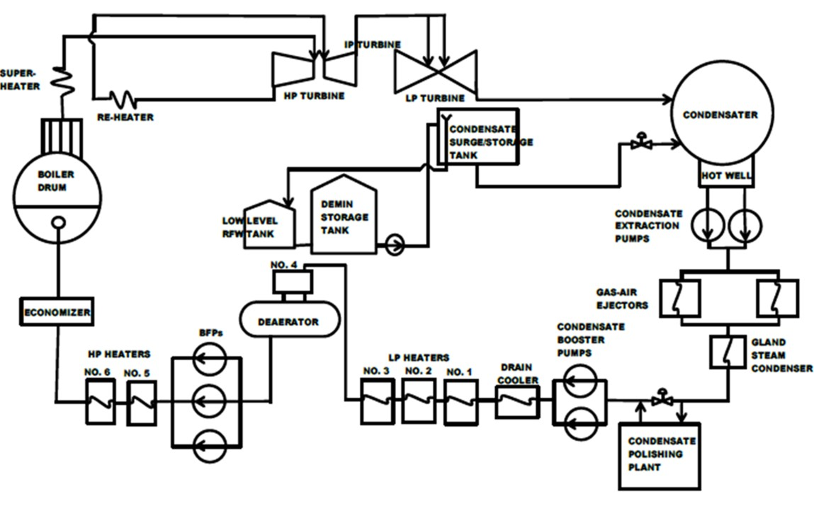

*Fig. 2.4: Steam Generation Flow Chart*

### 2.3.4 Steam Work Process (Turbine System)

The Steam Work Process in Egbin Power Plc is one which is similar to the conventional thermodynamic heat engine process. A heat engine is used in converting heat or thermal energy into mechanical work (shaft work) and does this by bringing a working fluid from a very high temperature state to a very low temperature state.

In Egbin Power Plc, a multi-stage steam turbine is utilized in converting thermal energy from steam (working fluid) into shaft work which in turn drives the synchronous generator, which is otherwise known as an *alternator,* after which the steam is thus taken down to a lower temperature in the condenser.

The systems involved in the Steam Work Process in Egbin Power Plc are:

1. **High-Pressure Turbine:** This is the first stage in the multi-stage setup where steam pressure is used in driving the shaft. The steam from the superheaters is admitted into this stage for expansion after which the expanded steam is sent into the reheater so as to improve cycle efficiency and maintain the steam process temperature as much as possible. The High-Pressure Turbine is designed to share boundaries with the Intermediate-Pressure Turbine and it consist of *8-blade stages* through which the steam expands.
2. **Intermediate-Pressure Turbine:** This is the second stage in the multi-stage setup where steam expansion through the turbine blades also occurs. The steam from the reheater is admitted into this stage and the *6-blade stage* configuration of the Intermediate-Pressure Turbine helps in converting the thermal energy from the steam into shaft work. After expansion of steam here, it is directly sent into the Low-Pressure Turbine through the crossover pipe.
3. **Low-Pressure Turbine:** This is the last stage in the multi-stage setup where steam expansion further drives the shaft. Steam is admitted directly into the Low-Pressure Turbine from the Intermediate-Pressure Turbine through the crossover pipe. The Low-Pressure Turbine consist of a *dual 5-blade stage* through which steam expands before falling into the condenser for cooling.
4. **Generator:** This is an electro-mechanical device which converts mechanical energy into electrical energy. The Synchronous generator consists of static stator (Armature windings) and a rotor (field windings). As rotor rotates inside the stator, electric current is induced within its coils (in accordance with **Faraday’s law** which states that: ‘*The magnitude of the induced electromotive force in any circuit is proportional to the rate of change of the magnetic flux linking the circuit*.’). The rotor of the generator is directly coupled with the turbine shaft so they both turn at 3000rpm. The coils are connected to two slip rings (positive and negative slip rings). The carbon brush makes an electrical contact with the slip rings to create an interface between the stationary part and the rotating part.

The generator employs single excitation. This means the field windings are energized by direct current supply mainly 440V gotten from the operation of the thyristor stacks and Silicon Controlled Rectifier (SCR) and 110V from battery bank for **field flashing**. Exciting current is supplied to the field winding through the collector rings. The main brush conducts current from the moving slip rings of the generator to the output lines.

The generator output voltage and current are functions of its magnetic field. This magnetic field is determined by excitation currents. The field flashing circuit provides the means for feeding the generator rotor windings with exciting direct currents. The generator’s rotor and stator are **hydrogen** cooled and sealed with oil to avoid leakage.

## 2.4 Common Service Equipment

Common service equipment is the number seven asset of the plant which is common to all the six units in the plant. It includes the following:

1. **Hydrogen Plant:** This is a section where hydrogen is been produced for the plant’s use (cooling of the turbine generator).
2. **Compressor:** This is a device that increases the pressure of air in the plant in order to produce service air and instrument air for plant’s use. Service air is first gotten while instrument air is gotten from further filtration of service air. The instrument air is a dry air channeled to each unit for pneumatic instrumentation while service air is channeled to the plant workshop and units for domestic use.
3. **Lagoon Water:** This is one of the reason it is found where it is today. The lagoon water is taken into the plant by the action of Circulating Water Pump and Lagoon Water Pump for the cooling of feed water and some equipment.
4. **Stack:** This is an overhead structure which gives of exhaust gas to the atmosphere. The tip is painted red and white and connected to it are red lights usually on at night for easy identification by aircraft. There are two stacks in Egbin Power Plc., one for the first three units and the other for the second three units.
5. **Gas Turbine Generator and Emergency Diesel Generators:** A Gas Turbine Generator is a combustion engine. Its basic operation is a Brayton Cycle with air as the working fluid. The installed capacity of the Gas Turbine generator in Egbin Power Plc. is 24.5MW.

There are two Emergency Diesel Generators in the company, with an installed capacity of 1.5MW each. The GTG and EDG are used for black start whenever there is power outage in the plant. Other common service equipment is chiller, water treatment plant, demineralized water plant.

# CHAPTER THREE

# MAJOR UTILITY EQUIPMENT AND TOOLS

This chapter discusses the mode of operations and application of the steady state equipment used in the production of electricity in Egbin power plc.

# 3.1 BOILER

Boiler is a closed vessel in which fluid (generally water) boils. Boilers are used to produce steam. The generation part of a steam system uses a boiler to add energy to a feed water supply to generate steam. The energy is released from the combustion of fossil fuels or from process waste heat. Steam Boilers are generally divided into two types, which are; fire tube and water tube. In Egbin power plc the water tube boiler is the type used which is shown in fig . Therefore, the water tube boiler will be discussed in the next section.

### 3.1.1 WATER TUBE BOILER

In water tube boilers, the water flows inside the tubes while the hot gas flows outside. It is more thermally efficient than fire-tube, more complex to construct and less tolerant of poor water quality. They are used when steam demand is high and for high pressure operations. The tubes contain water and the hot gases produced by combustion of fuel flow outside. The hot flue gases from the furnace are made to flow around the water tubes a sufficient number of times. The gases thus give up their heat to an appreciable extent, get cooled and are discharged to the stack. The steam formed separates from water in the drum and gets accumulated in the steam space.

### 3.1.2 IGNITION

The ignition coil is the component that connects directly with electricity line and includes two transformer windings. The primary winding feeds into the distributor, while the secondary winding connects to the spark plugs. When enough energy has been created, the spinning cam opens a breaker, which causes a high-voltage jump in the ignition coil. This voltage surge is transported to the spark plugs, resulting in the necessary electric spark to begin ignition. At the beginning of the firing of the burner small amount of natural gas and air is needed. This small amount of gas is known as ignition gas which is supplied into the burner by ignition pipe or line. After the burner is on the ignition line is turned off and main line for fuel and air supply is turned on.

### 3.1.3 BURNER

Burner is the chamber in the boiler where natural gas or coal is burned with the presence of air for producing heated gas or flue gas. In Egbin power plc, natural gas is burned with the presence of air for generating heat for making steam. In steam turbine power plant of Egbin each furnace chamber has nine furnaces. The treated water from the feed water tank through economizer enters into the boiler through tubes and the flue gas produced inside the furnace passes through the tubes.

### 3.1.4 BOILER EFFICIENCY

Boiler efficiency is defined as the ratio of heat energy utilized by feed water in converting it into steam in the boiler to the heat energy realized by complete combustion of fuel during the same time.

### 3.1.5 BOILER DRUM

It is the place where the water is reserved which comes through the economizer. Inside the drum upper and lower level of amount of water is measured by the level transmitters. If the level crosses the upper limit or goes below the lower limit then the plant will trip. So it is very important to control the level of the water. This is done by an automatic system. From the boiler drum the saturated steam is transferred into super heater.

### 3.1.6 SAFETY VALVE

The function of the safety valve is to permit the steam in the boiler to escape to atmosphere when the pressure in the steam space exceeds a certain specified limit. Thus the safety valve prevents the building up of excessive pressure in the boiler. The safety valve is located above the steam space in the boiler. The safety valves operate on the principle that a valve is pressed against its seat through some agency such as strut, screw or spring by external weights or force. When the steam force due to boiler pressure acting under the valve exceeds the external force, the valve gets lifted off its seat and some of the steam rushes out until normal pressure is restored again.

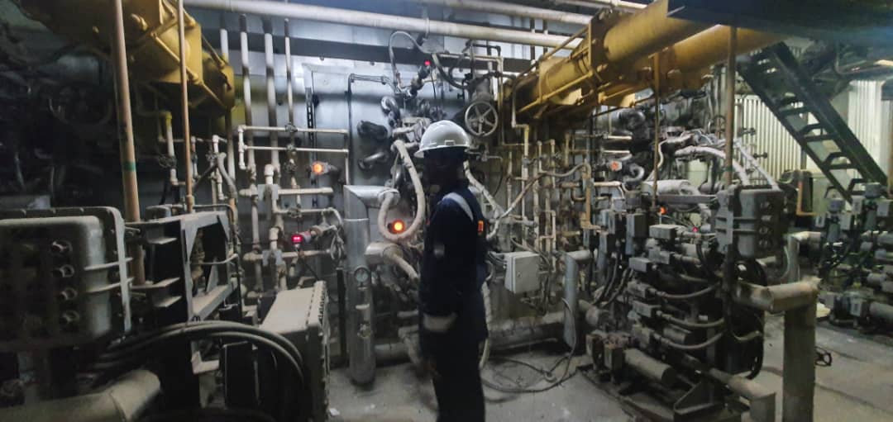

## 3.2 GENERATOR **UNIT BASIC**

Generator is an electro-mechanical device that converts mechanical energy into electrical energy. The operation of the electrical generators used depends upon the principle of electromagnetic conduction. When conductors move through a magnetic field or when a magnetic field in moved past conductors an induced current develops. The current that is induced into the conductors produces an induced electromotive force or voltage.

Electromagnetic induction is the principle used for a generator to convert mechanical energy to electrical energy. Generator output voltage and VAR flow control is controlled by changing the strength of the magnetic field applied to the machine. The following are steps taken to achieve electrical power.

• A D.C. excitation is applied to the rotor field winding

• The rotor rotates within the stator providing relative motion between the magnetic field and the stationary conductor windings (stator)

• A.C. voltage is induced in the stator armature windings

• The stator voltage is the output voltage of the generator at its terminals

### 3.2.1 A.C. Generator Components

Ac generator also called synchronous generators or alternators. Ac generators are the principal sources of electrical power throughout the world. Alternating voltage may be generated by rotating a coil in the magnetic field or rotating by magnetic field within a stationary coil. The value of voltage generated depends on the following:

• Rotating Magnetic Field (Rotor)

• Series of Stationary Conductors (Stator)

• Source of D.C. Voltage (Exciter)

The rotor produces the magnetic field which is established and fed by the exciter’s direct current when the rotor is rotated within the stator, alternating current is induced in the stator windings. The changing polarity of the rotor produces the alternating characteristics of the current.

• The generated voltage is proportional to the:

‒ Strength of the magnetic field

‒ Number of coils and number of windings on each coil

‒ Speed at which the rotor turns

Rotor winding is a multi-coil, single circuit, energized with DC power fed through the shaft from the collector rings

The rotor is a low voltage, low power circuit; a major factor in building a generator with a rotating field instead of a rotating armature.

### 3.2.2 EXCITER

The exciter is the "backbone" of the generator control system. It is the power source that supplies the dc magnetizing current to the field windings of a synchronous generator thereby ultimately inducing ac voltage and current in the generator armature. Two basic kinds of exciters

• Rotating (Brush and brushless)

• Static exciters (Shunt and series)

The amount of excitation required to maintain the output voltage constant is a function of the generator load. As the generator load increases, the amount of excitation increases. Reactive lagging pf loads require more excitation than unity pf loads while leading pf loads require less excitation than unity pf load

ROTATING EXCITERS

Brushless: do not require slip-rings, commutators, brushes and are practically maintenance free.

Brush Type: require slip-rings, commutators and brushes and require periodic maintenance STATIC EXCITERS

Static excitation means no moving parts. It provides faster transient response than rotary exciters Shunt Type: operating field power from generator output voltage Series Type: operating field power from generator output voltage & current

### 3.2.3 PRINCIPLE OF AUTOMATIC VOLTAGE REGULATOR

Voltage transformers provide signals proportional to line voltage to the avr where it is compared to a stable reference voltage. The difference (error) signal is used to control the output of the exciter field. For example, if load on the generator increases, the reduction in output voltage produces an error signal which increases the exciter field current resulting in a corresponding increase in rotor current and thus generator output voltage. Due to the high inductance of the generator field windings, it is difficult to make rapid changes in field current.

This introduces a considerable "lag" in the control system which makes it necessary to include a stabilizing control to prevent instability and optimize the generator voltage response to load changes. Without stabilizing control, the regulator would keep increasing and reducing excitation and the line voltage would continually fluctuate above and below the required value. Modern voltage regulators are designed to maintain the generator line voltage within better than +/- 1% of nominal for wide variations of machine load.

### 3.2.4 GENERATOR ROTATIONAL SPEED

A generator which is connected to the grid has a constant speed which is dictated by grid frequency. Doubling the magnet or windings in the stator ensures the magnetic field rotates at half the speed. When doubling the poles in the stator, the magnets in the rotor must also be doubled.

Where N = synchronous speed

F = frequency

P = poles

### 3.2.5 GENERATOR CAPABILITY CURVE

The curve indicates the available steady state capability of a generator as influenced by power factor. The curves are divided so that the generator load is limited in each region as a function of the generator component most affected.

Operation in the portion of the curve from (A to B) is from zero power factor lagging to rated power factor

-Generator is over excited

- field current is at rated value

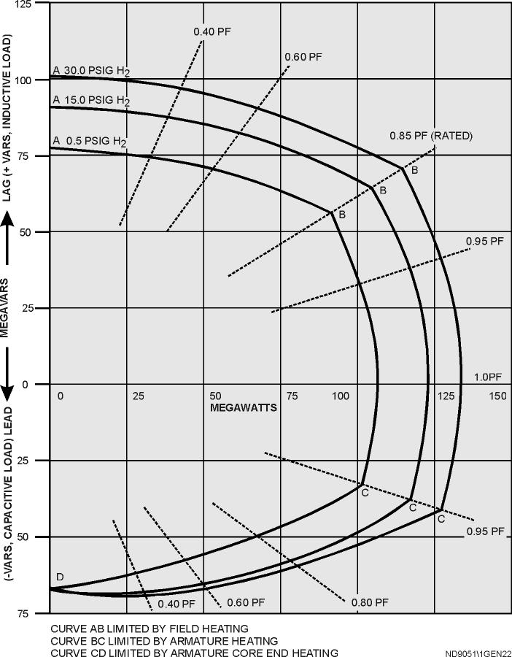

Operation in the portion of the curve from (B to C), which is rated power factor lagging through unity to 0.95 power factor leading.

- Limit is on the stator current

- Max nameplate stator amps should not be exceeded

Operation in the region of the curve from (C to D) which is leading power factor operation, causes the end leakage flux from the core to be at right angles to the stator laminations causing excessive beating in the stator end iron and structural steel members

Synchronizing torque is reduced because of reduced terminal voltage which could cause stability issues.

### 3.2.6 SYNCHRONIZATION

Suppose that generator G2 is to be connected to the running system shown in fig. the following steps should be taken to accomplish the paralleling.

First, using voltmeters, the field current of the oncoming generator should be adjusted until its terminal voltage is equal to the line voltage of the running system.

Second, the phase sequence of the oncoming generator must be compared to the phase sequence of the running system. The phase sequence of the running system. The sequence can be checked in a number of different ways. One way is to alternately connect a small induction motor to the terminals of each of the two generators. If the motor rotates in the same direction each time. Then the phase sequence is the same for both generators if the motor rotates in opposite directions, then the phase sequence differ and two of the conductors on the incoming generator must be reversed.

Another way to check the phase sequence is the three light bulb method. In this approach, three light bulbs are stretched across the open terminals of the switch connecting the generator to the system. As the phase changes between the twoi systems. The two systems, the light bulbs first get bright (large phase difference) and then get dim (small phase difference). If the three bulbs get bright and dark together, then the systems have the same phase sequence.

If the bulbs brighten in succession, then the systems have the opposite phase sequence and one of the sequences must be reversed.

Next, the frequency of the oncoming generator is adjusted to be slightly higher than the frequency of the running system. This is done first by watching a frequency meter until the frequencies are close and then by observing changes in phase between the systems.

Once the frequencies are very nearly equal, the voltages in the two systems change phase with respect to each other very slowly. The phases changes are observed and when the phase angles are equal, the switch connecting the two systems together is shut.

When the three light bulbs all go out, the voltage difference across them is zero and the systems are in phase. This simple scheme works but it is not very accurate. A better approach is to employ a synchroscope. A synchroscope is a meter that measures the difference in phase angle between the a phases of the two systems.

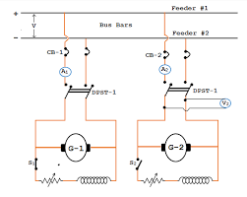

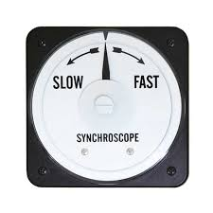

GENERATOR PROTECTION

A modern generating unit is a complex system comprising the generator stator winding, associated transformer and unit transformer, the rotor with its field winding and excitation system, and the prime mover with its associated auxiliaries. Faults of many kinds can occur within this system for which diverse forms of electrical and mechanical protection are required. The amount of protection applied will be governed by economic consider rations, taking into account the value of the machine, and the value of its output to Egbin power plc. The following problems require consideration from the point of view of applying Generator:

#### 3.2.7.1 OVER CURRENT WITH UNDER VOLTAGES

Over current with under voltages consist of under voltages section and under voltages section, if only over current activated the relay do not operate .when over current and under voltage operate then the over current with under voltages relay operate .in the over current section if current flow 1.2 in than it does not effect on the terminal voltages, if current flow more the 1.2times of in in than the terminal voltages reduces. when in the power system both condition appear then the under voltages with over current relay activated .if over current relay activated we understands that huge amount of fault in the system occurred ,if under voltage appear we can be confused if it is fault or over load occurred or over voltages. In the power system main causes of over voltages occur due to sudden load rejection, Lightening, Line fault

#### 3.2.7.2 STATOR WINDING PROTECTION

To respond quickly to a phase fault with damaging heavy current, sensitive, high-speed differential protection is normally applied to generators rated in excess of 1MVA. For large generating units, fast fault clearance will also maintain stability of the main power system. The zone of differential protection can be extended to include an associated step-up transformer. For smaller generators, IDMT/instantaneous over current protection is usually the only phase fault protection applied.

#### 3.2.7.3 OVER SPEED PROTECTION

The speed of a turbo-generator set rises when the steam input is in excess of that required to drive the load at nominal frequency. The speed governor can normally control the speed, and, in any case, a set running in parallel with others in an interconnected system cannot accelerate much independently even if synchronism is lost. However, if load is suddenly lost when the HV circuit breaker is tripped, the set will begin to accelerate When a generator operating in parallel with others loses its power input, it remains in synchronism with the system and continues to run as a synchronous motor, drawing sufficient power to drive the prime mover. This condition may not appear to be dangerous and in some circumstances will not be so. However, there is a danger of further damage being caused.

#### 3.2.7.4 UNDER FREQUENCY PROTECTION

An under frequency relay is one which operates when the frequency of the system falls below a certain value. Overloading of a generator, perhaps due to loss of system generation and insufficient load shedding, can lead to prolonged operation of the generator at reduced frequencies. This can cause particular problems for gas or steam turbine generators, which are susceptible to damage from operation outside of their normal frequency band. The turbine is usually considered to be more restrictive than the generator at reduced frequencies because of possible mechanical resonance in the many stages of the turbine blades. If the generator speed is close to the natural frequency of any of the blades, there will be an increase in vibration. Cumulative damage to the blades due to this vibration can lead to cracking of the blade structure .While load-shedding is the primary protection against generator overloading, under frequency relays should be used to provide additional protection. Alarm: 48 Hz.

#### 3.2.7.5 Minimum impedance and Distance protection

Minimum impedance relay always deal with ratio of voltages and current .minimum impedance relay generally use in transmission line, transformer, Grid, Generator. Minimum impedance mean if voltages and current fluctuates then they always have ratio is call set point ,in Egbin power plc, we use terminal voltages 110V and current 5A then minimum impedance is R= V/I = 110V/5 = 22. If in the power system over load appear then current will increase in the terminal, let current will increase 5Ato 18A then minimum impedance will be R=V/I=18 if in the power system short circuit occurred then current will increase in the terminal, let voltages will decrease 5Ato 18A then minimum impedance will be R=V/I=80V/5A=16. In both case the plant will be trip distance protection relay work same principle distance protection indicate the direction in which direction fault appear left or right side of generator.

#### 3.2.7.6 STATOR GROUND FAULT PROTECTION

Stator ground faults are short circuits between any of the stator windings and ground, via the iron core of the stator. Typically, when a single machine is connected to the power system through a step-up transformer, it is grounded through high impedance. As a result, the amount of the short circuit current during stator ground faults is driven by the amount of capacitive coupling in the machine and its step-up transformer. Ground faults can be detected throughout most of the winding through the use of an overvoltage relay responding to the fundamental component of the voltage across the grounding impedance. This stator ground fault is sometimes known as 100% stator ground fault protection.

#### 3.2.7.7 ROTOR EARTH FAULT PROTECTION

Two methods are available to detect this type of fault. The first method is suitable for generators that incorporate brushes in the main generator field winding. The second method requires at least a slip-ring connection to the field circuit.

## 3.3 TRANSFORMERS

An electrical power transformer is a static device which transforms electrical energy from one circuit to another without any direct electrical connection but with the help of a mutual induction between two windings. Transformers are commonly used to increase or decrease voltages of alternating currents in electric power applications. The two types of power transformers employed in EGBIN Power Plant are:

**Generator Transformer -** This is the main power transformer employed in the plant. It steps the voltage from 16kV to 330kV and delivers the power. Stepping up the voltage reduces the transmission losses which occur during power transmission to long distances. The rating of this transformer, Mega Volt Amp (MVA) rating, will be almost equal to the alternator or generator rating.

**Unit Auxiliary Transformers** - These transformers are connected to the Generator Transformer bus. These transformers step down the voltage from 16kV to 6.6kV and supply the power to the electrical auxiliaries present in the plant (motors, drives, lighting and other plant loads).

### 3.3.1 Principles of Transformer: Ideal Transformer

An ideal transformer is a theoretical linear transformer that is lossless and perfectly coupled. Perfect coupling implies infinitely high core magnetic permeability and winding inductances and zero net magneto motive force (i.e. ipnp - isns = 0).

Ideal transformer connected with source VP on primary and load impedance ZL on secondary, where 0 < ZL < ∞.

### 3.3.2 Ideal transformer and Induction Law

A varying current in the transformer's primary winding attempts to create a varying magnetic flux in the transformer core, which is also encircled by the secondary winding. This varying flux at the secondary winding induces a varying electromotive force (EMF, voltage) in the secondary winding due to electromagnetic induction and the secondary current so produced creates a flux equal and opposite to that produced by the primary winding, in accordance with Lenz's law. The windings are wound around a core of infinitely high magnetic permeability so that all of the magnetic flux passes through both the primary and secondary windings. With a voltage source connected to the primary winding and a load connected to the secondary winding, the

Transformer currents flow in the indicated directions and the core magneto-motive force cancels to zero.

According to Faraday's law, since the same magnetic flux passes through both the primary and secondary windings in an ideal transformer, a voltage is induced in each winding proportional to its number of windings. The transformer winding voltage ratio is directly proportional to the winding turns ratio.

The load impedance referred to the primary circuit is equal to the turns ratio squared times the secondary circuit load impedance.

### 3.3.3 Real Transformer

The ideal transformer model neglects the following basic linear aspects of real transformers:

(a) Core losses, collectively called magnetizing current losses, consisting of

(i) Hysteresis losses due to nonlinear magnetic effects in the transformer core, and

(ii) Eddy current losses due to joule heating in the core that are proportional to the square of the transformer's applied voltage.

(b) Unlike the ideal model, the windings in a real transformer have non-zero resistances and inductances associated with:

(i) Joule losses due to resistance in the primary and secondary windings

(ii) Leakage flux that escapes from the core and passes through one winding only resulting in primary and secondary reactive impedance.

(c) Similar to an inductor, parasitic capacitance and self-resonance phenomenon due to the electric field distribution. Three kinds of parasitic capacitance are usually considered and the closed-loop equations are provided:

(i) Capacitance between adjacent turns in any one layer;

(ii) Capacitance between adjacent layers;

(iii) Capacitance between the core and the layer(s) adjacent to the core;

Inclusion of capacitance into the transformer model is complicated, and is rarely attempted; the ‘real’ transformer model’s equivalent circuit does not include parasitic capacitance. However, the capacitance effect can be measured by comparing open-circuit inductance, i.e., the inductance of a primary winding when the secondary circuit is open, to a short-circuit inductance when the secondary winding is shorted.

### 3.3.4 Transformer Cooling System

The conservator (reservoir) at top provides liquid-to-atmosphere isolation as coolant level and temperature changes. The walls and fins provide required heat dissipation.

It is a rule of thumb that the life expectancy of electrical insulation is halved for about every 7 °C to 10 °C increase in operating temperature (an instance of the application of the Arrhenius equation). Small dry-type and liquid-immersed transformers are often self-cooled by natural convection and radiation heat dissipation. As power ratings increase, transformers are often cooled by forced-air cooling, forced-oil cooling, water-cooling, or combinations of these. Large transformers are filled with transformer oil that both cools and insulates the windings. Transformer oil is a highly

Refined mineral oil that cools the windings and insulation by circulating within the transformer tank. The mineral oil and paper insulation system has been extensively studied and used for more than 100 years. It is estimated that 50% of power transformers will survive 50 years of use that the average age of failure of power transformers is about 10 to 15 years, and that about 30% of power transformer failures are due to insulation and overloading failures. Prolonged operation at elevated temperature degrades insulating properties of winding insulation and dielectric coolant, which not only shortens transformer life but can ultimately lead to catastrophic transformer failure. Transformer oil testing are carried out using various methods like using the dielectric tester to test the dielectric quality of the transformer oil getting its breakdown voltage.

Building regulations in many jurisdictions require indoor liquid-filled transformers to either use dielectric fluids that are less flammable than oil, or be installed in fire-resistant rooms. Air cooled dry transformers can be more economical where they eliminate the cost of a fire-resistant transformer room.

The tank of liquid filled transformers often has radiators through which the liquid coolant circulates by natural convection or fins. Some large transformers employ electric fans for forced-air cooling, pumps for forced-liquid cooling, or have heat exchangers for water-cooling. An oil-immersed transformer may be equipped with a Buchholz relay, which, depending on severity of gas accumulation due to internal arcing, is used to either alarm or de-energize the transformer. Oil-immersed transformer installations usually include fire protection measures such as walls, oil containment, and fire suppression sprinkler systems.

Polychlorinated biphenyls have properties that once favored their use as a dielectric coolant, though concerns over their environmental persistence led to a widespread ban on their use. Today, non-toxic, stable silicone-based oils, or fluorinated hydrocarbons may be used where the expense of a fire resistant liquid offsets additional building cost for a transformer vault. Some transformers, instead of being liquid-filled, have their windings enclosed in sealed, pressurized tanks and cooled by nitrogen or sulphur hexafluoride gas. Experimental power transformers in the 500‐to‐1,000 kVA range have been built with liquid nitrogen or helium cooled superconducting windings, which eliminates winding losses without affecting core losses

## 3.4 CIRCUIT BREAKERS

A circuit breaker is a switching device that interrupts the abnormal or fault current. It is a mechanical device that disturbs the flow of high magnitude (fault) current and in additions performs the function of a switch. The circuit breaker is mainly designed for closing or opening of an electrical circuit, thus protects the electrical system from damage. Circuit breakers are made in varying sizes, from small devices that protect low-current circuits or individual household appliance, up to large switchgear designed to protect high voltage circuits feeding an entire city. The generic function of a circuit breaker, or fuse, as an automatic means of removing power from a faulty system is often abbreviated as OCPD (Over Current Protection Device).

### 3.4.1 Operation of Circuit Breakers

All circuit breaker systems have common features in their operation, but details vary substantially depending on the voltage class, current rating and type of the circuit breaker. The circuit breaker must first detect a fault condition. In small mains and low voltage circuit breakers, this is usually done within the device itself. Typically, the heating or magnetic effects of electric current are employed.

Circuit breakers for large currents or high voltages are usually arranged with protective relay pilot devices to sense a fault condition and to operate the opening mechanism. These typically require a separate power source, such as a battery, although some high-voltage circuit breakers are self-contained with current transformers, protective relays, and an internal control power source. Once a fault is detected, the circuit breaker contacts must open to interrupt the circuit; this is commonly done using mechanically stored energy contained within the breaker, such as a spring or compressed air to separate the contacts. Circuit breakers may also use the higher current caused by the fault to separate the contacts, such as thermal expansion or a magnetic field. Small circuit breakers typically have a manual control lever to switch off the load or reset a tripped breaker, while larger units use solenoids to trip the mechanism, and electric motors to restore energy to the springs. The circuit breaker contacts must carry the load current without excessive heating, and must also withstand the heat of the arc produced when interrupting (opening) the circuit. Contacts are made of copper or copper alloys, silver alloys and other highly conductive materials. Service life of the contacts is limited by the erosion of contact material due to arcing while interrupting the current. Miniature and molded case circuit breakers are usually discarded when the contacts have worn, but power circuit breakers and high-voltage circuit breakers have replaceable contacts. When a high current or voltage is interrupted, an arc is generated. The length of the arc is generally proportional to the voltage while the intensity (or heat) is proportional to the current. This arc must be contained, cooled and extinguished in a controlled way, so that the gap between the contacts can again withstand the voltage in the circuit. Different circuit breakers use vacuum, air, insulating gas, or oil as the medium the arc forms in.

### 3.4.2 Types of Circuit Breakers

Circuit breakers are mainly classified on the basis of rated voltages. Circuit breakers below rated voltage of 1000V are known as the low voltage circuit breakers and above 1000V are called the high voltage circuit breakers. The most general way of the classification of the circuit breaker is on the basis of the medium of arc extinction. Such types of circuit breakers are as follows:-

(i) Oil Circuit Breaker

(ii) Bulk Oil Circuit Breaker

(iii) Minimum Oil Circuit Breaker

(iv) Minimum Circuit Breaker

(v) Air Blast Circuit Breaker

(vi) Sulphur Hexafluoride Circuit Breaker

(vii) Vacuum Circuit Breaker

(viii) Air Break Circuit Breaker

All high-voltage circuit breakers may be classified under two main categories i.e oil circuit breakers and oil-less circuit breaker.

# 3.5 UNINTERRUPTIBLE POWER SUPPLY UPS

UPS means a standby electric power source connected between a utility / power supply and a load. Egbin power plc. UPS essentially consist of 240V battery bank and battery charger, 110V battery bank and battery charger with an inverter, static no-break transfer switch and a line regulator.

This arrangement ensures a constant power supply to various critical loads in the event of a planned maintenance outage, system trip or total black out.

### 3.5.1 UPS STRUCTURE

Although all UPS disregarding its capacity / appearance actually have the same basic components which includes Utility power supply input, Voltage regulator, Inverter, Batteries and Battery charger. But what distinguishes each type of UPS is how these internal components interact with each other to produce a constant output power, and their capacity.

The major UPS topographies are:

A) Off line or Standby

B) Line interactive

C) On-line double conversion

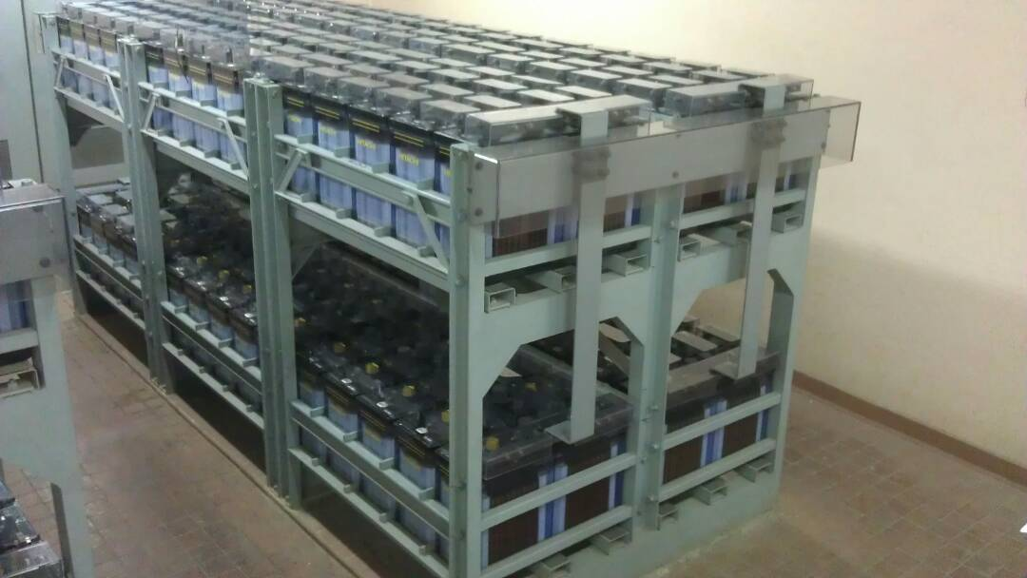

## 3.6 ELECTRIC MOTORS

# CHAPTER FOUR

# TECHNICAL EXPERIENCE

The mandatory six month industrial training carried out at Egbin Power Plc had me go through two departments namely;

1. Health, Safety and Environment (HSE) Department
2. Maintenance Department.

## 4.1 Health, Safety and Environment (HSE) Department

Egbin Power Plc is big on the safety of its staffs and the environment as it should be expected of any organization. The Health, Safety and Environment department is saddled with the responsibility of maintaining a safe, healthful working environment in the plant.

### 4.1.1 Roles of HSE Department

1. The HSE department is responsible for training new staffs, visitors, and interns. They see to it that everyone within the organization knows and is in total compliance to the company’s safety policy in ensuring the safety of everyone and the protection of the environment.
2. The HSE department also monitors the day-to-day activities of all operation carried out in the plant as related to maintenance.
3. They see to it that adequate safety education on a job is done by an experienced member of a team on the risk and safety measures associated with the job.
4. The department is responsible for the provision of safety materials especially in sensitive workspace.
5. The department is responsible for certifying that a working environment is safe and safety measures are duly followed.

### 4.1.2 My Safety Journey in Egbin Power Plc

The first three days into the SIWES program was used as an induction into the Health Safety and Environment (HSE) Department, where I was taught by a few safety officers about various issues as regards HSE as a subject. Some of the things discussed were: the company’s safety policies, safety guidelines, general hazard challenges within and without the plant, near misses, use of Personal Protective Equipment (PPE), incidents and accidents, first aid, colour codes as regards the plant and that used in the general public, risk management, manual handling, emergency response and so on and so fault. The induction was wrapped up with an assessment to ensure we were being carried along.

After the induction, my everyday across all other sections visited started with the safety pledge (I pledge to ensure the safety of everyone and the protection of the environment at all times) and a safety talk from a member of the section, which once fell on me. Also, before going out for a job, we always gather as a team for the toolbox talk, where we get a briefing from the team head on the nature of the job to be done, the risk associated with it and the safety measures to be taken. All of which would be documented in the toolbox form and submitted to the HSE department for approval before going in for the job.

On about three occasions during my attachment, I took part in the ‘walk to work’ day; a day set aside in which all staffs are expected to walk or at best cycle to the office. The practice of not burning fossil fuel in cars and motorcycles on that day is to show our solidarity towards an eco-friendly, greenhouse gas free ecosystem.

I also partook in a fire drill. On that day while working, the fire alarm came on and as instructed during the orientation, my team members and I immediately left the job at hand and walked to the muster point where we all gathered and wrote our names according to our respective departments for a headcount.

## 4.2 Maintenance

Maintenance involves operational and functional checks, servicing, repairing or replacing necessary devices, equipment, machinery, building infrastructure and supporting utilities in industrial, business, government and residential installation. Overtime, it has come to often include both scheduled and preventive maintenance as cost-effective practice to keep equipment ready for operation at the utilization state of a system lifecycle. Maintenance department is an improvement unit of a well-functioning production. It helps companies maintain their resources while controlling time and cost to ensure maximum efficiency of the manufacturing process, the utilities and related facilities.

### 4.2.1 Types of maintenance

1. Reactive Maintenance:Reactive maintenance (also known as breakdown maintenance) refers to repairs that are done when equipment has already broken down, in order to restore the equipment to its normal operating condition. There are two types of reactive maintenance, they are:
2. Corrective maintenance: This type of maintenance is performed to identify, isolate, and rectify fault so that failed equipment, machines or system can be restored to an operational condition within the tolerance or limit established from in-service operation. The primary purpose of corrective maintenance is to restore breakdown system.

This approach is based on a firm’s belief that the costs sustained for downtime and repair in case of fault are lower than the investment required for a maintenance program. This strategy may be cost-effective until catastrophic faults occur.

1. [Emergency maintenance](https://www.onupkeep.com/learning/maintenance-types/emergency-maintenance): Emergency maintenance occurs when an asset requires immediate attention in order to keep a facility operational or safe. This is the most reactive and intrusive type of maintenance as it pulls technicians away from other jobs and lowers schedule compliance. In extreme circumstances, emergency maintenance can set an organization back days depending on the scope of the repair, available parts, and the asset’s level of importance. To reduce the amount of emergency maintenance that is both unplanned and unscheduled, organizations adopt various forms of proactive maintenance.
2. Proactive Maintenance:Proactive maintenance refers to a collection of activities, inspections, tests and procedures that are used to prevent the failure of equipment, a machine or a material in the future. It focuses on determining potential root causes of machine or material failure, and dealing with those issues before problems occur. Types of proactive maintenance are:
3. Predictive maintenance: It is a type of maintenance to predict future failure point of machine component, so that component can be replaced based on plan, just before it fails. Thus, equipment downtime is minimized and component lifetime is maximized. This maintenance strategy uses sensors to monitor key parameters within a machine or system and uses the data in conjunction with analysed historical trend to continuously evaluate the system health and predict a breakdown before it happens. This technique allows maintenance to be performed more effectively.
4. Preventive Maintenance: This is the most common type of maintenance. It is in sometimes referred to as Routine Maintenance. It is the type of maintenance performed with the intent of avoiding failures, safety violations, unnecessary production cost and losses and to conserve original materials of fabrication. PM is always carried out on regular basis, that it, a routine action carried out to keep equipment up and running, preventing any unplanned downtime and expensive cost from unanticipated failure. It involves checks, cleaning and lubrication of rotating parts as per schedule.
5. Condition Monitoring: Condition maintenance is quite similar to the predictive maintenance in that they sense the parameters of the system before breakdown. The difference now being that condition monitoring only gives the real-time parameters of the system.
6. Planned maintenance: It is a practical approach to maintenance in which maintenance work is scheduled to take place on a regular basis. The type of work to be done and frequency vary based on the equipment being maintained and environment in which it is operating. Planned maintenance is created for every item separately according to manufacturer’s recommendation or legislation. Plans can be date-based, based on equipment running hours, or on the distance travelled by the vehicle. A good example of a planned maintenance program is car maintenance, where time and distance determine fluid change requirements.

## 4.3 MAINTENANCE DEPARTMENT

Egbin Power Plc maintenance department is divided into five sections and I was scheduled to go through them all. The sections in the order in which I visited them during the course of my industrial training are given below:

1. Electrical Maintenance
2. Mechanical Workshop
3. Instrumentation and Control
4. Mechanical Maintenance

### 4.3.1 ELECTRICAL MAINTENANCE DEPARTMENT

For effective running of the plant operation and reduced down-time, plant equipment are routinely maintained and when breakdown occurs; they are restored back to normalcy by the maintenance crew. Hence, electrical department in conjunction with other maintenance divisions work day and night to ensure safe and healthy plant operation.

This department is responsible for maintaining the Generator, Transformers, Circuit Breakers, Switch Gears, AC & DC Motors, Battery and UPS, Motor Control Centre (MCC) and industrial lighting. I spent two (2) months in electrical department, the following gives a description on the work done during my stint in the department.

#### 4.3.1.1 DAILY ROUTINE MAINTENANCE CHECKS ON 16KV GENERATOR CARBON BRUSHES

A **carbon brush** is a sliding piece that transmits electrical current from the static part of a generator to the rotating part, minimizing the sparking between the two contacts.

Carbon brushes are typically made from one or multiple carbon blocks (including copper graphite, natural graphite, electro graphite, silver graphite, bonded carbon, and pitch bonded carbon), with one or more terminals. Carbon is used as it is a reasonably good conductor of electricity, while it is soft enough to give a consistent contact point. However, this soft property means it does wear over time, and hence the need to regularly replace carbon brushes.

The Carbon brush maintenance is carried out daily and during the routine, the length and temperature of the carbon brushes are recorded, as well as the ambient temperature of the carbon brushes and slip-rings. The carbon brush wears out at about 10-15mm per 1000hr at a current density of 6-8A/cm2. When the length of the carbon brush is below 54mm, a new carbon brush is set to replace it.

The instruments and materials necessary for this maintenance includes: Fluke IR thermometer (measures temperature of carbon), Vernier Caliper (measures the length of the carbon), Screwdriver (for replacement of short carbon), Clean clothes (for cleaning of soot deposited on the carbon brush), nose mask (protection from the inhaling of soot particles), hand gloves (the carbon brushes are usually hot), eye goggle

The process of maintenance of generator carbon brushes is stated below;

1. Checking the ambient temperature of each carbon brush on the positive and negative slip ring in all six generator – turbine units.
2. Check that the spring tensions are correct
3. Measurement of length of each carbon brush with a vernier calliper
4. Check mechanical run-out and conditions of slip-rings

#### 4.3.1.2 UPS ROUTINE FOR 110V AND 240V BATTERY

For this job, we check the batteries, battery current, battery fault, the battery charger (Input voltage, input current, output voltage, output current, fuse blowout, charger high voltage, charger low voltage, AC source, float, equalizer, AC failure and circuit breaker trip) for both 110V and 240V batteries for each unit.

For the AVR panel (25KVA) we check the AC input voltage, AC output voltage and AC output current.

For the AVR panel (25kVA) we checked the AC output voltage and AC output current. The line regulator checks include input voltage, input current, AC source and line regulation operation. We also check the battery current.

We also check for static switch output voltage, output current, and output frequency if we are using the battery for field flashing for excitation and the 240V in powering some motors.

The process of routine maintenance done on the battery bank are stated below;

1. Making sure the extraction work
2. The AC (Air conditioner) must be working to reduce temperature
3. The Battery terminals are retightened often
4. Ensuring the battery chargers are readily charged and on float

#### 4.3.1.3 Low voltage (415V) and medium voltage (6.6kV) electric motors and switchgears

In Egbin power plc, there are 415V low voltage and 6.6kV medium voltage electric motors**.**

The 415V motors include the gas air heaters, lubricating oil pump, jacking oil pump, oil purifier, and flame detectors.

The medium voltage electric motors include; condensate extraction pump (CEP) A, B 50% duty, condensate extraction booster pump (CBP) 50% duty, boiler feed pump (BFP) A,B,C 50% duty with C on standby, forced draft fan (FDF), circulating water pump (CWP), lagoon

water pump (LWP) and the common services for all the six units, the COMPRESSORS A,B,C.

The process of routine maintenance on these motors are listed below;

1. Checking the temperature of the drive end and non-drive end of the motor
2. Checking the temperature of the windings of the motor
3. Checking the running currents on the three phases of the motors with a clamp on meter
4. Checking for vibrations and abnormal noise

#### 4.3.1.4 TRANSFORMER AND GANTRY TEMPERATURE CHECK

In egbin power plc, various sizes and ratings of transformers are used; they are classified according to their usage to include:

1. Generator transformers: A 270MVA step up transformer used to step up generator 16kV output to 330 which is synchronized to the grid. It is present in all six generator – turbine units of the plant.
2. Station service transformers: Rated 12/18MVA, station service transformers are used to step down 132kV to 6.6kV (station A) and 33 kV to 6.6kV (station B and C) needed for the running of 6.6kV station auxiliaries like compressors and other common service equipment. The primary is fed from inter bus transformers located at the switchyard while the secondary side supplies the station boards.
3. The station boards are three in number: station A services unit boards 1 and 2. Station B services unit boards 3 and 4 while station C services unit boards 5 and 6.
4. The main use of the station service boards is for importation of power needed for initial start-up of the plant.
5. Unit transformers: unit transformers are 16/6.6kV, 10/15MVA transformers installed in each of the six units. The function is to power the 6.6kV unit boards. The input supply is from 16kV from the output of the generator. In normal operation, it supplies the 6.6kV unit board through which 6.6kV unit auxiliaries like condensate extraction pumps (CEP), condensate booster pumps (CBP), Forced draft fans (FDF) etc. are supplied.
6. Unit auxiliary transformers: they are located at the 415V auxiliary board, it steps down 6.6kV to 415V used to supply 415V auxiliaries like heavy fuel oil pumps, gas air heaters etc.
7. Black start transformers: it is a 14/21MVA transformer used at system collapse or at start up to supply 6.6kV through the black start board to the station board. Supply to this transformer is usually from the gas turbine generator (GTG) which generates 11 kV. The 11 kV is then stepped down to 6.6 kV by this transformer. During normal operation, it reverses the operation. 6.6 kV from the station board (through the black start board) is stepped up to 11 kV and supplied to 11 kV substation through which the housing colony, water wells and other 11 kV loads are supplied.

In this job, I did routine checks with the electrical engineers on all the six (6) generator transformers (16/330kV), unit service transformers (16/6.6kV), three station transformer (132/11kV) and (33/11kV) and one (1) black-start transformer (11/6.6kV). We checked for the transformer bushing for the red, yellow and blue phase, the tank temperature (up and down), the transformer load, checked the color of silica gel in the breather, oil level, oil temperature, winding temperature, the cooling fans working conditions, abnormal noise, vibrations, and gantry check using the thermal imaging camera.

#### 4.3.1.5 TRANSFORMER OIL FILTRATION

The Transformer oil is an essential part of the high-power transformer because it serves as a means of insulation to the coil and also to prevent explosion from occurring inside the transformer. A good working transformer oil have certain criteria such as the Dielectric strength of BS 148(30-60KV), Viscosity of 14.00cSt (max), Moisture not greater than 200 ppm, Acidity <0.2mg/g, Flash point 146oC (min), Specific Gravity @15oC 0.89(max of the oil spilled during the operation. The below table shows the transformer condition based on the observed oil colour. I took part in setting up the oil filtration machine.

|  |  |  |
| --- | --- | --- |
| OIL COLOR | OIL STATUS | TRANSFORMER CONDITION |
| WATER WHITE | EXCELLENT | GOOD |
| YELLOW TINT | GOOD | SLUDGE DISSOLVE IN OIL |
| YELLLOW SOLUTION | MARGINAL | ACID COATING INSULATION, SLUDGE READY TO DEPOSIT IN TRANSFORMER |
| ORANGE | BAD | SLUDGE IN RADIATORS, COILS AND CORE. |
| REDDISH BROWN | VERY BAD | SLUDGE HARDENING & LAYERING, INSULATION IS SHRINKING & WEAKENING |
| BROWN | EXTREMELY BAD | RADIATORS BLOCKED WITH BAD SLUDGE, INCREASED OPERATING TEMPERATURE |
| BLACK | HIGHLY RISKY | TRANSFORMER FAILURE IS LIKELY |

#### 4.3.1.6 SKIMMING OF UNIT 6 GENERATOR SLIP RING

The carbon brush housing attached to the positive slip ring of unit 6 of the turbine-generator unit was disassembled after the housing got burnt along with the carbon brushes in contact with the slip ring.

The following procedure was followed in carrying out this job;

1. The unit was shut down from the control room
2. The excitation cubicle of the generator of the unit was opened
3. The carbon brushes on the housing were removed
4. The entire carbon brush housing was decoupled from the slip ring’
5. Skimming was done on the slip ring
6. A new carbon brush housing was coupled back to the slip ring after skimming
7. New set of carbon brushes were attached firmly back in contact with the positive slip ring.
8. The excitation cubicle of the generator was closed
9. The unit was fired and the generator was back running normally.

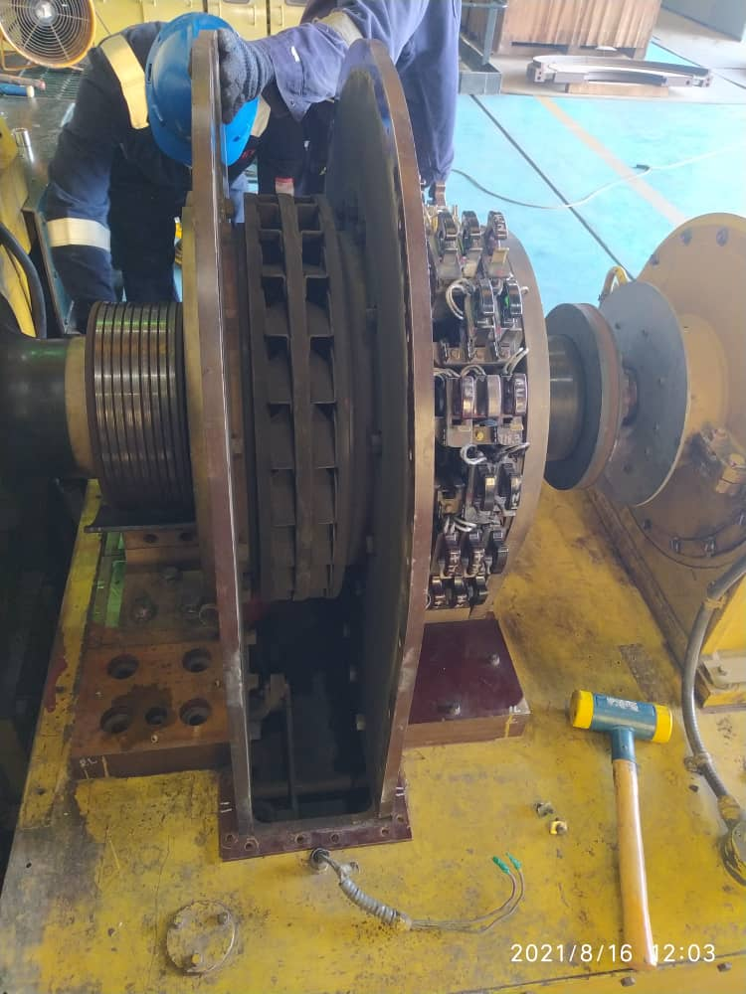

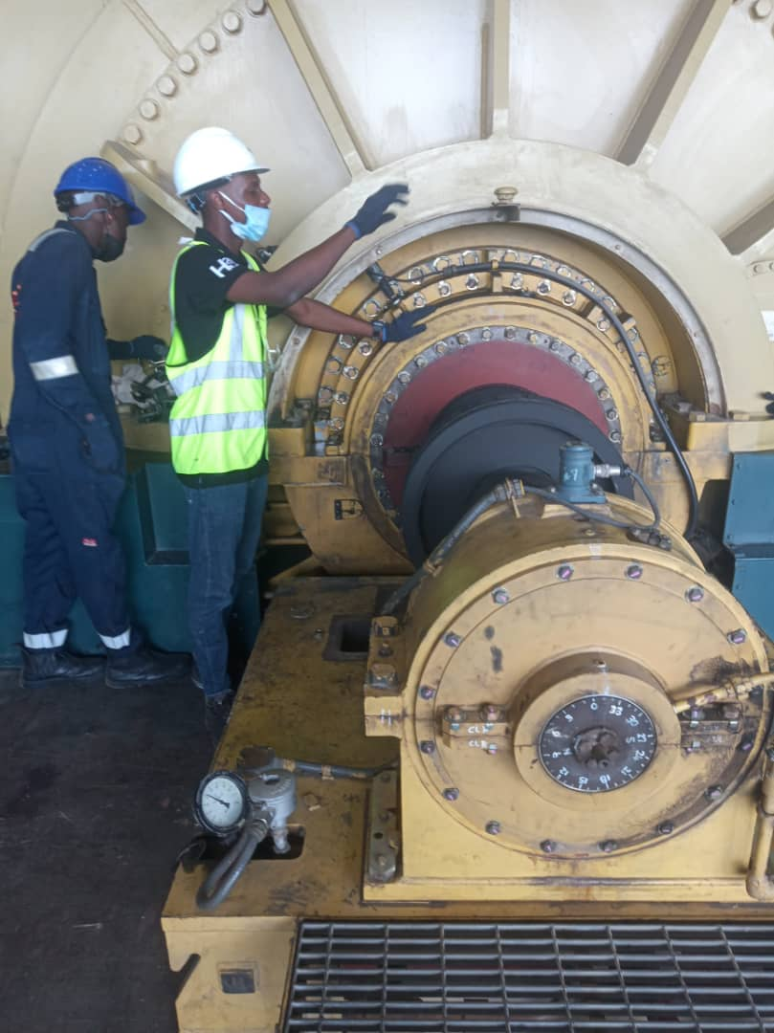

### MECHANICAL DEPARTMENT

The mechanical maintenance section of Egbin is responsible for the maintenance of the turbine and its auxiliaries, and the boiler and its auxiliaries. They ensure the optimal condition of machineries and continuous generation of power. This section is consistent with its preventive maintenance culture and still when the need arises respond to defect (i.e., corrective maintenance) on both rotating and static components of the plant. This department ensures the maintenance of the mechanical hardware of each unit of the plant which includes; the turbine, shaft sealing system, boiler, pumps, valves, common service equipment etc.

Some of the major works I did in the mechanical maintenance section are highlighted below

#### 4.3.2.1 High pressure heater 5 tube leakage repair work in unit 5

Some of the tubes that constitute the tube bundle of the high-pressure heater were discovered to be leaking. Hence, the leaking tubes had to be blocked with machined plugs, grinded and welded. The tools used in carrying out this job are steel plugs, propeller, soap solution, hand grinding machine, welding machine and spanner.

The procedure followed in carrying out this task is listed below:

1. The unit was shut down and the heater allowed to cool down.
2. The manhole of the pressure heater 5 was opened to allow for further cooling and all inlet, outlet, by-pass and extraction steam line were isolated by closing all their motorized valves.
3. Soap bubble method was used in identifying the leaking tubes and the tubes marked for plugging.
4. The surfaces of the tubes to be plugged were grinded and the tubes blocked by using steel plugs tapered to different diameters in the workshop.
5. The surfaces of the tubes blocked were further welded to ensure it is leak-proofed.
6. The plugged and welded tubes were further tested for leakages by placing soap solution on all the tubes and injecting compressed air into the shell of the heater.
7. After it had been verified that all tubes were leak proof the outlet manhole was covered as well as the heater manhole.
8. All the lines isolated were opened and the unit was fired and the heater put back into service.

#### 4.3.2.2 Repair of ARC (Automatic Recirculation Control) valve A and C of unit 3.

Arc valve A was passing recirculated water through the minimum flow line while Arc valve C was leaking water due to faulty gasket. The following tools were used in the repair of the valve; chain block, hammer, sandpaper, wire string, monkey jack, and trolley.

Enumerated below are the procedures followed in completing the task.

1. The section line as well as the discharge line of boiler feed pump A and C were isolated using valves. This was done so as to prevent the flow of water downstream from the pump and upstream from the common header connection of all three Arc valves
2. The insulating/lagging materials were removed from the body of the valve.
3. The minimum flow line of both arc valve A and C were opened and their components which includes control head, bushing, bypass orifice and camshaft were removed and cleaned thoroughly.
4. All the bolts and studs used in connecting the arc valves to the minimum flow line were removed.
5. A chain block and monkey jack were used in the removal of the arc valve C from the main flow line and unto a trolley which was used to carry it to the mechanical workshop for filling with metal as well as lapping.
6. The gasket of arc valve A was replaced and the components of the minimum flow line were assembled properly and installed on the discharge line of the boiler feed pump A.
7. Arc valve C was returned and installed on the discharge line of boiler feed pump C.
8. The isolation valve was opened and the Arc valves were tested

#### 4.3.2.3 Repair of a faulty unit of oil purifier of unit 1

The oil purifier motor was not engaging with the purifiers bowl spindle and gear pump. It was discovered that the brake pad and spindle bearing were bad. In carrying out this task, the tools used are listed as follows; Hammer, screwdriver, sandpaper and extractor.

The procedures followed in carrying out the job are stated below:

The purifier oil supply line was isolated and its motor removed.

1. The worn wheel, worn shaft, and gear pump were removed exposing the bad bearing and brake pad.
2. All the components removed were cleaned properly using sandpaper and checked for defects.
3. A new bearing was installed on the worn shaft and the brake pad was installed properly.
4. The oil purifier was coupled back with its electric motor and tested to ensure proper operation.

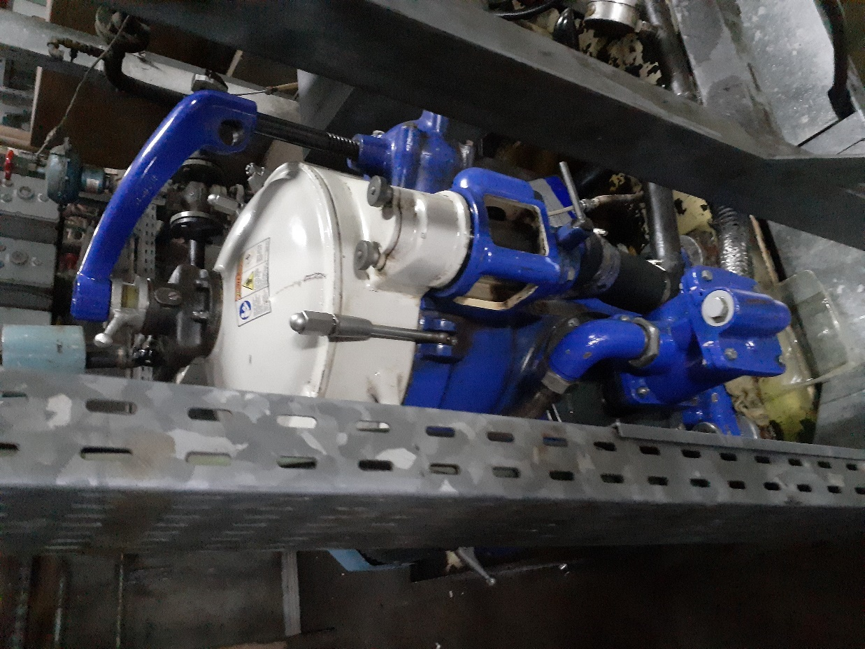

### INSTRMENTATION AND CONTROL (I & C) DEPARTMENT

The instrumentation role played by the I&C Crew is to ensure that the values of some system parameters, pressure, flow, level or temperature, to mention a few, are measured and that signals, proportional to the measured parameters, are supplied in order to stabilize the system’s working condition or increase its level of performance. The output signals are standard signals that can be processed by other equipment to provide indications, alarms or automatic controls. There are a number of standard signals; however, those used in EGBIN Power Plant are the 4-20mA, 1-5V electronic signals and the 20-100kPa pneumatic signals.

The highlight of some of the major work done during my time in this department are discussed below:

#### 4.3.3.1 REHEAT SPRAY CONTROL VALVE

Reheat spray control valve is an important accessory in Egbin Power Plc which help to regulate the temperature of the reheater.

The reheat spray flow control valve had a ruptured diaphragm. The flow control valve is an air to open valve, so the air leakage on the diaphragm made the valve return to a safe position which is fully close position. A new control valve had to be installed.

Issues faced when using the former control valve: air leakage, the control valve on fully close position and unable to control the temperature of the reheater. The following action were executed to fix the problem:

* Work permit (OF11) was collected
* The Accessories on the control valve were replaced with new ones (i.e. the positioner and Air filter regulator) and new piping modification was constructed.
* Supply air pressure set at 340Kpa.
* Calibration of the control valve
* Loop check was carried out on the control valve

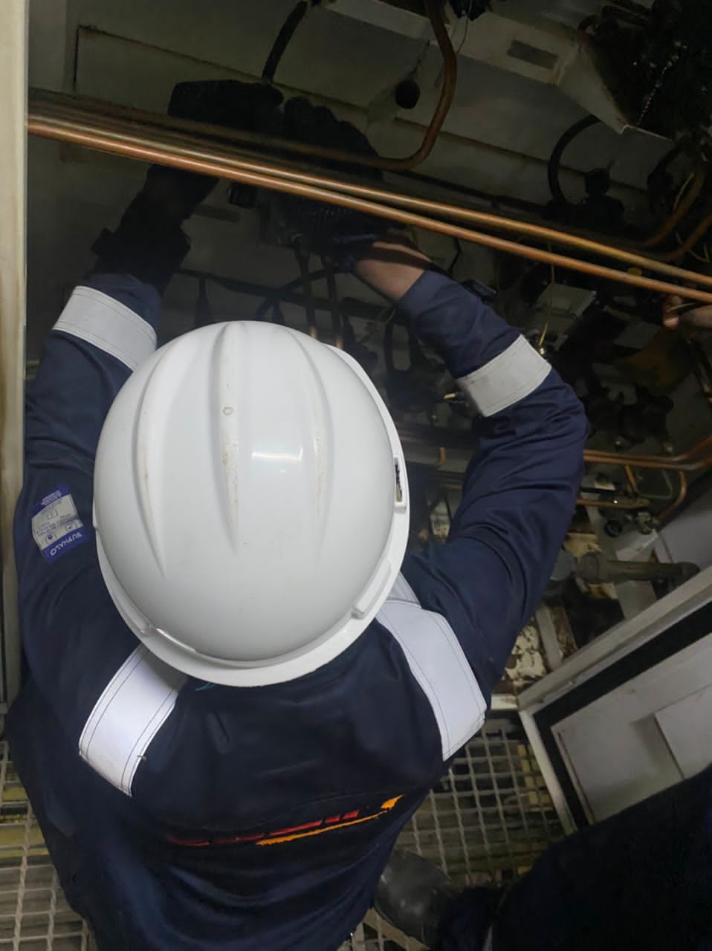

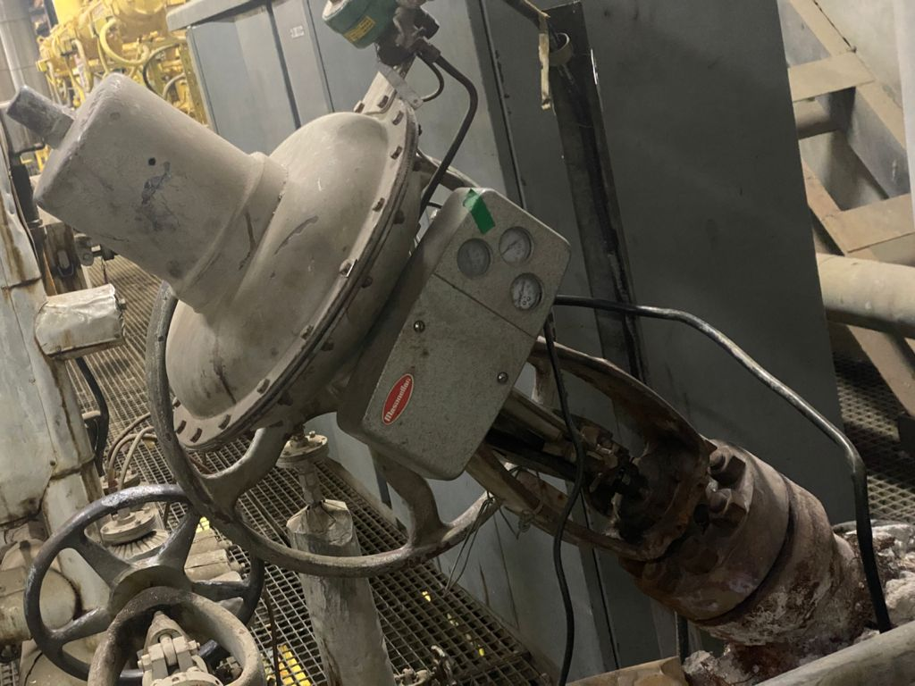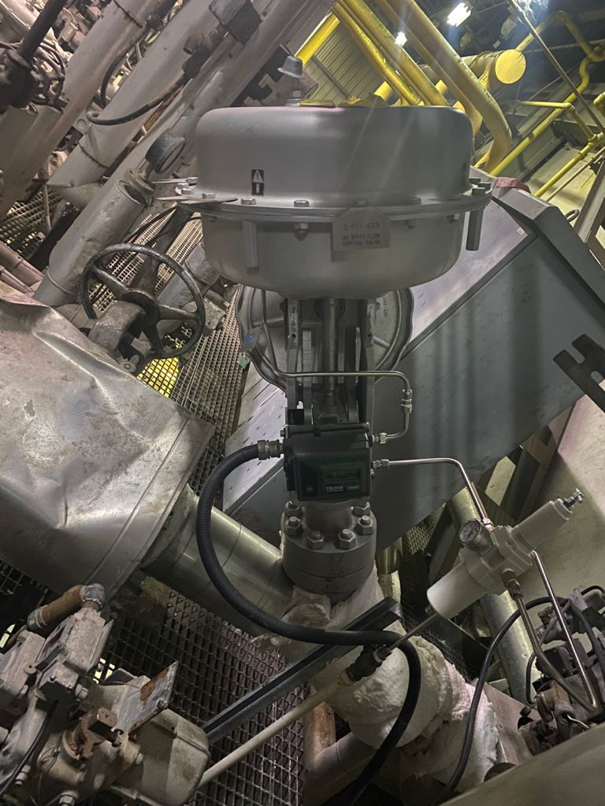

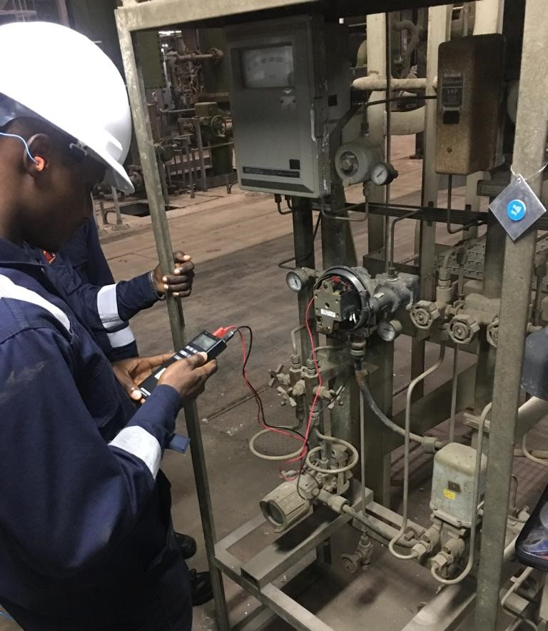

#### 4.3.3.2 REPLACEMENT OF PNEUMATIC ACTUATOR GAS VALVE

I worked with the instrumentation and control engineer team to replace a pneumatic actuator (5-FCV-105), we replaced the gas valve and installed its auxiliaries (positioner, air filter, booster relay, air regulator and lock up valve). I was given the opportunity to calibrate it using a mA calibrator of 4 – 20 mA. The Pneumatic actuators generate operating energy through the efficient use of compressed **air**. The instrument air builds up force or pressure which applies against the diaphragm or piston. This then moves the valve actuator to position on the valve stem and the result is mechanical motion.

#### 4.3.3.3 RECALIBRATION OF ELECTRO-PNEUMATIC TRANSDUCER OF DEAERATOR LEVEL CONTROL VALVE

The deaerator level control valve (LCV-1059) of unit 2 was not completely closing fully on stroking the valve remotely from the control room and even locally. On troubleshooting the deaerator level control valve shown in Fig. , it was discovered that the electro-pneumatic transducer needed to be recalibrated. The electro-pneumatic transducer converts a current or voltage input into proportional output pressure. The following tools were used in the recalibration of the electro-pneumatic transducer: mA calibrator 4-20 (mA), ammeter, pressure gauge.

**CALIBRATION DATA OF THE FLOW CONTROL VALVE FCV-639**

|  |  |  |  |
| --- | --- | --- | --- |
| STANDARD | | CALIBRATION | |
| Input(mA) | Stroke (%) | UP (%) | DOWN (%) |
| 4 | 0 | 0 | 0 |
| 8 | 25 | 25 | 25 |
| 12 | 50 | 50 | 50 |
| 16 | 75 | 75 | 75 |
| 20 | 100 | 100 | 100 |

### MECHANICAL WORKSHOP MAINTENANCE DEPARTMENT

This department is in charge of the fabrication, repair and production of components needed in the plant. It is divided into three (3) sections; components repair, machining and welding section.

Components repair: This is a section of the mechanical workshop where decoupling and disassembling of parts of equipment in the plant takes place.

Machining section: This section deals with the fabrication of parts. Machines in this section include the; lathe machine, milling machine, drilling machine

Welding section: Welding section is saddled with the responsibility of carrying out fabrication work in the department. The work carried out in the section cut across modification of existing machine parts, fixing of leakage in pipes, and fabrication of new components.

The highlights of the activities carried out in the mechanical workshop departments are stated as follows:

#### 4.3.4.1 Work done: Fabrication of roof cover for newly acquired forklift

Equipment: A forklift is an industrial vehicle with a power-operated fork-like pronged platform that can be raised and lowered for insertion under a load, often on pallets, to be lifted and moved.

Aim: To fabricate a roof cover for the forklift to protect the steering wheel and operator seat.

Type of maintenance: Preventive maintenance

Tool: Grinding machine, mallet, electric arc welding machine, radial arm drilling machine, center punch, tape rule, hand drilling machine

Procedure:

* Measurements of the forklift overhead guard was taken.
* The measurements taken are marked out on the galvanized metal plate.
* An addition of about 15cm was added to each side and then marked out on a galvanized metal plate.
* The metal plate was cut out according to the added size and then divided in two halves along its length.
* A grinding machine with a cutting disc was used to cut the edges diagonally to the point of the measured overhead guard.
* The sides were malleted to the 15cm point to give slightly curved ends.
* The two halves were placed on the overhead guard, joined together and elevated along the joining with a suitable hollow square bar. Four points were then marked out on the metal plate and overhead guard with a center punch.
* Next the overhead guard was bored at the marked out points with a hand drilling machine and taped. Also the metal plates were taken down, and using a radial arm drilling machine were bored at the marked out points as well.
* The metal plates were then placed back on the overhead guard and hollow square bar, and bolts were screwed into the bored holes to hold the metal plate to the overhead guard.
* The metal plates were then welded together while the hollow square bar was being removed.
* The welded surface was then smoothened by using a grinding machine to remove the flux of the electrode, leaving behind only the filler metal.
* Finally, rectangular sections were cut off from the metal plate to allow water drain into the channel provided for it on the overhead guard of the forklift in the event of rain.

Precaution

* Ensured the use of a welding face shield and welding gloves.
* Ensured the grinding machine was always turned off from the socket when not in use

#### 4.3.4.2 Machining of a brass hex nipple.

A brass hex nipple is a short piece of brass pipe with hexagonal shape that is threaded on both side and are usually used to connect pipes to a valve, instrument or another pipe. The aim of this job is the machining of a brass hex nipple front to a brass hexagonal solid pipe. The tools used in carrying out the jobs were; Lathe machine, tap.

Procedure

* The power supply circuit breaker for the lathe machine was switched to an on position.
* The work piece, that is, a brass hexagonal solid pipe was tighten to the chuck of a lathe machine.
* The required length of the nipple was marked out.
* A cutting tool was then attached to the tool post of the lathe machine.
* The motor start button was turned on, and the spindle clutch lever engaged to start the rotation of the spindle.
* The carriage hand wheel was used to position the cutting tool a point slightly longer than the required length and the cross feed hand wheel was then used to adjust the cutting tool so as to cut the work piece.
* The work piece cut out was fastened to the chuck and changing tool on the tool post, a facing operation was done on both ends of the work piece to bring it to the exact length needed. After facing, chamfers were added to both ends of the work piece.
* A drilling bit was then attached to the tailstock and used to drill a hole through the work piece.
* The work piece was then clamped to a bench vice, and using a set on increasing taps, the required internal threading were made.

Precautions

* Ensure to turn off the lathe machine when not in use and always put on your safe goggles while carry any operation on the lathe machine.

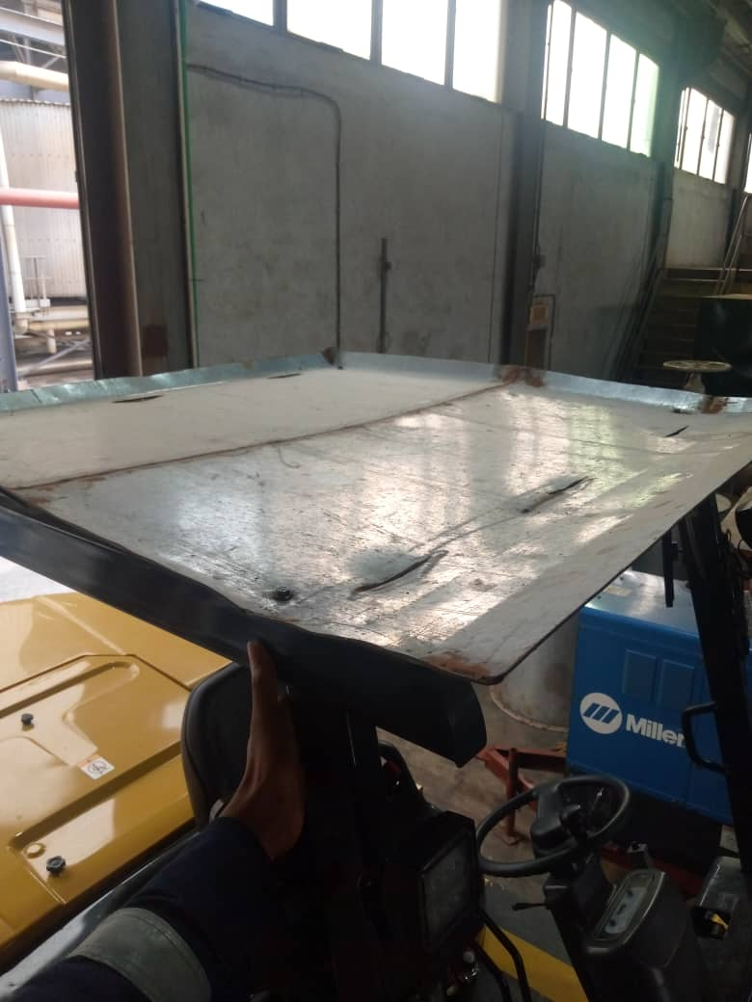

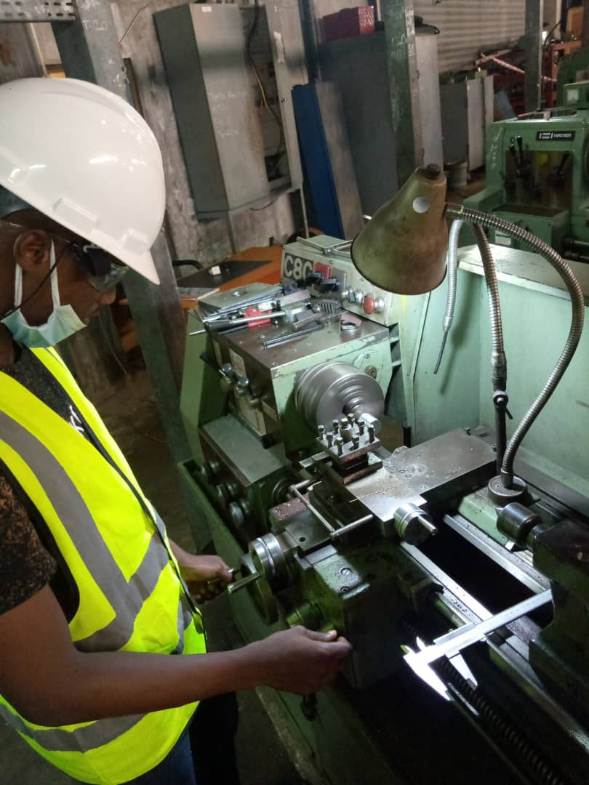

# CHAPTER FIVE

# SUMMARY, CONCLUSION AND RECOMMENDATION

## 5.1 SUMMARY OF WORK DONE

I was able to optimize the opportunity given to me by my school and Egbin Power Plc. to learn the way engineering is being practiced in reality. In the course of the training, I was also able to acquire technical skills as regards general engineering and that peculiar to the power station, soft skills which includes being able to speak and make presentation to a large number of people and some basic software as well. I was also able to build inter-relational skills with the other interns and the staffs of the company.

Due to the level of risk inherent to the job being done in the plant, it is not negotiable to learn about how one can keep one’s self safe and one’s environment. This therefore gave rise to the first Department that I visited which was the Department of Health, Safety and Environment. Here in this department, I underwent series of lectures and practical classes, for days, which were taken by experts in the field. At the end of it, there was an assessment based on information and knowledge passed on to me.

Going forward, I marched to the next Department which was the Department of Electrical. Here in this department, I learnt a lot about the electrical aspect of the power plant; from the operations of the alternators and its excitation system, to the operations and care of the breakers used, transformers, lighting system, and interpretation of electrical/wiring diagrams. I was also able to master, to a great extent, the use of some electrical instruments and ultimately, I was able to satisfy most of my curiosity with regard to my course of study.

The last four months of the internship was spent in the Department of Instrumentation and Control, Mechanical workshop and Mechanical department which was of course the last department visited. I was exposed to a lot more of things going on in the thermal power plant., I learnt more about the Distributed Control System (DCS), operation of various control instrument such as damper, recorder, mA calibrator, thermal imaging camera, infrared thermometer, clamp ammeter, etc. I gained basic knowledge on the use of Process Flow Diagrams (PFD), Piping and Instrumentation Drawing (P&ID) in analyzing and troubleshooting faults. I participated in the calibration of positioners and EP transducers, routine checks and maintenance on different equipment.

## 5.2 RELEVANCE OF EXPERIENCE TO COURSE OF STUDY

I was exposed to a lot of modern industrial technology which had the application of Electrical and Electronic Engineering theories as its underlying principles. Some of the courses that I came across during my internship experience are:

**CHE 201 – Thermodynamics:** The Thermal Power Plant made me appreciate the relevance of this course, it was an indisputable tool to understanding the plant as a system. I discovered early enough that the plant operates a modified Rankine cycle, modified because of the addition of reheating and segmenting the turbine into three sections for increased thermal efficiency. I appreciated the second law of thermodynamics and the gas laws.

**EEE 203 – Fundamental of Electrical Engineering I, EEG 204: Fundamental of Electrical Engineering II:**  This course made me understand circuit parameters, fundamental theory of electric circuit element and network theorems which I have been able to apply in the electrical department at Egbin thermal plant.

**EEE 310: Measurement and Instrumentation:** This course deals with measuring techniques, types of errors, system units and measurement conversion, general instrumentation etc. This course introduced the different types of measuring instruments and their principle of operation, absolute and relative errors. I was able to apply this measuring techniques in the plant and was also able to use different measuring devices both in Instrumentation and Control department and Electrical department for routine checks and calibrations.

**EEE 303 and 304 – Electromechanical Devices and Electrical Machines:** Part of the course deals with thermal power plants equipment such as alternators, induction machines, synchronous machine, transformers etc. I was able to obtain a good grasp of the underlying working principle for these electrical devices, how synchronization to the grid works and the operation of exciter circuit in an electrical generator.

**EEE 407 – Introduction to Control engineering I**: This course deals with understanding process control devices, elements, block diagrams, signal flow graph, closed and open loop control system etc. I was able to see how different process variables were measured and controlled, the diaphragms, the protective devices etc., I also obtained a first-hand experience into pneumatic control system and electronic control systems for various process variables. I appreciated the relevance of closed loop control and how actuation and control actions are taken to the field devices.

**EEE 403 - Electric Power Principle:** This course covers introduction to power system and sources of electric energy structure of electric power system load characteristics, electric power transmission and distribution, representation and per unit systems, transmitted power and losses, power system equipment, etc. This has helped me understand how the thermal plant works and how electricity is been generated, transmitted and distributed to the end – users.

## 5.3 CONCLUSION

In conclusion, I consider myself very privileged not only to have been a part of this insightful training but also to have been attached with Egbin Power Plc. and strongly believe that the knowledge and skills acquired from both the HSE and maintenance departments will be very instrumental in my career, especially in the power industry. The experiences I was exposed to was a great deal that I would not have ordinarily gotten them from anywhere else because I had an added advantage of interacting with and questioning professional engineers, well vast in their various fields, and they always gave satisfactorily answers without any ado.

Summarily, this experience has helped bridge the gap between theoretical knowledge and the practical applications which I lacked prior to my coming for the SIWES program.

## 5.4 RECOMMENDATION

I believe that I was able to get the best from SIWES II but then, I will like to make some recommendations which could improve the quality of the training.

**For students going on SIWES II.**, they should look forward to the SIWES as an avenue to consolidate on the theoretical knowledge already acquired in the classrooms. The program shouldn’t be taken with little or no seriousness as it could, most likely will, be a turning point in the career and even be a foundation to something very big to their lives and career.

Furthermore, the students should not be oblivious of the fact that whatever that is worth doing at all is worth doing well; the students should not convert the Industrial training to a period whereby they just want to make money. The learning process should be considered first before any other thing. However, it is only a student who has acquired enough knowledge, experience and information about his course that can thrive and get a good job and be useful to the society too.

**For the University**, I would propose that the university management and the department of Electrical/Electronic Engineering make it a norm for her students to undergo SIWES at least twice before they complete their five years in the university. I will also suggest that the school create a mutual relationship with a number of industries to accept more of her students for I.T. placements with accommodation, transportation and monetary support. I also would propose more frequent impromptu visit of the school supervisors so as to ensure that students are able to fully comprehend the theoretical work done in school, knowing fully well that the hunt for getting a placement for some people takes up to a month or more which shouldn’t be so. Hence, I implore the university to create strong ties with neighboring industries.