**EXPERIMENT 5**

Create a telegraph that will use SPI and create two different sounds for a dot and dash

*Description:* Two Arduinos (atmega328p) are used to communicate with each other through SPI. A master Arduino is set up to send bytes that represents whether to trigger a dot or dash sound. The other Arduino, a slave is set up to receive the byte and either trigger a dot sound or a dash sound.

**Master Main:  
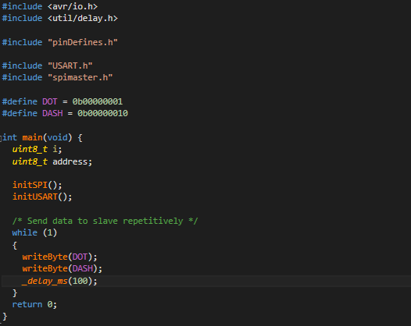**

**Master spimaster.h (used to send data to slave)**

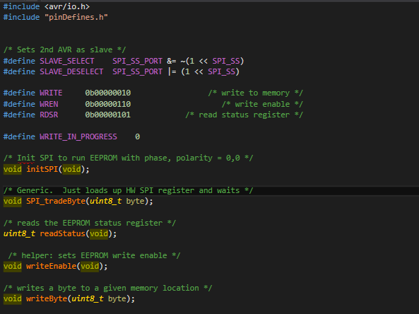

**Master spimaster.c (used to send data to slave)**

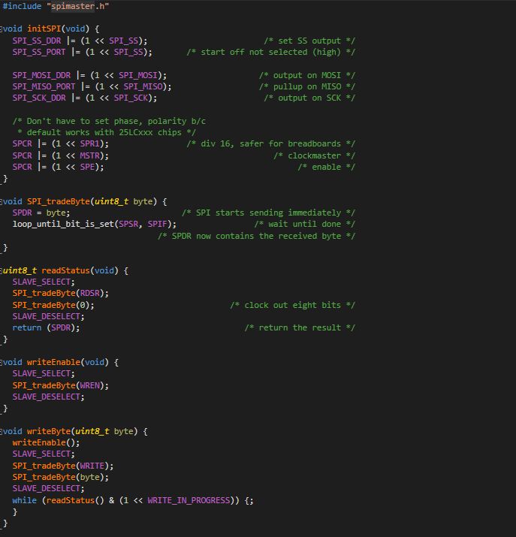

**Slave Main:**

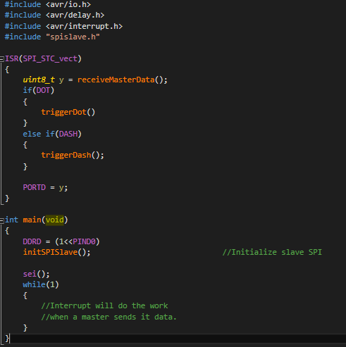

**Slave spislave.h (used to get data from master and make sounds)**

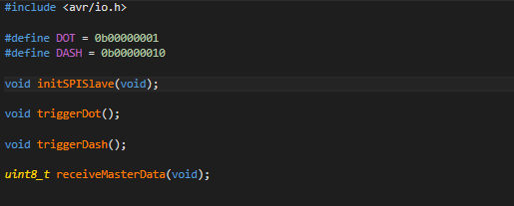

**Slave spislave.c (used to get data from master and make sounds)**

