Predicting U.S. IPO Underpricing
Leak-free expanding-window machine-learning study with SHAP explanations,
descriptive analysis and a validation-flaw ablation
Sample: 850 IPOs, 02 Feb 2010 – 19 Aug 2026
Report generated 19 October 2026 by predict_underpricing.py
Run configuration: full settings; seed 42

Contents
1 Executive summary
2 Data and descriptive analysis (training rows of one fold only)
3 Methodology: the full modelling process
4 Predictive results
5 Statistical confirmation
6 Data-leakage diagnostics
7 Explainability: SHAP values in probability units
8 Methodology comparison: our design versus common validation flaws
9 Limitations and interpretation
Appendix A Tuned hyper-parameters | Appendix B Output files

1 Executive summary
This report documents a leak-free evaluation of how well pre-IPO information predicts whether a U.S. IPO is underpriced (target = 1). The sample has 850 IPOs, of which 61.4% are underpriced. Models are trained on an expanding chronological window and tested on each calendar year from 2016 to 2026, giving 613 pooled out-of-sample predictions per model. All numbers below come from that run.
- Predictive power. Random Forest is the best model on all eight pillars combined, with a pooled out-of-sample AUC of 0.614 (95% bootstrap CI 0.567–0.660; label-permutation p = <0.001); accuracy 0.623 and balanced accuracy 0.576 at a 0.5 threshold. An AUC of 0.5 is chance.
- Time-only control: a model that only knows the calendar date (ipo_year) reaches AUC 0.551, compared with 0.614 for the same model using all pillars; the gap shows how much of the result goes beyond the passage of time.
- Pillars: for Random Forest the most informative single pillar is “7. Offer structure” (AUC 0.577) and the least informative is “4. Market conditions and sentiment” (AUC 0.508).
- Explainability: the three features with the largest mean absolute SHAP value (probability units) are log_prospectus_words (3.95 pp), log_offer_price (2.87 pp), yield_curve_spread (2.53 pp) for Random Forest. SHAP describes what the model relies on, not causation.
- Leakage: temporal-integrity checks all passed; refitting on shuffled training labels gave AUC 0.497 on average across models (honest pipelines return ≈0.5).
- Design comparison: holding data, features and models fixed, random 5-fold CV changes the mean AUC by +0.032, random CV with global preprocessing +0.030, and random CV with global preprocessing plus SMOTE before the split +0.084 relative to our design (S0), on identical real IPOs. See Section 8 for confidence intervals.
- Descriptive pattern: in the training rows of fold 2026 the underpricing rate ranges from 36% (2023) to 78% (2016) across years with at least 10 IPOs.
Take-away: a result is only as credible as the design that produced it. The AUC reported here is the one obtained under the strictest design; Section 8 quantifies how much weaker designs would have overstated it.

2 Data and descriptive analysis (training rows of one fold only)
To prevent data leakage, every descriptive statistic in this section is computed on the TRAINING rows of the last fold (test year 2026) only: 796 IPOs dated 02 Feb 2010 to 17 Dec 2025. No IPO from the test years is used, so nothing learnt here can influence model evaluation. The overall underpricing rate in these rows is 61.9%. Continuous features are shown after the fold's own training-fitted imputation and winsorization (the values the models actually saw); categorical groupings come from the raw workbook. The workbook records only the binary outcome (no first-day return), so the analysis is of the frequency, not the magnitude, of underpricing. Associations are descriptive, uncorrected for multiple testing and not causal.

2.1 Underpricing by IPO year
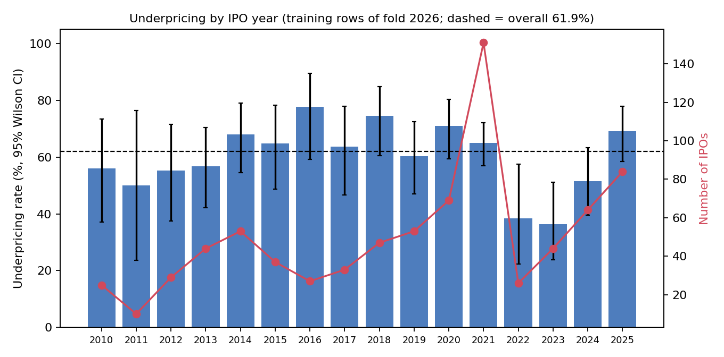
Figure 1. Underpricing rate and number of IPOs by year (training rows).
Table 1. Underpricing by year (training rows)
year | n | n underpriced | underpricing rate pct | ci low pct | ci high pct
2010 | 25 | 14 | 56.000 | 37.067 | 73.335
2011 | 10 | 5 | 50.000 | 23.659 | 76.341
2012 | 29 | 16 | 55.172 | 37.548 | 71.587
2013 | 44 | 25 | 56.818 | 42.224 | 70.317
2014 | 53 | 36 | 67.925 | 54.518 | 78.908
2015 | 37 | 24 | 64.865 | 48.759 | 78.175
2016 | 27 | 21 | 77.778 | 59.243 | 89.393
2017 | 33 | 21 | 63.636 | 46.616 | 77.813
2018 | 47 | 35 | 74.468 | 60.492 | 84.747
2019 | 53 | 32 | 60.377 | 46.941 | 72.411
2020 | 69 | 49 | 71.014 | 59.428 | 80.384
2021 | 151 | 98 | 64.901 | 57.004 | 72.058
2022 | 26 | 10 | 38.462 | 22.428 | 57.465
2023 | 44 | 16 | 36.364 | 23.783 | 51.134
2024 | 64 | 33 | 51.562 | 39.581 | 63.367
2025 | 84 | 58 | 69.048 | 58.511 | 77.918

2.2 Underpricing by sector and industry
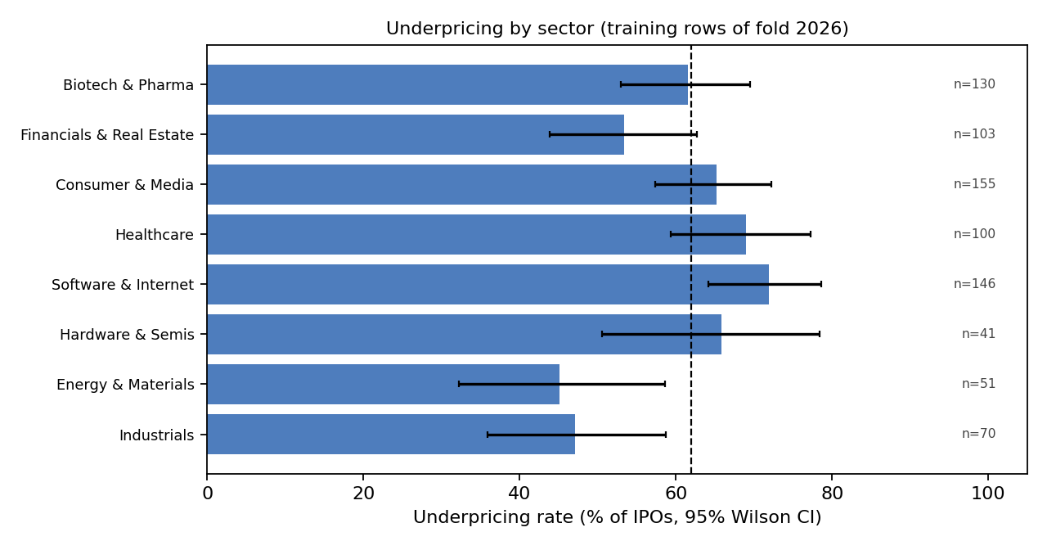
Figure 2. Underpricing rate by sector group (sector mapping defined in Section 3.2).
Table 2. Underpricing by sector
sector | n | n underpriced | underpricing rate pct | ci low pct | ci high pct
Biotech & Pharma | 130 | 80 | 61.538 | 52.958 | 69.456
Financials & Real Estate | 103 | 55 | 53.398 | 43.816 | 62.736
Consumer & Media | 155 | 101 | 65.161 | 57.376 | 72.213
Healthcare | 100 | 69 | 69.000 | 59.374 | 77.220
Software & Internet | 146 | 105 | 71.918 | 64.138 | 78.574
Hardware & Semis | 41 | 27 | 65.854 | 50.550 | 78.441
Energy & Materials | 51 | 23 | 45.098 | 32.267 | 58.616
Industrials | 70 | 33 | 47.143 | 35.905 | 58.678

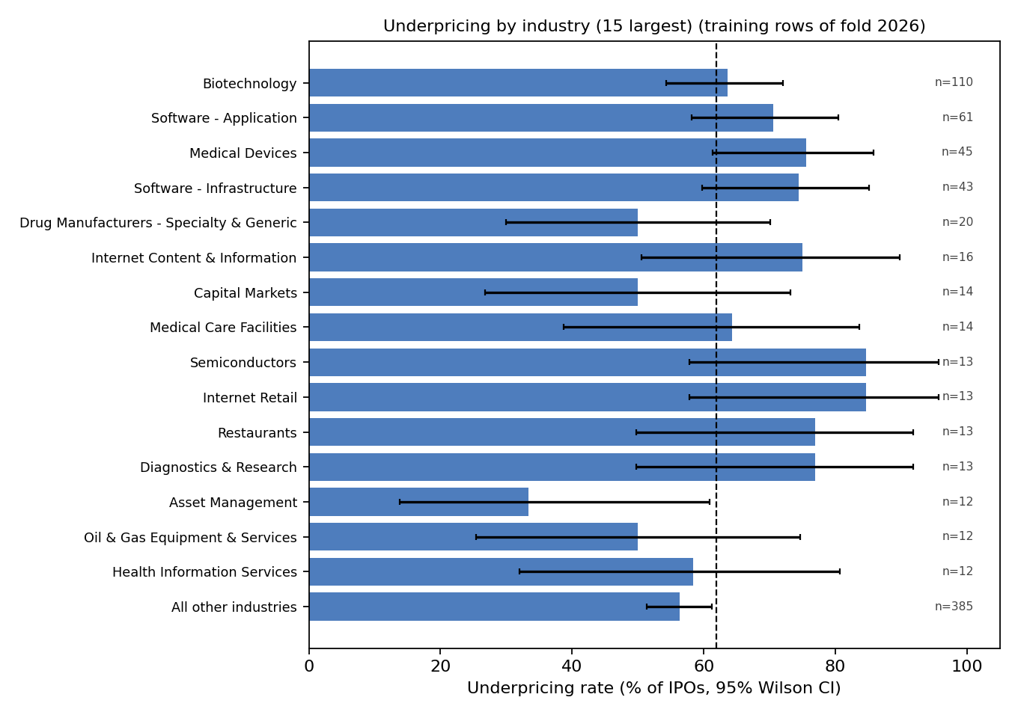
Figure 3. Underpricing rate for the 15 largest raw industries.
Table 3. Underpricing by industry (15 largest)
industry | n | n underpriced | underpricing rate pct | ci low pct | ci high pct
Biotechnology | 110 | 70 | 63.636 | 54.327 | 72.025
Software - Application | 61 | 43 | 70.492 | 58.110 | 80.445
Medical Devices | 45 | 34 | 75.556 | 61.326 | 85.765
Software - Infrastructure | 43 | 32 | 74.419 | 59.761 | 85.071
Drug Manufacturers - Specialty & Generic | 20 | 10 | 50.000 | 29.929 | 70.071
Internet Content & Information | 16 | 12 | 75.000 | 50.501 | 89.818
Capital Markets | 14 | 7 | 50.000 | 26.799 | 73.201
Medical Care Facilities | 14 | 9 | 64.286 | 38.764 | 83.656
Semiconductors | 13 | 11 | 84.615 | 57.765 | 95.674
Internet Retail | 13 | 11 | 84.615 | 57.765 | 95.674
Restaurants | 13 | 10 | 76.923 | 49.743 | 91.821
Diagnostics & Research | 13 | 10 | 76.923 | 49.743 | 91.821
Asset Management | 12 | 4 | 33.333 | 13.812 | 60.938
Oil & Gas Equipment & Services | 12 | 6 | 50.000 | 25.378 | 74.622
Health Information Services | 12 | 7 | 58.333 | 31.951 | 80.674
All other industries | 385 | 217 | 56.364 | 51.371 | 61.231

2.3 Underpricing by underwriter quality, exchange and governance
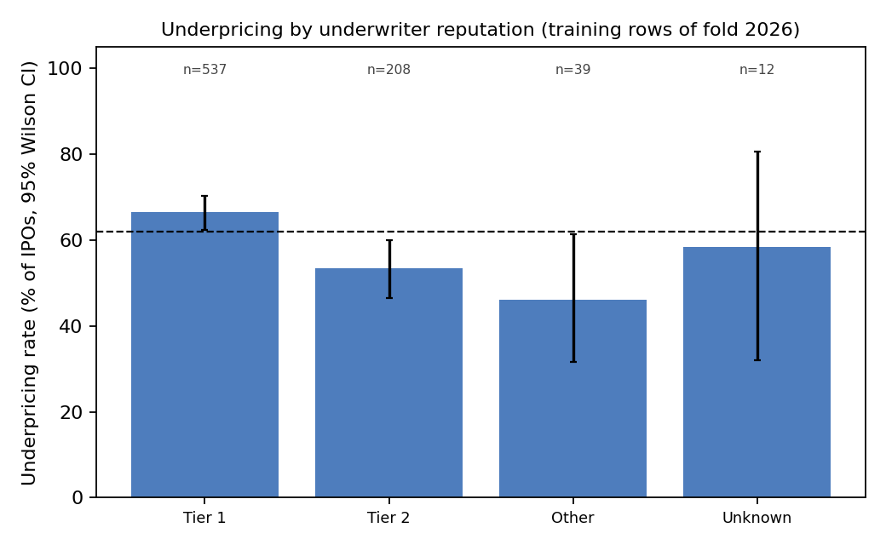
Figure 4. Underpricing by underwriter reputation tier.
Table 4. Underpricing by underwriter reputation
underwriter tier | n | n underpriced | underpricing rate pct | ci low pct | ci high pct
Tier 1 | 537 | 357 | 66.480 | 62.383 | 70.344
Tier 2 | 208 | 111 | 53.365 | 46.586 | 60.023
Other | 39 | 18 | 46.154 | 31.567 | 61.431
Unknown | 12 | 7 | 58.333 | 31.951 | 80.674

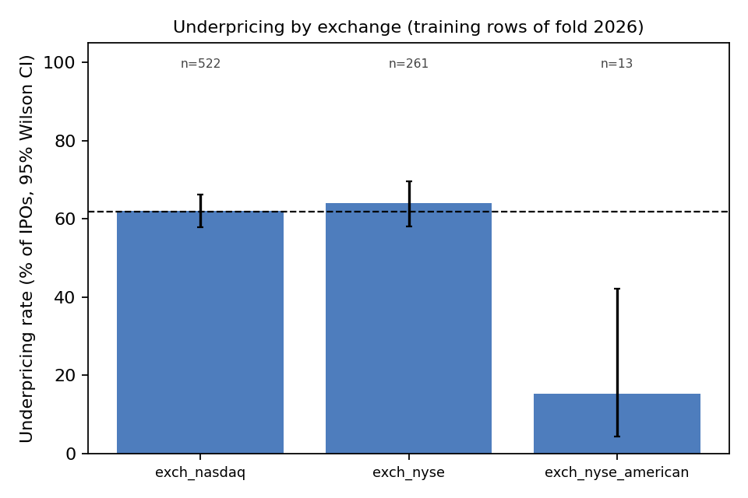
Figure 5. Underpricing by listing exchange.
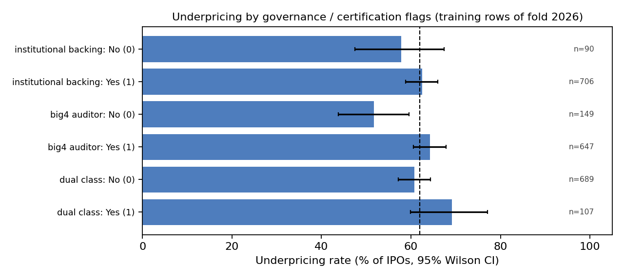
Figure 6. Underpricing by institutional backing, Big-4 auditor and dual-class structure.
Table 5. Binary certification / governance flags
feature | share equal 1 pct | rate if 1 pct | rate if 0 pct | chi2 p
institutional_backing | 88.693 | 62.465 | 57.778 | 0.455
big4_auditor | 81.281 | 64.297 | 51.678 | 0.006
dual_class | 13.442 | 69.159 | 60.813 | 0.122

Table 6. Chi-square tests of independence between each grouping and the outcome
breakdown | n groups | chi2 p value | min expected count
ipo_year | 16 | 0.002 | 3.807
sector | 8 | <0.001 | 15.607
industry (top 15 by n) | 16 | 0.013 | 4.568
underwriter_reputation | 4 | 0.002 | 4.568
Exchange | 3 | 0.002 | 4.948
institutional_backing | 2 | 0.455 | 34.259
big4_auditor | 2 | 0.006 | 56.717
dual_class | 2 | 0.122 | 40.730
Small p-values indicate that the underpricing rate differs across groups in the training sample; groups with small counts are unreliable.

2.4 All continuous features: summary statistics
Table 7. Summary statistics of continuous features (training rows, after train-fitted imputation and winsorization)
feature | n missing raw | mean | sd | min | p25 | median | p75 | max | skew
firm_age | 0 | 14.800 | 11.243 | 0.000 | 6.000 | 12.000 | 19.000 | 38.500 | 1.006
Free Cash Flow Margin | 0 | -0.237 | 0.612 | -1.370 | -0.474 | 0.014 | 0.124 | 0.997 | -0.886
Earnings Quality Ratio (FCF Conversion) | 5 | 0.788 | 1.403 | -1.814 | 0.129 | 0.788 | 1.424 | 3.367 | 0.062
profit_margin | 0 | -0.236 | 0.495 | -1.173 | -0.426 | -0.010 | 0.072 | 0.611 | -0.983
Price-to-Sales (P/S) Ratio | 0 | 3.716 | 4.510 | 0.0005 | 0.351 | 1.578 | 5.386 | 12.938 | 1.184
Price-to-Earnings (P/E) | 5 | -0.058 | 0.653 | -1.294 | -0.367 | -0.027 | 0.251 | 1.177 | -0.045
us_gdp | 0 | 1.236 | 0.735 | -0.158 | 0.857 | 1.171 | 1.533 | 2.547 | 0.153
us_inflation_pct | 0 | 0.075 | 0.348 | -0.700 | -0.114 | 0.057 | 0.276 | 0.862 | 0.315
prime_rate | 0 | 1.005 | 10.813 | -25.000 | 0.000 | 0.000 | 0.000 | 50.000 | 1.151
yield_curve_spread | 0 | 0.889 | 0.855 | -0.970 | 0.290 | 0.800 | 1.462 | 2.900 | 0.183
vix | 0 | 17.814 | 4.798 | 9.870 | 13.985 | 17.015 | 20.505 | 30.285 | 0.811
nasdaq_composite | 0 | 0.022 | 0.041 | -0.074 | -0.0002 | 0.025 | 0.049 | 0.124 | -0.241
ipo_count_30d | 0 | 6.098 | 4.756 | 0.000 | 2.000 | 5.000 | 8.000 | 17.000 | 0.918
n_known_underwriters | 6 | 5.871 | 3.704 | 0.000 | 3.000 | 5.000 | 8.000 | 15.500 | 0.671
log_prospectus_words | 6 | 11.656 | 0.287 | 10.936 | 11.481 | 11.664 | 11.843 | 12.388 | -0.219
risk_word_share | 13 | 0.0012 | 0.0004 | 0.0005 | 0.0009 | 0.0011 | 0.0014 | 0.0020 | 0.898
log_offer_price | 0 | 2.680 | 0.513 | 1.639 | 2.453 | 2.773 | 2.996 | 3.810 | -0.374
log_shares_offered | 0 | 15.989 | 1.108 | 13.397 | 15.348 | 15.956 | 16.649 | 18.600 | 0.046

Table 8. Continuous features by outcome: group means / medians, Mann–Whitney test and univariate AUC
feature | pillar | mean underpriced | mean not underpriced | median underpriced | median not underpriced | mannwhitney p | univariate auc | spearman with target
firm_age | 1. Firm fundamentals | 14.636 | 15.066 | 11.000 | 12.000 | 0.900 | 0.503 | 0.0045
Free Cash Flow Margin | 1. Firm fundamentals | -0.189 | -0.316 | 0.027 | -0.034 | 0.019 | 0.549 | 0.083
Earnings Quality Ratio (FCF Conversion) | 1. Firm fundamentals | 0.781 | 0.800 | 0.785 | 0.809 | 0.740 | 0.493 | -0.012
profit_margin | 1. Firm fundamentals | -0.223 | -0.257 | -0.011 | -0.0074 | 0.655 | 0.491 | -0.016
Price-to-Sales (P/S) Ratio | 2. Valuation | 3.664 | 3.800 | 1.563 | 1.712 | 0.778 | 0.494 | -0.0100
Price-to-Earnings (P/E) | 2. Valuation | -0.074 | -0.032 | -0.027 | -0.027 | 0.622 | 0.490 | -0.018
us_gdp | 3. Macroeconomic environment | 1.227 | 1.250 | 1.163 | 1.180 | 0.665 | 0.491 | -0.015
us_inflation_pct | 3. Macroeconomic environment | 0.087 | 0.055 | 0.077 | 0.038 | 0.214 | 0.526 | 0.044
prime_rate | 3. Macroeconomic environment | 0.659 | 1.568 | 0.000 | 0.000 | 0.457 | 0.490 | -0.026
yield_curve_spread | 3. Macroeconomic environment | 0.939 | 0.807 | 0.800 | 0.800 | 0.038 | 0.544 | 0.074
vix | 4. Market conditions and sentiment | 17.871 | 17.720 | 16.830 | 17.160 | 0.933 | 0.502 | 0.0030
nasdaq_composite | 4. Market conditions and sentiment | 0.024 | 0.019 | 0.027 | 0.022 | 0.069 | 0.538 | 0.065
ipo_count_30d | 4. Market conditions and sentiment | 6.371 | 5.653 | 5.000 | 4.000 | 0.042 | 0.543 | 0.072
n_known_underwriters | 5. Certification and governance | 6.122 | 5.462 | 5.000 | 5.000 | 0.003 | 0.562 | 0.105
log_prospectus_words | 6. Disclosure and information | 11.644 | 11.676 | 11.664 | 11.664 | 0.187 | 0.472 | -0.047
risk_word_share | 6. Disclosure and information | 0.0012 | 0.0012 | 0.0011 | 0.0011 | 0.084 | 0.464 | -0.061
log_offer_price | 7. Offer structure | 2.759 | 2.552 | 2.833 | 2.639 | <0.001 | 0.619 | 0.200
log_shares_offered | 7. Offer structure | 16.081 | 15.839 | 16.004 | 15.830 | 0.012 | 0.553 | 0.089
Univariate AUC > 0.5 means higher values go with underpricing; < 0.5 the opposite.
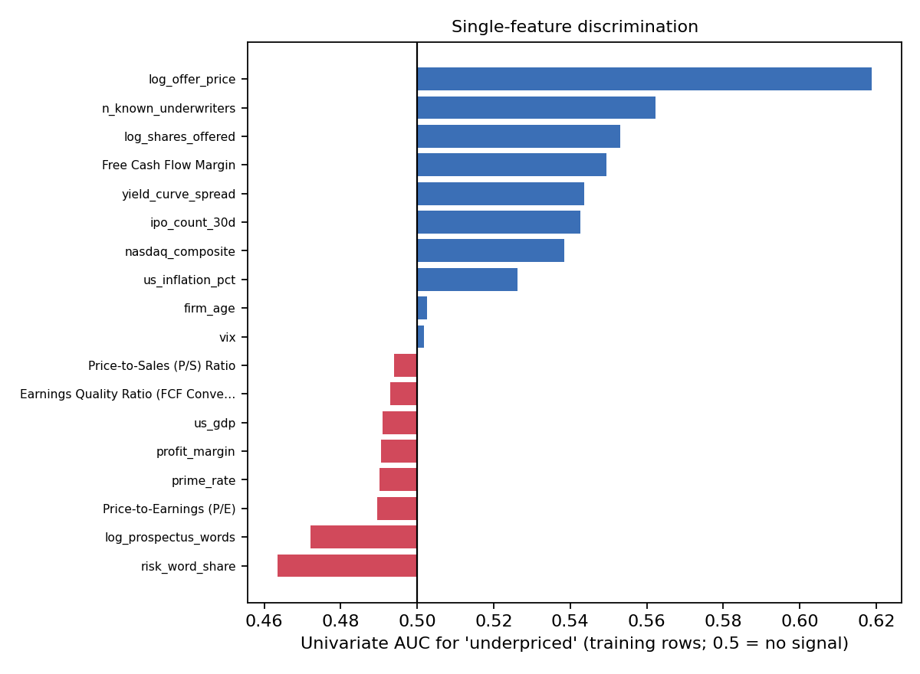
Figure 7. Univariate AUC of each continuous feature.

2.5 Underpricing across the range of every feature
Each feature is split into quintiles using training-row cut-points. Bars show the underpricing rate in each quintile (dashed = overall rate).
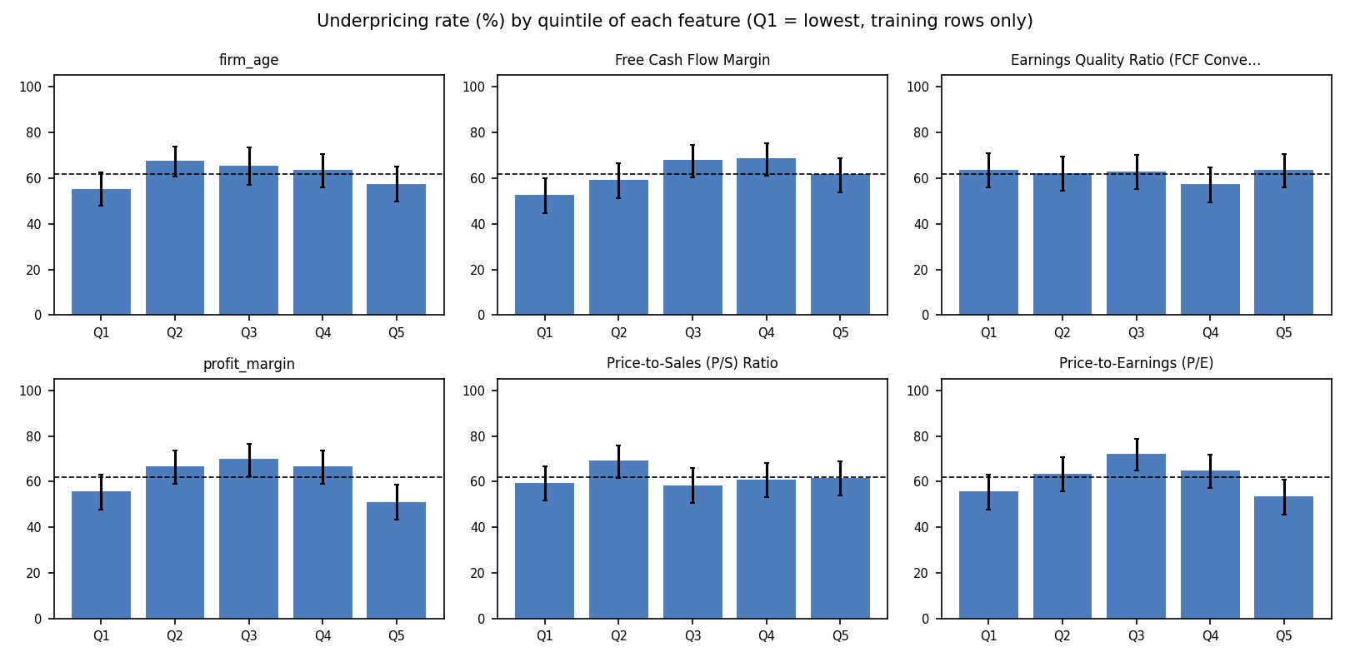
Figure 8. Underpricing rate by feature quintile (1 of 3).
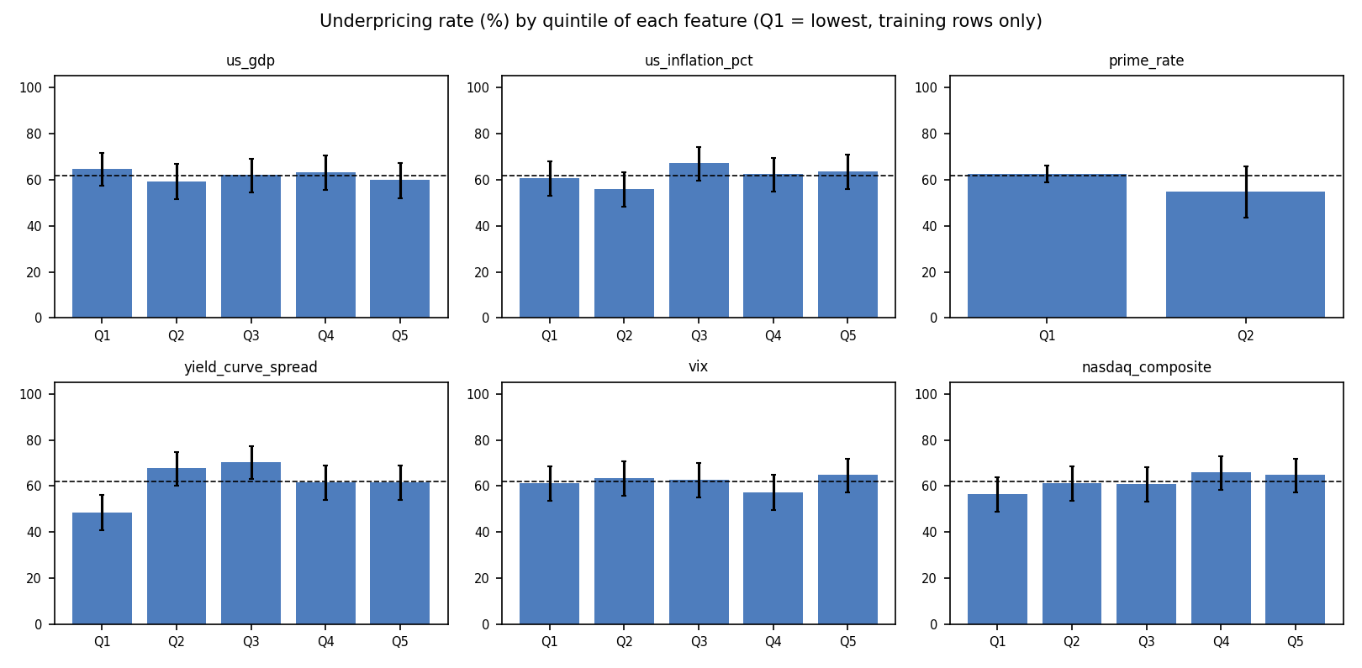
Figure 9. Underpricing rate by feature quintile (2 of 3).
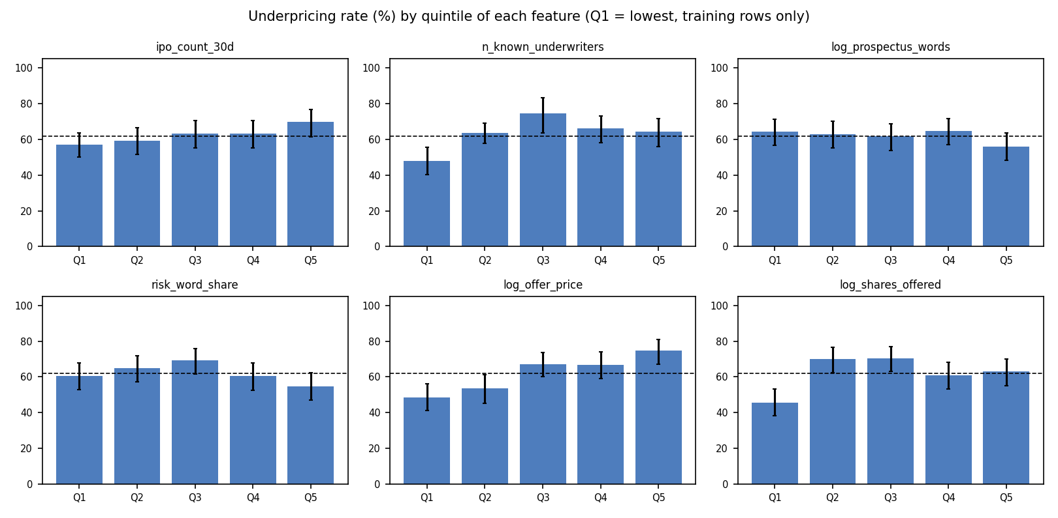
Figure 10. Underpricing rate by feature quintile (3 of 3).

2.6 Distributions by outcome
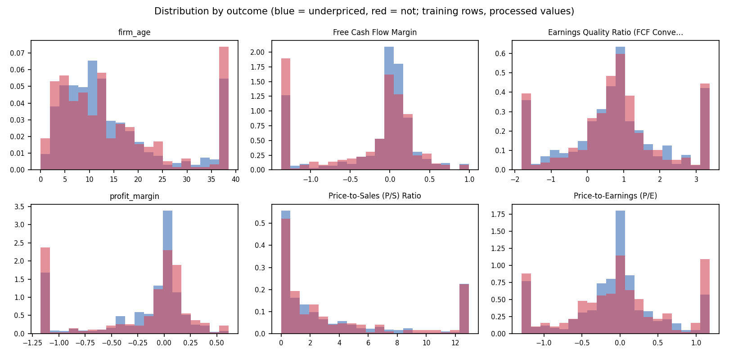
Figure 11. Feature distributions for underpriced vs not underpriced IPOs (1 of 3).
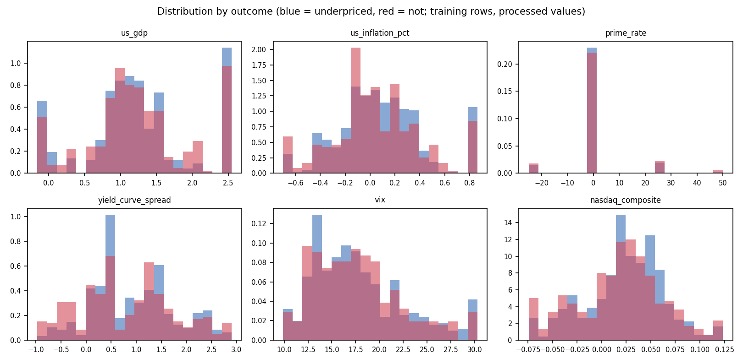
Figure 12. Feature distributions for underpriced vs not underpriced IPOs (2 of 3).
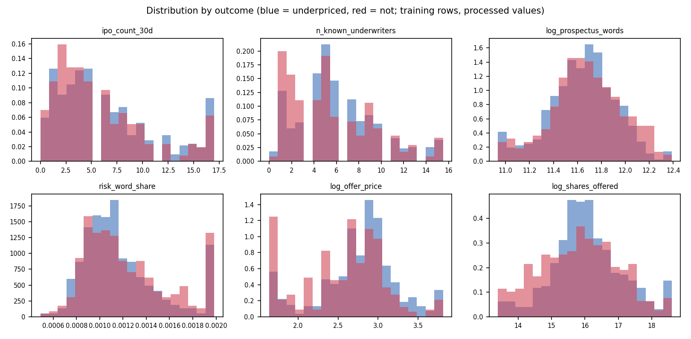
Figure 13. Feature distributions for underpriced vs not underpriced IPOs (3 of 3).

2.7 Features over time and feature correlations
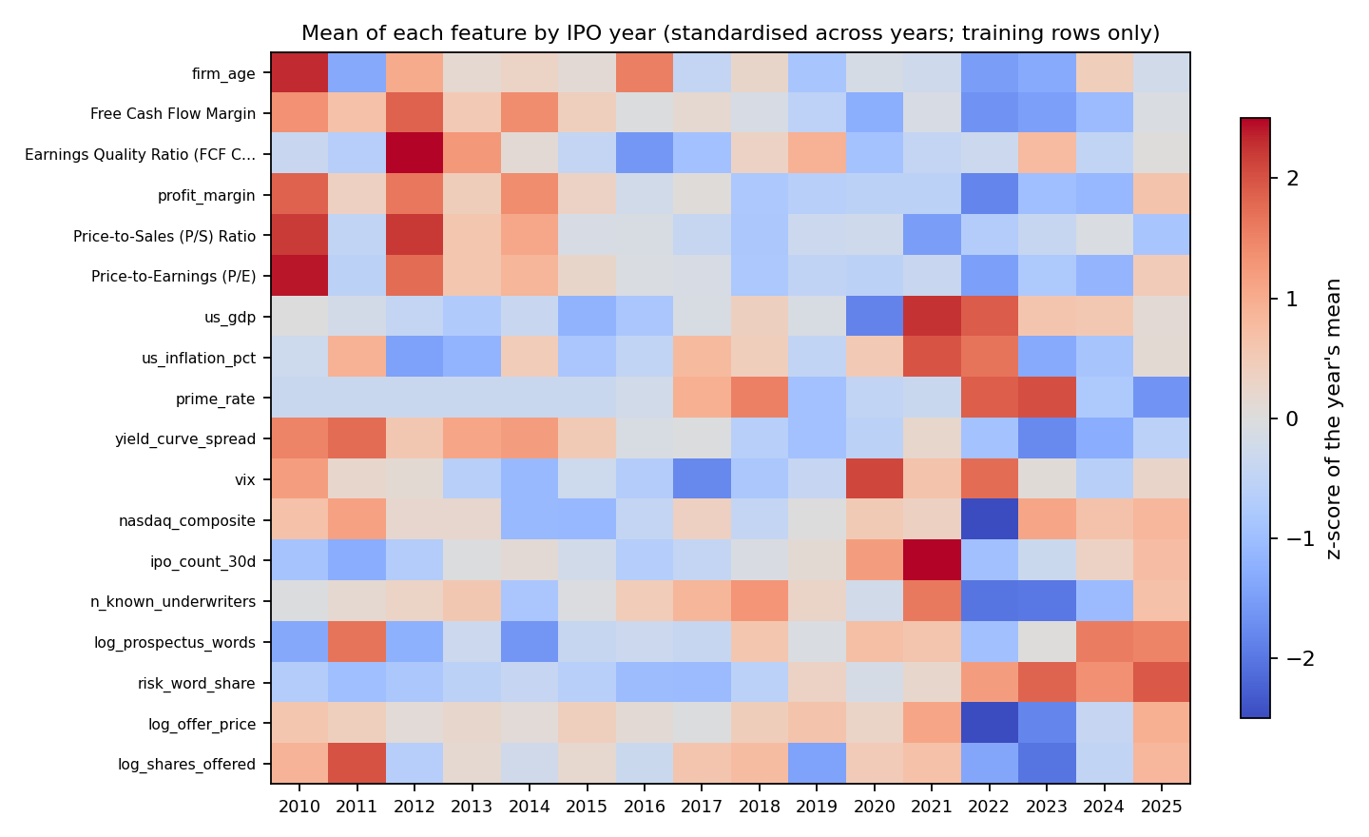
Figure 14. Yearly mean of each continuous feature, standardised across years.
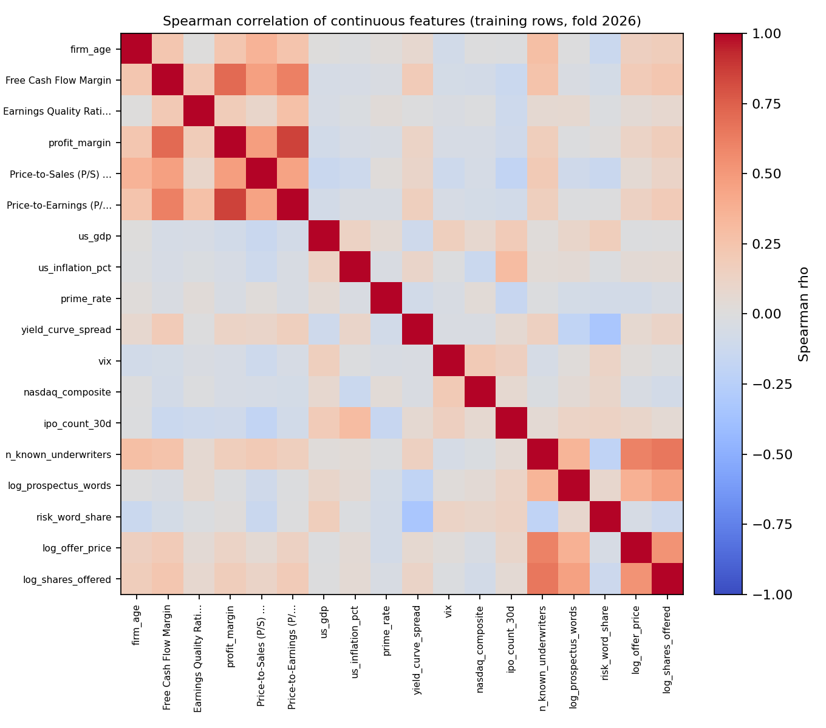
Figure 15. Spearman correlation matrix of continuous features.
Table 9. Feature pairs with |Spearman rho| ≥ 0.5
feature A | feature B | spearman
profit_margin | Price-to-Earnings (P/E) | 0.855
Free Cash Flow Margin | profit_margin | 0.705
n_known_underwriters | log_shares_offered | 0.654
Free Cash Flow Margin | Price-to-Earnings (P/E) | 0.615
n_known_underwriters | log_offer_price | 0.602
log_offer_price | log_shares_offered | 0.529
Strongly correlated features share credit in SHAP and make unpenalized-logit coefficients less stable (see VIF in Section 5).
Table 10. Yearly means of market and macro features with the underpricing rate (training rows)
year | n ipos | underpricing rate pct | vix | nasdaq composite | ipo count 30d | prime rate | yield curve spread | us gdp | us inflation pct
2,010 | 25.000 | 56.000 | 21.690 | 0.030 | 2.200 | 0.000 | 2.462 | 1.099 | -0.0056
2,011 | 10.000 | 50.000 | 18.268 | 0.036 | 1.200 | 0.000 | 2.715 | 1.016 | 0.181
2,012 | 29.000 | 55.172 | 17.952 | 0.023 | 2.724 | 0.000 | 1.576 | 0.892 | -0.192
2,013 | 44.000 | 56.818 | 15.218 | 0.023 | 4.409 | 0.000 | 2.063 | 0.743 | -0.144
2,014 | 53.000 | 67.925 | 13.576 | 0.0049 | 4.774 | 0.000 | 2.177 | 0.922 | 0.110
2,015 | 37.000 | 64.865 | 16.466 | 0.0045 | 3.946 | 0.000 | 1.508 | 0.517 | -0.094
2,016 | 27.000 | 77.778 | 15.005 | 0.014 | 2.778 | 0.926 | 0.933 | 0.691 | -0.037
2,017 | 33.000 | 63.636 | 11.040 | 0.025 | 3.364 | 8.333 | 1.002 | 1.055 | 0.161
2,018 | 47.000 | 74.468 | 14.572 | 0.014 | 4.277 | 12.234 | 0.424 | 1.296 | 0.105
2,019 | 53.000 | 60.377 | 15.943 | 0.020 | 4.792 | -3.774 | 0.145 | 1.053 | -0.036
2,020 | 69.000 | 71.014 | 25.039 | 0.027 | 7.580 | -0.725 | 0.502 | 0.187 | 0.120
2,021 | 151.0 | 64.901 | 19.788 | 0.025 | 12.325 | 0.000 | 1.242 | 2.228 | 0.351
2,022 | 26.000 | 38.462 | 23.757 | -0.021 | 2.077 | 14.423 | 0.163 | 2.050 | 0.300
2,023 | 44.000 | 36.364 | 17.750 | 0.036 | 3.659 | 15.341 | -0.650 | 1.400 | -0.169
2,024 | 64.000 | 51.562 | 15.240 | 0.030 | 5.312 | -2.734 | -0.201 | 1.367 | -0.097
2,025 | 84.000 | 69.048 | 18.416 | 0.032 | 6.369 | -8.333 | 0.478 | 1.160 | 0.057

3 Methodology: the full modelling process
This section explains every step from raw workbook to final statistic, in the order the code executes it. Each design choice is made to answer one question: could the number reported have been influenced by information that would not have been available when the IPO was priced?

3.1 Research question and target
The task is binary classification: predict whether an IPO is underpriced (underpriced = 1, otherwise 0) from information available at or before pricing. The workbook contains 850 U.S. IPOs from February 2010 to August 2026; 522 (61.4%) are underpriced. Because the classes are imbalanced, performance is summarised mainly by the area under the ROC curve (AUC), which does not depend on a classification threshold, and secondarily by threshold-based metrics.

3.2 Features: eight pillars
Features are grouped into eight conceptual pillars. Each pillar is modelled separately (to see which information matters) and all are combined in the ‘ALL pillars’ set. A control set with only the IPO date checks how much time alone predicts.
Table 11. Pillars and their features
pillar | n features | features
1. Firm fundamentals | 4 | firm_age, Free Cash Flow Margin, Earnings Quality Ratio (FCF Conversion), profit_margin
2. Valuation | 2 | Price-to-Sales (P/S) Ratio, Price-to-Earnings (P/E)
3. Macroeconomic environment | 4 | us_gdp, us_inflation_pct, prime_rate, yield_curve_spread
4. Market conditions and sentiment | 3 | vix, nasdaq_composite, ipo_count_30d
5. Certification and governance | 7 | institutional_backing, n_known_underwriters, big4_auditor, dual_class, uw_Tier2, uw_Other, uw_Unknown
6. Disclosure and information | 2 | log_prospectus_words, risk_word_share
7. Offer structure | 2 | log_offer_price, log_shares_offered
8. Listing venue and sector | 9 | exch_nyse, exch_nyse_american, sec_Financials_Real_Estate, sec_Consumer_Media, sec_Healthcare, sec_Software_Internet, sec_Hardware_Semis, sec_Energy_Materials, sec_Industrials

- Encoding: the exchange (reference: Nasdaq), underwriter reputation (reference: Tier 1; missing → ‘Unknown’) and nine sector groups (reference: Biotech & Pharma) are one-hot encoded with one level dropped to avoid the dummy-variable trap. Sector groups are built by ordered regular-expression rules applied to the raw industry label; anything unmatched is ‘Other’.
- Collinearity: log_proceeds is removed because it is almost exactly log_offer_price + log_shares_offered (VIF ≈ 85), which made coefficients of the unpenalized logit unstable. Columns that are constant (e.g. an empty sector bucket) are dropped automatically.
- Time control: ipo_year (fractional year) is used only in the control set, never in the eight pillars.

3.3 Validation design: expanding window with an embargo
Fold Y trains on every IPO dated before 1 January of year Y and tests on the IPOs of year Y. Test years run from 2016 to 2026. Earlier test and dropped IPOs re-enter later training sets, so the training window expands as time passes. IPOs in the first 29 days of a test year (on or before 29 January) are dropped from that fold’s test set (embargo) because their market conditions and information overlap with the end of the training window. The chronological order guarantees the model never sees the future; the embargo further reduces serial-dependence spillover. Pooled metrics concatenate all out-of-sample predictions.
Table 12. Fold table (n_dropped = embargoed January IPOs)
fold | n train | n test | n dropped | train last | test first
2016 | 198 | 27 | 0 | YRD (2015-12-18) | EDIT (2016-02-03)
2017 | 225 | 31 | 2 | ICHR (2016-12-09) | INVH (2017-02-01)
2018 | 258 | 43 | 4 | NMRK (2017-12-15) | OSS (2018-02-01)
2019 | 305 | 53 | 0 | MRNA (2018-12-07) | NFE (2019-01-31)
2020 | 358 | 67 | 2 | INDO (2019-12-19) | ONEM (2020-01-31)
2021 | 427 | 141 | 10 | UPST (2020-12-16) | ONTF (2021-02-03)
2022 | 578 | 23 | 3 | NXGL (2021-12-22) | SKYX (2022-02-10)
2023 | 604 | 41 | 3 | COYA (2022-12-29) | ASST (2023-02-03)
2024 | 648 | 60 | 4 | ZKH (2023-12-15) | AS (2024-02-01)
2025 | 712 | 80 | 4 | NTCL (2024-12-13) | BBNX (2025-01-30)
2026 | 796 | 47 | 7 | MDLN (2025-12-17) | BOBS (2026-02-05)

3.4 Preprocessing fitted on training rows only
For each fold, the following steps are fitted on that fold’s training rows and then applied unchanged to its test rows:
- Imputation: missing continuous values are replaced by the training median; missing binary/dummy values by the training mode.
- Winsorization: bounds are Tukey fences (Q1 − 1.5·IQR, Q3 + 1.5·IQR) computed on the training rows, applied, and recomputed repeatedly until no value lies outside (iterative winsorization); if the IQR is zero the 1st/99th percentiles are used. Test values are clipped to the training bounds.
- Scaling: median/IQR (robust) scaling for the models that need it (SVM, Neural Network, Logit (unpenalized)); Random Forest, Gradient Boosting use unscaled values.
Consequently no future IPO can influence a fill value, a clipping bound or a scaling constant. Section 8 shows what happens when this rule is broken.

3.5 Models and class imbalance
Table 13. Models
model | role | imbalance handling
Random Forest | machine-learning model | class_weight = balanced_subsample
Gradient Boosting | machine-learning model | balanced sample weights
SVM | machine-learning model | class_weight = balanced; Platt probabilities
Neural Network | machine-learning model | random oversampling inside the training rows
Logit (unpenalized) | confirmatory classical benchmark (own IRLS code, HC3 robust SEs) | none (inference model)
Baseline: train prior | predicts the training underpricing rate for every IPO (AUC 0.5) | –

Class imbalance is handled with class weights rather than synthetic oversampling, so no artificial observation is ever created. Because of the weighting, predicted probabilities are centred near 0.5, not near the raw underpricing rate; they rank IPOs well but are not calibrated frequencies (see Section 9).

3.6 Hyper-parameter tuning without peeking
Within each fold’s training window, hyper-parameters are chosen on a purged chronological validation block: the last 20% of training IPOs (at least 30) form the validation set, and training rows within 30 days before it are removed (purge). Preprocessing is re-fitted on the remaining sub-training rows. Random Forest, Gradient Boosting, SVM, Neural Network use a random search of 20 draws from their hyper-parameter grids. The criterion is validation AUC. The winning configuration is then refitted on the full training window and used once on the test year. The test year is never used for tuning.

3.7 Evaluation metrics and statistical tests
- Discrimination: pooled AUC over all test years, with a 2000-resample bootstrap 95% CI and a one-sided label-permutation p-value (2000 permutations, labels shuffled within each test year).
- Threshold and probability metrics: accuracy, balanced accuracy, F1 at the 0.5 threshold, Brier score and log-loss (pooled and per fold).
- Comparisons: DeLong tests for paired AUC differences (model vs model on ALL; ALL vs each pillar and the control), McNemar tests on 0.5-threshold predictions, and Wilcoxon signed-rank tests on fold AUCs.
- Classical inference: an unpenalized logit on the full sample gives odds ratios with HC3 robust standard errors, a likelihood-ratio test per pillar set, drop-one-pillar tests, McFadden R², AIC/BIC and VIF. These are descriptive (full sample), not part of the out-of-sample evidence.

3.8 Data-leakage safeguards
- Temporal integrity: for every fold: training dates precede test dates, the embargo is respected, no row or dropped IPO appears in test, and the target is not a feature.
- Label-permutation refit: training labels are shuffled, models are refitted with the tuned parameters and scored on the real test labels; an honest pipeline returns AUC ≈ 0.5.
- Univariate screen: every feature’s single-variable AUC is screened; values far from 0.5 would signal a leaked variable.
- Random vs chronological gap: random 5-fold versus chronological CV with default parameters, reported as a diagnostic only.

3.9 Explainability with SHAP in probability units
SHAP (Shapley additive explanations) splits each prediction into feature contributions. Here they are expressed directly in probability units (percentage points, pp): for every IPO, base value + the sum of SHAP values = the model’s predicted probability. Explanations are strictly out-of-sample: each fold’s fitted ALL-pillars model explains that fold’s test IPOs, using a background sample of 30 training rows as the reference distribution (interventional SHAP). Engines used – Random Forest: shap.TreeExplainer (probability); Gradient Boosting: shap.TreeExplainer (probability); SVM: shap.PermutationExplainer (probability); Neural Network: shap.PermutationExplainer (probability). Global importance is the mean absolute SHAP value; direction is the Spearman correlation between a feature’s value and its SHAP value; pillar importance sums SHAP values of the pillar’s features per IPO before taking absolute values, so offsetting features inside a pillar net out.

3.10 Descriptive analysis and the validation-flaw ablation
Descriptive statistics (Section 2) use only the training rows of one fold. The ablation (Section 8) re-runs the same data, features and models with fixed default hyper-parameters under six designs, from ours (S0) to a typical flawed pipeline (S5), and scores every design on one common set of real IPOs so that differences are purely due to the design.

4 Predictive results
Table below gives pooled out-of-sample AUC for every model on every feature set; Figure shows the same with 95% bootstrap intervals.
Table 14. Pooled out-of-sample AUC by feature set and model
set | Baseline: train prior | Gradient Boosting | Logit (unpenalized) | Neural Network | Random Forest | SVM
1. Firm fundamentals | – | 0.555 | 0.537 | 0.528 | 0.556 | 0.446
2. Valuation | – | 0.549 | 0.481 | 0.553 | 0.567 | 0.458
3. Macroeconomic environment | – | 0.555 | 0.501 | 0.521 | 0.544 | 0.509
4. Market conditions and sentiment | – | 0.510 | 0.522 | 0.529 | 0.508 | 0.492
5. Certification and governance | – | 0.568 | 0.556 | 0.571 | 0.576 | 0.477
6. Disclosure and information | – | 0.539 | 0.505 | 0.537 | 0.532 | 0.512
7. Offer structure | – | 0.571 | 0.603 | 0.580 | 0.577 | 0.597
8. Listing venue and sector | – | 0.566 | 0.562 | 0.562 | 0.567 | 0.553
ALL pillars | 0.478 | 0.591 | 0.610 | 0.570 | 0.614 | 0.596
Control: ipo_year only | – | 0.560 | 0.522 | 0.540 | 0.551 | 0.477

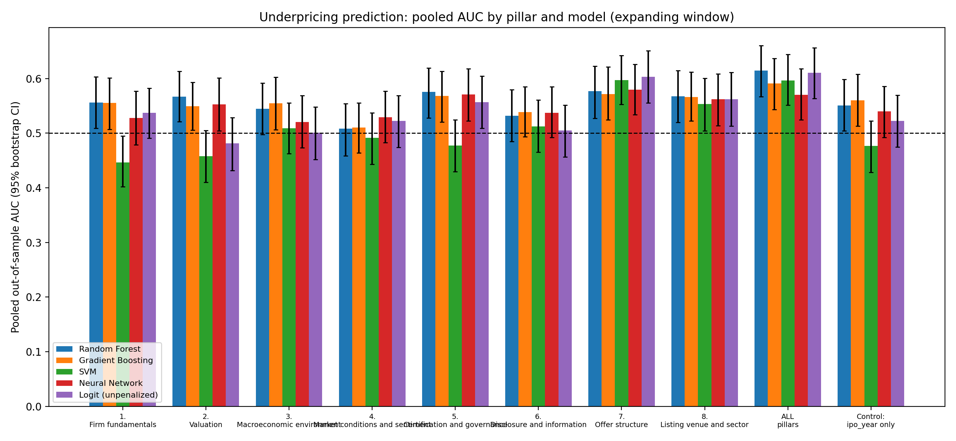
Figure 16. Pooled AUC by pillar and model (95% bootstrap CI; dashed line = chance).
Table 15. All pillars combined: pooled metrics
model | auc | auc ci low | auc ci high | perm p value auc | accuracy | balanced accuracy | f1 | brier | log loss | mean fold auc | std fold auc
Random Forest | 0.614 | 0.567 | 0.660 | <0.001 | 0.623 | 0.576 | 0.718 | 0.228 | 0.647 | 0.612 | 0.117
Gradient Boosting | 0.591 | 0.543 | 0.637 | 0.001 | 0.604 | 0.576 | 0.683 | 0.260 | 0.850 | 0.584 | 0.094
SVM | 0.596 | 0.551 | 0.644 | <0.001 | 0.639 | 0.541 | 0.767 | 0.229 | 0.650 | 0.603 | 0.081
Neural Network | 0.570 | 0.524 | 0.618 | 0.003 | 0.579 | 0.566 | 0.647 | 0.335 | 1.612 | 0.577 | 0.091
Logit (unpenalized) | 0.610 | 0.563 | 0.656 | <0.001 | 0.610 | 0.561 | 0.709 | 0.241 | 0.728 | 0.615 | 0.095
Baseline: train prior | 0.478 | 0.434 | 0.525 | 1.000 | 0.618 | 0.500 | 0.764 | 0.237 | 0.668 | 0.500 | 0.000

Table 16. Out-of-sample AUC by test year (ALL pillars)
fold | Gradient Boosting | Logit (unpenalized) | Neural Network | PRIOR | Random Forest | SVM
2,016 | 0.571 | 0.603 | 0.706 | 0.500 | 0.675 | 0.595
2,017 | 0.675 | 0.697 | 0.535 | 0.500 | 0.737 | 0.548
2,018 | 0.582 | 0.644 | 0.425 | 0.500 | 0.611 | 0.673
2,019 | 0.438 | 0.637 | 0.540 | 0.500 | 0.446 | 0.510
2,020 | 0.649 | 0.521 | 0.485 | 0.500 | 0.673 | 0.567
2,021 | 0.549 | 0.656 | 0.582 | 0.500 | 0.583 | 0.684
2,022 | 0.540 | 0.397 | 0.611 | 0.500 | 0.429 | 0.508
2,023 | 0.653 | 0.704 | 0.667 | 0.500 | 0.772 | 0.697
2,024 | 0.737 | 0.726 | 0.696 | 0.500 | 0.719 | 0.712
2,025 | 0.597 | 0.622 | 0.490 | 0.500 | 0.592 | 0.632
2,026 | 0.434 | 0.562 | 0.612 | 0.500 | 0.495 | 0.502

Fold-level AUCs are noisy because individual test years contain few IPOs (see the fold table); the pooled estimate and its interval are the main evidence.

5 Statistical confirmation
Table 17. DeLong tests: model vs model (ALL pillars)
model A | model B | auc A | auc B | auc diff | z | p value
Random Forest | Gradient Boosting | 0.614 | 0.591 | 0.023 | 1.535 | 0.125
Random Forest | SVM | 0.614 | 0.596 | 0.018 | 0.871 | 0.384
Random Forest | Neural Network | 0.614 | 0.570 | 0.045 | 1.604 | 0.109
Random Forest | Logit (unpenalized) | 0.614 | 0.610 | 0.0041 | 0.196 | 0.845
Gradient Boosting | SVM | 0.591 | 0.596 | -0.0051 | -0.236 | 0.814
Gradient Boosting | Neural Network | 0.591 | 0.570 | 0.021 | 0.754 | 0.451
Gradient Boosting | Logit (unpenalized) | 0.591 | 0.610 | -0.019 | -0.884 | 0.377
SVM | Neural Network | 0.596 | 0.570 | 0.027 | 1.079 | 0.281
SVM | Logit (unpenalized) | 0.596 | 0.610 | -0.014 | -0.890 | 0.373
Neural Network | Logit (unpenalized) | 0.570 | 0.610 | -0.041 | -1.583 | 0.113

Table 18. DeLong tests: ALL pillars vs each pillar / control (Random Forest)
ALL auc | other set | other auc | auc diff | z | p value
0.614 | 1. Firm fundamentals | 0.556 | 0.059 | 2.146 | 0.032
0.614 | 2. Valuation | 0.567 | 0.048 | 1.613 | 0.107
0.614 | 3. Macroeconomic environment | 0.544 | 0.070 | 2.773 | 0.006
0.614 | 4. Market conditions and sentiment | 0.508 | 0.106 | 3.643 | <0.001
0.614 | 5. Certification and governance | 0.576 | 0.039 | 1.225 | 0.221
0.614 | 6. Disclosure and information | 0.532 | 0.083 | 3.047 | 0.002
0.614 | 7. Offer structure | 0.577 | 0.037 | 1.373 | 0.170
0.614 | 8. Listing venue and sector | 0.567 | 0.047 | 1.617 | 0.106
0.614 | Control: ipo_year only | 0.551 | 0.064 | 2.545 | 0.011

Table 19. McNemar tests on 0.5-threshold predictions
model A | model B | A right B wrong | A wrong B right | p value
Random Forest | Gradient Boosting | 60 | 48 | 0.290
Random Forest | SVM | 69 | 79 | 0.460
Random Forest | Neural Network | 117 | 90 | 0.070
Random Forest | Logit (unpenalized) | 74 | 66 | 0.554
Gradient Boosting | SVM | 82 | 104 | 0.123
Gradient Boosting | Neural Network | 106 | 91 | 0.319
Gradient Boosting | Logit (unpenalized) | 78 | 82 | 0.813
SVM | Neural Network | 130 | 93 | 0.016
SVM | Logit (unpenalized) | 74 | 56 | 0.136
Neural Network | Logit (unpenalized) | 79 | 98 | 0.176

Table 20. Wilcoxon signed-rank tests on fold AUCs
model A | model B | mean fold auc A | mean fold auc B | wilcoxon p
Random Forest | Gradient Boosting | 0.612 | 0.584 | 0.102
Random Forest | SVM | 0.612 | 0.603 | 0.831
Random Forest | Neural Network | 0.612 | 0.577 | 0.365
Random Forest | Logit (unpenalized) | 0.612 | 0.615 | 1.000
Gradient Boosting | SVM | 0.584 | 0.603 | 0.413
Gradient Boosting | Neural Network | 0.584 | 0.577 | 0.831
Gradient Boosting | Logit (unpenalized) | 0.584 | 0.615 | 0.278
SVM | Neural Network | 0.603 | 0.577 | 0.638
SVM | Logit (unpenalized) | 0.603 | 0.615 | 0.831
Neural Network | Logit (unpenalized) | 0.577 | 0.615 | 0.320

5.1 Classical logit inference (full sample, descriptive)
Table 21. Unpenalized logit fit by feature set
set | n | k features | loglik | LR chi2 vs null | LR p value | McFadden R2 | AIC | BIC | possible separation
1. Firm fundamentals | 850 | 4 | -561.4 | 10.938 | 0.027 | 0.0096 | 1,133 | 1,156 | no
2. Valuation | 850 | 2 | -566.8 | 0.109 | 0.947 | 0.0001 | 1,140 | 1,154 | no
3. Macroeconomic environment | 850 | 4 | -563.3 | 7.121 | 0.130 | 0.0063 | 1,137 | 1,160 | no
4. Market conditions and sentiment | 850 | 3 | -563.8 | 6.106 | 0.107 | 0.0054 | 1,136 | 1,155 | no
5. Certification and governance | 850 | 7 | -557.3 | 19.071 | 0.008 | 0.017 | 1,131 | 1,169 | no
6. Disclosure and information | 850 | 2 | -563.4 | 6.826 | 0.033 | 0.0060 | 1,133 | 1,147 | no
7. Offer structure | 850 | 2 | -551.6 | 30.446 | <0.001 | 0.027 | 1,109 | 1,123 | no
8. Listing venue and sector | 850 | 9 | -548.7 | 36.348 | <0.001 | 0.032 | 1,117 | 1,165 | no
ALL pillars | 850 | 33 | -512.7 | 108.3 | <0.001 | 0.096 | 1,093 | 1,255 | no

Table 22. Drop-one-pillar likelihood-ratio tests (ALL pillars model)
pillar removed | df | LR chi2 | p value
1. Firm fundamentals | 4 | 13.948 | 0.007
2. Valuation | 2 | 4.982 | 0.083
3. Macroeconomic environment | 4 | 2.365 | 0.669
4. Market conditions and sentiment | 3 | 7.429 | 0.059
5. Certification and governance | 7 | 4.352 | 0.738
6. Disclosure and information | 2 | 19.560 | <0.001
7. Offer structure | 2 | 26.888 | <0.001
8. Listing venue and sector | 9 | 26.864 | 0.001

Table 23. Odds ratios (HC3 robust; continuous features median/IQR scaled), ordered by |z|
feature | odds ratio | OR ci low | OR ci high | z | p value
log_offer_price | 1.720 | 1.351 | 2.190 | 4.400 | <0.001
log_prospectus_words | 0.567 | 0.431 | 0.745 | -4.074 | <0.001
sec_Industrials | 0.333 | 0.161 | 0.689 | -2.962 | 0.003
sec_Energy_Materials | 0.330 | 0.148 | 0.734 | -2.720 | 0.007
Free Cash Flow Margin | 1.379 | 1.071 | 1.775 | 2.489 | 0.013
nasdaq_composite | 1.263 | 1.036 | 1.541 | 2.306 | 0.021
Price-to-Earnings (P/E) | 0.799 | 0.654 | 0.975 | -2.204 | 0.028
sec_Financials_Real_Estate | 0.451 | 0.221 | 0.920 | -2.189 | 0.029
exch_nyse_american | 0.261 | 0.059 | 1.150 | -1.775 | 0.076
log_shares_offered | 1.293 | 0.973 | 1.718 | 1.773 | 0.076
n_known_underwriters | 0.793 | 0.556 | 1.130 | -1.283 | 0.199
us_inflation_pct | 1.144 | 0.931 | 1.406 | 1.277 | 0.202
firm_age | 0.870 | 0.702 | 1.078 | -1.269 | 0.204
big4_auditor | 1.313 | 0.828 | 2.081 | 1.158 | 0.247
sec_Software_Internet | 0.741 | 0.387 | 1.421 | -0.902 | 0.367
ipo_count_30d | 1.093 | 0.884 | 1.350 | 0.821 | 0.412
Earnings Quality Ratio (FCF Conversion) | 1.056 | 0.907 | 1.230 | 0.701 | 0.483
yield_curve_spread | 0.920 | 0.713 | 1.187 | -0.638 | 0.524
us_gdp | 0.953 | 0.815 | 1.115 | -0.597 | 0.550
sec_Consumer_Media | 0.827 | 0.430 | 1.590 | -0.569 | 0.569

Table 24. Largest variance-inflation factors
feature | VIF
profit_margin | 3.376
Free Cash Flow Margin | 2.847
sec_Consumer_Media | 2.777
n_known_underwriters | 2.557
sec_Software_Internet | 2.529
sec_Financials_Real_Estate | 2.501
log_shares_offered | 2.229
log_offer_price | 2.151
uw_Tier2 | 2.093
sec_Industrials | 2.011

6 Data-leakage diagnostics
Temporal-integrity result: PASS (training precedes embargo precedes test in every fold; no row overlap).
Table 25. Temporal integrity by fold
fold | train before test | gap days train last to test first | embargo respected | dropped not in test | row overlap train test | companies in both train and test | target in features | test dates after all train dates
2016 | yes | 47 | yes | yes | 0 | 0 | no | yes
2017 | yes | 54 | yes | yes | 0 | 0 | no | yes
2018 | yes | 48 | yes | yes | 0 | 0 | no | yes
2019 | yes | 55 | yes | yes | 0 | 0 | no | yes
2020 | yes | 43 | yes | yes | 0 | 0 | no | yes
2021 | yes | 49 | yes | yes | 0 | 0 | no | yes
2022 | yes | 50 | yes | yes | 0 | 0 | no | yes
2023 | yes | 36 | yes | yes | 0 | 0 | no | yes
2024 | yes | 48 | yes | yes | 0 | 0 | no | yes
2025 | yes | 48 | yes | yes | 0 | 0 | no | yes
2026 | yes | 50 | yes | yes | 0 | 0 | no | yes

Table 26. Label-permutation refit (shuffled training labels, real test labels)
model | real pooled auc | perm auc mean | perm auc sd | perm auc max | p value real vs shuffled | shuffled labels near 0.5
Random Forest | 0.614 | 0.496 | 0.019 | 0.529 | 0.048 | yes
Gradient Boosting | 0.591 | 0.497 | 0.019 | 0.528 | 0.048 | yes
SVM | 0.596 | 0.477 | 0.025 | 0.524 | 0.048 | yes
Neural Network | 0.570 | 0.506 | 0.026 | 0.560 | 0.048 | yes
Logit (unpenalized) | 0.610 | 0.507 | 0.028 | 0.553 | 0.048 | yes
Honest pipelines return AUC ≈ 0.5 with shuffled labels; a high shuffled AUC would indicate leakage.
Table 27. Univariate AUC screen of every feature (top 10 by distance from 0.5)
feature | univariate auc | abs auc from 0.5 | corr with target | flag suspicious(auc>0.70 or <0.30)
log_offer_price | 0.612 | 0.112 | 0.184 | no
n_known_underwriters | 0.563 | 0.063 | 0.078 | no
log_shares_offered | 0.550 | 0.050 | 0.104 | no
Free Cash Flow Margin | 0.549 | 0.049 | 0.067 | no
big4_auditor | 0.545 | 0.045 | 0.109 | no
uw_Tier2 | 0.456 | 0.044 | -0.099 | no
yield_curve_spread | 0.544 | 0.044 | 0.075 | no
risk_word_share | 0.459 | 0.041 | -0.050 | no
ipo_count_30d | 0.539 | 0.039 | 0.062 | no
nasdaq_composite | 0.536 | 0.036 | 0.047 | no

Table 28. Random 5-fold versus chronological CV (default parameters, diagnostic)
model | chronological auc default params | random 5fold auc default params | gap random minus chrono
Random Forest | 0.628 | 0.629 | 0.0005
Gradient Boosting | 0.617 | 0.622 | 0.0054
SVM | 0.587 | 0.615 | 0.028
Neural Network | 0.566 | 0.579 | 0.013

7 Explainability: SHAP values in probability units
All values below are in percentage points (pp) of predicted probability and are out-of-sample. Figures use the ALL-pillars models. Mean |SHAP| measures how much a feature moves predictions on average; the beeswarm shows each IPO (red = high feature value, blue = low). SHAP reflects what the fitted models use, not causal effects, and correlated features share credit.

7.1 Random Forest
Table 29. Random Forest: top features by mean |SHAP| (pp)
feature | pillar | mean abs shap pp | share of total pct | mean signed shap pp | direction (Spearman)
log_prospectus_words | 6. Disclosure and information | 3.947 | 14.177 | -1.576 | -0.838
log_offer_price | 7. Offer structure | 2.871 | 10.311 | -0.084 | 0.822
yield_curve_spread | 3. Macroeconomic environment | 2.534 | 9.101 | 0.265 | -0.100
log_shares_offered | 7. Offer structure | 2.364 | 8.492 | -0.275 | -0.300
Price-to-Earnings (P/E) | 2. Valuation | 1.647 | 5.915 | 0.257 | -0.642
profit_margin | 1. Firm fundamentals | 1.572 | 5.645 | -0.035 | -0.387
us_gdp | 3. Macroeconomic environment | 1.517 | 5.448 | 0.847 | 0.626
Free Cash Flow Margin | 1. Firm fundamentals | 1.372 | 4.929 | -0.280 | 0.723
risk_word_share | 6. Disclosure and information | 1.158 | 4.159 | -0.223 | -0.293
nasdaq_composite | 4. Market conditions and sentiment | 1.122 | 4.030 | 0.121 | 0.669
firm_age | 1. Firm fundamentals | 1.065 | 3.827 | 0.139 | 0.081
Earnings Quality Ratio (FCF Conversion) | 1. Firm fundamentals | 0.751 | 2.696 | -0.0017 | -0.633

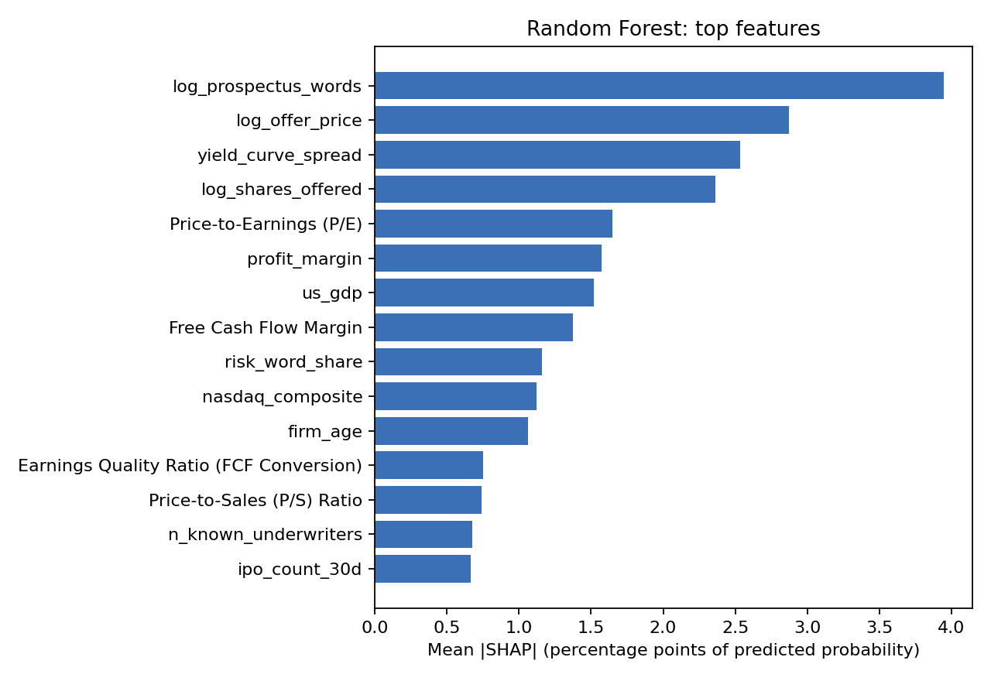
Figure 17. Random Forest: mean |SHAP| of the top features.
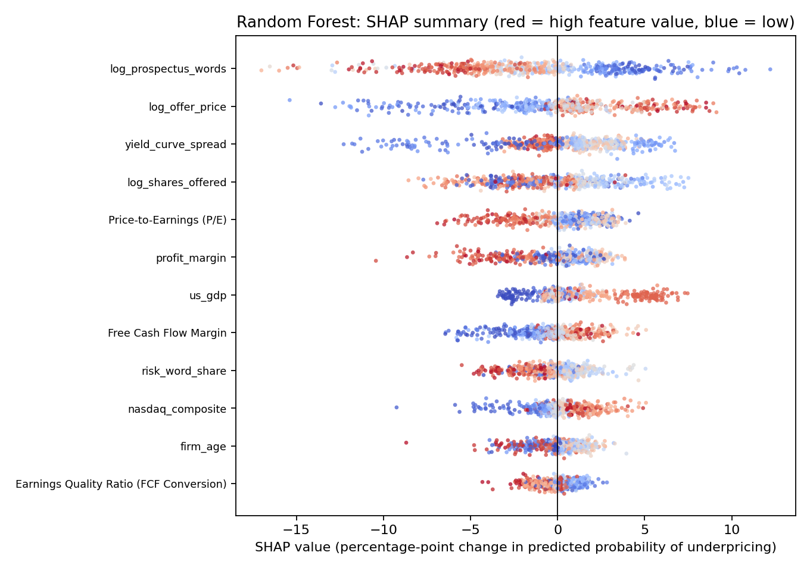
Figure 18. Random Forest: SHAP summary (beeswarm).

7.2 Gradient Boosting
Table 30. Gradient Boosting: top features by mean |SHAP| (pp)
feature | pillar | mean abs shap pp | share of total pct | mean signed shap pp | direction (Spearman)
log_prospectus_words | 6. Disclosure and information | 5.141 | 9.748 | -0.977 | -0.744
log_offer_price | 7. Offer structure | 3.890 | 7.376 | 0.161 | 0.632
yield_curve_spread | 3. Macroeconomic environment | 3.801 | 7.206 | 1.741 | 0.080
us_gdp | 3. Macroeconomic environment | 3.574 | 6.777 | 2.293 | 0.700
log_shares_offered | 7. Offer structure | 3.452 | 6.544 | -0.219 | 0.037
nasdaq_composite | 4. Market conditions and sentiment | 3.436 | 6.515 | 0.196 | 0.653
Free Cash Flow Margin | 1. Firm fundamentals | 3.015 | 5.717 | -0.426 | 0.808
Price-to-Earnings (P/E) | 2. Valuation | 2.661 | 5.045 | 1.027 | -0.571
firm_age | 1. Firm fundamentals | 2.622 | 4.971 | 0.634 | 0.101
profit_margin | 1. Firm fundamentals | 2.493 | 4.727 | 0.360 | -0.282
risk_word_share | 6. Disclosure and information | 2.476 | 4.695 | 0.223 | -0.286
vix | 4. Market conditions and sentiment | 2.459 | 4.663 | -0.698 | -0.285

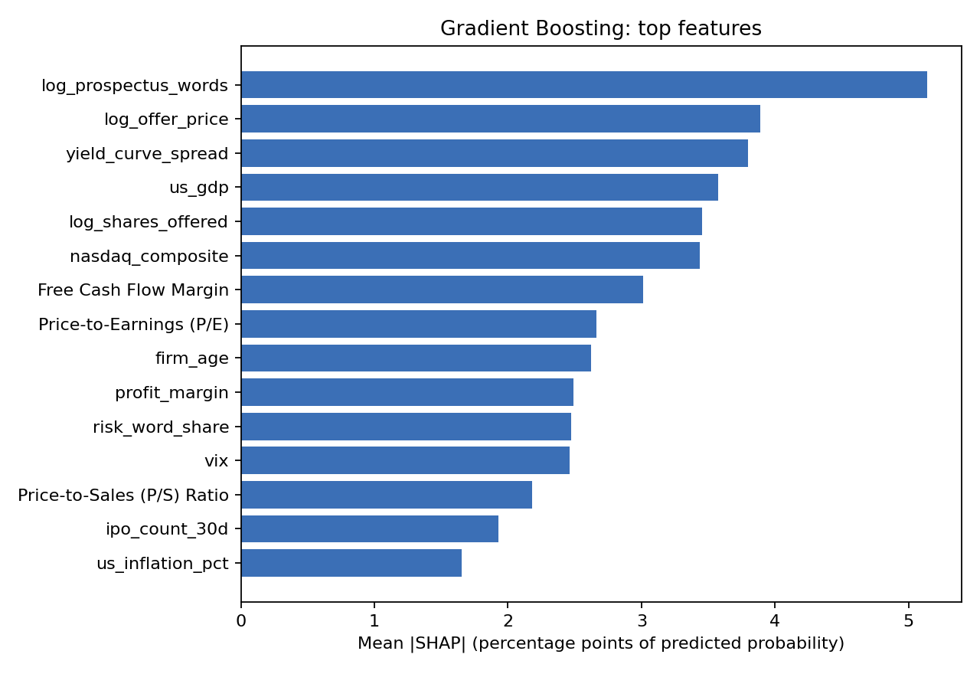
Figure 19. Gradient Boosting: mean |SHAP| of the top features.
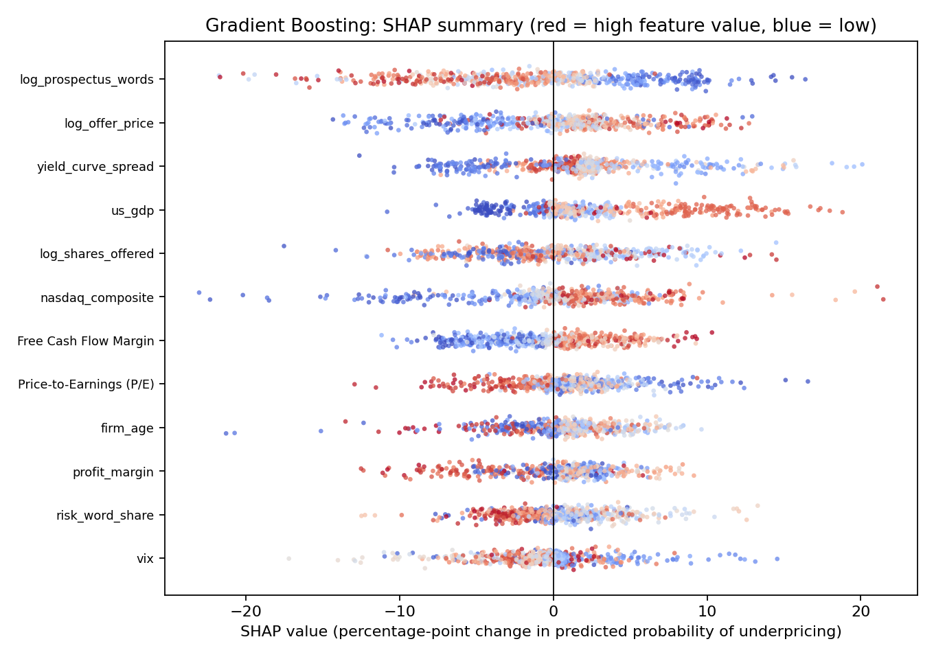
Figure 20. Gradient Boosting: SHAP summary (beeswarm).

7.3 SVM
Table 31. SVM: top features by mean |SHAP| (pp)
feature | pillar | mean abs shap pp | share of total pct | mean signed shap pp | direction (Spearman)
log_prospectus_words | 6. Disclosure and information | 3.204 | 11.359 | -1.690 | -0.957
log_offer_price | 7. Offer structure | 2.256 | 7.998 | 0.138 | 0.951
Free Cash Flow Margin | 1. Firm fundamentals | 1.894 | 6.714 | -0.223 | 0.888
nasdaq_composite | 4. Market conditions and sentiment | 1.631 | 5.781 | 0.323 | 0.915
Price-to-Earnings (P/E) | 2. Valuation | 1.618 | 5.737 | 0.335 | -0.874
log_shares_offered | 7. Offer structure | 1.423 | 5.044 | 0.054 | 0.424
big4_auditor | 5. Certification and governance | 1.418 | 5.028 | -0.200 | 0.702
us_gdp | 3. Macroeconomic environment | 1.028 | 3.643 | 0.198 | 0.392
prime_rate | 3. Macroeconomic environment | 1.020 | 3.615 | -0.042 | 0.068
sec_Industrials | 8. Listing venue and sector | 0.984 | 3.489 | -0.231 | -0.518
firm_age | 1. Firm fundamentals | 0.966 | 3.423 | 0.022 | -0.774
yield_curve_spread | 3. Macroeconomic environment | 0.818 | 2.899 | 0.560 | -0.859

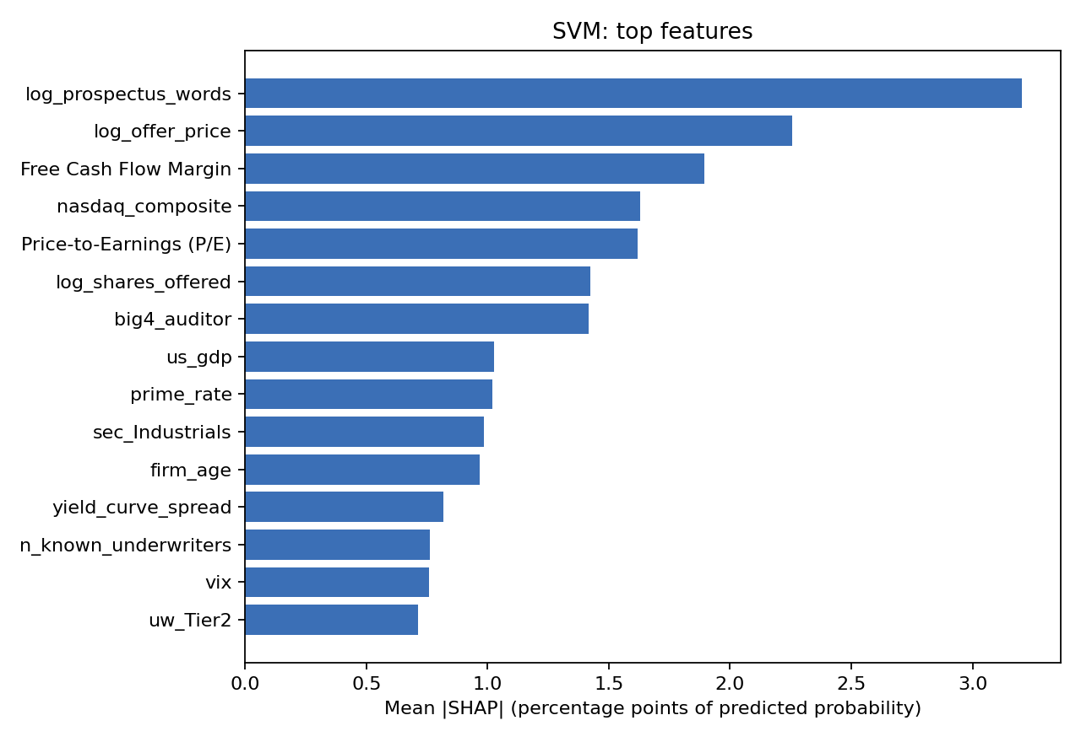
Figure 21. SVM: mean |SHAP| of the top features.
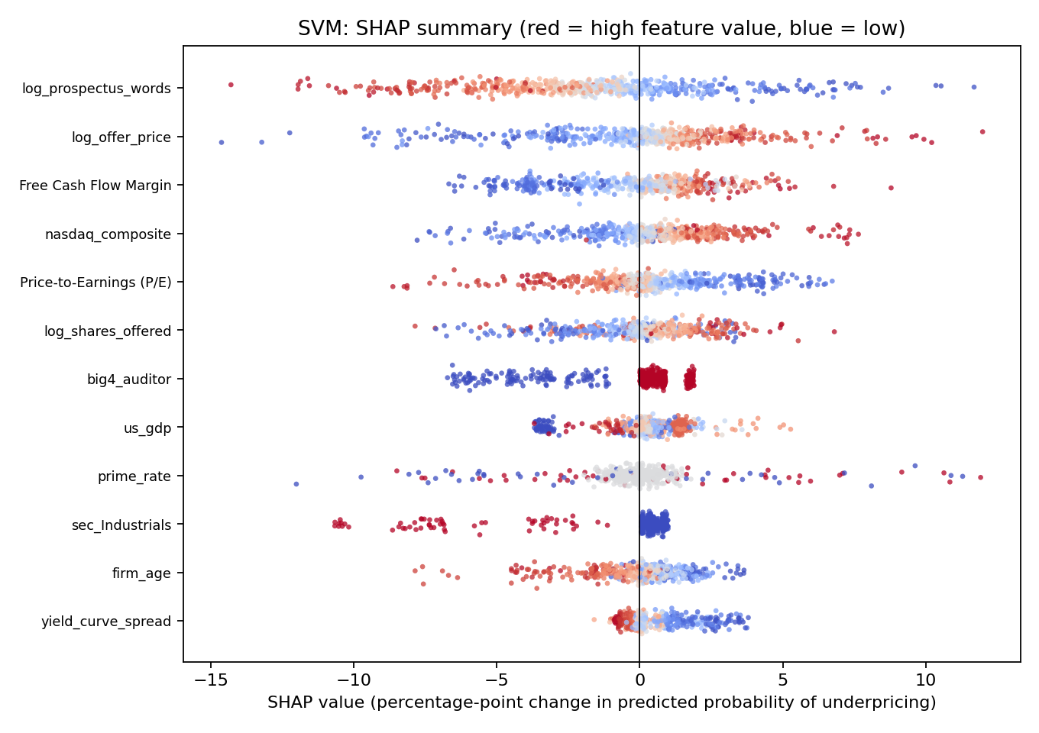
Figure 22. SVM: SHAP summary (beeswarm).

7.4 Neural Network
Table 32. Neural Network: top features by mean |SHAP| (pp)
feature | pillar | mean abs shap pp | share of total pct | mean signed shap pp | direction (Spearman)
log_offer_price | 7. Offer structure | 8.601 | 7.977 | 1.008 | 0.723
log_prospectus_words | 6. Disclosure and information | 7.566 | 7.017 | -3.359 | -0.881
ipo_count_30d | 4. Market conditions and sentiment | 5.329 | 4.943 | -3.619 | -0.290
n_known_underwriters | 5. Certification and governance | 5.156 | 4.782 | -0.470 | -0.494
us_gdp | 3. Macroeconomic environment | 5.049 | 4.683 | 1.694 | 0.421
nasdaq_composite | 4. Market conditions and sentiment | 4.777 | 4.431 | -0.210 | 0.791
Price-to-Earnings (P/E) | 2. Valuation | 4.287 | 3.976 | 0.945 | -0.759
sec_Industrials | 8. Listing venue and sector | 4.214 | 3.908 | 0.082 | -0.519
log_shares_offered | 7. Offer structure | 4.197 | 3.892 | -0.037 | 0.176
us_inflation_pct | 3. Macroeconomic environment | 4.192 | 3.888 | 1.130 | 0.482
yield_curve_spread | 3. Macroeconomic environment | 4.061 | 3.767 | 0.891 | -0.364
Price-to-Sales (P/S) Ratio | 2. Valuation | 3.889 | 3.607 | -0.809 | 0.518

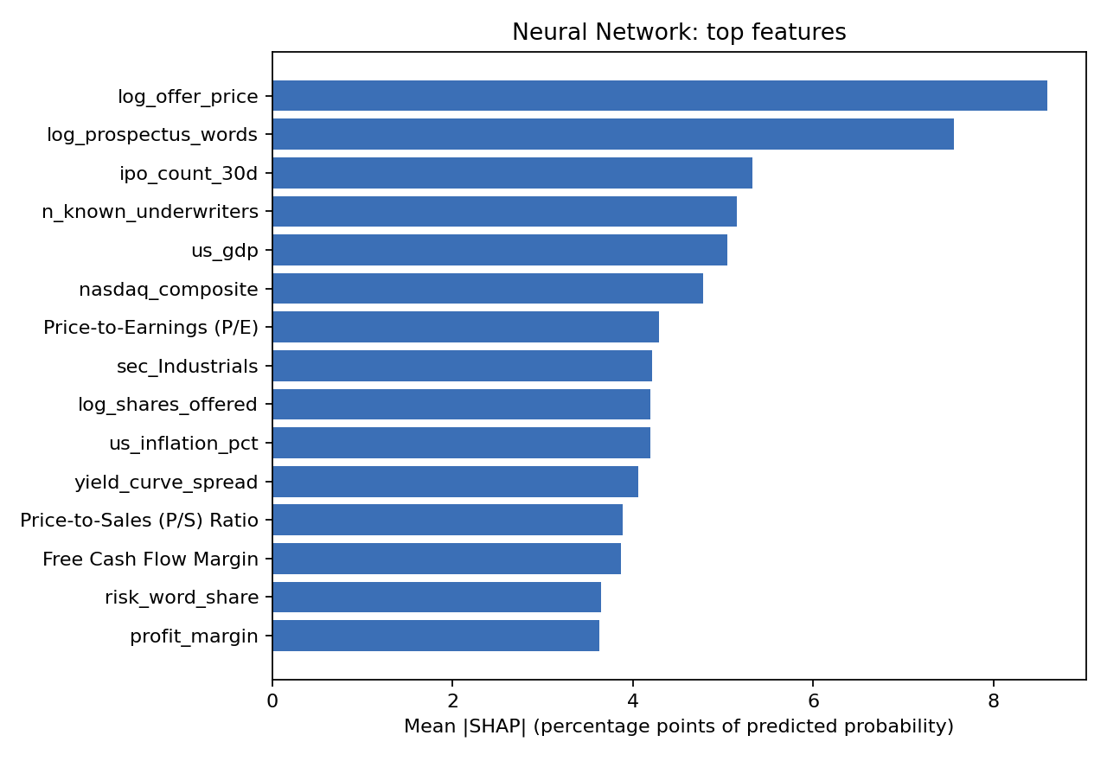
Figure 23. Neural Network: mean |SHAP| of the top features.
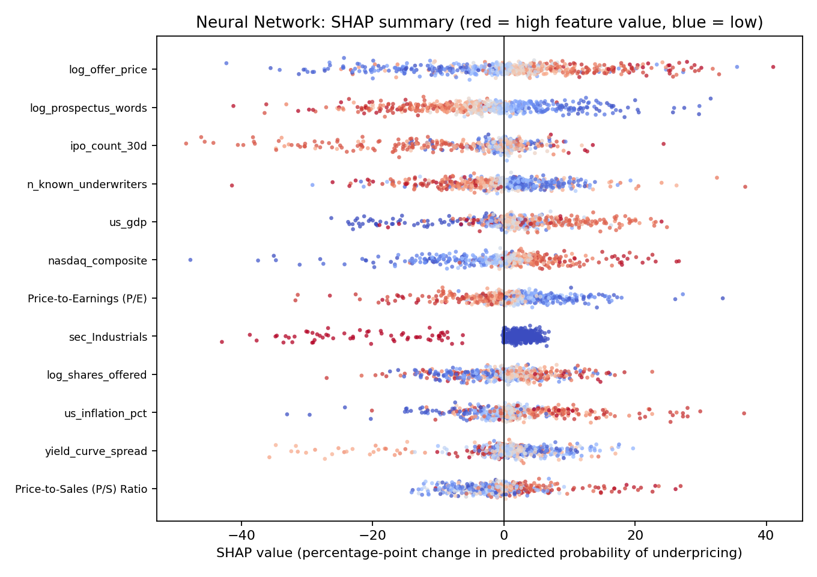
Figure 24. Neural Network: SHAP summary (beeswarm).

7.5 Pillar contributions
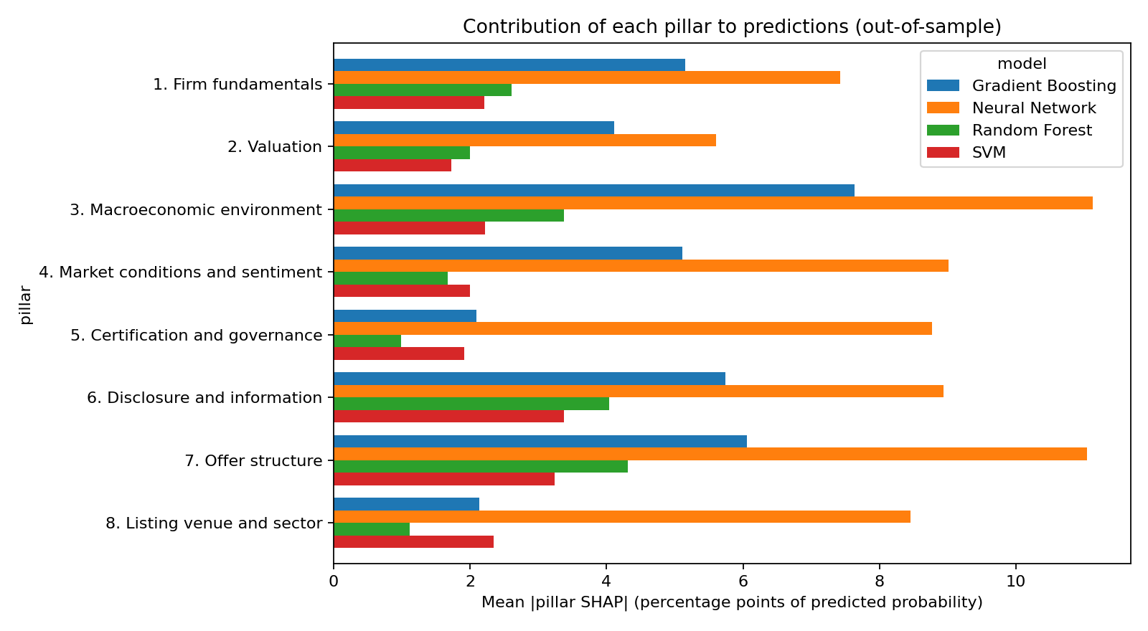
Figure 25. Mean absolute pillar-level SHAP.
Table 33. Mean |pillar SHAP| (pp)
pillar | Gradient Boosting | Neural Network | Random Forest | SVM
1. Firm fundamentals | 5.158 | 7.421 | 2.609 | 2.205
2. Valuation | 4.116 | 5.608 | 1.998 | 1.723
3. Macroeconomic environment | 7.631 | 11.127 | 3.373 | 2.221
4. Market conditions and sentiment | 5.110 | 9.014 | 1.670 | 1.995
5. Certification and governance | 2.096 | 8.773 | 0.987 | 1.917
6. Disclosure and information | 5.737 | 8.942 | 4.037 | 3.373
7. Offer structure | 6.060 | 11.037 | 4.307 | 3.239
8. Listing venue and sector | 2.138 | 8.454 | 1.115 | 2.348

7.6 How the best model’s predictions respond to its top features
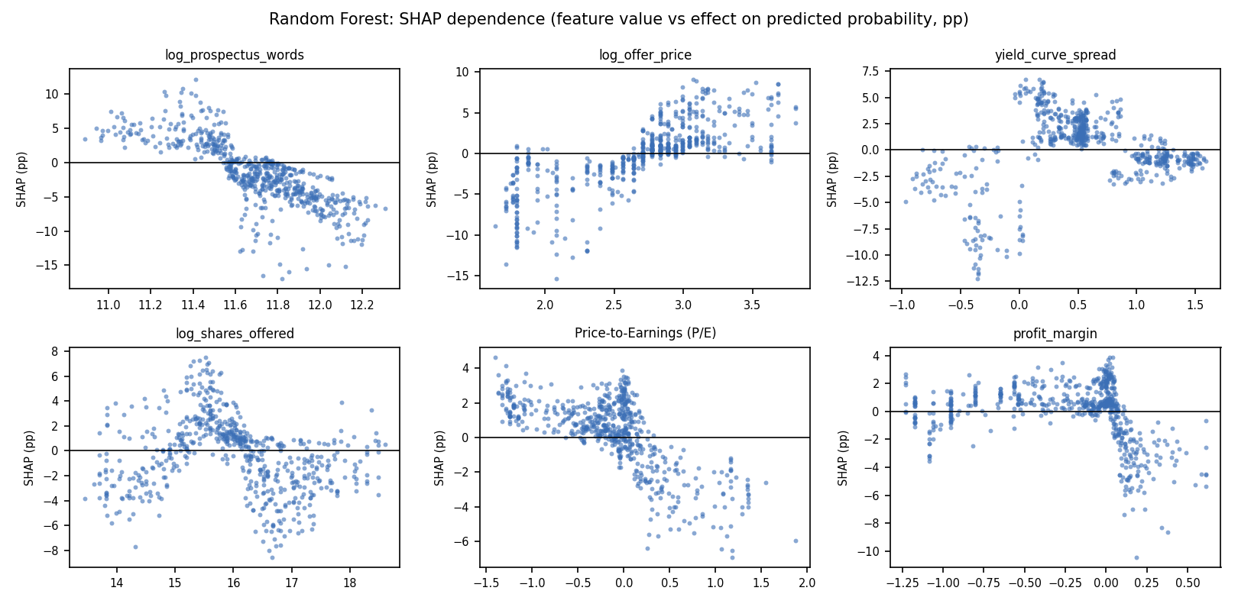
Figure 26. Random Forest: SHAP dependence of the top features (value on x-axis, effect on probability in pp on y-axis).

7.7 Stability of importance across test years
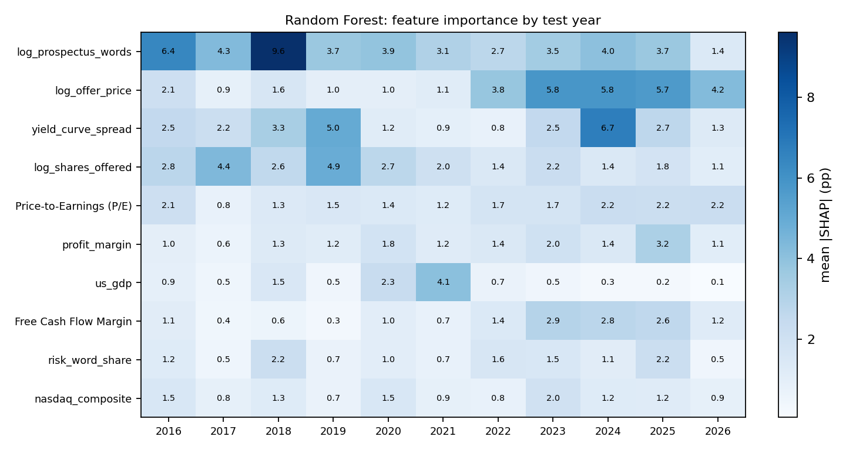
Figure 27. Random Forest: mean |SHAP| (pp) of the top features by test year.

7.8 Additivity check
Table 34. SHAP additivity: base value + Σ SHAP − predicted probability (should be ≈ 0)
model | engine | n explained | max abs additivity error | mean abs additivity error
Random Forest | shap.TreeExplainer (probability) | 613 | 0.0069 | 0.0001
Gradient Boosting | shap.TreeExplainer (probability) | 613 | 0.0082 | 0.0000
SVM | shap.PermutationExplainer (probability) | 613 | 0.0000 | 0.0000
Neural Network | shap.PermutationExplainer (probability) | 613 | 0.0000 | 0.0000

The full per-IPO SHAP values, per-IPO top drivers and yearly importance are in shap_values_probability.xlsx.

8 Methodology comparison: our design versus common validation flaws
Many published IPO and finance machine-learning results rely on designs that let future information reach the model. The ablation below holds the data, the ALL-pillars features, the models and FIXED default hyper-parameters constant (so tuning cannot explain any difference) and changes only the validation design. Every design is scored on the same set of real IPOs (the embargoed test IPOs of S0), so differences are pure design effects.
Table 35. The six validation designs
scenario | what changes relative to S0
S0 Our design (chrono + embargo + in-fold prep) | Baseline: chronological expanding window, 30-day embargo, preprocessing fitted in-fold.
S1 No embargo | January IPOs of each test year are NOT dropped (embargo removed).
S2 Global preprocessing | Imputation, winsorization and scaling are fitted on ALL IPOs, including the test IPOs.
S3 Random 5-fold CV | Stratified random 5-fold CV instead of chronological folds (preprocessing in-fold); future IPOs train the model.
S4 Random CV + global preprocessing | Random CV and global preprocessing combined.
S5 Random CV + global prep + SMOTE before split | S4 plus SMOTE applied to the whole dataset BEFORE the split, so synthetic neighbours of test IPOs sit in training.

Random-split designs average 5 random seeds; 1000 bootstrap resamples of IPOs give 95% intervals for each difference versus S0.
Table 36. AUC on the common set of real test IPOs
scenario | Gradient Boosting | Neural Network | Random Forest | SVM | mean over models
S0 Our design (chrono + embargo + in-fold prep) | 0.632 | 0.548 | 0.612 | 0.576 | 0.592
S1 No embargo | 0.632 | 0.548 | 0.612 | 0.576 | 0.592
S2 Global preprocessing | 0.628 | 0.547 | 0.620 | 0.573 | 0.592
S3 Random 5-fold CV | 0.643 | 0.568 | 0.655 | 0.630 | 0.624
S4 Random CV + global preprocessing | 0.642 | 0.560 | 0.655 | 0.629 | 0.621
S5 Random CV + global prep + SMOTE before split | 0.676 | 0.649 | 0.724 | 0.656 | 0.676

Table 37. Inflation versus our design S0 (AUC points; positive = the flawed design looks better)
scenario | Gradient Boosting | Neural Network | Random Forest | SVM | mean over models
S0 Our design (chrono + embargo + in-fold prep) | 0.000 | 0.000 | 0.000 | 0.000 | 0.000
S1 No embargo | 0.000 | 0.000 | 0.000 | 0.000 | 0.000
S2 Global preprocessing | -0.0040 | -0.0010 | 0.0090 | -0.0020 | 0.000
S3 Random 5-fold CV | 0.011 | 0.021 | 0.043 | 0.055 | 0.032
S4 Random CV + global preprocessing | 0.010 | 0.012 | 0.044 | 0.053 | 0.030
S5 Random CV + global prep + SMOTE before split | 0.044 | 0.101 | 0.112 | 0.080 | 0.084

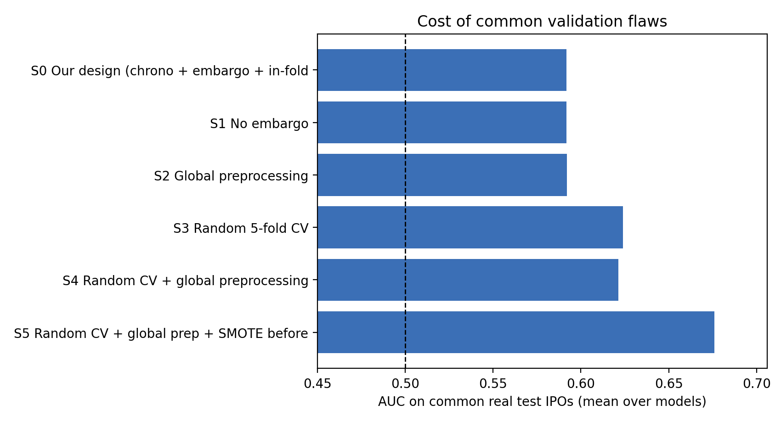
Figure 28. Mean AUC over models on the common set, by validation design.
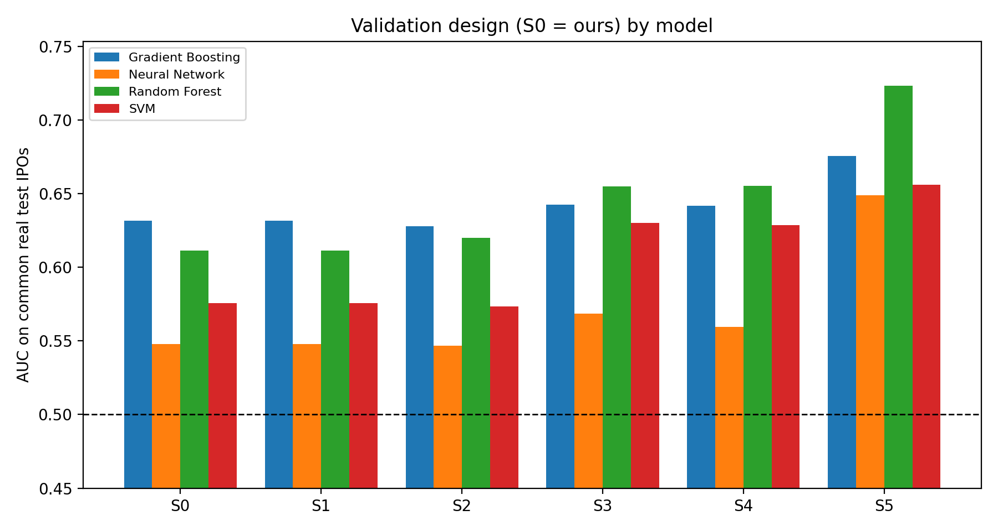
Figure 29. AUC by validation design and model.
Table 38. Inflation versus S0 with 95% paired bootstrap interval
model | scenario | delta vs S0 | delta ci low | delta ci high
Random Forest | S1 No embargo | 0.000 | 0.000 | 0.000
Random Forest | S2 Global preprocessing | 0.0085 | -0.0009 | 0.018
Random Forest | S3 Random 5-fold CV | 0.043 | 0.0006 | 0.087
Random Forest | S4 Random CV + global preprocessing | 0.044 | 0.0009 | 0.087
Random Forest | S5 Random CV + global prep + SMOTE before split | 0.112 | 0.073 | 0.156
Gradient Boosting | S1 No embargo | 0.000 | 0.000 | 0.000
Gradient Boosting | S2 Global preprocessing | -0.0036 | -0.017 | 0.0099
Gradient Boosting | S3 Random 5-fold CV | 0.011 | -0.027 | 0.052
Gradient Boosting | S4 Random CV + global preprocessing | 0.010 | -0.027 | 0.051
Gradient Boosting | S5 Random CV + global prep + SMOTE before split | 0.044 | 0.0060 | 0.085
SVM | S1 No embargo | 0.000 | 0.000 | 0.000
SVM | S2 Global preprocessing | -0.0022 | -0.020 | 0.016
SVM | S3 Random 5-fold CV | 0.055 | 0.010 | 0.099
SVM | S4 Random CV + global preprocessing | 0.053 | 0.0076 | 0.098
SVM | S5 Random CV + global prep + SMOTE before split | 0.080 | 0.036 | 0.126
Neural Network | S1 No embargo | 0.000 | 0.000 | 0.000
Neural Network | S2 Global preprocessing | -0.0010 | -0.031 | 0.025
Neural Network | S3 Random 5-fold CV | 0.021 | -0.025 | 0.066
Neural Network | S4 Random CV + global preprocessing | 0.012 | -0.034 | 0.056
Neural Network | S5 Random CV + global prep + SMOTE before split | 0.101 | 0.055 | 0.148

Table 39. AUC on each design’s own real test set (S1 also scores the embargoed January IPOs)
scenario | Gradient Boosting | Neural Network | Random Forest | SVM | mean over models
S0 Our design (chrono + embargo + in-fold prep) | 0.632 | 0.548 | 0.612 | 0.576 | 0.592
S1 No embargo | 0.621 | 0.537 | 0.607 | 0.581 | 0.587
S2 Global preprocessing | 0.628 | 0.547 | 0.620 | 0.573 | 0.592
S3 Random 5-fold CV | 0.619 | 0.569 | 0.635 | 0.611 | 0.608
S4 Random CV + global preprocessing | 0.618 | 0.563 | 0.635 | 0.609 | 0.606
S5 Random CV + global prep + SMOTE before split | 0.666 | 0.651 | 0.713 | 0.636 | 0.666

Table 40. S5: AUC a SMOTE-before-split paper would report (synthetic rows included in test folds)
model | auc own incl synthetic
Random Forest | 0.788
Gradient Boosting | 0.757
SVM | 0.648
Neural Network | 0.711

8.1 Reading the comparison
- Random CV: with identical models and parameters, moving from our chronological design to random 5-fold changes the mean AUC by +0.032. Random folds let the model learn from IPOs that happened after the ones it is tested on, which is not possible in practice.
- Global preprocessing: fitting preprocessing on all IPOs changes the mean AUC by +0.000 (chronological) and +0.030 versus S0 when combined with random CV.
- SMOTE before split: adding SMOTE before the split moves the mean AUC on real IPOs by +0.084; the figure a paper would report, which scores synthetic rows, is shown in the S5 table above.
- Embargo: the embargo removes test IPOs only, so on the common set S1 equals S0 by construction; its effect is visible only in the ‘own test set’ table.
- Caution: intervals that include zero mean the data cannot separate that flaw’s effect from noise; the point estimate is then not evidence of inflation. The magnitudes are specific to this dataset and default-parameter models.
Why our design is preferable: it matches deployment (train on the past, predict the future), isolates preprocessing and tuning from test data, avoids synthetic observations, and is validated by negative controls (label permutation ≈ 0.5, time-only control, integrity checks).

9 Limitations and interpretation
- Sample size and power. Test years contain few IPOs, so fold-level AUCs are noisy and the final test year may be a partial year. Rely on pooled estimates and their intervals.
- Binary target. The workbook records whether an IPO was underpriced, not the size of first-day return; magnitude and economic value are not assessed.
- Probabilities are not calibrated frequencies. Class weights shift predicted probabilities towards 0.5. Use them for ranking, or recalibrate on a validation block before using absolute probabilities.
- SHAP is not causal. It explains the fitted models, shares credit between correlated features, and depends on the background sample. Explanations are only as stable as the models.
- Multiple comparisons. Many models, feature sets and tests are reported; individual p-values are not adjusted.
- Regime change. IPO markets shift (for example 2020–2021). An expanding window averages across regimes; a rolling window or regime indicators could be examined.
- Ablation scope. Inflation estimates apply to this dataset and fixed default parameters; other data may differ in magnitude.
- Reproducibility. All random elements use fixed seeds (seed = 42); results can differ slightly across library versions.

Appendix A Tuned hyper-parameters
Table 41. Selected hyper-parameters per fold (ALL pillars)
fold | model | params
2016 | Random Forest | {'n_estimators': 200, 'max_depth': 8, 'min_samples_leaf': 10, 'max_features': 0.5}
2016 | Gradient Boosting | {'n_estimators': 200, 'max_depth': 2, 'learning_rate': 0.05, 'subsample': 1.0, 'min_samples_leaf': 5}
2016 | SVM | {'C': 100.0, 'gamma': 0.001}
2016 | Neural Network | {'hidden_layer_sizes': (16,), 'alpha': 0.001, 'learning_rate_init': 0.003}
2017 | Random Forest | {'n_estimators': 200, 'max_depth': 3, 'min_samples_leaf': 1, 'max_features': 0.5}
2017 | Gradient Boosting | {'n_estimators': 100, 'max_depth': 4, 'learning_rate': 0.03, 'subsample': 0.8, 'min_samples_leaf': 10}
2017 | SVM | {'C': 100.0, 'gamma': 0.1}
2017 | Neural Network | {'hidden_layer_sizes': (32,), 'alpha': 0.001, 'learning_rate_init': 0.01}
2018 | Random Forest | {'n_estimators': 400, 'max_depth': None, 'min_samples_leaf': 5, 'max_features': 1.0}
2018 | Gradient Boosting | {'n_estimators': 400, 'max_depth': 3, 'learning_rate': 0.03, 'subsample': 1.0, 'min_samples_leaf': 5}
2018 | SVM | {'C': 10.0, 'gamma': 0.01}
2018 | Neural Network | {'hidden_layer_sizes': (16,), 'alpha': 0.001, 'learning_rate_init': 0.003}
2019 | Random Forest | {'n_estimators': 400, 'max_depth': 3, 'min_samples_leaf': 1, 'max_features': 0.5}
2019 | Gradient Boosting | {'n_estimators': 100, 'max_depth': 3, 'learning_rate': 0.05, 'subsample': 0.6, 'min_samples_leaf': 3}
2019 | SVM | {'C': 10.0, 'gamma': 0.001}
2019 | Neural Network | {'hidden_layer_sizes': (64,), 'alpha': 0.01, 'learning_rate_init': 0.001}
2020 | Random Forest | {'n_estimators': 400, 'max_depth': 8, 'min_samples_leaf': 3, 'max_features': 'sqrt'}
2020 | Gradient Boosting | {'n_estimators': 100, 'max_depth': 2, 'learning_rate': 0.05, 'subsample': 0.6, 'min_samples_leaf': 3}
2020 | SVM | {'C': 100.0, 'gamma': 0.001}
2020 | Neural Network | {'hidden_layer_sizes': (16,), 'alpha': 0.1, 'learning_rate_init': 0.01}
2021 | Random Forest | {'n_estimators': 200, 'max_depth': 8, 'min_samples_leaf': 1, 'max_features': 'sqrt'}
2021 | Gradient Boosting | {'n_estimators': 400, 'max_depth': 4, 'learning_rate': 0.1, 'subsample': 0.6, 'min_samples_leaf': 3}
2021 | SVM | {'C': 100.0, 'gamma': 0.001}
2021 | Neural Network | {'hidden_layer_sizes': (16,), 'alpha': 0.001, 'learning_rate_init': 0.01}
2022 | Random Forest | {'n_estimators': 600, 'max_depth': 8, 'min_samples_leaf': 5, 'max_features': 'sqrt'}
2022 | Gradient Boosting | {'n_estimators': 100, 'max_depth': 3, 'learning_rate': 0.1, 'subsample': 0.6, 'min_samples_leaf': 1}
2022 | SVM | {'C': 100.0, 'gamma': 0.001}
2022 | Neural Network | {'hidden_layer_sizes': (32, 16), 'alpha': 0.001, 'learning_rate_init': 0.001}
2023 | Random Forest | {'n_estimators': 400, 'max_depth': 8, 'min_samples_leaf': 3, 'max_features': 1.0}
2023 | Gradient Boosting | {'n_estimators': 400, 'max_depth': 4, 'learning_rate': 0.01, 'subsample': 0.8, 'min_samples_leaf': 5}
2023 | SVM | {'C': 100.0, 'gamma': 0.001}
2023 | Neural Network | {'hidden_layer_sizes': (16,), 'alpha': 0.0001, 'learning_rate_init': 0.001}
2024 | Random Forest | {'n_estimators': 600, 'max_depth': 5, 'min_samples_leaf': 5, 'max_features': 1.0}
2024 | Gradient Boosting | {'n_estimators': 100, 'max_depth': 4, 'learning_rate': 0.01, 'subsample': 0.6, 'min_samples_leaf': 3}
2024 | SVM | {'C': 100.0, 'gamma': 0.001}
2024 | Neural Network | {'hidden_layer_sizes': (16,), 'alpha': 0.001, 'learning_rate_init': 0.01}
2025 | Random Forest | {'n_estimators': 400, 'max_depth': 8, 'min_samples_leaf': 10, 'max_features': 0.5}
2025 | Gradient Boosting | {'n_estimators': 400, 'max_depth': 3, 'learning_rate': 0.01, 'subsample': 0.6, 'min_samples_leaf': 10}
2025 | SVM | {'C': 10.0, 'gamma': 0.01}
2025 | Neural Network | {'hidden_layer_sizes': (64,), 'alpha': 0.0001, 'learning_rate_init': 0.001}
2026 | Random Forest | {'n_estimators': 600, 'max_depth': 3, 'min_samples_leaf': 3, 'max_features': 0.5}
2026 | Gradient Boosting | {'n_estimators': 200, 'max_depth': 4, 'learning_rate': 0.03, 'subsample': 1.0, 'min_samples_leaf': 5}
2026 | SVM | {'C': 1.0, 'gamma': 0.01}
2026 | Neural Network | {'hidden_layer_sizes': (32,), 'alpha': 0.01, 'learning_rate_init': 0.001}

Appendix B Output files
file | content
underpricing_results.xlsx | All metrics, tests, leakage checks, tuned parameters and out-of-sample predictions
preprocessed_data_by_fold.xlsx | Imputed/winsorized data each fold used, with fill values and bounds
shap_values_probability.xlsx / shap_report.html | SHAP values in probability units (global, pillar, yearly, per IPO)
descriptive_statistics_train_foldYYYY.xlsx | Descriptive tables from the chosen fold’s training rows
ablation_results.xlsx | Validation-flaw ablation tables
IPO_underpricing_report.docx | This report

