Parcel-Level Flood Risk and Structural Deprivation Assessment in Nairobi's Informal Settlements Using a Multi-Task Deep Learning System

[Internal Project]

Ochieng Emmanuel Amor
169765
ICS 4B

Supervisor Name
Mr. Kelvin Ouma

An Informatics and Computer Science Project Documentation Submitted to the School of Computing and Engineering Sciences in Partial Fulfilment of the Requirements for the Award of a Degree in Bachelor of Science in Informatics and Computer Science

School of Computing and Engineering Sciences
Strathmore University
Nairobi, Kenya

June 2026

Declaration and Approval
I declare that this work has not been previously submitted and approved for the award of a degree by this or any other university. To the best of our knowledge and belief, the research proposal contains no material previously published or written by another person except where due reference is made in the research proposal itself.

Student Name: Emmanuel Amor Ochieng
Admission Number: 169765
Student Signature: _________________________ Date:

The Documentation of Emmanuel Ochieng has been reviewed and approved by Mr. Kelvin Ouma.
Supervisor Signature: _________________________ Date:

Abstract
Seasonal floods in Nairobi's informal settlements of Kibera, Mathare, and Mukuru annually destroy homes, displace residents, and claim lives. These communities house over 60% of the city's population yet sit along flood-prone river corridors, leaving them acutely vulnerable. City authorities have responded either by demolishing entire riverside communities without assessing individual plot risk, or by doing nothing due to the absence of localised data. This study developed an Artificial Intelligence system that reads satellite imagery, terrain measurements, and infrastructure maps to assess both flood risk and housing deprivation at the individual plot level across all three settlements. Two models operate in parallel: one maps flood boundaries while the other evaluates housing conditions and access to water and sanitation against UN-Habitat standards. Their combined output generates a three-class policy recommendation per plot, covering land tenure security, targeted drainage investment, or compensated relocation, and delivers these through a browser-based interactive map that presents city planners and community groups with both the recommendation and the evidence behind it. The resulting system is a practical, evidence-based tool that moves Nairobi away from blunt evictions and inaction toward targeted, fair, and transparent governance decisions.
Keywords: Informal settlements, flood risk, artificial intelligence, satellite imagery, urban governance, housing deprivation, Nairobi, explainable AI, community resettlement

Table of Contents
Declaration and Approval ii
Abstract iii
List of Figures viii
List of Tables ix
List of Abbreviations x
Chapter 1: Introduction 1
1.1 Background Information 1
1.2 Problem Statement 2
1.3 Research Objectives 2
1.3.1 Aim 2
1.3.2 Specific Objectives 2
1.4 Research Questions 3
1.5 Justification 3
1.6 Scope 4
1.7 Limitations and Delimitations 5
1.7.1 Delimitations 5
1.7.2 Limitations 5
Chapter 2: Literature Review 6
2.1 Introduction 6
2.2 Current State of Geospatial Deep Learning and Multi-Hazard Risk Assessment in Urban Informal Settlements 6
2.3 Related Works: Existing Systems 8
2.3.1 FloodMap Kenya: SAR-Based Urban Flood Delineation Tool 8
2.3.2 Slum Upgrading Prioritisation Index (SUPI): Nairobi City County 9
2.3.3 OpenCities AI: Building Footprint Extraction for Disaster Risk 9
2.3.4 REACH Nairobi: Flood Risk and WASH Mapping Initiative 10
2.4 Gaps in Related Works 12
2.5 Theoretical Framework 13
2.6 Conceptual Framework 14
Chapter 3: Methodology 16
3.1 Introduction 16
3.2 Research Paradigm 16
3.2.1 Data Acquisition 16
3.2.2 Data Processing 17
3.2.3 Structural Deprivation Label Generation from the SUPI Framework 18
3.2.4 Model Training 19
3.2.5 Model Validation and Testing 21
3.3 System Development Methodology and Justification 22
3.3.1 Justification of the Methodology 23
3.4 Methodology Diagram 23
3.4.1 Prototype Planning 23
3.4.2 Initial Prototype Development 24
3.4.3 Iterative Refinement (Agile Sprints) 24
3.4.4 Testing 25
3.4.5 Final Prototype Evaluation 25
3.5 Analysis Diagrams 25
3.5.1 Use Case Diagram 26
3.5.2 Activity Diagram 26
3.5.3 Sequence Diagram 26
3.6 Design Diagrams 26
3.6.1 Class Diagram 27
3.6.2 System Architecture Diagram 27
3.6.3 Wireframes 27
3.7 Deliverables 28
3.7.1 Trained Multi-Task Deep Learning Model 28
3.7.2 Explainable AI Planning dashboard 28
3.7.3 System Documentation 28
3.8 Tools and Techniques 28
3.8.1 Python 3.11 29
3.8.2 PyTorch 2.x 29
3.8.3 PyTorch Geometric 29
3.8.4 Google Earth Engine API 29
3.8.5 Rasterio 29
3.8.6 GeoPandas and osmnx 29
3.8.7 Captum 29
3.8.8 SHAP 30
3.8.9 Folium 30
3.8.10 Google Colab Notebook 30
3.8.11 GitHub 30
Chapter 4: System Analysis and Design 28
4.1 Introduction 28
4.2 System Requirements 28
4.2.1 Functional Requirements 28
4.2.2 Non-Functional Requirements 29
4.2.3 Data Requirements 30
4.2.4 Interface and Integration Requirements 30
4.3 System Analysis Diagrams 31
4.3.1 Use Case Diagram 31
4.3.2 Sequence Diagram 32
4.3.3 Entity Relationship Diagram 33
4.3.4 Class Diagram 34
4.3.5 Activity Diagram 35
4.4 System Design Diagrams 36
4.4.1 Logical Data Storage Structure 36
4.4.2 Wireframes 37
4.4.3 System Architecture 39
Bibliography 41
Appendix xi
Appendix 1: Gantt Chart xi
Appendix 2: Similarity report xii

List of Figures
Figure ‎2.1 Conceptual Framework of the System 15
Figure ‎3.1 Agile Scrum methodology diagram 23
Figure ‎4.1 Use Case Diagram 32
Figure ‎4.2 Sequence Diagram 33
Figure ‎4.3 Entity Relationship Diagram 34
Figure ‎4.4 Class Diagram 35
Figure ‎4.5 Activity Diagram 36
Figure ‎4.6 Logical Data Storage Structure 37
Figure ‎4.7 Full Settlement Choropleth Map 38
Figure ‎4.8 XAI Summary Dashboard 39
Figure ‎4.9 System Architecture Diagram 40

List of Tables
Table 2.1 Comparative Analysis of Related Systems 10
Table 3.1 Data Sources and Their Roles in the Proposed System 17
Table 3.2 SUPI Indicators and Their Remote-Sensing Proxies 18

List of Abbreviations
ACTED - Agency for Technical Cooperation and Development
AI - Artificial Intelligence
API - Application Programming Interface
AUC-ROC – Area Under the Receiver Operating Characteristic Curve
CNN - Convolutional Neural Network
CRS - Coordinate Reference System
DEM - Digital Elevation Model
DSM - Digital Surface Model
EPSG - European Petroleum Survey Group
ESA - European Space Agency
GDAL – Geospatial Data Abstraction Library
GEE - Google Earth Engine
GFDRR - Global Facility for Disaster Reduction and Recovery
GIS - Geographic Information System
GNN - Graph Neural Network
GPU - Graphics Processing Unit
Grad-CAM - Gradient-weighted Class Activation Mapping
HEC-RAS – Hydrologic Engineering Centre’s River Analysis System
HTML - Hypertext Markup Language
I/O - Input / Output
IGAD - Intergovernmental Authority on Development
IPCC - Intergovernmental Panel on Climate Change
KISIP II - Kenya Informal Settlements Improvement Project II
LIME – Local Interpretable Model Agnostic Explanations
MSI - Multispectral Imagery
MTL - Multi-Task Learning
NASA - National Aeronautics and Space Administration
NCC - Nairobi City County
NRCC - Nairobi Rivers Regeneration and Conservation Committee
NRRP - Nairobi Rivers Regeneration Programme
OBIA - Object-Based Image Analysis
OOAD - Object-Orientated Analysis and Design
OSM - OpenStreetMap
SAR - Synthetic Aperture Radar
SHAP - Shapley Additive explanations
SRTM - Shuttle Radar Topography Mission
SUPI - Slum Upgrading Prioritisation Index
SVM - Support Vector Machine
TWI - Topographic Wetness Index
UAT - User Acceptance Testing
UML - Unified Modelling Language
UN - United Nations
UNEP - United Nations Environment Programme
UNICEF - United Nations International Children's Emergency Fund
VHR - Very-High-Resolution
WASH - Water, Sanitation, and Hygiene
WGS84 - World Geodetic System 1984
XAI – Explainable Artificial Intelligence

Introduction

Background Information
Urbanisation across sub-Saharan Africa has accelerated at a pace that outstrips the capacity of municipal governments to deliver formal housing, infrastructure and land-use planning. Nairobi exemplifies this structural tension acutely: an estimated 60% of its population resides within informal settlements that occupy less than 10% of the city’s residential land area (Un-Habitat, 2022). Settlements such as Kibera, Mathare and Mukuru have emerged as densely populated socioeconomic hubs over several decades, shaped by historical rural-urban migration, post-colonial land tenure inequities and the city’s sustained failure to expand affordable formal housing supply(Huchzermeyer, 2011).These communities are neither temporary nor marginal; they are entrenched, economically vital and home to millions of Nairobi’s residents.
A defining geographic constraint of Nairobi’s informal settlements is their concentration along environmentally hazardous terrain. Due to a combination of historical displacement from higher, drier land and the progressive occupation of lower-value plots, these communities are disproportionately situated in low-lying valley bottoms, on steep slopes and within active riparian plains along the Nairobi, Mathare and Ngong rivers (UNEP, 2015). This spatial configuration renders residents acutely vulnerable to climate-induced hazards, particularly seasonal flash flooding and associated secondary risks such as landslides, structural collapse, and waterborne disease outbreaks. As climate variability intensifies under global warming trajectories, the frequency and severity of such events are projected to increase significantly across East Africa (IPCC, 2023).
The discipline of geospatial analysis and remote sensing has evolved substantially over the past two decades, offering powerful tools for characterising complex urban environments. Early satellite-based mapping approaches relied on coarse-resolution imagery and manual classification, severely limiting their applicability at the sub-parcel scales required for informed urban planning in dense informal settlements (Kohli et al., 2012). More recent advances in very-high-resolution (VHR) satellite platforms, Synthetic Aperture Radar (SAR) imaging, and deep learning-based computer vision have begun to narrow this gap. Convolutional neural networks and their semantic segmentation variants, such as the U-Net architecture (Ronneberger et al., 2015), have demonstrated strong performance in extracting urban morphology, classifying land cover, and delineating flood extents from satellite imagery. Simultaneously, Graph Neural Networks (GNNs) have emerged as a promising paradigm for modelling spatial relational data, making them well-suited to capturing the networked topology of urban infrastructure and building adjacency in informal settlements (Wu et al., 2021).
This study framed urban risk assessment as two related but distinct prediction tasks operating over the same geographic parcels; Task one is a flood hazard segmentation and Task two is a prediction of housing deprivation severity from the settlement's building graph. Both tasks share the same downstream purpose of informing a single parcel-level policy decision and the same underlying settlements but require fundamentally different input, which motivates two independent model heads rather than a single shared-backbone network.

Problem Statement
Urban governance in Nairobi’s informal settlements ought to be guided by precise, localised and continuously updated multi-hazard geospatial data that enables city authorities to distinguish high-risk structures and plots from those that are safe, structurally sound and eligible for tenure security and upgrading investment.
In practice, however, the lack of integrated, dynamically updated and legally recognised multi-hazard geospatial data at this granularity drives this. First, city authorities frequently deploy blanket eviction policies applying rigid 30–60 metre riparian buffers without evaluating local elevation, topography or actual hazard exposure, resulting in the unnecessary displacement of communities residing on safe, elevated ground (Amnesty International, 2021). Second, the same data void produces systemic inaction: without localised engineering evidence, critical infrastructure upgrades such as paved storm drains and raised access pathways are indefinitely deferred, leaving thousands exposed to catastrophic flood events and secondary health hazards. Existing mapping approaches are manual, slow and unable to scale; they cannot keep pace with the rapid urban changes that continuously alter the risk landscape within these settlements.

Research Objectives

Aim
To develop a multi-task learning deep learning system for parcel-level flood hazard micro-zonation and structural deprivation assessment in Nairobi’s Kibera, Mathare, and Mukuru.

Specific Objectives
In pursuance of the general objective, the study aimed:
- To review the current state of geospatial deep learning and multi-hazard risk assessment in urban informal settlements.
- To analyse existing flood risk mapping and structural deprivation assessment systems applied to African informal settlements.
- To identify the critical gaps in existing urban risk assessment tools with respect to parcel-level spatial resolution and multi-hazard integration.
- To develop a multi-task deep learning framework integrating an Attention U-Net and a GraphSAGE neural network for structural indicator evaluation.
- To implement an explainable AI planning dashboard that presents parcel-level policy recommendations.

Research Questions
- What is the current state of geospatial deep learning for multi-hazard risk assessment in urban informal settlements, and what methodological gaps persist?
- How have existing flood risk mapping and structural deprivation assessment systems performed in African informal settlement contexts, and where do their limitations lie?
- What data inputs, model architectures and late-fusion decision strategies are most effective for predicting flood hazard and structural deprivation at a parcel level?
- How well can the suggested method categorise parcels in the target settlements into Retain and Formalise, Retain and Upgrade, or Compensated Resettlement categories?
- How can explainable AI techniques be integrated into the system’s outputs to make its recommendations interpretable to city planners?

Justification
Substantial progress has been made in applying remote sensing and machine learning to urban flood mapping in the Global South. Studies such as Mateo-Garcia et al. (2021) have demonstrated the viability of deep learning for rapid flood extent mapping from satellite imagery, while Kohli et al. (2012) established foundational frameworks for object-based image analysis in informal settlement characterisation. The UN-Habitat Slum Deprivation Framework provides established, internationally recognised indicators for assessing housing durability, infrastructure deficit, and overcrowding, which have been applied in city-level assessments of Nairobi (Un-Habitat, 2022). The Nairobi Rivers Regeneration Programme has further identified 37 high-risk riparian zones, providing a spatial baseline for hazard delineation (Nairobi Rivers Regeneration and Conservation Committee (NRCC), 2021).
Despite these advances, no existing system integrated hydrological flood hazard modelling with structural deprivation assessment at the parcel level across Nairobi’s informal settlements. Existing flood maps operate at spatial resolutions too coarse to differentiate safe elevated parcels from high-risk plots within the same settlement block. Structural deprivation assessments remain static, manually produced, and disconnected from hazard data. Critically, no tool at the time translated multi-hazard and deprivation data into automated, policy-actionable governance recommendations framed within the UN-Habitat and Nairobi City County regulatory context.

Scope
The study focused on the design, development and validation of a multi-task deep learning decision-support system, operating within the following defined boundaries:
Geographic Scope: The study is strictly bounded to the three informal settlements of Kibera, Mathare, and Mukuru within Nairobi County, Kenya. This focused scope ensures high-fidelity data acquisition, modelling, and validation without over-generalisation.
Technical Scope: The system integrated Sentinel-2 multispectral imagery, Sentinel-1 SAR inundation footprints, DEM-derived topographic wetness indexes, and OpenStreetMap vector layers, all freely accessible through Google Earth Engine at no subscription cost, processed through an attention U-Net and a graph neural network within a multi-task learning framework. The implementation stack utilised Python, PyTorch, PyTorch Geometric, Rasterio, GeoPandas, Google Earth Engine API, Captum, and SHAP, a consolidated single-ecosystem environment that eliminates the infrastructure overhead of a production database server and reduces cross-framework integration complexity.
Functional Scope: The system classified individual parcels into one of three policy recommendation categories (Retain and Formalise, Retain and Upgrade, Compensated Resettlement) and expose outputs through a Folium-based interactive web dashboard with XAI justifications. The system does not provide legal tenure adjudication, nor model long-term climate projections beyond historical inundation footprints.
Time Scope: The study was conducted over the 2026 academic year, with phases covering data acquisition and preprocessing, model development and training, validation, dashboard development and final evaluation and reporting.

Limitations and Delimitations

Delimitations
The following intentional boundaries were established to maintain the study’s focus and feasibility. The geographic scope is restricted to Kibera, Mathare, and Mukuru; other informal settlements in Nairobi and elsewhere are excluded. The study focused exclusively on flood and structural hazards; other hazard types such as fire risk or seismic vulnerability are outside its scope. The policy recommendation framework is bounded to three categories aligned with existing Nairobi City County and UN-Habitat governance structures, without extending to broader land reform or legislative processes. The model was trained on satellite and remotely sensed data; field-level primary data collection such as household surveys was excluded to maintain the system’s scalability and replicability. The dashboard interface was designed for planner and civil society use, not for direct public interaction.

Limitations
Several potential constraints on the validity and generalisability of findings are acknowledged. The availability and spatial resolution of historical SAR inundation data for Nairobi’s settlements was inconsistent across time periods, potentially affecting the accuracy of flood boundary predictions. Ground-truth validation data for informal settlement parcels was limited by the absence of comprehensive cadastral records, which may introduce uncertainty into model evaluation. The rapid pace of physical change in informal settlements meant that satellite imagery, even at high temporal resolution, cannot fully capture real-time structural changes. Computational resource constraints affected the scale of hyperparameter tuning and model optimisation achievable within the study timeframe. Finally, the model’s performance characteristics did not generalise without retraining to informal settlements in other geographic or climatic contexts.

Literature Review

Introduction
This chapter critically surveyed the scholarly literature underpinning the development of a multi-task learning (MTL) deep learning system for micro-zonation and risk assessment in Nairobi’s informal settlements. The review was organised thematically in alignment with the study’s specific objectives. Section 2.2 examined the current state of geospatial deep learning and multi-hazard risk assessment in urban informal settlements, identifying prevailing methodological approaches and their limitations. Section 2.3 surveyed and benchmarked existing systems and tools most closely related to this study’s proposed solution, drawing on applications across sub-Saharan African informal settlement contexts. Section 2.4 synthesised the persistent gaps that collectively define the knowledge deficit this research targets. Section 2.5 presented the conceptual framework, integrating insights from the reviewed literature into a theoretical and architectural model that guided the study’s design and development phases.

Current State of Geospatial Deep Learning and Multi-Hazard Risk Assessment in Urban Informal Settlements
The application of remote sensing to informal settlement characterisation has evolved through three broad methodological generations. The first, spanning the 1990s to mid-2000s, relied on manual photointerpretation, with Kohli et al. (2012) providing a foundational ontological framework for image-based slum classification whose spatial indicators include roof material texture, plot regularity, road network morphology and water body proximity continue to structure feature extraction in contemporary deep learning models. The second generation applied object-based image analysis (OBIA) and shallow machine learning classifiers to very-high-resolution (VHR) satellite imagery: Kit O, Lüdeke M (2019) achieved overall accuracies above 80% using texture-based SVM classification for settlement delineation, while Wurm et al. (2019) improved cloud-condition robustness by integrating Sentinel-1 SAR data with optical imagery in a Random Forest framework. The contemporary third generation leverages convolutional neural networks (CNNs) and semantic segmentation architectures, which Persello et al. (2022) confirmed consistently outperform prior OBIA approaches. Central to this study's architecture is the U-Net (Ronneberger et al., 2015), an encoder-decoder model extended by Oktay et al. (2018) with attention mechanisms that learn to suppress irrelevant feature activations; a property particularly valuable in the heterogeneous visual environments of informal settlements.
In the domain of flood risk prediction, Bonafilia et al. (2020) released the Sen1Floods11 benchmark dataset demonstrating that deep learning segmentation networks combining SAR and optical inputs substantially outperform traditional thresholding methods in complex urban flood delineation. Bates et al. (2021) further showed that fusing DEM derivatives specifically the Topographic Wetness Index (TWI), slope, and flow accumulation rasters with neural network classifiers yields significantly higher flash flood prediction fidelity than hydraulic models alone, a finding that directly informed this study's hydrological data pipeline. Despite these advances, a critical limitation persists across virtually all published flood deep learning studies: they operate at settlement or city scale and do not produce the parcel-level hazard gradients essential for evidence-based riparian buffer governance in densely packed informal settlements (Nairobi Rivers Regeneration and Conservation Committee (NRCC), 2021).
Graph Neural Networks (GNNs) address the complementary structural modelling challenge that CNNs cannot resolve. Wu et al. (2021) confirmed in a comprehensive survey that GNNs consistently outperform CNN-based and conventional spatial statistics approaches on graph-structured urban datasets. For informal settlements specifically, GNNs offer the ability to represent irregular building and plot adjacency as spatial graphs, conduct multi-scale neighbourhood message passing, and integrate heterogeneous feature types within a unified representational framework. Among these, GraphSAGE (Sample and Aggregate) stands out as the most used, scalable, and well-documented graph neural network for node classification tasks. By learning aggregators over localized neighbourhoods rather than training static embeddings on a fixed graph, GraphSAGE easily generalizes to unseen nodes, a crucial trait given the rapid, unpredictable layout shifts in urban slums. This architecture enjoys a strong precedent in the South African upgrading study by Peng et al. (2023), who demonstrated that graph-derived structural vulnerability scores were highly predictive of upgrading outcomes.
Underpinning the deployment of these parallel networks is multi-task learning (MTL) theory, where Caruana et al. (1997) established that optimizing a system for related tasks improves overall generalization. While early deep learning approaches attempted to force multi-task networks to share internal layers using "shared feature backbones" and complex "multi-objective gradient fusion" techniques (e.g., LIU et al., 2019), recent geospatial implementations show that such techniques introduce immense optimization overhead and gradient conflicts. To bypass these engineering bottlenecks while maintaining identical policy outputs, this system uses a late fusion strategy at the decision layer. Under this paradigm, the Attention U-Net and Graph SAGE models are trained completely independently. Their resulting probability distributions are combined directly within the final decision engine, resulting in a cleaner, vastly simplified implementation workflow. This design departs from the hard parameter-sharing form of multi-task learning that Caruana (1997) originally described, in which multiple tasks share most network weights through a common backbone. Ruder (2017) situates such shared-backbone designs as one point on a broader spectrum of multi-task architectures that also includes soft parameter sharing and decision-level (late) fusion, in which task-specific models remain fully independent and are combined only at the output stage. This study adopts the late-fusion end of that spectrum deliberately: because the raster segmentation task and the graph classification task operate over structurally incompatible input spaces, forcing them through a shared backbone would require an artificial common representation with no clear theoretical benefit and would additionally introduce the gradient-conflict optimisation difficulties documented by LIU et al. (2019). The multi-task framing is therefore retained at the level of the system with two related governance tasks solved and jointly interpreted through a single decision layer rather than at the level of shared network parameters.
Finally, as machine learning outputs are deployed within high-stakes governance processes, Explainable AI (XAI) remains an essential design requirement. Arrieta et al. (2019) established that black-box opacity constitutes a significant barrier to adoption in planning contexts. The integration of Grad-CAM to visualize spatial attention over the Attention U-Net flood boundaries and SHAP to attribute feature weights to the Graph SAGE-based structural deprivation indicators directly provides the transparency required to handle sensitive tenure and relocation frameworks.

Related Works: Existing Systems

2.3.1 FloodMap Kenya: SAR-Based Urban Flood Delineation Tool
FloodMap Kenya is a web-accessible flood monitoring platform developed through a collaboration between the Intergovernmental Authority on Development (IGAD) Climate Prediction and Applications Centre and the European Space Agency, providing near real-time flood extent maps for major Kenyan urban centres derived from Sentinel-1 SAR imagery. The platform applies change-detection algorithms to SAR backscatter time series, classifying pixels as flooded or non-flooded and publishing outputs as downloadable GeoTIFF rasters and web map layers.
The technology it uses includes Sentinel-1 SAR change detection, thresholding and Otsu’s method for binary flood classification. Spatial resolution: 10 metres. Update frequency: 2–6 days depending on satellite revisit schedule.
Performance validation against ground surveys during the 2021 Nairobi long rains season reported an overall accuracy of 78% and an F1-score of 0.71(71%) for urban flood pixels. Performance degraded significantly in densely built environments where building shadow and double-bounce SAR effects confound flood detection (IGAD, 2021).

2.3.2 Slum Upgrading Prioritisation Index (SUPI): Nairobi City County
The Slum Upgrading Prioritisation Index was developed by Nairobi City County in collaboration with UN-Habitat under the Kenya Informal Settlements Improvement Project II (KISIP II) framework to rank informal settlements for upgrading investment allocation. SUPI aggregates five UN-Habitat Slum Deprivation Framework indicators; housing durability, water access, sanitation access, overcrowding, and security of tenure into a composite score for each of Nairobi’s 136 gazetted informal settlement clusters (Nairobi Rivers Regeneration and Conservation Committee (NRCC), 2021).
It uses Composite index scoring from household survey data and administrative records. No remote sensing or machine learning components.
SUPI has been applied to guide capital allocation across three KISIP II investment tranches (2019–2023), with reported improvements in water access in 14 priority settlements. The index lacks a publicly reported predictive accuracy metric as it is an administrative prioritisation tool rather than a predictive model.

2.3.3 OpenCities AI: Building Footprint Extraction for Disaster Risk
OpenCities AI is an open-source initiative by the Global Facility for Disaster Reduction and Recovery (GFDRR) that applies deep learning to extract building footprints from VHR satellite imagery across selected African cities, including Kampala, Accra, and Dar es Salaam, for use in disaster risk assessment workflows. The project trained a U-Net-based segmentation model on manually labelled VHR imagery (0.3–0.5m resolution from Maxar), achieving high-precision building footprint polygons used to quantify building density, estimate population exposure, and support risk analytics.
The AI uses U-Net semantic segmentation on VHR optical imagery; training dataset of over 790,000 manually labelled building polygons across four cities. Post-processing with instance segmentation to individualise building footprints.
The performance of the model subject to IoU (Intersection over Union) scores of 0.76–0.82 for building footprint extraction across the four target cities, with performance variability driven by imagery resolution and settlement density. Manual quality review rated 88% of extracted footprints as usable for risk analytics (GFDRR, 2020).

2.3.4 REACH Nairobi: Flood Risk and WASH Mapping Initiative
REACH is a research programme implemented by the University of Oxford, UNICEF, and ACTED that has conducted multi-year flood risk and water, sanitation, and hygiene (WASH) infrastructure mapping in Nairobi’s informal settlements, with particular focus on Korogocho and Mathare. REACH’s Nairobi work combines high-resolution drone survey data, GPS-tracked field enumeration of WASH infrastructure, and hydrological modelling to produce flood hazard maps and WASH coverage deficiency maps at plot level within its target settlements (REACH, 2021).
It uses Drone-derived Digital Surface Models (DSMs) at 0.1-metre resolution, GPS field enumeration, and HEC-RAS hydrological modelling for flood boundary delineation.
REACH’s Mathare flood maps achieved parcel-level flood boundary accuracy validated against community flood recall surveys, with 85% agreement between model-predicted and community-reported flood extent boundaries. WASH coverage mapping provided the most granular published infrastructure deficit data available for any Nairobi informal settlement.
Table 2.1 Comparative Analysis of Related Systems
System | Geographic Scope | Spatial Resolution | Hazard Data | Deprivation Data | Policy Output | XAI
FloodMap Kenya | Nairobi city-wide | 10 m (SAR) | Binary flood extent | None | None | None
SUPI (KISIP II) | 136 settlement clusters | Cluster level | None | 5 UN-Habitat indicators (survey) | Investment ranking | None
OpenCities AI | Kampala, Accra, Dar es Salaam | 0.3–0.5 m | None | None | None | None
REACH Nairobi | Korogocho, parts of Mathare | 0.1 m (drone) | HEC-RAS flood model | WASH infrastructure only | None | None
Proposed System (This Study) | Kibera, Mathare, Mukuru (parcel level) | 10m–30m (Sentinel-2 + Sentinel-1 SAR mapped to sub-metre OSM building vectors) | Probabilistic flash-flood gradient (Attention U-Net) | 5 UN-Habitat indicators via Graph SAGE (satellite-derived) | 3-class parcel policy matrix (Late Fusion Decision Engine) | Grad-CAM + SHAP via Folium dashboard
Note. GEE = Google Earth Engine; SAR = Synthetic Aperture Radar; WASH = Water, Sanitation, and Hygiene; XAI = Explainable Artificial Intelligence; SUPI = Slum Upgrading Prioritisation Index; KISIP = Kenya Informal Settlements Improvement Project; OSM = Open Street Map.

Gaps in Related Works
A critical synthesis of the four reviewed systems reveals five persistent and intersecting limitations that collectively define the knowledge deficit this study addresses. The most consequential of these is the universal absence of parcel-level spatial granularity. FloodMap Kenya's 10-metre resolution conflates multiple plots within a single pixel in Nairobi's densest settlement blocks; SUPI produces only cluster-level deprivation scores; and while OpenCities AI ingests sub-metre imagery, it performs footprint extraction alone without downstream risk classification. Only REACH Nairobi approaches parcel-level resolution, but through drone surveys is too resource-intensive to sustain at operational scale. This spatial coarseness is directly linked to the governance failures identified in the problem statement, since blanket eviction policies emerge precisely because no system can currently identify which specific plots within a riparian buffer are genuinely hazardous and which are not (Amnesty International, 2021).
Compounding this is a fundamental disciplinary disconnection: none of the reviewed systems simultaneously models hydrological flood hazard and structural deprivation. FloodMap Kenya and REACH Nairobi address hazard exclusively; SUPI addresses deprivation exclusively; OpenCities AI addresses neither in a risk context. This separation makes evidence-based Retain versus Relocate governance decisions impossible, since a settlement with high deprivation scores on safe ground warrants in-situ upgrading, while one with low deprivation scores in an acute flood zone requires compensated resettlement, a distinction that demands simultaneous assessment of both dimensions at matching spatial resolution. Beyond the absence of integrated data, all reviewed systems share a further limitation: they produce geospatial data products, but none translates these into automated governance recommendations aligned with operational policy frameworks. The Nairobi Rivers Regeneration Programme's 37 high-risk zones represent the closest approximation, yet these remain coarse, manually produced polygons with no structural deprivation dimension and no mechanism for continuous algorithmic updating (Nairobi Rivers Regeneration and Conservation Committee (NRCC), 2021).
The reviewed systems are also constrained by scalability and sustainability challenges. Approaches that achieve meaningful spatial resolution depend on either manual field enumeration or drone acquisition, neither of which supports the continuous update cycles required to track the rapid physical transformations across Kibera, Mathare, and Mukuru settlements, which collectively house an estimated 750,000 to one million residents (Mulesi et al., 2026).Finally, none of the four systems incorporates XAI mechanisms, an absence that in the governance context of Nairobi's informal settlements constitutes not merely a technical shortcoming but an ethical and political failing. Communities in these settlements have historically experienced data-justified displacement without evidence transparency or meaningful consultation (Arrieta et al., 2019); city planners, community organisations, and affected residents therefore require the ability to understand, question, and contest the basis of risk classifications affecting their tenure and livelihoods. The integration of Grad-CAM to visualize spatial attention over the Attention U-Net flood boundary predictions and SHAP to attribute feature weights to the GNN-based structural deprivation indicators directly addresses this gap.

Theoretical Framework
The deep learning workflow in this study relied on five core theoretical pillars. Together, these theories justify why specific models were selected for each stage of the flood mapping pipeline:
Spatial Feature Extraction (U-Net): Convolutional networks are uniquely suited for imagery because they recognize visual patterns (like a flooded roof) regardless of where they appear in a frame. By using a U-Net encoder-decoder structure, the model builds a hierarchy of features moving from simple textures to complex settlement-scale contexts before generating a pixel-by-pixel map. (Ronneberger et al., 2015). This dense, per-pixel approach is far more accurate for mapping fluid flood boundaries than a standard box or patch-based classifier.
Targeted Attention Gates: To prevent the model from becoming overwhelmed by urban clutter, attention gates are introduced (Oktay et al., 2018). These gates act as a filtering mechanism, automatically suppressing irrelevant background noise (like non-flooded structures) and focusing computational energy strictly on the water. This significantly narrows the model's search space, which is vital in visually chaotic informal settlements where floodwaters may only occupy a small fraction of the image.
Transfer Learning: Training a complex model from scratch requires massive amounts of data. Transfer learning solves this by reusing foundational visual features (like shapes and boundaries) already learned from a massive, global flood dataset (Sen1Floods11) (Bonafilia et al., 2020). By pre-training the model's encoder on global data and only training the attention and decoder layers from scratch, the system achieves high accuracy despite the scarce amount of labelled local data available in Nairobi.
Dynamic Graph Learning (GraphSAGE): GraphSAGE is selected over alternative models (like Graph Convolutional Network and Graph Attention Network) for two key reasons; One is dynamic adaptability as it is an inductive model, meaning it learns generalizable rules based on how neighbouring structures relate to one another rather than learning a fixed layout (Hamilton et al., 2017). This allows it to adapt instantly to new or modified buildings in rapidly changing settlements without requiring the entire model to be retrained from scratch and two, it is scalable as it uses neighbourhood sampling to easily process tens of thousands of structures at once, avoiding the heavy mathematical bottlenecks that slow down traditional graph networks.
Multi-Task Learning: This principle states that training a system to solve related tasks simultaneously improves its overall performance and generalizability, as the different tasks effectively keep each other in check (Caruana, 1997; Ruder, 2017). The architecture leverages this concept by strategically deciding where models share structural components and where they remain independent, creating a more robust final output

Conceptual Framework
The conceptual framework organised the system into three tiers: inputs, processing, and outputs. At the input tier, four Google Earth Engine-accessible data streams (Sentinel-2 optical imagery, Sentinel-1 SAR imagery, SRTM-derived terrain indices, and OpenStreetMap vector layers) are grouped into two feature sets according to which processing head consumes them: a raster feature set (Sentinel-1, Sentinel-2, SRTM/TWI) fed the flood hazard head, and a graph feature set (OSM building/plot topology and infrastructure proximity) fed the structural deprivation head.
At the processing tier, the Attention U-Net converts the raster feature set into a hyper-local flood probability surface which is the first task, while GraphSAGE converts the graph feature set into a node-level deprivation severity score which is the second task. The two heads are trained independently, and their outputs are combined only at a late-fusion decision layer, which applies a rule-based policy matrix.
At the output tier, the fused result is a single parcel-level policy classification, accompanied by its XAI attribution (Grad-CAM for the flood head, SHAP for the deprivation head), and rendered through the Folium dashboard.
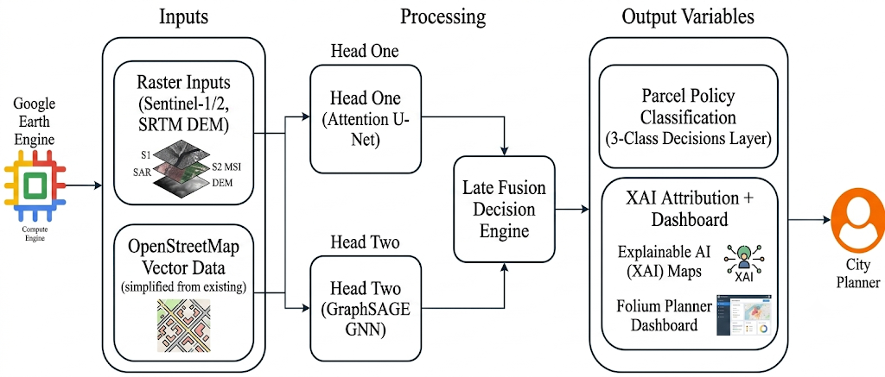
Figure ‎2.1 Conceptual Framework of the System

Methodology

Introduction
This chapter presents the methodological framework that governed the design, development, and validation of the proposed multi-task deep learning system for flood risk micro-zonation and structural deprivation assessment in Nairobi’s informal settlements. The study is positioned as an experimental, data-driven AI research project and accordingly adopts an Object-Oriented Analysis and Design (OOAD) paradigm to guide system modelling, as OOAD supports modular, iterative construction of independent components precisely the architecture required when training and validating two distinct neural network heads before combining them at the decision layer.

Research Paradigm
This project adopted an experimental research paradigm, in which hypotheses are validated through controlled data collection, model training, and quantitative performance evaluation. Unlike traditional software engineering projects, which centre on requirements capture and system design, AI-driven projects such as this one are defined by their data pipeline and model behaviour. The core experimental loop involved defining measurable objectives, acquiring and preprocessing geospatial datasets, training and tuning machine learning models, and evaluating their outputs against ground-truth benchmarks. The following subsections describe how each stage of this paradigm is applied to the present study.

Data Acquisition
This project acquired all geospatial datasets for free via Google Earth Engine (GEE), eliminating data subscription costs. The study integrates four primary data streams to evaluate conditions across Kibera, Mathare, and Mukuru:
Sentinel-2 Imagery (10m): A two-year (2023–2025) dry-season median composite minimized cloud cover and temporal noise. Visible, near-infrared, and shortwave-infrared bands are used to classify building materials, roof conditions, and vegetation.
Sentinel-1 SAR Imagery (10m): Active radar captures structural signatures in shadowed areas. Applying Otsu's thresholding to a 2019–2024 rainy season time series generated historical inundation footprints, which serve as training labels for the Attention U-Net.
SRTM DEM & TWI (30m): The 30-metre Digital Elevation Model yields slope and flow accumulation. These layers are used to calculate the Topographic Wetness Index, encoding the terrain's natural vulnerability to flood accumulation.
OpenStreetMap Vector Layers: Road networks, drainage, water points, and building footprints were extracted using Python via the OSM Overpass API. Leveraging extensive local mapping data, these vectors define infrastructure deficit edges in the GraphSAGE spatial graph based on distance metrics.
Table 3.1 Data Sources and Their Roles in the Proposed System
Dataset | Source | Resolution | Cost | Role
Sentinel-2 MSI | ESA / GEE | 10 m | Free | Optical spectral features for building classification, land cover, UN-Habitat indicators
Sentinel-1 SAR | ESA / GEE | 10 m | Free | Historical flood inundation labels and structural scattering features
SRTM DEM + TWI | NASA / GEE | 30 m | Free | Terrain-derived flood susceptibility (slope, flow accumulation, TWI)
OpenStreetMap vectors | OSM | Vector | Free | Graph edges: infrastructure proximity, drainage, water points, road network
Note. GEE = Google Earth Engine; ESA = European Space Agency; NASA = National Aeronautics and Space Administration; OSM = OpenStreetMap; MSI = Multispectral Imagery; SAR = Synthetic Aperture Radar; SRTM = Shuttle Radar Topography Mission; DEM = Digital Elevation Model; TWI = Topographic Wetness Index.

Data Processing
Each preprocessing step was chosen to address a specific data-quality risk. Band normalisation to the [0,1] range was applied because neural network optimisation via gradient descent converges more reliably when input features share a common scale, preventing bands with naturally larger numeric ranges (e.g., SAR backscatter) from dominating the loss gradient. Tiling into 256×256 patches with 50-pixel overlap balances two competing constraints: tiles must be small enough to fit GPU memory during training on the Colab T4 environment, while the overlap ensures flood boundary continuity is not lost at tile edges. Discarding low-data patches prevented the model from learning spurious patterns from mostly empty inputs. Flip and rotation augmentation is applied specifically to the raster stream to encode rotational and reflective invariance, since flood extent has no canonical orientation which will artificially expand the effective training set without additional data acquisition cost.

Structural Deprivation Label Generation from the SUPI Framework
Because the GraphSAGE head performs supervised node classification, every building node required a structural deprivation label. These labels were derived from the five indicators of the UN-Habitat Slum Deprivation Framework as operationalised by Nairobi City County's Slum Upgrading Prioritisation Index (SUPI): housing durability, water access, sanitation access, overcrowding and security of tenure. Because the study deliberately excluded household surveys to preserve scalability and reproducibility (Section 1.7), each SUPI indicator was approximated by a remotely sensed or vector-derived proxy computed for every building, as summarised in Table 3.2.
Table 3.2 SUPI Indicators and Their Remote-Sensing Proxies
SUPI indicator | Proxy feature(s) used | Data source | Direction of deprivation
Housing durability | Roof-material class from Sentinel-2 visible/NIR/SWIR reflectance and texture (durable iron/tile vs. temporary plastic/thatch roofs) | Sentinel-2 | Non-durable roofing → higher deprivation
Water access | Distance from the building to the nearest mapped improved water point | OpenStreetMap | Greater distance → higher deprivation
Sanitation access | Distance to the nearest mapped toilet/sanitation facility and to the drainage network | OpenStreetMap | Greater distance → higher deprivation
Overcrowding | Building footprint area per structure and local building density (footprints per unit area) | OSM footprints / Sentinel-2 | Smaller area & higher density → higher deprivation
Security of tenure | Distance to a paved/formal road, plot-layout regularity, and position relative to the riparian buffer | OSM / SRTM | Informal access, irregular layout, riparian location → higher deprivation
Each proxy was first cleaned and normalised to a common 0–1 scale so that indicators measured in different units (metres, square metres, reflectance) were directly comparable, with the orientation of every indicator fixed so that a higher value always denotes greater deprivation. Following the SUPI methodology, the five normalised indicator scores were then combined into a single composite deprivation index per building through a weighted linear sum; equal weighting was adopted as the default, with the weights isolated as configurable parameters so that they can be recalibrated to match the official SUPI weighting for a given policy cycle. The continuous composite index was finally discretised into the three ordinal deprivation severity classes used as node labels, namely Low, Moderate and Severe deprivation, by applying fixed cut-offs on the composite score (defaulting to tercile boundaries, i.e. the 33rd and 66th percentiles across all buildings in the study area). These three classes are the categories the GraphSAGE network was trained to predict, and they supply the deprivation dimension of the late-fusion policy matrix. Fixing the indicator set, the normalisation, the weighting and the class cut-offs in this way makes the labelling transparent and reproducible, and it is the same set of features that the SHAP analysis later attributes when explaining each node's predicted class.

Model Training
The two model heads are trained independently, consistent with the late-fusion design. This independence allows each model to be debugged, evaluated, and optimised without the risk of cross-model gradient interference.
For the Attention U-Net flood head, training proceeded via transfer learning. Pre-trained encoder weights from the Sen1Floods11 baseline model (Bonafilia et al., 2020), which was trained on Sentinel-1 SAR flood data from eleven global events, were used to initialise the network’s contracting path. Only the decoder layers and attention gate parameters was trained from random initialisation, substantially reducing the labelled data requirement and accelerating convergence. The model was trained using the Adam optimiser with an initial learning rate of 1 × 10⁻³, decayed using a cosine annealing schedule. The loss function is a weighted combination of binary cross-entropy and Dice loss to handle the class imbalance between flooded and non-flooded pixels. Training was run on 5-fold cross-validation, with each fold preserving spatial contiguity to avoid data leakage across overlapping tiles.
The Attention U-Net produced its output as a dense, pixel-level prediction rather than a single label per image. For every 256×256 input tile, the network's decoder reconstructed a full-resolution map in which each pixel was assigned, through a final sigmoid activation, a flood probability between 0 and 1 estimating the likelihood of that 10-metre ground cell being inundated. The attention gates on the decoder skip-connections weighted the encoder features so that hydrologically relevant regions contributed more strongly to each pixel's prediction than background clutter such as dry roofing or vegetation. Because the tiles were generated with a 50-pixel overlap, the per-tile probability maps were then stitched back into a single continuous flood-probability raster for each settlement, with the overlapping margins averaged to remove discontinuities at tile boundaries. The output of this stage was therefore a seamless, settlement-wide raster surface of per-pixel flood probabilities aligned to the WGS84 grid.
This pixel-level surface was subsequently converted into a single building- or parcel-level flood hazard measure through zonal aggregation against the OSM footprint polygons that defined the parcels. For each parcel, its footprint geometry, extended by a small fixed buffer (taken here as five metres to capture floodwater reaching the structure's immediate perimeter), was overlaid on the flood-probability raster, and the probabilities of all pixels falling inside that zone were summarised into one scalar flood hazard score for the parcel. The mean pixel probability within the zone was used as the primary parcel flood hazard value because it is robust to individual noisy pixels, while the maximum was retained as a secondary indicator of worst-case exposure. This aggregated per-parcel probability is the flood_probability attribute stored in the FloodPrediction entity, and it is the value the late-fusion decision engine consumed alongside the GraphSAGE deprivation output. The conversion from a continuous pixel surface to a per-parcel scalar is thus the step that makes the segmentation output directly comparable with the graph model's node-level output and usable for parcel-level policy classification.
For the Graph SAGE structural deprivation head, a two-layer Graph SAGE network with mean aggregation was trained for node-level multi-class classification across the three deprivation severity categories derived from the SUPI framework, as described in the preceding subsection. The model was trained using the Adam optimiser with an initial learning rate of 5 × 10⁻³ and L2 weight decay of 5 × 10⁻⁴ to regularise against graph overfitting. The building nodes were divided into training, validation and test sets in a 60/20/20 ratio, but because the nodes form a spatial graph in which GraphSAGE aggregates features from each node's local neighbourhood, the split was constructed spatially rather than by sampling individual nodes at random. Each settlement graph was first partitioned into contiguous spatial blocks, and whole blocks, rather than individual buildings, were assigned to the training, validation or test set, so that a building and its immediate neighbours almost always fell within the same split. To prevent information from flowing across split boundaries during neighbourhood aggregation, edges connecting nodes in different splits were removed and a one-hop buffer of boundary nodes was excluded from the evaluation sets, so that no test node could receive messages originating from training nodes and vice versa. Block assignment was stratified so that each of the three deprivation classes remained proportionally represented across the three splits, controlling for class imbalance while still respecting spatial separation.
Once both models were independently trained and their validation performance was confirmed, the late-fusion decision engine is constructed. For each parcel, the U-Net outputs a flood hazard probability score and the Graph SAGE network outputs a deprivation severity class probability vector. These two probability distributions were concatenated and passed to a lightweight rule-based classification matrix that assigned each parcel to one of the three governance categories: Retain and Formalize, Retain and Upgrade, or Compensated Resettlement.
The Attention U-Net was selected over a plain U-Net and a patch-based CNN classifier because flood boundary delineation is a dense prediction problem: policy decisions require knowing where on a parcel flooding occurs, which rules out image-level classifiers. The attention-gated variant was further preferred over a standard U-Net because informal settlement imagery contains substantial non-flood visual clutter (dense roofing, vegetation, shadow), and the attention gates provided a mechanism, evaluated through the training loss and Grad-CAM inspection, for verifying that the network was attending to hydrologically relevant regions rather than spurious correlates.

Model Validation and Testing
Two distinct validation strategies were used because the two heads have different data structures, but both were designed around the same principle of preventing spatial information from leaking between the data used to train a model and the data used to evaluate it. The Attention U-Net used 5-fold cross-validation with folds constrained to preserve spatial contiguity, that is, entire spatial blocks (not individual overlapping tiles) were assigned wholesale to a single fold, because standard random tile-level splitting would allow overlapping tiles to appear in both the training and validation sets and produce an inflated, overly optimistic accuracy estimate through spatial data leakage. The GraphSAGE head required an analogous safeguard rather than a simple random split: because it is a spatial graph model whose prediction for a node depends on messages aggregated from that node's neighbours, a purely random 60/20/20 node split would let a test building's features propagate into the training set through shared neighbours, and would place directly adjacent buildings on opposite sides of the split, so that near-identical, spatially autocorrelated structures would appear in both the training and test data. To avoid this, the GraphSAGE split was spatially blocked: contiguous blocks of buildings were assigned wholesale to a single split, cross-split edges were removed, and a boundary buffer was masked out before evaluation, so that neighbourhood aggregation never mixed training and test information. Stratification by deprivation class was then applied on top of this spatial blocking to control the additional class-imbalance risk that arises when the minority Severe-deprivation class is unevenly distributed across the settlement.
The two evaluation metrics were chosen to match each task's error characteristics. The Attention U-Net was evaluated on F1-score (with a ≥0.75 threshold) because flood versus non-flood pixels was highly imbalanced (flooded pixels are typically a minority class within any given tile), and F1 balances precision and recall better than raw accuracy under this imbalance. The GraphSAGE head was evaluated on macro-F1 (with a ≥0.70 threshold) rather than micro-F1 or accuracy because macro-F1 weights all three deprivation severity classes equally regardless of how many parcels fall into each class, which was important given that the "Compensated Resettlement" category was expected to be a minority class relative to "Retain and Formalise.

System Development Methodology and Justification
This project used Agile Scrum combined with iterative prototyping. Agile is ideal for AI development because machine learning performance is highly uncertain at the start and requires empirical experimentation (Schwaber & Sutherland, 2020). Development was organized into two-week sprints, allowing the data pipeline, U-Net flood head, GraphSAGE deprivation head, late-fusion decision engine, and Folium dashboard to be built, tested, and refined before final integration.
Prototyping mitigates risk by validating individual neural networks before merging their outputs into the fusion engine. For instance, testing a U-Net prototype on a small Kibera subset within a single sprint verifies transfer-learning convergence before committing computational resources to the full dataset. This evidence-based progression matches successful geospatial AI deployment workflows found in contemporary literature (Persello et al., 2022).

Justification of the Methodology
Agile Scrum is selected to facilitate iterative optimization of AI models, enabling measurable improvements through structured, feedback driven development cycles. Object-Oriented Analysis and Design (OOAD) is employed to align the system’s modular components such as the data pipeline and model wrappers with the architecture of PyTorch and PyTorch Geometric, resulting in precise system documentation.

Methodology Diagram
The prototyping model, embedded within the Agile Scrum framework, governs the development cycle of this project. Figure 3.1 presents the prototyping lifecycle adapted for this study.
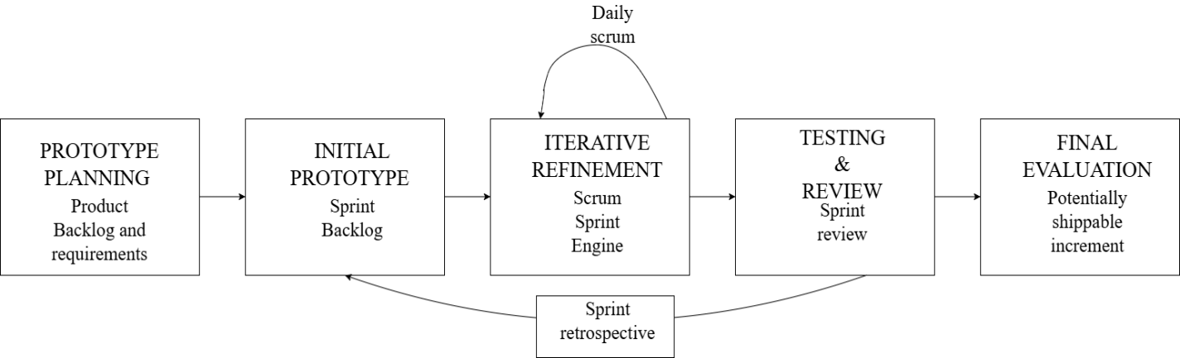
Figure ‎3.1 Agile Scrum methodology diagram
The following subsections describe how each stage of the prototyping lifecycle is applied to the proposed system.

Prototype Planning
System requirements were derived from established secondary frameworks including the UN-Habitat Slum Deprivation Framework, the Nairobi Rivers Regeneration Programme's (NRRP) 37 high-risk designations, and the Sen1Floods11 dataset documentation to govern the spatial, architectural, and input formats of the models. The initial development milestone targeted a functional, end-to-end Minimum Viable Product (MVP) pipeline across a 5 km² sub-area of Kibera. This baseline pipeline validates raw Google Earth Engine data ingestion, pre-trained Attention U-Net inference, and an initial graph construction pass through an untrained GraphSAGE network to confirm code execution paths before model training.

Initial Prototype Development
The development approach was iterative and incremental, following OOAD principles. Each system component was designed as a Python class with defined inputs, outputs, and responsibilities. The core classes include: a Data Pipeline class responsible for GEE queries, raster preprocessing, and graph construction; an Attention U Net class wrapping the PyTorch model with methods for training, inference, and Captum XAI extraction; a GraphSAGE Model class wrapping the PyTorch Geometric model with equivalent methods; a Fusion Engine class that accepts the probability outputs of both models and applies the policy classification matrix; and a Dashboard Renderer class that serialises all outputs to a Folium HTML file with embedded SHAP charts.

Iterative Refinement (Agile Sprints)
The six sprints span twelve weeks in sequential two-week cycles. The first sprint covers weeks one and two and focused on data pipeline validation, confirming that all four data sources comprising Sentinel-2, Sentinel-1 SAR, SRTM DEM, and OSM vectors can be acquired, pre-processed, and stored correctly for all three settlements, with the deliverable being a validated multi-band GeoTIFF stack and a serialised PyTorch Geometric graph for Kibera. The second sprint across weeks three and four established the U-Net transfer learning baseline by fine-tuning the Sen1Floods11 pre-trained U-Net on the Kibera flood mask labels, targeting a trained model with an IoU of at least 0.60 on the Kibera validation fold to confirm that transfer learning is converging. Weeks five and six constitute the third sprint, in which the two-layer Graph SAGE network is trained on the Kibera deprivation node labels with a target macro-F1 of at least 0.60 on the validation split. The fourth sprint in weeks seven and eight extends both model heads to Mathare and Mukuru through retraining or fine-tuning on the full three-settlement dataset, producing validated models for all three settlements that meet the minimum performance thresholds defined in Section 3.2.5. During weeks nine and ten, the fifth sprint integrates both model outputs into the Fusion Engine class and validates the three-class parcel outputs against the NRRP high-risk zone reference polygons, delivering a policy-classified parcel layer covering all three settlements. The sixth and final sprint in weeks eleven and twelve completes XAI integration and dashboard development by generating Grad-CAM maps via Captum and SHAP charts for the Graph SAGE head, rendering all outputs in the interactive Folium dashboard to produce a functioning, locally hosted interface with drill-down XAI panels.

Testing
The multi-tier validation strategy spanned code verification, quantitative model audits, and expert interpretability evaluation. Unit testing covered the TWI derivation script and the graph-construction routine that converts OSM building footprints into PyTorch Geometric node objects, checking specifically for disconnected subgraphs and incorrectly thresholder adjacency edges (buildings wrongly linked or missed at the 15-metre proximity cut-off), since these errors propagate silently into GraphSAGE's neighbourhood-aggregation step without raising a runtime exception. Integration testing confirmed that both model heads correctly consume the outputs of the Data Pipeline class such as raster tensors for the Attention U-Net and serialized graph objects for GraphSAGE and that their independent outputs were correctly shaped for the Fusion Engine. End-to-end system testing runs a full inference pass on a held-out settlement tile. Quantitative auditing evaluates the U-Net against IoU and Dice thresholds and GraphSAGE against macro-F1 and per-class recall catching majority-class bias toward the largest deprivation category, while robustness testing includes black-box analysis of noisy SAR scenes for the U-Net and adversarial node-feature perturbation for GraphSAGE, alongside white-box inspection of attention gates via Captum. Simulated UAT with expert evaluators then assesses dashboard interpretability, following the Arrieta et al. (2019) framework.

Final Prototype Evaluation
The final prototype evaluation assessed whether the completed system meets the project’s performance thresholds, deliverable criteria, and governance alignment objectives before the study is considered complete. Success was measured against three criteria. First, quantitative: both model heads must meet or exceed the minimum performance thresholds stated in Section 3.2.5. Second, functional: the Folium dashboard must successfully render a policy-classified parcel map with XAI overlays for all three settlements without error. Third, interpretive: the XAI outputs must pass the simulated UAT review, with the independent reviewer correctly identifying the policy basis for at least five sampled parcel classifications using only the dashboard’s visual explanation panels.

Analysis Diagrams
The following diagrams support the system analysis phase of the OOAD paradigm. They define the functional requirements and interaction sequences of the proposed system from the perspective of its actors and use cases. All diagrams were drawn in accordance with the Unified Modelling Language (UML) standard.

Use Case Diagram
The Use Case Diagram identified the primary actors of the system and the functional use cases they interact with. The two primary actors are the City Planner who accesses the Folium dashboard to view policy recommendations and XAI justifications for individual parcels and the System Administrator, who triggers the data pipeline and model inference runs. Secondary actors include the Google Earth Engine API (data provider), the OSM Overpass API (vector data provider), and the PyTorch model training environment. The core use cases are: Acquire Geospatial Data, Preprocess Raster and Graph Data, Train Attention U-Net, Train Graph SAGE, Run Late-Fusion Decision Engine, Generate XAI Outputs, and Render Folium Dashboard.

Activity Diagram
The Activity Diagram mapped the end-to-end workflow of the system from data acquisition to dashboard output, showing decision points, parallel processing branches, and the sequence of actions across the data pipeline, model training, and output generation stages. The parallel branch at the model training stage explicitly shows the Attention U-Net and GraphSAGE training occurring independently before their outputs converge at the late-fusion decision engine a structural representation of the late-fusion architecture described in Section 3.2.4.

Sequence Diagram
The Sequence Diagram illustrated the temporal order of method calls and data exchanges between system components during a single inference run that is, when the trained models are applied to generate the policy classification map for a new settlement area. The sequence begins with the Data Pipeline object querying GEE and osmnx, proceeds through tensor and graph construction, passes data to both model objects for forward inference, feeds outputs to the Fusion Engine, and concludes with the Dashboard Renderer serialising the output HTML file. This diagram is particularly important for validating the correctness of the late-fusion integration logic.

Design Diagrams
The following diagrams address the system design phase, specifying the internal structure of the software components and the overall architecture within which they operate.

Class Diagram
This system relied on five core Python classes built on compositional relationships rather than inheritance, maintaining a modular late-fusion architecture. The system was built around five Python classes. The Data Pipeline class queries the GEE and OSM Overpass APIs, preprocesses raster stacks, and serialises PyTorch Geometric graph objects, with a single class structure enforcing strict input/output contracts between the data layer and both model heads. The Attention U-Net class wraps the PyTorch encoder-decoder model for training, sliding-window inference, and Grad-CAM extraction, while the GraphSAGE model class wraps the PyTorch Geometric network for graph loading, node-level classification, and SHAP value extraction. The Fusion Engine class concatenates the probability vectors from both model heads and applies a rule-based policy matrix to assign a final governance category, with this logic deliberately isolated into a standalone class so that policy thresholds can be adjusted for different cities without modifying trained weights. Finally, the Dashboard Renderer class serialises classifications, Grad-CAM overlays, and SHAP charts into a self-contained Folium HTML file with embedded Leaflet.js.

System Architecture Diagram
The System Architecture Diagram provided a high-level view of the system’s deployment architecture, showing the relationship between the GEE and OSM external data sources, the local Python processing environment, the PyTorch and PyTorch Geometric model training infrastructure, and the Folium HTML dashboard output. The diagram distinguishes between the offline training pipeline (conducted once per model on a GPU-enabled machine) and the inference pipeline (which can be run repeatedly on new data without retraining). This separation is important for communicating the system’s scalability: once the models are trained, generating updated policy maps for a new period requires only the inference pipeline, which runs on standard hardware.

Wireframes
The Folium dashboard interface consists of two primary views. The first is a full-settlement choropleth map rendering parcel-level policy classifications in three colours: green for Retain and Formalize, amber for Retain and Upgrade, and red for Compensated Resettlement. Each parcel is clickable, triggering a pop-up panel displaying the flood probability score, the deprivation severity score, the assigned policy category, and the Grad-CAM attention overlay for that parcel’s satellite image tile. The second view is an XAI summary panel showing the top five SHAP feature contributors for the selected parcel’s Graph SAGE classification as a horizontal bar chart. Both views are rendered as static HTML with embedded JavaScript, requiring no server infrastructure.

Deliverables
The following were the concrete outputs of this project upon completion of all sprint cycles and the final prototype evaluation:

Trained Multi-Task Deep Learning Model
The core deliverable was a validated multi-task deep learning system comprising three interconnected components. The first is a geospatial data pipeline that acquires, preprocesses, and stores all four data sources across Kibera, Mathare, and Mukuru. The second was a trained Attention U-Net flood risk model fine-tuned from Sen1Floods11 pre-trained weights, targeting an F1-score of at least 0.75 for flood boundary prediction, alongside a trained GraphSAGE structural deprivation model targeting a macro-F1 score of at least 0.70 for node-level deprivation classification. These two models feed into a late-fusion decision engine that combines their outputs into a three-class parcel policy classification layer across all three settlements, validated against the 37 high-risk zone reference polygons established by the Nairobi Rivers Regeneration Programme.

Explainable AI Planning dashboard
A Folium XAI planning dashboard: a standalone HTML file rendering the policy classification map with interactive parcel-level pop-ups displaying Grad-CAM attention overlays and SHAP feature attribution charts, requiring no specialist GIS software to open or use.

System Documentation
A full research report documenting all phases of the study from literature review through methodology, implementation, results, and conclusions, submitted in accordance with Strathmore University School of Computing and Engineering Sciences BSc project guidelines.

Tools and Techniques
The tools selected for this project form a consolidated Python ecosystem that eliminates the need for multiple frameworks or external infrastructure.

Python 3.11
Universal core language in geospatial AI research. Chosen over R and Julia for its comprehensive geospatial deep learning stack. It balances interpreter speed with wide library compatibility.

PyTorch 2.x
Industry standard deep learning framework for research-grade model development. Selected over TensorFlow since its dynamic computation graph simplifies runtime debugging of model layers. It natively reuses the Sen1Floods11 checkpoint.

PyTorch Geometric
Graph neural network framework built natively on PyTorch. It provides GraphSAGE, data loaders, and graph transformations. Preferred over DGL and StellarGraph since it prevents data conversion errors at the pipeline boundary.

Google Earth Engine API
Enables free programmatic access to Sentinel-1, Sentinel-2, and SRTM archives. Preferred over NASA downloads as it performs cloud-side preprocessing to fit within local storage constraints.

Rasterio
Purpose-built raster processing library for geospatial I/O and Coordinate Reference System (CRS) management. It is selected over GDAL and OpenCV because it converts geospatial metadata into NumPy arrays without manual typecasting.

GeoPandas and osmnx
Vector processing and graph construction tools. Chosen over PostGIS and raw Overpass queries, GeoPandas manages spatial joins and clipping without a database server, while osmnx enables reproducible OpenStreetMap data queries.

Captum
Native PyTorch explainable AI (XAI) library. It extracts Grad-CAM and integrated gradients without additional architectural overhead. It is preferred over standalone XAI tools, ensuring long-term API stability for Grad-CAM extraction.

SHAP
Model-agnostic feature attribution library used for Graph SAGE interpretability. It generates clear, human-readable charts suitable for planning dashboards. Preferred over LIME because its Shapely values accurately map non-linear feature interactions for deployment safety.

Folium
Chosen over Mapbox and Kepler.gl to output standalone HTML maps that function without paid API keys or server hosting.

Google Colab Notebook
Provides free GPU access, native Google Earth Engine authentication via Google account, and persistent Google Drive integration for model checkpoint storage therefore preferred to Kaggle Notebooks and local GPU hardware.

GitHub
Version control system to maintain a detailed commit history and enable code rollbacks if model updates degrade performance. GitHub was selected over GitLab and BitBucket because its integration with Google Colab allows notebooks to be cloned and executed directly from repository Uniform Resource Locator (URL) without additional configuration.

System Analysis and Design

Introduction
This chapter utilizes the Object-Oriented Analysis and Design methodology to describe the system and to explain its behavior. Section 4.2 discusses the functional, non-functional, data and interface requirements that the system satisfies as well as the verification process of each requirement. Section 4.3 provides analysis diagrams including the use case diagram, sequence diagram, entity relationship diagram and activity diagram that identify the actors, the processes, the data and the behavior associated with the requirements. Section 4.4 will provide design diagrams, which include class diagram, logical data storage schema, dashboard wireframes and the system architecture diagram. The interpretation of each diagram is provided after the discussion about its main concepts.

System Requirements
Some of the system reviewed requirements include:

Functional Requirements
- FR-01: The system acquired Sentinel-2 multispectral imagery, Sentinel-1 SAR inundation footprints, SRTM DEM-derived topographic layers, and OpenStreetMap vector data for Kibera, Mathare and Mukuru via the Google Earth Engine API and the OSM Overpass API without manual download steps.
- FR-02: The system preprocessed raw raster data into normalized multi-band GeoTIFF stacks aligned to the WGS84 coordinate reference system tiled into 256$×$256 patches with a 50-pixel overlap, and augmented training tiles with random flips and rotations. OSM building footprints were converted into PyTorch Geometric graph objects with building nodes carrying roof material, footprint area, and infrastructure proximity features, connected by edges to all neighbouring buildings within 15 metres.
- FR-03: The system trained an Attention U-Net model for parcel-level probabilistic flood boundary prediction, initializing the encoder with Sen1Floods11 pre-trained weights and fine-tuning decoder layers and attention gates on Nairobi-specific SAR inundation labels through 5-fold spatially contiguous cross-validation.
- FR-04: The system trained a two-layer GraphSAGE network for node-level multi-class structural deprivation classification across three severity categories derived from the UN-Habitat SUPI framework, using a spatially blocked, class-stratified 60% training, 20% validation and 20% test split in which contiguous blocks of buildings were held out together and cross-split graph edges were removed to prevent spatial leakage between neighbouring nodes.
- FR-05: The system combined the flood hazard probability score from the Attention U-Net and the deprivation severity probability vector from GraphSAGE through a rule-based classification matrix to assign each parcel one of three governance categories: Retain and Formalize, Retain and Upgrade, or Compensated Resettlement.
- FR-06: The system generated Grad-CAM spatial attention maps for Attention U-Net flood boundary predictions and SHAP feature attribution charts for GraphSAGE deprivation classifications, rendering all parcel-level outputs in a standalone Folium HTML dashboard with clickable parcel pop-ups and drill-down XAI justification panels requiring no server infrastructure or specialist GIS software.

Non-Functional Requirements
- NFR-01: Performance – The Attention U-Net was required to achieve an F1-score of at least 0.75 on the held-out flood boundary test set. GraphSAGE model was required to achieve a macro-F1 score of at least 0.70 for node-level deprivation classification across all three settlements.
- NFR-02: Scalability – The data pipeline was designed to support onboarding of the additional settlement areas without modification to the core model architecture, requiring only retraining on settlement-specific data. The separation of the offline training pipeline from the inference pipeline ensured that generating updated policy maps for new time periods required only inference, not retraining.
- NFR-03: Usability – The Folium dashboard was designed to be fully operable by a non-specialist city planner without GIS software or server infrastructure, opening as a self-contained HTML file in any modern web browser.
- NFR-04: Reproducibility – All data acquisition steps were scripted via the GEE API and OSM Overpass API such that the complete pipeline could be re-executed from source without any manual data download steps.
- NFR-05: Interpretability – Every parcel classification output was accompanied by a quantitative XAI justification enabling a reviewer to identify the top contributing features without access to model internals.
- NFR-06: Cost – The entire system operated using exclusively free and open data sources including Sentinel-1, Sentinel-2, SRTM DEM, and OpenStreetMap and free compute infrastructure via Google Colab, with no paid API subscriptions or dataset licenses required.

Data Requirements
The system depends on four externally sourced datasets; Sentinel-2 multispectral imagery and Sentinel-1 SAR inundation footprints from the European Space Agency’s Copernicus programme, SRTM digital elevation data from NASA, and building-footprint and infrastructure vector data from OpenStreetMap contributors. Flood-hazard labels were derived from the Sen1Floods11 benchmark dataset, used to initialise the Attention U-Net encoder before fine-tuning on Nairobi-specific SAR inundation labels; this transfer-learning step was necessary because locally labelled flood imagery for Kibera, Mathare and Mukuru is limited. Structural-deprivation labels were assigned across three severity categories derived from the UN-Habitat Slum Upgrading Prioritisation Index framework. The flood model was evaluated using five-fold spatially contiguous cross-validation, and the deprivation model using a spatially blocked, class-stratified 60 percent training, 20 percent validation and 20 percent test split in which contiguous blocks of buildings were assigned wholesale to a single split and cross-split graph edges were removed, both strategies being chosen to prevent spatial leakage between adjacent or connected buildings. Because the project covers only three settlements, model performance may not generalise to informal settlements with different building materials, layouts or flood exposure, and OpenStreetMap completeness is known to vary between the three sites, which introduces a potential source of bias toward areas with denser volunteer mapping. Processed raster stacks, graph objects and model checkpoints are retained per settlement and versioned by training run date to allow rollback and comparison, and every stored prediction carries the model version used to produce it, providing the audit trail needed to reproduce a given classification.

Interface and Integration Requirements
The system integrates with two external data services: the Google Earth Engine API, accessed under an authenticated GEE project identity to retrieve Sentinel and SRTM imagery, and the OSM Overpass API, queried without authentication to retrieve vector infrastructure data. Both integrations are read-only and are invoked only during the offline data-acquisition stage; if either service is unavailable or returns an incomplete response, the pipeline shall retry a bounded number of times before halting acquisition for the affected settlement and reporting the failure to the system administrator, rather than proceeding on partial data. PyTorch and PyTorch Geometric are internal computational libraries rather than external interfaces and are not treated as system actors. Google Drive functions as the sole interface between the two operationally separate pipelines described in Section 4.4.3, holding the model checkpoint files that the inference pipeline loads independently of any training run. The Folium dashboard is delivered as a self-contained HTML file and requires no server-side interface or network connection to operate once generated.
Each functional and non-functional requirement above is realised by a specific class or module shown in the design diagrams in Section 4.4 and is exercised by a corresponding test case in the evaluation chapter. Any change to a requirement during development was reviewed against the affected design diagrams and test cases and discussed with the supervisor before being adopted.

System Analysis Diagrams

Use Case Diagram
There are two key users. First, the City Planner who uses the Folium dashboard to look at policy recommendations for specific parcels, check Grad-CAM attention overlays, review SHAP feature attribution charts, and explore explanations for each parcel. The second main user is the System Administrator, who manages the data pipeline, runs model inference tasks, and keeps the code and model versions up to date. The primary actions highlighted in the diagram include acquiring geospatial data, preprocessing data, training models, running decision engines, and generating visual outputs for the Folium dashboard.
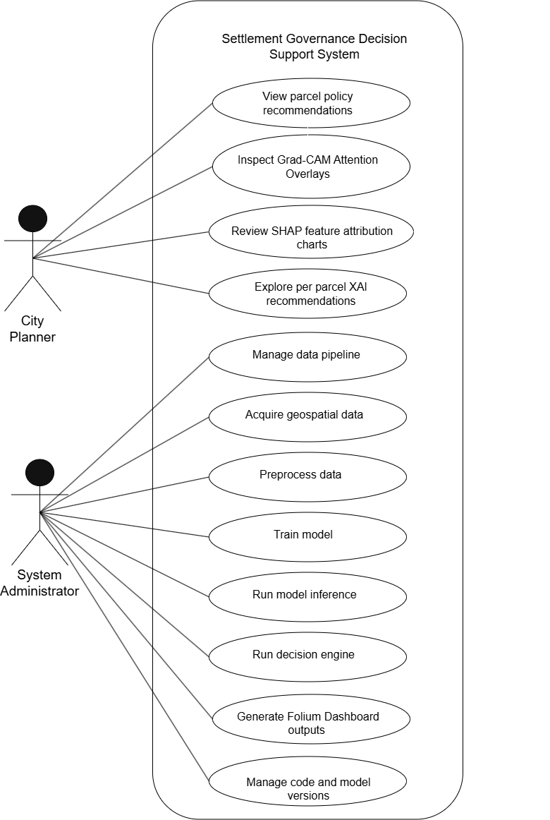
Figure ‎4.1 Use Case Diagram

Sequence Diagram
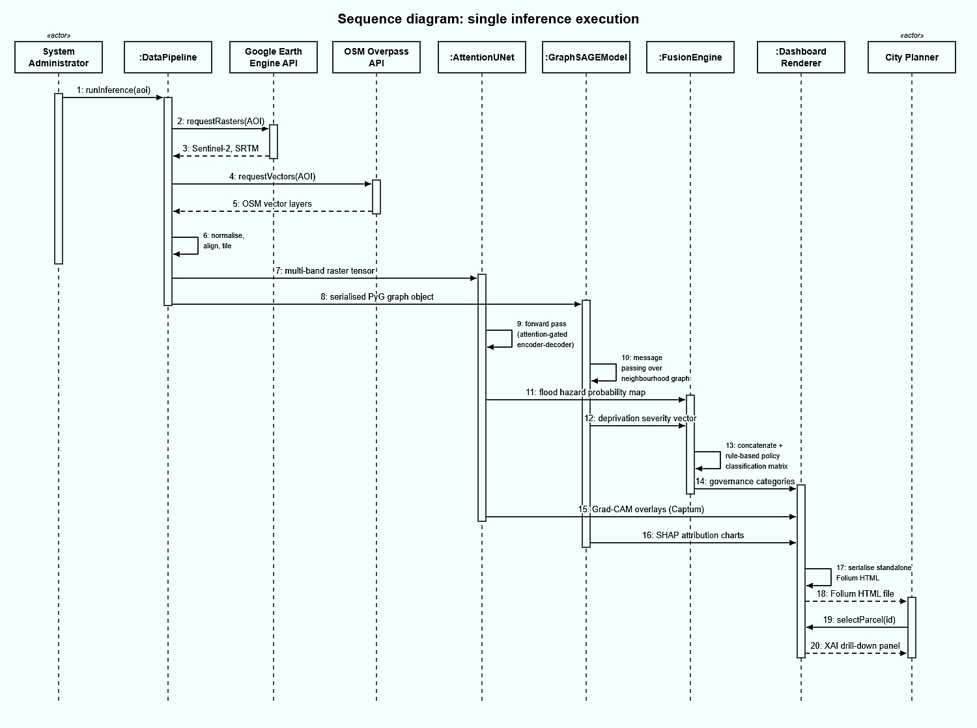
Sequence Diagram showed the order in which methods called and communicated with each other over time throughout a single inference execution process. Sequence started from System Administrator's initiation of DataPipeline object that requested raster and vector data from GEE API and the OSM Overpass API respectively for the target settlement. As a result, DataPipeline returned normalised multi-band raster tensor and serialised PyTorch Geometric graph object. AttentionUNet class received the raster tensor, ran a forward inference through an encoder-decoder model with attention gates and returned parcel-level flood hazard probability map. At the same time, GraphSAGEModel class received the graph object, performed a message passing on the spatial neighbourhood graph and returned the node-level deprivation severity probability vector for each building. Probability maps from both classes were sent to the FusionEngine class, where these probabilities were concatenated and classified according to the rule-based policy classification matrix to produce governance category for each parcel. Finally, DashboardRenderer class received the classifications, Grad-CAM overlays computed with Captum and SHAP attribution charts and serialised these objects into a stand-alone Folium HTML file. City Planner then opened this HTML file in browser and clicked on individual parcels to see the drill-down XAI explanation panels.
Figure ‎4.2 Sequence Diagram

Entity Relationship Diagram
The diagram comprises six entities. A Settlement contains many Parcels (one-to-many), and each Parcel corresponds to one OSM building footprint. Crucially, a Parcel relates to its FloodPrediction and DeprivationPrediction records as one-to-many rather than one-to-one: because the two models are re-run and versioned, a parcel accumulates a new prediction for each combination of inference date, model version and run identifier, and every prediction stores these versioning fields alongside its results (flood probability and Grad-CAM path for FloodPrediction; deprivation class, probability vector and SHAP values for DeprivationPrediction). Each PolicyDecision is derived from one FloodPrediction and one DeprivationPrediction and is likewise linked to its Parcel as one-to-many, producing a new timestamped governance record per run. Finally, RasterTile holds preprocessed GeoTIFF metadata in a many-to-one relationship with Settlement.
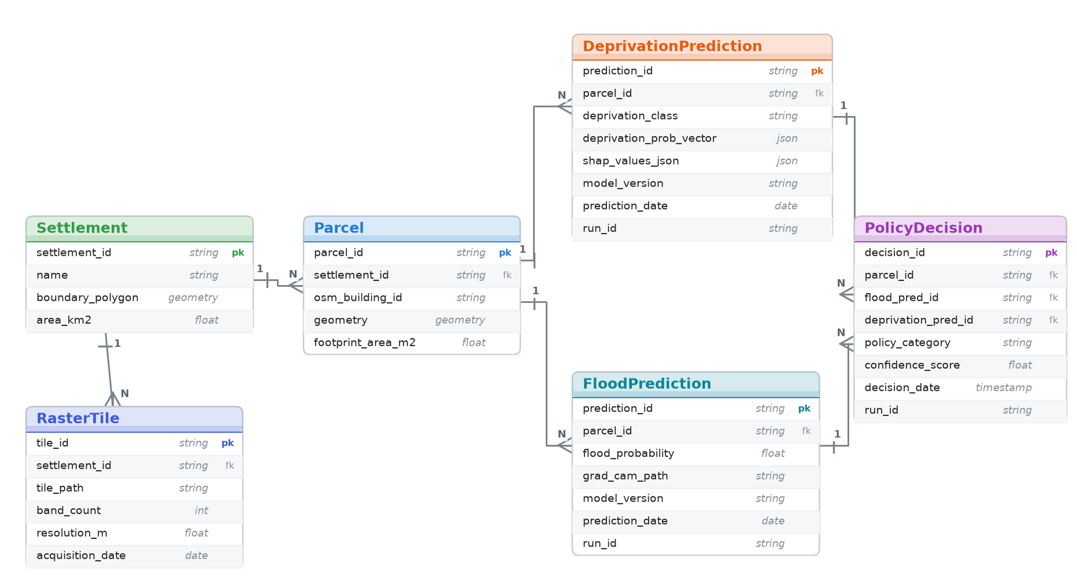
Figure ‎4.3 Entity Relationship Diagram

Class Diagram
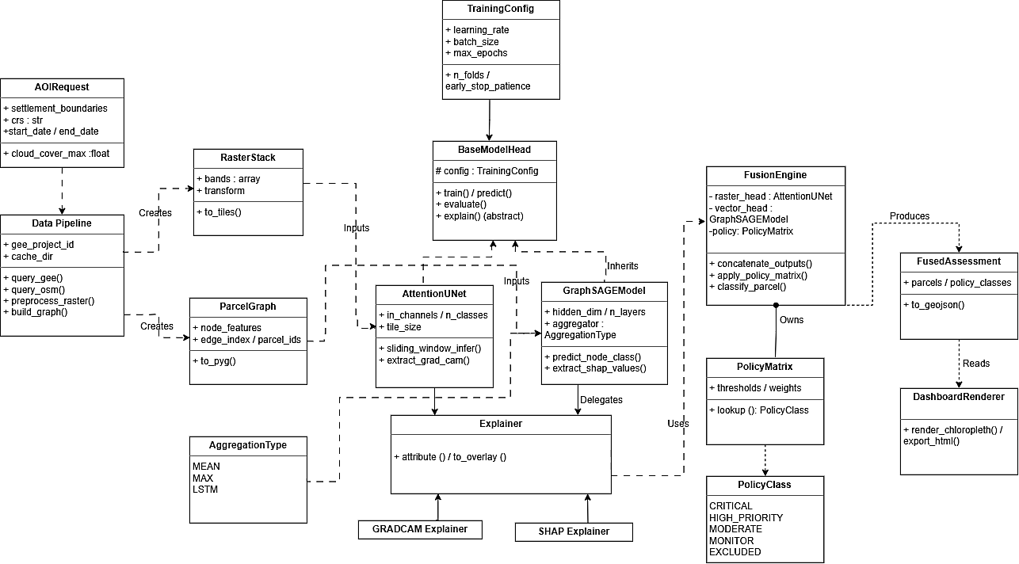
DataPipeline was the class handling all data acquisition and pre-processing. The attributes were: geometries of the settlement boundaries, GEE project ID, and OSM query parameters. The methods were: query_gee(), query_osm(), preprocess_raster(), build_graph(), export_geotiff() and serialize_graph (). AttentionUNet was a wrapper of the PyTorch-based encoder-decoder model with exposed methods for training, sliding window inference and Grad-CAM visualization through the Captum library. The attributes were: the path to model weights, learning rate, Dice and cross-entropy loss weights, and the number of cross-validation folds. GraphSAGE model was a wrapper of the PyTorch Geometric graph neural network with exposed methods for graph loading, node classification, SHAP value extraction, and macro-F1 scoring. The attributes were: the number of GraphSAGE layers, mean aggregation type, learning rate, and L2 regularization parameter. The Fusion Engine received probability outputs of both model heads and applied the policy classification matrix.
Figure ‎4.4 Class Diagram

Activity Diagram
The workflow began with the System Administrator triggering the DataPipeline, which queried GEE and the OSM Overpass API in parallel for raster and vector data respectively. Both data streams were merged in the preprocessing stage, producing a normalised multi-band raster stack and a serialised PyTorch Geometric graph. At the model training stage, the workflow split into two independent parallel branches: the Attention U-Net training branch and the GraphSAGE training branch, which executed simultaneously and without interaction. Each branch included a decision point at which the model's validation performance was checked against the minimum threshold specified in Chapter 3. If a model did not meet the threshold, it looped back to hyperparameter tuning and retraining; if it met the threshold, it proceeded to save the validated model checkpoint. Once both branches completed successfully, the workflow converged at the FusionEngine, which combined the two probability outputs and produced the parcel classification layer. The final stage generated Grad-CAM maps via Captum and SHAP charts, before the DashboardRenderer serialised all outputs to the Folium HTML file. The workflow concluded with the City Planner accessing the dashboard in a browser.
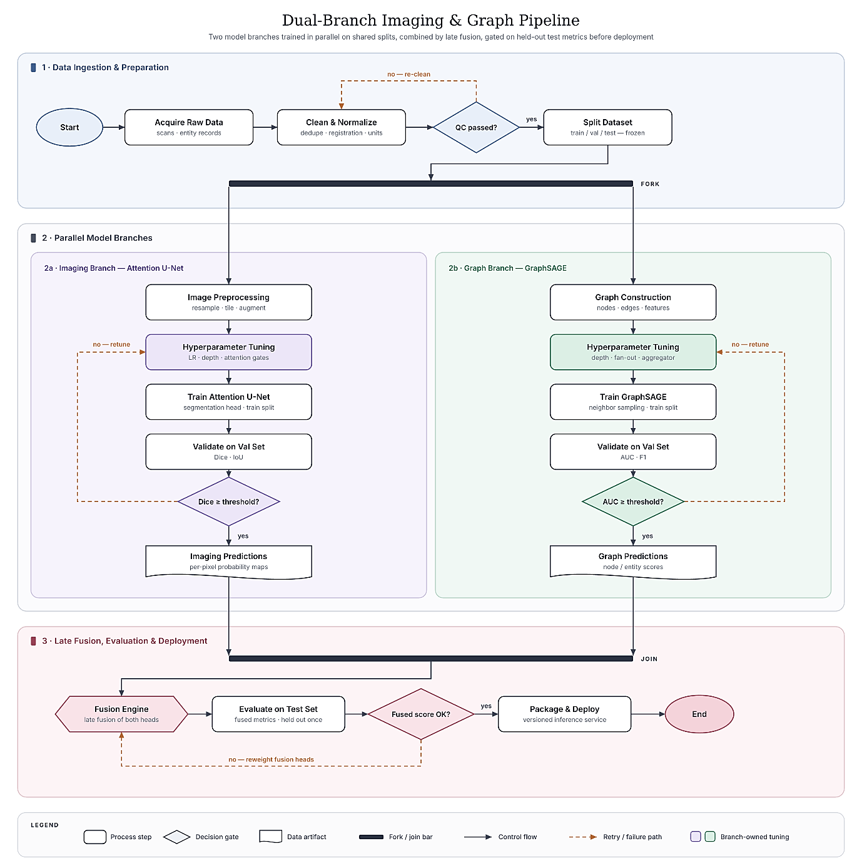
Figure ‎4.5 Activity Diagram

System Design Diagrams

Logical Data Storage Structure
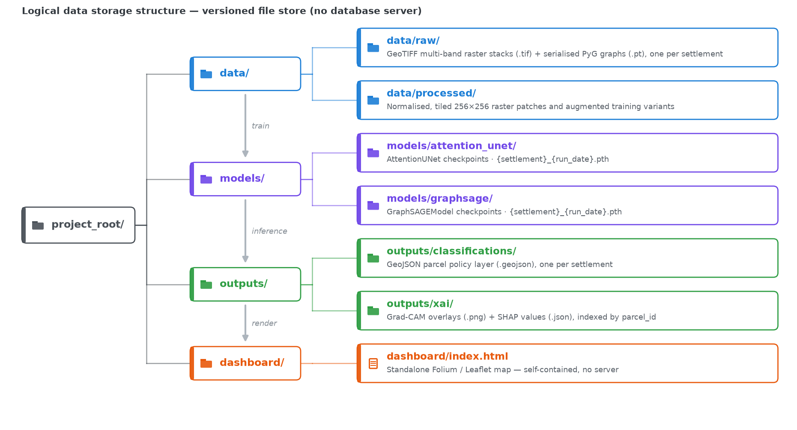
Since the system deliberately avoids a relational database server in favour of a single-ecosystem, file-based design (Section 1.6), its data is not persisted in database tables but as a versioned file store whose logical organisation is shown in Figure 4.6. As that diagram illustrates, the storage structure organised all system artefacts across six directories that also mirror the order of the processing pipeline. The /data/raw/ directory stored the unprocessed GeoTIFF raster stacks and serialised PyTorch Geometric graph objects, one per settlement. The /data/processed/ directory stored the normalised and tiled 256×256 raster patches and their augmented variants used for Attention U-Net training. The /models/ directory stored PyTorch checkpoint files for the AttentionUNet and GraphSAGEModel classes, versioned by settlement name and training run date to support rollback and comparison. The /outputs/classifications/ directory stored the GeoJSON parcel classification layer, one per settlement, containing each parcel's assigned governance category and confidence score. The /outputs/xai/ directory stored Grad-CAM overlay images and SHAP value JSON files indexed by parcel identifier. Finally, the /dashboard/ directory stored the standalone Folium HTML output file containing all rendered map layers, pop-up panels, and embedded SHAP charts.
Figure ‎4.6 Logical Data Storage Structure

Wireframes
The Folium dashboard interface was designed around two primary views, both rendered as static HTML with embedded JavaScript requiring no server infrastructure.
The first view was the full-settlement choropleth map, which rendered the parcel-level policy classification layer as an interactive Leaflet.js map centred on the selected settlement. Parcels were colour-coded in three categories: green for Retain and Formalise, amber for Retain and Upgrade, and red for Compensated Resettlement. A settlement selector dropdown allowed city planners to switch between Kibera, Mathare, and Mukuru. A collapsible legend panel explained the colour scheme and the governance categories. Each parcel was clickable, triggering the second view as an inline pop-up panel.
The second view was the parcel detail pop-up, displayed when a planner clicked any parcel on the choropleth map. The pop-up presented five elements: the flood hazard probability score as a numerical value, the deprivation severity class and probability vector, the assigned policy category label, the Grad-CAM spatial attention overlay rendered as a semi-transparent heatmap on the parcel's satellite image tile, and the top five SHAP feature contributors displayed as a horizontal bar chart. Both the Grad-CAM overlay and the SHAP chart were generated at inference time and embedded directly into the HTML file, ensuring the dashboard remained fully self-contained.
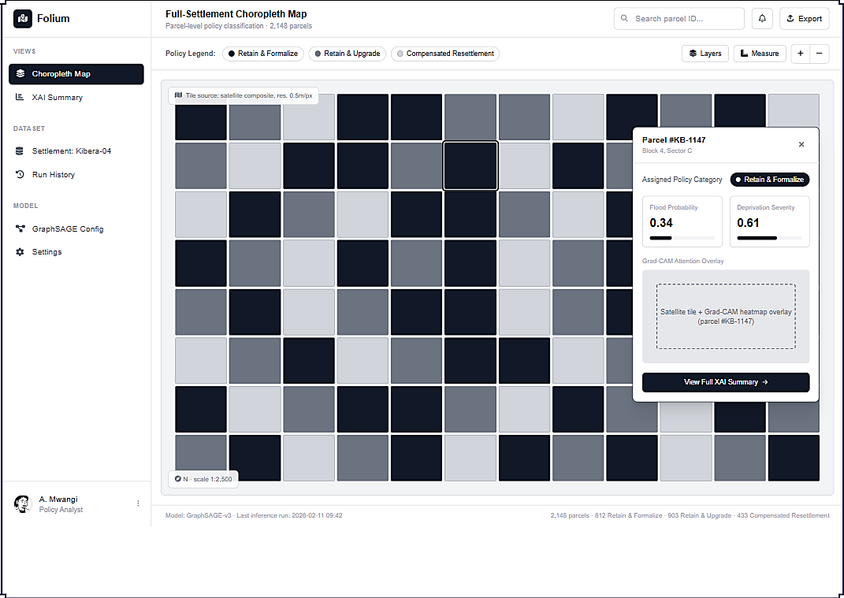
Figure ‎4.7 Full Settlement Choropleth Map

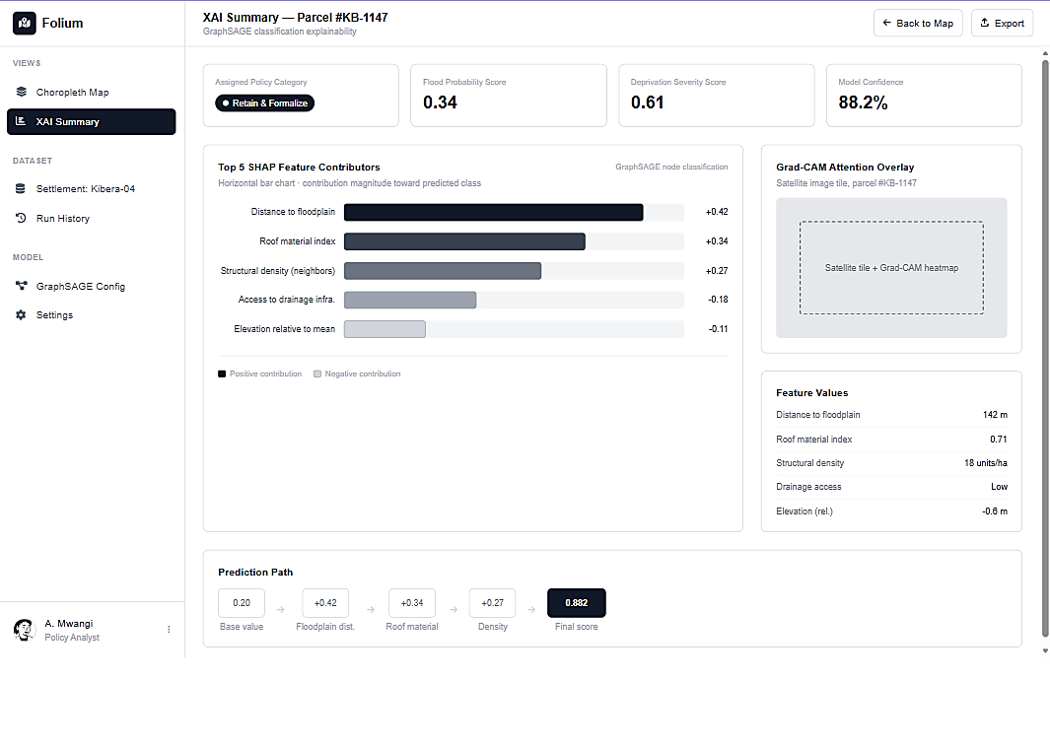
Figure ‎4.8 XAI Summary Dashboard

System Architecture
The System Architecture Diagram provided a high-level view of the system's deployment structure, illustrating the relationships between the external data sources, the local Python processing environment, the model training infrastructure, and the dashboard output. The architecture distinguished between two operationally separate pipelines.
The offline training pipeline was executed once per model on a GPU-enabled Google Colab environment. It consumed data from the GEE API and OSM Overpass API, processed it through the DataPipeline class, and trained the AttentionUNet and GraphSAGEModel classes independently. The trained model weights were saved as PyTorch checkpoint files to Google Drive for persistent storage. This pipeline was computationally intensive and not intended for repeated execution.
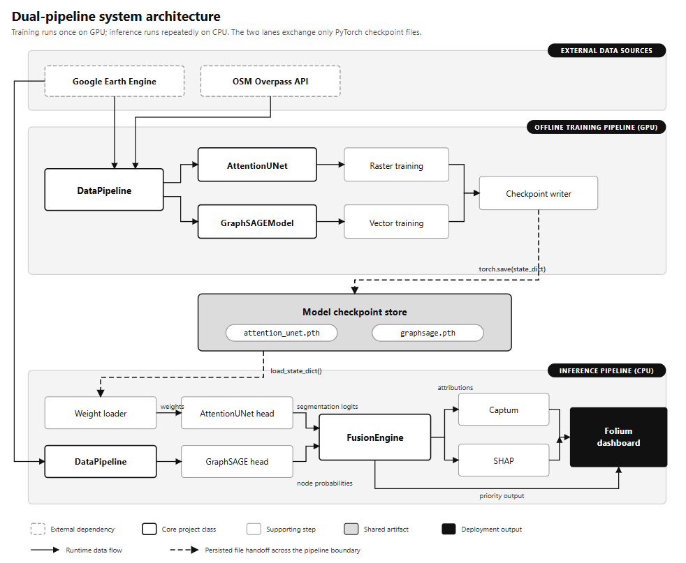
The inference pipeline was designed to run repeatedly on new data without retraining. It loaded the saved model checkpoints from Google Drive, acquired updated raster and vector data through the DataPipeline, executed forward inference through both model heads, combined their outputs in the FusionEngine, generated XAI outputs via Captum and SHAP, and produced the standalone Folium HTML dashboard. The inference pipeline could run on standard CPU hardware, making policy map updates accessible without specialised infrastructure. The two pipelines were connected solely through the shared model checkpoint files, which acted as the handoff point between training and deployment.
Figure ‎4.9 System Architecture Diagram

System Implementation, Testing and Evaluation

Introduction
This chapter explains how the approved design in Chapter 4 was implemented, tested and evaluated. The project followed the artificial intelligence and machine learning route. The chapter therefore moves from the implementation environment to the datasets, the two model heads, the late fusion engine and the dashboard. It then presents the test strategy, the test cases, the model results and the defects found during development. It closes with the evidence for each objective, a discussion of the results and the limitations of the evaluation. Conclusions and recommendations are left to Chapter 6.
All reported model metrics come from Google Colab notebooks that were executed and saved in the project repository. The offline unit tests and a short synthetic run were executed on a separate Linux machine without a GPU. Synthetic results are used only to show that the code path works and what it costs on a CPU. They are not presented as accuracy on Kibera, Mathare or Mukuru.

Implementation Environment
The solution used two environments. Earth Engine exports, model training and parcel level fusion ran in Google Colab with a GPU runtime and Google Drive storage. Code editing and the offline test suite ran on a Linux development machine with no GPU and no Earth Engine credentials. The dashboard is a private prototype. It was served from a Colab runtime or a local machine and was not deployed for public use.

Hardware and Deployment Environment
Table 5.1 lists the hardware and hosted resources that were actually used. Each stated minimum is the configuration on which the work was run and recorded. No lower configuration was tested.
Table 5.1 Implementation environment and minimum tested requirements
Item or layer | Minimum tested specification | Purpose and justification | Evidence or source
Training runtime | Google Colab GPU runtime with one NVIDIA Tesla T4 (16 GB GPU memory per the NVIDIA datasheet) | Trained both model heads and ran fusion inference. The T4 is the free Colab accelerator and fitted 256 × 256 tiles at batch size 2. | "GPU: Tesla T4" printed in notebooks 03, 04 and 05
Persistent storage | Google Drive folder nairobi_risk_mapping | Held raster stacks, tiles, graphs, checkpoints and the policy table. Colab clears local disk when a session ends. | Drive paths printed in notebooks 04 and 05
Earth Engine compute | Google Cloud project registered for noncommercial Earth Engine use | Built composites and labels on Google servers. Exports ran asynchronously and continued if Colab disconnected. | Export states READY, RUNNING and COMPLETED in notebook 04
Development and test machine | Linux virtual machine, 4 vCPU Intel Xeon, 15 GB RAM, no GPU, Python 3.12.3 | Ran the offline test suite and the synthetic CPU run. It showed that inference and fusion do not need a GPU. | Test log (129 passed in 8.19 s) and synthetic run log
Client device | Desktop browser with JavaScript enabled. Tested in Google Chrome on Linux. | Displays the sign in page, the parcel map and the explanation panel. No GIS software is required. | Figure 5.7 and the access control log
Network | Internet access to Earth Engine, the Overpass mirrors, Firebase and Colab | Data acquisition and sign in depend on these services. A saved policy table can be served without Earth Engine. | Overpass retries in notebook 03

[Note to author: Add the laptop model and browser you used to open the dashboard from Colab to the client device row.]

Software, Services and Configuration
Table 5.2 records the software that the implementation depends on. The second column gives the minimum version pinned in requirements.txt and the version installed on the offline test machine. Colab installed the same requirements file at the start of every notebook, but the resolved Colab versions were not printed and are therefore not reported.
Table 5.2 Software, services and tested versions
Component | Minimum / tested version | Purpose and reason for selection
Python | Colab default / 3.12.3 | Single language for data, models, tests and the dashboard server.
PyTorch | 2.2.0 / 2.14.0 | Attention U-Net, training loops, checkpoints and Grad-CAM hooks.
PyTorch Geometric | 2.5.0 / 2.8.0 | SAGEConv layers and graph Data objects for the GraphSAGE head.
Earth Engine Python API, geemap | 1.4.0 / 1.7.43; 0.32.0 / 0.38.5 | Sentinel and SRTM composites, the event flood label and Drive export.
osmnx | 1.9.0 / 2.1.1 | Settlement boundary lookup and OSM features through Overpass.
GeoPandas, Shapely, pyproj | 0.14.0 / 1.1.4; 2.0.0 / 2.1.2 | Vector processing, metric distances in EPSG:32737 and river corridor buffers.
Rasterio | 1.3.0 / 1.5.1 | GeoTIFF reading, tile windows and sampling flood probability at parcels.
NumPy, SciPy, networkx | 1.26 / 2.4.4; 1.18.1; 3.2 / 3.6.1 | Label construction, metrics, connected components and graph integrity checks.
Folium | 0.16.0 / 0.20.0 | Leaflet map of parcel actions.
Firebase Authentication and google.auth | Web SDK; 2.58.0 | Sign in by email and password, phone, Google or Apple, with a TOTP or SMS second factor. The server verifies each ID token.
cloudflared | Latest release, downloaded at run time | Public HTTPS address for the sign in page served from Colab.
pytest | 8.0.0 / 9.1.1 | Runner for the offline unit and integration tests.
Captum, SHAP | 0.7.0 / 0.9.0; 0.45.0 / 0.52.0 | Installed but not called. Both explanations were implemented directly (Section 5.4.4).
Git and GitHub | Not version pinned | Version history, pull requests and cloning into Colab.

All tunable values are held in src/config.py. These include settlement boxes, date windows, label thresholds, model targets and fusion thresholds. No container, database server or message service was used. Artefacts are stored as files: GeoTIFF stacks, NumPy tiles with JSON manifests, PyTorch graph and checkpoint files, and a compressed NumPy policy table. The Earth Engine project is read from the GEE_PROJECT_ID environment variable or a service account key. The Firebase web settings are read from FIREBASE_API_KEY, FIREBASE_AUTH_DOMAIN and FIREBASE_PROJECT_ID. The repository holds only an example file with placeholder values, and the real file is excluded by .gitignore. No key, token or password appears in the repository or in this report.

Deployment and Reproducibility
Table 5.3 gives the procedure that reproduces the reported run. Each step has a check that an authorised person can use to confirm it worked.
Table 5.3 Installation, execution and verification procedure
Step | Action | Verification
1 | Clone the repository and run pip install -r requirements.txt. | pytest tests/ reports 129 passed.
2 | In Colab, select a T4 runtime, authenticate Earth Engine and mount Google Drive. | The notebook prints the GPU name and the Drive path.
3 | For each settlement, call DataPipeline.acquire_raster_stack with the event label and Sentinel 1 inputs. | The export task reaches COMPLETED and the stack appears on Drive.
4 | Call tile_raster_stack on each stack. | A manifest_train.json file lists the kept tiles.
5 | Call acquire_graph_data for each settlement. | A graph file and an integrity report are saved.
6 | Run notebook 04 to train both heads. | A threshold summary is printed and checkpoints are saved.
7 | Run notebook 05 to fuse the heads. | policy_table.npz is saved and the justice audit passes.
8 | Set the Firebase variables and start the dashboard with python -m src.dashboard.app or the Colab launch cell. | The sign in page returns HTTP 200 and the map route returns 401 without a token.

Reproduction needs a Google account, an Earth Engine registration, a Firebase project with the sign in providers enabled, and access to the public Overpass mirrors. Overpass is rate limited, so graph rebuilds may need retries. The 37 NRRP high risk zone polygons are not in the repository. A run without them falls back to an OSM river corridor, as described in Section 5.5.4.

Dataset Description and Preparation
The project used two datasets built from open sources. A raster stack per settlement feeds the Attention U-Net. A building graph per settlement feeds GraphSAGE. No household survey, cadastral record or personal data was collected. Sentinel and SRTM data are open Copernicus and NASA products. OSM data is open under the Open Database Licence.

Raster Flood Dataset
Each raster stack holds twelve bands at 10 m resolution in the order shown in Table 5.4. Eleven bands are model inputs and one band is the training label.
Table 5.4 Bands in each exported raster stack
Band | Source and period | Role
B2, B3, B4, B8, B11, B12 | Sentinel 2 surface reflectance, cloud masked median of dry months (January, February, June to September) from June 2023 to June 2025 | Input
pre_vv | Sentinel 1 VV median, 1 February to 20 March 2024 | Input
event_vv | Sentinel 1 VV minimum, 20 April to 10 May 2024 | Input
flood_label | Change detection between the two VV composites | Target
elevation, slope, twi | SRTM 30 m elevation, slope and an approximate wetness index | Input

The flood label marks a pixel as flooded when VV backscatter dropped sharply between the dry baseline and the April to May 2024 flood window. The threshold is chosen by Otsu's method on the drop values, with a fixed 3 dB drop as fallback. Pixels steeper than 5 degrees, permanent water from the JRC Global Surface Water layer and blobs smaller than eight pixels are then removed. Table 5.5 shows the exported stacks and the tiles they produced.
Table 5.5 Exported raster stacks and tiles per settlement
Settlement | Raster size (pixels) | Export buffer | Training tile variants | Distinct tile locations
Kibera | 578 × 511 | Not printed | 16 | 4
Mathare | 758 × 511 | 1,550 m | 20 | 5
Mukuru | 571 × 510 | 2,269 m | 16 | 4

The buffer was enlarged for small settlements so that at least two 256 pixel windows fit in each direction. Without it, Mathare and Mukuru produced no usable tiles. As a result, a large part of each raster lies outside the settlement boundary.

Building Graph Dataset
Each building footprint from OSM became one node. Two buildings were linked when they were closer than 15 m. Each node carries five features: footprint area, distance to the nearest water point, distance to the nearest toilet, distance to the nearest road and a roof material score. The roof score defaults to 0.5 when OSM has no material tag. Table 5.6 shows the graph sizes recorded in Colab.
Table 5.6 Building graphs used for training
Settlement | Nodes before pruning | Nodes used | Integrity notes
Kibera | 15,421 | 11,053 | Before pruning: 2,029 components, 1,291 isolated buildings, largest component 22%. After pruning: 68 components, largest 31%.
Mathare | Not printed | 5,777 | All three classes present.
Mukuru | Not printed | 1,175 | All three classes present.
Total |  | 18,005 | Combined as separate graphs with no edges between settlements.

The deprivation label is a proxy for the UN-Habitat and SUPI indicators. Each of the five features is scored from 0 to 1, where 1 is most deprived. Distances are scaled against 200 m for water and sanitation and 50 m for roads. Footprints of 25 m² or less score as fully overcrowded. The five scores are averaged and cut at the 33rd and 66th percentiles of each settlement into low, medium and high classes. Kibera's final distribution was 4,125 low (37.3%), 4,205 medium (38.0%) and 2,723 high (24.6%). It is not an even three way split because the classes were assigned before small components were pruned.

Data Preparation and Partitioning
Optical and terrain bands were scaled to the 0 to 1 range between their 1st and 99th percentiles. The two VV bands used one fixed window from minus 30 dB to 0 dB, so the drop between dates survived scaling. Tiles of 256 pixels were cut with a 50 pixel overlap, and tiles with less than 60% valid pixels were discarded. Training tiles were augmented with a horizontal flip, a vertical flip and a 90 degree rotation.
The flood data was split by location, not by tile. One tile location per settlement was held out for validation, and all augmented copies of a location stayed in the same split. This gave 40 training entries and 12 validation entries. There were too few locations to reserve a separate test location.
Graph features were standardised to zero mean and unit variance within each settlement graph. Nodes were split 60/20/20 at random, stratified by class within each settlement, with seed 42. The combined graph gave 10,803 training, 3,601 validation and 3,601 test nodes.

System Implementation
Figure 5.1 shows the implemented pipeline. It follows the architecture in Chapter 4: two independent heads, a rule based fusion layer and a dashboard. The subsections follow the same order and link each component to its requirement.
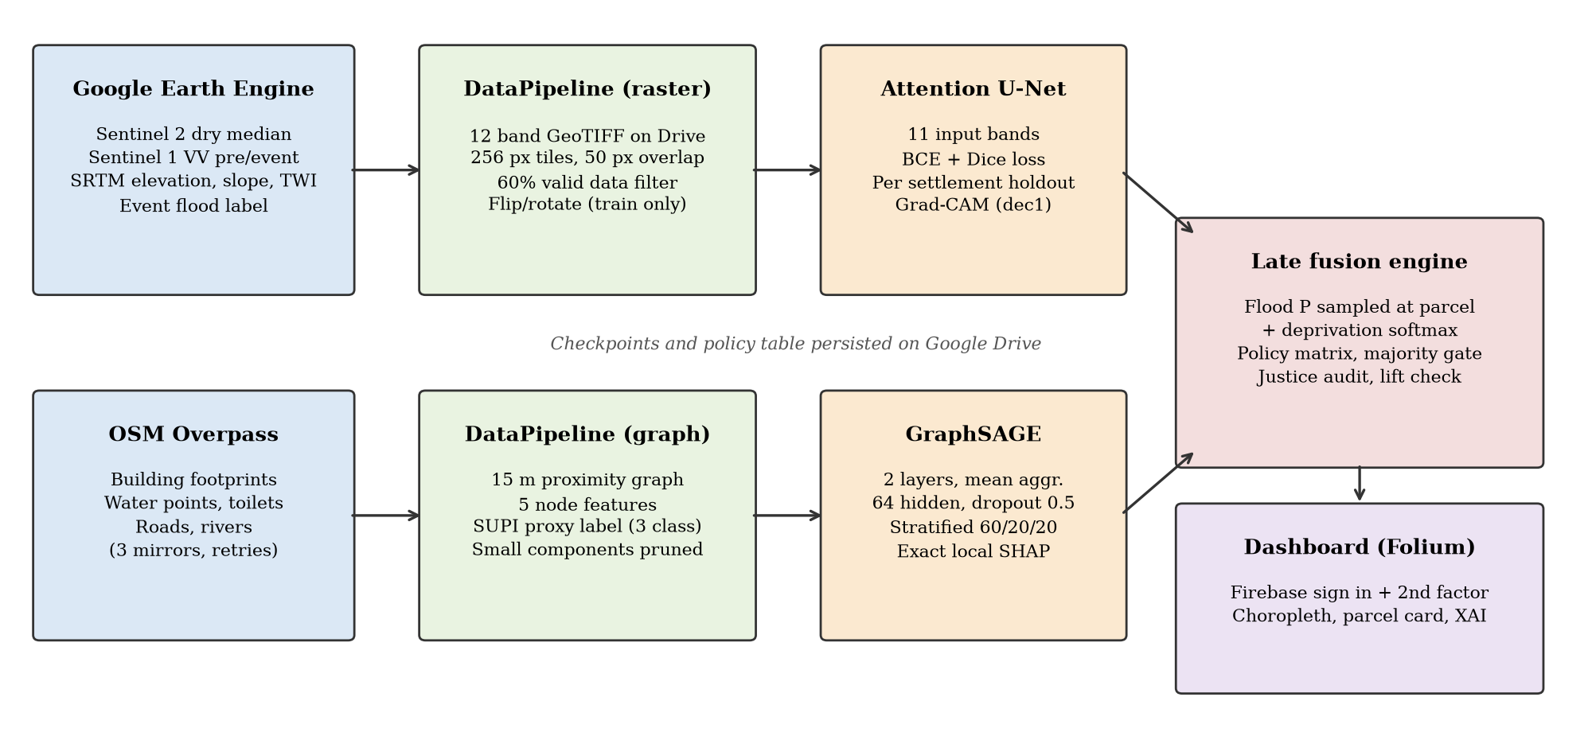
Figure 5.1 Implemented pipeline from data acquisition to the dashboard

Attention U-Net Flood Head
This component implements FR-03. The network is a four level encoder and decoder with an attention gate on every skip connection. Channel widths grow from 32 to 512 at the bottleneck, giving 7,857,021 parameters with eleven inputs. Dropout of up to 0.1 is applied at the bottleneck and in the decoder only. Training used Adam at a learning rate of 0.001 with cosine annealing, batch size 2 and a loss that weights binary cross entropy and Dice equally. The checkpoint with the best validation IoU was kept.
The head went through two versions. The first version used a seasonal Otsu label from 2019 to 2024 rainy season radar. It overfitted: training IoU reached about 0.77 while validation never beat a baseline that predicts flood everywhere, at about 0.31. Diagnostics showed that the label tracked land cover rather than water. The second version replaced it with the event change detection label, added the two VV bands as inputs and added weight decay, dropout and early stopping. The Sprint 4 run trained this second version on all three settlements.
The transfer learning loader for Sen1Floods11 weights was implemented and unit tested. No compatible checkpoint was available during the run, so the network was trained from random initialisation. The training log records this warning.

GraphSAGE Deprivation Head
This component implements FR-04. It has two SAGEConv layers with mean aggregation, 64 hidden units, ReLU and dropout of 0.5. Training was full batch with Adam at a learning rate of 0.005 and weight decay of 0.0005. The best checkpoint was selected on validation macro F1, with early stopping after 20 epochs without improvement in Sprint 3 and 25 in Sprint 4. Figure 5.2 shows the Kibera training curves saved by the Sprint 3 notebook. Validation macro F1 crossed the 0.60 sprint bar within the first few epochs and levelled off near 0.93. The curves are logged in training mode, so dropout keeps the training curve below the validation curve.
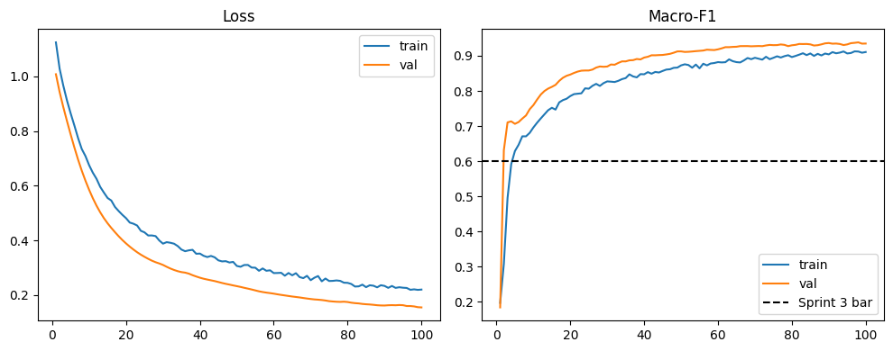
Figure 5.2 GraphSAGE loss and macro F1 on Kibera over 100 epochs (Colab output)

Late Fusion Policy Engine
This component implements FR-05. Each parcel's flood probability was read from the U-Net output at the building centroid. Where tiles overlapped, the values were averaged. The flood value was joined with the three GraphSAGE class probabilities and looked up in the policy matrix in Table 5.7.
Table 5.7 Policy matrix applied by the fusion engine
Flood hazard | Low deprivation | Medium deprivation | High deprivation
Low (probability below 0.5) | Retain and formalise | Retain and upgrade | Priority in situ upgrade
High (probability 0.5 or more) | Flood resilient upgrade | Flood resilient upgrade | Compensated resettlement

The approved design had three categories. The implementation splits them into five actions so that a planner can see why a parcel was upgraded. Two safeguards limit resettlement. First, resettlement needs a high flood row and a high deprivation probability above 0.5. A parcel where high deprivation is only the largest of three classes is routed to flood resilient upgrade instead. Second, an NRRP zone can force the high flood row, but it cannot skip the deprivation check. A justice audit recounts every resettlement against these rules after each run. Parcels with missing or corrupt inputs are marked as insufficient evidence rather than guessed.
The engine was validated with a lift statistic. Lift is the share of flood responsive parcels inside a reference zone divided by the share of all parcels inside it. A value above 1 means flood responsive actions concentrate in the reference zone. The lift is computed on the model decision before any NRRP override, so the zone cannot create the result by itself.

Explanations and Dashboard
This component implements FR-06. For GraphSAGE, the system computes exact Shapley values for one building's five features. Neighbours are held fixed and a missing feature is replaced by its mean across the graph. With five features this needs 32 model evaluations, so the values are exact rather than sampled. For the U-Net, Grad-CAM is taken from the last decoder convolution, which comes after the attention gates. The map is scaled to the 0 to 1 range.
The dashboard is a small Python web server. The home page contains only the sign in form and no parcel coordinates. The map, the parcel list, the summary and the per parcel explanation are served only after the server verifies a Firebase ID token that records a second factor. Accepted factors are a TOTP authenticator code or an SMS code. The signed in page shows a choropleth of actions with a parcel card, and an explanation view with SHAP bars, feature values and a prediction path. A banner states that the river corridor lift was 0.929, so the map is not presented as a validated flood hazard layer. Figures 5.3 and 5.4 show the signed in map and the explanation view. Figure 5.7 shows the sign in page.
[Insert screenshot here: Screenshot of the signed in choropleth map with a parcel card open, taken from your Colab dashboard session.]
Figure 5.3 Parcel policy map with the parcel card
[Insert screenshot here: Screenshot of the explanation view for the same parcel, showing the SHAP bars and the prediction path.]
Figure 5.4 Explanation view for a selected parcel

Deviations from the Approved Design
Table 5.8 records each material difference between Chapter 4 and the implemented system, with its reason.
Table 5.8 Deviations from the Chapter 4 design
Chapter 4 design | Implemented | Reason
Encoder initialised from Sen1Floods11 weights | Trained from random initialisation; loader built and tested | No compatible checkpoint was obtained in time.
Flood labels from seasonal Otsu inundation | Event change detection around the April to May 2024 floods | The seasonal label tracked land cover and the first model never beat the baseline.
Five fold spatially contiguous cross validation | One held out tile location per settlement | Each settlement yielded only four or five tile locations.
Spatially blocked graph split with cut edges | Random split stratified by class within each settlement | Not implemented in the time available. Section 5.8.3 discusses the effect.
Three policy categories | Five actions with a majority gate on resettlement | Explains the reason for each upgrade and makes displacement harder to trigger.
Captum Grad-CAM and the SHAP library | Direct Grad-CAM hooks and exact Shapley values | Five features allow an exact computation, and direct hooks avoided an extra dependency.
Standalone HTML file with no server | Python server behind Firebase sign in with a second factor | The map shows resettlement decisions, so open access was judged unsafe.
Validation against the 37 NRRP zones | OSM river corridor of 120 m as fallback | The NRRP polygons were not available.

Testing and Evaluation

Test Strategy and Acceptance Criteria
Testing combined four levels. Unit tests checked individual functions with synthetic arrays and geometries. Integration tests checked that the data pipeline output fits both heads and that both heads fit the fusion engine. System tests ran the complete pipeline in Colab on real data. Security tests checked the dashboard routes with valid, invalid and incomplete sessions. Unit and integration tests used white box knowledge of the code. System and security tests were black box and compared each output with a predefined expected result. Table 5.9 lists the acceptance criteria, all fixed in Chapter 3, Chapter 4 or src/config.py before the results were produced.
Table 5.9 Acceptance criteria
Requirement | Criterion | Measured on
FR-03, NFR-01 | Attention U-Net IoU of at least 0.60 and F1 of at least 0.75, pooled | Held out tile location per settlement
FR-04, NFR-01 | GraphSAGE macro F1 of at least 0.70, pooled and per settlement | Validation and test nodes
FR-05 | Zero justice audit violations | All fused parcels
FR-05 | Lift strictly greater than 1.0 | Reference zone membership of fused parcels
FR-06, NFR-05 | Shapley values sum to the prediction gap; Grad-CAM lies in the 0 to 1 range | Unit tests
Security | No parcel data without a verified second factor | HTTP responses of the dashboard
All modules | All offline tests pass | pytest

Unit and Integration Testing
The offline suite contains 129 tests in eleven files. All 129 passed in 8.19 seconds on the development machine. Table 5.10 summarises what each file verifies. The full log is kept with the project evidence.
Table 5.10 Offline test suite by module
Test file | Tests | What is verified
test_attention_unet.py | 24 | Output shapes, attention gate bounds, gradient flow, Dice and IoU, holdout keeps augmented copies together, encoder freezing, dropout, early stopping.
test_multi_settlement.py | 17 | Disjoint union of graphs, per settlement splits, no location leakage, export buffer sizing, threshold reports.
test_fusion.py | 15 | Every matrix cell, majority gate, NRRP override limits, corrupt inputs, justice audit on random batches, lift not created by the override, raster sampling.
test_graph_construction.py | 14 | Edges inside and outside 15 m, exact 15 m boundary excluded, isolated nodes flagged, no self loops, pruning, centroid alignment, Overpass mirror retry.
test_flood_label.py | 13 | Change image, threshold only on drops, stable land cover not flooded, slope and permanent water masks, speckle removal, Otsu.
test_dashboard.py | 12 | Second factor claim check, Shapley sum, Grad-CAM range, resettlement marker, refusal without second factor, tunnel URL parsing.
test_graphsage.py | 9 | Output shape, gradients, exclusive splits, macro F1, checkpointing, centroids stay on CPU, local SHAP.
test_label_validation.py | 8 | Confusion counts, lift above 1 for a concentrated label and near 1 for a land cover proxy, rasterised references.
test_deprivation_label.py | 6 | Roof material encoding, indicator scores and class cuts.
test_diagnostics.py | 6 | Pixel AUC and permutation importance used to diagnose the first flood label.
test_layout.py | 5 | Band layouts, input channel counts and fixed dB scaling of VV bands.

A synthetic end to end run was also executed on the CPU machine. It built a twelve band synthetic raster, tiled it and trained a reduced width U-Net for three epochs. It then trained GraphSAGE on an 18,005 node random graph, fused the two heads and ran the justice audit. Every stage completed and the audit passed. The run also measured CPU cost at the real parcel count. Fusing 18,005 parcels took 5 ms. GraphSAGE inference over 18,005 nodes took 15 ms. One exact SHAP explanation took 448 ms. A full width U-Net took 68 ms per tile on average and Grad-CAM took 213 ms. These timings show that the inference side can run without a GPU. They say nothing about accuracy.

Model Evaluation Results
Table 5.11 reports the GraphSAGE results. The Sprint 3 run trained on Kibera alone. The Sprint 4 run trained jointly on all three settlements.
Table 5.11 GraphSAGE deprivation results (macro F1 unless stated)
Run and split | Kibera | Mathare | Mukuru | Pooled | Target
Sprint 3, Kibera only, test | 0.9401 |  |  |  | 0.60
Sprint 4, validation | 0.8972 | 0.8755 | 0.7453 | 0.8813 | 0.70
Sprint 4, test | 0.9011 | 0.8930 | 0.7703 | 0.8906 | 0.70
Sprint 4, test accuracy | 0.9000 | 0.8927 | 0.7745

In the Sprint 3 test split, per class F1 was 0.958 for low, 0.919 for medium and 0.943 for high, over 2,210 nodes. Medium was the weakest class because it borders both others. Every settlement met the 0.70 target. Mukuru scored lowest. It has the smallest graph, with about 235 test nodes, and its smaller split makes its score less stable.
Table 5.12 reports the Attention U-Net results on the held out tile location of each settlement.
Table 5.12 Attention U-Net flood results on held out locations
Settlement | IoU | F1 | IoU target | F1 target
Kibera | 0.7360 | 0.8479 | 0.60 | 0.75
Mathare | 0.6379 | 0.7789 | 0.60 | 0.75
Mukuru | 0.7608 | 0.8642 | 0.60 | 0.75
Pooled | 0.7201 | 0.8373 | 0.60 | 0.75

Figure 5.5 compares both heads with their targets. Both heads passed on every settlement. Mathare was the closest to the IoU bar at 0.638. These numbers come from one location per settlement, which is four tile variants each. They show agreement with the change detection label at that location. Section 5.8 explains why they do not yet show agreement with observed flooding.
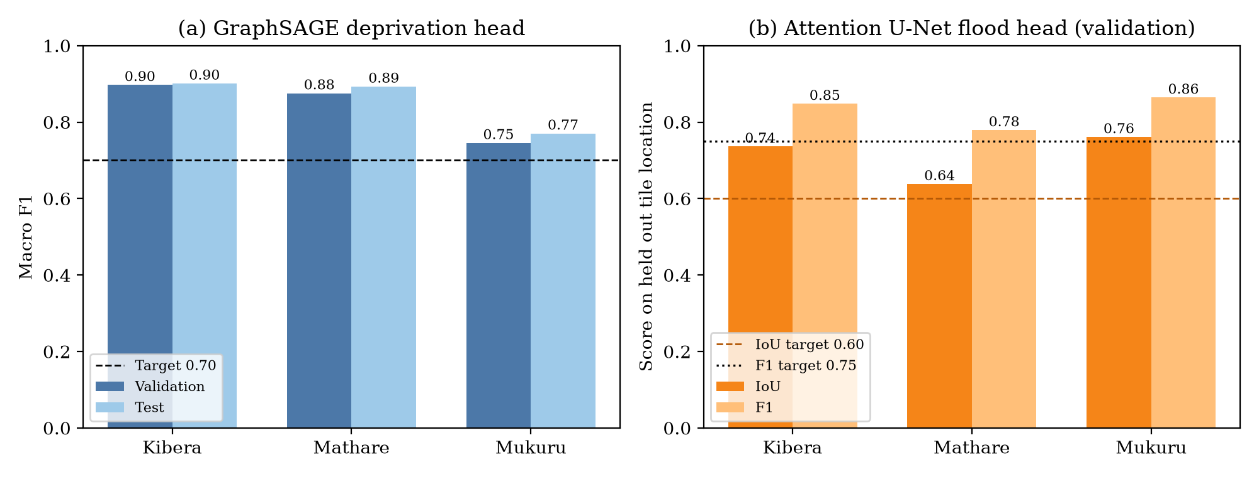
Figure 5.5 Per settlement results of both heads against their acceptance targets

Policy Engine Evaluation
The engine was first checked on synthetic parcels. Six parcels, one per matrix cell, produced the expected action in every case. A wet parcel with class probabilities of 0.40, 0.15 and 0.45 was not resettled because 0.45 is not a majority. A synthetic set built to concentrate in a reference zone gave a lift of 5.0, which confirmed that the statistic responds as intended.
The engine was then run on the real outputs of both heads. Every one of the 18,005 parcels received a valid flood value and a valid action. Table 5.13 and Figure 5.6 show the result.
Table 5.13 Policy actions assigned to all 18,005 parcels
Action | Parcels | Share
Retain and formalise | 4,485 | 24.9%
Retain and upgrade | 4,430 | 24.6%
Priority in situ upgrade | 4,141 | 23.0%
Flood resilient upgrade | 3,684 | 20.5%
Compensated resettlement | 1,265 | 7.0%
Insufficient evidence | 0 | 0.0%

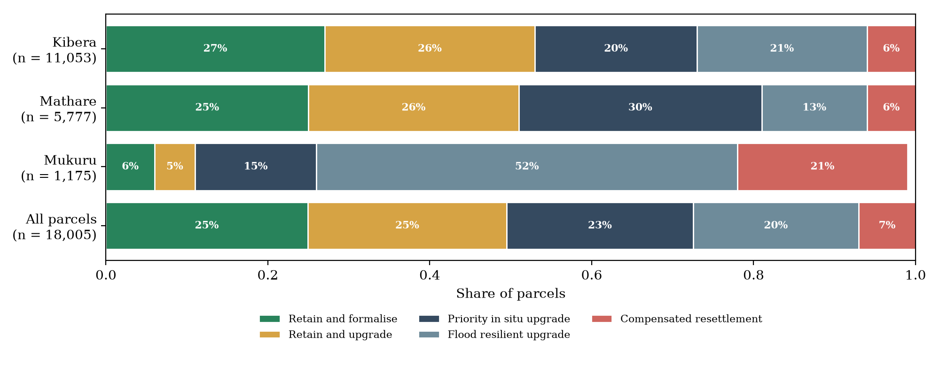
Figure 5.6 Share of policy actions by settlement (shares rounded as printed by the notebook)
The justice audit passed with zero violations. All 1,265 resettlement decisions had a high flood row and a majority high deprivation probability. The majority gate changed five parcels from resettlement to flood resilient upgrade.
The NRRP polygons were not available, so lift was measured against a 120 m buffer around 230 OSM river, stream and drain features. This corridor covered 7,317 of 11,053 Kibera parcels, 3,819 of 5,777 in Mathare and 952 of 1,175 in Mukuru. That is 67% of all parcels. The lift was 0.929, below the target of more than 1.0. About 62% of flood responsive parcels fell inside the corridor, against a 67% base rate. The Sprint 5 exit criterion was therefore not met.

System and Security Test Cases
Table 5.14 lists the system level test cases. Each compares an expected result with the observed result and names its evidence. Security cases used a stub token verifier that returns fixed Firebase claims, because a live Firebase project cannot be used in the offline environment. The stub replaces only Google's signature check. The route logic under test is the production code.
Table 5.14 System test cases and results
Test ID | Traceability | Scenario and data | Expected result | Actual result and evidence | Verdict
TC01 | FR-01 | Export twelve band stacks for all three settlements from Earth Engine | All tasks COMPLETED; stacks on Drive | All COMPLETED; 578 × 511, 758 × 511 and 571 × 510 pixels (notebook 04) | Pass
TC02 | FR-02 | Tile each stack at 256 pixels with 50 pixel overlap | A non empty manifest per settlement | 16, 20 and 16 tile variants (notebook 04) | Pass
TC03 | FR-02 | Build the Kibera graph at 15 m and check integrity | Graph saved; fragmentation reported | Graph saved; warning raised for a 22% largest component; small components pruned (notebook 03) | Pass
TC04 | FR-03, NFR-01 | Evaluate the U-Net on held out locations | Pooled IoU ≥ 0.60 and F1 ≥ 0.75 | IoU 0.7201, F1 0.8373 (notebook 04) | Pass
TC05 | FR-04, NFR-01 | Evaluate GraphSAGE on test nodes of each settlement | Macro F1 ≥ 0.70 everywhere | 0.9011, 0.8930, 0.7703; pooled 0.8906 (notebook 04) | Pass
TC06 | FR-05 | Six synthetic parcels, one per matrix cell, plus one plurality case | Matrix actions; plurality not resettled | All seven as expected (notebook 05, section 2) | Pass
TC07 | FR-05 | Fuse 18,005 real parcels and run the justice audit | Zero violations | Zero violations; 1,265 resettlements (notebook 05) | Pass
TC08 | FR-05 | Lift of model actions against the reference zone | Lift > 1.0 | 0.929 against the river corridor (notebook 05) | Fail
TC09 | FR-06, NFR-05 | Explain one node and one tile | Shapley sum equals the logit gap; Grad-CAM in 0 to 1 | Both hold (test_dashboard.py) | Pass
TC10 | Security | Request the map with no token, an invalid token and a password only token | 401, 401 and 403; no coordinates returned | 401, 401 and 403; no coordinates in any body (access control log) | Pass
TC11 | Security | Request the map with a TOTP session and with a phone session | 200 with the map | 200 for both (access control log) | Pass
TC12 | Security | Request /assets/../app.py | 404; no source returned | 404 (access control log) | Pass
TC13 | Security | Open the dashboard with no Firebase settings | Sign in stays closed | Message shown and the map stays closed (Figure 5.7) | Pass
TC14 | NFR-03 | Planners complete tasks on the dashboard | Reviewer identifies the policy basis for five parcels | Not executed | Not run


Figure 5.7 Dashboard sign in page failing closed when no Firebase settings are configured (TC13)

Defects and Retesting
Table 5.15 records the defects found during development, the fix and the retest. Commit identifiers refer to the project repository. The failed first flood model is kept in the record rather than replaced by the later result.
Table 5.15 Defects, corrective changes and retest outcomes
ID | Defect | Correction | Retest outcome | Status
D01 | First U-Net overfitted; validation never beat the flood everywhere baseline (about 0.31) | Event change detection label, lift check, VV inputs, regularisation (PR #4) | Pooled validation IoU 0.7201 in Sprint 4 | Closed
D02 | Overpass returned 502 errors at capacity | Retry across three mirrors with backoff (a859db8) | Kibera graph rebuilt in Colab; unit test passes | Closed
D03 | Mathare and Mukuru rasters too small to tile | Size aware export buffer (a07c7a8) | 20 and 16 tile variants produced | Closed
D04 | Empty tile manifests stopped the Sprint 4 split | Skip settlements with too few locations (625fedd) | Unit tests pass | Closed
D05 | Older graphs had no building centroids for flood sampling | Copy centroids when node features match (7c564b0) | 18,005 of 18,005 parcels received a flood value | Closed
D06 | GraphSAGE inference moved centroids to the GPU | Keep centroids on the CPU (c6f8e79) | Dedicated unit test passes | Closed
D07 | Dashboard blank inside Colab because it pointed at localhost | Public HTTPS tunnel with cloudflared (ce460f1) | Tunnel URL parsing test passes | Closed
D08 | Settlement keys loaded from the policy table raised an error | Convert keys to plain strings (21036d4) | Dedicated unit test passes | Closed
D09 | Policy lift below 1.0 | None yet; the NRRP polygons are required | 0.929 against the river corridor | Open

Version Control and Implementation Evidence
The source code, notebooks and tests are held in the Project repository at https://github.com/emmanuelamor5/nairobi-risk-mapping. At the time of writing the main branch held 50 commits made between 24 August and 22 October 2026. Work followed a branch per sprint. Each sprint was merged through a pull request, as shown in Table 5.16. Figure 5.8 shows the commit history. Colab notebooks cloned the sprint branch directly, so every recorded result can be traced to a commit.
Table 5.16 Merged pull requests by sprint
Pull request | Content | Merged
#1 | Headless Earth Engine authentication with a service account | 20 September 2026
#4 | Sprint 2 v2: event flood label, validation and retraining | 12 October 2026
#6 | Sprint 3: GraphSAGE deprivation head | 19 October 2026
#8 | Sprint 4: both heads on Mathare and Mukuru | 19 October 2026
#12 | Sprint 5: late fusion policy matrix and lift check | 21 October 2026
#14 | Sprint 6: dashboard behind Firebase sign in with a second factor | 21 October 2026
#16 | Dashboard layout aligned to the Figma design | 22 October 2026

The repository contains a README with setup, Colab and test instructions, a requirements file and a .gitignore. The .gitignore excludes data, rasters, tiles, checkpoints, environment files and the Firebase settings file. Seven further pull requests on dashboard refinement and NRRP validation were still open and are not part of the evaluated system. No release tag or licence file had been added.
[Insert screenshot here: Screenshot of the GitHub Insights or commit history page for the repository.]
Figure 5.8 Repository commit history

Author Oversight and Use of AI Assisted Tools
Cursor AI coding agents, provided by Anysphere, were used to draft much of the code, the unit tests and the notebooks. Each change was proposed on a separate branch and pull request. The author reviewed each pull request, ran the notebooks in Colab on real data and merged the work. The same tool assisted with drafting and language refinement of this chapter. All figures quoted in the chapter were checked against the saved notebook outputs, the repository and the test logs. The author made the final decisions and takes full responsibility for the submitted work.
[Note to author: Confirm this declaration matches how you used the tools, and add any other tool you used.]

Evaluation Results, Discussion and Limitations

Results Against the Objectives
Table 5.17 links each implementation objective to its evidence. The review objectives one to three were met in Chapter 2 and are not repeated.
Table 5.17 Evidence for the implementation objectives
Objective | Output | Criterion | Observed | What the evidence supports
4. Develop the multi task framework | Attention U-Net, GraphSAGE and fusion engine for three settlements | IoU ≥ 0.60, F1 ≥ 0.75, macro F1 ≥ 0.70, zero audit violations, lift > 1.0 | IoU 0.72, F1 0.84, macro F1 0.89, zero violations, lift 0.929 | The framework works end to end and meets its model targets. It does not yet show that its flood actions match an independent hazard reference.
5. Implement the XAI dashboard | Authenticated Folium dashboard with SHAP and Grad-CAM | Map and explanations served only after a second factor; reviewer task test | Access control passed; reviewer test not run | The dashboard is functional and secure in testing. Its interpretability for planners is not yet evaluated.

Discussion
The GraphSAGE scores are high because the task is easy by construction. The label is an average of scores computed from the same five features the model receives. A macro F1 of 0.89 therefore shows that the network reproduces the proxy rule. It does not show that it predicts deprivation as a household survey would measure it. The lower Mukuru score is consistent with its small graph and with sparser OSM tagging.
The U-Net result needs similar care. Its label is computed from the pre event and event VV bands, and both bands are also inputs. A network can reach a high IoU by learning the change detection rule. This was a deliberate choice, since the first version failed when it had to infer water from optical bands alone. It does mean that the IoU measures agreement with the label rule and not with observed flooding. The validation set was also small, one location and four tile variants per settlement.
The lift of 0.929 is the most important result for the policy engine. Flood responsive actions were not more common inside the river corridor than outside it. Two explanations are possible. The corridor covers two thirds of all parcels, so it separates parcels weakly and a lift near 1 is expected even for a sound model. Alternatively, the flood probabilities may not follow the river network closely enough. The current evidence cannot separate these explanations. The official NRRP zones are needed for that.
The engine's safeguards behaved as designed. No parcel was resettled without high hazard and a majority high deprivation probability, and the gate changed five borderline cases. Mukuru is the exception to watch. It had 21% resettlement and 52% flood resilient upgrade, against 6% resettlement in Kibera and Mathare. Mukuru also had the largest export buffer, the most corridor coverage at 81% and the weakest GraphSAGE score. Its actions should be reviewed before anyone relies on them.
These findings agree with the gap identified in Chapter 2. Parcel level resolution and joint hazard and deprivation assessment were achieved technically. The validation evidence that a planner would need before acting on a resettlement decision is still missing.

Limitations
Labels are proxies. The deprivation label comes from OSM distances and sparse roof tags, not surveys. The flood label comes from one radar event and was not checked against field reports. Both limit what the high metrics can show.
The evaluation design was weaker than planned. The U-Net was validated on one location per settlement without a separate test location. The graph split was random, so test buildings share neighbours with training buildings, and features were standardised over all nodes before splitting. Both choices likely raise the reported scores. Each model was trained once with seed 42, so variation across runs is unknown.
Boundaries and inputs are approximate. Kibera's boundary fell back to a hardcoded box when the OSM lookup failed. The buffered exports extend well beyond each settlement. The wetness index uses a smoothing proxy rather than true flow routing. The U-Net was trained without the planned transfer learning.
The policy lift was measured against a coarse river corridor and failed. The 37 NRRP zones have not been tested. No user acceptance test with planners was carried out, so usability and interpretability for the intended users remain unverified. The dashboard has only been run as a private prototype on Colab and a local machine.

Bibliography
Amnesty International. (2021). Forced evictions of informal settlement dwellers.
Arrieta, A. B., Díaz-Rodríguez, N., Del Ser, J., Bennetot, A., Tabik, S., Barbado, A., García, S., Gil-López, S., Molina, D., Benjamins, R., Chatila, R., & Herrera, F. (2019). Explainable Artificial Intelligence (XAI): Concepts, Taxonomies, Opportunities and Challenges toward Responsible AI. http://arxiv.org/abs/1910.10045
Bates, P. D., Quinn, N., Sampson, C., Smith, A., Wing, O., Sosa, J., Savage, J., Olcese, G., Neal, J., Schumann, G., Giustarini, L., Coxon, G., Porter, J. R., Amodeo, M. F., Chu, Z., Lewis-Gruss, S., Freeman, N. B., Houser, T., Delgado, M., … Krajewski, W. F. (2021). Combined Modeling of US Fluvial, Pluvial, and Coastal Flood Hazard Under Current and Future Climates. Water Resources Research, 57(2). https://doi.org/10.1029/2020WR028673
Bonafilia, D., Tellman, B., Anderson, T., & Issenberg, E. (2020). Sen1Floods11: a georeferenced dataset to train and test deep learning flood algorithms for Sentinel-1. Retrieved www.cloudtostreet.info
Caruana, R., Pratt, L., & Thrun, S. (1997). Multitask Learning * (Vol. 28). Kluwer Academic Publishers.
GFDRR. (2020). OpenCities AI: Building footprint extraction for disaster risk in African cities. Global Facility for Disaster Reduction and Recovery. World Bank Group. www.gfdrr.org
Hamilton, W., Ying, Z., & Leskovec, J. (2017). Inductive representation learning on large graphs. Advances in Neural Information Processing Systems, 30.
Huchzermeyer. (2011). Tenement Cities From 19th Century Berlin To 21st Century Nairobi.
Intergovernmental Panel on Climate Change (IPCC). (2023). Climate Change 2022 – Impacts, Adaptation and Vulnerability. In Climate Change 2022 – Impacts, Adaptation and Vulnerability. Cambridge University Press. https://doi.org/10.1017/9781009325844
Kit, O., & Lüdeke, M. (2019). MANUSCRIPT Revisions pending for ISPRS Journal of Photogrammetry and Remote Sensing Automated detection of slum area change in Hyderabad, India using multitemporal satellite imagery.
Kohli, D., Sliuzas, R., Kerle, N., & Stein, A. (2012). An ontology of slums for image-based classification. Computers, Environment and Urban Systems, 36(2), 154–163. https://doi.org/10.1016/j.compenvurbsys.2011.11.001
LIU, L. U., Zhou, T., Long, G., Jiang, J., & Zhang, C. (2019). Learning to Propagate for Graph Meta-Learning. In H. Wallach, H. Larochelle, A. Beygelzimer, F. d Alché-Buc, E. Fox, & R. Garnett (Eds.), Advances in Neural Information Processing Systems (Vol. 32). Curran Associates, Inc. https://proceedings.neurips.cc/paper_files/paper/2019/file/00ac8ed3b4327bdd4ebbebcb2ba10a00-Paper.pdf
Mateo-Garcia, G., Veitch-Michaelis, J., Smith, L., Oprea, S. V., Schumann, G., Gal, Y., Baydin, A. G., & Backes, D. (2021). Towards global flood mapping onboard low cost satellites with machine learning. Scientific Reports, 11(1). https://doi.org/10.1038/s41598-021-86650-z
Mulesi, P., Onkware, K., & Lutomia, G. (2026). Police Professionalism and Civilian Oversight in the Management of Political Transition-Related Conflicts in Nairobi City County Informal Settlements. Eastern African Journal of Humanities and Social Sciences, 5(2), 85–104. https://doi.org/10.58721/eajhss.v5i2.1792
Nairobi Rivers Regeneration and Conservation Committee (NRCC). (2021). Nairobi Rivers Regeneration Programme: Baseline assessment report. Nairobi City County.
Oktay, O., Schlemper, J., Folgoc, L. Le, Lee, M., Heinrich, M., Misawa, K., Mori, K., McDonagh, S., Hammerla, N. Y., Kainz, B., Glocker, B., & Rueckert, D. (2018). Attention U-Net: Learning Where to Look for the Pancreas. http://arxiv.org/abs/1804.03999
Peng, Q., Ge, S., Li, W., Xiao, L., Fu, J., Yu, Q., Zhao, Z., & Gao, J. (2023). Identification of densely populated-informal settlements and their role in Chinese urban sustainability assessment. GIScience and Remote Sensing, 60(1). https://doi.org/10.1080/15481603.2023.2249748
Persello, C., Wegner, J. D., Hansch, R., Tuia, D., Ghamisi, P., Koeva, M., & Camps-Valls, G. (2022). Deep Learning and Earth Observation to Support the Sustainable Development Goals: Current approaches, open challenges, and future opportunities. IEEE Geoscience and Remote Sensing Magazine, 10(2), 172–200. https://doi.org/10.1109/MGRS.2021.3136100
Ronneberger, O., Fischer, P., & Brox, T. (2015). U-Net: Convolutional Networks for Biomedical Image Segmentation. http://arxiv.org/abs/1505.04597
Ruder, S. (2017). An overview of multi-task learning in deep neural networks. arXiv. http://arxiv.org/abs/1706.05098
REACH (2021). Urban water, sanitation and hygiene mapping: Mathare informal settlement, Nairobi – Final report. REACH Resource Centre.
Schwaber, K., & Sutherland, J. (2020). The Scrum Guide The Definitive Guide to Scrum: The Rules of the Game.
Towards an IGAD Regional Flood Risk Profile (2021) This study was undertaken during Phase I of the Horn of Africa Partnership for Early Warning for Early Action project, aiming to increase the availability and use of disaster risk information for decision-making in the IGAD region. (Document prepared for consultation with Member States). (2021). https://www.undrr.org/contact-us
UNEP. (2015). The environmental crisis of Nairobi’s rivers and open spaces. United Nations Environment Programme.
Un-Habitat. (2022). World cities report 2022: Envisaging the future of cities. UN.
Wu, Z., Pan, S., Chen, F., Long, G., Zhang, C., & Yu, P. S. (2021). A Comprehensive Survey on Graph Neural Networks. IEEE Transactions on Neural Networks and Learning Systems, 32(1), 4–24. https://doi.org/10.1109/TNNLS.2020.2978386
Wurm, M., Stark, T., Zhu, X. X., Weigand, M., & Taubenböck, H. (2019). Semantic segmentation of slums in satellite images using transfer learning on fully convolutional neural networks. ISPRS Journal of Photogrammetry and Remote Sensing, 150, 59–69. https://doi.org/10.1016/j.isprsjprs.2019.02.006

Appendix

Appendix 1: Gantt Chart

Appendix 1 Gantt Chart

Appendix 2: Similarity report
Page 2 of 48 - Integrity Overview Submission ID trn: oid:::2945:393071941
16% Overall Similarity
The combined total of all matches, including overlapping sources, for each database.

Filtered from the Report





Bibliography
Quoted Text
Match Groups
96
Not Cited or Quoted 15%
Matches with neither in-text citation nor quotation marks
12
Missing Quotations 1%
Matches that are still very similar to source material
0
Missing Citation 0%
Matches that have quotation marks, but no in-text citation
0
Cited and Quoted 0%
Matches with in-text citation present, but no quotation marks
Top Sources
9
%
Internet sources
%
4
Publications
%
14
Submitted works (Student Papers)

