System Implementation, Testing and Evaluation

Introduction
This chapter explains how the approved design in Chapter 4 was implemented, tested and evaluated. The project followed the artificial intelligence and machine learning route. The chapter therefore moves from the implementation environment to the datasets, the two model heads, the late fusion engine and the dashboard. It then presents the test strategy, the test cases, the model results and the defects found during development. It closes with the evidence for each objective, a discussion of the results and the limitations of the evaluation. Conclusions and recommendations are left to Chapter 6.
All reported model metrics come from Google Colab notebooks that were executed and saved in the project repository. The offline unit tests and a short synthetic run were executed on a separate Linux machine without a GPU. Synthetic results are used only to show that the code path works and what it costs on a CPU. They are not presented as accuracy on Kibera, Mathare or Mukuru.

Implementation Environment
The solution used two environments. Earth Engine exports, model training and parcel level fusion ran in Google Colab with a GPU runtime and Google Drive storage. Code editing and the offline test suite ran on a Linux development machine with no GPU and no Earth Engine credentials. The dashboard is a private prototype. It was served from a Colab runtime or a local machine and was not deployed for public use.

Hardware and Deployment Environment
Table 5.1 lists the hardware and hosted resources that were actually used. Each stated minimum is the configuration on which the work was run and recorded. No lower configuration was tested.
Table 5.1 Implementation environment and minimum tested requirements
Item or layer | Minimum tested specification | Purpose and justification | Evidence or source
Training runtime | Google Colab GPU runtime with one NVIDIA Tesla T4 (16 GB GPU memory per the NVIDIA datasheet) | Trained both model heads and ran fusion inference. The T4 is the free Colab accelerator and fitted 256 × 256 tiles at batch size 2. | "GPU: Tesla T4" printed in notebooks 03, 04 and 05
Persistent storage | Google Drive folder nairobi_risk_mapping | Held raster stacks, tiles, graphs, checkpoints and the policy table. Colab clears local disk when a session ends. | Drive paths printed in notebooks 04 and 05
Earth Engine compute | Google Cloud project registered for noncommercial Earth Engine use | Built composites and labels on Google servers. Exports ran asynchronously and continued if Colab disconnected. | Export states READY, RUNNING and COMPLETED in notebook 04
Development and test machine | Linux virtual machine, 4 vCPU Intel Xeon, 15 GB RAM, no GPU, Python 3.12.3 | Ran the offline test suite and the synthetic CPU run. It showed that inference and fusion do not need a GPU. | Test log (129 passed in 8.19 s) and synthetic run log
Client device | Desktop browser with JavaScript enabled. Tested in Google Chrome on Linux. | Displays the sign in page, the parcel map and the explanation panel. No GIS software is required. | Figure 5.7 and the access control log
Network | Internet access to Earth Engine, the Overpass mirrors, Firebase and Colab | Data acquisition and sign in depend on these services. A saved policy table can be served without Earth Engine. | Overpass retries in notebook 03

[Note to author: Add the laptop model and browser you used to open the dashboard from Colab to the client device row.]

Software, Services and Configuration
Table 5.2 records the software that the implementation depends on. The second column gives the minimum version pinned in requirements.txt and the version installed on the offline test machine. Colab installed the same requirements file at the start of every notebook, but the resolved Colab versions were not printed and are therefore not reported.
Table 5.2 Software, services and tested versions
Component | Minimum / tested version | Purpose and reason for selection
Python | Colab default / 3.12.3 | Single language for data, models, tests and the dashboard server.
PyTorch | 2.2.0 / 2.14.0 | Attention U-Net, training loops, checkpoints and Grad-CAM hooks.
PyTorch Geometric | 2.5.0 / 2.8.0 | SAGEConv layers and graph Data objects for the GraphSAGE head.
Earth Engine Python API, geemap | 1.4.0 / 1.7.43; 0.32.0 / 0.38.5 | Sentinel and SRTM composites, the event flood label and Drive export.
osmnx | 1.9.0 / 2.1.1 | Settlement boundary lookup and OSM features through Overpass.
GeoPandas, Shapely, pyproj | 0.14.0 / 1.1.4; 2.0.0 / 2.1.2 | Vector processing, metric distances in EPSG:32737 and river corridor buffers.
Rasterio | 1.3.0 / 1.5.1 | GeoTIFF reading, tile windows and sampling flood probability at parcels.
NumPy, SciPy, networkx | 1.26 / 2.4.4; 1.18.1; 3.2 / 3.6.1 | Label construction, metrics, connected components and graph integrity checks.
Folium | 0.16.0 / 0.20.0 | Leaflet map of parcel actions.
Firebase Authentication and google.auth | Web SDK; 2.58.0 | Sign in by email and password, phone, Google or Apple, with a TOTP or SMS second factor. The server verifies each ID token.
cloudflared | Latest release, downloaded at run time | Public HTTPS address for the sign in page served from Colab.
pytest | 8.0.0 / 9.1.1 | Runner for the offline unit and integration tests.
Captum, SHAP | 0.7.0 / 0.9.0; 0.45.0 / 0.52.0 | Installed but not called. Both explanations were implemented directly (Section 5.4.4).
Git and GitHub | Not version pinned | Version history, pull requests and cloning into Colab.

All tunable values are held in src/config.py. These include settlement boxes, date windows, label thresholds, model targets and fusion thresholds. No container, database server or message service was used. Artefacts are stored as files: GeoTIFF stacks, NumPy tiles with JSON manifests, PyTorch graph and checkpoint files, and a compressed NumPy policy table. The Earth Engine project is read from the GEE_PROJECT_ID environment variable or a service account key. The Firebase web settings are read from FIREBASE_API_KEY, FIREBASE_AUTH_DOMAIN and FIREBASE_PROJECT_ID. The repository holds only an example file with placeholder values, and the real file is excluded by .gitignore. No key, token or password appears in the repository or in this report.

Deployment and Reproducibility
Table 5.3 gives the procedure that reproduces the reported run. Each step has a check that an authorised person can use to confirm it worked.
Table 5.3 Installation, execution and verification procedure
Step | Action | Verification
1 | Clone the repository and run pip install -r requirements.txt. | pytest tests/ reports 129 passed.
2 | In Colab, select a T4 runtime, authenticate Earth Engine and mount Google Drive. | The notebook prints the GPU name and the Drive path.
3 | For each settlement, call DataPipeline.acquire_raster_stack with the event label and Sentinel 1 inputs. | The export task reaches COMPLETED and the stack appears on Drive.
4 | Call tile_raster_stack on each stack. | A manifest_train.json file lists the kept tiles.
5 | Call acquire_graph_data for each settlement. | A graph file and an integrity report are saved.
6 | Run notebook 04 to train both heads. | A threshold summary is printed and checkpoints are saved.
7 | Run notebook 05 to fuse the heads. | policy_table.npz is saved and the justice audit passes.
8 | Set the Firebase variables and start the dashboard with python -m src.dashboard.app or the Colab launch cell. | The sign in page returns HTTP 200 and the map route returns 401 without a token.

Reproduction needs a Google account, an Earth Engine registration, a Firebase project with the sign in providers enabled, and access to the public Overpass mirrors. Overpass is rate limited, so graph rebuilds may need retries. The 37 NRRP high risk zone polygons are not in the repository. A run without them falls back to an OSM river corridor, as described in Section 5.5.4.

Dataset Description and Preparation
The project used two datasets built from open sources. A raster stack per settlement feeds the Attention U-Net. A building graph per settlement feeds GraphSAGE. No household survey, cadastral record or personal data was collected. Sentinel and SRTM data are open Copernicus and NASA products. OSM data is open under the Open Database Licence.

Raster Flood Dataset
Each raster stack holds twelve bands at 10 m resolution in the order shown in Table 5.4. Eleven bands are model inputs and one band is the training label.
Table 5.4 Bands in each exported raster stack
Band | Source and period | Role
B2, B3, B4, B8, B11, B12 | Sentinel 2 surface reflectance, cloud masked median of dry months (January, February, June to September) from June 2023 to June 2025 | Input
pre_vv | Sentinel 1 VV median, 1 February to 20 March 2024 | Input
event_vv | Sentinel 1 VV minimum, 20 April to 10 May 2024 | Input
flood_label | Change detection between the two VV composites | Target
elevation, slope, twi | SRTM 30 m elevation, slope and an approximate wetness index | Input

The flood label marks a pixel as flooded when VV backscatter dropped sharply between the dry baseline and the April to May 2024 flood window. The threshold is chosen by Otsu's method on the drop values, with a fixed 3 dB drop as fallback. Pixels steeper than 5 degrees, permanent water from the JRC Global Surface Water layer and blobs smaller than eight pixels are then removed. Table 5.5 shows the exported stacks and the tiles they produced.
Table 5.5 Exported raster stacks and tiles per settlement
Settlement | Raster size (pixels) | Export buffer | Training tile variants | Distinct tile locations
Kibera | 578 × 511 | Not printed | 16 | 4
Mathare | 758 × 511 | 1,550 m | 20 | 5
Mukuru | 571 × 510 | 2,269 m | 16 | 4

The buffer was enlarged for small settlements so that at least two 256 pixel windows fit in each direction. Without it, Mathare and Mukuru produced no usable tiles. As a result, a large part of each raster lies outside the settlement boundary.

Building Graph Dataset
Each building footprint from OSM became one node. Two buildings were linked when they were closer than 15 m. Each node carries five features: footprint area, distance to the nearest water point, distance to the nearest toilet, distance to the nearest road and a roof material score. The roof score defaults to 0.5 when OSM has no material tag. Table 5.6 shows the graph sizes recorded in Colab.
Table 5.6 Building graphs used for training
Settlement | Nodes before pruning | Nodes used | Integrity notes
Kibera | 15,421 | 11,053 | Before pruning: 2,029 components, 1,291 isolated buildings, largest component 22%. After pruning: 68 components, largest 31%.
Mathare | Not printed | 5,777 | All three classes present.
Mukuru | Not printed | 1,175 | All three classes present.
Total |  | 18,005 | Combined as separate graphs with no edges between settlements.

The deprivation label is a proxy for the UN-Habitat and SUPI indicators. Each of the five features is scored from 0 to 1, where 1 is most deprived. Distances are scaled against 200 m for water and sanitation and 50 m for roads. Footprints of 25 m² or less score as fully overcrowded. The five scores are averaged and cut at the 33rd and 66th percentiles of each settlement into low, medium and high classes. Kibera's final distribution was 4,125 low (37.3%), 4,205 medium (38.0%) and 2,723 high (24.6%). It is not an even three way split because the classes were assigned before small components were pruned.

Data Preparation and Partitioning
Optical and terrain bands were scaled to the 0 to 1 range between their 1st and 99th percentiles. The two VV bands used one fixed window from minus 30 dB to 0 dB, so the drop between dates survived scaling. Tiles of 256 pixels were cut with a 50 pixel overlap, and tiles with less than 60% valid pixels were discarded. Training tiles were augmented with a horizontal flip, a vertical flip and a 90 degree rotation.
The flood data was split by location, not by tile. One tile location per settlement was held out for validation, and all augmented copies of a location stayed in the same split. This gave 40 training entries and 12 validation entries. There were too few locations to reserve a separate test location.
Graph features were standardised to zero mean and unit variance within each settlement graph. Nodes were split 60/20/20 at random, stratified by class within each settlement, with seed 42. The combined graph gave 10,803 training, 3,601 validation and 3,601 test nodes.

System Implementation
Figure 5.1 shows the implemented pipeline. It follows the architecture in Chapter 4: two independent heads, a rule based fusion layer and a dashboard. The subsections follow the same order and link each component to its requirement.
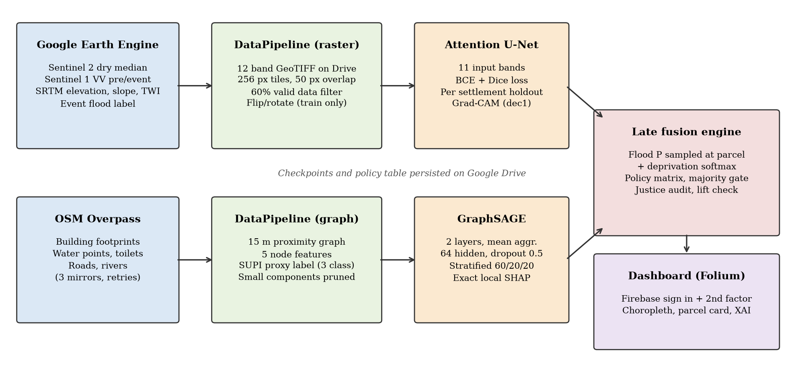
Figure 5.1 Implemented pipeline from data acquisition to the dashboard

Attention U-Net Flood Head
This component implements FR-03. The network is a four level encoder and decoder with an attention gate on every skip connection. Channel widths grow from 32 to 512 at the bottleneck, giving 7,857,021 parameters with eleven inputs. Dropout of up to 0.1 is applied at the bottleneck and in the decoder only. Training used Adam at a learning rate of 0.001 with cosine annealing, batch size 2 and a loss that weights binary cross entropy and Dice equally. The checkpoint with the best validation IoU was kept.
The head went through two versions. The first version used a seasonal Otsu label from 2019 to 2024 rainy season radar. It overfitted: training IoU reached about 0.77 while validation never beat a baseline that predicts flood everywhere, at about 0.31. Diagnostics showed that the label tracked land cover rather than water. The second version replaced it with the event change detection label, added the two VV bands as inputs and added weight decay, dropout and early stopping. The Sprint 4 run trained this second version on all three settlements.
The transfer learning loader for Sen1Floods11 weights was implemented and unit tested. No compatible checkpoint was available during the run, so the network was trained from random initialisation. The training log records this warning.

GraphSAGE Deprivation Head
This component implements FR-04. It has two SAGEConv layers with mean aggregation, 64 hidden units, ReLU and dropout of 0.5. Training was full batch with Adam at a learning rate of 0.005 and weight decay of 0.0005. The best checkpoint was selected on validation macro F1, with early stopping after 20 epochs without improvement in Sprint 3 and 25 in Sprint 4. Figure 5.2 shows the Kibera training curves saved by the Sprint 3 notebook. Validation macro F1 crossed the 0.60 sprint bar within the first few epochs and levelled off near 0.93. The curves are logged in training mode, so dropout keeps the training curve below the validation curve.
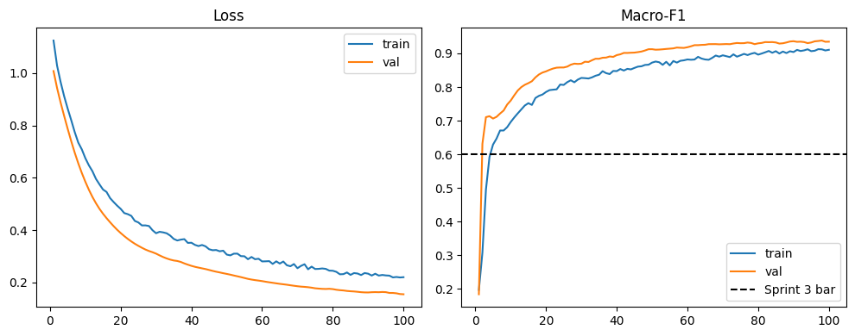
Figure 5.2 GraphSAGE loss and macro F1 on Kibera over 100 epochs (Colab output)

Late Fusion Policy Engine
This component implements FR-05. Each parcel's flood probability was read from the U-Net output at the building centroid. Where tiles overlapped, the values were averaged. The flood value was joined with the three GraphSAGE class probabilities and looked up in the policy matrix in Table 5.7.
Table 5.7 Policy matrix applied by the fusion engine
Flood hazard | Low deprivation | Medium deprivation | High deprivation
Low (probability below 0.5) | Retain and formalise | Retain and upgrade | Priority in situ upgrade
High (probability 0.5 or more) | Flood resilient upgrade | Flood resilient upgrade | Compensated resettlement

The approved design had three categories. The implementation splits them into five actions so that a planner can see why a parcel was upgraded. Two safeguards limit resettlement. First, resettlement needs a high flood row and a high deprivation probability above 0.5. A parcel where high deprivation is only the largest of three classes is routed to flood resilient upgrade instead. Second, an NRRP zone can force the high flood row, but it cannot skip the deprivation check. A justice audit recounts every resettlement against these rules after each run. Parcels with missing or corrupt inputs are marked as insufficient evidence rather than guessed.
The engine was validated with a lift statistic. Lift is the share of flood responsive parcels inside a reference zone divided by the share of all parcels inside it. A value above 1 means flood responsive actions concentrate in the reference zone. The lift is computed on the model decision before any NRRP override, so the zone cannot create the result by itself.

Explanations and Dashboard
This component implements FR-06. For GraphSAGE, the system computes exact Shapley values for one building's five features. Neighbours are held fixed and a missing feature is replaced by its mean across the graph. With five features this needs 32 model evaluations, so the values are exact rather than sampled. For the U-Net, Grad-CAM is taken from the last decoder convolution, which comes after the attention gates. The map is scaled to the 0 to 1 range.
The dashboard is a small Python web server. The home page contains only the sign in form and no parcel coordinates. The map, the parcel list, the summary and the per parcel explanation are served only after the server verifies a Firebase ID token that records a second factor. Accepted factors are a TOTP authenticator code or an SMS code. The signed in page shows a choropleth of actions with a parcel card, and an explanation view with SHAP bars, feature values and a prediction path. A banner states that the river corridor lift was 0.929, so the map is not presented as a validated flood hazard layer. Figures 5.3 and 5.4 show the signed in map and the explanation view. Figure 5.7 shows the sign in page.
[Insert screenshot here: Screenshot of the signed in choropleth map with a parcel card open, taken from your Colab dashboard session.]
Figure 5.3 Parcel policy map with the parcel card
[Insert screenshot here: Screenshot of the explanation view for the same parcel, showing the SHAP bars and the prediction path.]
Figure 5.4 Explanation view for a selected parcel

Deviations from the Approved Design
Table 5.8 records each material difference between Chapter 4 and the implemented system, with its reason.
Table 5.8 Deviations from the Chapter 4 design
Chapter 4 design | Implemented | Reason
Encoder initialised from Sen1Floods11 weights | Trained from random initialisation; loader built and tested | No compatible checkpoint was obtained in time.
Flood labels from seasonal Otsu inundation | Event change detection around the April to May 2024 floods | The seasonal label tracked land cover and the first model never beat the baseline.
Five fold spatially contiguous cross validation | One held out tile location per settlement | Each settlement yielded only four or five tile locations.
Spatially blocked graph split with cut edges | Random split stratified by class within each settlement | Not implemented in the time available. Section 5.8.3 discusses the effect.
Three policy categories | Five actions with a majority gate on resettlement | Explains the reason for each upgrade and makes displacement harder to trigger.
Captum Grad-CAM and the SHAP library | Direct Grad-CAM hooks and exact Shapley values | Five features allow an exact computation, and direct hooks avoided an extra dependency.
Standalone HTML file with no server | Python server behind Firebase sign in with a second factor | The map shows resettlement decisions, so open access was judged unsafe.
Validation against the 37 NRRP zones | OSM river corridor of 120 m as fallback | The NRRP polygons were not available.

Testing and Evaluation

Test Strategy and Acceptance Criteria
Testing combined four levels. Unit tests checked individual functions with synthetic arrays and geometries. Integration tests checked that the data pipeline output fits both heads and that both heads fit the fusion engine. System tests ran the complete pipeline in Colab on real data. Security tests checked the dashboard routes with valid, invalid and incomplete sessions. Unit and integration tests used white box knowledge of the code. System and security tests were black box and compared each output with a predefined expected result. Table 5.9 lists the acceptance criteria, all fixed in Chapter 3, Chapter 4 or src/config.py before the results were produced.
Table 5.9 Acceptance criteria
Requirement | Criterion | Measured on
FR-03, NFR-01 | Attention U-Net IoU of at least 0.60 and F1 of at least 0.75, pooled | Held out tile location per settlement
FR-04, NFR-01 | GraphSAGE macro F1 of at least 0.70, pooled and per settlement | Validation and test nodes
FR-05 | Zero justice audit violations | All fused parcels
FR-05 | Lift strictly greater than 1.0 | Reference zone membership of fused parcels
FR-06, NFR-05 | Shapley values sum to the prediction gap; Grad-CAM lies in the 0 to 1 range | Unit tests
Security | No parcel data without a verified second factor | HTTP responses of the dashboard
All modules | All offline tests pass | pytest

Unit and Integration Testing
The offline suite contains 129 tests in eleven files. All 129 passed in 8.19 seconds on the development machine. Table 5.10 summarises what each file verifies. The full log is kept with the project evidence.
Table 5.10 Offline test suite by module
Test file | Tests | What is verified
test_attention_unet.py | 24 | Output shapes, attention gate bounds, gradient flow, Dice and IoU, holdout keeps augmented copies together, encoder freezing, dropout, early stopping.
test_multi_settlement.py | 17 | Disjoint union of graphs, per settlement splits, no location leakage, export buffer sizing, threshold reports.
test_fusion.py | 15 | Every matrix cell, majority gate, NRRP override limits, corrupt inputs, justice audit on random batches, lift not created by the override, raster sampling.
test_graph_construction.py | 14 | Edges inside and outside 15 m, exact 15 m boundary excluded, isolated nodes flagged, no self loops, pruning, centroid alignment, Overpass mirror retry.
test_flood_label.py | 13 | Change image, threshold only on drops, stable land cover not flooded, slope and permanent water masks, speckle removal, Otsu.
test_dashboard.py | 12 | Second factor claim check, Shapley sum, Grad-CAM range, resettlement marker, refusal without second factor, tunnel URL parsing.
test_graphsage.py | 9 | Output shape, gradients, exclusive splits, macro F1, checkpointing, centroids stay on CPU, local SHAP.
test_label_validation.py | 8 | Confusion counts, lift above 1 for a concentrated label and near 1 for a land cover proxy, rasterised references.
test_deprivation_label.py | 6 | Roof material encoding, indicator scores and class cuts.
test_diagnostics.py | 6 | Pixel AUC and permutation importance used to diagnose the first flood label.
test_layout.py | 5 | Band layouts, input channel counts and fixed dB scaling of VV bands.

A synthetic end to end run was also executed on the CPU machine. It built a twelve band synthetic raster, tiled it and trained a reduced width U-Net for three epochs. It then trained GraphSAGE on an 18,005 node random graph, fused the two heads and ran the justice audit. Every stage completed and the audit passed. The run also measured CPU cost at the real parcel count. Fusing 18,005 parcels took 5 ms. GraphSAGE inference over 18,005 nodes took 15 ms. One exact SHAP explanation took 448 ms. A full width U-Net took 68 ms per tile on average and Grad-CAM took 213 ms. These timings show that the inference side can run without a GPU. They say nothing about accuracy.

Model Evaluation Results
Table 5.11 reports the GraphSAGE results. The Sprint 3 run trained on Kibera alone. The Sprint 4 run trained jointly on all three settlements.
Table 5.11 GraphSAGE deprivation results (macro F1 unless stated)
Run and split | Kibera | Mathare | Mukuru | Pooled | Target
Sprint 3, Kibera only, test | 0.9401 |  |  |  | 0.60
Sprint 4, validation | 0.8972 | 0.8755 | 0.7453 | 0.8813 | 0.70
Sprint 4, test | 0.9011 | 0.8930 | 0.7703 | 0.8906 | 0.70
Sprint 4, test accuracy | 0.9000 | 0.8927 | 0.7745

In the Sprint 3 test split, per class F1 was 0.958 for low, 0.919 for medium and 0.943 for high, over 2,210 nodes. Medium was the weakest class because it borders both others. Every settlement met the 0.70 target. Mukuru scored lowest. It has the smallest graph, with about 235 test nodes, and its smaller split makes its score less stable.
Table 5.12 reports the Attention U-Net results on the held out tile location of each settlement.
Table 5.12 Attention U-Net flood results on held out locations
Settlement | IoU | F1 | IoU target | F1 target
Kibera | 0.7360 | 0.8479 | 0.60 | 0.75
Mathare | 0.6379 | 0.7789 | 0.60 | 0.75
Mukuru | 0.7608 | 0.8642 | 0.60 | 0.75
Pooled | 0.7201 | 0.8373 | 0.60 | 0.75

Figure 5.5 compares both heads with their targets. Both heads passed on every settlement. Mathare was the closest to the IoU bar at 0.638. These numbers come from one location per settlement, which is four tile variants each. They show agreement with the change detection label at that location. Section 5.8 explains why they do not yet show agreement with observed flooding.
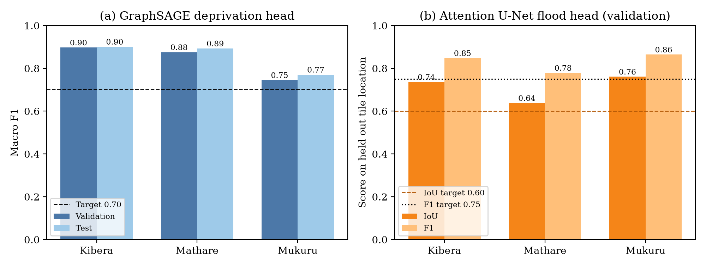
Figure 5.5 Per settlement results of both heads against their acceptance targets

Policy Engine Evaluation
The engine was first checked on synthetic parcels. Six parcels, one per matrix cell, produced the expected action in every case. A wet parcel with class probabilities of 0.40, 0.15 and 0.45 was not resettled because 0.45 is not a majority. A synthetic set built to concentrate in a reference zone gave a lift of 5.0, which confirmed that the statistic responds as intended.
The engine was then run on the real outputs of both heads. Every one of the 18,005 parcels received a valid flood value and a valid action. Table 5.13 and Figure 5.6 show the result.
Table 5.13 Policy actions assigned to all 18,005 parcels
Action | Parcels | Share
Retain and formalise | 4,485 | 24.9%
Retain and upgrade | 4,430 | 24.6%
Priority in situ upgrade | 4,141 | 23.0%
Flood resilient upgrade | 3,684 | 20.5%
Compensated resettlement | 1,265 | 7.0%
Insufficient evidence | 0 | 0.0%

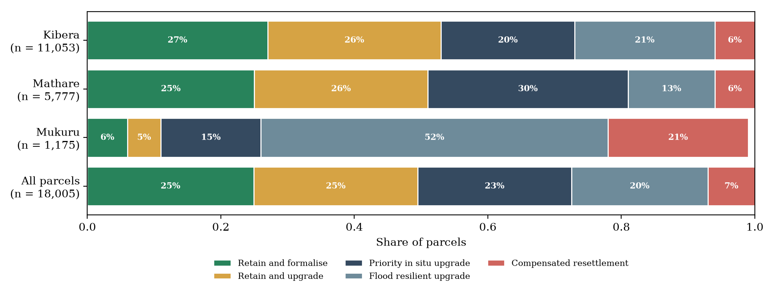
Figure 5.6 Share of policy actions by settlement (shares rounded as printed by the notebook)
The justice audit passed with zero violations. All 1,265 resettlement decisions had a high flood row and a majority high deprivation probability. The majority gate changed five parcels from resettlement to flood resilient upgrade.
The NRRP polygons were not available, so lift was measured against a 120 m buffer around 230 OSM river, stream and drain features. This corridor covered 7,317 of 11,053 Kibera parcels, 3,819 of 5,777 in Mathare and 952 of 1,175 in Mukuru. That is 67% of all parcels. The lift was 0.929, below the target of more than 1.0. About 62% of flood responsive parcels fell inside the corridor, against a 67% base rate. The Sprint 5 exit criterion was therefore not met.

System and Security Test Cases
Table 5.14 lists the system level test cases. Each compares an expected result with the observed result and names its evidence. Security cases used a stub token verifier that returns fixed Firebase claims, because a live Firebase project cannot be used in the offline environment. The stub replaces only Google's signature check. The route logic under test is the production code.
Table 5.14 System test cases and results
Test ID | Traceability | Scenario and data | Expected result | Actual result and evidence | Verdict
TC01 | FR-01 | Export twelve band stacks for all three settlements from Earth Engine | All tasks COMPLETED; stacks on Drive | All COMPLETED; 578 × 511, 758 × 511 and 571 × 510 pixels (notebook 04) | Pass
TC02 | FR-02 | Tile each stack at 256 pixels with 50 pixel overlap | A non empty manifest per settlement | 16, 20 and 16 tile variants (notebook 04) | Pass
TC03 | FR-02 | Build the Kibera graph at 15 m and check integrity | Graph saved; fragmentation reported | Graph saved; warning raised for a 22% largest component; small components pruned (notebook 03) | Pass
TC04 | FR-03, NFR-01 | Evaluate the U-Net on held out locations | Pooled IoU ≥ 0.60 and F1 ≥ 0.75 | IoU 0.7201, F1 0.8373 (notebook 04) | Pass
TC05 | FR-04, NFR-01 | Evaluate GraphSAGE on test nodes of each settlement | Macro F1 ≥ 0.70 everywhere | 0.9011, 0.8930, 0.7703; pooled 0.8906 (notebook 04) | Pass
TC06 | FR-05 | Six synthetic parcels, one per matrix cell, plus one plurality case | Matrix actions; plurality not resettled | All seven as expected (notebook 05, section 2) | Pass
TC07 | FR-05 | Fuse 18,005 real parcels and run the justice audit | Zero violations | Zero violations; 1,265 resettlements (notebook 05) | Pass
TC08 | FR-05 | Lift of model actions against the reference zone | Lift > 1.0 | 0.929 against the river corridor (notebook 05) | Fail
TC09 | FR-06, NFR-05 | Explain one node and one tile | Shapley sum equals the logit gap; Grad-CAM in 0 to 1 | Both hold (test_dashboard.py) | Pass
TC10 | Security | Request the map with no token, an invalid token and a password only token | 401, 401 and 403; no coordinates returned | 401, 401 and 403; no coordinates in any body (access control log) | Pass
TC11 | Security | Request the map with a TOTP session and with a phone session | 200 with the map | 200 for both (access control log) | Pass
TC12 | Security | Request /assets/../app.py | 404; no source returned | 404 (access control log) | Pass
TC13 | Security | Open the dashboard with no Firebase settings | Sign in stays closed | Message shown and the map stays closed (Figure 5.7) | Pass
TC14 | NFR-03 | Planners complete tasks on the dashboard | Reviewer identifies the policy basis for five parcels | Not executed | Not run


Figure 5.7 Dashboard sign in page failing closed when no Firebase settings are configured (TC13)

Defects and Retesting
Table 5.15 records the defects found during development, the fix and the retest. Commit identifiers refer to the project repository. The failed first flood model is kept in the record rather than replaced by the later result.
Table 5.15 Defects, corrective changes and retest outcomes
ID | Defect | Correction | Retest outcome | Status
D01 | First U-Net overfitted; validation never beat the flood everywhere baseline (about 0.31) | Event change detection label, lift check, VV inputs, regularisation (PR #4) | Pooled validation IoU 0.7201 in Sprint 4 | Closed
D02 | Overpass returned 502 errors at capacity | Retry across three mirrors with backoff (a859db8) | Kibera graph rebuilt in Colab; unit test passes | Closed
D03 | Mathare and Mukuru rasters too small to tile | Size aware export buffer (a07c7a8) | 20 and 16 tile variants produced | Closed
D04 | Empty tile manifests stopped the Sprint 4 split | Skip settlements with too few locations (625fedd) | Unit tests pass | Closed
D05 | Older graphs had no building centroids for flood sampling | Copy centroids when node features match (7c564b0) | 18,005 of 18,005 parcels received a flood value | Closed
D06 | GraphSAGE inference moved centroids to the GPU | Keep centroids on the CPU (c6f8e79) | Dedicated unit test passes | Closed
D07 | Dashboard blank inside Colab because it pointed at localhost | Public HTTPS tunnel with cloudflared (ce460f1) | Tunnel URL parsing test passes | Closed
D08 | Settlement keys loaded from the policy table raised an error | Convert keys to plain strings (21036d4) | Dedicated unit test passes | Closed
D09 | Policy lift below 1.0 | None yet; the NRRP polygons are required | 0.929 against the river corridor | Open

Version Control and Implementation Evidence
The source code, notebooks and tests are held in the Project repository at https://github.com/emmanuelamor5/nairobi-risk-mapping. At the time of writing the main branch held 50 commits made between 24 August and 22 October 2026. Work followed a branch per sprint. Each sprint was merged through a pull request, as shown in Table 5.16. Figure 5.8 shows the commit history. Colab notebooks cloned the sprint branch directly, so every recorded result can be traced to a commit.
Table 5.16 Merged pull requests by sprint
Pull request | Content | Merged
#1 | Headless Earth Engine authentication with a service account | 20 September 2026
#4 | Sprint 2 v2: event flood label, validation and retraining | 12 October 2026
#6 | Sprint 3: GraphSAGE deprivation head | 19 October 2026
#8 | Sprint 4: both heads on Mathare and Mukuru | 19 October 2026
#12 | Sprint 5: late fusion policy matrix and lift check | 21 October 2026
#14 | Sprint 6: dashboard behind Firebase sign in with a second factor | 21 October 2026
#16 | Dashboard layout aligned to the Figma design | 22 October 2026

The repository contains a README with setup, Colab and test instructions, a requirements file and a .gitignore. The .gitignore excludes data, rasters, tiles, checkpoints, environment files and the Firebase settings file. Seven further pull requests on dashboard refinement and NRRP validation were still open and are not part of the evaluated system. No release tag or licence file had been added.
[Insert screenshot here: Screenshot of the GitHub Insights or commit history page for the repository.]
Figure 5.8 Repository commit history

Author Oversight and Use of AI Assisted Tools
Cursor AI coding agents, provided by Anysphere, were used to draft much of the code, the unit tests and the notebooks. Each change was proposed on a separate branch and pull request. The author reviewed each pull request, ran the notebooks in Colab on real data and merged the work. The same tool assisted with drafting and language refinement of this chapter. All figures quoted in the chapter were checked against the saved notebook outputs, the repository and the test logs. The author made the final decisions and takes full responsibility for the submitted work.
[Note to author: Confirm this declaration matches how you used the tools, and add any other tool you used.]

Evaluation Results, Discussion and Limitations

Results Against the Objectives
Table 5.17 links each implementation objective to its evidence. The review objectives one to three were met in Chapter 2 and are not repeated.
Table 5.17 Evidence for the implementation objectives
Objective | Output | Criterion | Observed | What the evidence supports
4. Develop the multi task framework | Attention U-Net, GraphSAGE and fusion engine for three settlements | IoU ≥ 0.60, F1 ≥ 0.75, macro F1 ≥ 0.70, zero audit violations, lift > 1.0 | IoU 0.72, F1 0.84, macro F1 0.89, zero violations, lift 0.929 | The framework works end to end and meets its model targets. It does not yet show that its flood actions match an independent hazard reference.
5. Implement the XAI dashboard | Authenticated Folium dashboard with SHAP and Grad-CAM | Map and explanations served only after a second factor; reviewer task test | Access control passed; reviewer test not run | The dashboard is functional and secure in testing. Its interpretability for planners is not yet evaluated.

Discussion
The GraphSAGE scores are high because the task is easy by construction. The label is an average of scores computed from the same five features the model receives. A macro F1 of 0.89 therefore shows that the network reproduces the proxy rule. It does not show that it predicts deprivation as a household survey would measure it. The lower Mukuru score is consistent with its small graph and with sparser OSM tagging.
The U-Net result needs similar care. Its label is computed from the pre event and event VV bands, and both bands are also inputs. A network can reach a high IoU by learning the change detection rule. This was a deliberate choice, since the first version failed when it had to infer water from optical bands alone. It does mean that the IoU measures agreement with the label rule and not with observed flooding. The validation set was also small, one location and four tile variants per settlement.
The lift of 0.929 is the most important result for the policy engine. Flood responsive actions were not more common inside the river corridor than outside it. Two explanations are possible. The corridor covers two thirds of all parcels, so it separates parcels weakly and a lift near 1 is expected even for a sound model. Alternatively, the flood probabilities may not follow the river network closely enough. The current evidence cannot separate these explanations. The official NRRP zones are needed for that.
The engine's safeguards behaved as designed. No parcel was resettled without high hazard and a majority high deprivation probability, and the gate changed five borderline cases. Mukuru is the exception to watch. It had 21% resettlement and 52% flood resilient upgrade, against 6% resettlement in Kibera and Mathare. Mukuru also had the largest export buffer, the most corridor coverage at 81% and the weakest GraphSAGE score. Its actions should be reviewed before anyone relies on them.
These findings agree with the gap identified in Chapter 2. Parcel level resolution and joint hazard and deprivation assessment were achieved technically. The validation evidence that a planner would need before acting on a resettlement decision is still missing.

Limitations
Labels are proxies. The deprivation label comes from OSM distances and sparse roof tags, not surveys. The flood label comes from one radar event and was not checked against field reports. Both limit what the high metrics can show.
The evaluation design was weaker than planned. The U-Net was validated on one location per settlement without a separate test location. The graph split was random, so test buildings share neighbours with training buildings, and features were standardised over all nodes before splitting. Both choices likely raise the reported scores. Each model was trained once with seed 42, so variation across runs is unknown.
Boundaries and inputs are approximate. Kibera's boundary fell back to a hardcoded box when the OSM lookup failed. The buffered exports extend well beyond each settlement. The wetness index uses a smoothing proxy rather than true flow routing. The U-Net was trained without the planned transfer learning.
The policy lift was measured against a coarse river corridor and failed. The 37 NRRP zones have not been tested. No user acceptance test with planners was carried out, so usability and interpretability for the intended users remain unverified. The dashboard has only been run as a private prototype on Colab and a local machine.

