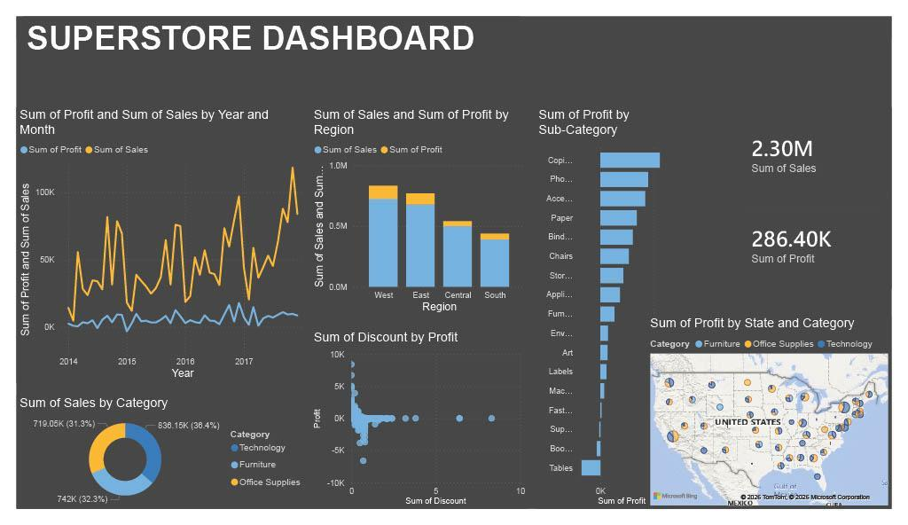
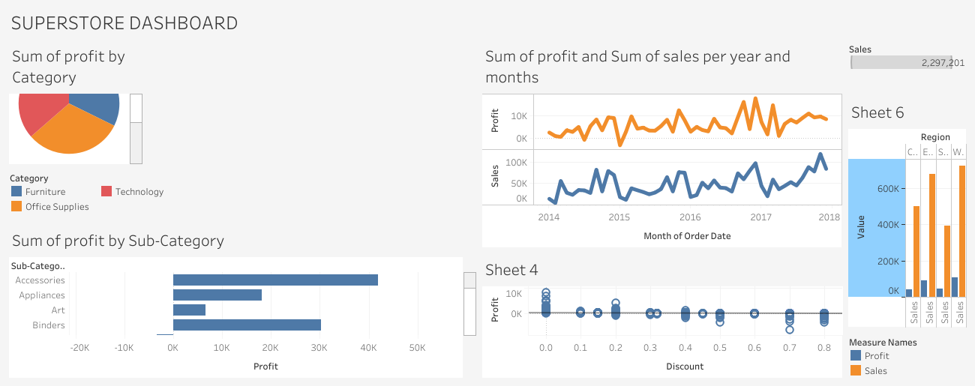

1. Executive Summary
This report presents a structured analysis of the Superstore Sales Power BI dashboard. The dashboard provides a comprehensive, single-page view of the company’s retail performance, drawing on transactional order data to surface trends in revenue, profitability, regional performance, and product-level margins. The report explains what each visual in the dashboard measures, what questions it is designed to answer, and what business decisions it should inform.

2. About the Dataset
The underlying data source is the Sample Superstore dataset, a widely recognized retail transaction dataset. It captures order-level records across the United States and is structured around the following core fields:

Field | Description | Used For
Sales | Total revenue generated per order line | Revenue tracking, KPIs
Profit | Net margin after cost of goods | Profitability analysis
Discount | Discount rate applied at order level | Margin impact analysis
Order Date | Date the order was placed | Time-series trending
Category | High-level product grouping (3 categories) | Segment mix analysis
Sub-Category | Detailed product type (17 sub-categories) | Granular margin analysis
Region | US regional grouping (East, West, Central, South) | Geographic benchmarking
State | US state-level location | Geographic mapping
Segment | Customer type (Consumer, Corporate, Home Office) | Customer segmentation

3. Dashboard Structure
The report consists of a single page (Page 1) containing nine visual components displayed on a 1,280 × 720 canvas using the Innovate theme. The visuals are organized to give a top-level summary view before drilling into category, regional, and product-level detail.

3.1 Key Performance Indicators (KPI Cards)
Two card visuals appear prominently on the dashboard, each surfacing a single headline figure:
- Total Sales — the sum of all revenue across the entire dataset. This is the primary business volume indicator.
- Total Profit — the sum of net profit across all orders. This figure, read alongside Total Sales, gives a quick read on overall margin health.
These two cards are the first numbers a reader should reference. A large gap between Sales and Profit signals cost or discount pressure and would warrant further investigation into the charts below.

3.2 Sales by Category (Donut Chart)
The donut chart breaks down total sales across the three product categories. It answers the question: where is the bulk of revenue coming from? Each segment of the donut represents one category’s proportional contribution to overall sales. A category with a large revenue share but poor profitability (visible in other visuals) would be a strategic concern.

3.3 Sales & Profit Over Time (Line Chart)
The line chart plots both Sales and Profit on a shared time axis, navigable at the Year and Month level. This is the dashboard’s primary trend indicator. Key things to look for include:
- Whether profit is growing proportionally with sales, or lagging — which would indicate rising costs or increasing discounts over time.
- Seasonal spikes: retail typically shows peaks around Q4. A sharp increase in sales without a corresponding profit increase in the same period points to heavy promotional discounting.
- Divergence between the two lines at any point in time is a signal for management attention.

3.4 Discount vs. Profit (Scatter Chart)
This is arguably the most analytically significant visual in the report. Each point on the scatter plot represents a transaction, positioned by its discount rate (X-axis) and resulting profit (Y-axis).
A downward-sloping pattern from left to right confirms that higher discounts correlate with lower or negative profit — a common and costly retail dynamic. Points appearing in the lower-right quadrant (high discount, negative profit) represent loss-making orders. Management should use this chart to set discount ceiling policies, particularly for categories or sub-categories where the margin is already thin.

3.5 Sales & Profit by Region (Column Chart)
The grouped column chart compares total Sales and Profit side by side across the four US regions: East, West, Central, and South. This visual answers: which regions are performing well on both volume and margin, and which are volume-heavy but unprofitable?
A region with high sales but a small profit column is a margin problem. A region with both metrics low may be an untapped opportunity or a territory with structural cost challenges.

3.6 Profit by Sub-Category (Bar Chart)
This horizontal bar chart ranks all sub-categories by total profit. It is the most granular profitability view in the dashboard and surfaces the specific products driving or destroying margin.
Sub-categories with negative bars (profit below zero) are selling at a net loss — typically the result of excessive discounting or unfavorable cost structures. These items require either a pricing correction or a review of their position in the product portfolio. High-profit sub-categories should be protected and potentially expanded.

3.7 Profit by State (Geographic Map)
The bubble map visualizes profit at the state level, with bubble size representing the magnitude of profit and color coding indicating product category. This allows geographic patterns to emerge at a glance — for example, whether certain states are systematically unprofitable regardless of category, or whether specific categories underperform in particular regions.
States with large negative profit bubbles should be flagged for a root-cause review of local pricing, freight costs, or promotional activity.

4. Business Questions This Dashboard Answers

Business Question | Visual to Reference
What is our total revenue and profit right now? | KPI Cards (Visuals 6 & 8)
Which product category generates the most sales? | Donut Chart (Visual 2)
Are sales and profits growing over time? | Line Chart (Visual 3)
Is discounting hurting our profitability? | Scatter Chart (Visual 4)
Which regions are most and least profitable? | Column Chart (Visual 5)
Which specific products are losing money? | Bar Chart — Sub-Category (Visual 7)
Are there geographic clusters of underperformance? | Map (Visual 9)

5. Recommended Actions
Based on the analytical framework embedded in this dashboard, the following areas warrant priority review:

- Discount Policy Review: The scatter chart (Discount vs. Profit) should be used to establish a maximum allowable discount threshold per category. Orders beyond that threshold consistently generate losses.
- Sub-Category Rationalization: Any sub-category showing a negative profit bar should be subject to a formal margin review. If cost reduction is not feasible, pricing adjustments or product discontinuation should be considered.
- Regional Strategy: Regions or states with high sales volume but low profit margins should be audited for local cost drivers — including logistics, local promotions, and returns rates.
- Seasonal Planning: Time-series trends in the line chart should inform inventory and staffing plans for peak periods, ensuring that sales volume increases in those periods are accompanied by disciplined margin management.

