Rafting Site Plan – Branding Submission

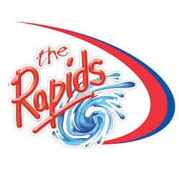

primary-color: #264969

secondary-color: #505033

accent1-color: #CFCFB4

accent2-color: #B4CDE4

heading-font: Playfair Display

text-font: Open Sans

Color Palette URL: <https://coolors.co/264969-505033-cfcfb4-b4cde4>