Emmanuel Briones

Lab 1 Report

Introduction:

The problem that was to be solved was to have to traverse all of the comments of a reddit article and also access the replies of the comments. Every single comment and reply had to be accessed. After accessing the comment, the comment had to be classified as positive, neutral, or negative and added to the list of either positive, negative, or neutral. After doing all of the traversing, there should be three lists with their respective comments.

Proposed Solution Design and Implementation:

First, I tried to access all the main comment and its replies using if statements and using 6 parameters, four lists and two indexes, but it was not an efficient approach because I had to call the method every time with the next comment in the comments list. I decided to use another method to access every main comment and its replies. So, I decided to use a for loop with just 4 parameters (comments list, positive list, neutral list, and negative list) to access all of the main comments first. In that for loop, I would get its negative, positive, and neutral value and then compare all three to see what kind of comment it was. Depending on what its value turned out to be, the comment’s body was added to one of the three lists using the append command and using item.body (item is the variable I decided to use to access every comment in the list using the for loop) to access the comment. After assigning that comment to its respective list, I. made the recursive call within the for loop. The new parameters were the same except for the comments list parameters, which I changed to item.replies to see if the current comment had any replies. That recursive call would be repeated with every single comment that was accessed using the for loop. That way, every comment and its replies were accessed.

Experimental Results

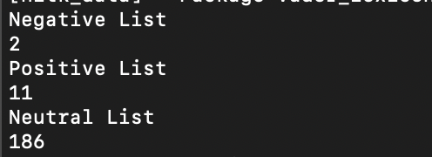 The first test I decided to do was print out the size of the three lists to see how big each list was. The output that I got from these three lists was that positive_comments had 11 comments, negative_comments had 2 comments, and neutral_comments had 186 comments.

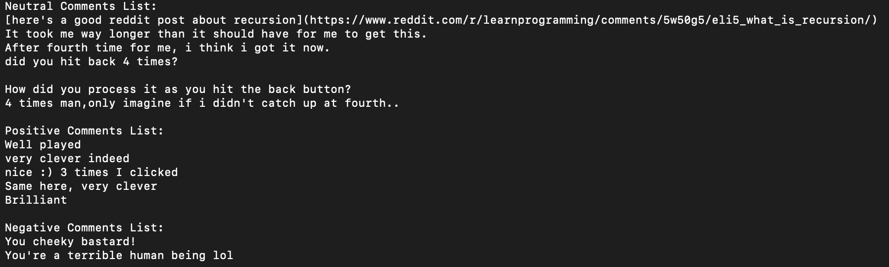Then I decided to test it again by printing out the first five elements of the positive and neutral elements because they were bigger lists and print out all of the negative list because it was just made up of 2 comments. I decided to do that to compare them with the comments on the reddit website to see if they were correct. The output was the following:

After that, I decided to print the last comment of each list and compare it with the reddit webpage to see if there was a similarity. For the neutral list, the output was the last comment of the whole reddit webpage, so that proves that the method did work because it did access all of the comments all the way to the very last comment on reddit. This was the output:

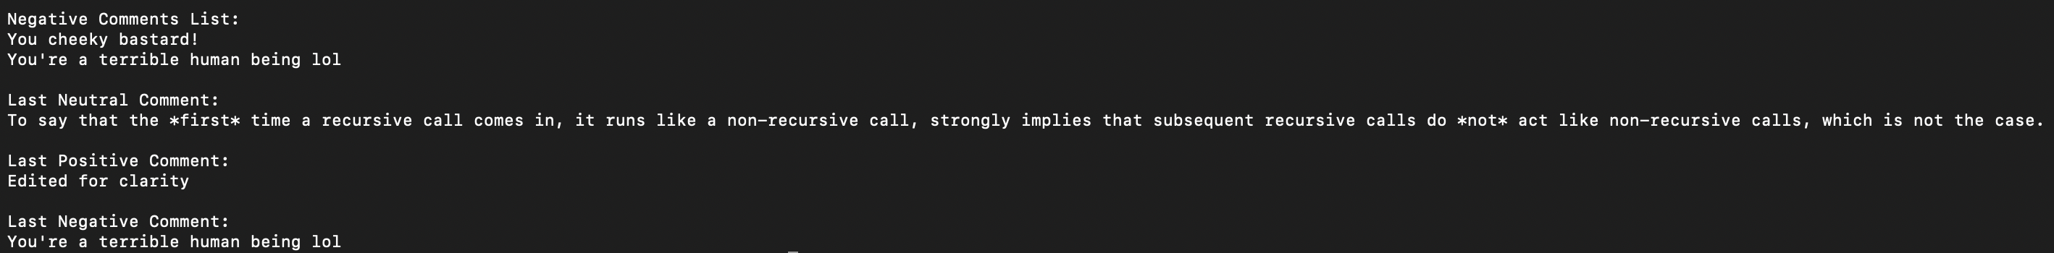j

Conclusions:

What I learned from this assignment was to be open to change your code. At first, I wanted to stick with what I started to do but then, I realized that I was doing it more complicated than it was. I was afraid of starting over because I had already dedicated a lot of time to the code that I was doing. I finally decided that I was making it hard by myself and then decided to start again and delete the previous work that I was on. I also learned that recursion makes your life easier because you just have to call it once and it will do the rest for you. Without recursion, it would be a lot more complicated.