Emmanuel C.S.I. Church, Philadelphia  4937 Church Avenue,  Feasterville-Trevose, PA 19053  Sunday school at 9:00 a.m.  Sunday Worship at 10:00 a.m.  1st & 3rd - Malayalam Holy Communion  2nd – English Holy Communion  4th – English Holy Communion  5th – Malayalam Matins  Teleconference Prayer – Every Wednesday @ 8:00 PM  Fasting Prayer – Every Saturday @ 10:00 AM  Contact Information:  President: Rev. Sandeep Jacob: (215) 688-2289  Vice-president: Mr. Koshy K. Varghese - (267) 312-5373  Secretary: Mr. Cherian M. Abraham - (215) 620-7324  Jt. Secretary: Mr. Ivan Pattemthanam - (215) 720-5058  Treasurer: Mr. Saju Issac Mathew - (215) 327-9875  Web Master: Miss Reeba Ivan: (215) 353-6592  www.emmanuelcsi.com  https://www.facebook.com/ecsopa  Email: emmanuelcsichurchpa@gmail.com |  |  |  | Newsletter of  Emmanuel C.S.I. Church, Philadelphia  July 2025    SPEAK OUT @ EMMANUEL  (A monthly Publication)  4937 Church Avenue  Feasterville-Trevose, PA 19053
 | 2025 Year Plan  Importance days of the Church Calendar  Date Event  Harvest Festival  Harvest Festival  08/03/2025 Mission Sunday Laity Sunday  08/09/2025 Church Picnic  09/06/2025 Sunday School Competitions  09/21/2025 Choir Sunday  09/27/2025 CSI Formation Day  09/28/2025 Senior Citizen’s Sunday  10/05/2025 Laity Sunday  10/19/2025 Church Day  10/26/2025 Reformation Sunday  11/02/2025 Sunday school Sunday  11/09/2025 Unity Sunday  11/23/2025 Thanksgiving Sunday  11/29/2025 House to House Caroling (Local areas)  12/06/2025 House to House Caroling (outside areas)  12/--/2025 Christmas Carol 21 or 28  12/25/2025 Christmas Day  8  Birthday Greetings:  The following members will be celebrating their birthdays in the month of July. They are requested to attend Thanksgiving prayer during the Service.  Mr. Aji Sam Mathew 07/02  Miss Angelina Prasad 07/09  Miss Maya Abigail Russal 07/11  Dr. Susan R. Samuel 07/12  Miss Vivienne Korah Jacob 07/14  Mr. Navin George 07/17  Mrs. Renjini John Koshy 07/22  God’s richest blessings be upon you as you celebrate yet another year on this journey with Christ and as you commit each day into the hands of the Lord.    Wedding Anniversaries:  Congratulations and best wishes to all the couples who will be celebrating their anniversaries in the month of July. They are requested to attend Thanksgiving prayer during the Service.  Mr. Jeremy V. Thomas & Dr. Mrs. Keerthy D. joseph 07/01  Mr. Reny Eapen Mathew & Mrs. Anu Reny 07/29  May you truly sense God’s love as you celebrate your Wedding Anniversary and see the future years together as memories to be made. M.S.Lowndes    2 |  |  |  | 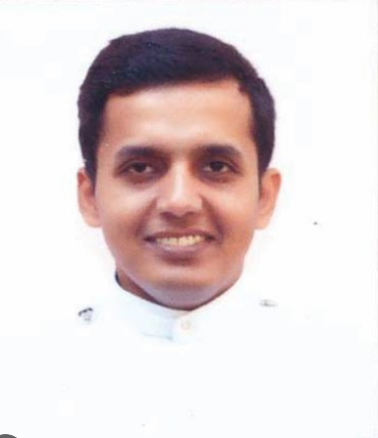  From Achen’s Desk  Dear Friends,  Greetings in the Name of Our Lord Jesus Christ.  The month of July brings us warm days. I pray that this season offers you some peace, rest, and joy—gifts from the Lord that refresh our bodies and souls.  This month we celebrate Independence Day. Let us pray for those in leadership. May we also commit ourselves anew to being peacemakers and witnesses of Gospel values in our communities.  On July 25th, the Church celebrates the Feast of Saint James the Apostle, also known as James the Greater. He was one of Jesus’ first disciples and the brother of John. Alongside Peter and John, James witnessed some of the most intimate moments of Jesus’ ministry, including the Transfiguration and the agony in the garden. Saint James is remembered for his bold faith and his willingness to suffer for Christ—he was the first of the apostles to be martyred.  As we enjoy the blessings of summer, may our hearts be renewed in faith and joy. Let us walk together in trust, giving thanks for each day and for the grace God continues to pour into our lives.  Rev. Sandeep Jacob  1    7
 | 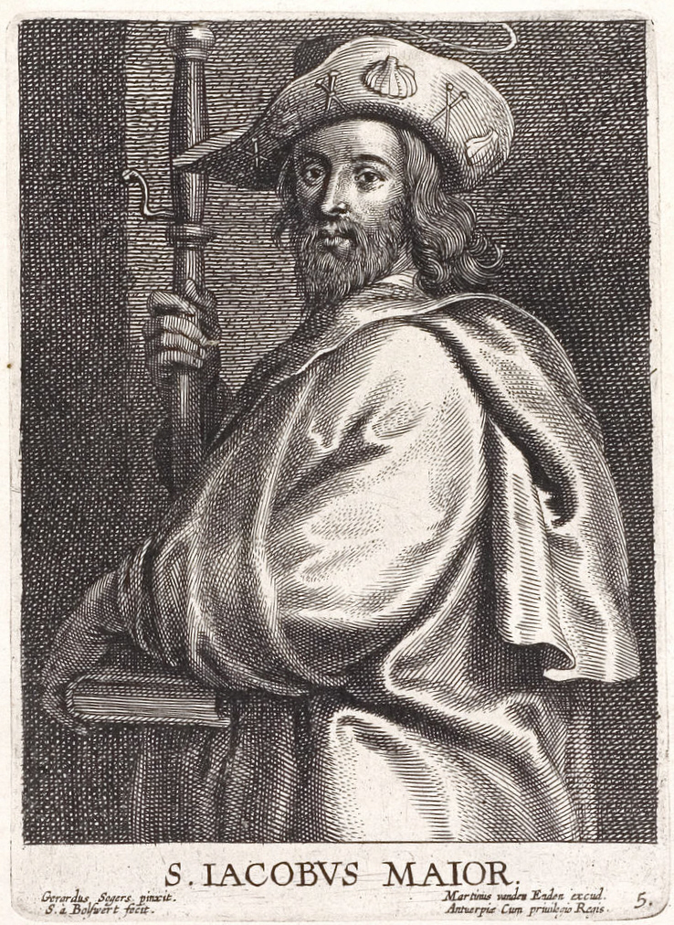  Feast of Saint James  The Feast of Saint James, also known as Saint James' Day, is a commemoration of the apostle James the Great celebrated on July 25 of the liturgical calendars of the Catholic Church and the Church of England.  According to the legends surrounding his life, it is said that James preached the gospel in Hispania as well as in the Holy Land. After his martyrdom at the hands of Herod Agrippa, his followers transported his body by sea to Galicia, where they landed at Iria Flavia, and then carried his remains to Santiago de Compostela for burial.^{[4]} The location of the grave was lost to memory, and was believed to be rediscovered by bishop Theodemir of Iria on July 25, 812, during the reign of Alfonso II.^{[4]}  Due to his purported role in leading a Christian victory in the mythical Battle of Clavijo as James Matamoros (James the Moor-slayer), James is held as patron saint of the Spaniards. Because of his role in northern Spain, James is venerated throughout the Basque Country and Galicia where July 25 is a public holiday.^{[3]}  A traditional pilgrimage called the Way of St James (Camino de Santiago) is held that day, bringing people to the town of Santiago de Compostela and the Santiago de Compostela Cathedral. It is the town's largest annual festival, with processions and fireworks. The cathedral holds a special Mass, and its Botafumeiro may be swung. During a Jacobean Holy Year, pilgrims may enter the cathedral through the Holy Door (Porta Santa) to gain a plenary indulgence.^{[5]}  6  Lectionary for July/August 2025  July 27 7th Sunday after Pentecost  Theme: Ordained Ministry: Fragrance of Christ  Holy Communion Service (English)  1 Lesson: Exodus 29: 1 -9  Psalm 99  2 Lesson: Ephesians 5: 1 -14  Gospel: Luke 10: 1 - 11  Lay Ministry: Sunday School Children  August 03 8th Sunday after Pentecost  Mission Sunday  Theme: Mission: From Everywhere to Everywhere  Malayalam Holy Communion Service  1 Lesson: 1 Kings 17: 1 - 16  Psalm 107: 1 - 15  2 Lesson: Galatians 2: 1 - 10  Gospel: Matthew 13: 47 - 52  Songs:  Lay Ministry:  August 10 9th Sunday after Pentecost  Theme: Marriage: Lasting Life of Love  Holy Communion Service (English)  1 Lesson: Genesis 29: 1 - 20  Psalm 128  2 Lesson: Hebrews 13:1 - 6  Gospel: Matthew 19: 3 - 9  Songs:  Lay Ministry: Youth Fellowship  4 |  |  |  | Lectionary for July 2025  July 06 4th Sunday after Pentecost  Stewardship Sunday (H. C. Malayalam)  Theme: Giving without Counting the Cost  1 Lesson: Genesis 13: 8 - 18  Psalm 15  2 Lesson: 2 Corinthians 8: 1 - 15  Gospel: Mark 14: 3 – 11  Songs:  Lay Ministry: Mr. Prasad Philip & Family  July 13 5th Sunday after Pentecost  English Holy Communion Service  Theme: Theological Education: Making of the Faithful  1 Lesson: Joshua 4: 1-9  Psalm 1  2 Lesson: 1 Timothy 6: 11-16  Gospel: Matthew 13: 1-9  Lay Ministry: Youth Fellowship  July 20 6th Sunday after Pentecost  Malayalam Holy Communion Service  Theme: People of God: Flock of Christ  1 Lesson: Genesis 35: 1 - 15  Psalm 95  2 Lesson: Acts 16: 11 - 15  Gospel: John 1: 15 - 6  Lay Ministry:  3  Thomas, Apostle of India  (Celebrated on July 03)  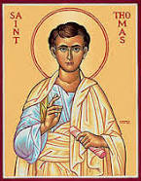  Thomas the Apostle, also called Didymus, was one of the Twelve Apostles of Jesus according to the New Testament. Thomas is commonly known as "Doubting Thomas" because he doubted Jesus' resurrection when first told of it; later, he confessed his faith, "My Lord and my God," on seeing Jesus' crucifixion wounds.  Born: Galilee, Israel  Died: St Thomas Mount, St. Thomas Mount, India  Nickname: doubting Thomas  Full name: Judas Thomas  Buried: Santhome Cathedral Basilica, Chennai, India  According to traditional accounts of the Saint Thomas Christians of modern-day Kerala in India, Thomas is believed to have travelled outside the Roman Empire to preach the Gospel, travelling as far as the Malabar Coast which is in modern-day Kerala. According to their tradition, Thomas reached Muziris (modern-day North Paravur and Kodungalloor in the state of Kerala, India) in AD 52. In 1258, some of the relics were brought to Ortona, in Abruzzo, Italy, where they have been held in the Church of Saint Thomas the Apostle.^{[9]} He is often regarded as the patron saint of India,  Source: Wikipedia  5

