CHAPTER 3
IT PROJECT ON DESIGN AND IMPLEMENTATION OF A CAMPUS LOST AND FOUND WEB APPLICATION WITH AUTOMATIC ITEM MATCHING USING NEXT.JS AND POSTGRESQL

INTRODUCTION
This chapter presents the IT project titled "Design and Implementation of a Campus Lost and Found Web Application with Automatic Item Matching Using Next.js and PostgreSQL." The project produced a complete web application named campusfind, in which University of Uyo students post items they have lost or found, search every post on campus, contact the person who posted an item, send a claim to prove that a found item is theirs, and close the post once the item has been returned. Its most important feature is a matching engine: as soon as an item is posted, the application lists the posts of the opposite kind (lost against found) that most likely describe the same object, with a score and the reasons for each suggestion.
The chapter describes the problem, the requirements, the methodology, the architecture and database, the matching algorithm, the claim workflow and its rules, security, the user interface, testing and evaluation, and deployment.

3.1 PROJECT OVERVIEW
campusfind is a full stack web application built with React and Next.js 16 (App Router), written in TypeScript and backed by a PostgreSQL database accessed through the Drizzle ORM. Pages are rendered on the server and all changes go through Server Actions, so no separate API layer had to be written or secured.
Every user is a student. A student who has lost something posts a lost item with a title, category, place, date and description (and a photo if they have one). A student who has found something posts a found item, usually with a photo, and is advised to leave out one identifying detail so that the real owner can prove ownership. The feed shows all active posts as photo cards marked LOST or FOUND and can be searched by text and filtered by type, by ten categories, and by whether the item is still active or already returned.
Each item page shows the photo, the date, the place, the category, the description and the poster, with buttons to email, phone or WhatsApp them. Any other student can send a claim: a short message describing something only the owner (or the finder) would know, with an optional phone number. Claims are visible only to the poster, who can accept or decline them. Accepting one claim marks the item as claimed and declines the others; after the handover the poster marks the item as returned, which closes it and moves it to the Returned tab. Under every open item the application lists its possible matches.
The scope covers sign-in and sessions, the feed with search and filters, posting with photo upload, item pages with contact links, the matching engine, the claim workflow, the student's own posts and claims, responsive layouts for phones, automated tests at three levels, a PDF user guide, and deployment on Railway with a separate PostgreSQL database. A staff or security desk role, notifications by email or SMS, and integration with the university's student records are outside the scope of this report.

3.2 BACKGROUND OF THE STUDY
On a large campus such as the University of Uyo, students lose phones, calculators, ID cards, keys, earbuds, wallets, textbooks and clothing every day in lecture theatres, libraries, hostels, cafeterias and on shuttle buses. Honest finders usually want to return what they find, but they do not know who the owner is. The common practice is to announce the item in one or two WhatsApp groups, hand it to a porter or a departmental office, or keep it and hope the owner asks around. Owners, in turn, post "Lost: black calculator, please call..." messages that reach only some groups and quickly scroll out of sight.
Two problems make this worse. First, the lost message and the found message are rarely seen by the right people at the same time, even when both have been posted. Second, there is no safe way to check who the real owner is: anyone can claim a valuable item that was announced with a full description.
A web application with a shared, searchable record of lost and found items, a way to match the two kinds of post automatically, and a structured claim step that asks for proof addresses both problems. Text matching does not need artificial intelligence services: a well designed scoring function that compares categories, words, places and dates is enough to surface likely matches, and it can be explained and tested.

3.3 PROBLEM STATEMENT
Lost and found items on campus are reported through scattered WhatsApp groups, porters and departmental offices. Lost and found reports are not seen together, so owners and finders who are looking for each other often never connect. Announcements disappear as new messages arrive, there is no way to search them by item, place or date, and there is no record of whether an item has already been returned. When an item is announced with a full description, there is no structured way for the finder to check that the person asking for it is really the owner.
There is therefore a need for a simple, mobile-friendly web application where students can post lost and found items with photos, search all posts, be shown likely matches automatically, contact the poster, and complete a claim, accept and return process that keeps a clear status for every item. The project also addresses the learning need to apply React, Next.js, TypeScript, PostgreSQL, text-matching techniques, automated testing, Git and cloud deployment in one complete application.

3.4 AIM AND OBJECTIVES
Aim: To design, implement, test and deploy a campus lost and found web application that matches lost and found posts automatically and supports a verified claim process, using Next.js and PostgreSQL.
Objectives:
- To identify the functional and non-functional requirements of a campus lost and found service.
- To design the database schema, the architecture and the life cycle of items and claims.
- To design and implement a transparent scoring algorithm that suggests likely matches between lost and found posts.
- To implement the user interface with React and Next.js, including photo upload and a responsive layout for phones.
- To implement the claim, accept, decline and resolve workflow with rules enforced on the server and in the database.
- To secure sign-in and ensure each student only sees the private data they are entitled to.
- To test the application with unit, integration and end-to-end tests on desktop and mobile, and evaluate it.
- To manage the code with Git and GitHub and deploy it on Railway with its own database and a health check.

3.5 REQUIREMENTS GATHERING / INFORMATION GATHERING
Requirements were gathered by reading lost and found messages typical of student WhatsApp groups and noting what information they contain and what they leave out; by informal conversations with students about items they had lost or found and how they were (or were not) returned; by reviewing how general marketplaces and lost-property services present items, contact details and status; and by testing how different students describe the same object (for example "black Oraimo earbuds" against "earbuds charging case"), which shaped the matching rules. No personal information about real people was collected; all names and phone numbers in the application are fictional.
The functional requirements are listed in Table 3.1 and the non-functional requirements in Table 3.2. Figure 3.1 shows the use cases.
Table 3.1: Functional requirements
ID | Requirement
FR1 | Students can sign in with an email and password and sign out; the sign-in page is prefilled with a demo account.
FR2 | Visitors without a valid session are redirected to the sign-in page.
FR3 | Students can post a lost or found item with type, title, category, place, date, details and an optional photo.
FR4 | The feed shows active posts newest first, with photo (or a category icon), LOST or FOUND tag, place, age and number of replies.
FR5 | Students can search by text and filter by type, category and Active or Returned.
FR6 | Each item page shows the details and the poster, with email, phone and WhatsApp contact links.
FR7 | Each open item lists its possible matches with a score, a label and the reasons.
FR8 | A student can send one claim per item with a message and optional phone number; claims on one's own post are not allowed.
FR9 | Only the poster sees the claims on a post and can accept or decline them.
FR10 | Accepting a claim marks the item claimed and declines the other pending claims.
FR11 | The poster can mark the item as returned (resolved), which closes it.
FR12 | Students can see their own posts (with new claims highlighted) and their own claims (with status).
FR13 | Forms show errors under each invalid field; dates in the future or older than six months are rejected.
FR14 | The interface works on phones, with a bottom tab bar.

Table 3.2: Non-functional requirements
Quality | Requirement and how it is met
Privacy | Claim messages and claimant phone numbers are only returned to the poster of the item; My posts and My claims are scoped to the signed-in student.
Integrity | One claim per student per item (unique constraint); claim messages of at least 10 characters (check constraint); accepting and claiming lock the item row in a transaction.
Security | bcrypt password hashes, signed HTTP-only session cookies, server-side checks in every action, parameterised SQL, photo type and size checks.
Explainability | Every suggested match lists its reasons (same category, shared words, same place, time gap) so students understand why it was suggested.
Performance | Server-rendered pages, indexes on type and status, category and poster; photos resized to 1000 by 750 pixels.
Usability | Large prompt-style search box, clear LOST and FOUND tags, one-tap contact buttons, plain language.
Testability | CAMPUSFIND_TODAY=YYYY-MM-DD freezes the clock so dates and ages are repeatable.
Maintainability | Matching and claim rules are pure functions with unit tests; strict TypeScript.

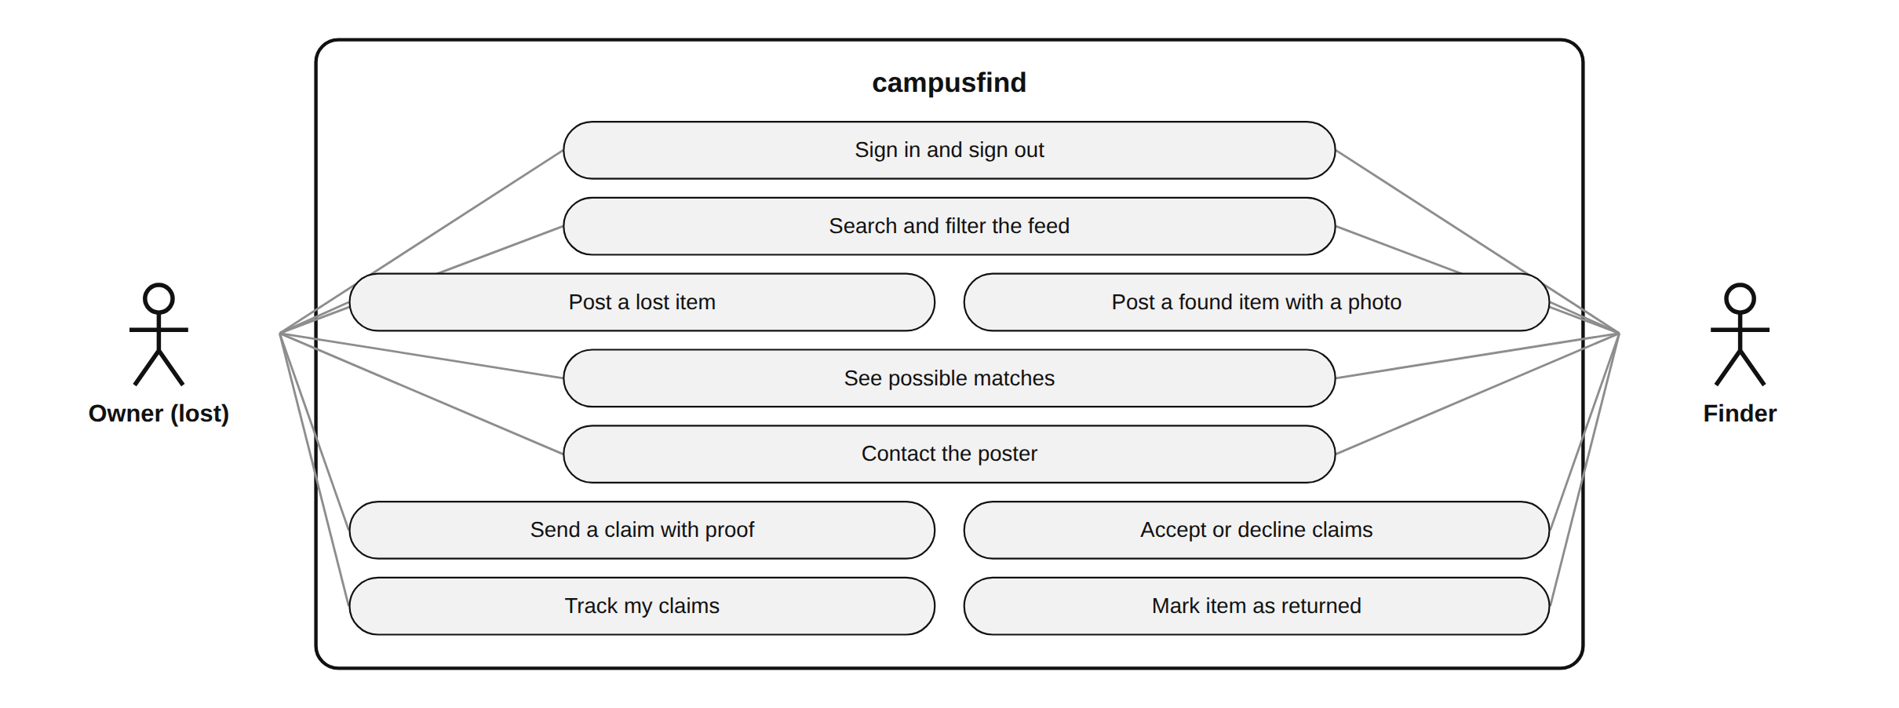
Figure 3.1: Use case diagram of campusfind (every student can act as owner or finder)

3.6 METHODOLOGY
The project followed an iterative and incremental approach. The matching algorithm was developed test-first: example pairs of posts that should and should not match were written as unit tests before the scoring function was written, and the function was tuned until all of them passed. The iterations are summarised in Table 3.3 and the technology in Table 3.4.
Table 3.3: Development iterations
Iteration | Work done | Outcome
1 | Setup, schema (users, items, claims, uploads), migrations, seed data with real photos | 47 realistic posts and 17 claims
2 | Matching engine: tokenizer, stemming, synonyms, scoring, threshold, labels | Unit-tested matcher with explainable reasons
3 | Claim rules (claimBlocker, canAcceptClaim, canResolve), date and contact helpers | Rules shared by pages and server actions
4 | Sign-in, proxy, feed with search and filters, item page with contact links | Browsing and contact working
5 | Posting with photo upload and preview; possible matches on item pages | Post then see matches immediately
6 | Claims, accept and decline, mark as returned, My posts, My claims | Complete return workflow
7 | Integration and end-to-end tests, PDF guide, Railway deployment | 32 Vitest and 6 Playwright tests passing; live URL

Table 3.4: Technology used
Area | Technology | Purpose
User interface | React 19 | Feed cards, forms, owner panel, match list
Framework | Next.js 16 (App Router) | Server Components, Server Actions, route handlers, proxy
Language | TypeScript (strict) | Application, tests and scripts
Database | PostgreSQL 16 | Items, claims, users and photos with constraints
Data access | Drizzle ORM, drizzle-kit, node-postgres | Typed queries, transactions, migrations
Validation | Zod | Item and claim schemas with inline errors
Authentication | bcryptjs, jose | Password hashing and signed session tokens
Icons, avatars, fonts | lucide-react, DiceBear, Fontsource (Geist) | Category icons, generated avatars, self-hosted fonts
Testing | Vitest, Playwright | Unit, integration and browser tests
Version control and hosting | Git, GitHub, Railway | Code history, pull requests, hosting and database

3.7 SYSTEM DESIGN AND IMPLEMENTATION

3.7.1 System architecture
Figure 3.2 shows the architecture. The browser talks only to the Next.js server. proxy.ts checks the session on every request; Server Components read data through functions in src/lib/queries.ts; Server Actions handle posting (including the photo, sent as multipart form data), claims, decisions and resolving; and the pure rules in src/lib/matching.ts and src/lib/items.ts are used both to render pages and to enforce decisions on the server. Photos are stored in PostgreSQL and served by /api/images/[id].
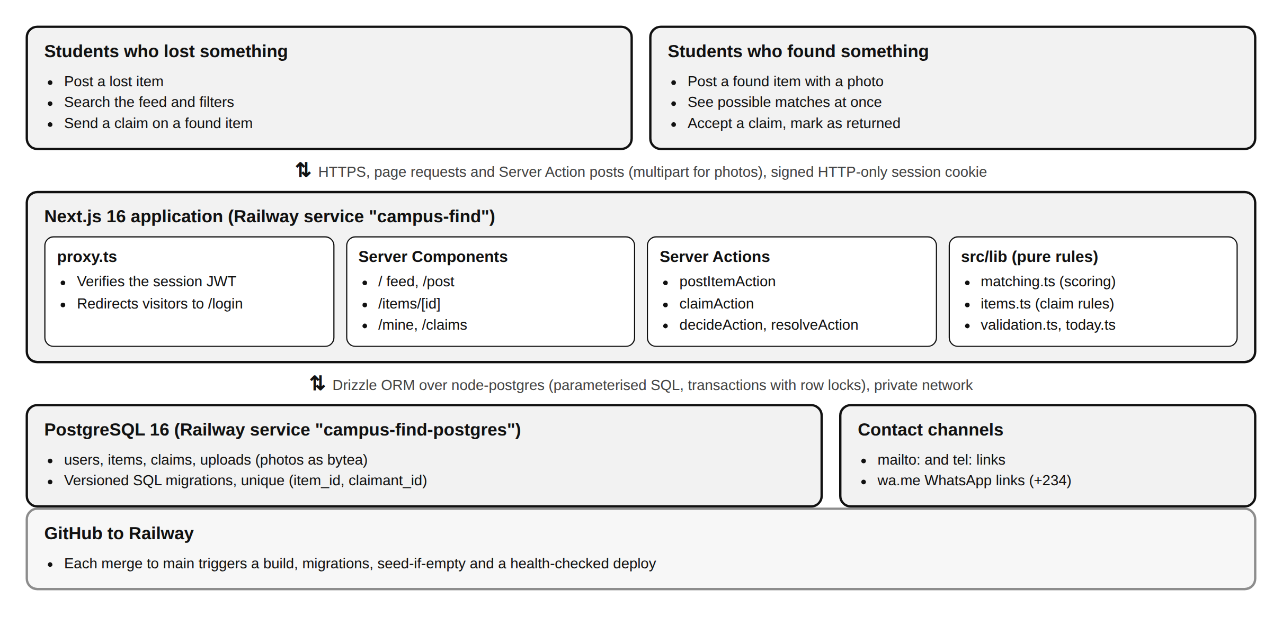
Figure 3.2: System architecture of campusfind as deployed on Railway

3.7.2 Database design
The database has four tables (Table 3.5, Figure 3.3). An item is posted by a user and receives claims from other users. Status values are enumerated types, so an item can only be open, claimed or resolved and a claim can only be pending, accepted or declined.
Table 3.5: Database tables
Table | Main columns | Constraints and notes
users | id, name, email, phone, password_hash, role, department, created_at | email unique
items | id, type, title, description, category, location, happened_on, image_url, status, posted_by, created_at, resolved_at | indexes on (type, status), category and posted_by
claims | id, item_id, claimant_id, message, contact, status, created_at | UNIQUE (item_id, claimant_id); CHECK length(message) >= 10; ON DELETE CASCADE
uploads | id (uuid), mime, data (bytea), uploaded_by, created_at | Photos uploaded with posts

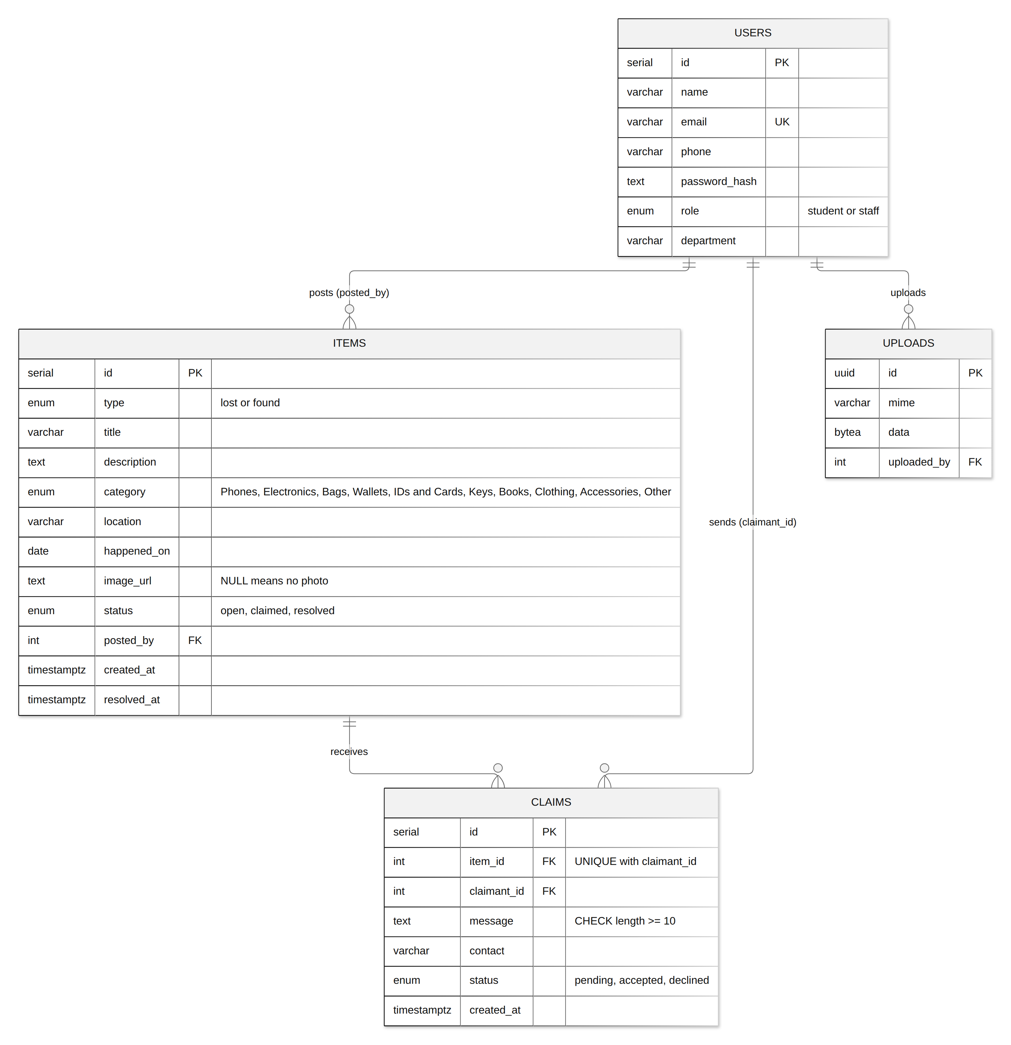
Figure 3.3: Entity relationship diagram of the campusfind database
happened_on is a calendar date (the day the item was lost or found) rather than a timestamp, because students rarely know the exact time; it is used both for display ("2 days ago") and by the matcher to compare when the item was lost and when it was found.

3.7.3 Item and claim life cycle
Figure 3.4 shows the life cycle of an item and Figure 3.5 the life cycle of a claim. The rules that allow each transition are pure functions in src/lib/items.ts, listed in Table 3.6.
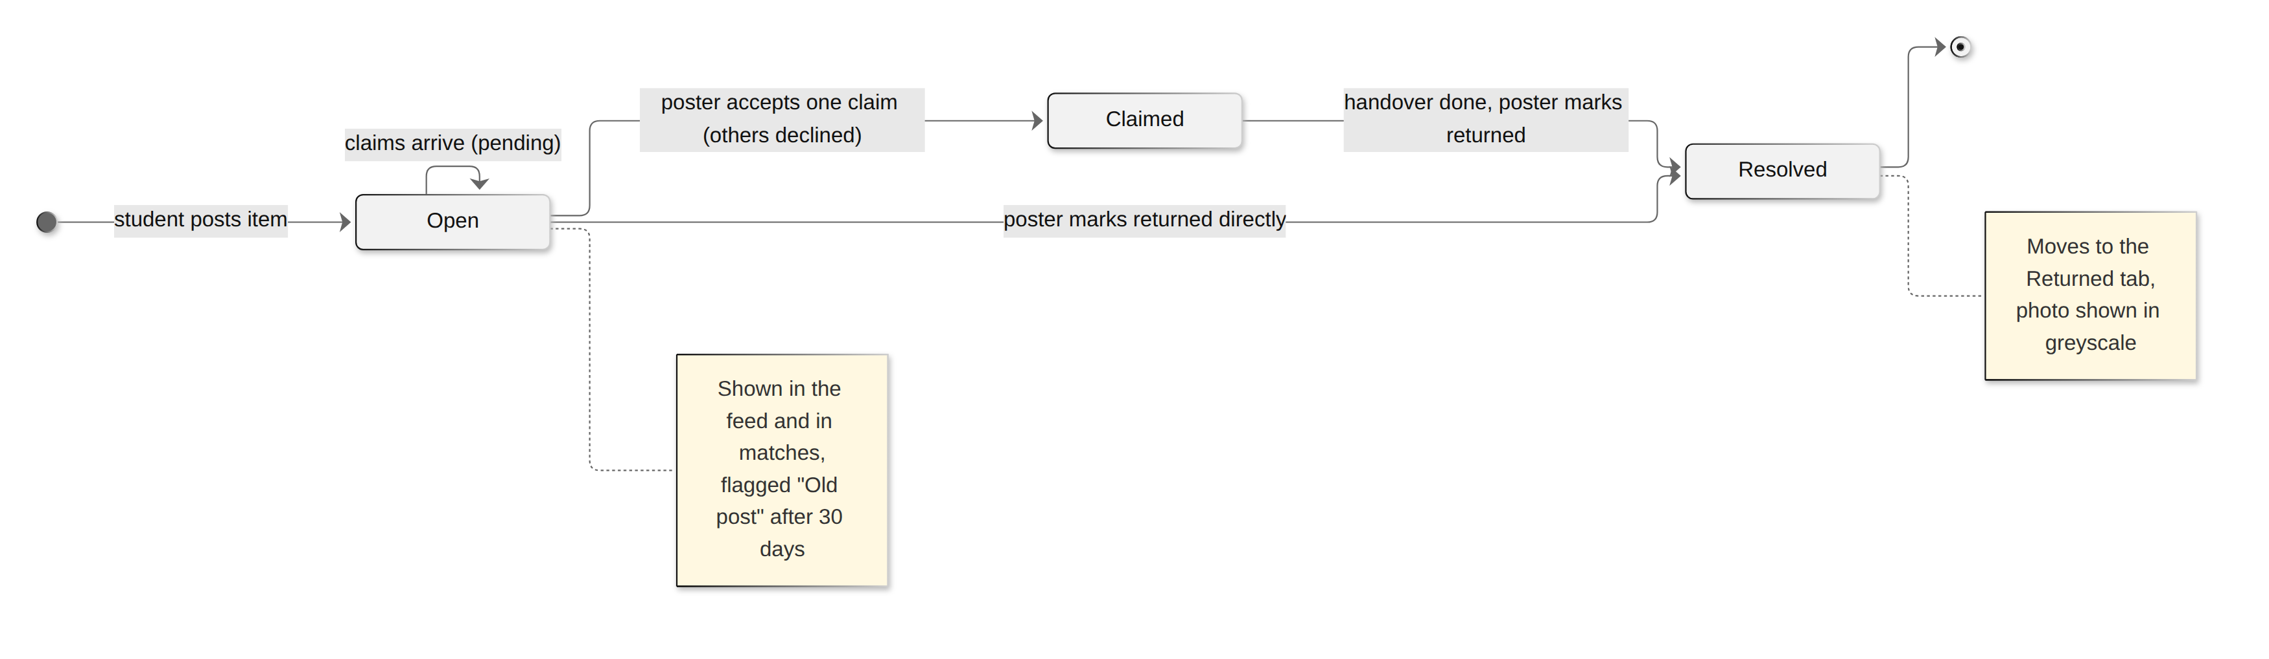
Figure 3.4: Life cycle of an item
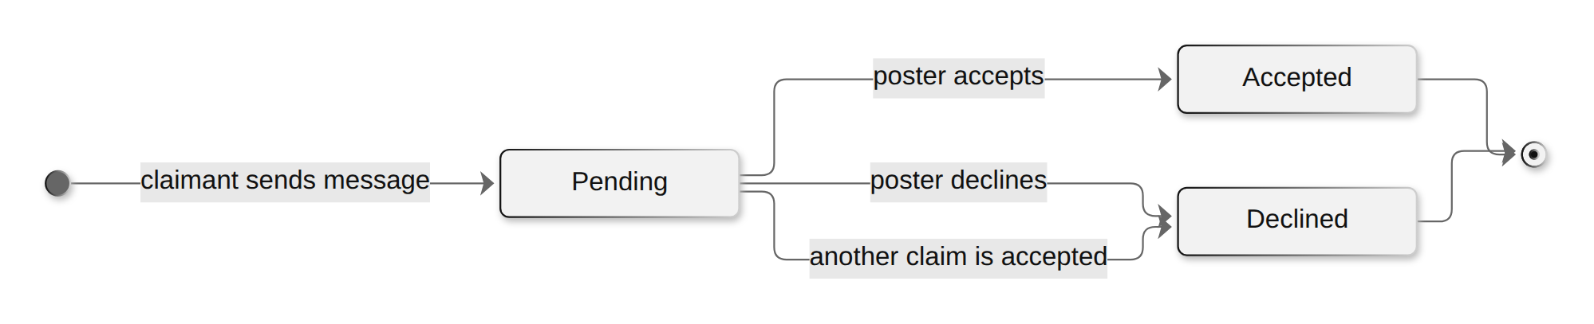
Figure 3.5: Life cycle of a claim
Table 3.6: Rule functions in src/lib/items.ts
Function | Rule
claimBlocker(item, user, alreadyClaimed) | Blocks claims on your own post, on resolved items, on items whose poster already accepted a claim, and repeat claims; returns the message shown to the student.
canAcceptClaim(item, user, claimStatus) | Only the poster, only while the item is open, only for pending claims.
canResolve(item, user) | Only the poster, only if not already resolved.
agoLabel(day, today) | Today, Yesterday, N days ago, N weeks ago, N months ago.
isStale(item, today) | Open posts older than 30 days get an "Old post" flag.
checkHappenedOn(day, today) | Rejects invalid dates, future dates and dates older than 6 months.
whatsappLink(phone, text) | Turns 0803 123 4567 or +234 803... into https://wa.me/2348031234567 with a prefilled message, or null for other numbers.

3.7.4 The matching algorithm
The matcher answers one question: given a newly posted item, which posts of the opposite type probably describe the same object? It must be fast, explainable and predictable, so a scoring approach was chosen rather than an external AI service. The process has two stages: turning text into comparable words, and scoring pairs of posts.

Stage 1: tokenizing text
Students describe the same item differently, so text is normalised before comparison (Figure 3.6). The text is lower-cased and split into words; common words (in, a, my, lost, near, the) and numbers are removed; plural endings are removed (keys to key, batteries to battery, glasses to glass) without damaging words such as campus; and brand names and synonyms are mapped to one shared word (iPhone, Tecno, Samsung and Infinix become phone; AirPods and Oraimo become earbud; backpack, rucksack and handbag become bag; specs and spectacles become glass). Place names use the same process but ignore generic words such as Main, Campus, Faculty and Hall, so "Cafeteria, Main Campus" and "Main Auditorium" are not treated as the same place.
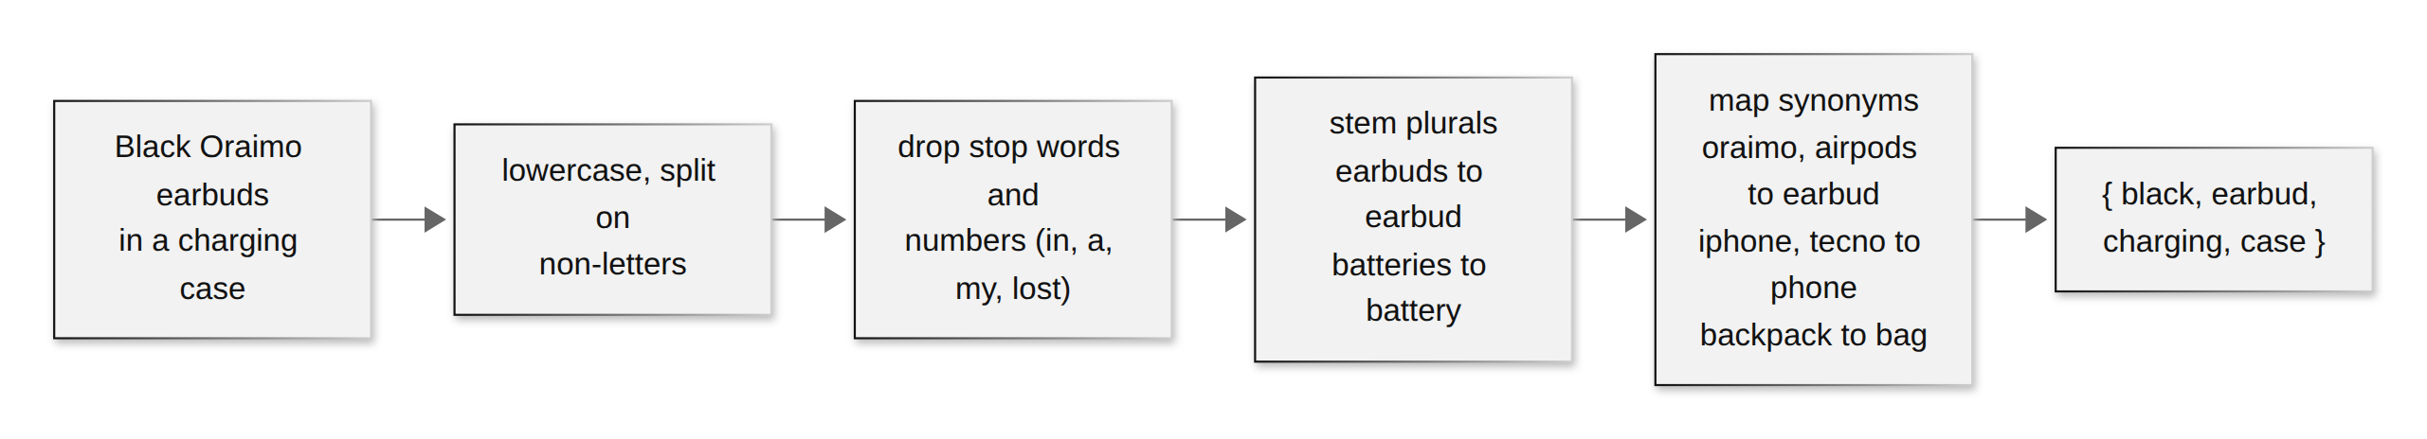
Figure 3.6: Turning a description into comparable words

Stage 2: scoring a pair of posts
matchScore(a, b) compares two posts and returns a score from 0 to 100 together with the shared words and the reasons. Figure 3.7 shows the full decision flow and Table 3.7 the points awarded. Hard filters come first: two posts of the same type, two posts by the same student, or a resolved post can never match, and an item cannot be found more than a day before it was lost (one day of tolerance allows for wrong dates) or more than 45 days after. Posts in different categories only match when they share at least two words, which still allows an "Accessories" post to match an "Electronics" post about the same smartwatch.
Table 3.7: Points awarded by matchScore()
Signal | Points | Notes
Same category | +35 | The strongest single signal
Shared words | up to +40 | Jaccard similarity of the two word sets x 100, plus 8 for each word shared by both titles
Same place | +15 | Exact match of the place text
Nearby place | +7 | At least one shared, non-generic place word
Found within 3 days of being lost | +10 | Including the same day
Found within 4 to 14 days | +5

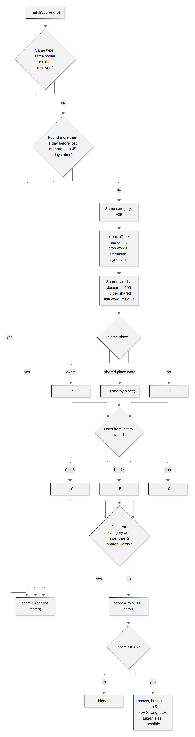
Figure 3.7: Decision flow of the matching score
Only candidates scoring 45 or more are shown, best first, at most five. Scores of 80 or more are labelled Strong match, 62 or more Likely match, and the rest Possible match. Candidates are drawn from open posts of the opposite type dated up to 60 days before the item, which keeps the comparison small and fast. For example, when the demo student posts a found "Black scientific calculator" at the Faculty of Science, the lost "Casio fx-991ES calculator" posted the day before at the same place scores 100 (same category 35, shared words 40, same place 15, found the next day 10), while a lost "HP scientific calculator" at the Faculty of Engineering six days earlier scores lower and appears second.
export function findMatches(item, candidates, limit = 5) {
return candidates
.map((c) => ({ item: c, ...matchScore(item, c) }))
.filter((m) => m.score >= MATCH_THRESHOLD) // 45
.sort((x, y) => y.score - x.score || x.item.id - y.item.id)
.slice(0, limit);
}

3.7.5 Posting an item and showing matches
Figure 3.8 shows what happens when a student posts. The form is a client component that shows a preview of the selected photo; the Server Action validates every field with Zod plus the date rule, checks the photo type and size, stores the photo, inserts the item and redirects to the item page, which computes the matches on the server and shows them straight away with the message "Posted. We found 2 possible matches below."
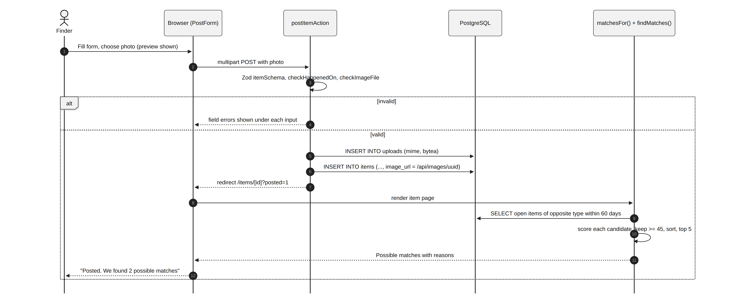
Figure 3.8: Sequence of posting an item and computing its matches

3.7.6 Claims and returning an item
Figure 3.9 shows the claim workflow. Claim submission and claim decisions run in database transactions that lock the item row with SELECT ... FOR UPDATE, so two claims cannot be accepted for the same item even if the poster clicks quickly on two devices. When a claim is accepted, all other pending claims are declined in the same transaction and the item becomes claimed. The claimant sees the result on their My claims page together with the poster's phone number, and the poster marks the item returned after the handover.
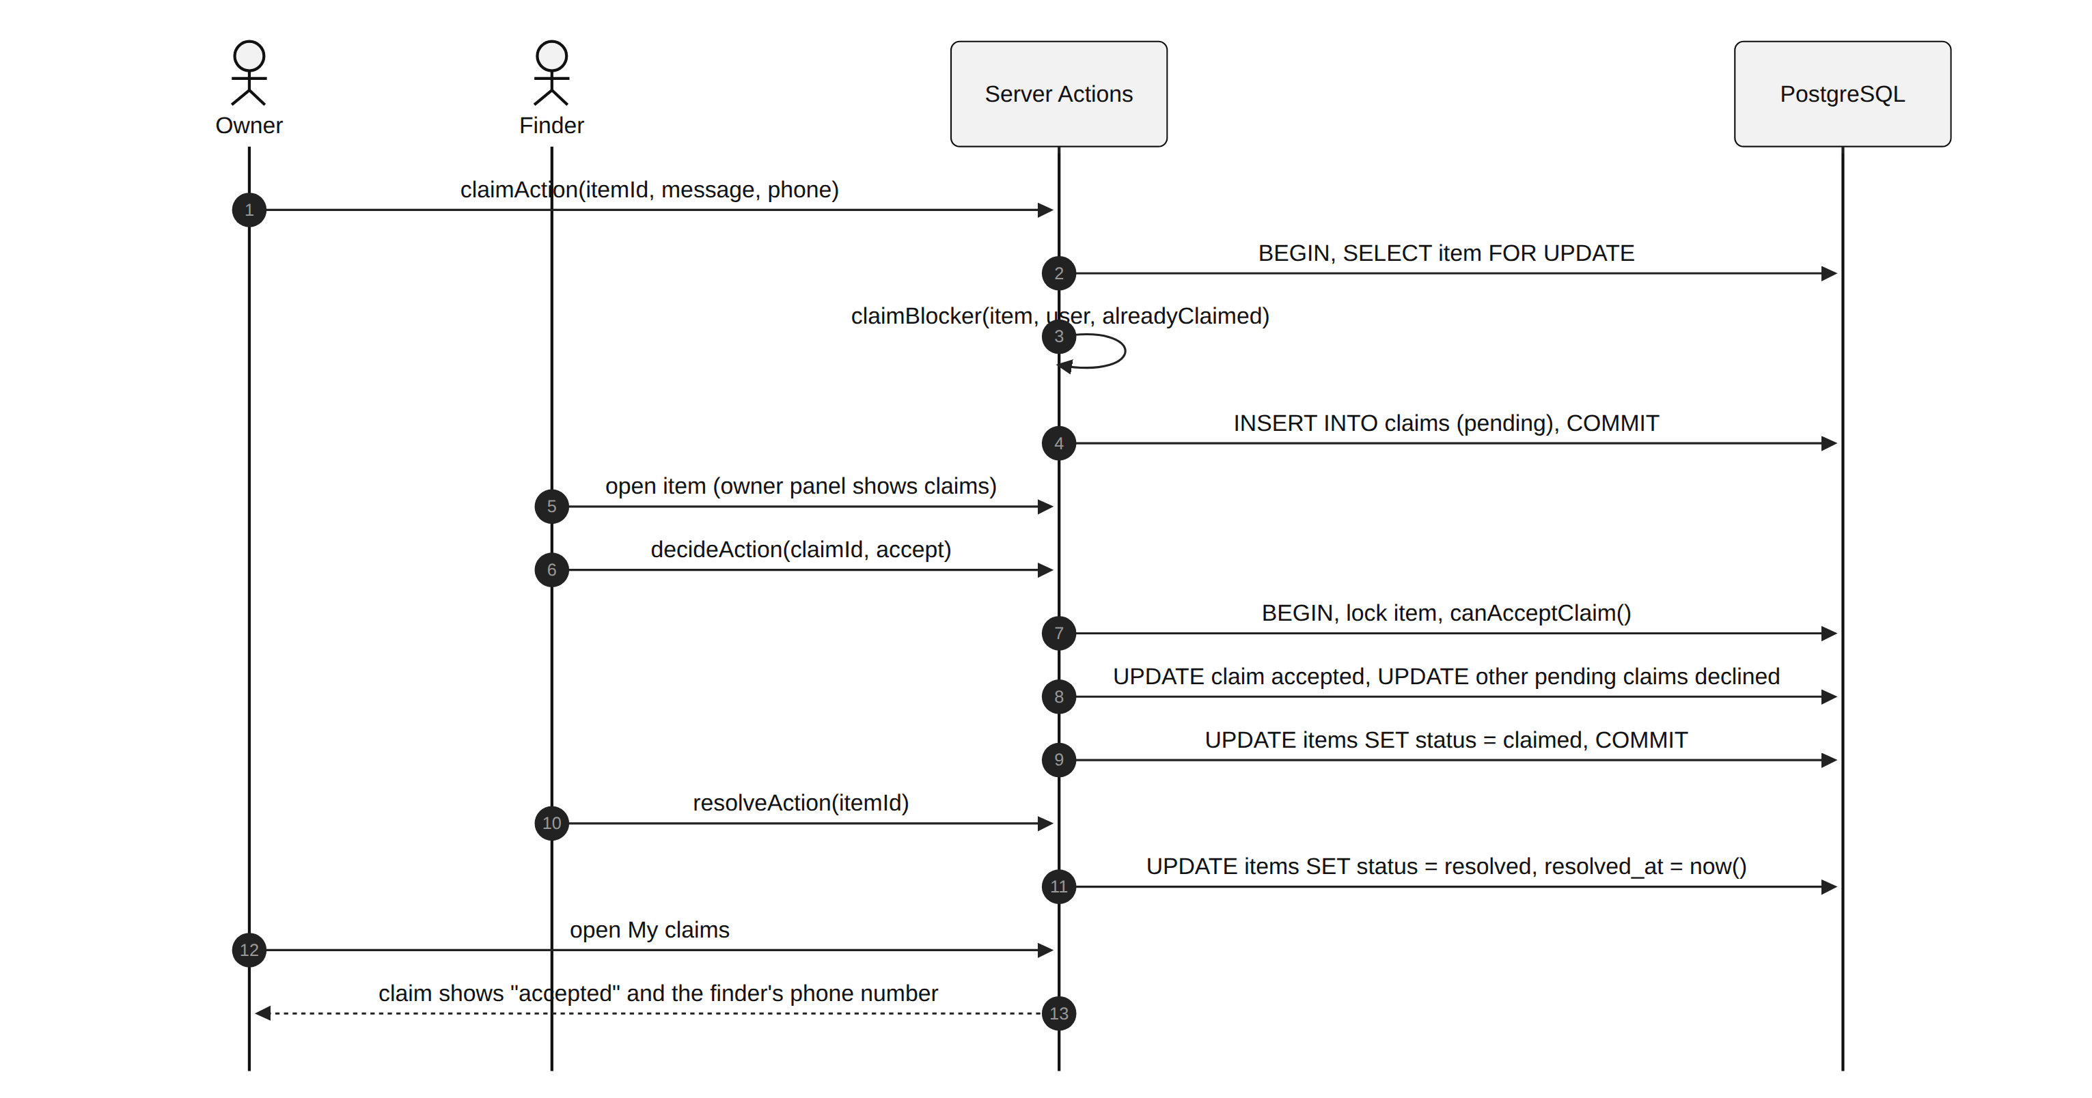
Figure 3.9: Sequence of a claim being sent, accepted and resolved

3.7.7 Authentication, privacy and security
- Passwords and sessions: bcrypt hashes; a JWT signed with HS256 using SESSION_SECRET, valid for seven days, stored in an HTTP-only, SameSite=Lax cookie (Secure in production).
- Route protection: proxy.ts redirects visitors without a valid token to /login; every page and Server Action checks the session again with requireUser() or getSession().
- Privacy: getItem() only includes the list of claims when the viewer is the poster; other viewers only see whether they themselves have claimed and the total number of replies.
- Server-side rules: the same rule functions that hide buttons in the interface are enforced in the actions, so a crafted request cannot accept a claim on someone else's post or claim one's own item.
- Validation: Zod schemas for posts and claims; phone numbers must look like a phone number; photos must be JPEG, PNG or WebP up to 4 MB.
- SQL injection: all queries use Drizzle with parameters.

3.7.8 User interface design
The visual design follows the dark, minimal style of xAI's Grok: a black canvas, white text, thin grey borders, rounded pill-shaped buttons, a large prompt-style search box in the centre of the feed, and monospace labels (Geist Mono) for tags and metadata. LOST and FOUND tags carry a small red or green dot so the two types are easy to tell apart. Item photos are real Creative Commons photographs found through Openverse and stored with the application; posts without a photo show a category icon. On phones the sidebar is replaced by a top bar and a bottom tab bar, and all grids use minmax(0, 1fr) columns so nothing pushes the page sideways.

3.7.9 Seed data
Table 3.8: Seeded demonstration data
Item | Quantity and notes
Students | 40, with Nigerian names, departments and phone numbers
Items | 47: 22 lost and 25 found, 40 with photos, across 10 categories (11 electronics, 6 accessories, 5 bags, 4 each of phones, wallets, keys, books and clothing)
States | 4 resolved, 1 claimed, the rest open; 2 open posts older than 30 days (Old post flag)
Claims | 17: 10 pending, 4 accepted and 3 declined
Demo stories | The demo student lost Oraimo earbuds that someone found; posted a found wallet with two claims (one specific, one vague); and lost calculators exist to match a calculator posted live

3.7.10 Version control and deployment
The code is kept on GitHub and deployed by Railway from the main branch (Figure 3.10). The application service receives DATABASE_URL=${{campus-find-postgres.DATABASE_URL}}, a random SESSION_SECRET and NODE_ENV=production. On start it applies migrations, seeds the database only if it is empty, and starts Next.js; Railway waits for /api/health to answer before switching traffic. The live application is available at https://campus-find-production-34f9.up.railway.app.
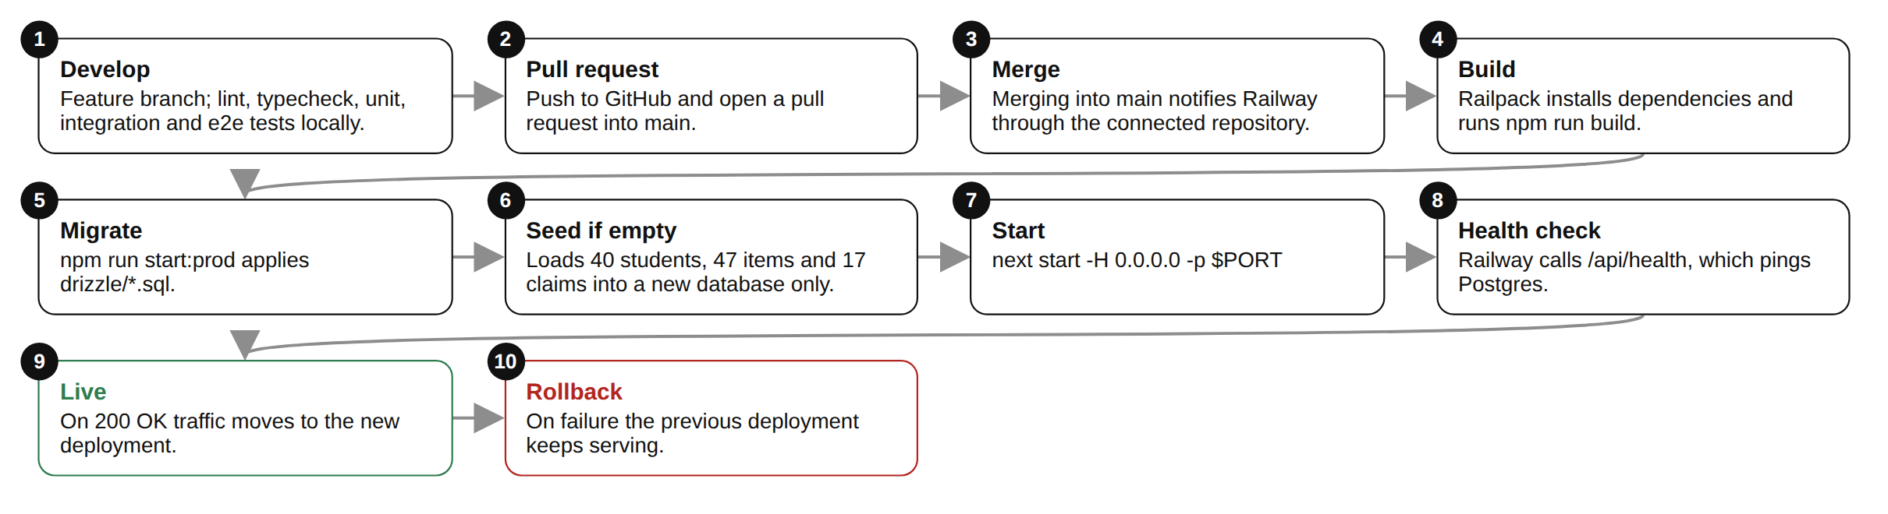
Figure 3.10: Build and deployment pipeline from GitHub to Railway

3.7.11 Application screens
Figure 3.11 to Figure 3.27 show the main screens, captured from the application running in production mode with the deployment's seed data and the clock fixed at 5 October 2026.
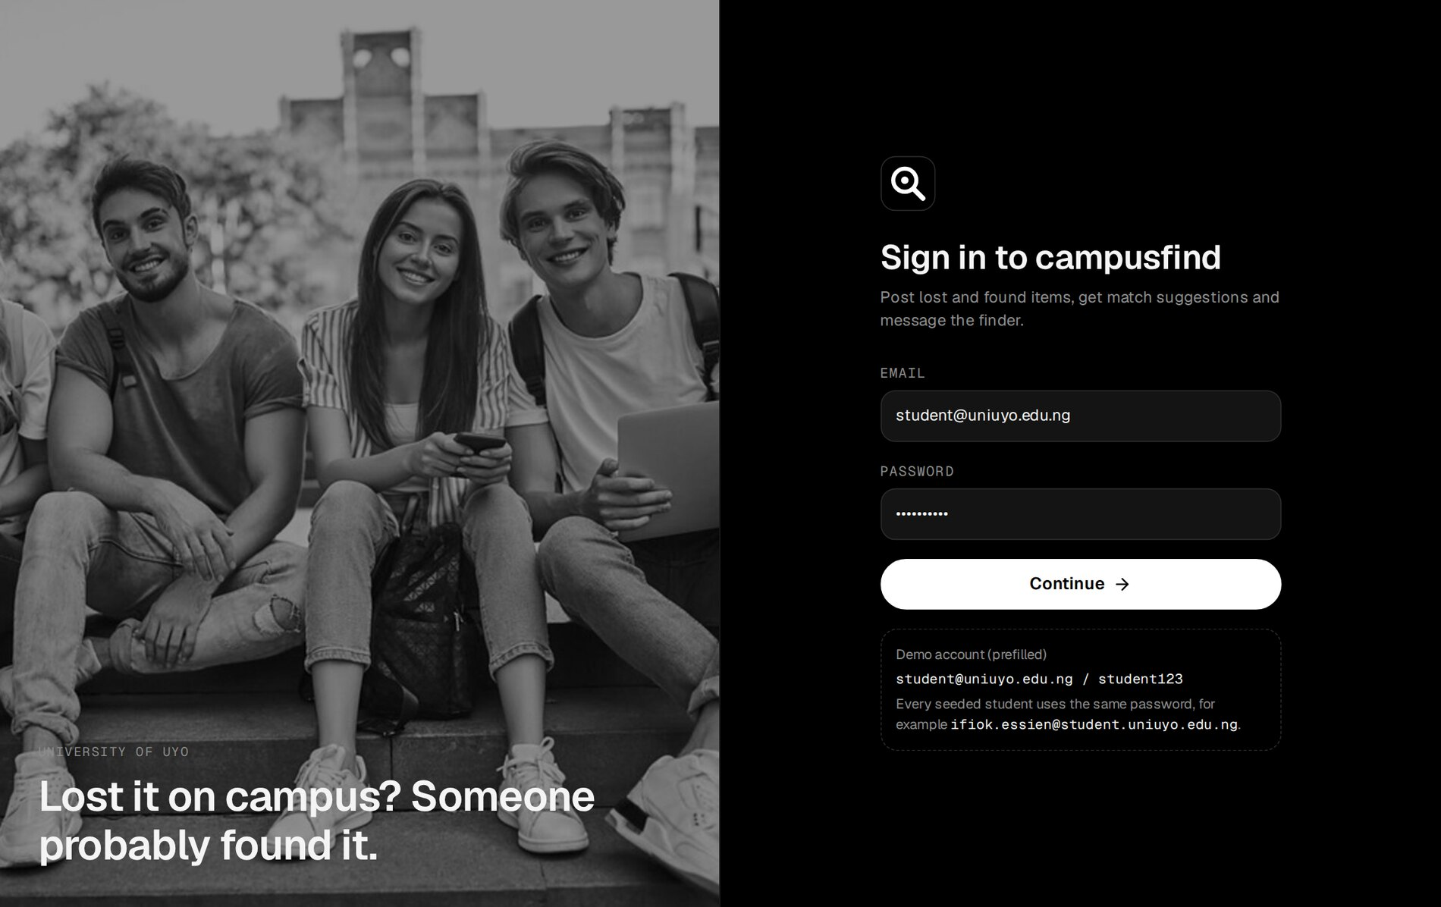
Figure 3.11: Sign-in page with the demo account prefilled
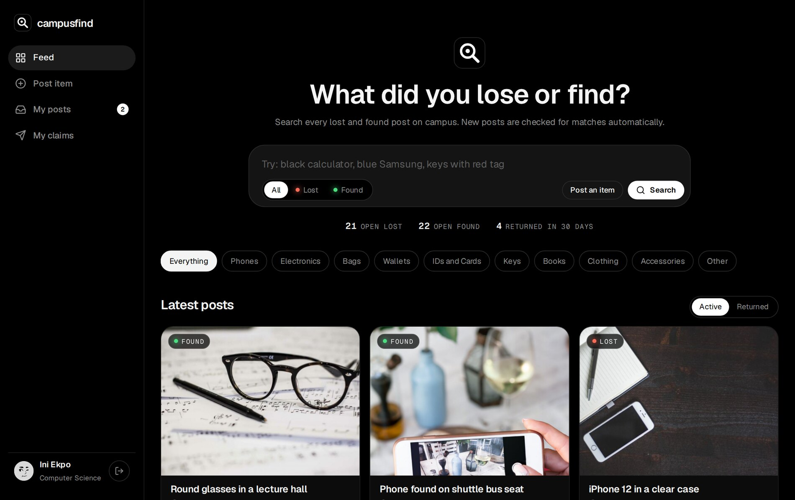
Figure 3.12: Feed: search box with Lost/Found toggle, live totals and category filters
Figure 3.13: Latest posts as cards with LOST or FOUND tags, place, category, age and reply count
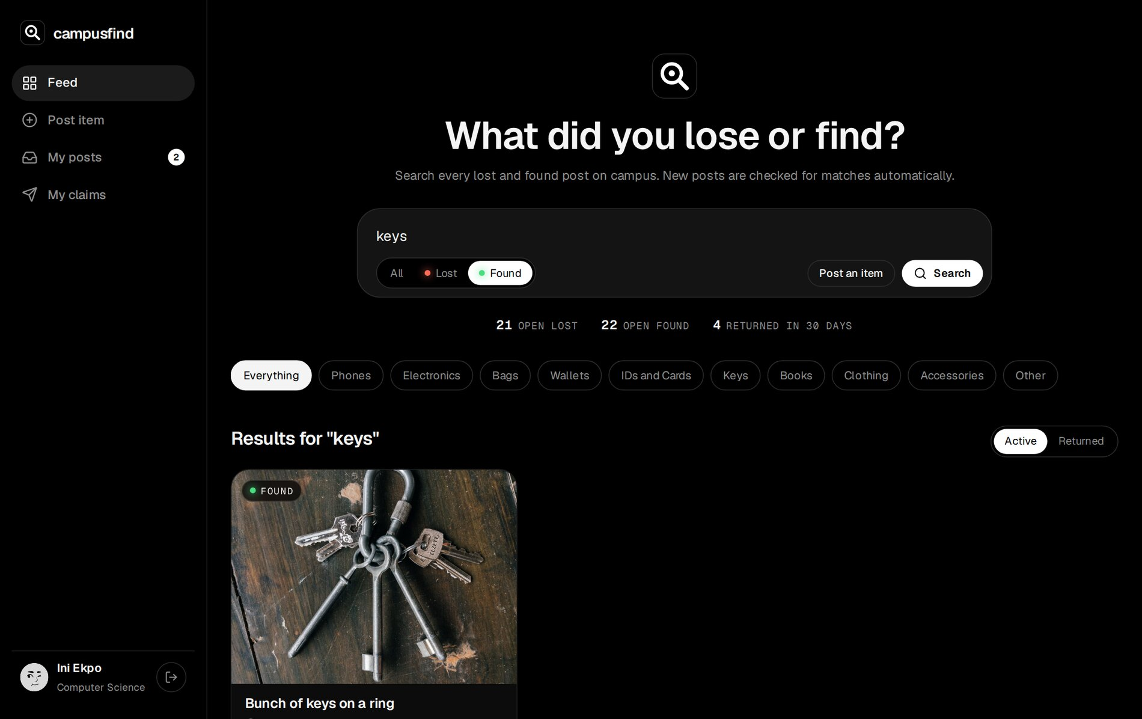
Figure 3.14: Search for "keys" limited to found items
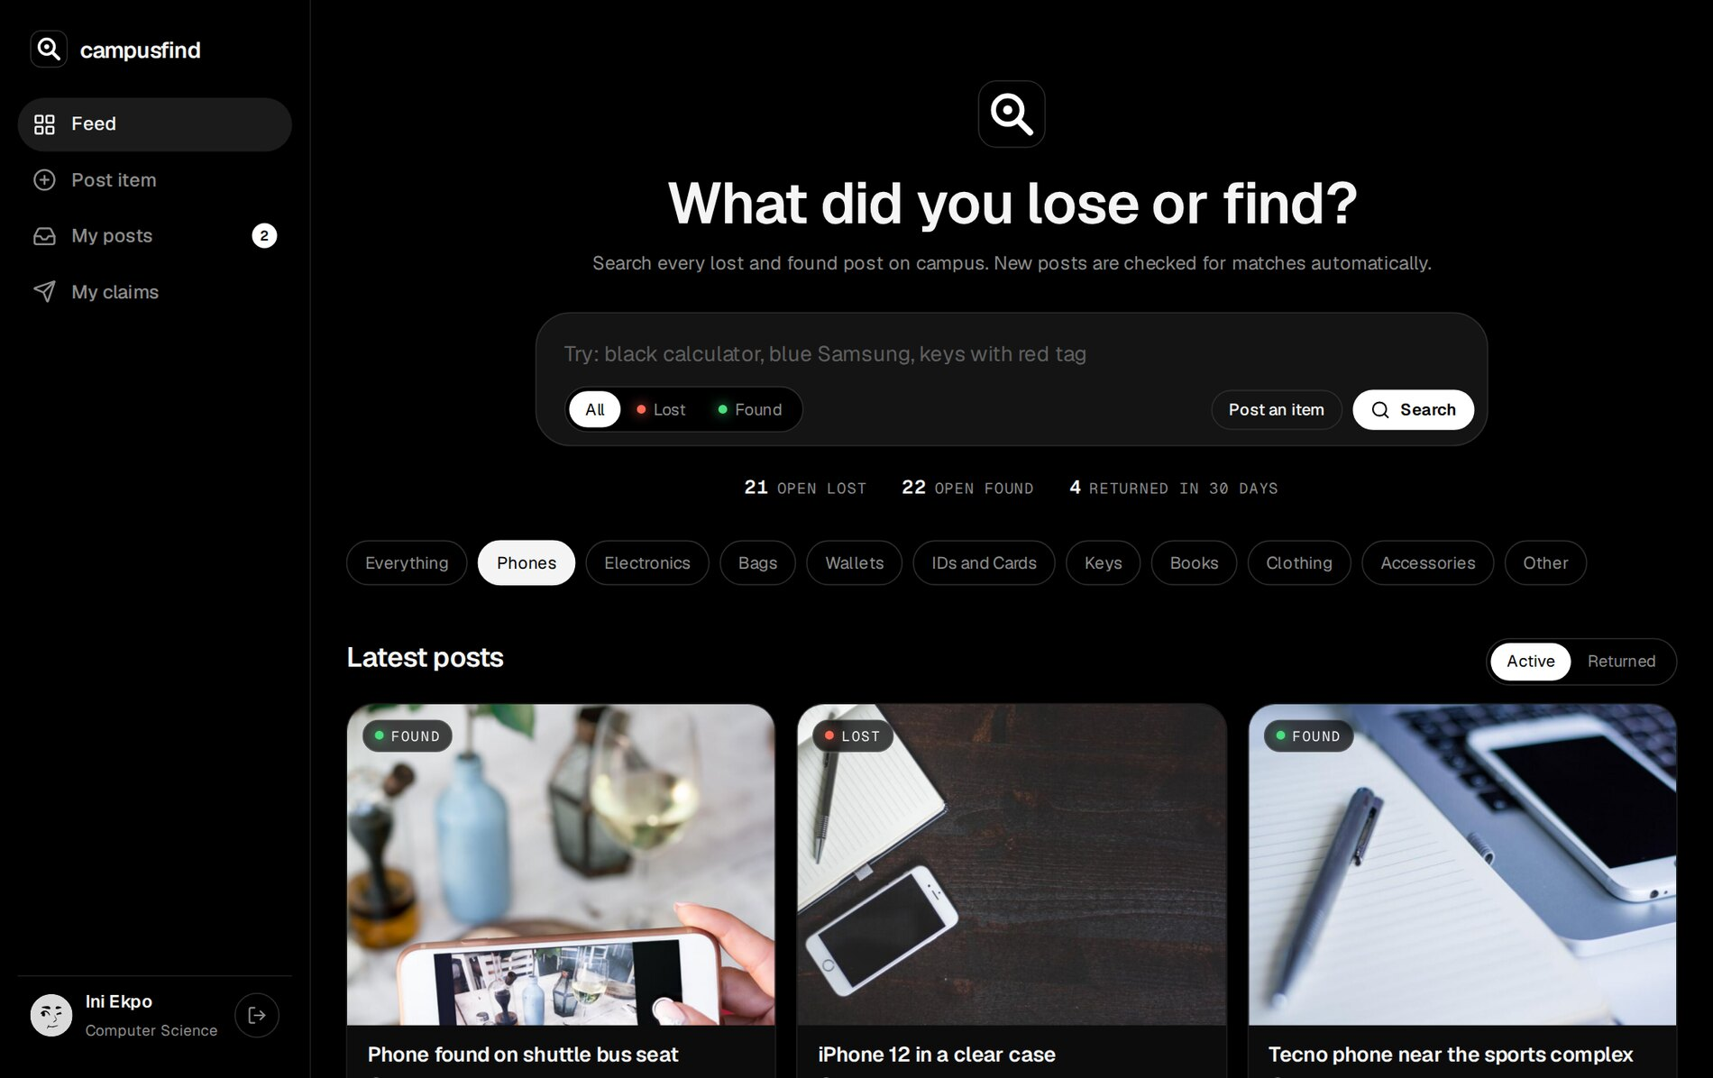
Figure 3.15: Feed filtered to the Phones category
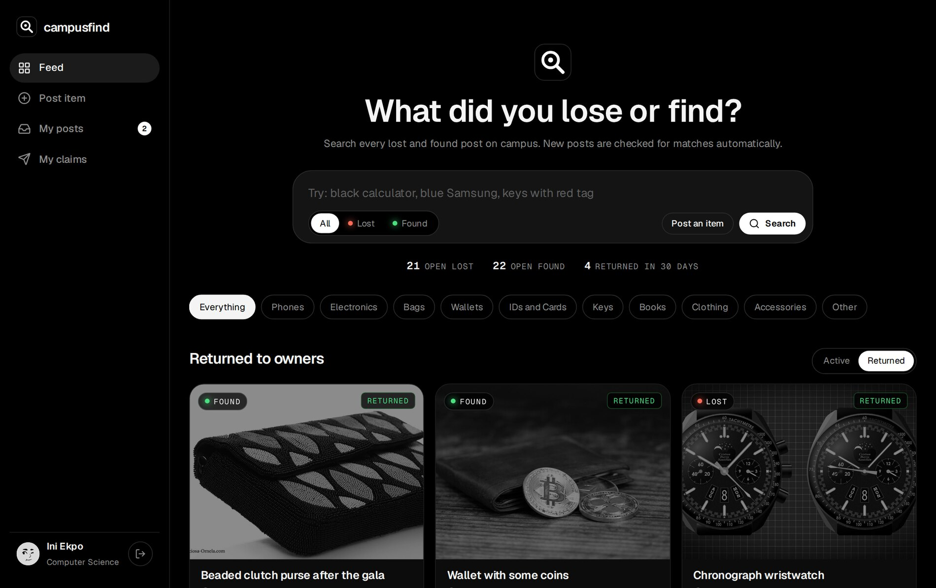
Figure 3.16: Returned tab: items already back with their owners, shown in greyscale
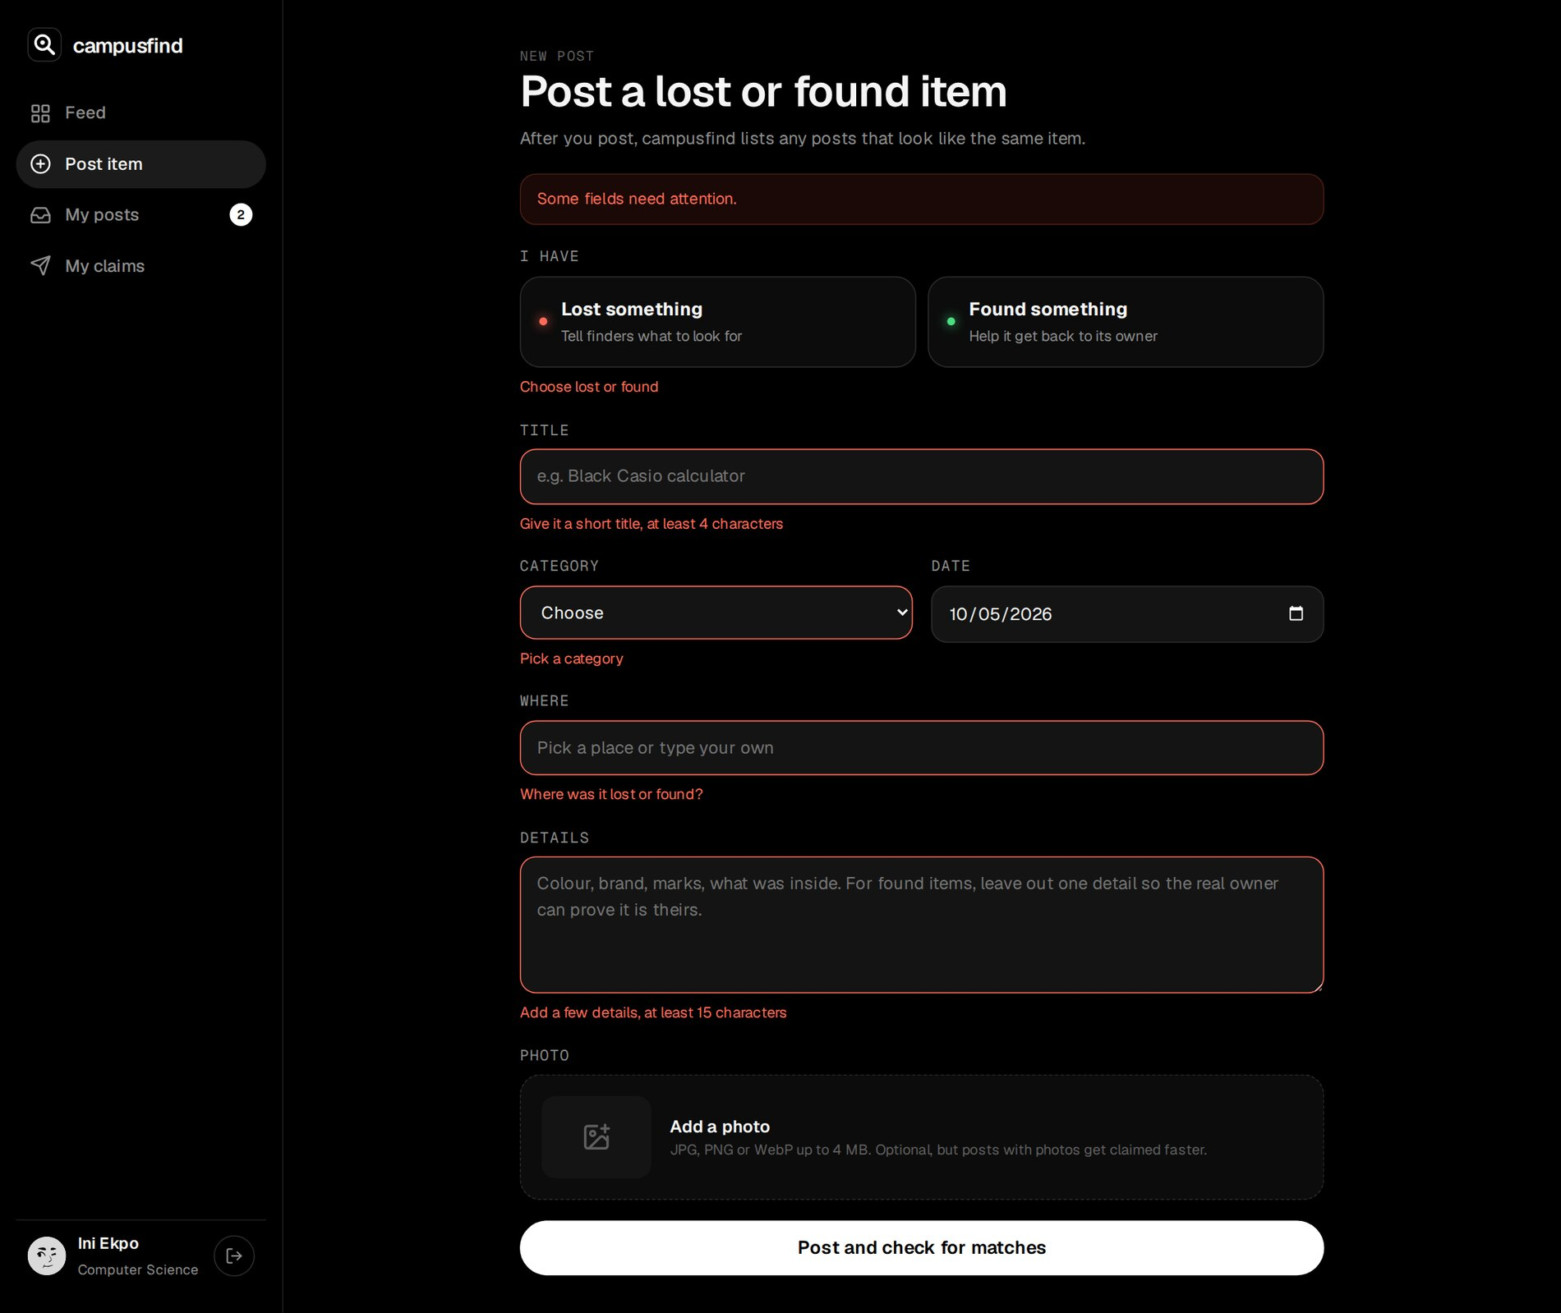
Figure 3.17: Post form after submitting it empty, with an error under each field
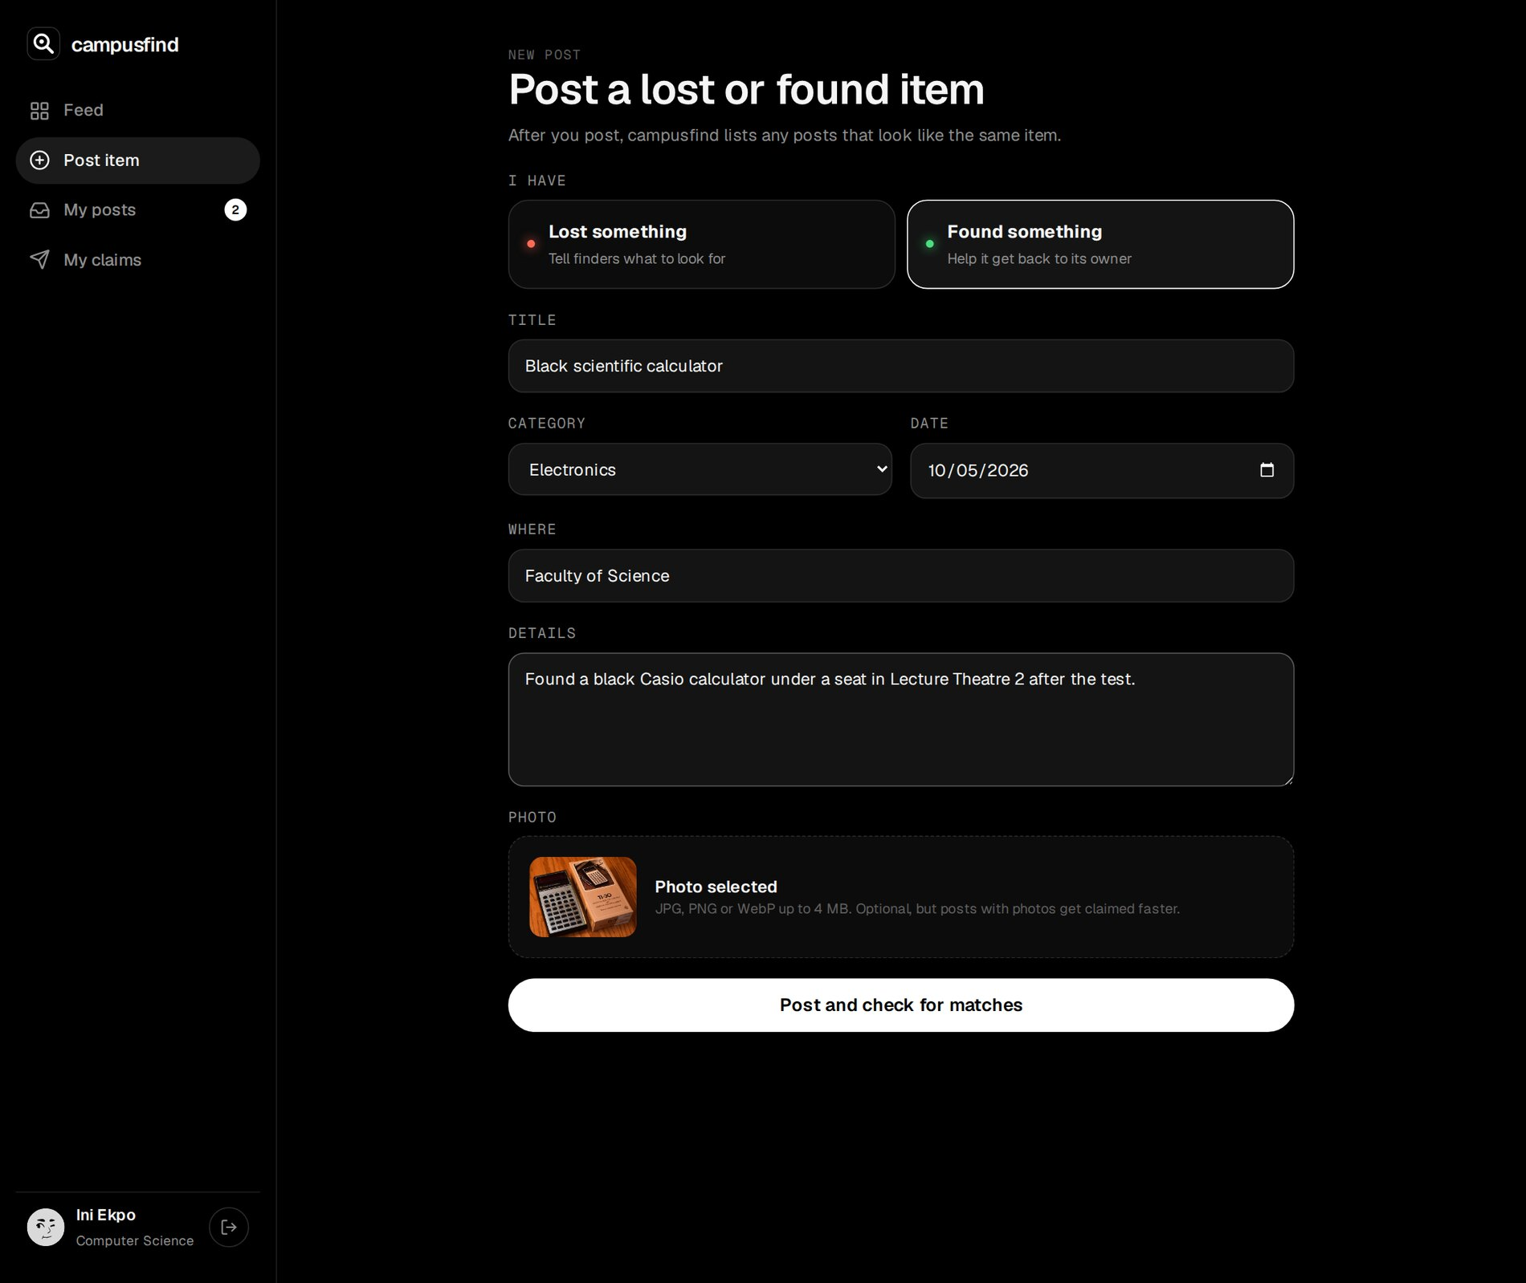
Figure 3.18: Post form filled in for a found calculator, with the photo preview
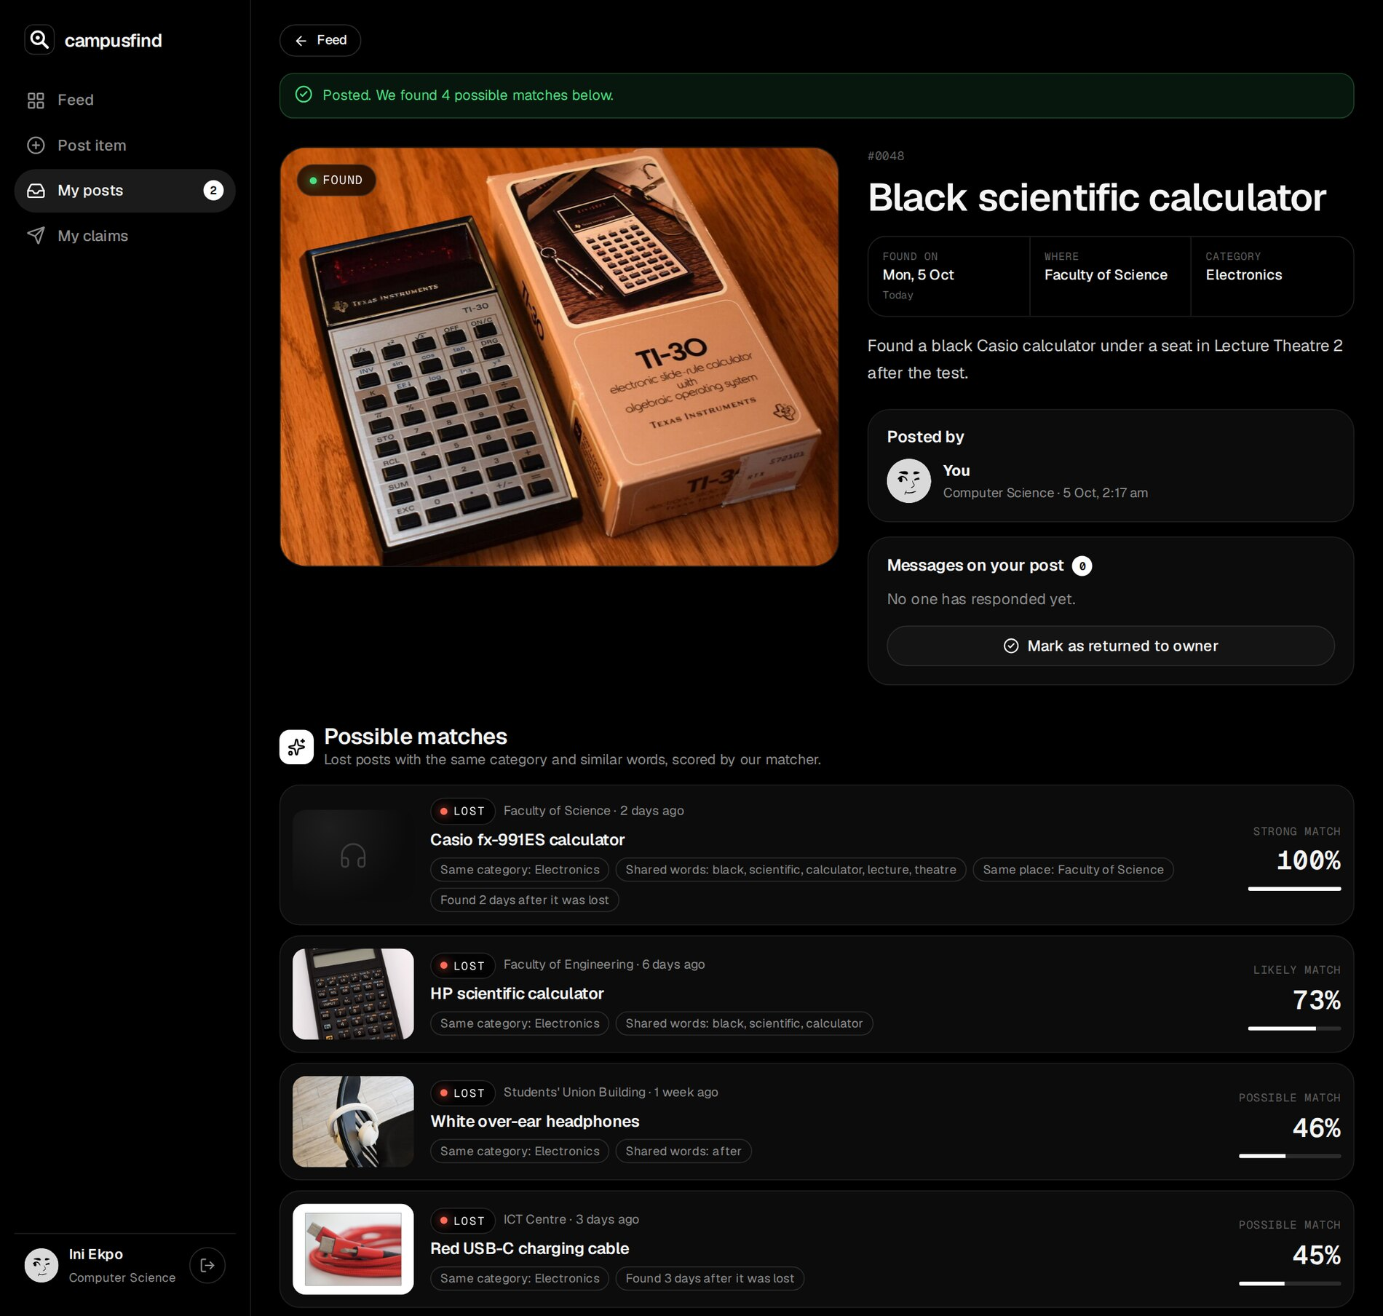
Figure 3.19: Immediately after posting: the lost Casio calculator is suggested as a strong match
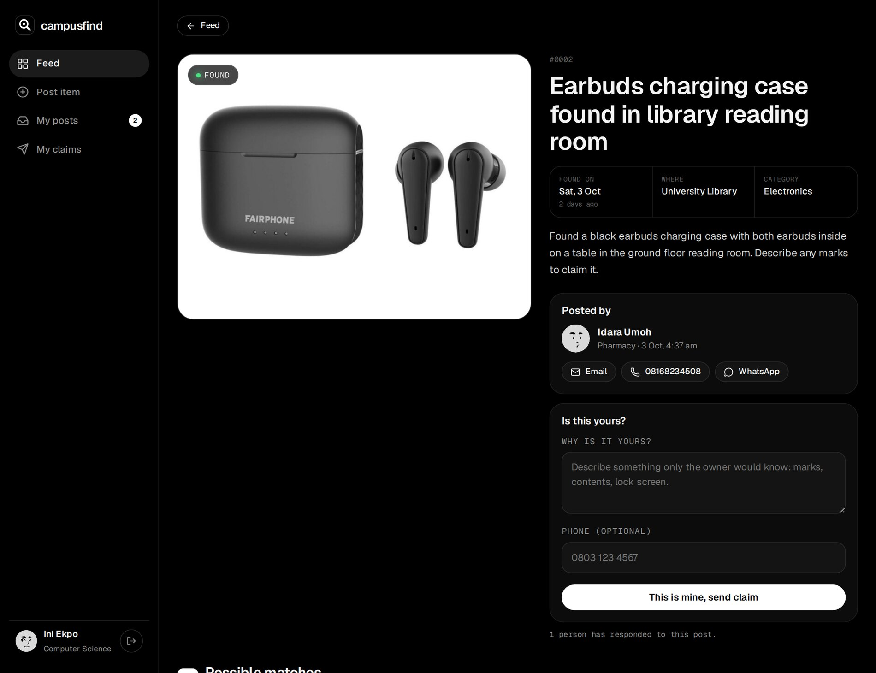
Figure 3.20: A found item seen by another student: contact buttons, claim form and the student's own lost earbuds as a match
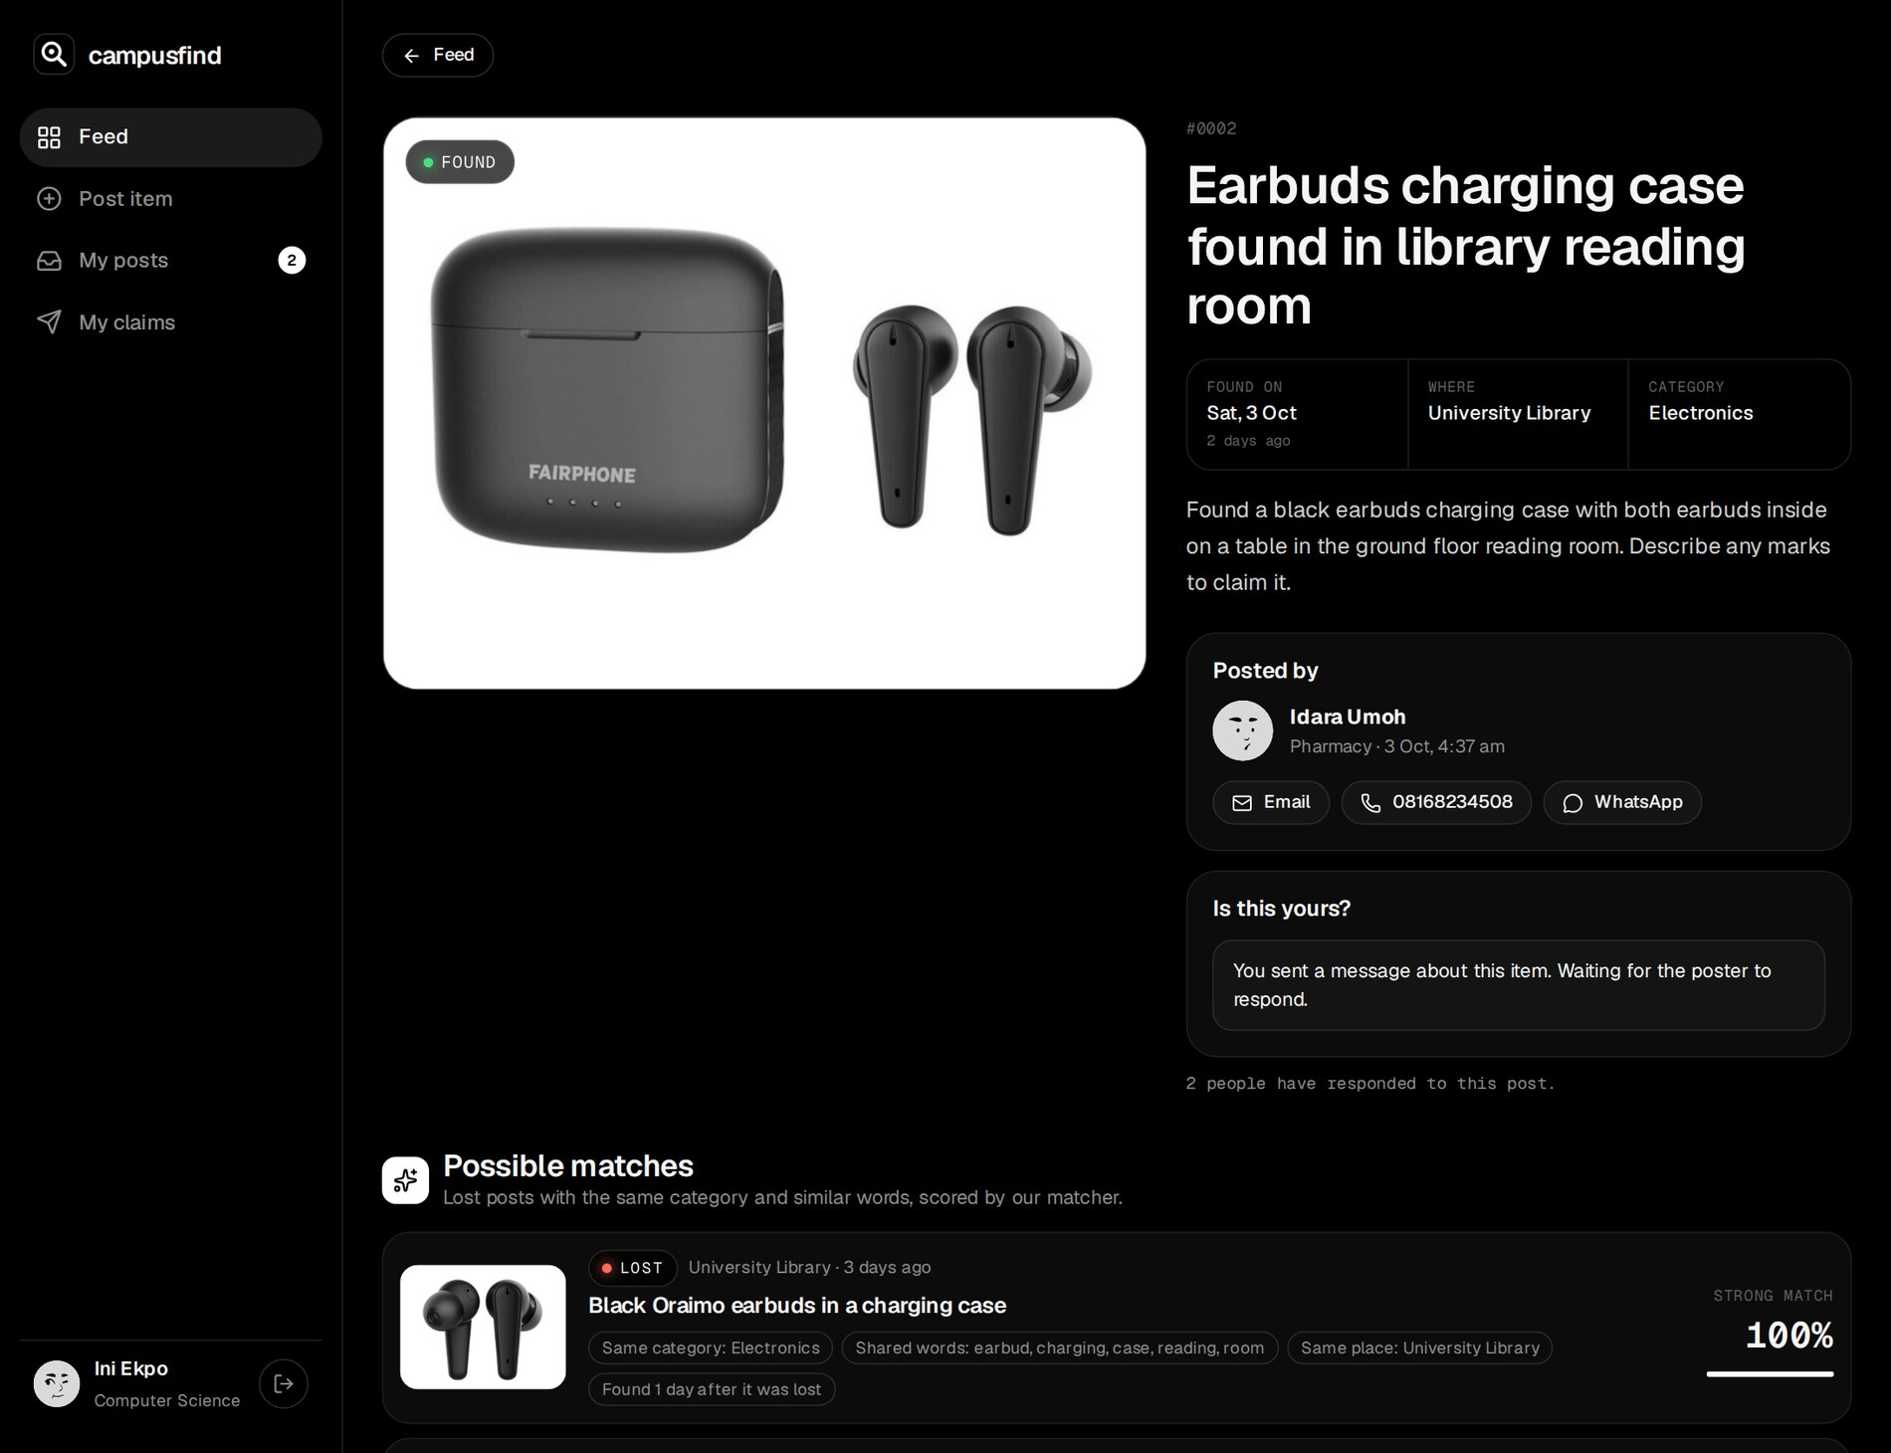
Figure 3.21: After sending the claim, the form is replaced by its status
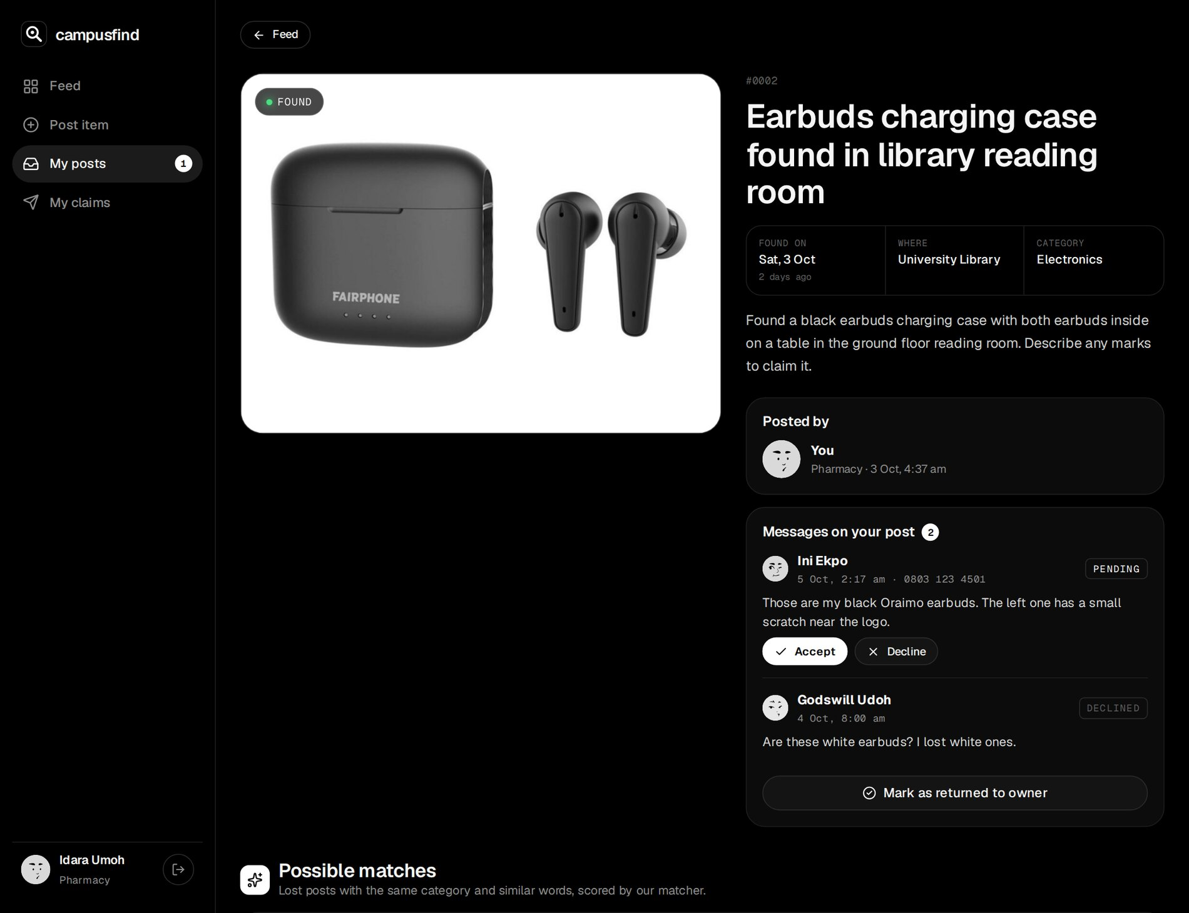
Figure 3.22: The finder's view of the same post: claims with Accept and Decline
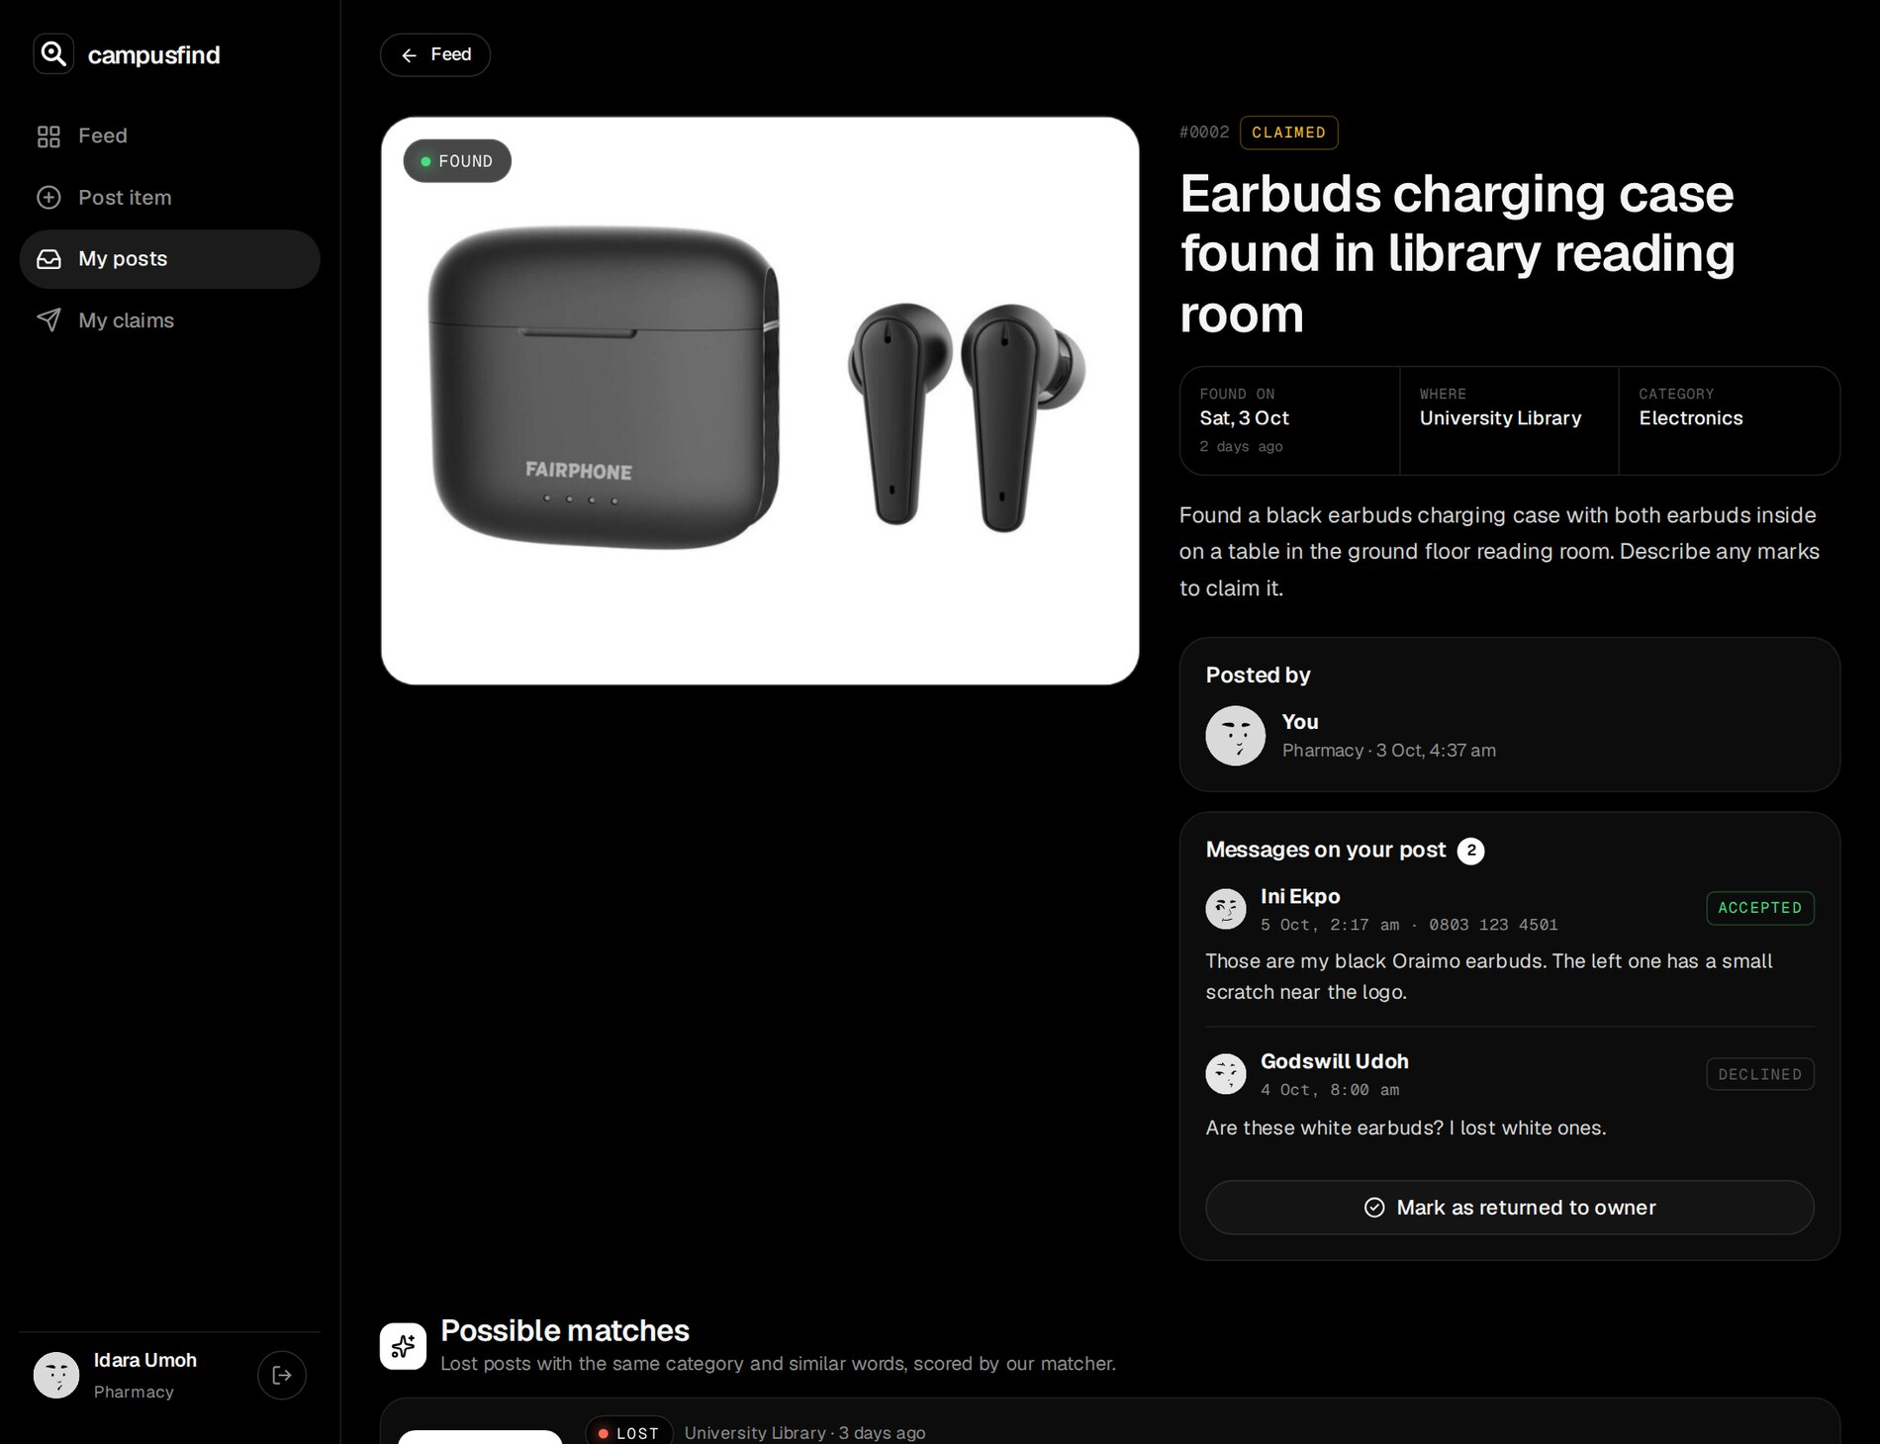
Figure 3.23: After accepting: the claim is accepted, the other claim declined and the item claimed
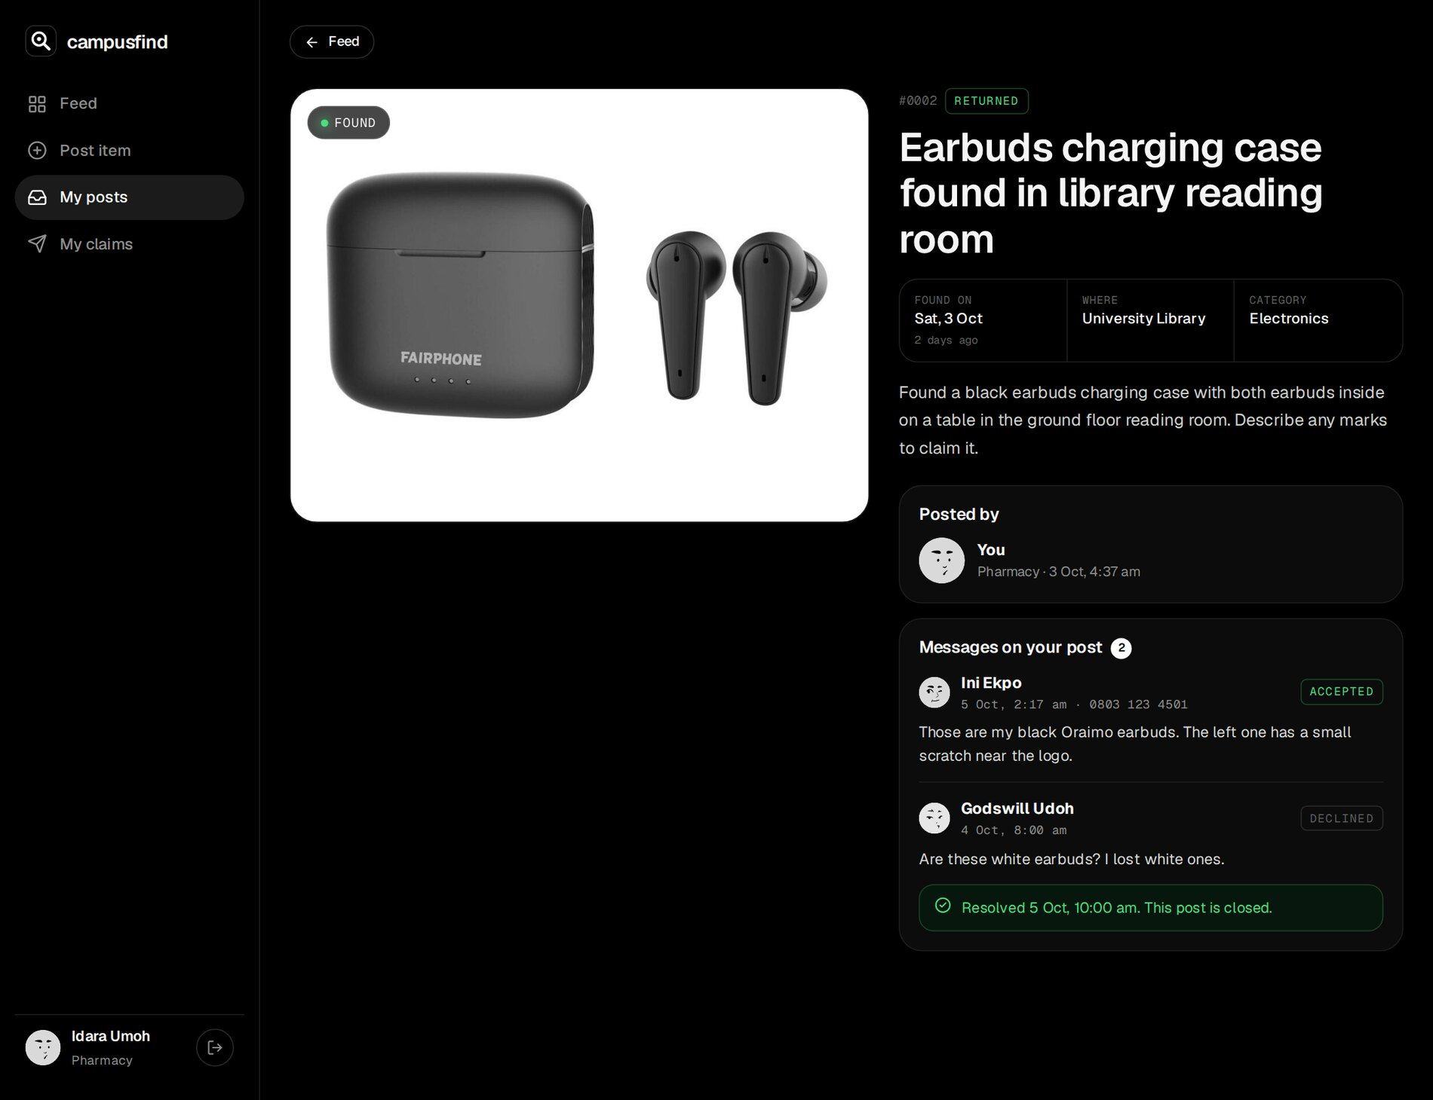
Figure 3.24: After marking the item as returned
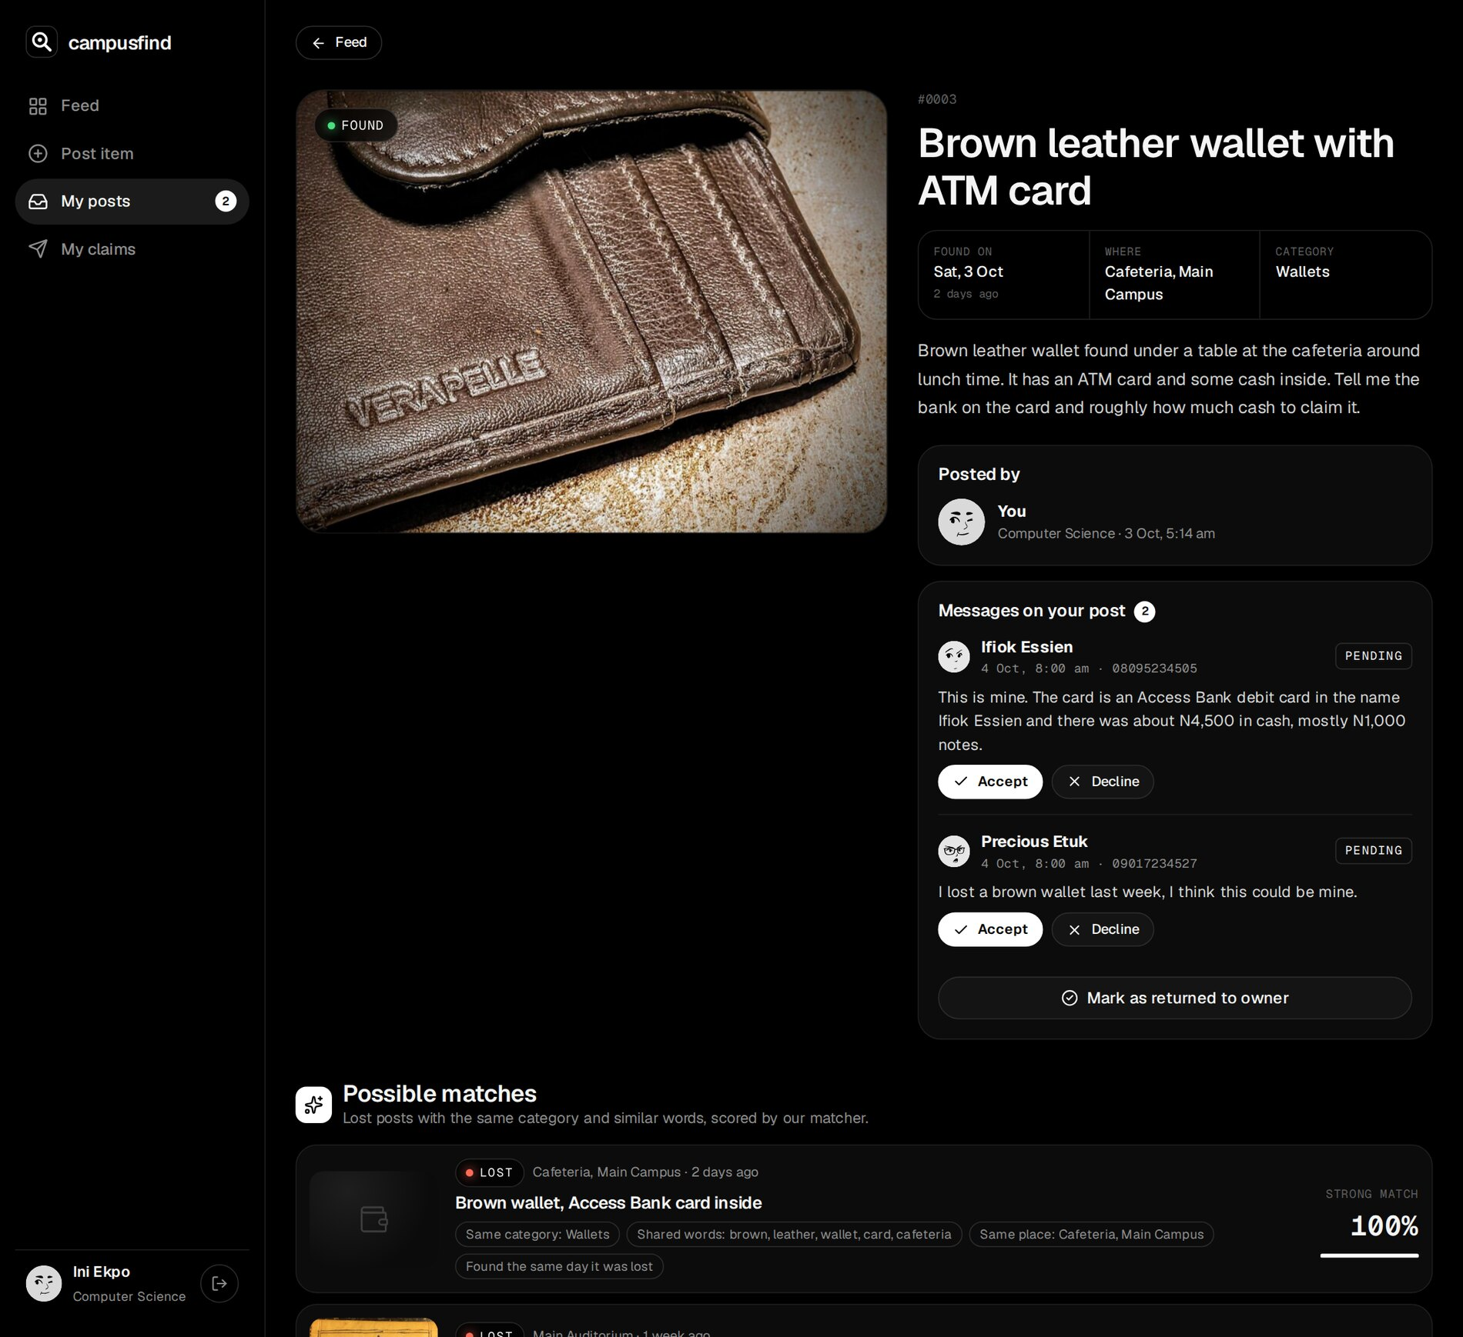
Figure 3.25: The demo student's found wallet with a specific and a vague claim, and the matching lost wallet
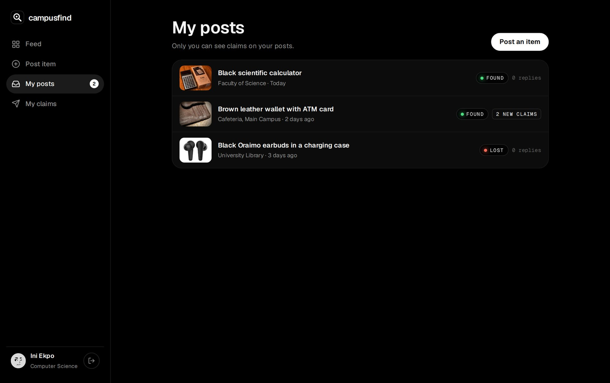
Figure 3.26: My posts, with new claims highlighted
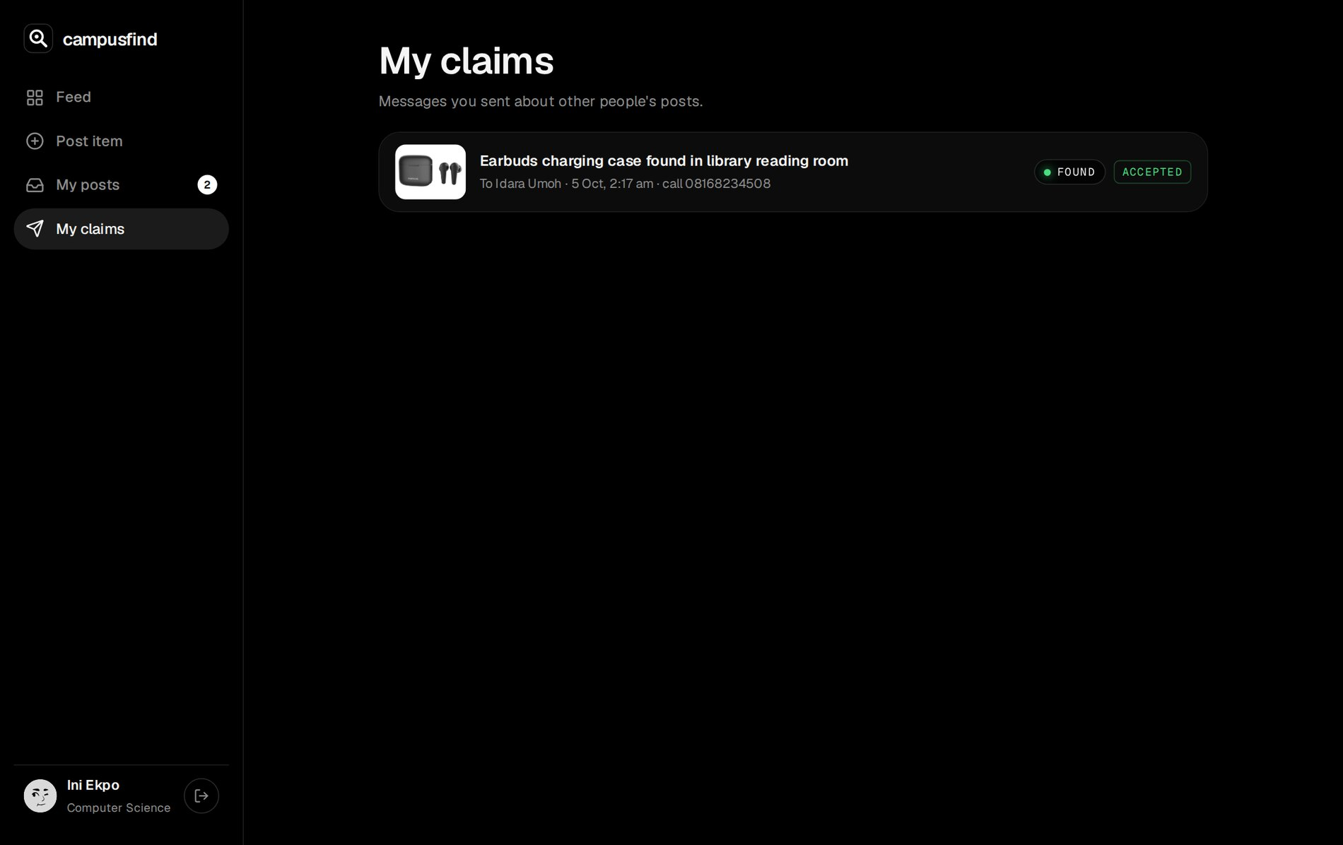
Figure 3.27: My claims with their status

3.8 TESTING AND EVALUATION
Testing was automated at three levels (Table 3.9). Unit tests exercise the matcher and rules with hand-made examples; integration tests run the real queries against a separate PostgreSQL database (campusfind_test) that is migrated and re-seeded first; and Playwright drives Chromium against a production build, on a desktop screen and on a Pixel 7 profile, including a full claim, accept and resolve exchange between two separate browser sessions.
Table 3.9: Test levels and results
Level | Tool | What is tested | Result
Unit | Vitest | Tokenizer, stemming, synonyms, place words, match score and hard filters, symmetry, ranking, claim and resolve rules, date labels and validation, WhatsApp links, schemas, photo checks, sessions | 23 of 23 passed
Integration | Vitest + PostgreSQL | Seed, matches for a new calculator, single claim, own-post block, privacy of claims, accept then resolve, unique constraint, scoping, filters | 9 of 9 passed
End to end | Playwright (Chromium) | Desktop journeys (5 tests) and a mobile journey (1 test) | 6 of 6 passed

Table 3.10: Representative test cases
ID | Test | Expected result | Actual result
T1 | Open /mine without signing in | Redirected to /login, demo account prefilled | Pass
T2 | Search "keys" with the Found filter | Only FOUND cards about keys | Pass
T3 | Submit the post form empty | Errors: choose lost or found, title, place and others | Pass
T4 | Post a found calculator with a photo | Photo served from /api/images as image/jpeg; first match is the lost Casio fx-991ES with reason "Same category: Electronics" | Pass
T5 | matchScore of two lost posts, same poster, or a resolved post | Score 0 | Pass
T6 | matchScore when found 2 weeks before it was lost | Score 0 | Pass
T7 | Rank a Casio and an HP calculator against a found calculator | Casio first, HP second, keys not listed | Pass
T8 | normalise("glasses"), "batteries", "campus" | glass, battery, campus | Pass
T9 | Send a claim twice on the same item | Second refused: already sent | Pass
T10 | Claim your own post | Refused | Pass
T11 | Another student opens a post with claims | Claims list empty for them; only their own claim status shown | Pass
T12 | A stranger tries to accept a claim; then the poster accepts | Stranger refused; poster's accept declines the other claim and sets item to claimed | Pass
T13 | Finder accepts the demo student's claim and marks returned (two browsers) | Finder sees accepted then resolved; demo student's My claims shows accepted | Pass
T14 | WhatsApp link for 0803 123 4567 | https://wa.me/2348031234567?text=... | Pass
T15 | Phone: open My posts, the wallet post and its claims | Two claims and the matching lost wallet; no sideways scroll | Pass

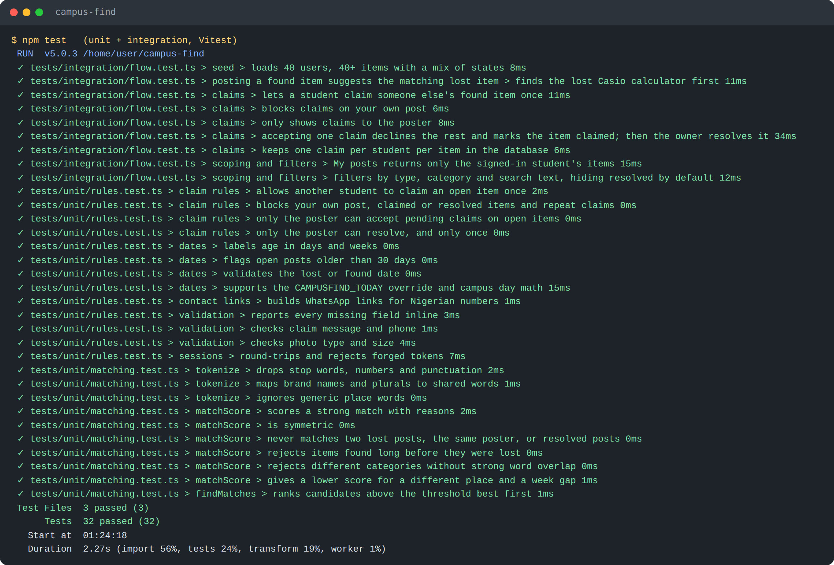
Figure 3.28: Output of the unit and integration test run (32 tests passed)
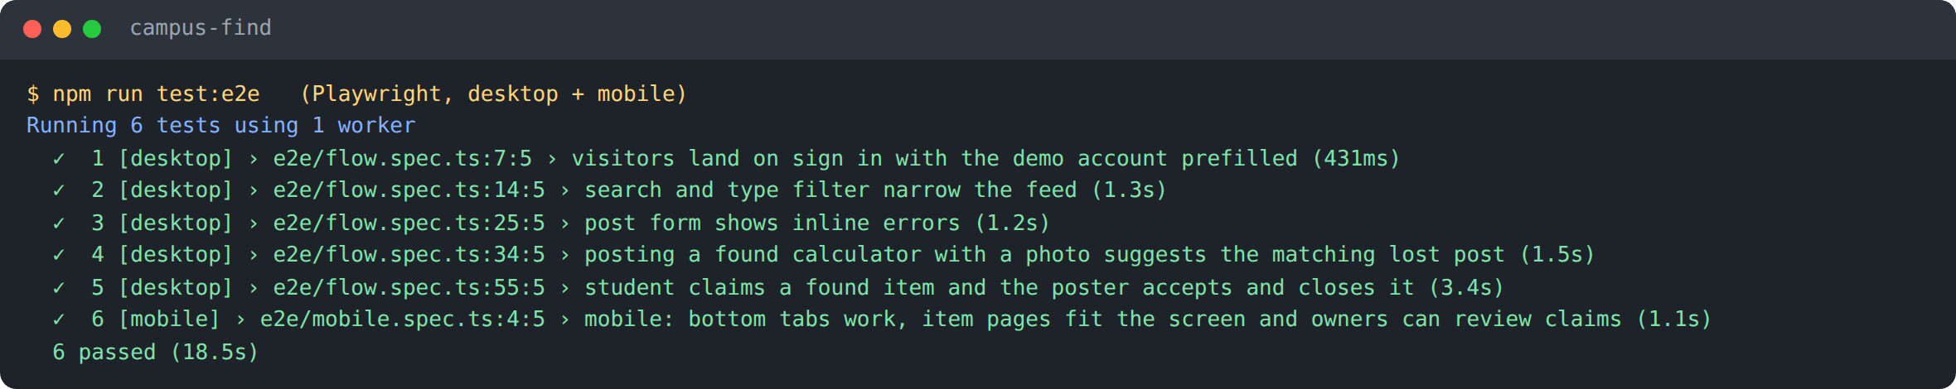
Figure 3.29: Output of the end-to-end test run (6 tests passed on desktop and mobile)
The evaluation considered the following factors:
- Correctness: every functional requirement is covered by a passing test; the totals on the feed (open lost, open found, returned in 30 days) match the seed data.
- Match quality: a script ran the matcher for every open seeded post. Every intended pair is the top suggestion for both of its posts: the earbuds (score 100), the brown wallet (100), the student ID card at the Faculty of Law (100), the iPhone on the shuttle (94), the keys with a red tag (92), the glasses in Lecture Room 4 (88) and the chemistry textbook (77). Weaker suggestions also appear below them, mostly inside the broad Electronics category, where the 35-point category bonus plus one shared word such as "black" can reach the threshold (for example a lost HP calculator against found flash drives at 65). These are labelled Possible or Likely match and never outrank the true match in the seed data, but they show that the threshold and categories need tuning with real use (Sections 3.9 and 3.10).
- Privacy and security: claim contents are only visible to the poster; actions re-check rules on the server; passwords, sessions and SQL follow OWASP guidance.
- Usability: a student can post an item and see matches in under a minute; the claim form asks for proof in plain words; contact is one tap.
- Responsiveness: the mobile test and Appendix E show the layout working on a phone.
- Maintainability: the matcher is one small module with unit tests that document its behaviour.

3.9 RECOMMENDATIONS AND FUTURE ENHANCEMENTS
- Notify the owner of a lost item by email or SMS when a new found item matches it strongly.
- Tune the matcher with real posts: split broad categories such as Electronics into sub-types (calculators, chargers, audio, storage), give colour words less weight, and raise the threshold if weak suggestions prove distracting.
- Add a Security desk role so items handed in at the porters' lodge can be posted and released with an ID check.
- Use image similarity in addition to text to improve matches for posts with photos.
- Let posters blur part of a photo (for example an ID card number) before it is published.
- Expire and archive old open posts automatically after a set period, with a reminder to the poster.
- Add in-app messaging so phone numbers do not need to be shared.
- Run the test suites on every pull request with GitHub Actions.

3.10 LIMITATIONS OF THE STUDY
The project was completed within a limited time for a 300-level course. The matcher is rule-based and depends on the words students choose; a very vague description may not be matched, synonyms had to be listed by hand, and broad categories produce some weak suggestions alongside the true matches. Testing used seeded data and automated browsers; no load testing or study with real students was carried out. Accounts are created by the seed script rather than linked to the university's student records, and the application relies on students to hand items over in person.

3.11 CONCLUSION
The project designed, implemented, tested and deployed campusfind, a lost and found web application for the University of Uyo that lets students post and search items, suggests likely matches between lost and found posts with a transparent score, and supports a claim, accept and return process that protects owners and finders. It showed how React, Next.js Server Components and Server Actions, PostgreSQL with Drizzle, and automated tests work together, and how a simple, explainable algorithm can solve a real matching problem without external services. The recommendations in Section 3.9 indicate the direction for further work.

REFERENCES
Drizzle Team (n.d.) Drizzle ORM documentation. Available at: https://orm.drizzle.team/docs/overview (Accessed: 5 October 2026).
Git (n.d.) Git documentation. Available at: https://git-scm.com/doc (Accessed: 5 October 2026).
GitHub (n.d.) GitHub Docs. Available at: https://docs.github.com/ (Accessed: 5 October 2026).
Jaccard, P. (1912) 'The distribution of the flora in the alpine zone', New Phytologist, 11(2), pp. 37-50.
Manning, C.D., Raghavan, P. and Schutze, H. (2008) Introduction to Information Retrieval. Cambridge: Cambridge University Press.
Meta Open Source (n.d.) React documentation. Available at: https://react.dev/ (Accessed: 5 October 2026).
Microsoft (n.d.) Playwright documentation. Available at: https://playwright.dev/ (Accessed: 5 October 2026).
Openverse (n.d.) Openverse: openly licensed media. Available at: https://openverse.org/ (Accessed: 5 October 2026).
OWASP Foundation (n.d.) OWASP Top Ten. Available at: https://owasp.org/www-project-top-ten/ (Accessed: 5 October 2026).
PostgreSQL Global Development Group (n.d.) PostgreSQL documentation. Available at: https://www.postgresql.org/docs/ (Accessed: 5 October 2026).
Railway (n.d.) Railway documentation. Available at: https://docs.railway.com/ (Accessed: 5 October 2026).
Vercel (n.d.) Next.js documentation. Available at: https://nextjs.org/docs (Accessed: 5 October 2026).
WhatsApp (n.d.) How to use click to chat. Available at: https://faq.whatsapp.com/ (Accessed: 5 October 2026).

APPENDICES

Appendix A: Test accounts
Table 3.11: Demonstration accounts
Email | Password | Role in the demonstration
student@uniuyo.edu.ng | student123 | Ini Ekpo, the demo student (owner of lost earbuds, finder of a wallet)
idara.umoh@student.uniuyo.edu.ng | student123 | Finder of the earbuds case
ifiok.essien@student.uniuyo.edu.ng | student123 | Owner of the lost wallet, sent the detailed claim

All 40 seeded students use the password student123. These accounts exist only in the demonstration data.

Appendix B: Routes
Table 3.12: Application routes
Route | Access | Purpose
/login | Public | Sign in
/ | Signed in | Feed with search, type, category and status filters
/post | Signed in | Post a lost or found item
/items/[id] | Signed in | Item details, contact, claim form or owner panel, possible matches
/mine | Signed in | The student's own posts
/claims | Signed in | The student's own claims
/api/health | Public | Health check with a database ping
/api/images/[id] | Public | Uploaded photos

Appendix C: Project structure
campus-find/
drizzle/ SQL migrations
e2e/ Playwright tests (flow.spec.ts, mobile.spec.ts)
docs/ PDF user guide and its generator
public/images/items/ Item photographs and credits.json
public/demo/ Sample photo for the live demonstration
scripts/ migrate.ts, seed.ts
src/
app/ Feed, post, items/[id], mine, claims, login, api
actions/ auth.ts, items.ts
components/ Shell, ItemCard, PostForm, ClaimForm, icons, LiveRefresh
db/ schema.ts, index.ts, seed-data.ts
lib/ matching.ts, items.ts, queries.ts, validation.ts,
today.ts, format.ts, auth.ts, session.ts, avatar.ts
proxy.ts
tests/unit/, tests/integration/
railway.json

Appendix D: Environment variables
Table 3.13: Environment variables
Variable | Purpose
DATABASE_URL | PostgreSQL connection string (on Railway: ${{campus-find-postgres.DATABASE_URL}})
SESSION_SECRET | Random secret used to sign session tokens
NODE_ENV | production on Railway
CAMPUSFIND_TODAY | Optional YYYY-MM-DD to freeze the clock
TEST_DATABASE_URL | Database used by integration and end-to-end tests

Appendix E: Mobile screenshots
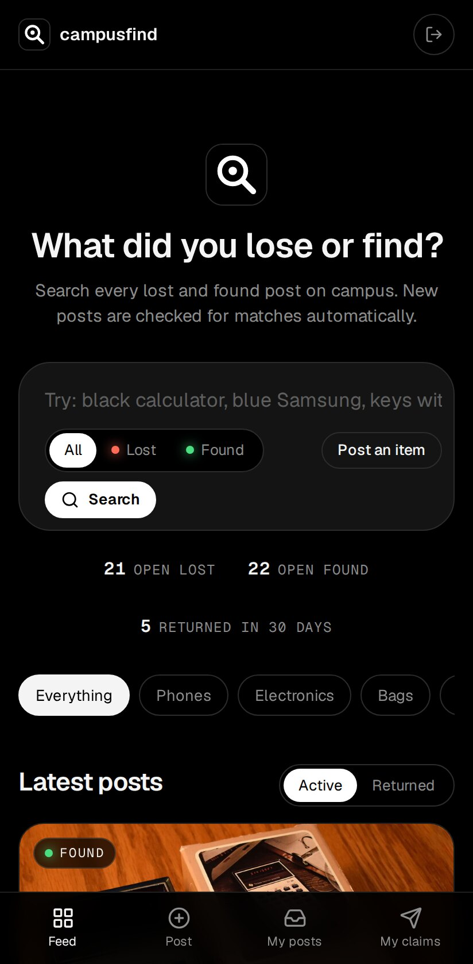
Figure E.1: Feed on a phone
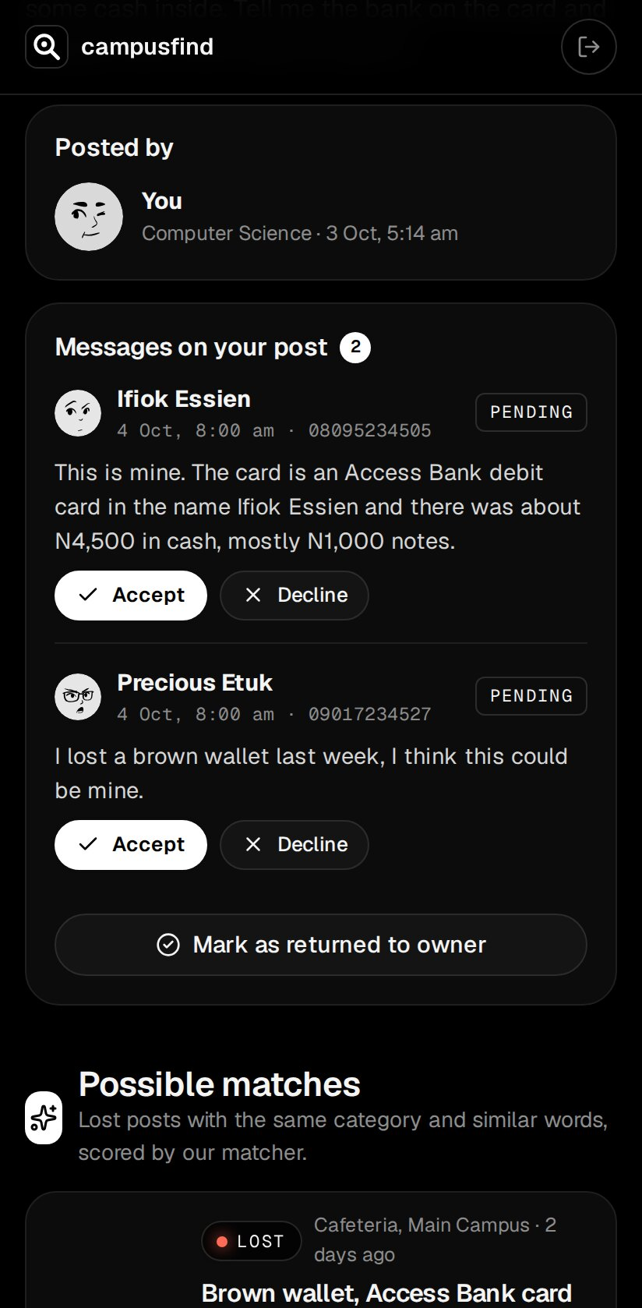
Figure E.2: Owner panel with claims on a phone
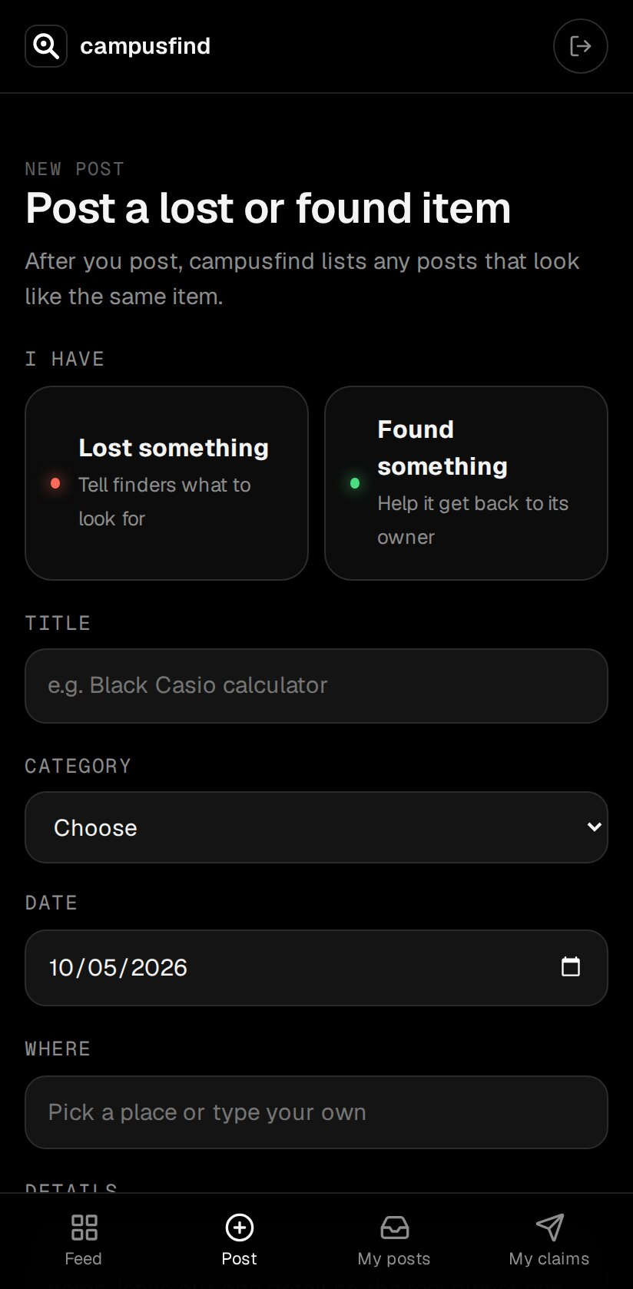
Figure E.3: Post form on a phone

