CHAPTER 3
IT PROJECT ON DESIGN AND IMPLEMENTATION OF A CAMPUS EVENT BOARD WITH LIVE RSVP AND GOOGLE CALENDAR INTEGRATION USING NEXT.JS AND POSTGRESQL

INTRODUCTION
This chapter presents the IT project titled "Design and Implementation of a Campus Event Board with Live RSVP and Google Calendar Integration Using Next.js and PostgreSQL." The project produced a complete web application named Eventard, which gives the students of the University of Uyo a single place to discover campus events (talks, career fairs, sports, concerts, workshops and cultural days), reserve a seat with one click, watch the number of attendees update live, and copy any event into their own Google Calendar. Student Affairs staff use the same application to publish events, follow RSVPs as they arrive, cancel or restore events, and see who is coming.
The project is presented as a software engineering project. The chapter covers the problem the application solves, the requirements, the methodology, the design of the architecture and the database, the rules that decide who may RSVP and when, the measures that stop an event from being overbooked, the way the Google Calendar link is built, security, testing and evaluation, and the deployment of the finished application.

3.1 PROJECT OVERVIEW
Eventard is a full stack web application. The part that runs in the browser is built with React components; the server side is written with Next.js Server Components, which read data, and Server Actions, which change data; and all data is stored in a PostgreSQL database accessed through the Drizzle ORM. Every page is rendered on the server and sent to the browser as HTML, so the application loads quickly on low-end phones and works on any modern browser without installation.
The application has two roles. A student signs in with a university email address and sees an event board that greets them by name, lists what is happening today, highlights the next upcoming event and shows every other event as a card with its banner photograph, date, venue, category and a live count of attendees. The student can search, filter by category, switch between upcoming and past events, open an event to read the details, RSVP or cancel, and press an "Add to Google Calendar" button that opens Google Calendar with the event already filled in. A "My RSVPs" page lists only the events that student has booked.
An admin from Student Affairs sees a dashboard with the number of upcoming events, events in the next seven days, RSVPs for upcoming events and events that are full, followed by a table of all events with a capacity bar for each. The admin can publish a new event with a banner (uploaded or chosen from a library of real photographs), edit any event, cancel and restore an event, delete it, and see the full attendee list with each student's department and level. When an admin publishes an event, every student who has the board open sees it appear within a few seconds without reloading the page.
The scope of the project covers sign-in and sessions, role-based access, the event board with search and filters, event details, RSVPs with capacity limits, live counts, Google Calendar links, the student's own RSVP list, the admin dashboard and event management, banner uploads, responsive layouts for phones, automated tests at three levels, a PDF user guide, and deployment on Railway with its own PostgreSQL database. Ticket sales, payment, email reminders, QR check-in at the venue and native mobile apps are outside the scope of this report.

3.2 BACKGROUND OF THE STUDY
Universities host many events every week. Departments run seminars and public lectures, Career Services organise CV clinics and career fairs, the Sports Council runs inter-faculty leagues, student societies hold hackathons, concerts, drama productions and cultural days, and the Health Centre runs blood drives and wellness talks. At the University of Uyo, as in most Nigerian universities, these events are announced on printed posters, notice boards, departmental WhatsApp groups, class representatives' broadcasts and social media pages. Each channel reaches a different group of students, and none of them keeps a complete, searchable list.
Organisers also struggle to plan. A venue such as a computer laboratory or a workshop has a fixed number of seats, but organisers rarely know how many students are coming until the day. Some events are overcrowded while others are poorly attended, and when an event is cancelled or moved there is no reliable way to inform everyone who intended to come.
Modern web technologies make a better solution practical for a student project. React and Next.js allow a single code base to deliver fast, server-rendered pages that work well on phones; PostgreSQL provides reliable storage with transactions and constraints that protect data integrity; and cloud platforms such as Railway can host the application and its database with automatic deployment from GitHub. Google Calendar accepts a specially formatted link that pre-fills a new event, which means calendar integration is possible without any API keys, OAuth consent screens or paid services.

3.3 PROBLEM STATEMENT
Campus events at the University of Uyo are announced through scattered channels. Students miss events they would have attended because they never saw the announcement, or because they forgot the date and time. There is no single place where a student can see what is happening today, this week or this month, search for events by topic, or check whether there are still seats available. Organisers cannot tell how many students intend to come, cannot stop a laboratory session from being overbooked, and cannot reliably tell interested students when an event is cancelled. Because announcements are not linked to calendars, students must copy dates and times by hand, which leads to mistakes, especially with time zones when events are shared online.
There is therefore a need for a simple, fast, mobile-friendly web application in which Student Affairs can publish events once, students can discover them and RSVP, attendance numbers are visible as they change, capacity limits are enforced even when many students respond at the same moment, and any event can be added to a personal calendar with a single tap. The project also addresses the learning need to apply React, Next.js, TypeScript, PostgreSQL, automated testing, Git and cloud deployment together in a complete application.

3.4 AIM AND OBJECTIVES
Aim: To design, implement, test and deploy a full stack web application that lets University of Uyo students discover campus events, RSVP with live attendance counts and add events to Google Calendar, while giving Student Affairs the tools to publish and manage those events.
Objectives:
- To identify the functional and non-functional requirements of an event board for students and event organisers.
- To design the database schema, the application architecture and the rules that govern RSVPs and event status.
- To implement a responsive user interface with React and Next.js Server Components.
- To implement server-side logic with Server Actions and PostgreSQL, including a transaction that prevents overbooking.
- To generate correct Google Calendar links from stored event data, including conversion to UTC and URL encoding.
- To implement secure sign-in, role-based access and validation of all user input.
- To test the application with unit, integration and end-to-end tests on desktop and mobile, and evaluate it against the requirements.
- To manage the source code with Git and GitHub and deploy the application on Railway with its own database and a health check.

3.5 REQUIREMENTS GATHERING / INFORMATION GATHERING
Requirements were gathered in four ways: by observing how events are currently announced (posters, WhatsApp broadcasts and departmental pages) and noting what information each announcement usually carries; by informal discussion with students about why they miss events and with student organisers about planning for limited venues; by reviewing existing event tools such as general ticketing sites and calendar invitations, and noting which of their features suit a free university setting; and by studying how Google Calendar's event template link works. No personal data about real students was collected; all names in the application are fictional seed data.
The functional requirements are listed in Table 3.1 and the non-functional requirements in Table 3.2. Figure 3.1 shows the use cases of each role.
Table 3.1: Functional requirements
ID | Requirement
FR1 | Users can sign in with an email and password and sign out. The sign-in page is prefilled with a demo account for presentations.
FR2 | Visitors without a valid session are sent to the sign-in page; students cannot open admin pages.
FR3 | Students see a board with a greeting, today's events, the next upcoming event and all other upcoming events as cards.
FR4 | Students can search events by title, venue or description, filter by one of seven categories and switch between upcoming and past events.
FR5 | Each event page shows the banner, category, relative day (Today, Tomorrow, In 5 days), date, time range, venue, capacity, description and who is going.
FR6 | Students can RSVP to an open event and cancel their RSVP; an event cannot be booked beyond its capacity.
FR7 | RSVP is closed for events that are live, ended or cancelled, and the reason is shown.
FR8 | RSVP counts update on every open screen without a page reload.
FR9 | Each upcoming event has an "Add to Google Calendar" button that opens Google Calendar with the title, start and end time, description and venue filled in.
FR10 | Students can see a list of their own RSVPs, split into upcoming and past.
FR11 | Admins see dashboard statistics and a table of all events with RSVP counts and capacity bars.
FR12 | Admins can publish an event with title, category, venue, start and end, optional capacity, description and a banner (upload or library).
FR13 | Admins can edit, cancel, restore and delete events, and see the full attendee list.
FR14 | Forms show an error message under each invalid field.
FR15 | The interface works on phones, tablets and desktops.

Table 3.2: Non-functional requirements
Quality | Requirement and how it is met
Security | Passwords stored only as bcrypt hashes; signed HTTP-only session cookies; every Server Action checks the session and role; parameterised SQL; uploads checked for type and size.
Integrity | Capacity cannot be exceeded, even with simultaneous RSVPs (row lock in a transaction); one RSVP per student per event (unique constraint); end time must be after start time (check constraint).
Performance | Pages rendered on the server; indexes on events.starts_at and rsvps.user_id; images pre-sized to 1200 by 675 pixels and served as compressed JPEG.
Usability | Each role lands on its main page; plain language; clear status labels (Full, 3 spots left, Happening now, Cancelled, Ended).
Reliability | Health check at /api/health pings the database; migrations applied automatically on every start; failed deployments do not replace the running one.
Maintainability | Business rules are pure functions in src/lib with unit tests; strict TypeScript; consistent folder structure; Git history in clear steps.
Testability | The clock can be frozen with EVENTARD_TODAY=YYYY-MM-DD so tests and demos always see the same data.
Portability | Runs anywhere Node.js 22 and PostgreSQL run; configuration only through environment variables.

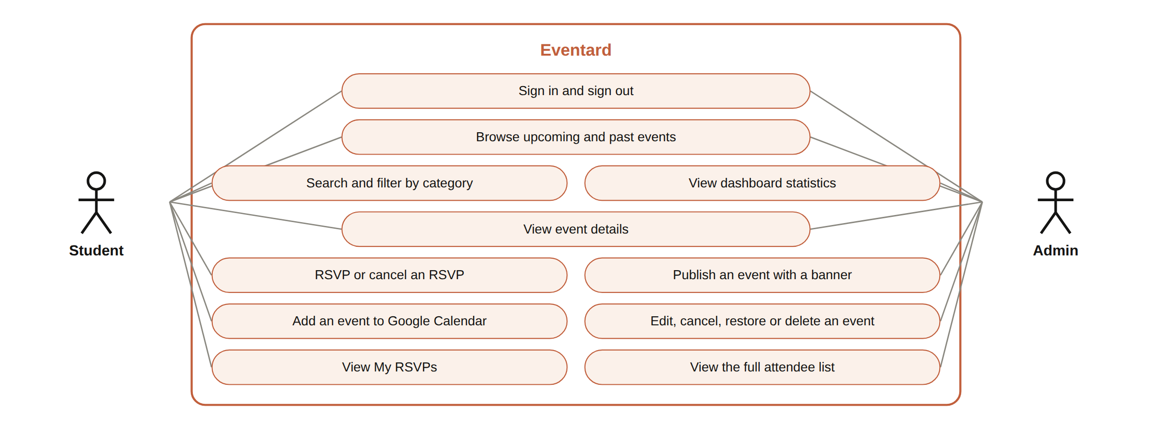
Figure 3.1: Use case diagram of Eventard showing the student and admin roles

3.6 METHODOLOGY
The project followed an iterative and incremental approach. Each iteration planned a small set of features, implemented them, tested them, and reviewed the result in the browser on both desktop and phone screen sizes before the next iteration began. Business rules were written first as pure functions with unit tests, so that the rules could be checked before any page used them. The iterations are summarised in Table 3.3.
Table 3.3: Development iterations
Iteration | Work done | Outcome
1 | Project setup, database schema, migrations, seed data relative to today | Database with users, events, RSVPs and uploads; realistic demo data
2 | Rules in src/lib: event phase, RSVP state, capacity, relative day labels, time validation, Google Calendar link | Unit-tested rules independent of the user interface
3 | Sign-in, sessions, route protection with proxy.ts | Students and admins land on the correct page; protected pages redirect
4 | Event board, event page, RSVP with transaction, live refresh, My RSVPs | Core student journey working end to end
5 | Admin dashboard, create, edit, cancel, restore, delete, banner upload | Complete organiser workflow
6 | Integration tests on PostgreSQL, Playwright tests on desktop and mobile, PDF user guide | 54 Vitest tests and 7 Playwright tests passing
7 | Deployment to Railway with its own database, health check and automatic deploys from GitHub | Live application at a public URL

The technology used is summarised in Table 3.4.
Table 3.4: Technology used
Area | Technology | Purpose
User interface | React 19 | Components for pages, cards, forms and panels
Framework | Next.js 16 (App Router) | Server Components, Server Actions, routing, route handlers, proxy
Language | TypeScript (strict mode) | Type-checked application, tests and scripts
Database | PostgreSQL 16 | Relational storage with transactions and constraints
Data access | Drizzle ORM, drizzle-kit, node-postgres | Typed queries, versioned SQL migrations
Validation | Zod | Schemas for sign-in and event forms with inline errors
Authentication | bcryptjs, jose | Password hashing and signed JWT session cookies
Icons, avatars, fonts | lucide-react, DiceBear, Fontsource | Icons, locally generated attendee avatars, self-hosted fonts
Testing | Vitest, Playwright | Unit and integration tests; browser tests on desktop and mobile
Version control | Git and GitHub | History, branches and pull requests
Deployment | Railway | Hosting the application and its PostgreSQL database

3.7 SYSTEM DESIGN AND IMPLEMENTATION
The application was designed in three tiers: the React interface in the browser, the Next.js server that applies the rules and talks to the database, and the PostgreSQL database. The main design and implementation decisions are described in the subsections below.

3.7.1 System architecture
Figure 3.2 shows the architecture. Every request from the browser first passes through proxy.ts, which checks the signed session cookie and redirects visitors without a valid session to the sign-in page. Pages are Server Components: they run on the server, call query functions in src/lib/queries.ts, and return HTML. Changes such as an RSVP or a new event go through Server Actions, which check the session and role again, validate the input, call the database and then revalidate the affected pages. The database is never reached from the browser; on Railway it is only reachable over the private network between the two services.
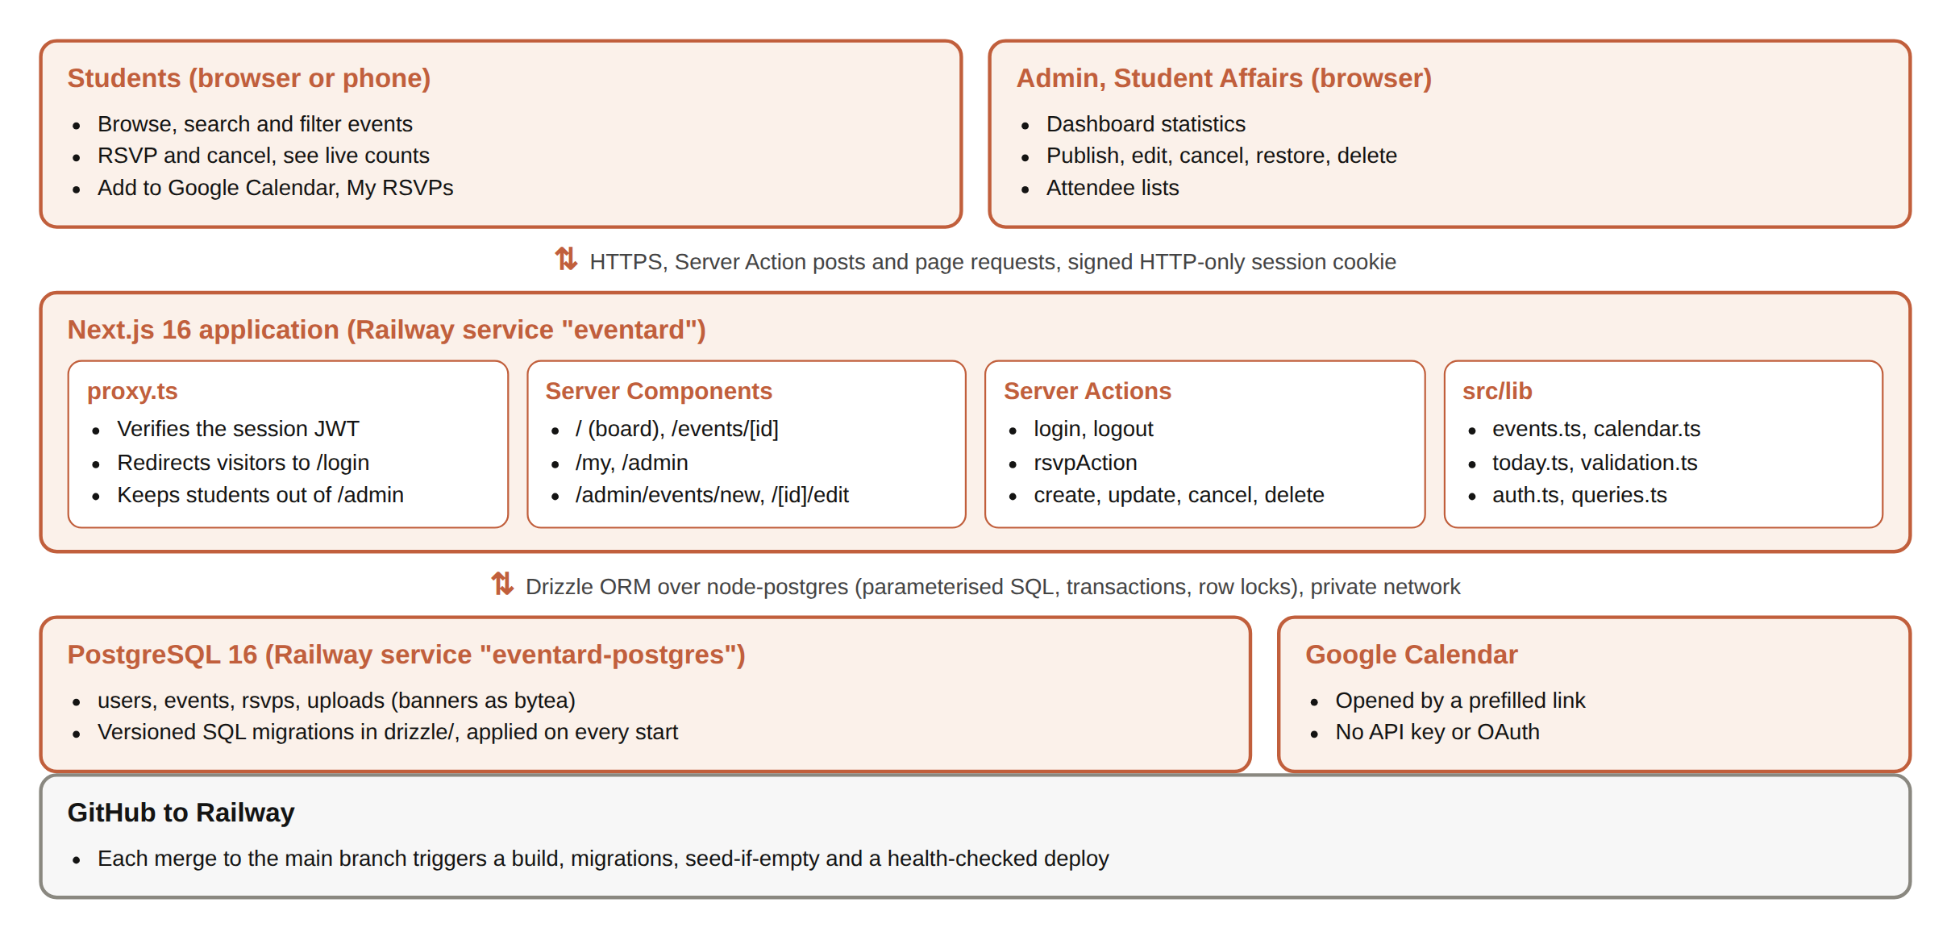
Figure 3.2: System architecture of Eventard as deployed on Railway
Keeping the rules in src/lib as plain functions that take the current time as an argument was a deliberate decision. The same function decides what the RSVP button shows on the page and whether the server accepts an RSVP, so the interface and the server can never disagree, and the rules can be tested without a browser or a database.

3.7.2 Database design
The database has four tables, listed in Table 3.5 and shown in Figure 3.3. Each event is created by an admin user; each RSVP links one student to one event. Enumerated types restrict roles to student and admin, statuses to scheduled and cancelled, and categories to seven fixed values. Banners uploaded by admins are stored in the uploads table as binary data, because the file system of a cloud container is replaced on every deployment.
Table 3.5: Database tables
Table | Main columns | Constraints and notes
users | id, name, email, password_hash, role, department, level, created_at | email unique; role is student or admin
events | id, title, description, category, venue, starts_at, ends_at, banner_url, capacity, status, created_by, created_at | CHECK ends_at > starts_at; CHECK capacity is NULL or > 0; index on starts_at
rsvps | id, event_id, user_id, created_at | UNIQUE (event_id, user_id); ON DELETE CASCADE; index on user_id
uploads | id (uuid), mime, data (bytea), uploaded_by, created_at | Served by /api/images/[id] with a one-year cache header

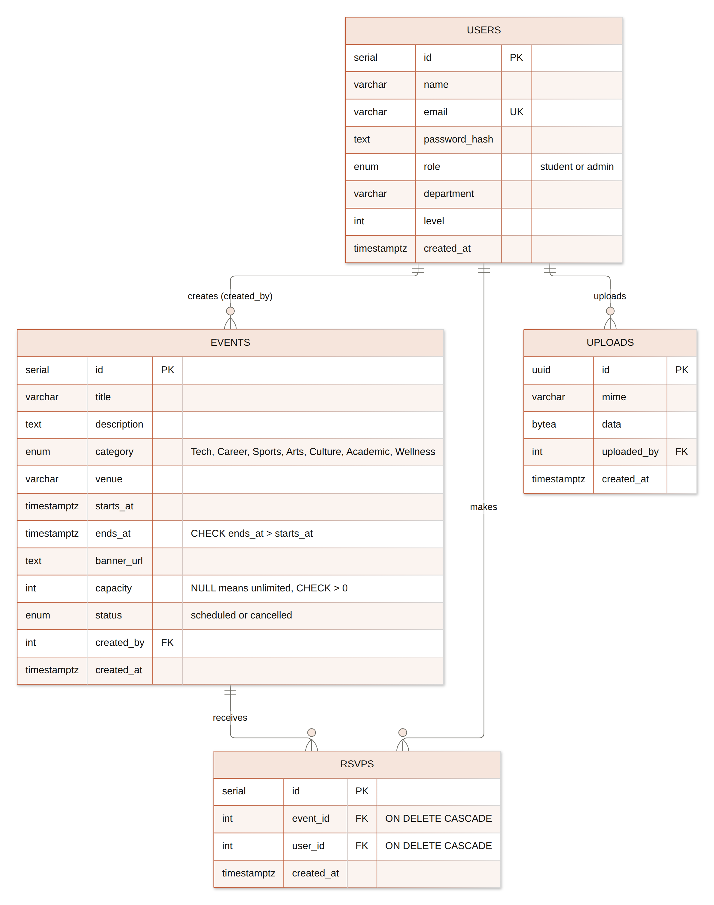
Figure 3.3: Entity relationship diagram of the Eventard database
Times are stored as timestamptz (timestamp with time zone). The campus is in West Africa Time (UTC+1, no daylight saving), and all display formatting uses the Africa/Lagos time zone, while calendar links are generated in UTC. The schema is written in TypeScript in src/db/schema.ts, and drizzle-kit generates versioned SQL migration files from it in the drizzle/ folder. These files are committed to Git and applied automatically every time the application starts.

3.7.3 Event lifecycle and RSVP rules
An event moves through the states in Figure 3.4. Its phase is never stored; it is calculated from the current time by eventPhase(), so an event becomes live and then ended without any scheduled job. Only cancellation is stored, as the status column, because it is a decision made by a person.
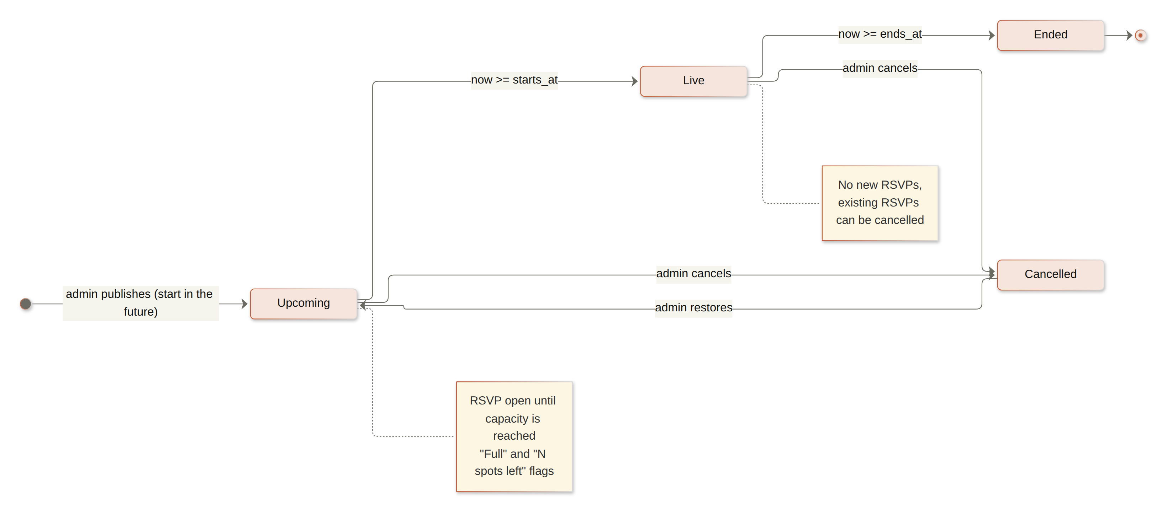
Figure 3.4: Event lifecycle
Whether the current student may RSVP is decided by rsvpState(), shown in Figure 3.5. The order of the checks matters: a cancelled event is closed even if it has seats; a student who is already going may cancel even when the event is full or has started, which frees the seat for someone else; and no new RSVPs are accepted once an event has started.
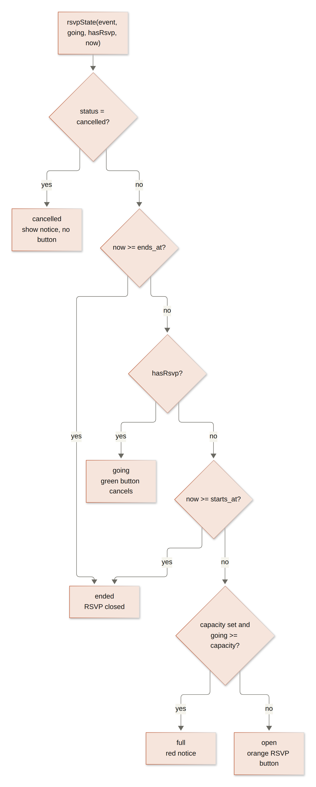
Figure 3.5: Decision flow of rsvpState()
Table 3.6: Business rule functions in src/lib
Function | What it does
eventPhase(event, now) | Returns upcoming, live, ended or cancelled.
rsvpState(event, going, hasRsvp, now) | Returns open, going, full, ended or cancelled (Figure 3.5).
spotsLeft, fillRatio, isAlmostFull | Remaining seats (never negative), fill ratio, and the "N spots left" flag at 85 percent or more.
relativeDayLabel(start, now) | Today, Tomorrow, Yesterday, In N days or N days ago, measured in campus days, so 23:30 UTC counts as the next day in Lagos.
checkEventTimes(times, now) | Rejects invalid dates, a start in the past (for new events), an end before the start and events longer than three days.
splitByTime(list, now) | Splits a list into upcoming (including live) and past, sorted for display.
toGoogleDate, googleCalendarUrl | Build the Google Calendar link (Section 3.7.5).
resolveNow(override) | Returns the real time, or 10:00 Lagos time on the day given in EVENTARD_TODAY.

3.7.4 Preventing overbooking
Capacity limits are only useful if they hold when many students respond at once, for example when a popular workshop is announced in a class group chat. If two requests both read "59 of 60 seats taken" and both insert an RSVP, the event ends up with 61 attendees. To prevent this, toggleRsvp() runs inside a database transaction and first locks the event row with SELECT ... FOR UPDATE. A second request for the same event waits until the first has committed, then reads the new count. Figure 3.6 shows the full sequence.
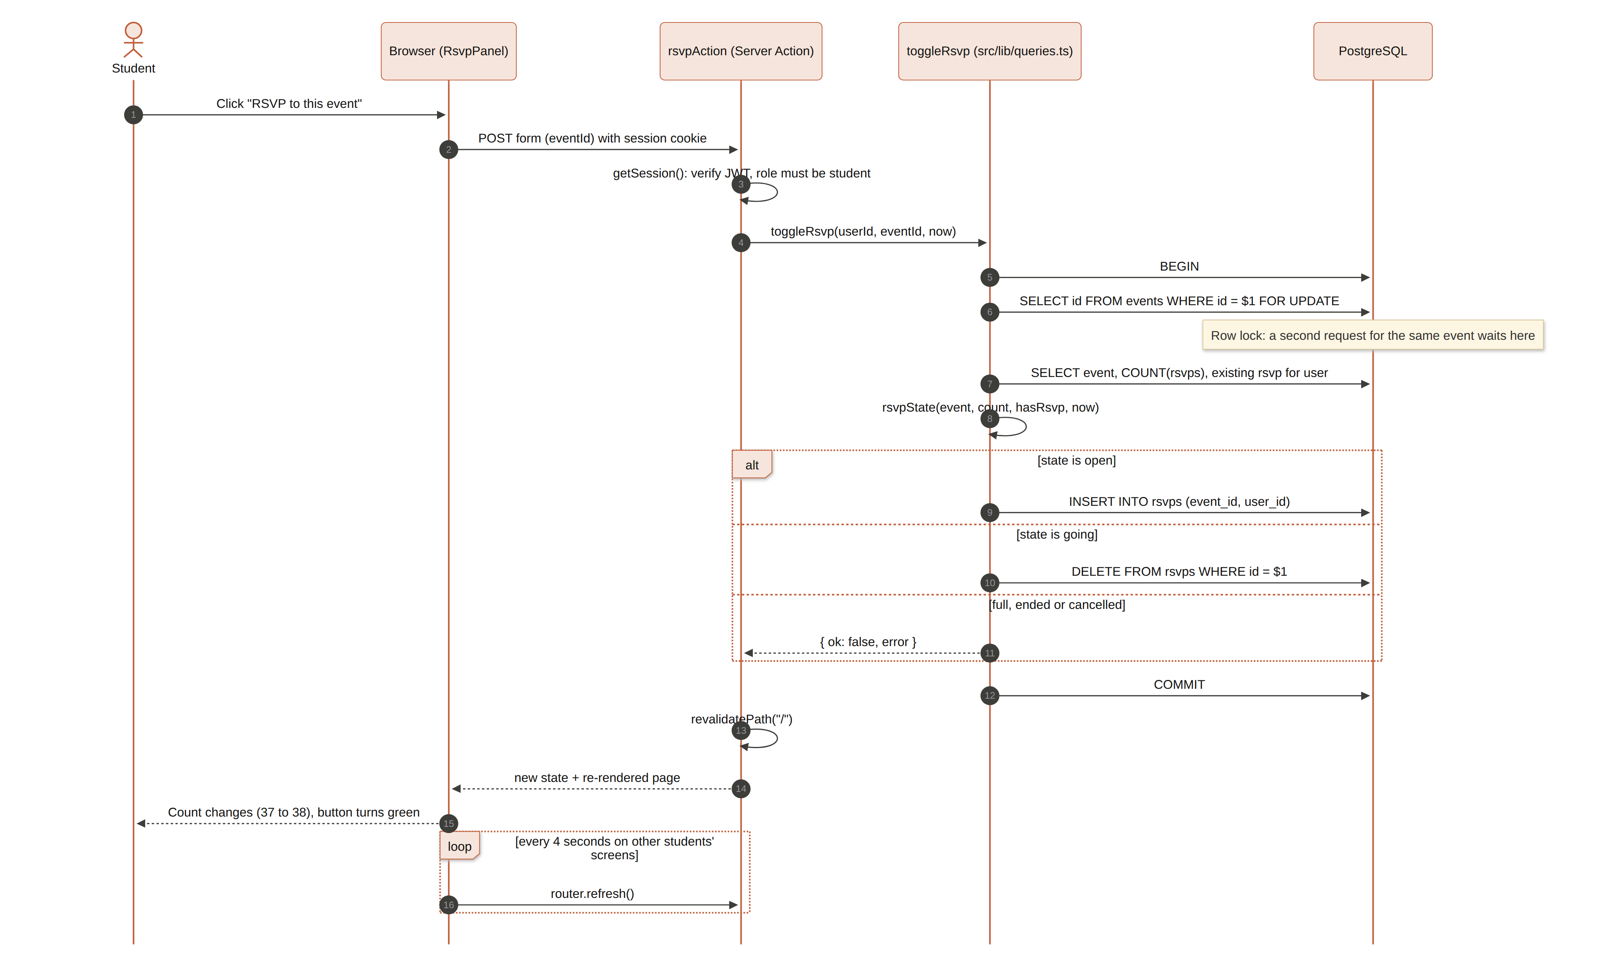
Figure 3.6: Sequence of an RSVP, including the row lock that prevents overbooking
export async function toggleRsvp(db, userId, eventId, now) {
return db.transaction(async (tx) => {
await tx.execute(sql`select id from events where id = ${eventId} for update`);
const [e] = await tx.select().from(events).where(eq(events.id, eventId));
const [{ n }] = await tx.select({ n: count() }).from(rsvps).where(eq(rsvps.eventId, eventId));
const mine = await tx.select().from(rsvps).where(and(eq(rsvps.eventId, eventId), eq(rsvps.userId, userId)));
const state = rsvpState(e, n, mine.length > 0, now);
if (state.kind === "going") { await tx.delete(rsvps).where(eq(rsvps.id, mine[0].id)); return { ok: true, going: n - 1 }; }
if (state.kind === "open") { await tx.insert(rsvps).values({ eventId, userId }); return { ok: true, going: n + 1 }; }
return { ok: false, error: messageFor(state.kind) };
});
}
The unique constraint on (event_id, user_id) is a second line of defence: even if a student double-clicks the button, the database cannot store two RSVPs for the same student and event. The integration test suite checks both protections, including a test that fires ten RSVP requests at a three-seat event at the same time and confirms that exactly three succeed.

3.7.5 Google Calendar integration
Google Calendar accepts a link of the form https://calendar.google.com/calendar/render?action=TEMPLATE&text=...&dates=START/END&details=...&location=... and opens a new event form filled with those values. No API key, OAuth sign-in or server-to-server call is needed, and the student remains in control because Google asks them to save the event. Figure 3.7 shows how the link is built.
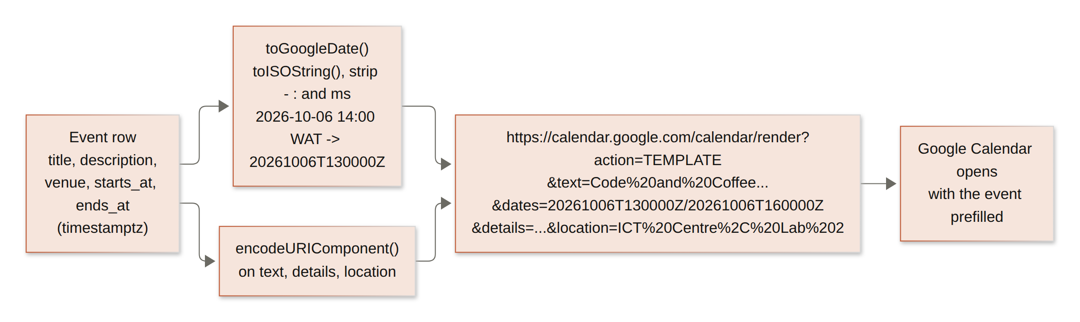
Figure 3.7: Construction of the Add to Google Calendar link
Two details make the link correct. First, Google expects dates in the compact UTC format 20261015T140000Z. The function toGoogleDate() converts the stored timestamp to an ISO string and removes the dashes, colons and milliseconds, so an event that starts at 2:00 pm West Africa Time becomes 130000Z. Second, every text value is passed through encodeURIComponent(), so titles containing spaces, colons, ampersands or commas (such as "Code and Coffee: Build a Web App" or "ICT Centre, Lab 2") are transmitted exactly. The event page also appends a link back to the event page inside the description, so the calendar entry leads the student back to Eventard.
export function toGoogleDate(d: Date) {
return d.toISOString().replace(/[-:]/g, "").replace(/\.\d{3}/, ""); // 20261006T130000Z
}
export function googleCalendarUrl(e, detailsUrl?) {
const params = [["action", "TEMPLATE"], ["text", e.title],
["dates", `${toGoogleDate(e.startsAt)}/${toGoogleDate(e.endsAt)}`],
["details", detailsUrl ? `${e.description}\n\nDetails: ${detailsUrl}` : e.description],
["location", e.venue]];
return "https://calendar.google.com/calendar/render?" +
params.map(([k, v]) => `${k}=${encodeURIComponent(v)}`).join("&");
}

3.7.6 Live updates
The requirement that counts change without a reload (FR8) is met with a small client component, LiveRefresh, placed on the board, event and dashboard pages. Every four to six seconds, while the browser tab is visible, it calls router.refresh(). Next.js then re-renders the Server Components on the server and sends only the changed parts to the browser, so the page keeps its scroll position and any form input. When the current user performs an action, the Server Action calls revalidatePath(), so their own change appears immediately. This approach needs no WebSocket server, which keeps hosting simple and costs nothing extra on Railway, and it was sufficient for the expected number of students.

3.7.7 Authentication, authorisation and security
- Passwords: stored only as bcrypt hashes with a cost factor of 10; the plain password is never stored or logged.
- Sessions: a successful sign-in creates a JSON Web Token signed with HS256 using the SESSION_SECRET environment variable, holding the user id, role and name, and valid for seven days. It is stored in an HTTP-only, SameSite=Lax cookie (Secure in production), so page scripts cannot read it.
- Route protection: proxy.ts (the Next.js 16 replacement for middleware) verifies the token on every request and redirects visitors to /login and students away from /admin. This is an optimistic check; every page and every Server Action checks the session again on the server with requireUser() or requireAdmin().
- Scoping: the My RSVPs query only selects rows where user_id is the signed-in student, and each event card's "Going" flag is computed for the signed-in user only.
- Validation: Zod schemas validate every form; invalid fields return messages that are shown under the inputs. Start and end times are checked by checkEventTimes().
- SQL injection: all queries go through Drizzle, which sends values as parameters, never as concatenated SQL text.
- Uploads: banners must be JPEG, PNG or WebP and at most 3 MB; the request body limit for Server Actions is raised to 5 MB in next.config.ts and nothing else is accepted.
- Secrets: the database URL and session secret are environment variables set on Railway and never committed to Git.

3.7.8 Deterministic dates for testing and demonstration
Event data only makes sense relative to today: an event dated last week is "past" and one tomorrow is "upcoming". The seed script therefore creates events at offsets from the current day (from 29 days ago to 40 days ahead), so the demonstration data is always fresh. For tests and rehearsals, setting EVENTARD_TODAY=2026-10-05 freezes the clock at 10:00 Lagos time on that day; every rule receives the time from resolveNow(), so the same screens and counts appear every time.

3.7.9 User interface design
The visual design follows the calm style of Anthropic's Claude interface: a warm ivory background, serif headings (Source Serif 4), a clean sans-serif body (Instrument Sans), soft borders and a terracotta accent used for the main action on each screen. Event banners are real Creative Commons photographs found through Openverse, resized and stored with the application, with credits in public/images/events/credits.json. Attendee avatars are generated on the server with DiceBear, so no external image requests are made. Layout grids use minmax(0, 1fr) columns so long titles never push the page wider than a phone screen; on narrow screens the navigation collapses to icons and all grids become a single column.

3.7.10 Seed data
The seed script loads realistic data so the application can be demonstrated immediately, as summarised in Table 3.7. Names are typical Nigerian names, venues are typical campus locations, and the data deliberately includes problem cases such as a full event, an almost full event, a cancelled event and events happening right now.
Table 3.7: Seeded demonstration data
Item | Quantity and notes
Users | 50: 2 Student Affairs admins and 48 students across 12 departments and 5 levels
Events | 38: 13 past, 3 today, 21 upcoming and 1 cancelled, across 7 categories
Capacity limits | 13 events have a capacity; 3 of them are full (for example Robotics Club Open Day, 45 of 45)
RSVPs | 1,092, with timestamps spread before each event
Demo student | Imaobong Udo, Computer Science, 300 Level, going to 8 events but not the featured one, so the demo can RSVP live

3.7.11 Version control and deployment
The code is kept in a GitHub repository with commits made in clear steps (setup and schema, screens, tests, documentation). Work is done on a feature branch and merged into main through a pull request. The repository is connected to a Railway service; a separate Railway PostgreSQL service holds the database, and the application receives its address through the variable DATABASE_URL=${{eventard-postgres.DATABASE_URL}}. The file railway.json defines the build command, the start command and the health check, as shown in Figure 3.8. The live application is available at https://eventard-production.up.railway.app.
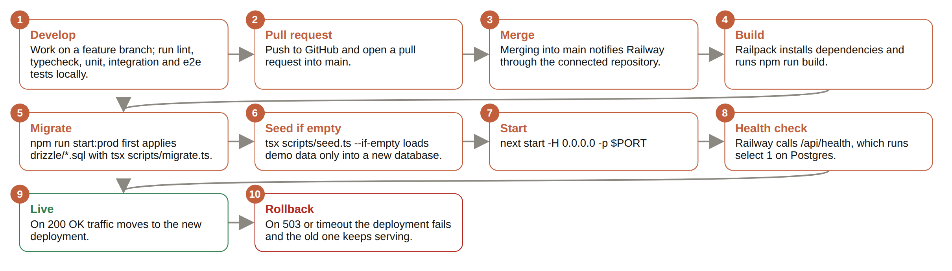
Figure 3.8: Build and deployment pipeline from GitHub to Railway
{
"build": { "builder": "RAILPACK", "buildCommand": "npm run build" },
"deploy": { "startCommand": "npm run start:prod",
"healthcheckPath": "/api/health", "healthcheckTimeout": 180,
"restartPolicyType": "ON_FAILURE", "restartPolicyMaxRetries": 5 } }

"start:prod": "npm run db:migrate && npm run db:seed:if-empty && next start -H 0.0.0.0 -p ${PORT:-3000}"

3.7.12 Application screens
Figure 3.9 to Figure 3.25 show the main screens. They were captured from the application running in production mode with the same seed data used by the deployment, with the clock fixed at 5 October 2026 so that the dates are consistent.
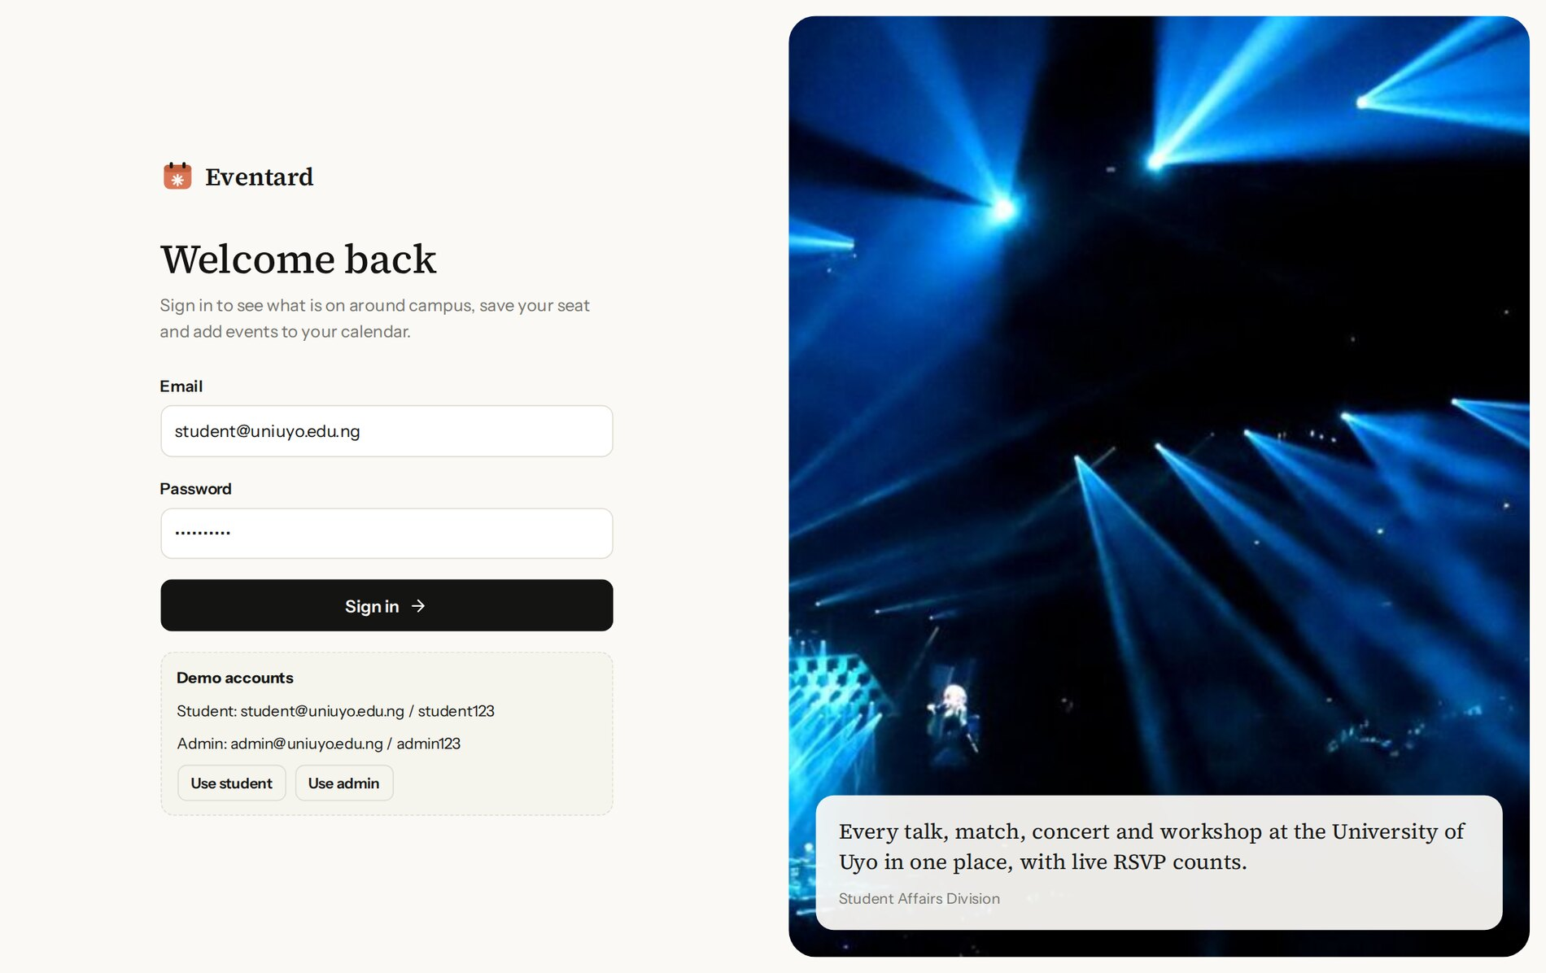
Figure 3.9: Sign-in page with the demo student account prefilled and both demo accounts listed
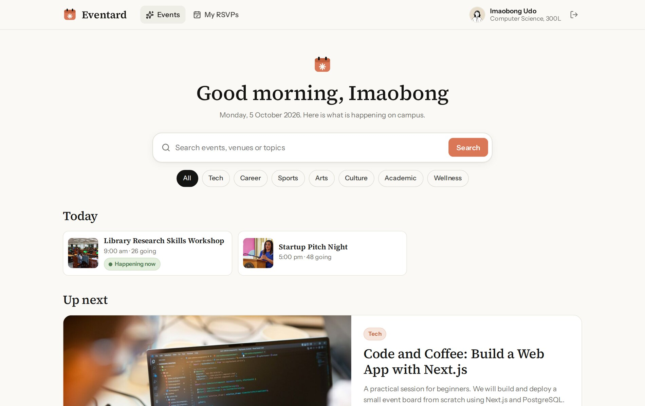
Figure 3.10: Event board: greeting, search box, category chips, today's events and the next upcoming event
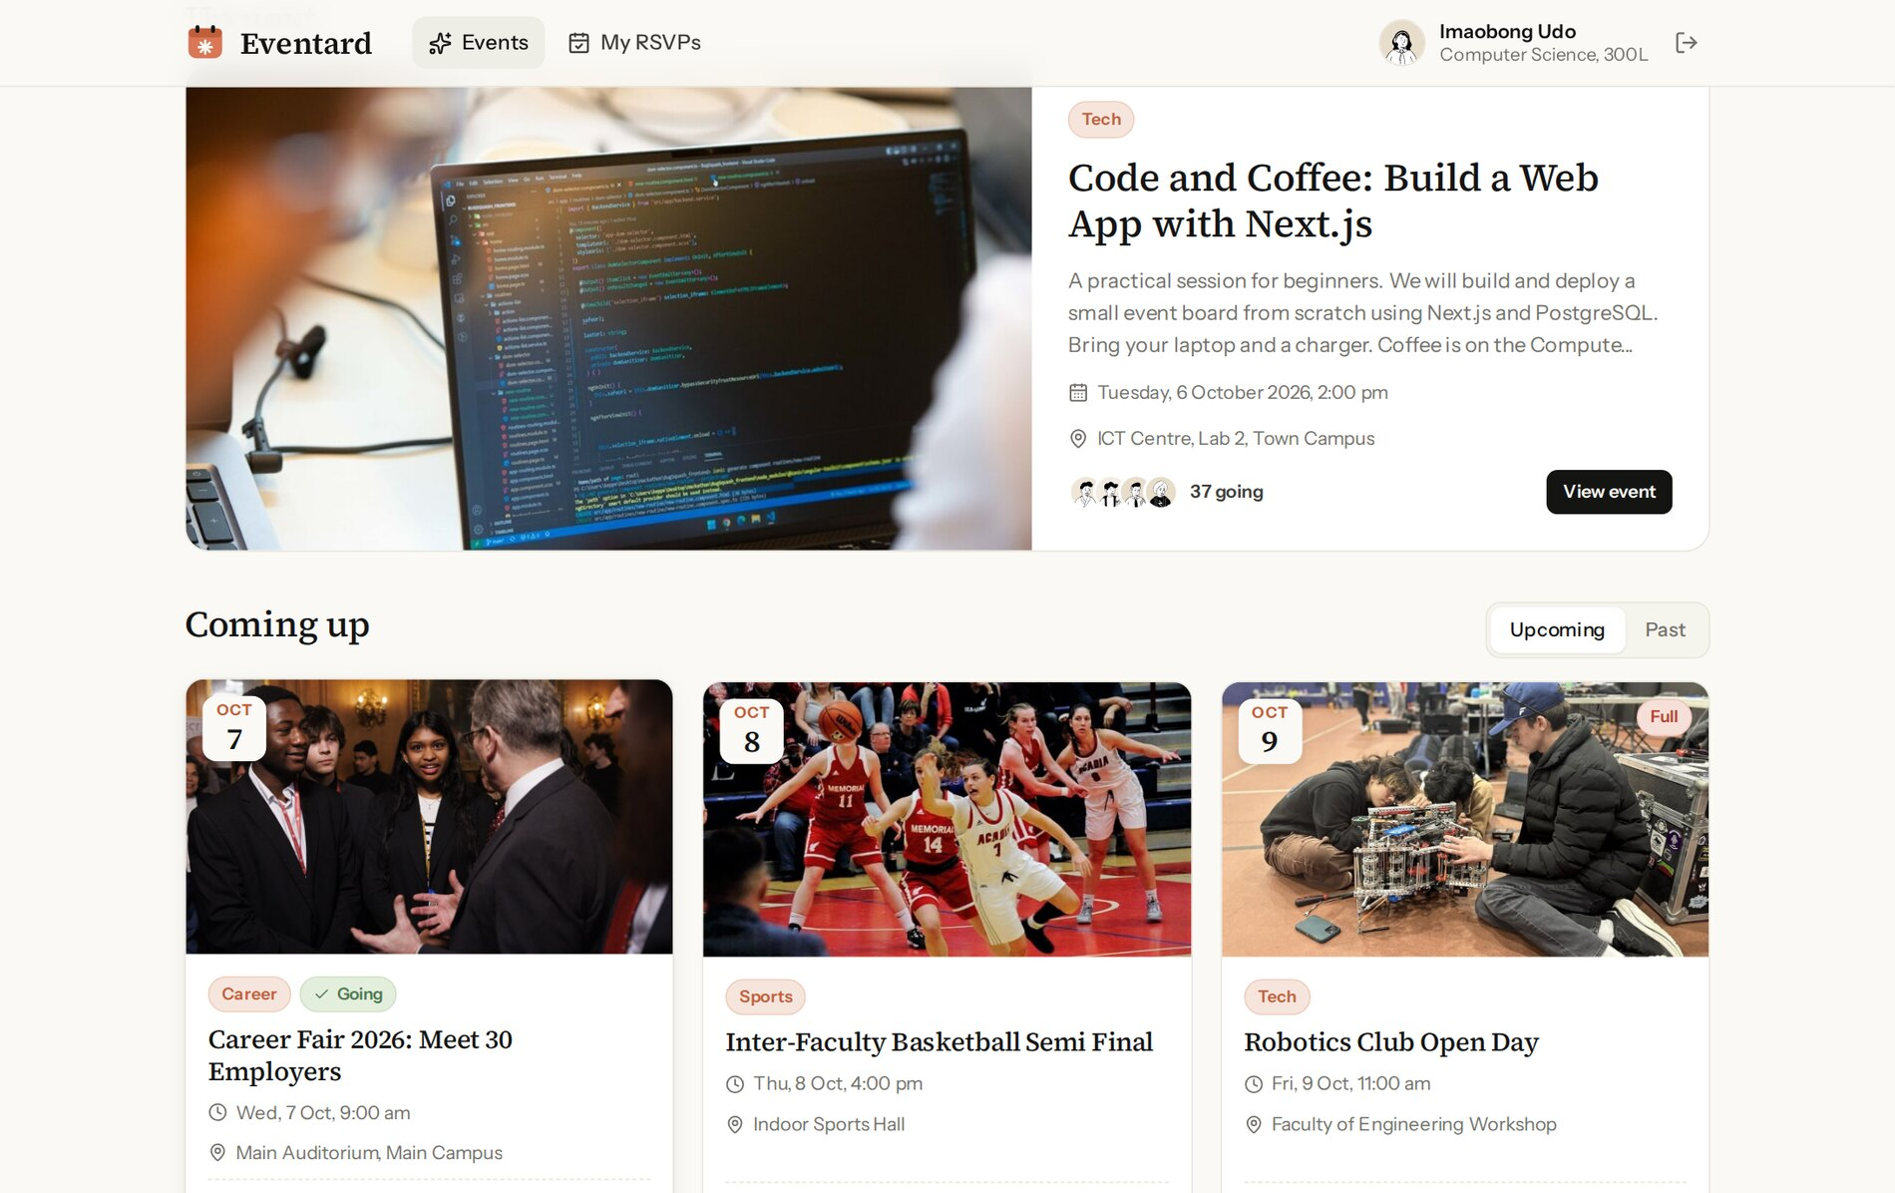
Figure 3.11: Upcoming events as cards with date badge, status flag, category, venue and avatars of attendees
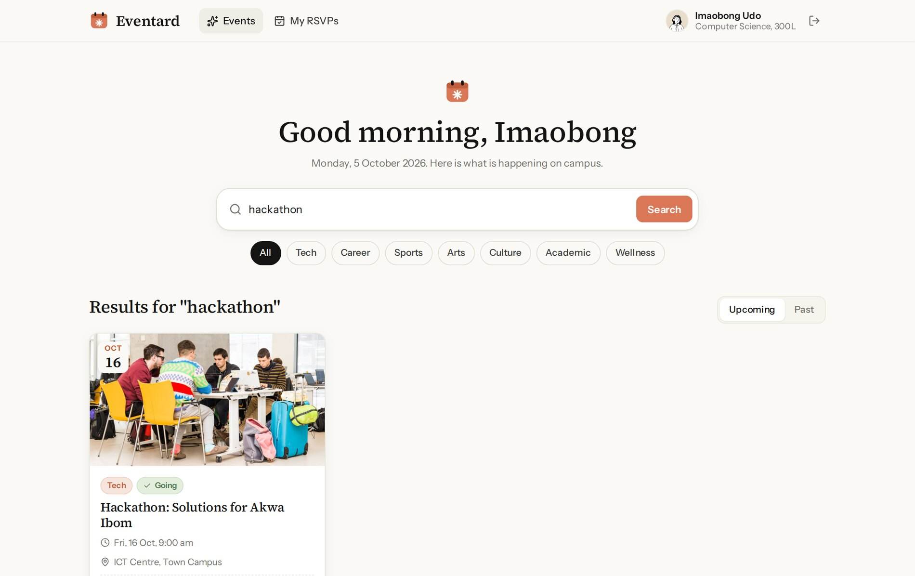
Figure 3.12: Search results for "hackathon"
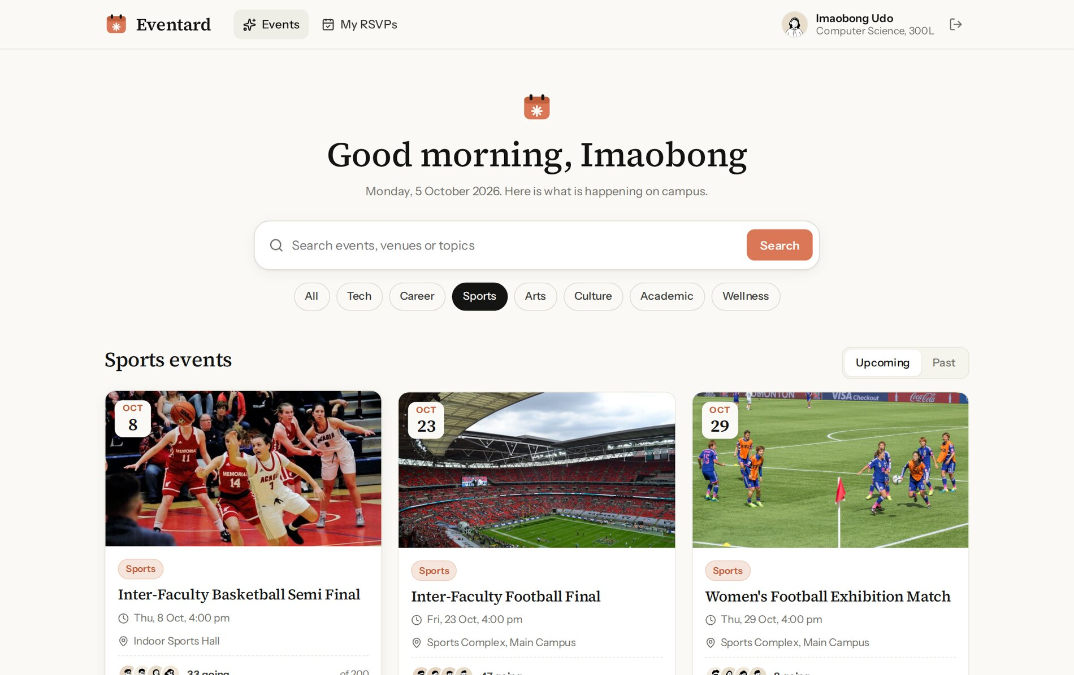
Figure 3.13: Events filtered by the Sports category
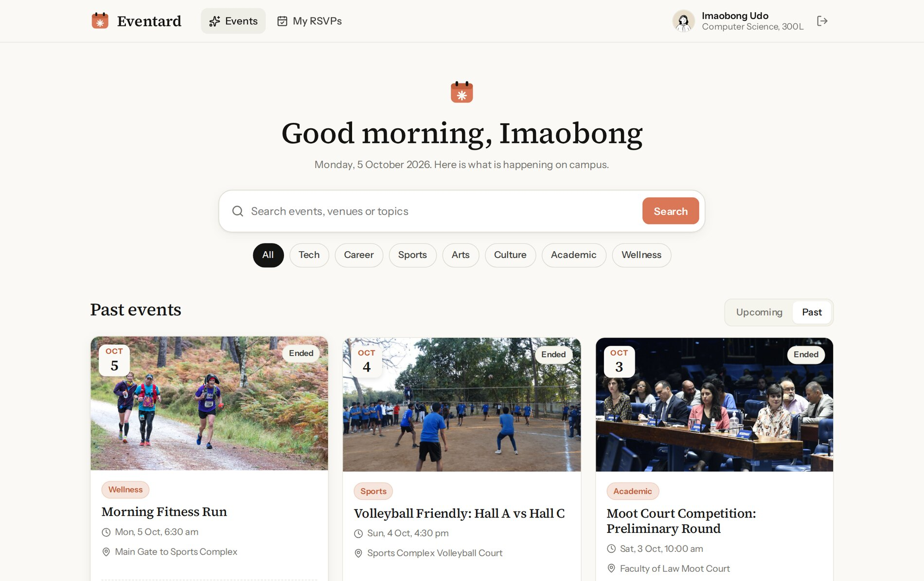
Figure 3.14: Past events tab
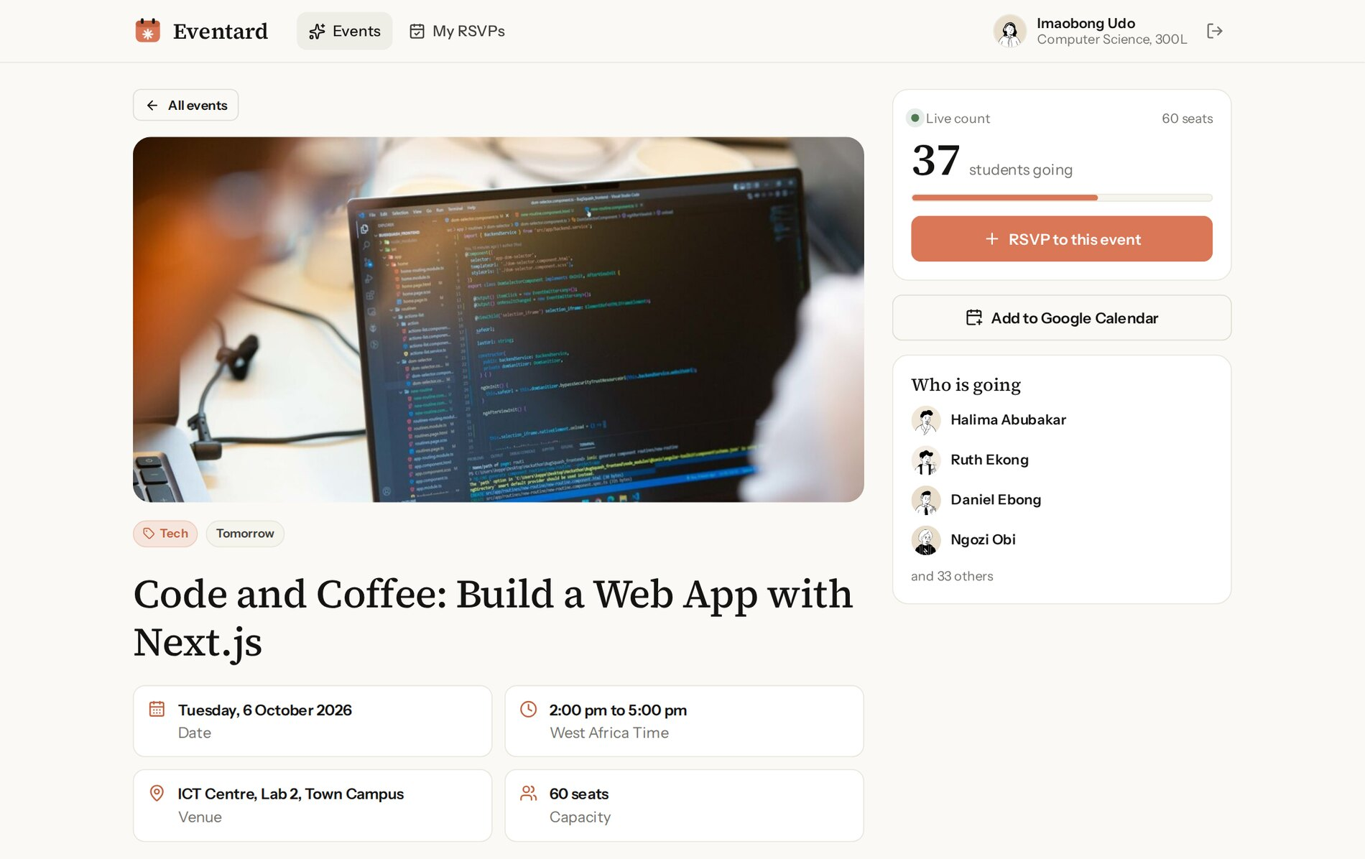
Figure 3.15: Event page before RSVP: 37 students going out of 60 seats
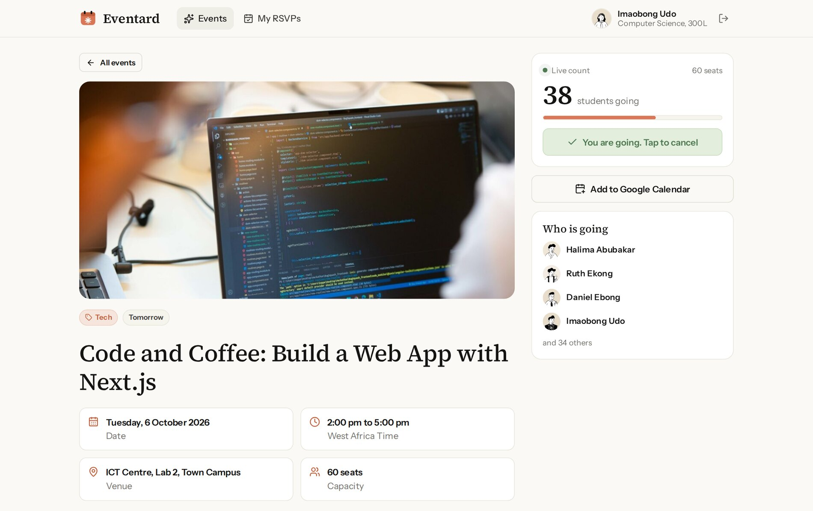
Figure 3.16: The same event immediately after the student presses RSVP: the count is 38 and the button turns green
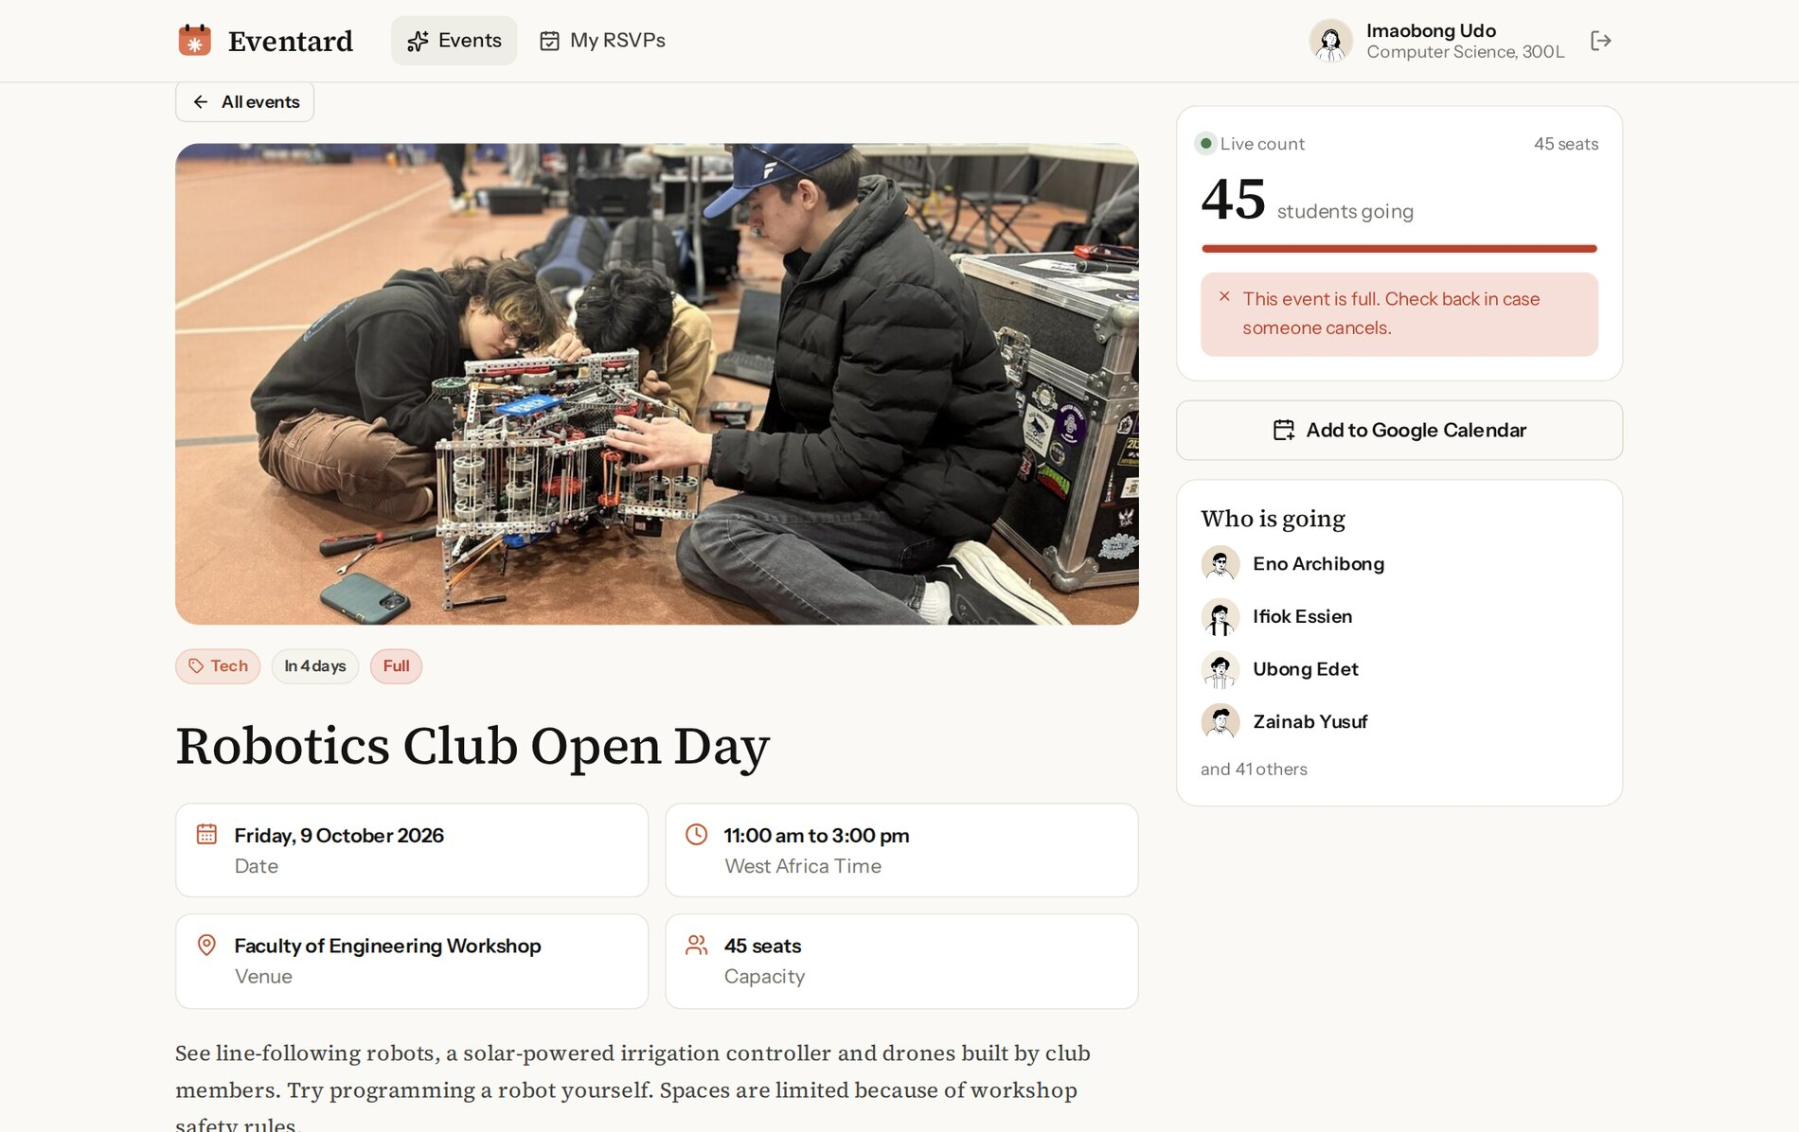
Figure 3.17: A full event: the RSVP button is replaced by a notice
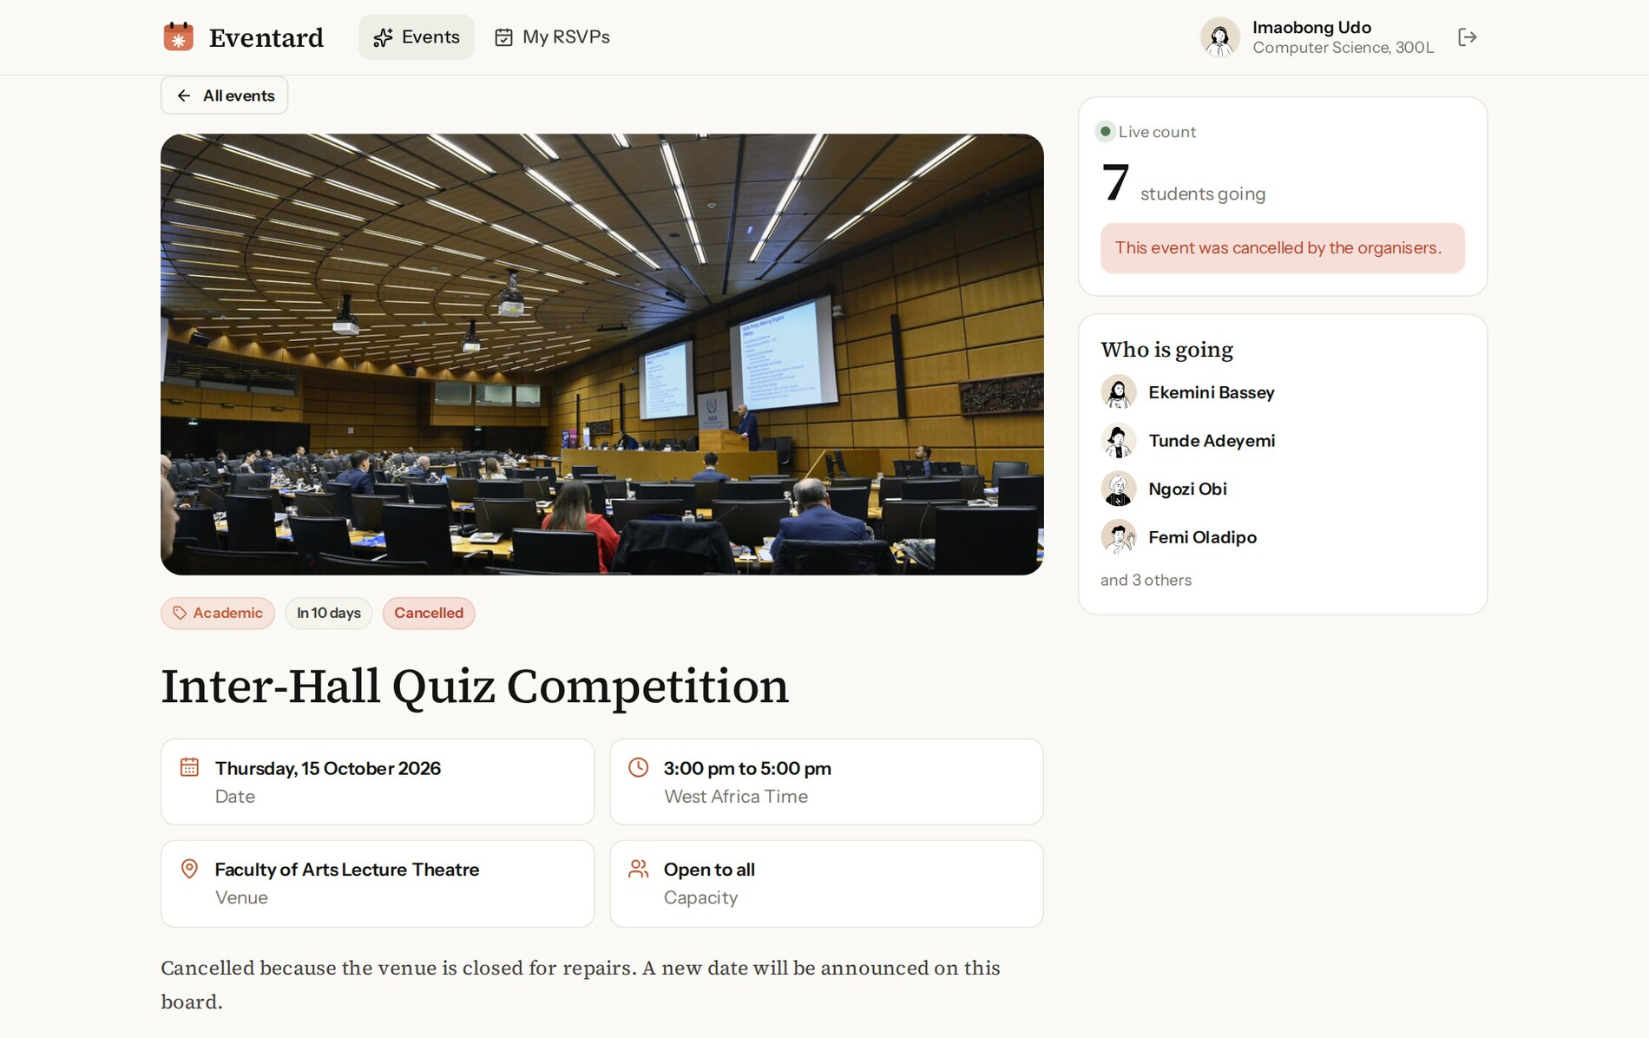
Figure 3.18: A cancelled event
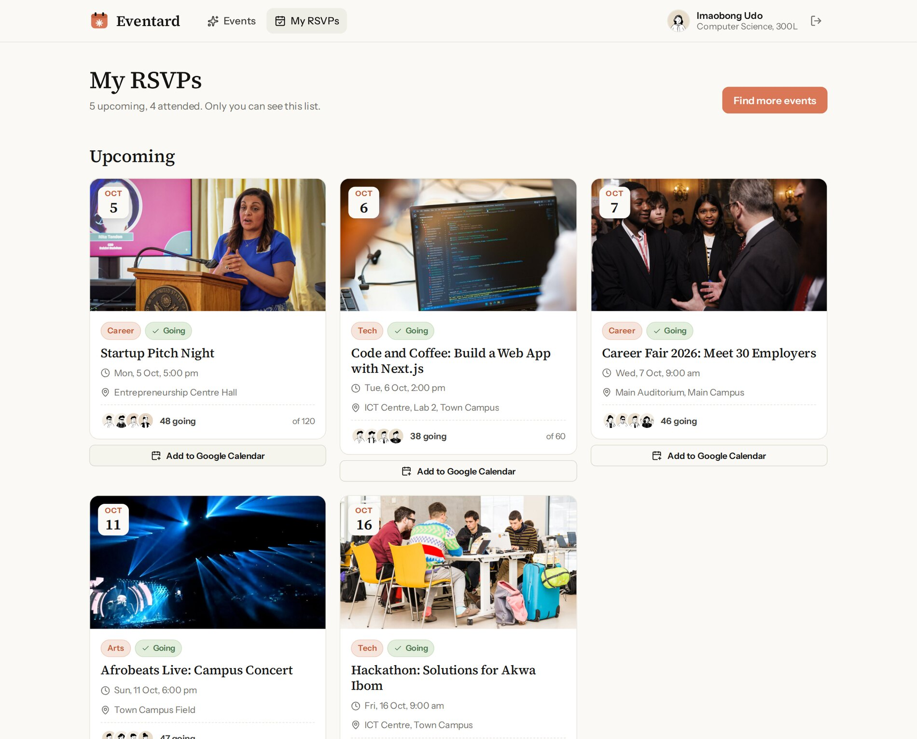
Figure 3.19: My RSVPs page, with an Add to Google Calendar button under each upcoming booking
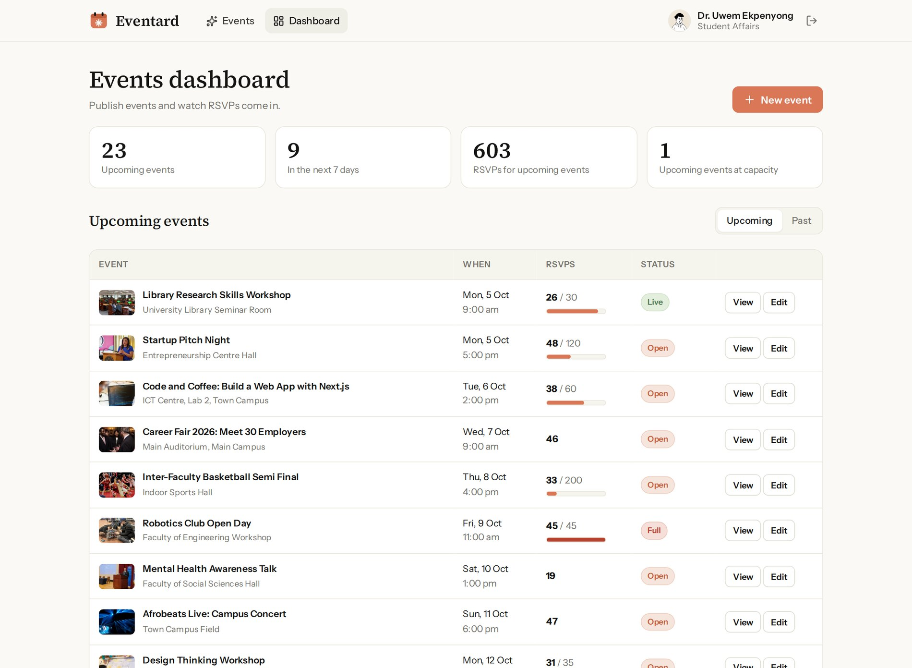
Figure 3.20: Admin dashboard with statistics and the events table with capacity bars
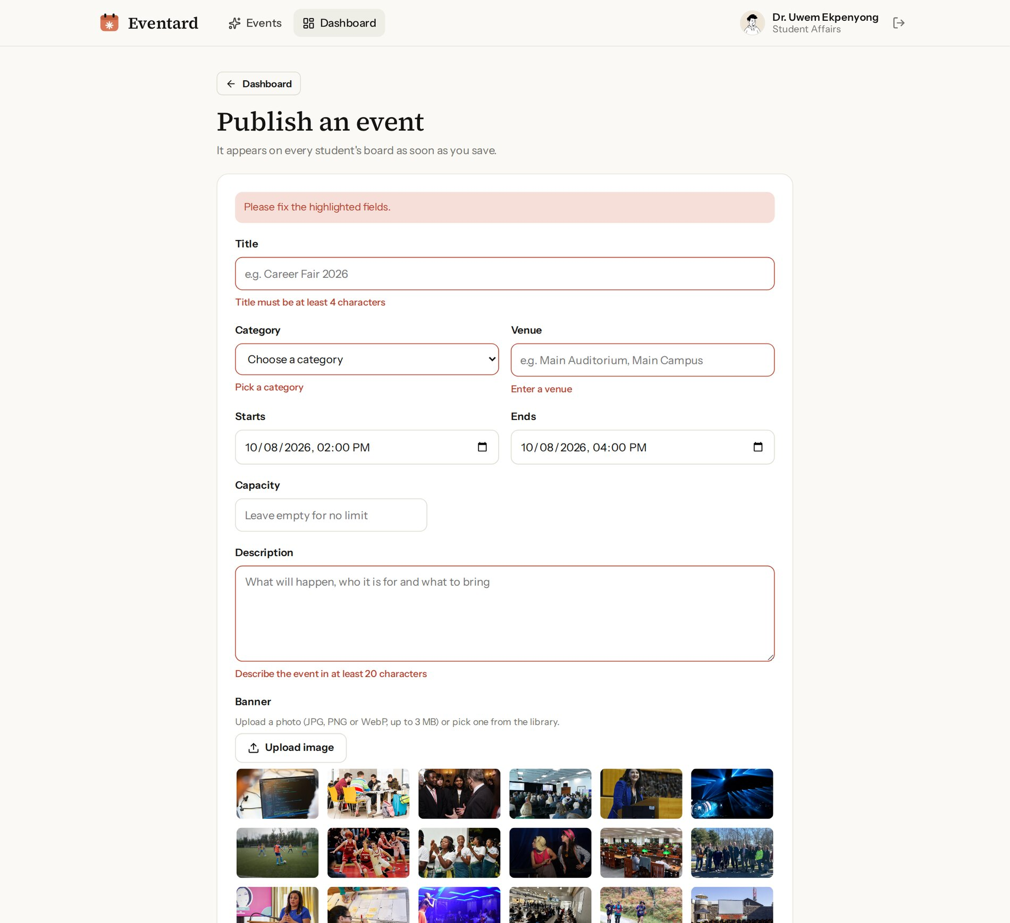
Figure 3.21: Publish an event: inline validation errors after submitting the empty form
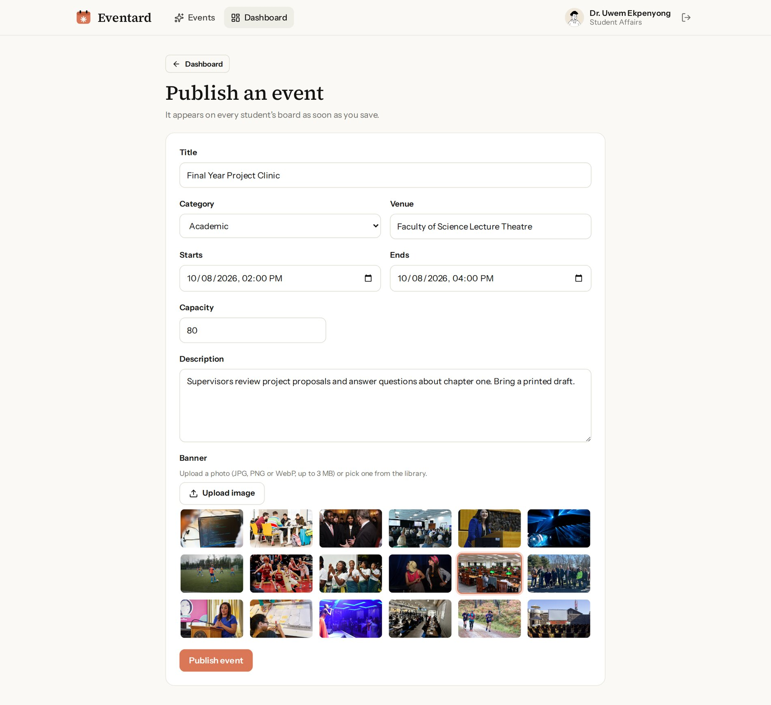
Figure 3.22: Publish an event: completed form with a banner chosen from the library
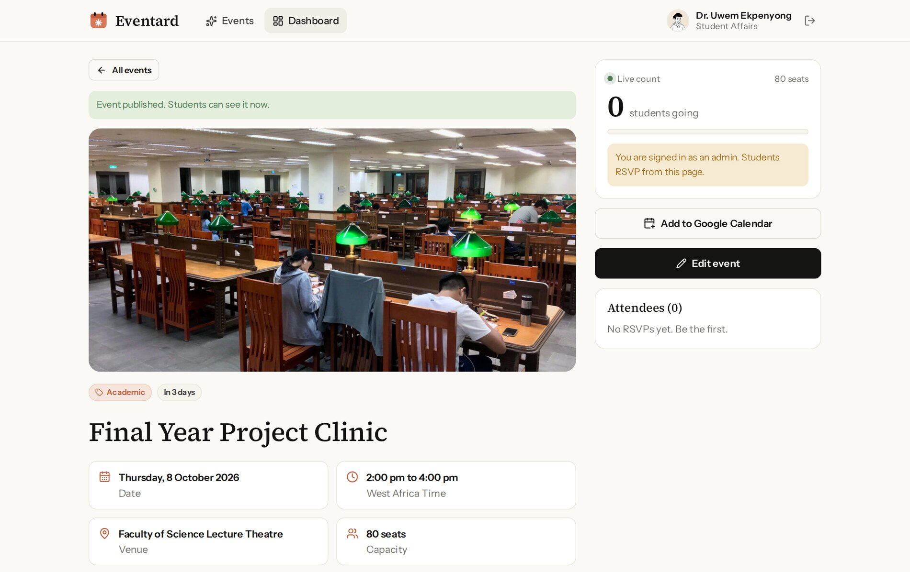
Figure 3.23: The new event immediately after publishing
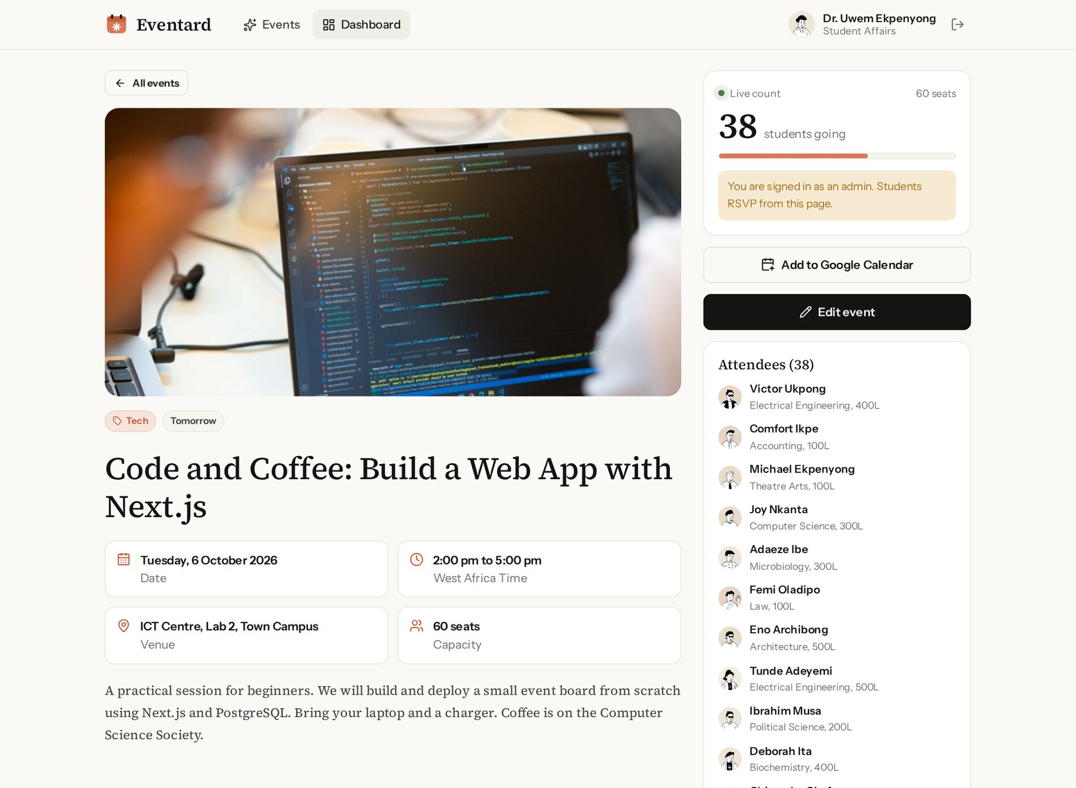
Figure 3.24: Admin view of an event with the full attendee list
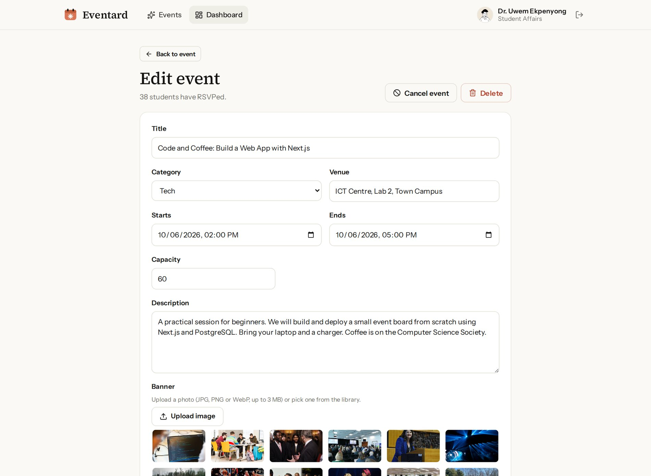
Figure 3.25: Edit event page with Cancel event and Delete actions

3.8 TESTING AND EVALUATION
Testing was automated at three levels so that every change could be checked quickly and repeatably, as summarised in Table 3.8. Unit tests check the pure rules; integration tests run the real query functions against a separate PostgreSQL test database (eventard_test) that is migrated and re-seeded before the tests; and end-to-end tests use Playwright to drive a real Chromium browser against a production build of the application, on a desktop screen and on a Pixel 7 phone profile. All tests passed before each deployment.
Table 3.8: Test levels and results
Level | Tool | What is tested | Result
Unit | Vitest | Event phases, RSVP rules, capacity helpers, day labels across UTC midnight, time validation, calendar date format and URL encoding, date input conversion, Zod schemas, image checks, session tokens | 42 of 42 passed
Integration | Vitest + PostgreSQL | Seed data, RSVP toggle, refusals, unique constraint, concurrent RSVPs, scoping, search and filters, admin statistics, check constraint | 12 of 12 passed
End to end | Playwright (Chromium) | Real browser journeys on desktop (6 tests) and mobile (1 test) | 7 of 7 passed

Representative test cases and their results are listed in Table 3.9.
Table 3.9: Representative test cases
ID | Test | Expected result | Actual result
T1 | Open /my without signing in | Redirected to /login with the demo account prefilled | Pass
T2 | Sign in with a wrong password | "Email or password is incorrect" shown, no session | Pass
T3 | Student RSVPs to "Code and Coffee" | Count goes from 37 to 38 and button shows "You are going" | Pass
T4 | Read the Google Calendar link for that event | text is the title; dates = 20261006T130000Z/20261006T160000Z; location = ICT Centre, Lab 2, Town Campus | Pass
T5 | Open a full event (Robotics Club Open Day) | "This event is full" notice, no RSVP button | Pass
T6 | RSVP via the query layer to full, ended and cancelled events | Refused with the matching message | Pass
T7 | Ten students RSVP at the same moment to a 3-seat event | Exactly 3 RSVPs succeed; count is 3 | Pass
T8 | Insert the same RSVP twice directly in the database | Second insert rejected by the unique constraint | Pass
T9 | Create an event whose end is before its start | Rejected by the CHECK constraint | Pass
T10 | Admin submits the new event form empty | Errors under title, category and banner | Pass
T11 | Admin publishes an event while a student has the board open | Event appears on the student's screen within 15 seconds without reload | Pass
T12 | My RSVPs for the demo student | Only that student's RSVPs are returned | Pass
T13 | A token signed with another secret | Session rejected | Pass
T14 | Day label for 23:30 UTC on 5 October | "Tomorrow" (00:30 on 6 October in Lagos) | Pass
T15 | Phone (Pixel 7): open today's event, cancel and RSVP again | Count goes down then up; page never scrolls sideways | Pass

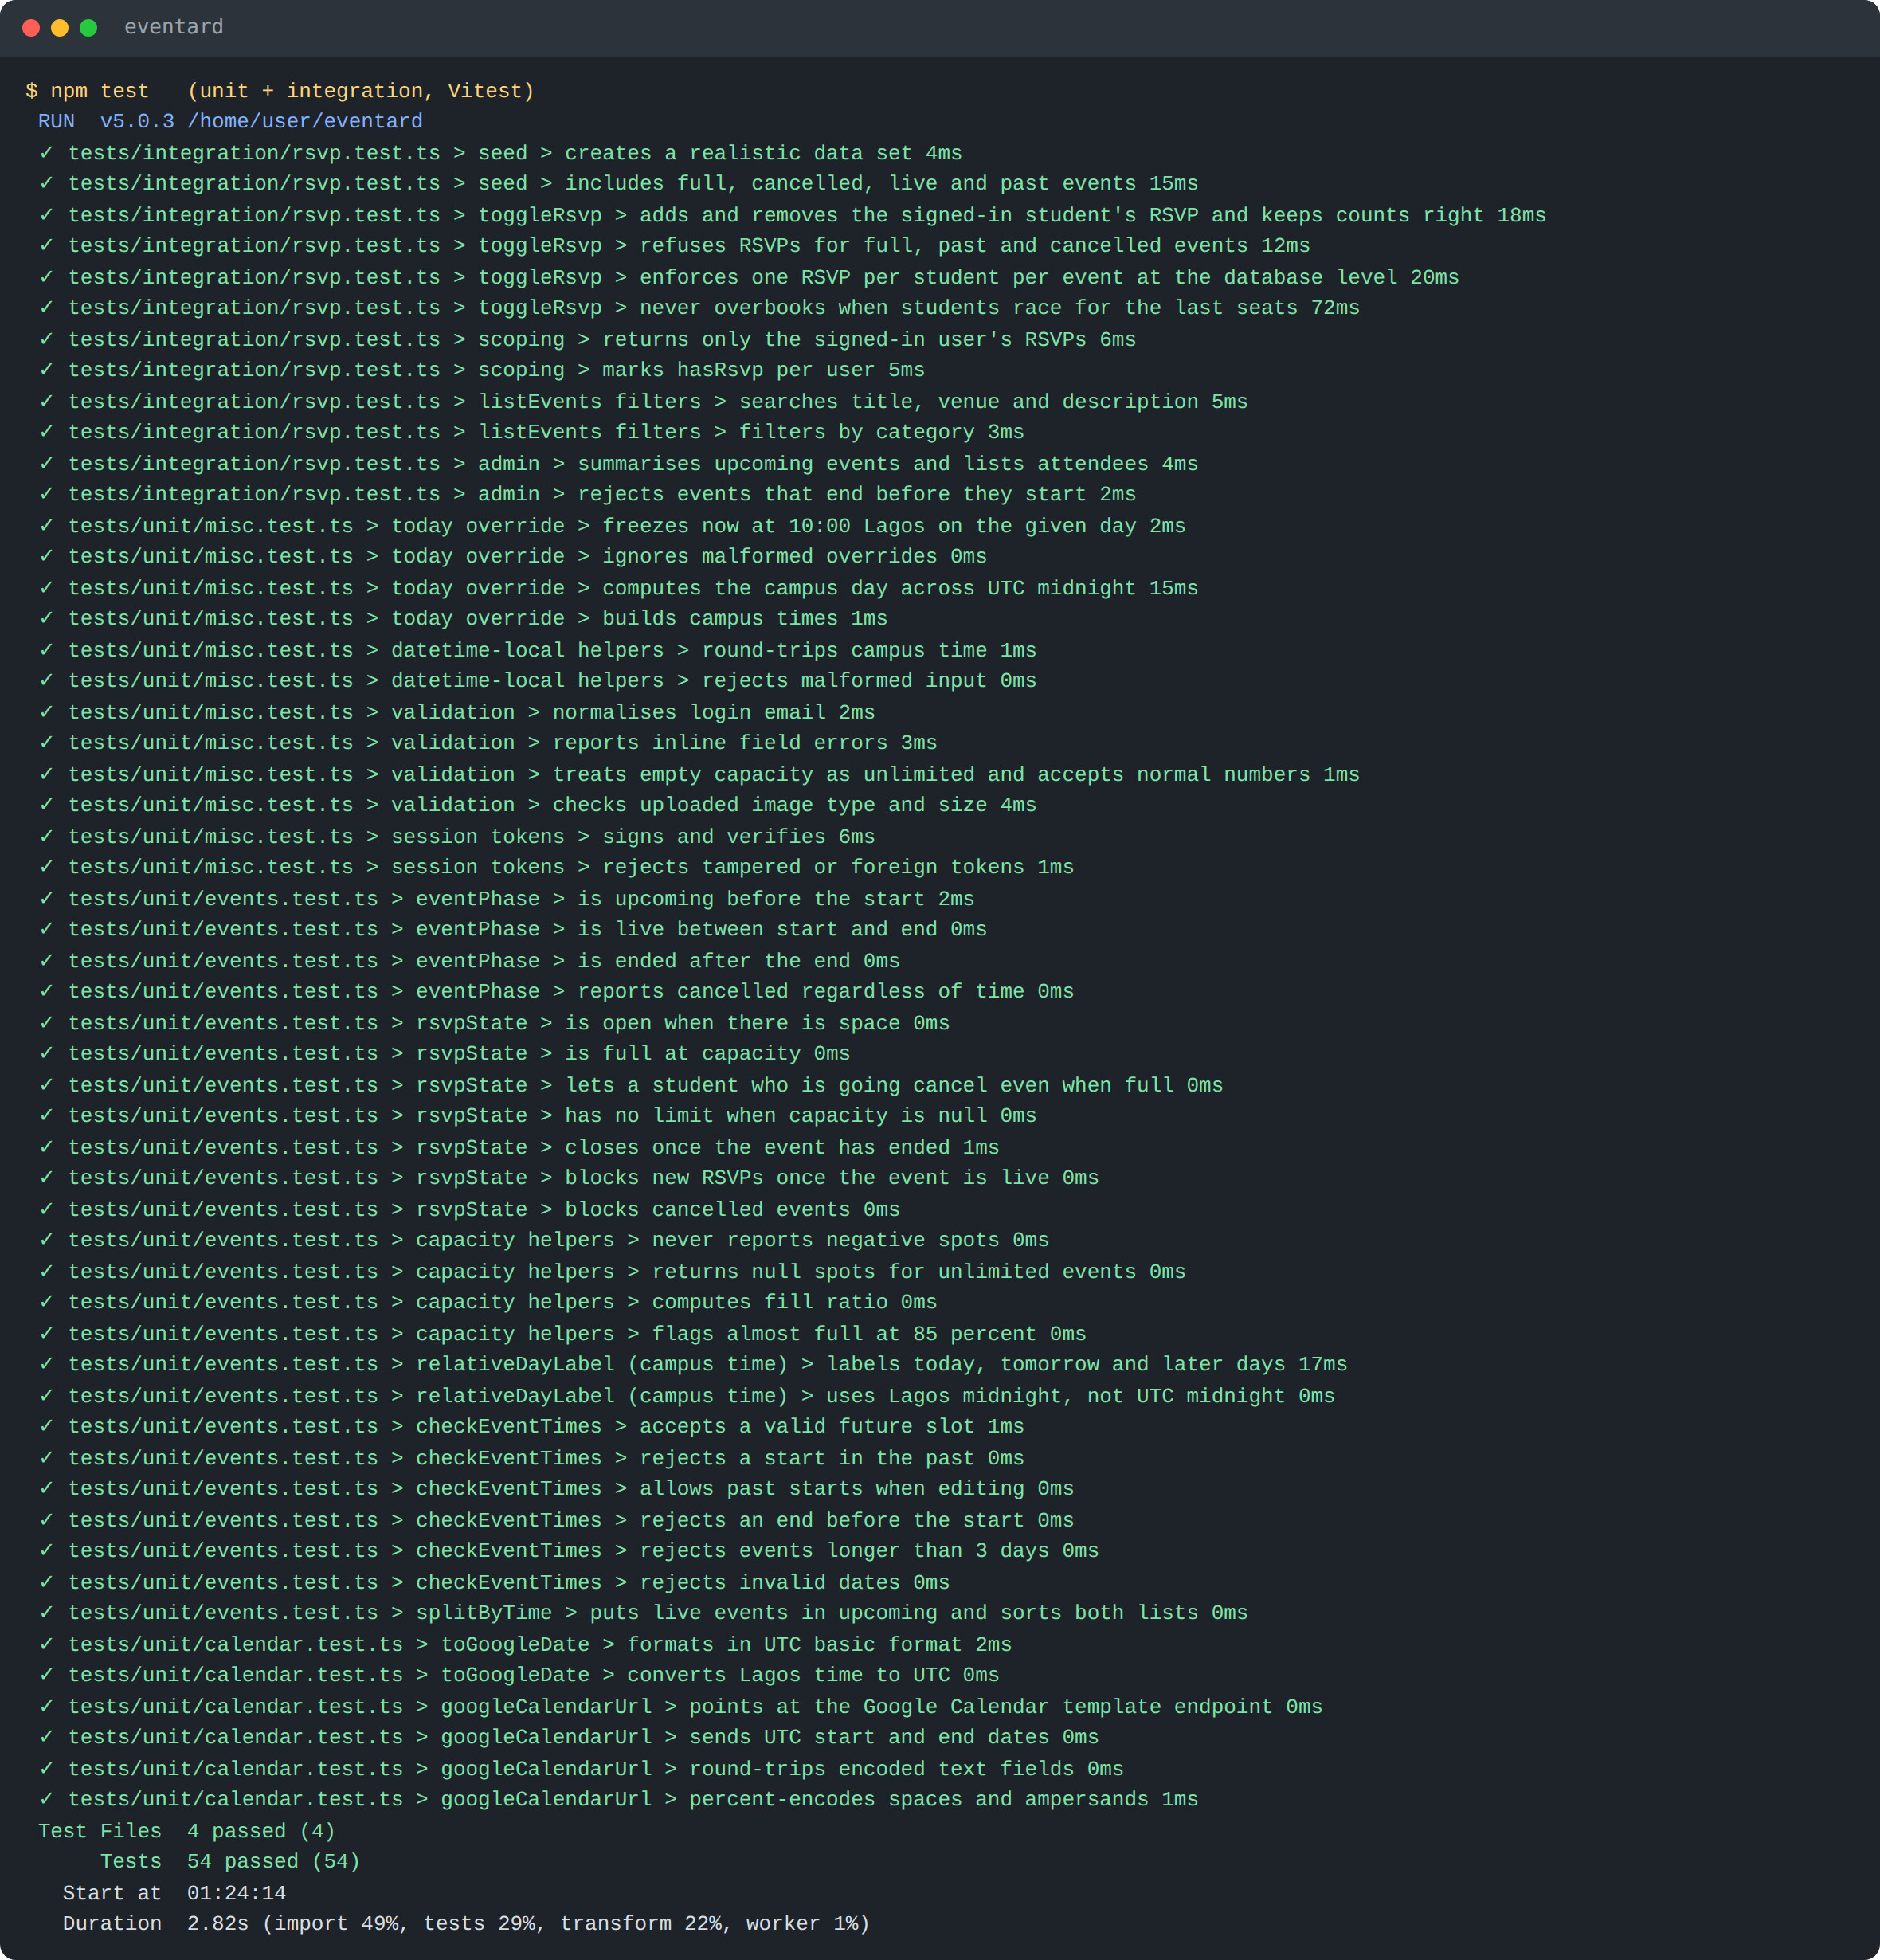
Figure 3.26: Output of the unit and integration test run (54 tests passed)
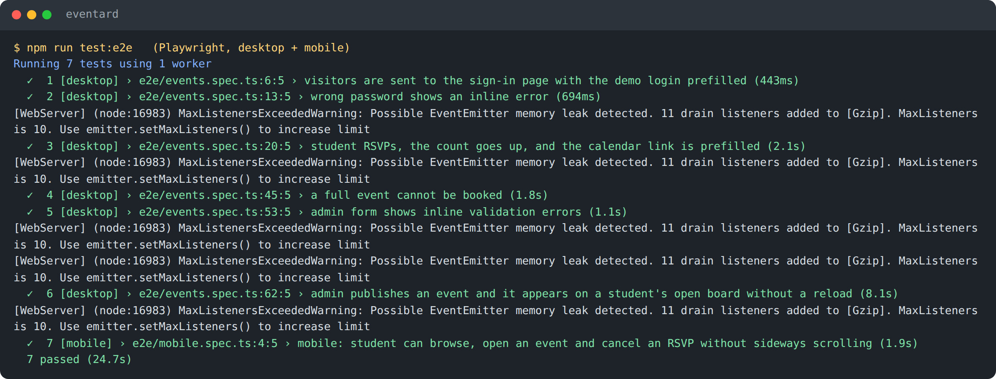
Figure 3.27: Output of the end-to-end test run (7 tests passed on desktop and mobile)
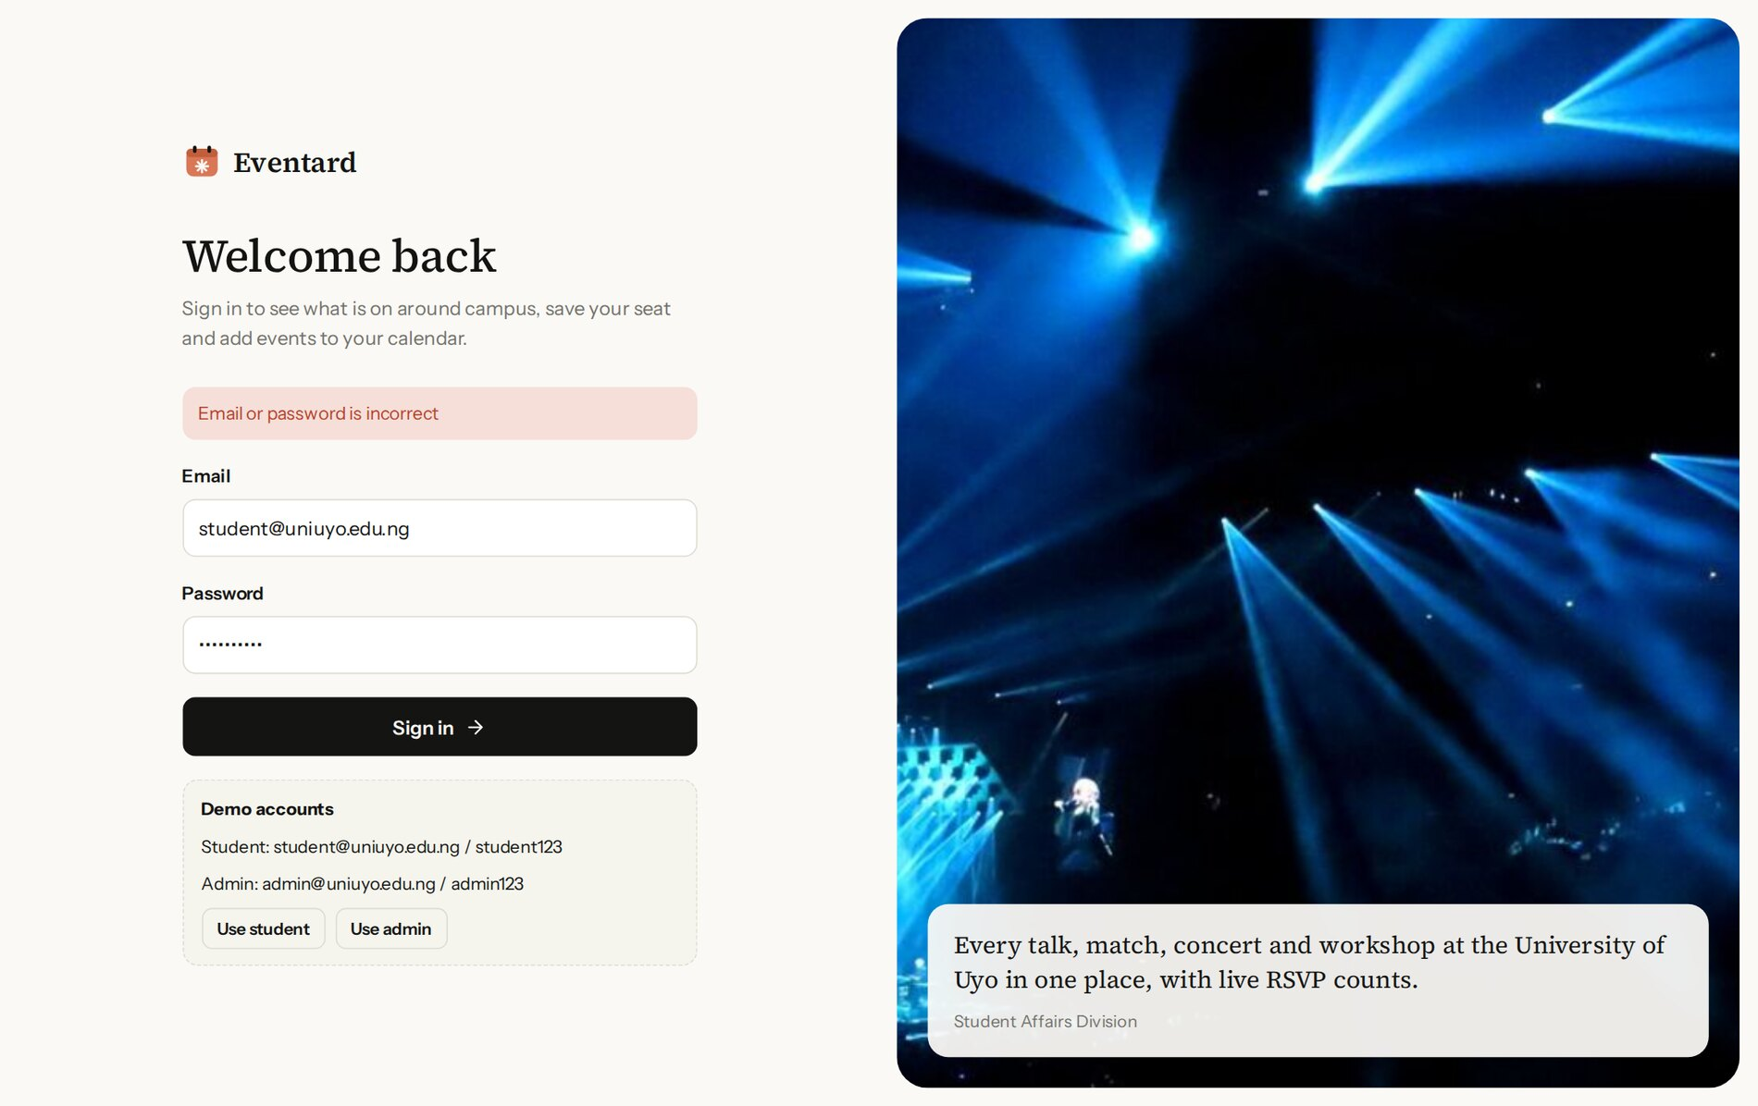
Figure 3.28: Result of test T2, a sign-in attempt with the wrong password
The evaluation considered the following factors:
- Correctness: every functional requirement in Table 3.1 is covered by at least one passing test, and the dashboard, cards and event pages show figures consistent with the seed data (for example 23 upcoming events and 603 RSVPs for upcoming events on the frozen date).
- Integrity: the concurrency test (T7) shows that the row lock prevents overbooking, and the constraint tests (T8, T9) show the database protects itself even if application code were wrong.
- Security: hashed passwords, signed HTTP-only cookies, server-side checks in every action, parameterised SQL and validated uploads follow common web security practice such as the OWASP Top Ten.
- Usability: students reach the most useful information (today and up next) without scrolling; RSVP is one tap; status labels explain why an event cannot be booked.
- Responsiveness: the mobile end-to-end test and the screenshots in Appendix E show the layout working on a phone without horizontal scrolling.
- Maintainability: rules are isolated in small, tested functions, and the TypeScript compiler and ESLint report no errors.

3.9 RECOMMENDATIONS AND FUTURE ENHANCEMENTS
- Send email or push reminders a day and an hour before events the student has booked.
- Add a waiting list that offers a freed seat to the next student automatically when someone cancels a full event.
- Add QR check-in at the venue so organisers can compare RSVPs with actual attendance.
- Allow student societies to request organiser accounts limited to their own events, with approval by Student Affairs.
- Replace the polling refresh with server-sent events if the number of simultaneous users grows large.
- Export attendee lists to CSV and offer an iCalendar (.ics) feed for students who use calendars other than Google Calendar.
- Run the test suites automatically on every pull request with GitHub Actions before Railway deploys.
- Carry out an accessibility review with screen readers and keyboard-only navigation.

3.10 LIMITATIONS OF THE STUDY
The project was built within a limited time for a 300-level course, so features such as reminders, waiting lists and attendance check-in were not implemented. Testing used seeded data and automated browsers; no load testing was carried out, so behaviour with thousands of simultaneous users is not measured, although the row lock guarantees correctness under concurrency. Live updates rely on periodic refresh, which adds a delay of a few seconds. Accounts are created by the seed script rather than through a registration page linked to the university's student records. The Google Calendar link depends on Google's public template format, which could change in future.

3.11 CONCLUSION
The project designed, implemented, tested and deployed Eventard, a full stack web application that gives University of Uyo students one place to find campus events, RSVP with live counts and add events to Google Calendar, and gives Student Affairs the tools to publish and manage those events. It demonstrated how React, Next.js Server Components and Server Actions, PostgreSQL with Drizzle, and automated tests work together in one application, and how a database transaction with a row lock solves a real concurrency problem. The main lessons were the value of keeping business rules in small pure functions, of letting the database enforce integrity with constraints, of freezing the clock to make date-based software testable, and of disciplined use of Git and automated deployment. The recommendations in Section 3.9 indicate the direction for further work.

REFERENCES
Drizzle Team (n.d.) Drizzle ORM documentation. Available at: https://orm.drizzle.team/docs/overview (Accessed: 5 October 2026).
Git (n.d.) Git documentation. Available at: https://git-scm.com/doc (Accessed: 5 October 2026).
GitHub (n.d.) GitHub Docs. Available at: https://docs.github.com/ (Accessed: 5 October 2026).
Google (n.d.) Google Calendar Help: create events. Available at: https://support.google.com/calendar (Accessed: 5 October 2026).
Meta Open Source (n.d.) React documentation. Available at: https://react.dev/ (Accessed: 5 October 2026).
Microsoft (n.d.) Playwright documentation. Available at: https://playwright.dev/ (Accessed: 5 October 2026).
Openverse (n.d.) Openverse: openly licensed media. Available at: https://openverse.org/ (Accessed: 5 October 2026).
OWASP Foundation (n.d.) OWASP Top Ten. Available at: https://owasp.org/www-project-top-ten/ (Accessed: 5 October 2026).
PostgreSQL Global Development Group (n.d.) PostgreSQL documentation: explicit locking. Available at: https://www.postgresql.org/docs/current/explicit-locking.html (Accessed: 5 October 2026).
Railway (n.d.) Railway documentation. Available at: https://docs.railway.com/ (Accessed: 5 October 2026).
Vercel (n.d.) Next.js documentation. Available at: https://nextjs.org/docs (Accessed: 5 October 2026).
Vitest (n.d.) Vitest documentation. Available at: https://vitest.dev/ (Accessed: 5 October 2026).
Zod (n.d.) Zod documentation. Available at: https://zod.dev/ (Accessed: 5 October 2026).

APPENDICES

Appendix A: Test accounts
Table 3.10: Demonstration accounts
Email | Password | Role | Home page
student@uniuyo.edu.ng | student123 | Student (Imaobong Udo) | / (event board)
admin@uniuyo.edu.ng | admin123 | Admin (Dr. Uwem Ekpenyong) | /admin
events@uniuyo.edu.ng | admin123 | Admin (Mrs. Nkoyo Ita) | /admin

All other seeded students use the password student123. These accounts exist only in the demonstration data.

Appendix B: Routes
Table 3.11: Application routes
Route | Role | Purpose
/login | Public | Sign in
/ | Signed in | Event board with search, filters, Today and Up next
/events/[id] | Signed in | Event details, RSVP panel, calendar link, attendees
/my | Student | The student's own RSVPs
/admin | Admin | Dashboard and events table
/admin/events/new | Admin | Publish an event
/admin/events/[id]/edit | Admin | Edit, cancel, restore or delete an event
/api/health | Public | Health check with a database ping
/api/images/[id] | Public | Uploaded banner images

Appendix C: Project structure
eventard/
drizzle/ SQL migrations generated by drizzle-kit
e2e/ Playwright tests (desktop and mobile)
docs/ PDF user guide and its generator
public/images/events/ Banner photographs and credits.json
scripts/ migrate.ts, seed.ts
src/
app/ Pages (App Router), Server Actions, route handlers
actions/ auth.ts, rsvp.ts, events.ts
admin/, events/, my/, login/, api/
components/ TopBar, EventCard, RsvpPanel, EventForm, LiveRefresh, Avatars
db/ schema.ts, index.ts, seed-data.ts
lib/ events.ts, calendar.ts, today.ts, format.ts, validation.ts,
auth.ts, session.ts, queries.ts, avatar.ts
proxy.ts Route protection
tests/unit/, tests/integration/ Vitest tests
railway.json Build, start and health check settings

Appendix D: Environment variables
Table 3.12: Environment variables
Variable | Purpose
DATABASE_URL | PostgreSQL connection string (on Railway: ${{eventard-postgres.DATABASE_URL}})
SESSION_SECRET | Random secret used to sign session tokens
NODE_ENV | production on Railway (enables Secure cookies)
EVENTARD_TODAY | Optional YYYY-MM-DD to freeze the clock for tests and rehearsals
TEST_DATABASE_URL | Database used by integration and end-to-end tests

Appendix E: Mobile screenshots
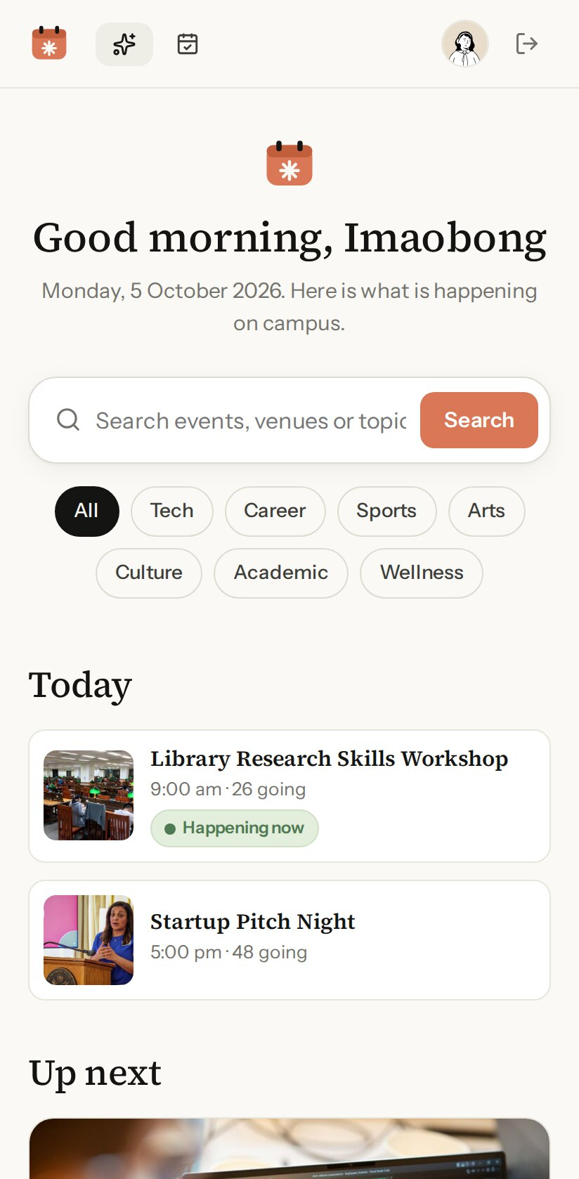
Figure E.1: Event board on a phone
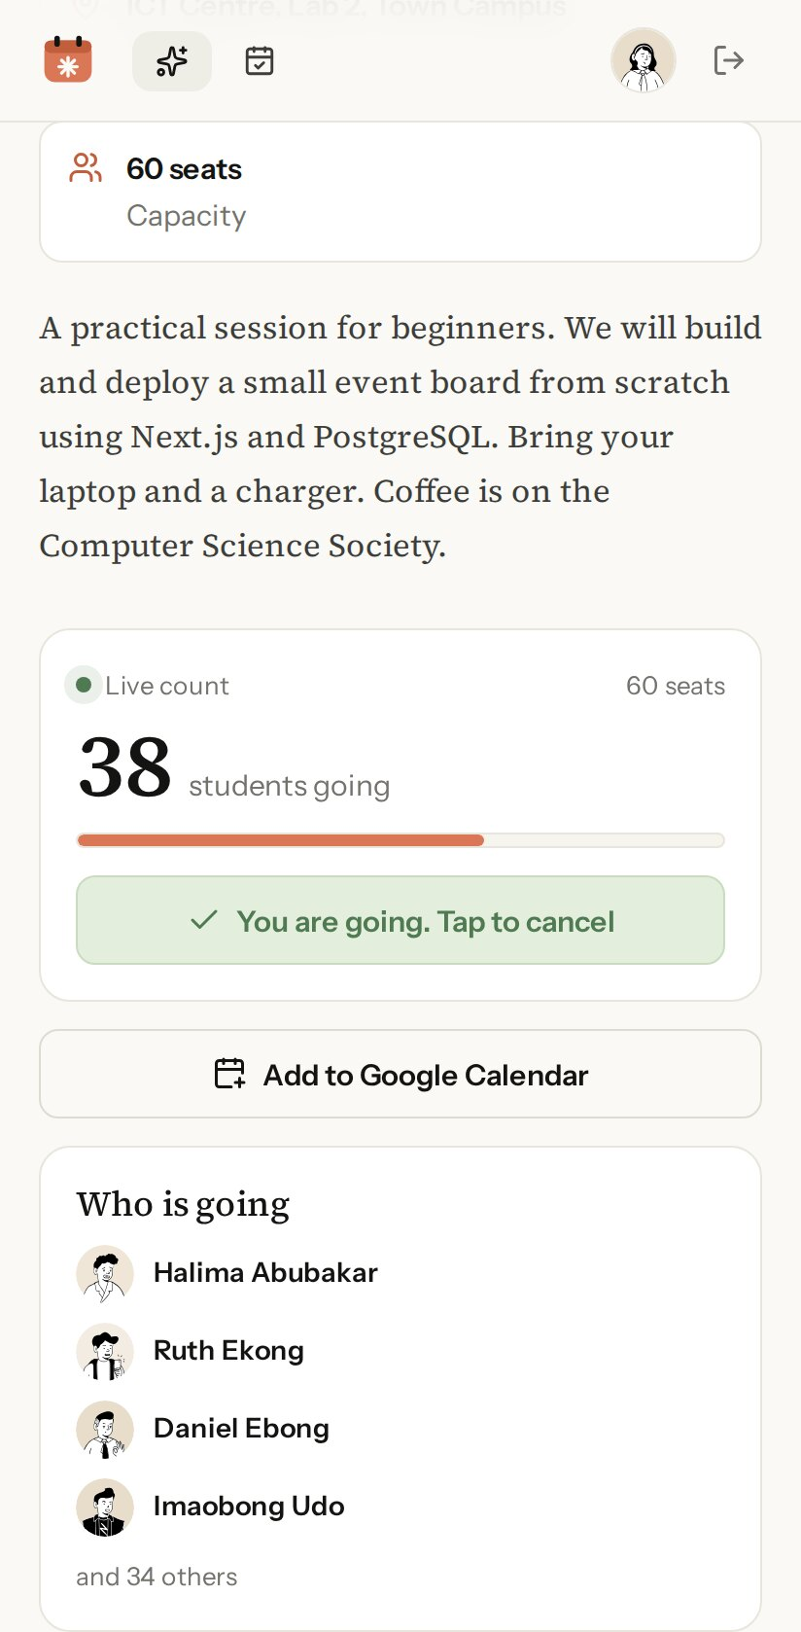
Figure E.2: RSVP panel on a phone
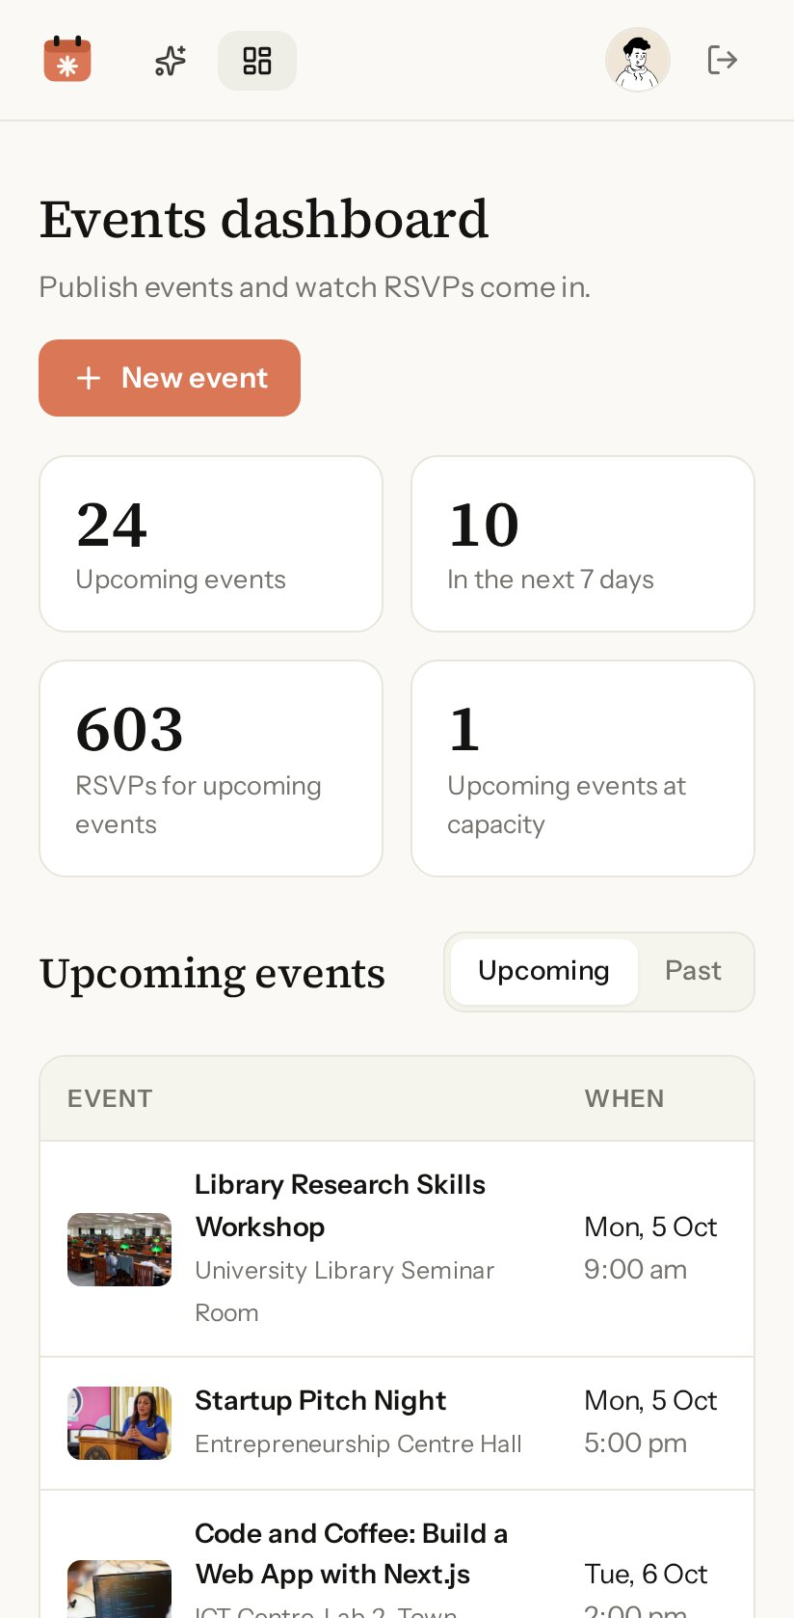
Figure E.3: Admin dashboard on a phone
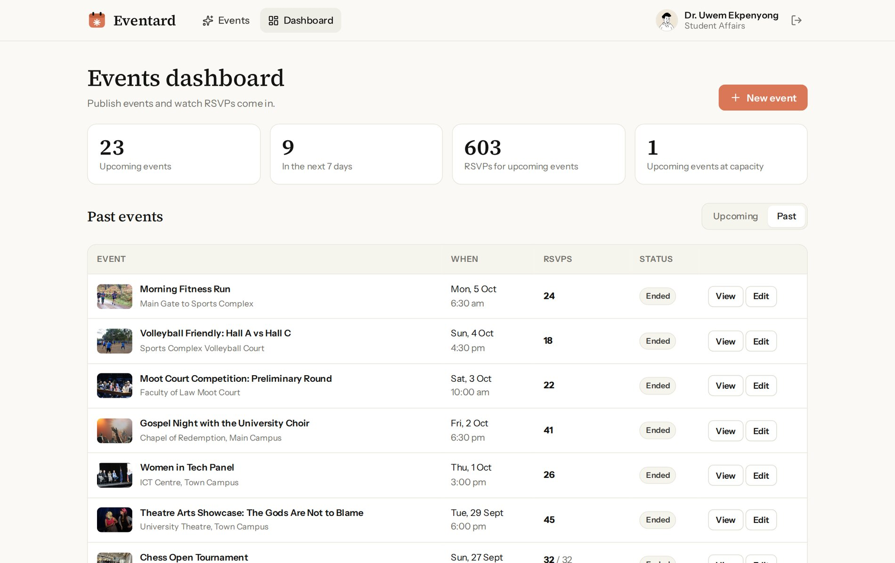
Figure E.4: Admin dashboard, past events tab

