IT PROJECT REPORT ON
STUDENT INDUSTRIAL WORK EXPERIENCE SCHEME (SIWES)
UNDERTAKEN AT

ACADEVA LIMITED

BY

[STUDENT FULL NAME]
[MATRICULATION NUMBER]
DEPARTMENT OF COMPUTER SCIENCE,
FACULTY OF COMPUTING,
UNIVERSITY OF UYO, UYO.

SUBMITTED TO

DEPARTMENT OF COMPUTER SCIENCE,
FACULTY OF COMPUTING,
UNIVERSITY OF UYO, UYO.

IN PARTIAL FULFILLMENT OF THE REQUIREMENT FOR THE AWARD OF A
BACHELOR OF SCIENCE (B.Sc.) DEGREE IN COMPUTER SCIENCE.

OCTOBER 2026
TABLE OF CONTENTS
Cover Page - - - - - - - - - - i
Table of Contents - - - - - - - - - - ii
Chapter 1: Introduction To SIWES Placement - - - - - - - - - - 1
Chapter 2: Practical Skills Acquired During SIWES - - - - - - - - - - 4
Chapter 3: Design and Implementation of an AI-Assisted Lecture Notes and Textbook Recommendation Web Application - - - - - - - - - - 12
References - - - - - - - - - - 29
Appendices - - - - - - - - - - 29

CHAPTER 1
INTRODUCTION TO SIWES PLACEMENT
INTRODUCTION
This chapter introduces the Student Industrial Work Experience Scheme (SIWES) and the organization that hosted the author's industrial training, Acadeva Limited. It explains why the scheme exists, describes the company, its history and guiding values, and sets out how long the placement lasted and what it covered. Together these provide the background for the skills described in Chapter 2 and the project presented in Chapter 3.
1.1 BACKGROUND OF THE SIWES PROGRAM
SIWES is a national training programme that places undergraduates in organizations related to their course of study for a period of supervised work. Its purpose is to close the gap between what is taught in lecture halls and what is expected in the workplace, by letting students handle real tools, real deadlines and real users before they graduate.
Through the scheme, students learn how organizations plan and deliver work, how professionals communicate, and how theory is turned into working products. In computing, this means exposure to modern programming frameworks, cloud services, collaborative software practices and the habit of learning new technologies quickly, which a classroom alone cannot fully provide.
1.2 ABOUT ACADEVA LIMITED
Acadeva Limited is an education technology company in Nigeria. It gathers study materials, past questions and course PDFs from Nigerian universities and arranges them by institution, department and course code, so that a student can quickly locate the material for a particular course. Materials can be downloaded for offline reading and shared with classmates, and students can keep a shared academic timetable with reminders. On top of this library, Acadeva provides study aids such as quizzes and summaries.
The Acadeva apps run on Android, iOS, iPadOS, Windows, macOS and Linux. The company is registered with the Corporate Affairs Commission (CAC) and is based in Akwa Ibom State, Nigeria. Its library is also exposed through a public search interface (api.acadeva.xyz), which other student tools can query, and which was used in the project described in this report.
A small core team handles engineering, machine learning and design, and a wider group of about nine people contributes to development, design and marketing. The author was placed on the Web Development track and worked under the supervision of John Henry, combining guided study with hands-on product work.
1.3 HISTORY, VISION, MISSION, AND CORE VALUES
Organizational History
Acadeva began as a prototype that took first and second place at a campus technology competition in November 2024. The Android app was released on 20 June 2025, and over 2,000 students registered in the six months that followed. In July 2025 the company was named First Runner-Up at DevEast Entrepreneurship Week, held at the Federal University of Technology, Owerri (FUTO), and received startup funding.
Partnerships with student bodies and academic communities have driven the company's growth since then. More than 1,000 books have been shared through its library, and it has organized over 20 large quiz events. Apps for iOS, iPadOS, Windows, macOS and Linux followed the Android release, along with paid subscription plans.
Vision Statement
To make quality academic resources accessible to every student and create a more connected way for students to learn together.
Mission Statement
To make study resources accessible and learning more effective by building collaborative and innovative tools designed around students' real academic needs.
Core Values
- Accessibility
- Collaboration
- Innovation
- Student-Centricity
- Integrity
1.4 DURATION AND SCOPE OF INTERNSHIP
The placement ran for six months, from May 2026 to October 2026. It was organized so that the author could see how a product used by students is designed, built and improved, and then apply that understanding directly. Work was carried out on the Web Development track under the supervision of John Henry, with emphasis on React, Next.js, TypeScript, integration with external web services and AI models, and version control with Git and GitHub.
Activities included the study of modern front-end and full stack development, practice exercises on components, routing, browser media APIs and HTTP requests, and the design, implementation, testing and documentation of an IT project: Lecture Follow-Up, a web application that turns a recorded or uploaded lecture into structured study notes and recommends related textbooks from the Acadeva library. The project brought together speech-to-text transcription, a large language model, the Acadeva search service and a streamed, stage-by-stage user interface.
1.5 CONCLUSION
This chapter described the SIWES programme, the host organization and the scope of the placement. The next chapter sets out the practical skills that were developed during the training.

CHAPTER 2
PRACTICAL SKILLS ACQUIRED DURING SIWES
INTRODUCTION
This chapter describes the main skills gained during the placement. For each one, it explains what the technology is and why it matters, then describes how it was used in practice, with the Lecture Follow-Up project as the running example.
2.1 FRONT-END DEVELOPMENT WITH REACT AND TYPESCRIPT
React is a JavaScript library for building interfaces out of components: small, self-contained pieces of user interface that receive data through props and keep their own state. Hooks such as useState, useEffect, useRef and useCallback let a component store values, react to changes and clean up after itself. TypeScript adds static types to JavaScript, so mistakes such as passing the wrong kind of data between components are caught before the code runs.
- Practical activity: Built the Lecture Follow-Up interface as a set of typed React components: a recorder panel with Record and Upload tabs, a live recording waveform, a playback waveform, a processing-stages tracker, a Markdown notes viewer and a grid of book cards. The page component holds the overall state (idle, transcribing, explaining, finding books, done or error) and passes it down to the components that display it.
- Tools/technologies used: React 19, TypeScript 5, Tailwind CSS 4, shadcn/ui components, lucide-react icons, browser developer tools.
- Skills acquired: Component design, props and state, hooks, typed interfaces, conditional rendering and handling user events.
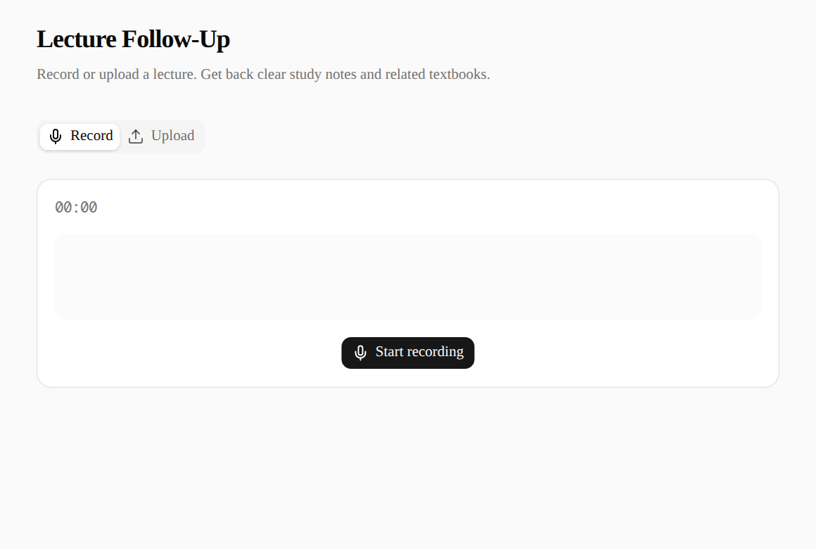
Figure 2.1: The Lecture Follow-Up home page with the Record and Upload tabs.
2.2 FULL STACK DEVELOPMENT WITH NEXT.JS
Next.js is a framework built on React that adds routing, server rendering and back-end endpoints to the same project. With the App Router, each folder under app/ becomes a route, and a route.ts file defines a route handler that responds to HTTP requests on the server. Secrets such as API keys stay on the server, while the browser receives only the results.
- Practical activity: Created the main page in app/page.tsx and a route handler at app/api/lecture/route.ts that accepts a POST request containing an audio file. The handler checks the audio format, converts the file to base64, calls the transcription and note-writing services, searches for books, and returns the progress to the browser. The application was built for production with next build and served with next start.
- Tools/technologies used: Next.js 16 (App Router), Node.js 22, pnpm, environment variables (OPENROUTER_KEY, OPENROUTER_STT_MODEL, OPENROUTER_EXPLAIN_MODEL).
- Skills acquired: Routing, client and server components, route handlers, request validation, environment configuration and production builds.
2.3 WORKING WITH AUDIO IN THE BROWSER
Modern browsers can capture sound from a microphone through the MediaDevices and MediaRecorder APIs, and can read files chosen by the user through the File API. Displaying audio as a waveform gives users visual feedback that recording is working and lets them check a file before sending it. Different browsers record in different formats, so an application must detect and handle the format it receives.
- Practical activity: Used wavesurfer.js and its Record plugin to show a live waveform while recording, with a choice of microphone, a running timer and pause and stop controls. Built an upload area that accepts files by clicking or by drag-and-drop (mp3, wav, m4a, ogg, webm, aac and flac), and a playback waveform that shows the duration before processing. On the server, the format is resolved first from the MIME type and then from the file extension.
- Tools/technologies used: wavesurfer.js 7 and its Record plugin, MediaRecorder API, File API, Blob and object URLs.
- Skills acquired: Media capture, file handling, waveform visualization, format detection and cleaning up browser resources.
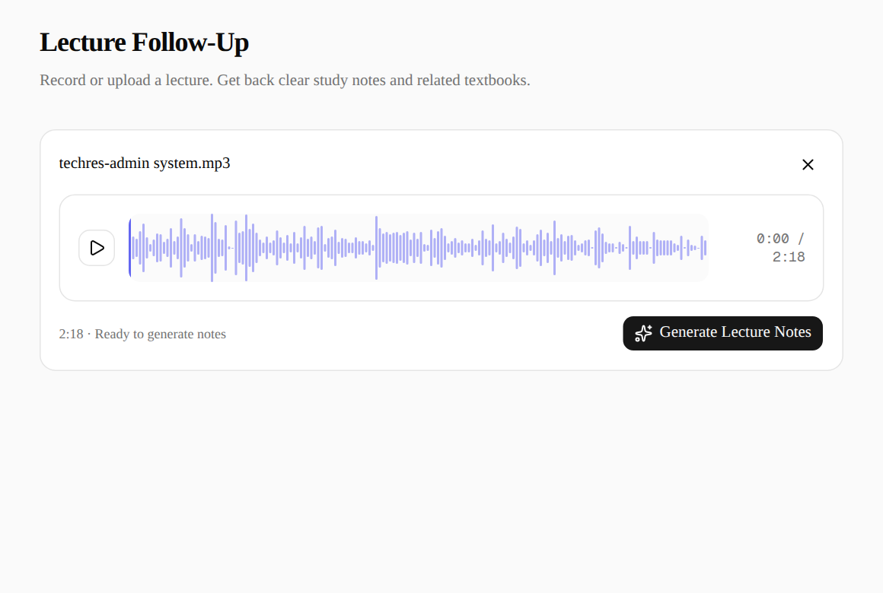
Figure 2.2: An uploaded lecture recording shown as a playback waveform, ready for processing.
2.4 INTEGRATING AI MODELS THROUGH AN API
Speech-to-text models convert spoken audio into text, and large language models (LLMs) can read text and produce new, structured text from it. OpenRouter is a service that gives access to many such models through one HTTP interface. To make an LLM's answer usable by a program, the request can include a JSON schema, which forces the model to reply with data in an exact shape.
- Practical activity: Wrote lib/openrouter.ts with two functions. transcribeAudio sends the base64 audio to OpenRouter's transcription endpoint (openai/whisper-large-v3 by default). explainLecture sends the transcript to a chat model (openai/gpt-4o-mini by default) with a written system instruction and a strict JSON schema, so the reply always contains a Markdown study note and a list of three to six textbook-style search terms. Both model names can be changed through environment variables without changing code.
- Tools/technologies used: OpenRouter API, Whisper large-v3, GPT-4o mini, JSON Schema structured output, fetch.
- Skills acquired: Prompt writing, structured output, calling external REST APIs, error handling and keeping API keys on the server.
2.5 CONSUMING THE ACADEVA LIBRARY API
Applications often combine data from several services. Calling an external API well means building correct URLs, handling failed or slow requests gracefully, and transforming the raw response into the shape the rest of the application needs.
- Practical activity: Wrote lib/acadeva.ts, which takes the search terms produced by the language model, removes blanks and duplicates, and queries the Acadeva search endpoint for each term in parallel. Results are merged by book ID, ranked first by how many terms matched and then by rating and downloads, and the top eight are returned. If fewer than five books are found, a combined fallback search is run. Each book is mapped to a cover image URL, a view link and a direct download link. A failed search for one term is logged and skipped rather than stopping the whole request.
- Tools/technologies used: Acadeva public books search API, Promise.all, Map and Set, TypeScript interfaces.
- Skills acquired: API integration, parallel requests, de-duplication, ranking and defensive error handling.
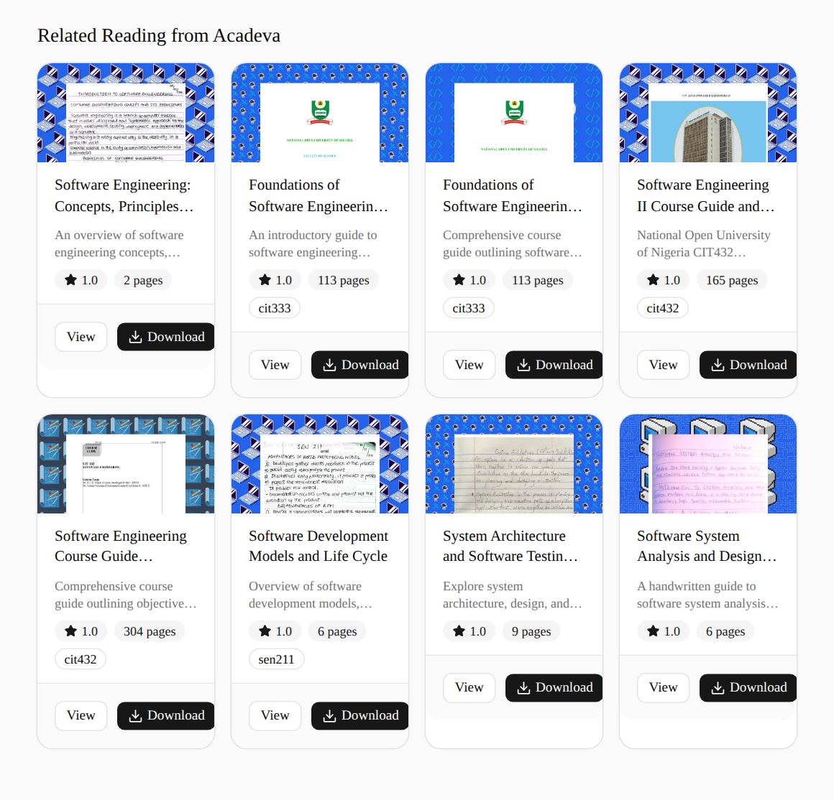
Figure 2.3: Related textbooks returned from the Acadeva library, with cover, rating, pages, course code and download links.
2.6 VERSION CONTROL WITH GIT AND GITHUB
Git records the history of a project as a series of commits, so that changes can be traced, compared and undone. GitHub hosts Git repositories online and adds collaboration features such as pull requests and code review, and a README that tells others how to install and run the project.
- Practical activity: Created the repository from the Create Next App starter, committed the working application, and added sample lecture recordings for manual testing. The project was pushed to GitHub under the repository lecture-follow-up, and a README was written describing how the application works, how to run it and which environment variables it needs. Table 2.1 shows the commit history.
- Tools/technologies used: Git, GitHub, command line.
- Skills acquired: Committing, writing commit messages, working with remote repositories and writing project documentation.
Table 2.1: Commit history of the Lecture Follow-Up repository
Commit | Date | Description
91add7a | 18 Sep 2026 | Initial commit from Create Next App
ff9ddad | 18 Sep 2026 | First commit: lecture recording, transcription, notes and book search
ca60e02 | 18 Sep 2026 | Add sample audio files (ECEWS report and TechRes admin system) for testing

2.7 OTHER TECHNICAL OR PROFESSIONAL SKILLS
Beyond the main technologies, the placement built working habits that matter in any software team: reading official documentation before writing code, checking work with linters and builds, designing for phones as well as desktops, and reporting progress clearly to a supervisor.
- Practical activity: Read the Next.js documentation shipped with the framework to follow the conventions of the installed version, kept the code free of lint errors with ESLint, built a layout that works on narrow phone screens, used Playwright to drive the application in a browser and capture screenshots, and tested the failure paths of the API by sending deliberately wrong requests.
- Tools/technologies used: ESLint, Playwright, browser developer tools, curl, official documentation.
- Skills acquired: Debugging, self-directed learning, responsive design, testing, time management and professional communication.
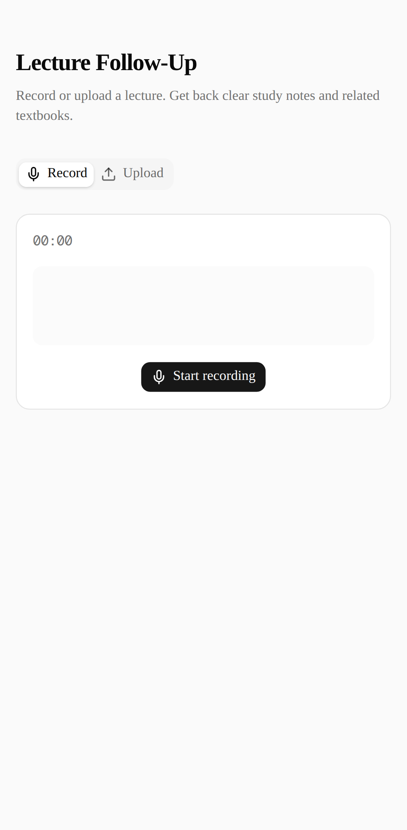
Figure 2.4: Lecture Follow-Up on a phone-sized screen (Pixel 7).
2.8 CONCLUSION
The skills described in this chapter cover the whole path of a modern web feature, from capturing input in the browser, through server logic and third-party AI services, to presenting results clearly. They were applied together in the project presented in the next chapter.

CHAPTER 3
IT PROJECT ON DESIGN AND IMPLEMENTATION OF AN AI-ASSISTED LECTURE NOTES AND TEXTBOOK RECOMMENDATION WEB APPLICATION USING NEXT.JS
INTRODUCTION
This chapter presents the IT project carried out during the placement at Acadeva Limited, titled "Design and Implementation of an AI-Assisted Lecture Notes and Textbook Recommendation Web Application Using Next.js." The application, Lecture Follow-Up, lets a student record a lecture in the browser or upload a recording, and returns organized study notes together with related textbooks from the Acadeva library. The chapter covers the problem, objectives, requirements, design, implementation, testing and evaluation of the system.
3.1 PROJECT OVERVIEW
Lecture Follow-Up is a single-page web application with a small back end. In the browser, the student either records the lecture with a live waveform or uploads an audio file. When the student clicks Generate Lecture Notes, the audio is sent to a Next.js route handler, which passes it through three stages: transcription by a speech-to-text model, note writing by a large language model, and a textbook search on the Acadeva library using topics identified by the model. The server reports each stage to the browser as it starts, so the student sees progress instead of a single spinner, and the final result is shown as formatted notes followed by a grid of books that can be viewed or downloaded.
The project covers recording and uploading audio, transcription, generation of study notes, textbook recommendation and the streamed progress display. User accounts, saving notes for later, editing notes inside the application and exporting notes to PDF are outside the scope of this version.
3.2 BACKGROUND OF THE STUDY
Lectures remain the main way university courses are taught in Nigeria, yet students often struggle to take complete notes while also listening and understanding. Large classes, poor acoustics, fast speakers and unfamiliar terms make it easy to miss key points, and recordings made on a phone are rarely played back because listening again takes as long as the lecture itself.
Recent advances in speech recognition and large language models make it practical to convert speech to text and then rewrite that text as structured explanations. At the same time, Acadeva has built a large, course-organized library of Nigerian university materials. Connecting the two allows a student to go from a lecture they have just attended to clear notes and to the textbooks and course guides that cover the same topics. This fits Acadeva's mission of making study resources accessible and learning more effective, and it exercises the full stack and integration skills learned during the placement.
3.3 PROBLEM STATEMENT
Students often leave lectures with incomplete or disorganized notes and no clear idea of which books cover the material. Raw recordings are long and hard to review, and a plain transcript is unstructured, full of filler words and still not a study note. Finding relevant reading material requires knowing the right search terms, which a student new to a topic may not know. There is a need for a simple tool that accepts a lecture recording and returns concise, well-organized notes along with suitable textbooks from a trusted student library.
3.4 AIM AND OBJECTIVES
Aim: To design, implement and evaluate a web application that converts a recorded or uploaded lecture into structured study notes and recommends related textbooks from the Acadeva library.
Objectives:
- To identify the functional and non-functional requirements of the application.
- To design the architecture and the flow of data between the browser, the server and the external services.
- To implement in-browser recording and file upload with waveform feedback using React and wavesurfer.js.
- To implement transcription and note generation using speech-to-text and large language models through the OpenRouter API.
- To implement textbook recommendation by querying and ranking results from the Acadeva library API.
- To manage the source code with Git and GitHub, and to test and evaluate the application.
3.5 REQUIREMENTS GATHERING / INFORMATION GATHERING
Requirements came from discussions with the supervisor, the author's own experience and that of classmates in taking lecture notes, a review of the Acadeva library and its search interface, and a review of the speech-to-text and language models available through OpenRouter. The functional requirements are listed in Table 3.1.
Table 3.1: Functional requirements
ID | Requirement
FR1 | The user can record a lecture in the browser, choose a microphone, pause, resume and stop, with a live waveform and timer.
FR2 | The user can upload an audio file (mp3, wav, m4a, ogg, webm, aac or flac) by selecting it or dragging it onto the page.
FR3 | The user can play back the captured audio, see its duration, and remove it to start again.
FR4 | The system transcribes the audio into text.
FR5 | The system produces Markdown study notes with a title, sections, highlighted key terms and a Key Takeaways list.
FR6 | The system identifies the lecture's topics and recommends up to eight related books from the Acadeva library, with cover, rating, pages, course code, a view link and a download link.
FR7 | The interface shows the progress of each stage (transcribing, writing notes, finding books) and shows a clear message if any stage fails.
FR8 | The interface adapts to phone and desktop screens.

The non-functional requirements are: API keys must never be exposed to the browser; unsupported files must be rejected with a clear message; the user must receive feedback while long tasks run; a failure in the book search must not lose the notes already produced; and the code must be easy to configure and maintain.
3.6 METHODOLOGY
The project followed an incremental approach. The work was divided into small working pieces (capture, upload, transcription, note generation, book search, progress display) and each piece was built and checked in the browser before the next was added. External services were wrapped in their own modules so they could be developed and replaced independently. Source code was tracked in Git and hosted on GitHub. The technologies used are summarized in Table 3.2.
Table 3.2: Technology used
Area | Technology | Purpose
User interface | React 19 | Components for recording, upload, progress, notes and books
Framework | Next.js 16 (App Router) | Page routing, route handler for /api/lecture, production build
Language | TypeScript | Type-checked code and shared types for stage events and books
Styling | Tailwind CSS 4, shadcn/ui, lucide-react | Responsive layout, tabs, cards, buttons, badges and icons
Audio | wavesurfer.js and Record plugin | Live recording waveform and playback waveform
Transcription | OpenRouter, openai/whisper-large-v3 | Converting lecture audio to text
Note generation | OpenRouter, openai/gpt-4o-mini | Writing study notes and search terms as structured JSON
Book search | Acadeva public books API | Finding related textbooks and course materials
Rendering | react-markdown, remark-gfm, Tailwind Typography | Displaying the Markdown notes
Notifications | Sonner | Toast messages for errors
Quality | ESLint, Playwright | Static checks and browser-driven checks
Version control | Git and GitHub | History and remote hosting of the code

3.7 SYSTEM DESIGN AND IMPLEMENTATION
The system has three parts: the React interface in the browser, the Next.js route handler on the server, and three external services (OpenRouter transcription, an OpenRouter chat model and the Acadeva library). The main design and implementation decisions are described below.
- Architecture: the browser never calls the AI services directly. It sends the audio to POST /api/lecture, and the server, which holds the OpenRouter key, calls each service in turn. Figure 3.1 shows the architecture.
- Audio capture: the recorder uses wavesurfer.js with its Record plugin to capture microphone audio as a Blob and draw a live waveform. Uploaded files are read directly. Both paths end in the same state, a captured audio object with its MIME type and file name, which is shown with a playback waveform.
- Request validation: the route handler rejects a request with no audio file (HTTP 400) and resolves the audio format from the MIME type, falling back to the file extension; unsupported formats are rejected with a message listing the accepted formats.
- Streamed progress: instead of waiting for the whole job, the handler returns a stream of newline-delimited JSON (NDJSON) events: transcribing, transcribed, explaining, finding-books, and finally done with the result, or error with a message. The browser reads the stream line by line and updates the progress tracker as each event arrives. The event types are defined once in lib/types.ts and shared by both sides.
- Note generation: the system instruction asks the model to write explanations in its own words rather than a cleaned transcript, with one H1 title, H2 sections in lecture order, bold key terms, examples and a Key Takeaways section, and to return three to six catalogue-style search terms. A strict JSON schema guarantees that the reply can be parsed.
- Book recommendation: search terms are cleaned, limited to six and searched in parallel; results are merged, ranked by the number of matching terms and then by rating and downloads, topped up by a fallback search when fewer than five books are found, and limited to eight. Download links use Acadeva's CDN with a parameter that forces a direct download.
- Error handling: failures in transcription or note writing end the stream with a clear error event, shown in a red panel and a toast message. A failure in the book search is logged and the notes are still returned with an empty book list.
- Configuration and security: the OpenRouter key and model names are read from server-side environment variables only, so they never reach the browser.
- Responsive design: the page uses a single centered column that narrows on phones, and the book grid changes its number of columns with the screen width.
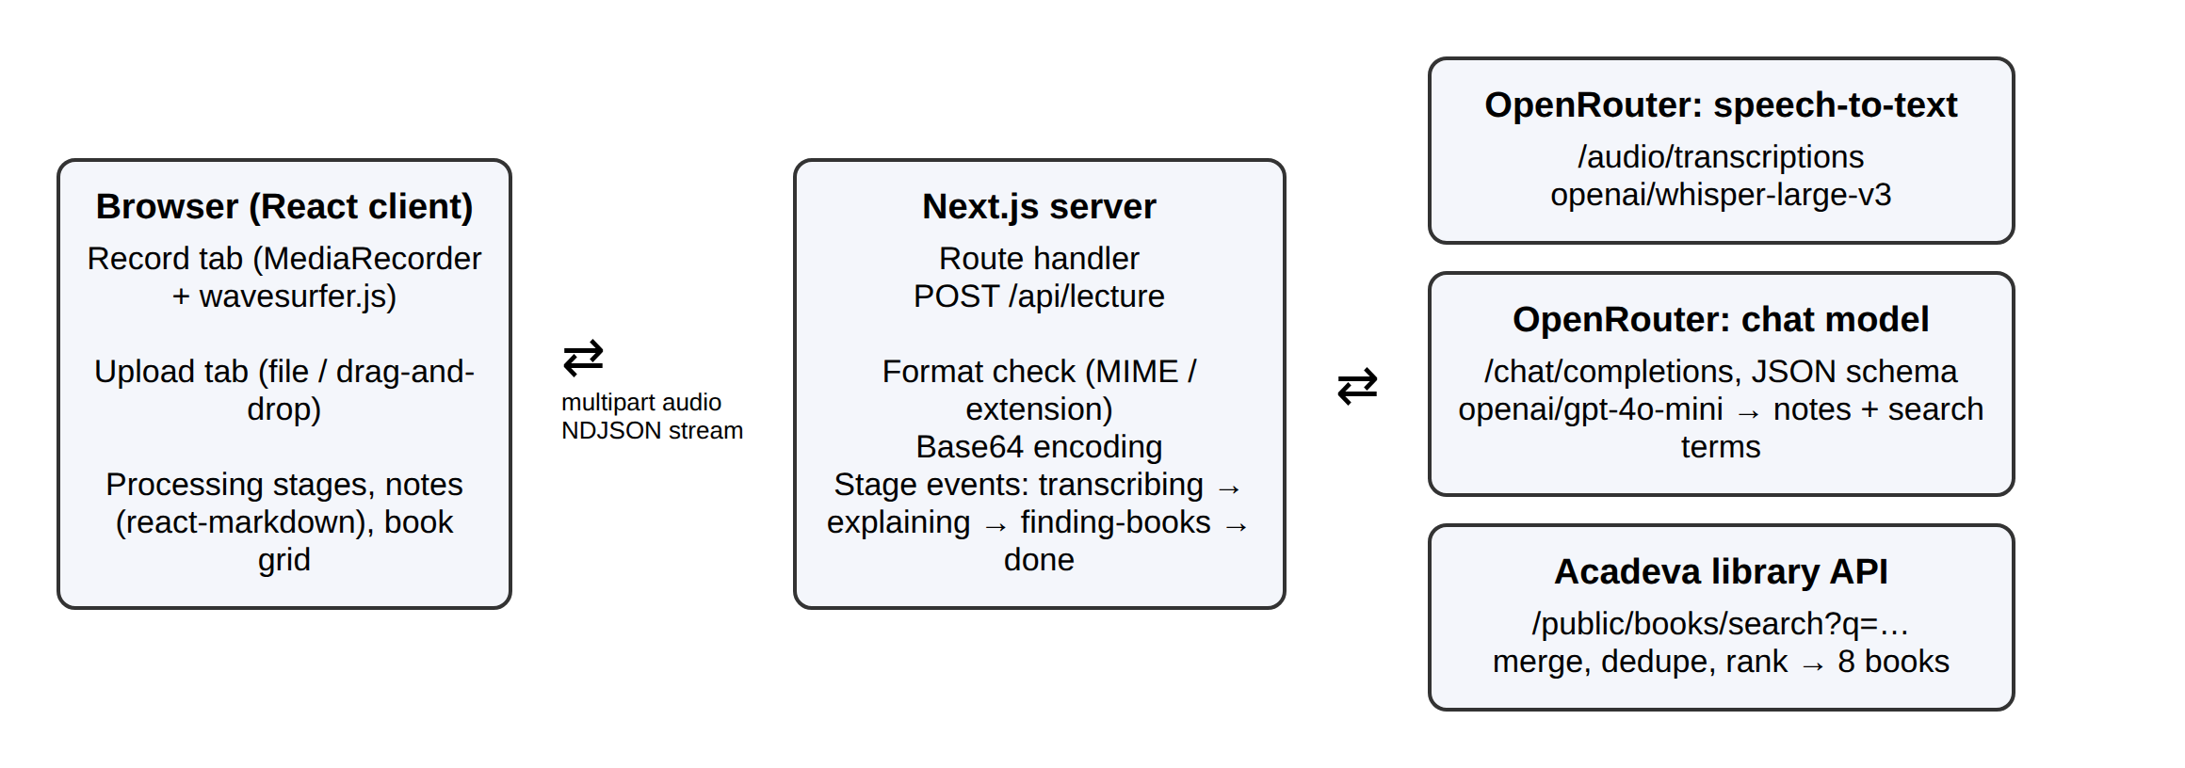
Figure 3.1: Architecture of Lecture Follow-Up.
Table 3.3: Stage events streamed from POST /api/lecture
Event | When it is sent | Content
transcribing | Before the audio is sent for transcription | Stage name only
transcribed | When transcription succeeds | The transcript text
explaining | Before the transcript is sent to the chat model | Stage name only
finding-books | Before the Acadeva search starts | Stage name only
done | When all stages finish | Markdown notes, search terms and the list of books
error | When transcription or note writing fails | A readable error message

The main screens of the application are shown in Figures 3.2 to 3.5.
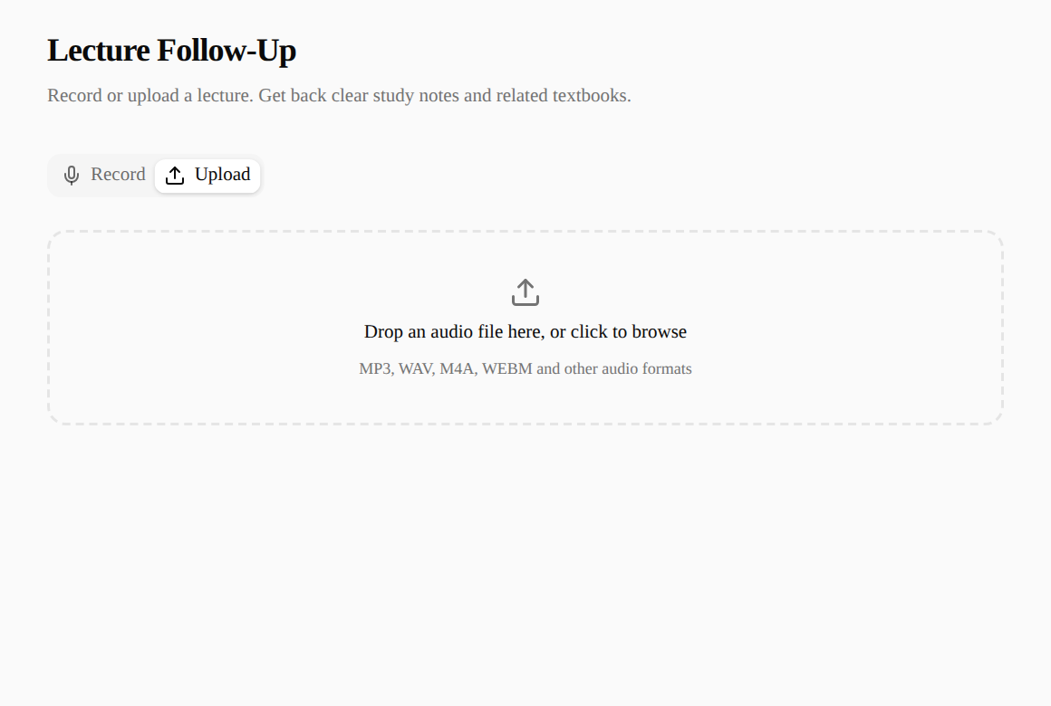
Figure 3.2: Upload tab with the drag-and-drop area and the list of accepted formats.
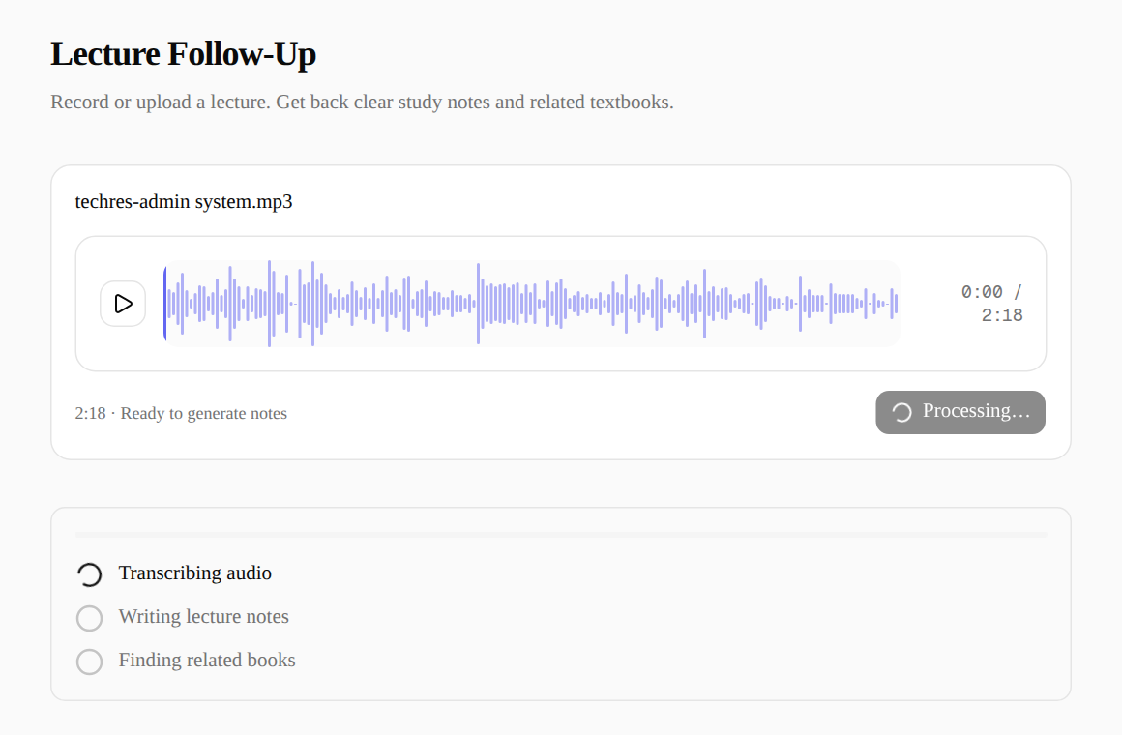
Figure 3.3: Progress tracker while the lecture is being transcribed.
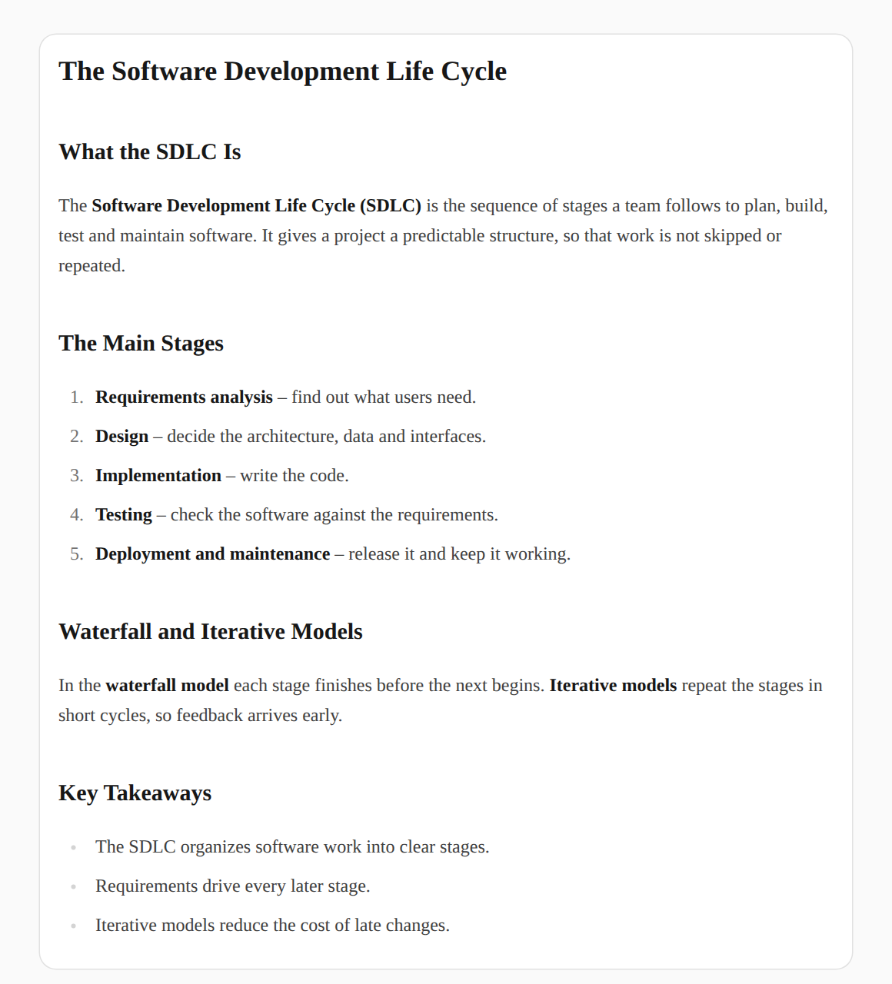
Figure 3.4: The results view: completed stages and the generated study notes (the notes shown here are sample content supplied to the interface for illustration).
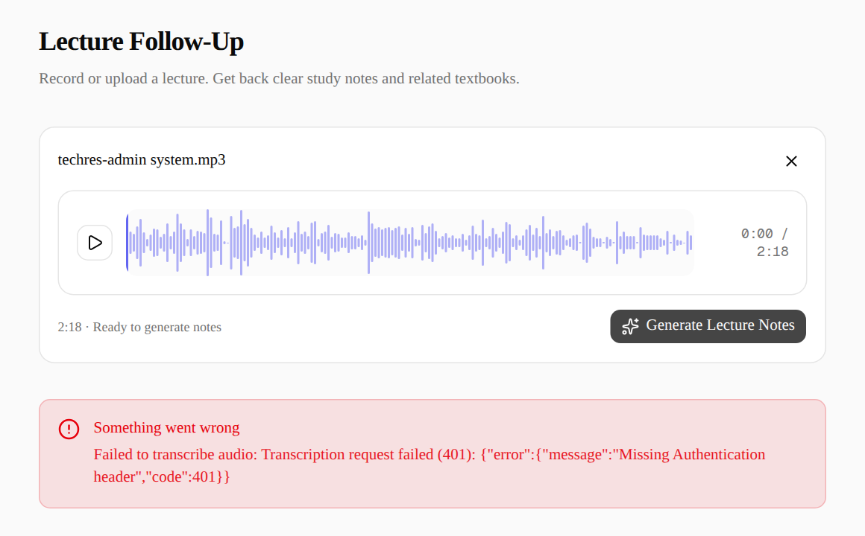
Figure 3.5: Error panel shown when the transcription service rejects the request (here, because no API key was configured).
3.8 TESTING AND EVALUATION
The application was checked in four ways. First, ESLint was run over the whole code base and reported no errors, and a production build with next build completed successfully. Second, the API was tested directly with curl, sending requests with no audio, with an unsupported file type and with a real lecture recording. Third, the interface was driven in a Chromium browser with Playwright at desktop size and on an emulated Pixel 7 phone, using the sample recordings in the testfiles folder; for the progress and results screens, the network response was supplied by the test so each state could be checked on its own. Fourth, the Acadeva search endpoint was queried directly to confirm that it returns real books for typical search terms. Table 3.4 lists representative test cases.
Table 3.4: Representative test cases
ID | Test | Expected result | Actual result
T1 | POST /api/lecture with no audio field | HTTP 400 with "No audio file provided" | Pass
T2 | POST a plain text file as audio | HTTP 400 naming the unsupported format and listing accepted formats | Pass
T3 | Upload techres-admin system.mp3 | Playback waveform appears with duration 2:18 and the Generate button | Pass
T4 | Click Generate while the request is in progress | Button shows Processing… and the tracker shows Transcribing audio | Pass
T5 | Submit audio when the transcription service rejects the key | Stream ends with an error event; red panel and toast show the reason | Pass
T6 | Results returned by the server | Stages marked complete, notes rendered as formatted Markdown, books shown in a grid | Pass
T7 | Search Acadeva for "software engineering" | Eight related books returned with covers and course codes | Pass
T8 | Open the page on a Pixel 7 screen size | Layout fits the screen without horizontal scrolling | Pass

The evaluation considered the following factors:
- Correctness: whether each functional requirement behaves as specified.
- Security: the API key is kept on the server, input is checked before any external call, and error messages do not reveal secrets.
- Usability: a lecture can be turned into notes with two actions (record or upload, then Generate), and progress is visible throughout.
- Robustness: each external call is handled separately, so one failure produces a clear message and a book-search failure does not lose the notes.
- Maintainability: services are isolated in lib/openrouter.ts and lib/acadeva.ts, models are configurable, and types are shared between server and client.
3.9 RECOMMENDATIONS AND FUTURE ENHANCEMENTS
Based on the work done, the following improvements are recommended:
- Add user accounts so students can save, search and revisit their notes.
- Allow notes to be edited and exported to PDF or shared with classmates through Acadeva.
- Split long recordings into chunks so that lectures of an hour or more can be processed reliably.
- Generate quizzes and flashcards from the notes, linking to Acadeva's existing quiz features.
- Match recommendations to the student's own school and course code when they are known.
- Add automated unit and end-to-end tests and run them on every pull request with GitHub Actions.
- Improve accessibility, including keyboard control of the recorder and screen reader labels for each stage.
3.10 LIMITATIONS OF THE STUDY
The project was built within a six-month, learning-focused placement, which limited its scope. It depends on paid third-party services: transcription and note generation require an OpenRouter key with available credit, and the quality of the notes depends on the clarity of the recording and on the chosen models, which can still make mistakes. Very long recordings may exceed the request limits of the transcription service. Notes are not stored, so they are lost when the page is closed. The system was tested with sample recordings rather than in a formal study with students, and no load testing was carried out.
3.11 CONCLUSION
The project designed and implemented Lecture Follow-Up, a web application that turns a recorded or uploaded lecture into structured study notes and recommends related textbooks from the Acadeva library, using React, Next.js, OpenRouter AI models and the Acadeva API. It showed how a browser interface, a server route and several external services can be combined into one dependable flow. The main lessons were the importance of keeping secrets on the server, asking AI models for structured output, handling every external failure explicitly, and giving users continuous feedback during slow operations. The recommendations in Section 3.9 indicate the direction for further work.

REFERENCES
Acadeva (n.d.) Acadeva. Available at: https://acadeva.xyz/ (Accessed: 4 October 2026).
Git (n.d.) Git documentation. Available at: https://git-scm.com/doc (Accessed: 4 October 2026).
GitHub (n.d.) GitHub Docs. Available at: https://docs.github.com/ (Accessed: 4 October 2026).
Meta Open Source (n.d.) React documentation. Available at: https://react.dev/ (Accessed: 4 October 2026).
Microsoft (n.d.) Playwright documentation. Available at: https://playwright.dev/docs/intro (Accessed: 4 October 2026).
MDN Web Docs (n.d.) MediaRecorder API. Available at: https://developer.mozilla.org/en-US/docs/Web/API/MediaRecorder (Accessed: 4 October 2026).
OpenRouter (n.d.) OpenRouter API documentation. Available at: https://openrouter.ai/docs (Accessed: 4 October 2026).
Radford, A. et al. (2023) 'Robust speech recognition via large-scale weak supervision', Proceedings of the 40th International Conference on Machine Learning (ICML).
Tailwind Labs (n.d.) Tailwind CSS documentation. Available at: https://tailwindcss.com/docs (Accessed: 4 October 2026).
Vercel (n.d.) Next.js documentation. Available at: https://nextjs.org/docs (Accessed: 4 October 2026).
wavesurfer.js (n.d.) wavesurfer.js documentation. Available at: https://wavesurfer.xyz/ (Accessed: 4 October 2026).
APPENDICES
Appendix A: Environment variables and running the project
After cloning the repository, the project is installed with pnpm install and started with pnpm dev (development) or pnpm build followed by pnpm start (production). OPENROUTER_KEY is required; OpenRouter requires at least $0.50 of available credit on the key for audio requests. OPENROUTER_STT_MODEL (default openai/whisper-large-v3) and OPENROUTER_EXPLAIN_MODEL (default openai/gpt-4o-mini) are optional and allow other models to be used without code changes.
Appendix B: Sample recordings
The testfiles folder contains three recordings used for manual testing of the upload path: "Welcome back to Square One.mp3" (about 1.0 MB), "techres-admin system.mp3" (about 1.9 MB, 2 minutes 18 seconds) and "ecews-report.mp3" (about 7.7 MB).
Appendix C: Project structure
- app/page.tsx: the main page; holds the processing state and reads the NDJSON stream.
- app/api/lecture/route.ts: the route handler that validates audio and runs the three stages.
- lib/openrouter.ts: transcription and note generation through OpenRouter.
- lib/acadeva.ts: Acadeva book search, merging, ranking and link building.
- lib/types.ts: shared types for books, results and stage events.
- components/lecture/: recorder panel, waveform recorder and player, processing stages, lecture notes, book grid and book card.
Appendix D: Additional screenshots
Figure D.1: The Record tab before recording starts.

