CHAPTER 3
IT PROJECT ON DESIGN AND IMPLEMENTATION OF A DIGITAL STUDENT IDENTITY CARD SYSTEM WITH QR CODE VERIFICATION USING NEXT.JS AND POSTGRESQL

INTRODUCTION
This chapter presents the IT project titled "Design and Implementation of a Digital Student Identity Card System with QR Code Verification Using Next.js and PostgreSQL." The project produced a complete web application named UniUyo ID. It builds on the university's existing register of students (names, registration numbers, departments and levels): each student receives a digital identity card on their phone carrying a cryptographically signed QR code, and a lecturer scans that code at the door of a class to learn immediately whether the card is genuine, whether the person is a University of Uyo student in good standing, and whether they are registered for the course being taught.
The third question was the starting point of the project. A lecturer may know that someone is a University of Uyo student but not whether they belong to the department or the class; the system answers both at once, with a clear instruction such as ADMIT, NOT IN THIS CLASS or REJECT. The chapter describes the problem, requirements, methodology, design of the signed QR token and the verification rules, the database, the user interfaces for students and lecturers, security, testing and evaluation, and deployment.

3.1 PROJECT OVERVIEW
UniUyo ID is a full stack web application built with React and Next.js 16 (App Router), written in TypeScript, with a PostgreSQL database accessed through the Drizzle ORM. QR codes are generated on the server with the qrcode library, and QR codes are read in the lecturer's browser with the jsQR library from the phone or laptop camera, so no special scanner hardware or app installation is needed.
A student signs in and sees an ID wallet: a security-printed card showing a photograph, full name, registration number, department, level, faculty, expiry date and QR code, which can be flipped to show the back, printed, or opened full screen with a live clock for scanning. Beside the card the student sees whether the card is valid, expiring soon, expired or suspended, and the list of courses the card admits them to.
A lecturer signs in to a checkpoint console for one of the courses they teach. A session strip shows the course, venue and date with live counters (admitted, flagged, class size). The lecturer starts the camera and points it at a student's QR code, uploads a photo of a QR code, or types a registration number. The result panel then shows a large colour-coded instruction, the student's photograph and details for comparison with the person, and the three checks behind the decision. Every check is logged, so the lecturer also has an attendance register for each class showing who was admitted today, and a scan log that can be filtered by result and by course.
Anyone who scans a card's QR code with an ordinary phone camera is taken to a public verification page that confirms whether the card is genuine and current, showing only the details printed on the card; course registration is only revealed to signed-in lecturers.
The scope covers sign-in and roles, the student ID wallet, signed QR codes, the lecturer checkpoint with camera, photo and typed input, the eight verification outcomes, the attendance register, the scan log, the public verification page, responsive layouts, automated tests at three levels, a PDF user guide, and deployment on Railway with its own PostgreSQL database. Card printing on PVC, enrolment of photographs and synchronisation with the university's live records system are outside the scope of this report.

3.2 BACKGROUND OF THE STUDY
Universities issue identity cards so that staff can recognise their students, control access to examinations, libraries and hostels, and take attendance. At the University of Uyo, as at many Nigerian universities, the identity card is a printed plastic card. Printed cards are easy to lose and slow to replace, and a convincing copy can be made with a photograph and a colour printer. A lecturer who looks at a card can confirm only what is printed on it, not whether it is current, whether the student is still in good standing, or whether that student registered for the course.
Course registration data already exists in the university's records, and almost every student carries a smartphone. QR codes are a familiar, low-cost way to move a short piece of data from one screen to another camera, and keyed-hash message authentication codes (HMAC) allow a server to detect any change to data it has signed. Browsers can now open the camera and decode QR codes directly, which means a lecturer can verify cards with the laptop or phone they already use. Combining these elements gives a verification system that is cheap to run and much harder to forge than a printed card.

3.3 PROBLEM STATEMENT
Lecturers cannot reliably tell whether a person in their class or examination hall is a University of Uyo student, let alone whether that person belongs to the department or is registered for the course. Printed identity cards can be copied or used after they expire, replaced cards remain in circulation, and checking a student against the class list by hand takes time that a lecturer does not have at the start of a lecture. Students, for their part, often leave their plastic card in the hostel.
There is therefore a need for a digital identity card, linked to the existing student register, whose QR code cannot be forged or edited, and a simple checkpoint tool that tells a lecturer in one scan whether the card is genuine, whether the student is in good standing, and whether the student belongs to the class, while keeping a record of each check. The project also addresses the learning need to apply React, Next.js, PostgreSQL, cryptographic signing, browser camera access, automated testing, Git and cloud deployment in one application.

3.4 AIM AND OBJECTIVES
Aim: To design, implement, test and deploy a digital student identity card system with signed QR codes and a lecturer checkpoint that verifies a student's identity, standing and course registration in one scan.
Objectives:
- To identify the requirements of students, lecturers and third parties who need to check a student's identity.
- To design a database that reuses the existing student register and adds courses, registrations, logins and a scan log.
- To design a compact QR token signed with HMAC-SHA256 that cannot be forged or edited, and that becomes invalid when a card is replaced.
- To define and implement ordered verification rules with eight clear outcomes.
- To implement a student ID wallet and a lecturer checkpoint with camera scanning, photo upload and typed registration numbers.
- To implement secure sign-in with role-based access, so that course data is only visible to lecturers for their own courses.
- To test the system with unit, integration and end-to-end tests on desktop and mobile, and evaluate it.
- To manage the code with Git and GitHub and deploy it on Railway with its own database and a health check.

3.5 REQUIREMENTS GATHERING / INFORMATION GATHERING
Requirements were gathered by discussing the problem with students and lecturers (the starting point was a lecturer's need to know whether a person "belongs to this class" or is "from UniUyo but not from the department being taught"); by examining the information printed on student identity cards; by reviewing how QR codes are used for tickets and boarding passes and the weaknesses of codes that are not signed; and by studying browser support for the camera API. No real student data was used; the register in the application contains fictional students.
The functional requirements are listed in Table 3.1, the non-functional requirements in Table 3.2, and the use cases in Figure 3.1.
Table 3.1: Functional requirements
ID | Requirement
FR1 | Students and lecturers sign in with an email and password; demo accounts can be selected on the sign-in page.
FR2 | Students only reach student pages; lecturers only reach lecturer pages; visitors are redirected to sign in.
FR3 | A student sees their ID card with photo, name, registration number, department, level, faculty, expiry date and QR code, and can flip and print it.
FR4 | A student can show the QR code full screen with a live clock.
FR5 | A student sees the card status (valid, expiring within 30 days, expired, suspended) and the courses the card admits them to.
FR6 | A lecturer selects one of their own courses and verifies a student by camera, by an uploaded photo of a QR code, or by a typed registration number.
FR7 | Each verification returns one of eight outcomes with a colour-coded instruction, the student's photograph and details, and the checks behind the decision.
FR8 | A forged or edited QR code is rejected; a replaced card's old QR code is rejected.
FR9 | Every verification is logged with lecturer, course, student and result.
FR10 | A lecturer sees today's admitted and flagged counts and the log for the current class.
FR11 | A lecturer sees an attendance register per class (present today, card problems) and a scan log filterable by result and course.
FR12 | Anyone can open the QR link to see whether the card is genuine and current, without course details.
FR13 | Inputs are validated with clear error messages; the interface works on phones.

Table 3.2: Non-functional requirements
Quality | Requirement and how it is met
Authenticity | QR payloads carry an HMAC-SHA256 signature keyed with a server secret; signatures are compared in constant time.
Privacy | The public page shows only what is printed on the card; course registration is only shown to lecturers, and only for courses they teach.
Speed | A scan is decoded in the browser and verified in a single server round trip with a few indexed queries.
Security | bcrypt passwords, signed HTTP-only session cookies, role checks in the proxy and on every page and action, parameterised SQL.
Usability | One large instruction per scan (ADMIT, NOT IN THIS CLASS, REJECT), photograph for face comparison, demo cards for rehearsal.
Accountability | Every check is stored in the scans table and visible in the scan log.
Testability | UNIID_TODAY=YYYY-MM-DD freezes the clock so expiry rules are repeatable.
Maintainability | Token and verdict logic are small pure modules with unit tests; strict TypeScript.

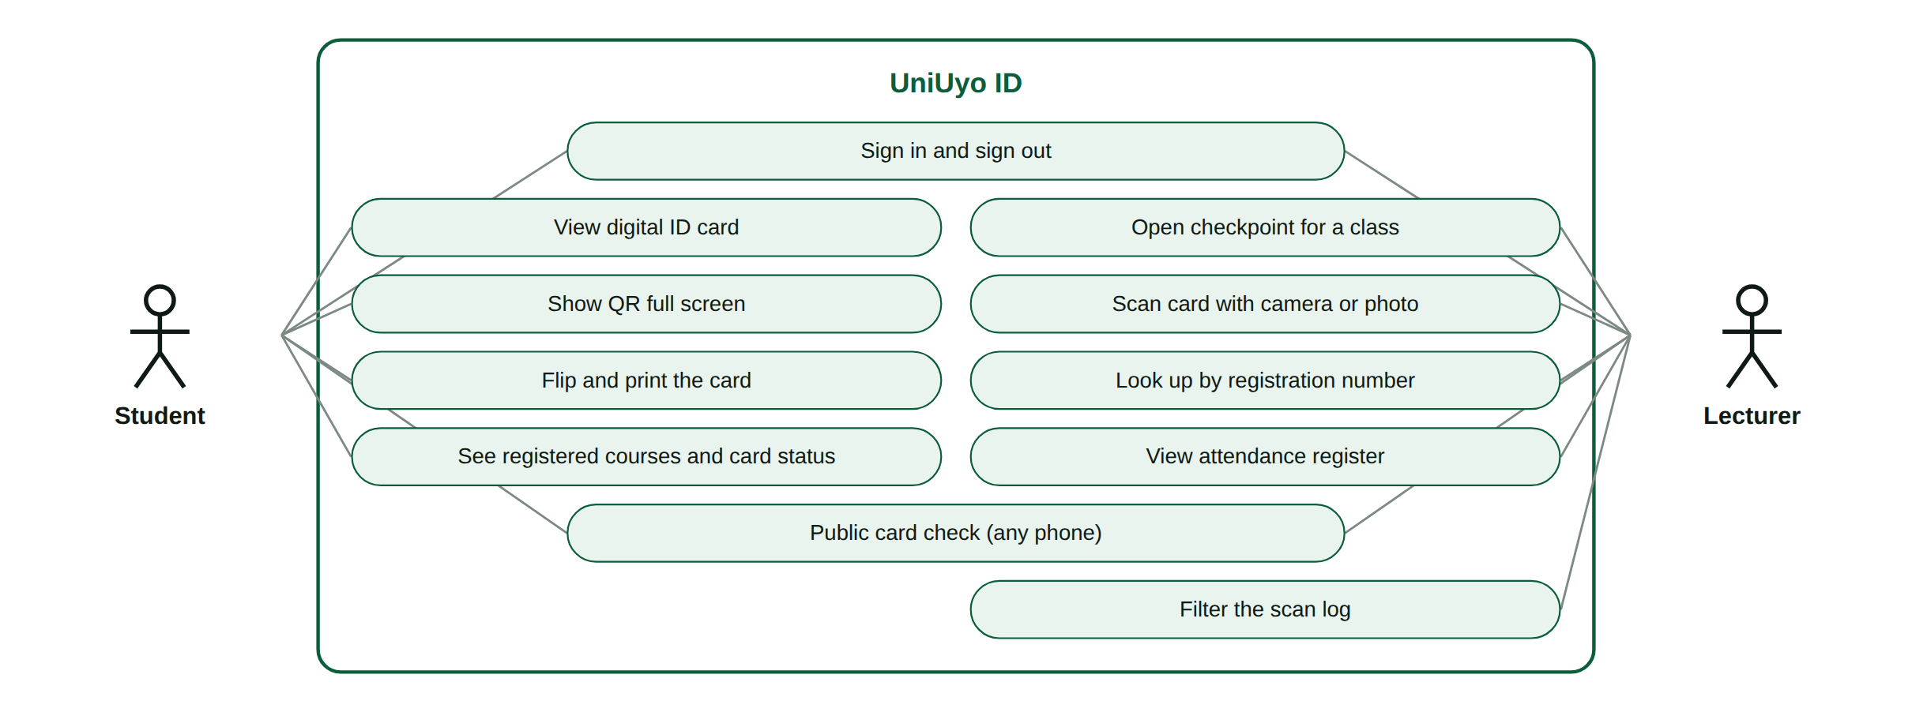
Figure 3.1: Use case diagram of UniUyo ID

3.6 METHODOLOGY
The project followed an iterative and incremental approach. The security-critical parts (the token format and the verdict rules) were built first as pure functions with unit tests covering every outcome, before any screen used them. The user interface was then built and refined in a second cycle: the first version used a chat-style layout, which was replaced by a checkpoint console and a wallet view after review, because the layout should reflect what the system does. The iterations are summarised in Table 3.3 and the technology in Table 3.4.
Table 3.3: Development iterations
Iteration | Work done | Outcome
1 | Schema for the student register, users, courses, enrollments and scans; migrations; seed register | 48 students, 3 lecturers, 7 courses
2 | Signed QR token (idtoken.ts) and verdict rules (verify.ts) | Unit-tested security core
3 | Sign-in with roles, proxy route guard, verifyScan query and Server Action | Verification working end to end
4 | First interface: student card and chat-style scanner | Working but did not look like a checkpoint
5 | Redesign: checkpoint console, ID wallet, classes, attendance register, scan log, certificate-style public page | Layout follows each role's task
6 | Integration and end-to-end tests, PDF guide, Railway deployment | 33 Vitest and 8 Playwright tests passing; live URL

Table 3.4: Technology used
Area | Technology | Purpose
User interface | React 19 | Wallet, checkpoint, tables
Framework | Next.js 16 (App Router) | Server Components, Server Actions, proxy, route handlers
Language | TypeScript (strict) | Application, tests and scripts
Database | PostgreSQL 16 | Register, courses, registrations, logins, scan log
Data access | Drizzle ORM, drizzle-kit, node-postgres | Typed queries and migrations
QR codes | qrcode, jsQR | Generate SVG QR codes on the server; decode QR codes from camera frames and photos in the browser
Cryptography | Node.js crypto (HMAC-SHA256) | Sign and verify QR payloads
Validation | Zod | Sign-in and scan input
Authentication | bcryptjs, jose | Password hashing and session tokens
Icons, portraits, fonts | lucide-react, DiceBear, Fontsource (Inter, JetBrains Mono) | Icons, generated ID portraits, self-hosted fonts
Testing | Vitest, Playwright | Unit, integration and browser tests
Version control and hosting | Git, GitHub, Railway | History, pull requests, hosting and database

3.7 SYSTEM DESIGN AND IMPLEMENTATION

3.7.1 System architecture
Figure 3.2 shows the architecture. The browser never talks to the database. proxy.ts checks the session and the role on every request. Pages are Server Components; a scan is sent to a single Server Action, verifyAction, which validates the input, confirms that the course belongs to the signed-in lecturer, verifies the token, reads the register and the class list, decides the verdict, logs the scan and returns the result. The QR codes on cards are rendered on the server as SVG from the signed verification URL.
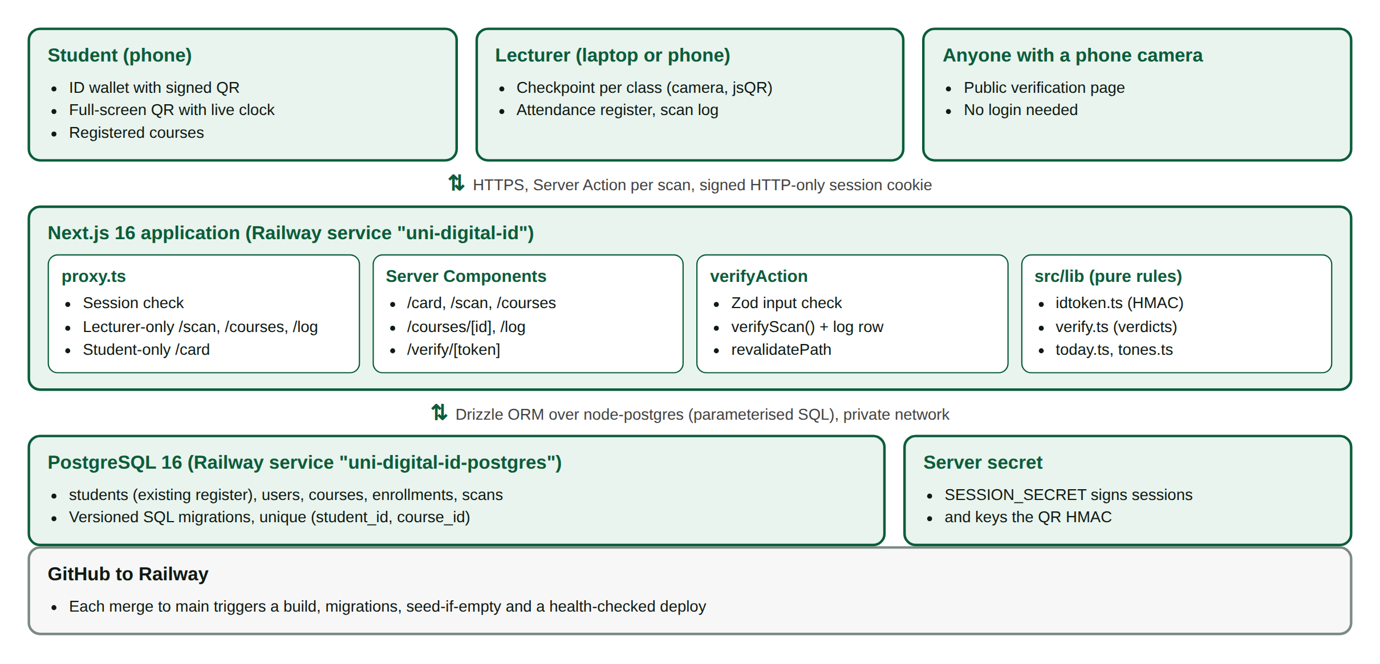
Figure 3.2: System architecture of UniUyo ID as deployed on Railway

3.7.2 Database design
The students table models the university's existing register; the other tables are added by this system (Table 3.5, Figure 3.3). A student login (users row) points to exactly one register entry. card_version starts at 1 and is increased whenever a card is reissued. Each scan stores the result as one of eight enumerated values.
Table 3.5: Database tables
Table | Main columns | Constraints and notes
students | id, reg_no, first_name, last_name, other_name, gender, faculty, department, level, entry_year, status, id_issued_on, id_expires_on, card_version, blood_group | reg_no unique; status active, suspended or graduated; index on department
users | id, name, email, password_hash, role, department, student_id | email unique; student_id unique; role student or lecturer
courses | id, code, title, department, level, units, venue, lecturer_id | code unique
enrollments | id, student_id, course_id | UNIQUE (student_id, course_id); cascades
scans | id, lecturer_id, course_id, student_id, result, scanned_at | student_id NULL for unrecognised codes; indexes on (lecturer_id, scanned_at) and course_id

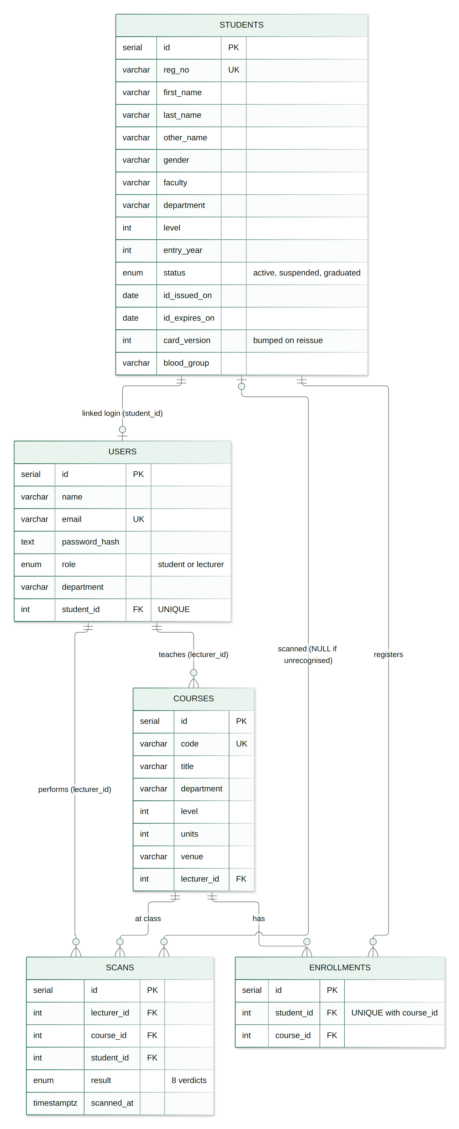
Figure 3.3: Entity relationship diagram of the UniUyo ID database

3.7.3 The signed QR token
The QR code on each card encodes a link to the public verification page, ending in a token. Figure 3.4 shows how the token is built. The body contains a version marker (UU1), the registration number in base64url and the card version; the signature is the first 16 bytes of an HMAC-SHA256 of the body, using a key derived from the server's SESSION_SECRET, encoded in base64url (22 characters). The whole link fits comfortably in a QR code that a phone camera reads quickly.
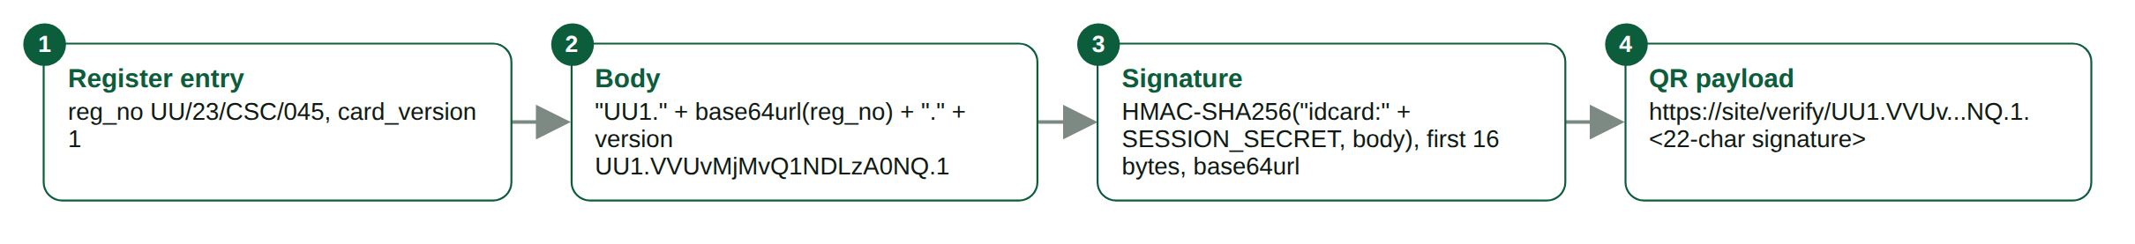
Figure 3.4: Structure of the QR payload
export function makeIdToken(regNo: string, cardVersion: number) {
const body = `UU1.${b64url(regNo)}.${cardVersion}`;
return `${body}.${sign(body)}`; // sign = HMAC-SHA256, first 16 bytes, base64url
}
export function readIdToken(raw: string) {
const parts = extractToken(raw).split("."); // accepts the full /verify/ URL too
if (parts.length !== 4 || parts[0] !== "UU1" || !/^\d+$/.test(parts[2])) return { ok: false, reason: "format" };
const expected = Buffer.from(sign(parts.slice(0, 3).join(".")));
const given = Buffer.from(parts[3]);
if (expected.length !== given.length || !timingSafeEqual(expected, given)) return { ok: false, reason: "signature" };
return { ok: true, regNo: unb64url(parts[1]), cardVersion: Number(parts[2]) };
}
Three properties follow from this design. A student cannot create a card for someone else, because they cannot compute the signature without the secret. A student cannot edit their own card to change the registration number or version, because any change breaks the signature. And when a card is reissued, the old card still carries a valid signature but an older version number, so the system recognises it and rejects it as an old card. Comparing signatures with timingSafeEqual prevents an attacker from learning the correct signature from response times.

3.7.4 Verification rules
verifyForCourse() turns the token, the register entry, the course and the registration into one of eight outcomes. The order of the checks is important: a forged or unknown card is rejected before anything else, card problems (replaced, suspended, expired) come next, and course registration is checked last. Figure 3.5 shows the full decision flow and Table 3.6 the outcomes.
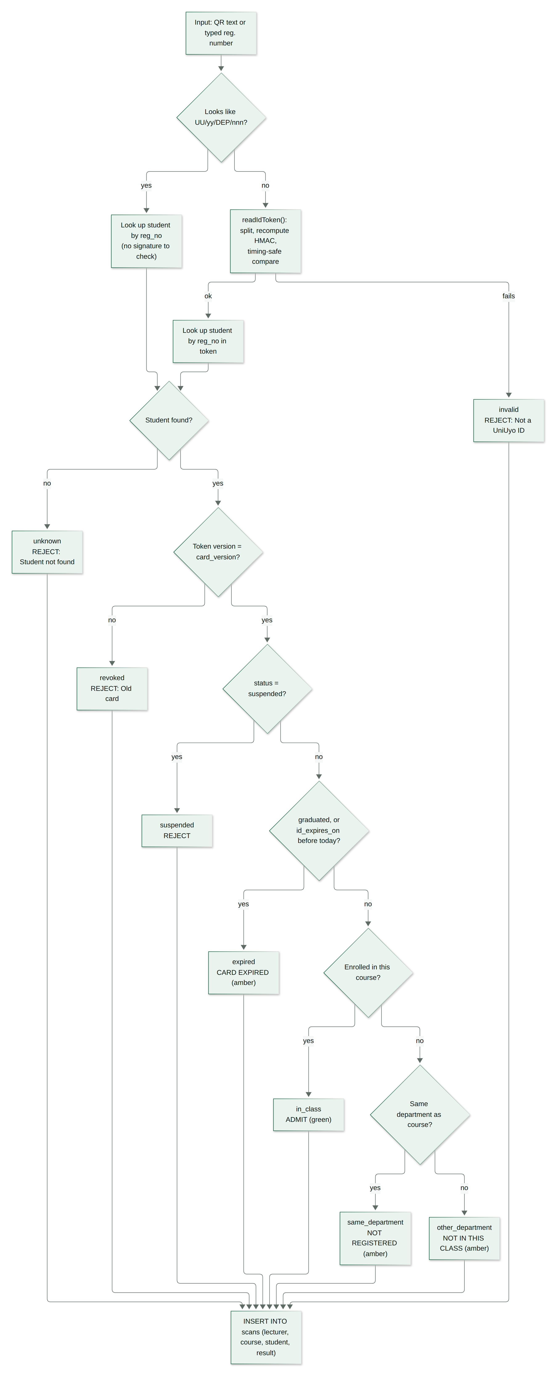
Figure 3.5: Decision flow of a verification
Table 3.6: Verification outcomes
Result | Instruction shown | Colour | Meaning
in_class | ADMIT | Green | Genuine card, active student, registered for this course
same_department | NOT REGISTERED | Amber | UniUyo student in the course's department but not on the class list
other_department | NOT IN THIS CLASS | Amber | UniUyo student from another department
expired | CARD EXPIRED | Amber | Card past its expiry date, or the student has graduated
suspended | REJECT | Red | The register marks the student as suspended
revoked | REJECT | Red | Valid signature but an old card version (card replaced)
unknown | REJECT | Red | Valid signature but the registration number is not in the register
invalid | REJECT | Red | Not a UniUyo ID: wrong format or signature does not match

Under each result the checkpoint lists the three checks behind it (card genuine, student in good standing, registered for this course), each marked passed, failed, warning or not checked. When a lecturer types a registration number instead of scanning, the signature check is marked as skipped and the footer says "Looked up by registration number", so the lecturer knows no card was presented.

3.7.5 Scanning in the browser
Figure 3.6 shows a complete scan. The checkpoint asks the browser for the rear camera with getUserMedia, draws each video frame onto a hidden canvas and passes the pixels to jsQR. When a code is found, the text is sent to verifyAction together with the selected course; the same code is ignored for four seconds to avoid duplicate logs while it stays in view. Uploaded photos go through the same decoder. On phones, the page scrolls to the result automatically. After the action, revalidatePath refreshes the counters and today's log.
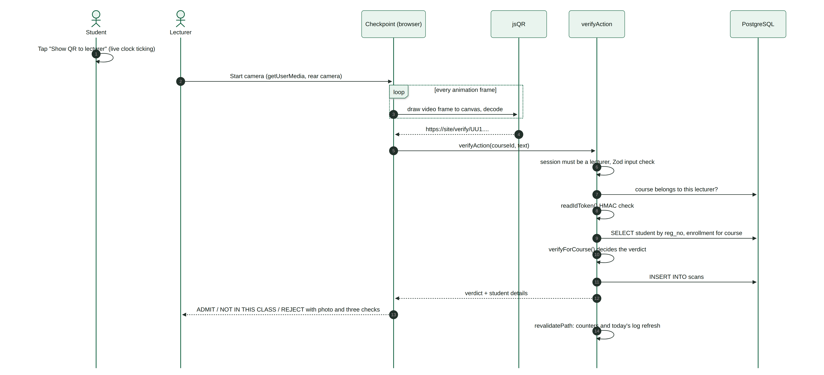
Figure 3.6: Sequence of a scan from the student's phone to the lecturer's result

3.7.6 Card status
Figure 3.7 shows the states a card can be in. Expiry is computed from id_expires_on and the current date; a card within 30 days of expiry shows a warning in the student's wallet; suspension comes from the register; and reissuing a card increases card_version, which invalidates the old QR code immediately without any list of revoked cards.
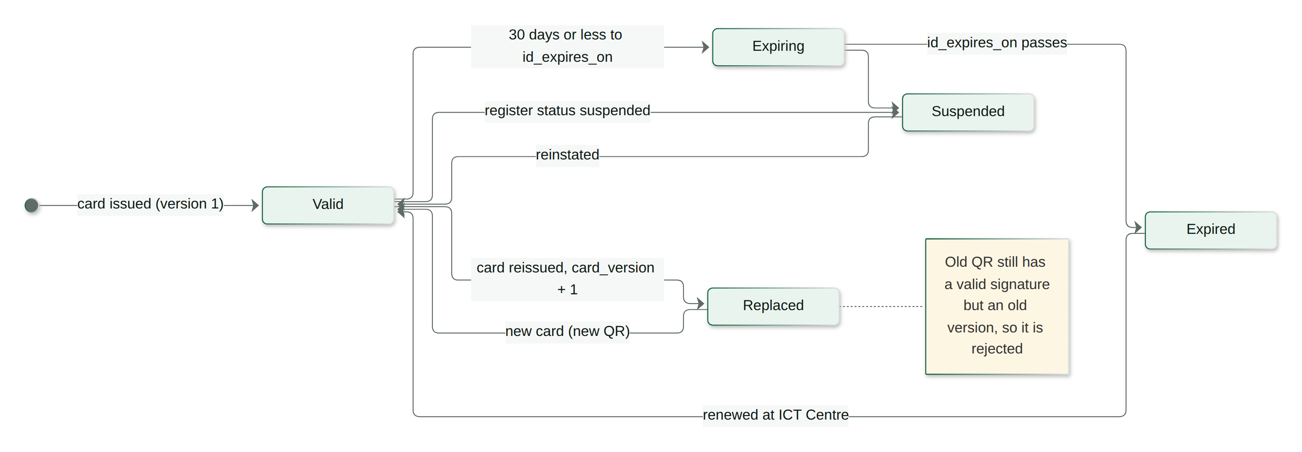
Figure 3.7: States of an ID card

3.7.7 Anti-screenshot measure
Because the QR code is shown on a phone, someone could try to present a screenshot of another student's card. The full-screen QR view therefore shows a large live clock that ticks every second, together with the student's name and registration number; a lecturer can see at a glance whether the screen is live. The verification result also shows the student's photograph so the lecturer can compare it with the face of the person.

3.7.8 Authentication, authorisation and privacy
- Passwords and sessions: bcrypt hashes; HS256-signed session tokens in HTTP-only, SameSite=Lax cookies (Secure in production), valid for seven days.
- Role separation: proxy.ts sends students away from /scan, /courses and /log and lecturers away from /card; requireRole() repeats the check in every page.
- Course scoping: verifyScan, classRoster, sessionLog and scanLog all filter by the signed-in lecturer's id, so a lecturer cannot verify against, or read the register of, a course they do not teach.
- Student scoping: myStudentRecord returns only the signed-in student's register entry and courses.
- Public page: shows only the name, registration number, department, level, expiry and card version, which are already printed on the card.
- Validation and SQL: Zod validates scan input; Drizzle sends all values as parameters.
- Key management: SESSION_SECRET is set on Railway and never committed; changing it invalidates every QR code, which acts as an emergency reset.

3.7.9 User interface design
Each role's screen follows its task. The lecturer's checkpoint is arranged like an access-control console: a dark session strip with the course switcher and counters, the camera viewport with a scan frame on the left, and on the right a result panel whose top band says what to do in large type and colour, followed by the student's photo, details and checks, and today's log. The student's view is a wallet: a card that looks like a security-printed ID (guilloche pattern, gold stripe, holographic seal, magnetic-stripe back) on a green stage, with large buttons to show the QR or flip the card. The palette is University of Uyo green with a gold accent; Inter is used for text and JetBrains Mono for registration numbers. ID photographs are portraits generated with DiceBear rather than real faces, so no real person's image is attached to a fictional record.

3.7.10 Seed data
Table 3.7: Seeded demonstration data
Item | Quantity and notes
Student register | 48 students: 28 Computer Science, 6 Law, 6 Economics, 5 Electrical/Electronic Engineering, 3 Microbiology
Lecturers | 3, including the demo lecturer Dr. Aniefiok Ekong (CSC 311, CSC 305, CSC 201)
Courses and registrations | 7 courses and 64 registrations; CSC 311 has 21 students
Problem cases | 1 suspended student, 2 expired cards (one graduated), 1 card expiring within 30 days, 1 reissued card (version 2)
Scan history | 36 past scans across the demo lecturer's courses
Demo students | Ubong Akpan (CSC 311 and CSC 305) and Uduak Etuk (Law, for the not-in-this-class case)

3.7.11 Version control and deployment
The repository is on GitHub and connected to a Railway service that deploys the main branch (Figure 3.8), with a separate Railway PostgreSQL service supplying DATABASE_URL=${{uni-digital-id-postgres.DATABASE_URL}}. On start, migrations are applied, the register is seeded only if empty, and the health check at /api/health must pass before traffic is switched. The QR codes are generated from the request's public origin, so cards printed from the deployed site point to the deployed verification page. The live application is available at https://uni-digital-id-production.up.railway.app.
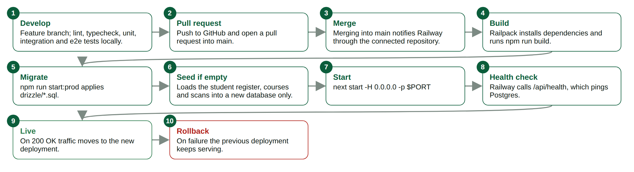
Figure 3.8: Build and deployment pipeline from GitHub to Railway

3.7.12 Application screens
Figure 3.9 to Figure 3.26 show the screens, captured from the application running in production mode with the deployment's seed data and the clock fixed at 5 October 2026.
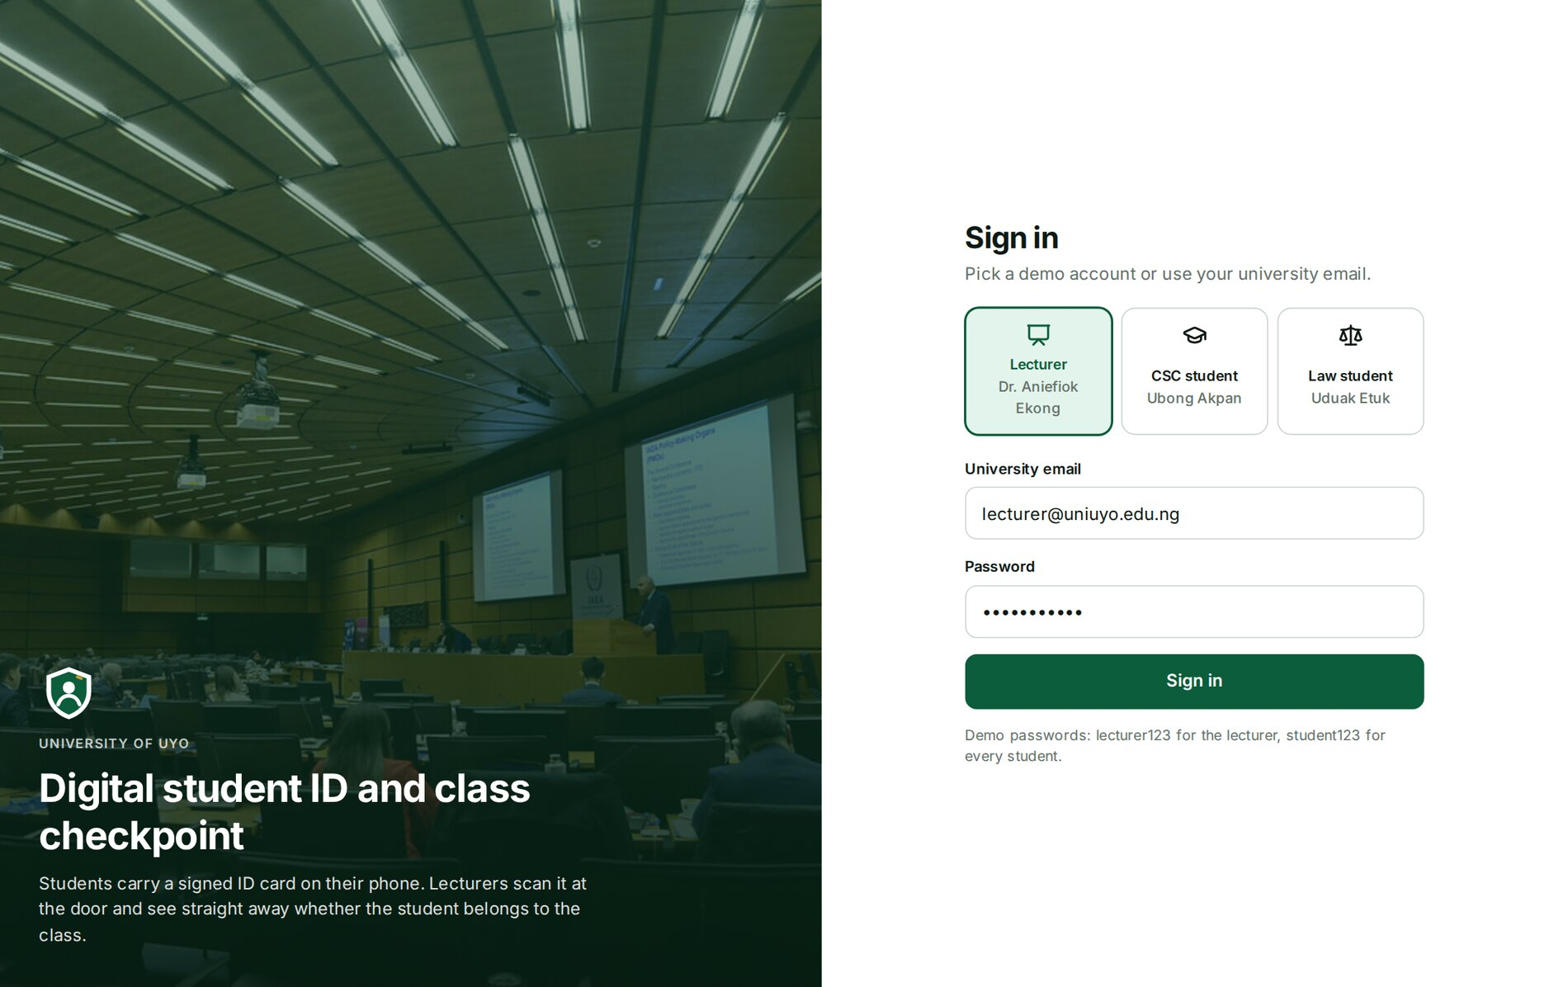
Figure 3.9: Sign-in page with role selection for the three demo accounts
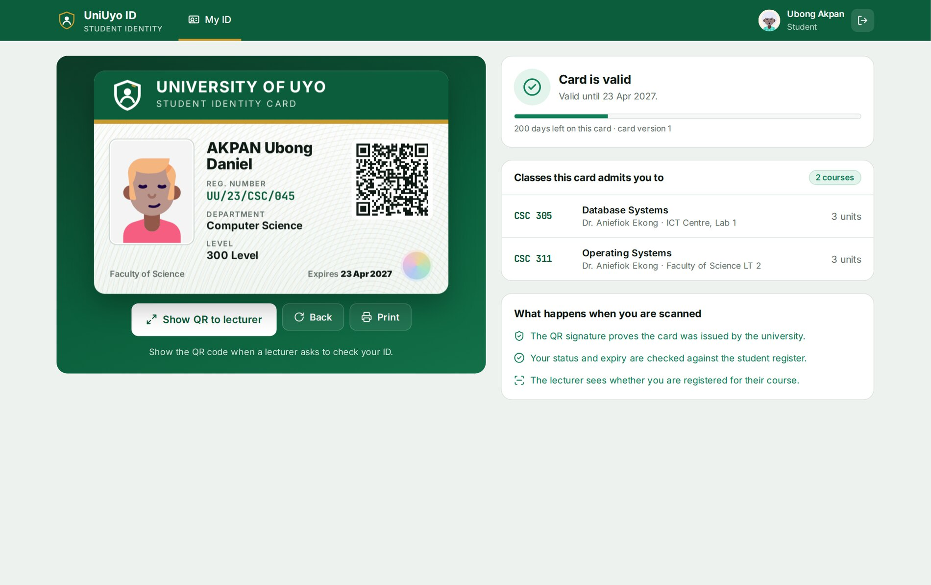
Figure 3.10: Student ID wallet: card, status, classes the card admits the student to, and how scanning works
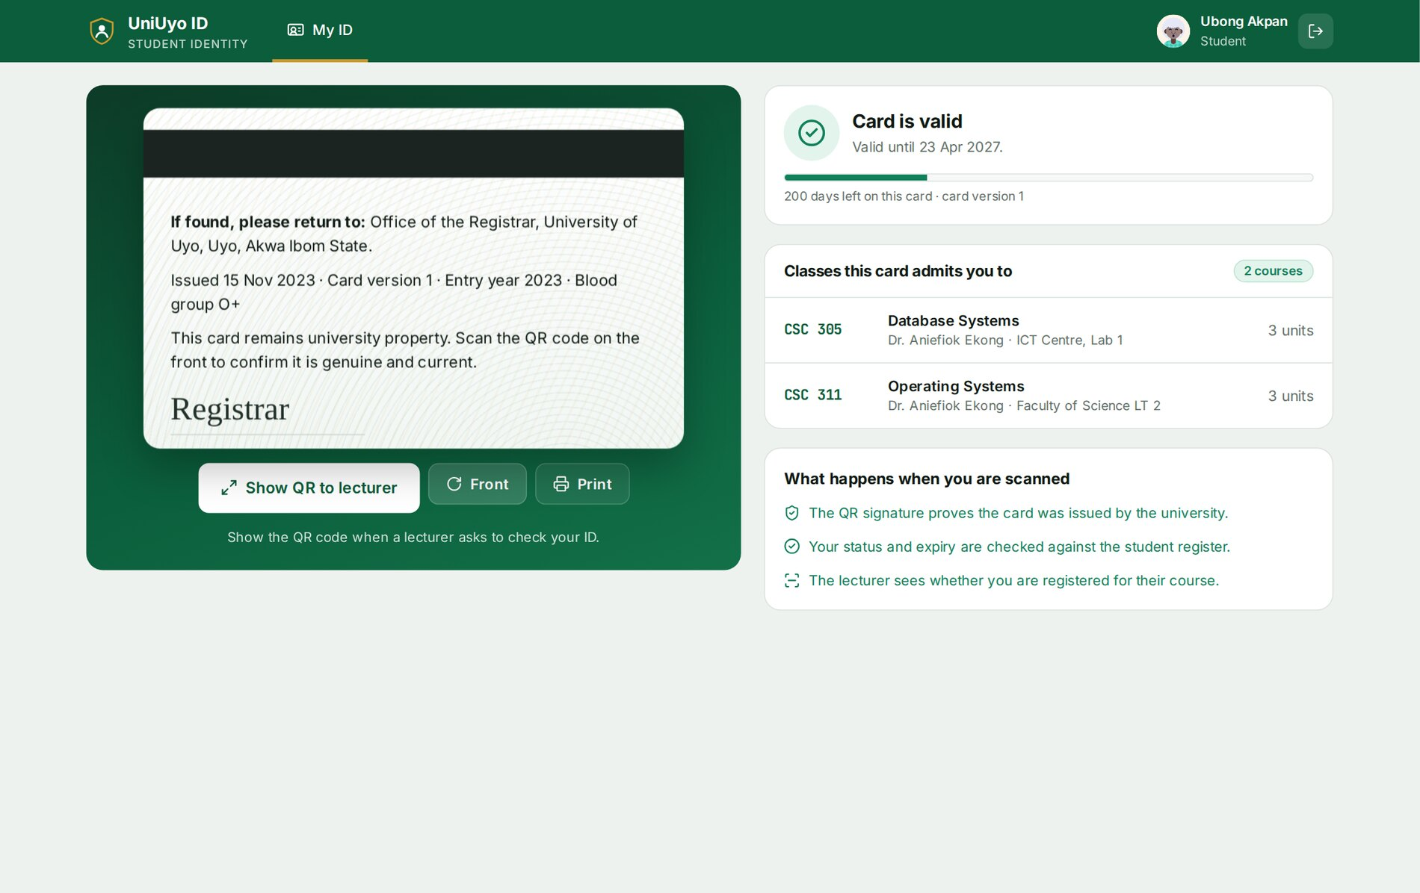
Figure 3.11: The back of the card after pressing Back
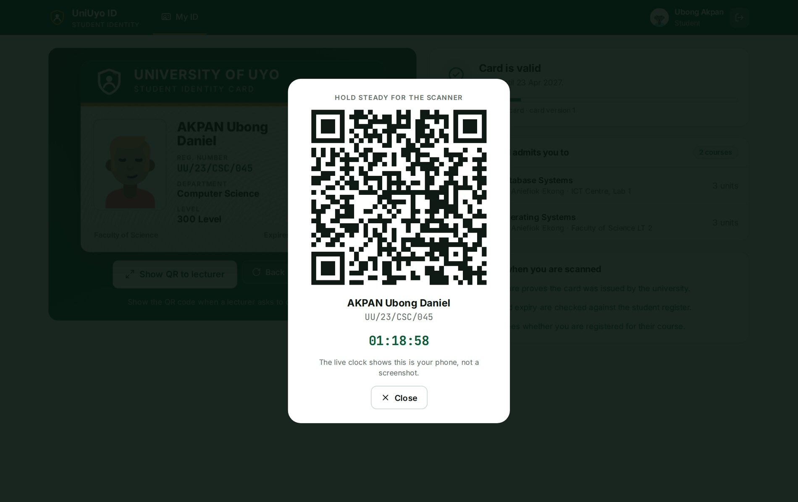
Figure 3.12: QR code shown full screen with a live clock
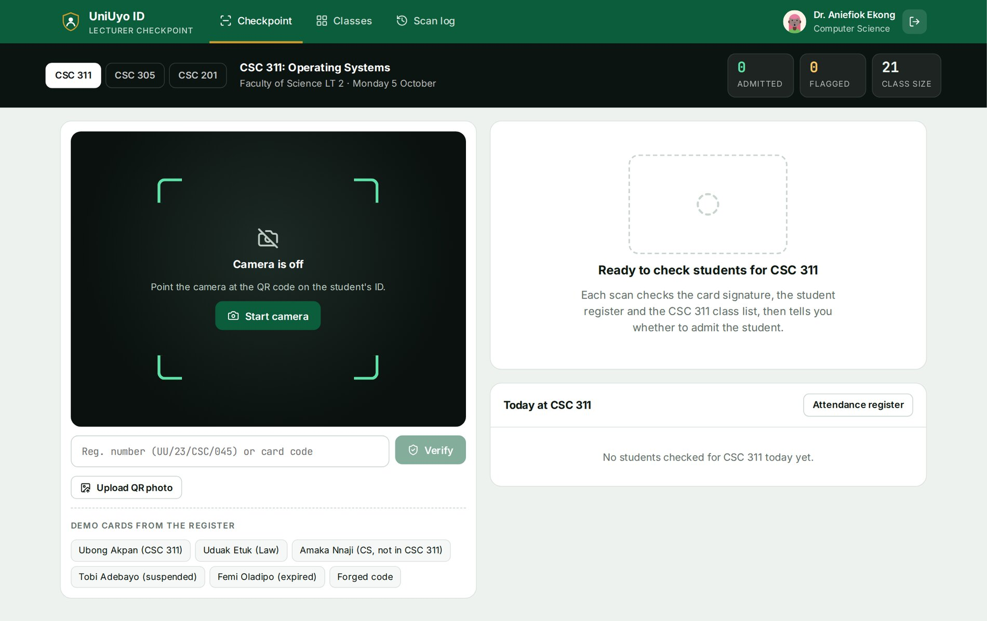
Figure 3.13: Lecturer checkpoint for CSC 311 before the first scan
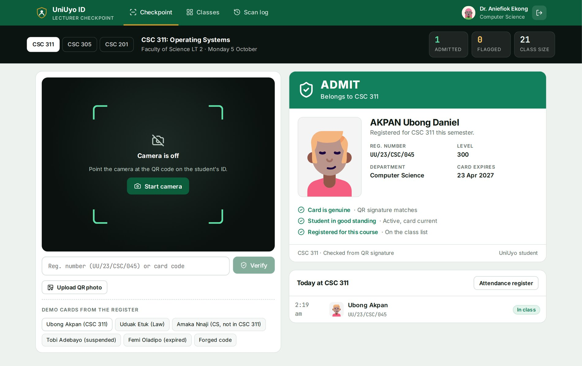
Figure 3.14: A registered student: ADMIT
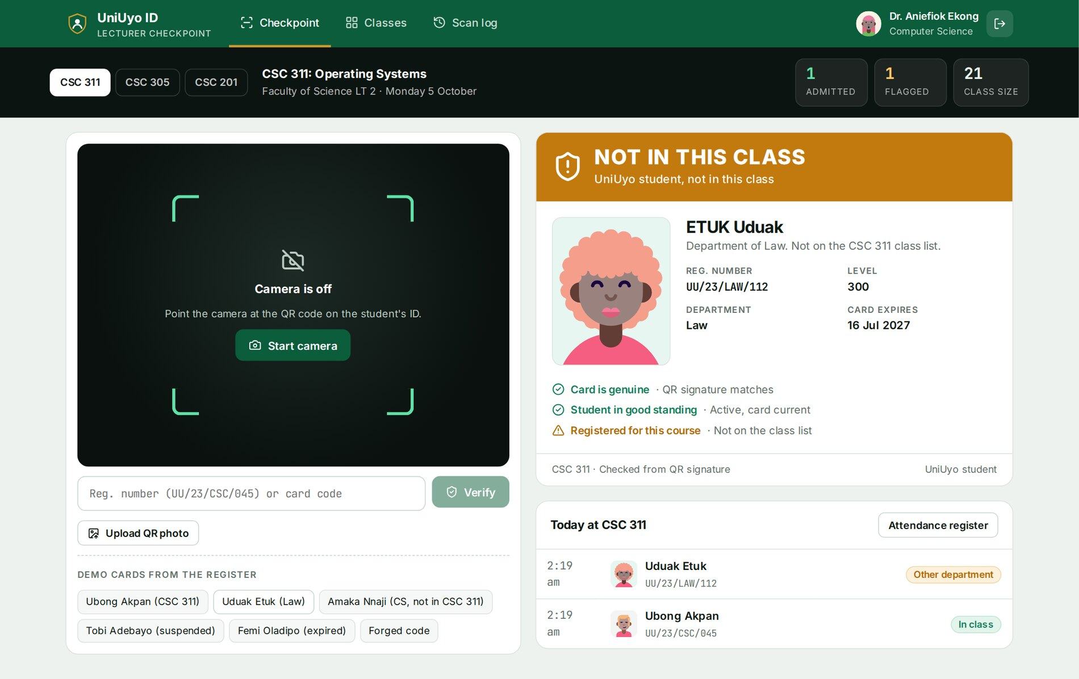
Figure 3.15: A Law student scanned at CSC 311: NOT IN THIS CLASS
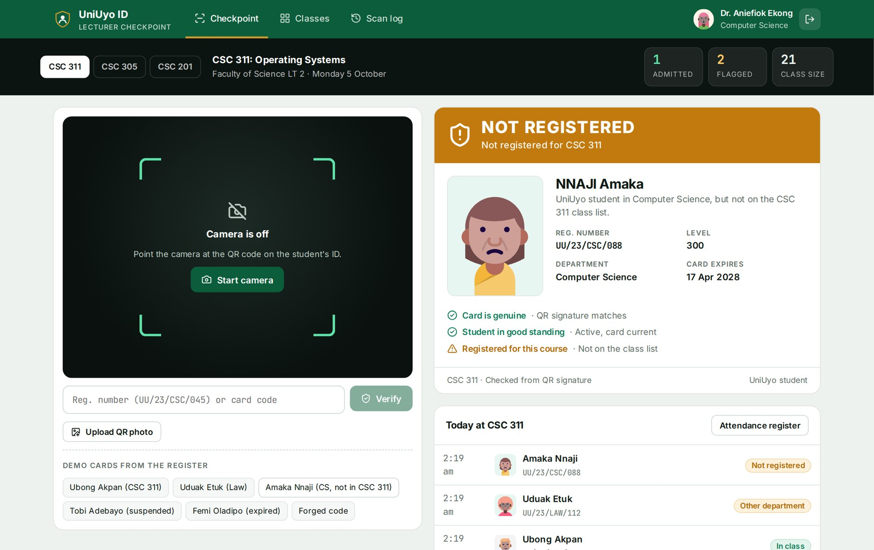
Figure 3.16: A Computer Science student who did not register for CSC 311: NOT REGISTERED
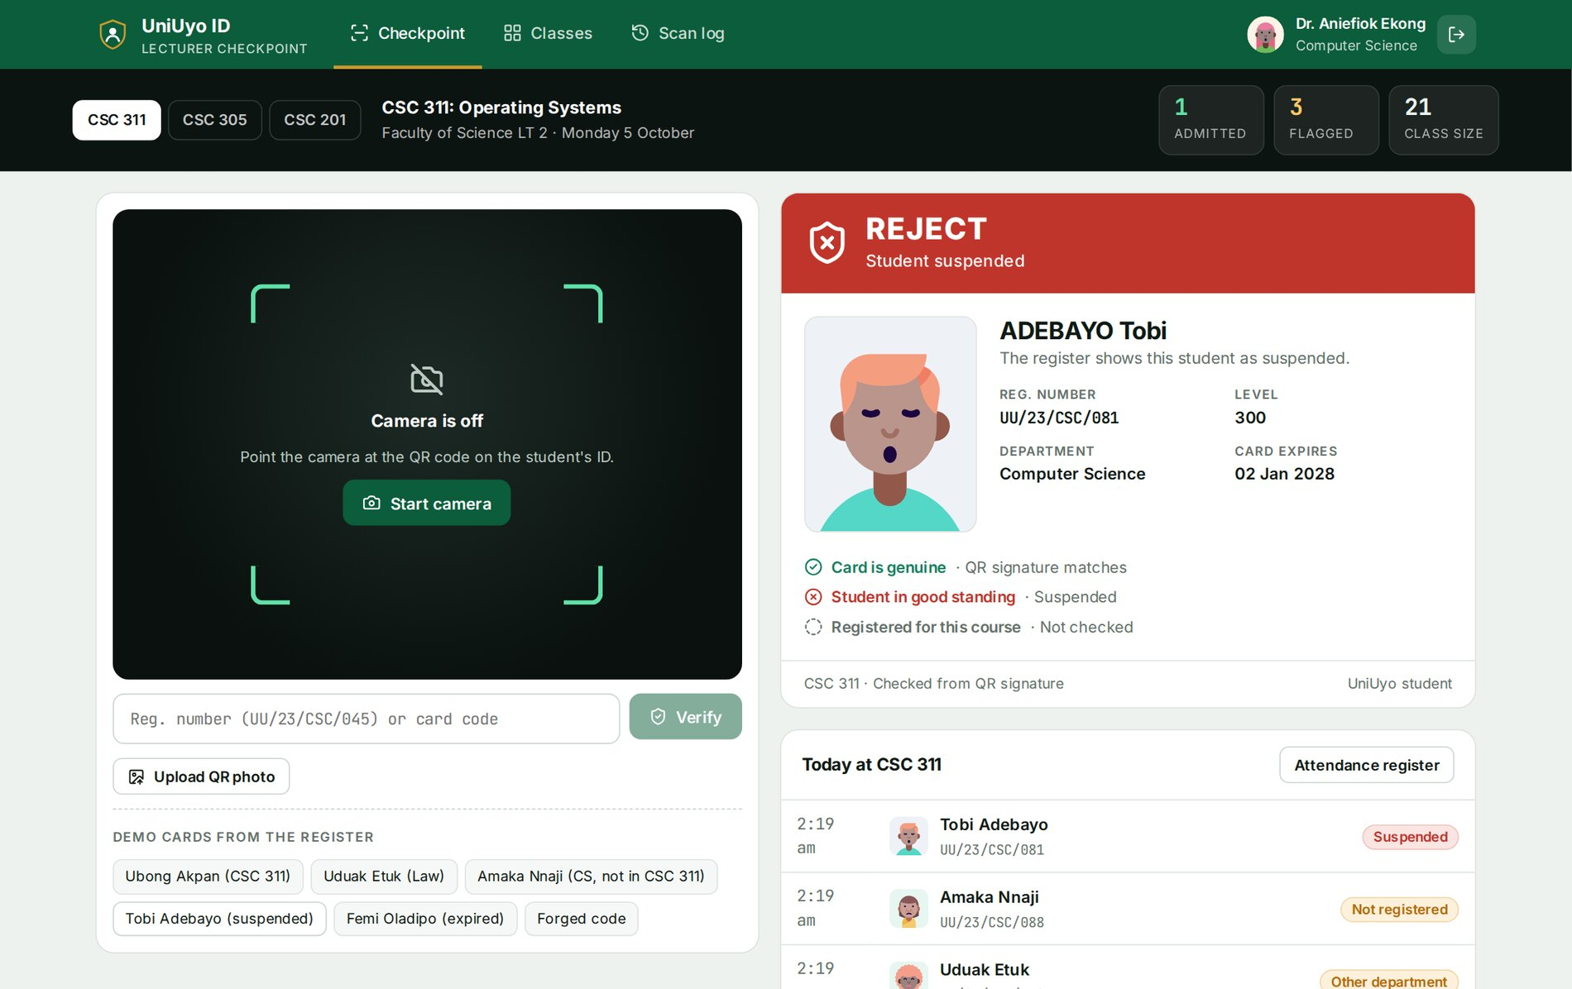
Figure 3.17: A suspended student: REJECT
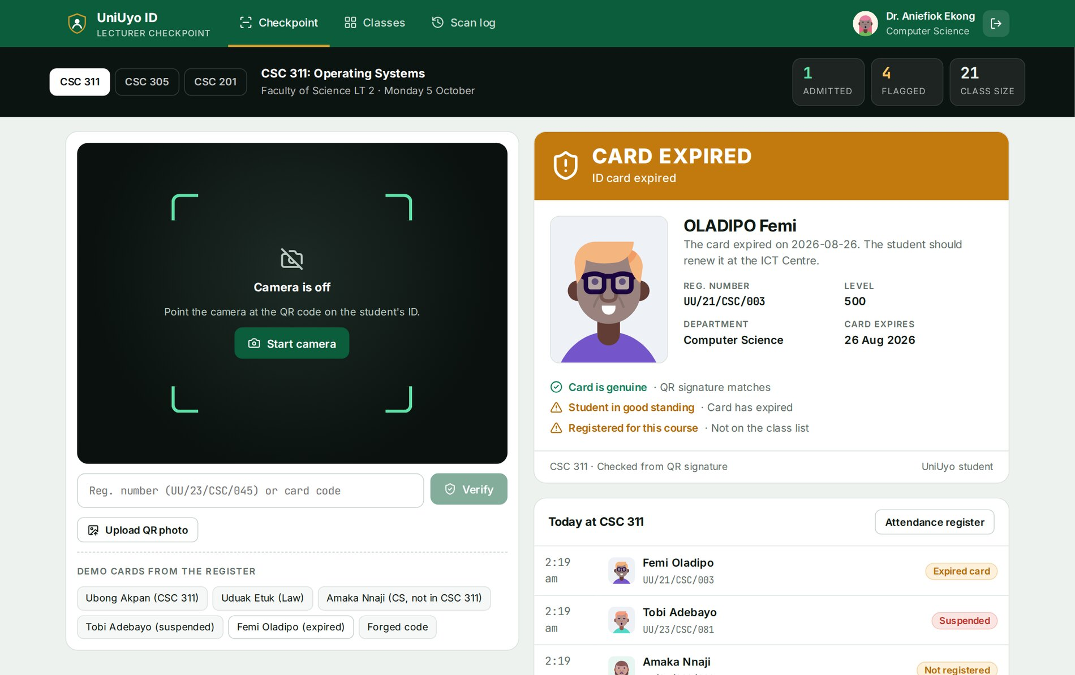
Figure 3.18: A graduated student's expired card: CARD EXPIRED
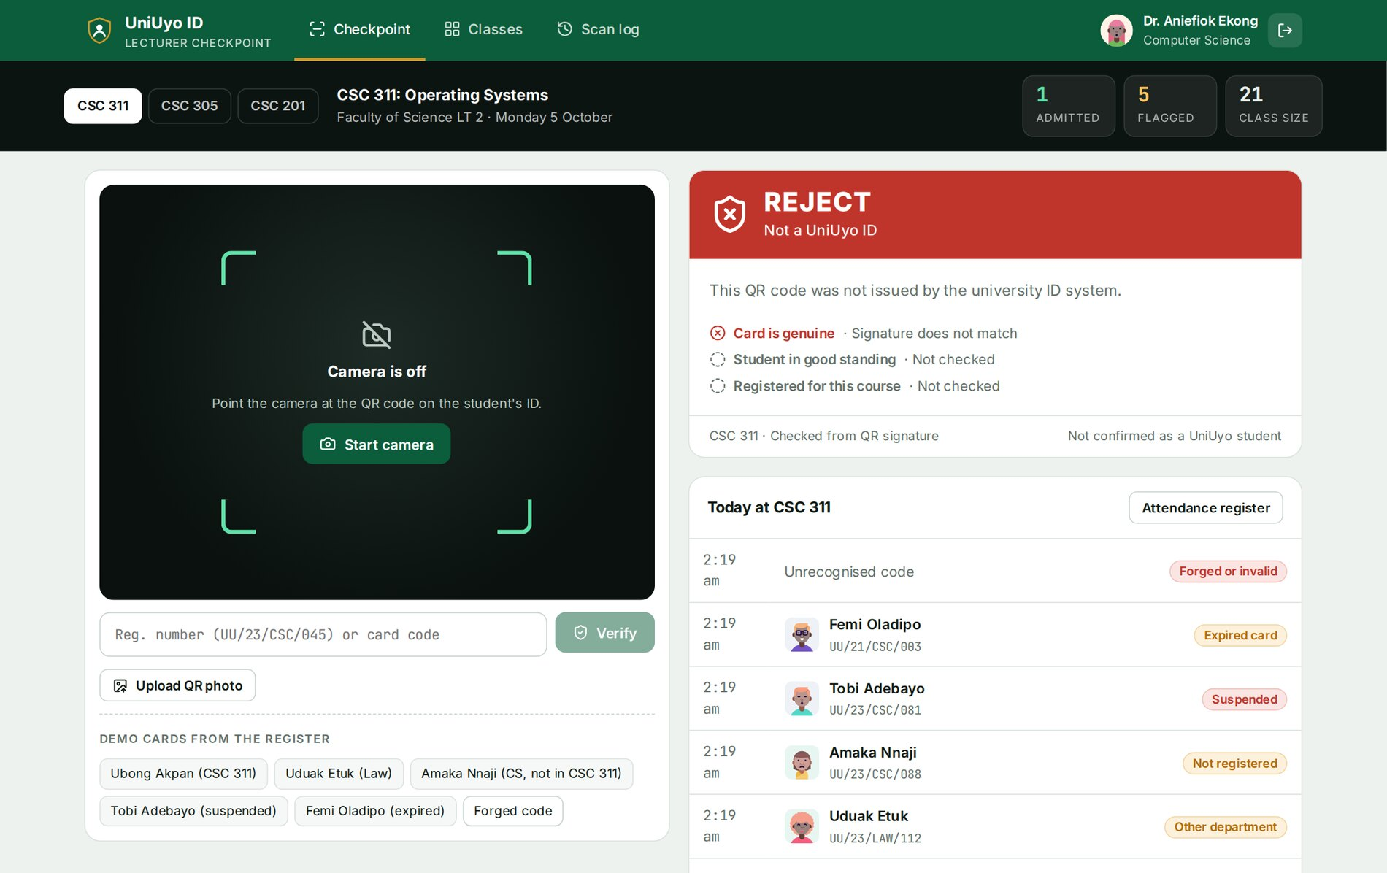
Figure 3.19: A forged code: REJECT, not a UniUyo ID
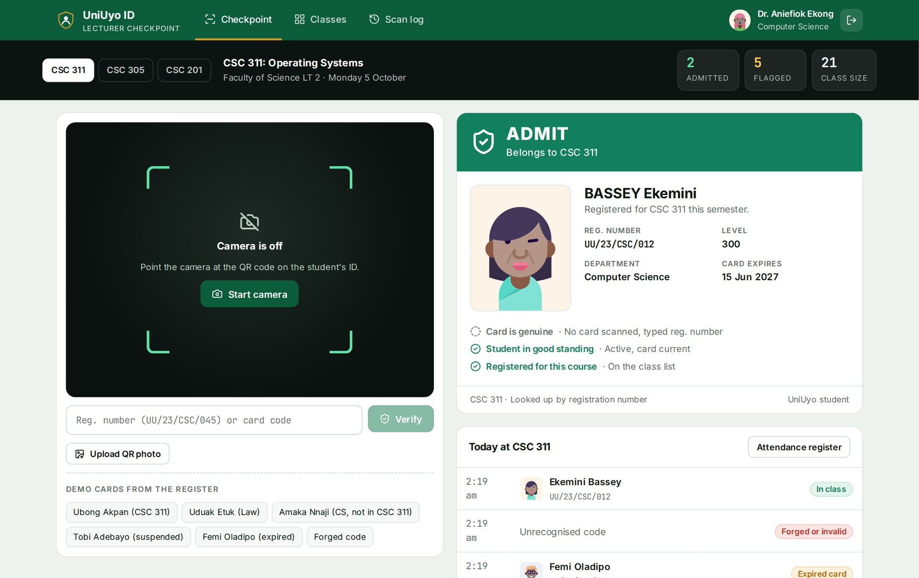
Figure 3.20: Verification by a typed registration number (signature check skipped)
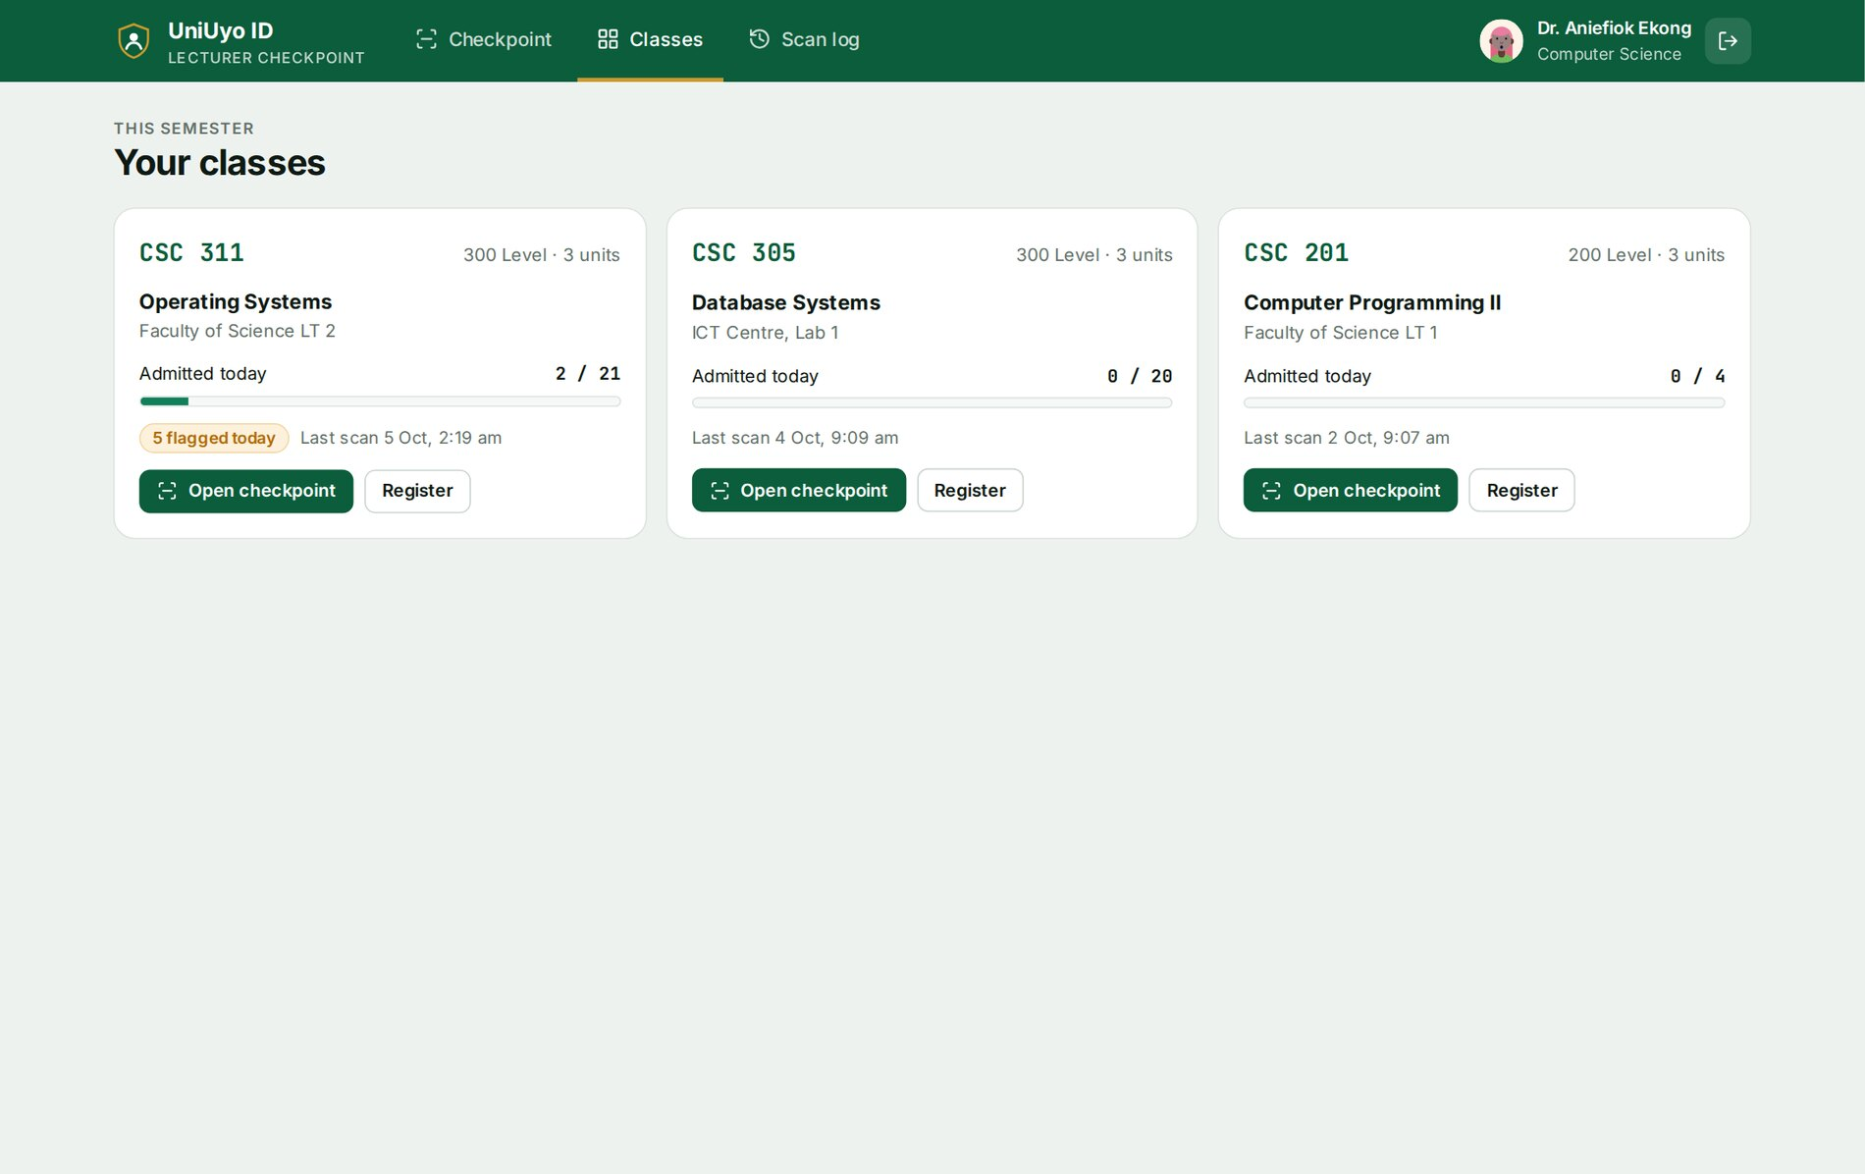
Figure 3.21: The lecturer's classes with admitted-today progress
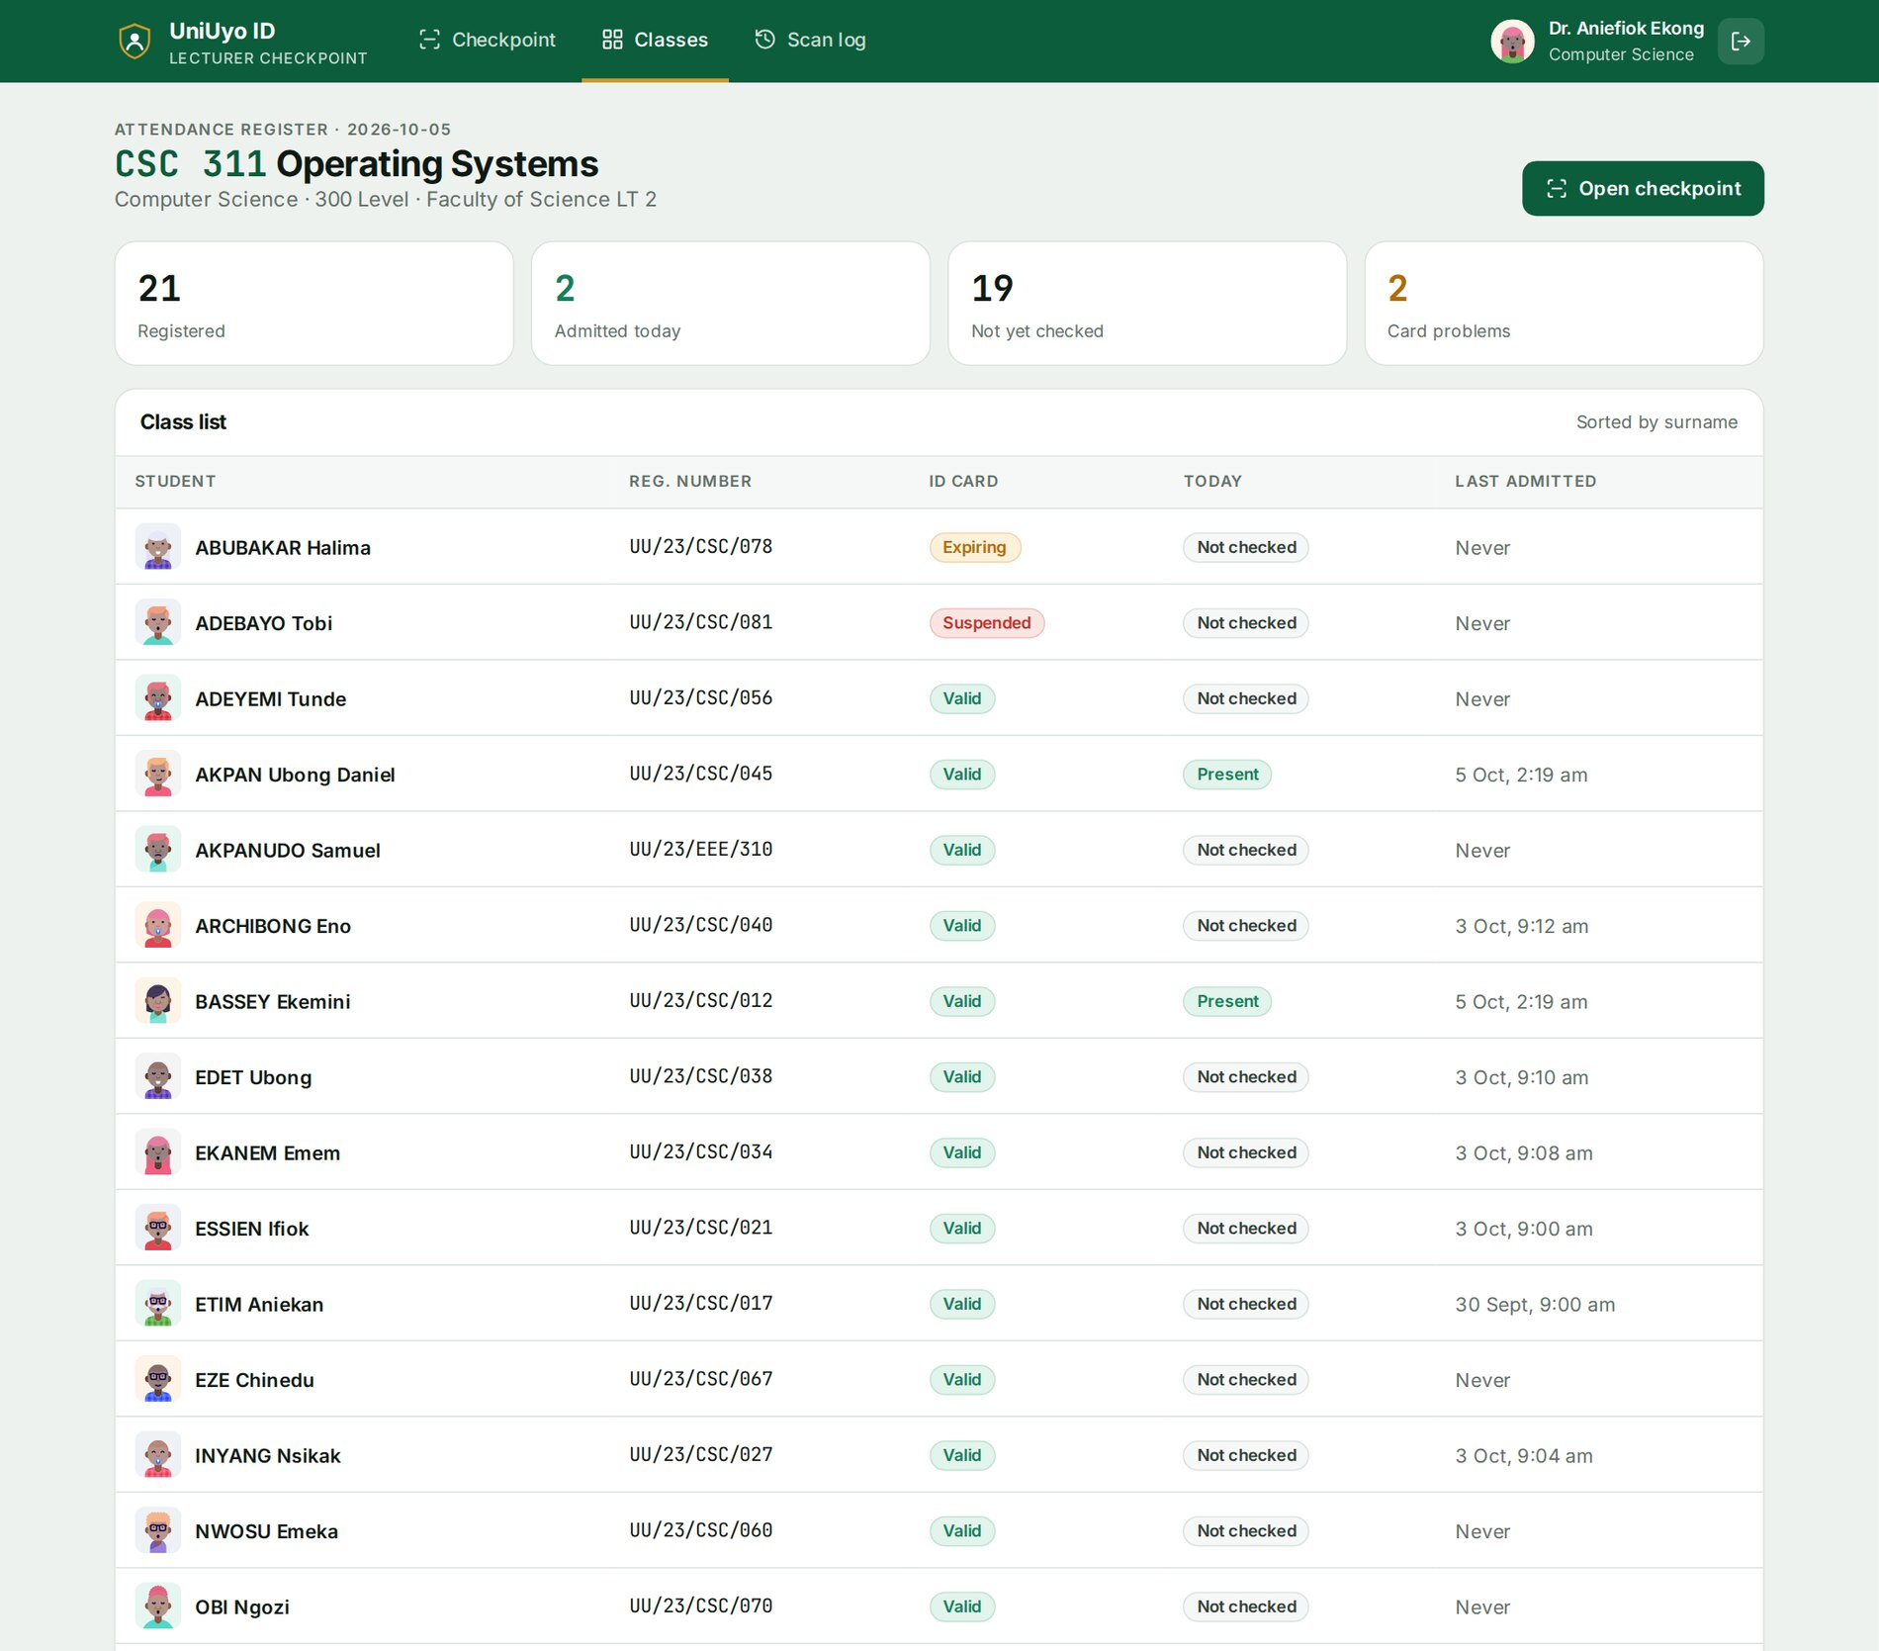
Figure 3.22: Attendance register for CSC 311
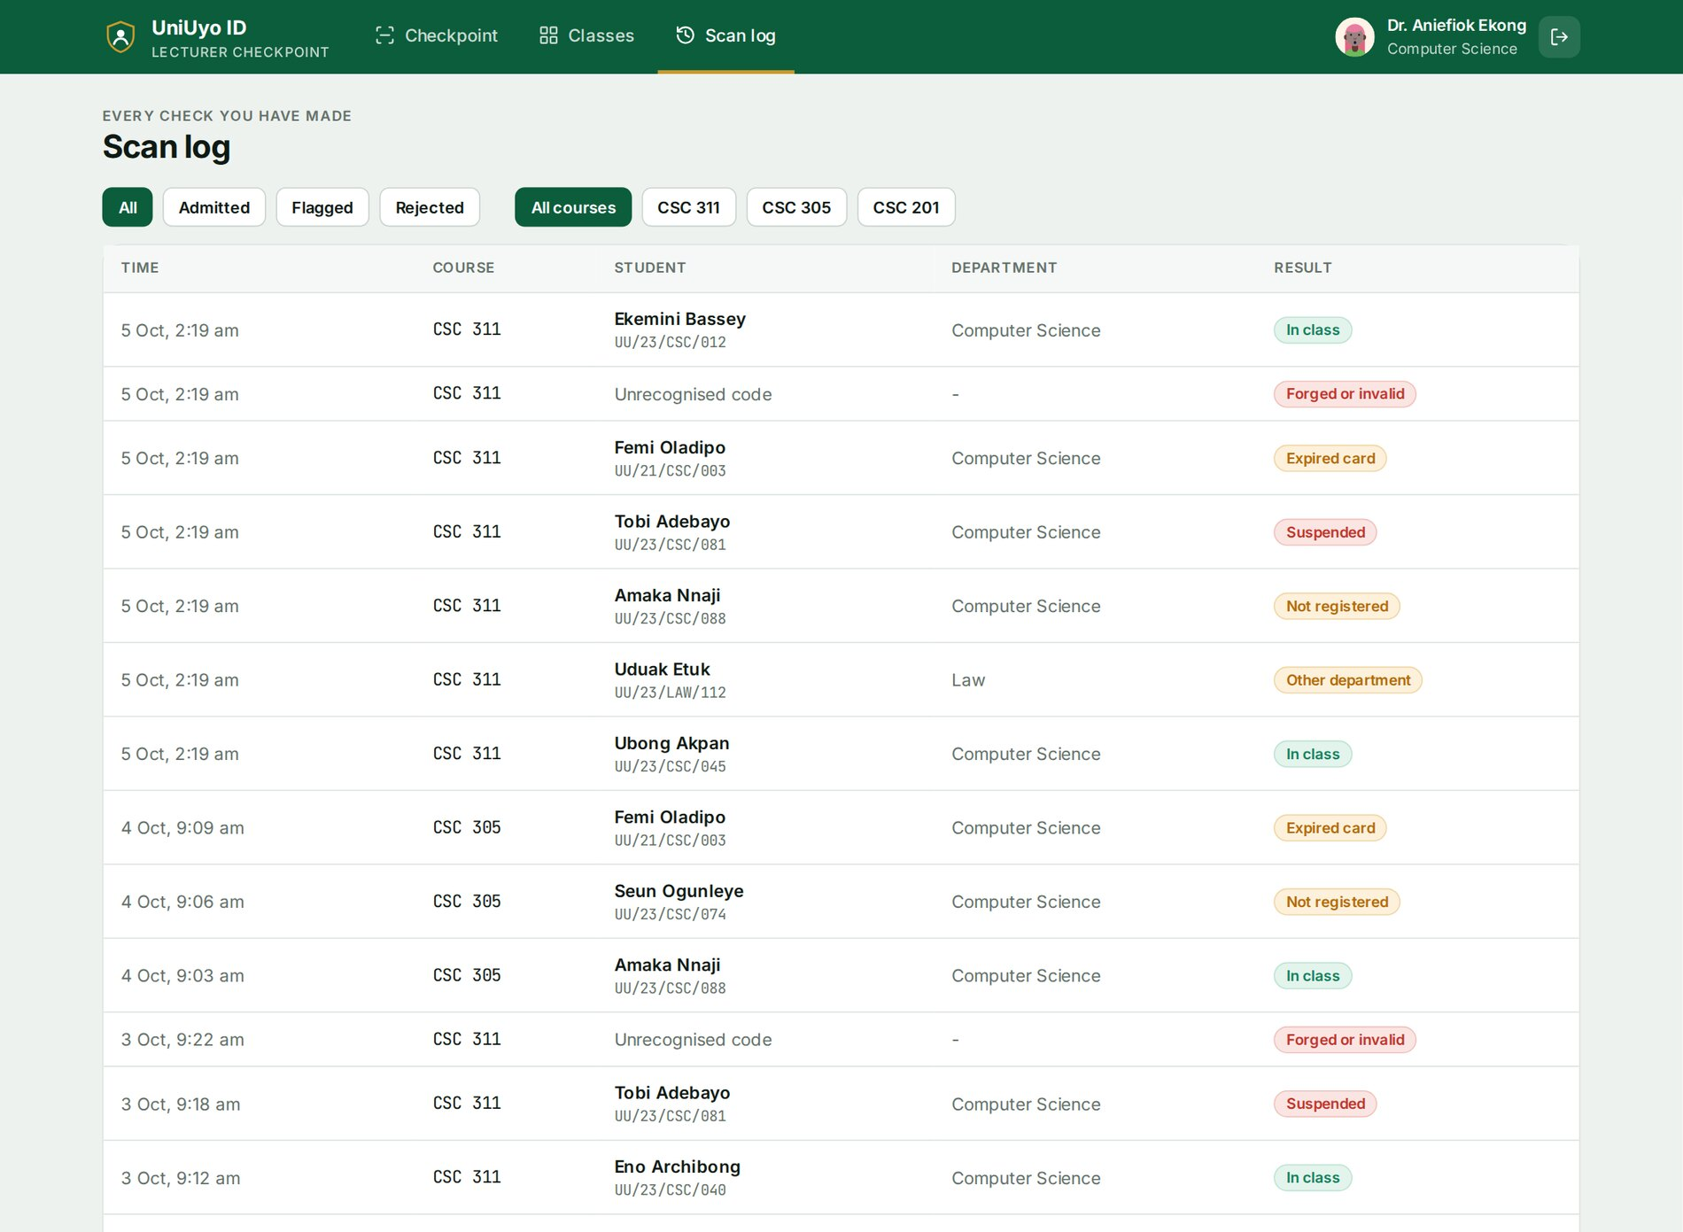
Figure 3.23: Scan log of all checks
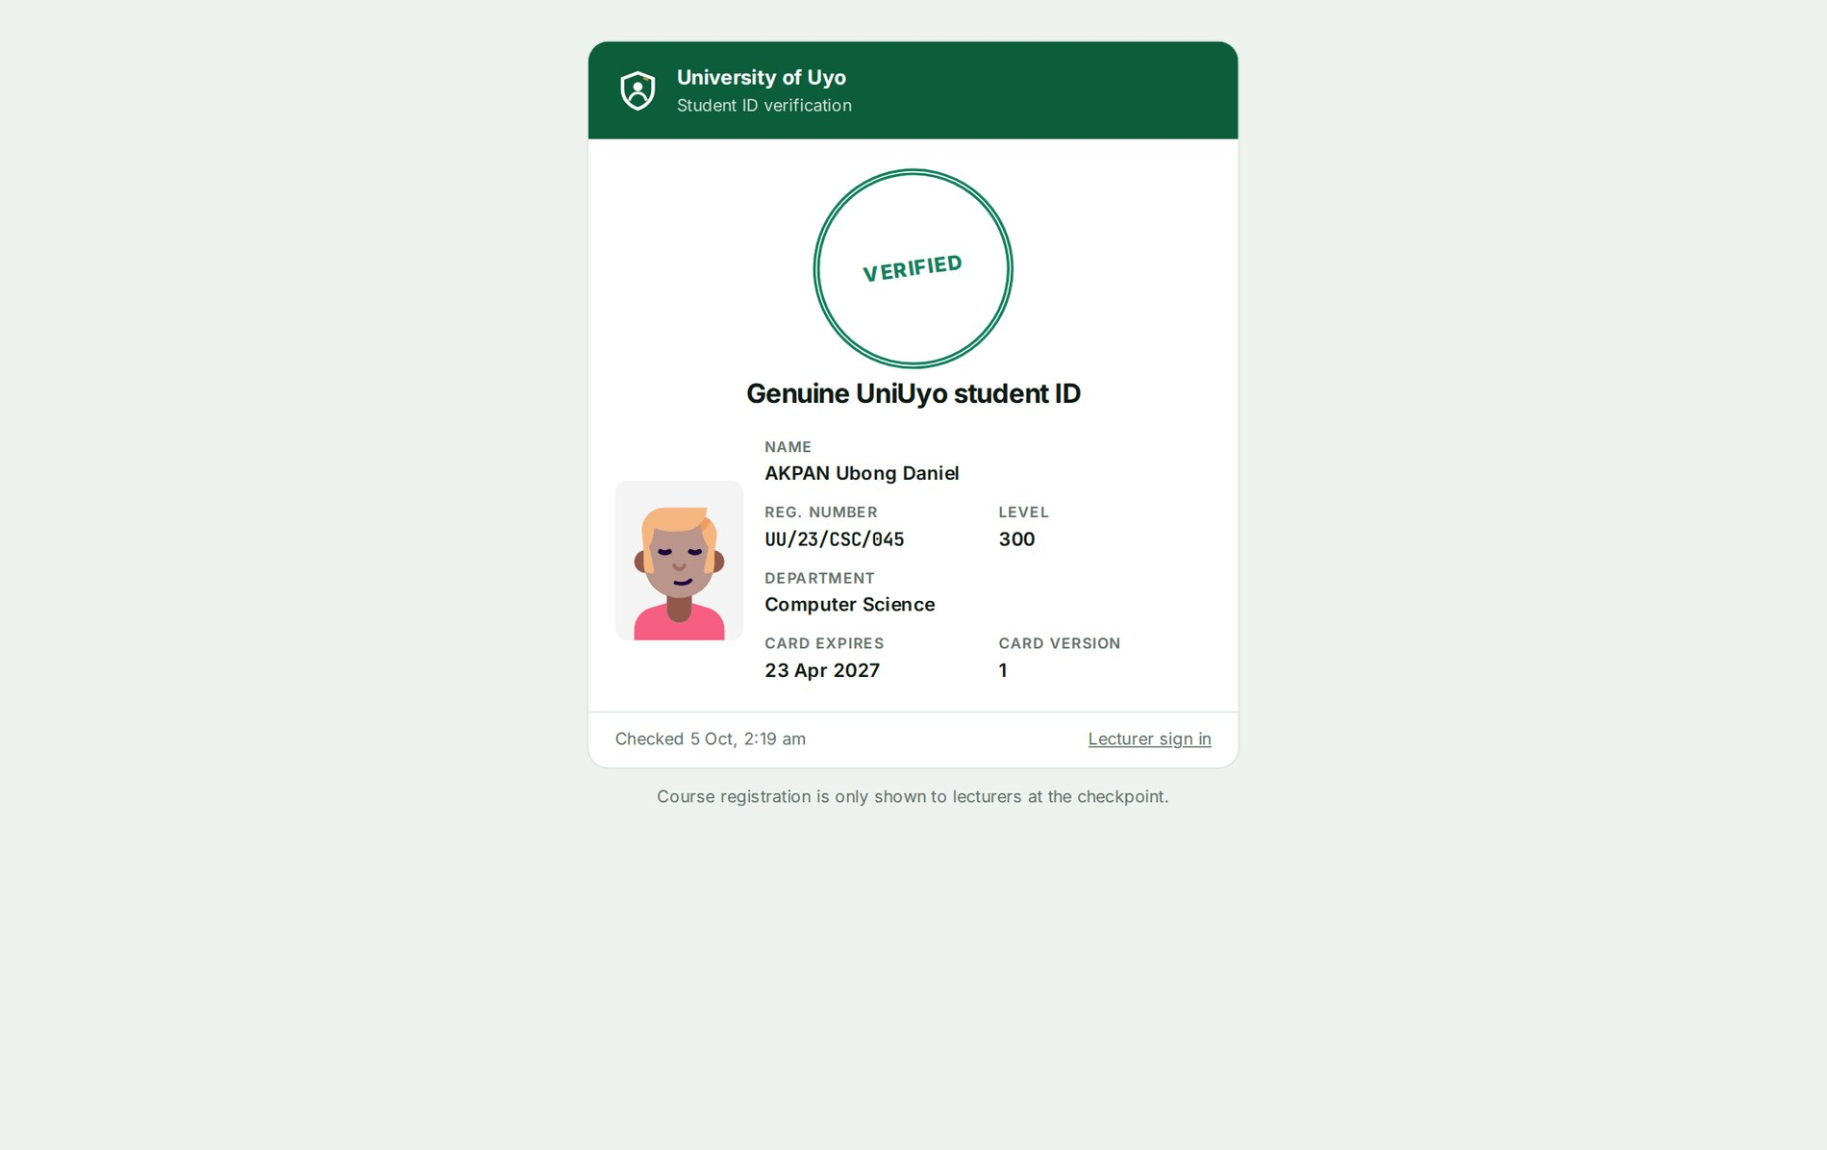
Figure 3.24: Public verification page opened from a genuine card
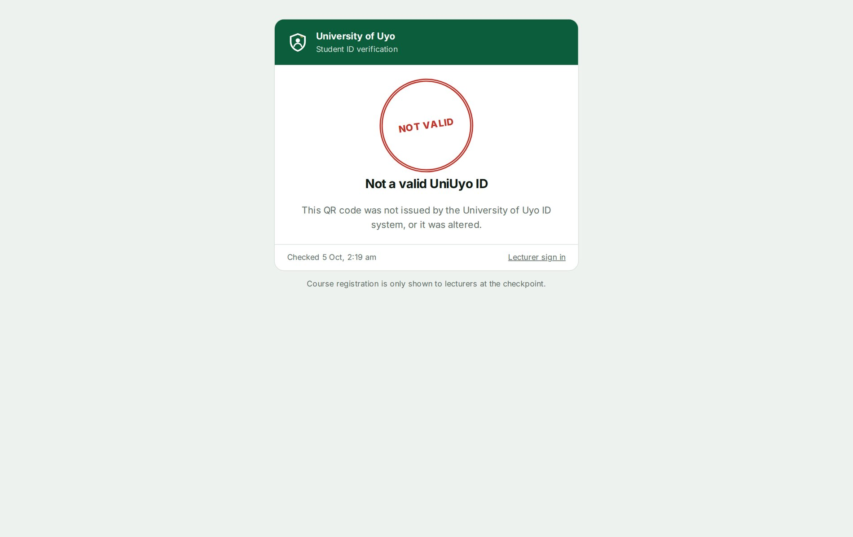
Figure 3.25: Public verification page for a forged code
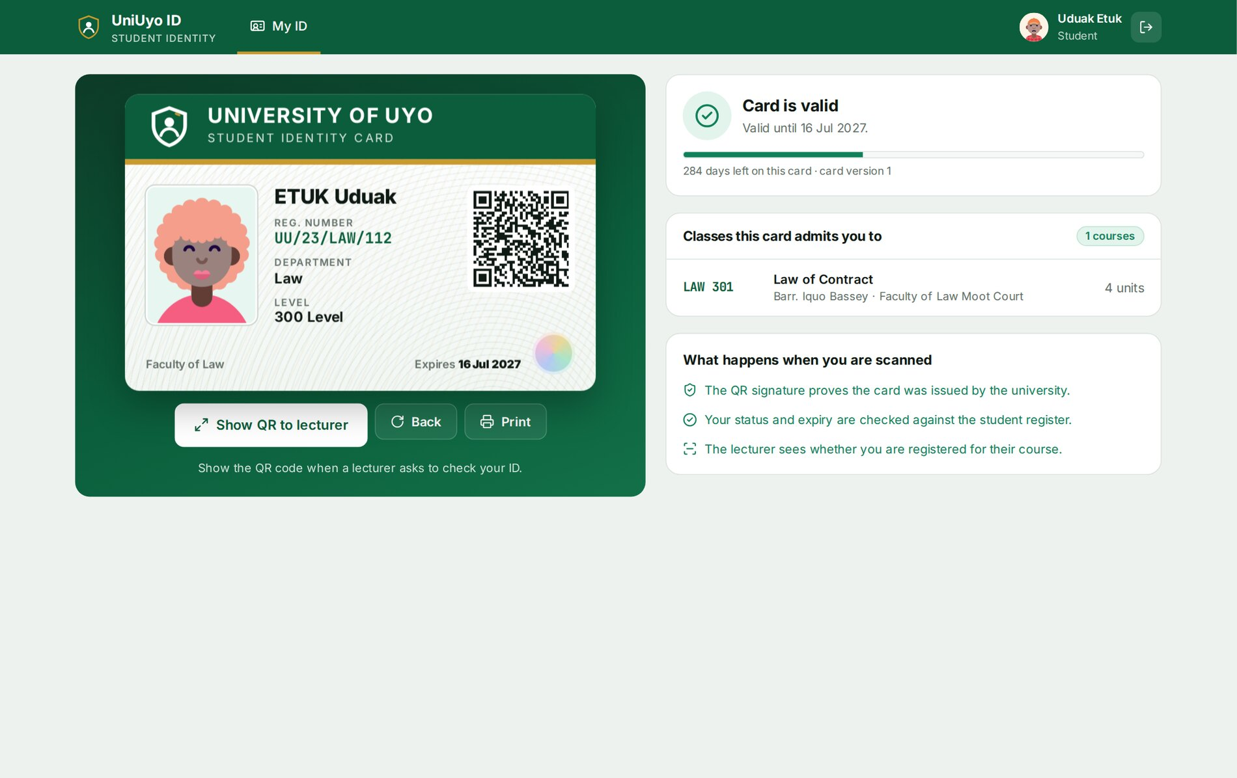
Figure 3.26: The Law student's own ID wallet

3.8 TESTING AND EVALUATION
Testing was automated at three levels (Table 3.8). Unit tests cover the token and every verdict; integration tests run the real queries against a separate database (uniid_test); and Playwright drives Chromium against a production build on a desktop screen and a phone-sized screen. One end-to-end test generates a real QR image with the test server's key, uploads it on the checkpoint and checks that it is decoded in the browser and verified.
Table 3.8: Test levels and results
Level | Tool | What is tested | Result
Unit | Vitest | Token format, round trip, edited registration number, bumped version, wrong key, junk, URL extraction; every verdict and their order; card states; registration number normalising; dates; sessions | 19 of 19 passed
Integration | Vitest + PostgreSQL | All outcomes against the seeded register, typed lookup, course ownership, scoping, roster, public lookup, scan log | 14 of 14 passed
End to end | Playwright (Chromium) | Desktop journeys (7 tests) and a mobile journey (1 test) | 8 of 8 passed

Table 3.9: Representative test cases
ID | Test | Expected result | Actual result
T1 | Open /scan without signing in | Redirected to /login, lecturer account prefilled | Pass
T2 | Student opens their wallet | Name AKPAN Ubong Daniel, UU/23/CSC/045, Valid, CSC 311 listed | Pass
T3 | Show QR full screen | Registration number shown and clock in HH:MM:SS format | Pass
T4 | Open the card's QR link | "Genuine UniUyo student ID" | Pass
T5 | Scan a CSC 311 student at CSC 311 | ADMIT, "Belongs to CSC 311"; admitted counter 1; name in today's log | Pass
T6 | Type the Law student's registration number | NOT IN THIS CLASS; ETUK Uduak shown | Pass
T7 | Submit a forged code | REJECT, "Not a UniUyo ID" | Pass
T8 | Upload a photo of a QR code for a CS student not in CSC 311 | Decoded in the browser; NOT REGISTERED; "Checked from QR signature" | Pass
T9 | Scan the reissued card's old QR (version 1), then the new one (version 2) | Old card rejected; new card admitted | Pass
T10 | Scan suspended and graduated students | suspended and expired outcomes | Pass
T11 | Token signed with another key, or with an edited registration number | Rejected (signature) | Pass
T12 | Verify against a course taught by another lecturer | Refused (no result, no log) | Pass
T13 | Filter the scan log by Rejected | Only Suspended, Old card, Not in register, Forged or invalid rows | Pass
T14 | Law student opens /scan | Redirected to /card | Pass
T15 | Phone: student card and lecturer scan | No sideways scroll; result scrolled into view | Pass

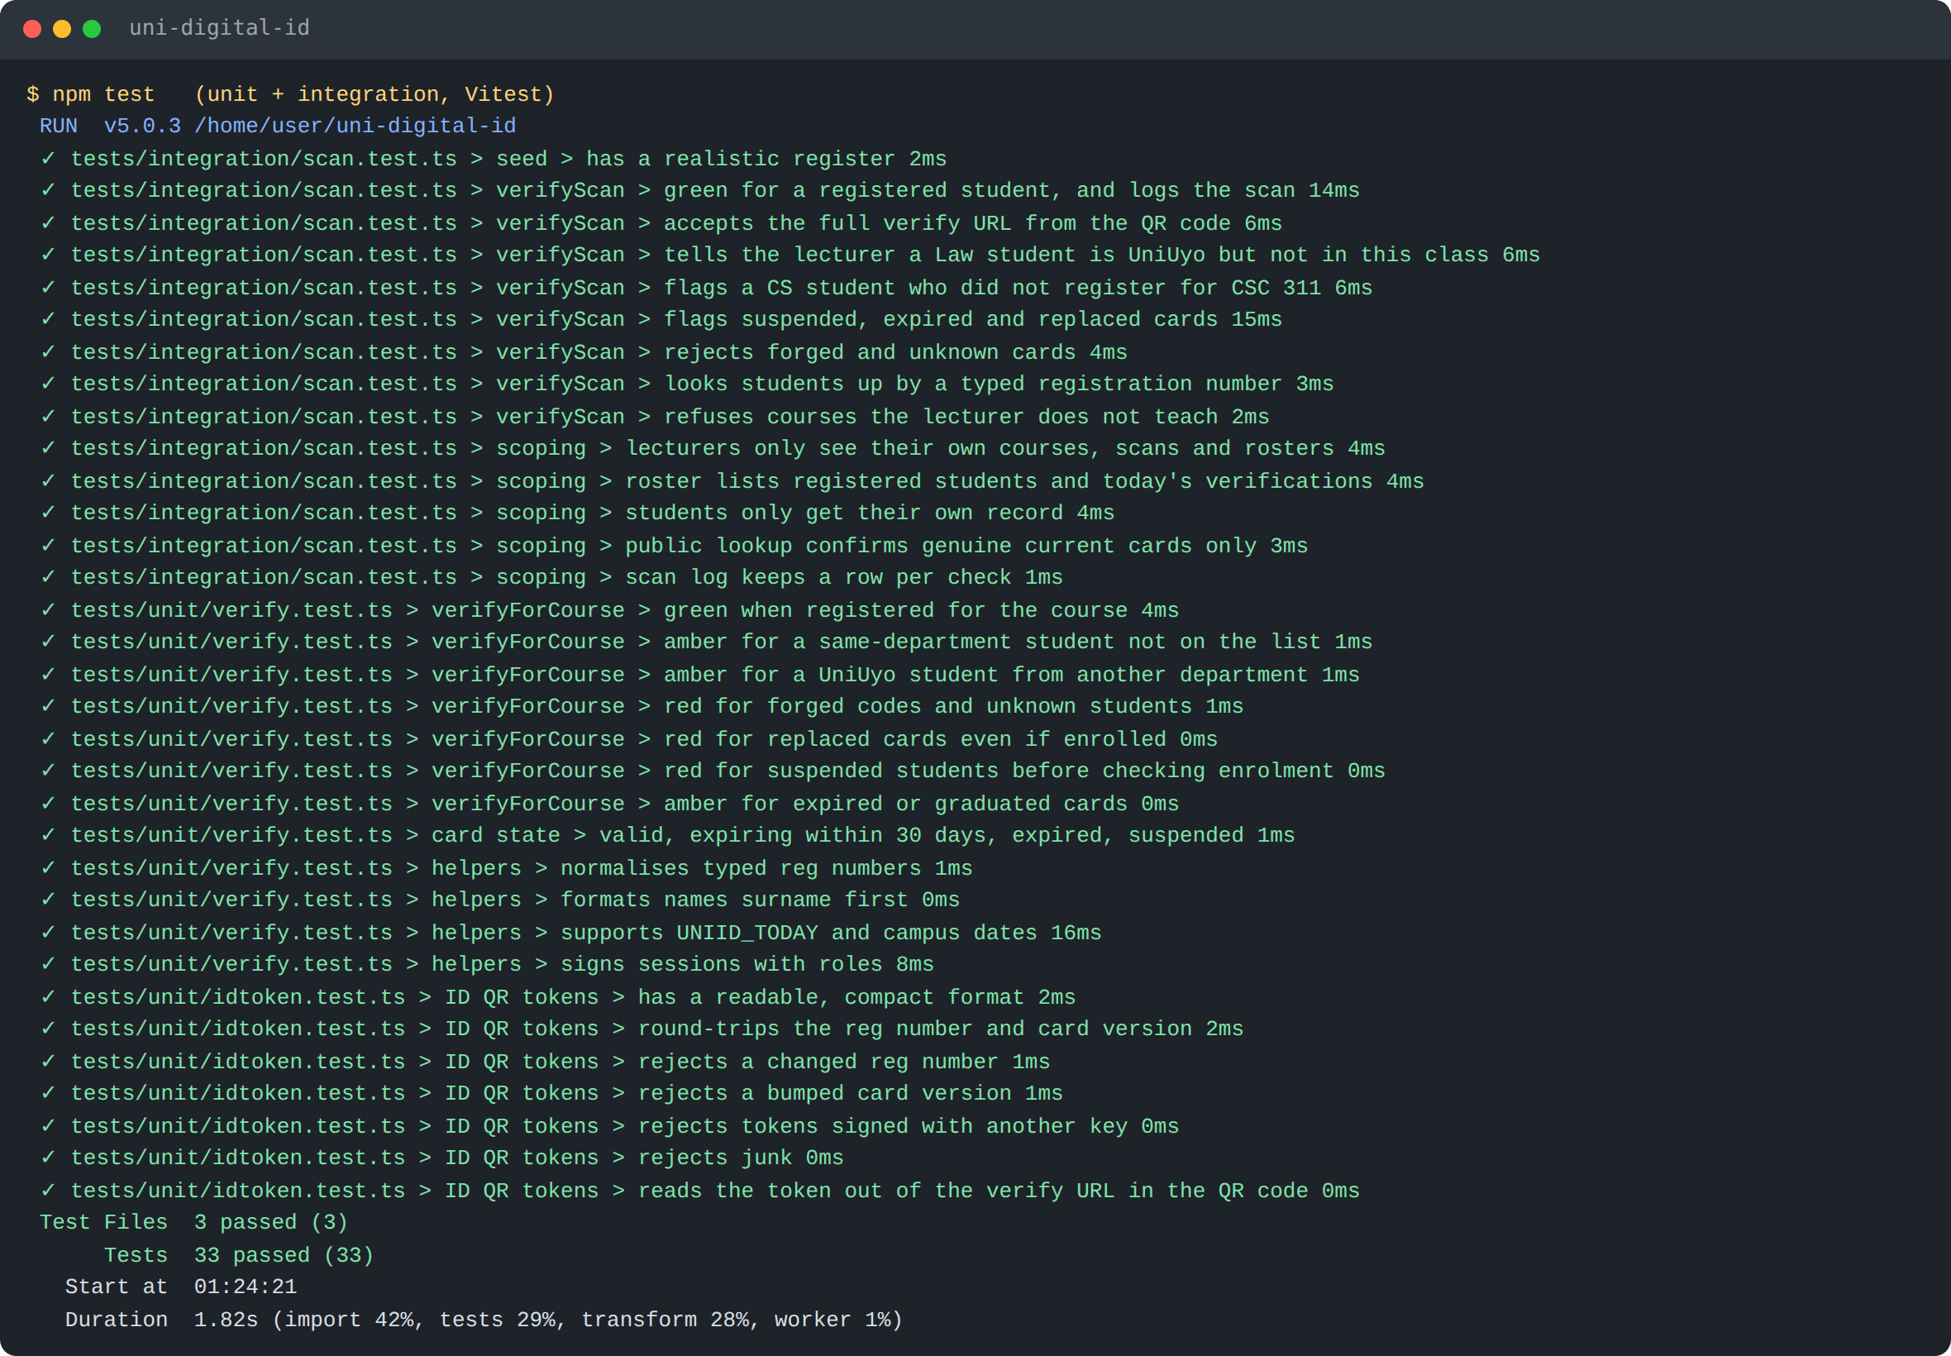
Figure 3.27: Output of the unit and integration test run (33 tests passed)
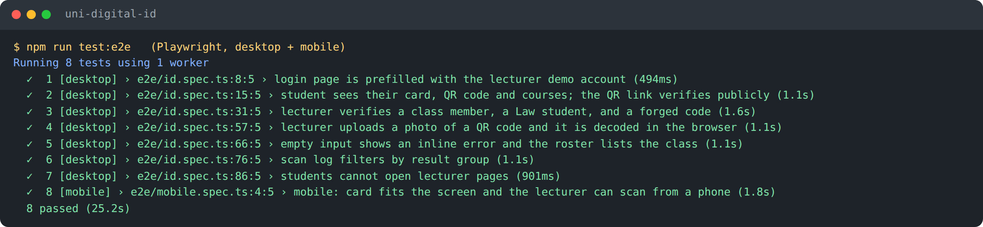
Figure 3.28: Output of the end-to-end test run (8 tests passed on desktop and mobile)
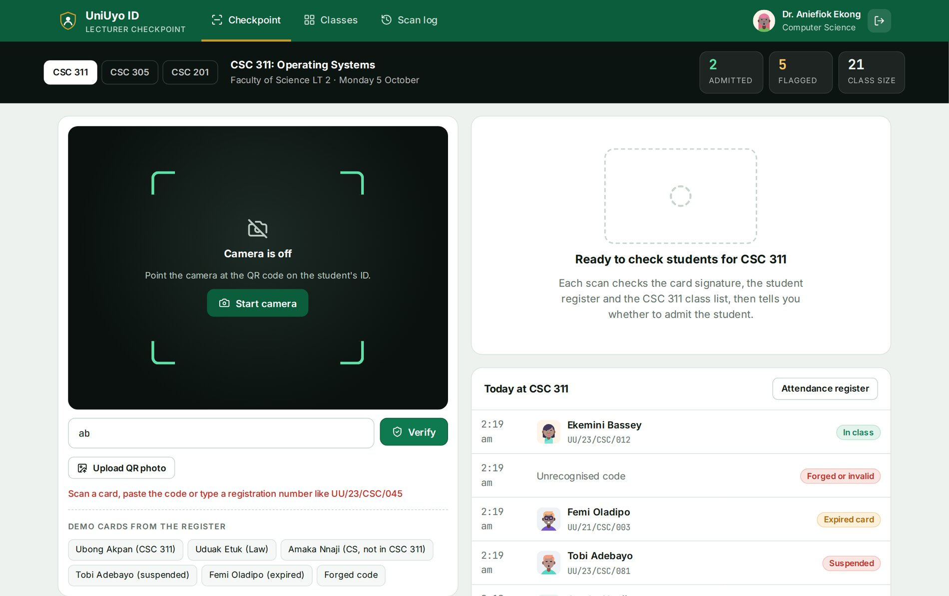
Figure 3.29: Inline error when the input is too short to be a code or a registration number
The evaluation considered the following factors:
- Correctness: all eight outcomes were produced by the seeded demonstration cards and matched Table 3.6; the counters and register agree with the scan log.
- Security: edited, forged and foreign-key tokens were all rejected; replaced cards were rejected by version; course and student data were scoped to the signed-in user.
- Speed: decoding happens in the browser and verification takes one server round trip; in the end-to-end runs each scan result appeared in well under two seconds.
- Usability: the lecturer reads one large word in colour; the photograph supports a face check; the student needs one tap to show the QR.
- Responsiveness: the mobile test and Appendix E show both roles working on a phone.
- Maintainability: token and verdict logic are small, documented modules covered by unit tests.

3.9 RECOMMENDATIONS AND FUTURE ENHANCEMENTS
- Connect the register to the university's live student records and course registration system instead of seeded data.
- Capture real ID photographs at enrolment, stored securely, to replace generated portraits.
- Add an ICT Centre role to reissue cards (incrementing the card version) and to suspend or reinstate students.
- Export the attendance register per lecture to CSV or the departmental attendance format.
- Rotate the signing key without invalidating all cards by adding a key identifier to the token.
- Add time-limited QR codes that change every minute for examinations.
- Support offline scanning for halls with poor network coverage, syncing the log later.
- Run the test suites automatically on every pull request with GitHub Actions.

3.10 LIMITATIONS OF THE STUDY
The system was built within a limited time for a 300-level course and uses a fictional register rather than the university's real records. The signing key is shared with the session secret, so changing it signs every user out as well as invalidating every QR code. The live clock makes screenshots easier to spot but does not prevent a student from lending their phone. Camera scanning requires HTTPS and a browser with camera permission; very old phones may not decode QR codes quickly. No load testing or trial with real lecturers and students was carried out.

3.11 CONCLUSION
The project designed, implemented, tested and deployed UniUyo ID, a digital student identity card system in which every card carries an HMAC-signed QR code and a lecturer can learn in one scan whether the card is genuine, whether the student is in good standing, and whether the student belongs to the class. It showed how React, Next.js, PostgreSQL, browser camera access and standard cryptography combine into a practical, low-cost system, and how ordering simple rules carefully gives clear, trustworthy answers. A redesign during the project also showed the value of shaping each screen around the task its user performs. The recommendations in Section 3.9 indicate the direction for further work.

REFERENCES
Cosmo Wolfe (n.d.) jsQR: a pure JavaScript QR code reading library. Available at: https://github.com/cozmo/jsQR (Accessed: 5 October 2026).
Drizzle Team (n.d.) Drizzle ORM documentation. Available at: https://orm.drizzle.team/docs/overview (Accessed: 5 October 2026).
Krawczyk, H., Bellare, M. and Canetti, R. (1997) HMAC: Keyed-Hashing for Message Authentication. RFC 2104. Available at: https://www.rfc-editor.org/rfc/rfc2104 (Accessed: 5 October 2026).
MDN Web Docs (n.d.) MediaDevices.getUserMedia(). Available at: https://developer.mozilla.org/en-US/docs/Web/API/MediaDevices/getUserMedia (Accessed: 5 October 2026).
Meta Open Source (n.d.) React documentation. Available at: https://react.dev/ (Accessed: 5 October 2026).
Microsoft (n.d.) Playwright documentation. Available at: https://playwright.dev/ (Accessed: 5 October 2026).
Node.js (n.d.) Crypto module documentation. Available at: https://nodejs.org/api/crypto.html (Accessed: 5 October 2026).
OWASP Foundation (n.d.) OWASP Top Ten. Available at: https://owasp.org/www-project-top-ten/ (Accessed: 5 October 2026).
PostgreSQL Global Development Group (n.d.) PostgreSQL documentation. Available at: https://www.postgresql.org/docs/ (Accessed: 5 October 2026).
Railway (n.d.) Railway documentation. Available at: https://docs.railway.com/ (Accessed: 5 October 2026).
soldair (n.d.) node-qrcode. Available at: https://github.com/soldair/node-qrcode (Accessed: 5 October 2026).
Vercel (n.d.) Next.js documentation. Available at: https://nextjs.org/docs (Accessed: 5 October 2026).

APPENDICES

Appendix A: Test accounts
Table 3.10: Demonstration accounts
Email | Password | Role
lecturer@uniuyo.edu.ng | lecturer123 | Lecturer, Dr. Aniefiok Ekong (CSC 311, CSC 305, CSC 201)
student@uniuyo.edu.ng | student123 | Student, Ubong Akpan, UU/23/CSC/045 (CSC 311, CSC 305)
uduak.etuk@student.uniuyo.edu.ng | student123 | Student, Uduak Etuk, UU/23/LAW/112 (Law)

All seeded students use the password student123; the other lecturers use lecturer123. Registration numbers follow the pattern UU/<entry year>/<department code>/<number>, which may differ from the university's real format.

Appendix B: Routes
Table 3.11: Application routes
Route | Role | Purpose
/login | Public | Sign in
/card | Student | ID wallet
/scan?course=ID | Lecturer | Checkpoint for one class (camera=1 starts the camera)
/courses | Lecturer | Classes overview
/courses/[id] | Lecturer | Attendance register
/log?group=&course= | Lecturer | Scan log with filters
/verify, /verify/[token] | Public | Card check
/api/health | Public | Health check with a database ping

Appendix C: Project structure
uni-digital-id/
drizzle/ SQL migrations
e2e/ Playwright tests (id.spec.ts, mobile.spec.ts)
docs/ PDF user guide and its generator
public/ Logos and campus photographs (credits.json)
scripts/ migrate.ts, seed.ts
src/
app/ card, scan, courses, log, verify, login, api
actions/ auth.ts, scan.ts
components/ AppBar, IdCard, Wallet, Checkpoint, ResultPill
db/ schema.ts, index.ts, seed-data.ts
lib/ idtoken.ts, verify.ts, tones.ts, queries.ts, samples.ts,
today.ts, format.ts, auth.ts, session.ts, origin.ts, avatar.ts
proxy.ts
tests/unit/, tests/integration/
railway.json

Appendix D: Environment variables
Table 3.12: Environment variables
Variable | Purpose
DATABASE_URL | PostgreSQL connection string (on Railway: ${{uni-digital-id-postgres.DATABASE_URL}})
SESSION_SECRET | Signs session tokens and keys the QR HMAC
NODE_ENV | production on Railway
UNIID_TODAY | Optional YYYY-MM-DD to freeze the clock
TEST_DATABASE_URL | Database used by integration and end-to-end tests

Appendix E: Mobile screenshots
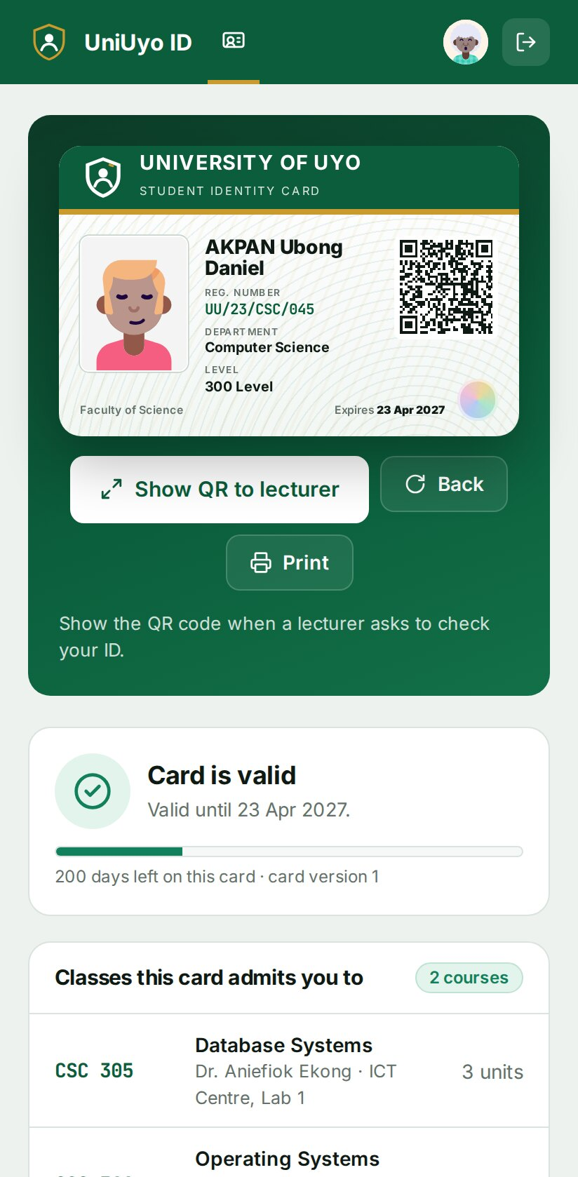
Figure E.1: Student ID wallet on a phone
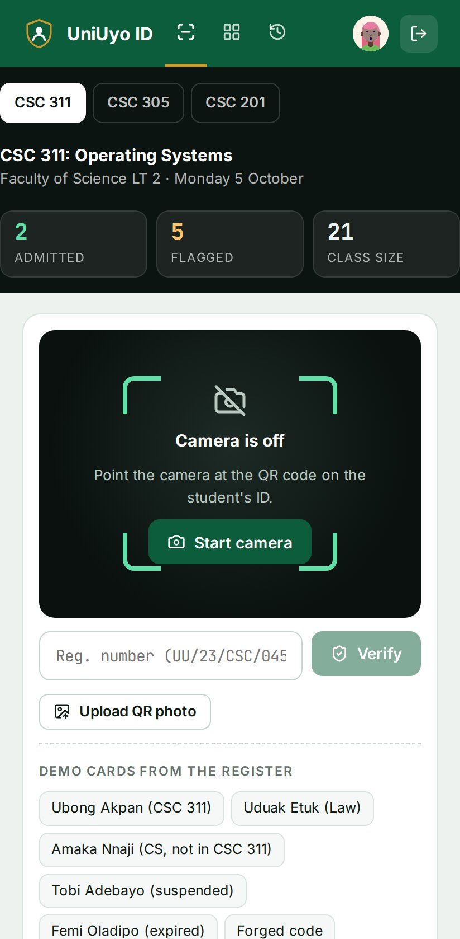
Figure E.2: Lecturer checkpoint on a phone
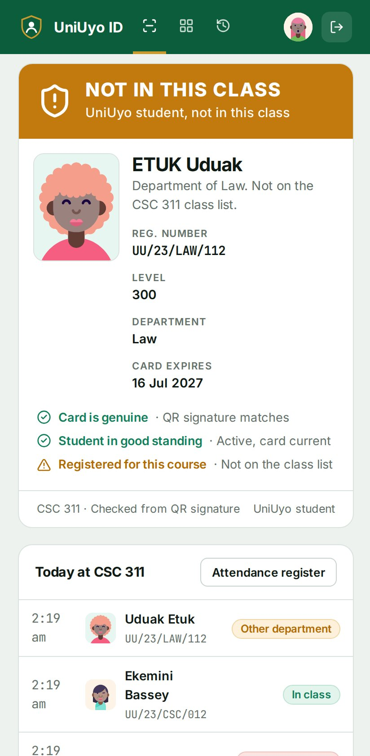
Figure E.3: Result on a phone after a scan
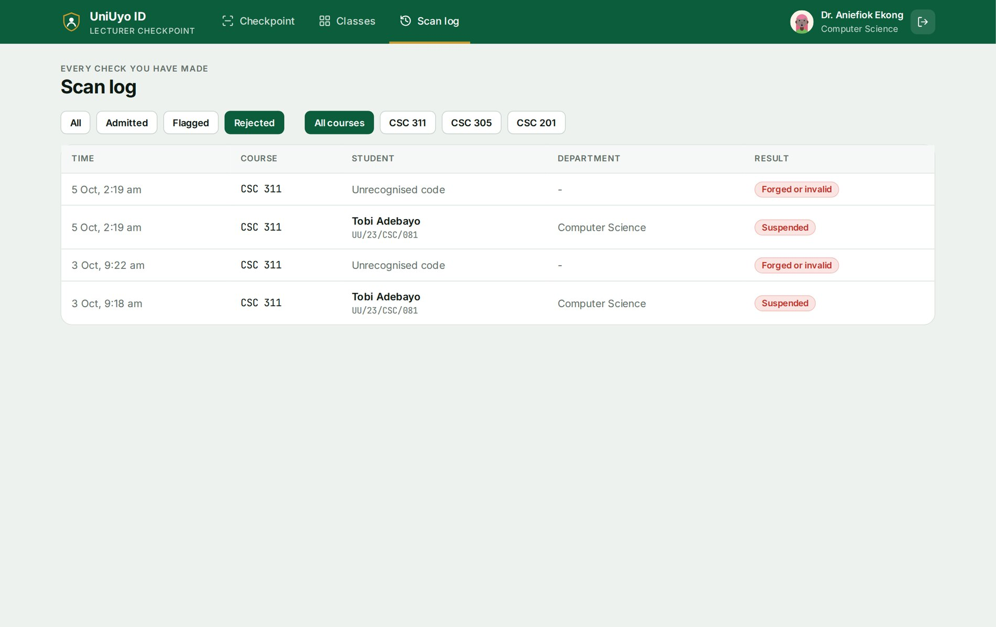
Figure E.4: Scan log filtered to rejected checks

