KTI ADMISSIONS AUTOMATION SYSTEM
Google Forms + Google Sheets + Google Apps Script + Gmail
Project Case Study | Ketkinz Technologies Institute (KTI)

Project Overview
KTI needed a lightweight admissions workflow that could receive program applications, acknowledge applicants by email, track admissions decisions, and advance successful applicants through payment and enrollment without requiring staff to manually send every message or update every stage.
A working admissions automation was implemented using Google Forms for intake, Google Sheets as the admissions tracker, Google Apps Script for business logic, and Gmail for transactional communications.

Business Problem
Manual admissions processing creates repetitive work and makes it easier to miss follow-ups. KTI needed a temporary but functional process while the permanent KTI web platform is being developed. The solution needed to preserve human control over admissions approval and payment verification while automating repetitive communications and status changes.

Solution Architecture
Component | Role
Google Forms | Collects applicant information and program interest.
Google Sheets | Stores applications and tracks the current admissions status.
Google Apps Script | Runs event-driven workflow logic on form submissions and status edits.
Gmail | Sends application, acceptance, payment, and enrollment communications.
Installable Triggers | Runs on form submission and on status edits without manual script execution.

Admissions Workflow
Application Submitted → Contacted → Review → Accepted → Payment Pending → Paid → Enrolled
Automation handles the repetitive transitions. A new form submission generates an acknowledgment email and moves the application to Contacted. KTI retains control of the admissions decision: staff manually select Accepted after review. The script then sends the acceptance email and advances the record to Payment Pending. Payment is also deliberately human-verified; after staff select Paid, the system sends the confirmation/enrollment communication and changes the record to Enrolled.

Automation Logic
1. New application: An installable form-submit trigger runs onFormSubmit. The script reads the submitted row, sends the KTI application-received email, and updates Application Status to Contacted.
2. Admissions decision: KTI reviews the application. Selecting Accepted is the intentional human approval checkpoint.
3. Acceptance: The on-edit trigger detects Accepted, sends the acceptance email, and automatically changes the status to Payment Pending.
4. Payment verification: The applicant remains Payment Pending until KTI verifies actual payment. Staff then select Paid.
5. Enrollment: The script sends the payment/enrollment communication and automatically changes the status to Enrolled.

Implementation Evidence
The following screenshots were captured during configuration and live testing. Personal applicant information and email-account details have been obscured in this case study.
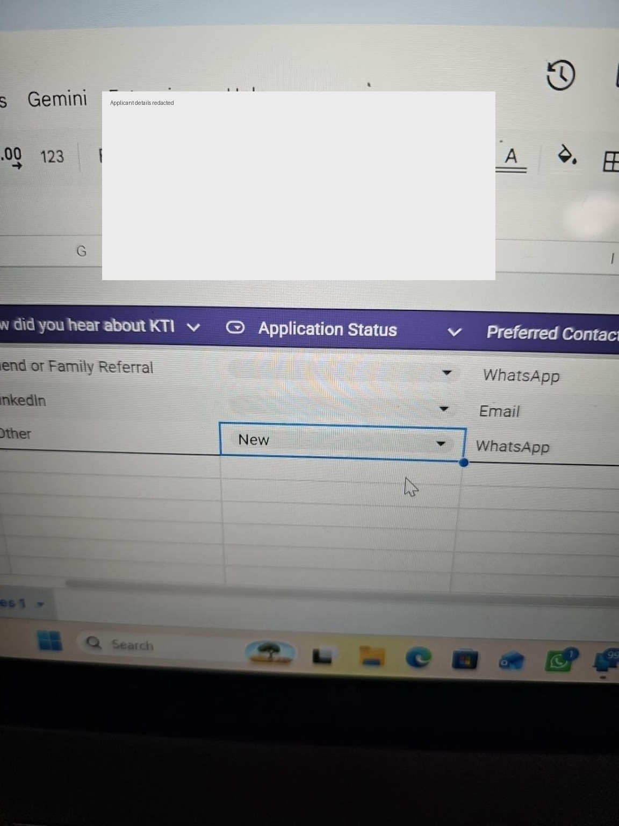
Application tracking sheet with the Application Status field.
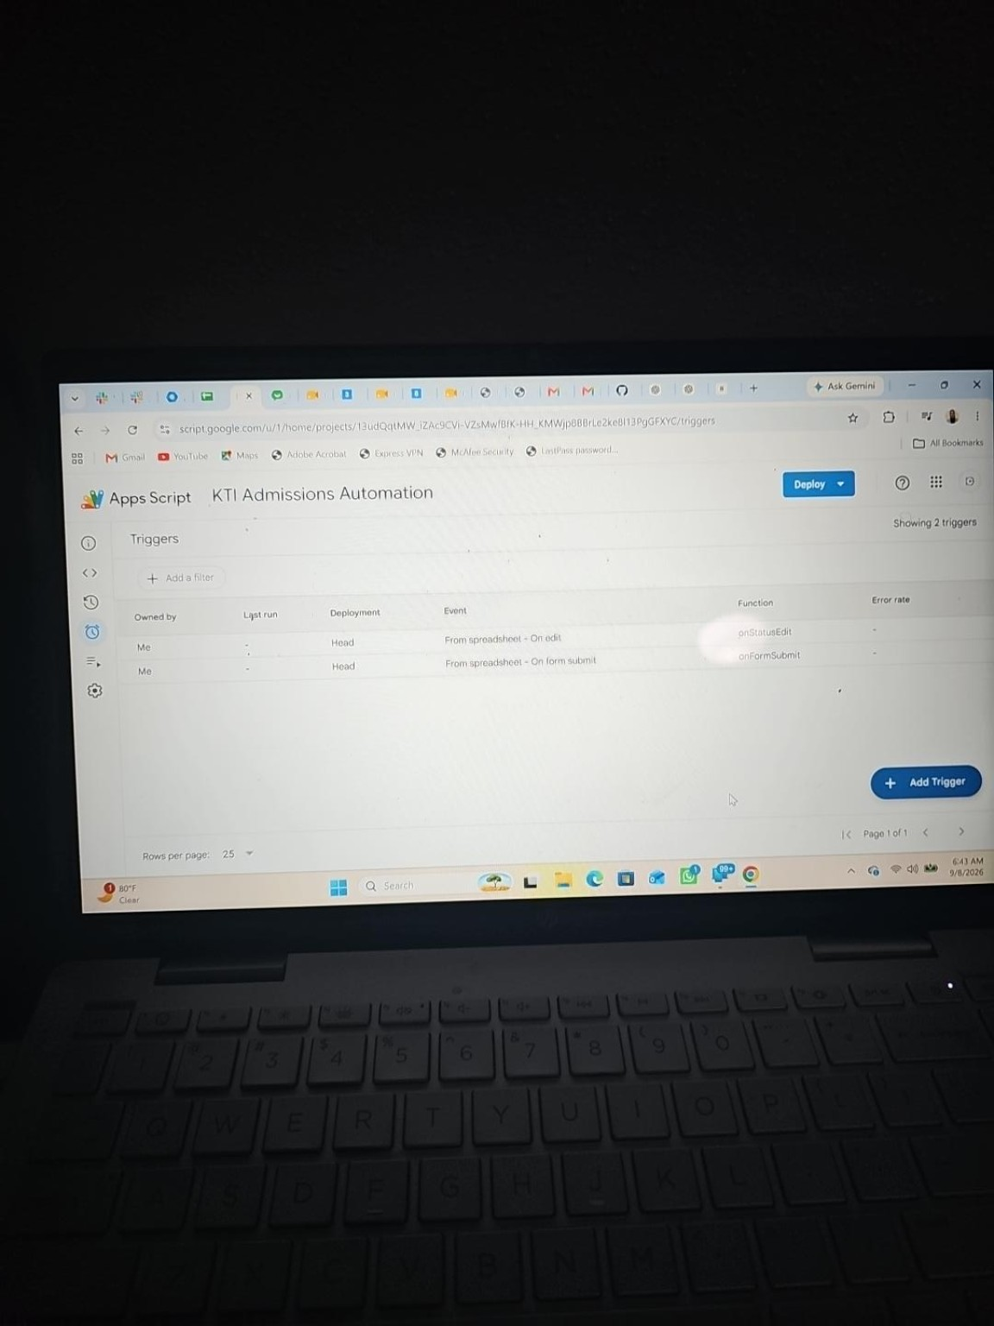
Apps Script trigger configuration showing form-submit and edit automations.
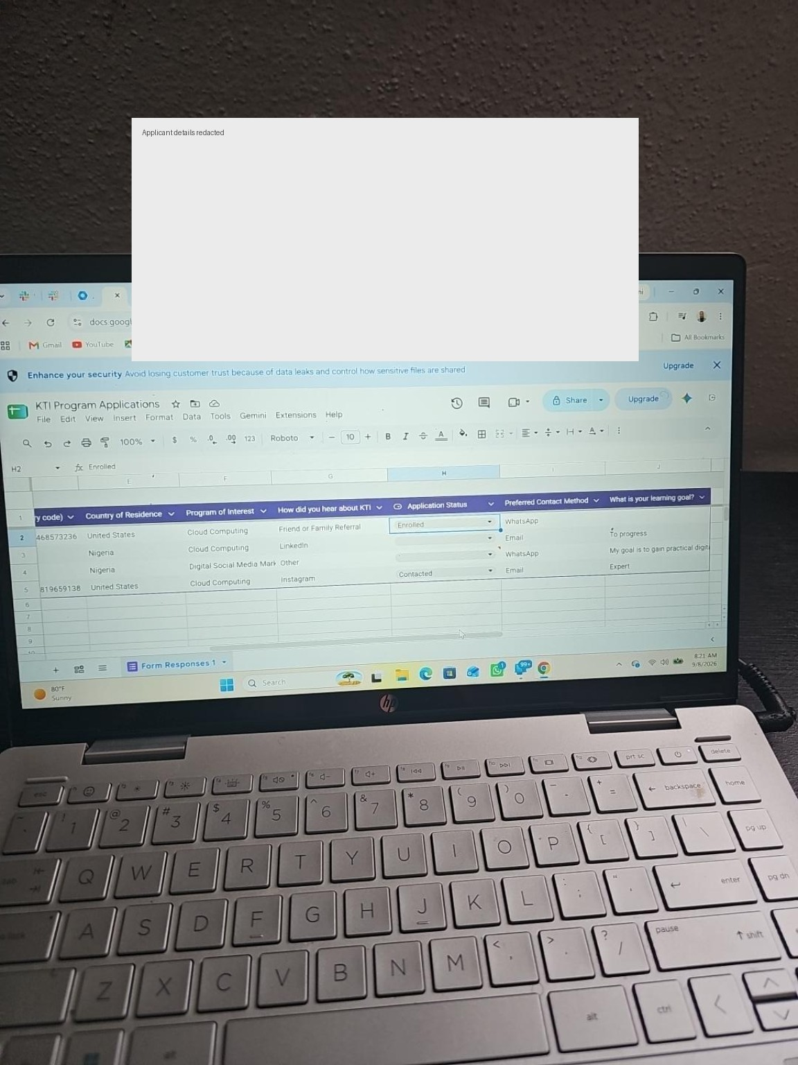
Test application automatically recorded and moved to Contacted.
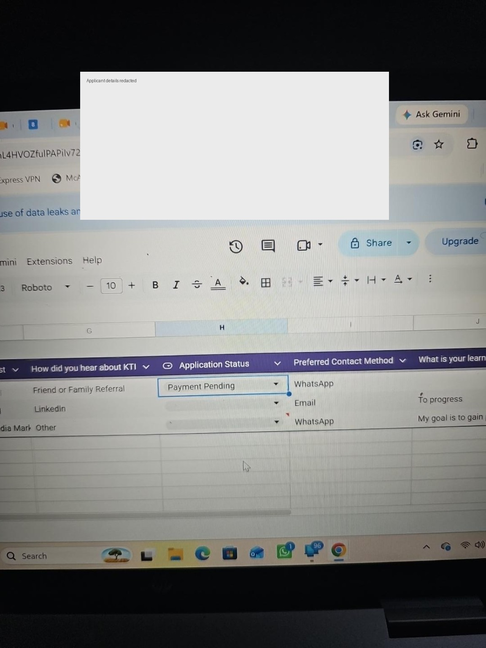
Accepted application automatically moved to Payment Pending.
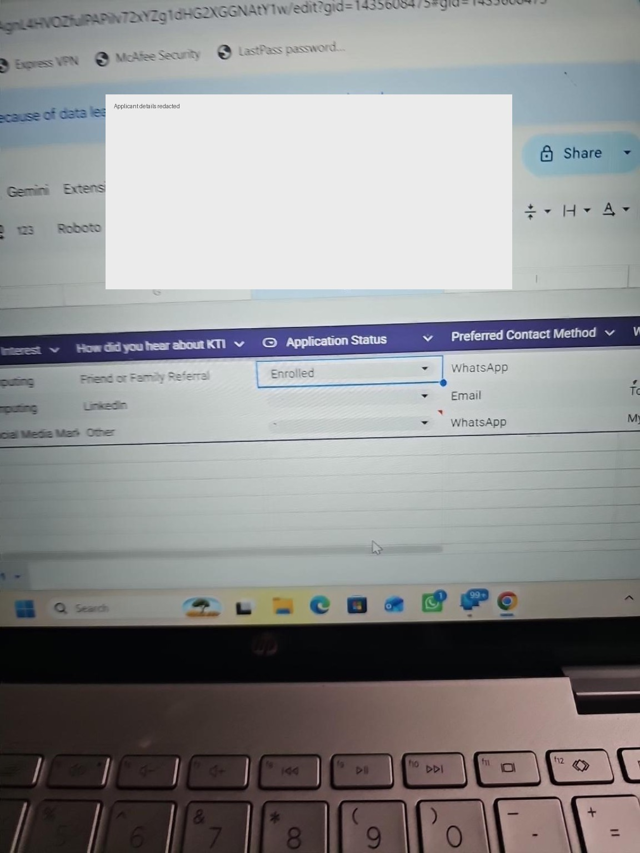
Payment confirmation workflow automatically moved the test applicant to Enrolled.
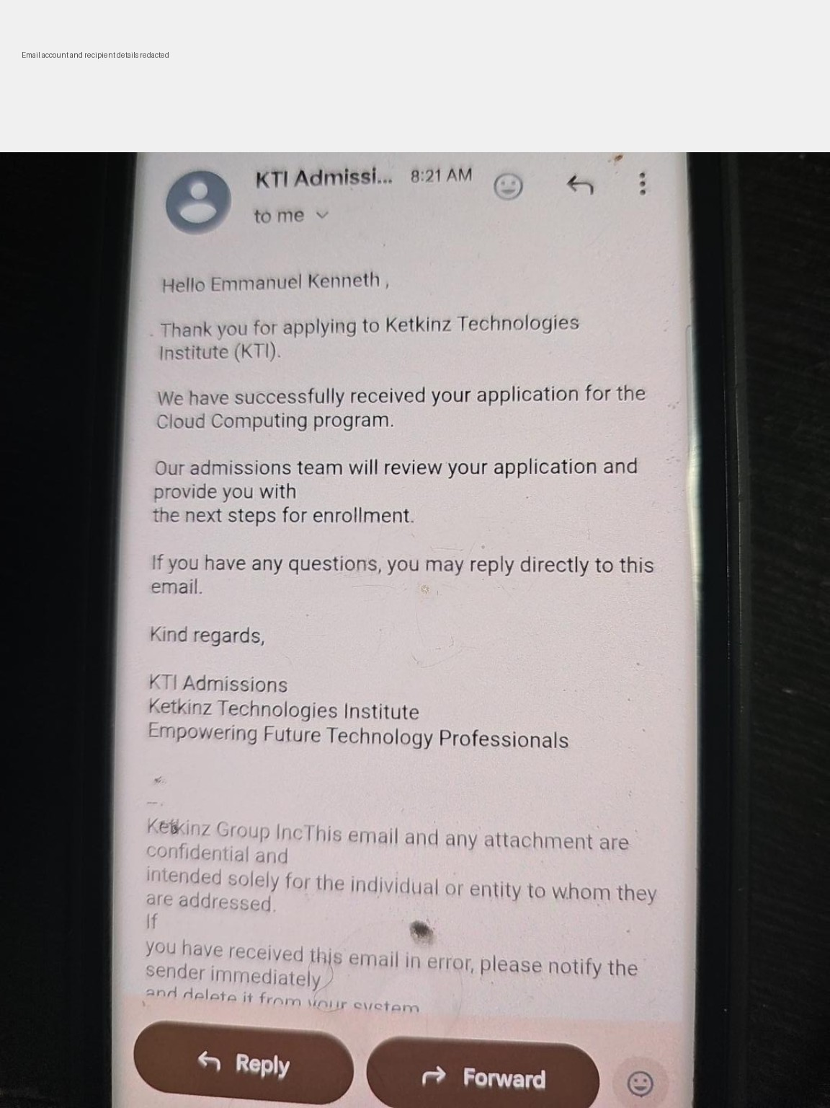
Automated application-received email generated by the workflow.
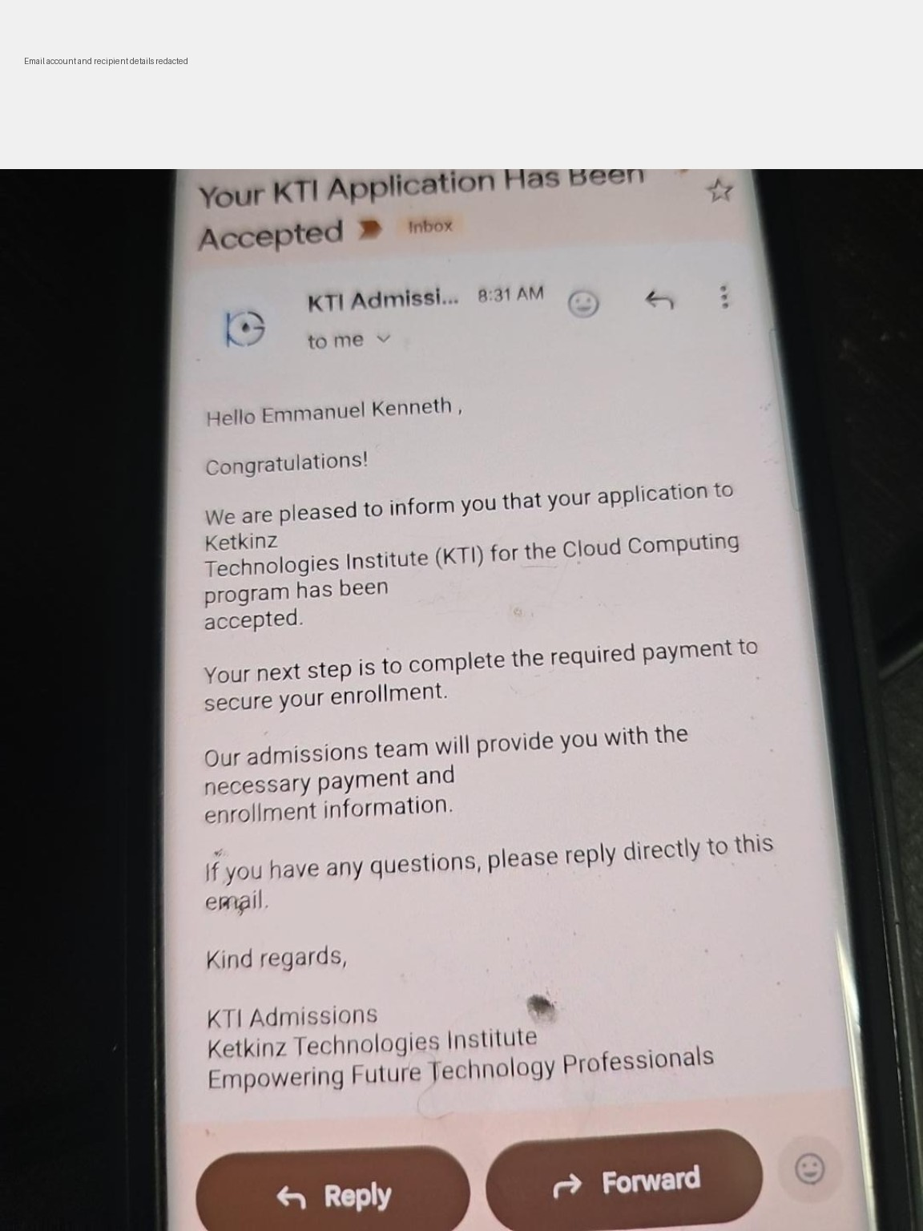
Automated acceptance email generated after an admissions decision.

Testing Performed
- Submitted a fresh test application through the KTI Google Form.
- Verified that a new response appeared in the admissions sheet.
- Verified that the application-received email was sent automatically.
- Verified that the new application moved to Contacted automatically.
- Changed a test application to Accepted and verified the acceptance email.
- Verified that Accepted automatically advanced to Payment Pending.
- Changed a test application to Paid and verified that it automatically advanced to Enrolled.
- Confirmed both Apps Script triggers were installed and executing without manual Run actions.

Design & Control Decisions
The workflow intentionally does not auto-approve applicants or infer payment. Admissions approval remains a human decision, and Paid is selected only after payment has genuinely been confirmed. This avoids false admissions or payment states while still automating repetitive downstream actions.

Skills Demonstrated
Google Workspace administration; Google Forms; Google Sheets data validation; Google Apps Script; event-driven automation; installable triggers; Gmail automation; workflow design; status/state management; testing and troubleshooting; business-process automation.

Result
KTI now has a functioning lightweight admissions management workflow that can receive applications and move qualified applicants through communication, acceptance, payment-pending, and enrollment stages with substantially less manual administration.

Future Production Migration
This Google Workspace workflow serves as a working prototype and interim admissions system. When the permanent KTI platform is ready, the same business rules should be implemented and tested end-to-end in the website: application intake, admissions approval, transactional emails, payment confirmation, automated enrollment, Student ID generation, and student-portal access. The Google workflow should remain available until the production platform passes full end-to-end acceptance testing.

Portfolio Summary
Built an event-driven admissions workflow for Ketkinz Technologies Institute using Google Forms, Google Sheets, Google Apps Script, and Gmail. Automated application acknowledgment, acceptance communications, status transitions, payment-pending tracking, and enrollment while preserving human approval for admissions and payment verification.

