EduSparring Platform
Implementation Status & Visual Overview
Generated: April 8, 2026

1. Platform Overview
EduSparring is an AI-powered competitive learning platform that turns knowledge into battles. The platform features real-time multiplayer sparring, AI tutor practice sessions, video lessons, gamification elements, and comprehensive social features. The core experience is centered around the Sparring Arena where users can either practice with an AI bot or compete with other students worldwide.

2. Key Features Implemented
Feature | Status & Details
Sparring Arena | Central hub for battles with Bot (AI Tutor) and Multiplayer (Live Matches)
AI Tutor | Practice mode with adaptive difficulty and personalized coaching feedback
Multiplayer Arena | Real-time live battles with matchmaking and spectator mode
Video Lessons | Educational video content with progress tracking
Leaderboard | Global ranking system with Knowledge Rating (KR)
Social Features | Friends, Activity Feed, Study Circles, Peer Tutoring
Gamification | Daily Quests, Streaks, Season Pass, Spin Wheel, Achievements
Global Search | Ctrl+K command palette for quick navigation across all pages
PWA Support | Progressive Web App with offline capabilities
Multi-language | Support for 7 languages: EN, ES, FR, PT, AR, HI, ZH

3. Navigation System
The platform features a comprehensive navigation system ensuring users can move between any pages seamlessly. The implementation includes consistent header navigation, bottom navigation for mobile users, and a Global Search feature accessible via Ctrl+K keyboard shortcut. This hybrid approach maintains the existing UI/UX while adding enhanced discoverability.

3.1 Global Search (Ctrl+K)
A subtle, non-intrusive global search component has been implemented that opens with Ctrl+K (or Cmd+K on Mac). The search provides quick access to all pages, features, and actions without altering the existing layout. Users can navigate with arrow keys, press Enter to select, and Escape to close.

4. Visual Screenshots
The following screenshots demonstrate the current implementation of the EduSparring platform:

4.1 Landing Page / Homepage

The landing page showcases the hero section with animated Sparring icon, feature highlights including Real-Time Battles, Rank System, AI-Powered Learning, Global Community, Tournaments, and Multiple Subjects. Clear call-to-action buttons guide users to sign up or sign in.

4.2 Sparring Arena (Main Dashboard)
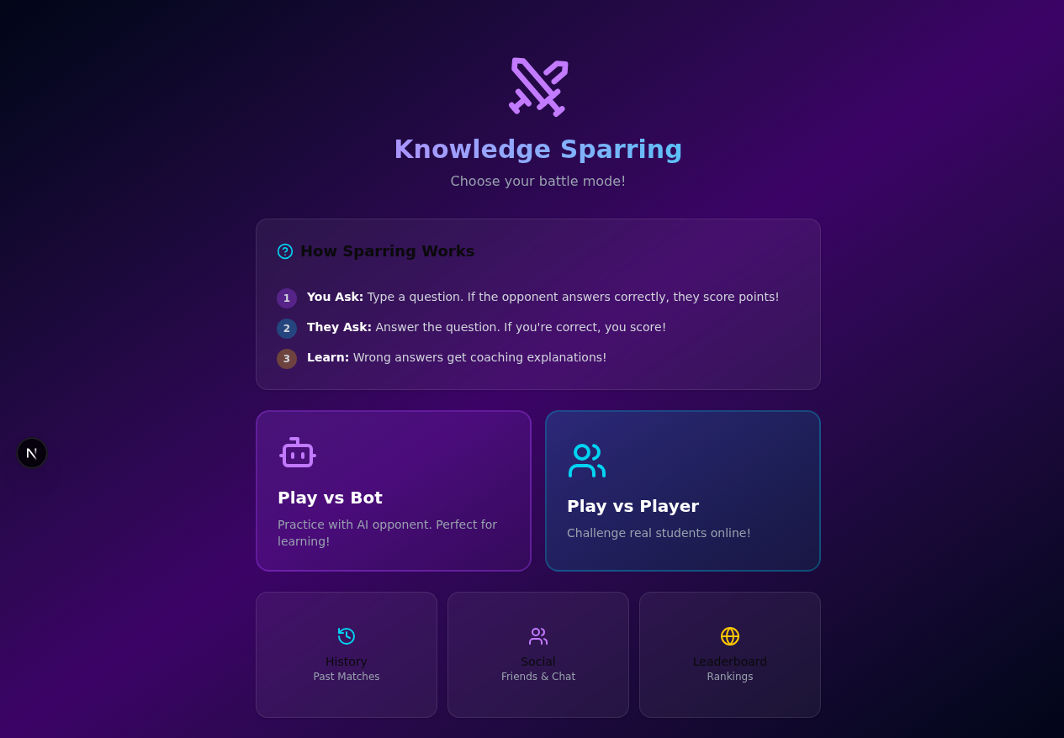
The Sparring Arena is the central hub where users select subjects (Math, Physics, Chemistry, Biology, History, Geography) and choose between two main modes: Play with Bot for AI practice sessions, and Play with Student for live multiplayer matches. The dashboard displays user stats (KR Rating, Wins, Streak) and quick access to other features.

4.3 AI Tutor Page
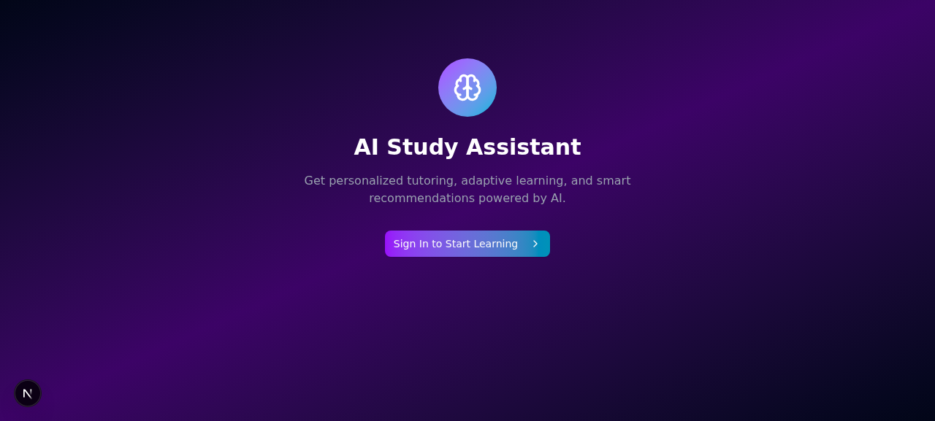
The AI Tutor page provides personalized practice sessions with adaptive difficulty. The "Play with Bot" tab allows users to practice against an AI opponent with customizable difficulty levels, while receiving instant feedback and coaching suggestions after each session.

4.4 Sign In Page
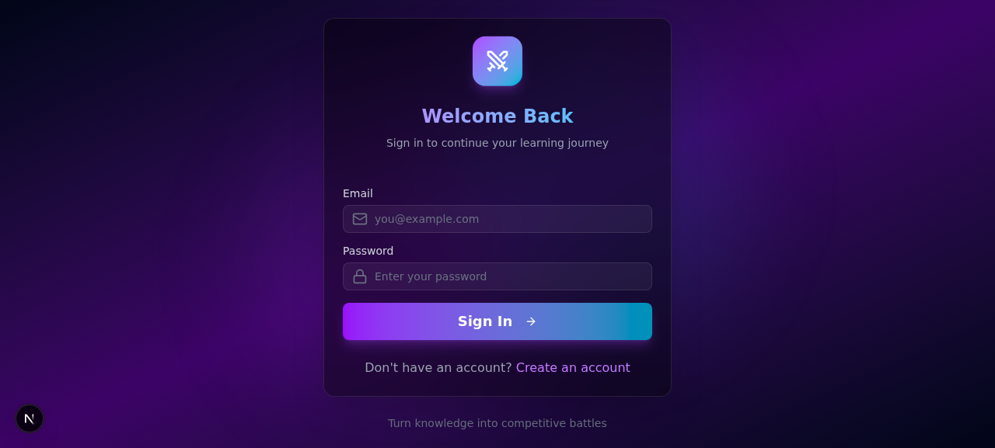
The authentication page supports multiple sign-in methods including Google OAuth and email/password. New users are guided through an onboarding wizard to set up their profile, select subjects of interest, and customize their learning preferences.

4.5 Global Leaderboard
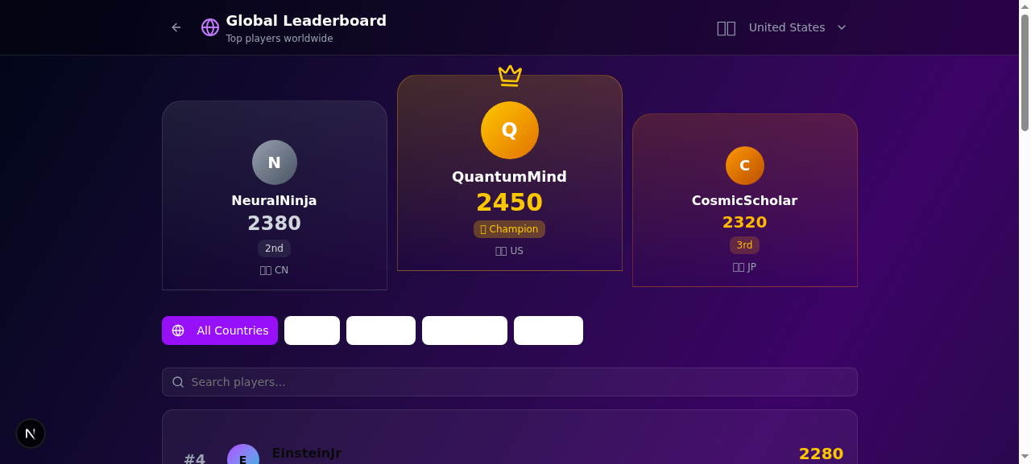
The leaderboard displays top performers across different subjects and time periods. Users can filter by category (All, Math, Physics, etc.) and view detailed player profiles. The Knowledge Rating (KR) system ranges from Beginner (800-999) to Elite (1800+).

5. Technical Implementation
The EduSparring platform is built with modern technologies ensuring performance, scalability, and maintainability:
Technology | Details
Frontend Framework | Next.js 16.1.3 with React 18, TypeScript
Styling | Tailwind CSS 4 with shadcn/ui components
State Management | Zustand for global app state
Animations | Framer Motion for smooth transitions
Backend | Next.js API Routes with Prisma ORM
Authentication | NextAuth.js with Google OAuth
Database | SQLite with Prisma schema
Real-time | WebSocket for multiplayer features
AI Integration | z-ai-web-dev-sdk for AI features
PWA | Service Worker with offline support

6. Accessing the Platform
The EduSparring development server is currently running on localhost:3000. To access the platform:
Preview URL: https://preview-chat-c044950b-c7a4-4fad-a0b3-0c629b941ed2.space.z.ai/
Local Server: http://localhost:3000
The dev server may require a moment to compile pages on first load. All pages are connected with consistent navigation, and the Global Search (Ctrl+K) provides quick access to any feature.

