Burden and antimicrobial resistance patterns of surgical site infections in East, Central and Southern Africa
  - Results and Methods
ECSA SSI/AMR systematic review and meta-analysis
21 October 2026
Table of Contents

This document presents the Results first and the Methods second, in manuscript order. All counts, estimates and confidence intervals are generated directly from the curated analysis datasets when the document is rendered; no result was typed manually. The corresponding scripts, datasets and figure files are listed at the end.

Results

Study selection and characteristics
The supplied, de-duplicated corpus contained 56 documents. After screening, 18 documents were excluded and 38 unique cohorts were included (Figure S4). Exclusions comprised 9 duplicate or overlapping reports, 5 documents that were not primary studies or contained no extractable data, 3 studies with the wrong population or outcome, and 1 post-hoc FALCON secondary analysis (Table S12). Of the 38 included cohorts, 26 had an SSI incidence component, 25 entered the primary SSI meta-analysis, 26 had an AMR component, and 12 were AMR-only cohorts without an operated-patient denominator (Tables S1 and S2).
The 25 cohorts in the primary SSI meta-analysis contributed 13,233 surgical patients and 2,077 SSI events (Table 1). Studies were published between 2013 and 2026; 19 of 25 (76.0%) were published from 2020 onwards. The cohorts came from 9 countries: Ethiopia (11 cohorts), Tanzania (4), Rwanda (3), Kenya (2), and one each from the Democratic Republic of the Congo, Gabon, Malawi, Namibia and Zambia. By ECSA sub-region, 20 cohorts were from East Africa, 3 from Southern Africa and 2 from Central Africa. 18 cohorts were from tertiary or referral hospitals, 4 from secondary or primary hospitals and 3 from mixed hospital networks. The design distribution was 12 cohort studies, 9 cross-sectional studies, 2 randomised trials and 2 before–after or quality-improvement cohorts. Surgical specialty was mixed or other in 13 cohorts, general surgery in 5, obstetrics/gynaecology in 5 and orthopaedics in 2. Study quality was high in 2 cohorts, moderate in 15 and low in 8.
Table 1 (Panel A). Study, setting and design characteristics of the 25 cohorts in the primary SSI incidence meta-analysis.
Study | Country | Subregion | Hospital level | Design | Specialty | Quality
Dinda 2013 | Kenya | East Africa | Tertiary/referral | Prospective cohort | General surgery | Moderate
Mengesha 2014 | Ethiopia | East Africa | Tertiary/referral | Prospective cross-sectional | Mixed/other | High
Scherbaum 2014 | Gabon | Central Africa | Tertiary/referral | Prospective surveillance cohort | Mixed/other | Moderate
Kisibo 2017 | Tanzania | East Africa | Tertiary/referral | Cross-sectional | Orthopaedic | Moderate
Billoro 2019 | Ethiopia | East Africa | Tertiary/referral | Prospective cohort | Mixed/other | Low
Mukagendaneza 2019 | Rwanda | East Africa | Tertiary/referral | Prospective observational cohort | Mixed/other | Moderate
Gentilotti 2020 | Tanzania | East Africa | Tertiary/referral | Before-after intervention cohort | Obstetrics/gynaecology | Moderate
Kefale 2020 | Ethiopia | East Africa | Secondary | Retrospective cross-sectional | General surgery | Moderate
Forrester 2021 | Ethiopia | East Africa | Mixed (five hospitals) | Prospective pre-post quality improvement cohort | Mixed/other | Moderate
Misha 2021 | Ethiopia | East Africa | Tertiary/referral | Prospective cohort | Mixed/other | Moderate
Ntirushwa 2021 | Rwanda | East Africa | Secondary (district) | Randomised controlled trial | Obstetrics/gynaecology | Low
Velin 2021 | Rwanda | East Africa | Secondary (district) | Prospective cohort | Obstetrics/gynaecology | Low
Abayneh 2022 | Ethiopia | East Africa | Tertiary/referral | Prospective observational cohort | Mixed/other | Low
Ali 2023 | Ethiopia | East Africa | Tertiary/referral | Hospital-based cross-sectional | Mixed/other | Moderate
Bayardorj 2023 | Tanzania | East Africa | Secondary (district) | Retrospective cross-sectional | Mixed/other | High
Habtemariam 2023 | Ethiopia | East Africa | Tertiary/referral | Prospective cross-sectional | Mixed/other | Moderate
Kachipedzu 2024 | Malawi | Southern Africa | Tertiary/referral | Prospective cohort | Obstetrics/gynaecology | Moderate
Mammo 2024 | Ethiopia | East Africa | Mixed (nine hospitals, five clusters) | Stepped-wedge cluster randomised clinical trial | Obstetrics/gynaecology | Low
Boru 2025 | Ethiopia | East Africa | Tertiary/referral | Institution-based cross-sectional | Mixed/other | Moderate
Deyem 2025 | Democratic Republic of the Congo | Central Africa | Tertiary/referral | Prospective longitudinal analytical | General surgery | Low
Haifete 2025 | Namibia | Southern Africa | Tertiary/referral (two hospitals) | Retrospective cross-sectional chart review | Mixed/other | Moderate
Hamudu 2025 | Tanzania | East Africa | Mixed (tertiary and regional referral) | Longitudinal prospective cohort | Orthopaedic | Low
Kazuma 2025 | Zambia | Southern Africa | Tertiary/referral (three hospitals) | Prospective observational cross-sectional | General surgery | Moderate
Agade 2026 | Kenya | East Africa | Tertiary/referral | Retrospective cohort | General surgery | Moderate
Gashaw 2026 | Ethiopia | East Africa | Tertiary/referral | Longitudinal prospective cohort | Mixed/other | Low

Table 1 (Panel B). SSI counts, definitions and data availability in the same 25 cohorts.
Study | Cohort n | SSI events | SSI % | SSI definition | Derived numerator | AMR data
Dinda 2013 | 171 | 12 | 7.0 | ‘True SSI’ (CDC) | No | Yes
Mengesha 2014 | 610 | 128 | 21.0 | Clinical post-surgical wound infection | No | Yes
Scherbaum 2014 | 1,022 | 14 | 1.4 | SSI (CDC/RKI) | Yes | Yes
Kisibo 2017 | 300 | 75 | 25.0 | Clinical SSI | No | No
Billoro 2019 | 255 | 42 | 16.5 | Clinical SSI (CDC) | No | Yes
Mukagendaneza 2019 | 294 | 34 | 11.6 | Clinical SSI (CDC), superficial only | No | No
Gentilotti 2020 | 467 | 225 | 48.2 | Clinical SSI (CDC) within 30 days | No | Yes
Kefale 2020 | 281 | 55 | 19.6 | Clinical SSI (CDC) | Yes | No
Forrester 2021 | 374 | 28 | 7.5 | Postoperative surgical infection (modified CDC) | Yes | No
Misha 2021 | 251 | 53 | 21.1 | Clinical SSI (CDC) | No | Yes
Ntirushwa 2021 | 301 | 12 | 4.0 | Clinical SSI (CDC) within 30 days | No | No
Velin 2021 | 795 | 45 | 5.7 | Clinical SSI (CDC) at POD 11 | No | Yes
Abayneh 2022 | 262 | 33 | 12.6 | Clinical SSI (CDC) within 30 days | No | Yes
Ali 2023 | 338 | 49 | 14.5 | Clinical SSI (CDC) | No | Yes
Bayardorj 2023 | 128 | 14 | 10.9 | Clinical SSI documented in records | No | No
Habtemariam 2023 | 204 | 126 | 61.8 | Clinical SSI (CDC) | No | No
Kachipedzu 2024 | 208 | 20 | 9.6 | Clinical SSI (CDC) within 30 days | No | Yes
Mammo 2024 | 2,483 | 265 | 10.7 | Clinical SSI (CDC) within 30 days | No | No
Boru 2025 | 183 | 29 | 15.8 | Culture-confirmed SSI | No | Yes
Deyem 2025 | 218 | 71 | 32.6 | Clinical SSI (CDC) within 30 days | No | No
Haifete 2025 | 1,248 | 126 | 10.1 | SSI documented in chart | No | No
Hamudu 2025 | 120 | 36 | 30.0 | Clinical SSI (CDC) within 3 months | No | Yes
Kazuma 2025 | 1,122 | 218 | 19.4 | Clinical SSI with pus swab | No | No
Agade 2026 | 393 | 55 | 14.0 | Clinical SSI | No | No
Gashaw 2026 | 1,205 | 312 | 25.9 | Clinical SSI (WHO/CDC) within 28 days | No | Yes
The 12 AMR-only cohorts were observational studies of patients already diagnosed with SSI; they reported pathogen isolation and susceptibility results but no operated-patient denominator, so they could not contribute to SSI incidence (Table 2). They were retained for the AMR synthesis because they satisfy the AMR eligibility criterion (microbiologically confirmed SSI with antimicrobial susceptibility testing).
Table 2. Characteristics of the 12 AMR-only cohorts.
Study | Country | Subregion | Hospital level | Design | AMR rows | Quality
Iyamba 2014 | Democratic Republic of the Congo | Central Africa | Tertiary/referral (two hospitals) | Cross-sectional | 2 | High
Manyahi 2014 | Tanzania | East Africa | Tertiary/referral | Descriptive cross-sectional | 4 | High
Hope 2019 | Uganda | East Africa | Tertiary/referral | Descriptive cross-sectional | 2 | High
Amulioto 2020 | Kenya | East Africa | Secondary | Cross-sectional descriptive | 2 | High
Wekesa 2020 | Uganda | East Africa | Tertiary/referral | Cross-sectional | 6 | High
Abosse 2021 | Ethiopia | East Africa | Tertiary/referral | Hospital-based cross-sectional | 5 | High
Garoy 2021 | Eritrea | East Africa | Tertiary/referral (two national referral hospitals) | Cross-sectional | 1 | High
Burugu 2022 | Kenya | East Africa | Tertiary/referral | Cross-sectional | 2 | High
Worku 2023 | Ethiopia | East Africa | Tertiary/referral (four hospitals) | Multicentre cross-sectional | 4 | High
Odoko 2024 | Ethiopia | East Africa | Mixed (two hospitals) | Hospital-based cross-sectional | 5 | High
Chipaga 2025 | Tanzania | East Africa | Tertiary/referral | Descriptive cross-sectional | 7 | High
Mbabazi 2025 | Uganda | East Africa | Tertiary/referral | Prospective cohort | 3 | High
Two inclusion decisions require explicit justification. First, Starr 2023 was retained in the review (Table S1) but excluded from the primary pooling. The paper reports 152 SSI events in 1,575 pre-intervention patients (23.2%) and 144 events in 1,789 post-intervention patients (17.4%), but the counts and percentages are incompatible: 152/1,575 is 9.7%, not 23.2%, and 144/1,789 is 8.1%, not 17.4%. The reported percentages imply denominators of approximately 655 and 828, respectively, rather than the stated cohort sizes. Because no reliable event count can be recovered, including either estimate would introduce an arbitrary and potentially large bias; Starr 2023 is therefore described narratively and in Table S1 but not pooled.
Second, the FALCON secondary analysis (Aaron Oladipo 2024) was excluded at screening. It is a post-hoc secondary analysis of a multinational trial conducted across seven low- and middle-income countries (Benin, Ghana, India, Mexico, Nigeria, Rwanda and South Africa), of which only Rwanda and South Africa are in ECSA. It reports no ECSA-specific strata and is not a primary ECSA surgical cohort. Including it would violate the population criterion and risk double-counting trial participants; the exclusion is recorded in Table S2.
One further harmonisation decision affected a pooled estimate. Mukagendaneza 2019 reported 10.2% in the results and 10.9% in the abstract, whereas its extracted counts give 11.6% (34/294). The count-based estimate (11.6%) was used, consistent with the pre-specified rule of preferring reported counts over inconsistently reported percentages.

Primary outcome: SSI incidence
Across the 25 cohorts, 2,077 SSI events occurred among 13,233 patients. The random-effects pooled SSI proportion was 15.03% (95% CI 10.60%–20.89%), with a 95% prediction interval of 2.35%–56.57% (Table 3; Figure 1). The crude, unweighted proportion was 15.7% (2,077/13,233). Between-study heterogeneity was very high: I² = 97.5%, tau² = 0.8986 on the logit scale, and Cochran Q = 962 (df = 24, p <0.001). Individual study estimates ranged from 1.4% (Scherbaum 2014) to 61.8% (Habtemariam 2023).
The prediction interval is a better guide to transportability than the confidence interval alone: a future ECSA surgical population with a similar distribution of settings could plausibly have an SSI proportion anywhere between 2.3% and 56.6%. The common-effect estimate was 18.45% (95% CI 17.72%–19.21%) and the random-effects model with a conventional Wald interval gave 15.03% (95% CI 10.81%–20.52%); both are presented only as sensitivity comparisons, because the common-effect assumption is not credible with this degree of heterogeneity.
Table 3. Primary random-effects meta-analysis of SSI incidence.
Analysis | k | Events | Patients | Pooled SSI % (95% CI) | Prediction interval | I² (%) | tau² | Q | p heterogeneity
Primary random-effects model | 25 | 2,077 | 13,233 | 15.03 (10.60–20.89) | 2.35–56.57 | 97.5 | 0.8986 | 962 | <0.001
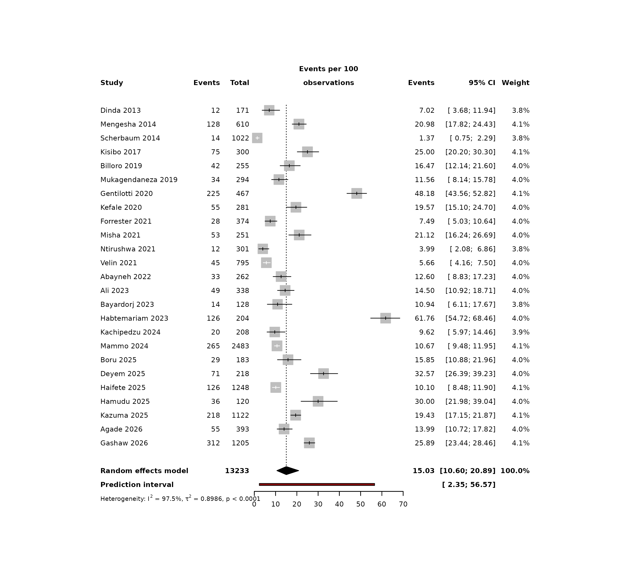
Figure 1. Forest plot of SSI incidence in the 25 primary cohorts. Weights are inverse-variance random-effects weights; the diamond is the pooled estimate and the red bar is the 95% prediction interval. The x-axis is truncated at 60% for readability; one study estimate (Habtemariam 2023, 61.8%) lies beyond the plotted range.

Publication bias and sensitivity analyses
Visual inspection of the funnel plot showed no clear asymmetry (Figure 2). Egger’s regression test did not indicate small-study effects (test statistic -1.251; bias coefficient -3.665, SE 2.929, p = 0.223), whereas Begg’s rank-correlation test was statistically significant (test statistic -2.242; Kendall score -96.0, SE 42.8, p = 0.025). Trim-and-fill added 6 hypothetical studies and shifted the pooled estimate to 20.26% (95% CI 14.07%–28.28%). The discrepancy between Egger’s and Begg’s tests, and the trim-and-fill result, suggest that some small studies with low SSI proportions may be missing; the primary estimate should therefore be interpreted with caution rather than as a definitive regional burden.
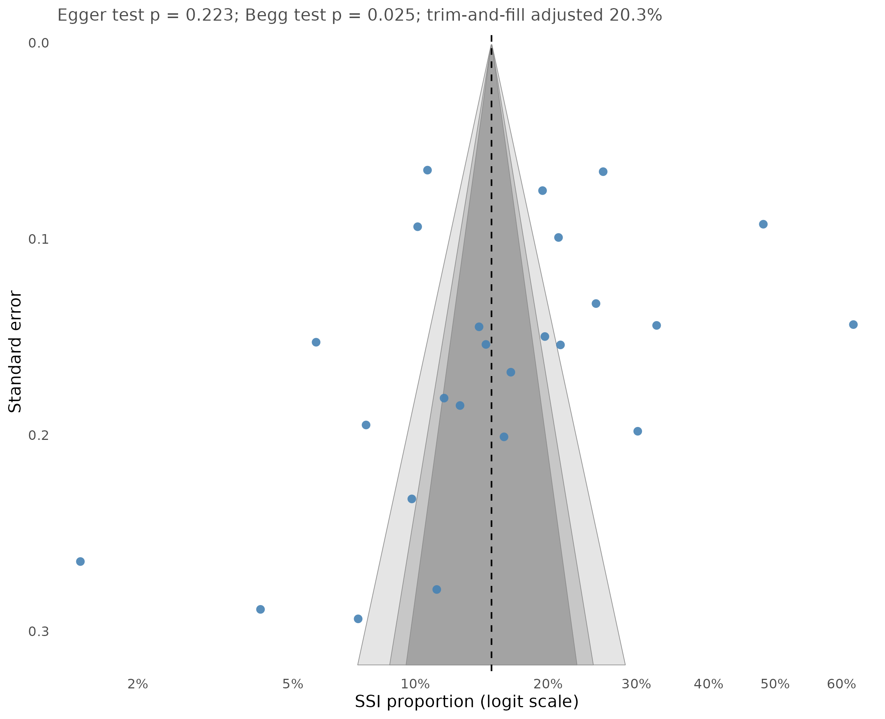
Figure 2. Funnel plot of study-level SSI proportions against precision. The dashed line is the random-effects pooled estimate. Egger’s test p = 0.223; Begg’s test p = 0.025.
Leave-one-out analysis produced pooled estimates from 13.92% to 16.42%; the pooled estimate remained within this range in every leave-one-out model (Table S4; Figure S1). The largest change followed omission of Habtemariam 2023 (13.92%, 95% CI 10.08%–18.92%), the cohort with the highest observed SSI proportion. The primary conclusion was not sensitive to any single study.
The pre-specified sensitivity analyses are summarised in Table S3. Excluding the 3 cohorts with derived incidence counts gave 16.83% (95% CI 12.18%–22.79%, k = 22). Excluding low-quality cohorts gave 15.28% (95% CI 9.61%–23.45%, k = 17). Excluding before–after/quality-improvement designs gave 14.54% (95% CI 10.21%–20.29%, k = 23). Restricting to cohort studies gave 12.73% (95% CI 7.27%–21.37%, k = 12). Excluding cohorts with more than 1,000 patients gave 16.59% (95% CI 11.57%–23.21%, k = 20). All sensitivity estimates remained within the range of the primary estimate and its prediction interval, although the cohort-only estimate was lower (12.73%).
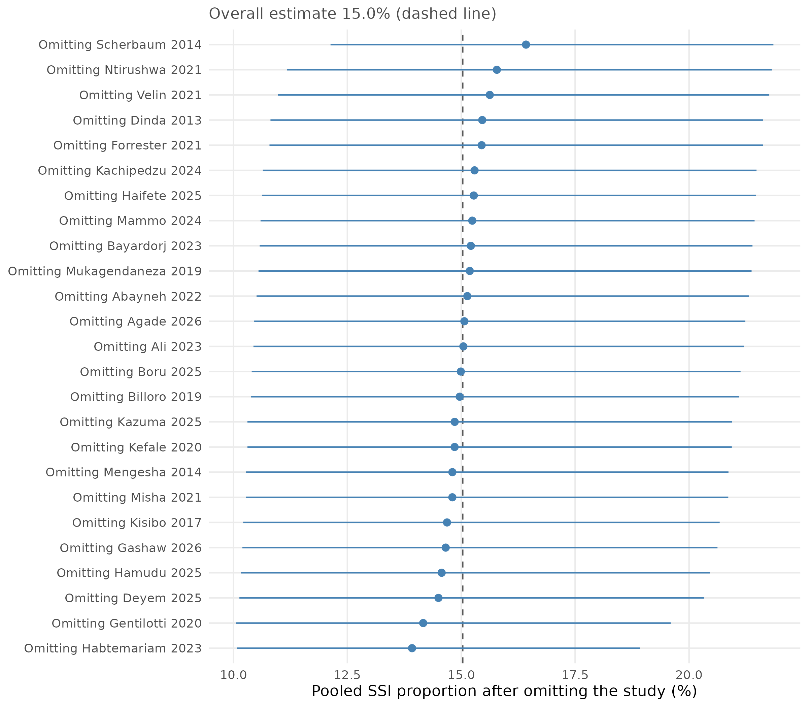
Figure S1. Leave-one-out sensitivity analysis. Each point is the pooled SSI proportion after omitting the named cohort; horizontal bars are 95% confidence intervals.

Pre-specified subgroup analyses
Subgroup analyses are shown in Table 4 and Figure 3 (specialty forest plot in Figure S2). There was evidence of differences by surgical specialty (p = 0.014), but not by hospital level (p = 0.233), ECSA sub-region (p = 0.602), study design (p = 0.160) or publication period (p = 0.302).
For surgical specialty, the pooled proportions were 17.3% (95% CI 8.5%–32.2%, k = 5) in general surgery, 14.4% (8.2%–24.0%, k = 13) in mixed/other surgery, 26.6% (7.5%–61.8%, k = 2) in orthopaedics and 11.2% (2.7%–36.1%, k = 5) in obstetrics/gynaecology. For hospital level, tertiary/referral hospitals had 17.1% (11.1%–25.4%, k = 18), secondary/primary hospitals 8.6% (2.6%–24.8%, k = 4) and mixed networks 13.8% (1.8%–57.9%, k = 3).
Regional estimates were 16.4% (11.5%–22.9%, k = 20) in East Africa, 7.6% (0.0%–100.0%, k = 2) in Central Africa and 12.7% (4.4%–31.5%, k = 3) in Southern Africa. The Central African estimate is based on only two cohorts and has a confidence interval spanning the entire allowable range; it should not be interpreted as a regional burden estimate. The same caution applies to the orthopaedic (k = 2), mixed-hospital (k = 3), before–after/quality-improvement (k = 2) and randomised-trial (k = 2) subgroups. These sparse subgroups are reported for completeness, as required by the protocol, but were not used to support comparative conclusions.
Table 4. Pre-specified subgroup analyses of SSI incidence.
Subgroup variable | Subgroup | k | Events | Patients | SSI % (95% CI) | I² (%) | p within | p between
Surgical specialty | General surgery | 5 | 411 | 2,185 | 17.3 (8.5–32.2) | 91.2 | <0.001 | 0.014
Surgical specialty | Mixed/other | 13 | 988 | 6,374 | 14.4 (8.2–24.0) | 97.3 | <0.001 | 0.014
Surgical specialty | Orthopaedic | 2 | 111 | 420 | 26.6 (7.5–61.8) | 9.0 | 0.294 | 0.014
Surgical specialty | Obstetrics/gynaecology | 5 | 567 | 4,254 | 11.2 (2.7–36.1) | 99.1 | <0.001 | 0.014
Hospital level | Tertiary/referral | 18 | 1,622 | 8,751 | 17.1 (11.1–25.4) | 97.4 | <0.001 | 0.233
Hospital level | Secondary/primary | 4 | 126 | 1,505 | 8.6 (2.6–24.8) | 94.5 | <0.001 | 0.233
Hospital level | Mixed | 3 | 329 | 2,977 | 13.8 (1.8–57.9) | 95.4 | <0.001 | 0.233
ECSA sub-region | East Africa | 20 | 1,628 | 9,415 | 16.4 (11.5–22.9) | 97.5 | <0.001 | 0.602
ECSA sub-region | Central Africa | 2 | 85 | 1,240 | 7.6 (0.0–100.0) | 99.3 | <0.001 | 0.602
ECSA sub-region | Southern Africa | 3 | 364 | 2,578 | 12.7 (4.4–31.5) | 95.5 | <0.001 | 0.602
Study design | Cohort | 12 | 727 | 5,194 | 12.7 (7.3–21.4) | 96.4 | <0.001 | 0.160
Study design | Cross-sectional | 9 | 820 | 4,414 | 20.0 (12.1–31.5) | 96.9 | <0.001 | 0.160
Study design | Before-after/QI | 2 | 253 | 841 | 21.6 (0.0–100.0) | 99.2 | <0.001 | 0.160
Study design | RCT | 2 | 277 | 2,784 | 6.8 (0.0–98.3) | 91.9 | <0.001 | 0.160
Publication period | 2013-2019 | 6 | 305 | 2,652 | 10.5 (3.4–28.4) | 96.4 | <0.001 | 0.302
Publication period | 2020-2026 | 19 | 1,772 | 10,581 | 16.7 (11.5–23.7) | 97.8 | <0.001 | 0.302
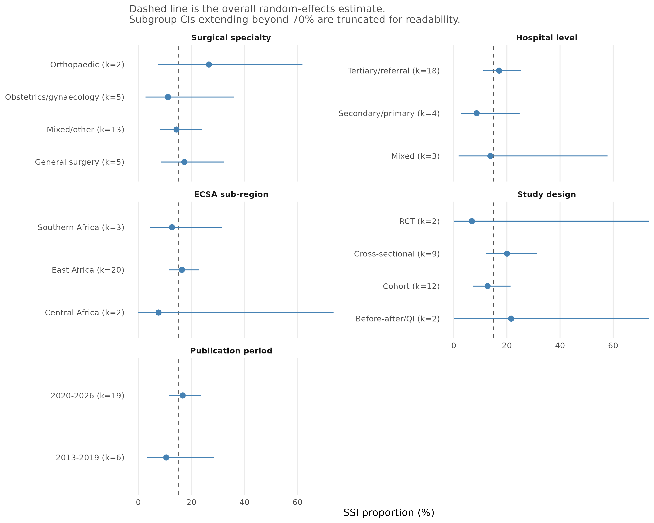
Figure 3. Subgroup summary plot for SSI incidence. Points are subgroup random-effects estimates; horizontal bars are 95% confidence intervals. The dashed line is the overall random-effects estimate. Confidence intervals extending beyond 70% are truncated for readability.
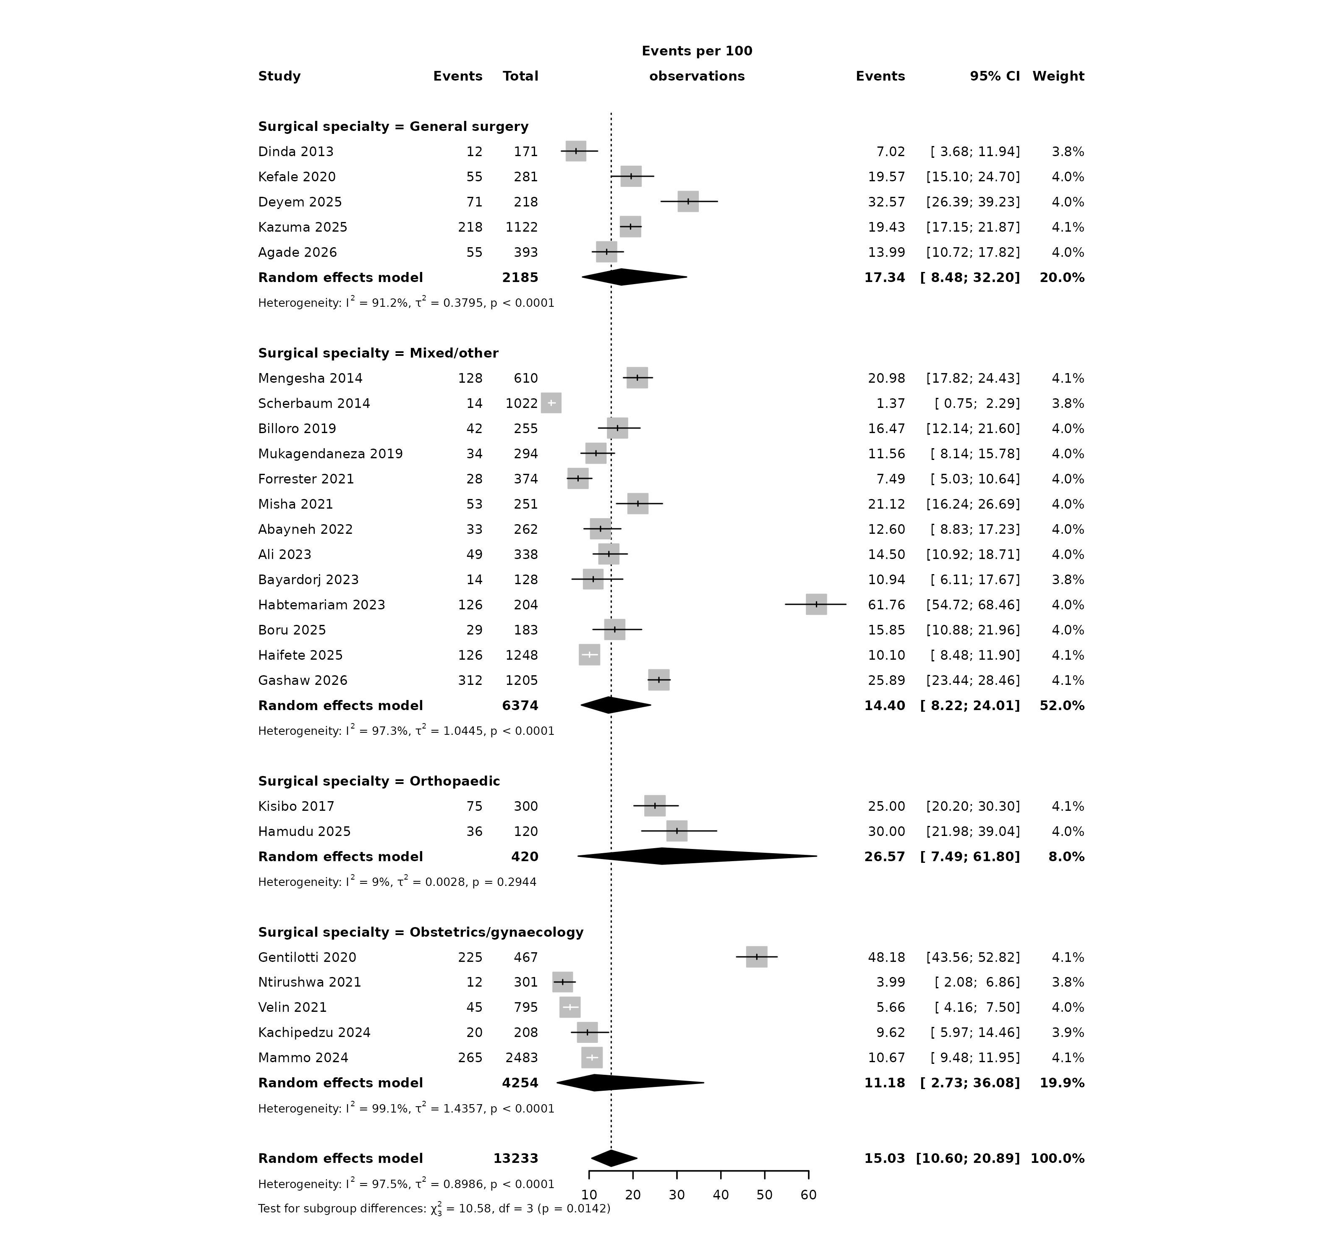
Figure S2. Forest plot of SSI incidence by surgical specialty.
The protocol also specified wound contamination class as a subgroup. Studies in the incidence component did not report SSI incidence stratified by CDC wound class, so this subgroup could not be estimated at the incidence level. Wound class was instead examined in the SSI-positive ecological analyses described below, using study-level proportions of contaminated or dirty wounds among SSI cases; that analysis does not substitute for an incidence subgroup and is interpreted accordingly.

SSI-positive ecological analyses
To explore whether characteristics of SSI-positive patients explained between-study variation, we assembled study-level data on the proportion of SSI cases who were male, HIV-positive, exposed to preoperative antibiotic prophylaxis, or had a contaminated/dirty wound (Table 5). Data were available for 17 cohorts for gender, 5 for HIV, 14 for preoperative prophylaxis and 9 for wound class. These are ecological, study-level analyses, not individual-patient subgroup analyses: the exposure and outcome are both aggregated within each cohort, and the resulting odds ratios describe between-cohort associations.
None of the four SSI-positive characteristics was statistically associated with the pooled SSI proportion. A 10-percentage-point higher proportion of male SSI cases was associated with an OR of 1.09 (95% CI 0.95–1.24, p = 0.210, k = 17, R² = 3.3%). For HIV, the OR was 0.73 (95% CI 0.26–2.01, p = 0.395, k = 5, R² = 0.0%). For preoperative antibiotic prophylaxis, the OR was 0.90 (95% CI 0.76–1.06, p = 0.182, k = 14, R² = 7.6%). For contaminated or dirty wounds, the OR was 1.09 (95% CI 0.96–1.25, p = 0.162, k = 9, R² = 15.7%).
Two additional study-level covariates were examined. Each additional publication year was associated with an OR of 1.08 (95% CI 0.98–1.20, p = 0.128), and each doubling of cohort size with an OR of 0.81 (95% CI 0.57–1.16, p = 0.235). Neither was statistically significant. The absence of associations should not be read as evidence that gender, HIV, prophylaxis or wound class are unrelated to SSI risk: the analyses are underpowered, exposure definitions vary across studies, and ecological bias can operate in either direction.
Table 5. Exploratory study-level meta-regression of SSI incidence.
Covariate | k | Increment | OR (95% CI) | p | R² (%) | tau²
Male proportion among SSI cases | 17 | per 10 percentage points | 1.09 (0.95–1.24) | 0.210 | 3.3 | 0.5240
HIV positivity among SSI cases | 5 | per 10 percentage points | 0.73 (0.26–2.01) | 0.395 | 0.0 | 0.2489
Preoperative antibiotic prophylaxis | 14 | per 10 percentage points | 0.90 (0.76–1.06) | 0.182 | 7.6 | 0.5815
Contaminated or dirty wound class | 9 | per 10 percentage points | 1.09 (0.96–1.25) | 0.162 | 15.7 | 0.1711
Publication year | 25 | per year | 1.08 (0.98–1.20) | 0.128 | 5.4 | 0.8499
Cohort size (log10) | 25 | per doubling | 0.81 (0.57–1.16) | 0.235 | 2.1 | 0.8797

Priority AMR outcomes
The AMR component yielded 54 extracted priority estimates from 23 studies. After removing duplicate third-generation cephalosporin/ESBL rows for the same study and pathogen, 51 rows remained; collapsing species-level rows into one estimate per study and outcome produced 40 study–outcome rows. The three priority outcomes were MRSA, third-generation cephalosporin/ESBL resistance, and carbapenem resistance.
Across studies, MRSA was identified in 283 of 517 tested isolates (16 studies; crude aggregate 54.7%; median study estimate 56.7%, range 10.0–100.0%; IQR 41.5–72.3%). Third-generation cephalosporin/ESBL resistance was identified in 597 of 759 isolates (15 studies; crude 78.7%; median 79.3%, range 27.3–98.2%; IQR 57.9–93.7%). Carbapenem resistance was identified in 102 of 286 isolates (9 studies; crude 35.7%; median 29.4%, range 0.0–84.2%; IQR 27.9–34.1%) (Table 6; Figures 4 and 5).
These estimates are not pooled. The studies differ in whether the denominator is infected patients or isolates, in whether species-level or aggregate Gram-negative results are reported, in AST method and breakpoint interpretation, and in the resistance definition (phenotypic MRSA, oxacillin/cefoxitin resistance, 3GC resistance, ESBL phenotype or carbapenemase production). A random-effects pooled prevalence would be statistically precise but clinically difficult to interpret and would not transport to a particular setting. We therefore report the median study estimate (equal weight per study), the range and IQR (between-study variation), and the crude aggregate proportion (isolate-weighted, for transparency). This is a deliberate departure from the protocol’s pooled-prevalence wording, justified by the heterogeneity described in the Methods.
Table 6. Priority AMR outcomes: study-level and crude aggregate summaries.
Outcome | Studies | Isolates tested | Resistant isolates | Crude aggregate % | Median study % | Range % | IQR %
MRSA | 16 | 517 | 283 | 54.7 | 56.7 | 10.0-100.0 | 41.5-72.3
3GC/ESBL resistance | 15 | 759 | 597 | 78.7 | 79.3 | 27.3-98.2 | 57.9-93.7
Carbapenem resistance | 9 | 286 | 102 | 35.7 | 29.4 | 0.0-84.2 | 27.9-34.1
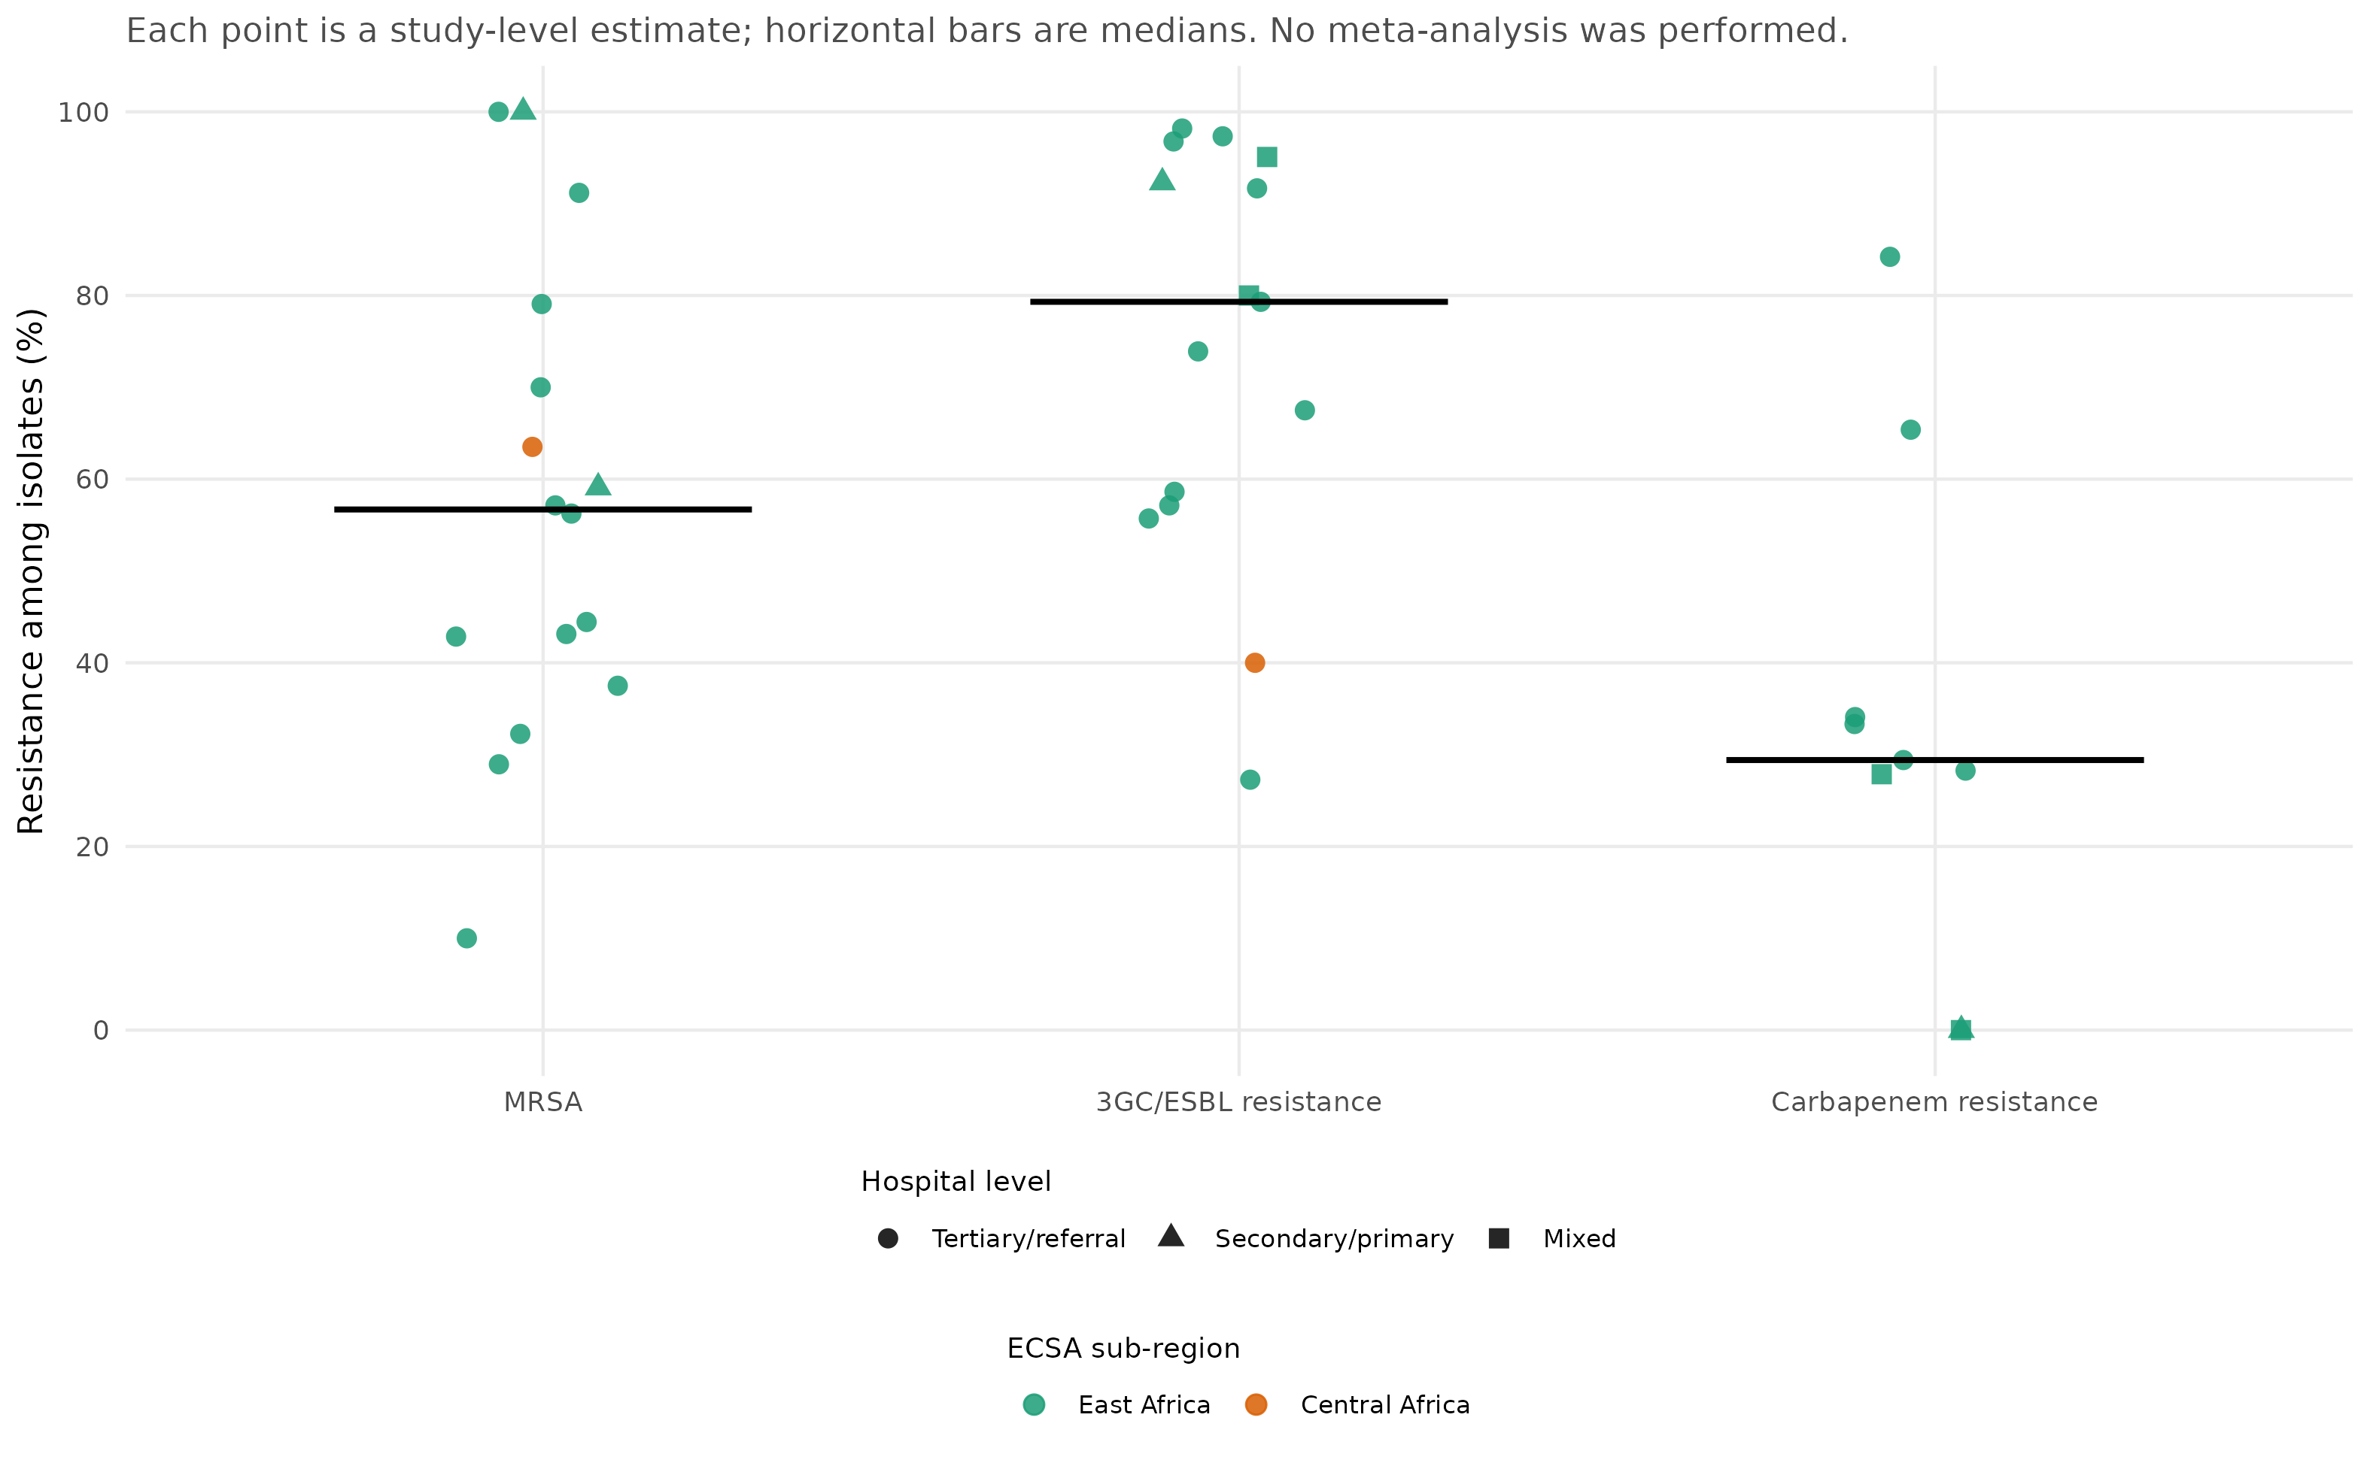
Figure 4. Study-level priority AMR estimates. Each point is one study-level proportion; horizontal bars are medians. Point shape indicates hospital level and colour indicates ECSA sub-region. No meta-analysis was performed.
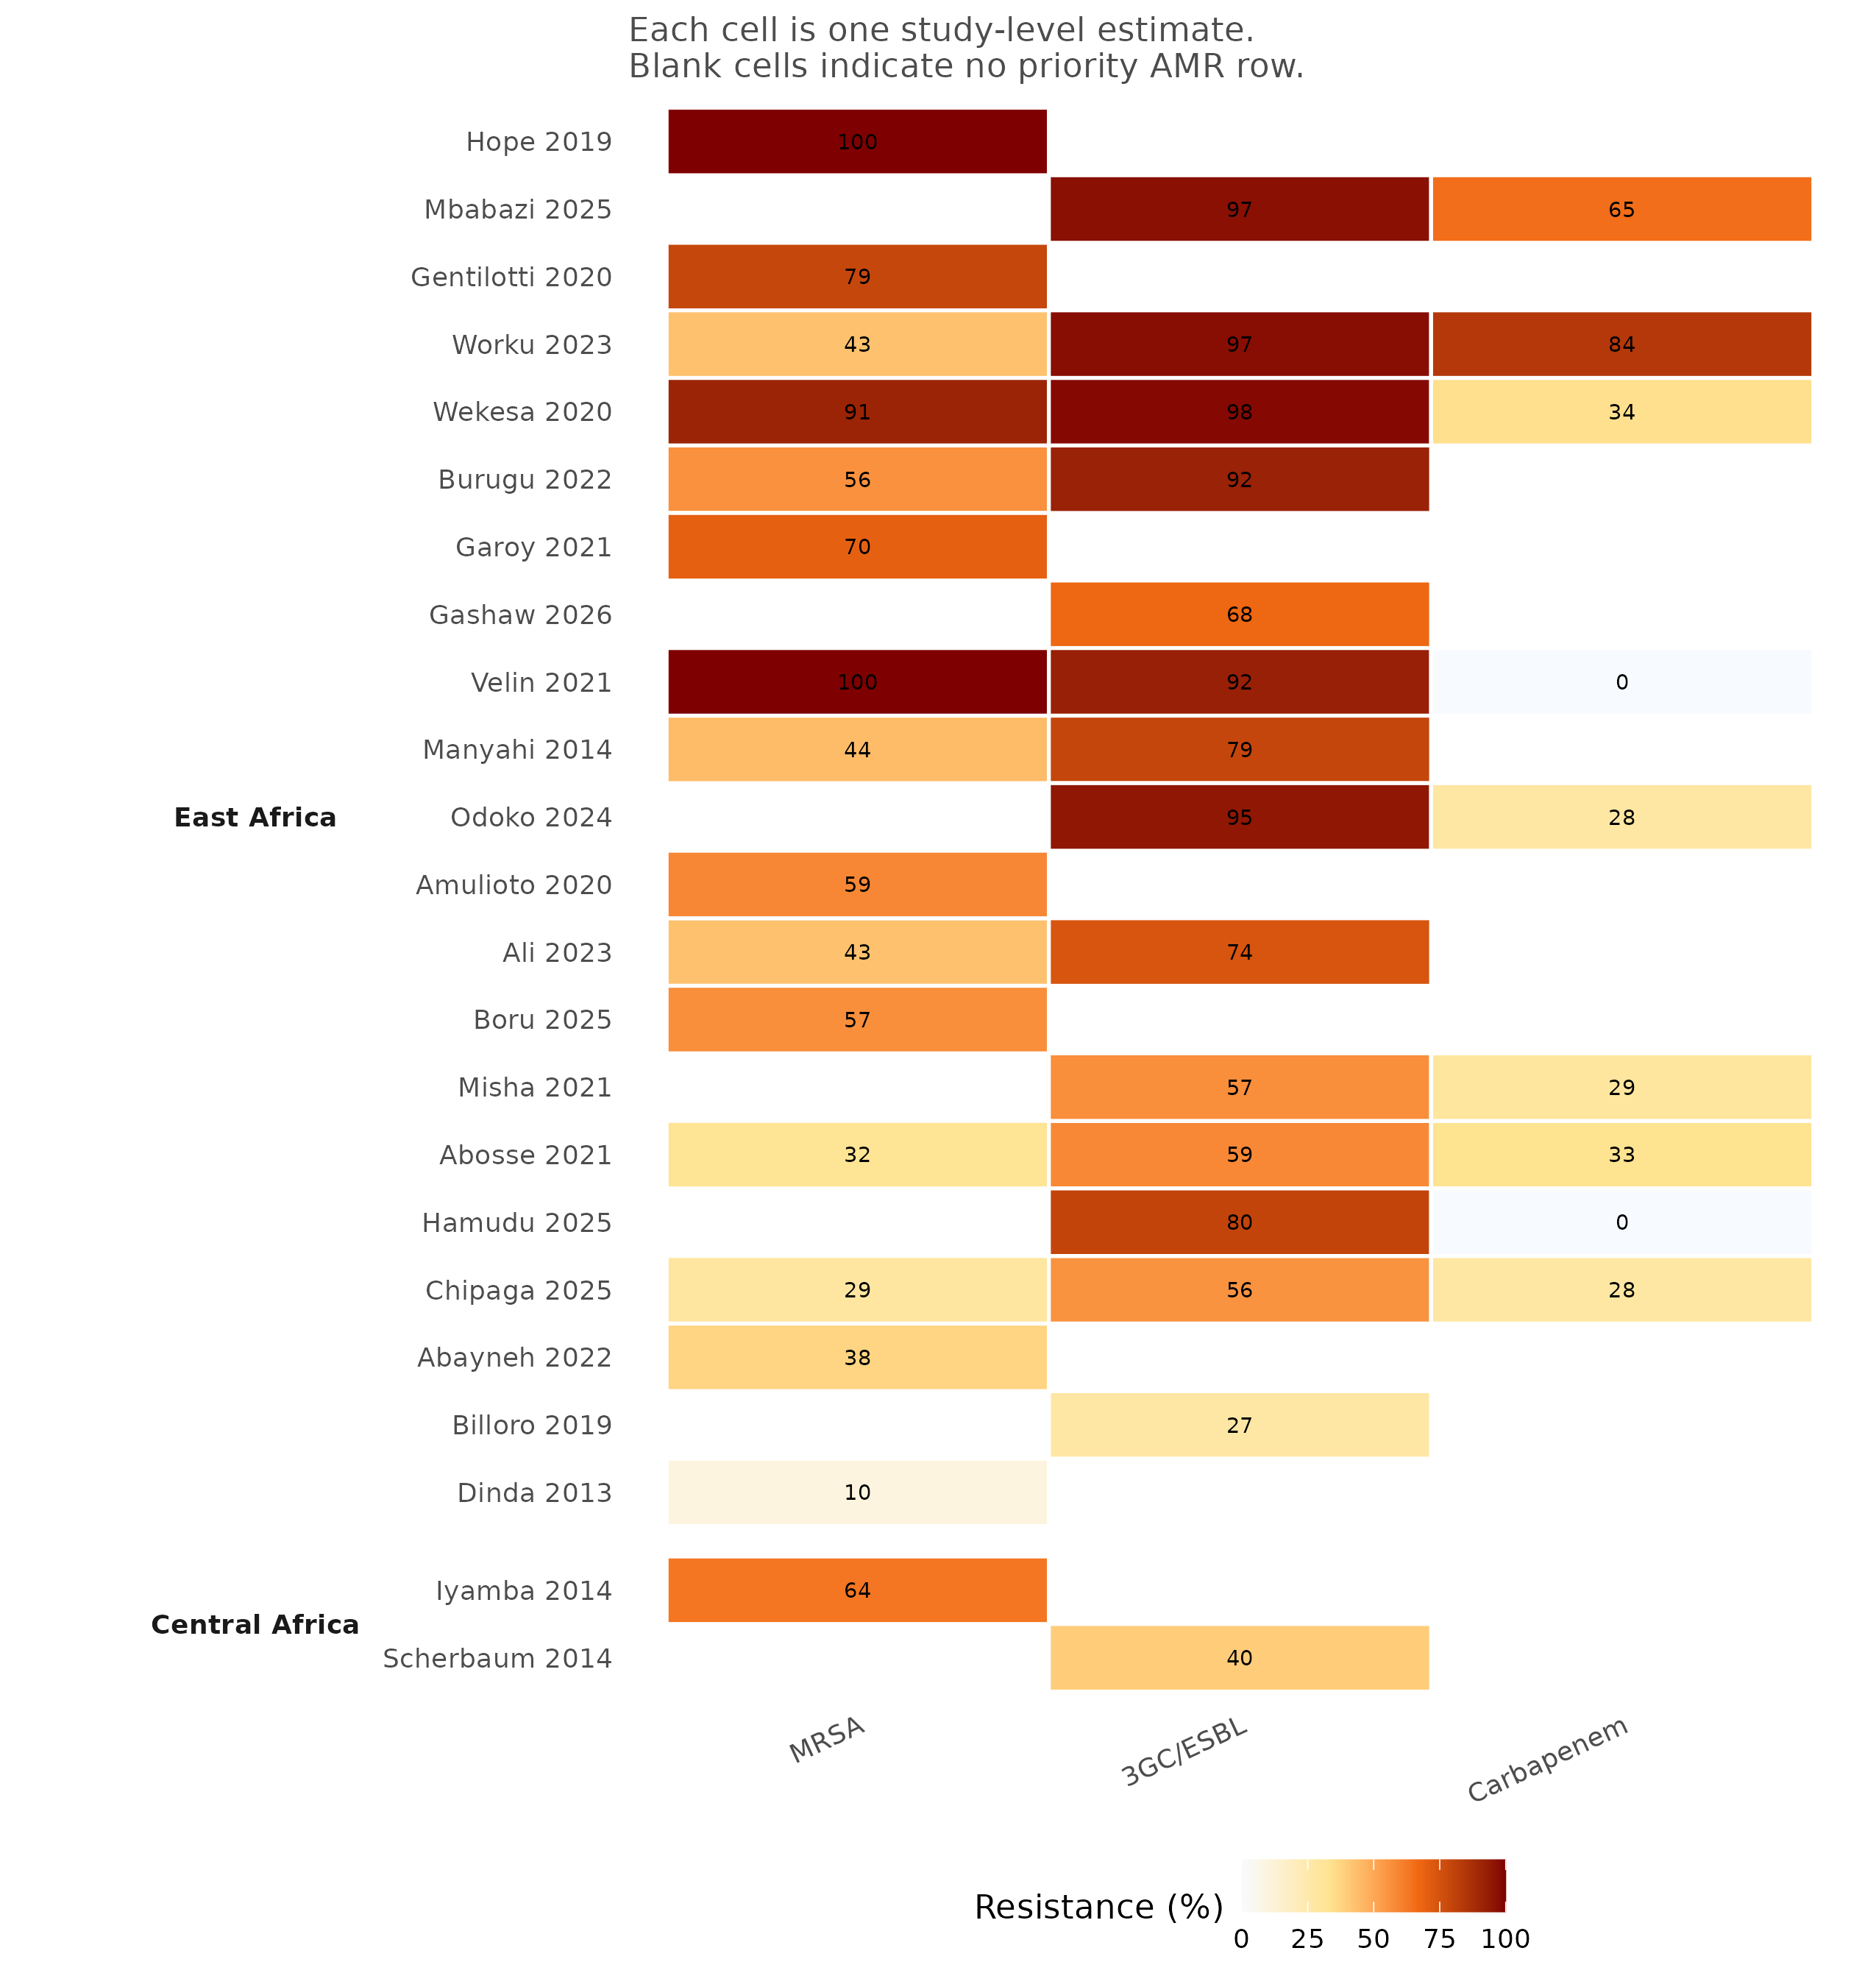
Figure 5. Heatmap of study-level priority AMR estimates by ECSA sub-region. Each cell is one study-level estimate; blank cells indicate no priority AMR row for that study and outcome.

Regional and hospital-level patterns
Priority AMR data were concentrated in East Africa (Table 7). MRSA was reported by 15 East African studies (236/443 isolates; crude 53.3%; median 56.2%) and by one Central African study (47/74; 63.5%). Third-generation cephalosporin/ESBL resistance was reported by 14 East African studies (589/739; crude 79.7%; median 79.7%) and by one Central African study (8/20; 40.0%). Carbapenem resistance was reported only by East African studies (9 studies; 102/286; crude 35.7%; median 29.4%). No Southern African study contributed a priority AMR estimate, and Central Africa contributed only one estimate for MRSA and one for 3GC/ESBL resistance. The regional comparison is therefore a description of where evidence exists, not a test of regional differences.
Table 7. Priority AMR outcomes by ECSA sub-region.
Outcome | Region | Studies | Isolates tested | Resistant isolates | Crude aggregate % | Median study % | Range % | IQR %
MRSA | East Africa | 15 | 443 | 236 | 53.3 | 56.2 | 10.0-100.0 | 40.2-74.5
MRSA | Central Africa | 1 | 74 | 47 | 63.5 | 63.5 | 63.5-63.5 | 63.5-63.5
3GC/ESBL resistance | East Africa | 14 | 739 | 589 | 79.7 | 79.7 | 27.3-98.2 | 60.8-94.4
3GC/ESBL resistance | Central Africa | 1 | 20 | 8 | 40.0 | 40.0 | 40.0-40.0 | 40.0-40.0
Carbapenem resistance | East Africa | 9 | 286 | 102 | 35.7 | 29.4 | 0.0-84.2 | 27.9-34.1
By hospital level (Table 8), MRSA crude prevalence was 54.4% in tertiary/referral hospitals (14 studies; median 50.3%) and 62.5% in secondary/primary hospitals (2 studies; median 79.5%). Third-generation cephalosporin/ESBL resistance was 76.2% in tertiary/referral hospitals (12 studies; median 70.7%), 92.3% in the single secondary/primary study and 92.1% in mixed hospital networks (2 studies). Carbapenem resistance was 47.2% in tertiary/referral hospitals (6 studies; median 33.7%), 0.0% in the single secondary/primary study and 22.4% in mixed hospital networks (2 studies). These hospital-level contrasts are based on very few studies and should be treated as hypothesis-generating.
Table 8. Priority AMR outcomes by hospital level.
Outcome | Hospital level | Studies | Isolates tested | Resistant isolates | Crude aggregate % | Median study % | Range % | IQR %
MRSA | Tertiary/referral | 14 | 493 | 268 | 54.4 | 50.3 | 10.0-100.0 | 38.8-68.4
MRSA | Secondary/primary | 2 | 24 | 15 | 62.5 | 79.5 | 59.1-100.0 | 69.3-89.8
3GC/ESBL resistance | Tertiary/referral | 12 | 644 | 491 | 76.2 | 70.7 | 27.3-98.2 | 56.8-92.9
3GC/ESBL resistance | Secondary/primary | 1 | 39 | 36 | 92.3 | 92.3 | 92.3-92.3 | 92.3-92.3
3GC/ESBL resistance | Mixed | 2 | 76 | 70 | 92.1 | 87.5 | 80.0-95.1 | 83.8-91.3
Carbapenem resistance | Tertiary/referral | 6 | 180 | 85 | 47.2 | 33.7 | 28.3-84.2 | 30.4-57.6
Carbapenem resistance | Secondary/primary | 1 | 30 | 0 | 0.0 | 0.0 | 0.0-0.0 | 0.0-0.0
Carbapenem resistance | Mixed | 2 | 76 | 17 | 22.4 | 13.9 | 0.0-27.9 | 7.0-20.9

Pathogen-specific patterns
Pathogen-specific estimates are shown in Table 9 and Figure S3 (pathogen-by-region detail in Table S7). Among S. aureus isolates, MRSA prevalence was 54.7% (283/517; 16 studies; median 56.7%, range 10.0–100.0%). Third-generation cephalosporin/ESBL resistance was 80.6% in E. coli (191/237; 10 studies; median 92.0%, range 35.7–100.0%) and 80.4% in Klebsiella spp. (148/184; 9 studies; median 68.8%, range 11.1–100.0%). Carbapenem resistance was 67.9% in A. baumannii (55/81; 4 studies; median 51.4%) and 32.6% in P. aeruginosa (15/46; 2 studies; median 44.4%).
Table 9. Priority AMR outcomes by pathogen group.
Outcome | Pathogen | Studies | Isolates tested | Resistant isolates | Crude aggregate % | Median study % | Range % | IQR %
MRSA | Staphylococcus aureus | 16 | 517 | 283 | 54.7 | 56.7 | 10.0-100.0 | 41.5-72.3
3GC/ESBL resistance | E. coli | 10 | 237 | 191 | 80.6 | 92.0 | 35.7-100.0 | 58.3-97.8
3GC/ESBL resistance | Enterobacterales (aggregate) | 4 | 299 | 222 | 74.2 | 77.0 | 67.5-95.1 | 72.3-83.8
3GC/ESBL resistance | Gram-negative (aggregate) | 1 | 39 | 36 | 92.3 | 92.3 | 92.3-92.3 | 92.3-92.3
3GC/ESBL resistance | Klebsiella spp. | 9 | 184 | 148 | 80.4 | 68.8 | 11.1-100.0 | 52.9-93.8
Carbapenem resistance | A. baumannii | 4 | 81 | 55 | 67.9 | 51.4 | 33.3-84.2 | 36.5-70.1
Carbapenem resistance | E. coli | 1 | 9 | 0 | 0.0 | 0.0 | 0.0-0.0 | 0.0-0.0
Carbapenem resistance | Enterobacterales (aggregate) | 2 | 76 | 17 | 22.4 | 13.9 | 0.0-27.9 | 7.0-20.9
Carbapenem resistance | Gram-negative (aggregate) | 1 | 30 | 0 | 0.0 | 0.0 | 0.0-0.0 | 0.0-0.0
Carbapenem resistance | Klebsiella spp. | 1 | 44 | 15 | 34.1 | 34.1 | 34.1-34.1 | 34.1-34.1
Carbapenem resistance | P. aeruginosa | 2 | 46 | 15 | 32.6 | 44.4 | 26.3-62.5 | 35.4-53.5
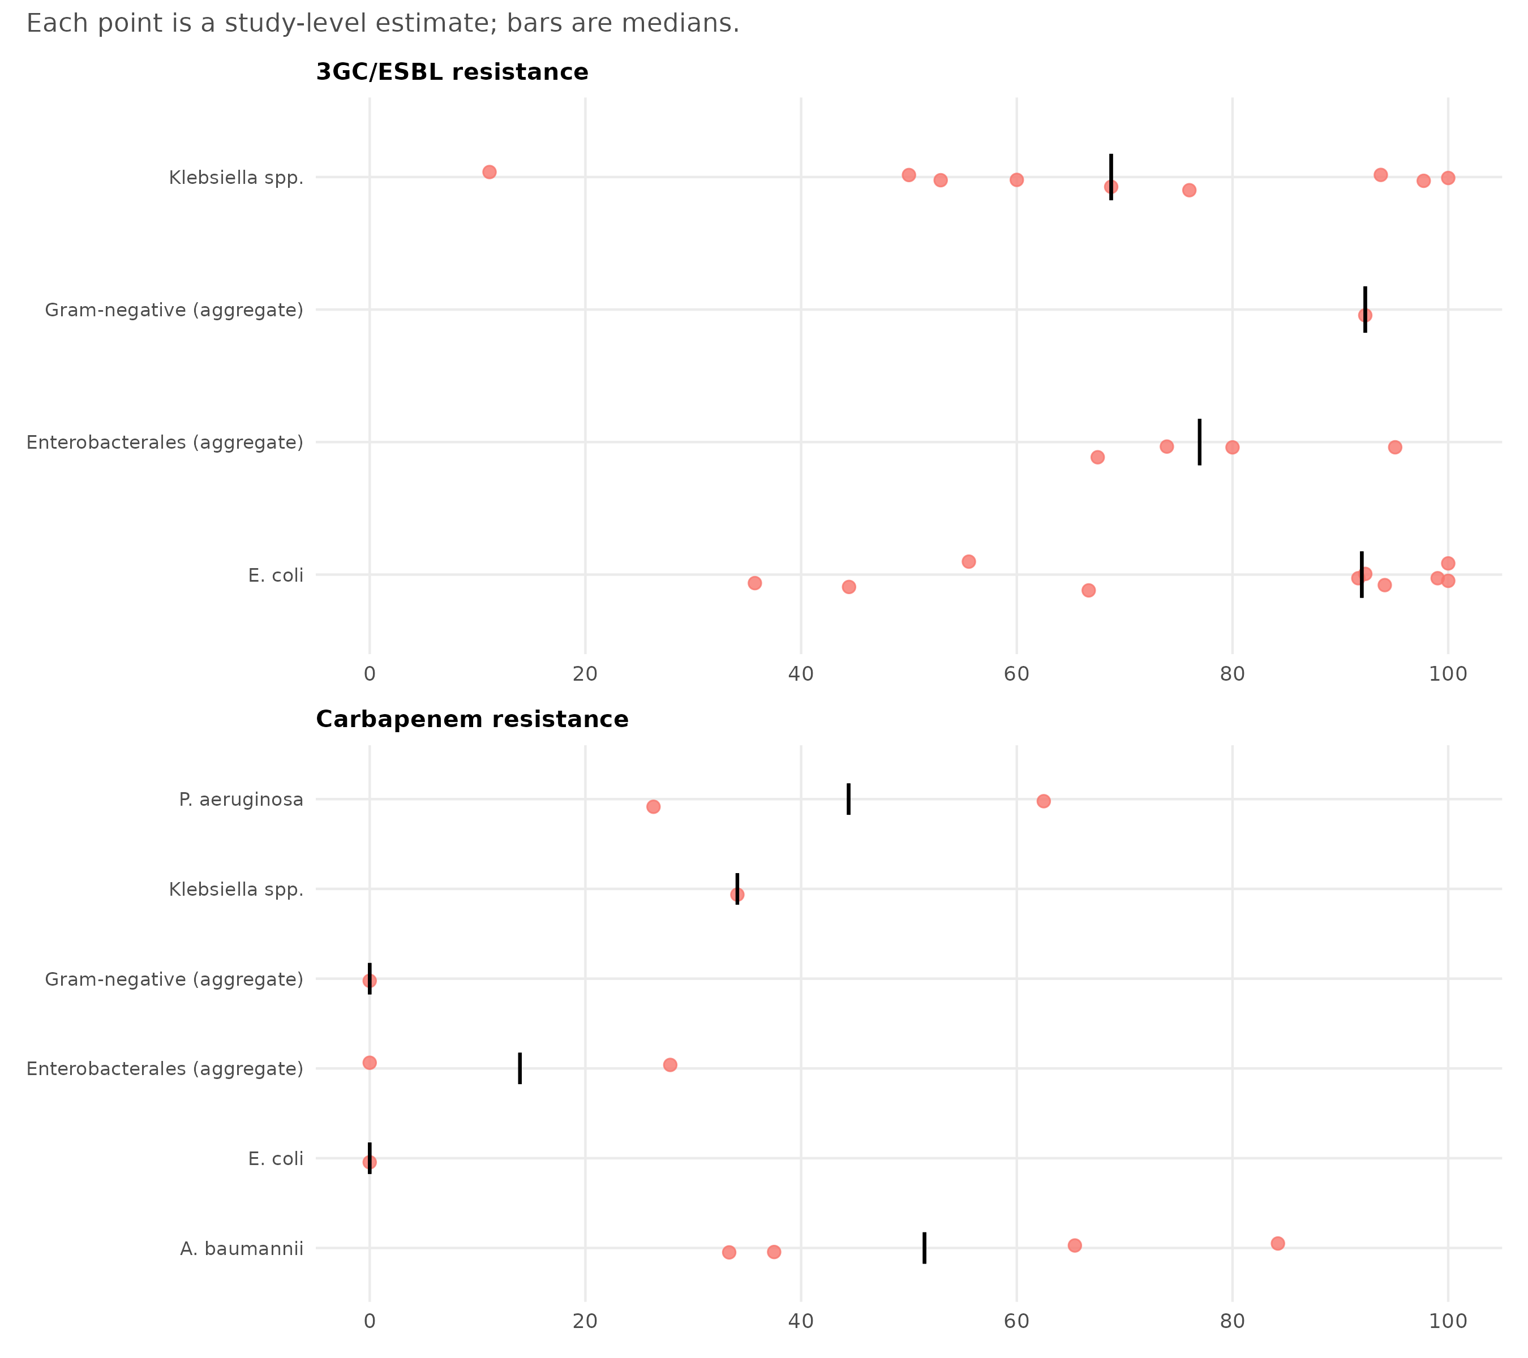
Figure S3. Pathogen-specific priority AMR estimates. Each point is a study-level estimate; horizontal bars are medians. No meta-analysis was performed.

Antimicrobial susceptibility patterns
The AST panel contained 535 isolate–drug observations from 16 studies and five pathogens (Tables S9 and S10). Equivalent agents were combined into drug classes (for example, oxacillin and cefoxitin as the MRSA marker; cefotaxime and ceftriaxone as third-generation cephalosporins; meropenem and imipenem as carbapenems), and repeated agents within the same study and class were averaged so that each study contributed once per class. The resulting 107 pathogen–drug summaries are displayed in Figures 6 and 7; all values are medians of study-level resistance percentages, not pooled prevalence estimates.
For S. aureus (Figure 7), median resistance was 40.2% for oxacillin/cefoxitin (12 studies; range 10.0–100.0%), 0.0% for vancomycin (9 studies; maximum 31.3%), 15.2% for gentamicin, 26.8% for ciprofloxacin, 28.7% for clindamycin, 47.5% for erythromycin/azithromycin and 92.1% for penicillin. The low median vancomycin resistance is reassuring, but the maximum of 31.3% shows that non-susceptible isolates have been reported; the number of studies contributing to each drug varies widely.
For Gram-negative pathogens (Figure 6), median third-generation cephalosporin resistance was 75.9% in E. coli (14 studies; range 25.0–100.0%) and 66.7% in K. pneumoniae (13 studies; range 11.1–100.0%). Median carbapenem resistance was 6.7% in E. coli (7 studies), 12.0% in K. pneumoniae (9 studies), 18.7% in P. aeruginosa (10 studies) and 35.4% in A. baumannii (6 studies). Amikacin resistance was consistently lower than resistance to the other agents shown, with medians of 12.9% in E. coli, 12.0% in K. pneumoniae, 9.1% in P. aeruginosa and 13.6% in A. baumannii.
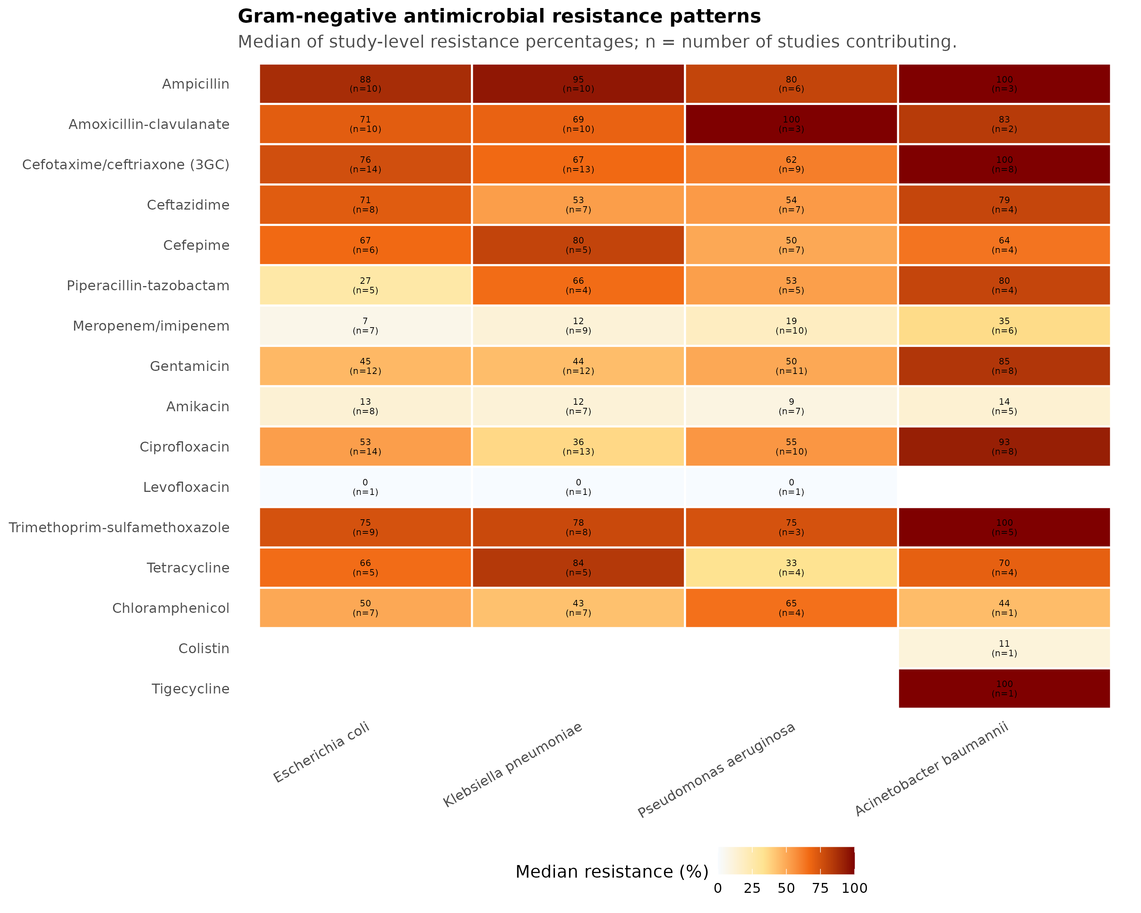
Figure 6. Heatmap of median antimicrobial resistance among Gram-negative pathogens. Cell values are medians of study-level resistance percentages; n is the number of studies contributing to each pathogen–drug cell.
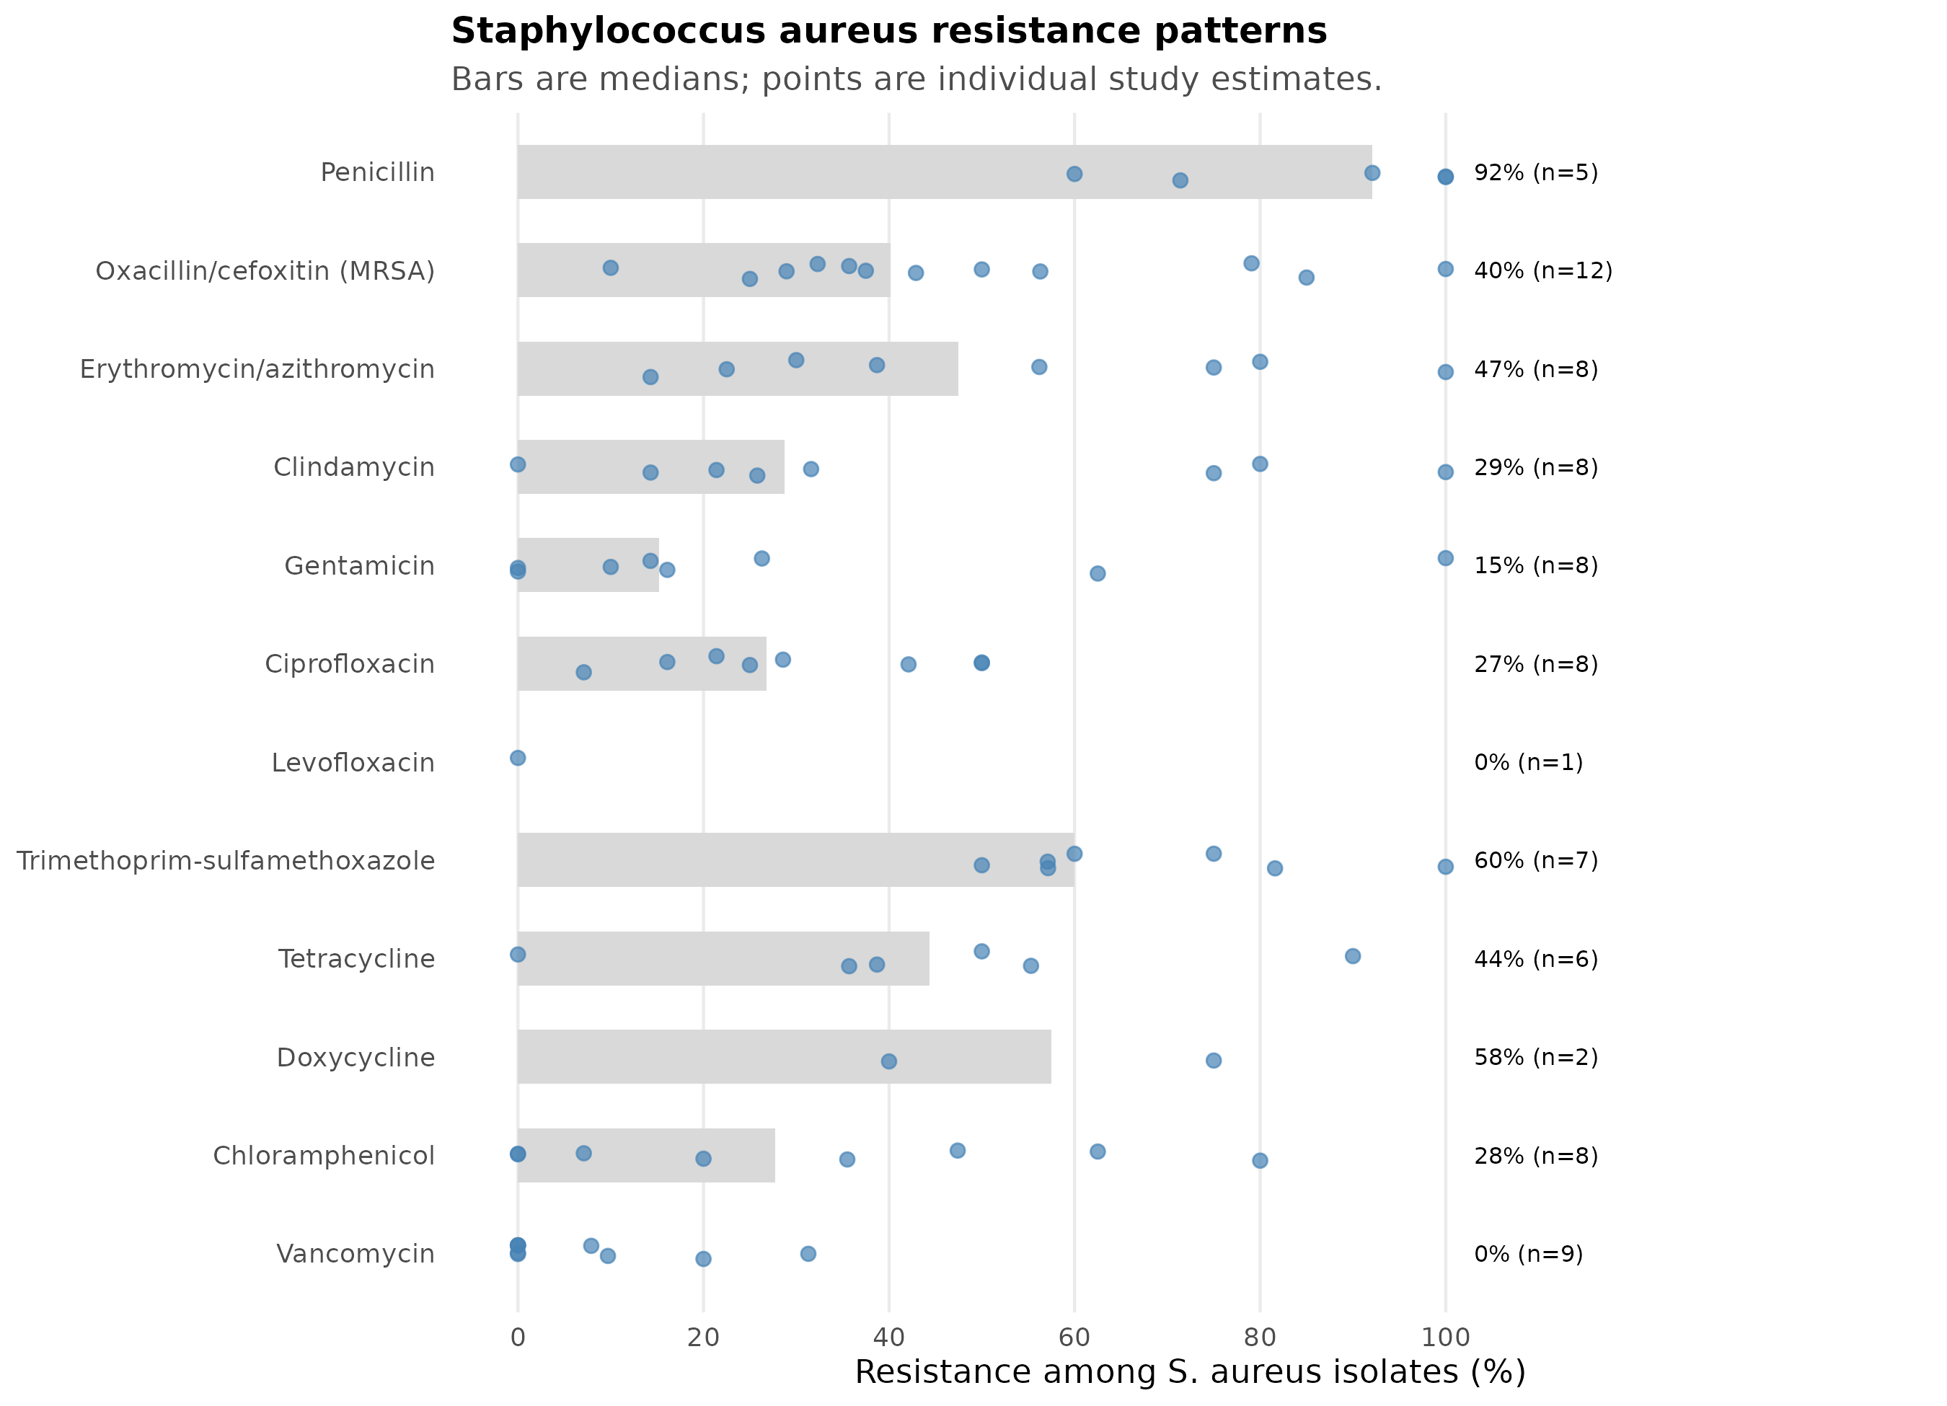
Figure 7. Staphylococcus aureus resistance patterns. Bars are medians of study-level resistance percentages; points are individual study estimates; n is the number of contributing studies.

Secondary clinical and economic outcomes
Twelve outcome rows were extracted from 7 studies (Table 10). Mortality was reported by five studies. Agade 2026 reported 34/393 deaths (8.7%) in the whole cohort; Deyem 2025 reported 24/218 (11.0%) and a strong association between SSI and mortality (23.94% vs 4.76%; OR 6.30, 95% CI 2.50–16.00, p < 0.0001); Mukagendaneza 2019 reported 3/294 (1.0%); Starr 2023 reported 4.4% vs 5.5% (p = 0.34); and Forrester 2021 reported 20 deaths in total without an SSI-specific denominator. The mortality definitions and time windows were not comparable, and only one study provided an SSI-versus-no-SSI contrast, so no pooled mortality estimate was calculated.
Length of stay was reported by three studies. Agade 2026 reported a mean of 5 days and a median of 3 days (IQR 3–10); Starr 2023 reported 5.1 vs 5.6 days (p = 0.35); and Forrester 2021 reported no numeric estimate. Gentilotti 2020 reported an estimated hospital cost saving of approximately EUR 1500 after the intervention, explicitly described by the authors as an estimate rather than a measured provider cost. Kachipedzu 2024 reported readmission in 12/20 (60%) women with SSI, and Starr 2023 reported reoperation in 1.0% vs 2.9% (p < 0.001). The paucity of comparable definitions, time horizons and denominators precluded meta-analysis; the evidence is summarised narratively.
Table 10. Reported clinical and economic outcomes associated with SSI.
Study | Year | Country | Domain | Outcome | Group / comparator | Reported value | Effect (95% CI) | p
Gentilotti 2020 | 2020 | Tanzania | Economic | Estimated hospital cost saving after intervention | All patients | Approximately EUR 1500 | Approximately EUR 1500 estimated hospital saving (author estimate) | NA
Agade 2026 | 2026 | Kenya | Length of stay | Hospital length of stay | All patients | Mean 5 days; median 3 (IQR 3-10) | NA | NA
Forrester 2021 | 2021 | Ethiopia | Length of stay | Duration of hospital stay | All patients | Unchanged (no numeric estimate reported) | NA | NA
Starr 2023 | 2023 | Ethiopia | Length of stay | Length of stay, pre vs post implementation | All patients | 5.1 vs 5.6 days | NA | 0.35
Agade 2026 | 2026 | Kenya | Mortality | All-cause in-hospital mortality | All patients | 34/393 (8.7%) | NA | NA
Deyem 2025 | 2025 | Democratic Republic of the Congo | Mortality | All-cause mortality | All patients | 24/218 (11.0%) | NA | NA
Deyem 2025 | 2025 | Democratic Republic of the Congo | Mortality | Mortality by SSI status | SSI vs No SSI | 23.94% vs 4.76% | OR 6.30 (95% CI 2.50-16.00) | <0.0001
Forrester 2021 | 2021 | Ethiopia | Mortality | Deaths during follow-up | All patients | 20 deaths in total | NA | NA
Mukagendaneza 2019 | 2019 | Rwanda | Mortality | In-hospital mortality | All patients | 3/294 (1.0%) | NA | NA
Starr 2023 | 2023 | Ethiopia | Mortality | Overall mortality, pre vs post implementation | All patients | 4.4% vs 5.5% | NA | 0.34
Kachipedzu 2024 | 2024 | Malawi | Readmission | Readmission among women with SSI | SSI | 12/20 (60%) | NA | NA
Starr 2023 | 2023 | Ethiopia | Reoperation | Need for subsequent operations, pre vs post implementation | All patients | 1.0% vs 2.9% | NA | <0.001

Reported drivers of SSI and AMR
Twenty-six driver rows were extracted from 13 studies across 12 domains; 21 rows contained a ratio estimate with a confidence interval and are displayed in Figure 8 (Tables 11 and 12). The most consistent signal was wound contamination: Kefale 2020 reported adjusted odds ratios of 6.01 (95% CI 1.77–16.80) for contaminated wounds and 7.20 (1.23–12.10) for dirty wounds relative to clean wounds; Deyem 2025 reported 4.50 (1.80–11.50) for contaminated or dirty wounds; and Boru 2025 reported 3.17 (1.21–8.30) for clean-contaminated wounds. These estimates are directionally consistent despite different adjustment sets and outcome definitions.
Hospital stay was associated with SSI in several studies, most extreme in Mukagendaneza 2019 (stay >14 days: OR 42.30, 95% CI 16.40–108.90), with smaller estimates from Haifete 2025 (postoperative stay ≥5 days: COR 3.18, 2.13–4.75), Boru 2025 (hospital stay ≥10 days: AOR 2.66, 1.06–6.66), Odoko 2024 (stay >15 days: AOR 3.81, 2.08–6.95) and others. These associations are vulnerable to reverse causation, because postoperative stay may be prolonged because of SSI rather than causing it; they should not be interpreted as causal effects.
Antimicrobial prophylaxis was examined in four studies. Billoro 2019 reported an adjusted risk ratio of 5.05 (95% CI 1.79–14.21) for administration more than 1 hour before incision relative to administration within 1 hour; Gashaw 2026 reported a crude hazard ratio of 1.50 (1.19–1.92) for no preoperative prophylaxis; and Kefale 2020 reported an AOR of 6.63 (0.89–19.30) for no surgical antibiotic prophylaxis, which the authors described as significant although the confidence interval includes 1. Kefale 2020 also reported higher odds for prophylaxis given 1–2 hours before incision (AOR 8.20, 4.34–18.10) and for a 48-hour duration of prophylaxis (AOR 7.20, 1.23–28.17), suggesting that timing and duration, not only receipt, matter.
Infection prevention and control was examined by Forrester 2021, where high compliance with at least three critical IPC standards was associated with a lower risk of SSI (RR 0.54, 95% CI 0.30–0.97), and by Gashaw 2026, where no chlorhexidine cloth wash was associated with higher risk (cHR 2.30, 2.11–3.30). Diagnostic capacity was directly quantified by Kachipedzu 2024: only 10/20 women with SSI had culture results, and only 5/10 of those were culture-positive, illustrating the fragility of AMR estimates based on routine culture. Other reported drivers included previous antibiotic use (388/752, 52.9%, Worku 2023), previous hospital admission (619/752, 82.4%), blood transfusion (OR 6.80, 2.90–16.30), operation duration ≥2 hours (AOR 2.64, 1.01–6.90), comorbidity (AOR 9.18, 5.17–17.90) and age >54 years (AOR 4.76, 1.10–20.56).
Table 11. Reported drivers of SSI and AMR.
Study | Year | Country | Domain | Driver | Comparison | Effect (95% CI) | p | Direction
Worku 2023 | 2023 | Ethiopia | Antibiotic exposure | Previous use of antibiotics | No previous use | 51.6% | NA | Descriptive
Billoro 2019 | 2019 | Ethiopia | Antimicrobial prophylaxis | Antibiotic administered before 1 hour pre-incision | Administration within 1 hour of incision | ARR 5.05 (95% CI 1.79-14.21) | 0.002 | Increases risk
Gashaw 2026 | 2026 | Ethiopia | Antimicrobial prophylaxis | No preoperative prophylaxis | Preoperative prophylaxis | cHR 1.50 (95% CI 1.19-1.92) | 0.001 | Increases risk
Gentilotti 2020 | 2020 | Tanzania | Antimicrobial prophylaxis | Pre-operative single-dose prophylaxis | 3-day postoperative intravenous course | 98.0% | <0.001 | Practice change
Kefale 2020 | 2020 | Ethiopia | Antimicrobial prophylaxis | 48-hour duration of prophylaxis | Shorter duration | AOR 7.20 (95% CI 1.23-28.17) | 0.027 | Increases risk
Kefale 2020 | 2020 | Ethiopia | Antimicrobial prophylaxis | No surgical antibiotic prophylaxis | Prophylaxis given | AOR 6.63 (95% CI 0.89-19.30) | 0.006 | Increases risk
Kefale 2020 | 2020 | Ethiopia | Antimicrobial prophylaxis | Prophylaxis 1-2 hours before incision | Guideline-concordant timing | AOR 8.20 (95% CI 4.34-18.10) | 0.001 | Increases risk
Kefale 2020 | 2020 | Ethiopia | Comorbidity | Presence of comorbidity | No comorbidity | AOR 9.18 (95% CI 5.17-17.90) | <0.001 | Increases risk
Kachipedzu 2024 | 2024 | Malawi | Diagnostic capacity | SSI cases with microbiology culture result | All clinically diagnosed SSI | 50.0% | NA | Capacity gap
Worku 2023 | 2023 | Ethiopia | Healthcare exposure | History of hospital admission | No previous admission | 82.3% | NA | Descriptive
Billoro 2019 | 2019 | Ethiopia | Hospital stay | Surgery waiting time >7 days | <=7 days | ARR 2.48 (95% CI 1.28-4.79) | 0.007 | Increases risk
Boru 2025 | 2025 | Ethiopia | Hospital stay | Hospital stay >=10 days | <10 days | AOR 2.66 (95% CI 1.06-6.66) | NA | Increases risk
Haifete 2025 | 2025 | Namibia | Hospital stay | Postoperative stay >=5 days | <5 days | COR 3.18 (95% CI 2.13-4.75) | NA | Increases risk
Mukagendaneza 2019 | 2019 | Rwanda | Hospital stay | Hospital stay >14 days | <=14 days | OR 42.30 (95% CI 16.40-108.90) | <0.001 | Increases risk
Odoko 2024 | 2024 | Ethiopia | Hospital stay | Length of stay >15 days | Shorter stay | AOR 3.81 (95% CI 2.08-6.95) | NA | Increases risk
Forrester 2021 | 2021 | Ethiopia | Infection prevention | High compliance with >=3 critical IPC standards | Low compliance (<=2 standards) | RR 0.54 (95% CI 0.30-0.97) | 0.038 | Decreases risk
Gashaw 2026 | 2026 | Ethiopia | Infection prevention | No chlorhexidine cloth wash | Chlorhexidine cloth wash | cHR 2.30 (95% CI 2.11-3.30) | <0.001 | Increases risk
Boru 2025 | 2025 | Ethiopia | Operation factors | Operation duration >=2 hours | <2 hours | AOR 2.64 (95% CI 1.01-6.90) | NA | Increases risk
Deyem 2025 | 2025 | Democratic Republic of the Congo | Operation factors | Laparotomy | Other abdominal procedures | AOR 4.20 (95% CI 1.70-10.30) | <0.0001 | Increases risk
Boru 2025 | 2025 | Ethiopia | Patient factors | Age >54 years | Younger age | AOR 4.76 (95% CI 1.10-20.56) | NA | Increases risk
Abayneh 2022 | 2022 | Ethiopia | Patient/operation factors | Age >50, comorbidity, postoperative stay >14 days, ASA >=III, contaminated wound | Reference categories | NA | <0.05 | Increases risk
Mukagendaneza 2019 | 2019 | Rwanda | Transfusion | Blood transfusion during surgery | No transfusion | OR 6.80 (95% CI 2.90-16.30) | <0.001 | Increases risk
Boru 2025 | 2025 | Ethiopia | Wound class | Clean-contaminated wound | Clean wound | AOR 3.17 (95% CI 1.21-8.30) | NA | Increases risk
Deyem 2025 | 2025 | Democratic Republic of the Congo | Wound class | Contaminated or dirty wound | Clean/clean-contaminated wound | AOR 4.50 (95% CI 1.80-11.50) | <0.0001 | Increases risk
Kefale 2020 | 2020 | Ethiopia | Wound class | Contaminated wound | Clean wound | AOR 6.01 (95% CI 1.77-16.80) | 0.019 | Increases risk
Kefale 2020 | 2020 | Ethiopia | Wound class | Dirty wound | Clean wound | AOR 7.20 (95% CI 1.23-12.10) | 0.029 | Increases risk

Table 12. Driver domains, number of studies and availability of ratio estimates.
Domain | Studies | Estimates | Ratio estimates with CI | Example drivers
Hospital stay | 5 | 5 | 5 | Hospital stay >=10 days; Surgery waiting time >7 days; Hospital stay >14 days
Antimicrobial prophylaxis | 4 | 6 | 5 | No surgical antibiotic prophylaxis; Prophylaxis 1-2 hours before incision; 48-hour duration of prophylaxis
Wound class | 3 | 4 | 4 | Contaminated wound; Dirty wound; Clean-contaminated wound
Infection prevention | 2 | 2 | 2 | No chlorhexidine cloth wash; High compliance with >=3 critical IPC standards
Operation factors | 2 | 2 | 2 | Operation duration >=2 hours; Laparotomy
Antibiotic exposure | 1 | 1 | 0 | Previous use of antibiotics
Comorbidity | 1 | 1 | 1 | Presence of comorbidity
Diagnostic capacity | 1 | 1 | 0 | SSI cases with microbiology culture result
Healthcare exposure | 1 | 1 | 0 | History of hospital admission
Patient factors | 1 | 1 | 1 | Age >54 years
Patient/operation factors | 1 | 1 | 0 | Age >50, comorbidity, postoperative stay >14 days, ASA >=III, contaminated wound
Transfusion | 1 | 1 | 1 | Blood transfusion during surgery
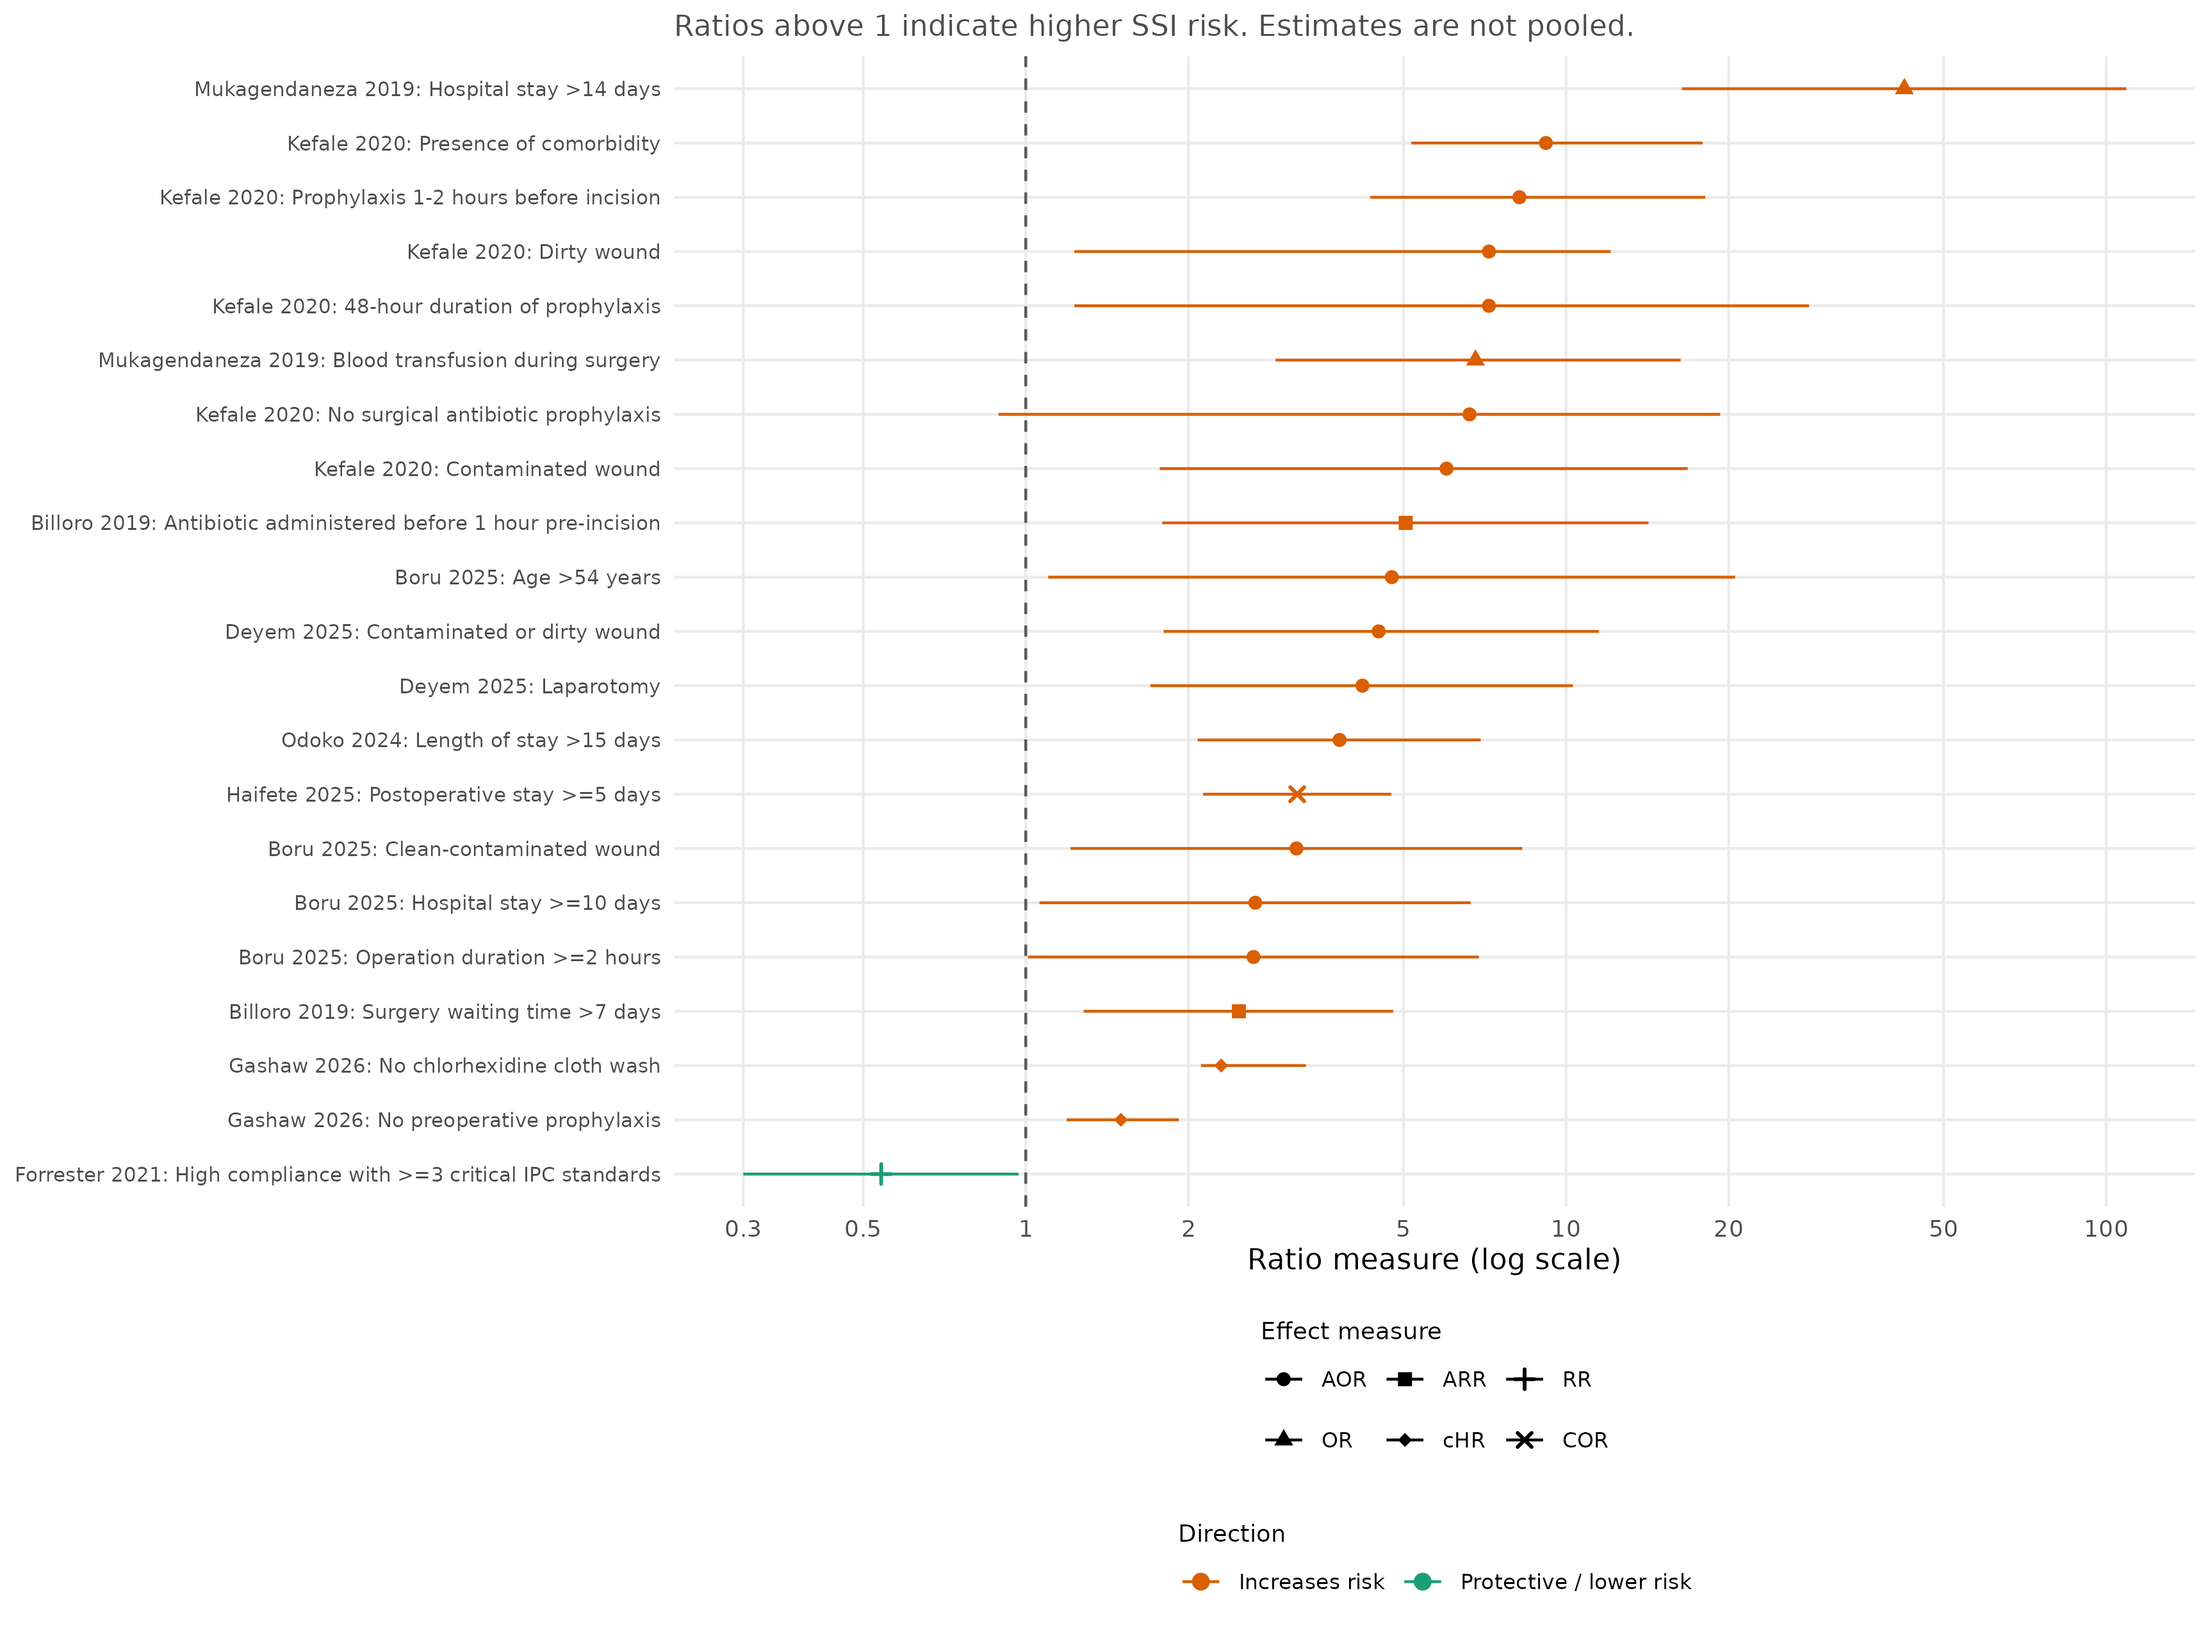
Figure 8. Study-level ratio estimates for reported drivers of SSI. Ratios above 1 indicate higher SSI risk; the x-axis is logarithmic. Estimates are not pooled. Point shape indicates the effect measure and colour indicates the direction of association.

Certainty of evidence
Certainty in the pooled SSI estimate was very low. The included evidence is almost entirely observational, between-study heterogeneity was extreme (I² = 97.5%), SSI definitions and follow-up windows varied, several cohorts were of moderate or low quality, and the small-study tests were inconsistent. The prediction interval (2.35%–56.57%) is wide enough that the pooled estimate should be viewed as a regional average rather than a setting-specific parameter. Certainty in the AMR estimates was also very low, because the estimates are descriptive, geographically concentrated, based on different denominators and breakpoints, and not pooled. Certainty in the secondary clinical and economic outcomes was very low because definitions, time horizons and denominators were not comparable and the number of studies was small.

Methods

Design and reporting
This was a systematic review and meta-analysis of studies reporting SSI incidence and/or antimicrobial resistance among patients undergoing surgery in East, Central and Southern Africa (ECSA). The review was conducted according to a pre-specified protocol that defined the population, exposure, eligible designs, outcomes, subgroup analyses and synthesis strategy (protocol archived with the project). Reporting follows the PRISMA 2020 statement. The protocol’s main outcomes were the pooled incidence/prevalence of SSI and the prevalence of priority AMR combinations; additional outcomes were mortality, length of stay, readmission, economic costs and reported drivers of AMR.
The protocol text contains an internal inconsistency: one line states that “only randomized study types will be included”, while the adjacent list of eligible designs includes non-randomised cohort, case–control and cross-sectional studies. Because the review question is descriptive and the evidence base is overwhelmingly observational, we included randomised trials and the listed observational designs, and excluded only the design categories that the protocol explicitly excluded (case reports and small case series with fewer than 10 participants, editorials, expert opinion, animal studies and in vitro studies). This interpretation is stated here as a protocol deviation.

Eligibility criteria
Population. Patients undergoing surgical procedures in ECSA countries. Studies of non-surgical wounds, all hospital-acquired infections without a surgical denominator, or post-traumatic wounds without a surgical procedure were excluded.
Exposure. For the SSI-incidence question, the exposure was having undergone a surgical procedure. For the AMR question, the exposure was a microbiologically confirmed SSI with pathogen isolation and antimicrobial susceptibility testing.
Designs. Randomised controlled trials, prospective and retrospective cohort studies, case–control studies and cross-sectional studies were eligible. Case reports, small case series (n < 10), reviews, editorials, expert opinion, animal studies and in vitro studies were excluded.
Outcomes. The primary outcome was SSI incidence (proportion of operated patients who developed SSI). Priority AMR outcomes were MRSA; third-generation cephalosporin/ESBL resistance in E. coli and Klebsiella spp.; and carbapenem resistance in A. baumannii and P. aeruginosa. Additional outcomes were antimicrobial susceptibility patterns for the commonest bacteria, mortality, length of hospital stay, readmission, reoperation, direct provider and out-of-pocket costs, and reported contextual drivers of AMR.
Language and date. Studies published in English from 1 January 2011 onwards were eligible; there was no end date. The included studies were published between 2013 and 2026.
Setting. Hospitals and surgical care settings in ECSA. The included cohorts came from Ethiopia, Tanzania, Rwanda, Kenya, the Democratic Republic of the Congo, Gabon, Malawi, Namibia and Zambia.

Search and screening
The protocol specified searches of MEDLINE/PubMed, Embase, Scopus, the Cochrane Central Register of Controlled Trials, African Journals Online, the WHO Global Index Medicus/African Index Medicus and ECAJS, supplemented by citation searching. The analysis used the supplied, de-duplicated corpus of 56 documents. Stage-level identification and de-duplication counts were not available in the supplied corpus, so the PRISMA diagram begins at the assessed-for-eligibility stage and does not report database-specific yield (Table S11). This is a limitation of the available audit trail rather than a claim that no searches were performed.
Documents were screened against the eligibility criteria and decisions were recorded in a structured screening log with reasons and linked study identifiers. Exclusion reasons are reported in Table S2 and summarised in Table S12. The log records the final decisions but does not contain reviewer-level fields, so independent duplicate screening could not be verified from the supplied corpus; this is acknowledged in the limitations below.

Data extraction and harmonisation
A standardised extraction form captured study identifiers, first author, publication year, country, ECSA subregion, hospital level, design, surgical specialty, study period, cohort size, SSI events and denominator, SSI definition and follow-up, AMR organism and susceptibility results, quality domains and verbatim evidence (page and quote) for each quantitative estimate. Extracted data were stored in the project workbook and exported to analysis-ready CSV files.
SSI counts were extracted as reported. Where a study reported a percentage and a denominator but not an event count, the count was derived by multiplying the percentage by the denominator; 3 of the 25 cohorts required this step. Where reported counts and percentages disagreed, the count-based estimate was preferred. This affected Mukagendaneza 2019 (34/294 = 11.6%, rather than the reported 10.2% or 10.9%). Starr 2023 was not pooled because its counts and percentages could not be reconciled (see Results and Table S1).
AMR data were extracted at the level of study, pathogen and resistance outcome. To avoid double counting, one estimate was retained per study, pathogen and outcome. When a study reported both a direct third-generation cephalosporin result and an ESBL phenotype for the same isolates, the direct 3GC result was preferred, followed by non-susceptibility and then ESBL. When a study reported an aggregate Enterobacterales or Gram-negative row, that row was used alone; otherwise species-level rows were summed. These steps reduced 54 extracted rows to 51 de-duplicated rows and 40 study–outcome rows.
For the AST panel, equivalent agents were combined into drug classes (oxacillin/cefoxitin for the MRSA marker; cefotaxime/ceftriaxone for third-generation cephalosporins; meropenem/imipenem for carbapenems; erythromycin/azithromycin; amoxicillin-clavulanate). Within each study, pathogen and drug class, repeated agent results were averaged so that one study contributed once per class. The panel contained 535 isolate–drug observations from 16 studies.
For the SSI-positive ecological analyses, we extracted the number of male SSI cases, the number of HIV-positive SSI cases and the number with known HIV status, the number exposed to preoperative antibiotic prophylaxis, and the number with a contaminated or dirty wound, together with the SSI denominator. These variables were available for 17, 5, 14 and 9 cohorts, respectively.

Quality assessment
Study quality was assessed with a structured five-domain rubric covering selection, outcome ascertainment, denominator validity, AMR methods and analysis. Each domain was rated high, moderate or low, and an overall rating was assigned. The rubric was modelled on the domains of ROBINS-I for observational studies and RoB 2 for the randomised cohorts, but it was not a formal application of either tool because the included studies were predominantly observational and did not provide the information required for domain-level signalling questions. Overall quality was high in 2 of the 25 primary cohorts, moderate in 15 and low in 8. The AMR-only cohorts were all rated high because they had clear microbiological denominators, although they could not contribute to incidence.

Outcomes and effect measures
The primary effect measure was the proportion of operated patients who developed SSI, with 95% confidence intervals. Priority AMR outcomes were study-level proportions of resistant isolates among tested isolates, summarised descriptively. Secondary clinical outcomes were extracted as counts, percentages, means/medians with dispersion, or ratios with 95% confidence intervals, depending on what each study reported. Economic outcomes were extracted as reported costs or cost savings and are presented narratively.

Statistical analysis
Primary meta-analysis. Proportions were pooled with a random-effects model using the logit transformation (meta::metaprop, sm = "PLOGIT"), inverse-variance weights, restricted maximum likelihood (REML) estimation of tau², and Hartung–Knapp confidence intervals. A 95% prediction interval was calculated to describe the range of true effects expected in a future setting. A common-effect model was fitted only as a sensitivity analysis. The logit transformation was chosen because it respects the 0–1 bounds of proportions and stabilises variances; studies with zero cells would receive the default continuity correction, although no primary cohort had zero SSI events.
Heterogeneity. Between-study heterogeneity was quantified with Cochran’s Q, I² and tau². I² was interpreted as the proportion of variability attributable to between-study heterogeneity rather than sampling error; tau² describes the absolute magnitude of that heterogeneity on the logit scale.
Subgroups. Pre-specified subgroup analyses were performed for surgical specialty, hospital level, ECSA subregion, study design and publication period. Each subgroup was fitted with a separate random-effects model, and differences between subgroups were tested with a Q-between test. Subgroups with fewer than three studies were reported for completeness but interpreted cautiously; the protocol’s general threshold of at least three studies per subgroup was applied to interpretation rather than to suppression of results. Wound contamination class was pre-specified but could not be analysed at the incidence level because studies did not report SSI incidence stratified by CDC wound class.
Meta-regression. Exploratory univariable random-effects meta-regression was used to examine study-level covariates: the proportion of SSI cases who were male, HIV-positive, exposed to preoperative antibiotic prophylaxis, or had a contaminated/dirty wound; publication year; and log10 cohort size. Odds ratios for proportion covariates are expressed per 10-percentage-point increase; publication year per additional year; and cohort size per doubling. R² was used to describe the proportion of between-study variance explained. These analyses are ecological and do not estimate individual-level effects.
Sensitivity analyses. Pre-specified sensitivity analyses excluded cohorts with derived incidence counts, low-quality cohorts, before–after/quality-improvement designs and the culture-confirmed-only cohort (Boru 2025); restricted to cohort studies; excluded cohorts with more than 1,000 patients; and compared common-effect and Wald-interval models. Leave-one-out analysis was used to identify influential cohorts.
Publication bias. Funnel-plot asymmetry was assessed visually and with Egger’s regression test and Begg’s rank-correlation test. Trim-and-fill (Duval–Tweedie) was used to estimate the number of potentially missing studies and an adjusted pooled proportion. These methods are exploratory and can be misleading when heterogeneity is high; they were interpreted alongside the sensitivity analyses rather than as definitive evidence of bias.
AMR synthesis. Priority AMR outcomes were not meta-analysed. For each outcome, we report the number of studies, the number of resistant and tested isolates, the crude aggregate proportion (sum of resistant isolates divided by sum of tested isolates), the median of study-level proportions, the range and the interquartile range. This descriptive approach was chosen because the studies differ in denominator (patients vs isolates), pathogen scope (species vs aggregate), AST method and breakpoint interpretation, and resistance definition. A random-effects pooled estimate would be dominated by these differences and would not be clinically transportable. The same descriptive approach was applied to the AST panel, where medians of study-level resistance percentages are reported for each pathogen–drug combination.
Secondary outcomes and drivers. Clinical and economic outcomes were synthesised narratively because fewer than three studies shared a comparable definition and time horizon for any outcome. Reported drivers were tabulated with their effect measure, comparison, confidence interval, direction and adjustment set where available. Ratio estimates were plotted on a logarithmic scale but were not pooled, because the drivers were measured in different populations with different adjustment sets and because some associations are vulnerable to reverse causation.
Software and reproducibility. Analyses were performed in R version 4.4.3 with meta 8.5-0, metafor 5.0-1, ggplot2 4.0.3, dplyr 1.2.1, knitr 1.52 and rmarkdown 2.32. The analysis is fully scripted: 00_setup.R defines paths, themes and helpers; 01_data_prep.R builds the analysis datasets and descriptive tables; 02_primary_meta.R fits the primary model, subgroups, meta-regression, sensitivity analyses and publication-bias tests; 03_amr.R produces the AMR and AST summaries; 04_secondary.R produces the secondary-outcome and driver tables; 05_prisma.R produces the PRISMA flow; and 00_run_all.R runs the pipeline and renders this document. 99_verify.R checks the key counts and estimates against pre-specified expectations. All derived datasets, table CSV files, figure PNG files and logs are retained in analysis/data, analysis/output/tables, analysis/output/figures and analysis/output/logs.

Inclusion and exclusion decisions
The 18 excluded documents fall into four categories (Table S12). Nine were duplicate or overlapping reports; they were removed to prevent double counting of the same cohort. Five were not primary studies or contained no extractable data (the human data-extraction workbook, the review protocol, a response to reviewers and similar documents). Three had the wrong population or outcome: Kihla 2014 (mixed wounds), Kumburu 2015 (all hospital infections) and Jung 2024 (post-traumatic wounds). One was the post-hoc FALCON secondary analysis.
The FALCON analysis was excluded because it pooled seven low- and middle-income countries, only two of which (Rwanda and South Africa) are in ECSA, and reported no ECSA-specific strata. It is a secondary analysis of a trial rather than a primary ECSA cohort, and including it would violate the population criterion and risk double-counting. Starr 2023 was included in the review but excluded from the primary pool because its reported counts and percentages are incompatible: 152/1,575 = 9.7%, not the reported 23.2%, and 144/1,789 = 8.1%, not the reported 17.4%. No reliable event count could be recovered, so pooling either estimate would introduce arbitrary bias. Starr 2023 remains in Table S1 and in the narrative synthesis.
The 12 AMR-only cohorts were included because they reported SSI with pathogen isolation and susceptibility testing but lacked an operated-patient denominator. They contribute to the AMR synthesis only and are listed separately in Table 2. Three AMR-component cohorts contributed no species-level priority estimate: Kachipedzu 2024 and Mengesha 2014 reported organisms outside the priority panel, and Mukagendaneza 2019 reported no usable isolate-level susceptibility data.

Protocol deviations and limitations
Several deviations from the protocol should be explicit. First, the protocol specified pooled prevalence for priority AMR outcomes, but the observed heterogeneity in denominators, pathogens, AST methods and resistance definitions made pooling uninterpretable; we therefore used a descriptive synthesis with medians, ranges and crude aggregate proportions. Second, the pre-specified wound contamination subgroup could not be estimated at the incidence level because studies did not report SSI incidence by CDC wound class; we examined wound class in the SSI-positive ecological analyses instead. Third, the protocol specified GRADE; we used a narrative certainty assessment rather than a formal GRADEpro table, and rated certainty as very low for the primary and AMR outcomes. Fourth, the protocol specified RoB 2 and ROBINS-I; we used a structured five-domain quality rubric modelled on those tools because the included studies were predominantly observational and did not provide the information needed for formal domain-level judgements. Fifth, identification and de-duplication counts were unavailable, so the PRISMA diagram begins at the eligibility stage. Sixth, independent duplicate screening could not be verified from the supplied screening log. Seventh, the protocol’s statement that only randomised studies would be included conflicts with its list of eligible observational designs; we included the listed observational designs.
The main limitations follow from these choices. The evidence base is observational and heterogeneous; SSI definitions, follow-up windows and denominators vary; several cohorts are small; Ethiopia contributes 11 of 25 cohorts and East Africa 20 of 25, so regional estimates are dominated by one country and one subregion. The SSI-positive covariate analyses are ecological and underpowered. AMR estimates are concentrated in East Africa, with no Southern African priority estimate and only one Central African estimate for MRSA and one for 3GC/ESBL resistance. AST methods and breakpoints were not harmonised across studies, and the number of studies contributing to each pathogen–drug cell is often small. The secondary outcome and driver evidence is narrative and vulnerable to reverse causation, selective reporting and uncontrolled confounding. Finally, the review was restricted to English-language publications, and the search yield could not be independently audited from the supplied corpus.
These limitations do not invalidate the main descriptive findings: SSI remains common in ECSA surgical cohorts, with a pooled proportion of about one in seven and a prediction interval extending from very low to very high; MRSA and third-generation cephalosporin/ESBL resistance are widespread among the pathogens studied; and carbapenem resistance, although based on fewer studies, is present in several settings. The estimates should be used to plan surveillance and infection-prevention research, not as setting-specific targets.

Supplementary material

Supplementary figures
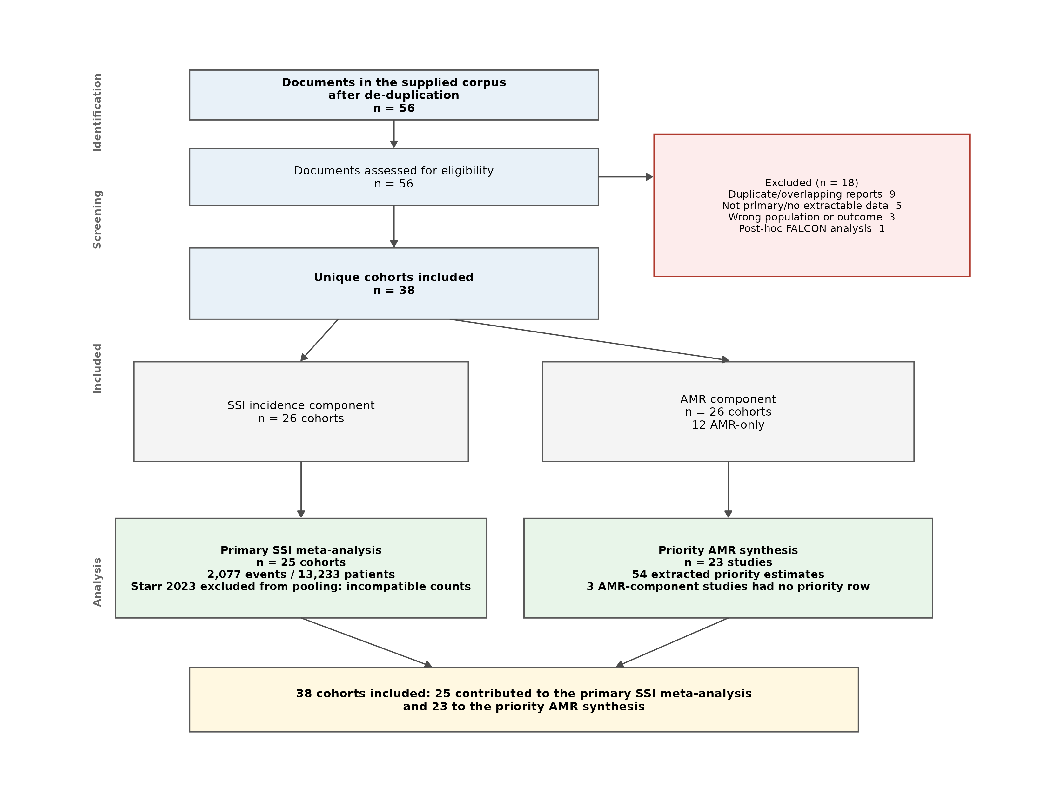
Figure S4. PRISMA 2020 flow diagram. The supplied corpus began after database searching and de-duplication, so identification counts are not shown.

Supplementary tables
Table S1. All 38 included cohorts, including Starr 2023 and the AMR-only cohorts. Starr 2023 had an incidence component but no primary pooled row because its counts and percentages were incompatible.
Study | Country | Subregion | Hospital level | Design | Cohort n | Incidence component | AMR | Primary incidence rows | AMR rows | Quality
Abayneh 2022 | Ethiopia | East Africa | Tertiary/referral | Prospective observational cohort | 262 | Yes | Yes | 1 | 2 | Low
Abosse 2021 | Ethiopia | East Africa | Tertiary/referral | Hospital-based cross-sectional | 165 | No | Yes | 0 | 5 | High
Agade 2026 | Kenya | East Africa | Tertiary/referral | Retrospective cohort | 393 | Yes | No | 1 | 0 | Moderate
Ali 2023 | Ethiopia | East Africa | Tertiary/referral | Hospital-based cross-sectional | 338 | Yes | Yes | 1 | 3 | Moderate
Amulioto 2020 | Kenya | East Africa | Secondary | Cross-sectional descriptive | 58 | No | Yes | 0 | 2 | High
Bayardorj 2023 | Tanzania | East Africa | Secondary (district) | Retrospective cross-sectional | 128 | Yes | No | 1 | 0 | High
Billoro 2019 | Ethiopia | East Africa | Tertiary/referral | Prospective cohort | 255 | Yes | Yes | 1 | 2 | Low
Boru 2025 | Ethiopia | East Africa | Tertiary/referral | Institution-based cross-sectional | 183 | Yes | Yes | 1 | 2 | Moderate
Burugu 2022 | Kenya | East Africa | Tertiary/referral | Cross-sectional | 62 | No | Yes | 0 | 2 | High
Chipaga 2025 | Tanzania | East Africa | Tertiary/referral | Descriptive cross-sectional | 158 | No | Yes | 0 | 7 | High
Deyem 2025 | Democratic Republic of the Congo | Central Africa | Tertiary/referral | Prospective longitudinal analytical | 218 | Yes | No | 1 | 0 | Low
Dinda 2013 | Kenya | East Africa | Tertiary/referral | Prospective cohort | 268 | Yes | Yes | 1 | 1 | Moderate
Forrester 2021 | Ethiopia | East Africa | Mixed (five hospitals) | Prospective pre-post quality improvement cohort | 2,213 | Yes | No | 1 | 0 | Moderate
Garoy 2021 | Eritrea | East Africa | Tertiary/referral (two national referral hospitals) | Cross-sectional | 83 | No | Yes | 0 | 1 | High
Gashaw 2026 | Ethiopia | East Africa | Tertiary/referral | Longitudinal prospective cohort | 1,205 | Yes | Yes | 1 | 2 | Low
Gentilotti 2020 | Tanzania | East Africa | Tertiary/referral | Before-after intervention cohort | 1,040 | Yes | Yes | 1 | 2 | Moderate
Habtemariam 2023 | Ethiopia | East Africa | Tertiary/referral | Prospective cross-sectional | 204 | Yes | No | 1 | 0 | Moderate
Haifete 2025 | Namibia | Southern Africa | Tertiary/referral (two hospitals) | Retrospective cross-sectional chart review | 1,248 | Yes | No | 1 | 0 | Moderate
Hamudu 2025 | Tanzania | East Africa | Mixed (tertiary and regional referral) | Longitudinal prospective cohort | 120 | Yes | Yes | 1 | 2 | Low
Hope 2019 | Uganda | East Africa | Tertiary/referral | Descriptive cross-sectional | 83 | No | Yes | 0 | 2 | High
Iyamba 2014 | Democratic Republic of the Congo | Central Africa | Tertiary/referral (two hospitals) | Cross-sectional | 130 | No | Yes | 0 | 2 | High
Kachipedzu 2024 | Malawi | Southern Africa | Tertiary/referral | Prospective cohort | 208 | Yes | Yes | 1 | 1 | Moderate
Kazuma 2025 | Zambia | Southern Africa | Tertiary/referral (three hospitals) | Prospective observational cross-sectional | 1,122 | Yes | No | 1 | 0 | Moderate
Kefale 2020 | Ethiopia | East Africa | Secondary | Retrospective cross-sectional | 281 | Yes | No | 1 | 0 | Moderate
Kisibo 2017 | Tanzania | East Africa | Tertiary/referral | Cross-sectional | 300 | Yes | No | 1 | 0 | Moderate
Mammo 2024 | Ethiopia | East Africa | Mixed (nine hospitals, five clusters) | Stepped-wedge cluster randomised clinical trial | 5,153 | Yes | No | 1 | 0 | Low
Manyahi 2014 | Tanzania | East Africa | Tertiary/referral | Descriptive cross-sectional | 100 | No | Yes | 0 | 4 | High
Mbabazi 2025 | Uganda | East Africa | Tertiary/referral | Prospective cohort | 66 | No | Yes | 0 | 3 | High
Mengesha 2014 | Ethiopia | East Africa | Tertiary/referral | Prospective cross-sectional | 610 | Yes | Yes | 1 | 2 | High
Misha 2021 | Ethiopia | East Africa | Tertiary/referral | Prospective cohort | 251 | Yes | Yes | 1 | 4 | Moderate
Mukagendaneza 2019 | Rwanda | East Africa | Tertiary/referral | Prospective observational cohort | 294 | Yes | Yes | 1 | 0 | Moderate
Ntirushwa 2021 | Rwanda | East Africa | Secondary (district) | Randomised controlled trial | 301 | Yes | No | 1 | 0 | Low
Odoko 2024 | Ethiopia | East Africa | Mixed (two hospitals) | Hospital-based cross-sectional | 422 | No | Yes | 0 | 5 | High
Scherbaum 2014 | Gabon | Central Africa | Tertiary/referral | Prospective surveillance cohort | 1,022 | Yes | Yes | 1 | 2 | Moderate
Starr 2023 | Ethiopia | East Africa | Mixed (seven hospitals) | Prospective pre-post quality improvement cohort | 3,364 | Yes | No | 0 | 0 | High
Velin 2021 | Rwanda | East Africa | Secondary (district) | Prospective cohort | 795 | Yes | Yes | 1 | 3 | Low
Wekesa 2020 | Uganda | East Africa | Tertiary/referral | Cross-sectional | 109 | No | Yes | 0 | 6 | High
Worku 2023 | Ethiopia | East Africa | Tertiary/referral (four hospitals) | Multicentre cross-sectional | 752 | No | Yes | 0 | 4 | High

Table S2. Documents excluded at screening and reasons.
Document | Document ID | Reason | Linked study | Notes
FALCON secondary analysis (Aaron Oladipo 2024) | aaron-oladipo-et-al | FALCON post-hoc secondary analysis across seven LMICs (Benin, Ghana, India, Mexico, Nigeria, Rwanda, South Africa); no ECSA-specific strata | NA | NA
Copy of Gashaw 2026 | copy-of-gashaw-et-al-amr | Duplicate copy of the included Gashaw 2026 article | gashaw2026 | NA
Copy of Mbabazi 2025 | copy-of-mbabazi-et-al-amr | Duplicate copy of the included Mbabazi 2025 article | mbabazi2025 | NA
Human data-extraction workbook | data-extraction | Human data-extraction workbook, not a primary study | NA | NA
Kihla 2014 (mixed wounds) | kihla-et-al | Wound infections across healthcare facilities, including non-surgical wounds; no SSI-specific operated-patient denominator | NA | NA
Kumburu 2015 (all hospital infections) | kumburu-et-al | All hospital-acquired infections at a tertiary hospital, not restricted to SSI | NA | NA
Jung 2024 (post-traumatic wounds) | laura-jung-et-al | Post-traumatic wound infections, not surgical site infections | NA | NA
De Nardo 2016 (duplicate cohort) | nardo-et-al | Duplicate/overlapping report of the Gentilotti 2020 pre-intervention cohort | gentilotti2020 | NA
Ojulong 2009 (isolate-level MRSA) | ojulong-et-al | Isolate-level MRSA report without an SSI-patient denominator; duplicate report of the same Mulago cohort | NA | NA
Ojulong 2010 (duplicate cohort) | ojulongandezera | Duplicate report of the Ojulong 2009 Mulago SSI cohort | NA | NA
Clean Cut pilot duplicate | pmc10364890-clean-cut-ethiopia | Duplicate report of the Forrester 2021 Clean Cut pilot cohort | forrester2021 | NA
Review protocol | protocol | Review protocol, not a study | NA | NA
Response to reviewers | response-to-reviewers-1 | Response to reviewers, not a study | NA | NA
Similar systematic review correction | similar-sr-to-ssis-in-ecsa | Correction/other systematic review, not a primary study | NA | NA
One-page image | soi230088-featured-1707866555-17813 | One-page image with no extractable study data | NA | NA
Orthopaedic DOCX duplicate | surgical-site-infection-among-patients-undergone-orthopaedic-surgery-at-muhimbil | Duplicate DOCX of the Kisibo 2017 orthopaedic cohort | kisibo2017 | NA
Worku 2023 molecular report | worku-et-al-molecular | Overlapping molecular report of the Worku 2023 SSI cohort | worku2023 | NA
Worku 2023 molecular report | worku-et-al-b6295820 | Overlapping molecular report of the Worku 2023 SSI cohort | worku2023 | NA

Table S3. Sensitivity analyses for the primary SSI estimate.
Analysis | k | Events | Patients | SSI % | 95% CI | I2 (%) | tau2
Primary (all cohorts) | 25 | 2077 | 13233 | 15.03 | 10.6-20.9 | 97.5 | 0.8986
Excluding derived incidence counts | 22 | 1980 | 11556 | 16.83 | 12.2-22.8 | 97.5 | 0.6912
Excluding low-quality studies | 17 | 1261 | 7594 | 15.28 | 9.6-23.4 | 97.6 | 1.0176
Excluding before-after/quality-improvement designs | 23 | 1824 | 12392 | 14.54 | 10.2-20.3 | 96.8 | 0.8221
Excluding the culture-confirmed-only cohort (Boru 2025) | 24 | 2048 | 13050 | 14.99 | 10.4-21.1 | 97.6 | 0.9394
Cohort studies only | 12 | 727 | 5194 | 12.73 | 7.3-21.4 | 96.4 | 0.9072
Excluding cohorts with >1,000 patients | 20 | 1142 | 6153 | 16.59 | 11.6-23.2 | 97.0 | 0.7648
Common-effect model | 25 | 2077 | 13233 | 18.45 | 17.7-19.2 | 97.5 | 0.8986
Random-effects model with Wald CI | 25 | 2077 | 13233 | 15.03 | 10.8-20.5 | 97.5 | 0.8986

Table S4. Leave-one-out sensitivity analysis.
Omitted study | Pooled SSI % | 95% CI | I2 (%)
Omitting Habtemariam 2023 | 13.92 | 10.1-18.9 | 97.0
Omitting Gentilotti 2020 | 14.16 | 10.0-19.6 | 96.8
Omitting Deyem 2025 | 14.50 | 10.1-20.3 | 97.5
Omitting Hamudu 2025 | 14.57 | 10.2-20.5 | 97.6
Omitting Gashaw 2026 | 14.66 | 10.2-20.6 | 97.5
Omitting Kisibo 2017 | 14.69 | 10.2-20.7 | 97.6
Omitting Misha 2021 | 14.80 | 10.3-20.9 | 97.6
Omitting Mengesha 2014 | 14.80 | 10.3-20.9 | 97.6
Omitting Kefale 2020 | 14.85 | 10.3-20.9 | 97.6
Omitting Kazuma 2025 | 14.86 | 10.3-20.9 | 97.6
Omitting Billoro 2019 | 14.97 | 10.4-21.1 | 97.6
Omitting Boru 2025 | 14.99 | 10.4-21.1 | 97.6
Omitting Ali 2023 | 15.05 | 10.4-21.2 | 97.6
Omitting Agade 2026 | 15.07 | 10.5-21.2 | 97.6
Omitting Abayneh 2022 | 15.13 | 10.5-21.3 | 97.6
Omitting Mukagendaneza 2019 | 15.19 | 10.5-21.4 | 97.6
Omitting Bayardorj 2023 | 15.21 | 10.6-21.4 | 97.6
Omitting Mammo 2024 | 15.24 | 10.6-21.4 | 97.3
Omitting Haifete 2025 | 15.28 | 10.6-21.5 | 97.5
Omitting Kachipedzu 2024 | 15.29 | 10.6-21.5 | 97.6
Omitting Forrester 2021 | 15.45 | 10.8-21.6 | 97.5
Omitting Dinda 2013 | 15.46 | 10.8-21.6 | 97.6
Omitting Velin 2021 | 15.63 | 11.0-21.8 | 97.4
Omitting Ntirushwa 2021 | 15.78 | 11.2-21.8 | 97.5
Omitting Scherbaum 2014 | 16.42 | 12.1-21.9 | 97.3

Table S5. Small-study-effect tests and trim-and-fill adjustment.
Test | Estimate | p_value | Detail
Egger regression | -1.2514192 | 0.2233607 | bias coefficient -3.665 (SE 2.929)
Begg rank correlation | -2.2420770 | 0.0249564 | Kendall score -96.0 (SE 42.8)
Trim-and-fill (adjusted) | 0.2025775 | NA | 6 studies added; adjusted proportion 20.3% (95% CI 14.1-28.3)

Table S6. Study-level SSI estimates and Wilson confidence intervals.
Study | Country | Subregion | Surgical specialty | Hospital level | Events | Patients | SSI % | Wilson 95% CI | Derived count | Quality
Abayneh 2022 | Ethiopia | East Africa | Mixed/other | Tertiary/referral | 33 | 262 | 12.6 | 9.1-17.2 | No | Low
Agade 2026 | Kenya | East Africa | General surgery | Tertiary/referral | 55 | 393 | 14.0 | 10.9-17.8 | No | Moderate
Ali 2023 | Ethiopia | East Africa | Mixed/other | Tertiary/referral | 49 | 338 | 14.5 | 11.1-18.6 | No | Moderate
Bayardorj 2023 | Tanzania | East Africa | Mixed/other | Secondary/primary | 14 | 128 | 10.9 | 6.6-17.5 | No | High
Billoro 2019 | Ethiopia | East Africa | Mixed/other | Tertiary/referral | 42 | 255 | 16.5 | 12.4-21.5 | No | Low
Boru 2025 | Ethiopia | East Africa | Mixed/other | Tertiary/referral | 29 | 183 | 15.8 | 11.3-21.8 | No | Moderate
Deyem 2025 | Democratic Republic of the Congo | Central Africa | General surgery | Tertiary/referral | 71 | 218 | 32.6 | 26.7-39.0 | No | Low
Dinda 2013 | Kenya | East Africa | General surgery | Tertiary/referral | 12 | 171 | 7.0 | 4.1-11.9 | No | Moderate
Forrester 2021 | Ethiopia | East Africa | Mixed/other | Mixed | 28 | 374 | 7.5 | 5.2-10.6 | Yes | Moderate
Gashaw 2026 | Ethiopia | East Africa | Mixed/other | Tertiary/referral | 312 | 1205 | 25.9 | 23.5-28.4 | No | Low
Gentilotti 2020 | Tanzania | East Africa | Obstetrics/gynaecology | Tertiary/referral | 225 | 467 | 48.2 | 43.7-52.7 | No | Moderate
Habtemariam 2023 | Ethiopia | East Africa | Mixed/other | Tertiary/referral | 126 | 204 | 61.8 | 54.9-68.2 | No | Moderate
Haifete 2025 | Namibia | Southern Africa | Mixed/other | Tertiary/referral | 126 | 1248 | 10.1 | 8.5-11.9 | No | Moderate
Hamudu 2025 | Tanzania | East Africa | Orthopaedic | Mixed | 36 | 120 | 30.0 | 22.5-38.7 | No | Low
Kachipedzu 2024 | Malawi | Southern Africa | Obstetrics/gynaecology | Tertiary/referral | 20 | 208 | 9.6 | 6.3-14.4 | No | Moderate
Kazuma 2025 | Zambia | Southern Africa | General surgery | Tertiary/referral | 218 | 1122 | 19.4 | 17.2-21.8 | No | Moderate
Kefale 2020 | Ethiopia | East Africa | General surgery | Secondary/primary | 55 | 281 | 19.6 | 15.4-24.6 | Yes | Moderate
Kisibo 2017 | Tanzania | East Africa | Orthopaedic | Tertiary/referral | 75 | 300 | 25.0 | 20.4-30.2 | No | Moderate
Mammo 2024 | Ethiopia | East Africa | Obstetrics/gynaecology | Mixed | 265 | 2483 | 10.7 | 9.5-11.9 | No | Low
Mengesha 2014 | Ethiopia | East Africa | Mixed/other | Tertiary/referral | 128 | 610 | 21.0 | 17.9-24.4 | No | High
Misha 2021 | Ethiopia | East Africa | Mixed/other | Tertiary/referral | 53 | 251 | 21.1 | 16.5-26.6 | No | Moderate
Mukagendaneza 2019 | Rwanda | East Africa | Mixed/other | Tertiary/referral | 34 | 294 | 11.6 | 8.4-15.7 | No | Moderate
Ntirushwa 2021 | Rwanda | East Africa | Obstetrics/gynaecology | Secondary/primary | 12 | 301 | 4.0 | 2.3-6.8 | No | Low
Scherbaum 2014 | Gabon | Central Africa | Mixed/other | Tertiary/referral | 14 | 1022 | 1.4 | 0.8-2.3 | Yes | Moderate
Velin 2021 | Rwanda | East Africa | Obstetrics/gynaecology | Secondary/primary | 45 | 795 | 5.7 | 4.3-7.5 | No | Low

Table S7. Priority AMR estimates by pathogen group and ECSA sub-region.
Outcome | Pathogen | Region | Studies | Isolates tested | Resistant isolates | Crude aggregate % | Median study % | Range % | IQR %
3GC/ESBL resistance | E. coli | Central Africa | 1 | 14 | 5 | 35.7 | 35.7 | 35.7-35.7 | 35.7-35.7
3GC/ESBL resistance | E. coli | East Africa | 9 | 223 | 186 | 83.4 | 92.3 | 44.4-100.0 | 66.7-99.0
3GC/ESBL resistance | Enterobacterales (aggregate) | East Africa | 4 | 299 | 222 | 74.2 | 77.0 | 67.5-95.1 | 72.3-83.8
3GC/ESBL resistance | Gram-negative (aggregate) | East Africa | 1 | 39 | 36 | 92.3 | 92.3 | 92.3-92.3 | 92.3-92.3
3GC/ESBL resistance | Klebsiella spp. | Central Africa | 1 | 6 | 3 | 50.0 | 50.0 | 50.0-50.0 | 50.0-50.0
3GC/ESBL resistance | Klebsiella spp. | East Africa | 8 | 178 | 145 | 81.5 | 72.4 | 11.1-100.0 | 58.2-94.7
Carbapenem resistance | A. baumannii | East Africa | 4 | 81 | 55 | 67.9 | 51.4 | 33.3-84.2 | 36.5-70.1
Carbapenem resistance | E. coli | East Africa | 1 | 9 | 0 | 0.0 | 0.0 | 0.0-0.0 | 0.0-0.0
Carbapenem resistance | Enterobacterales (aggregate) | East Africa | 2 | 76 | 17 | 22.4 | 13.9 | 0.0-27.9 | 7.0-20.9
Carbapenem resistance | Gram-negative (aggregate) | East Africa | 1 | 30 | 0 | 0.0 | 0.0 | 0.0-0.0 | 0.0-0.0
Carbapenem resistance | Klebsiella spp. | East Africa | 1 | 44 | 15 | 34.1 | 34.1 | 34.1-34.1 | 34.1-34.1
Carbapenem resistance | P. aeruginosa | East Africa | 2 | 46 | 15 | 32.6 | 44.4 | 26.3-62.5 | 35.4-53.5
MRSA | Staphylococcus aureus | Central Africa | 1 | 74 | 47 | 63.5 | 63.5 | 63.5-63.5 | 63.5-63.5
MRSA | Staphylococcus aureus | East Africa | 15 | 443 | 236 | 53.3 | 56.2 | 10.0-100.0 | 40.2-74.5

Table S8. Priority AMR estimates by ECSA sub-region and hospital level.
Outcome | Region | Hospital level | Studies | Isolates tested | Resistant isolates | Crude aggregate % | Median study % | Range % | IQR %
3GC/ESBL resistance | Central Africa | Tertiary/referral | 1 | 20 | 8 | 40.0 | 40.0 | 40.0-40.0 | 40.0-40.0
3GC/ESBL resistance | East Africa | Mixed | 2 | 76 | 70 | 92.1 | 87.5 | 80.0-95.1 | 83.8-91.3
3GC/ESBL resistance | East Africa | Secondary/primary | 1 | 39 | 36 | 92.3 | 92.3 | 92.3-92.3 | 92.3-92.3
3GC/ESBL resistance | East Africa | Tertiary/referral | 11 | 624 | 483 | 77.4 | 73.9 | 27.3-98.2 | 57.9-94.2
Carbapenem resistance | East Africa | Mixed | 2 | 76 | 17 | 22.4 | 13.9 | 0.0-27.9 | 7.0-20.9
Carbapenem resistance | East Africa | Secondary/primary | 1 | 30 | 0 | 0.0 | 0.0 | 0.0-0.0 | 0.0-0.0
Carbapenem resistance | East Africa | Tertiary/referral | 6 | 180 | 85 | 47.2 | 33.7 | 28.3-84.2 | 30.4-57.6
MRSA | Central Africa | Tertiary/referral | 1 | 74 | 47 | 63.5 | 63.5 | 63.5-63.5 | 63.5-63.5
MRSA | East Africa | Secondary/primary | 2 | 24 | 15 | 62.5 | 79.5 | 59.1-100.0 | 69.3-89.8
MRSA | East Africa | Tertiary/referral | 13 | 419 | 221 | 52.7 | 44.4 | 10.0-100.0 | 37.5-70.0

Table S9. Study-level priority AMR estimates.
Study | Year | Country | Region | Hospital level | Outcome | Pathogens | Resistance method | Resistant | Tested | Resistance %
Abayneh 2022 | 2022 | Ethiopia | East Africa | Tertiary/referral | MRSA | Staphylococcus aureus | MRSA | 3 | 8 | 37.5
Abosse 2021 | 2021 | Ethiopia | East Africa | Tertiary/referral | MRSA | Staphylococcus aureus | MRSA | 10 | 31 | 32.3
Ali 2023 | 2023 | Ethiopia | East Africa | Tertiary/referral | MRSA | Staphylococcus aureus | MRSA | 6 | 14 | 42.9
Amulioto 2020 | 2020 | Kenya | East Africa | Secondary/primary | MRSA | Staphylococcus aureus | MRSA | 13 | 22 | 59.1
Boru 2025 | 2025 | Ethiopia | East Africa | Tertiary/referral | MRSA | Staphylococcus aureus | MRSA | 8 | 14 | 57.1
Burugu 2022 | 2022 | Kenya | East Africa | Tertiary/referral | MRSA | Staphylococcus aureus | MRSA | 9 | 16 | 56.2
Chipaga 2025 | 2025 | Tanzania | East Africa | Tertiary/referral | MRSA | Staphylococcus aureus | MRSA | 11 | 38 | 28.9
Dinda 2013 | 2013 | Kenya | East Africa | Tertiary/referral | MRSA | Staphylococcus aureus | MRSA | 1 | 10 | 10.0
Garoy 2021 | 2021 | Eritrea | East Africa | Tertiary/referral | MRSA | Staphylococcus aureus | MRSA | 14 | 20 | 70.0
Gentilotti 2020 | 2020 | Tanzania | East Africa | Tertiary/referral | MRSA | Staphylococcus aureus | MRSA | 34 | 43 | 79.1
Hope 2019 | 2019 | Uganda | East Africa | Tertiary/referral | MRSA | Staphylococcus aureus | MRSA | 20 | 20 | 100.0
Manyahi 2014 | 2014 | Tanzania | East Africa | Tertiary/referral | MRSA | Staphylococcus aureus | MRSA | 8 | 18 | 44.4
Velin 2021 | 2021 | Rwanda | East Africa | Secondary/primary | MRSA | Staphylococcus aureus | MRSA | 2 | 2 | 100.0
Wekesa 2020 | 2020 | Uganda | East Africa | Tertiary/referral | MRSA | Staphylococcus aureus | MRSA | 31 | 34 | 91.2
Worku 2023 | 2023 | Ethiopia | East Africa | Tertiary/referral | MRSA | Staphylococcus aureus | MRSA | 66 | 153 | 43.1
Iyamba 2014 | 2014 | Democratic Republic of the Congo | Central Africa | Tertiary/referral | MRSA | Staphylococcus aureus | MRSA | 47 | 74 | 63.5
Abosse 2021 | 2021 | Ethiopia | East Africa | Tertiary/referral | 3GC/ESBL resistance | E. coli; Klebsiella spp. | 3GC resistance | 17 | 29 | 58.6
Ali 2023 | 2023 | Ethiopia | East Africa | Tertiary/referral | 3GC/ESBL resistance | Enterobacterales (aggregate) | 3GC resistance | 17 | 23 | 73.9
Billoro 2019 | 2019 | Ethiopia | East Africa | Tertiary/referral | 3GC/ESBL resistance | E. coli; Klebsiella spp. | 3GC resistance | 3 | 11 | 27.3
Burugu 2022 | 2022 | Kenya | East Africa | Tertiary/referral | 3GC/ESBL resistance | E. coli | 3GC resistance | 11 | 12 | 91.7
Chipaga 2025 | 2025 | Tanzania | East Africa | Tertiary/referral | 3GC/ESBL resistance | E. coli; Klebsiella spp. | ESBL | 39 | 70 | 55.7
Gashaw 2026 | 2026 | Ethiopia | East Africa | Tertiary/referral | 3GC/ESBL resistance | Enterobacterales (aggregate) | ESBL | 135 | 200 | 67.5
Hamudu 2025 | 2025 | Tanzania | East Africa | Mixed | 3GC/ESBL resistance | Enterobacterales (aggregate) | 3GC resistance | 12 | 15 | 80.0
Manyahi 2014 | 2014 | Tanzania | East Africa | Tertiary/referral | 3GC/ESBL resistance | E. coli; Klebsiella spp. | ESBL | 23 | 29 | 79.3
Mbabazi 2025 | 2025 | Uganda | East Africa | Tertiary/referral | 3GC/ESBL resistance | E. coli; Klebsiella spp. | 3GC resistance | 30 | 31 | 96.8
Misha 2021 | 2021 | Ethiopia | East Africa | Tertiary/referral | 3GC/ESBL resistance | E. coli; Klebsiella spp. | 3GC resistance | 8 | 14 | 57.1
Odoko 2024 | 2024 | Ethiopia | East Africa | Mixed | 3GC/ESBL resistance | Enterobacterales (aggregate) | 3GC resistance | 58 | 61 | 95.1
Velin 2021 | 2021 | Rwanda | East Africa | Secondary/primary | 3GC/ESBL resistance | Gram-negative (aggregate) | 3GC non-susceptibility | 36 | 39 | 92.3
Wekesa 2020 | 2020 | Uganda | East Africa | Tertiary/referral | 3GC/ESBL resistance | E. coli; Klebsiella spp. | 3GC resistance | 54 | 55 | 98.2
Worku 2023 | 2023 | Ethiopia | East Africa | Tertiary/referral | 3GC/ESBL resistance | E. coli; Klebsiella spp. | 3GC resistance | 146 | 150 | 97.3
Scherbaum 2014 | 2014 | Gabon | Central Africa | Tertiary/referral | 3GC/ESBL resistance | E. coli; Klebsiella spp. | ESBL | 8 | 20 | 40.0
Abosse 2021 | 2021 | Ethiopia | East Africa | Tertiary/referral | Carbapenem resistance | A. baumannii | Carbapenem resistance | 3 | 9 | 33.3
Chipaga 2025 | 2025 | Tanzania | East Africa | Tertiary/referral | Carbapenem resistance | A. baumannii; P. aeruginosa | Carbapenem resistance | 13 | 46 | 28.3
Hamudu 2025 | 2025 | Tanzania | East Africa | Mixed | Carbapenem resistance | Enterobacterales (aggregate) | Carbapenem resistance | 0 | 15 | 0.0
Mbabazi 2025 | 2025 | Uganda | East Africa | Tertiary/referral | Carbapenem resistance | A. baumannii | Carbapenem resistance | 17 | 26 | 65.4
Misha 2021 | 2021 | Ethiopia | East Africa | Tertiary/referral | Carbapenem resistance | E. coli; P. aeruginosa | Carbapenem resistance | 5 | 17 | 29.4
Odoko 2024 | 2024 | Ethiopia | East Africa | Mixed | Carbapenem resistance | Enterobacterales (aggregate) | Carbapenem resistance | 17 | 61 | 27.9
Velin 2021 | 2021 | Rwanda | East Africa | Secondary/primary | Carbapenem resistance | Gram-negative (aggregate) | Carbapenem resistance | 0 | 30 | 0.0
Wekesa 2020 | 2020 | Uganda | East Africa | Tertiary/referral | Carbapenem resistance | Klebsiella spp. | Carbapenem resistance | 15 | 44 | 34.1
Worku 2023 | 2023 | Ethiopia | East Africa | Tertiary/referral | Carbapenem resistance | A. baumannii | Carbapenem resistance | 32 | 38 | 84.2

Table S10. Antimicrobial susceptibility summary: median study-level resistance by pathogen and drug class.
Pathogen | Drug | Studies | Median resistance % | Range % | IQR %
Acinetobacter baumannii | Ampicillin | 3 | 100.0 | 88.9-100.0 | 94.5-100.0
Acinetobacter baumannii | Cefotaxime/ceftriaxone (3GC) | 8 | 100.0 | 0.0-100.0 | 89.8-100.0
Acinetobacter baumannii | Cefuroxime | 1 | 100.0 | 100.0-100.0 | 100.0-100.0
Acinetobacter baumannii | Piperacillin | 1 | 100.0 | 100.0-100.0 | 100.0-100.0
Acinetobacter baumannii | Tigecycline | 1 | 100.0 | 100.0-100.0 | 100.0-100.0
Acinetobacter baumannii | Trimethoprim-sulfamethoxazole | 5 | 100.0 | 62.7-100.0 | 67.0-100.0
Acinetobacter baumannii | Ciprofloxacin | 8 | 92.8 | 33.3-100.0 | 62.4-100.0
Acinetobacter baumannii | Cefoxitin | 1 | 88.9 | 88.9-88.9 | 88.9-88.9
Acinetobacter baumannii | Tobramycin | 1 | 86.3 | 86.3-86.3 | 86.3-86.3
Acinetobacter baumannii | Gentamicin | 8 | 85.0 | 0.0-100.0 | 47.5-93.2
Acinetobacter baumannii | Amoxicillin-clavulanate | 2 | 83.3 | 66.7-100.0 | 75.0-91.7
Acinetobacter baumannii | Piperacillin-tazobactam | 4 | 79.5 | 0.0-100.0 | 58.5-85.8
Acinetobacter baumannii | Ceftazidime | 4 | 79.2 | 0.0-100.0 | 50.0-93.8
Acinetobacter baumannii | Tetracycline | 4 | 69.8 | 56.0-100.0 | 60.4-83.3
Acinetobacter baumannii | Cefepime | 4 | 64.0 | 0.0-100.0 | 37.5-83.5
Acinetobacter baumannii | Chloramphenicol | 1 | 44.4 | 44.4-44.4 | 44.4-44.4
Acinetobacter baumannii | Meropenem/imipenem | 6 | 35.4 | 0.0-65.4 | 16.6-47.6
Acinetobacter baumannii | Amikacin | 5 | 13.6 | 0.0-25.0 | 0.0-21.6
Acinetobacter baumannii | Colistin | 1 | 11.1 | 11.1-11.1 | 11.1-11.1
Escherichia coli | Ampicillin | 10 | 88.0 | 82.2-100.0 | 83.3-100.0
Escherichia coli | Moxifloxacin | 1 | 87.5 | 87.5-87.5 | 87.5-87.5
Escherichia coli | Piperacillin | 1 | 82.1 | 82.1-82.1 | 82.1-82.1
Escherichia coli | Cefotaxime/ceftriaxone (3GC) | 14 | 75.9 | 25.0-100.0 | 58.3-86.7
Escherichia coli | Trimethoprim-sulfamethoxazole | 9 | 75.0 | 22.2-100.0 | 75.0-82.2
Escherichia coli | Ceftazidime | 8 | 71.4 | 41.7-83.3 | 44.4-75.0
Escherichia coli | Amoxicillin-clavulanate | 10 | 70.8 | 0.0-100.0 | 56.3-88.4
Escherichia coli | Amoxicillin | 1 | 66.7 | 66.7-66.7 | 66.7-66.7
Escherichia coli | Cefepime | 6 | 66.7 | 17.8-100.0 | 61.7-71.6
Escherichia coli | Tetracycline | 5 | 66.0 | 16.7-100.0 | 58.3-73.3
Escherichia coli | Cefuroxime | 4 | 52.8 | 25.0-87.5 | 43.8-63.5
Escherichia coli | Ciprofloxacin | 14 | 52.8 | 16.7-100.0 | 35.4-68.6
Escherichia coli | Tobramycin | 1 | 51.8 | 51.8-51.8 | 51.8-51.8
Escherichia coli | Cefoxitin | 4 | 50.6 | 11.1-83.3 | 34.9-64.5
Escherichia coli | Chloramphenicol | 7 | 50.0 | 11.1-100.0 | 42.3-69.7
Escherichia coli | Gentamicin | 12 | 45.4 | 22.2-73.3 | 33.3-50.0
Escherichia coli | Erythromycin/azithromycin | 1 | 33.3 | 33.3-33.3 | 33.3-33.3
Escherichia coli | Piperacillin-tazobactam | 5 | 26.7 | 0.0-66.1 | 9.1-53.3
Escherichia coli | Amikacin | 8 | 12.9 | 0.0-41.7 | 0.0-19.1
Escherichia coli | Meropenem/imipenem | 7 | 6.7 | 0.0-16.7 | 2.8-12.8
Escherichia coli | Levofloxacin | 1 | 0.0 | 0.0-0.0 | 0.0-0.0
Klebsiella pneumoniae | Amoxicillin | 1 | 100.0 | 100.0-100.0 | 100.0-100.0
Klebsiella pneumoniae | Piperacillin | 1 | 100.0 | 100.0-100.0 | 100.0-100.0
Klebsiella pneumoniae | Ampicillin | 10 | 94.8 | 20.0-100.0 | 83.2-100.0
Klebsiella pneumoniae | Tetracycline | 5 | 84.0 | 40.0-93.1 | 58.8-88.0
Klebsiella pneumoniae | Tobramycin | 1 | 81.1 | 81.1-81.1 | 81.1-81.1
Klebsiella pneumoniae | Cefepime | 5 | 80.0 | 40.0-88.0 | 42.9-83.8
Klebsiella pneumoniae | Moxifloxacin | 1 | 78.4 | 78.4-78.4 | 78.4-78.4
Klebsiella pneumoniae | Trimethoprim-sulfamethoxazole | 8 | 78.0 | 40.0-100.0 | 72.9-89.3
Klebsiella pneumoniae | Amoxicillin-clavulanate | 10 | 69.1 | 20.0-100.0 | 65.8-85.7
Klebsiella pneumoniae | Cefotaxime/ceftriaxone (3GC) | 13 | 66.7 | 11.1-100.0 | 52.9-86.2
Klebsiella pneumoniae | Piperacillin-tazobactam | 4 | 66.0 | 52.0-75.7 | 55.8-75.2
Klebsiella pneumoniae | Cefuroxime | 3 | 60.0 | 0.0-97.3 | 30.0-78.7
Klebsiella pneumoniae | Doxycycline | 2 | 54.1 | 33.3-75.0 | 43.7-64.6
Klebsiella pneumoniae | Ceftazidime | 7 | 52.9 | 20.0-100.0 | 36.6-78.5
Klebsiella pneumoniae | Erythromycin/azithromycin | 1 | 44.8 | 44.8-44.8 | 44.8-44.8
Klebsiella pneumoniae | Gentamicin | 12 | 44.2 | 11.8-100.0 | 31.9-61.7
Klebsiella pneumoniae | Cefoxitin | 4 | 43.7 | 18.9-75.0 | 26.2-62.8
Klebsiella pneumoniae | Chloramphenicol | 7 | 42.9 | 29.4-84.0 | 33.3-77.5
Klebsiella pneumoniae | Ciprofloxacin | 13 | 36.4 | 0.0-84.0 | 23.5-50.0
Klebsiella pneumoniae | Amikacin | 7 | 12.0 | 0.0-33.3 | 0.0-15.2
Klebsiella pneumoniae | Meropenem/imipenem | 9 | 12.0 | 0.0-40.0 | 0.0-20.0
Klebsiella pneumoniae | Levofloxacin | 1 | 0.0 | 0.0-0.0 | 0.0-0.0
Klebsiella pneumoniae | Penicillin | 1 | 0.0 | 0.0-0.0 | 0.0-0.0
Pseudomonas aeruginosa | Amoxicillin-clavulanate | 3 | 100.0 | 53.9-100.0 | 77.0-100.0
Pseudomonas aeruginosa | Cefuroxime | 2 | 87.5 | 75.0-100.0 | 81.2-93.8
Pseudomonas aeruginosa | Doxycycline | 1 | 80.0 | 80.0-80.0 | 80.0-80.0
Pseudomonas aeruginosa | Ampicillin | 6 | 79.8 | 37.5-100.0 | 68.8-96.2
Pseudomonas aeruginosa | Piperacillin | 4 | 75.0 | 42.9-100.0 | 48.2-100.0
Pseudomonas aeruginosa | Trimethoprim-sulfamethoxazole | 3 | 75.0 | 0.0-75.0 | 37.5-75.0
Pseudomonas aeruginosa | Amoxicillin | 2 | 66.7 | 33.3-100.0 | 50.0-83.3
Pseudomonas aeruginosa | Chloramphenicol | 4 | 65.0 | 34.6-100.0 | 46.1-85.0
Pseudomonas aeruginosa | Cefotaxime/ceftriaxone (3GC) | 9 | 61.5 | 0.0-100.0 | 50.0-100.0
Pseudomonas aeruginosa | Cefoxitin | 1 | 57.7 | 57.7-57.7 | 57.7-57.7
Pseudomonas aeruginosa | Ciprofloxacin | 10 | 55.0 | 0.0-89.5 | 4.8-74.4
Pseudomonas aeruginosa | Ceftazidime | 7 | 53.9 | 25.0-72.7 | 50.0-60.2
Pseudomonas aeruginosa | Piperacillin-tazobactam | 5 | 52.6 | 0.0-100.0 | 50.0-75.0
Pseudomonas aeruginosa | Cefepime | 7 | 50.0 | 0.0-100.0 | 23.7-92.8
Pseudomonas aeruginosa | Gentamicin | 11 | 50.0 | 0.0-100.0 | 29.1-55.0
Pseudomonas aeruginosa | Tobramycin | 1 | 45.5 | 45.5-45.5 | 45.5-45.5
Pseudomonas aeruginosa | Erythromycin/azithromycin | 1 | 36.4 | 36.4-36.4 | 36.4-36.4
Pseudomonas aeruginosa | Tetracycline | 4 | 33.4 | 0.0-100.0 | 12.5-62.5
Pseudomonas aeruginosa | Meropenem/imipenem | 10 | 18.7 | 0.0-62.5 | 0.0-27.1
Pseudomonas aeruginosa | Amikacin | 7 | 9.1 | 0.0-71.4 | 0.0-20.4
Pseudomonas aeruginosa | Levofloxacin | 1 | 0.0 | 0.0-0.0 | 0.0-0.0
Pseudomonas aeruginosa | Moxifloxacin | 1 | 0.0 | 0.0-0.0 | 0.0-0.0
Staphylococcus aureus | Penicillin | 5 | 92.1 | 60.0-100.0 | 71.4-100.0
Staphylococcus aureus | Amoxicillin | 2 | 84.8 | 82.5-87.1 | 83.7-85.9
Staphylococcus aureus | Ceftazidime | 1 | 71.4 | 71.4-71.4 | 71.4-71.4
Staphylococcus aureus | Ampicillin | 6 | 65.5 | 56.3-90.0 | 57.9-83.4
Staphylococcus aureus | Trimethoprim-sulfamethoxazole | 7 | 60.0 | 50.0-100.0 | 57.1-78.3
Staphylococcus aureus | Doxycycline | 2 | 57.5 | 40.0-75.0 | 48.8-66.2
Staphylococcus aureus | Amoxicillin-clavulanate | 4 | 56.2 | 35.7-75.0 | 46.4-65.6
Staphylococcus aureus | Erythromycin/azithromycin | 8 | 47.5 | 14.3-100.0 | 28.1-76.2
Staphylococcus aureus | Tetracycline | 6 | 44.4 | 0.0-90.0 | 36.5-54.0
Staphylococcus aureus | Oxacillin/cefoxitin (MRSA) | 12 | 40.2 | 10.0-100.0 | 31.5-62.0
Staphylococcus aureus | Clindamycin | 8 | 28.7 | 0.0-100.0 | 19.6-76.2
Staphylococcus aureus | Chloramphenicol | 8 | 27.8 | 0.0-80.0 | 5.3-51.2
Staphylococcus aureus | Ciprofloxacin | 8 | 26.8 | 7.1-50.0 | 20.1-44.1
Staphylococcus aureus | Cefotaxime/ceftriaxone (3GC) | 4 | 25.9 | 0.0-90.0 | 10.7-50.6
Staphylococcus aureus | Gentamicin | 8 | 15.2 | 0.0-100.0 | 7.5-35.4
Staphylococcus aureus | Cefuroxime | 1 | 10.0 | 10.0-10.0 | 10.0-10.0
Staphylococcus aureus | Amikacin | 2 | 7.1 | 0.0-14.3 | 3.6-10.7
Staphylococcus aureus | Levofloxacin | 1 | 0.0 | 0.0-0.0 | 0.0-0.0
Staphylococcus aureus | Meropenem/imipenem | 1 | 0.0 | 0.0-0.0 | 0.0-0.0
Staphylococcus aureus | Nitrofurantoin/rifampicin | 1 | 0.0 | 0.0-0.0 | 0.0-0.0
Staphylococcus aureus | Tigecycline | 1 | 0.0 | 0.0-0.0 | 0.0-0.0
Staphylococcus aureus | Vancomycin | 9 | 0.0 | 0.0-31.3 | 0.0-9.7

Table S11. PRISMA flow counts.
Stage | n | Note
Documents in supplied corpus after de-duplication | 56 | Starting point of the supplied extraction; identification counts were not available.
Documents excluded | 18 | See Table S12 for reasons.
Unique cohorts included | 38 | No duplicate study IDs among included documents.
Cohorts with an SSI incidence component | 26 | Includes Starr 2023.
Cohorts in the primary SSI meta-analysis | 25 | Starr 2023 excluded from pooling because the reported counts and percentages are incompatible.
Cohorts with an AMR component | 26 | Incidence and/or AMR data.
AMR-only cohorts | 12 | No operated-patient denominator; AMR synthesis only.
Studies contributing priority AMR estimates | 23 | 3 AMR-component studies contributed no species-level priority row.
Priority AMR estimates (rows) | 54 | Before within-pathogen de-duplication; 51 rows after de-duplication.

Table S12. Exclusion categories and examples.
Exclusion category | n | Examples
Duplicate or overlapping reports | 9 | Copy of Gashaw 2026; Copy of Mbabazi 2025; De Nardo 2016 (duplicate cohort)
Not a primary study or no extractable data | 5 | Human data-extraction workbook; Review protocol; Response to reviewers
Wrong population or outcome | 3 | Kihla 2014 (mixed wounds); Kumburu 2015 (all hospital infections); Jung 2024 (post-traumatic wounds)
Post-hoc FALCON secondary analysis | 1 | FALCON secondary analysis (Aaron Oladipo 2024)

Software and session information
R version: R version 4.4.3 (2025-02-28)
meta 8.5.0
metafor 5.0.1
ggplot2 4.0.3
dplyr 1.2.1
readr 2.2.0
tidyr 1.3.2
knitr 1.52
rmarkdown 2.32
patchwork 1.3.2
scales 1.4.0
forcats 1.0.1
stringr 1.6.0

Data and code availability
The analysis-ready datasets are in analysis/data/. The primary incidence dataset is analysis_incidence.csv (25 cohorts); the priority AMR dataset is analysis_amr.csv (54 extracted rows); the AST panel is ast_panel.csv (535 isolate–drug rows); and ssi_positive_characteristics.csv contains the study-level covariates used in the ecological analyses. The analysis scripts are in analysis/R/, the rendered tables in analysis/output/tables/, the figures in analysis/output/figures/ and the run logs in analysis/output/logs/. The source PDFs are not redistributed for copyright reasons; the derived text and extraction workbook are retained in the project corpus.
The pipeline can be reproduced from the repository root with:
.analysis-env/r-env/bin/Rscript analysis/R/00_run_all.R
which runs scripts 01–05 in order, executes 99_verify.R, and renders this document to HTML and DOCX.

