NORTHBRIDGE UTILITIES GROUP
Employee Turnover and Retention:
An Evidence-Based Workforce Analytics Report for the HR Director and CEO
Prepared by: People Analytics Consultant
MN3526 Big Data and People Analytics — Portfolio Assessment
University of Leicester School of Business
July 2026

Introduction
According to the CIPD (2025) report, the median rate of employee turnover is approximately 15% in the UK with an Annual Population Survey churn measure of about 34%. Additionally, of the total UK’S turnover, 27% move to other employers in different roles while 6.6% no longer work in the following year due to further studies, retirement or as a result of long term sickness and caring responsibilities (CIPD, 2025).As such, Northbridge Utilities Group (NUG) reported an annual turnover rate of 20.9%, considerably above the national median in the last twelve months. This is noteworthy because NUG is a leading UK provider of essential services with approximately 7,500 employees across its units of operations. To critically evaluate the impact of employee turnover on the performance of an organisation and the long term sustainability of the workforce, this report treats employee turnover as a strategic organisational issue rather than isolated HR metric. This is because workforce sustainability ensures knowledge gained with experience in a certain organisation is retained. It also implies that technical skills are maintained while the cost of recruitment and training is reduced. Higher employee turnover negatively impacts organisational performance due to lower productivity, bad customer service, and lack of operational continuity. On the other hand, higher turnover tends to increase workload among the remaining staff and as a result, increase their level of stress (Allen, Bryant and Vardaman, 2010).
Scholars have examined turnover and implicitly associated it with models that explain reasons why employees depart an organisation. For instance, Earlier turnover theories primarily emphasised job satisfaction (Mobley, 1977), whereas later research recognised the importance of organisational rewards (Price, 2001). More recent studies argue that employee embeddedness and organisational fit provide a more comprehensive explanation of turnover behaviour (Hom et al., 2017). Consequently, the data under study should depict the indication of tenure, pay, working pattern and employee engagement in decision making as factors that have different variations within the NUG’s turnover rate. As a result, the underlying factors are likely to be captured by different variables since the problem investigated by this report heavily depends on the context that HR issues are often multi-dimensional.
2. Workforce Data overview
Four datasets that are integrated to support the analysis, and from which NUG’s people analytics has drawn its function from;
- The employee_admin_2026.csv is the key organisational dataset at the employee level. It has a summary of employee census as of 30th September 2026, where n = 7,500. Each employee has one row with attributes such as their personal demographics, job level, pay band, their tenure, absence, overtime worked, and the outcome fields such as leaver_flag_12m and leaver_reason.
- The team_admin_2026.csv includes team characteristics, where n = 37 teams at the team level. This dataset aids in accessing contextual variables such as the rate of turnover in each team, the tenure of a manager, and how their span is controlled. Additionally, attributes such as restructuring methods, flags that portray different budget-pressure and operational KPIs are also included in the dataset.
- The performance_eval_2026.csv has 6,565 completed annual reviews of the year 2026 that include the ratings of managerial work, the risk in retaining managers, free-text manager and employee comments. This dataset is operational at the review level.
- Finally, the annual_engagement_survey_2026.csv is data from individual volunteers with 2,565 raw responses that captures the engagement of the respondents, their well-being, relationship with the manager, inclusion, resourcing sub-scales as well as other open ended questions.
Structured data has a fixed schema and fits neatly into rows and columns, such as personal demographics such as age and education level. On the other hand, unstructured data has no fixed schema and can have a more complex format, such as employee comments. Therefore, the four datasets combine structured fields such as pay and absence days with a few unstructured parameters of self-reported data such as the survey scores and free text from the volunteer respondents. There is acknowledgement of data quality issues that were a concern before the analysis. These issues included 204 rows of altered employee identifiers, 25 duplicate from the submitted files, 112 with no embedded attention check and 179 submissions that were not complete. As a result the valid survey responses was about 28% with performance data covering roughly 87% of the total employees’ performance level. These datasets were combined to ensure that turnover is not addressed in isolation but within all its surrounding context and other external influences.

3. Construction of the Analytical Dataset
To construct the analytical dataset, the tidyverse family of packages in R (dplyr, tidyr, stringr) were used. This followed a five stage workflow approach that has the following steps; import and inspect, clean, join, derive variable and finally validate. For reference purposes, the full reproducible code is provided in the Appendix.

3.1 Import, Inspection and Cleaning
After the datasets were inspected, employee_admin_2026.csv was confirmed to have no duplicate values in the employee_id column. Additionally, this dataset had a complete key structural fields that supported it as a suitable population frame for the analysis. It was also noted that in the team_id column of the team_admin_2026.csv dataset, there is exactly one row per team_id which fully covers all the 376 teams referenced in the employee file. Further, since there was only one 2026 review for every reviewed employee_id column in the performance_eval_2026.csv dataset, there was no need for aggregation before joining.
Extensive cleaning before linkage was conducted for the survey. This included matching all the regular-expressions patterns as well as removing all the 204 altered identifiers. Afterwards, the rows were data-filtered to the following predicates; completion_status == "complete", duplicate_flag == 0, and attention_check == 4 which were the designated correct responses. However, 2,076 usable responses were left allowing a 27.7% clean response rate through the quality filtering from a nominal response rate of 31.2%. Finally, the most recent response by response_date from an employee who had more than one valid response was retained to avoid double-counting.

3.2 Joins and Integration
To form an integrated dataset, three left joins were used by keying them to allow preservation of the full employee population. A reduced team_admin table was built by left-joining the employee_admin table on the team_id column. Further, the result was left-joined to a reduced performance_eval table on employee_id column and eventually left-joined again to the cleaned, deduplicated engagement survey on employee_id column. The left join majorly used to ensure that employees who had no reviews and responses where still retained as valid population members rather than dropping them. On the other hand, the inner join would have been biased by skewing the analysis to more visible and engaged employees. Consequently, the final dataset under analysis has one row per employee where n= 7,500 with 86 variables.

3.3 Derived Variables
For this analysis and making observations as well as measurements, several variables were operationalized. The tenure variable was put into bands that has six categories (<1, 1–2, 2–5, 5–10, 10–20, 20+ years) which allows non-linear relationships with the examination of the rate of turnover, This is due to the fact that recent studies tend to emphasize that risk is not always monotonic across tenure (Hom et al., 2017). Absence was categorized into low, moderate or high absence band of the 12 month analysis while there was a binary high overtime flag for those who were noticed to have an overtime of 20 hours and above in the preceding 3 months as proxy for their workload strain. Further, the engagement score was categorized into row-wise of six sub-scale means that include overall engagement, well-being, manager relationship, inclusion, resourcing and leadership confidence. This was only applicable to employees who only had survey data that was valid. To avoid NA values and reduce sample sizes in the later computations, explicit survey-response and performance-review coverage indicator flags were also created. This ensured that the missingness was able to be tracked and reported transparently throughout the analysis.
The workflow above allowed implementation of every transformation of the data in a version-controlled R code. As a result, transparency was supported and thus the pipeline can be re-run unchanged with the availability of new HRIS, survey and performance data in the future cycles. This will be essential when NUG decides to monitor these turnover drivers on a continuous basis rather than one time exercise.

4. What Do the Organisational Data Tell Us?
The results of the analysis showed that 20.9% of the NUG’s employees departed from the organization in the last one year ending September 2026. Out of those, 71.9% of them, which is equivalent to the voluntary turnover rate of 15% of the whole workforce, resigned willingly. The rest were involuntary departure (10.5% of leavers), the end of fixed term contracts (4.9%of leavers), retirement (7.7% of leavers) and redundancy (4.9% of leavers). This indicates that turnover represents a strategic organisational concern rather than normal workforce mobility. Moreover, a single segment of voluntary exits alone is close to this UK rate. Therefore, the reported figures tend to be reflecting turnovers driven majorly by structural factor rather than the common retention problems.

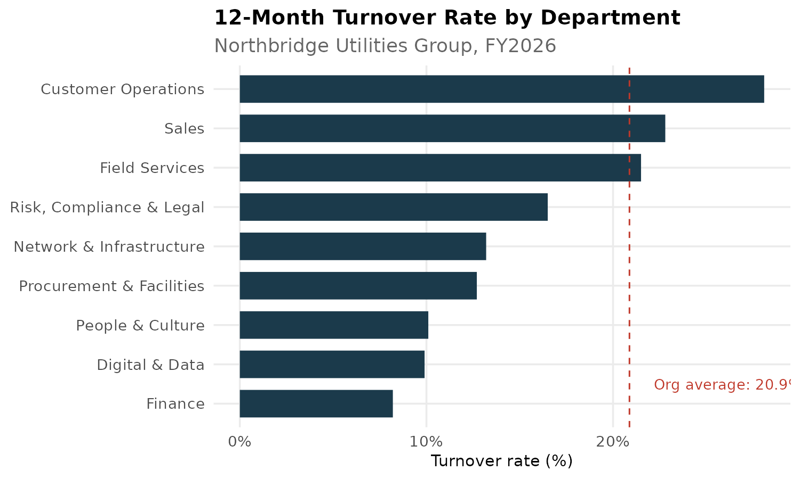
Figure 1: 12-month turnover rate by department, against the organisational average (dashed line).
When the rate is aggregated, substantial variations are noticeable. The highest departmental turnover was at 28.1% (20.6% voluntary), followed by Sales (22.8%) and Field Services (21.5%), while Finance (8.2%), Digital & Data (9.9%) and People & Culture (10.1%) are seen to be below organizational average. This indicates that attrition tends to be linked to the job characteristics as suggested in the turnover theory (Price, 2001). Further, there is a clear gradient indicated by the structural and reward variables. This suggests that reward structures and career progression opportunities may improve employee retention, consistent with Price (2001). This is seen from 28.8% in the lowest band (PB1) to 8.7% in the highest (PB5) while by job level, from 23.7% at entry level to 14.1% among senior managers. On the other hand, there is a strong association between working pattern and attrition. This is shown in night workers (27.9%) and weekend workers (27.8%) leave at over 1.5 times the rate of standard-day employees (16.7%) while on-site staff (23.0%) leave at nearly twice the rate of hybrid (14.8%) or remote (14.0%) colleagues.

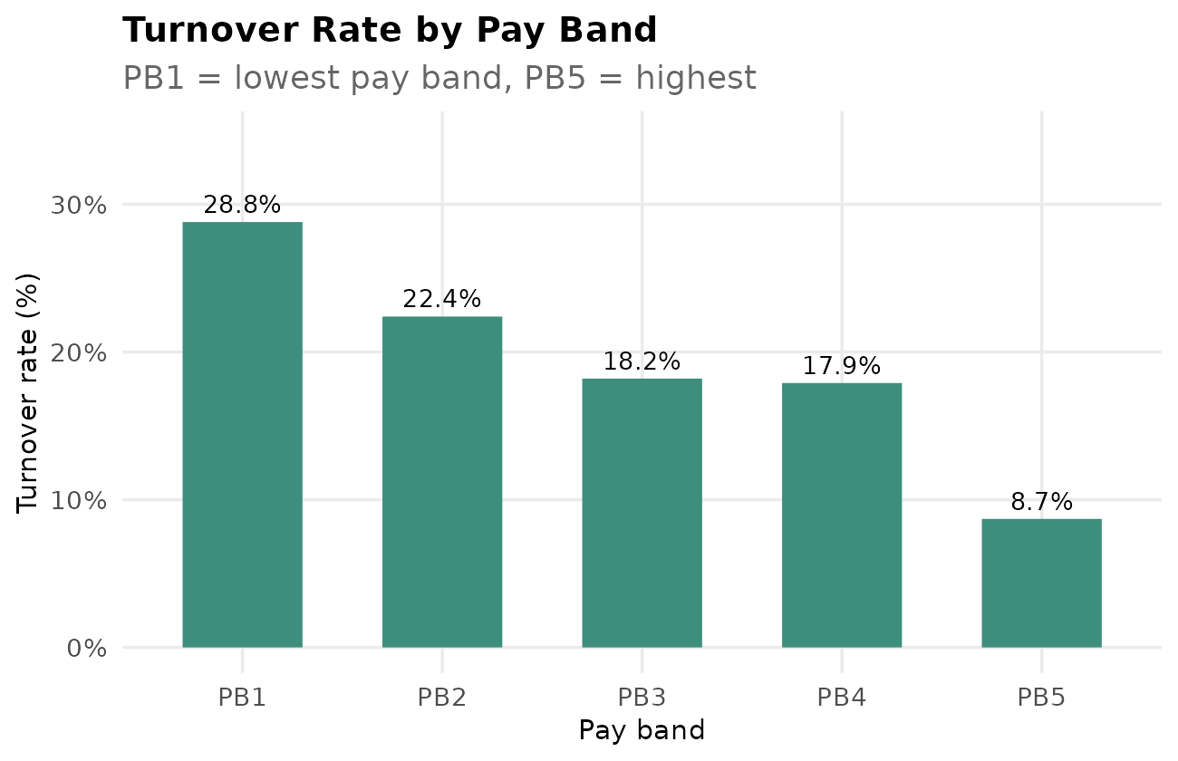
Figure 2: Turnover rate by pay band (PB1 = lowest, PB5 = highest).
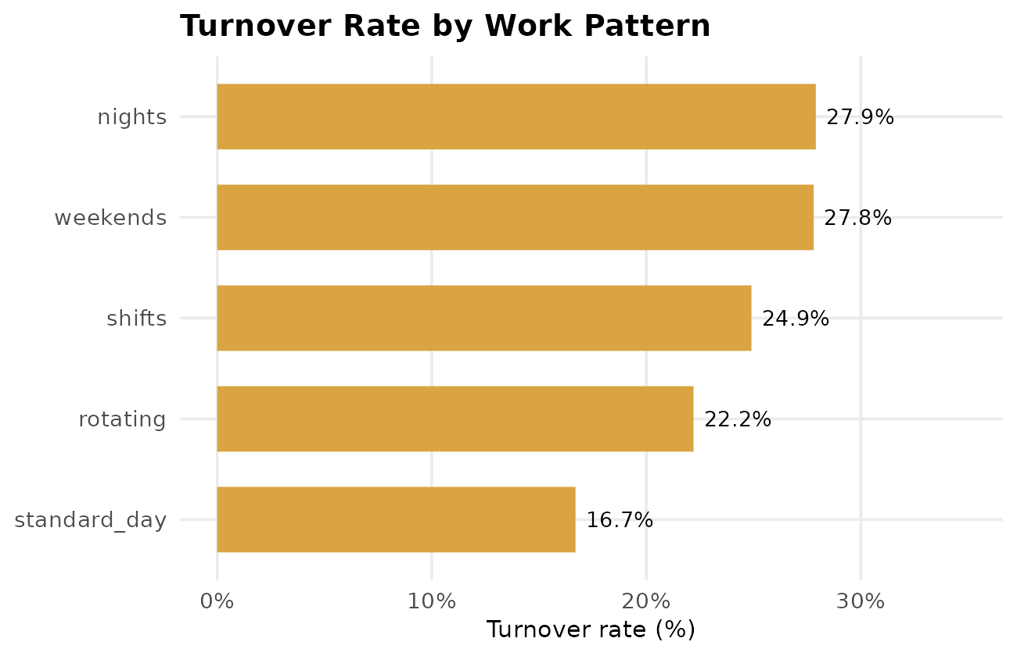
Figure 3: Turnover rate by work pattern.
There is a U-shaped like pattern showed by tenure. The rate of turnover is highest in the first two years with 27.9% in the first year and 30.6 in the next year. This is came as unexpected finding before falling and likely stabilizing around 19 to 21% among those staff who have had served for long.
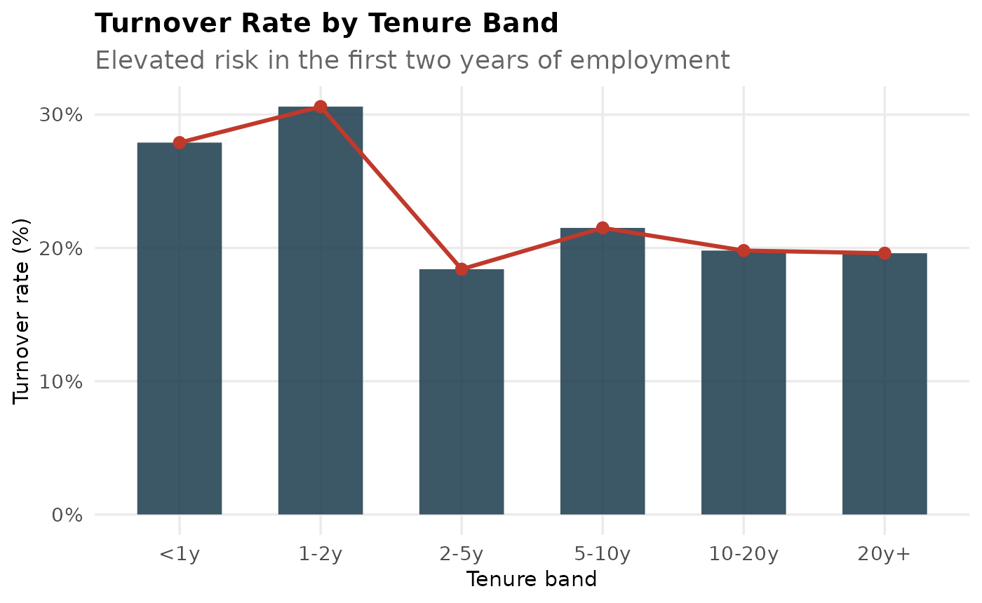
Figure 4: Turnover rate by tenure band.
There is validity of the managerial risk indicator in the actual NUG’S predictive ability is questionable. The manager-assessed retention risk, which is recorded at the annual review of each employee, is compared against the actual departure resulting to a modest gradient. This gradient shows that employees who rated low risk left at 17.5%, median at the rate of 22.2% and high at the rate of 24.7%. However, there is a 7.0% of the responses spread between the extremes as a result of discriminative power. This shows that turnover does not primarily occur in managerial high risk flags as most would suggest. Further, comparing this flag with other documented performance issues showed that managerial’ risks issues are not predominantly influenced by structured performance data but by other informal drivers.

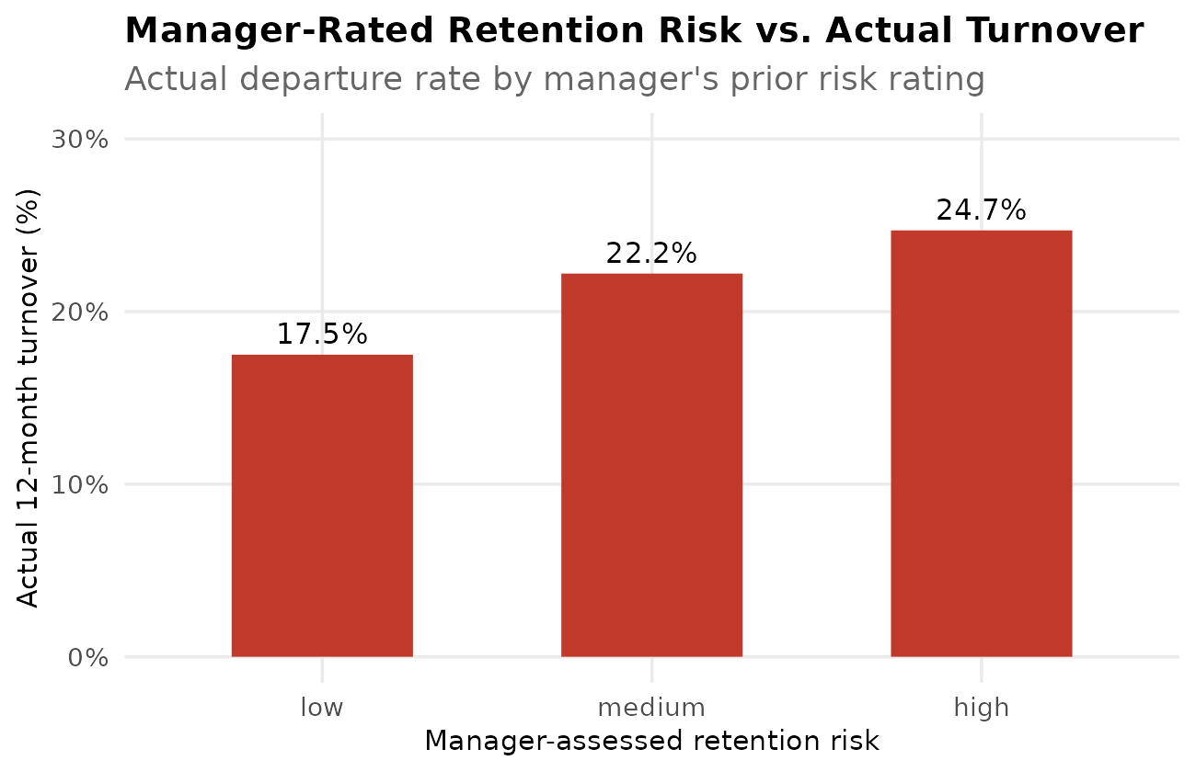
Figure 5: Manager-rated retention risk versus actual 12-month turnover.
There is a slight variation among demographic parameters as indicated by their narrow range of 19.7% and 22.7% across gender and ethnicity categories. This is an indication that turnover at NUG has a strong pattern with other protected characteristics. However, the rate of modesty is slightly higher among women 22.1% for women and 20.0% for men as well a higher among union members 23.5% and 19.4% for non-members which being monitored than been dismissed. Additionally, there is a very narrow difference between the absence and overtime rates for both the employers who leave and those that remain behind. Leavers recorded 6.6 absence days with 6.1 overtime hours while those that stay recorded 6.1 absence days and 5.7 overtime hours worked. Consequently, it is clear that administrative variables tend to be weak predictors of departure.

4.1 Validity, Reliability and Measurement Limitations
There are some validity, reliability and measurement drawbacks in these findings. Firstly, noticeable subjective judgement among the manager assessed retention risk is a weak observed relationship with actual turnover is itself informative evidence of limited criterion validity. Conversely, leaver_flag_12m demonstrates strong criterion validity with the determination if the employee was exited in the actual payroll system rather than perception. Secondly, there were 4,898 missing schedule_adherence_pct files for 7,500 employees (65%) in roles where the metric did not apply during the survey. This means it was a systematic issue which was not random and as a result analysis using the files automatically excludes certain job families. However, the data that is associated with HR administrative factors were organized systematically, resulting in apparent differences across departments that reflect genuine underlying attrition risk.

5. Bringing in Employee Voice
Quantitative analytical outcomes are majorly limited in depicting the actual reasons behind the turnover drivers. To address this, two complementary text analytic methods were used to analyze the free employee comments. These methods, dictionary-based sentiment scoring and keyword frequency analysis, are always consistent with the common practices applied in HR text-analytics (Marler and Boudreau, 2017).

5.1 Sentiment Analysis of Performance Review Comments
The 6,565 employee_comment entries were used in the primary sentiment analysis that were in the 2026 performance review dataset. This dataset has a substantial higher coverage of 87.5% of the workforce with 1,359 out of 1,566 leavers compared to the engagement survey that had lower coverage. For this analysis, a custom lexicon of workplace-relevant positive and negative terms (e.g. “supportive”, “flexible”, “valued” versus “understaffed”, “unpredictable”, “burnt out”) was matched against each lowercased and tokenised comment. Further, a net sentiment score (positive-word count minus negative-word count) classified each comment as positive, neutral or negative.

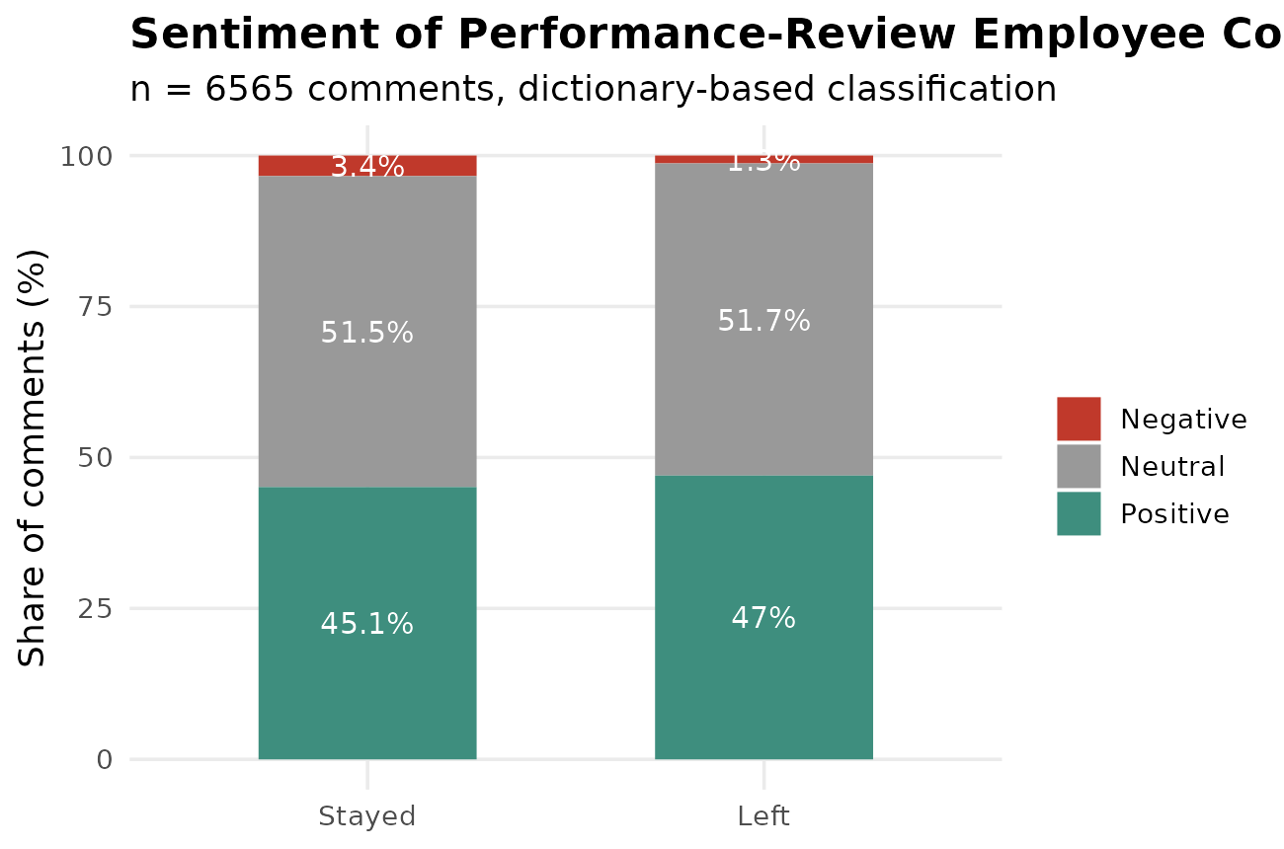
Figure 6: Sentiment classification of performance-review employee comments, stayers vs. leavers.
In the contrary, there were some distribution similarities between leavers and stayers with 45.1% of stayers' comments classified positive and those of leavers at 47.0%. On the other hand, only 3.4% for the stayers 1.3% for the leavers were reported to be negative. This pattern portrays the limitation present in the measurements rather than the equality in the leavers’ content. The major limitation is that performance-review comments are formally written in manager’s visible setting that is tied to a document that is capable of affecting pay and progression. As a result, there is some negative disclosure that is usually plausibly suppressed. This is a noteworthy finding since it indicates that the seemingly plausible sentiment metric should not serve as a reliable indicator of employee retention and attrition.
A department-level breakdown of comment sentiment reinforces this concern rather than resolving it. This is showed by the concentration of negative-sentiment comments in Procurement & Facilities (40.4%) and Digital & Data (35.2%). Further, 0% negative rate was recorded in every other department including customer operations which has the highest actual turnover. On the other hand, this implausible pattern where most departments shown almost no negative language at all, strongly suggests that comment phrasing in parts of this dataset is templated. As a result, sentiment outputs should never be reported to leadership without visible confidence caveats and human spot-checking of underlying comments.

5.2 Thematic Keyword Analysis of Open-Tet Survey Responses
A second, complementary analysis examined open-text responses to the engagement survey question “what one thing would you change?” This was done using keyword frequency analysis that is based on 2,076 valid responses after cleaning. The most frequent substantive terms were “reduce”, “better”, “systems”, “staffing”, “predictable”, “rotas”, “pressure”, “peak”, “periods”, “kpi” and “crash”.
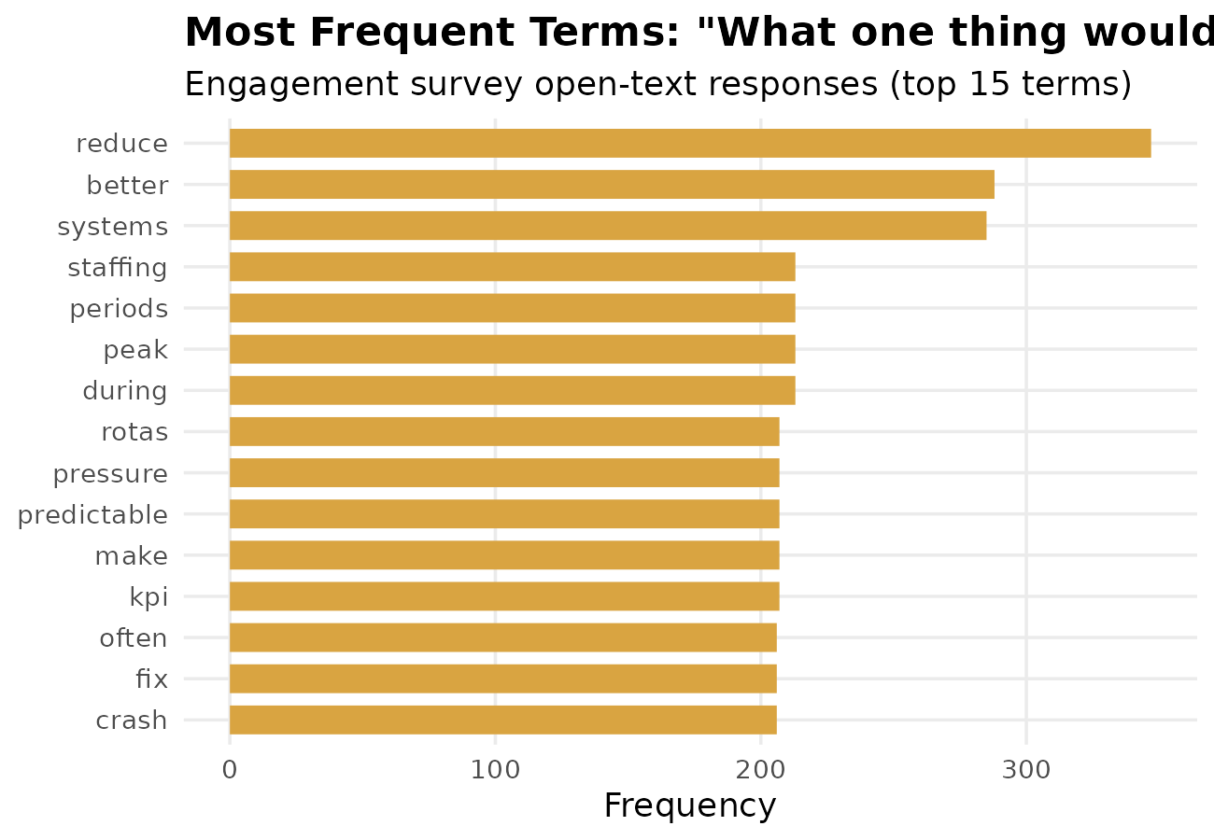
Figure 7: Most frequent terms in responses to “what one thing would you change?” (top 15).
Read together rather than as isolated words, these terms cluster around three recurring organisational themes: staffing and scheduling. These themes indicate employees' desire for more predictable rotas and adequate cover during peak periods, echoing the earlier finding that shift, night and weekend workers show the highest structural turnover. Further, these themes strongly triangulate with the quantitative findings on work pattern and department, giving greater confidence that scheduling unpredictability and operational tooling are material drivers of attrition risk in the highest-turnover areas.

5.3 Strengths, Weaknesses and Integration
Several limitations of this text analysis must be acknowledged. Dictionary-based sentiment scoring cannot detect sarcasm, negation (e.g. “not at all supportive”), or context-dependent meaning, and a simple word-count lexicon will misclassify comments using domain-specific or ambiguous language. Coverage is also unequal: the engagement survey achieved only a 27.7% clean response rate, and response is unlikely to be random — employees who are highly disengaged, or already disengaging from the organisation, may be systematically less likely to complete a voluntary survey, which would bias “voice” data toward moderately satisfied respondents and understate the severity of concerns among the highest-risk group. For this reason, employee-voice findings have been triangulated against, rather than substituted for, the structured administrative analysis in Section 4, and should be treated as indicative of organisational themes rather than a precise, generalisable measure of workforce sentiment.

6. Ethical and Practical Implications
There are ethical questions raised due to the use of workforce data in the inference and prediction of turnover risks. Firstly, employees’ whose comments and responses are used in the analysis for sentiment and outcomes expect their data to have privacy and surveillance metrics. This ensures that data is not used for other purposes than the agreed ones without their consent (Tursunbayeva, Di Lauro and Pagliari, 2018). Therefore, NUG ought to practice transparency with its employees on the data that it analyses with several regulations in place. Secondly, there is a need to have the algorithmic logic and human bias work together rather than being separable concerns. For instance manager assessed retention risk was found to have a weak predictive validity, suggesting that they were likely as a result of informal and unrecorded managerial impressions caused by biasness (Leicht-Deobald et al., 2019). As such, NUG would have encoded and scaled any bias through automating retention-risk scoring. Therefore, future models should have the capacity to invalidate objective outcomes and audit disparate impact before operationalisation. Thirdly, there are important power-dynamics and trust implications where employees may correctly feel that increasingly granular behavioural and textual analysis constitutes intensified managerial surveillance. Moreover, Analytics may improve decision quality; however, excessive monitoring risks reducing employee trust and engagement. Finally, there is need for acknowledgment of practical implementation constraints. As such, HR business partners and line managers that are analytically literate require adequate resourcing to facilitate professional interpretation and act on findings once they are identified. Moreover, a clear data governance improves both the ethical defensibility and the practical value of this kind of analysis going forward.

7. Recommendations for HR Leadership
With the evidence drawn from the implications above, there is a proposal for five recommendations that are presented in sequence by priority. This differentiates short-term operational actions from longer-term strategic interventions.

7.1 Redesign scheduling and staffing in shift-based functions (short-term, operational)
Turnover is approximately 1.6 times higher among weekend and shift workers (27% to 28%) that of the standard-day staff (16.7%). Analysis done on the open-text data showed that “predictable rotas” and “staffing during peak periods” were the periods that most employees requested changes. As such, operation leaders with the help of HR need to pilot more predictable, employee informed rota systems with better peak periods for staffing buffer.

7.2 Strengthen early-tenure onboarding and support (short-term)
Hom et al. (2017) contend that there tends to be unexpected mechanism during socialization rather than generalized dissatisfaction. In support of this, turnover peaks at 27.9 in year one and 30.6% in year two and then falls significantly. Therefore, NUG should pilot a structured two-year onboarding programme with defined manager check ins at 30,90,180 and 365 days. The responsibility should include learning and development with an outcome of a lower first-two-year attrition curve

7.3 Review operational systems and tools in high-friction teams (medium-term)
There were recurring concerns regarding operational systems during keyword analysis that concentrated in operationally intensive teams. As such, HR should work with IT and Operations to commission a focused reliability and usability review in the teams generating the most related feedback. This is because unreliable tools plausibly compound workload pressure that is identified elsewhere in the data. The responsibility should be ensuring digital and data functions jointly with the heads of the affected departments. Further the expected outcome is to reduce system related complaints in the survey cycles that follows and therefore reduce turnover initiated by workload factors.

7.4 Supplement, rather than replace, manager judgement on retention risk (medium-term)
Manager’s input should be supplemented with structured and evidence based indicators than just doing away with the manager input. This is due to very low predictive validity (17.5% to 24.7%) and little relationship with the documented performance concerns. With the indicators, the gap is addressed with little to no leap to a risk score that is fully automated and results to analysis that is not justifiable. The responsibility would be for the people analytics functions with the expected outcome being to have a more targeted retention interventions as well as audit trials that are clearer in trial linking risk flags to the underlying evidence

7.5 Improve the quality and reach of employee voice data (longer-term, strategic)
Dissatisfaction is not candidly captured in the survey as shown in the clean survey response rate of only 27.7% and the current free-text fields. For this reason, NUG should redesign its employee listening architecture by making the survey shorter and simpler to improve completion. Moreover, an anonymous listening channel should be set and the responses shared to the department leaders rather than HR alone for effective implementation. Responsibility should lie with the HR Director, supported by the Executive Committee. The expected outcome is an improved response rate to at least 50% within one survey cycle and a validated channel that is less socially desirable for capturing the reasons for attrition.
Across all the five recommendations, resourcing and feasibility have been explicitly considered. Moreover, none require large new headcount, but some of them require operational and IT investment that HR cannot authorise alone. Finally, leadership should also remain alert to unintended consequences such as the increase of employee surveillance due to poor communication concerning visible risk indicators for every intervention

8. Limitations
There are three limitations that apply to this report despite having specific measurement issues raised in each analytical section. Firstly, the data are cross sectional with alignment to a single point in time (the 2026 HRIS snapshot, 2026 review cycle and 2026 survey wave). Therefore, there can be no causal claims made that independently affect both pay and turnover since they have no clear association that exist between them. Secondly, there are limited representatives at the survey level with only 27.7% clean response rate. This show that the engagement and open-text findings are likely to understate the level and impact of dissatisfaction among the highest turnover groups. Thirdly, there are organizational constructs rather than objective facts in several fields. For instance, how departure was classified as either voluntary or involuntary, the manager assessed retention risk as well as performance ratings all depend on the manager discretion. This leads to partial reflection of recording practice rather than genuine underlying differences in the employee experience.
These limitations do not undermine the value of the patterns identified but they do mean recommendations should be implemented as monitored pilots rather than treated as definitively proven solutions.

References
Allen, D.G., Bryant, P.C. and Vardaman, J.M. (2010) 'Retaining talent: Replacing misconceptions with evidence-based strategies', Academy of Management Perspectives, 24(2), pp.48–64.
CIPD (2025) Employee turnover. Available at: https://www.cipd.org/uk/knowledge/datahub/employee-turnover/ (Accessed: 6 July 2026).
Holtom, B.C., Mitchell, T.R., Lee, T.W. and Eberly, M.B. (2008) 'Turnover and retention research: A glance at the past, a closer review of the present, and a venture into the future', Academy of Management Annals, 2(1), pp.231–274.
Hom, P.W., Lee, T.W., Shaw, J.D. and Hausknecht, J.P. (2017) 'One hundred years of employee turnover theory and research', Journal of Applied Psychology, 102(3), pp.530–545.
Leicht-Deobald, U., Busch, T., Schank, C., Weibel, A., Schafheitle, S., Wildhaber, I. and Kasper, G. (2019) 'The challenges of algorithm-based HR decision-making for personal integrity', Journal of Business Ethics, 160(2), pp.377–392.
Marler, J.H. and Boudreau, J.W. (2017) 'An evidence-based review of HR Analytics', The International Journal of Human Resource Management, 28(1), pp.3–26.
Mobley, W.H. (1977) 'Intermediate linkages in the relationship between job satisfaction and employee turnover', Journal of Applied Psychology, 62(2), pp.237–240.
Price, J.L. (2001) 'Reflections on the determinants of voluntary turnover', International Journal of Manpower, 22(7), pp.600–624.
Tursunbayeva, A., Di Lauro, S. and Pagliari, C. (2018) 'People analytics—A scoping review of conceptual boundaries and value propositions', International Journal of Information Management, 43, pp.224–247.

Appendix: R Code Used for Analysis
The following R code was used to clean, integrate, analyse, and visualise the four NUG datasets. It is provided in full for reproducibility and is not included in the report word count.
## =====================================================================
## MN3526 Big Data and People Analytics
## Northbridge Utilities Group (NUG) - Turnover & Retention Analysis
## Full analytical pipeline: data integration, descriptive statistics,
## sentiment analysis, and visualisation
## =====================================================================

suppressMessages({
library(dplyr)
library(tidyr)
library(stringr)
library(ggplot2)
library(scales)
})

setwd("/home/claude/nug/data")
fig_dir <- "/home/claude/nug/figs"
out_dir <- "/home/claude/nug/out"

theme_set(theme_minimal(base_size = 12) +
theme(plot.title = element_text(face = "bold"),
panel.grid.minor = element_blank()))
nug_pal <- c("#1B3A4B", "#C0392B", "#3E8E7E", "#D9A441", "#7D8CA3")

## ---------------------------------------------------------------------
## 1. LOAD RAW DATASETS
## ---------------------------------------------------------------------
emp <- read.csv("employee_admin_2026.csv", stringsAsFactors = FALSE)
team <- read.csv("team_admin_2026.csv", stringsAsFactors = FALSE)
perf <- read.csv("performance_eval_2026.csv", stringsAsFactors = FALSE)
eng <- read.csv("annual_engagement_survey_2026.csv", stringsAsFactors = FALSE)

## ---------------------------------------------------------------------
## 2. DATA QUALITY CHECKS
## ---------------------------------------------------------------------
dq <- list(
n_employees = nrow(emp),
n_dup_employee_id = sum(duplicated(emp$employee_id)),
n_teams = nrow(team),
n_perf_reviews = nrow(perf),
n_dup_perf_id = sum(duplicated(perf$employee_id)),
n_survey_rows = nrow(eng),
n_survey_bad_id = sum(!str_detect(eng$employee_id, "^E[0-9]{6}$")),
n_survey_dup_flag = sum(eng$duplicate_flag == 1),
n_survey_attn_fail = sum(eng$attention_check != 4),
n_survey_partial = sum(eng$completion_status != "complete")
)

## Clean engagement survey: keep only valid employee IDs, complete
## responses, non-duplicate submissions, and passed attention check
eng_clean <- eng %>%
filter(str_detect(employee_id, "^E[0-9]{6}$"),
completion_status == "complete",
duplicate_flag == 0,
attention_check == 4)

dq$n_survey_clean <- nrow(eng_clean)
dq$response_rate_raw <- round(length(unique(eng$employee_id[str_detect(eng$employee_id,"^E[0-9]{6}$")])) / nrow(emp) * 100, 1)
dq$response_rate_clean <- round(length(unique(eng_clean$employee_id)) / nrow(emp) * 100, 1)

# if an employee somehow has >1 clean survey row, keep most recent by response_date
eng_clean <- eng_clean %>%
group_by(employee_id) %>%
arrange(desc(response_date)) %>%
slice(1) %>%
ungroup()

## ---------------------------------------------------------------------
## 3. CONSTRUCT INTEGRATED ANALYTICAL DATASET
## employee_admin = spine (LEFT JOIN team, perf, engagement)
## ---------------------------------------------------------------------
eng_small <- eng_clean %>%
select(employee_id,
eng_mu, wb_mu, mgr_mu, inc_mu, res_mu, lead_mu,
eng_intend_stay_12m, wb_feel_burnt_out, wb_stress_reasonable,
mgr_support, mgr_trust,
open_best_thing, open_one_change, open_reason_stay_or_leave,
schedule_control, overtime_frequency)

perf_small <- perf %>%
select(employee_id, overall_rating, overall_rating_label,
goal_achievement_pct, potential_flag, succession_ready,
performance_concerns_flag, pip_flag, retention_risk_manager_view,
strength_area, improvement_area, manager_comment, employee_comment)

team_small <- team %>%
select(team_id, team_size, avg_tenure_years, team_turnover_rate_12m,
team_promotion_rate_24m, manager_tenure_years, manager_span_of_control,
recent_restructure_flag, budget_pressure_flag,
team_absence_days_avg_12m, team_engagement_score_prev_year) %>%
rename(team_avg_tenure = avg_tenure_years)

analytic <- emp %>%
left_join(team_small, by = "team_id") %>%
left_join(perf_small, by = "employee_id") %>%
left_join(eng_small, by = "employee_id")

## ---------------------------------------------------------------------
## 4. DERIVED VARIABLES
## ---------------------------------------------------------------------
analytic <- analytic %>%
mutate(
tenure_band = cut(tenure_years, breaks = c(-Inf,1,2,5,10,20,Inf),
labels = c("<1y","1-2y","2-5y","5-10y","10-20y","20y+")),
absence_rate_flag = case_when(
absence_days_12m >= 10 ~ "High (10+ days)",
absence_days_12m >= 4 ~ "Moderate (4-9 days)",
TRUE ~ "Low (0-3 days)"),
high_overtime_flag = ifelse(overtime_hours_3m >= 20, 1, 0),
survey_responded = ifelse(!is.na(eng_mu), 1, 0),
perf_reviewed = ifelse(!is.na(overall_rating), 1, 0),
leaver_flag_12m = as.integer(leaver_flag_12m),
voluntary_leaver = ifelse(leaver_flag_12m==1 & leaver_reason=="voluntary", 1, 0),
engagement_composite = rowMeans(cbind(eng_mu, wb_mu, mgr_mu, inc_mu, res_mu, lead_mu), na.rm=FALSE),
pay_band = factor(pay_band, levels=c("PB1","PB2","PB3","PB4","PB5"))
)

write.csv(analytic, file.path(out_dir, "analytic_dataset.csv"), row.names = FALSE)

cat("Analytical dataset dimensions:", nrow(analytic), "rows x", ncol(analytic), "cols\n")

## ---------------------------------------------------------------------
## 5. DESCRIPTIVE STATISTICS: TURNOVER
## ---------------------------------------------------------------------
overall_turnover <- mean(analytic$leaver_flag_12m) * 100
voluntary_rate <- mean(analytic$voluntary_leaver) * 100

by_dept <- analytic %>%
group_by(dept) %>%
summarise(n = n(), leavers = sum(leaver_flag_12m),
turnover_pct = round(mean(leaver_flag_12m)*100,1),
voluntary_pct = round(mean(voluntary_leaver)*100,1)) %>%
arrange(desc(turnover_pct))

by_tenure <- analytic %>%
group_by(tenure_band) %>%
summarise(n = n(), turnover_pct = round(mean(leaver_flag_12m)*100,1))

by_joblevel <- analytic %>%
group_by(job_level) %>%
summarise(n = n(), turnover_pct = round(mean(leaver_flag_12m)*100,1)) %>%
arrange(desc(turnover_pct))

by_payband <- analytic %>%
filter(!is.na(pay_band)) %>%
group_by(pay_band) %>%
summarise(n = n(), turnover_pct = round(mean(leaver_flag_12m)*100,1))

by_workpattern <- analytic %>%
group_by(work_pattern) %>%
summarise(n = n(), turnover_pct = round(mean(leaver_flag_12m)*100,1)) %>%
arrange(desc(turnover_pct))

by_hybrid <- analytic %>%
group_by(hybrid_status) %>%
summarise(n = n(), turnover_pct = round(mean(leaver_flag_12m)*100,1))

by_region <- analytic %>%
group_by(region) %>%
summarise(n = n(), turnover_pct = round(mean(leaver_flag_12m)*100,1)) %>%
arrange(desc(turnover_pct))

absence_ot <- analytic %>%
group_by(leaver = factor(leaver_flag_12m, labels=c("Stayed","Left"))) %>%
summarise(mean_absence = round(mean(absence_days_12m),1),
mean_overtime = round(mean(overtime_hours_3m),1),
mean_tenure = round(mean(tenure_years),1))

## Manager retention-risk view vs actual departure (predictive validity check)
risk_validity <- analytic %>%
filter(!is.na(retention_risk_manager_view)) %>%
group_by(retention_risk_manager_view) %>%
summarise(n = n(), actual_turnover_pct = round(mean(leaver_flag_12m)*100,1)) %>%
arrange(match(retention_risk_manager_view, c("low","medium","high")))

## Team-level relationship: restructure / budget pressure vs turnover
team_context <- analytic %>%
filter(!is.na(recent_restructure_flag)) %>%
group_by(recent_restructure_flag, budget_pressure_flag) %>%
summarise(n=n(), turnover_pct = round(mean(leaver_flag_12m)*100,1), .groups="drop")

## Engagement composite vs leaver status (among survey respondents)
eng_vs_leaver <- analytic %>%
filter(survey_responded==1) %>%
group_by(leaver = factor(leaver_flag_12m, labels=c("Stayed","Left"))) %>%
summarise(n=n(),
mean_engagement = round(mean(engagement_composite, na.rm=TRUE),2),
mean_intend_stay = round(mean(eng_intend_stay_12m, na.rm=TRUE),2),
pct_burnt_out_high = round(mean(wb_feel_burnt_out>=4, na.rm=TRUE)*100,1))

## Save all summary tables
tabs <- list(dq=dq, overall_turnover=overall_turnover, voluntary_rate=voluntary_rate,
by_dept=by_dept, by_tenure=by_tenure, by_joblevel=by_joblevel,
by_payband=by_payband, by_workpattern=by_workpattern, by_hybrid=by_hybrid,
by_region=by_region, absence_ot=absence_ot, risk_validity=risk_validity,
team_context=team_context, eng_vs_leaver=eng_vs_leaver)
saveRDS(tabs, file.path(out_dir, "summary_tables.rds"))

for (nm in names(tabs)) {
x <- tabs[[nm]]
if (is.data.frame(x)) write.csv(x, file.path(out_dir, paste0("tab_", nm, ".csv")), row.names = FALSE)
}
cat("\n--- KEY FIGURES ---\n")
cat("Overall turnover:", round(overall_turnover,1), "%\n")
cat("Voluntary turnover:", round(voluntary_rate,1), "%\n")
print(by_dept)
print(risk_validity)
print(eng_vs_leaver)

cat("\nData quality summary:\n")
print(dq)
suppressMessages({library(dplyr); library(ggplot2); library(scales)})
fig_dir <- "/home/claude/nug/figs"
out_dir <- "/home/claude/nug/out"
tabs <- readRDS(file.path(out_dir, "summary_tables.rds"))

theme_set(theme_minimal(base_size = 13) +
theme(plot.title = element_text(face="bold", size=14),
plot.subtitle = element_text(color="grey40"),
panel.grid.minor = element_blank(),
axis.title = element_text(size=11)))
navy <- "#1B3A4B"; red <- "#C0392B"; teal <- "#3E8E7E"; gold <- "#D9A441"

## 1. Turnover by department
p1 <- tabs$by_dept %>%
mutate(dept = reorder(dept, turnover_pct)) %>%
ggplot(aes(dept, turnover_pct)) +
geom_col(fill = navy, width=0.7) +
geom_hline(yintercept = tabs$overall_turnover, linetype="dashed", color=red) +
annotate("text", x=1.5, y=tabs$overall_turnover+1.3, label=paste0("Org average: ", round(tabs$overall_turnover,1),"%"), color=red, size=3.5, hjust=0) +
coord_flip() +
labs(title="12-Month Turnover Rate by Department", subtitle="Northbridge Utilities Group, FY2026",
x=NULL, y="Turnover rate (%)") +
scale_y_continuous(labels = function(x) paste0(x,"%"))
ggsave(file.path(fig_dir,"fig1_turnover_by_dept.png"), p1, width=7.5, height=4.5, dpi=200)

## 2. Turnover by pay band and work pattern (combined panel via facet using patchwork not available; do two)
p2 <- tabs$by_payband %>%
ggplot(aes(pay_band, turnover_pct)) +
geom_col(fill = teal, width=0.6) +
geom_text(aes(label=paste0(turnover_pct,"%")), vjust=-0.5, size=3.5) +
labs(title="Turnover Rate by Pay Band", subtitle="PB1 = lowest pay band, PB5 = highest",
x="Pay band", y="Turnover rate (%)") +
scale_y_continuous(labels=function(x) paste0(x,"%"), limits=c(0, max(tabs$by_payband$turnover_pct)*1.2))
ggsave(file.path(fig_dir,"fig2_turnover_by_payband.png"), p2, width=6.5, height=4.2, dpi=200)

## 3. Turnover by work pattern
p3 <- tabs$by_workpattern %>%
mutate(work_pattern = reorder(work_pattern, turnover_pct)) %>%
ggplot(aes(work_pattern, turnover_pct)) +
geom_col(fill = gold, width=0.65) +
geom_text(aes(label=paste0(turnover_pct,"%")), hjust=-0.15, size=3.5) +
coord_flip(clip="off") +
labs(title="Turnover Rate by Work Pattern", x=NULL, y="Turnover rate (%)") +
scale_y_continuous(labels=function(x) paste0(x,"%"), limits=c(0,max(tabs$by_workpattern$turnover_pct)*1.25))
ggsave(file.path(fig_dir,"fig3_turnover_by_workpattern.png"), p3, width=6.5, height=4.2, dpi=200)

## 4. Turnover by tenure band (U-shape / early tenure risk)
p4 <- tabs$by_tenure %>%
filter(!is.na(tenure_band)) %>%
ggplot(aes(tenure_band, turnover_pct, group=1)) +
geom_col(fill=navy, width=0.6, alpha=0.85) +
geom_line(color=red, linewidth=1) +
geom_point(color=red, size=2.5) +
labs(title="Turnover Rate by Tenure Band", subtitle="Elevated risk in the first two years of employment",
x="Tenure band", y="Turnover rate (%)") +
scale_y_continuous(labels=function(x) paste0(x,"%"))
ggsave(file.path(fig_dir,"fig4_turnover_by_tenure.png"), p4, width=7,height=4.3, dpi=200)

## 5. Manager-assessed retention risk vs actual turnover (validity check)
p5 <- tabs$risk_validity %>%
mutate(retention_risk_manager_view = factor(retention_risk_manager_view, levels=c("low","medium","high"))) %>%
ggplot(aes(retention_risk_manager_view, actual_turnover_pct)) +
geom_col(fill=red, width=0.55) +
geom_text(aes(label=paste0(actual_turnover_pct,"%")), vjust=-0.5, size=4) +
labs(title="Manager-Rated Retention Risk vs. Actual Turnover",
subtitle="Actual departure rate by manager's prior risk rating",
x="Manager-assessed retention risk", y="Actual 12-month turnover (%)") +
scale_y_continuous(labels=function(x) paste0(x,"%"), limits=c(0,30))
ggsave(file.path(fig_dir,"fig5_manager_risk_validity.png"), p5, width=6.5, height=4.2, dpi=200)

## 6. Engagement composite: stayed vs left
eng_dat <- readRDS(file.path(out_dir,"summary_tables.rds"))$eng_vs_leaver
p6 <- eng_dat %>%
tidyr::pivot_longer(cols=c(mean_engagement, mean_intend_stay), names_to="metric", values_to="value") %>%
mutate(metric = recode(metric, mean_engagement="Overall engagement (1-5)", mean_intend_stay="Intend to stay 12m (1-5)")) %>%
ggplot(aes(leaver, value, fill=leaver)) +
geom_col(width=0.55, position="dodge") +
geom_text(aes(label=value), vjust=-0.4, size=3.8) +
facet_wrap(~metric) +
scale_fill_manual(values=c(teal, red), guide="none") +
labs(title="Employee Engagement: Stayed vs. Left",
subtitle="Among the 2,076 valid survey respondents",
x=NULL, y="Mean score (1-5 scale)") +
ylim(0,5)
ggsave(file.path(fig_dir,"fig6_engagement_leavers.png"), p6, width=7, height=4.3, dpi=200)

cat("Charts 1-6 saved.\n")
suppressMessages({library(dplyr); library(stringr); library(tidyr); library(ggplot2)})
setwd("/home/claude/nug/data")
fig_dir <- "/home/claude/nug/figs"
out_dir <- "/home/claude/nug/out"

emp <- read.csv("employee_admin_2026.csv", stringsAsFactors=FALSE)
perf <- read.csv("performance_eval_2026.csv", stringsAsFactors=FALSE)
eng <- read.csv("annual_engagement_survey_2026.csv", stringsAsFactors=FALSE)

eng_clean <- eng %>%
filter(str_detect(employee_id, "^E[0-9]{6}$"), completion_status=="complete",
duplicate_flag==0, attention_check==4) %>%
group_by(employee_id) %>% arrange(desc(response_date)) %>% slice(1) %>% ungroup()

## ---- Custom HR-context sentiment lexicon (author-built, not sourced) ----
positive_words <- c("good","great","strong","support","supportive","supported","fair","valued",
"valuable","recognition","recognised","recognized","flexible","flexibility","stable","stability",
"friendly","helpful","reliable","manageable","satisfied","satisfying","enjoy","enjoyable","proud",
"positive","trust","trusted","respect","respected","reasonable","balance","balanced","progress",
"opportunity","opportunities","development","developing","growth","invest","investment","improve",
"improved","improving","clear","transparent","secure","security","motivated","motivating","rewarding",
"reward","fun","welcoming","inclusive","empowered","confident","efficient","cooperative","teamwork",
"collaborative","appreciate","appreciated","calm","consistent")

negative_words <- c("poor","bad","frustration","frustrated","frustrating","unfair","unstable","unclear",
"pressure","stressed","stress","stressful","burnt","burnout","overworked","understaffed","short-staffed",
"shortstaffed","delay","delays","delayed","difficult","hard","exhausted","exhausting","tired","tiring",
"unpredictable","chaotic","inconsistent","low","lack","lacking","insufficient","overwhelmed","overwhelming",
"toxic","micromanage","micromanaged","micromanagement","bullying","bully","disrespect","disrespected",
"unsupported","ignored","undervalued","underpaid","underpay","backlog","turnover","conflict","tension",
"concern","concerns","worried","worry","anxious","anxiety","complaints","complaint","broken","outdated",
"slow","rigid","inflexible","excessive","unmanageable","unreasonable")

pos_pat <- paste0("\\b(", paste(positive_words, collapse="|"), ")\\b")
neg_pat <- paste0("\\b(", paste(negative_words, collapse="|"), ")\\b")

score_text <- function(txt) {
txt <- tolower(txt)
words <- str_count(txt, "\\w+")
pos <- str_count(txt, pos_pat)
neg <- str_count(txt, neg_pat)
tibble(n_words=words, n_pos=pos, n_neg=neg, net=pos-neg)
}

## ---- Apply to performance-review employee comments (largest coverage) ----
perf_txt <- perf %>%
filter(!is.na(employee_comment), employee_comment != "") %>%
select(employee_id, employee_comment) %>%
left_join(emp %>% select(employee_id, leaver_flag_12m, dept), by="employee_id")

sc <- bind_rows(lapply(perf_txt$employee_comment, score_text))
perf_txt <- bind_cols(perf_txt, sc) %>%
mutate(sentiment = case_when(net > 0 ~ "Positive", net < 0 ~ "Negative", TRUE ~ "Neutral"),
leaver = factor(leaver_flag_12m, labels=c("Stayed","Left")))

sent_summary <- perf_txt %>%
group_by(leaver, sentiment) %>%
summarise(n=n(), .groups="drop") %>%
group_by(leaver) %>%
mutate(pct = round(n/sum(n)*100,1))

write.csv(sent_summary, file.path(out_dir,"tab_sentiment_summary.csv"), row.names=FALSE)

cat("=== Sentiment distribution (performance review employee comments) ===\n")
print(sent_summary)
cat("\nTotal comments analysed:", nrow(perf_txt), "\n")
cat("Mean net sentiment score - Stayed:", round(mean(perf_txt$net[perf_txt$leaver=="Stayed"]),3),
"| Left:", round(mean(perf_txt$net[perf_txt$leaver=="Left"]),3), "\n")

## Sentiment by department
sent_by_dept <- perf_txt %>%
group_by(dept) %>%
summarise(n=n(), pct_negative = round(mean(sentiment=="Negative")*100,1)) %>%
arrange(desc(pct_negative))
write.csv(sent_by_dept, file.path(out_dir,"tab_sentiment_by_dept.csv"), row.names=FALSE)
print(sent_by_dept)

## ---- Theme/keyword analysis: engagement survey "reason to stay or leave" & "one change" ----
theme_txt <- eng_clean %>%
select(employee_id, open_reason_stay_or_leave, open_one_change, open_best_thing) %>%
left_join(emp %>% select(employee_id, leaver_flag_12m), by="employee_id") %>%
mutate(leaver = factor(leaver_flag_12m, labels=c("Stayed","Left")))

## simple keyword frequency in "one change" field to identify improvement themes
stopwords <- c("the","and","to","of","a","in","for","is","on","with","more","that","be","would","it",
"at","as","are","this","have","or","not","if","we","our","i","need","needs","like","also",
"than","so","but","just","can","get","when","from","some","been","being","into","which","an")

tokens <- theme_txt %>%
filter(open_one_change != "", !is.na(open_one_change)) %>%
pull(open_one_change) %>%
tolower() %>%
str_replace_all("[[:punct:]]", " ") %>%
str_split("\\s+") %>%
unlist()
tokens <- tokens[tokens != "" & !(tokens %in% stopwords) & nchar(tokens) > 2]
word_freq <- as.data.frame(table(tokens)) %>% arrange(desc(Freq)) %>% head(15)
names(word_freq) <- c("word","freq")
write.csv(word_freq, file.path(out_dir,"tab_word_freq_onechange.csv"), row.names=FALSE)
print(word_freq)

## ---- CHARTS ----
theme_set(theme_minimal(base_size=13) + theme(plot.title=element_text(face="bold"), panel.grid.minor=element_blank()))
navy<-"#1B3A4B"; red<-"#C0392B"; teal<-"#3E8E7E"; gold<-"#D9A441"

p7 <- sent_summary %>%
mutate(sentiment=factor(sentiment, levels=c("Negative","Neutral","Positive"))) %>%
ggplot(aes(leaver, pct, fill=sentiment)) +
geom_col(position="stack", width=0.55) +
geom_text(aes(label=paste0(pct,"%")), position=position_stack(vjust=0.5), color="white", size=3.8) +
scale_fill_manual(values=c(Negative=red, Neutral="grey60", Positive=teal), name=NULL) +
labs(title="Sentiment of Performance-Review Employee Comments",
subtitle=paste0("n = ", nrow(perf_txt), " comments, dictionary-based classification"),
x=NULL, y="Share of comments (%)")
ggsave(file.path(fig_dir,"fig7_sentiment_by_leaver.png"), p7, width=6.5, height=4.3, dpi=200)

p8 <- word_freq %>%
mutate(word=reorder(word, freq)) %>%
ggplot(aes(word, freq)) +
geom_col(fill=gold, width=0.7) +
coord_flip() +
labs(title="Most Frequent Terms: \"What one thing would you change?\"",
subtitle="Engagement survey open-text responses (top 15 terms)",
x=NULL, y="Frequency")
ggsave(file.path(fig_dir,"fig8_wordfreq_onechange.png"), p8, width=6.5, height=4.5, dpi=200)

cat("\nCharts 7-8 saved.\n")

