In Class 12 Intro to Firebase Part 1
Emmanuel Gohourou
CSC 4360 / ACS67 / Undergraduate
November 3, 2026
My app can add, show, edit, and delete products in Firestore. Search and price filters worked with the five class products. This report has the test results, screenshots, and answers to Q1 through Q10.

Setup and code
Android emulator: InClass09_Test, sdk_gphone16k_arm64, Android 17 API 37. Flutter 3.47.2, Dart 3.13.2, firebase_core 5.1.0, cloud_firestore 7.1.0. The project is inclass12-products, using the default Firestore database in nam5. The Android package is com.example.autumn_products.
https://github.com/emmanuelori00/MADProjects/tree/inclass_act12/inclass_act12
All 14 local tests passed and flutter analyze reported no issues. The Android build installed and ran. The local form tests use a fake database, so the live tests below are separate evidence.

What I changed and how to run it
The products collection has a name string and a numeric price in each document. The generated document ID tells records apart. I kept the starter create/edit form, added delete by ID with confirmation and error handling, and added a name search, inclusive price bounds, and Reset. Search ignores capitals and matches any part of the name. Invalid input shows a message. Bad document types show an error with their ID instead of crashing the normal product card.
Open inclass_act12 and run flutter pub get. Connect Firebase CLI to your class project. Run flutterfire configure --platforms=android to generate the local platform settings. Create the default Firestore database and add the five class products with numeric prices. Start an Android emulator and run flutter run. Use flutter analyze and flutter test for the local checks. Generated Firebase settings and credentials are not in the repository.
The live tests used made-up products. Core features are finished. The answers include ideas for stock and a larger product catalogue. The live class rules still expire on December 3, 2026. The restricted rules were simulated and discarded, not published.

Test results
Expected results below are the assignment pass conditions. Actual results came from the Android app and Console on November 3. T4 through T8 were run with the five class products before adding the temporary T1 through T3 products. Both temporary products were removed afterward.
Test | Expected | Actual and evidence
T1 Create and read | Same name, numeric 12.50, and ID in app and Console. | Passed. Maple Test Nov3 was 12.50 in the app and numeric 12.5 in Console. Both showed ID R2iFWNYtmSvxT4CNTJ7F.
T2 Live update | Console price edit reaches the open app without refresh. | Passed. The same document went from 12.50 to 15.00. No refresh or restart was used.
T3 Edit and delete | App edit affects the right ID. Deleting one duplicate leaves the other. | Passed. Original changed to 17.25. Duplicate ZjfQDs03vcjvDsfEfFM9 stayed at 12.50 after original R2iFWNYtmSvxT4CNTJ7F was deleted. Both temporary records were then cleaned up.
T4 Search | cEdAr finds Cedar; a missing name finds nothing. | Passed. cEdAr showed Cedar Mug. missingproduct showed No products found.
T5 Filters | Inclusive range, combined search, equal/one-sided bounds, and Reset work. | Passed. 12.50 to 20 gave Cedar, Tea, amber (3). Adding tea gave Tea (1). Equal 12.50 gave Cedar (1). Min-only 20 gave Wool and amber (2). Max-only 12.50 gave Autumn and Cedar (2). Reset gave all 5.
T6 Invalid input | Reject bad values without writing or crashing. Accept zero and empty bounds. Cancel writes nothing. | Passed after fixing test entry. Spaces-only name; blank, toast, -7, NaN, Infinity prices; bad supplied bounds; and min 20/max 12.50 showed errors. Empty bounds showed all 5. Autumn Sample accepted 0. Cancel/reopen gave blank fields.
T7 Offline | Observe loaded data offline, after restart, then compare after reconnect. | All 5 remained with Wi-Fi and mobile data off, including after force-stop/reopen. Data was not cleared. Reconnected Cedar matched Console at 12.50 and the same ID. This tests known cached data, not offline writes.
T8 Failure state | One intended allow and one deny in unpublished Rules Playground. | Passed as a simulation. get on Cedar: auth on with UID market-manager allowed; auth off denied. No payload. Original rules restored by discarding the draft.

Critical thinking answers

Q1 Initialization order
I expect Firebase to need Flutter's connection to the Android side before the product page starts. My order is main, WidgetsFlutterBinding.ensureInitialized(), await Firebase.initializeApp(options: DefaultFirebaseOptions.currentPlatform), then runApp. The binding is ready first, and await makes the app wait for Firebase. The app opened and loaded the five products on Android.
Without the binding, an early plugin call can fail because the platform connection isnt ready. The exact result depends on the platform and plugin version.

Q2 StreamBuilder and FutureBuilder
I expected the open list to change when I edited the price in Console. T2 showed Maple Test Nov3 changing from 12.50 to 15.00 without a refresh. Its ID stayed R2iFWNYtmSvxT4CNTJ7F. The sequence was: first snapshot at 12.50 -> Console saves 15.00 -> another snapshot -> StreamBuilder shows 15.00.
StreamBuilder fits this list because it keeps responding to later snapshots. A FutureBuilder with one get() would show the first result, but that same future wouldnt automatically deliver the later 15.00 change. I would need another read. A one-time read makes more sense for a saved receipt that should show the purchase price, instead of changing whenever the store changes its current price.

Q3 NoSQL and SQL
I expected one Firestore document to work a bit like one SQL row. Cedar Mug has a name string and a price double of 12.5. Its document ID is Fa0jScSiYJc8Oth4Me36. Firestore keeps fields inside documents in a collection instead of requiring one fixed table schema. The ID is separate from the name, so matching names dont mean matching records.
In SQL I would have Products(id, name, price, category_id) and Categories(id, name), with a foreign key. In Firestore I would keep categories documents and put a categoryId in each product. That is easy to read on a phone and works with live updates, but a categoryId doesnt automatically give me SQL foreign-key checks or joins. I would need rules or backend checks so a deleted category doesnt leave bad references.

Critical thinking answers

Q4 Test mode and access control
I expected a signed-in reader to pass my proposed rule and an anonymous reader to fail. T8 did exactly that for /products/Fa0jScSiYJc8Oth4Me36. The allow test used get, Authenticated on, and the simulated UID market-manager. The deny test used get with Authenticated off. Neither test needed write data.
I would let signed-in users read. Only the real manager account could create, edit, or delete. I used market-manager as a fake UID in the draft. Create and edit would also check that the only fields are name and price, the name is a string with a non-space character, and price is a number between zero and 1000000. That upper limit is a proposed store policy.
The live class rule allows reads and writes until December 3, 2026, so it isnt production security. I kept a copy and discarded the draft without publishing it. Hiding Delete only changes the screen. Someone could still send a request another way, so the server must check access. A real denied save should leave the editor open and show the permission error. The local denied-save test checks that UI behavior with a fake database.

Q5 Input validation
I wasnt sure what would happen when the minimum was higher than the maximum. With min 20 and max 12.50, T6 showed 'Min price cant be higher than max price.' The list asked me to fix the range. Reset cleared it and brought the five products back. The explanation is that no price can be at least 20 and at most 12.50 at the same time.
The form trims the name and rejects an empty name. It parses the price, checks isFinite, and rejects negative values. A blank price or text cant be saved; NaN and Infinity also fail. Zero is valid, which the Autumn Sample record shows. Empty filter bounds mean no limit, and equal bounds are allowed. These checks happen before the Firestore write. Server rules still need checks because a direct request or Console edit can bypass the Flutter form.

Critical thinking answers

Q6 A catalogue of 10000 products
The current stream reads the whole products collection before the phone filters it. Assume a fresh server query, 10000 documents, no useful cache, no changes, and one listener. That means about 10000 document reads even if the search shows one item. Ten separate fresh clients would mean about 100000. Index-entry reads, reconnects, and later updates are extra considerations. Typing in the current local filter doesnt create a new stream.
A limit of 30 with a cursor would make browsing smaller: three full pages would read about 90 documents under the same assumptions. Price conditions can move into a Firestore query, with the indexes its filters and ordering require. But filtering only the first page on the phone would miss matches on later pages. Pagination alone doesnt fix full-catalogue search.
I would keep substring matching. For example, dar should still find Cedar Mug. A simple prefix query changes that behavior because Cedar doesnt start with dar. My larger-app design would use a search service with a lowercased name index, substring matching, and price filtering, then page through its results. I would recheck a product in Firestore before editing it because the search index might be behind. Elasticsearch supports wildcard matching, but leading wildcards can be slow; I would compare an n-gram index and verify the same substring results. This adds another service and index-update work, so it isnt needed for five products.

Q7 Real time listeners and costs
I expected a Console edit to reach the open app without pressing Refresh. In T2, Console saved 15.00 for R2iFWNYtmSvxT4CNTJ7F and the app changed from 12.50 to 15.00. The listener receives snapshots and StreamBuilder rebuilds the list. Network speed and the server can affect how long it takes.
An app event alone isnt proof that a write reached the server, because local writes can appear in listeners before the server accepts them. Here, the change started in Console, and both Console and the app showed 15.00. In T3, the app edit also showed 17.25 in Console. The save code waits for the write, but this app doesnt show snapshot metadata.
Listeners read the initial results and can add document reads as matching documents change. Those updates also use bandwidth. A listener left open on a busy collection could cost more than a small occasional read. Reconnects can add reads too. My stream is kept in the page state, so typing a filter doesnt make a new subscription every build. StreamBuilder handles its subscription while mounted.
For an all-day screen, I would listen only to the visible page and stop listening when the screen is no longer in use. I would reconnect when needed, knowing that can require another read. I would compare a quiet hour and a busy hour using the same products, then record listener events, Firestore usage reads, network bytes, and update delays.

Critical thinking answers

Q8 Generated Firebase options
I expected the Android options to connect this app to inclass12-products. The Console fixtures and app showed the same document IDs, including Cedar Mug, which supports that the selected project is the right one. FlutterFire generated lib/firebase_options.dart for Android. DefaultFirebaseOptions.currentPlatform gives initializeApp the platform's project and app identifiers. They are configuration, not a rule allowing access.
If I picked the wrong project, I would first compare the projectId in the generated options with the Console project. Then I would create a uniquely named test product and check whether the same document ID appears in that Console. Missing matching IDs or a permission error would be clues to investigate. A permission error by itself wouldnt prove the project was wrong. The settings stay local in this repo; another person runs FlutterFire for their own project. Rules must still protect the data.

Q9 Evolving the product model
I expect a stock field to make it easier to see what is available, but old products wont have it. I would add stock as a nonnegative whole number. For an older document with no stock field, I would display 'Stock not set' and ask for a count on its next edit. I wouldnt show zero automatically because missing stock doesnt prove that an item is sold out. New products would need a count, the edit form would load it, and the list would show it under the price.
A bad legacy example is Cedar Mug with price stored as the string '12.50'. That example was rejected by my local malformed-document test; I didnt put it in the live collection. validProduct checks the types before building a normal card. The list would show the bad document ID and ask for its name/price types to be checked. I would correct price to a number in Console after checking the intended amount.

Critical thinking answers

Q10 Offline support and local storage
I expected already loaded products to stay available without a connection, but I needed to check a restart too. In T7, Android Wi-Fi and mobile data were both disabled with adb. The network report said Active default network: none. All five products stayed visible. I force-stopped and reopened the app without clearing its data, and they were still there. After reconnecting, Cedar Mug still showed ID Fa0jScSiYJc8Oth4Me36 and 12.50, matching Console.
Firestore persistence is on by default on Android and Apple platforms. Web persistence is different and is not enabled by default in the documented setup. The SDK can keep used data locally and synchronize changes after reconnecting. My test supports an offline read and restart on this Android emulator. It doesnt prove that every product is cached or that an offline write reached the server. This app doesnt display isFromCache or hasPendingWrites. Showing those flags, with includeMetadataChanges enabled for metadata-only events, would make the source and pending writes clearer.
Browser localStorage keeps string values for one browser origin and can survive a normal reload. Clearing browser storage can remove them; another phone doesnt automatically get them. Flutter SQLite stores a local database on the app device. Neither one automatically synchronizes this catalogue with Firestore.
Suppose two devices load a product at 12.50. Phone A goes offline and changes it to 18. Phone B is online and saves 22. If A reconnects later and its queued write is accepted last, I expect 18 to become the shared price. Firestore documents use last-write-wins behavior for these competing changes. I would warn about pending edits and use a checked version or a server-side conflict process if losing a price change mattered.

Debugging revision
I expected replacing the price text to enter -7, NaN, and Infinity separately. The first attempt left letters from toast, so the field actually said toas-7 and similar mixed text. That only tested bad text, not the exact values I needed. I changed the test entry to clear the existing characters, opened a fresh form for each case, and checked the actual field text. The rerun rejected exact -7, NaN, and Infinity with the finite-price message. I changed the test method, not the app validation.

Create and read
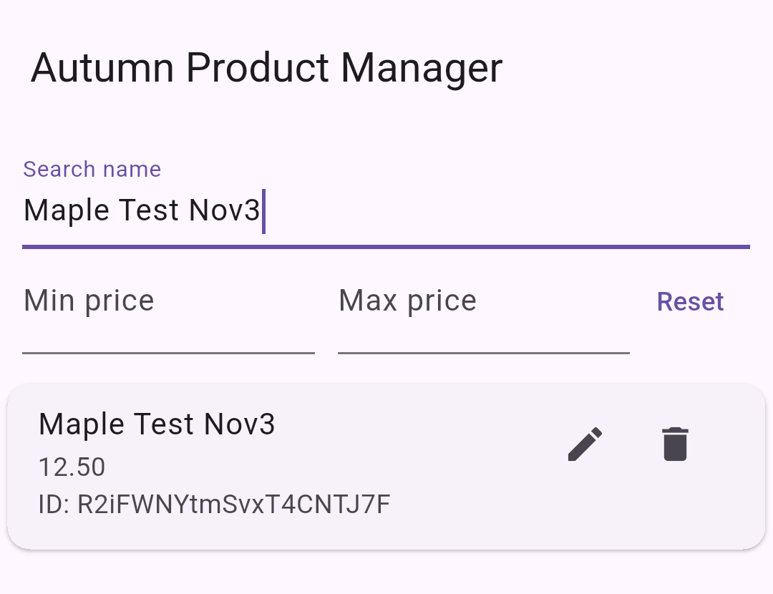
T1. Maple Test Nov3 at 12.50 in the app. ID R2iFWNYtmSvxT4CNTJ7F.
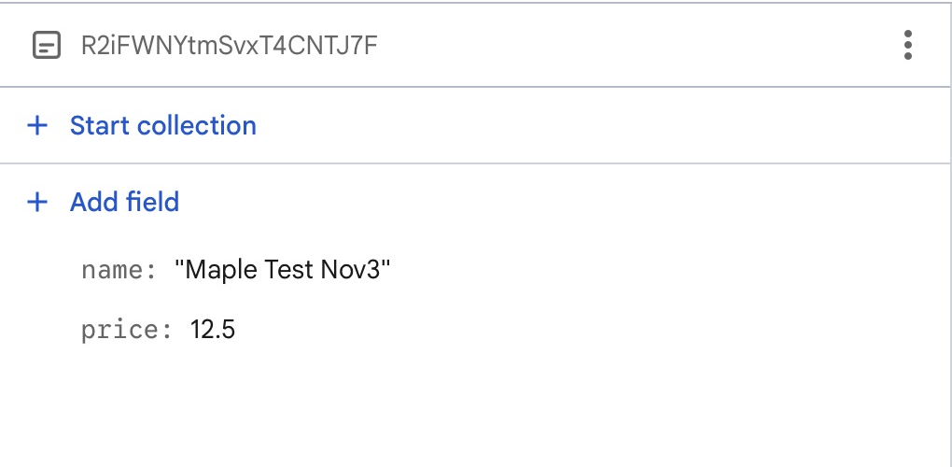
The same name and ID in Console, with numeric price 12.5. Console identified the field as double. The app just displays two decimal places.

Live update
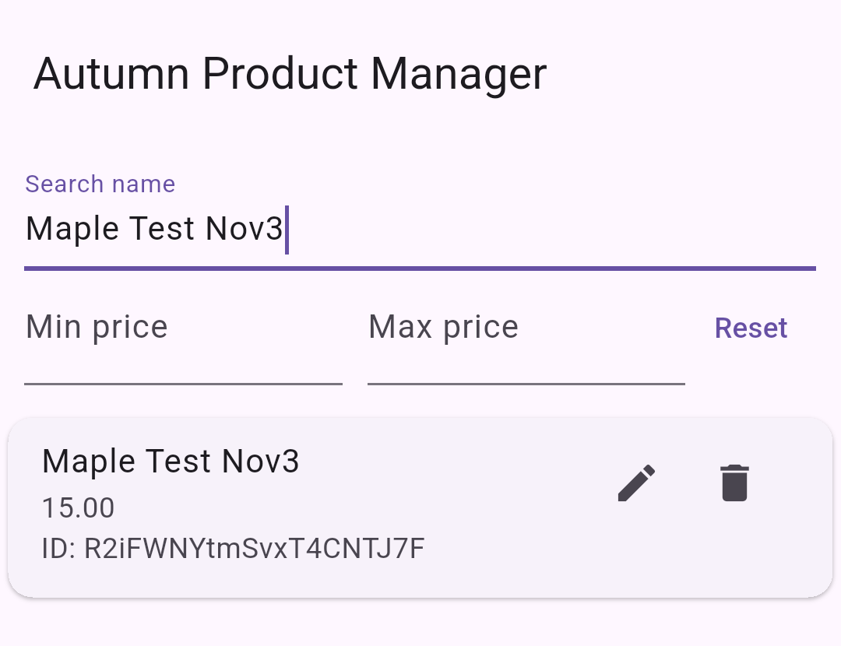
T2. The open app changed from 12.50 to 15.00. There was no manual refresh.
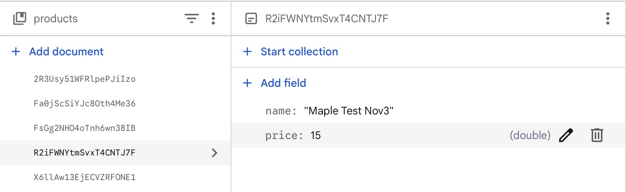
Console after changing that same document to numeric 15. The ID still matches the app.

Edit from the app
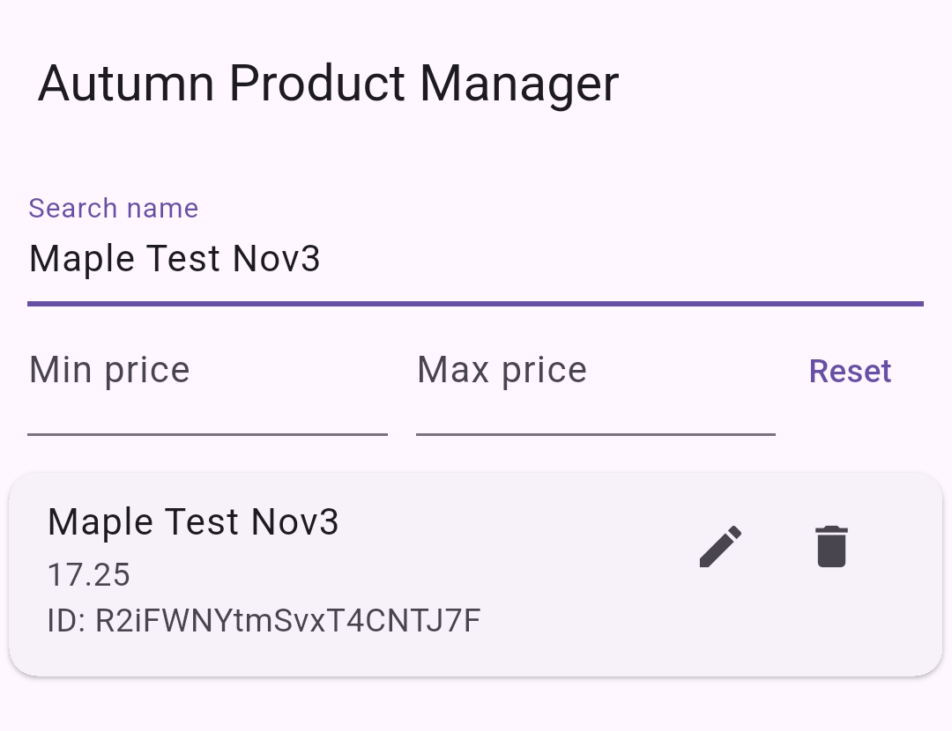
T3. The app edit changed the original Maple document from 15.00 to 17.25.
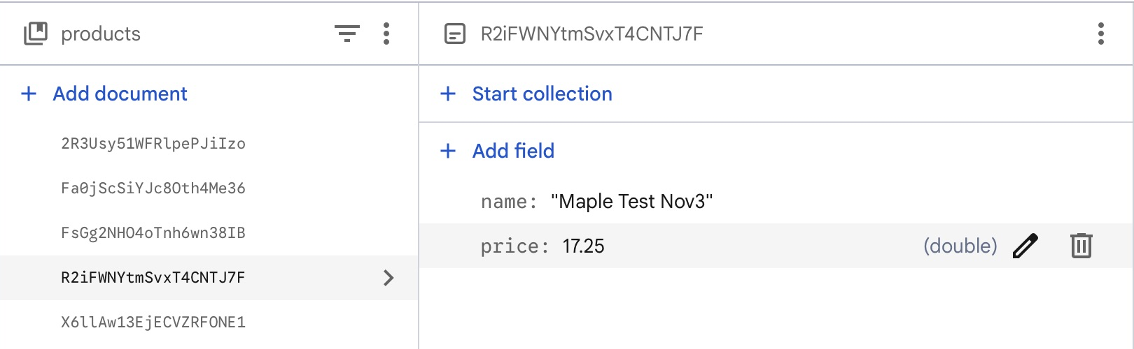
Console also showed 17.25 on R2iFWNYtmSvxT4CNTJ7F after the app save.

Delete only one duplicate
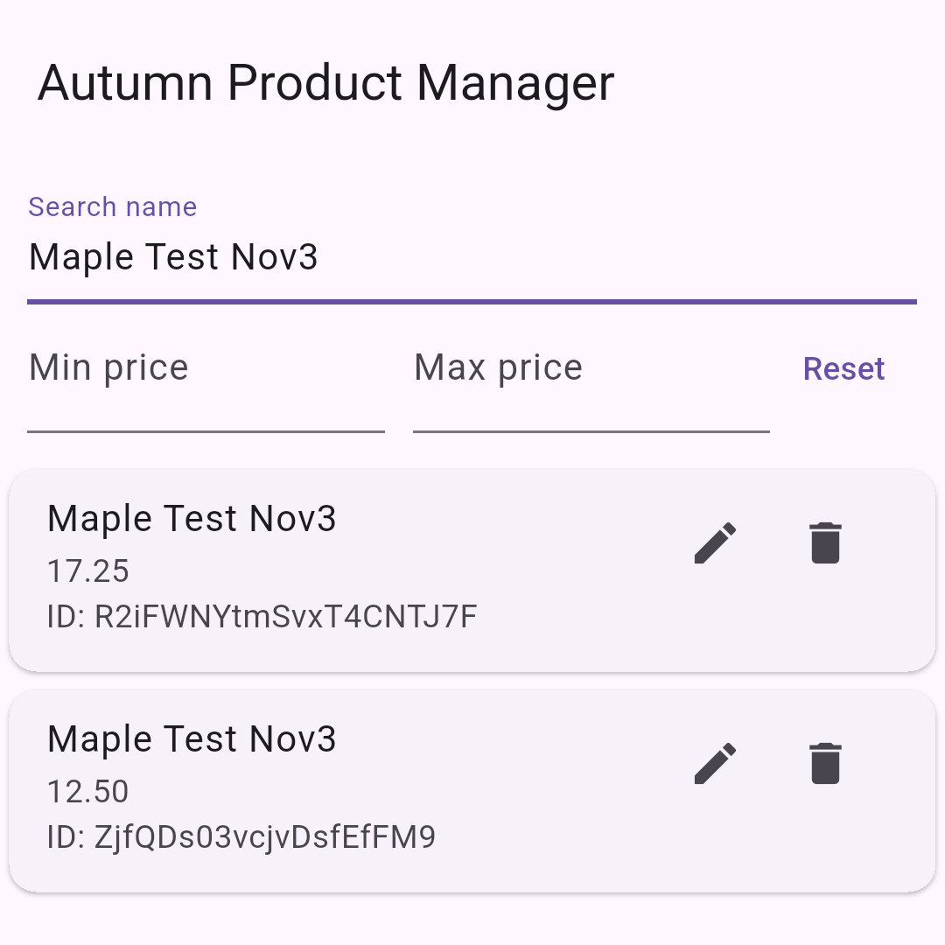
Before deletion, two Maple names had different IDs and prices. The original ended TJ7F and the duplicate ended fFM9.
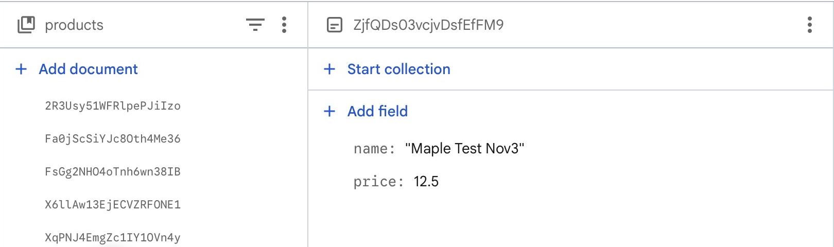
After deleting R2iFWNYtmSvxT4CNTJ7F, the collection no longer listed it. Duplicate ZjfQDs03vcjvDsfEfFM9 remained at 12.50 in the app check and Console. After capturing this result, that duplicate was removed too, restoring the five class products.

Search
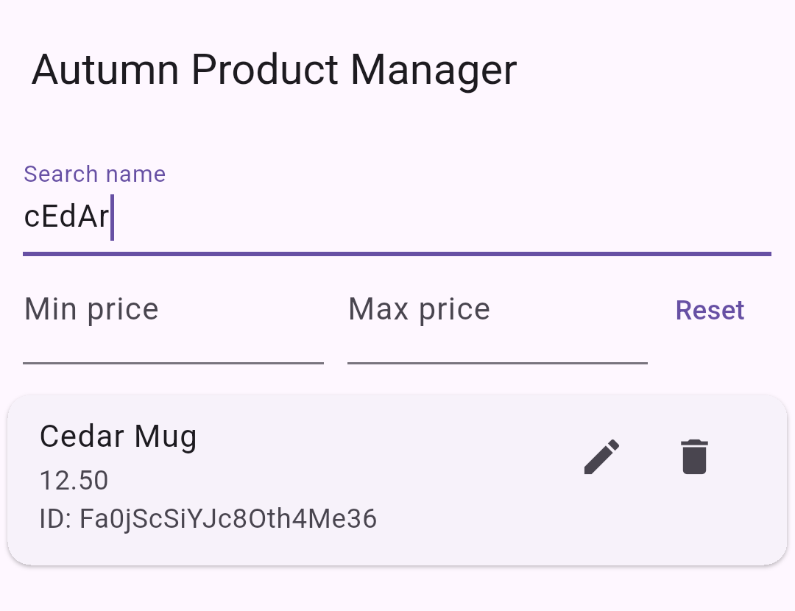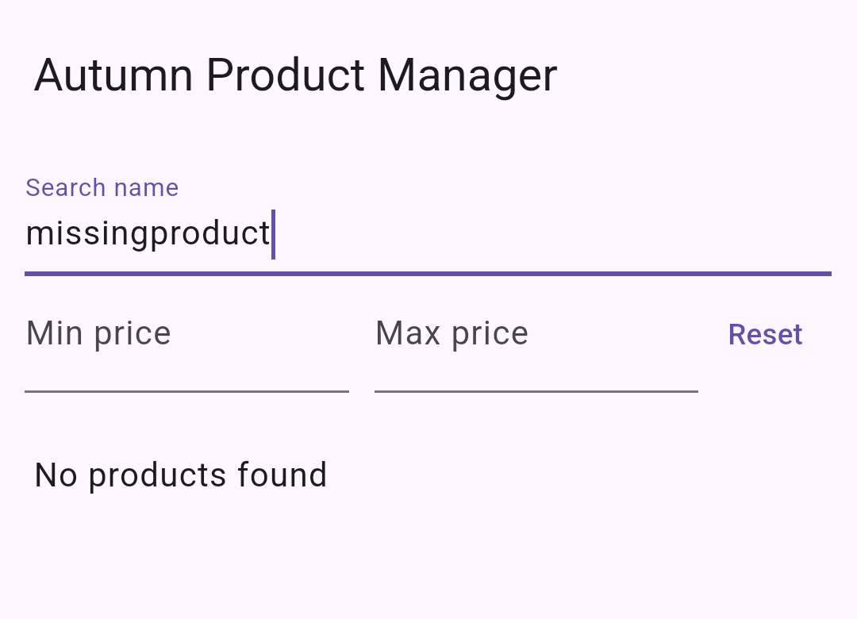
Left: cEdAr found Cedar Mug even with mixed capitals. Right: missingproduct showed No products found.

Range and combined filtering
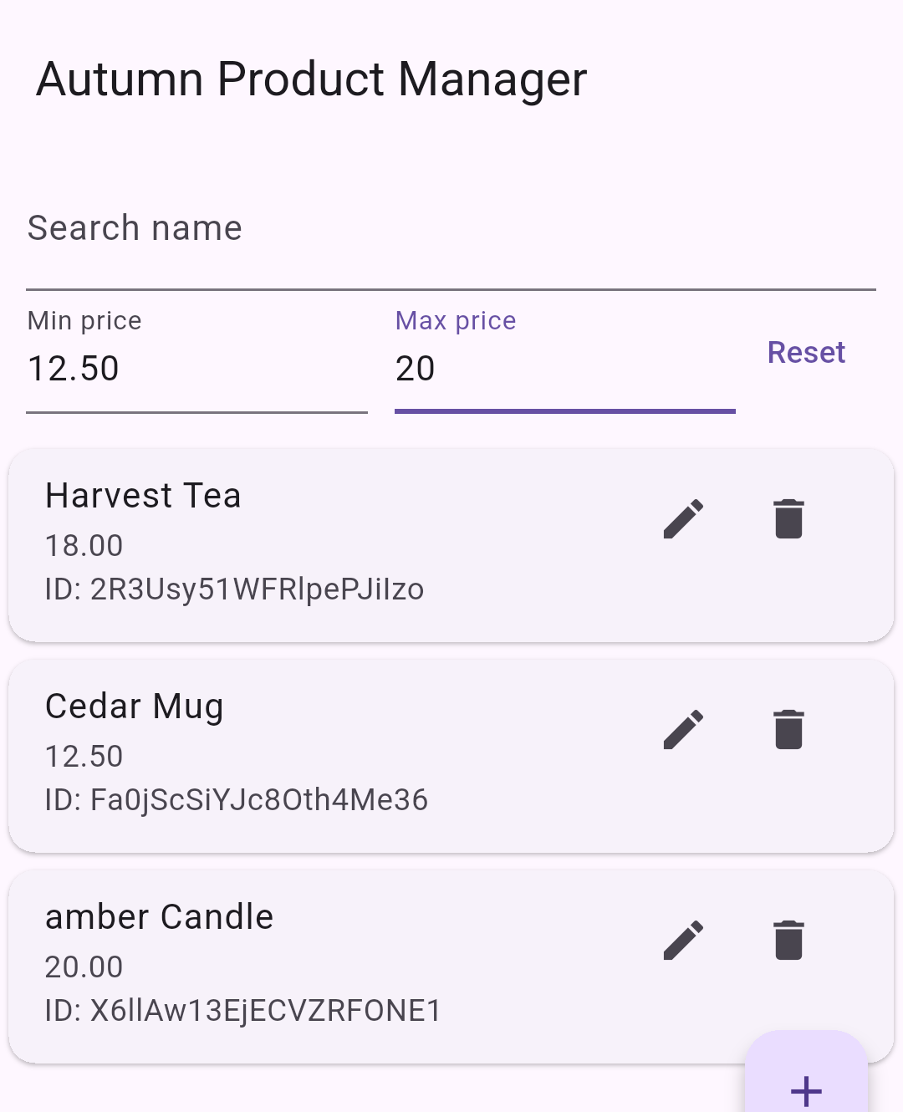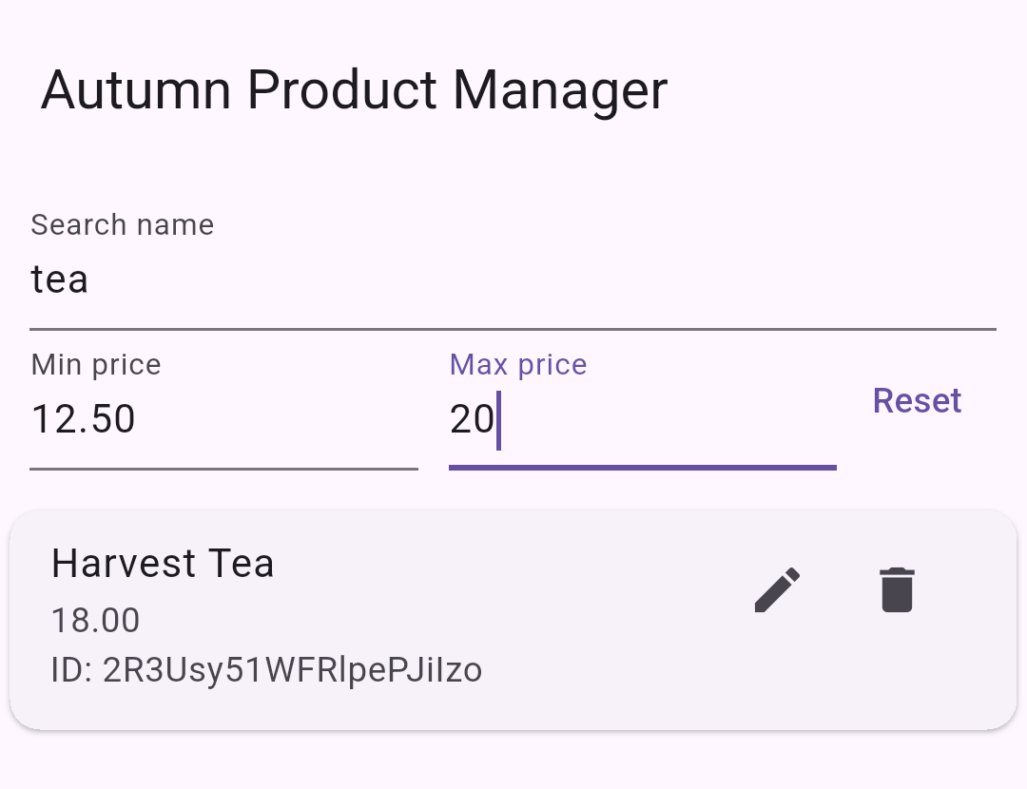
Left: Min 12.50 and max 20 included Cedar, Harvest Tea, and amber Candle. Right: Keeping those bounds and searching tea showed only Harvest Tea.

Equal bounds and Reset
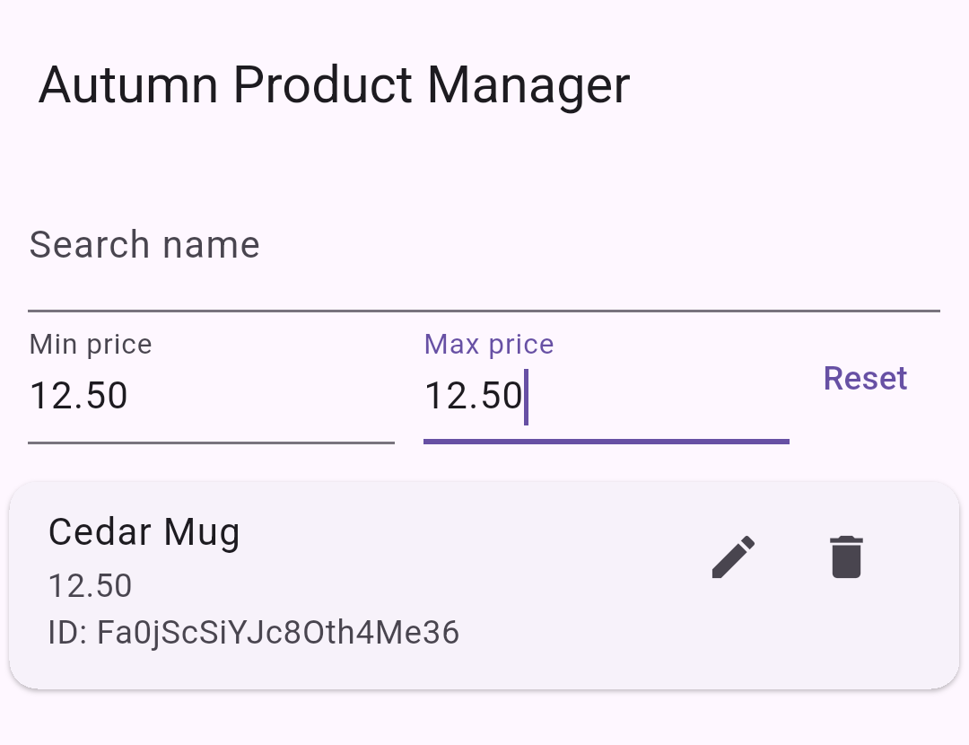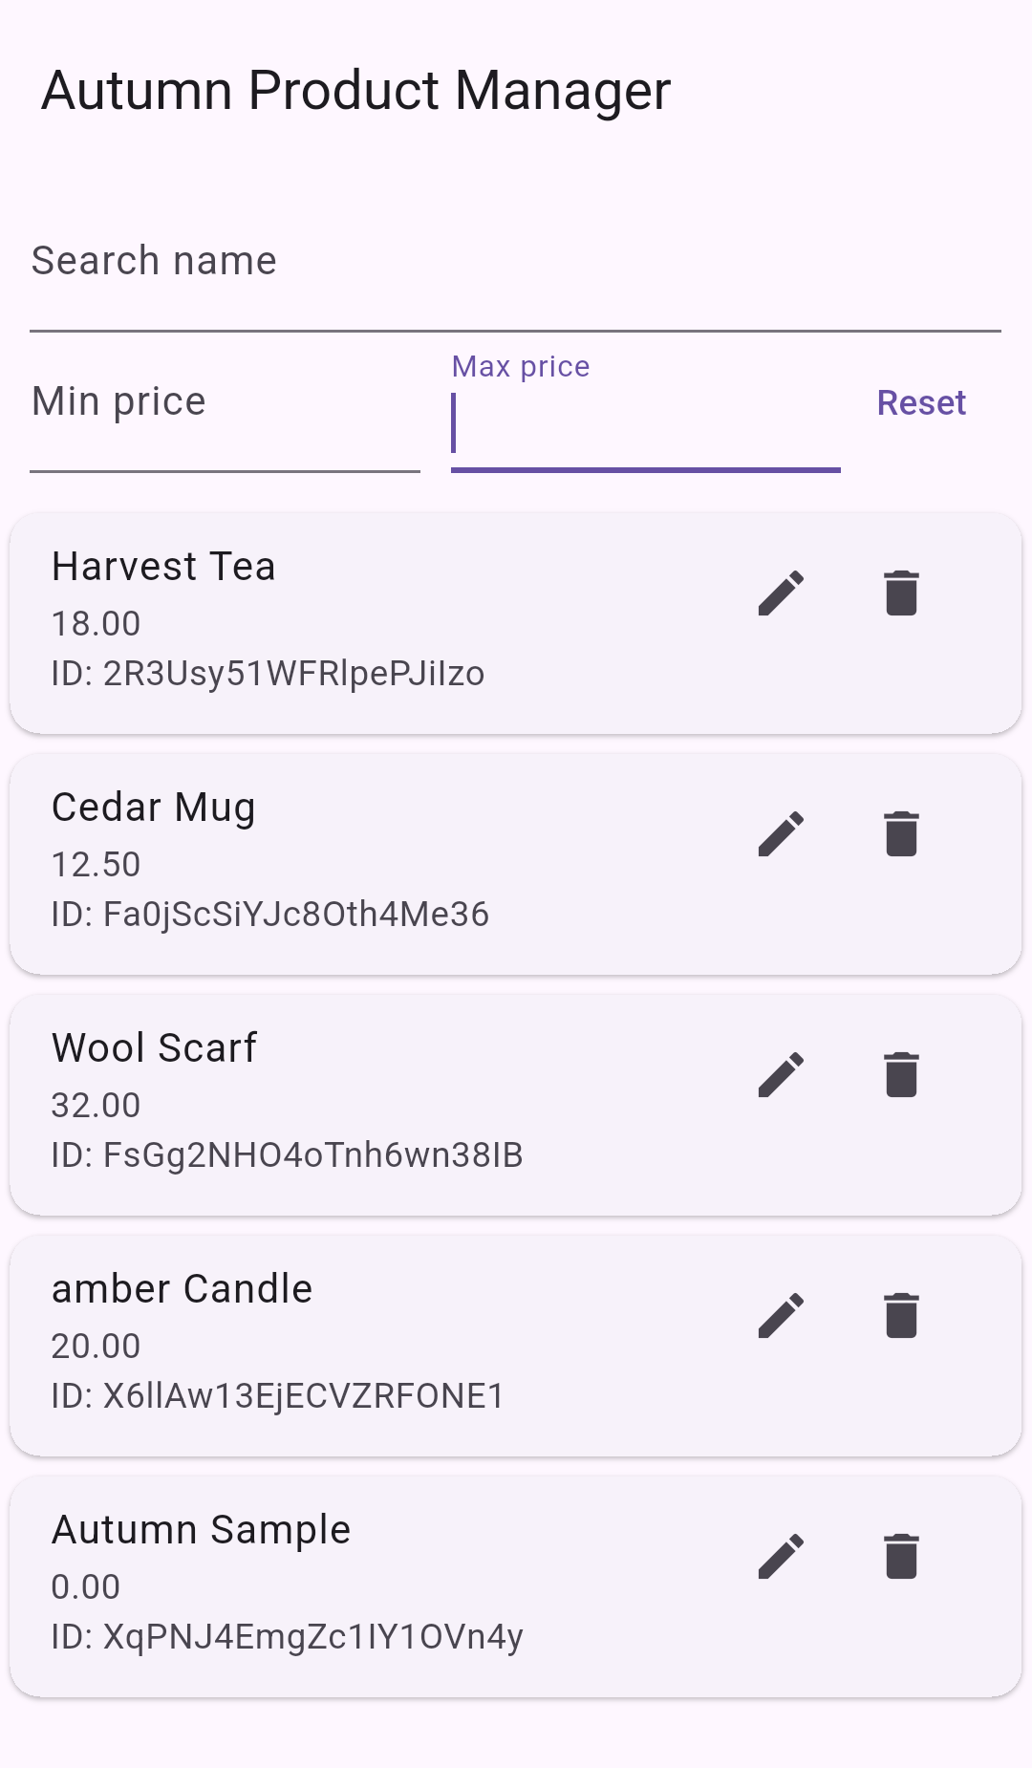
Left: Equal bounds of 12.50 included Cedar Mug. Right: Reset cleared search and both bounds, showing all five products.
The separate min-only 20 test showed amber Candle and Wool Scarf. The max-only 12.50 test showed Autumn Sample and Cedar Mug. Both were checked with the other bound blank.

Invalid input
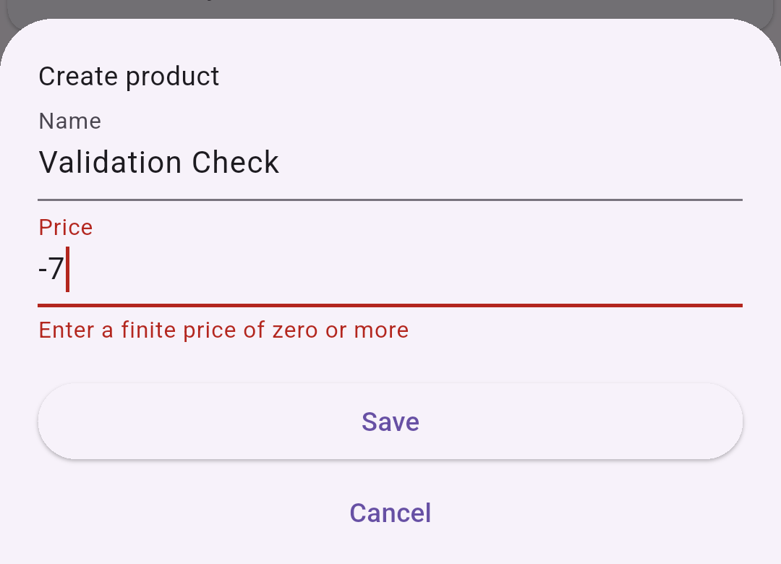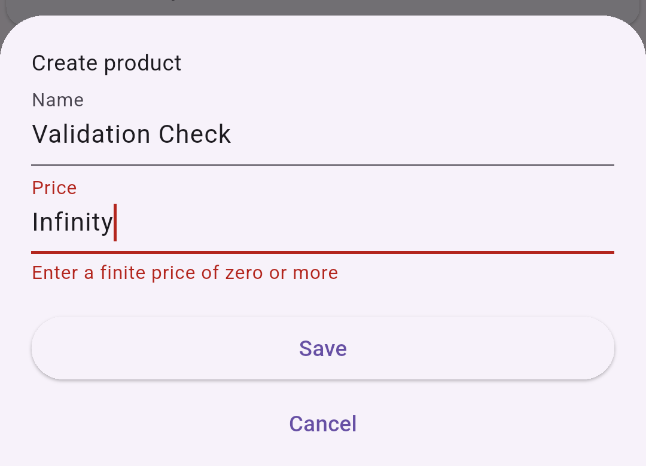
Left: Exact -7 was rejected. Right: Exact Infinity was rejected.
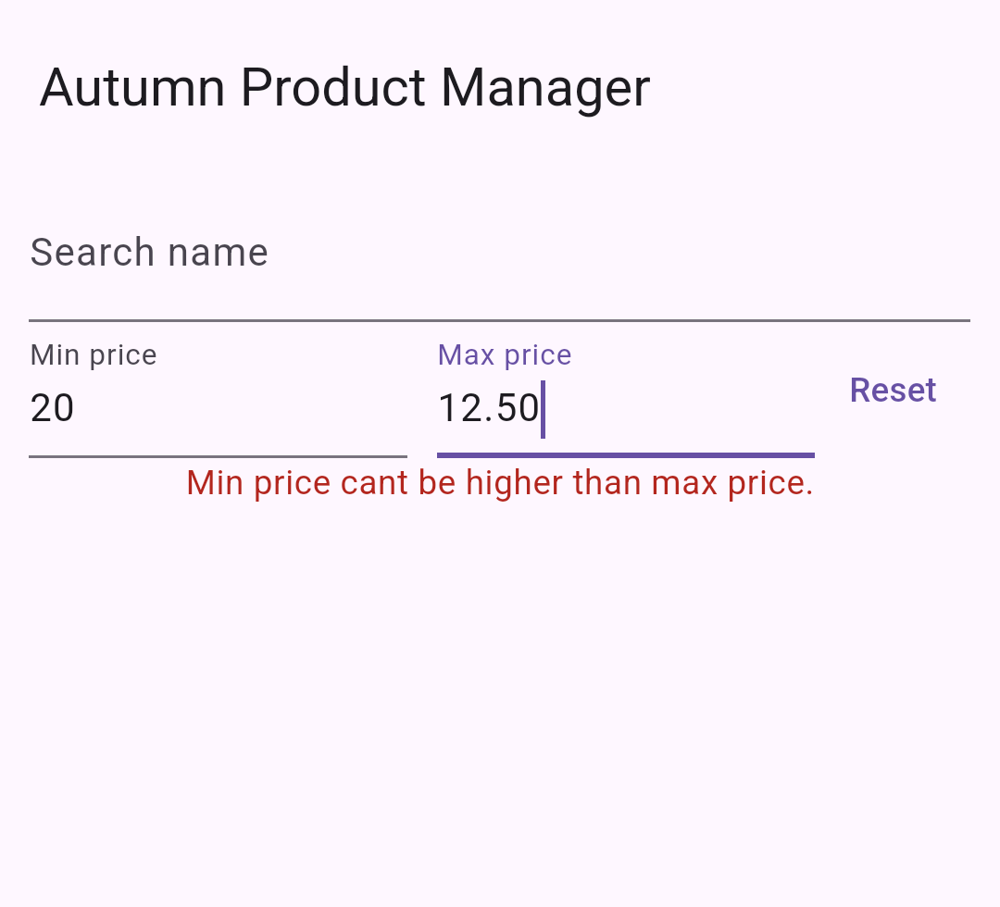
Min 20 with max 12.50 showed Min price cant be higher than max price. Reset cleared the error.

Debugging the input test
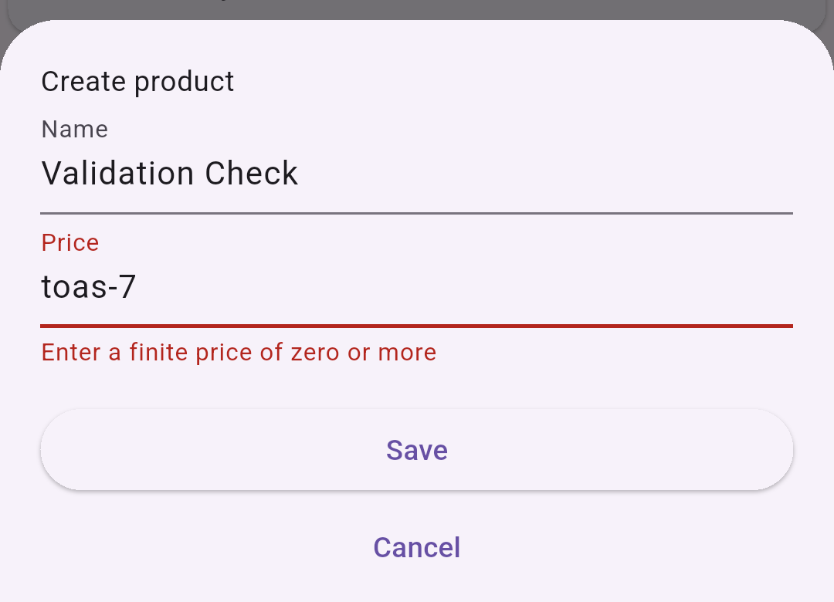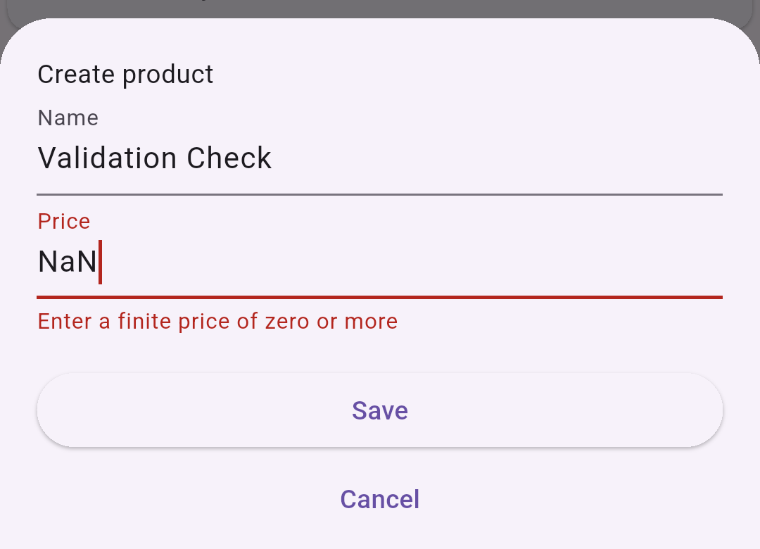
Left: The first replacement left toas-7, so it wasnt a clean negative-number test. Right: A fresh form with exact NaN showed the finite-price error. Exact -7 and Infinity were also rerun.
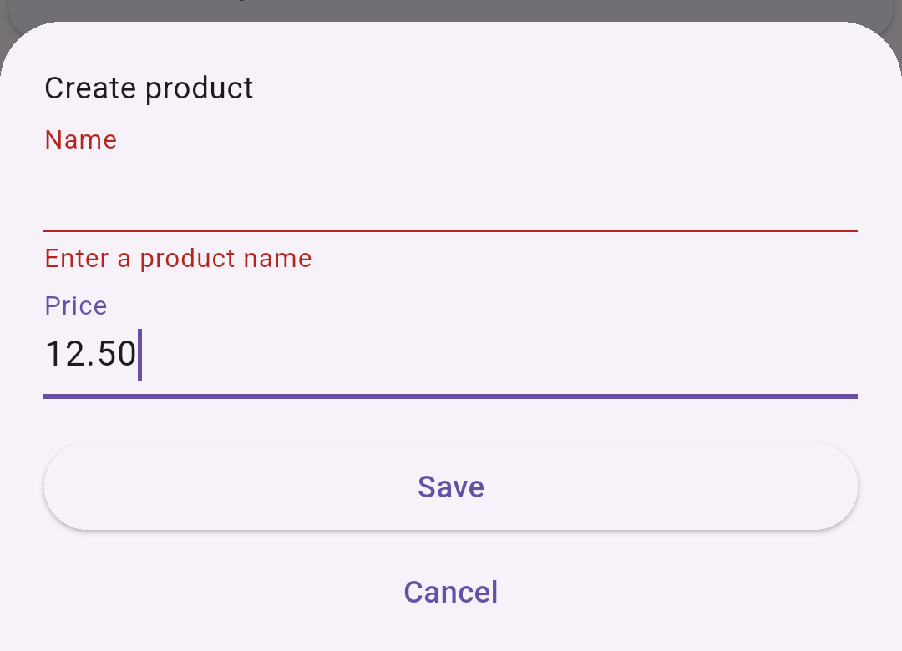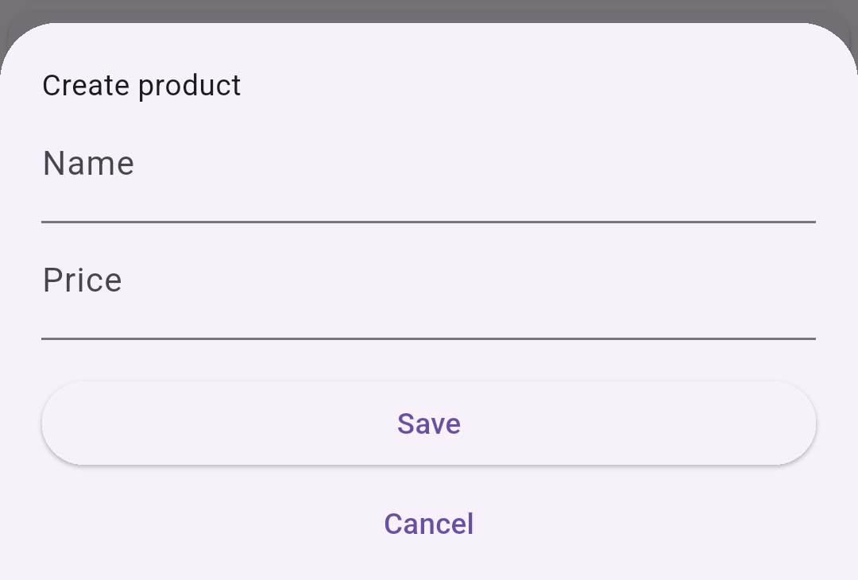
Left: A spaces-only name showed Enter a product name. Right: After Cancel, a new Create form had blank fields. No Validation Check record was created.
Blank and toast prices also showed the finite-price error. Supplied toast/NaN minimums and -7/Infinity maximums showed bound errors. Empty bounds accepted all five products. Autumn Sample accepted zero.

Offline and reconnect
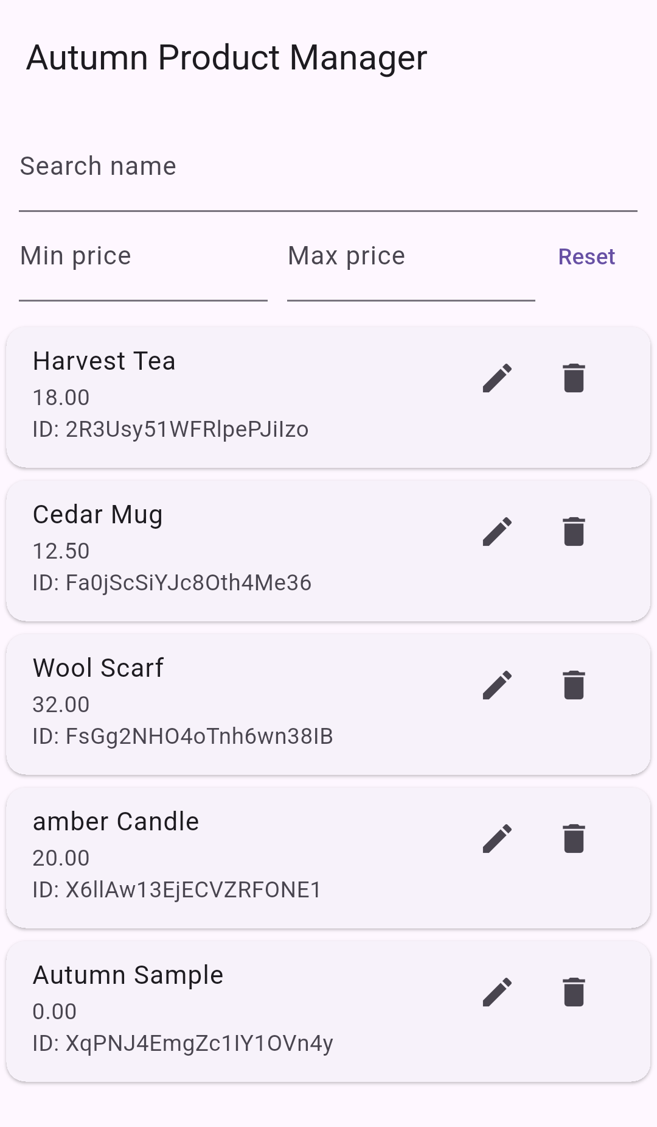
Left: All five products after force-stop and reopen with both network controls disabled. Right: All five after Wi-Fi and mobile data were enabled again.
The Android network check said Active default network: none. No uninstall or data clearing occurred. Cedar stayed at 12.50 with ID Fa0jScSiYJc8Oth4Me36, matching Console. This app doesnt show cache or pending-write flags, so the pictures alone dont prove server state.

Rules Playground simulations
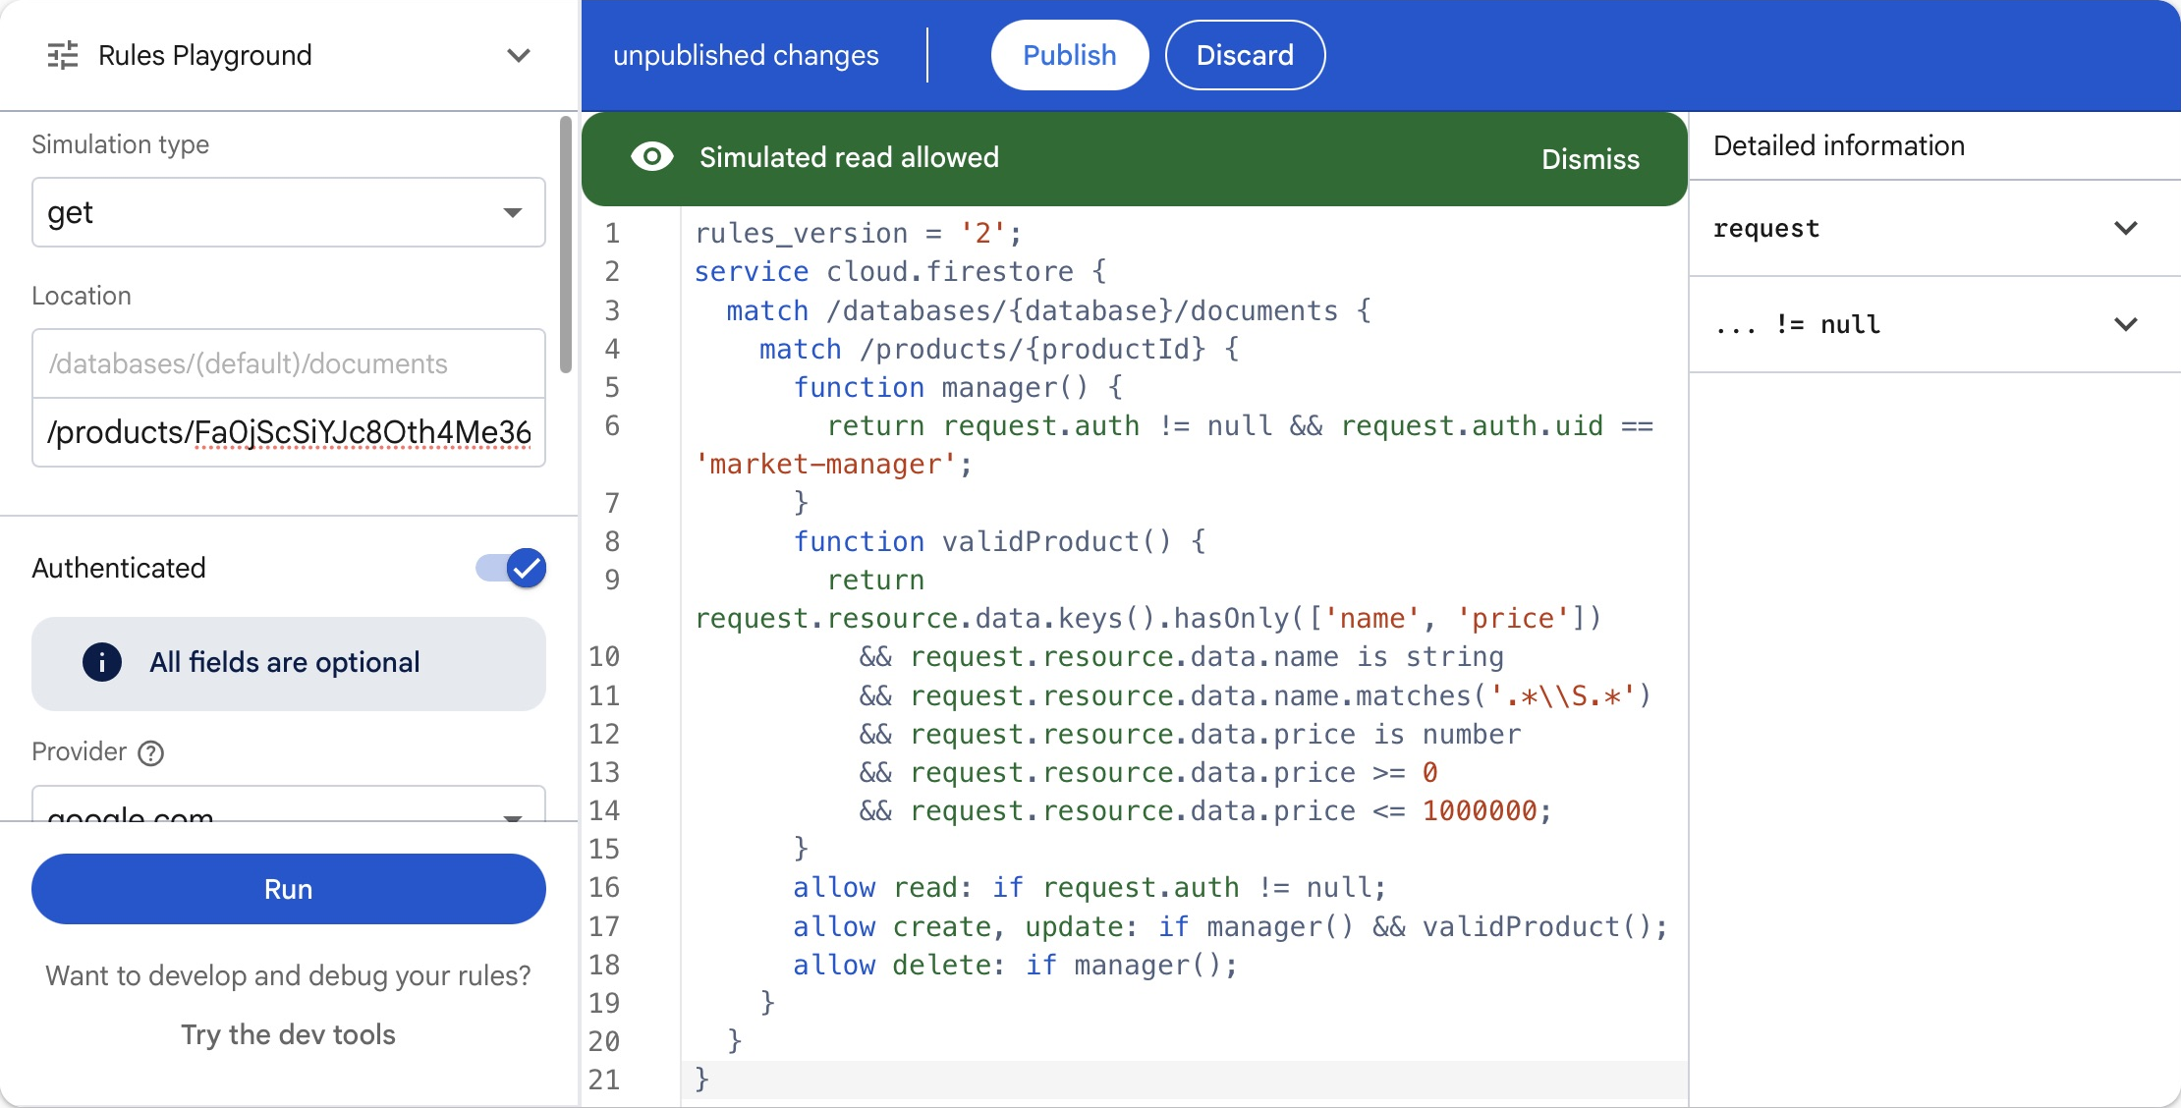
Allowed: get /products/Fa0jScSiYJc8Oth4Me36. Authenticated on, UID market-manager, provider google.com. Other optional auth fields were blank. No write payload for get.
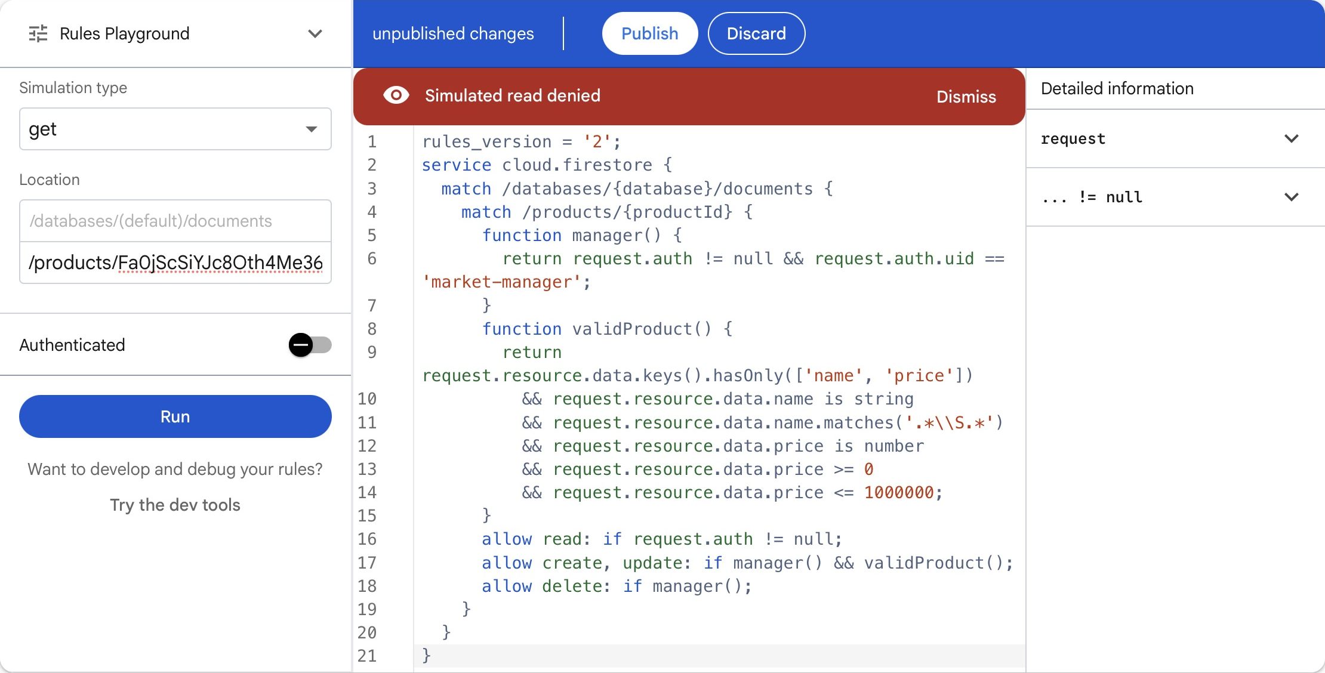
Denied: the same get path with Authenticated off and no UID or payload. These were unpublished simulations. The draft was discarded and the original live rules stayed in place.

