08

**Fall**

Software Design Document

**Name (s):  Emmanuel Santillana**

**Date: 11/11/2014**

**Version 1.0**

|  |  |  |  |
| --- | --- | --- | --- |
| **Version** | **Date** | **Change Description** | **Author** |
| 1.0 | 11/11/14 | Initial draft | Emmanuel Santillana |
|  |  |  |  |
|  |  |  |  |

*Software Design Document*

TABLE OF CONTENTS

1.  INTRODUCTION 3

1.1 Purpose   3

1.2 Scope  3

1.3 Overview  3

2.  SYSTEM OVERVIEW  3

3.  SYSTEM ARCHITECTURE   3

3.1 Architectural Design   3

4.  HUMAN INTERFACE DESIGN    4

4.1 Overview of User Interface    4

4.2 Screen Images    5

5.  CLASS DIAGRAM 5

6. SEQUENCE DIAGRAM 6

7. Project TimeLine 6

1. INTRODUCTION

1.1 Purpose

The purpose of this document is to describe the implementation of the QsARC described in the SRS. This software will provide an University Acreditation for several collages and departments.

1.2 Scope

The QsARC will consist of a tree view, when clicked it will be asking specific information for the university, collages, departments, faculties, and students, and will store it in a Database where it can be accessed when need it. More functionalities could be added before the project is complete.

1.3 Overview

This document will first provide you the overview of this QsARC system so that you will have a general sense of what it is. Then followed by system architecture and system design. We also provide the data design, human interface design and component design in the following part.

2.  SYSTEM OVERVIEW

A client Java Software for the University of Texas, It will be asking information and while it is being filled it will be storing the data and populating other areas until it is completed. Filled with collages, departments, faculties, and students.

3. SYSTEM ARCHITECTURE

3.1 Architectural Design

It will be programmed using Java, with a basic tree view on one side panel, the center panel will ask for information, the left side will display data, and the lower panel will have the buttons to save, next, exit. All data will be asked in a wizard format.

4. HUMAN INTERFACE DESIGN

4.1 Overview of User Interface

The interface will be for several users depending on the area they will fall, like collages, departments, faculty,students.

For collages:

After filling all the information the collages will have the rights to create departments.

For Departments:

After filling the basic information of the department it has the ability to add faculties in the database, print data, or add data.

For faculty:

It will have the right to assign courses, grades, students,etc.

**4.2 Screen Images**

It will be added while being created.

5. CLASS DIAGRAM

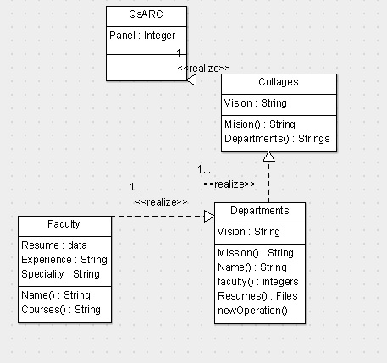

**6. Sequence Diagram**

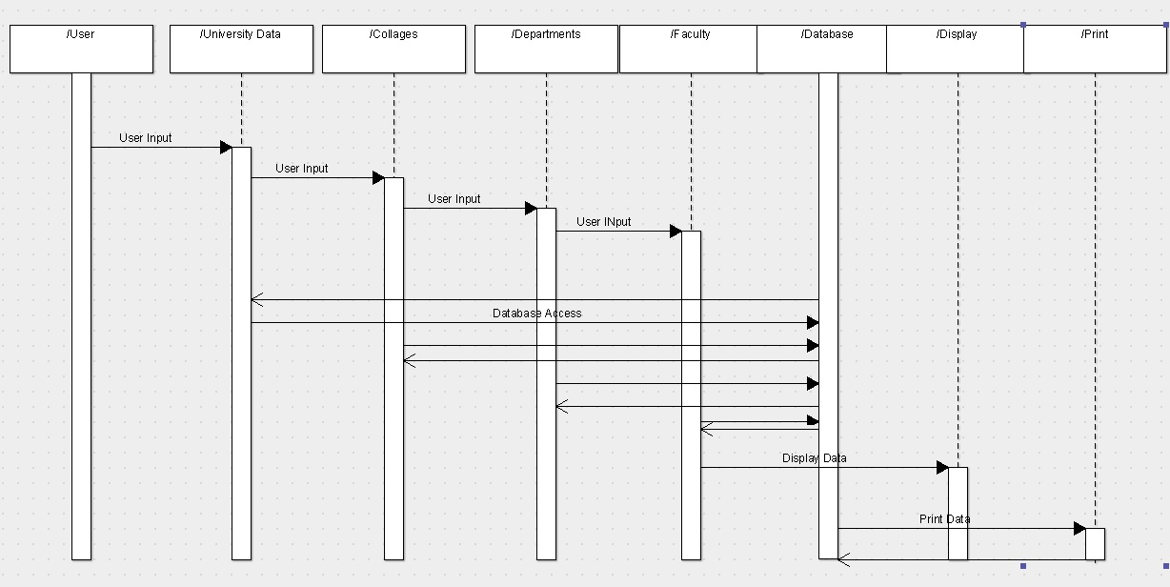

**7. Project Timeline**

Throughout the process, this document and the specifications document will be updated as implementation introduces additional features or futher details concerning ways and means become available.

Activity Start End

SRS 10/16/14 10/29/14

SDD 11/01/14 11/12/14

GUI 11/11/14 12/12/14

Backend Dev. 11/20/14 12/12/14

Testing 12/01/14 12/12/14

Bug Fixes 12/09/14 12/12/14

Final Testing 12/12/14 12/13/14

Submit Project 12/13/14 12/13/14