What Hit My Honeypot in 13 Days
AI Honeypot project | Cowrie SSH honeypot | Sep 23 to Oct 5, 2026
By Emmanuel | github.com/emmanuelthattil112/ai-honeypot

Summary
I put a real SSH honeypot on the internet and let it run for 13 days to see who would show up. It got 67,244 connections from 1,484 different IP addresses, which works out to about 5,000 a day. Nobody knew about the server and I never advertised it. Automated scanners found it anyway.
Almost everything I saw was automated. Bots tried common logins, ran a quick check on the system, and then most of them stopped. A smaller group tried to take over the machine: they replaced the SSH keys so they could get back in later, and some tried to download malware from other servers. The rest of this report covers what they did and what a defender could watch for.
Number | Result
Days of data | 13 (Sep 23 to Oct 5, 2026)
Connections (sessions) | 67,244
Unique attacker IPs | 1,484
Average per day | about 5,170
Busiest day | Oct 1, with 11,013 connections
Logins the honeypot accepted | 64,098, from 653 IPs
Commands run by attackers | 66,899

How I set it up
I used Cowrie, an open source SSH honeypot. It pretends to be a normal Linux server, lets attackers log in, and records everything they type, without giving them access to a real system.
- Server: a small DigitalOcean droplet (Ubuntu 24.04, New York) running Cowrie on port 22, where attackers expect SSH.
- My own admin access moved to port 443, so I could manage the server without mixing my logins into the data.
- Logs: Cowrie writes one JSON file per day. I copied all of them to my laptop and wrote a Python script to count the results.
- The first and last days (Sep 23 and Oct 5) are probably partial days, so the totals may be slightly low.

What I saw

Volume
Traffic was steady, with a few spikes. The biggest was Oct 1 at 11,013 connections, more than double a typical day.
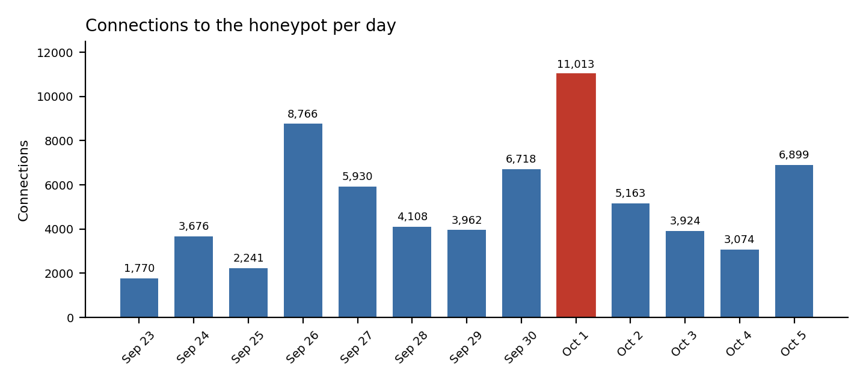

An important note on the login numbers
The honeypot accepted 64,098 logins and only turned away 336. That is because Cowrie is built to let attackers in so it can watch what they do next. So these numbers do not mean the attackers cracked anything. They show which usernames and passwords the bots tried, and nearly all of them got in on the first go.

Who was connecting
Ten IPs made up about 37% of all connections. Nine of those ten start with 109.160.32, which means they sit in the same address block. Their counts also repeat exactly (1,600 four times, 2,699 twice, 2,198 twice), which fits one operator running the same script from many addresses. I can't say who is behind it from logs alone.
Rank | IP address | Sessions | Share
1 | 195[.]178[.]110[.]218 | 5,278 | 7.8%
2 | 109[.]160[.]32[.]47 | 3,297 | 4.9%
3 | 109[.]160[.]32[.]178 | 2,699 | 4.0%
4 | 109[.]160[.]32[.]40 | 2,699 | 4.0%
5 | 109[.]160[.]32[.]31 | 2,198 | 3.3%
6 | 109[.]160[.]32[.]34 | 2,198 | 3.3%
7 | 109[.]160[.]32[.]48 | 1,600 | 2.4%
8 | 109[.]160[.]32[.]161 | 1,600 | 2.4%
9 | 109[.]160[.]32[.]38 | 1,600 | 2.4%
10 | 109[.]160[.]32[.]159 | 1,600 | 2.4%
IPs are written with [.] so nobody clicks them by accident.

Usernames and passwords
The lists look like what you'd expect: root first by a wide margin, then default and generic names, with passwords like 123456 and admin.
Rank | Username (times tried) | Password (times tried)
1 | root (17,036) | 123456 (3,067)
2 | ubuntu (2,320) | 123 (1,418)
3 | admin (2,203) | 1234 (1,170)
4 | user (1,090) | 12345678 (850)
5 | deploy (859) | admin (722)
6 | test (660) | 1 (699)
7 | user1 (467) | password (657)
8 | postgres (412) | root (550)

One odd one: the string 345gs5662d34 was used 371 times as both the username and the password. It shows up in other people's honeypot data too, including a SANS Internet Storm Center write-up, and nobody seems to know exactly why bots use it. I'm flagging it as a known oddity, not something I solved.

What they did after logging in
Most sessions were short and the same few steps repeated across thousands of connections.
Behavior | Count | What it means
uname -s -v -n -r -m | 59,532 | A quick check of the operating system and kernel. Counting the /bin/./uname version too, that is about 89% of all 66,899 commands.
Big system-profiling script | 1,101 | Collects OS, CPU type and count, uptime, graphics card info, and recent logins. The graphics card check may mean they look for machines with GPUs to use.
Shell test using a file named xxxxxx | 2,202 | Writes a tiny script, runs it, and deletes it. Looks like a check on how the shell behaves, possibly to spot honeypots.
chattr -ia on the .ssh folder | 394 | Strips protections from the .ssh folder so it can be overwritten.
Replace .ssh/authorized_keys | 379 | Deletes the existing keys and adds the attacker's own, so they can log back in without a password.
scp / wget / curl dropper | 31 | Pulls a second-stage script from an outside server, with a fallback if the first method fails.

The authorized_keys command ends with a key labeled mdrfckr. That key is well known: other honeypot operators and threat researchers tie it to a botnet campaign (linked to the Outlaw group) that has been around since about 2018. Seeing it here means my honeypot was hit by a long-running, widely active campaign and not something custom aimed at me.

Malware download attempts
Attackers tried to download files from a few outside servers. The names are what you'd expect from IoT-style botnets: shell scripts and small programs named telnetd, telnet, and kworker. kworker is also the name of a normal Linux kernel process, so that name looks chosen to blend in. I only kept the logs, so I haven't looked inside any of these files.
Source (defanged) | File | Times | Notes
213[.]232[.]114[.]14 | handshakebins.sh | 63 | Two paths, 33 + 30
213[.]232[.]114[.]14 | telnetd, telnet, kworker | 22 each | Same host
192[.]227[.]210[.]190 | dred | 27
217[.]60[.]103[.]56 | sh (script) | 31 | Pulled with scp using a key built into the command

Mapping to MITRE ATT&CK
ID | Technique | What I saw
T1110.001 | Brute Force: Password Guessing | Common usernames and passwords tried across 67,244 connections
T1078 | Valid Accounts | Bots logged in with default or guessed credentials the honeypot accepted
T1082 | System Information Discovery | uname checks and the system-profiling script
T1222.002 | File and Directory Permissions Modification: Linux | chattr -ia on the .ssh folder
T1098.004 | Account Manipulation: SSH Authorized Keys | Attacker key written to authorized_keys (379 times)
T1105 | Ingress Tool Transfer | wget, curl, and scp downloads from outside servers
T1497.001 | Virtualization/Sandbox Evasion: System Checks | The xxxxxx shell test (possible, I can't confirm intent)

What a defender could take from this
If this were a real server, here is what I'd want an alert or a setting for:
- Turn off password logins for SSH. Use keys only, and disable direct root login. Nearly everything here depended on weak or default passwords.
- Watch authorized_keys. A rewrite of that file outside of normal admin work is a strong sign of compromise.
- Alert on chattr against .ssh. There is almost no good reason for it.
- Look for bursts from one address block. Many SSH sessions from the same /24 in a short time points to one coordinated operation.
- Control outbound traffic. A server running wget or curl and piping the result into sh, or using scp to an unknown host, should raise a flag.
- Rate limit and block. Tools like fail2ban cut down repeat attempts from the same address.

Limits
- One honeypot, one provider, 13 days. A different location or timeframe could look different.
- Cowrie accepts logins by design, so the numbers show what bots try, not how strong any real password is.
- Counts are sessions and commands, not people. One operator can show up as many IPs, and some IPs may be hacked machines being used as relays.
- I did not look up where the IPs are located, whether they are still active, or what the downloaded files contain. Checking the file hashes and URLs on VirusTotal would be a good next step.

Indicators from the logs
For anyone who wants to block or search for these. IPs and URLs are defanged.
Type | Value
Top scanning IP | 195[.]178[.]110[.]218
Address block | 109[.]160[.]32[.]0/24 (nine of the top ten IPs)
Download hosts | 213[.]232[.]114[.]14, 192[.]227[.]210[.]190, 217[.]60[.]103[.]56
Download files | handshakebins.sh, telnetd, telnet, kworker, dred
Key comment | mdrfckr (in authorized_keys commands)
Cowrie file hash (SHA-256) | af77b643964afd794460d28ab8a11b0ec8790cd5463abfde126613a4f3bccd32 (2,202 times)
Cowrie file hash (SHA-256) | a8460f446be540410004b1a8db4083773fa46f7fe76fa84219c93daa1669f8f2 (379 times)
Cowrie file hash (SHA-256) | 43728fbfb98bb39ff61a2db0fc2905bd6937997062b05b9ab8b186fdee18c09a (39 times)
Cowrie file hash (SHA-256) | 00b6f15c2274420217ed3098a9f5f00545bf1793d7a324fd18a7809cbbf5b12b (39 times)

