The left and right images of some of these cases were facing the wrong way (eg below)

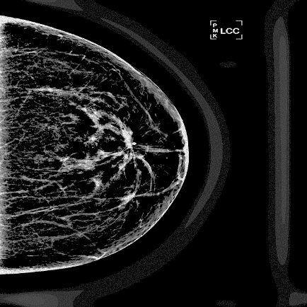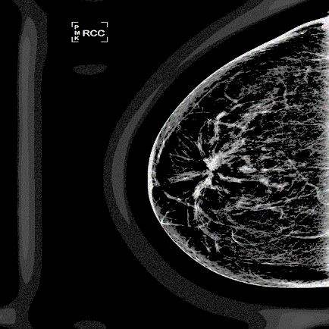

Left Right

This was circumvented by swapping the name of left and right in those cases, which shows them nicely as



But this DOES mean that the Left and right cases are actually the inverse…. SO that can be confusing if you are gonna present unilateral cases of contralaterals/abnormals….

So pay close attention:

|  |  |  |
| --- | --- | --- |
| Image type | Switched? | Normal? |
| N | Only 56 to 63 | 1 to 55 |
| AC | 1-20 | - |
| AD | - | All Normal |
| AP | 1-20 | - |

This applies to all Filtered folders AND to the masks.