ER Diagram

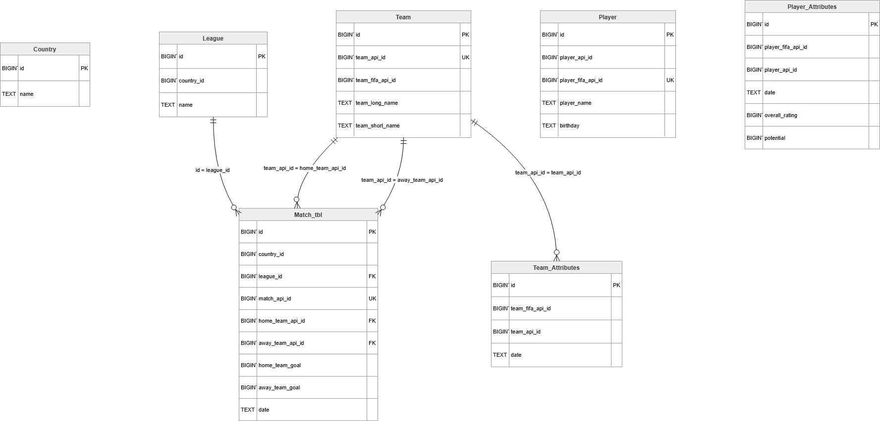

I designed my project in the `soccer_proj` schema with 7 relational tables and 1 view. The ER diagram is shown above :
1) Country
2) League
3) Team
4) Player
5) Team_Attributes
6) Player_Attributes
7) Match_tbl
View: league_match_summary_view

Relational schema (PK, UNIQUE, FK):

Country(
id PK,
name
)

League(
id PK,
country_id FK -> Country(id),
name
)

Team(
id PK,
team_api_id UNIQUE,
team_fifa_api_id UNIQUE,
team_long_name,
team_short_name
)

Player(
id PK,
player_api_id UNIQUE,
player_fifa_api_id UNIQUE,
player_name,
birthday,
height,
weight
)

Team_Attributes(
id PK,
team_api_id FK -> Team(team_api_id),
team_fifa_api_id FK -> Team(team_fifa_api_id),
date,
buildUpPlaySpeed,
buildUpPlayPassing,
chanceCreationPassing,
defencePressure
-- plus additional team attribute columns
)

Player_Attributes(
id PK,
player_api_id FK -> Player(player_api_id),
player_fifa_api_id FK -> Player(player_fifa_api_id),
date,
overall_rating,
potential
-- plus additional player attribute columns
)

Match_tbl(
id PK,
country_id FK -> Country(id),
league_id FK -> League(id),
home_team_api_id FK -> Team(team_api_id),
away_team_api_id FK -> Team(team_api_id),
home_player_1 ... home_player_11 FK -> Player(player_api_id),
away_player_1 ... away_player_11 FK -> Player(player_api_id),
match_api_id,
season,
stage,
date,
home_team_goal,
away_team_goal
-- plus betting/event columns
)

View created
create or replace view soccer_proj.league_match_summary_view as
select
l."id" as league_id,
l."name" as league_name,
count(*) as total_matches,
avg(m."home_team_goal")::numeric(10,2) as avg_home_goals,
avg(m."away_team_goal")::numeric(10,2) as avg_away_goals,
avg((m."home_team_goal" + m."away_team_goal"))::numeric(10,2) as avg_total_goals
from soccer_proj."Match_tbl" as m
join soccer_proj."League" as l
on l."id" = m."league_id"
group by l."id", l."name";

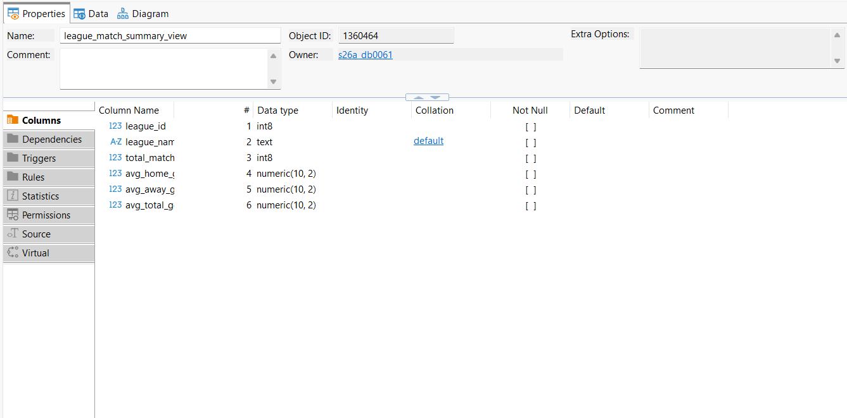

select *
from soccer_proj.league_match_summary_view
limit 5;

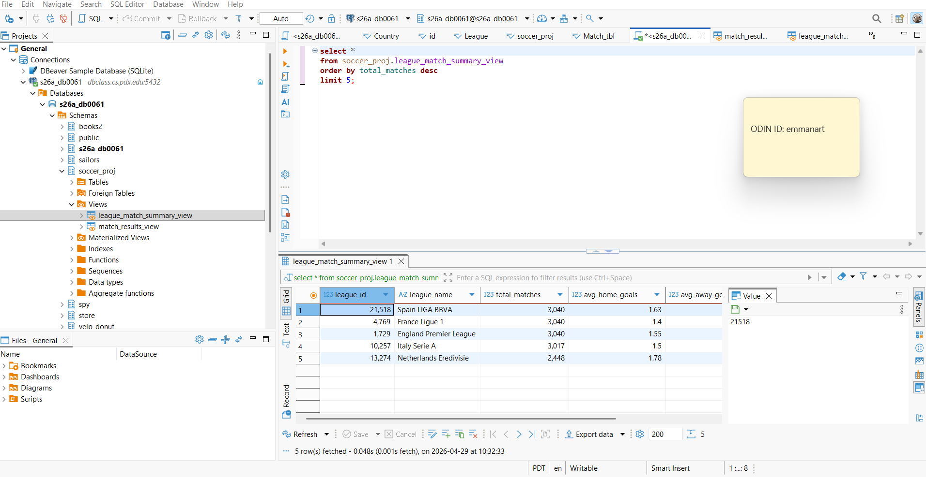

select count(*) from soccer_proj.league_match_summary_view ;

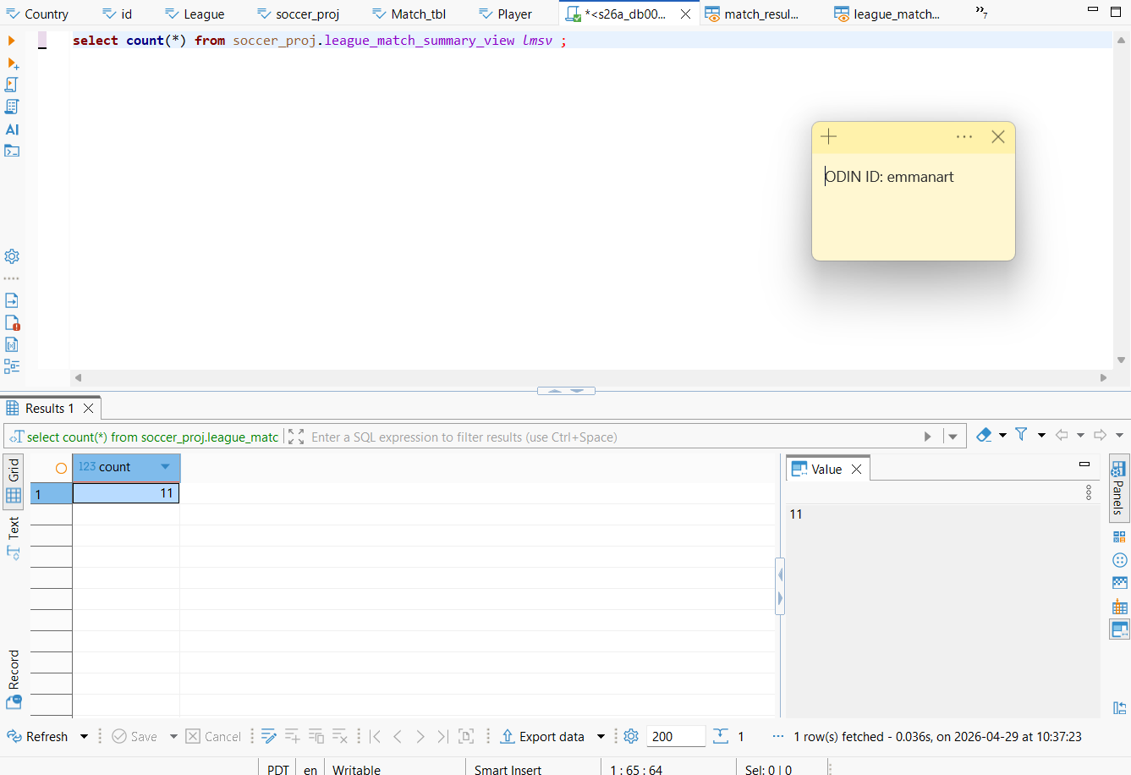

Current loaded table row counts (real data):
- Country: 11
- League: 11
- Team: 299
- Player: 11,060
- Team_Attributes: 1,458
- Player_Attributes: 183,978
- Match_tbl: 25,979

Total rows across tables = 222,796, which exceeds the undergrad minimum (1,000) and grad minimum (10,000).

