CS 486/586 – Homework 2
Student 1 name and ODIN id: Emmanuel Arthur emmanart

Student 2 name and ODIN id: __________________________________________

Please read this entire assignment, every word, before you start working on the code. There might be some things in here that make it easier to complete. Several of the questions build from previous questions.
The data for this assignment can be found in Canvas (students-examples.sql).
You are going to be writing oodles of joins in this assignment. Queries are worth 10 points, except where noted (the last 4). Be sure to read the question carefully and include the correct screenshot for each question.
All joins must be done using the explicit join syntax. Use of the implicit syntax will simply yield a zero on that question.
Use of the word all in a question is indicative of some form of outer join. If the word all is not used in the question description, it is unlikely to be an outer join.

Submission Instructions
- Since this is a group assignment, I would like to clearly understand each member’s contribution. Please include a table on the first page listing all group members and the sections they completed (e.g., Esme – Answers 1, 2, and 3).
- Each member must submit their own copy of the homework. All submissions should be identical across group members. If your submission does not match your group’s work, please ensure it is aligned prior to submission; otherwise, the lowest score among the group submissions may be applied.
- Edit this document directly and place your answers immediately below each question.
- Answers must appear in the same order as the questions.
- If your answers are out of order or hard to locate, they may be marked incorrect so put them in the same order as the question.
Advice: If you are unable to complete an assignment on time, submit whatever you have completed by the deadline. You will receive full credit for the portion you submit. The remaining incomplete portion may be eligible for up to 50% partial credit if completed and submitted later, and it will be graded at the end of the term. This opportunity is intended for partial recovery and does not replace timely submission.
Assignment deadlines are firm, and extensions will not be granted. Please do not email requesting deadline extensions. In case of exceptional circumstances or emergencies, you are encouraged to discuss your situation during office hours.
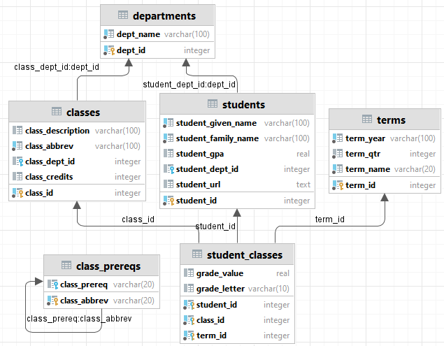
Below is a diagram of the tables and references.

- Load the data into your data source of choice (the PSU server or a local server). Include a select statement limiting the result to the first 5 rows of the student_classes table and a screenshot of those 5 rows for 10 points. Yes, you must use the LIMIT clause.

- Write a select statement that shows the classes and departments that have classes worth fewer than 4 credits. Along with the department name, show the class abbreviation, the class description, and the class credits. Order by dept_name and class_abbrev. This should result in 3 rows returned. Include your select statement and a screenshot of the first 3 rows.

- Write a select statement that shows the classes and departments that have classes worth 4 credits or more. Along with the department name, show the class abbreviation, the class description, and the class credits. Order by dept_name and class_abbrev. This should result in 23 rows returned. Include your select statement and a screenshot of the first 5 rows.

- Write a select statement that shows all classes and departments that have classes worth fewer than 4 credits. Along with the department name, show the class abbreviation, the class description, and the class credits. Order by dept_name and class_abbrev. This should result in 4 rows returned. Include your select statement and a screenshot of the first 4 rows.

- Write a select statement that shows all classes and departments that have classes worth 4 credits or more. Along with the department name, show the class abbreviation, the class description, and the class credits. Order by dept_name and class_abbrev. This should result in 25 rows returned. Include your select statement and a screenshot of the last 5 rows.

- Write a select statement that shows all students and departments they are in. Order by dept_name, student_family_name, and student_given_name. This should result in 29 rows returned. Include your select statement and a screenshot of the last 6 rows.
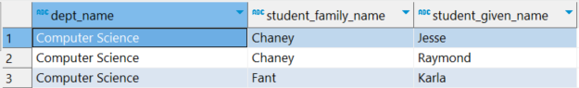

- Modify your select statement from question 6 to show all departments and which students are in them. Order by dept_name, student_family_name, and student_given_name. This should result in 26 rows returned. Include your select statement and a screenshot of the first 6 rows.
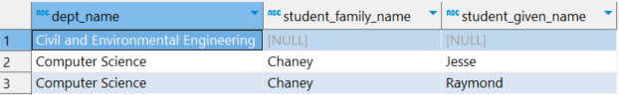

- Modify your select statement from question 6 to show all departments and all students are in them. Order by dept_name, student_family_name, and student_given_name. This should result in 31 rows returned. Include your select statement and a screenshot of the last 7 rows.

- Write a select statement that shows all the students and all the classes that each student has taken and the department in which the class is housed. Show student_given_name, student_family_name, class_abbrev, and dept_name. Order by student_given_name, student_family_name, class_abbrev, and dept_name. This should result in 194 197 rows. Include your select statement and a screenshot of the last 5 rows.
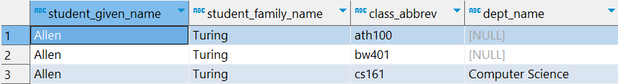

- Write a select statement that shows all the classes that John von Neumann has taken and the department in which the class is housed. Show student_given_name, student_family_name, class_abbrev, and dept_name. Order by student_given_name, student_family_name, class_abbrev, and dept_name. This should result in 7 rows. Include your select statement and a screenshot of all 7 rows.
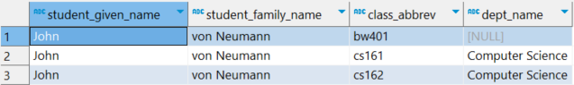

- Write a select statement that shows all the students who have not taken a class. Show student_family_name, student_given_name, and class_abbrev. Order by student_family_name, and student_given_name. This should result in 7 rows. This should result in 7 rows. Include your select statement and a screenshot of all 7 rows.
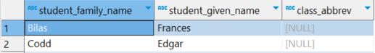

- Write a select statement that shows the term by term classes and students who have taken the classes. Show term_year, term_name, class_abbrev, student_family_name, and student_given_name. Order by term_year, term_name, class_abbrev, student_family_name, and student_given_name. This should result in 194 197 rows. Include your select statement and a screenshot of the data students taking cs161 and cs162 for spring 21/22.
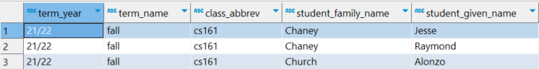

- Modify your select statement from question 12 to show all terms. Display the same data and order by the same columns. This should result in 202 205 rows. Include your select statement and a screenshot of the last 6 rows.
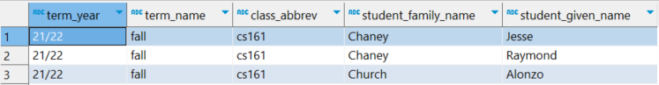

- Write a select statement that shows what students are taking classes summer of 22/23 and what department the student is in. Show student_family_name, student_given_name, dept_name, class_abbrev, term_year, and term_name. Order by dept_name, student_family_name, student_given_name, and class_abbrev. This should result in 36 39 rows. Include your select statement and a screenshot of the last 6 rows.
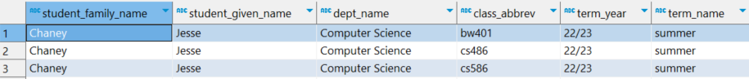

- Modify your select statement from question 14 to show only students who are not in the Computer Science department taking classes this summer (term_year = ‘22/23’ and term_name = ‘summer’). Display the same data and order by the same columns. This should result in 24 27 rows. Include your select statement and a screenshot of the last 5 rows.

- Modify your select statement from question 15 to show all students who are not in a department and are taking classes this summer. This should result in 9 rows. Include your select statement and a screenshot of the first 5 rows.

- (20 points) Write a select statement that shows students in a department, what department the student is in, what classes the student is taking this summer, what department the class is in. Show student_family_name, student_given_name, student dept_name, class_abbrev, and class dept_name. Order by student dept_name, student_family_name, student_given_name, and class_abbrev. This should result in 18 19 rows. Include your select statement and a screenshot of the last 5 rows. Note: You may need to join with a table more than once.
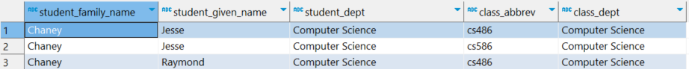

- (20 points) Modify your select statement from question 17 to show all students taking classes and all classes they are taking this summer that are not in the Computer Science department. Show student_family_name, student_given_name, student dept_name, class_abbrev, and class dept_name. Order by student dept_name, student_family_name, student_given_name, and class_abbrev. This should result in 25 27 rows. Include your select statement and a screenshot of the first 7 rows. Note: You may need to join with a table more than once. A comparison with <> can generate some interesting interaction with null. Consider this reference.

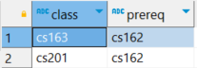
- (15 points) Using the class_prereqs table, write a select statement that shows all class that have a prerequisite. Show both the class_abbrev and the abbreviation for the prerequisite. Order by class_prereq. This should result in 10 rows. Include both your query and the full result set. Note: this is not a current full collection of classes and perquisites. References: Self Join or Self Join

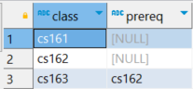
- (15 points) Modify your query from question 19 to show all the classes and any prerequisite for the class. Show both the class_abbrev and the abbreviation for the prerequisite. Order by class_prereq. This should result in 13 rows. Include both your query and the first 10 rows. Note: this is not a current full collection of classes and perquisites.

