COMMUNITY HEALTH SCREENING
& INTEROPERABILITY PLATFORM
Portfolio-Grade Project Planning & Technical Design
Offline-First Community Hypertension Screening, Referral, Follow-up, FHIR Interoperability, and Clinician AI Assistance
Primary Pilot Context | Babungo community, Cameroon
Project Status | Planned / In Progress
Primary Clinical Focus | Hypertension screening and longitudinal follow-up
Primary Users | Community screeners, administrators, hospitals, doctors
Interoperability Goal | FHIR R4-based data exchange
Document Purpose | Portfolio planning, implementation roadmap, and architecture baseline
Prepared as a design and delivery plan. No claim is made that all components are currently implemented.

1. Executive Summary
This project proposes a focused digital health platform for communities where routine primary care access is limited and preventable complications may be discovered only after significant organ damage has occurred. The initial use case is weekly community-based hypertension screening at trusted gathering points such as churches and quarter meetings. The platform is designed to operate fully offline at the point of screening, preserve a longitudinal record for each registered participant, track referrals and follow-up outcomes, synchronize data when connectivity becomes available, publish standardized FHIR resources for authorized healthcare organizations, and provide clinicians with a secure portal for patient review and AI-assisted analysis.
The project is intentionally not positioned as an autonomous diagnostic system. Community screening staff record observations and follow approved screening and referral protocols. Clinical decisions remain with qualified healthcare professionals. The software supports continuity, trend visibility, referral accountability, interoperability, and evidence-based review.
Portfolio Positioning
This is a planned real-world clinical informatics and interoperability project. The portfolio should emphasize the problem, clinical workflow, architecture, FHIR mapping, security model, Agile delivery plan, and implementation progress as the system is built.

2. Problem Statement
In many underserved communities, individuals may not have an established primary care provider and may seek formal healthcare only when illness becomes severe. Hypertension is particularly dangerous in this context because it can remain clinically silent for years while contributing to stroke, chronic kidney disease, visual impairment, heart disease, and other long-term complications.
Community members may already gather predictably each week at churches, faith communities, village meetings, and quarter meetings. These gatherings create an opportunity for repeated screening and follow-up without requiring individuals to first enter a formal health system. However, paper-based screening records make it difficult to identify trends, retrieve previous readings, follow referrals, or understand whether a person ultimately reached a healthcare provider.

2.1 Core Problems to Solve
- Limited access to routine primary care and preventive screening.
- Delayed detection of persistently elevated blood pressure.
- Fragmented paper records that cannot reliably support longitudinal trend analysis.
- Weak referral follow-through and limited visibility into whether referred individuals received care.
- Unstable or unavailable internet connectivity at community screening locations.
- Limited interoperability between community-generated data and future hospital information systems.
- Insufficient structured context about lifestyle, food patterns, and over-the-counter medication use that may affect clinical interpretation.

3. Proposed Solution
Build a complete but focused offline-first community health screening platform centered on hypertension detection, referral, follow-up, and longitudinal patient history. Each participant is registered before screening. Subsequent visits are linked to the same patient record, enabling trends to be reviewed over time. The field application operates without internet, queues changes locally, and synchronizes with a central operational API when connectivity becomes available.
The central platform manages organizations, hospital onboarding, approved access, synchronization, audit history, workflow reporting, and publication of standardized FHIR resources. Authorized clinicians use a doctor portal to retrieve patient information, view longitudinal trends, review uploaded laboratory reports and other clinical documents, and interact with an LLM-based clinical copilot that produces evidence-linked summaries and draft recommendations for clinician review.

3.1 Solution Boundaries
- The community application screens and refers; it does not diagnose hypertension or prescribe treatment.
- Automated rules may classify screening urgency only according to an approved protocol.
- The LLM is a clinician-assistance tool, not an autonomous medical decision-maker.
- The operational PostgreSQL database remains the primary workflow system of record; FHIR is the interoperability representation.

4. Product Goals and Non-Goals

4.1 Product Goals
- Provide reliable offline patient registration and repeated community screening.
- Maintain longitudinal blood pressure, pulse, lifestyle, food-pattern, and OTC medication history.
- Create and track referrals through follow-up and closure.
- Synchronize data safely and idempotently when connectivity returns.
- Enable hospital onboarding, approval, and scoped access to shared patient data.
- Publish standardized FHIR R4 resources through a dedicated interoperability layer.
- Provide a doctor portal for chart review, document upload, and evidence-linked AI assistance.
- Demonstrate clinical workflow design, health data interoperability, offline-first engineering, and secure API architecture.

4.2 Non-Goals
- Replacing a hospital EHR or becoming a full national health information system.
- Providing autonomous diagnosis or treatment decisions.
- Allowing unrestricted hospital access to all community participant data.
- Using the FHIR server as the primary business-workflow database.
- Requiring continuous internet connectivity for community screening operations.

5. Users and Stakeholders
Role | Primary Need | Key Capabilities | Access Scope
Community Screener | Fast, reliable offline workflow | Search/register patient; record screening; lifestyle/food/OTC history; referral; follow-up; print | Assigned screening locations and permitted records
Local Administrator | Operate the screening program | Manage users/locations; review sync status; local reports | Organization or deployment scope
Platform Administrator | Govern central access | Approve hospitals; manage API clients; audit; monitor sync and publication | Central platform
Hospital Organization | Receive approved interoperability access | Organization enrollment; credentials; FHIR API access | Approved scopes and permitted patient access
Doctor | Review patient information and make clinical decisions | Patient search; trends; documents; AI workspace; notes | Hospital-scoped, authenticated, auditable
Participant / Patient | Receive early screening and continuity | Consent; screening; referral information; follow-up | Own care journey

6. Clinical Workflow
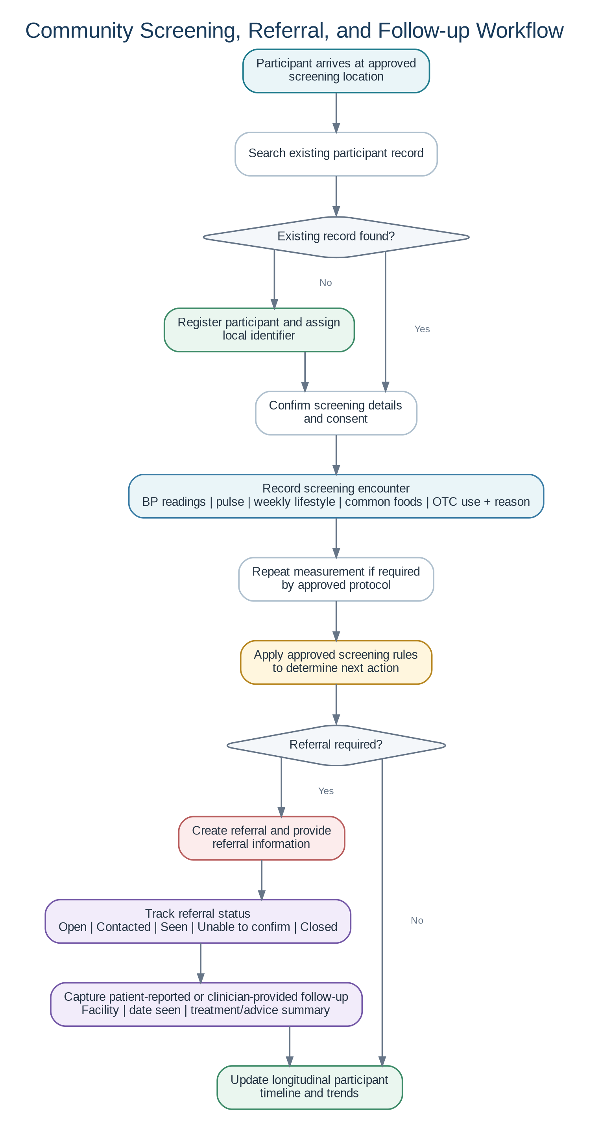
Figure 1. Community screening, referral, and follow-up workflow.

6.1 Patient Registration
- Search before creating a new patient to reduce duplicate records.
- Register demographics, preferred contact information, community/location association, and local identifier.
- Capture appropriate consent or participation acknowledgment.

6.2 Weekly Screening Encounter
- Record one or more blood pressure readings according to the approved protocol.
- Record pulse and screening metadata: date/time, location, screener, device if tracked, and notes.
- Collect weekly lifestyle activity, commonly consumed foods, OTC medications, and the reason each OTC medication was taken.
- Apply approved screening rules to determine the next action; do not generate a diagnosis.

6.3 Referral and Follow-up
- Create a referral record when screening criteria require professional evaluation.
- Track referral status from creation through contact, attendance confirmation, and closure.
- Capture follow-up information: whether a provider was seen, facility, date, patient-reported outcome, medications or advice reported, and next follow-up action.
- Keep provenance clear: distinguish patient-reported information from clinician-entered or document-derived information.

7. Functional Scope

7.1 Offline Desktop Application
- Role-based login for administrator, nurse, and trained screener roles.
- Patient search, duplicate-prevention support, and registration.
- Location and screening-session management.
- Blood pressure and pulse recording with multiple readings per encounter.
- Weekly lifestyle, food-pattern, and OTC medication questionnaires.
- Referral creation, printing, status tracking, and follow-up capture.
- Patient timeline, trend charts, and local reports.
- Offline operation with local SQLite storage and transactional outbox.
- Manual and automatic synchronization when internet becomes available.
- Local audit trail and visible sync status.

7.2 Central Operational Platform
- Sync ingestion API with authentication, idempotency, validation, and per-item acknowledgement.
- Central PostgreSQL operational database as the primary workflow system of record.
- Hospital/organization account request, review, approval, rejection, suspension, and revocation.
- API-client credential lifecycle and scoped token management.
- Operational reports, referral follow-up visibility, audit logging, and sync monitoring.
- FHIR publication queue and mapping status.

7.3 FHIR Interoperability Layer
- Separate FHIR server or API backed by its own FHIR resource store.
- Mapping of operational records to standardized FHIR R4 resources.
- Stable references between operational record identifiers and FHIR resource identifiers.
- Authorized hospital retrieval through scoped FHIR endpoints.
- Publication/retry status and error monitoring.

7.4 Doctor Portal
- Doctor authentication under an approved hospital organization.
- Patient lookup using permitted identifiers and access rules.
- Longitudinal patient timeline combining screening, referral, follow-up, lifestyle, OTC, and uploaded clinical data.
- Charts and summarized trends.
- Upload and review of laboratory results, clinical notes, PDFs, and images.
- AI workspace for natural-language clinical questions and evidence-linked responses.

7.5 AI Clinical Copilot
- Build a bounded patient context from authorized structured data and uploaded documents.
- Generate structured summaries, trend interpretations, abnormal findings, missing-data prompts, and draft recommendations for clinician review.
- Return evidence references to the source records or documents used.
- Log AI requests, context identifiers, outputs, model metadata, and clinician disposition.
- Never automatically write AI-generated recommendations back as verified clinical facts without clinician action.

8. System Architecture
The architecture is divided into four primary domains: the offline community edge application, the central operational platform, the FHIR interoperability layer, and the clinician/AI experience. This separation keeps field operations resilient, business workflows relational and auditable, interoperability standards-focused, and AI access tightly governed.
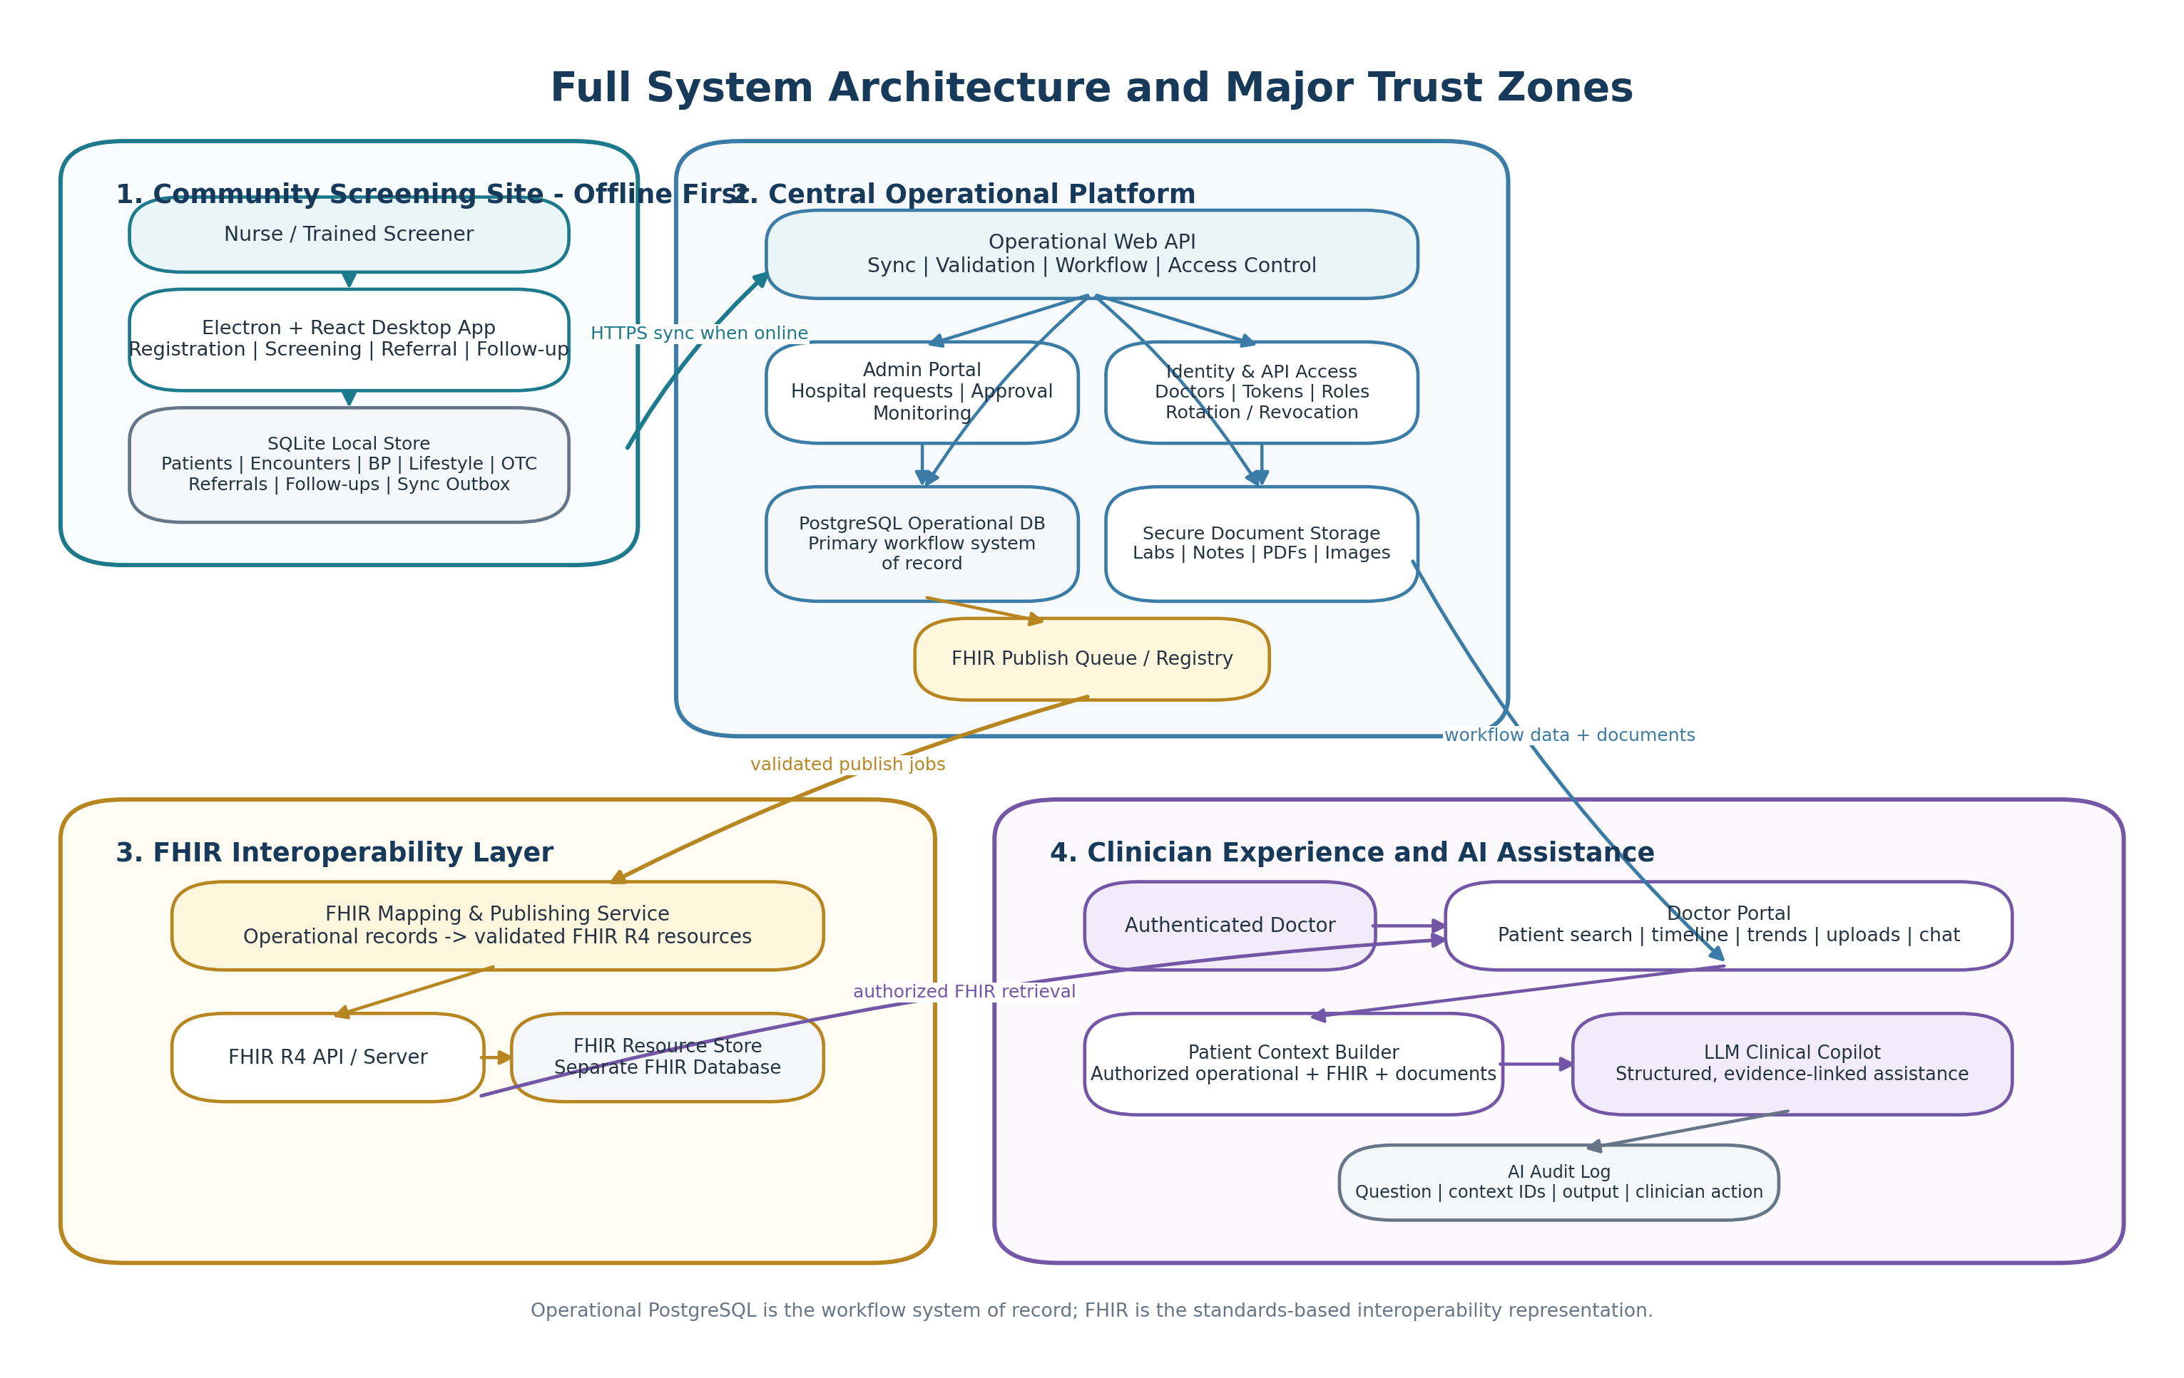
Figure 2. Full system architecture and major trust zones.

8.1 Architectural Principles
- Offline-first: the field application must remain usable without network connectivity.
- Operational database first: workflow is stored in relational form that matches the real program operations.
- FHIR as interoperability: standards-based resources are published from operational data rather than used as the only workflow database.
- Eventual consistency with visibility: local and central systems may temporarily differ, but sync status is explicit and recoverable.
- Least privilege: organizations and doctors receive only the access needed for their approved use.
- Human-in-the-loop AI: clinician judgment remains authoritative.
- Traceability: clinical data, sync activity, FHIR publication, document processing, and AI use are auditable.

9. End-to-End Data Flow
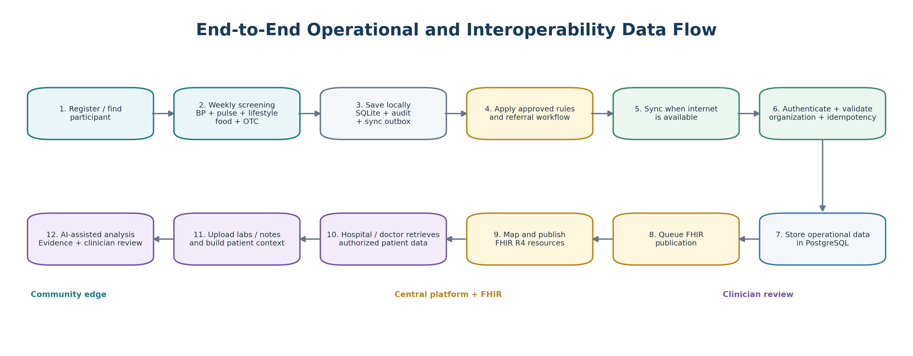
Figure 3. End-to-end operational and interoperability data flow.

9.1 Offline Data Capture
A user action writes the clinical or workflow record to SQLite in the same local transaction that creates an outbox entry. The user receives a successful response only after the local transaction commits. The application can therefore continue to operate even when the central platform is unavailable.

9.2 Synchronization
The sync service batches pending outbox items, authenticates to the operational API, and submits records with stable client-generated identifiers. The server validates the organization and payload, applies idempotency and duplicate checks, writes accepted records to PostgreSQL, and returns an item-level acknowledgement. Local outbox records are then marked sent, retried, or failed with diagnostic information.

9.3 FHIR Publication
After operational data is accepted, a publication job maps eligible records to FHIR resources. The FHIR layer maintains its own standards-oriented store and resource identifiers. Publication failures do not invalidate the operational workflow; they remain visible for retry and investigation.

10. Data Architecture

10.1 Local SQLite Domain
Table | Purpose
users | Local authentication and role assignment
locations | Church, quarter, community, or screening location
patients | Participant demographics and local identifiers
screening_sessions | Organized screening event metadata
screening_encounters | One participant visit within a screening context
bp_readings | One or more BP measurements per encounter
lifestyle_logs | Weekly activity and related lifestyle information
food_logs | Commonly consumed foods or diet-pattern responses
otc_medication_logs | Patient-reported OTC products and reasons for use
referrals | Referral initiation and current status
followups | Follow-up contacts and outcomes
sync_outbox | Durable queue of unsynchronized changes
audit_log | Important user actions and data changes
meta | Schema version and local application metadata

10.2 Central PostgreSQL Domain
Table Group | Purpose
organizations / organization_requests | Hospital and partner onboarding lifecycle
users / hospital_doctors | Central identities and organization membership
api_clients / credentials | Machine-to-machine integration access
patients / identifiers | Central patient identity and source identifiers
screening_sessions / encounters / observations | Synchronized operational screening records
lifestyle / food / OTC records | Patient-reported longitudinal context
referrals / followups | Referral lifecycle and follow-up
sync_jobs / sync_items | Batch and item-level synchronization history
uploaded_documents | Clinical document metadata and storage references
document_extractions | Extracted text/structured values with provenance
fhir_publish_queue / registry / status | FHIR publication lifecycle and identifier mapping
ai_requests / ai_responses / ai_evidence_links | AI auditability and evidence trace
audit_logs | Security and workflow audit trail

11. FHIR Interoperability Design
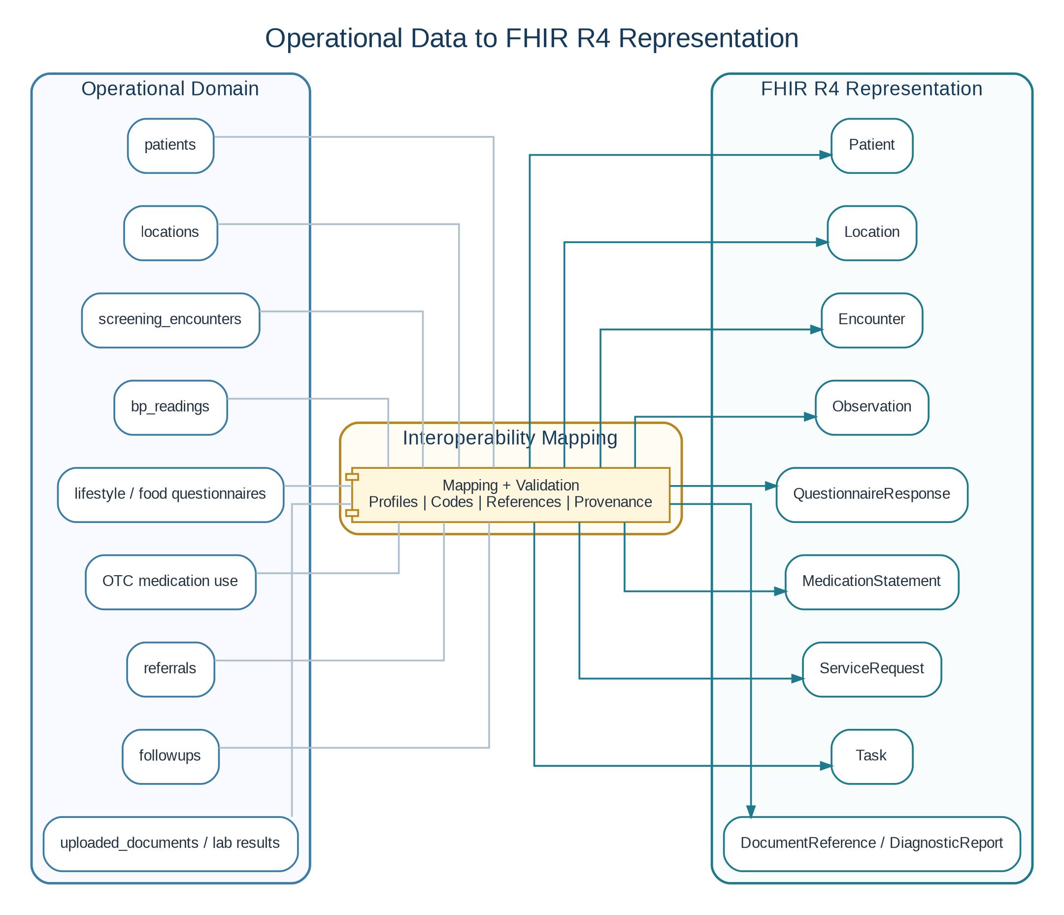
Figure 4. Proposed operational-to-FHIR mapping.
The mapping shown is a planning baseline and should be refined as profiles, terminology, identifiers, consent rules, and hospital exchange requirements become concrete. The objective is to demonstrate standards-based modeling without forcing the internal application workflow to mirror FHIR storage structures.
Operational Concept | FHIR Resource
Patient demographics and identifiers | Patient
Screening location | Location
Community screening visit | Encounter
Blood pressure and pulse | Observation
Lifestyle and food responses | QuestionnaireResponse (or Observation where appropriate)
Patient-reported OTC medication use | MedicationStatement
Referral | ServiceRequest
Referral/follow-up execution state | Task
Uploaded documents | DocumentReference
Structured or formal lab report | DiagnosticReport + Observation where appropriate

11.1 Hospital Access Pattern
- A hospital submits an organization access request.
- A platform administrator verifies and approves the organization.
- The platform creates organization-scoped credentials and permitted API/FHIR scopes.
- Individual doctors authenticate with their own user accounts under the approved hospital rather than manually entering a raw hospital token for every patient lookup.
- Every retrieval is authorized, scoped, and audited.
- Machine-to-machine credentials may still be issued for approved system integrations.

12. Doctor Portal and AI-Assisted Clinical Review
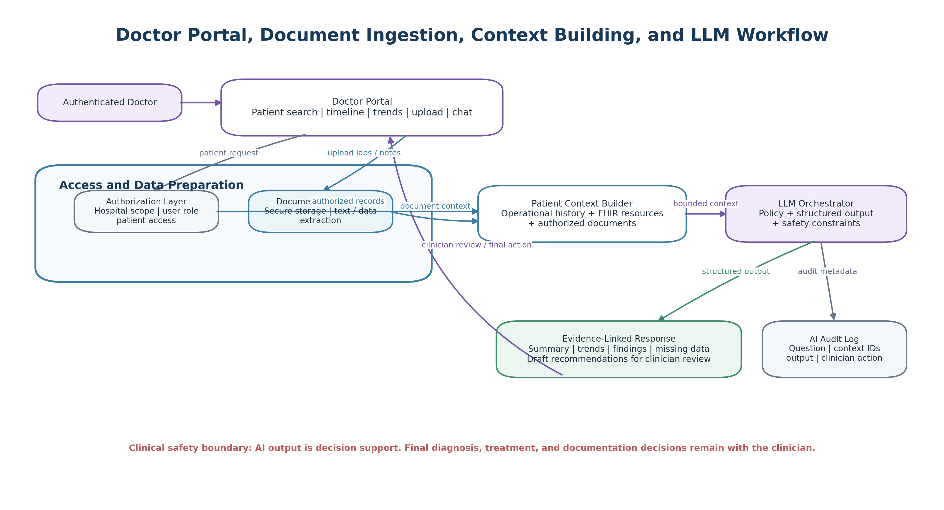
Figure 5. Doctor portal, document ingestion, context building, and LLM workflow.

12.1 Doctor Workspace
- Patient identification and access authorization.
- Longitudinal timeline and blood-pressure trend visualization.
- Referral and follow-up history.
- Lifestyle, common food patterns, OTC medication use, and reasons for use.
- Uploaded lab reports, notes, and supporting documents.
- Natural-language question interface and structured AI output.

12.2 AI Output Contract
- Patient summary
- Relevant longitudinal trends
- Abnormal or concerning findings
- Potential contributing factors
- Missing or conflicting information
- Questions the clinician may wish to clarify
- Draft recommendations for clinician review
- Evidence/source references and uncertainty notes
Clinical Safety Boundary
AI responses must be presented as decision support for an authenticated clinician. The system must not silently convert AI output into verified diagnoses, medication orders, or treatment plans. Final clinical decisions and documentation remain the clinician’s responsibility.

13. Security, Privacy, and Governance
Control Area | Planning Requirement
Authentication | Separate local and central identities where appropriate; strong authentication for central administrators and doctors.
Authorization | Role-based and organization-scoped access; patient access checks for doctor retrieval.
Transport Security | TLS for all central API, sync, portal, and FHIR traffic.
Data at Rest | Encrypted server storage and backups; evaluate encrypted local database strategy and device controls for field systems.
Credential Management | No long-lived plaintext tokens stored in UI code; support token rotation, revocation, and expiration.
Auditability | Record authentication, sensitive patient access, exports, changes, FHIR retrieval, document upload, and AI use.
Consent and Data Sharing | Define what participants consent to, how data may be shared, and how access is limited.
Backup and Recovery | Back up central PostgreSQL, FHIR store, and document storage; define restore testing.
AI Data Governance | Minimize data sent to the model, enforce authorization before context assembly, log context identifiers, and review provider data-handling requirements before real patient deployment.
Clinical Governance | Screening thresholds, urgent referral rules, and patient-facing recommendations must be approved and version-controlled.

14. Non-Functional Requirements

Offline Resilience
- All essential field workflows work without internet.
- Local writes are durable and recoverable after application restart.

Synchronization
- At-least-once transmission with server-side idempotency.
- Per-item status, retry strategy, and dead-letter/failure visibility.

Performance
- Patient search and data-entry screens should remain responsive on low-cost Windows hardware.
- Central APIs should use pagination, indexing, and bounded responses.

Maintainability
- Clear module boundaries; migrations for local and server databases; documented FHIR mappings.
- Configuration separated from source code.

Observability
- Structured logs, sync metrics, API errors, FHIR publication failures, and AI request audits.

Accessibility and Usability
- Large readable controls for field use; minimal typing where possible; clear offline/sync indicators.

Data Quality
- Required fields, range validation, duplicate-prevention workflow, source provenance, and timestamps.

15. Agile Delivery Plan
The project should be delivered incrementally as a sequence of vertical slices. Each epic ends with a demonstrable, testable capability rather than only internal code. The sprint count below is a planning baseline and can be adjusted to actual development capacity.
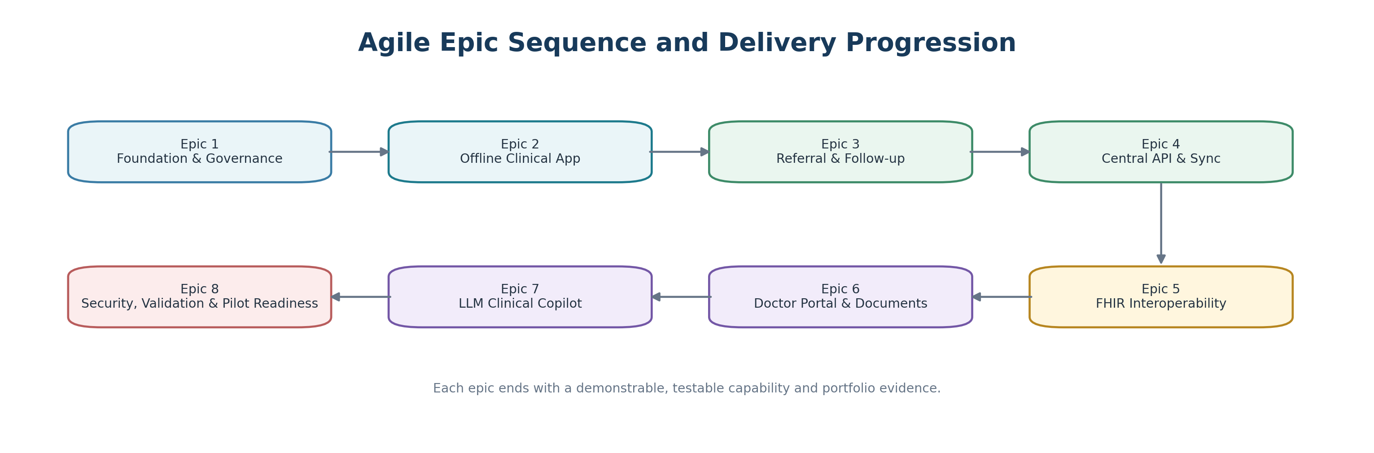
Figure 6. Agile epic sequence and delivery progression.
Epic | Objective | Primary Deliverables | Definition of Done
Epic 1 - Foundation & Governance | Freeze workflows, terminology, architecture, and project skeleton. | Clinical workflow specification; wireframes; repo structure; database migration strategy; threat model; development standards. | Approved workflow and schema baseline; apps start locally; CI runs lint/test/build.
Epic 2 - Offline Clinical Application | Deliver complete local patient and screening workflow. | Auth/roles; locations; registration/search; screening sessions; BP/pulse; lifestyle/food/OTC; patient timeline; local reports. | All core workflows function with network disabled; data persists after restart; audit/outbox records created.
Epic 3 - Referral & Follow-up | Close the community screening loop. | Referral rules integration; referral creation; print/export; referral status; follow-up capture; outcome reporting. | A referred patient can be tracked from screening through documented follow-up/closure.
Epic 4 - Central API & Synchronization | Create central workflow platform and reliable offline sync. | Operational API; PostgreSQL; auth; sync batch endpoint; idempotency; acknowledgements; admin monitoring; hospital onboarding. | Disconnected records sync safely without duplicates; failures are retriable and visible; organization approval workflow works.
Epic 5 - FHIR Interoperability | Publish standards-based clinical resources. | FHIR mapping service; resource registry; Patient/Location/Encounter/Observation/ServiceRequest/Task and selected questionnaire/document mappings; FHIR access controls. | Synced operational records can be represented and retrieved as valid, linked FHIR resources.
Epic 6 - Doctor Portal & Documents | Provide clinician-facing patient review. | Doctor login; patient access; timeline; trend charts; referral history; upload/storage; document metadata and extraction pipeline. | Authorized doctor can find an allowed patient, review history, and upload/review supporting documents.
Epic 7 - LLM Clinical Copilot | Add governed AI-assisted chart analysis. | Context builder; natural-language Q&A; structured output; evidence links; AI audit logs; safety prompts and UI warnings. | Doctor receives evidence-linked AI assistance using authorized patient context; all requests are auditable; no autonomous write-back.
Epic 8 - Security, Validation & Pilot Readiness | Harden the system for controlled field use. | Security review; backups; restore test; performance test; sync failure drills; FHIR validation; user acceptance testing; deployment/runbooks. | Critical test scenarios pass; backups are restorable; operational and clinical runbooks exist; known limitations documented.

15.1 Suggested Sprint Breakdown
Sprint | Theme | Demonstrable Outcome
Sprint 1 | Discovery & Architecture | Freeze workflow; project structure; local/central/FHIR data models; UI navigation; engineering standards.
Sprint 2 | Local Foundation | Electron/React setup; secure IPC; SQLite migrations; local auth; users; locations.
Sprint 3 | Patient & Screening | Patient search/registration; screening session; encounter; multiple BP readings; pulse; validation.
Sprint 4 | Community Context | Lifestyle, activity, food-pattern, OTC medication and reason capture; patient timeline and reports.
Sprint 5 | Referral Loop | Referral creation; printing; status lifecycle; follow-up; outcome reporting.
Sprint 6 | Operational Backend | Web API; PostgreSQL; central schema; organization/admin modules; central auth.
Sprint 7 | Offline Sync | Outbox batching; API sync; idempotency; conflict/duplicate handling; retries; sync dashboard.
Sprint 8 | Hospital Access | Hospital request/approval; API clients; doctor accounts; access scopes; audit trail.
Sprint 9 | FHIR Core | Mapping pipeline; Patient, Location, Encounter, Observation; FHIR registry and validation.
Sprint 10 | FHIR Workflow | ServiceRequest, Task, questionnaire/medication/document mappings; authorized retrieval.
Sprint 11 | Doctor Portal | Patient lookup; timeline; charts; documents; secure file storage and extraction.
Sprint 12 | AI & Hardening | LLM context builder; evidence-linked outputs; AI audit; security testing; backup/restore; UAT; runbooks.

16. Initial Product Backlog by Epic

Epic 1 - Foundation
- Define patient identifier strategy.
- Finalize approved screening/referral protocol interface.
- Create domain glossary and status enums.
- Create architecture decision records for Electron, SQLite, PostgreSQL, FHIR server, and file storage.
- Define development, test, staging, and production environments.

Epic 2 - Offline App
- Create secure preload/IPC boundary.
- Create database migrations and repositories.
- Build role-based navigation.
- Build patient registration and search.
- Build screening entry and repeated BP measurements.
- Build lifestyle/food/OTC forms.
- Build patient timeline and trend report.

Epic 3 - Referral
- Create referral domain model.
- Create referral print template.
- Add referral status transitions.
- Add follow-up form and outcome sources.
- Add overdue/open referral report.

Epic 4 - Central & Sync
- Create central API auth.
- Create sync contracts and schema versioning.
- Implement stable UUIDs and idempotency keys.
- Implement batch sync and acknowledgement.
- Implement retry/error dashboards.
- Implement hospital request and approval.

Epic 5 - FHIR
- Select FHIR R4 server approach.
- Define canonical identifiers and resource references.
- Map Patient/Location/Encounter/Observation.
- Map ServiceRequest/Task.
- Map lifestyle/OTC/document concepts.
- Add FHIR validation tests and example bundles.

Epic 6 - Doctor Portal
- Build doctor identity and hospital membership.
- Implement patient access policy.
- Create timeline/trend views.
- Add secure upload and document registry.
- Add extraction workflow and provenance display.

Epic 7 - AI
- Define allowed AI tasks and prohibited behaviors.
- Build patient context assembler.
- Implement structured response schema.
- Attach evidence IDs to outputs.
- Create AI audit and clinician review flow.
- Test hallucination, missing-data, and conflicting-data scenarios.

Epic 8 - Hardening
- Threat-model review.
- Backup/restore runbook and test.
- Field offline failure tests.
- Sync replay and duplicate tests.
- FHIR conformance tests.
- User acceptance testing with representative workflows.
- Pilot deployment and support runbook.

17. End-to-End Acceptance Scenarios
Offline New Patient: A screener with no internet registers a new participant, records screening data, lifestyle/food/OTC information, and closes the app. After restart, the complete record is still available and marked pending sync.
Repeat Screening: An existing participant is found without creating a duplicate. The new encounter appears on the longitudinal timeline and previous readings remain unchanged.
Referral Follow-through: A screening creates a referral. A later follow-up records whether the participant saw a provider and captures the source and outcome of that information.
Connectivity Recovery: Multiple pending records sync after internet returns. Replaying the same batch does not create duplicate central records.
FHIR Publication: An accepted BP encounter produces linked Patient, Encounter, and Observation resources with stable identifiers and correct references.
Hospital Onboarding: A hospital requests access, is reviewed and approved, receives scoped integration access, and its doctors authenticate individually.
Doctor Review: An authorized doctor opens a patient and sees the longitudinal screening, referral, lifestyle, OTC, and document history permitted to that organization.
AI Question: A doctor asks a natural-language question. The system builds authorized context, returns a structured evidence-linked response, and logs the request and response.
Unauthorized Access: A doctor or API client without the required scope cannot retrieve the patient record and the denied attempt is logged.
Backup Recovery: A documented restore procedure recovers the operational database and associated document metadata in a test environment.

18. Key Risks and Mitigations
Risk | Impact | Mitigation
Clinical misuse | Users may interpret screening output as diagnosis. | Use explicit screening/referral language; approved protocols; training; clinician oversight.
Duplicate patient identities | Participants may be registered more than once. | Search-first workflow, stable identifiers, duplicate review tools, conservative merge process.
Lost or stolen field device | Local health data may be exposed. | Device login, session timeout, minimum local retention where practical, encryption/device controls, remote operational procedures.
Sync conflicts or duplicates | Offline clients may replay or edit records independently. | Client-generated UUIDs, idempotency keys, append-only clinical observations, clear conflict policies.
FHIR complexity | Premature standards work could slow delivery. | Keep operational model independent; add mapping tests incrementally; use a bounded resource set.
AI hallucination or overreach | Model may infer unsupported conclusions. | Evidence-linked outputs, structured schema, uncertainty fields, clinician review, no autonomous orders/diagnoses.
Poor internet | Large sync or files may fail. | Batch limits, resumable/retry behavior, background queues, delayed document upload where necessary.
Community trust and consent | Participants may not understand future data sharing. | Plain-language consent, transparent purpose, limited access, documented withdrawal/access policies.
Sustainability | A small team may struggle to operate many services. | Prefer simple deployment boundaries, managed services where justified, strong automation and runbooks.

19. Portfolio Presentation Strategy
The portfolio should present this project as an evolving engineering case study. The planning artifact is valuable before implementation because it demonstrates the ability to translate a real clinical problem into a governed workflow, data model, architecture, interoperability plan, and delivery roadmap. Implementation claims should be updated only as each deliverable is completed.

19.1 Suggested Portfolio Page Structure
- Project header: name, status badge (In Progress), clinical domain, technology categories.
- Problem: why community hypertension screening and follow-up matter.
- Proposed solution: concise overview of offline capture, sync, FHIR, and doctor portal.
- Clinical workflow: screening -> referral -> follow-up diagram.
- Architecture: interactive or expandable system architecture diagram.
- Interoperability: operational-to-FHIR resource mapping.
- Engineering challenges: offline-first sync, identity, audit, authorization, and FHIR publication.
- Agile delivery progress: epic cards with Planned / In Progress / Completed status.
- Artifacts: architecture document, API specification, database schema, FHIR examples, screenshots, test evidence, and runbooks as they become available.
- Lessons learned: update throughout implementation.

19.2 Portfolio Status Language
Recommended wording
“In Progress - Designed as an offline-first community hypertension screening and referral platform for low-connectivity settings. Current work focuses on clinical workflow modeling, local data architecture, central synchronization, FHIR R4 interoperability, and a clinician-facing AI-assisted review experience.”

20. Success Measures
- Percentage of repeat participants correctly linked to an existing record.
- Percentage of screening encounters successfully synchronized.
- Number and percentage of referrals with documented follow-up status.
- Median time from referral creation to follow-up confirmation.
- Rate of sync failures and duplicate prevention events.
- FHIR publication success rate for eligible records.
- Doctor portal access failures or unauthorized attempts detected.
- AI responses with valid evidence references and completed clinician review.
- User-reported ease of registration, screening, referral, and follow-up workflows.

21. Project Deliverables Checklist
Deliverable Group | Expected Output
Planning & Governance | Problem statement; workflow; architecture; data model; security plan; Agile roadmap.
Offline Desktop App | Packaged Electron application with complete community workflow.
Operational Backend | Web API, PostgreSQL schema, admin workflow, hospital onboarding, sync services.
FHIR Layer | FHIR server/API, resource mappings, validation examples, access controls.
Doctor Portal | Secure clinician access, patient timeline, trends, document upload/review.
AI Clinical Copilot | Bounded context builder, natural-language questions, structured evidence-linked outputs, AI audit.
Testing Evidence | Unit, integration, offline, sync, authorization, FHIR validation, and end-to-end tests.
Operations | Deployment manifests, configuration guide, backup/restore, monitoring, incident and support runbooks.
Portfolio Artifacts | Architecture diagrams, screenshots, demo video, API examples, FHIR examples, implementation status, lessons learned.

22. Immediate Next Steps
- Approve this project scope and architecture baseline.
- Finalize the exact clinical screening/referral protocol with qualified clinical governance.
- Finalize the local SQLite and central PostgreSQL logical schemas.
- Define identifiers, sync payload contracts, and conflict/idempotency rules.
- Select the FHIR server implementation approach and document the initial resource profiles.
- Create low-fidelity screen flows for the desktop app, admin portal, and doctor portal.
- Create repositories and start Epic 1 engineering setup.
- Publish the planning document and architecture diagrams to the portfolio with status clearly marked In Progress.

Appendix A - Proposed Technology Direction
Area | Planned Direction
Offline Client | Electron + React + TypeScript; SQLite; secure preload/IPC boundary
Central API | Node.js/TypeScript service architecture (framework to be finalized)
Operational Database | PostgreSQL
FHIR | FHIR R4-compatible server/API with separate resource store
Documents | Secure object storage plus metadata in PostgreSQL
Doctor Portal | React web application
AI Integration | Server-side LLM orchestration with structured output and evidence links
Deployment | Containerized services; deployment target to be selected based on cost and operational needs
CI/CD | Automated test, security scan, build, and deployment pipelines

