Health Screening Offline Desktop Application
Detailed Design and Delivery Plan
Portfolio Planning Artifact
July 2026
Project status: Planned / In Progress
Primary pilot context: Babungo community, Cameroon
Clinical scope: Community hypertension screening, referral, follow-up, and longitudinal history
Document scope: Offline desktop application only
Deferred scope: Central web API, PostgreSQL, hospital onboarding, FHIR layer, doctor portal, and AI clinical copilot
Clinical boundary: The desktop application supports screening, protocol-based next-action classification, referral, and follow-up. It does not diagnose hypertension, prescribe treatment, or replace clinical judgment.

Document Purpose
This document separates the overall Community Health Screening and Interoperability Platform into two independently deliverable systems:
- Offline desktop application: the field application used at churches, quarter meetings, and other approved community screening locations. This is the subject of the present design.
- Web application: the future connected platform that will receive synchronized data, operate the central PostgreSQL workflow database, onboard hospitals, publish FHIR resources, support the doctor portal, and orchestrate AI-assisted clinical review. The web application is intentionally deferred.
The objective is to define the offline application with enough precision that the design can later be decomposed into small, testable Codex implementation tasks. The document specifies functional behavior, screens, local architecture, data model, security controls, tools, development sequence, deliverables, and acceptance criteria.

1. System Separation and Delivery Boundary
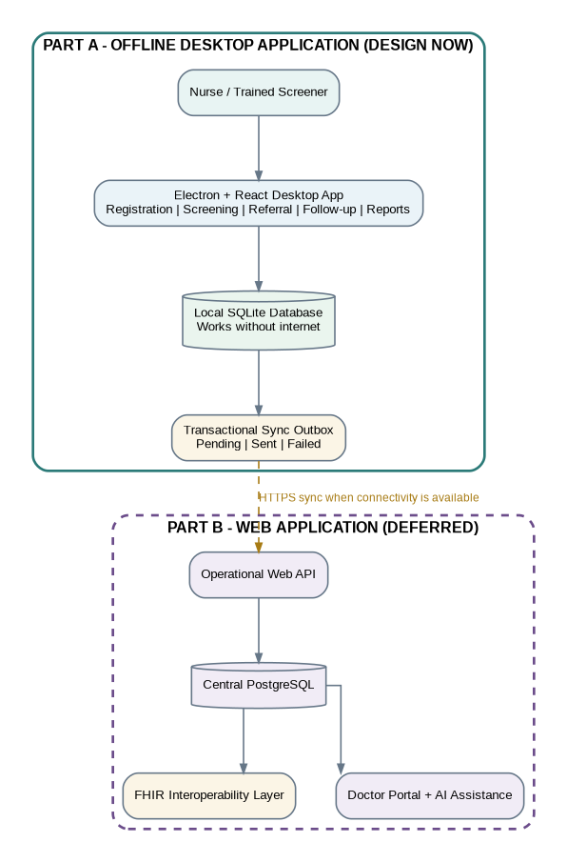
System separation between the offline desktop application and the deferred web application.

1.1 Part A - Offline Desktop Application
The offline application is the source of field data and must remain fully usable without internet access. It owns the following local workflows:
- first-run installation and local configuration;
- local users, roles, login, lockout, and session handling;
- screening location and screening-session management;
- participant search, duplicate warnings, registration, and consent capture;
- repeated blood-pressure measurements and pulse capture;
- weekly lifestyle activity, common food patterns, and OTC medication use with reason for use;
- protocol-based next-action classification without diagnosis;
- referral creation, printing, status history, and follow-up capture;
- patient timeline, trends, and local operational reports;
- local audit history;
- durable sync outbox and sync status;
- local backup, restore, and packaged Windows distribution.

1.2 Part B - Web Application - Deferred
The following components are explicitly excluded from the current implementation plan:
- operational web API;
- central PostgreSQL workflow database;
- hospital account requests, approval, suspension, and revocation;
- machine credentials and doctor identities;
- FHIR publication and FHIR resource store;
- doctor portal, document upload, and AI clinical copilot;
- centralized reporting, monitoring, and cloud deployment.
The offline application must nevertheless preserve a stable integration boundary so that the web system can be added without redesigning local clinical workflows.

1.3 Interface Assumptions Reserved for the Future Web System
The desktop design will assume the future server provides:
- HTTPS endpoints;
- installation or organization-scoped authentication;
- idempotent batch synchronization;
- item-level accepted, duplicate, rejected, or retry responses;
- stable support for client-generated identifiers;
- explicit payload and schema versions;
- server-time feedback and error codes;
- no requirement for continuous internet connectivity.
The desktop will initially implement a SyncTransport interface and a mock adapter. The real HTTP adapter can be activated after the web API contract is finalized.

2. Offline Product Definition

2.1 Product Statement
Build a Windows-first, offline-first desktop application that allows trained community screeners to register participants, conduct repeated hypertension screening, record patient-reported lifestyle, food, and OTC medication context, create referrals, document follow-up, view longitudinal trends, print reports, and queue all eligible changes for later synchronization.

2.2 Primary Outcome
A participant should be identifiable across repeated weekly visits, and every completed screening should contribute to a reliable local timeline. When referral criteria are met, the referral should remain visible until follow-up is documented or the referral is formally closed.

2.3 Non-Goals of the Offline Application
The desktop application will not:
- make a diagnosis;
- prescribe medication or alter treatment;
- expose a hospital or doctor web interface;
- run FHIR queries locally;
- replace the future operational PostgreSQL system;
- require online authentication for normal field work;
- upload laboratory reports or use an LLM in the first desktop implementation;
- automatically merge possible duplicate patient records;
- hard-delete completed clinical observations.

2.4 Initial Platform Assumptions
- Operating system: Windows 10/11, x64 first.
- Deployment model: one installed application and one local database per field laptop.
- Users per device: multiple local users may share one installation.
- Connectivity: intermittent, slow, or unavailable for long periods.
- Language: English first, with localization readiness for later languages.
- Input hardware: keyboard, mouse or touchpad; optional printer; optional external BP device remains manual-entry unless a validated integration is added later.
- Data scale: thousands of participants and repeated weekly encounters, not national-scale storage on one laptop.

3. Users, Roles, and Permissions

3.1 Local Roles
Role | Purpose | Allowed capabilities
Local Administrator | Configure and operate one desktop deployment | Manage local users, locations, protocol activation, backups, restore, reports, sync settings, and audit review
Nurse | Conduct and oversee clinical screening workflow | Search/register patients, record screening, review history, create referrals, record follow-up, print reports
Trained Screener | Perform approved screening tasks | Search/register patients, record permitted screening data, create protocol-indicated referrals, view limited patient history

3.2 Permission Rules
- Every IPC operation must declare the roles allowed to invoke it.
- The UI may hide unavailable actions, but main-process authorization remains authoritative.
- Deactivated users cannot log in.
- Only an administrator may create, deactivate, reset, or change another user’s role.
- Users may not delete clinical records. Correction workflows must create an amendment or void record with a reason.
- Audit events must include the acting user, entity, action, timestamp, and device installation ID.

3.3 First-Run Administrator
On first application launch:
- detect that no installation configuration exists;
- display first-run setup;
- capture deployment name, primary location, timezone, and administrator username;
- create the initial administrator with a temporary password;
- force password change at first login;
- record installation and user-creation audit events;
- generate the local installation UUID used later in sync payloads.

4. Clinical and Data-Safety Boundaries

4.1 Screening Rather Than Diagnosis
The application may calculate a protocol-defined next action, such as:
- continue routine screening;
- repeat measurement;
- create non-urgent referral;
- create urgent referral.
The UI must avoid diagnostic statements such as “patient has hypertension.” All wording should describe recorded observations and the approved next action.

4.2 Versioned Protocol Rules
Clinical rules must not be scattered through UI components. The design will include a versioned protocol service containing:
- protocol identifier and version;
- activation status and effective date;
- validation ranges;
- number and timing of repeat measurements;
- calculation method, when approved;
- next-action categories;
- referral reason codes;
- patient-facing instruction templates;
- checksum and import metadata.
Only an approved active protocol may classify an encounter. Existing encounters retain the protocol version used at the time of screening.

4.3 Provenance
The application must distinguish:
- directly measured data;
- screener-entered observations;
- patient-reported information;
- family-reported follow-up information;
- provider-provided or document-supported information.
Every material record includes source_type, recorded_by, and recorded_at where applicable.

5. End-to-End Offline Workflows

5.1 Daily Site Preparation
- User launches the application.
- Local database migrations run before the login screen is shown.
- User logs in.
- Dashboard displays database health, active location, today’s session, open referrals, unsynchronized item count, and last successful backup.
- User selects an existing screening session or creates a new session for the current date and location.
- The application remains operational regardless of network status.

5.2 First-Time Participant Workflow
- Screener opens Patient Search.
- Screener searches by local patient code, name, phone, date of birth, approximate age, village, or quarter.
- Application displays exact and possible matches.
- Screener confirms that no existing record belongs to the participant.
- Screener opens registration.
- Required demographics and contact fields are captured.
- Participation or data-sharing acknowledgment is recorded according to the approved process.
- Application generates a UUID and human-readable local patient code.
- Patient, identifier, consent, audit, and outbox records commit in one transaction.
- Patient profile opens and the screener may begin the screening encounter.

5.3 Repeat Participant Workflow
- Search finds the existing patient.
- User verifies at least two identity elements before opening the record.
- Patient timeline displays prior screenings and active referrals.
- A new encounter is created under the active screening session.
- Previous encounters remain unchanged.

5.4 Screening Encounter Workflow
- Create encounter in DRAFT status.
- Confirm patient, location, session, screener, and protocol version.
- Record first blood-pressure reading and pulse.
- Capture measurement metadata required by the approved protocol.
- Add repeat readings when required.
- Capture weekly lifestyle activity, food patterns, OTC products, and reasons for use.
- Validate required fields and plausible numeric ranges.
- Protocol service returns the next-action category and evidence used.
- User reviews the screening summary.
- If referral is required, referral workflow opens before encounter completion.
- Encounter is committed as COMPLETED; the audit and outbox records are committed in the same transaction.

5.5 Referral Workflow
- Application proposes referral initiation only when the active protocol indicates it or an authorized nurse manually selects referral with a reason.
- Referral records patient, encounter, referral reason, urgency, destination if known, due date, and creator.
- Referral starts with OPEN status.
- A printable referral slip is generated.
- Each status transition is appended to referral_status_history.
- Referral appears on patient timeline and open-referrals dashboard.

5.6 Follow-Up Workflow
- User searches open referrals or opens a patient’s timeline.
- User records contact date, method, information source, whether a provider was seen, facility, reported outcome, reported medications or advice, and next action.
- The application clearly labels patient-reported or family-reported information.
- Referral status changes according to an allowed state transition.
- Next follow-up date is recorded when needed.
- Closed referrals remain visible and auditable.

5.7 Application Close and Restart
- All completed writes must be durable before success is displayed.
- Draft encounters remain available after restart.
- Pending outbox records remain pending.
- The application performs a database integrity check on controlled startup conditions and surfaces recovery instructions if corruption is detected.

6. Functional Modules

6.1 Installation and Configuration Module
Functions:
- initialize installation UUID;
- configure deployment name and timezone;
- configure default location;
- show app version, schema version, and protocol version;
- store future sync endpoint configuration without exposing secrets in renderer code;
- display storage path and database health to administrators.

6.2 Authentication and Session Module
Functions:
- local username/password login;
- password hashing with Node.js crypto.scrypt and a unique random salt;
- constant-time credential comparison;
- failed-login tracking and temporary lockout;
- forced password change;
- session inactivity timeout;
- explicit lock and logout;
- role-aware session context held in the main process;
- no password or credential exposure through renderer logs.

6.3 User Administration Module
Functions:
- list local users;
- create nurse or screener accounts;
- activate/deactivate users;
- reset password and force change;
- change role with audit event;
- prevent deactivation of the last active administrator;
- show last login and account status.

6.4 Location Module
Functions:
- create and manage churches, quarters, villages, or approved screening locations;
- mark locations inactive without deleting historical links;
- store name, type, village, subdivision, region, and free-text directions;
- assign active location to screening sessions.

6.5 Screening Session Module
Functions:
- create a dated session for one location;
- open, close, and reopen with permission;
- show number screened, referrals created, and drafts remaining;
- prevent new encounters in a closed session unless reopened by an authorized user;
- retain protocol version used by the session.

6.6 Patient Registry Module
Functions:
- multi-field search;
- normalized search keys for names and phone numbers;
- duplicate-warning candidates;
- patient registration;
- patient code generation;
- demographic update with audit trail;
- patient status management;
- identifier and consent history;
- no automatic merge in the first implementation.

6.7 Screening Encounter Module
Functions:
- create draft encounter;
- add, edit, or discard a BP reading before encounter completion;
- preserve all raw readings used in the protocol decision;
- record pulse and measurement metadata;
- generate a screening summary;
- apply versioned protocol rules;
- complete, amend, or void an encounter with reason and authorization;
- maintain append-only history for completed measurements.

6.8 Lifestyle, Food, and OTC Module
Functions:
- capture weekly physical activity responses using approved questionnaire fields;
- record commonly consumed foods and frequency categories;
- support a configurable local food catalog plus free-text entry;
- record OTC product name, reason for use, dose text when known, frequency, duration, source, and whether currently taking;
- distinguish “unknown” from blank;
- display prior entries to reduce repeated typing while requiring confirmation for the current week.

6.9 Referral Module
Functions:
- create referral from an encounter;
- record reason, urgency, destination, due date, and instructions;
- print referral slip;
- enforce valid status transitions;
- show open and overdue referrals;
- preserve referral status history;
- prevent silent deletion.

6.10 Follow-Up Module
Functions:
- capture contact attempts and outcomes;
- identify information source;
- record provider attendance, facility, date seen, reported plan, and next action;
- schedule another follow-up;
- close referral only with a recorded reason/outcome;
- support unsuccessful-contact records without losing prior attempts.

6.11 Timeline and Reporting Module
Functions:
- chronological patient timeline;
- BP trend chart with individual readings and encounter summary values;
- referral and follow-up history;
- session summary;
- open/overdue referral report;
- daily or date-range screening report;
- pending synchronization report;
- user activity report for administrators;
- printable patient summary and referral slip.

6.12 Sync-Readiness Module
Functions:
- create outbox items transactionally with domain writes;
- display pending/sent/failed counts;
- support manual sync;
- support background sync attempts when enabled;
- validate payloads before transport;
- batch records without blocking the UI;
- record item-level acknowledgements;
- retry transient errors;
- preserve permanent rejections for review;
- operate with a mock transport until the web application exists.

6.13 Backup and Restore Module
Functions:
- administrator-initiated database backup;
- scheduled reminder based on last successful backup;
- SQLite online backup to a temporary file;
- integrity verification before marking a backup successful;
- optional encrypted export package;
- restore preview showing backup date, schema version, and installation identity;
- restore only after explicit confirmation and creation of a pre-restore safety backup;
- backup and restore audit events.

7. Screen-by-Screen Design
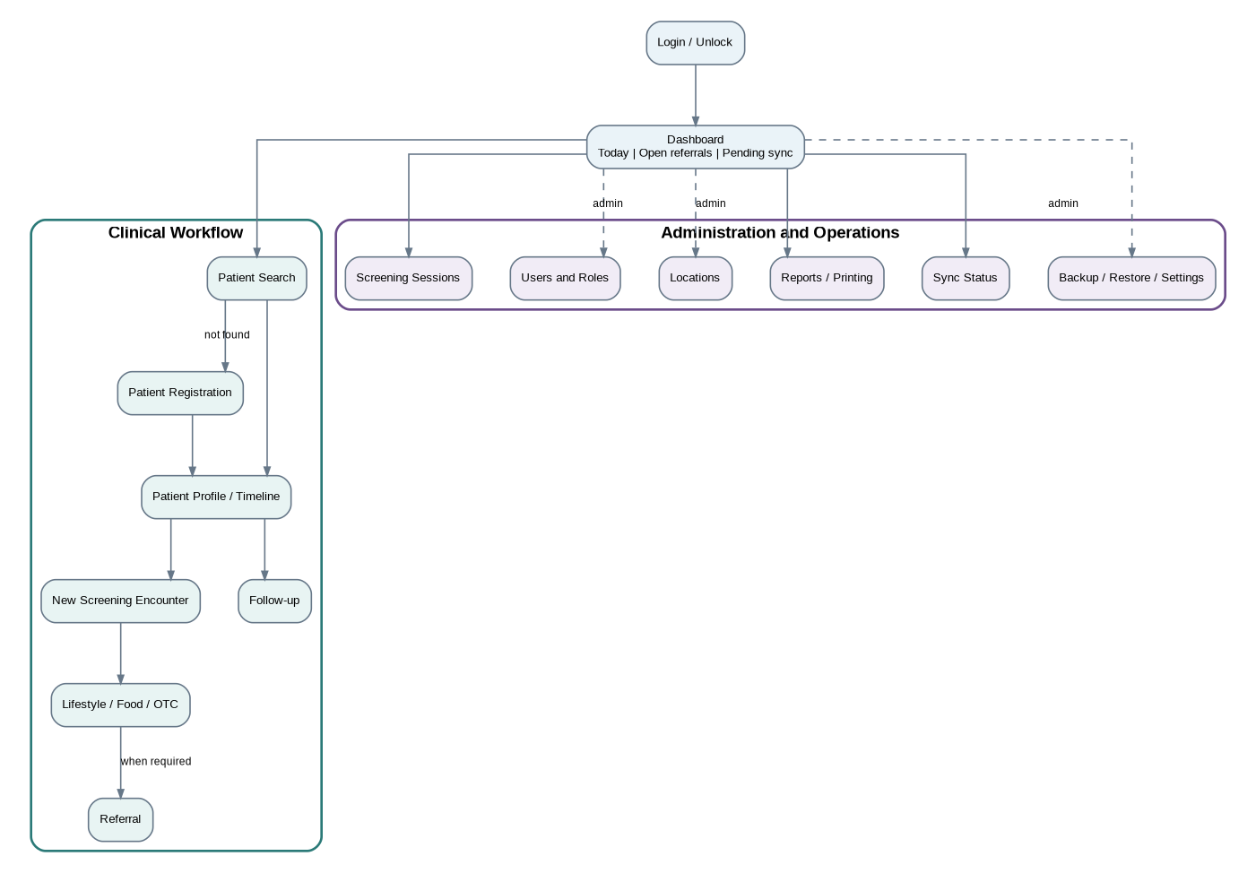
Proposed screen navigation for the offline desktop application.

7.1 First-Run Setup
Visible data: deployment name, timezone, first location, administrator username.
Actions: initialize application, cancel and exit.
Validation: required fields, unique username, password policy, writable application data directory.
Completion condition: installation, location, admin user, active protocol placeholder, and audit records exist.

7.2 Login / Unlock
Visible data: username, password, installation name, app version.
Actions: sign in, exit application.
Behavior: generic error message on authentication failure; temporary lockout after configured failed attempts; password change prompt when required.

7.3 Dashboard
Cards and indicators:
- current user and active role;
- active location and screening session;
- participants screened today;
- draft encounters;
- open and overdue referrals;
- pending and failed sync items;
- last successful backup;
- database or protocol warning banner.
Primary actions: find patient, create session, view referrals, view reports, sync now, lock application.

7.4 Patient Search
Search fields: patient code, name, phone, date of birth, approximate age, sex, village, quarter.
Results: patient code, name, age/DOB, sex, village, last screening date, active-referral indicator.
Duplicate support: show possible matches before registration; never auto-merge.
Actions: open record, refine search, register new patient.

7.5 Patient Registration
Required fields: locally approved minimum demographics and residence information.
Optional fields: phone and alternative contact details where available.
Consent section: participation/data-use acknowledgment and status.
Validation: normalized names, DOB or approximate age rules, phone normalization, duplicate candidates.
Save behavior: one transaction creates patient, identifier, consent, audit, and outbox records.

7.6 Patient Profile and Timeline
Header: minimum identifying details and patient code.
Tabs or sections: overview, screening history, referrals/follow-ups, lifestyle/food/OTC, identifiers/consent.
Actions: start screening, record follow-up, print patient summary, amend demographic data according to role.

7.7 Screening Session Management
List: date, location, status, protocol version, number screened, drafts, referrals.
Actions: create, open, close, reopen with permission.
Rule: completed encounters remain attached to their original session.

7.8 New Screening Encounter
Header: patient, active session, location, screener, protocol version.
Measurement grid: reading sequence, systolic, diastolic, pulse, arm, position, cuff/device details, timestamp.
Actions: add reading, discard reading with reason, save draft, continue to weekly context, cancel draft.
Validation: numeric range checks are safety validation, not diagnosis.

7.9 Weekly Lifestyle / Food / OTC
Lifestyle: approved activity questions with selectable responses.
Food: catalog search, common recent items, frequency choices, notes.
OTC: product, reason, current use, frequency, duration, source, free-text notes.
UX: minimize typing with chips, recent-value suggestions, and explicit confirmation.

7.10 Screening Review and Completion
Displays: all raw readings, protocol version, derived summary if defined, next-action category, missing required fields.
Actions: return to edit, complete without referral, create referral, save as draft.
Safety: no diagnosis wording; show the protocol basis and version.

7.11 Referral Form
Fields: encounter, reason codes, urgency, destination, due date, instructions, contact information.
Actions: create, print, reprint, cancel before final creation.
Output: referral slip with patient code, key observations, referral reason, date, and contact/follow-up instructions.

7.12 Referral Worklist
Filters: open, contacted, seen, unable to confirm, closed, overdue, location, date range.
Actions: open patient, record follow-up, print list.
Priority display: protocol-defined urgency and overdue state, not an AI risk score.

7.13 Follow-Up Form
Fields: contact date, contact method, source type, provider seen, facility, date seen, reported tests/treatment/advice, next action, next follow-up date.
Status transition: controlled list based on current status.
Evidence label: patient-reported, family-reported, provider-reported, or document-supported.

7.14 Reports / Printing
Reports: patient summary, BP trend, session activity, open/overdue referrals, follow-up outcomes, pending sync, user activity.
Actions: preview, print, export PDF where authorized.
Privacy: reports default to the minimum identifying information required.

7.15 Sync Status
Displays: connectivity observation, last attempt, last success, pending count, failed count, item details, error code, retry time.
Actions: sync now, retry selected, export diagnostics without clinical payload, copy support identifier.
Deferred behavior: real transport is disabled until server configuration and credentials exist.

7.16 Backup / Restore / Settings
Administrator functions: create backup, view backup history, restore, configure reminders, display paths, import approved protocol package, manage local app settings.
Safety: no restore while a clinical write transaction is active.

8. Desktop Application Architecture
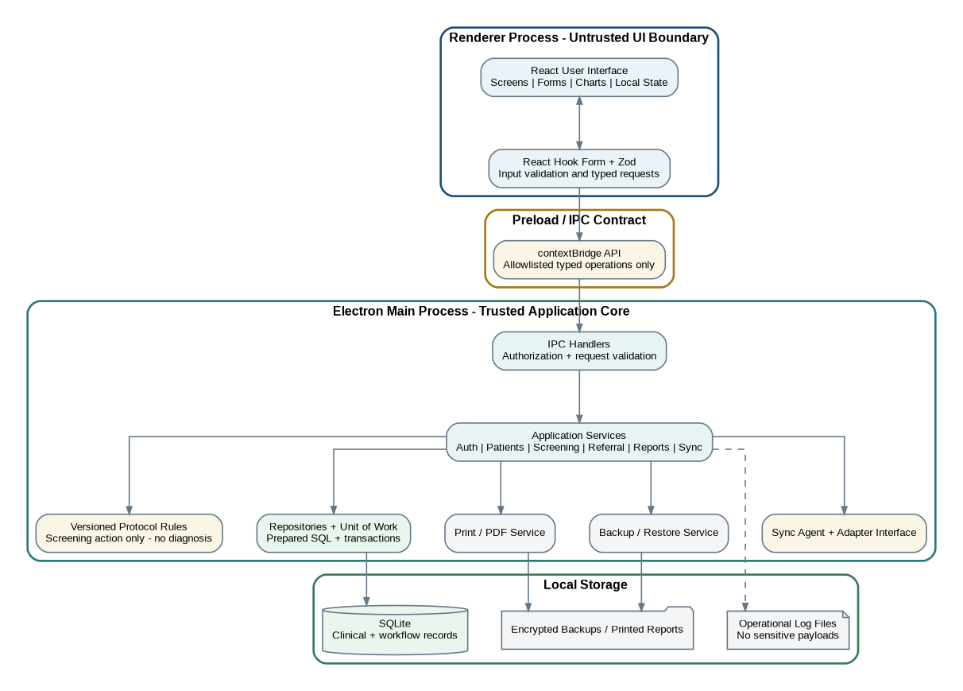
Internal architecture of the offline desktop application.

8.1 Electron Process Boundary

Renderer Process
The renderer contains presentation logic only:
- React components and routes;
- form state;
- display formatting;
- charts and tables;
- non-sensitive UI state.
It must not receive direct Node.js, filesystem, SQLite, process, or shell access.

Preload Process
The preload script exposes a small typed API through contextBridge. It provides explicit methods such as:
- auth.login();
- patients.search();
- patients.create();
- screenings.createEncounter();
- screenings.completeEncounter();
- referrals.create();
- followups.create();
- reports.getPatientSummary();
- sync.runNow().
It must not expose raw ipcRenderer, filesystem primitives, arbitrary SQL, or generic “execute” methods.

Main Process
The main process owns:
- BrowserWindow lifecycle and security configuration;
- IPC registration and authorization;
- application services;
- protocol service;
- repositories and transactions;
- SQLite connection lifecycle;
- printing and PDF generation;
- backup and restore;
- sync agent;
- operational logging.

8.2 IPC Request Lifecycle
- Renderer validates user input for immediate feedback.
- Preload sends a typed request to an allowlisted channel.
- Main-process handler validates the request again.
- Main process checks the authenticated session and required role.
- Application service performs the use case.
- Repository transaction writes domain, audit, and outbox records.
- Handler returns a typed success or typed application error.
- Renderer shows a user-safe message.

8.3 Error Taxonomy
Errors should use stable codes:
- AUTH_INVALID_CREDENTIALS;
- AUTH_ACCOUNT_LOCKED;
- AUTH_FORBIDDEN;
- VALIDATION_FAILED;
- DUPLICATE_CANDIDATE_REVIEW_REQUIRED;
- PATIENT_NOT_FOUND;
- SESSION_CLOSED;
- PROTOCOL_NOT_ACTIVE;
- INVALID_STATUS_TRANSITION;
- DATABASE_WRITE_FAILED;
- BACKUP_FAILED;
- SYNC_TRANSIENT_FAILURE;
- SYNC_PERMANENT_REJECTION.
The renderer receives safe messages; technical detail is written to operational logs without sensitive payloads.

9. Recommended Technology Stack
Area | Recommended tool | Purpose and design note
Desktop shell | Electron | Windows desktop runtime with controlled OS access in the main process
Build tooling | electron-vite | Separate main, preload, and renderer build targets with Vite-based development
UI | React + TypeScript in strict mode | Typed, component-based user interface
Styling | Tailwind CSS | Consistent responsive desktop UI without a heavy component framework
Routing | React Router | Screen navigation and protected route structure
Forms | React Hook Form | Efficient complex form state and error display
Validation | Zod | Shared runtime schemas and TypeScript inference for UI/IPC payloads
Local state | Zustand | Small, explicit session and UI-state stores; server-state library is unnecessary for local IPC
Database | SQLite through better-sqlite3 | Fast synchronous local transactions in the trusted main process
Migrations | Numbered SQL migrations | Transparent, reviewable, deterministic database upgrades
Charts | Recharts | Blood-pressure trend visualization in the renderer
Dates | date-fns | Display and date calculations while storing timestamps in UTC
Password security | Node.js crypto.scrypt | Built-in password derivation without another native package
Secret protection | Electron safeStorage | Protect the local data-encryption key or future sync secret using OS facilities
Unit/integration tests | Vitest | Fast tests aligned with Vite tooling
UI tests | React Testing Library | User-behavior-focused component tests
End-to-end tests | Playwright Electron support | Launch and automate the Electron app for critical workflows
Packaging | electron-builder, Windows NSIS target | Produce an installable .exe; rebuild native dependencies for Electron
Code quality | ESLint + Prettier | Consistent TypeScript and React standards
CI | GitHub Actions, Windows runner | Typecheck, lint, test, build, package, and preserve test artifacts

9.1 Version Policy
- Pin Electron, electron-vite, better-sqlite3, and electron-builder versions in the lockfile.
- Select a better-sqlite3 release with prebuilt support for the chosen Electron version, or prove the native rebuild in CI.
- Do not independently auto-upgrade Electron and better-sqlite3.
- Use a supported Electron stable line and plan regular security upgrades.
- Pin the package manager through the packageManager field and commit the lockfile.

9.2 Package Manager
Use pnpm for reproducible installation and efficient disk use. Recommended scripts:
pnpm dev
pnpm lint
pnpm typecheck
pnpm test
pnpm test:integration
pnpm test:e2e
pnpm build
pnpm package:win

10. Proposed Repository Structure
health-screening-desktop/
├── .github/
│ └── workflows/
│ ├── ci.yml
│ └── package-windows.yml
├── build/
│ ├── icon.ico
│ └── installer-assets/
├── docs/
│ ├── adr/
│ ├── clinical-workflow/
│ ├── database/
│ ├── ipc/
│ ├── security/
│ └── testing/
├── resources/
│ ├── protocols/
│ ├── print-templates/
│ └── seed-data/
├── src/
│ ├── main/
│ │ ├── app/
│ │ │ ├── bootstrap.ts
│ │ │ ├── window.ts
│ │ │ └── lifecycle.ts
│ │ ├── auth/
│ │ ├── config/
│ │ ├── database/
│ │ │ ├── connection.ts
│ │ │ ├── migrations/
│ │ │ ├── repositories/
│ │ │ └── transaction.ts
│ │ ├── ipc/
│ │ │ ├── handlers/
│ │ │ ├── authorize.ts
│ │ │ └── register.ts
│ │ ├── services/
│ │ │ ├── patients/
│ │ │ ├── sessions/
│ │ │ ├── screenings/
│ │ │ ├── referrals/
│ │ │ ├── followups/
│ │ │ ├── reports/
│ │ │ ├── sync/
│ │ │ └── backup/
│ │ ├── protocol/
│ │ ├── printing/
│ │ ├── logging/
│ │ └── security/
│ ├── preload/
│ │ ├── index.ts
│ │ └── api.ts
│ ├── renderer/
│ │ ├── app/
│ │ ├── components/
│ │ ├── features/
│ │ │ ├── auth/
│ │ │ ├── dashboard/
│ │ │ ├── patients/
│ │ │ ├── sessions/
│ │ │ ├── screenings/
│ │ │ ├── referrals/
│ │ │ ├── followups/
│ │ │ ├── reports/
│ │ │ ├── sync/
│ │ │ └── settings/
│ │ ├── routes/
│ │ ├── stores/
│ │ └── styles/
│ └── shared/
│ ├── contracts/
│ ├── schemas/
│ ├── enums/
│ ├── errors/
│ └── types/
├── tests/
│ ├── unit/
│ ├── integration/
│ ├── e2e/
│ ├── fixtures/
│ └── helpers/
├── electron.vite.config.ts
├── electron-builder.yml
├── package.json
├── pnpm-lock.yaml
├── tsconfig.json
└── README.md

11. Local SQLite Data Design
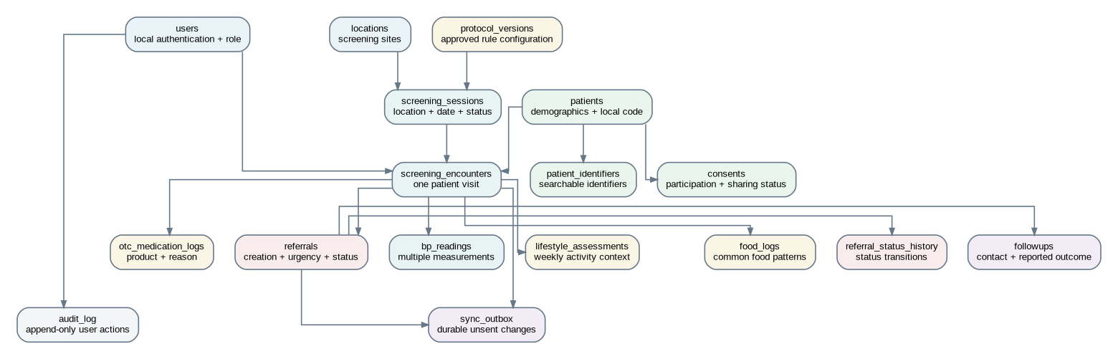
Simplified local data model.

11.1 Database Configuration
On every database connection:
- enable foreign-key enforcement;
- use write-ahead logging after verifying compatibility with backup and deployment behavior;
- set a bounded busy timeout;
- use prepared statements;
- execute writes through explicit transactions;
- keep one connection owned by the main process;
- never open the production database from the renderer.

11.2 Identifier and Timestamp Rules
- Use client-generated UUIDs for every synchronizable entity.
- Generate a separate human-readable local patient code for field identification.
- Store timestamps in UTC ISO-8601 format.
- Store installation timezone separately and convert only for display.
- Include created_at, updated_at, created_by, and updated_by where relevant.
- Completed clinical records use amendment/void metadata instead of destructive overwrite.

11.3 Core Tables and Key Fields

installations
- id UUID primary key;
- deployment_name;
- device_name;
- timezone;
- locale;
- created_at;
- app_config_version.

users
- id UUID;
- username unique normalized value;
- password_hash;
- password_salt;
- role enum;
- is_active;
- failed_attempts;
- locked_until;
- must_change_password;
- last_login_at;
- audit timestamps.

locations
- id UUID;
- name;
- location_type;
- village;
- subdivision;
- region;
- directions_text;
- is_active;
- audit timestamps.

patients
- id UUID;
- local_patient_code unique;
- name fields;
- normalized search name;
- sex;
- date of birth or approximate age fields;
- phone and normalized phone;
- village and quarter;
- contact preference;
- status;
- audit timestamps;
- amendment metadata.

patient_identifiers
- id UUID;
- patient_id foreign key;
- identifier_type;
- identifier_value;
- issuer;
- is_active;
- uniqueness rule appropriate to type and issuer.

consents
- id UUID;
- patient_id;
- consent_type;
- status;
- version;
- captured_at;
- captured_by;
- witness_name optional;
- notes.

protocol_versions
- id UUID;
- protocol_code;
- version;
- status;
- effective_date;
- rules_json;
- checksum;
- imported_at;
- imported_by.

screening_sessions
- id UUID;
- location_id;
- session_date;
- status (OPEN, CLOSED);
- protocol_version_id;
- opened_by, opened_at;
- closed_by, closed_at;
- notes.

screening_encounters
- id UUID;
- patient_id;
- screening_session_id;
- protocol_version_id;
- status (DRAFT, COMPLETED, VOIDED, AMENDED);
- encounter_time;
- screening_action;
- referral_required;
- summary_json for protocol-calculated, non-diagnostic summary;
- created_by;
- completion and amendment metadata.

bp_readings
- id UUID;
- encounter_id;
- sequence_number;
- systolic;
- diastolic;
- pulse optional according to workflow;
- arm, position, cuff_size, device_identifier optional/configurable;
- measured_at;
- is_discarded;
- discard_reason;
- recorded_by.

lifestyle_assessments
- id UUID;
- encounter_id unique when one assessment per encounter;
- approved typed questionnaire fields;
- additional_responses_json for versioned optional items;
- source_type fixed as patient-reported unless otherwise documented;
- recorded_by, recorded_at.

food_logs
- id UUID;
- encounter_id;
- food_catalog_id optional;
- food_name snapshot;
- frequency_code;
- portion_or_preparation_note;
- source_type;
- audit metadata.

otc_medication_logs
- id UUID;
- encounter_id;
- product_name;
- reason_for_use;
- dose_text optional;
- frequency_text optional;
- duration_text optional;
- source_of_medication optional;
- currently_taking;
- source_type;
- audit metadata.

referrals
- id UUID;
- patient_id;
- encounter_id;
- protocol_version_id;
- reason_codes_json;
- reason_text;
- urgency;
- destination_name;
- due_date;
- status;
- created_by, created_at;
- printed_at optional;
- closure metadata.

referral_status_history
- id UUID;
- referral_id;
- from_status;
- to_status;
- change_reason;
- changed_by;
- changed_at.

followups
- id UUID;
- referral_id;
- contact_date;
- contact_method;
- information_source;
- provider_seen;
- facility_name;
- date_seen;
- reported_outcome;
- reported_medications_or_advice;
- next_action;
- next_followup_date;
- recorded_by, recorded_at.

sync_outbox
- id UUID event ID;
- aggregate_type;
- aggregate_id;
- operation;
- payload_json;
- payload_schema_version;
- created_at;
- status (PENDING, IN_FLIGHT, SENT, FAILED);
- attempt_count;
- next_attempt_at;
- last_error_code;
- last_error_message sanitized;
- sent_at.

sync_attempts
- id UUID;
- batch_id;
- start and end timestamps;
- result status;
- item counts;
- sanitized error summary.

audit_log
- id UUID;
- installation_id;
- user_id nullable for startup/system events;
- action;
- entity_type;
- entity_id;
- occurred_at;
- metadata_json containing no unnecessary clinical payload;
- append-only enforcement in repositories.

schema_migrations
- migration version;
- name;
- checksum;
- applied timestamp;
- application version.

app_settings
- key;
- value JSON;
- updated timestamp;
- sensitivity classification.

11.4 Required Indexes
- patient code unique index;
- normalized patient name;
- normalized phone;
- patient plus encounter timestamp;
- screening session by location and date;
- referral status and due date;
- follow-up by referral and contact date;
- outbox status plus next attempt time;
- audit timestamp and entity;
- migration version unique index.

12. Transactional Outbox and Local Consistency
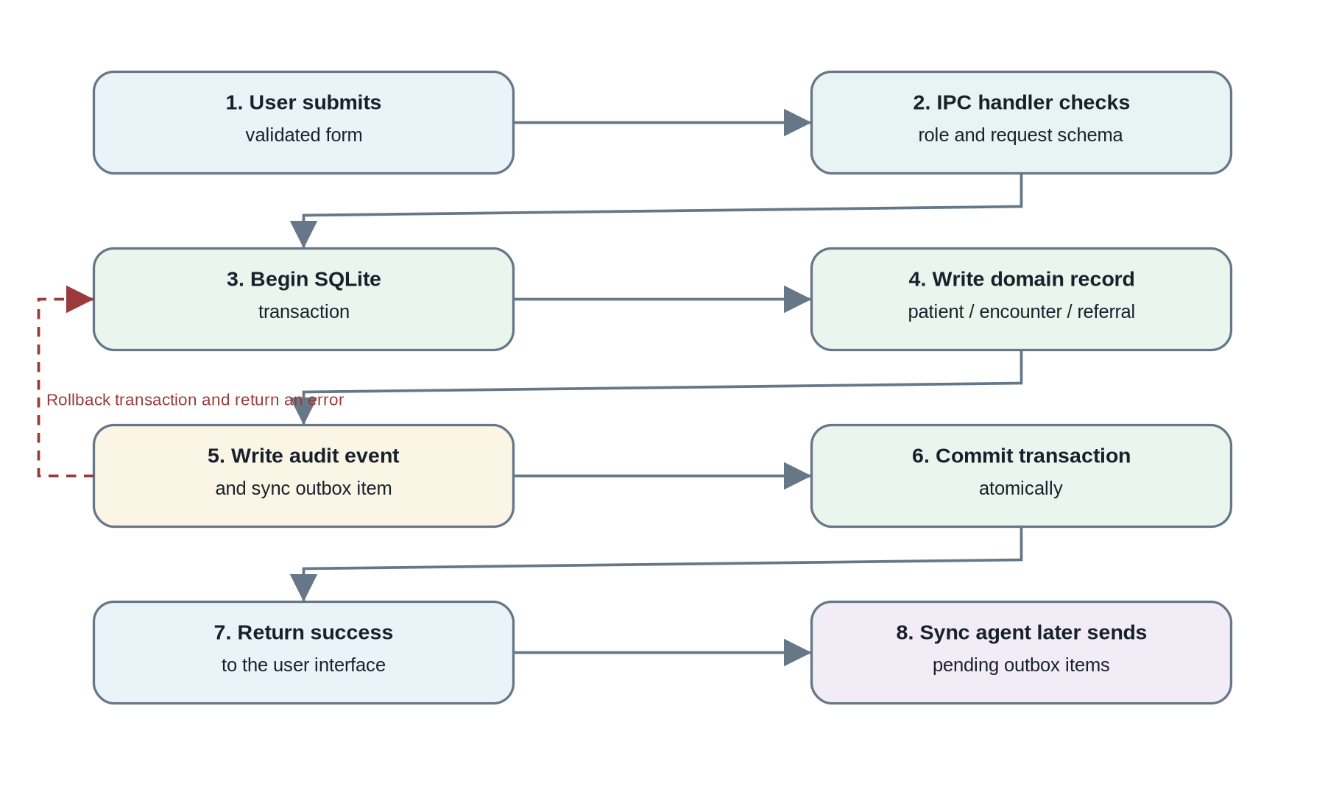
Transactional write and synchronization outbox flow.

12.1 Core Rule
A user-visible write is successful only when all required local records commit. For synchronizable changes, the business record and its outbox event must be written in the same SQLite transaction.

12.2 Example - Completing a Screening Encounter
One transaction should:
- validate encounter is still a draft;
- validate required readings and context;
- store or finalize protocol calculation results;
- change encounter status to completed;
- create referral when required and approved;
- append audit events;
- create outbox items for changed aggregates;
- commit;
- return completed encounter summary.
If any step fails, the transaction rolls back and no partial completion is displayed.

12.3 Outbox Payload Strategy
Use an event envelope:
{
"eventId": "client-generated-uuid",
"installationId": "installation-uuid",
"entityType": "screening_encounter",
"entityId": "entity-uuid",
"operation": "UPSERT",
"schemaVersion": "1.0",
"occurredAt": "UTC timestamp",
"payload": {}
}
The payload contains the minimum operational data needed by the future server. Secrets and local password data are never synchronized.

13. Sync Client Design - Server Deferred

13.1 Sync Adapter Interface
SyncTransport
- healthCheck(): ConnectivityResult
- sendBatch(request): BatchAcknowledgement
- refreshCredential(): CredentialResult
Implementations:
- MockSyncTransport for development and deterministic tests;
- HttpSyncTransport later, when the web API exists.

13.2 Sync Triggers
Recommended configurable triggers:
- manual “Sync now”;
- after successful login when connectivity is detected;
- when the operating system reports a connectivity change;
- periodic background attempt while the application is open;
- before controlled application shutdown when safe and not disruptive.
A connectivity signal does not guarantee server reachability. The authoritative test is a bounded server health request.

13.3 Batch Algorithm
- acquire a process-local sync lock;
- recover stale IN_FLIGHT items back to pending;
- select due pending items ordered by creation time;
- enforce maximum batch item and payload sizes;
- mark selected items IN_FLIGHT in a transaction;
- send batch through the transport;
- apply each acknowledgement in a transaction;
- mark accepted/duplicate items SENT;
- reschedule retryable items with capped exponential backoff and jitter;
- mark permanent rejections FAILED and surface them to an administrator;
- write a sync_attempts record;
- release the lock.

13.4 Conflict Policy
- Patient identity conflicts are not silently merged.
- Completed BP observations are append-only; the server should accept amendments rather than overwrite raw history.
- Local updates include entity version or updated timestamp.
- When the future server rejects a change, the local record remains available and the sync error is visible.
- A rejected sync must never block new offline screening.

13.5 Future Batch Contract
Proposed endpoint:
POST /v1/sync/batches
Request metadata:
- batch ID;
- installation ID;
- client app version;
- payload schema version;
- items.
Item acknowledgement statuses:
- ACCEPTED;
- DUPLICATE;
- REJECTED;
- RETRY.

14. Security and Privacy Design

14.1 Electron Hardening
- nodeIntegration: false;
- contextIsolation: true;
- renderer sandbox enabled where compatible;
- restrictive Content Security Policy;
- load only bundled local content;
- deny arbitrary navigation and new-window creation;
- no <webview> use;
- validate every IPC sender and request;
- expose one method per use case, not generic primitives;
- disable development tools in packaged production builds except controlled support mode;
- remain on a supported Electron stable line.

14.2 Local Data Protection
- Store the database under Electron’s application user-data directory.
- Require device-level Windows login and recommend BitLocker/device encryption for field laptops.
- Generate an application data-encryption key for selected sensitive fields if required.
- Protect the encryption key with Electron safeStorage rather than hardcoding it.
- Never store plaintext passwords.
- Never include patient data in crash messages, analytics, or routine logs.
- Clear sensitive screens after logout or inactivity lock.
- Minimize data shown on dashboard cards and printed outputs.

14.3 Password Handling
- derive password hashes with crypto.scrypt;
- unique random salt per user;
- store algorithm parameters for future upgrades;
- compare with timingSafeEqual;
- administrator reset creates a temporary password and must_change_password flag;
- enforce minimum length and block empty/common bootstrap passwords;
- do not impose complexity rules that encourage written-down passwords unless governance requires them.

14.4 Auditability
Audit at minimum:
- successful and failed login events;
- user creation, role change, deactivation, and password reset;
- patient creation and demographic amendment;
- consent change;
- encounter completion, amendment, or void;
- referral creation and status transition;
- follow-up entry;
- report print/export;
- backup and restore;
- sync attempt and permanent failure;
- protocol import and activation.

14.5 Data Retention and Deletion
The exact retention policy requires governance approval. The application design should support:
- inactive patient status;
- consent withdrawal status;
- controlled export or disclosure workflow later;
- no ad-hoc clinical hard deletion;
- administrative purge only through a separately approved process, never ordinary UI buttons.

15. Validation and Protocol Engine

15.1 Three Validation Layers
- Renderer validation: immediate form feedback.
- IPC contract validation: Zod validation of untrusted renderer requests.
- Domain validation: authoritative workflow and clinical-protocol validation in the main process.

15.2 Protocol Engine Inputs
- patient age information needed by approved rules;
- raw BP readings and pulse;
- measurement sequence and status;
- encounter context;
- active protocol version.

15.3 Protocol Engine Output
ScreeningDecision
- protocolVersion
- requiredRepeatMeasurement
- summaryValues
- nextActionCategory
- referralRequired
- urgency
- reasonCodes
- patientInstructionTemplate
- evidenceReadingIds
The engine does not return diagnosis codes.

15.4 Testability
Protocol rules must be pure functions where possible, with table-driven tests covering:
- boundary values;
- missing readings;
- discarded readings;
- repeat-reading requirements;
- protocol version changes;
- invalid configuration;
- referral and non-referral outcomes.
Actual clinical thresholds must be inserted only after governance approval.

16. Reporting and Printing Design

16.1 Patient Summary
Contents:
- minimum demographic identification;
- screening timeline;
- individual BP readings and protocol summary;
- lifestyle, food, and OTC context;
- active and completed referrals;
- follow-up outcomes;
- provenance labels.

16.2 Referral Slip
Contents:
- patient name and local code;
- screening date and location;
- recorded BP readings and pulse;
- referral reason and urgency language;
- destination, when selected;
- contact/follow-up instructions;
- statement that the community program performs screening and referral, not diagnosis.

16.3 Technical Printing Approach
- Render a dedicated local HTML template in a hidden BrowserWindow.
- Apply a restrictive Content Security Policy.
- Use webContents.print() for direct print and printToPDF() for PDF export.
- Do not print from the interactive screen DOM.
- Test page breaks and printer-unavailable errors.

17. Backup, Restore, and Recovery

17.1 Backup Workflow
- administrator requests backup;
- service checks available destination and free space;
- create SQLite online backup to a temporary file;
- verify database integrity and schema metadata;
- optionally encrypt backup package;
- move atomically to final destination;
- record checksum and backup history;
- display success with date and path.

17.2 Restore Workflow
- select backup file;
- validate file type, checksum, and schema compatibility;
- show backup metadata;
- require administrator confirmation;
- create current-database safety backup;
- close database connection;
- replace database atomically;
- reopen database and run migrations if supported;
- run integrity checks;
- record restore audit event in the restored database and operational log.

17.3 Recovery Scenarios
- application crash after a committed write;
- application termination during an uncommitted transaction;
- stale draft encounter;
- stale IN_FLIGHT sync items;
- failed migration;
- corrupt database;
- failed restore;
- printer unavailable;
- insufficient disk space.

18. Logging and Local Observability

18.1 Operational Logs
Use structured main-process logs for:
- startup and shutdown;
- database migration status;
- database errors;
- backup/restore events;
- sync transport status;
- unexpected exceptions;
- app version and operating-system metadata.
Do not log names, phone numbers, readings, questionnaire answers, referral details, or complete IPC payloads.

18.2 Health Indicators
Dashboard or settings should expose:
- database connection health;
- current schema version;
- active protocol version;
- last backup;
- outbox counts;
- failed sync count;
- disk-space warning;
- application version.

19. Accessibility and Field Usability
- Large, high-contrast controls.
- Clear keyboard focus and tab order.
- Labels remain visible; do not rely on placeholders alone.
- Minimal typing through selectable lists and recent-value suggestions.
- Patient search before registration is visually prominent.
- Save-draft behavior is explicit.
- Offline and sync states use text plus icon, not color alone.
- Confirmation is required before completing an encounter or closing a referral.
- Error messages state the corrective action.
- Screens remain usable on common low-cost laptop resolutions.

20. Testing Strategy

20.1 Unit Tests
- normalization and patient-code generation;
- password hashing and authentication rules;
- status transitions;
- protocol engine;
- outbox retry calculation;
- formatting and report data preparation;
- Zod contracts.

20.2 Repository Integration Tests
Use a temporary SQLite database for:
- migration from empty database;
- foreign-key enforcement;
- transaction rollback;
- patient creation plus outbox atomicity;
- encounter completion plus referral atomicity;
- unique constraints and indexes;
- backup and restore;
- migration upgrade from prior schema snapshots.

20.3 IPC Integration Tests
- role authorization;
- malformed request rejection;
- safe error mapping;
- session expiration;
- no generic or unauthorized channels;
- handler-to-service wiring.

20.4 Renderer Tests
- registration and screening forms;
- error display and required fields;
- duplicate-warning workflow;
- referral status transitions;
- keyboard navigation;
- empty, loading, and failure states.

20.5 End-to-End Electron Tests
Critical Playwright scenarios:
- first-run setup;
- login and forced password change;
- offline new-patient registration;
- repeat patient search;
- screening with multiple readings;
- lifestyle/food/OTC capture;
- referral creation and print preview;
- follow-up and closure;
- application restart with data persistence;
- pending outbox visibility;
- backup and restore;
- unauthorized action blocked.

20.6 Acceptance Tests
The build is not complete until:
- core workflows pass with the network disabled;
- completed data remains after restart;
- duplicate sync replay does not create duplicate local effects;
- failed writes do not produce partial records;
- all clinical corrections are auditable;
- packaged Windows installer passes a clean-machine smoke test.

21. CI/CD and Development Workflow

21.1 Branching
Recommended lightweight flow:
- main: releasable planning or application baseline;
- develop: integration branch if multiple contributors are active;
- feature/<task-id>-<slug>: one Codex or developer task;
- pull request required before merge.

21.2 Continuous Integration
On pull request:
- install with frozen lockfile;
- lint;
- typecheck;
- unit tests;
- repository integration tests;
- build main/preload/renderer;
- dependency and security checks;
- upload test reports on failure.
On approved release tag:
- run full CI;
- package Windows NSIS installer;
- generate checksums;
- code sign when certificate is available;
- publish installer artifact and release notes.

21.3 Definition of a Small Codex Task
Each later Codex task should:
- implement one bounded behavior;
- identify exact files to create or modify;
- include required types and interfaces;
- include tests;
- list commands to run;
- define acceptance criteria;
- name explicit out-of-scope behavior;
- avoid combining unrelated screens, schema changes, and infrastructure.

22. Step-by-Step Delivery Plan
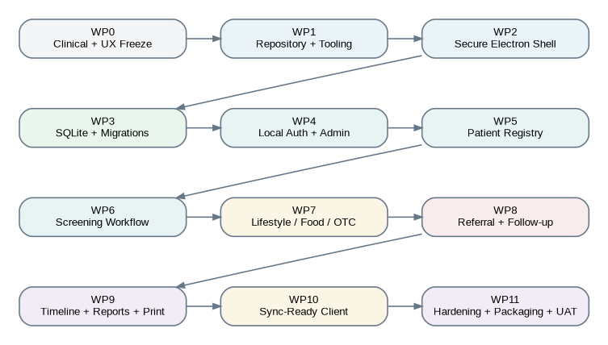
Work-package sequence for the offline desktop implementation.

WP0 - Clinical and UX Freeze
Objective: remove ambiguity before coding.
Activities: approve field workflow, role permissions, required patient fields, consent language, questionnaire content, referral statuses, clinical protocol interface, print content, and localization approach.
Deliverables: workflow specification, status enum catalog, low-fidelity wireframes, approved protocol placeholder, glossary.
Definition of done: every required field and state transition has an owner and written rule; no clinical threshold is invented by developers.

WP1 - Repository and Tooling
Objective: create a reproducible engineering baseline.
Activities: initialize Git repository, pnpm, TypeScript strict mode, electron-vite, React, linting, formatting, Vitest, path aliases, environment/config strategy, and CI skeleton.
Deliverables: app opens in development; lint/typecheck/test/build commands run; CI passes.
Definition of done: clean checkout can install and run with documented commands.

WP2 - Secure Electron Shell
Objective: establish security boundaries before feature development.
Activities: BrowserWindow hardening, preload/contextBridge, typed IPC contracts, CSP, navigation restrictions, structured error contract, session context skeleton.
Deliverables: secure shell with login placeholder and one sample typed IPC call.
Definition of done: renderer has no Node access; unauthorized IPC is rejected; production security settings are tested.

WP3 - SQLite and Migrations
Objective: establish durable local storage.
Activities: app data path, better-sqlite3 integration, native dependency rebuild, connection pragmas, migration runner, repositories, transaction helper, test database factory, integrity checks.
Deliverables: initial schema and migration tests.
Definition of done: fresh install and upgrade tests pass; rollback leaves no partial data.

WP4 - Local Authentication and Administration
Objective: provide controlled local access.
Activities: first-run setup, scrypt password handling, login, lockout, session timeout, users and roles, locations, audit events.
Deliverables: administrator can configure installation and manage nurse/screener accounts.
Definition of done: role-restricted operations are enforced in main process and tested.

WP5 - Patient Registry
Objective: register and reliably find repeat participants.
Activities: patient schema, identifiers, consent, normalized search, duplicate candidate display, registration, profile, demographic amendment.
Deliverables: complete patient search/register/profile workflow.
Definition of done: user can find an existing patient or create one offline; creation commits audit and outbox atomically.

WP6 - Screening Workflow
Objective: complete the core weekly screening encounter.
Activities: sessions, draft encounters, multiple BP readings, pulse, measurement metadata, protocol engine interface, completion, amendments, timeline entries.
Deliverables: completed screening workflow without lifestyle/referral extensions.
Definition of done: raw readings persist, protocol version is recorded, and completed records cannot be silently overwritten.

WP7 - Lifestyle, Food, and OTC Context
Objective: capture weekly context relevant to clinical interpretation.
Activities: approved questionnaire schema, food catalog, repeated-entry UX, OTC medication and reason capture, provenance.
Deliverables: context forms and timeline display.
Definition of done: current-week data is explicitly confirmed and previous entries remain historically accurate.

WP8 - Referral and Follow-Up
Objective: close the screening-to-care loop.
Activities: referral model, protocol integration, status machine, referral printing, worklist, follow-up form, outcome source, overdue logic.
Deliverables: patient can be tracked from referral creation through follow-up or closure.
Definition of done: invalid status transitions are blocked and every transition is auditable.

WP9 - Timeline, Reports, and Printing
Objective: make longitudinal information useful locally.
Activities: patient timeline, trend chart, session report, referral report, patient summary, print templates, PDF export.
Deliverables: operational and patient-level reports.
Definition of done: reports use local data only, print cleanly, and minimize unnecessary identifiers.

WP10 - Sync-Ready Client
Objective: complete the desktop side of future synchronization without building the web platform.
Activities: transactional outbox, sync transport interface, mock transport, batching, retries, status UI, schema versioning, diagnostics.
Deliverables: deterministic sync simulation and documented future API contract.
Definition of done: all eligible writes create outbox items; mock acknowledgements correctly update status; offline workflows never depend on sync.

WP11 - Hardening, Packaging, and UAT
Objective: produce a controlled pilot-ready desktop release.
Activities: backup/restore, security review, privacy review, migration rehearsal, crash/restart tests, performance tests, Windows installer, code-signing plan, user acceptance test, field runbook.
Deliverables: installer, test evidence, administrator guide, screener guide, support runbook, known-limitations list.
Definition of done: clean-machine installation and full offline acceptance scenarios pass.

23. Deliverables Checklist
Deliverable | Expected artifact
Design baseline | This document, architecture diagrams, ADR list
UX specification | Screen map, wireframes, field catalog, validation messages
Clinical configuration | Versioned protocol interface and approved rule package
Engineering baseline | Repository, CI, coding standards, contribution guide
Database package | Logical schema, migrations, indexes, seed data, migration tests
Secure desktop shell | Main/preload/renderer boundaries and typed IPC catalog
Local workflow | Users, locations, patient registry, screening, context, referral, follow-up
Reporting | Timeline, trends, referral worklist, print/PDF templates
Sync-ready client | Outbox, mock transport, retry logic, status UI, contract document
Quality evidence | Unit, integration, Electron E2E, security, recovery, and performance tests
Release package | Windows installer, checksum, release notes, administrator and field runbooks
Portfolio evidence | Screenshots, diagrams, test results, implementation status, lessons learned

24. Risks and Mitigations
Risk | Impact | Mitigation
Clinical rules coded before approval | Unsafe or misleading screening output | Externalize protocol; use placeholder configuration; require governance sign-off
Duplicate participant registration | Fragmented trends and referral history | Search-first workflow, normalized fields, duplicate warnings, no automatic merge
Lost or stolen laptop | Exposure of local health information | OS account, device encryption, local session lock, least data, protected secrets, response runbook
Native SQLite package mismatch | Build or packaged-app failure | Pin compatible Electron/better-sqlite3 versions and test Windows packaging in CI
Partial writes | Inconsistent clinical record | Explicit transactions and transactional outbox
Power or application failure | Lost draft or unclear completion state | Durable draft records, atomic commit, restart recovery tests
Sync unavailable for long period | Large pending queue | Bounded batches, retry schedule, visible queue, backup discipline
Sync replay | Duplicate central records later | Stable event IDs and server idempotency contract
Complex UI slows field work | Low adoption | Minimal typing, large controls, recent-value suggestions, UAT with screeners
Printer unavailable | Referral workflow interruption | Reprint queue, PDF option, manual fallback procedure
Uncontrolled local logs | Privacy exposure | Structured operational logging with prohibited PHI fields and tests
Premature web coupling | Desktop blocked by unfinished backend | Adapter interface, mock transport, client-generated IDs, independent local completion

25. Architecture Decision Records to Create
- ADR-001: Windows-first Electron desktop versus browser/PWA.
- ADR-002: Main-process-only SQLite access.
- ADR-003: better-sqlite3 and native dependency packaging policy.
- ADR-004: Numbered SQL migrations versus ORM-managed schema.
- ADR-005: Secure preload and typed IPC boundary.
- ADR-006: Client-generated UUID strategy.
- ADR-007: Transactional outbox for future synchronization.
- ADR-008: Append-only clinical measurements and amendment model.
- ADR-009: Versioned external protocol rules.
- ADR-010: Local credential and field-encryption approach.
- ADR-011: Manual/scheduled backup and restore strategy.
- ADR-012: Windows NSIS packaging and code-signing plan.

26. IPC Contract Catalog - Initial Baseline
Namespace | Operations
app | getInfo, getHealth, lock, exit
auth | login, logout, changePassword, getSession
users | list, create, updateRole, setActive, resetPassword
locations | list, create, update, setActive
sessions | list, create, open, close, reopen, getSummary
patients | search, get, create, updateDemographics, getTimeline
consents | listByPatient, record, withdraw
screenings | createDraft, get, addReading, discardReading, saveContext, review, complete, amend, void
referrals | create, get, list, transitionStatus, print
followups | create, listByReferral, updateDraft
reports | patientSummary, bpTrend, sessionSummary, openReferrals, print, exportPdf
sync | getStatus, runNow, retryItem, listFailures
backup | create, list, inspect, restore
settings | get, update, importProtocol, activateProtocol
audit | search, exportDiagnostics
Each operation requires a request schema, response schema, allowed roles, service method, audit rule, and automated tests.

27. Immediate Next Decisions Before Codex Task Decomposition
- Confirm Windows-only first release.
- Approve the local role names and exact permissions.
- Finalize required patient registration fields for Babungo.
- Finalize consent or participation-acknowledgment wording.
- Finalize weekly lifestyle questions.
- Create the initial common-food catalog and frequency choices.
- Finalize OTC medication fields and suggested common products without implying prescription advice.
- Approve referral statuses and follow-up outcomes.
- Obtain governance approval for the screening protocol and patient-facing wording.
- Confirm whether local field-level encryption is required in the first build or after pilot validation.
- Confirm printer and PDF requirements.
- Confirm installation, backup destination, and field-laptop support process.
- Approve the proposed technology stack and repository structure.
- Create the implementation repository and begin WP1.

Appendix A - Proposed Status Enums
UserRole: ADMIN | NURSE | SCREENER
UserStatus: ACTIVE | INACTIVE | LOCKED
SessionStatus: OPEN | CLOSED
EncounterStatus: DRAFT | COMPLETED | AMENDED | VOIDED
ScreeningAction: ROUTINE | REPEAT_REQUIRED | REFER | URGENT_REFERRAL
ReferralStatus: OPEN | CONTACTED | SEEN | UNABLE_TO_CONFIRM | CLOSED | CANCELLED
SyncItemStatus: PENDING | IN_FLIGHT | SENT | FAILED
ConsentStatus: GRANTED | DECLINED | WITHDRAWN
InformationSource: MEASURED | SCREENER_ENTERED | PATIENT_REPORTED | FAMILY_REPORTED | PROVIDER_REPORTED | DOCUMENT_SUPPORTED
These values are planning defaults and should be approved before implementation.

Appendix B - Codex Task Template for the Next Phase
Task ID and title
Goal
- One bounded capability.
Context
- Relevant work package, workflow, schema, and ADRs.
Files to create or modify
- Exact paths.
Implementation requirements
- Required interfaces, validation, authorization, database behavior, and UI behavior.
Tests
- Unit, integration, or E2E tests required.
Commands
- Exact lint, typecheck, test, and build commands.
Acceptance criteria
- Observable behavior that must pass.
Out of scope
- Explicitly excluded work.
Completion evidence
- Test output, screenshot, migration result, or packaged artifact.

Appendix C - Technical Reference Notes
The implementation should follow the official Electron security model: keep Node.js out of the renderer, use preload scripts and a narrow contextBridge API, enable context isolation and sandboxing, apply a restrictive Content Security Policy, and stay on a supported Electron release. The chosen SQLite package is a native dependency, so Electron compatibility and packaging must be verified in the lockfile and Windows CI. SQLite foreign keys must be explicitly enabled, and WAL behavior must be validated together with backup and restore. Electron’s safeStorage can protect locally stored encryption keys or future sync credentials through operating-system facilities. Playwright can automate Electron for end-to-end tests, while Vitest and Zod support the Vite/TypeScript testing and validation strategy.

Appendix D - Primary Technical References
- Electron: Using Preload Scripts
- Electron: Inter-Process Communication
- Electron: Security Recommendations
- Electron: Process Sandboxing
- Electron: safeStorage
- Electron: Release Support Policy
- electron-vite Guide
- better-sqlite3 Project Documentation
- SQLite: Foreign Key Support
- SQLite: Write-Ahead Logging
- electron-builder Documentation
- Playwright: Electron Automation
- Vitest Guide
- Zod Documentation

