TSDZ2 Parameter Configurator version 4.2 guide
TSDZ2 open source firmware v20.1C.2 update 2
modified version of 20 beta 1 (C)
adapted to the stock displays, VLCD5 - VLCD6 - XH18
Before using the software, carefully refer the following instructions and the display user manual.
The configurator is a graphical interface to set and modify the firmware parameters according to your needs. Refer the laws of your country and customize the parameters accordingly.
To use the program you need to install the Java Runtime Environment, have the ST-LINK V2 programmer or a clone and the connection cable to the motor.
It is also necessary to install in the root of C: \ , "SDCC Compiler" to compile the firmware (version 4.1.0 or higher) and "ST Visual Programmer" to flashing the motor.
If these software are not installed directly in C: \, set the correct path in the compile_and_flash.bat file.
With “ST Visual Programmer“, back up the original firmware, 3 hex files, one for each tab.
Start the configurator by double-click on the "JavaConfigurator.jar" file.
Check the type of motor, battery and display is correct.
The mandatory parameters to be configured to ensure correct operation are highlighted in red.
Caution. Change the values within the expected range, incorrect values can cause unpredictable behavior.

The configurator is organized into tabs and sections.

Tab 1 – Basic settings

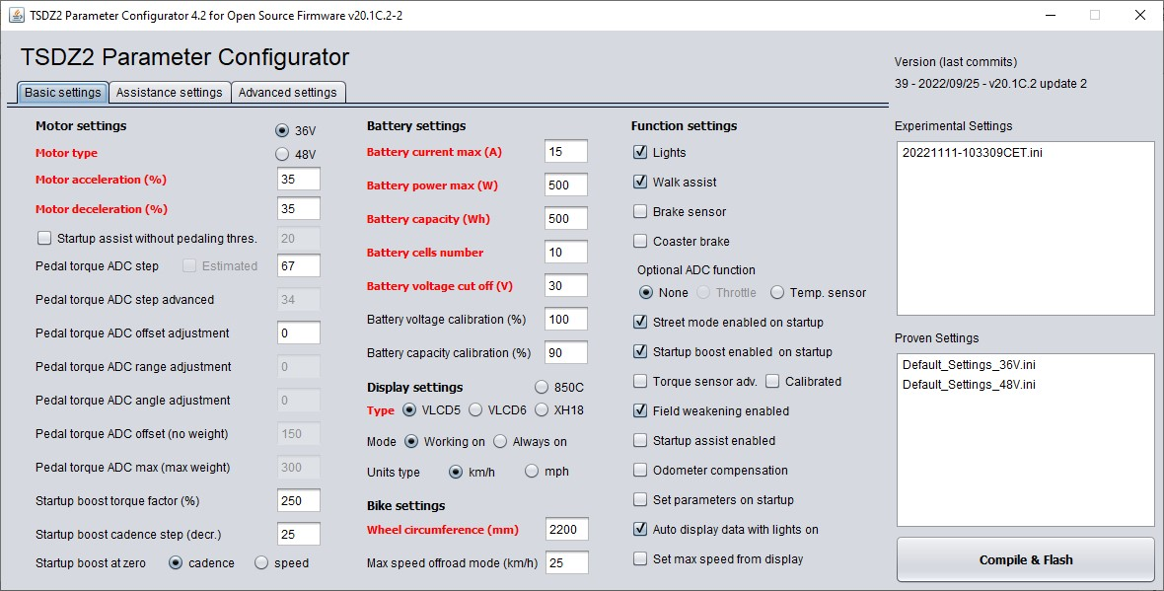
1 - Motor settings
- Motor type
Choice of 48V or 36V motor type, read motor plate data.
Caution. It is not the battery voltage.

- Motor acceleration
Acceleration of the motor.
As a first setting, use low values, then gradually increase if necessary.
Consider the values in the table as maximum values.
Set carefully, aware that setting a higher value than necessary can cause greater stress on the transmission.
Recommended values: 36 Volt motor, 36 volt battery = 35
36 Volt motor, 48 volt battery = 5
36 Volt motor, 52 volt battery = 0
48 Volt motor, 36 volt battery = 45
48 Volt motor, 48 volt battery = 35
48 Volt motor, 52 volt battery = 30
- Motor deceleration
Motor deceleration. If set to zero, the default deceleration ramp is active, if set to 100% the minimum deceleration ramp (faster stop).
The "Motor fast stop" feature of the previous version, is enabled with the deceleration ramp at 100%.

- Start-up assistance without pedaling
Enabled / Disabled.
It can also be enabled / disabled from the display as an alternative to “Lights mode 2”.
Assistance begins by simply pushing on the pedals without turning them.
It is recommended to use this function with the brake sensors installed and enabled.
The minimum thrust needed to start the assistance is adjusted with the next parameter.
It can also be enabled / disabled from the display, see section “Lights configuration”.
By setting “Pedal torque ADC offset adjustment” with a negative value, this feature is disabled (safety).
Attention, by enabling the BOOST function at the same time, the effect increases!
This can cause greater transmission stress.
Note, with Smooth Start function, it is recommended to set this to maximum and let Smooth Start to gradually apply the torque from the slightest pedal push.

- Assist without pedalling threshold
Sensitivity to start assistance without pedal rotation.
As a first setting, use low values, then gradually increase if necessary.
Set to 100% just apply a minimum torque to the pedals. Recommended values 10-30.
- Pedal torque ADC step
Conversion factor of the torque applied to the pedal.
Used only with “Torque sensor advanced on startup” disabled.
It is used to calculate the correct ratio between the assistance factor and the human power (only in "Power assist"), and to obtain a correct value of the human power to be shown on the display
A weight calibration is provided (see specific instructions). After calibration, enter the actual value.
Alternatively, an estimated value can be calculated, see previous parameter.
The value of "Pedal torque ADC step" is inversely proportional to the ADC range of the torque sensor.
If the human power display is of no interest, this parameter can be used to change the ratio when calculating the assistance% values at all levels (only in "Power assist").

- Estimated (24 kg)
Enabled/Disabled. Available only after enabling the torque sensor calibration and entering the actual values of "Pedal torque ADC offset" and "Pedal torque ADC max".
With this function it is possible to calculate an estimated value of “Pedal torque ADC step“ for a weight of 24kg. The value is less accurate than that obtained with calibration, but it is adequate for the purpose.
Attention, by modifying the “Pedal torque ADC step” value, it will also be necessary to modify the% values of the assistance levels in "Power assist" mode.

- Pedal torque ADC step advanced
Conversion factor of the torque applied to the pedal.
It has the same function as the previous parameter, but it is used only with “Torque sensor advanced on startup” enabled and “Torque sensor calibrated” enabled.
It is important for a correct calculation of human power. Do not use to change the amplification of the assistance levels, for this purpose use "Pedal torque ADC range adjustment".
Also for this parameter, an optional calibration with weight is provided (see specific instructions).
The value of "Pedal torque ADC step advanced" is constant, independent of the ADC range of the torque sensor.

- Pedal torque ADC offset adjustment
Parameter for adjusting the ADC offset of the torque sensor. Value from -20 to +20.
Also active with torque sensor calibration disabled.
When you need to increase the sensitivity at the start, for example with a hand-bike, set a negative value. Attention, too low a value can cause an undesired start and / or a delayed stop of the motor.
If, on the other hand, you want to decrease the sensitivity at the start, set a positive value.
With a negative value, it is advisable to disable “Assist without pedaling” and “Startup boost”.

- Pedal torque ADC range adjustment
Parameter for adjusting the ADC range of the torque sensor. Value from -20 to +20.
A negative value decreases the amplification of the range, a positive value increases it.
This variation has an effect at all levels in torque sensing modes.
It is necessary to first enable the torque sensor calibration and enter the actual values of “Pedal torque ADC offset” and “Pedal torque ADC max”. The range value is fixed at 160 (133 with -20, 186 with +20).

- Pedal torque ADC angle adjustment
Parameter for adjusting the initial angle of the torque sensor curve. Value from -20 to +20.
Try with zero value, then adjust to “feel”. With negative value, more gradual response and less consumption. With positive value, more reactive but with higher consumption. See the explanatory chart.
This variation has an effect at all levels in torque sensing modes.
It is necessary to first enable the torque sensor calibration and enter the actual values of “Pedal torque ADC offset” and “Pedal torque ADC max”. With positive value, it is advisable to disable "Startup boost".


Red curve, angle adj = - 20. Green curve, angle adj = 0. Blue curve, angle adj = 20.

- Torque sensor calibrated
Enabled / Disabled. Enable only after having entered the actual values of “Pedal torque ADC offset” and “Pedal torque ADC max”, obtained from the calibration. Enabling without having entered the correct parameters can lead to unpredictable operations. For calibration see the operating manual of the display.
Caution. The ADC values of the torque sensor over time may change, check periodically.
To use the entered parameters, it will also be necessary to enable "Torque sensor advanced".

- Pedal torque ADC offset (no weight)
ADC value of the torque sensor without any push on the pedals.
It is obtained from the calibration procedure to be carried out on the display.
Do not use to change the sensitivity of the torque sensor at the start, for this purpose use “Pedal torque ADC offset adjustment”.

- Pedal torque ADC max (max weight)

ADC value of the torque sensor with the maximum thrust applied to the pedal (cyclist standing, on the right pedal in horizontal position). It is obtained from the calibration procedure to be carried out on the display.

Do not use to change the amplification of the torque sensor range, for this purpose use "Pedal torque ADC range adjustment".

- Startup boost torque factor (%)

It is used to increase the starting assistance and at low cadence.

“Startup boost” must be enabled. Available only in "Power assist" mode.

It works both with standing start and with resuming pedaling in motion (to choose).

The value of this parameter is the percentage increase in torque applied to the pedals with cadence = 0.

This value gradually decreases as the cadence increases, depending on the next parameter.

Set carefully, aware that setting too high a value can cause greater stress to the transmission.

Recommended value 250, maximum 500.

- Startup boost cadence step

It is used to calculate the decrease in the boost torque factor as the cadence increases, until extinction.

Recommended value 25. Limits from 10 to 50, higher value = shorter effect.

- Startup boost at zero, cadence or speed

Startup Boost Mode:

- Cadence It intervenes both starting from a standstill and resuming pedaling with the bike in motion.

- Speed It only intervenes starting from a standstill, recommended for motors with coaster brake.

Startup boost explanatory chart.




2 - Bike settings
- Wheel circumference (mm)
This parameter is used to calculate the speed and kilometers traveled.
Enter the wheel perimeter in millimeters.
Indicative values:
26-inch wheel = 2050 mm
27-inch wheel = 2150 mm
27.5 inch wheel = 2215 mm
28-inch wheel = 2250 mm
29-inch wheel = 2300 mm
It is recommended to measure the actual perimeter and check the distance traveled with GPS.

- Max speed (km/h or mph)

Maximum speed limit in “Offroad mode”.

Beyond this value the motor stops.

Attention, if “Set max speed from display ”function is enabled, this limit is ignored and replaced by the one set on the display.

3 - Battery settings
- Battery current max (A)
Maximum battery current in Amperes.
Set the maximum current that the battery can deliver. Consult the characteristics of the battery.
Maximum recommended value 12 A for 48 V motor, 16 A for 36 V motor.
The maximum value is limited internally by the software to 18 A.
If you set a value near to the maximum, consider installing a temperature sensor.

- Battery power max (W)
Maximum power supplied by the battery in watts.
It is also the motor power limit in OFFROAD mode.

- Battery capacity (Wh)
Total battery capacity in Watt hours.
Calculate the capacity by multiplying the rated voltage by Ah.
Example: a 36 Volt, 17.5 Ah battery has a nominal capacity of 630 Wh..

- Battery cells number
Number of battery cells in series.
This value can be an integer from 7 to 14. 7 for 24 V battery; 10 36 V; 13 48 V; 14 of 52 V.

- Battery voltage cut off (V)
Cut-off voltage for low battery.
If the under-load voltage drops below this value, the controller will automatically lower the current so as not to drop below the minimum voltage limit.
Set this value by checking the characteristics of the cells from the battery.
Example: a 36 Volt battery, 2.9 Volt cut-off voltage x 10 cells = 29 Volt.
Higher values decrease the autonomy but increase the battery life.

- Battery voltage calibration (%)
Parameter to correct the voltage value shown on the display. Example, with a fully charged battery of nominal 36V, the voltage should be close to 42V, if it is lower try to increase the parameter one unit at a time until reading 42V, vice versa if the voltage is higher, the parameter must be decreased.

- Battery capacity calibration (%)

Parameter for setting the actual battery capacity.

Calibration procedure: With the battery fully charged, check the percentage on the display, it must be 99.9%.

At this point, use the bike until the battery is completely exhausted.

Check the residual percentage and calculate the effective percentage value (100 - residual value). Set the

parameter with this value. Example, final residual percentage 8%, effective capacity 92% (100 - 8).

4 - Display settings
- Display type
Choose the type of stock display used.
Choice between VLCD5, VLCD6, XH18, 850C (6-pin connector, TSDZ2 protocol).

- Display working on
Enables the display to turn off after 5 minutes of inactivity.
- Display always on
The display is always on.
This parameter is alternative to the previous one.

- Units type (km/h or mph)
Speed and odometer units type.

The same setting must also be made on the display.

5 - Function settings
- Lights
Enable the use of lights, on and off, via the lights button.
It is recommended to disable if the lights are not installed.

- Walk assist
Enables the use of the walk assist, walking the bike up to 6 km / h.
Attention. It must also be enabled in the hidden display menu.
See the “Walk assist mode” section.

- Brake sensor
Enable the use of brake sensors when installed.
It also enables the functions where the use of sensors is required:
- walk assist debounce delay
- cruise mode without pedal movement
- accelerator
For safety with the sensors installed, even with the function disabled, the motor stop is always active when braking.

- Coaster brake
Enable if you have a coaster brake motor.
To use the functions where the installation of brake sensors is required, also enable "Brake sensor".

- ADC optional disable
Select if throttle or temperature sensor are not installed.

- Throttle
Enable the throttle only if it has been installed.
Only with brake sensors installed and enabled.
Inquire about legislative restrictions regarding use.
At level 0-OFF the throttle is disabled.
Attention, the accelerator is an alternative to the temperature sensor. Both cannot be enabled!

- Temperature sensor
Enable only if the temperature sensor has been installed.
Warning, the temperature sensor is an alternative to the accelerator.
Both cannot be enabled!

- Street mode enabled on startup
Enable STREET mode at startup.
It can also be enabled / disabled from the display.
The STREET mode is a function that can be configured as a legal driving mode, it is possible to limit the
speed and power of the motor.
The throttle. cruise mode and walk assist are disabled. See the section “Street mode”.
Inquire about legislative restrictions regarding speed limit and power limit.

- Startup boost enabled on startup
Enable the BOOST function at power on.
It can also be enabled / disabled from the display.
The BOOST function increases assistance when starting and at low cadence in "Power assist" mode.
Attention, by enabling BOOST and "Start-up assistance without pedaling" at the same time, the effect increases! This can cause greater transmission stress.

- Field weakening enabled
Enabled / Disabled.
It can also be enabled / disabled from the display as an alternative to “Lights mode 1”.
The field weakening function increases the motor cadence (up to 120 RPM when possible) but there is also a loss of efficiency.
If enabled, field weakening is automatically activated when the PWM value reaches 100%.
- Startup assist enabled
Enabled / Disabled. It is used to start from a stationary on difficult climbs.
If enabled, it is activated with the lights on by pressing the “Walk assist”, and button holding it down to start pedaling. After starting, release the button. Usage time is limited to 10 seconds.
With the button pressed, the operation is similar to the throttle but to start you need to pedal, the power delivered depends on the level of assistance and the thrust on the pedals.
Attention, if “Startup assist” is enabled, “Walk assist” is only available with the lights off.

- Torque sensor advanced on startup
Advanced torque sensor mode at power up.
It can also be enabled / disabled from the display.
In advanced mode, the range of use of the torque sensor is optimized.
Calibration required, enter actual values in “Pedal torque ADC offset” and “Pedal torque ADC max”, “Torque sensor calibrated” must be enabled.

- Odometer compensation
Enable the compensation of the kilometers added when viewing the data.
Even when the bike is stationary, all data sent to the display increase the odometer.
By enabling this function, the distance added and not traveled is recovered, during this operation the speed displayed while driving remains at zero until the kilometers have been balanced.

- Set parameters enabled on startup
Enables the setting of the parameters at power on.
It can also be enabled / disabled from the display.

- Auto display data with lights on
Enables the automatic display of data in sequence, when the lights are turned on.
It can also be enabled / disabled from the display.
The type of data, the number of data, the order of the sequence and the display times of each individual data are set in the "Display advanced settings".

- Set max speed from display
Enable the speed limit set on the display.
The limit of the "Max speed" parameter is ignored.
The speed limit always remains active in STREET mode.
Attention, when the speed limit on the display is lower than that in STREET mode, the one on the display
has priority.
Example:
- display limit 30 km / h, STREET limit 25 km / h, limit used 25 km / h
- display limit 20 km / h, STREET limit 25 km / h, limit used 20 km / h
For setting the limit, consult the manual of your display.
Tab 2 – Assistance settings

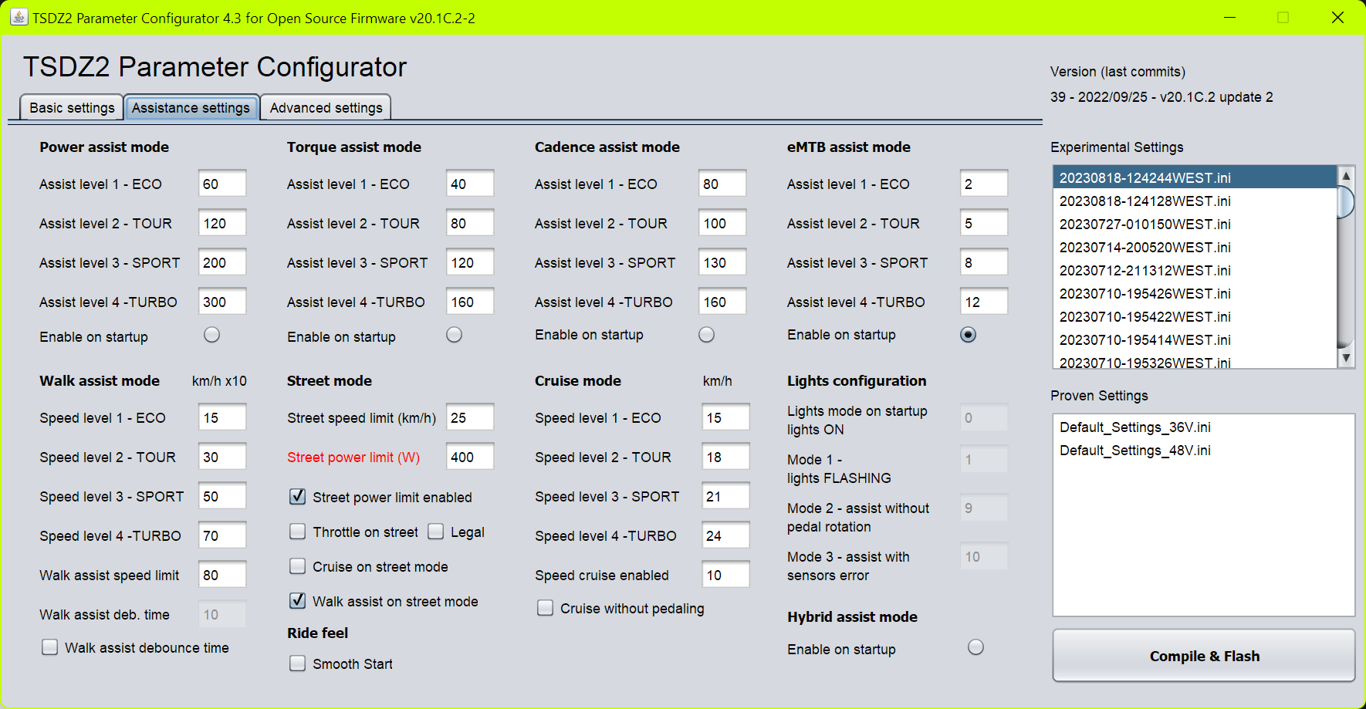
6 – Power assist mode
“Power assist” is an assistance mode proportional to the power on the pedals.
- Assist level 1 - ECO
- Assist level 2 - TOUR
- Assist level 3 - SPORT
- Assist level 4 - TURBO
Set assistance levels according to your needs. Values in percentages, maximum 500%.
For example, applying 100 Watt to the pedals, with 300% assistance, the motor delivers 300 Watt.
These assistance parameters are also used in the hybrid mode.
- Enable on startup
Activates the “Power assist” assistance mode at power on.
7 – Torque assist mode
“Torque assist” is an assistance mode proportional to the torque on the pedals.
- Assist level 1 - ECO
- Assist level 2 - TOUR
- Assist level 3 - SPORT
- Assist level 4 – TURBO
The power delivered by the motor is proportional to the applied torque and the set assistance values.
Set assistance levels according to your needs. Relative values, maximum 254.
These assistance parameters are also used in the hybrid mode.
- Enable on startup
Activates the “Torque assist” assistance mode at power on.

8 – Cadence assist mode
“Cadence assist” is an assistance mode subject to pedal movement.
- Assist level 1 - ECO
- Assist level 2 - TOUR
- Assist level 3 - SPORT
- Assist level 4 – TURBO
The power supplied by the motor depends partly on the assistance values set and partly on the cadence of
the pedals. Relative values, maximum 254.
It is recommended to use this assistance mode with the brake sensors installed and enabled.
- Enable on startup
Activates the “Cadence assist” assistance mode at power on.

9 – eMTB assist mode
“eMTB assist” is an assistance mode with progressive percentage of the torque on the pedals.
- Assist level 1 - ECO
- Assist level 2 - TOUR
- Assist level 3 - SPORT
- Assist level 4 – TURBO
The power supplied by the motor is progressively proportional to the applied torque.
20 predefined sensitivities are available.
Higher values correspond to a more reactive assistance, faster to reach the maximum motor power.
Choose your preferred sensitivity values from those available, from 1 to 20.
- Enable on startup
Activates the “eMTB assist” assistance mode at power on.

10 – Hybrid assist mode
“Hybrid assist” is a combination of the “Torque assist” and “Power assist” assistance modes.
The result is excellent low-cadence assistance typical of Torque mode, and the extension of high-cadence Power mode.
The assistance parameters are the same used in the two modes, combined with the same level.
- Enable on startup
Activates the “Hybrid assist” assistance mode at power on.

11 – Walk assist mode
“Walk assist” is an assistance mode when you want to accompany the bike on foot up to 6 km / h.
Activated with the dedicated button, consult the manual of your display.
- Assist level 1 - ECO
- Assist level 2 - TOUR
- Assist level 3 - SPORT
- Assist level 4 – TURBO
For each level, you set the speed to reach and maintain, in km / h x10 or in mph x10.
Maximum value 60 (6.0 km / h) or 37 (3.7 mph). Try low values ​​and gradually increase.
Recommended values ​​from 25 to 45 (2.5 to 4.5 km / h) or 15 to 28 (1.5 to 2.8 mph).
Starting "Walk assist" there will be an overrun of the set speed, this is an auto calibration.
It is used to define the ratio between wheel speed and engine revs, and to calculate the maximum power required in those conditions of use (gear ratio and slope to be overcome), then it stabilizes at the set speed.
The adjustment is made on the motor revolutions, therefore it remains constant even when setting undetectable speed values.
If necessary, it is possible to repeat the auto calibration, release the button and press again.
The set speed may not be reached due to the power limitation.
With speed sensor problems, walk assist does not work properly.
By enabling “Assist with error” on the display, walk assist will work like previous versions, without speed control.
- Walk assist speed limit
Maximum speed limit in walk assist mode, in km / h x10 or mph x10.
Please inquire about the legal restrictions regarding the speed limit. Maximum value in EU 6 km / h.

- Walk assist debounce time
Enable the debounce time on the walk assist button.
Useful on rough terrain, when a rebound can cause the button to be released unwanted.
Available only with brake sensors installed and enabled.

- Walk assist deb. time
Debounce time value on the walk assist button.
It is recommended to set this time as low as possible, slightly higher than that necessary for the activation of
the walk assist.
Attention, the assistance remains active after releasing the button for the set time.
To stop assistance during this time, change the level.
With display XH18 and VLCD5 it stops only when moving to the upper level.
In any case it is interrupted by passing to level 0-OFF.

12 – Street mode
STREET mode is a function that can be configured as a legal riding mode.
Inquire about legislative restrictions regarding speed limit and motor power.

- Street speed limit (km/h or mph)
Speed limit in km/h or mph, according to the unit of measurement chosen, when STREET mode is enabled.
As the speed approaches this limit value, the motor gradually reduces power until it stops.
This speed limit can be replaced by the one set on the display when the “Set max speed from display” function is enabled.

- Street power limit (W)
Power limit in watts when STREET mode is enabled.

- Street power limit enabled
Enable the power limit in STREET mode.

- Throttle on street mode
Enable the throttle, if installed, in STREET mode.
Available only with mounted and enabled brake sensors.

- Legal (Throttle on street mode)
The operation of the throttle depends on the movement of the pedals.
When you stop pedaling, the motor stops. It could be considered a legal mode.

- Cruise on street mode
Enable cruise mode in STREET mode.
Available in mode with active pedal movement, otherwise only with brake sensors installed and enabled.

- Walk assist on street mode
Enable walk assist in STREET mode.
Disable when “Walk assist debounce time” is enabled.

13 – Cruise mode
“Cruise assist” is a speed control assist mode.
- Speed level 1 - ECO
- Speed level 2 - TOUR
- Speed level 3 - SPORT
- Speed level 4 – TURBO
The value set in the levels is the target speed to be maintained in km / h or mph.
The power supplied by the motor adjusts itself to maintain the chosen speed.
Speed may not be reached due to limited motor power.
The speed limits seen above have priority.
Carefully read the function of the next parameter.

- Cruise without pedaling
Disabled.
The cruise activation mode is subordinated to the movement of the pedals.
Speed is maintained only with minimal pedal movement.
By stopping pedaling the motor stops. It is the default mode.
It can be compared to the “Cadence assist” mode, the difference is that changing the level does not change the power supplied by the motor but the speed to be achieved.
Enabled.
You can maintain your speed even without turning the pedals by pressing the walk assist button.
By releasing the button and stopping pedaling, the motor stops.
It can be compared to an accelerator with speed variation in steps. Increasing the level increases the speed,
decreasing it decreases, at 0-OFF the motor stops.
Available only with brake sensors installed and enabled.
Inquire about legislative restrictions regarding use.
In STREET mode with cruise mode disabled, assistance is activated in “Cadence assist” mode.

- Speed cruise enabled
Minimum speed limit for activating cruise mode, in km / h.
Below this value, assistance in “Cadence assist” mode is active.

- Smooth Start
The Smooth Start feature uses voltage control for precise torque at low speeds, providing a controlled acceleration and enhancing safety. This feature feels more like riding a bicycle than a motorcycle. It allows for quicker acceleration, particularly beneficial for mountain biking. The initial torque increase rate is consistent across different assist levels, ensuring predictability. The torque ramping feature deactivates when certain thresholds are reached, transitioning smoothly to full motor assistance. This feature can be used with all assist levels and other modifiers.
For optimal response, it’s highly recommended to set Motor Acceleration and Deceleration to 100 and Assist without Pedalling threshold to exactly 120.
14 – Lights configuration
- Lights mode on startup
Mode of operation of the lights at startup.
See below the various modes and their codes.
This value can be different from the 3 selectable in the display menu.
- Lights mode 1
- Lights mode 2
- Lights mode 3
Configuration of the light modes, selectable from the menu on the display.
Find out about compliance with current regulations.
Choose the 3 preferred modes among the 9 available.
With light control ON:
0 - on
1 - flashing
2 - on and fast flashing when braking
3 - flashing and on when braking
4 - flashing and fast flashing when braking
5 - on and on during braking also with light control OFF
6 - on and fast flashing when braking even with the light control OFF
7 - flashing and switched on when braking even with the light control OFF
8 - flashing and fast flashing when braking even with the light control OFF
The braking modes are only available with the brake sensors installed.

- Alternative functions to the configuration of the lights
If the brake sensors are not installed, the usable light modes are only: 0 = on, 1 = flashing, for this just configure "Lights mode1”.
“Lights mode 2” and “Lights mode 3” can then be used to set other functions on the display.
Lights mode 2
9 – “Start-up assistance without pedalling”, to enable/disable assistance at start without rotating the pedals.
Lights mode 3
10 – “Assistance with sensors error”, to enable assistance even in the presence of an error caused by a sensor failure. At power on, it is always disabled.
Tab 3 – Advanced settings

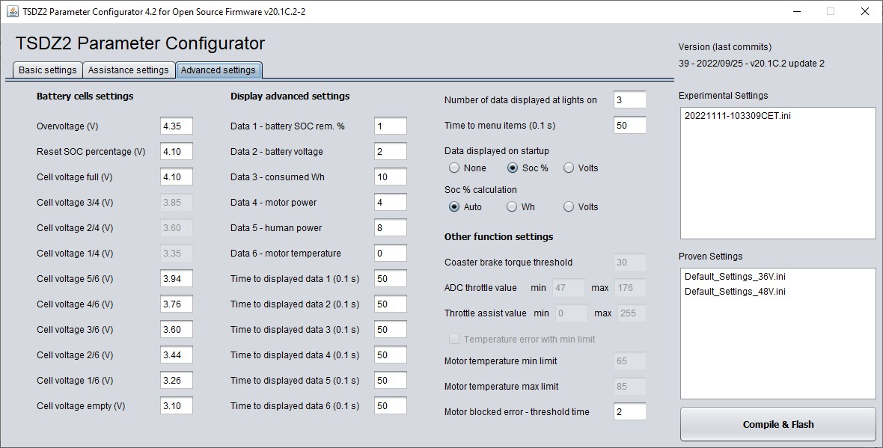
15 – Battery cells settings
- Overvoltage (V)
Value beyond which the error E08-ERROR_OVERVOLTAGE is displayed.
Possible if you set the wrong number of cells in series.
The unit of measurement of this and subsequent parameters is in Volts (of each single cell).

- Reset SOC percentage (V)
Value for automatic reset to 99.9% of the percentage of residual capacity, with battery fully charged.
Recommended values from 4.10 to 4.15, otherwise with lower values, after a short turn, if the voltage does not fall below this value, when it is switched on again it resets to 99.9 again. If the battery is not fully charged and the voltage is lower than this value, the reset is not automatically activated. If desired, it can be done manually by activating the procedure provided.

- Cell voltage full (V)
Minimum voltage value to display the complete battery charge status, 4 bars with VLCD6 and XH18 display, 6 bars with VLCD5.

- Cell voltage 3/4 (V)
- Cell voltage 2/4 (V)
- Cell voltage 1/4 (V)
Voltage value to display intermediate charge states.
From 1 to 3 bars, for VLCD6 and XH18 displays.

- Cell voltage 5/6 (V)
- Cell voltage 4/6 (V)
- Cell voltage 3/6 (V)
- Cell voltage 2/6 (V)
- Cell voltage 1/6 (V)
Voltage value to display intermediate charge states.
From 1 to 5 bars, for VLCD5 displays.

-Cell voltage empty (V)
Voltage value to display the state of the completely discharged battery, 0 bars.
Attention, this is the no-load voltage without load, it is not the cut-off value.
For all these parameters, check the technical characteristics of the cells used.

16 – Display advanced settings
- Data 1
- Data 2
- Data 3
- Data 4
- Data 5
- Data 6
Configuration of the data shown on the display.
Choose the data to be displayed, in the type and in the preferred order among those available.
0 – motor temperature, only with sensor installed (° C)
1 - remaining battery charge (%)
2 - battery voltage (Volt)
3 - battery current (Amp)
4 - power absorbed by the motor (Watt / 10)
5 - throttle adc value (8 bit)
6 - torque sensor adc value (10 bit)
7 - pedal cadence (rpm)
8 - human power (Watt / 10)
9 - torque sensor range (10 bit)
10- consumed Wh

- Time to displayed data 1 (0.1 s)
- Time to displayed data 2 (0.1 s)
- Time to displayed data 3 (0.1 s)
- Time to displayed data 4 (0.1 s)
- Time to displayed data 5 (0.1 s)
- Time to displayed data 6 (0.1 s)
If the "Automatic data display with lights on" function is enabled, the selected data is displayed in sequence when the lights are switched on.
These are the display times of each single data. The maximum value is 255 = 25.5 seconds.
By setting a time to zero, the data is displayed continuously, without time limit.
You can interrupt the data display by turning off the lights.
Changing the level before the end of the time takes you to the next data.
If the “Set parameters” function is enabled, the code and status of the selected parameter is first displayed.
- Number of data displayed at lights on
Number of data displayed automatically when the lights are turned on.
Value from 1 to 6.

- Time to menu items (0.1 s)
Time limit between the first pressure of the light button (on) and the second of confirmation (off), in the procedure for setting the parameters, if enabled.
It is also the time within which, after confirmation and with flashing code, it is possible to pass to the next parameter.
Beyond this time, if the parameter change is not confirmed, the “Auto display data with lights on” function is activated, if enabled.
It is also the display time of the selected data at power on.

- Data displayed on startup
Choice of data to be displayed at power on.
Available data: None = no data, Soc% = residual battery percentage, Volts = battery voltage.
- Soc % calculation
Choice of the method for calculating the remaining battery percentage.
Auto - soc%, calculation with Wh used.
Automatic reset at power on, when the soc% calculated with Wh used is different from that calculated with the voltage (+/- 15%), useful when you put a battery that is not fully charged.
Wh - soc% calculation with used Wh, reset only with fully charged battery (100%) or manual.
Volts - soc%, calculation with battery voltage, it is less accurate than the previous ones.
It can be useful if you have two batteries of different capacities
To obtain a correct correspondence between soc% and voltage, it may be necessary to calibrate the values of “Cell voltage x / x”, as for the bars.
17 – Other function settings
- Coaster brake torque threshold
Coaster brake sensitivity when pushing the pedals backwards.
The "Coaster brake" function must be enabled.
Attention, if you change the value of “Pedal torque ADC offset”, it may also be necessary to change this.

- ADC throttle value min
- ADC throttle value max
Throttle ADC input adjustment range, relative minimum and maximum values.
Check the “throttle adc value (8 bit)” values on the display, with throttle at minimum and maximum.

- Throttle assist value min
- Throttle assist value max
Throttle assistance adjustment range, minimum and maximum values. Limit value 255.

- Temperature error with min limit
If enabled, the error code E06 - ERROR_OVERTEMPERATURE is displayed when the minimum temperature limit is exceeded. If disabled when the maximum limit is exceeded.
Only available with installed temperature sensor.

- Motor temperature min limit
Set the temperature from which the motor protection will start, limiting the power. The power gradually decreases up to the maximum temperature limit, then the motor stops.

- Motor temperature max limit
Set the maximum motor temperature. At this temperature the motor will be turned off.
Values in degrees Celcius.

- Motor blocked error
ERROR_MOTOR_BLOCKED parameters for blocked motor or wheel control.
They have been moved to config.h to be able to easily modify them according to your needs.
The default values are for immediate intervention and to preserve the blue gear.
Change them in case of unwanted interventions.
MOTOR_BLOCKED_COUNTER_THRESHOLD, intervention time from 1 to 10 (1 = 0.1 seconds)
Threshold current and Threshold ERPS, are no longer present in the configurator.

18 – Compile & Flash
Attention. PC and motor must be connected via ST-LINK V2.
Make sure that ST Visual Programmer is closed.
Pressing the “Compile & Flash” button starts a series of operations automatically.
- A timestamp.ini file is created with the current settings in the “experimental settings” folder.
- The config.h file is saved with the new parameters.
- A "Command prompt" window opens.
- The files of the previous compile are deleted.
- The compile starts and when it is done, the main.ihx file is created.
- Flashing the main.ihx program file in the motor controller.
- Flashing the data.ihx data file empty, to delete the old data in the eeprom memory.
- When the operations are completed without errors, the "Command prompt" window closes automatically.

At the end, once the procedure is complete, click on "Eject device" at the bottom right next to the clock and disconnect the cable between the PC and motor.
Caution. During programming, the display must be off!
By pressing the "Compile & Flash" button without connecting the PC to the motor, there will be an error message in the "Command prompt" window, but all files will still be created and saved for later use.
In Windows Explorer, the timestamp.ini file can be moved to the "Proven Settings" folder and renamed, for example "mySetting.ini", for better recognizability.
In the configurator window, at the top right, the release date, number and description of the last "commit" on the GitHub repository are specified.
To get the latest version, check if there are any other commits after the release date and if subsequent changes are of interest.

