TSDZ2 with 860C

OSF version V20.1C.5 update 2
Features and configuration

CAUTION:
- Before using the bike with display and motor, read the manual carefully. Consult the laws of your country regarding road circulation with pedal-assisted bicycles.
- You can flash the firmware using a "bootloader box" connected between the display connector and the PC.
There are three recent versions of the 860C display, for each use the specific .bin file.
- Before flashing, if there is already an older version on the display, make a note of the Odometer value and the battery Charge cycles, so that it can be entered in the new version.
- Battery Setting. Do not exceed 15 Amps (36 Volts battery), 12 Amps (48 Volts battery), 10 Amps (52 Volts battery) or you run the risk of overheating your motor.
- Always use the same firmware version for both the TSDZ2 motor controller and display!
- Before using the TSDZ2 and display with new firmware, you must correctly configure the options on the display. For example, you should configure your battery’s low voltage cut-off so as not to over-discharge the battery. Do set all other parameters also to ensure proper operation.
- When installing new firmware, always check that no unwanted functions have become enabled or disabled during the install process.
- It is recommended that when installing OSF V20.1C configuring the display and motor using this guide that you take safety precautions. When the display is first turned on, you should keep the rear wheel off the ground in case the motor starts. For extra precaution, you should install brake cutoffs and have them easily accessible as well as be ready to disconnect or cut off power to the battery.
- Each time the display is turned on, do not touch the pedals for at least 5 seconds, until the system finishes booting...

860C Display Navigation
Boot screen
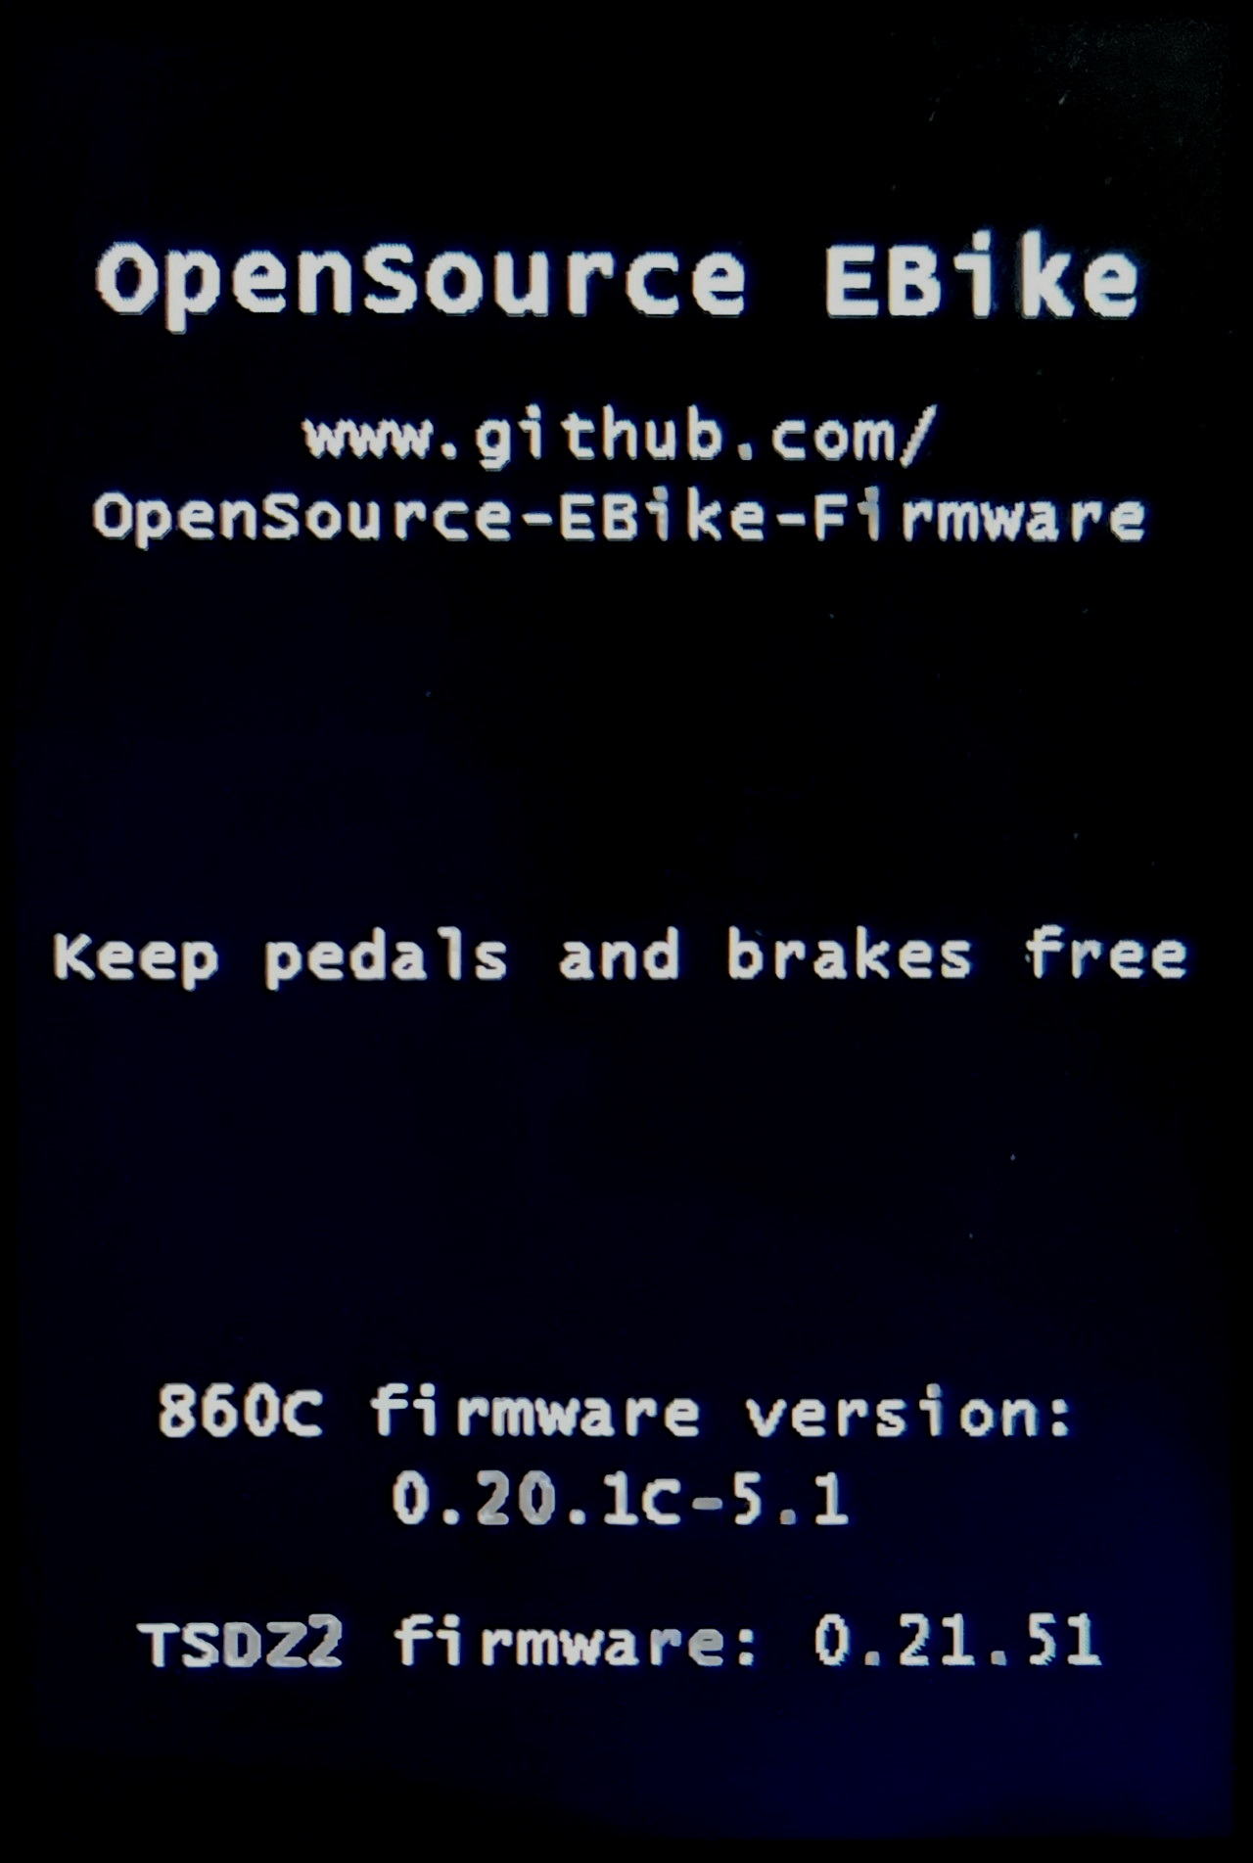

When the display is turned on, the boot screen appears for 2 seconds.
There is information about the open source firmware, the need to keep the pedals free when turning on, the firmware versions of the display and the motor.
If 2 seconds are not enough to read the info, hold down POWER as long as necessary.
Error messages may also be displayed if the boot fails.
Main screen
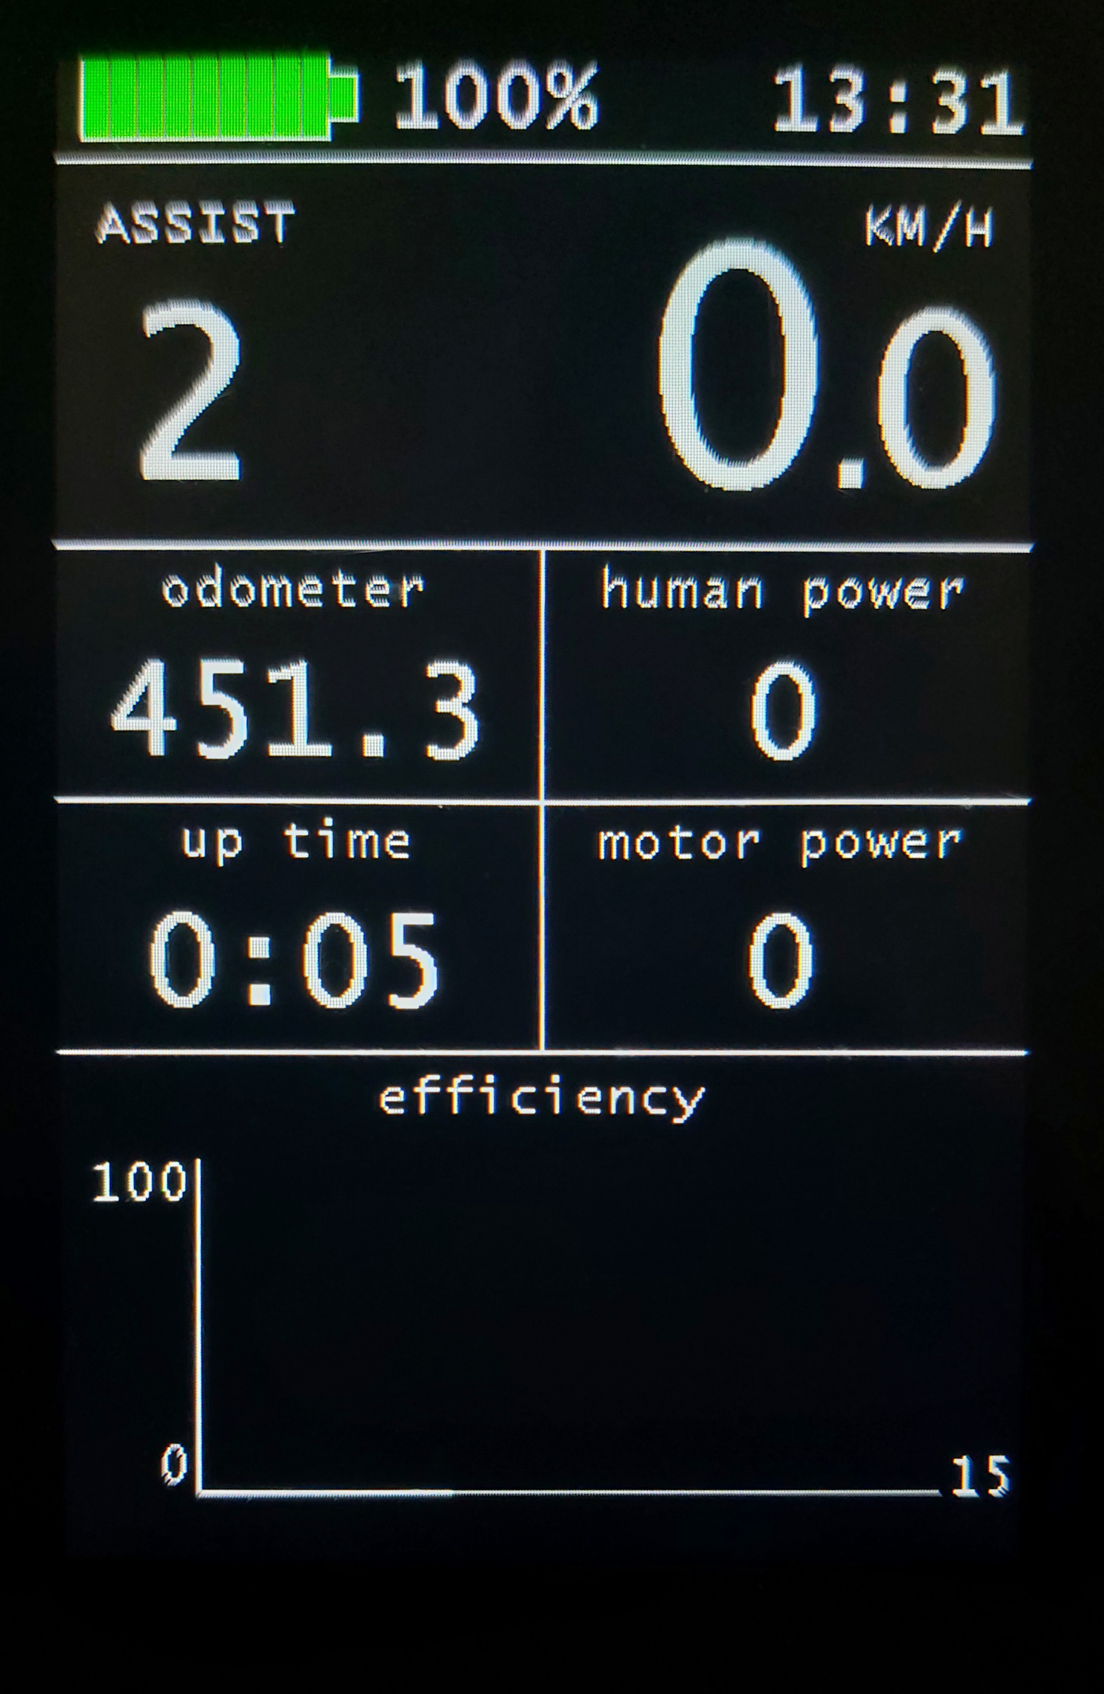
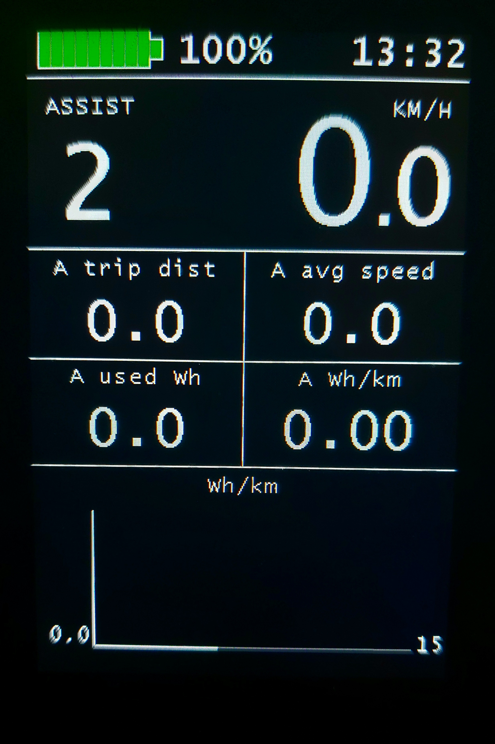
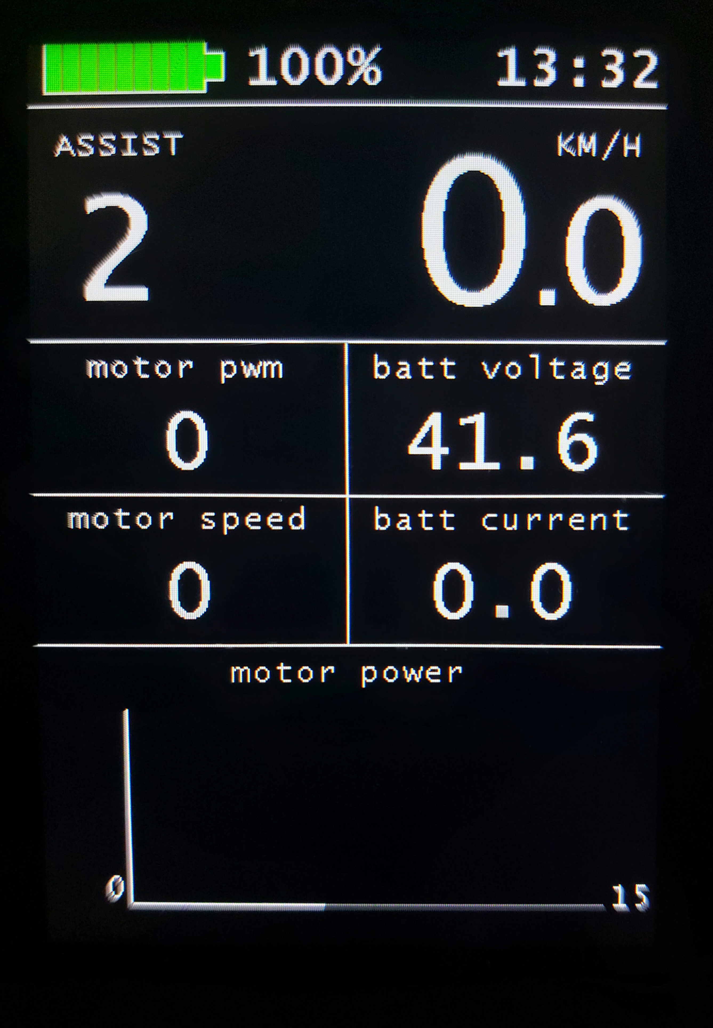
NOTE: The display has 3 different main screens with customized numeric and graph fields on each main screen. You can change the information/variables shown on these customized fields.
- Turn on/off: POWER (ON/OFF ) long-press,
- Change assist level: UP (+) or DOWN (-) click
- Change assist mode: At level 0 (zero,), POWER click to view the current mode, UP/DOWN click to change, POWER click to confirm.
- Turn on/off the lights: UP long press
- Startup assist: press and hold the UP key (startup assist must be enabled in the configuration menu)
- Walk assist: press and hold the DOWN key (walk assist must be enabled in the configuration menu)
- Street mode on/off: while pressing DOWN, long-press POWER (only if the hotkey is enabled in the configuration menu)
- Virtual throttle: in "Motor max power" mode, while pressing UP, long-press POWER (only if the hotkey is enabled in the configuration menu)
- Alternate main screen: POWER click, with assistance level greater than zero
- Enter configurations screen: simultaneous POWER, UP and DOWN, long press
With a assist level greater than zero, you can directly access the configuration screen by long pressing the MENU (M) key, if present.
Change variables on numeric fields or graph
- At zero level, long press the MENU key activates the customization of the numeric fields and graphs in the 3 main screens
- The first selected field flashes
- Choose a new variable: click UP or DOWN
- Jump to next fields: POWER click
- Exit: long press the MENU key
Assist mode
There are 5 assistance modes available, the choice is on the main screen.
- POWER ASSIST assistance proportional to the power on the pedals
- TORQUE ASSIST assistance proportional to the torque on the pedals
- CADENCE ASSIST assistance subordinated to the movement of the pedals
- EMTB ASSIST assistance with a progressive percentage of the torque on the pedals
- HYBRID ASSIST combined torque + power assistance
At level 0, POWER key to view the current mode, UP/DOWN button to change, POWER key to confirm.
Assistance values for all modes from 1 to 255.
“Hybrid assist” is a combination of the “Torque assist” and “Power assist” modes. The result is excellent low-cadence assistance typical of Torque mode, and the extension of high-cadence Power mode. The assistance parameters are the same used in the two modes, combined with the same level.

Available information to show on display
There are a few variables that can be selected to be shown on the customized numeric fields or graph. Note that only some of them are available to be shown on the graph. The underlined variables can be shown on the graph as well as in the numeric fields.
Variable | Description
up time | Time elapsed since the display was turned on.
odometer | Total number of km or miles traveled.
A trip dist | Amount of km/miles counted from the startup of the trip A
A trip time | Time spent on the move, from the start of the journey A
A avg speed | Average speed of trip A
A max speed | Maximum speed reached on trip A
A used Wh | Battery energy used in the trip A
A Wh / km (mi) | Battery energy used by each km/mile in trip A
B trip dist | Amount of km/miles counted from the startup of the trip B
B trip time | Time spent on the move, from the start of the journey B
B avg speed | Average speed of trip B
B max speed | Maximum speed reached on trip B
B used Wh | Battery energy used in the trip B
B Wh / km (mi) | Battery energy used by each km/mile in trip B
trip distance | Amount of km/miles counted from the startup of the trip.  There are two trips available, A and B.
speed | Current speed in km/h or mph.
cadence | Pedal cadence measured using the PAS sensor inside the TSDZ2 motor.
human power | Pedal human power.  This is calculated with a torque sensor ADC value obtained from calibration with a weight in kg or lbs.  pedal-torque in Nm is calculated as pedal-torque = weight Kgs on pedals * 9.81 (gravity) * 0.17 (0.17 is the arm cranks size)  pedal power in watts is calculated as: pedal power = (pedal-torque * pedal cadence * 2 * pi) / 60
motor power | This value is calculated by multiplying the battery current by the battery voltage.
Wh/km (Wh/mi) | Battery energy used for each km/mile since the display was turned on.
batt voltage | Battery voltage measured by the TSDZ2 motor controller.
batt current | Battery current measure by the TSDZ2 motor controller.
battery SOC | Battery state of charge (%), based on counting the amount of power pulled from the battery to power the TSDZ2 motor.
motor current | Motor current. This value is calculated as: motor current = measured battery current / PWM duty-cycle. Note that PWM duty-cycle value varies between 0 and 1.
motor temp | Motor temperature. Note that if the temperature sensor is not installed, this value has no meaning.
motor speed | In ERPS (electric rotation per second) units. The motor has 8 pairs of magnets inside, meaning each 1 ERPs equal to one RPS (rotation per second).
motor pwm | Motor PWM duty-cycle. This value can fluctuate between 0% and 100% max. Where 0 means 0 battery voltage applied to motor coils while 100 means max battery voltage applied. When this value hits the max of 100, means that the motor max power possible is being applied.
motor foc | Angle calculated by FOC algorithm, between 0 and 13. Higher motor phase current and/or higher motor speed makes this value increase.
efficiency | Percentage value of mechanical/electrical efficiency of the motor (power delivered to the wheel / power absorbed by the battery), shown in real time.
Configuration Menu
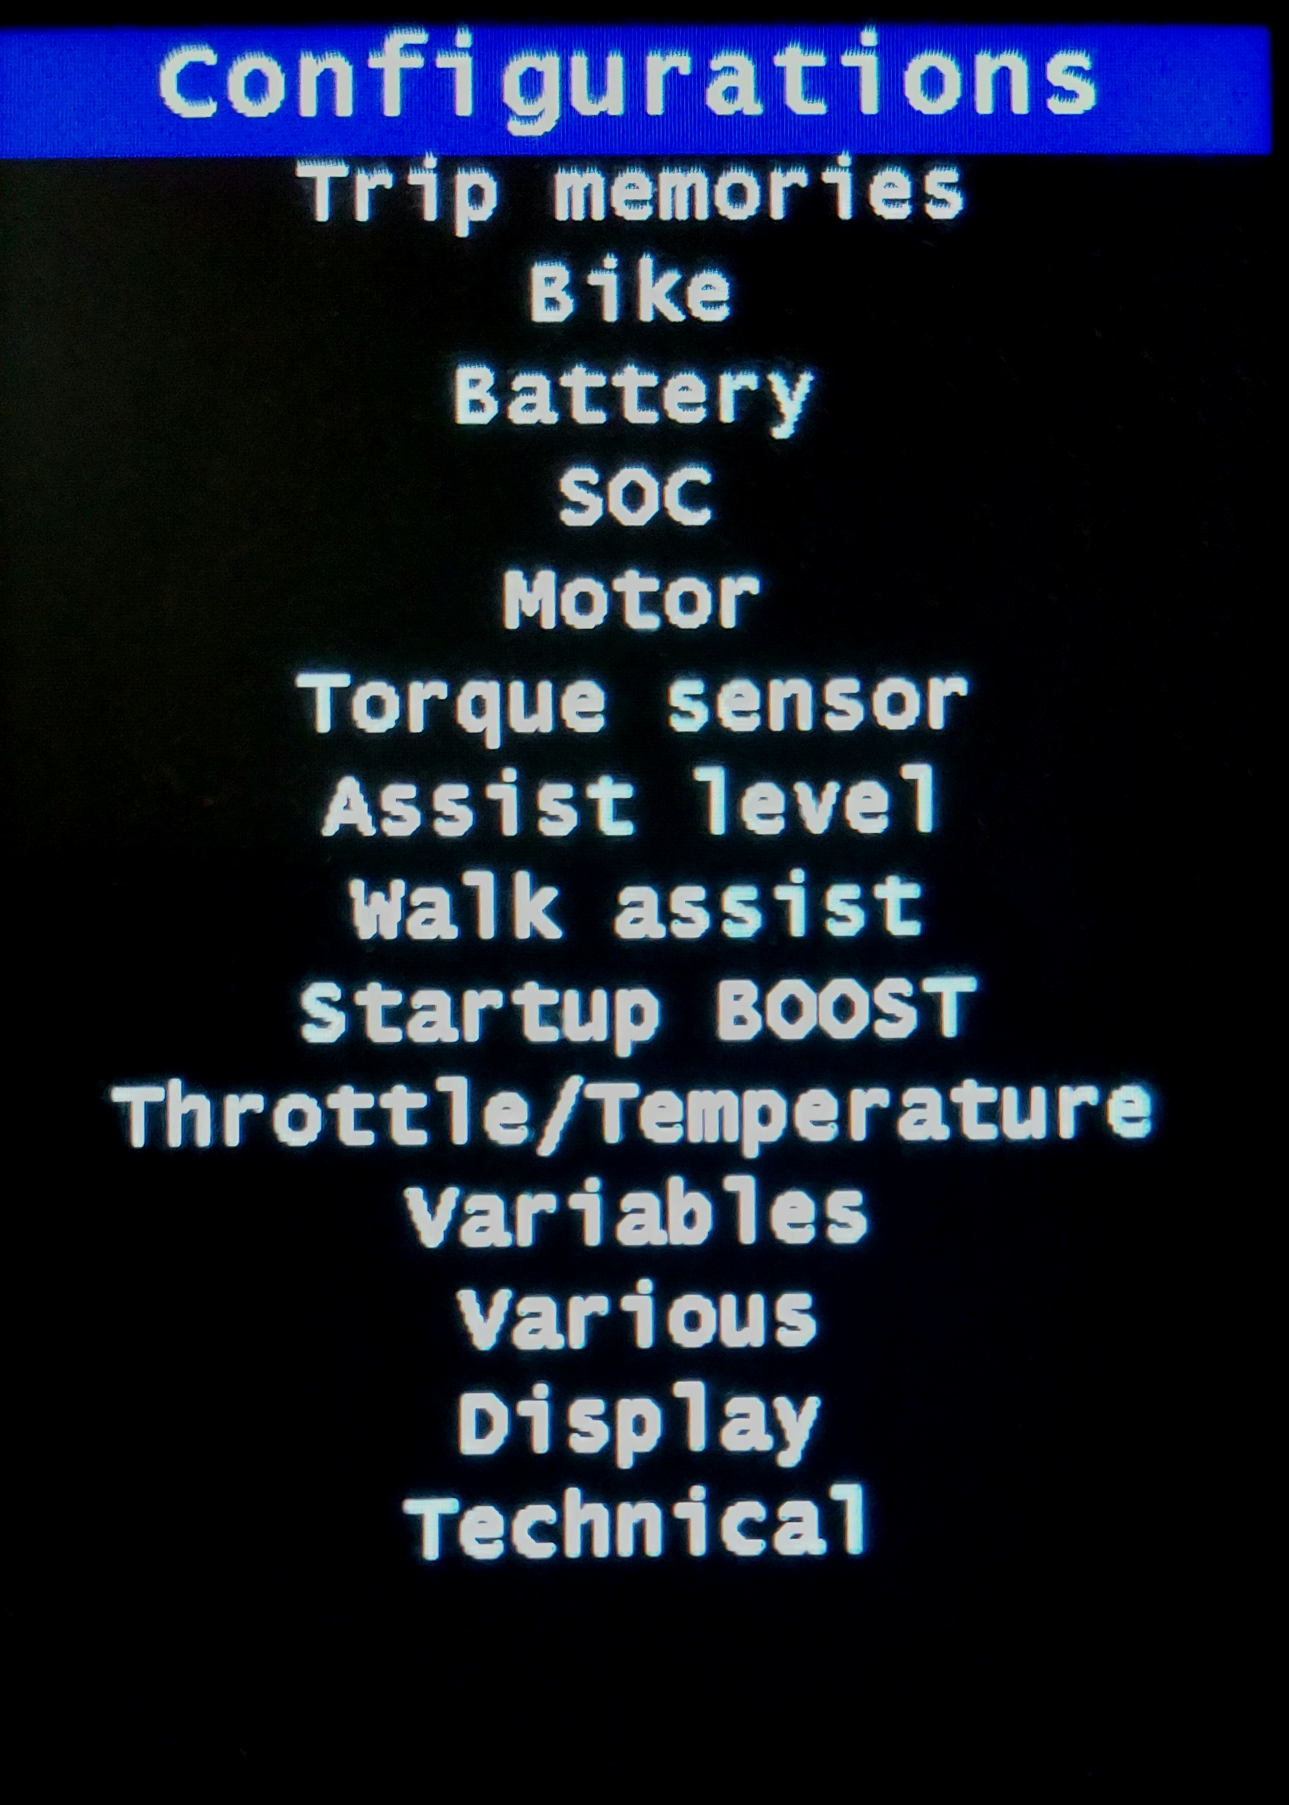

Navigating the Configuration Menu
- Enter Configuration Menu: Press and hold UP and DOWN, then immediately long-press POWER.
(There is a hotkey on the 860C which is a long press on the MENU key, with assist level greater than zero).
- Exit: POWER long press to go back
- Scroll up or down: UP or DOWN click
- Edit item: MENU click
- Change value: click UP or DOWN
- Apply: MENU click
Trip Memories
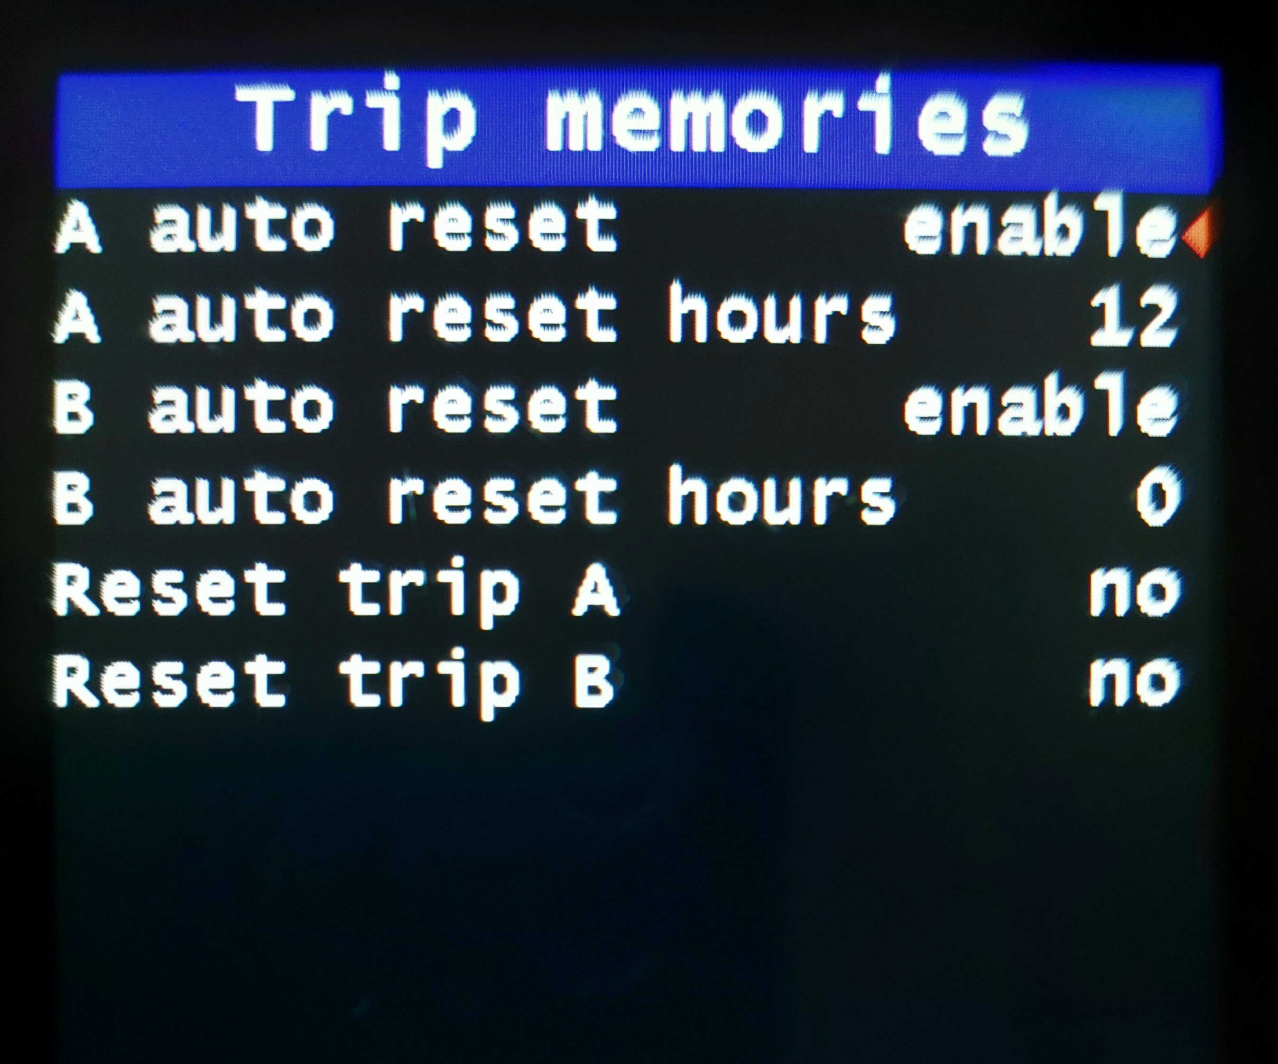

Name | Recommended value | Description
A Auto Reset | enable | This setting will auto-reset your trip A after the number of hours defined in “ Auto Reset Hours”.
A Auto Reset Hours | 12 | Number of hours before automatic trip reset A.  The hour countdown begins when the display turns off.  If you turn on the display during the countdown and resume your trip, the countdown will start again from the beginning.  Set to zero, trip reset at fully charged battery.
B Auto Reset | enable | This setting will auto-reset your trip B after the number of hours defined in “B Auto Reset Hours”.
B Auto Reset Hours | 0 | Number of hours before automatic trip reset B.  The hour countdown begins when the display turns off.  If you turn on the display during the countdown and resume your trip, the countdown will start again from the beginning.  Set to zero, trip reset at fully charged battery.
Reset Trip A | no | If you change this to yes, it clears trip A
Reset Trip B | no | If you change this to yes, it clears trip B

Bike
Replaces the Whell and Street menus.
All parameters in this menu can be password protected.
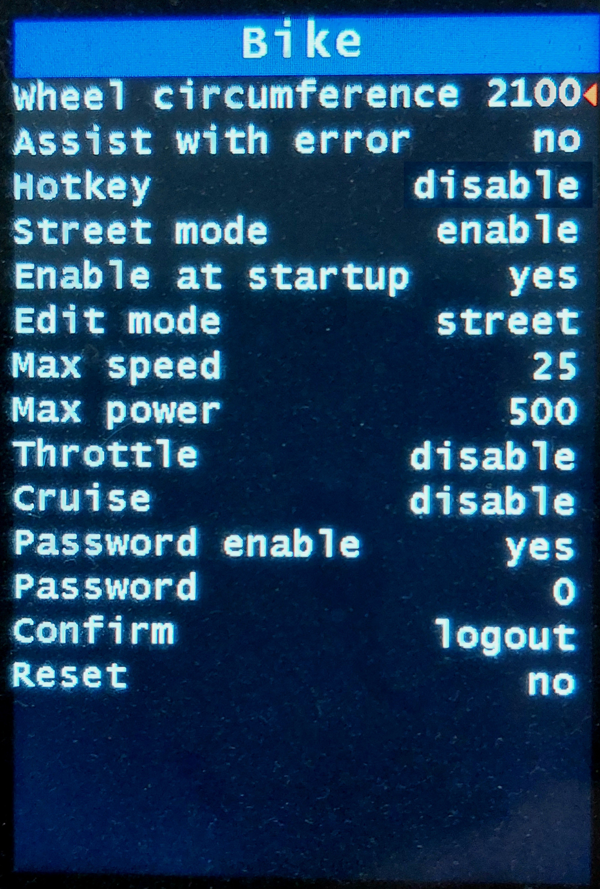

Name | Recommended value | Description
Wheel circumference | 2100 | Enter your wheel circumference so that speed and distance are calculated correctly. Tip: Google how to measure wheel circumference.  The following are approximate values ​​for quick setup.  Remember to calibrate with GPS for more precise adjustments.  20-inch wheel = 1595 mm  24-inch wheel = 1830 mm  26-inch wheel = 2060 mm  27-inch wheel = 2150 mm  27.5-inch wheel = 2215 mm  28-inch wheel = 2250 mm  29-inch wheel = 2300 mm
Assist with error | No | No / Yes. An error disables assistance in all modes.  However, assistance can be forced even in the event of an error if it is caused by a sensor problem (torque, cadence, or speed sensor).  You will need to select the assistance mode that does not use the faulty sensor.  Use only when necessary; with this feature enabled, assistance is limited.  See error codes below.
Hotkey | disable | Disabled/Enabled, enables activation via a button combination, the following functions:  Street/Offroad Mode.  Virtual throttle.
Street mode | enable | Enabled / Disabled, If this function is enabled, Street mode is active, if disabled, Offroad mode.
Enable at startup | yes | Determines whether Street mode should be active at system startup.
Edit mode | street | Street / Offroad, selection for subsequent parameters that are in shared fields.  Choose the mode to view and edit.  When accessing the menu, the Street mode parameters are always displayed.
Max speed | 25 km/h | This field is shared between Street and Offroad.  Speed limit with motor assistance in km/h or mph.  As the speed approaches this value, the motor gradually reduces power until it stops.  Check your country's legal restrictions regarding speed limits.
Max power | 500 | This field is shared between Street and Offroad.  Maximum motor power. Set a value that minimizes motor overheating and is compatible with the power the battery can deliver.  The maximum current used as a limit is the lower of "Max current" in the Battery menu and the value calculated with "Max power" / "Battery voltage".  A maximum value of 500W is recommended. Be careful, it must not be continuous!  Values ​​can only be modified in this menu.  In the Motor menu, the "Max motor power" item is display only.
Throttle | disable | This field is shared between Street and Offroad.  Enable / disable throttle if installed,  Choice:  - disabled: throttle disabled.  - pedaling: the operation of the throttle depends on the movement of the pedals.  When you stop pedaling, the motor stops.  - 6 km/h only: the throttle is only enabled up to 6 km/h, even without pedaling.  - 6 km/h & pedaling: the throttle is enabled up to 6 km/h without pedaling, beyond 6 km/h pedaling is required.  - unconditional: the throttle is always enabled, without conditions.  Regarding the use, find out about the legislative restrictions of your country.  The installation of brake sensors is recommended.  At 0-OFF level the throttle is disabled.  The choice also applies to the virtual throttle.
Cruise | disable | This field is shared between Street and Offroad.  Enable / disable the cruise function, Walk assist must also be enabled,  Choice:  - disabled: cruise function disabled.  - pedaling: the operation of the cruise depends on the movement of the pedals.  When you stop pedaling, the motor stops.  - unconditional: the cruise function is always enabled, without conditions.  Regarding the use, find out about the legislative restrictions of your country.  The installation of brake sensors is recommended.  At 0-OFF level the cruise mode is disabled.  Use: by pressing and holding the DOWN button at speeds above 9 km/h and with the function enabled, the current speed is memorized and maintained for as long as the button is pressed.  Speed may not be achieved due to limited motor power.  The speed limit takes priority.
Password enable | yes | No / Yes. Enables the use of a password.  It can only be disabled with the default password.  It can no longer be disabled after changing the password.
Password | 0 | Enter your password. The default one, to be used at the first access, is 1000.  With the default password it is not possible to change the parameters but only to enter a new password, or disable it.  Valid passwords from 1001 to 9999.  After entering the password, you need to confirm with login or change.
Confirm | logout | Operation on the entered password,  Choice:  - logout: closes access to password-protected parameters. Or the logout is automatic by exiting the configuration menu.  - login: to confirm the entered password, if valid, the wording login is kept and the protected parameters can be modified or a new password entered, otherwise it changes to logout.  - change: to confirm the password change, choice possible only after having logged in and entered the new password. After confirmation with change, login is automatic. This operation must be done at the first login.  - wait: waiting for confirmation (login or change) after entering the password.
Reset | no | In case of forgotten password, set Reset = yes.  Turn off the display within 10 seconds and update the firmware (re-flashing).
Battery
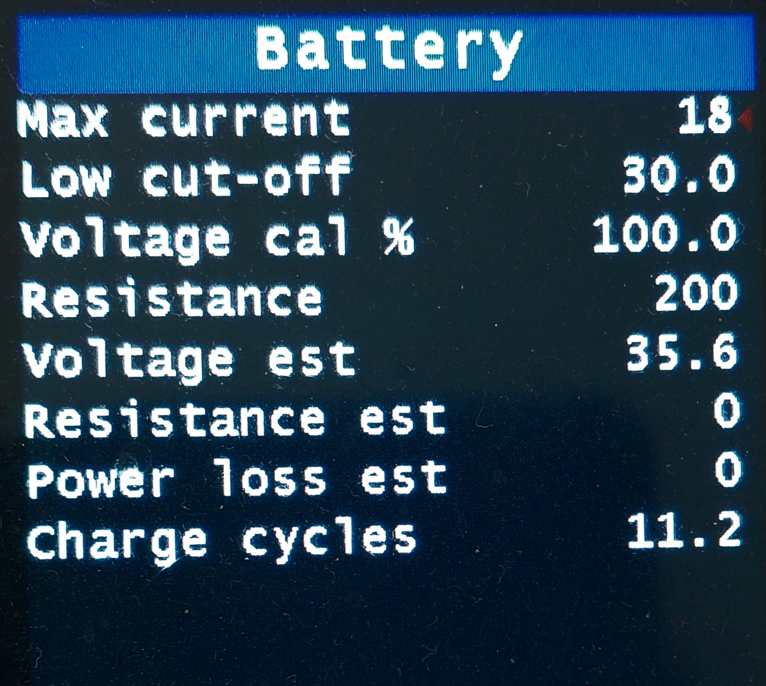

Name | Recommended value | Description
Max current | 12 Amp | Set maximum allowable current to be pulled from the battery - this value is a technical characteristic of your battery, you need to find it on your battery user manual or ask the manufacturer. Also, the TSDZ2 has its own limit of the max current it can pull from the battery that is 18 amps so the TSDZ2 firmware limits this value (no point for you to set up a higher value than 18).  The maximum value can be lower, see “Max power” in the Bike menu.  Recommended values: 15 Amps (36 Volts battery), 12 Amps (48 Volts battery), 10 Amps (52 Volts battery).  If you set it above these values, do not run this motor above 450 watts for more than a few minutes without installing the temperature sensor..
Low cut-off | 39 volts | The controller will reduce power to stay over this limit!  NOTE: You should only use a battery with a BMS to avoid dangerous conditions.  Calculate the Low cut-off limit by multiplying the number of cells in series with the safe cut-off-voltage per cell, which is usually between 2.8 - 3.0 volts. Example:  30.0 volts: 10 cells in series * 3 volts = 30.0 volts.  39.0 volts: 13 cells in series * 3 volts = 39.0 volts.  42.0 volts: 14 cells in series * 3 volts = 42.0 volts.  Note that by setting a high Low cut-off limit you will make less deep discharging cycles of your battery meaning the battery life will be increased AND you will then have less energy available to use and so less range.
Voltage cal % | 100.0 | Parameter to correct the voltage value shown on the display.  Example, with a fully charged battery of nominal 36V, the voltage must be close to 42V, if it is lower try increasing the parameter one tenth at a time until reading 42V, vice versa if the displayed value is higher, the parameter must be decreased.
Resistance | 200 milliohms | The battery SOC (State Of charge) indicator uses the battery resistance to consider the power loss inside the battery resistance and also the resistance on the cables. See Resistance set field instructions to know how you can get this value.  See Resistance auto estimate to enter as this number.
Voltage auto estimate | - | Real-time battery voltage value that is filtered using the battery pack resistance. If the battery resistance value is correct, this voltage should almost not change when the motor is not running or when the motor is running and pulling a high current from the battery.
Resistance auto estimate | - | Battery resistance estimated value that is automatically calculated so you can assess his value and then configure the Resistance field.  How to start the automatic battery pack resistance estimation:  start with the battery already discharged, with any value between 75% and 25%  - start pedaling for 10 consecutive seconds, make the motor pull high current value from the battery like 10 amps (use a high assist level). After 10 seconds you should see a value on the field. For battery pack of 14S3P 3500 mAh cells, I get a value near 200 milliohms.  - repeat the previous step a few times to make sure you always get a similar value  - set the measured value Resistance field (I always round up the value)
Power loss auto estimate | - | Power loss estimated value that happens inside the battery pack due to battery and cables resistance.
Charge cycles | 0 | Full battery charge cycles counter  You can also change the value, for example when replacing the display, or by setting it to zero with a new battery.

SOC
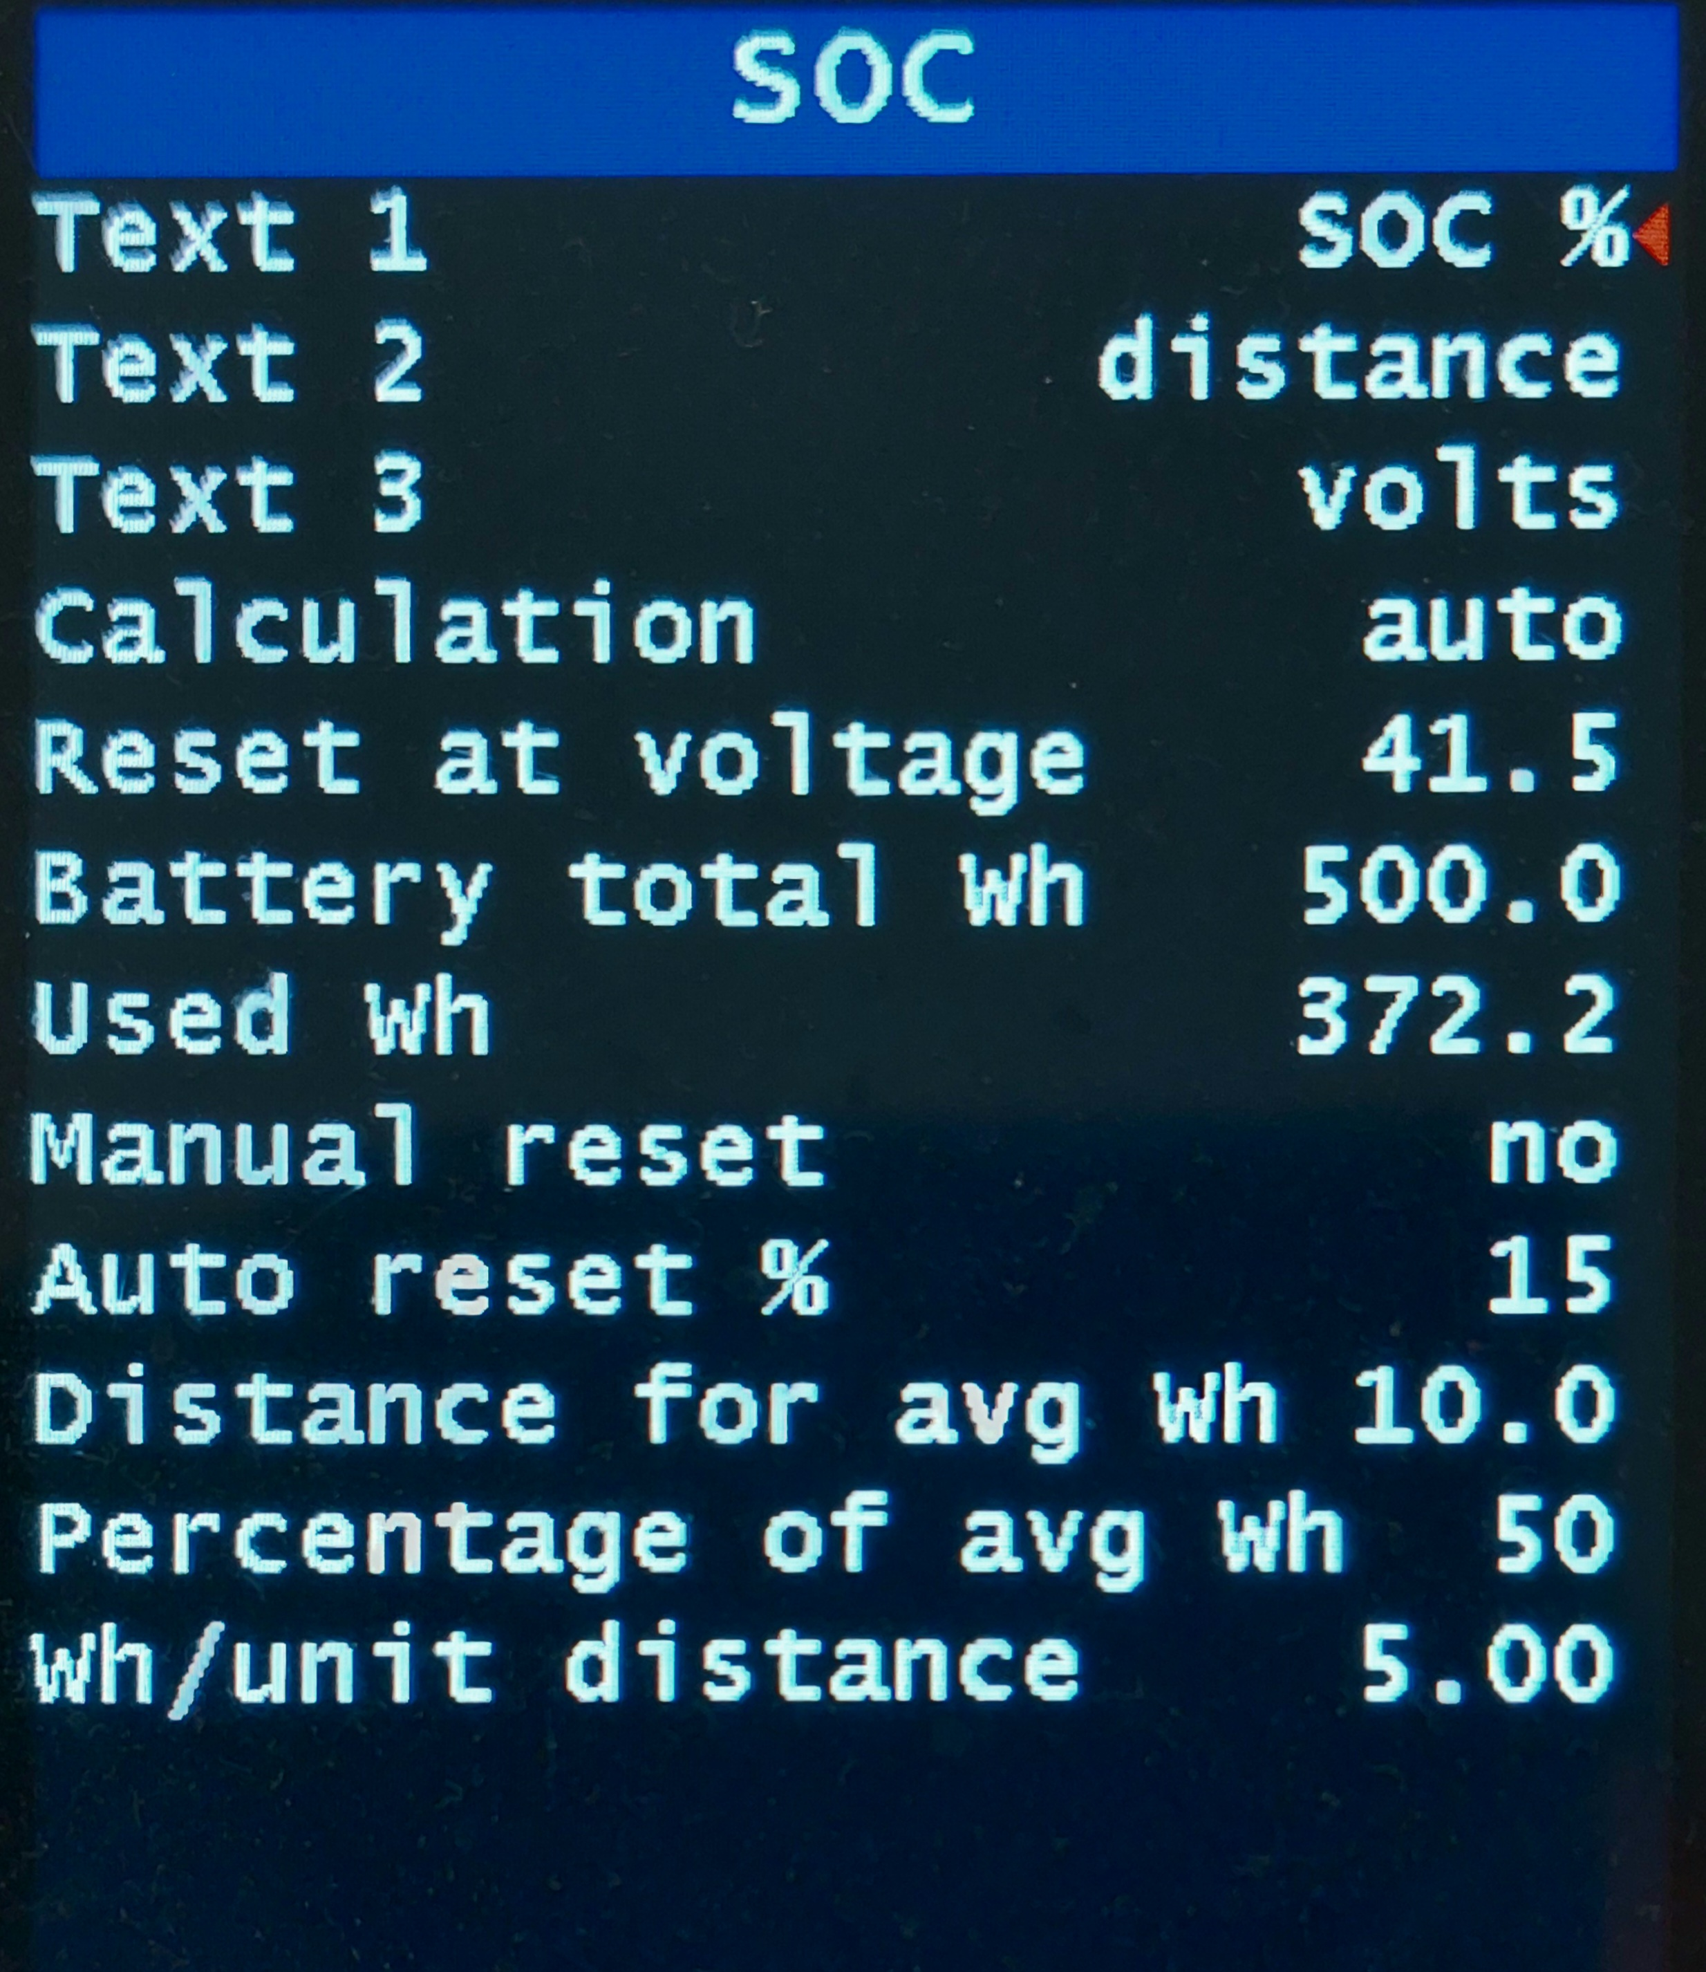

For correct configuration of SOC:
1. set battery Watt-hour value
2. set battery voltage to reset the SOC counter
3. set the battery internal resistance

The battery needs to be charged to at least the predefined battery voltage to reset the counter. You can set the reset voltage to any voltage you like.
Name | Recommended value | Description
Text 1 | SOC % | Variable shown on the main screen 1, next to the battery symbol.  "SOC %" to show the SOC % value.  "distance" to show the km/mi that can be traveled with the remaining battery capacity.  To calculate the remaining distance, see the average consumption parameters.  "Volts" to show the battery voltage.  "disable" to show nothing.  Default value: "SOC %"
Text 2 | distance | Variable shown on the main screen 2, next to the battery symbol.  Default value "distance"
Text 3 | Volts | Variable shown on the main screen 3, next to the battery symbol.  Default value "Volts"
Calculation | Auto | Choice of the method for calculating the remaining battery percentage.  Auto SOC% calculation with used Wh.  Automatic reset with fully charged battery (100%) or at power on when the SOC% calculated with Wh consumed is different from that calculated with the voltage (+/- "Auto reset%"), useful when you put a not fully charged battery.  Wh SOC% calculation with used Wh.  Reset only with fully charged battery (100%).  Or manual reset.  Volts SOC% calculation with battery voltage.  It is less accurate than the other methods.  It can be useful if you have two batteries of different capacity. To obtain a correct correspondence between SOC% and voltage, it may be necessary to adjust the values of “Reset at voltage” and “Low cut-off”.
Reset at voltage | 54.0 | Threshold voltage to reset the SOC watt-hour meter: when powering on the display this value is compared to the battery voltage. If the battery voltage is higher, then the battery is expected to be fully charged and the SOC watt-hour meter is reset, effectively resetting the SOC to 100%.  Tip: To find a suitable value, fully charge the battery and measure the voltage on the display, use a slightly lower value for the threshold voltage.  For example:  36V battery charge up to 42.0 volts, set threshold to 41.5.  48V battery charge up to 54.6 volts, set threshold to 54.1.  52V battery charge up to 58.8 volts, set threshold to 58.3.
Battery total Wh | 500 | Set the total capacity in watt-hours less 10% of what your battery has.  Tip: fully charge the battery and then discharge it completely and use the measured value to input here. NOTE that you also need first to set up the correct value of your battery internal resistance as also the low cut-off voltage.  Tip: the capacities stated by the suppliers are often too high, expect a value of around 80 % - 90 % of the stated value.  Tip: roughly calculate the capacity by multiplying the nominal voltage with the nominal amp hours. For example a 52 Volt, 10 Ah battery has a nominal watt-hour capacity of 520 Wh.
Used Wh | 0 | This value shows the SOC watt-hour meter value. You can change this value if you need, like in the event that the battery was not fully charged and this value is not accurate anymore.
Manual reset | no | Use when putting on an incompletely charged battery or at the first power on after the flashing. In this case, “Used Wh” is calculated with reference to voltage. When the battery is fully charged, the reset to 100% is automatic.
Auto reset % | 15 | Percentage difference (+/-) between socWh and socVolts for automatic reset at power on with "SOC Calculation" = Auto. Default 15%.
Distance for avg Wh | 10.0 | Last kilometers/miles traveled, from which average consumption is calculated.  Used in calculating remaining distance.  Default value: 10 km or 6.2 miles.  Maximum value: 25 km or 15.5 miles.
Percentage of avg Wh | 50 | The average consumption used to calculate the remaining distance is composed of two components:  one component is based on the average consumption of the last kilometers/miles traveled, to which the percentage set refers; and another component is based on the average consumption set by the user (percentage remaining). See the next parameter.
Wh/unit distance | 5.0 | Average consumption set by the user.  Used in calculating the remaining distance, with a percentage complementary to the previous parameter.  It depends on your habits, the type of route, the assistance level used, the average speed, etc.  The value to enter can be the battery energy used for each km/mile in trips A and B.  This is a reference value; it is then adjusted to the assistance level used.  Default value: 5 Wh/km or 3.1 Wh/mi.  Maximum value: 20 Wh/km or 12.4 Wh/mi.
Motor
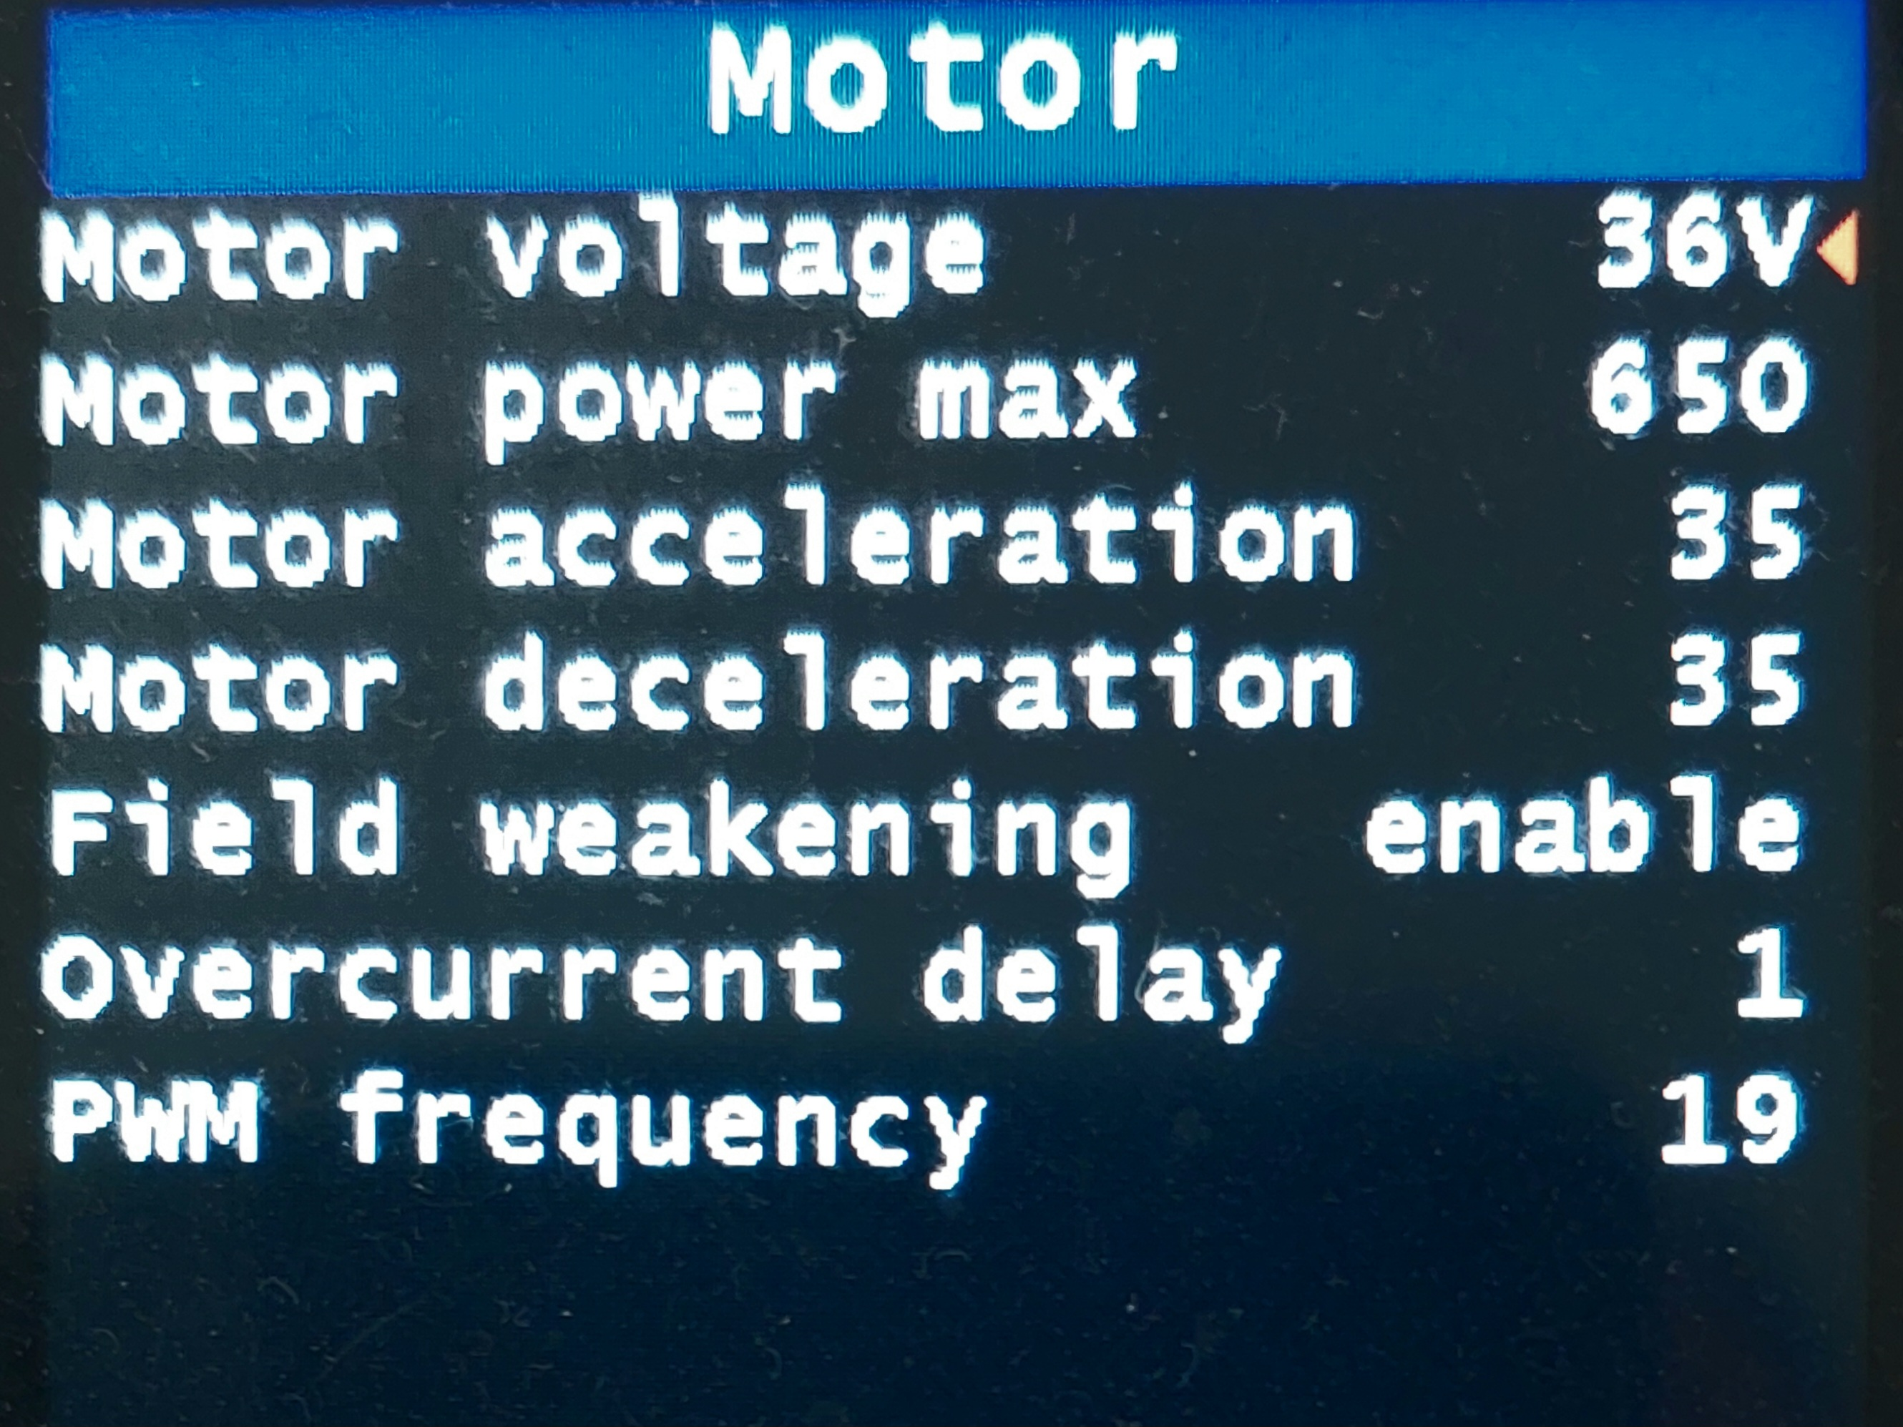

Name | Recommended value | Description
Motor voltage | 48V | Depending on the type of motor, set the appropriate value so that FOC calculations are correctly executed. The voltage of the battery does not matter, this value should always be set depending on the type of motor. Set "48V" for a 48V brushless motor (TSDZ2 52V version has a 48V brushless motor). Set "36V" for a 36V brushless motor.
Max motor power | 500W | Maximum motor power.  Warning: This is a display only.  The values ​​are set in the Bike menu.
Motor Acceleration | see table | Acceleration of the motor.  As a first setting, use low values, then gradually increase if necessary. Consider the values in the table as maximum values.  Set carefully, aware that setting a higher value than necessary can cause greater stress on the transmission.  Recommended values:  36 Volt motor, 36 volt battery = 35  36 Volt motor, 48 volt battery = 5  36 Volt motor, 52 volt battery = 0  48 Volt motor, 36 volt battery = 45  48 Volt motor, 48 volt battery = 35  48 Volt motor, 52 volt battery = 30
Motor Deceleration | 35 | Set to zero, the maximum deceleration ramp is active (slower stop), if set to 100% the minimum deceleration ramp (faster stop).
Field weakening | enabled | Enabled / Disabled. The field weakening function increases the motor cadence (up to 120 RPM when possible) but there is also a loss of efficiency.  If enabled, field weakening is automatically activated when the PWM value reaches 100%.
Overcurrent delay | 2 | Overcurrent error trip delay, in 25ms steps.  Valid values from 1 to 4, recommended 2.  Overcurrent error prevents damage to the controller and the blue gear.  Increase only in case of unwanted trips.
PWM Frequency | 19 | Display only, can be 18 or 19 kHz.  It cannot be set on the display, it depends on the OSF version of the motor used.
Torque sensor
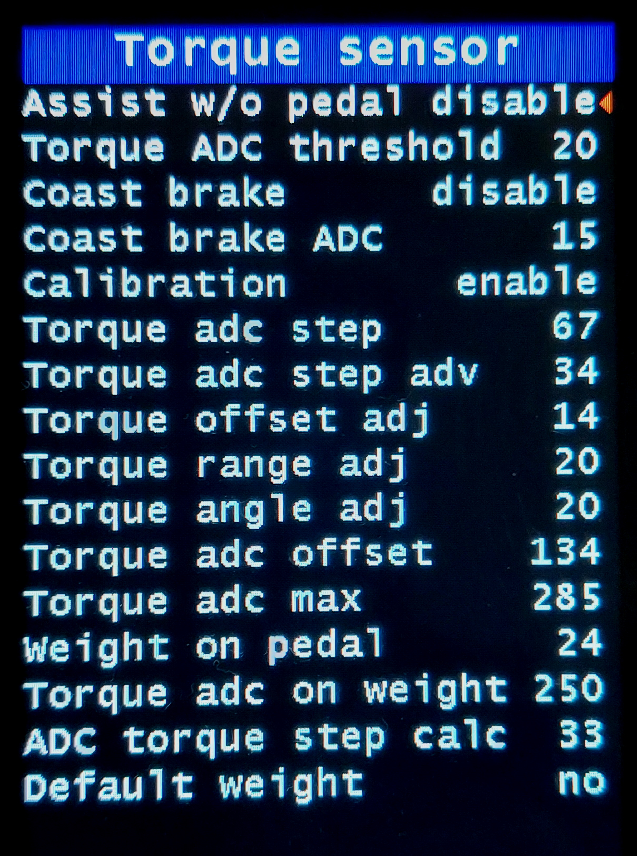

Name | Recommended value | Description
Assist w/o pedal rotation | Disable | Enable to get motor assistance once you press the pedals even without rotating them. Recommended keeping disabled if you do not have brake sensors installed.  Attention, if you set “Pedal torque ADC offset adjustment” to a value lower than 20, this feature is disabled (safety).
Torque ADC threshold | 10 | ADC pedal push threshold, for immediate start without rotation.  Now, this function is also activated with the bike in motion, when you resume pedaling after a break.  CAUTION: By enabling the BOOST function at the same time, the effect increases! This can cause greater transmission stress.
Coast brake | Disable | Needs to be enabled if you have a TSDZ2 coast brake version.
Coast brake ADC | 10 | The sensitivity of the coaster brake in ADC steps when pushing pedals backward.  Low value takes less strength, high value takes more strength. See for yourself the optimal value.  Limits from 5 to 40
Calibration | Enable | Enable only after having entered the actual values of “Pedal torque ADC offset” and “Pedal torque ADC max”, obtained from the calibration.  Enabling without having entered the correct values can lead to unpredictable operations.  Calibration procedure: see "ADC torque sensor" in the "Technical" menu, enter the ADC value of the torque sensor without any push on the pedals in "Pedal torque ADC offset".  Enter the ADC value of the torque sensor with the maximum thrust applied to the pedal (cyclist standing on the right pedal in horizontal position) in "Pedal torque ADC max".  Torque sensor calibration is required if the working range is limited.  “Pedal torque ADC max” - “Pedal torque ADC offset” Caution. The ADC values of the torque sensor over time may change, check periodically.
Torque sensor ADC step | 67 | Torque conversion factor applied to the pedal with calibration disabled.  It is used to calculate the correct ratio between the assistance factor and the human power (only in "Power assist") and for the calculation of the human power to be shown on the display, the actual value obtained from the calibration can be entered.  Warning: enter the “ADC torque step calc” value with calibration disabled.  The “Torque adc step” value is inversely proportional to the ADC range of the torque sensor
Torque adc step adv | 34 | Torque conversion factor applied to the pedal with calibration enabled.  It has the same function as the previous parameter, but only with calibration enabled.  In the calculation of human power, "Torque offset adj" and "Torque range adj" are also evaluated.  Do not use to change the amplification of the assistance levels, for this purpose use "Torque range adj".  An optional weight calibration is also provided for this parameter.  Warning: enter the “ADC torque step calc” value with calibration enabled.  The value of “Torque adc step adv” is constant, independent of the ADC range of the torque sensor.
Torque offset adj | 20 | Parameter for adjusting the ADC offset of the torque sensor.  Values from 0 to 34, default value 20 (neutral).  When you need to increase the sensitivity at the start, for example with a hand-bike, set a value lower than 20. Warning, a value that is too low can cause an undesired start and / or a delayed stop of the motor.  If, on the other hand, you want to decrease the sensitivity at the start, set a value greater than 20.  With a value less than 20 it is recommended to disable “Assist without pedaling” and “Startup boost”.
Torque range adj | 20 | Parameter for adjusting the ADC range of the torque sensor.  Values from 0 to 40, default value 20 (neutral).  A value below 20 decreases the amplification of the range, a value greater than 20 increases it. This variation has an effect at all levels in torque sensing modes.  Necessary first, enable the torque sensor calibration and enter the actual values of “Torque ADC offset” and “Torque ADC max”.  The range value is fixed at 160 (133 with 0, 186 with 40).
Torque angle adj | 20 | Parameter for adjusting the initial angle of the torque sensor curve. Value from 0 to 40, default value 20 (neutral).  Try 20, then adjust to “feel”. With a value below 20, more gradual response and less consumption. With a value greater than 20, more reactive but with higher consumption. See the explanatory chart.  This variation has an effect at all levels in torque sensing modes.  It is necessary to first enable the torque sensor calibration and enter the actual values of “Pedal torque ADC offset” and “Pedal torque ADC max”.  With a value greater than 20, it is advisable to disable "Startup boost".
Torque sensor ADC offset |  | ADC value of the torque sensor without any push on the pedals.  It is obtained from the calibration procedure to be carried out on the display.  Do not use to modify the sensitivity of torque sensor on startup, for this purpose use “Torque offset adj”.
Torque ADC max |  | ADC value of the torque sensor with the maximum thrust applied to the pedal (cyclist standing, on the right pedal in horizontal position).  It is obtained from the calibration procedure to be carried out on the display.  Do not use to change the amplification of the torque sensor range, for this purpose use "Torque range adj".
Weight on pedal | 25 kg or 55 lb | Weight to be applied to the pedal for the calibration of the ADC value of the torque sensor used for the calculation of the human power to be shown on the display.  Use a weight of 25 Kg. or 55 lb.  It is not essential, it does not affect the operation of the motor, it only serves for a correct display of human power.
Torque ADC on weight |  | ADC value of the torque sensor for the calculation of human power to be shown on the display, it is not used for the calculation of the assistance factor.  It is obtained from the calibration procedure with a weight, to be carried out on the display.
ADC torque step calc |  | Conversion factor of the torque applied to the pedal obtained from the calibration with the weight or from the calculation of the estimated value.  It can be used for the calculation of the human power shown on the display and for a correct ratio in the assistance calculation (only in "Power assist").  Warning: with calibration enabled or disabled, the calculated value is different.  With calibration disabled, enter the value in the “ADC torque step” parameter.  With calibration enabled, enter the value in the “ADC torque step adv” parameter.
Default weight | no | After having entered the calibration values in "Torque ADC offset" and "Torque ADC max", with this function it is possible to calculate an estimated value of "Torque ADC on weight" for a weight of 25Kg. The value is less accurate than that obtained with real calibration, but it is adequate for the purpose.

Assist level
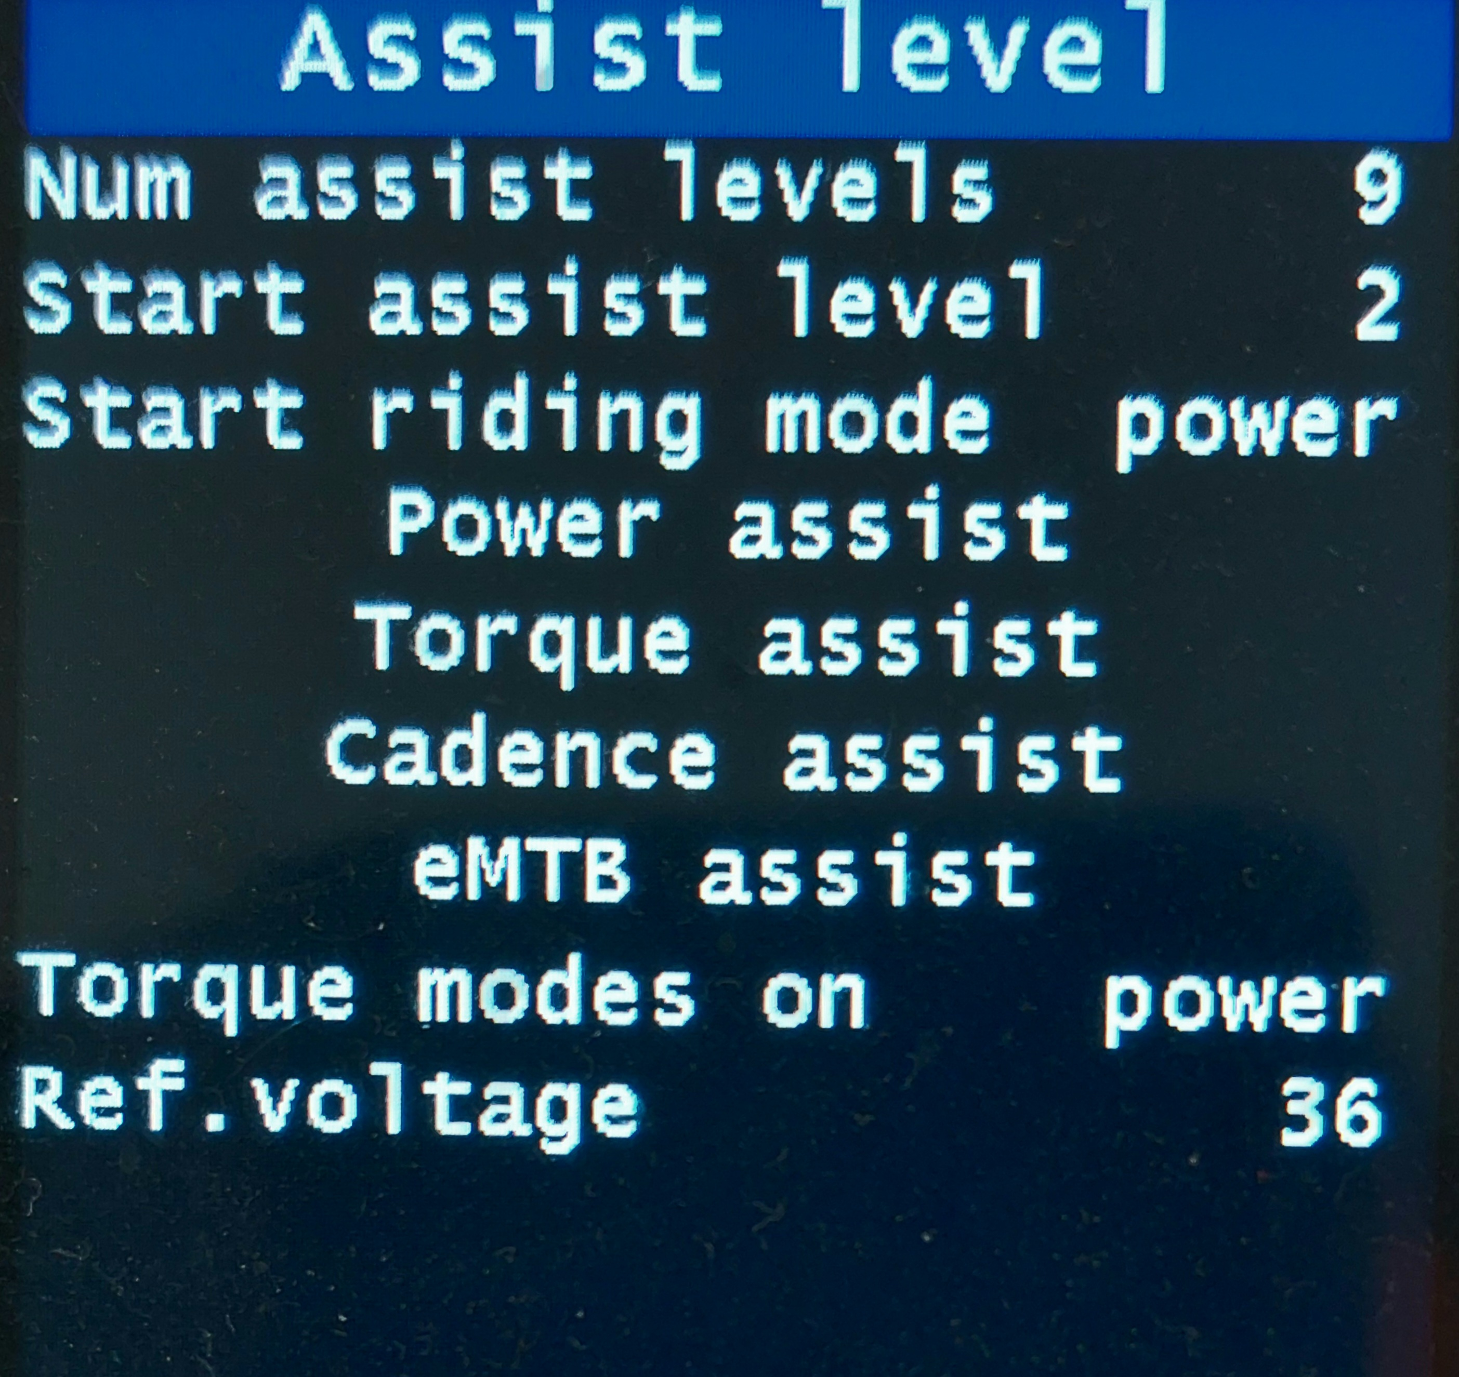

Name | Recommended value | Description
Num levels | 9 | Select the desired number of assist levels from a minimum of 1 to a maximum of 9. If you choose for instance 5, only the first 5 levels will be available.
Start assist level | last | Power-on assist level.
Start riding mode | power | Power-on assist mode.
Power Assist |  | Power assist levels setting menu.
Torque Assist |  | Torque assist levels setting menu.
Cadence Assist |  | Cadence assist levels setting menu.
eMTB assist |  | eMTB assist levels setting menu.
Torque modes on | current | Setting the assistance calculation in Torque, eMTB, and Hybrid modes.  - Current: Current-based, like previous OSF versions. However, this mode causes the power output to vary with voltage. For the same pedal torque, there is a difference in power output between a fully charged battery and one that is almost empty. Furthermore, the comparison between the various modes is distorted: in Torque, eMTB, and Hybrid modes, you will obtain greater power at 48V than at 36V, while in Power mode, with the same pedal torque and level parameter, the power output is constant, independent of battery voltage.  - Power: Power-based. Power is calculated with a reference voltage of 36 volts. This way, the comparison between the various modes is made under equal conditions.  Recommended setting for new users.  Users who already use one of the 3 torque-based modes (Torque, eMTB and Hybrid) and have already customized the level parameters, and want to take advantage of constant power between full and low battery (without changing the level parameters), can set the nominal battery voltage as the reference voltage.
Ref. Voltage | 36 | Reference voltage for calculating constant power assistance (Torque, eMTB, and Hybrid modes only). Default value: 36 Volts.
Power assist
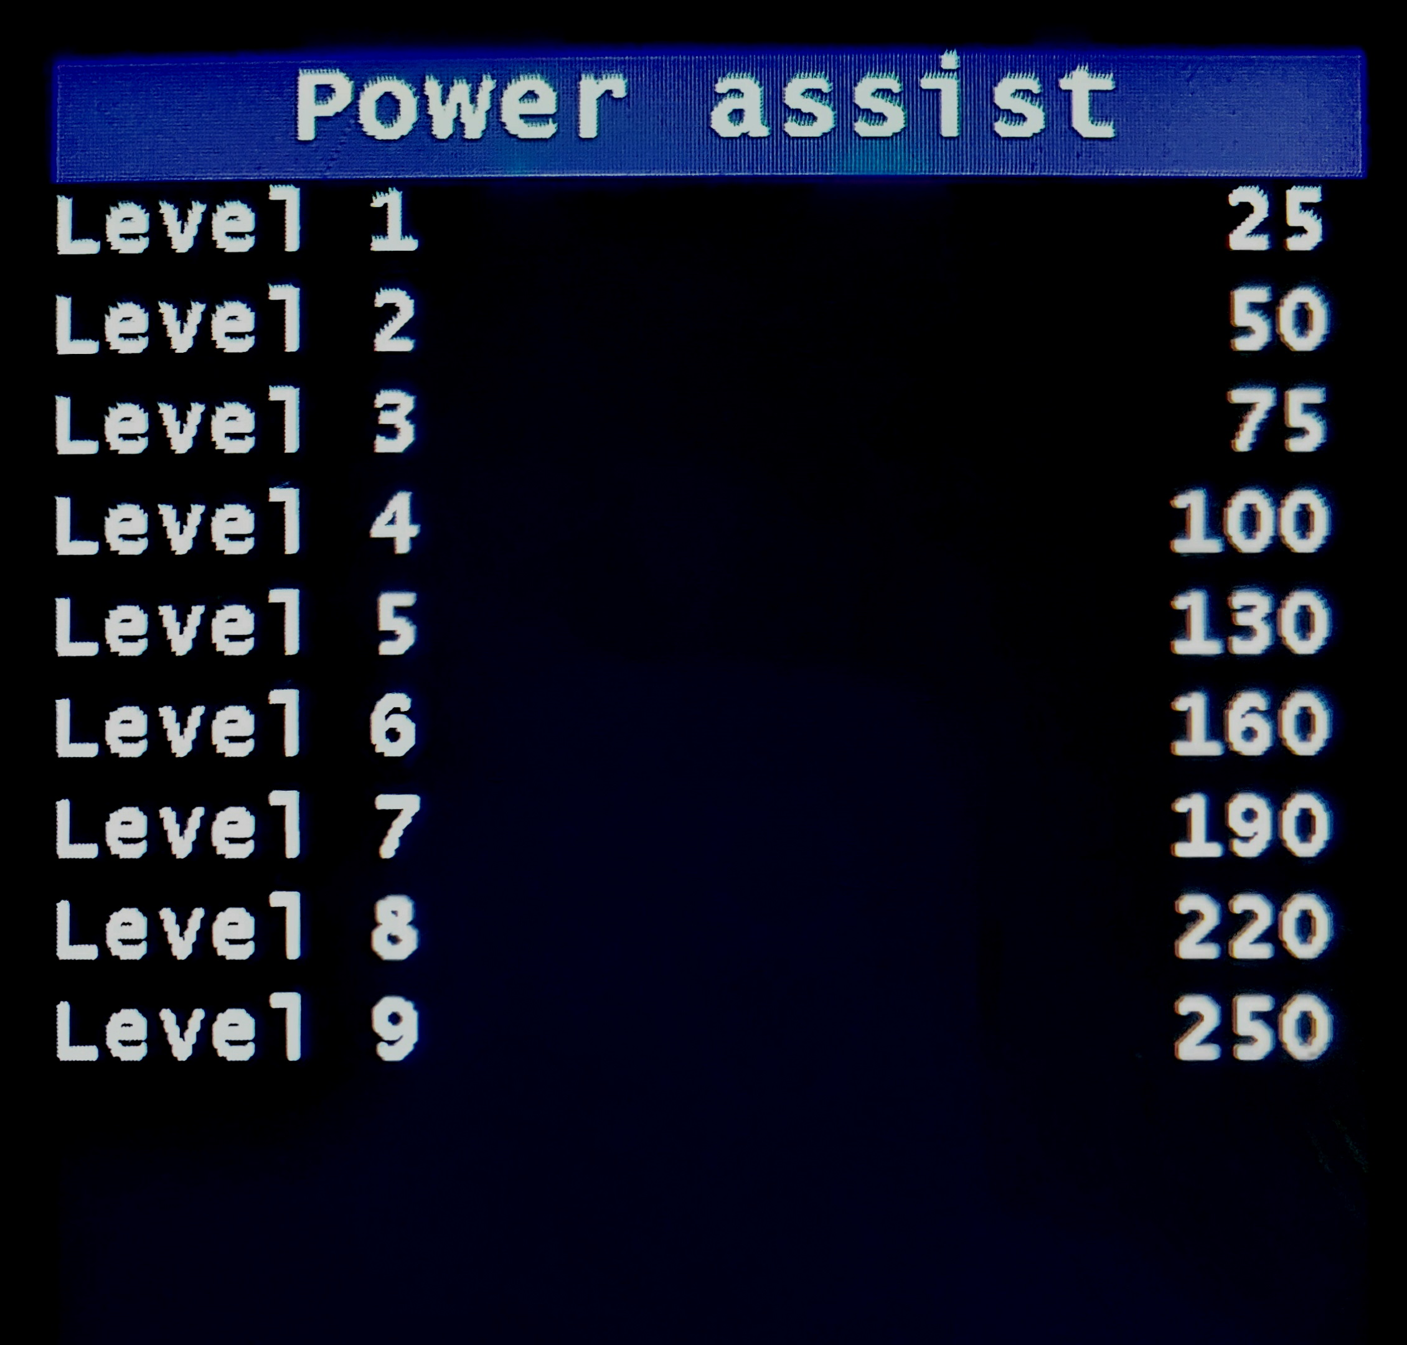

Name | Recommended value | Description
Power Assist | See image | “Power assist” is an assistance mode proportional to the power on the pedals.  Levels available from 1 to 9. Set assistance levels according to your needs.  Value in % / 2, maximum 254.  For example, applying 100 Watts to the pedals, with an assistance level of 150, the motor delivers 300 Watts, (150 x 2 = 300%).  These assistance parameters are also used in the high cadence hybrid mode.
Torque assist
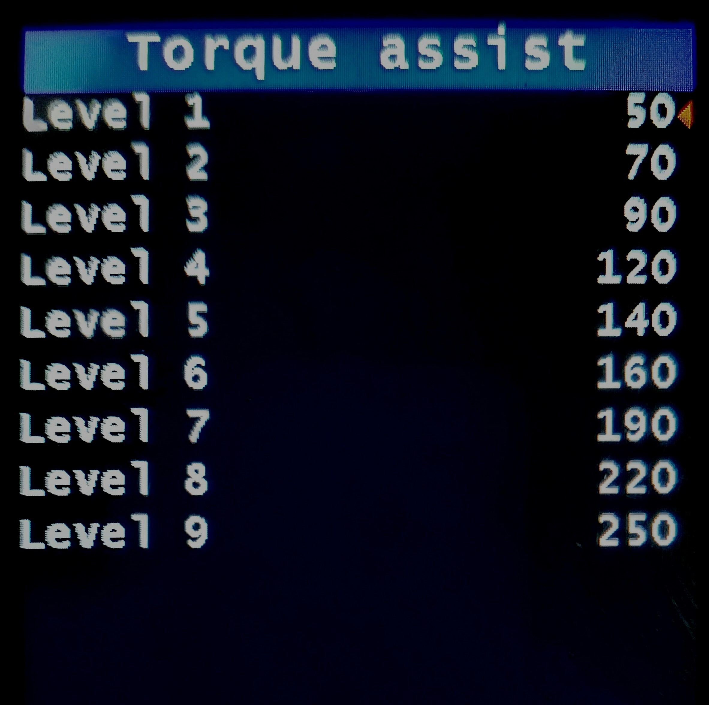

Name | Recommended value | Description
Torque Assist | See image | “Torque assist” is an assistance mode proportional to the torque on the pedals.  Levels available from 1 to 9. The power delivered by the motor is proportional to the applied torque and the set assistance values.  Set assistance levels according to your needs. Relative values, maximum 254.  These assistance parameters are also used in the low cadence hybrid mode.
Cadence assist
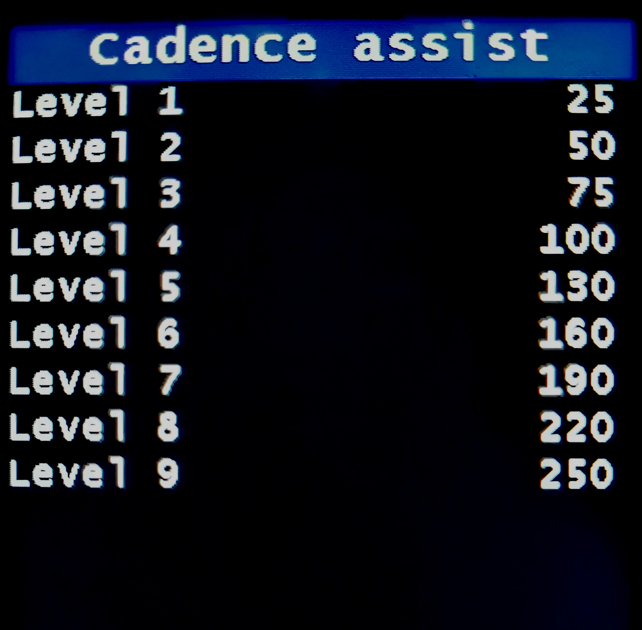

Name | Recommended value | Description
Cadence Assist | See image | “Cadence assist” is an assistance mode that uses cadence sensor only and does not use the torque sensor.  Levels available from 1 to 9.  The power supplied by the motor depends partly on the assistance values set and partly on the cadence of the pedals.  Values ​​proportional to current, maximum 254.  It is recommended to use this assistance mode with the brake sensors installed and enabled.
eMTB assist
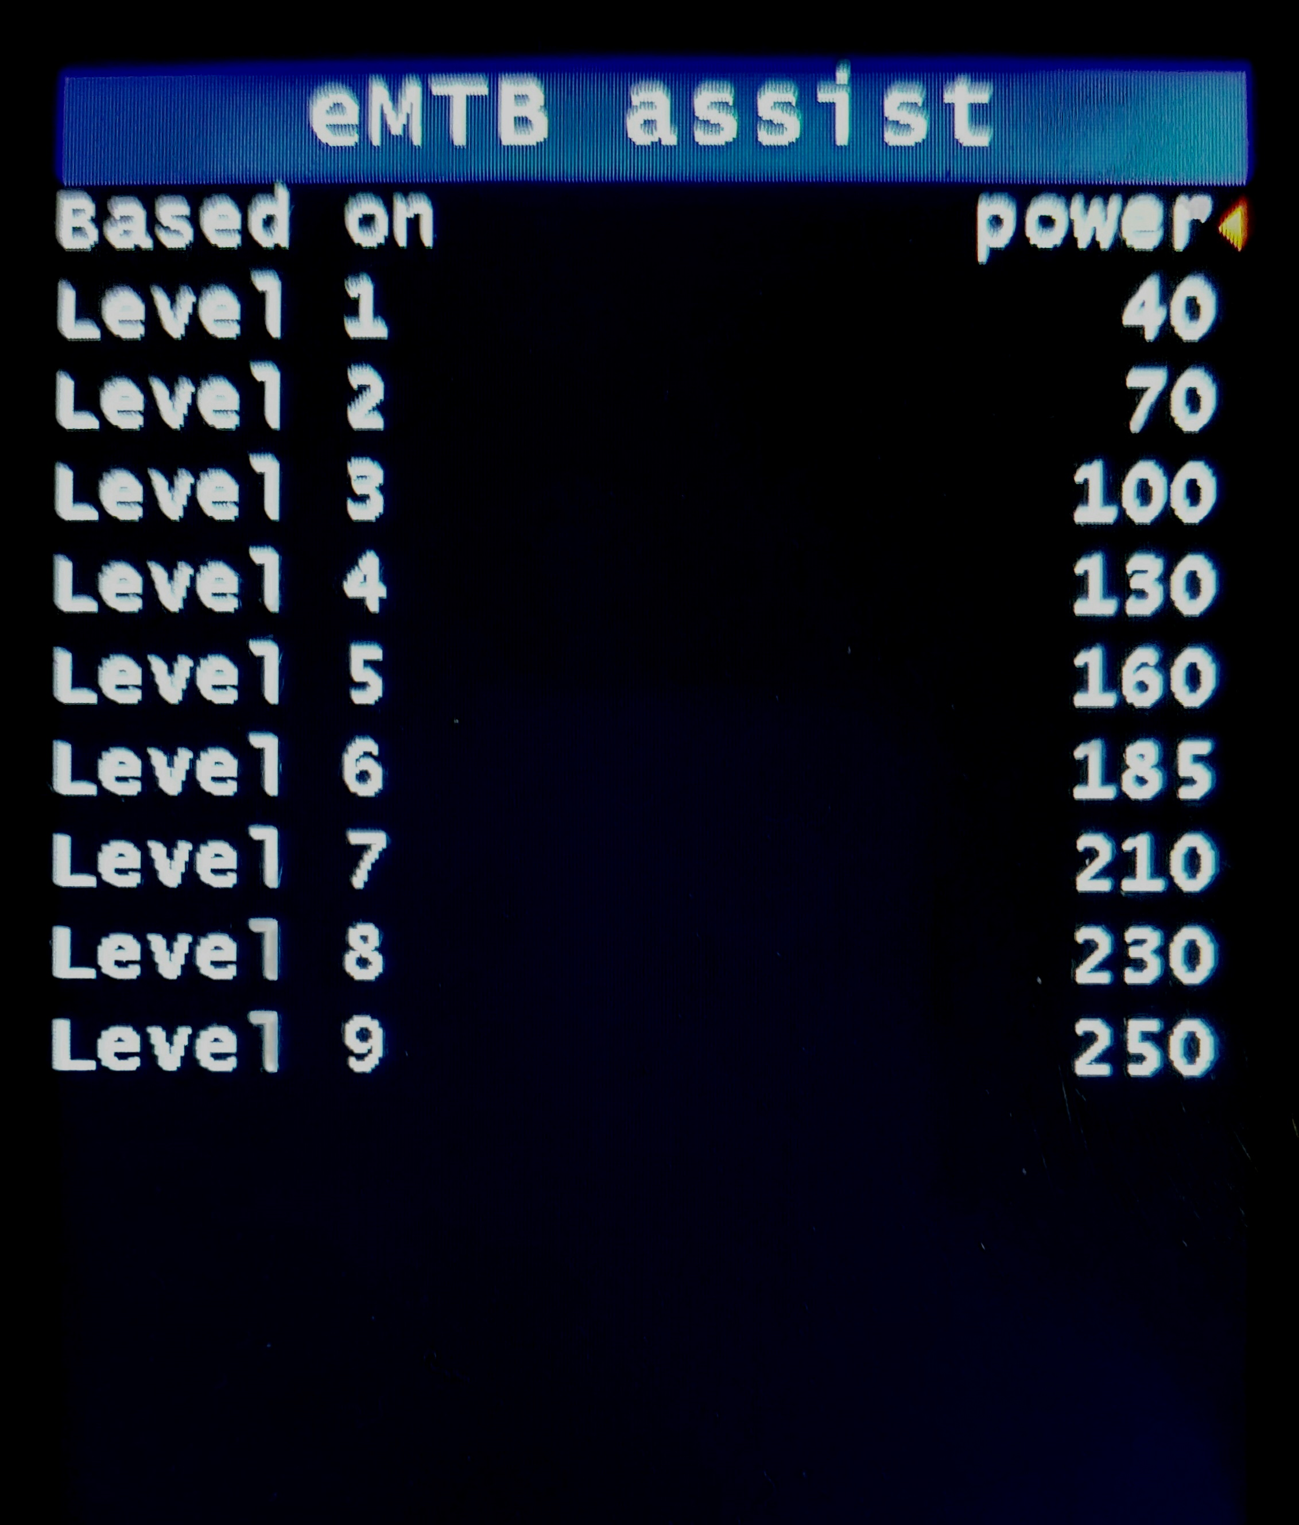

Name | Recommended value | Description
Based on | power | - power: progressive assistance is proportional to the power on the pedals.  - torque: progressive assistance is proportional to the torque on the pedals (same as previous versions).
eMTB assist | See image | “eMTB assist” is an assistance mode with a progressive percentage of the torque on the pedals. Levels available from 1 to 9. The power delivered by the motor is progressively proportional to the applied torque.  Relative values, maximum 254.  Higher values correspond to more responsive assistance, quicker to reach maximum motor power.

Walk assist
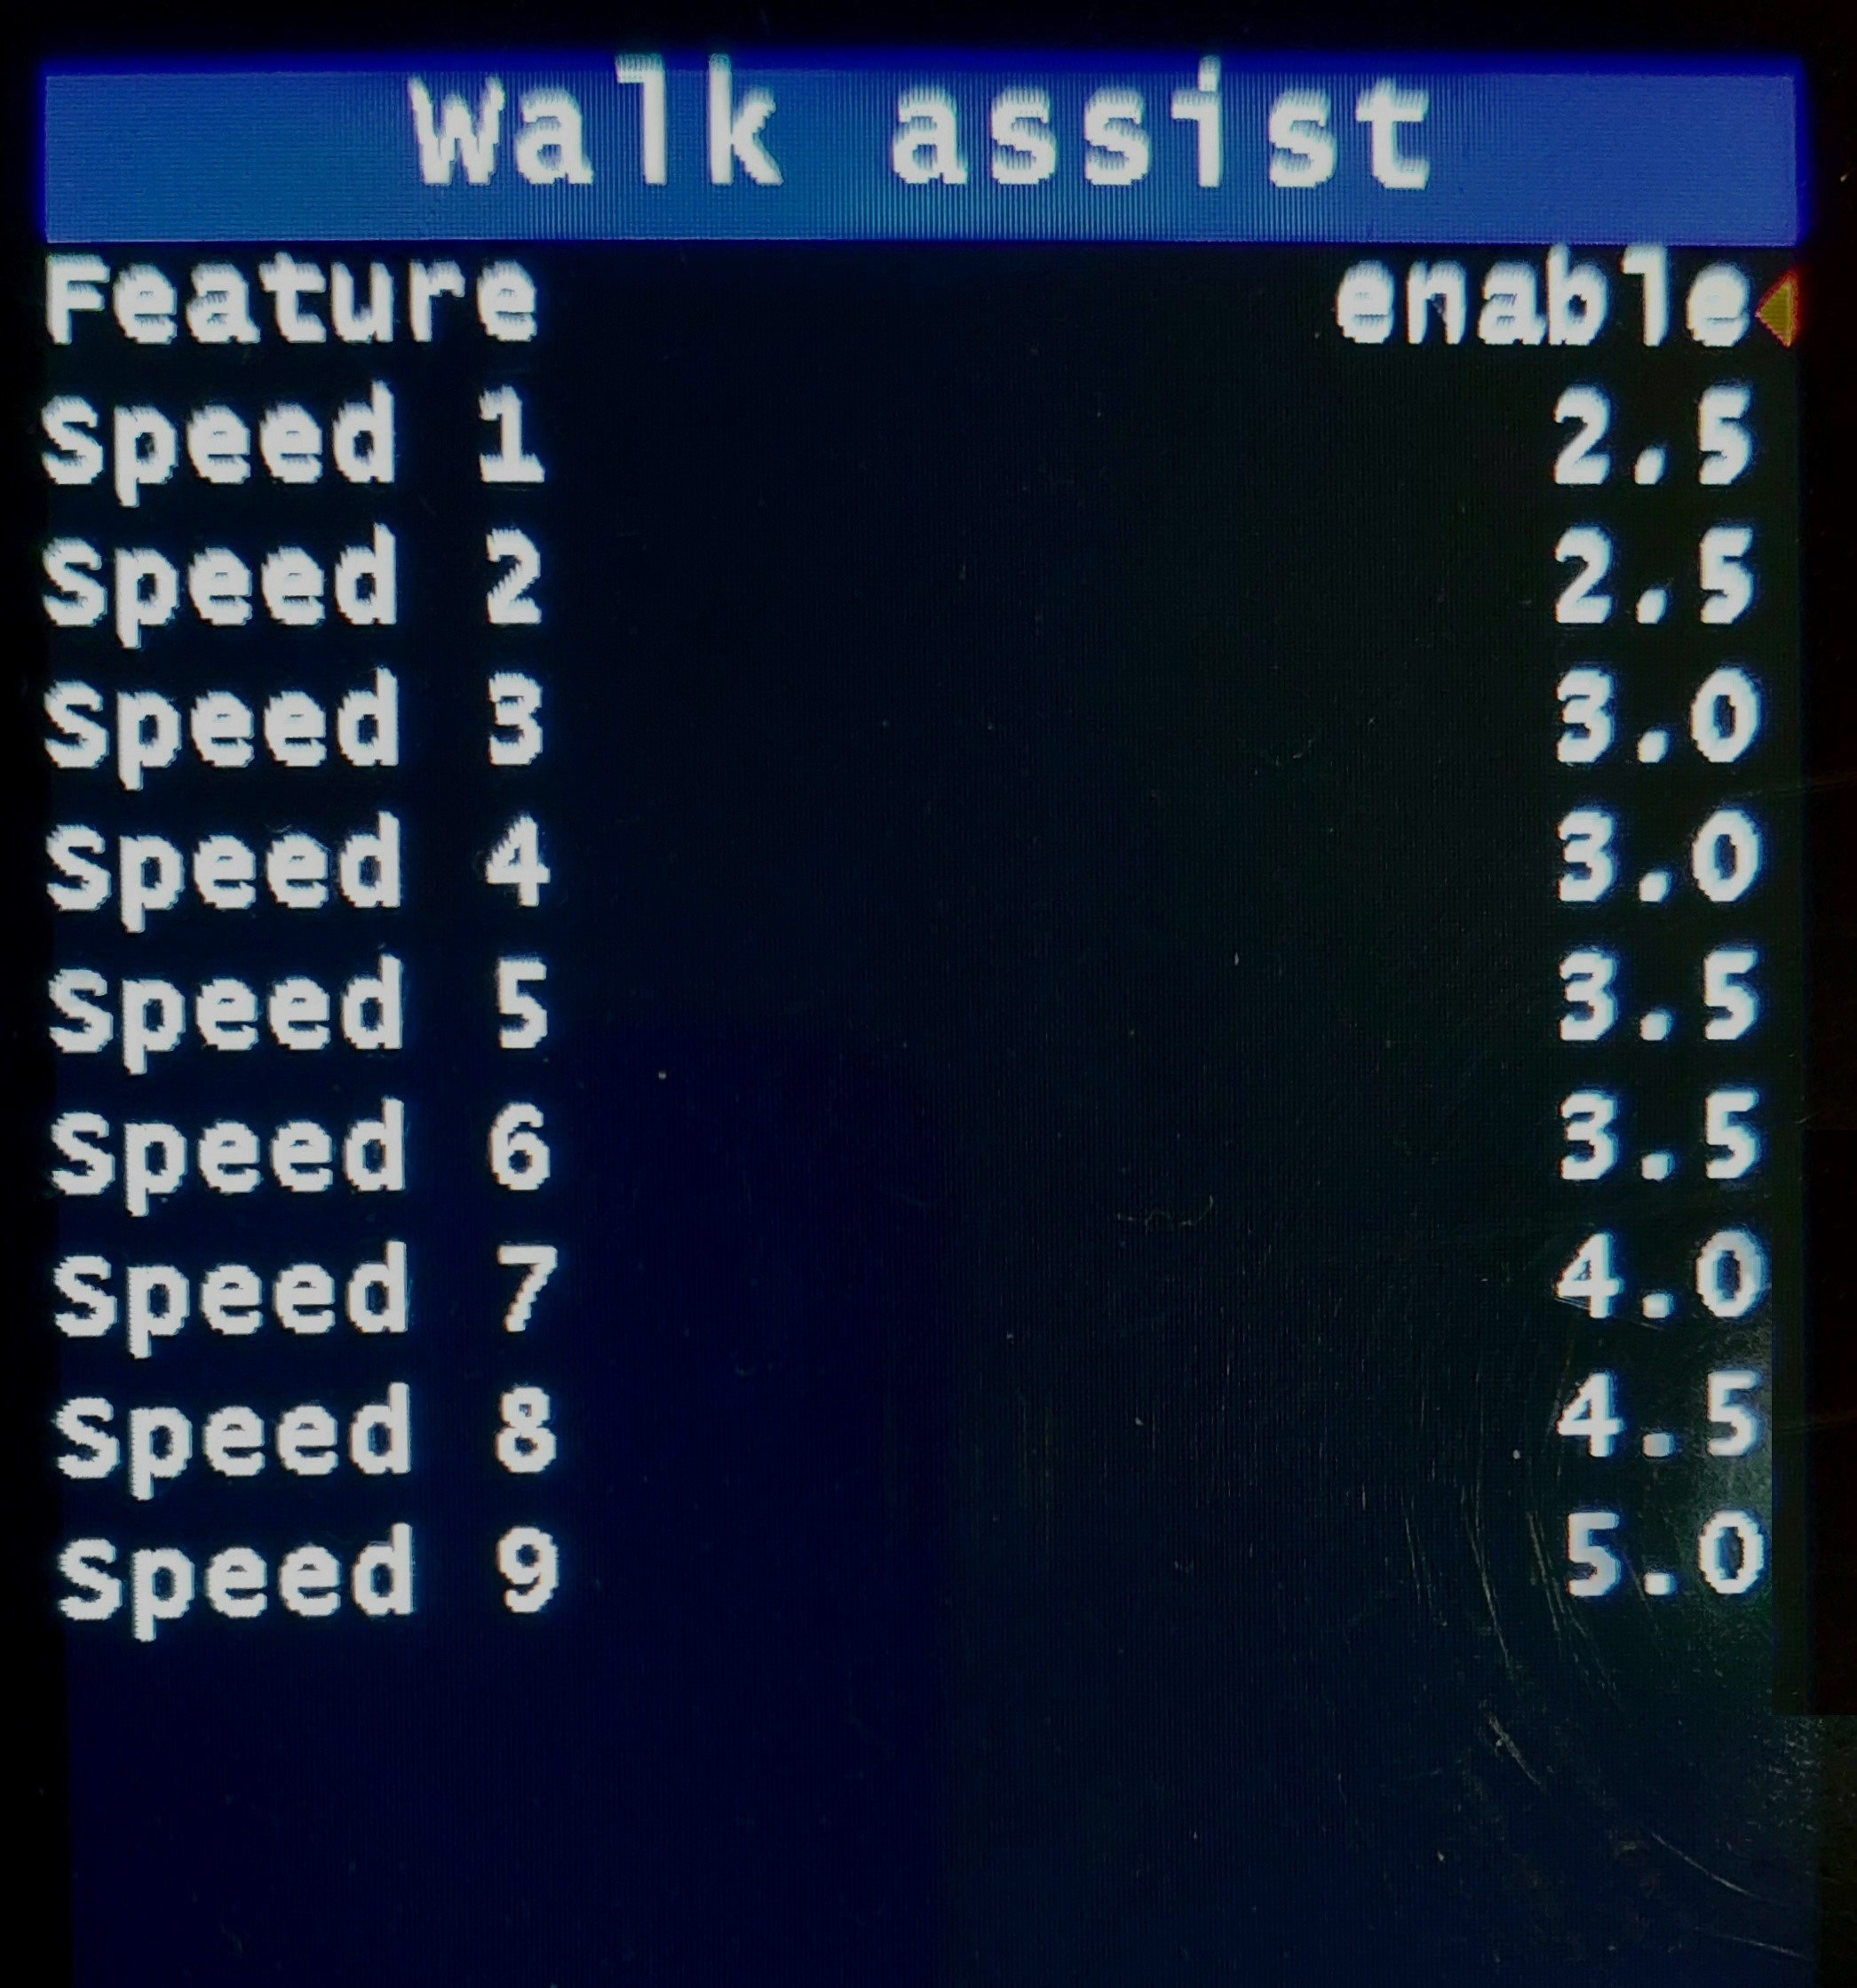

Name | Recommended value | Description
Feature | enable | Enable or disable the walk assist function.
Speed | 5 | DEFAULTS:  Speed 1: 2.5 km/h or 1.6 mph  Speed 2: 2.5 km/h or 1.6 mph  Speed 3: 3.0 km/h or 1.9 mph  Speed 4: 3.0 km/h or 1.9 mph  Speed 5: 3.5 km/h or 2.2 mph  Speed 6: 3.5 km/h or 2.2 mph  Speed 7: 4.0 km/h or 2.5 mph  Speed 8: 4.5 km/h or 2.8 mph  Speed 9: 5.0 km/h or 3.1 mph  For each level, you set the speed to reach and maintain, in km / h or in mph.  Maximum value 6.0 km / h or 3.7 mph.  Try low values ​and gradually increase.  Recommended values ​from 2.5 to 4.5 km / h or 1.5 to 2.8 mph.  Starting "Walk assist" there will be an overrun of the set speed, this is an auto calibration.  It is used to define the ratio between wheel speed and motor revs, and to calculate the maximum power required in those conditions of use (gear ratio and slope to be overcome), then it stabilizes at the set speed.  The adjustment is made on the motor revolutions, therefore it remains constant even when setting undetectable speed values.  If necessary, it is possible to repeat the self-calibration, release the button and press again.  The set speed may not be achieved due to the power limitation.  With speed sensor problems, walk assist does not work properly.  By enabling on the display in the “Bike” menu, “Assist with error”, walk assist will work like the previous versions, without speed control.
Startup BOOST
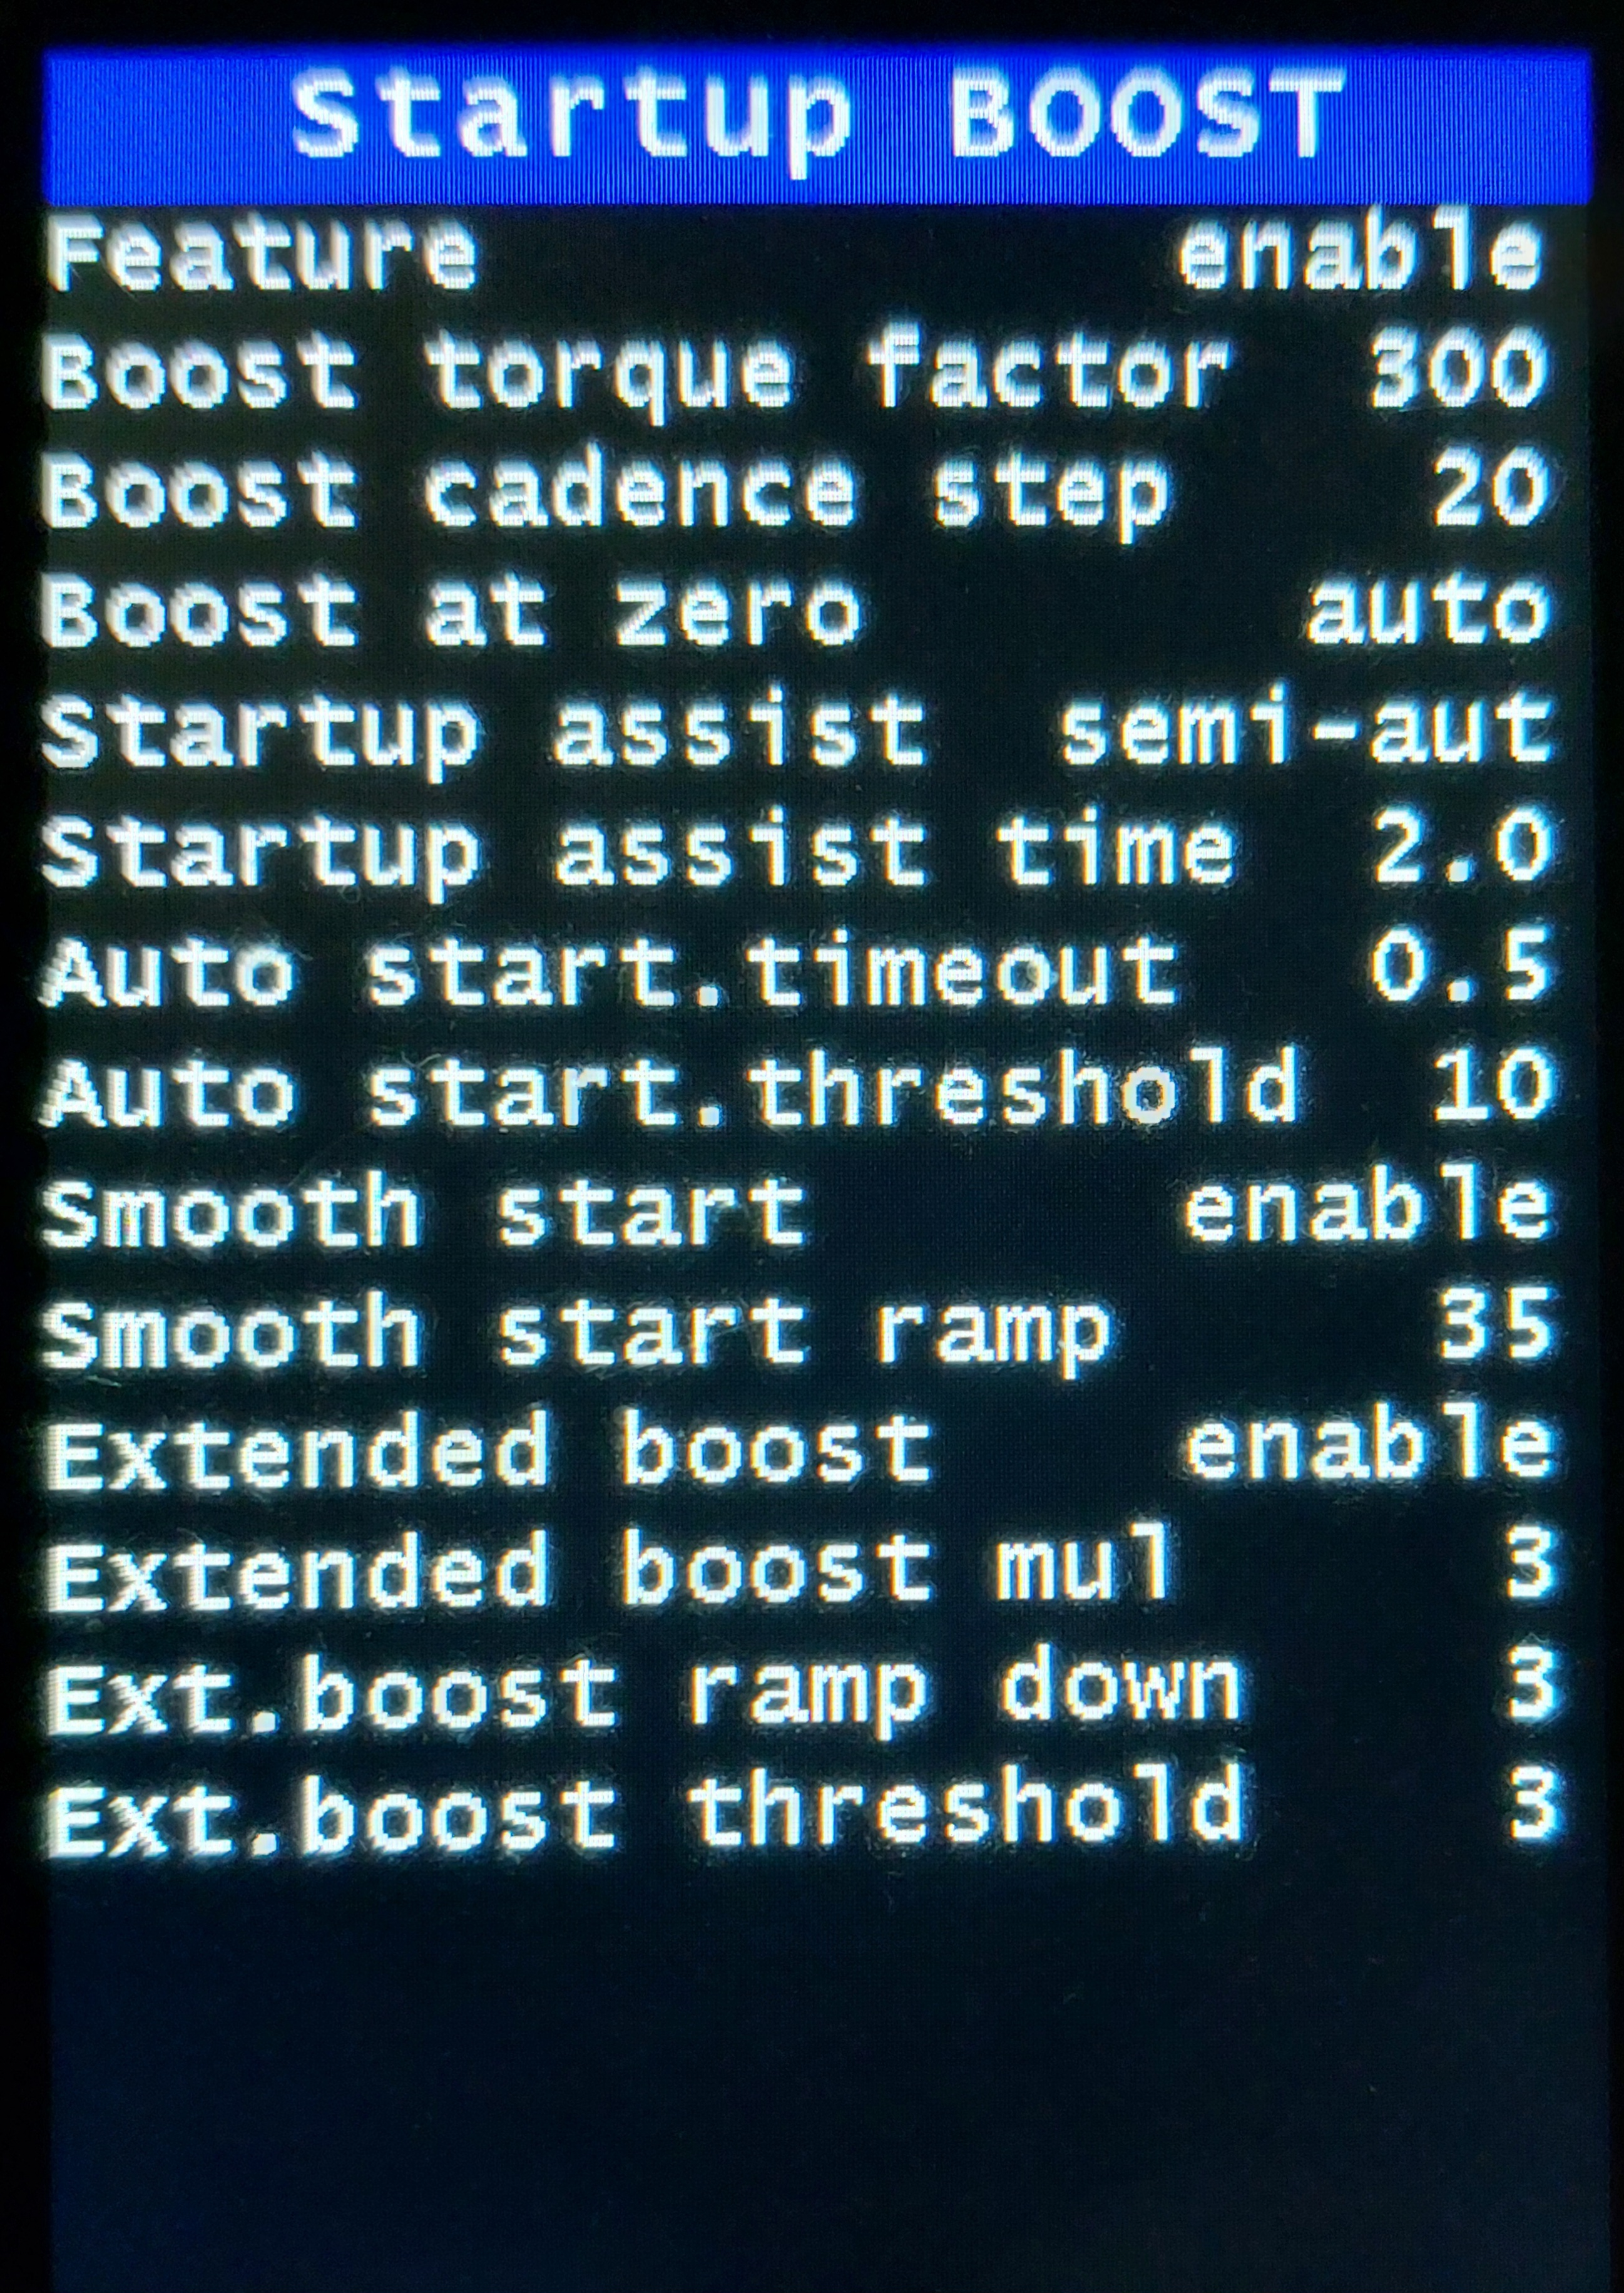

Name | Recommended value | Description
Feature | enable | Enabled / Disabled. Enables the “Startup boost” function. Only available in Power assist mode.  Used to get additional power at startup.
Boost Torque Factor | 300 | It is used to increase the starting assistance and at a low cadence.  Available only in "Power assist" mode.  It works both with a standing start and with resuming the pedaling in motion.  The value of this parameter is the percentage increase in torque applied to the pedals with cadence = 0. This value gradually decreases as the cadence increases, depending on the next parameter.  Set carefully, aware that setting too high a value can cause greater stress to the transmission. Value in %, recommended 300, maximum 500.
Startup boost cadence step | 20 | It is used to calculate the decrease in the boost torque factor as the cadence increases until extinction.  Recommended value 20. Limits from 10 to 50, higher value = shorter effect.
Startup boost at zero | auto | Startup Boost Mode:  Cadence: It intervenes both starting from a standstill and resuming pedaling with the bike in motion.  Speed: It only intervenes starting from a standstill, recommended for motors with coaster brake.  Auto: Like Cadence mode, but with an intervention threshold when the bike is in motion. This prevents unwanted boost intervention on descents when pedaling with little torque.  Recommended with Torque range adj < 20.
Startup assist | disable | Startup assist has five possible settings:  - disabled: Feature disabled.  - manual: This is the same as in previous OSF versions; the function is activated by pressing the UP button until the STARTUP message appears, and holding it down starts pedaling. The motor maintains maximum power reached until the button is released, even with the pedals in the upright position.  It makes starting from a standing start on very steep climbs easier.  Manual control also works while the bike is in motion.  Note: Holding down the UP button turns on the lights after 2 seconds, and the "Startup assist" function activates after another two seconds, so activation takes 4 seconds.  If lights are not installed or if you are only using the light sensor to turn them on, you can disable the "Lights" option in the "Various" menu. This way, the "Startup assist" function activates after just 2 seconds.  In situations where it is difficult to turn the pedals, "Startup assist" can be used temporarily as a throttle. In this case, holding down the UP button activates assistance simply by turning the pedals. After the "Startup assist time" has elapsed, the throttle speed limit for the current mode (Street or Offroad) is activated. Changing the throttle speed limit must therefore be a voluntary and informed choice by the user, in accordance with the laws of their country.  - semi-auto: The function is activated only by starting from a standstill by pressing the UP button, as described above. When the STARTUP message appears, you can release the button and begin pedaling.  The motor maintains the maximum power reached until the time set in "Startup assist time" elapses.  The timer starts when you begin pedaling.  If you stop pedaling during the set time, a safety timeout activates, and if you do not resume pedaling, the function is interrupted.  Warning: It is not possible to interrupt assistance before the safety timeout elapses unless brake sensors are installed.  If, after activating the function with the UP button, you do not begin pedaling within 5 seconds, the function is deactivated for safety reasons.  In "semi-auto" mode, "manual" mode can also be activated.  - auto: The function activates automatically when starting from a standstill with firm pressure on the pedals. The pressure threshold for activating the function is set in "Auto start.threshold"; the default value is 10. This does not refer to the torque applied to the pedals, but rather to the increase in torque over time. It is highly selective.  As in "semi-auto" mode, the motor maintains the maximum power reached until the time set in "Startup assist time" elapses. In this mode, too, if you stop pedaling, a safety timeout is activated.  Warning: it is not possible to interrupt assistance before the safety timeout elapses unless braking sensors are installed.  Applying the brakes while the motor is running, without brake sensors installed, can cause the e4-motor_blocked or e7-overcurrent error codes to activate and, if the power is high, mechanical damage to the motor.  In "auto" mode, "manual" and "semi-auto" modes can also be activated.  In all assistance modes, the maintained power is the maximum power reached after the function is activated (motor power + human power). It depends on the pressure on the pedals, the assistance level used, the new "Extended Boost" function and, in Power mode only, the "Startup Boost" function.  - extended: As with "auto" mode, the function activates automatically when the threshold is exceeded, not only when starting from a standstill, but also when the bike is in motion. Furthermore, if "Startup assist time" is already active when the threshold is exceeded, it restarts from zero.  It allows you to easily overcome roots, steps, and rocks.  Use only if you are able to control the bike in these situations.  In this mode too, if you stop pedaling, the safety timeout is activated.  In "extended" mode, it is also possible to activate the "manual" and "semi-aut" modes.
Startup assist time | 1.0 | Startup assist activation time in semi-automatic, automatic, and extended modes.  Default value: 1 second.  Maximum value in Street mode: 2 seconds.  Maximum value in Offroad mode: 5 seconds.  Please note: This time is valid up to a minimum detectable speed of 3.6 km/h. At higher speeds, the time is recalculated inversely proportional to the speed, so as to maintain a constant distance. 1 second = 1 meter.
Auto start. timeout | 0.5 | Safety timeout, to stop "Startup assist" activation when you stop pedaling.  Default value: 0.5 seconds.  Maximum value in Street mode: 1.0 second.  Maximum value in Offroad mode: 2.0 seconds.  This time is also recalculated based on speed; consequently, the maximum distance that can be traveled without pedaling is 1 meter in Street mode and 2 meters in Offroad mode.
Auto start. threshold | 10 | Pedal force threshold for activating "Startup Assist" in automatic and extended modes. This does not refer to pedal torque, but rather to torque increase over time.  Default value 10, minimum 8, maximum 20.  A value greater than 10 is recommended.
Smooth start | enable | Enabled / Disabled.  Enables the “Smooth start” function.  Choice available in Torque and Hybrid modes.  In Cadence mode it is always enabled.  It is used to attenuate the power at the start when using high assistance levels.
Smooth start ramp | 35 | Setting the “Smooth start” ramp, at zero the maximum ramp is active (slower start). Set to 100%, the minimum ramp is active (fastest start).  In Cadence mode, the maximum value is 35.
Extended boost | disabled | Enabled / Disabled.  This feature is useful for tackling trails with frequent climbs and descents, without having to constantly change the assistance level.  It could be described as a continuously variable automatic level change.  Using an appropriate assistance level not only saves battery life, but also allows for better control of the bike.  The feature is activated by an increase in pedal torque. With a constant torque, even if high, it does not activate.  The Extended Boost value is the increase in torque over time. It activates at any point on the torque scale, once a minimum threshold is exceeded.  This value is multiplied by "Extended Boost mul" and added to the parameter for the level in use.  The level increase is gradual and, with a multiplier of 5, can reach 125.  This is a temporary increase that ends with constant pedaling.  To avoid the "rubber band" effect, an "Ext.boost ramp down" time is provided, which defines the time required for the level parameter to gradually return to its base value.  Some considerations:  - "Extended Boost" is most effective when pedaling with low torque; if you're already pedaling with high torque, it's more difficult to increase it.  - "Extended Boost" is most effective at low assistance levels, as the percentage increase is greater. Furthermore, at high levels, with the addition of boost, the level parameter could exceed the maximum value of 255 and will then be truncated.  - "Extended Boost" is most effective in Power mode.  In Torque mode, the response is still good, while in eMTB mode it is less effective due to the characteristics of the assistance curve.  - Also consider the current and power limits; If one of the two is already at its maximum value, an increase in torque will have no effect.
Extended boost mul | 2 | Extended Boost torque increase multiplier.  The resulting value is added to the current assistance level parameter.  Default value 2, minimum 1, maximum 5.
Ext.boost ramp down | 3 | Extended boost ramp-down time when the torque boost ends.  Defines the time required for the level parameter to gradually return to its base value.  Default value 3, minimum 1, maximum 5.
Ext.Boost threshold | 3 | Pedal push threshold for activating "Extended Boost." This does not refer to pedal torque, but rather to the increase in torque over time.  Default value 3, minimum 1, maximum 20.  A value lower than 5 is recommended.
Throttle/Temperature
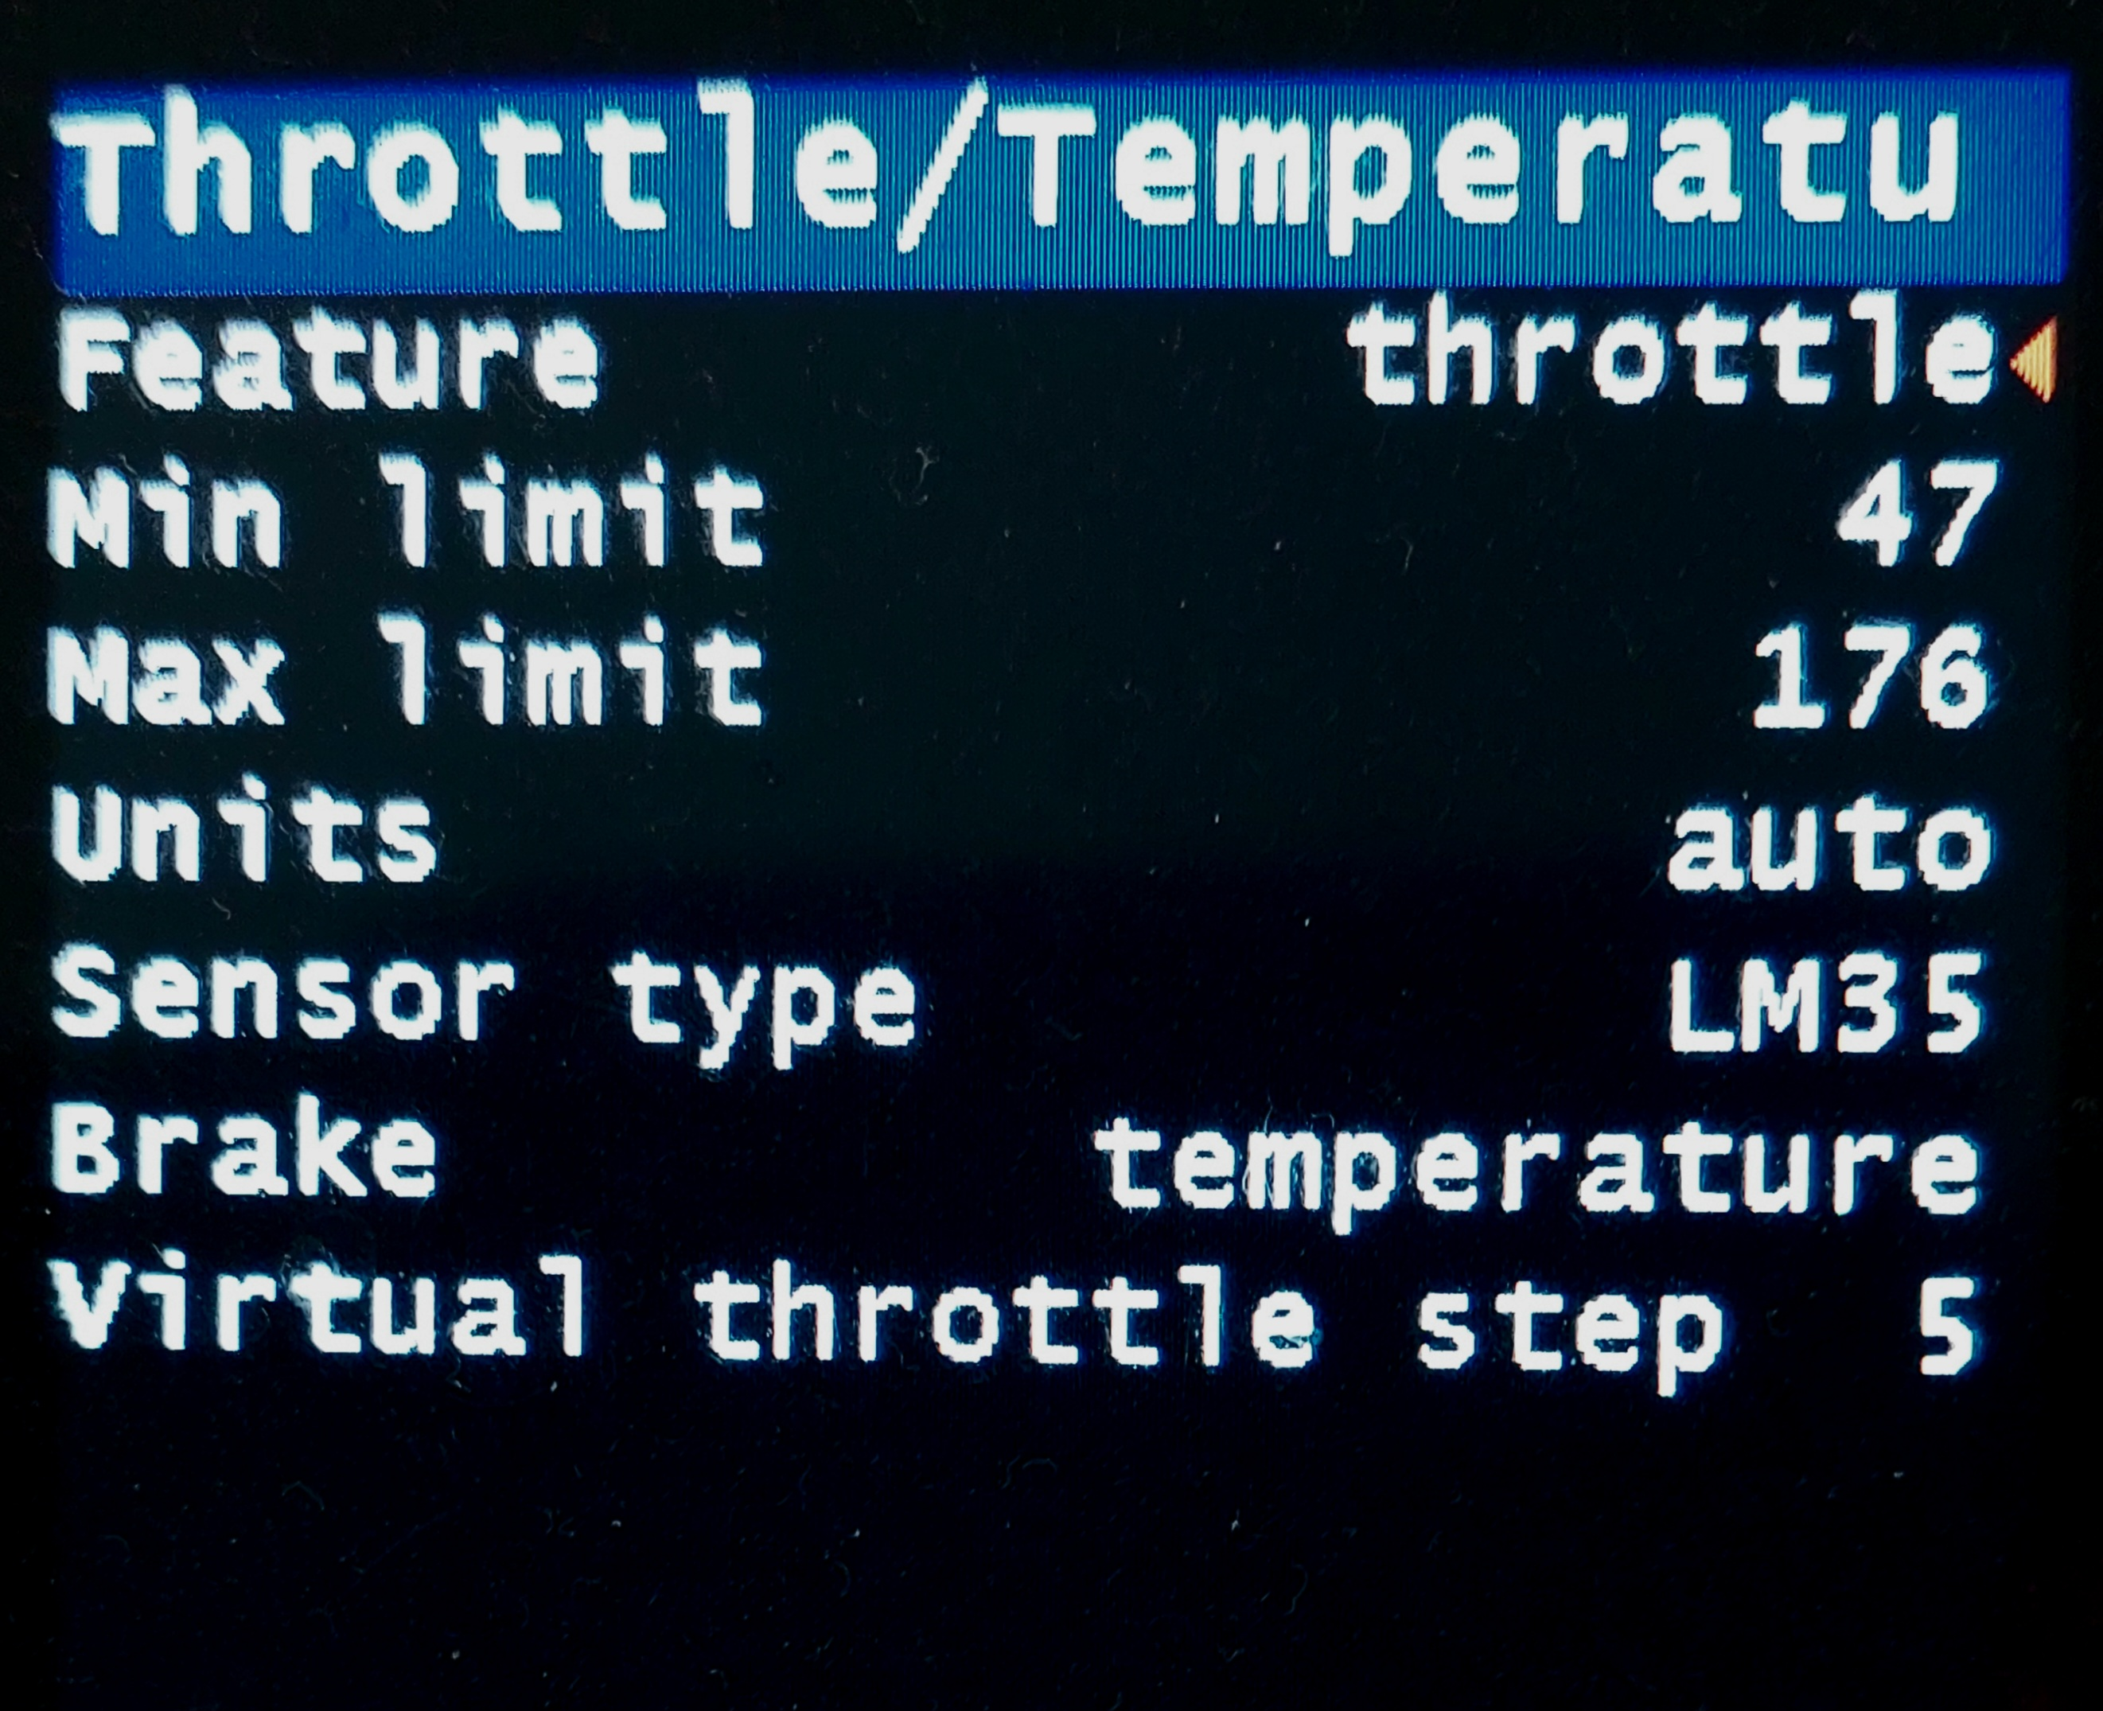

Here you can enable or disable the throttle or the motor temperature protection that will let you push the motor limits. Note that you must first install the motor temperature sensor.
NOTES:
- The throttle and the motor temperature protection cannot be active simultaneously. This is because they use the same hardware ports to operate.
- If the motor temperature sensor is installed it is not possible to use the throttle. Do NOT enable throttle if that is the case.
Name | Recommended value | Description
Feature | Throttle | WARNING: THIS SETTING ENABLES THE THROTTLE.  Choice:  - Disable, means that neither the motor temperature control sensor nor the throttle are enabled. Mandatory choice if they are not installed.  - Temperature, to enable the automatic motor temperature control limit.  Enable this function only if the temperature sensor is installed, it is also necessary to set the min and max limits of the motor temperature.  WARNING: DO NOT enable temperature if the throttle is installed.  - Throttle, enables the throttle.  The throttle must also be enabled in the “Bike” menu, and possibly also in the “Street mode” menu.  Enable this function only if the throttle is installed.  WARNING: DO NOT enable the throttle if the motor temperature sensor is installed.
Min limit | 149F or 75°C | If the function is set to:  - Temperature  Sets the minimum motor temperature at which power will begin to be limited.  Default value: 149°F or 75°C.  - Throttle  Sets the minimum value of the throttle ADC input.  Check the "ADC throttle sensor" value in the "Technical" menu, with the throttle at idle.  Default value: 47.
Max limit | 185F or 85°C | If the function is set to:  - Temperature  Sets the maximum motor temperature at which power will be completely cut off, meaning no motor assistance. The recommended maximum value is 85 degrees Celsius.  Default value is 185°F or 85°C.  - Throttle  Sets the maximum value of the throttle ADC input.  Check the "ADC throttle sensor" value in the "Technical" menu, with full throttle.  Default value is 176.
Units | Auto | Choice of temperature measurement units:  - Auto, Celsius with SI, Fahrenheit with Imperial.  - Celsius  - Fahrenheit
Sensor type | LM35 | Choice of temperature sensor type:  - LM35  - TMP36
Brake | brake | If the throttle input is not available, a thermostat can be installed to control the temperature, using the brake input.  Choice:  - brake, if brake sensor is installed.  - temperature, if an on/off thermostat is installed (NO max 85°C).  Attention, the choice affects only the display message, “BRAKE” or “Temp Shutdown” .  In theory, both can be installed (contacts in parallel), but the message is only one.
Virtual throttle step | 5 | Amount steps for each increase and decrease of Virtual throttle.

Variables
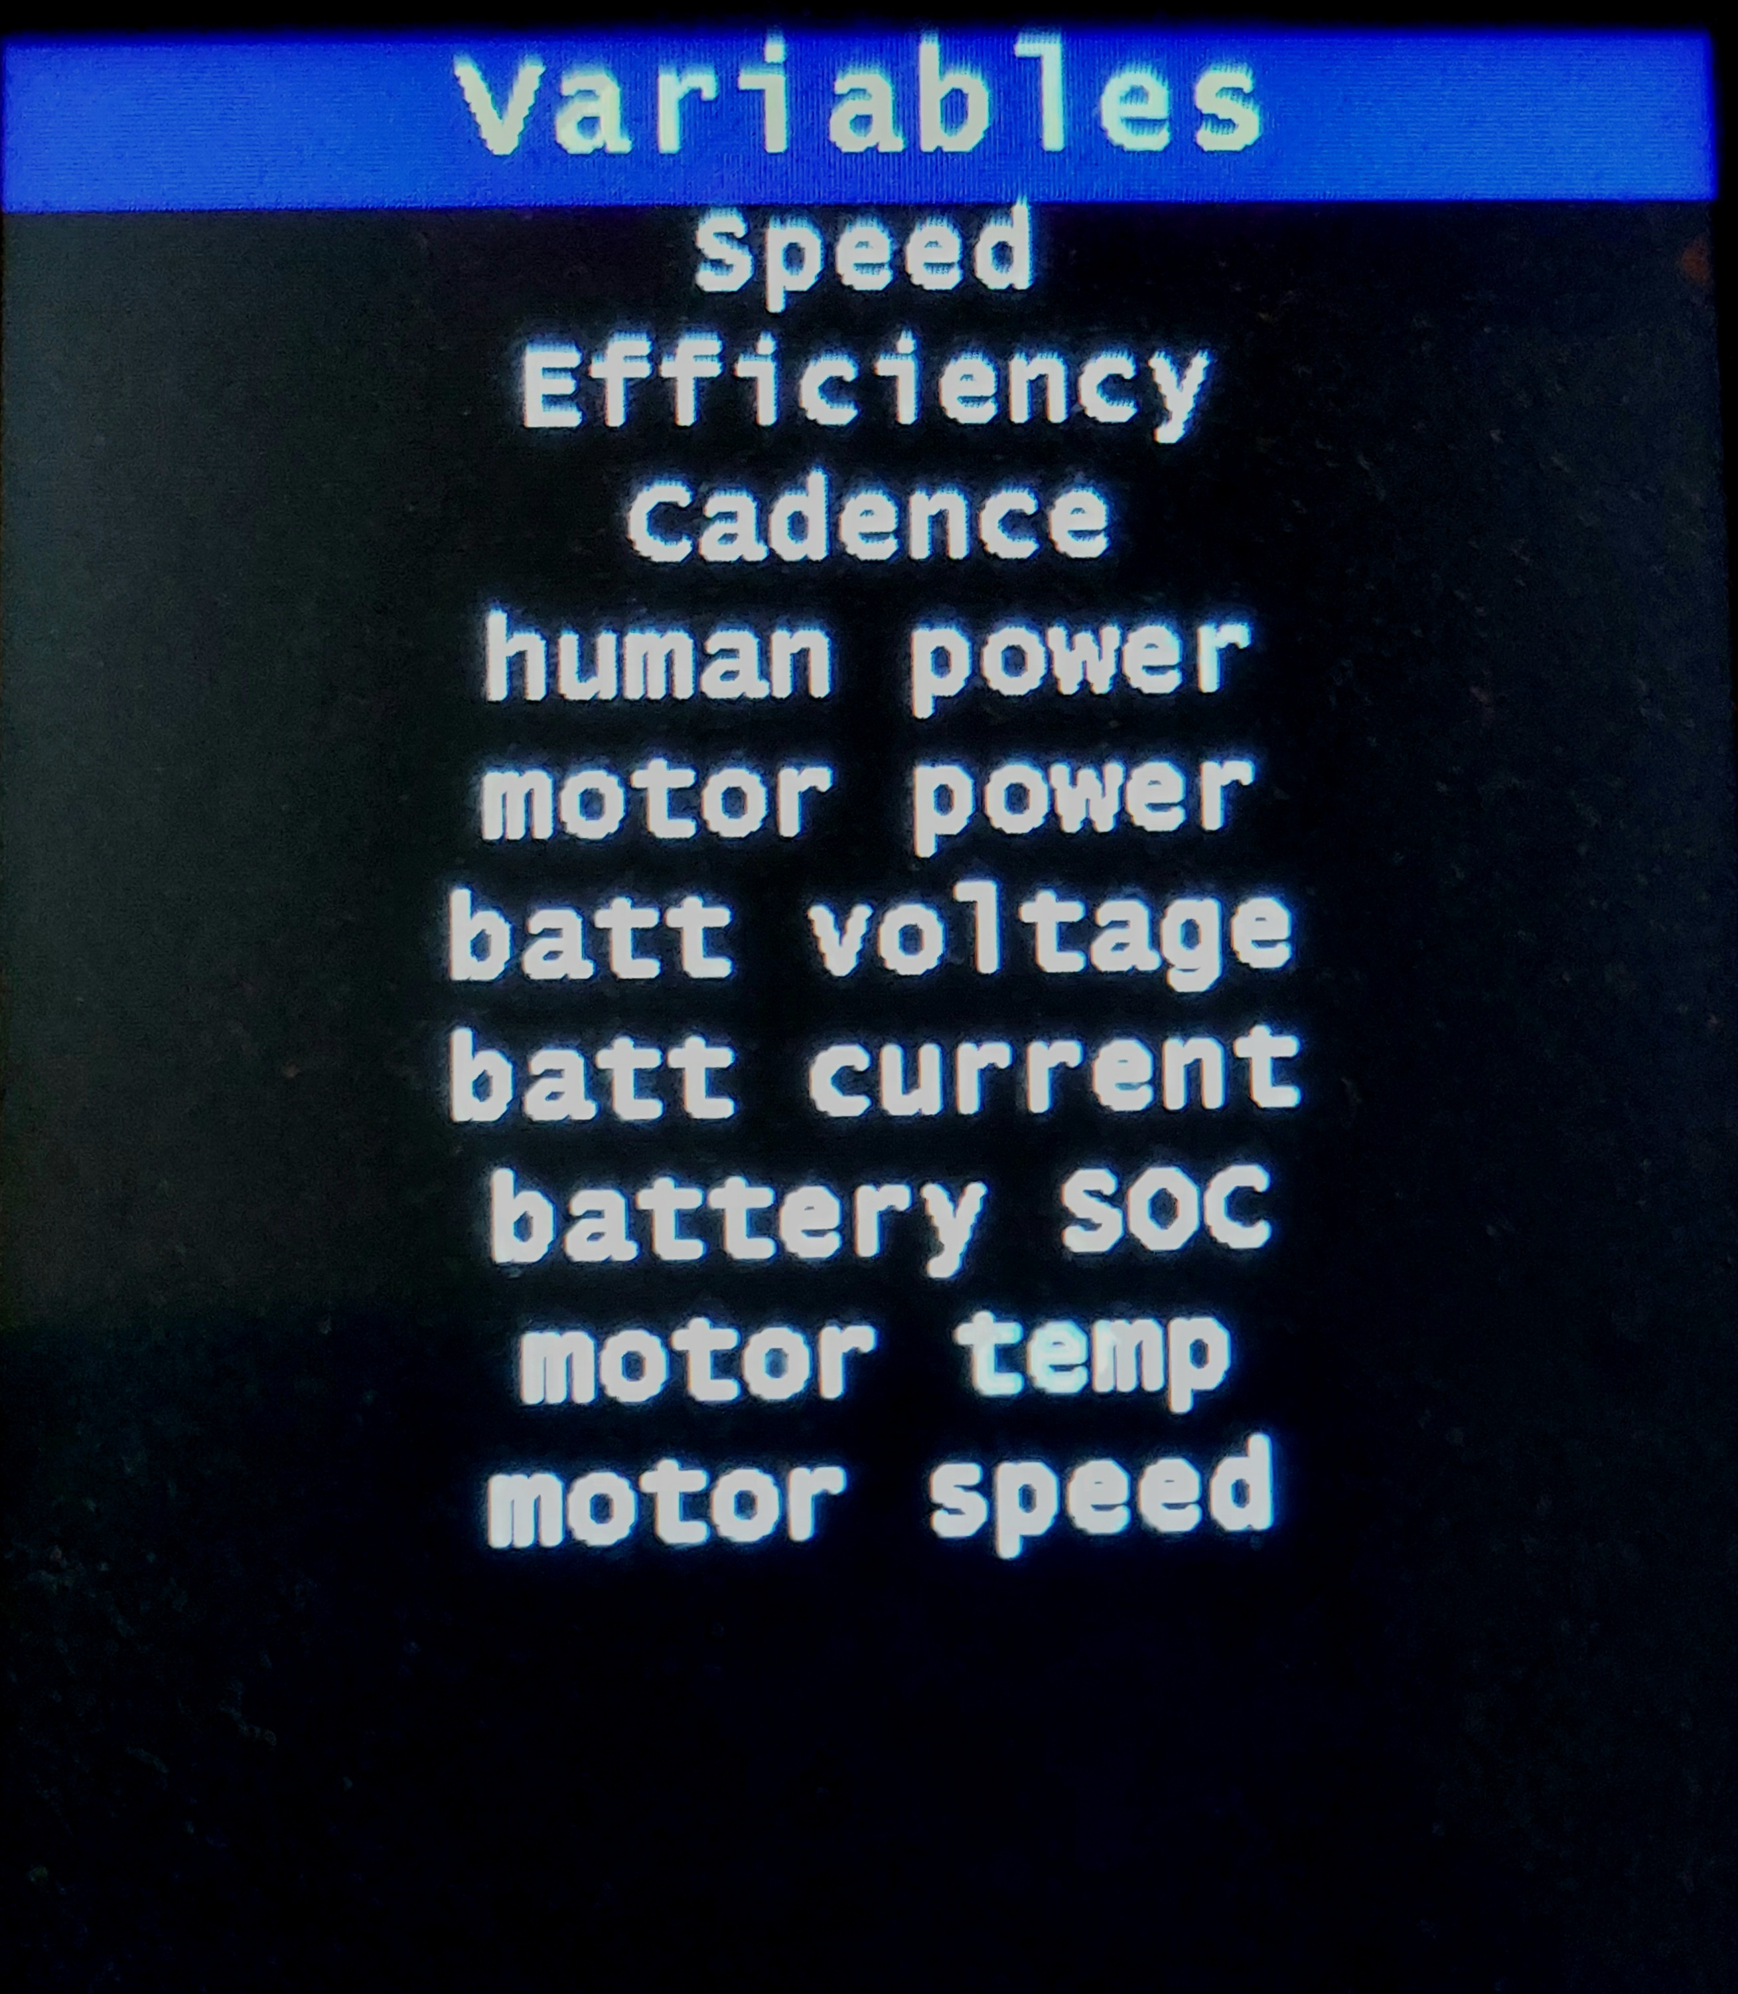

These menu items allow you to configure some options of the possible variables displayed in the numeric field and in the graphs.
Name | Recommended value | Description
Graph auto max min | x | Should the graph use automatic values for max and min or use the following manual values.
Graph max | x | Set the graph max value. Will be set up to when a new value on the graph is lower than this value.
Graph min | x | Set the graph min value. Will be set up to when a new value on the graph is higher than this value.
Thresholds | x | Thresholds will make the graph or numeric field values fade to yellow or red color, depending on the variable value. For instance, as soon as motor speed starts to approach near its max value, the color will fade first to yellow and then to red.  You can disable, set to manual or automatic the thresholds.
Max threshold | x | Set the value for manual max threshold, for red color.
Min threshold | x | Set the value for manual min threshold, for yellow color.

Various
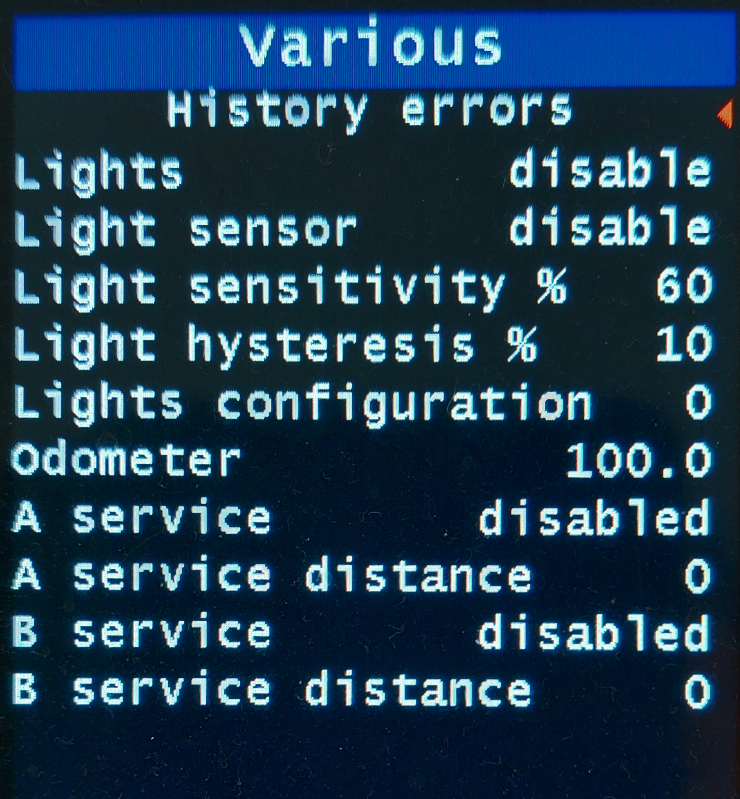

Name | Recommended value | Description
History errors |  | Error history view menu.
Lights | enable | Enable/disable manual light on/off.  If lights aren't installed or if you only use the light sensor to turn them on, you can disable manual light on. This allows you to activate the "Startup assist" function after just 2 seconds instead of 4.
Light sensor | disabled | Enable / disable automatic turning on/off of the lights.
Light sensitivity % | 60 | Light sensor sensitivity %.
Light hysteresis % | 10 | Light sensor hysteresis %. On/off range.
Lights configuration | 0 | Choose your preferred mode from the 9 available.  With light control ON:  0 – on  1 – flashing  2 - on and fast flashing when braking  3 - flashing and on when braking  4 - flashing and fast flashing when braking  5 - on and on during braking also with light control OFF  6 - on and fast flashing when braking even with the light control OFF  7 - flashing and switched on when braking even with the light control OFF  8 - flashing and fast flashing when braking even with the light control OFF  The braking modes are only available with the brake sensors installed.
Odometer | 0 | This field shows the current odometer value. You can also change the value, for example when replacing the display, or by setting it to 0 to reset the odometer with a new motor.
Service A | disable | Disabled or Enabled with chain, brakes, shocks, other. The choice will be displayed in the maintenance notice.  Enable maintenance warning A when the set distance is reached.
Service A distance | x | Distance for maintenance warning A, in km or miles.
Service B | disable | Disabled or Enabled with chain, brakes, shocks, other. The choice will be displayed in the maintenance notice.  Enables maintenance warning B when the set travel time is reached.
Service B distance | x | Distance for maintenance warning B, in km or miles.

History errors
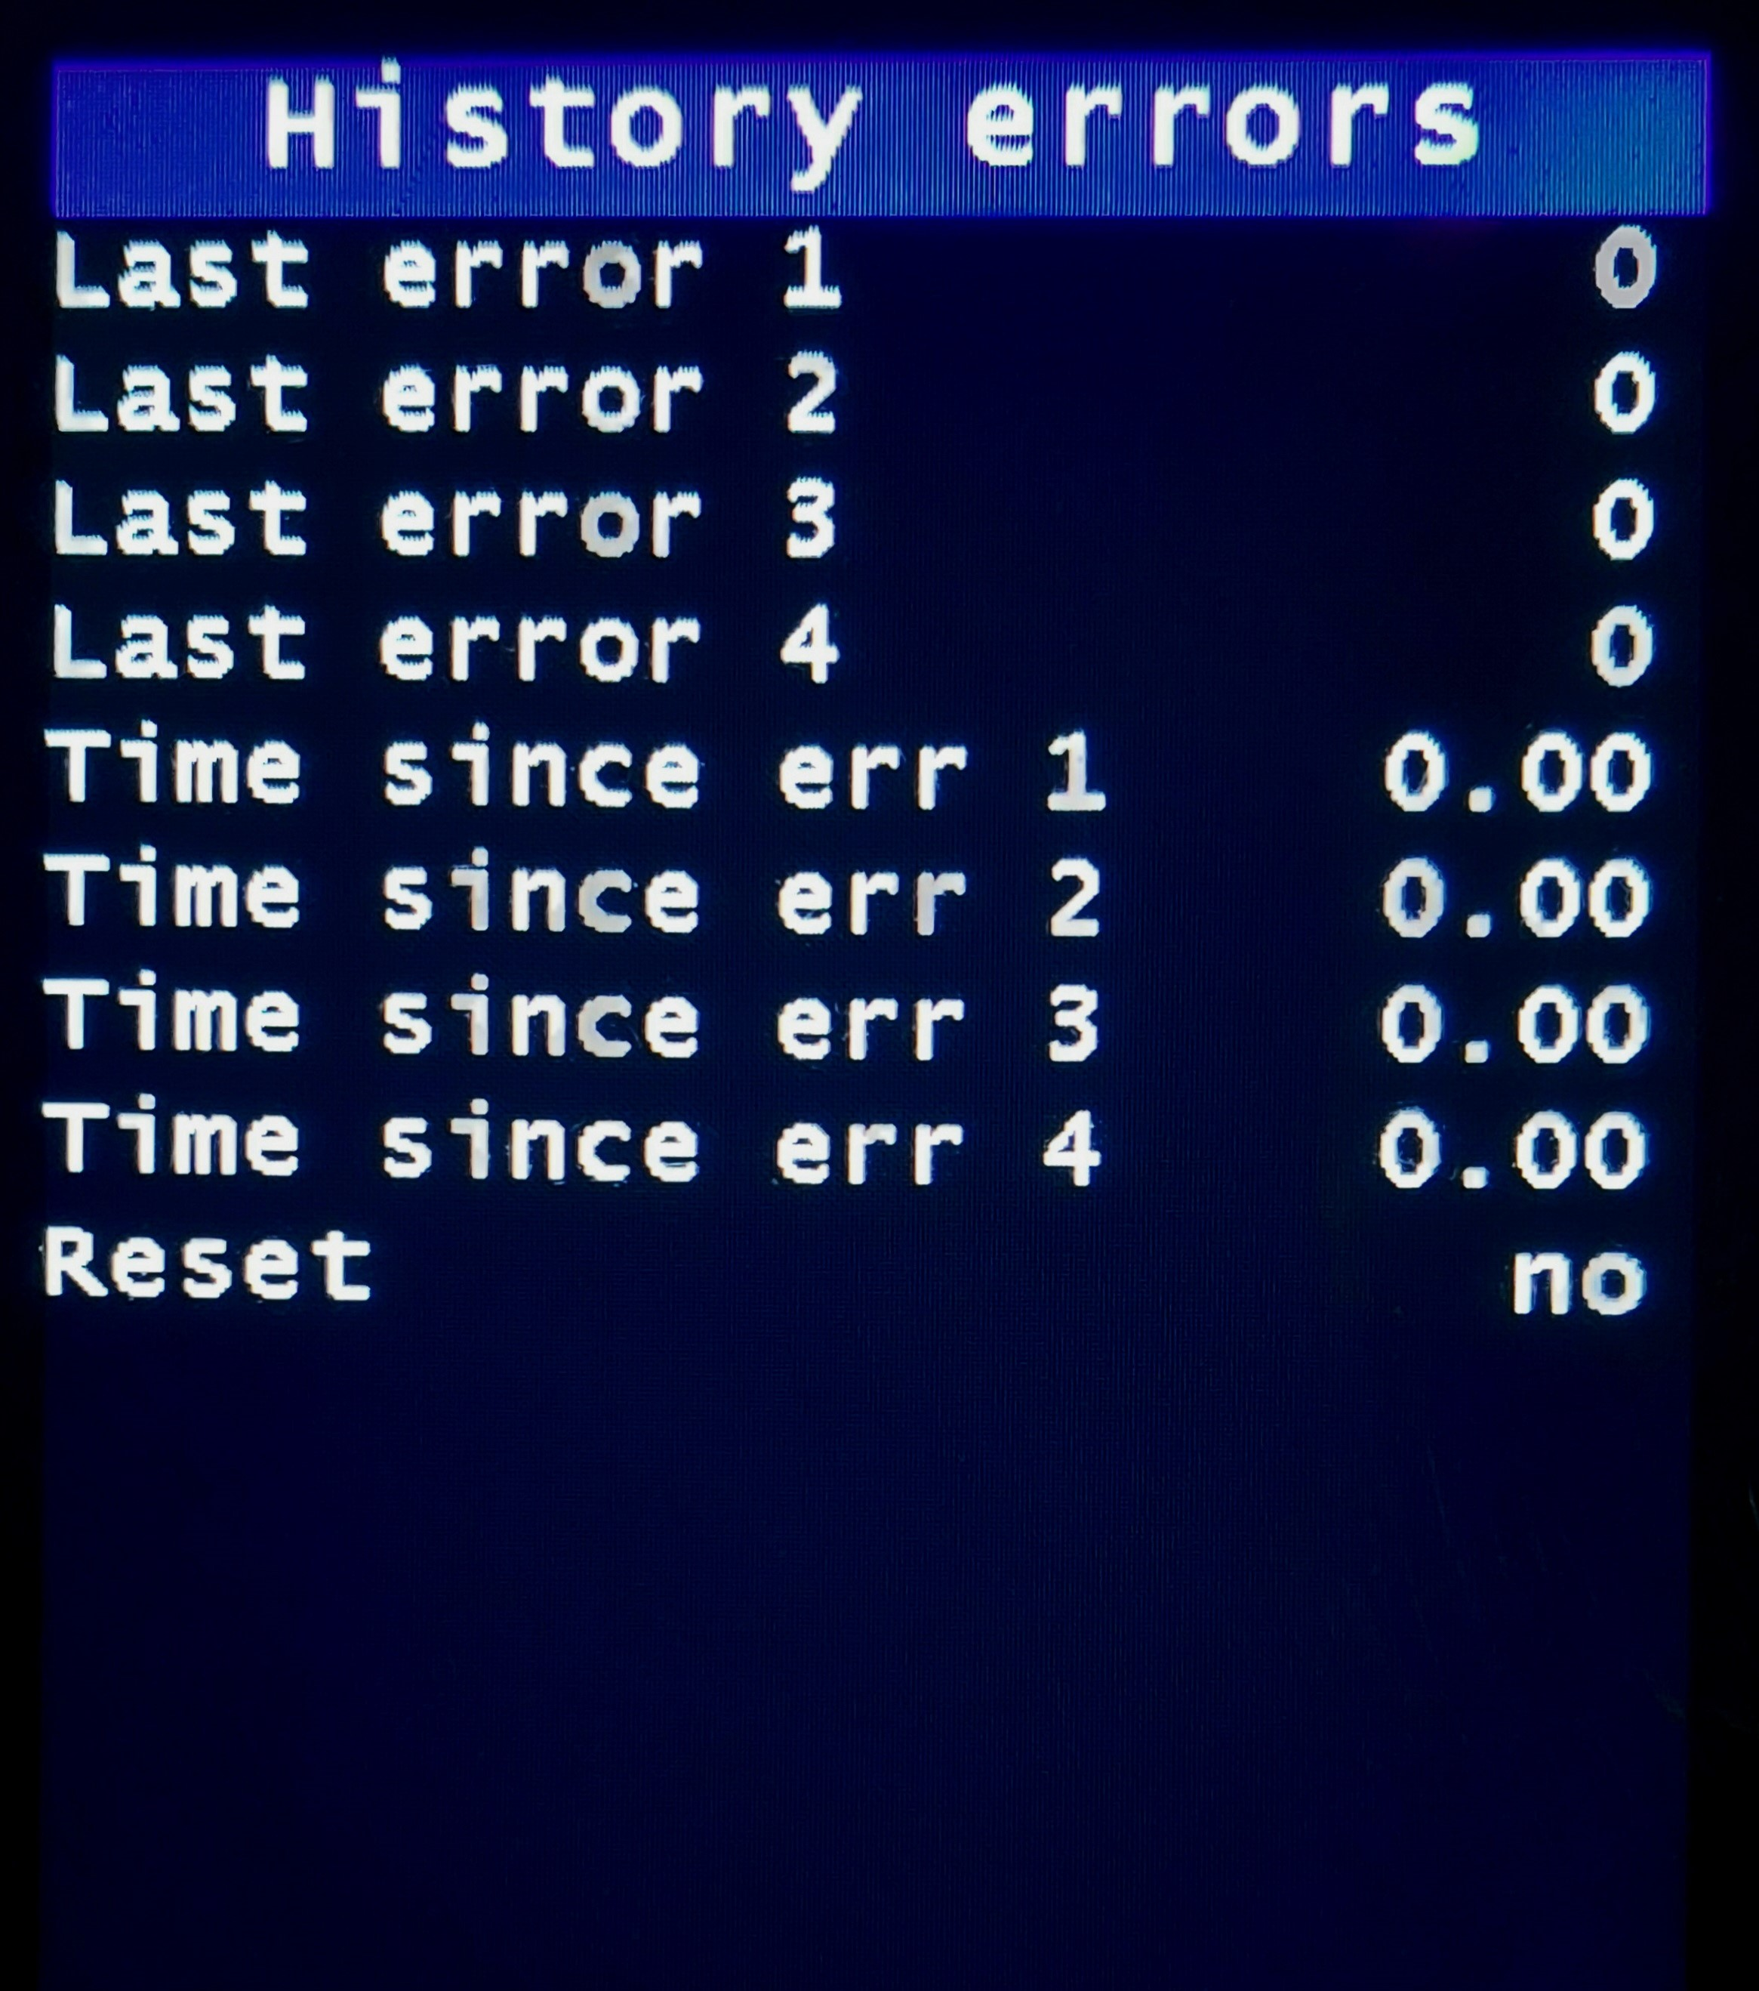

Name | Recommended value | Description
Last error 1 |  | Error 1, this is the most recent one.  See error codes for details.
Last error 2 |  | Error 2.
Last error 3 |  | Error 3.
Last error 4 |  | Error 4.
Time since err 1 |  | Time since error 1.  Format days.hours
Time since err 2 |  | Time since error 2.
Time since err 3 |  | Time since error 3.
Time since err 4 |  | Time since error 4.
Reset |  | History errors reset.
Display
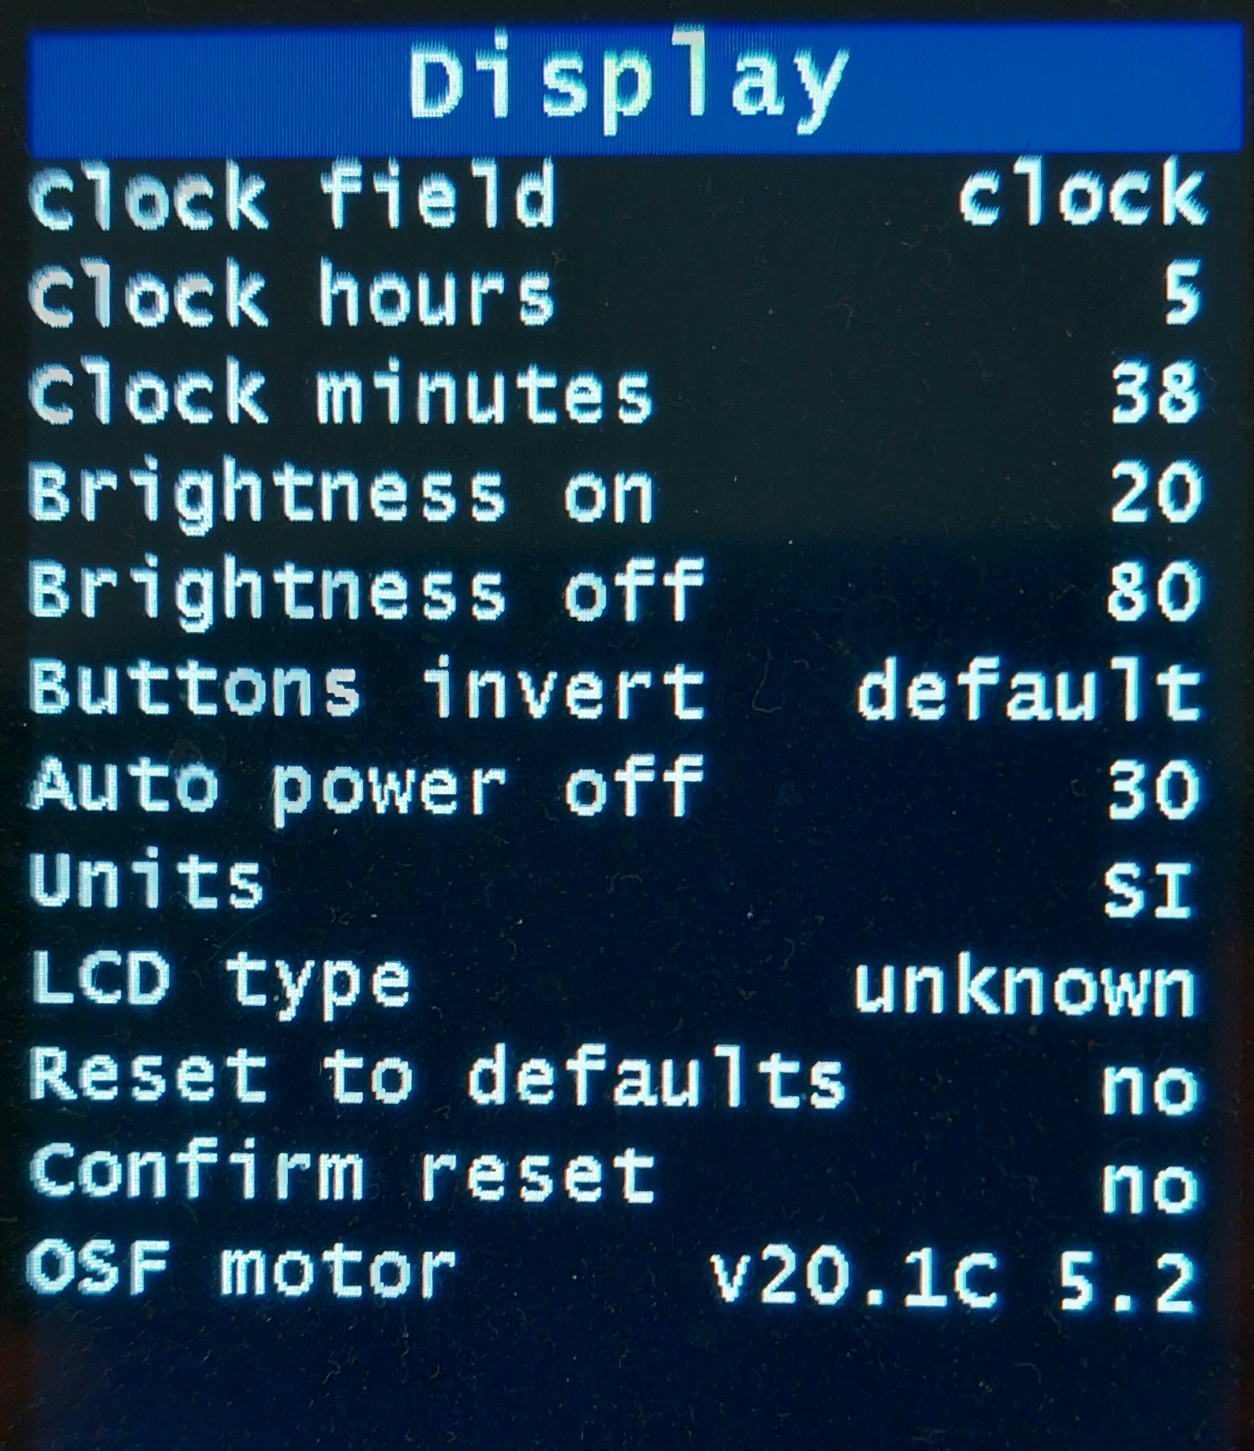

Name | Recommended value | Description
Clock field | clock | - disable  - clock  - batt soc %  - batt volts
Clock hours | 0 | See current hour value or set a different value.
Clock minutes | 0 | See current minutes value or set a different value.
Brightness on | 50% | Set display backlight brightness when lights are on.
Brightness off | 100% | Set display backlight brightness when lights are off.
Button invert | default | Button function:  - default  - invert
Auto power off | 30 | Set the number of minutes for the display automatic power off.  The auto power-off timer counter is reset when wheel speed or battery current is higher than 0, or if brakes or buttons are active.
Units | SI | Set units to SI or Imperial.
LCD type | unknown | This is read-only and is the LCD type on the display and is relevant for developers. Actual options are ILI9481, ST7796 and unknown.
Reset to defaults | no | Set yes to reset all the configurations to default values. Confirmation required.
Confirm reset | no | Confirm the default reset.  After this operation, before using the motor, it will be necessary to correctly configure the options on the display, in particular "Motor type" and "Low voltage cut-off". Also check and set all the other parameters to ensure the correct operation of the motor.
OSF motor v20.1C |  | OSF version installed on the motor controller.  From firmware version v20.1C.4 update 4, the exact correspondence between the one installed on the display and the one installed on the motor is no longer necessary.  The display version v20.1C.4 update 4 is compatible with motor firmware v20.1C.4 update 3 and later.

Technical
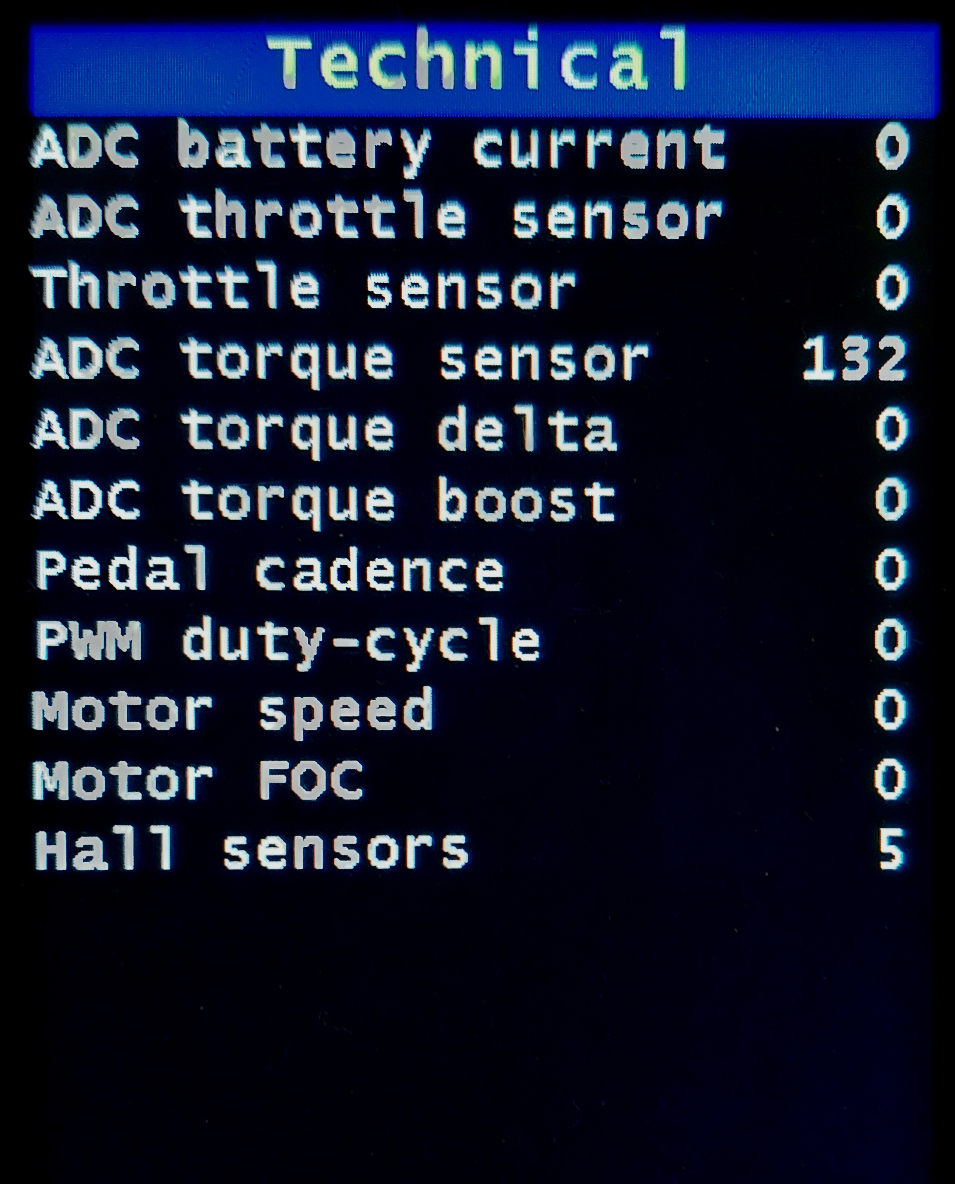

Here you can see the values of some variables of the system. This can help debug issues on TSDZ2 or help you understand how the system works.
Name | Recommended value | Description
ADC Battery Current | x | ADC value of the current being drawn by the battery.
ADC throttle sensor | x | Current adc value of the input signal from the throttle, values ​​to be entered in Min and Max in the Throttle/Temperature menu.
Throttle sensor | x | Current value of the throttle input signal remapped from 0 to 255.
ADC torque sensor | x | Torque sensor ADC values, to be used for calibration.  - Value of "Torque adc offset" without any push on the pedals.  - Value of "Torque adc max" with the maximum thrust applied to the pedal (standing cyclist,  on the right pedal in a horizontal position).  - Value of "Torque adc on weight" with a weight from 20 to 25Kg applied to the pedal.  Take note of the values obtained and enter them in the items of the “Torque sensor” menu.
ADC torque delta | x | ADC value of the torque sensor without offset.  It is possible to observe and analyze the variations resulting from the calibration.
ADC torque boost | x | ADC value of the torque sensor without offset and with the increase of the "Startup boost" function if enabled. Only in "Power assist" mode.
Pedal cadence | x | The instantaneous value of the pedal cadence.
PWM duty-cycle | x | These values can fluctuate between 0 and 100 max. Where 0 means 0 battery voltage applied to motor coils while 100 means max battery voltage applied. When this value hits the max of 100, means that the max motor power possible is being applied.
Motor speed | x | In ERPS (electric rotation per second) units. The motor has 8 pairs of magnets inside, meaning each 1 ERPs equal to one RPS (rotation per second).
Motor FOC | x | Angle calculated by FOC algorithm, between 0 and 15. Higher motor phase current and/or higher motor speed makes this value increase.
Hall sensors | x | The current value of the motor hall sensor. You can rotate very slowly the bicycle wheel back backward to see this value changing and it must always follow the next same sequence and values must be only the next ones: 4, 6, 2, 3, 1, 5.

Error codes
Error codes and description (red color).
Warning: To reset an error, you must turn the display off and on again.

e 1 Motor not init
Communication interrupted, the display receives data from the motor controller, but the controller does not receive it from the display. Check the wiring.

e 2 Torque Fault
A mechanical problem may have occurred with the torque sensor or the calibration at startup has not been performed correctly. A torque was probably applied to the pedals during power on. Switch off and on again so that the system can recalibrate, without forcing the pedals. If the "Torque sensor calibration" function is enabled, check on the display if the value of "Pedal torque ADC offset" with free pedals and "Pedal torque ADC max" with maximum effort, correspond to those entered.

e 3 Cadence Fault
While pedaling, no pulses are generated by the cadence sensor, possibly faulty.

e 4 Motor Blocked
Motor or wheel blocked, excessive current absorption without motor rotation.
Check the cause.

e 5 Throttle Fault
Throttle input check on power up, failed.

e 6 Fatal error
Communication problem between motor controller and display, check wiring.

e 7 Overcurrent
Excessive current draw. Turn the display off and on again.

e 8 Speed Fault
Faulty speed sensor or magnet too far away.

e 9 Undervoltage
Battery voltage too low.
It could be a wrong setting of the “Low cut-off” voltage, or a problem in the wiring.

Boot messages
These messages may appear on the boot screen:

Keep pedals and brakes free
Reminder to keep pedals free while turning on the display for at least 5 seconds, for correct self-calibration of the torque sensor.

Wait TSDZ2
The display is waiting to communicate with the motor controller.
If it doesn’t connect, there is a problem with the wiring or serial ports.

SIMULATING TSDZ2!
Display operation mode without connection to the motor.
Reserved for developers.

Error brakes or comms
Warning that the brake sensors are activated when the display is turned on.
If the sensors are not installed, it could be a communication or wiring problem.

Error RX line
Communication problem. Display is not receiving data from motor controller. Check wiring.

TSDZ2 firmware error
The firmware version of the display is not compatible with that of the motor controller.

System messages
These messages may appear when the display is turned on or when exiting the configuration menu:

Error set config
Problem configuring parameters, please revert to previous values ​​and file a detailed report on GitHub.

Motor init
Parameter configuration completed. Motor ready to use.

Report Bug!
Unexpected issue. Please file a GitHub report under what conditions the issue occurred.

Warning messages
These messages may appear during normal use (yellow color).

Service A (chain, brakes, shocks, other)
Service B (chain, brakes, shocks, other)
Maintenance warning, set distance reached.

Temp Warning
The minimum safe motor temperature has been reached, power starts to be limited. Only available with temperature sensor installed and enabled.

Temp Shutdown
Maximum safe motor temperature reached, power is blocked. Only available with temperature sensor installed and enabled.

Voltage cut-off
The cut-off voltage has been reached, the power starts to be limited until it stops.

Speed limit
Maximum speed with assistance has been reached, power begins to be limited to a motor stop.

Low efficiency
The minimum efficiency limit, set in the Variable→Efficiency menu, has been reached.
This is a suggestion to increase the cadence or change the gear ratio.

Function messages
These messages may appear during normal use (white color).

BRAKE
Brakes operated. Only available with brake sensor installed.

STARTUP
The Startup assist function is active.

WALK
The Walk assist function is active.

CRUISE
The Cruise function is active.

LIGHTS
The lights are on.

