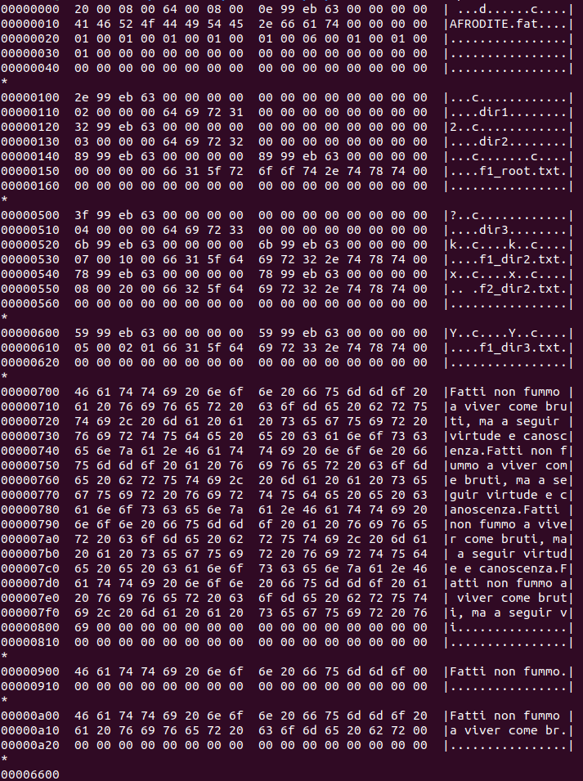
Boot record
FAT
Root directory
dir2 Directory Table
dir3 Directory Table
Data area
Cluster 5 e 6 del file: f1_dir3.txt
Indici della FAT: 0 e 5

