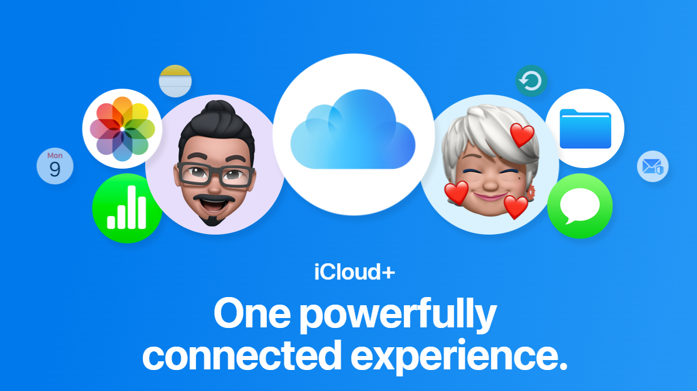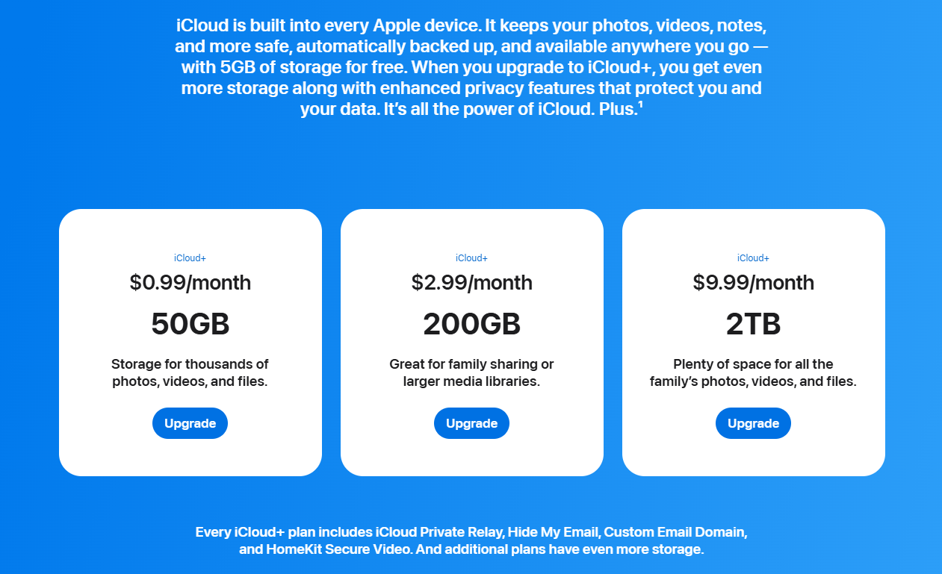

- Some iCloud+ features are not available in all countries or regions.
- Backup of purchased music is not available in all countries or regions. Previous purchases may not be restored if they are no longer on the iTunes Store, App Store, or Apple Books.
- iCloud Private Relay is not available in all countries or regions. Without access to your IP address, some websites may require extra steps to sign in or access content.
- HomeKit Secure Video requires a supported iCloud+ plan, compatible HomeKit-enabled security camera, and HomePod or Apple TV running as a home hub.
- Family Sharing requires a personal Apple Account signed in to iCloud and iTunes. Music, movies, TV shows, and books can be downloaded on up to 10 devices per account, five of which can be computers. iOS 8 or later and OS X Yosemite or later are required to set up or join a Family Sharing group and are recommended for full functionality. Not all content is eligible for Family Sharing. Content can be hidden by family members; hidden content is not available for download. Content downloaded from family members or acquired via redemption codes is not subject to Ask to Buy.
- The Apple One free trial includes only services that you are not currently using through a free trial or a subscription. Plan automatically renews after trial until cancelled. Restrictions and other terms apply.
- iCloud requires iOS 5 or later on iPhone 3GS or later, iPod touch (3rd generation or later), iPad Pro, iPad or later, iPad Air or later, or iPad mini or later; a Mac computer with OS X Lion 10.7.5 or later; or a PC with Windows 7 or Windows 8 (Outlook 2007 or later or an up-to-date browser is required for accessing email, contacts, and calendars). Some features require iOS 16, iPadOS 16, and macOS Ventura. Some features require a Wi-Fi connection. Some features are not available in all countries or regions. Access to some services is limited to 10 devices.

