Homework_4

Emmenta Janneh

2024-02-11

library(tidyverse)

## Warning: package 'tidyverse' was built under R version 4.3.2

## ── Attaching core tidyverse packages ──────────────────────── tidyverse 2.0.0 ──  
## ✔ dplyr 1.1.2 ✔ readr 2.1.4  
## ✔ forcats 1.0.0 ✔ stringr 1.5.0  
## ✔ ggplot2 3.4.3 ✔ tibble 3.2.1  
## ✔ lubridate 1.9.2 ✔ tidyr 1.3.0  
## ✔ purrr 1.0.2   
## ── Conflicts ────────────────────────────────────────── tidyverse_conflicts() ──  
## ✖ dplyr::filter() masks stats::filter()  
## ✖ dplyr::lag() masks stats::lag()  
## ℹ Use the conflicted package (<http://conflicted.r-lib.org/>) to force all conflicts to become errors

library(broom)

## Warning: package 'broom' was built under R version 4.3.2

## Conceptual Exercises

1. The standard error of β1 would decrease when a new observational unit is obtained with Xnew = Xmean. When Xnew = Xmean, the distance of each data point from the mean, Xi - Xmean, remains the same for all data points, including the new one. Therefore, the denominator of the formula remains constant.

* Since the denominator remains constant and Var is also assumed to be constant, the standard error SE would decrease as n ( the sample size) increases with the addition of the new observational unit.

1. 2 * pt(-7.52, df = 13)

* ## [1] 4.373129e-06
* 0.997 / 0.111
* ## [1] 8.981982
* ## # A tibble: 2 x 5  
  ## term estimate std.error statistic p.value  
  ## <chr> <dbl> <dbl> <dbl> <dbl>  
  ## 1 (Intercept) 8.39 1.11 7.52 0.00000437  
  ## 2 Years 0.997 0.111 8.982 0.000000618

1. estimate <- c(8.39, 0.997)  
   std_error <- c(1.11, 0.111)  
   statistic <- c(7.52, 8.982)  
   df <- 15 - 2  
   t_critical <- qt(0.975, df)  
     
   lower_ci <- estimate - t_critical * std_error  
   upper_ci <- estimate + t_critical * std_error  
     
   ci_data <- data.frame(term = c("(Intercept)", "Years"),  
    lower_ci = lower_ci,  
    upper_ci = upper_ci  
    )  
   ci_data

* ## term lower_ci upper_ci  
  ## 1 (Intercept) 5.9919908 10.788009  
  ## 2 Years 0.7571991 1.236801

## Wheatears

library(Sleuth3)

## Warning: package 'Sleuth3' was built under R version 4.3.2

data("ex0727")  
data("ex0727")  
wheat <- ex0727  
glimpse(wheat)

## Rows: 21  
## Columns: 2  
## $ Mass <dbl> 3.33, 4.62, 5.43, 5.73, 6.12, 6.29, 6.45, 6.51, 6.65, 6.75, 6.81…  
## $ Tcell <dbl> 0.252, 0.263, 0.251, 0.251, 0.183, 0.213, 0.332, 0.203, 0.252, 0…

lmout <- lm(Mass ~ Tcell, data = wheat)  
ggplot(wheat, aes(x = Tcell, y = Mass)) +   
 geom_point() +  
 geom_smooth(method = "lm", se = FALSE)

## `geom_smooth()` using formula = 'y ~ x'

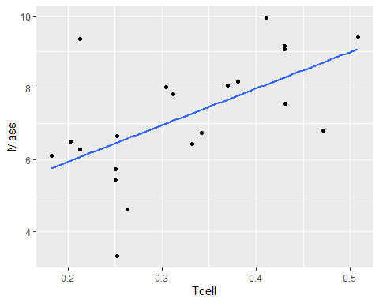

n <- nrow(wheat)  
n

## [1] 21

tidy(lmout, conf.int = TRUE)

## # A tibble: 2 × 7  
## term estimate std.error statistic p.value conf.low conf.high  
## <chr> <dbl> <dbl> <dbl> <dbl> <dbl> <dbl>  
## 1 (Intercept) 3.91 1.11 3.52 0.00230 1.58 6.24  
## 2 Tcell 10.2 3.30 3.08 0.00611 3.27 17.1

Form the above information, we have a positive linear association between Tcell and Mass. 3.91 is the y-intercept of the regression line. Birds with 1mm higher Tcell are estimated to carry on average 10.2g higher stone mass (95% confidence interval of 3.3g lower to 17.1g higher). With a strong evidence that this association is not due to chance alone *(p = 0.006, n = 21)*.

newbird <- data.frame(Tcell = c(0.35))  
predict(object = lmout, newdata = newbird, interval = "confidence") %>% cbind(newbird)

## fit lwr upr Tcell  
## 1 7.469063 6.793505 8.144621 0.35

We estimate that a bird with Tcell of 0.35mm can carry on average a stone with mass 7.5g (95% confidence interval of 6.8g lower to 8.1g higher).

newbird <- data.frame(Tcell = c(0.2))  
predict(object = lmout, newdata = newbird, interval = "confidence")

## fit lwr upr  
## 1 5.944295 4.869499 7.01909

Birds with 0.2mm Tcell are estimated to carry on average 5.9g mass of stone (95% confidence interval of 4.9g lower to 7.0g higher mass).

advbird <- data.frame(Tcell = c(20))  
predict(object = lmout, newdata = advbird, interval = "predict")

## fit lwr upr  
## 1 207.2137 71.45158 342.9758

We estimate that a "super" bird with Tcell of 20mm can carry on average 207.2g (95% prediction interval of 71.5g lower to 342.9g higher).