Web Developer

Foundation knowledge + FrontEnd + BackEnd + DevOps = Full Stack

<https://github.com/kamranahmedse/developer-roadmap>

# Foundation Knowledge

## Internet

- How does the internet works ?

- What is HTTP ?

- Browsers and how they works ?

- DNS and how it works ?

- what is Domain Name ?

- what is hosting ?

## Configuration

1. Version Control Systems

- Repo hosting servies

GitHub, GitLab, Bitbucket

- SSH

- Basic Terminal Usage

1. Web Security Knowledge

- HTTP/HTTPS and APIs

- Content Security Policy

- CORS

- OWASP Security Risks

- Learn to Research

- Data Structures and Algorithms

- Character Encoding

- Design Patterns

# FrontEnd

### 1) Learn the Basics

1. Learn HTML

- Learn the basics and how to write Semantic HTML

- Form and Validations

- Conventions and Best Practices

- Accessibility

- SEO Basics

1. Basic of CSS

- Learn the basics of CSS

- Making Layouts

○ Floats

○ Positioning

○ Display

○ Box Model

○ CSS Grid

○ Flex Box

- Responsive Design and media Queries

- Style the HTML Pages that you made in last step

1. Basics of JavaScript

- Learn the syntax and basic constructs

- Learn how to manipulate DOM

- Learn Fetch API / Ajax ( XHR )

- Learn Es6 + new features and writing modular JavaScript

- Understand the concepts such as Hoisting, Event bubbling, Scope, Prototype, shadow DOM, strict etc

1. jQuery

### 2) CSS Frameworks & Processors

1. Responsive Web
2. Choose Framework

- Foundation

- Bootstrap *

- Reactstrap *

- Material UI *

- Tailwind CSS *

- Chakra UI *

- Materialize CSS

- Semantic UI

- Bulma

1. Preprocessors

- Sass

- Less

- PostCSS

- Stylus

### **3) JS Client Frameworks + Tools**

1. ES6
2. Build Tools

- Task Runner

○ npm scripts

○ Gulp

- Module Bundlers

○ Webpack

○ Rollup

○ Parcel

- Module Loaders

○ Webpack

○ Require JS/ AMD

○ Browserify

- Linters and Formatters

○ Prettier

○ ESLint

○ StandardJS

1. Package Manager

- npm

- yarn

1. Choose a Framework

- Angular

○ RxJS

○ NgRx

- React

○ Flux

○ Redux

○ MobX

- Vue.js

○ VueX

- Ember JS

- Preact

- Inferno

1. Testing

- Jest

- Mocha

- Jasmine

1. Type Checkers

- TypeScript

- Flow

1. Progressive Web Apps

- Learn different Web APIs used in PWAs

○ Storage

○ Web Sockets

○ Service Workers

○ Location

○ Notifications

○ Device orientation

○ payments

○ Credentials

- Calculating, Measuring and improving performance

○ PRPL Pattern

○ RAIL Model

○ Performance Metrics

○ Using Lighthouse

○ Using Dev Tools

1. Server Side Rendering ( SSR )

- React.js

○ Next.js

○ After.js

- Angular ( Universal )

- Vue.js

○ Nuxt.js

1. Static Site Generators

- Next,js, GatsbyJS, Nuxt.js, Vuepress, Jekyll, Hugo

1. Mobile Applications

- React Native, NativeScript, Flutter, Ionic

1. Desktop applications

- Electron, NWjs, Carlo, Proton Native

### 4) CSS Mastery, Graphics & Visualization

1. CSS

- Methodologies

○ SUITCSS

○ BEM

○ OOCSS

○ SMACSS

○ Systematic CSS

- Mordern CSS

○ Styled components

○ CSS Modules

○ Styles JSX

○ Emotion

○ Radium

○ Glamorous

- Dive Deep CSS3

○ Flexbox

○ Gradients

○ Grids

○ Rotate

○ Transform

○ Skew

○ Scale

○ Transitions

○ …etc

1. SVG

- D3

1. JavaScript

- Design Patterns

- Regex

- GOF Design Patterns

- Learn different testing techniques

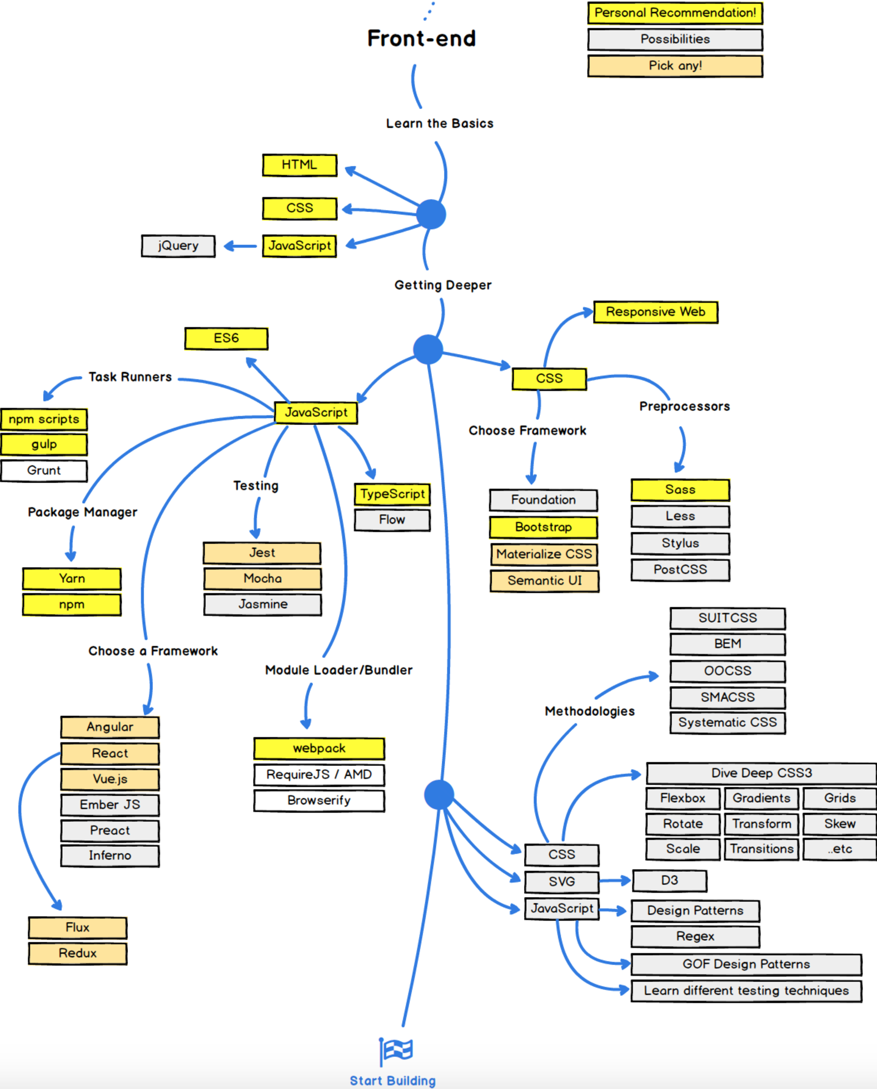

# Backend

## OS and General Knowledge

1. Terminal Usage
2. How OSs work in General
3. Process Management
4. Threads and Concurrency
5. Basic Terminal Commands

- grep, awk, sed, isof, curl, wget, tail, head, less, find, ssh, kill

1. Memory Management
2. Interprocess Communication
3. I/O Management
4. POSIX Basics

- stdin, stdout, stderr, pipes

1. Basic Networking Concepts

## Lean a Language

1. PHP
2. C#
3. JAVA
4. JavaScript
5. Python
6. Ruby
7. Rust
8. Go

## Node.js

1. Package Manager

- npm

- yarn

1. Framework

- Express

- hapi

- Koa

- Sails.js

1. Testing

- Jest

- Mocha

- Jasmine

- Chai

- should.js

## Infrastructure + Key Techniques

1. Web Server

- Coddy

- Apache

- Nginx

1. RESTful APIs

- JSON Web Token ( JWT )

- OAuth 2.0

1. Read about MVC
2. Authentication
3. SOLID, YAGNI, KISS, …
4. Regular Expressions
5. Security
6. GraphQL

- Apllo

- Relay Modern

1. Docker

## Database

1. Caching

- Memcached

- Redis

1. Relational Databases

- Oracle

- PostgreSQL

- MariaDB

- MySQL

- MS SQL

1. NoSQL Databases

- MongoDB

- RethinkDB

- CouchDB

- DynamoDB

## Patterns

1. Search engines

- Solr

- Shpinx

- ElasticSearch

1. GOF Design Patterns
2. Architectural Patterns
3. Give DDD a shot
4. Learn different testing techniques

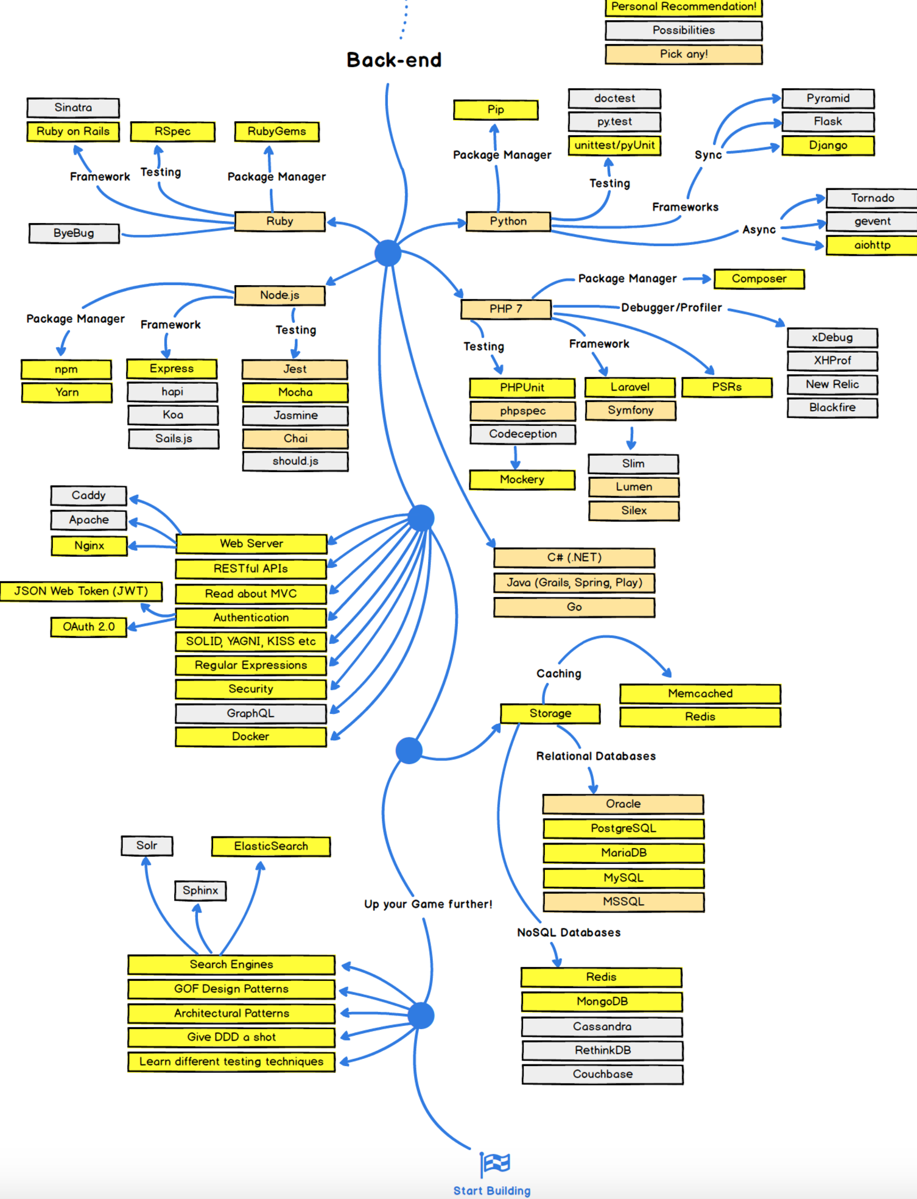

# DevOps

