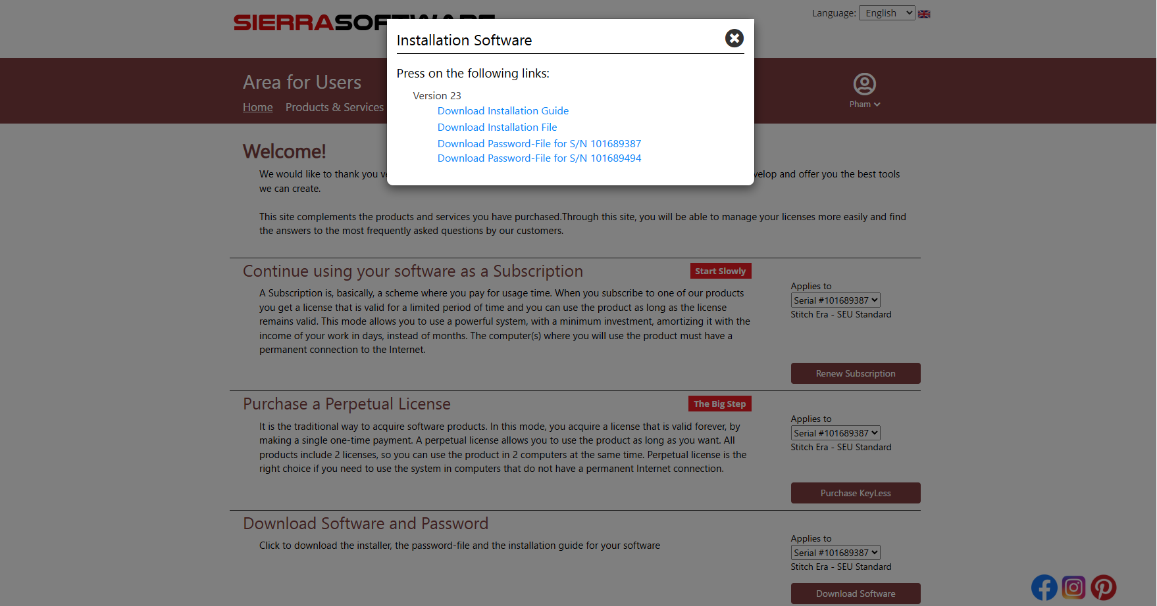

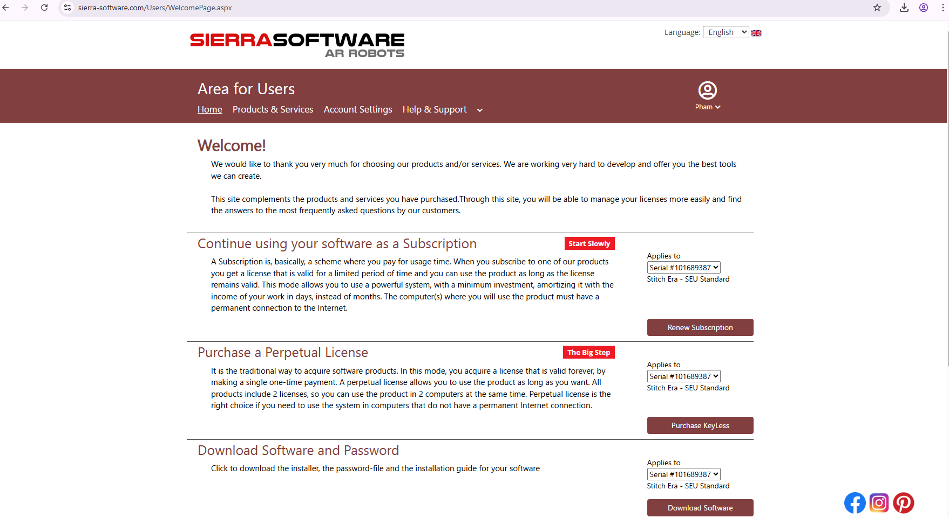 **Welcome!**

We would like to thank you very much for choosing our products and/or services. We are working very hard to develop and offer you the best tools we can create.  
  
This site complements the products and services you have purchased.Through this site, you will be able to manage your licenses more easily and find the answers to the most frequently asked questions by our customers.

Continue using your software as a Subscription

**Start Slowly**

A Subscription is, basically, a scheme where you pay for usage time. When you subscribe to one of our products you get a license that is valid for a limited period of time and you can use the product as long as the license remains valid. This mode allows you to use a powerful system, with a minimum investment, amortizing it with the income of your work in days, instead of months. The computer(s) where you will use the product must have a permanent connection to the Internet.

Applies to  
  Serial #101689387  Serial #101689494   
Stitch Era - SEU Standard

Purchase a Perpetual License

**The Big Step**

It is the traditional way to acquire software products. In this mode, you acquire a license that is valid forever, by making a single one-time payment. A perpetual license allows you to use the product as long as you want. All products include 2 licenses, so you can use the product in 2 computers at the same time. Perpetual license is the right choice if you need to use the system in computers that do not have a permanent Internet connection.

Applies to  
  Serial #101689387  Serial #101689494   
Stitch Era - SEU Standard

Download Software and Password

Click to download the installer, the password-file and the installation guide for your software

Applies to  
  Serial #101689387  Serial #101689494   
Stitch Era - SEU Standard