Emmett Culhane

MESc Candidate 2020

12/16/2018

**Math Final Project:**

**Describing coastal plankton density with a one dimensional diffusion-sedimentation model with spatially variable diffusion coefficient and sinusoidal excitation**

*I: Introduction*

This aim of this project is to develop a model that describes the variability of plankton density in-phase with the tidal current cycle of ~6 hours and 12 minutes. The model is intended to describe a short-duration localized periodicity of near-surface (top 1m) plankton density in terms of variable tidal current velocity. The behavior of the model will be compared to empirical data provided by 1) a SMartBuoy deployed in the Warp station estuary in the North Sea by the Center for Environment Fisheries and Aquaculture Science (CEFAS) and 2) tidal gauge data from the nearby Sheerness station collected by the British Oceanographic Data Center (BODC)(8)(17)(18).

The Warp station in the North Sea is located in a shallow tidal inlet, with stable depth of 15 meters and tidal range of 4.3 meters (8)(17). The water column is well mixed due to its shallow depth and turbulent mixing as a result of tidal current. The proposed model will make several simplifying assumptions, which follow from the short-duration temporal scale of the research question and the characteristics of the empirical context that is being explored. The model will assume the following: 1) there will be no loss of plankton due to grazing or death; 2) there will be no growth of plankton due to photosynthesis; 3) at any time (t) the horizontal (x, y) distribution of plankton density will be assumed to be uniform in the inlet; 4) there will be no consideration of changes in density corresponding to the change in volume due to rise and fall of the water level; 5) tidal current velocity will be treated as a laminar force perpendicular to the mouth of the inlet (10). The model then seeks only to describe variability in the vertical (z) dis tribution of plankton density in the water column as a consequence of laminar flow velocity.

The chlorophyll fluorescence readings used to validate the model are taken at a discrete point in the (x, y) space at a depth of 1 meter from the surface (17). The assumption of uniformity in the (x, y) plane parallel to the surface is made to eliminate the impact of horizontal transport of plankton during the tidal cycle. This assumption follows from the empirical observation that changes in salinity and temperature are dominated by the 12 hour semidiurnal tidal cycle, though remain relatively stable through the 6 hour tidal current cycle (8). Further the assumption allows for the proposition of a specific discrete state space in the (z) direction, which will make a solution by finite difference methods possible. Specifically, the model will attempt to describe the change in plankton density of a cylinder with a height of 15-meters and cross-sectional area of 1m^2, stretching from the surface of the water to the sea floor. The model will describe the change in plankton density at 1m spatial steps in the (z) direction, and at 1-second time steps through the tidal-current period of ~6 hours. The three dimensional distribution (x, y, z) of plankton within each section of the cylinder at any time (t) will be assumed to be uniform. The concentration P(z, t) of plankton at depth z and time t will be the output of the model at each step in time, though it is the concentration P(t(n), zmax) in the top 1 meter of the water column that is of specific interest given the availability of empirical data.

*II: Simple one dimensional diffusion over an infinite domain*

The base of the model is a one dimensional diffusion equation—Fickian diffusion or the heat equation—which describes the random motion of particles in a Newtonian fluid caused by unresolved turbulence or agitation (19). The equation is expressed as the following partial differential equation:



This equation is not solvable analytically, though it can be solved numerically for the variable concentration P(z, t) given known parameters for D and sufficient boundary conditions (3)(19)(20). The left-hand expression is of order 1 in time, and therefore requires a single boundary condition for t=0 at each interval in z. The right-hand expression is a second order spatial derivative, and therefore requires two boundary conditions at either edge of the domain {x=0, x=dx*n)(19). Boundary conditions and initialization of parameters will be discussed bellow. The simplest and most intuitive method of solving this equation numerically is to use a forward in time centered in space (FTCS) finite difference method(19). This method allows you to discretize the problem in space and time by representing the right and left side as finite differences using Taylor expansion. The left-hand temporal derivative is thus restated and rearranged for P’(x, t):





This is the forward difference approximation of the temporal derivative using the Taylor expansion(19). In my implementation of the FTCS scheme I have not considered the error term O(dt) and have disregarded the higher order terms. The central difference approximation for the right hand second order spatial derivative can be derived as follows:





From the first expression you can get the forward difference approximation as above for the time step t + dt but instead for z + dz, and the second yields the backwards difference approximation:



Subtracting the backward difference approximation from the forward approximation, you get the central difference approximation for the first order spatial term(19):



When you then add the backward and forward difference approximations you get an expression for the second order spatial term:



The terms on the end are truncation errors resulting from the discretization of the continuous diffusion equation. This error can become cumulatively significant in long-term model simulations. A more formal consideration of truncation error is something that would benefit the model proposed here given more time. These errors will not be considered in the remainder of this section.

Substituting in the forward difference expression for the first order temporal derivative on the left, and the central difference approximation of the second order spatial term on the right, gives the FTCS approximation of the one dimensional diffusion equation(20)(19):





This is the baseline equation that is used to build the model for this project, and can be used to describe the sequential change of concentration of particles specified by P(z, t +dt) at each step in time dt.

For this project I used python to build and simulate models, given that it is a lexicon I am very familiar with and allowed me to have more control (in the future I would like to use Mathematica, though it was too steep of a curve for me given what I wanted to do). The FTCS approximation of the diffusion equation specified above was easily transcribed into pure python and simulated for different time increments with the following function (all code, functions and visualizations related to the differential equations in this project are of my own making and can be run with no module dependencies):



The results that are produced by this method are dependent on the initialization of parameters (P(zn, t) vector for t=0 and z in (0, n*dz)), and the selection of the diffusion coefficient D. Often this solution is demonstrated with a single punctuated release, meaning that the initial concentration vector at t=0 is a zero vector with one component not equal to zero from which the concentration spreads (v0 = [0,0,0,40,0,0,0]) (19)(3). The situation I am trying to model takes in some distribution of plankton density P0 at t=0, which is then redistributed throughout the water column in (z) through the 6 hour tidal current cycle. This redistribution occurs with no loss of plankton mass, which is the effect of the assumption of uniform distribution of plankton density in the (x, y) plane (meaning that horizontal advection through the tidal cycle does not change the vertical gradient since it is the same throughout the inlet). I mention this because an initialization with a single punctuated release is not representative of this variable initial density distribution P0. For this reason I experimented with multiple punctuated release points of varying magnitudes and spacing. The following is a plot of the model when initialized with two symmetric concentrations (in magnitude and space) at t=0:

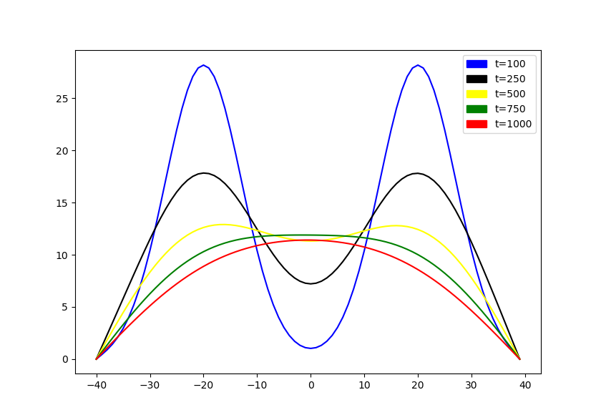

The behavior of this FTCS approximation of diffusion is in line with what would be expected for an infinite domain, with symmetrical punctuated release at t=0 (19)(21).

*III: Simple one dimensional diffusion with infinite boundary and sedimentation*

The one dimensional diffusion equation can be easily modified to incorporate a sedimentation term (10). This term is intended to describe the constant sinking of plankton due to gravity. Planktonic sinking is a well-studied phenomenon, and sinking rates for various species of plankton are correspondingly well documented. A study of suspended macro benthic gradients in submarine caves used a 2-dimensional diffusion-sedimentation model to describe the observed distribution of plankton perpendicular to the mouth of the cave(10). To parameterize the sinking term, the authors used a range of sedimentation rates between 10^-6 and 10^-3. I have experimented with a range of sinking rates based on the species of plankton common the region of the North Sea described by the empirical data (*Chaeotoceros, Paralia, Skeletonema, Eucampia, Cylindrotheca & Plagiogrammopsis*)(8). The relatively higher concentration of benthic diatoms in this region requires a higher range of sinking rates, between 10^-5 and 10^-2 ms^-1(8). The continuous one dimensional diffusion equation with a sedimentation term is as follows:



To incorporate the sedimentation term into the FTCS approximation, the first order spatial derivative must be replaced with the central difference approximation of the first derivative. Recall that this is the difference of the backward and forward difference approximations at P(x,z-1) and P(x,z+1), as given by the Taylor expansions. The sedimentation term then can be replaced by the expression:



The units of Ws are ms^-1, the units of dz are ms^-1, and the units of the concentration P(z,t) are mass*m^-3, so the expression has units mass*m^-3. This is the same as the units of the D * the second spatial derivative, and since the two terms are summed the resulting expression has the correct units. It is illustrative to compare the results of a simulation of this model with the previous diffusion equation.

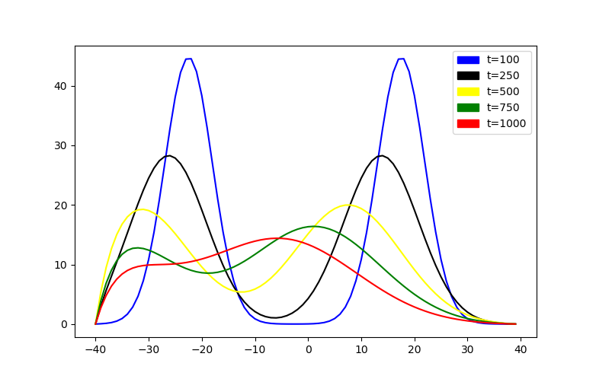

The initial condition of symmetrical peaks flattens out from the maximum of the function on both sides as in the diffusion model, though now the peaks also shift towards the bottom. This is a pretty satisfying result, because what is being illustrated in this graph—and by this model—is the gradual diffusive spreading out of particles in the water column with a simultaneous constant downward drift or sedimentation. This is intuitively what I imagine the motion of suspended plankton would look like in fluid completely free of turbulent forcing. This is then a kind of ‘null model’ of the latent physical movement of plankton, and sets up the next step of adding in a periodic excitation to mimic the cycle of tidal current velocity.

*IV: Simple one dimensional diffusion with sedimentation and periodic excitation*

Initially I intended to model the vertical fluctuation of plankton as a periodic upward velocity proportional to the tidal current speed. This is however not a physically meaningful approach, since the vertical component of velocity in this context is the result of turbulent mixing / diffusivity that propagates both upward and downward(21). It is therefore preferable to build the periodicity into the model through a spatiotemporal variability in the diffusion coefficient D. This is slightly more challenging than the addition of sedimentation though is ultimately pretty straightforward. The first step is to change the constant D in the model to a function of time and space D(z, t). For simplicity of representation—and since it does not have impact on the ultimate expression—I will disregard sedimentation in the derivation. The addition of D(z, t) yields the following from the first diffusion equation:



The left hand expression is already known by the forward difference approximation, though the right hand expression now has to be expanded by the chain rule. Applying the chain rule to the right hand expression we then get:



We have already found an expression for dP/dZ, so the only thing to do is to discretize D’(z,t). This step was tricky for me at first because of the fact that D is a function of both time and space, and the FTCS scheme treats the spatial and temporal derivatives differently, so I thought I might have to approximate the gradient of D. It will become more clear in a moment, but ultimately the notation D’(z,t) is a bit misleading, because D is not actually a function of time, but rather a function of tidal current speed. For this reason, D can be treated exactly as the spatial components of dP/dz, approximating central difference with a Taylor expansion:



It gets a bit messy here because the expressions are so long, but the one dimensional diffusion equation with variable diffusion coefficient is approximated as:



The complete model form for this paper is the above diffusion model with variable diffusion coefficient and the sedimentation term as specified in the last section (which can just be added on to the end of the above).

The point of expressing D as a function is to allow it to vary along with the fluctuation in tidal current speed. To simplify this, I now make the assumption that at t=0 the tide is at its high or low extreme, and therefore the derivative of tidal height, or current velocity, is 0. Based on some trial and error, and consideration of the physical context, I chose to represent the function D(z, t) as:



Such that:



There is lot going on here but it is actually quite simple and intuitive. The value of D will vary according to both 1) the tidal current velocity at time t, and 2) the distance from the mean value of z or the middle of the water column. The latter dimension of diffusive variation is based on the principle of wall-bounded diffusion (21), which in the most crude interpretation holds that the magnitude of diffusive velocity is inversely proportional to the distance between a point and a solid boundary. For the sake of simplicity I am considering that the surface of the water and the sea floor are both equivalently static boundaries, and therefore the proportional relationship of D and z is symmetric about the average value of z (zmean).

There are several other parameters to note in the above expressions. The value (e) is the constant of proportionality, and can be adjusted to bring about the desired relationship between D and Ws over time. The value v_min_mean is the initial value D(z,t) for z=zmean and t=0. At t=0, the sinusoidal term goes to zero and at z=zmean the function f(zmean, z) is at its maximum value of 1. Therefore D(zmean, 0) = v_min_zmean, and is the maximum value in the vector of D(zn, t=0) used to initialize the forward integration of the equation. The initial vector for D(zn, t=0) is pictured below

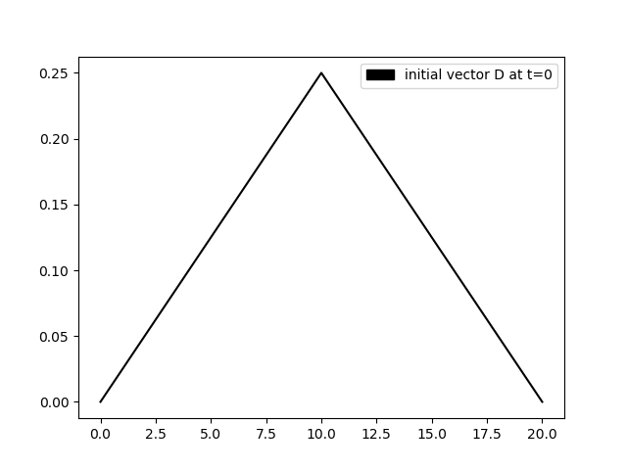

In order for the model to make consistent sense, the units of D(z,t) have to be the same as the constant D, m^2s^-1. Conveniently, the units of f(zmean, z) are meters, and therefore the function D(z,t) is of units m^2s^-1, so it works out in the larger equation.

A few more considerations have to be made before the model is in a workable form. First, the issue of the boundary conditions. When you plot the concentration SUM(P(zn, t)) for each time step, the impact of infinite domain on the model performance is very clear:

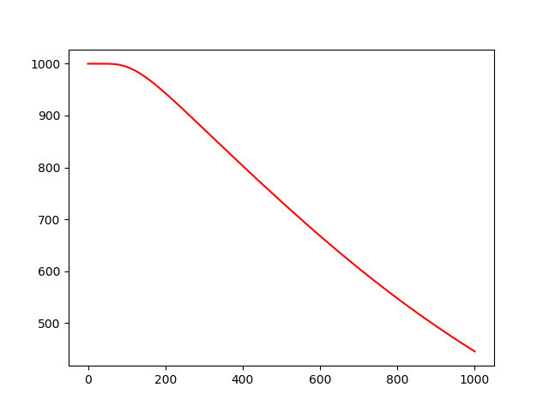

To avoid this loss of mass, I specified a impermeable boundary condition at the sea floor, or z=0, such that D(z=0,t) = -D(dP/dt) (19). This acts as an equal and opposite diffusive force at the low boundary, such that there is an effect of accumulation at the lower boundary. This improves the model both by retaining mass, but also bring the representation closer to the physical reality of particle sedimentation and suspension.

Finally, the model requires that parameters for d_initial (v_min_zmean) and (e) be chosen. Because of the way that I constructed this model—using FTCS approximation—the range of acceptable values for D is constrained by the value of dz and dt. In addition to its being the simplest option, the parameters dz and dt in this model are both equal to 1 in this model because of the units of the actual physical values being in ms^-1. The Courant–Friedrichs–Lewy condition states that D <= dx^2/2dt, or the model will be unstable in time (24). It took some time to figure out this was an actual rule, but even with D=0.5 for dz,dt =1 the model yields negative concentrations. If you set the diffusion coefficient to 1, the model concentrations are completely nonsensical. All this to say that the values for d_initial (v_min_zmean) and (e) were chosen such that at the peak of tidal current speed (for t divisible by 10800 seconds and not 21600), the maximum positional value of D(z,t), which is at z=zmean, will be equal to 0.5. To satisfy this, the values for d_initial and (e) were both set to 0.25. Further, this is defensible parameterization because this means that on average, Ws is an order of magnitude less than D(z,t), which is appropriate given the empirical range of values for those parameters presented in the literature (8)(10). When this is all put together, the function to iterate is actually quite simple:



The code here is very unpleasant to look at, though debugging this process was just a constant searching exercise so being clever with programmatic structure was not helpful. That’s said, the equation is not a particularly heavy operation and was straightforward to simulate. I ran the model for 10 cycles of 21600 time steps, which corresponds to 10 cycles of the tidal current period of 6 hours.



This plot shows the distribution of P(z,t) at intervals of half of the period of tidal current, where current speed alternates between its maximum and minimum values. If you look at the legend of the plot you can see that there are two lines missing at t=10800 and t=21600. They are not actually missing, they are just occluded by the subsequent lines at the same relative location in the tidal current cycle, which completely cover them. When you isolate the top 1meter of the z-axis (represented on the x-axis above) you can see that the concentration over time demonstrates the desired periodicity:

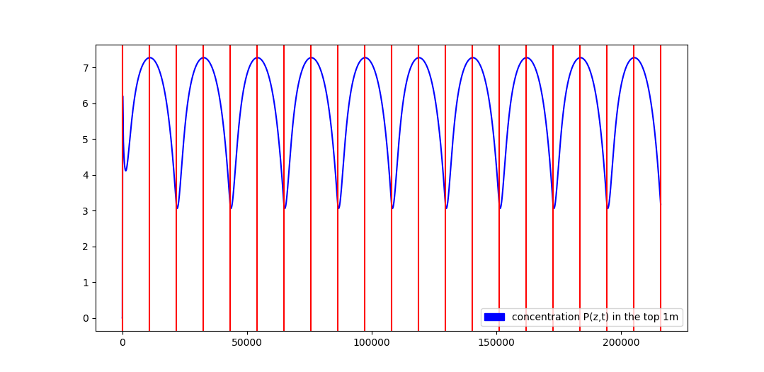

Ultimately, the diffusion model with sedimentation and period excitation through variable diffusion coefficient does produce the desired representation of fluctuation in plankton density. After a few thousand time steps, the model starts to do generally what it is intended to do: 1) particles sink to the bottom and accumulate; 2) while they sink, particles spread in space according to a diffusive random force; 3) particles that have accumulated on the sea floor are re-suspended at times of intense tidal current velocity; 4) the relationship between Ws and D(z,t) is structured such that the positive component of the diffusive force and the sedimentation velocity interact to produce a periodic variation in near surface plankton density in-phase with the tidal current cycle.

*V: Comparison to empirical data*

The purpose of this model is to describe the change in near-surface plankton density through the course of the tidal current cycle. The reason that I set out to built this model is because of a recent paper that conducted a statistical analysis of longitudinal near-surface chlorophyll data in the North Sea, and found that tidal periodicities accounted for much of the observed variation(8). The goal of this project was to see if I could build a model that incorporated some basic but physically meaningful components that would mimic the observed behavior. I explored the citations of this study and found that the tidal gauge data and the longitudinal near-surface chlorophyll data were publicly available upon request of the hosting organizations(8)(17)(18). Amazingly I was able to get ahold of both datasets in their entirety.

The data on near surface chlorophyll fluorescence—which in times of low ambient light is a very good proxy for phytoplankton density—are maintained by the Center for the Environment Fisheries and Aquaculture (CEFAS)(17). These data were collected from a Smart Buoy that automates the collection of oceanic data at regular intervals. Data on near surface chlorophyll is available for the period 2001-2018. While the CEFAS data has a number of interesting features, the buoy did not record tidal change and so I got the tidal gauge data from a very nearby station called Sheerness located in the same inlet in the North Sea. This dataset is maintained by the British Oceanographic Data Center (BODC)(18).

Both sets of data were replete with Null values and formatting inconsistencies, as well as substantial gaps in coverage and incongruous temporal resolutions. For this reason, the structuring and pre-processing of these data was a significant effort. The scripts to clean and structure the raw data are included along with this document (clean-and-structure-raw-data.py), along with the clean subset of data used for the following analysis (chl-tide-analysis-data-clean.csv, tide-2003-clean-analysis-range.csv). Both scripts have inline comments and should not require any cumbersome dependencies.

Given that the purpose of the analysis is to describe chlorophyll fluctuation in terms of tidal velocity, only periods with coverage in both datasets could be considered. Further, during certain periods the chlorophyll data is taken at highly irregular intervals, which makes the merging of the two datasets very difficult. Given time restrictions, I have decided to focus on the period of June 2003 🡪 December 2003, which is by far the best in terms of coverage. The temporal resolution of the two datasets over this period is also trivially easy to resolve. From here on I will refer to the datasets used in the analysis.

The tide gauge data is at 15-minute temporal resolution and the chlorophyll fluorescence data is at a 2-hour resolution, and so the analysis had to be done at 2-hour intervals. For each 2-hour interval, I brought in the discrete point tidal height, the discrete point tidal height from 2-hours previous, the chlorophyll fluorescence value at 1meter depth and the chlorophyll fluorescence value from 2-hours previous. Tidal current was then calculated as the absolute value of the difference in tide height between the two measurements:



This is in line with the way that the function for D(z,t) takes the absolute value of the periodic rate of change (abs(sin(pit/6))), which facilitates the comparison. The tidal data is at a fine-scale temporal resolution and produces nearly continuous plots over time (pictured below for week 1 & 2 June 2003):

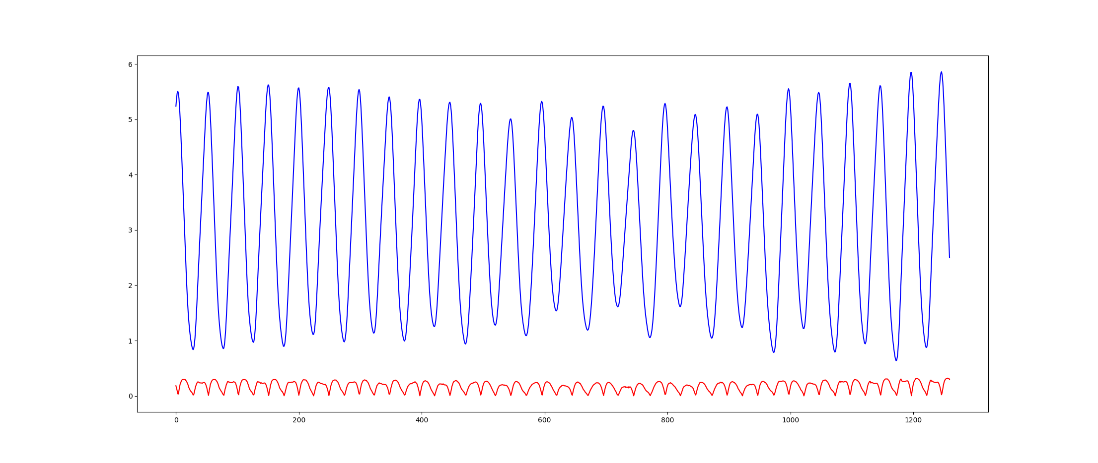

When the data are resolved to the less granular interval of the chlorophyll data, the graph becomes less smooth and the current differential is exaggerated (pictured below for week 1 June 2003):

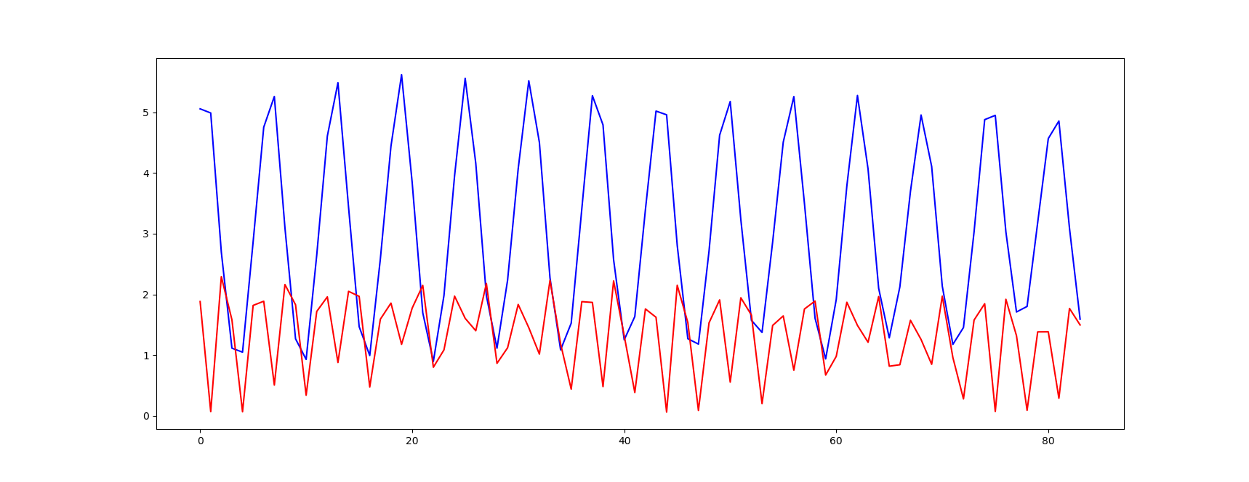

The chlorophyll fluorescence data is noisy and subject to instrumentation error and anomalous patchiness characteristic of phytoplankton. To try and smooth the data in time, the raw values are log transformed, and the change in density is measured as the differential of the natural log over the change in time(8). This expression can be restated through the application of the chain rule:



Which shows it is exactly equivalent to the relative rate of change in density. The final pre-processing step to mention is that ambient light or photosynthetically active radiance (PAR) can distort readings of chlorophyll fluorescence, and so intervals with PAR>1 at 1m depth, which is a proxy for daylight, should be excluded(8). The PAR values were not populated in the data I received, so I used the Astral module in python to evaluate the sunset and sunrise times for each record:



Given time constraints, I did not experiment with multiple statistical processes for evaluating the relationship between chlorophyll and tidal current. Fortunately the simple uni-variate OLS model showed reasonably good correspondence between the two values. The clean and merged data set has ~2500 records, so a good heuristic for train and test splits is 20% or 500 records. The data were split into X and Y vectors, with 500 records removed for performance evaluation of the linear model. The model yielded a coefficient of 0.07, a mean squared error of 0.03 and a R^2 of 0.21. The graph of the OLS best-fit line is shown below with relative rate of change of chlorophyll on the y-axis and tidal current velocity on the x-axis:

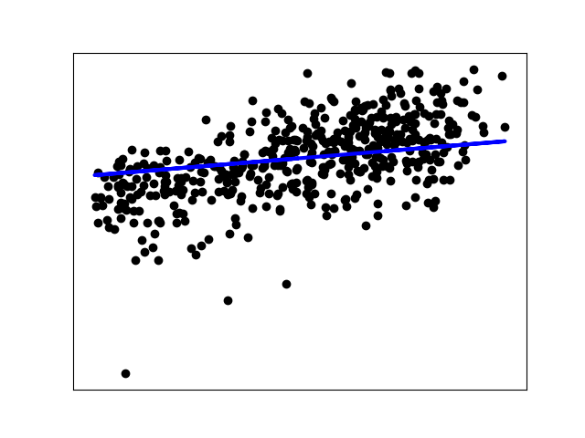

One purpose of doing this analysis of the empirical data is to confirm the relationship between near-surface plankton and current velocity presented by the study of the North Sea. I think just based on the most cursory analysis of the data, this relationship seems to be replicable. Another more interesting purpose of this effort is to see if the relationship can be explicitly quantified in a way that could help to evaluate the model I have proposed in this project. Going forward I hope to use multiple regression analysis and whole assortment of other statistical techniques to draw out more insightful relationships from these data that can be used to inform and optimize the diffusion model detailed

above.

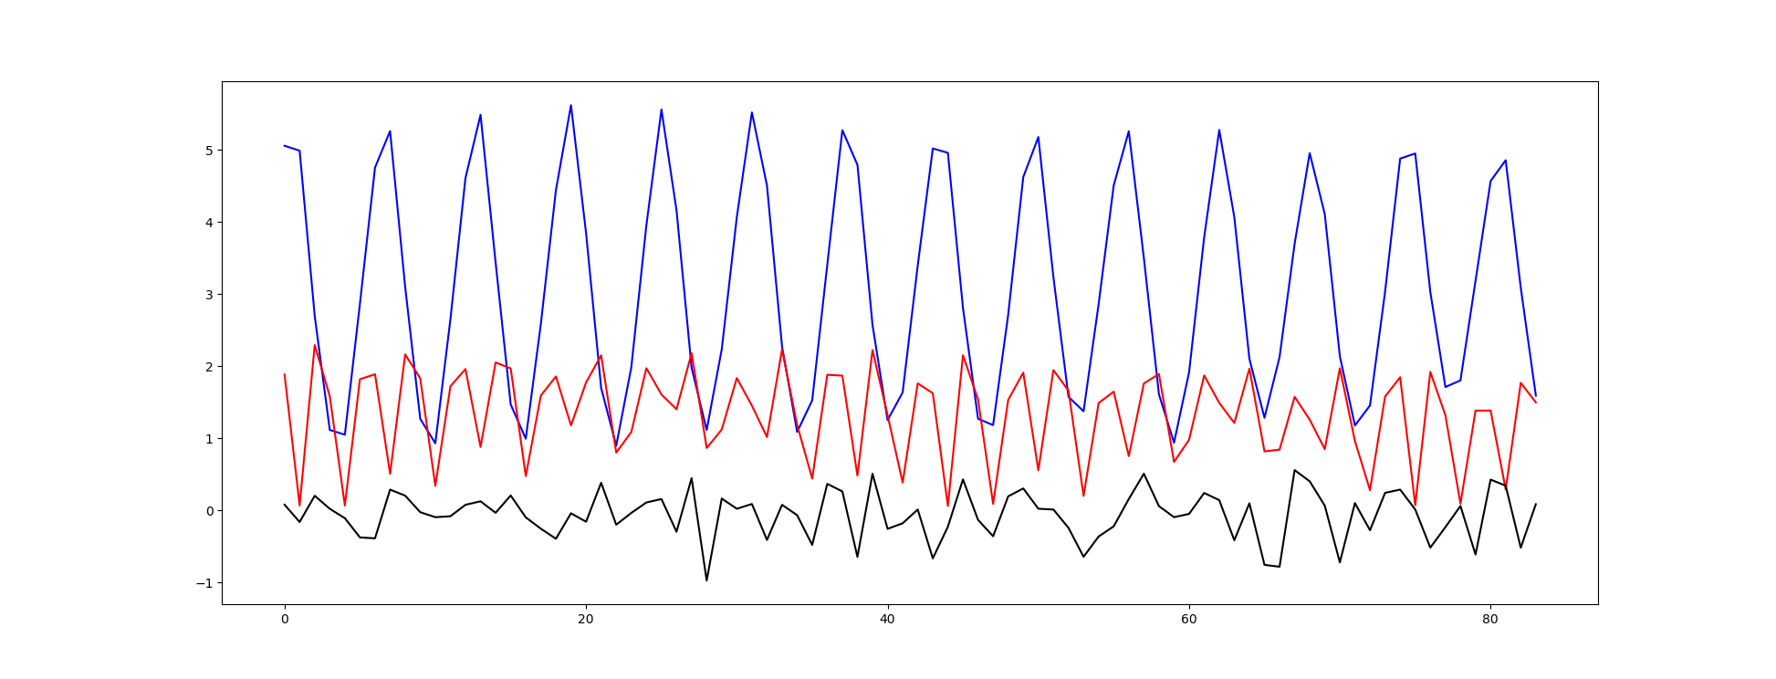

*V: Going forward*

There is a lot more I would like to do with this model now that the baseline functionality is in line with what I intended. Three main questions to consider jump out to me as low hanging fruit. First the assumption of new initial density distribution after each tidal cycle prevents the model from converging in a steady state. The behavior of the model is also most irregular during the first couple of hours after t=0, during which time the diffusive expansion has not yet reached the point at which periodic fluctuation starts to happen. Formalizing this input as a stochastic element would introduce some interesting variability that might yield some insightful results. Second, tuning the parameters of the model to optimize correspondence to the empirical data could help to describe in more detail how the modeled forces may actually be interacting. Specifically, the sinking rate (Ws) is based on individual diatoms, which does not account for flocculation or the forming of aggregates, which have much higher characteristic sinking rates than single organisms(8). There is a class of coagulation-separation models that have been used in interesting ways to describe this process, and treat the formation of planktonic aggregates as a Markov chain(12). Finally, I think an analysis of time-to-convergence of this model would be illustrative(3). The model is deterministic, but since it is intended to describe such short periods, the behavior of the model in the time before convergence is critical, and is something I would love to explore in more detail.

*VI: References*

(1) Franks, P.J.S. (2002). NPZ models of plankton dynamics: Their construction, coupling to physics, and application, Journal of Oceanography 58(2): 379–387.

(2) H. Malchow, F.M. Hilker, I. Siekmann, S.V. Petrovskii, A.B. Medvinsky Mathematical models of pattern formation in planktonic predation–diffusion systems: a review R.J. Hosking, E. Venturino (Eds.), Aspects of Mathematical Modelling, Birkhäuser, Basel (2008), pp. 1-26

(3) A Biologist’s Guide to Mathematical Modeling in Ecology and Evolution by Sarah P. Otto and Troy Day, Princeton, NJ, Princeton University Press, 2007, 732 pp., ISBN 0-69-112344-6

(4) Mellor GL, Yamada T (1982) Development of a turbulence closure model for geophysical fluid problems. Rev Geophys Space Phys 20(4):851–875

(5) Chen, C. and R.C. Beardsley, 1995: [A Numerical Study of Stratified Tidal Rectification over Finite-Amplitude Banks. Part I: Symmetric Banks.](https://journals.ametsoc.org/doi/abs/10.1175/1520-0485%281995%29025%3C2090%3AANSOST%3E2.0.CO%3B2) J. Phys. Oceanogr., 25, 2090–2110, [https://doi.org/10.1175/1520-0485(1995)025<2090:ANSOST>2.0.CO;2](https://doi.org/10.1175/1520-0485(1995)025%3C2090:ANSOST%3E2.0.CO;2)

(6) J.H. Steele, E.W. Henderson A simple model for plankton patchiness

Journal of Plankton Research, 14 (1992), pp. 1397-1403

(7) Franks, P. S. J., and C. Chen (1996), Plankton production in tidal fronts: A model of Georges Bank in summer, J. Mar. Res., 54, 631–651.

(8) Blauw AN, Beninca` E, Laane RWPM, Greenwood N, Huisman J (2012) Dancing with the Tides: Fluctuations of Coastal Phytoplankton Orchestrated by Different Oscillatory Modes of the Tidal Cycle. PLoS ONE 7(11): e49319. doi:10.1371/journal.pone.0049319

(9) May CL, Koseff JR, Lucas LV, Cloern JE, Schoellhamer DH (2003) Effects of spatial and temporal variability of turbidity on phytoplankton blooms. Mar Ecol Prog Ser 254: 111–128, doi: 10.3354/meps254111.

(10) Garrabou, J. & Flos, J. (1995) A simple model to explain planktonic gradients in a sea cave. Marine Ecology Progress Series, 123, 273–280

(11) Qian Zhang, Zheng Gong, Changkuan Zhang, Zeng Zhou, and Ian Townend (2016) Hydraulic and Sediment Dynamics at times of Very Shallow Water on Intertidal Mudflats: The Contribution of Waves. Journal of Coastal Research: Special Issue 75 - Proceedings of the 14th International Coastal Symposium, Sydney, 6-11 March 2016: pp. 507 – 511.

(12) Wieczorek, Radoslaw. (2010). Markov chain model of phytoplankton dynamics. Applied Mathematics and Computer Science. 20. 763-771. 10.2478/v10006-010-0058-7.

(13) Tamminga A., Hugenholtz C., Eaton B. and Lapointe M. (2015), Hyperspatial Remote Sensing of Channel Reach Morphology and Hydraulic Fish Habitat Using an Unmanned Aerial Vehicle (UAV): A First Assessment in the Context of River Research and Management, River Res. Applic., 31, pages 379–391, doi:10.1002/rra.2743

(14) Courty, L. G., Pedrozo-Acuña, A., and Bates, P. D.: Itzï (version 17.1): an open-source, distributed GIS model for dynamic flood simulation, Geosci. Model Dev., 10, 1835-1847, https://doi.org/10.5194/gmd-10-1835-2017, 2017.

(15) Steele, J. H. and E. W. Henderson (1981) : A Simple Plankton Model. Am. Nat., 117, 676-691.

(16) R.K. Upadhyay, W. Wang, N.K. Thakur Spatiotemporal dynamics in a spatial plankton system Math Model Nat Phenom, 5 (5) (2010), pp. 01-121

(17) CEFAS[https://www.cefas.co.uk/cefas-data-hub/smartbuoys/]

(18) BODC[https://www.bodc.ac.uk/]

(19) Cushman-Roisin, Benoit & Jean-Marie, Beckers. (2011). Introduction to Geophysical Fluid Dynamics: Physical and Numerical Aspects.

(20) Gupta, Abhishek. (2014). Numerical Methods using MATLAB. 10.1007/978-1-4842-0154-1.

(21) Lee, Xuhui. 2018. *Fundamentals of boundary-layer meteorology*. http://dx.doi.org/10.1007/978-3-319-60853-2.