Sprint 3 Plan

Flsh

11/7/17

Release 0.0

Sprint 3 Plan

**Goal:**

The goal of sprint 3 is to have implement data structures, finalize and implement UI page design, and find restrooms on google maps.

**User Stories:**

US1: As a user, I want to be able to see nearby restrooms.

Task 1: Display Google Map Markers on restrooms (6)

Task 2: Design a custom toilet marker(4)

Task 3: Coordinate bathrooms with database (6)

Total for user story:16 hours

US2: As a developer, I want to set up data structures for restroom profiles

Task 1: Finalize data structure design (6)

Task 2: implement restroom profile

Total for user story: 5 hours

US3: As a user, I want to be able to log in.

Task 1: Test authentication(3)

Total for user story: 3 hours

US4: As a user, I want to be able to navigate the aesthetically pleasing pages.

Task 1: Getting all pages to display on the app (6)

Task 2: Begin connecting pages (4)

Total for user story: 6 hours

**Team Roles:**

Jessica Del Rio Product Owner, Developer

Emily Bettencourt Developer

Sabrina Leano 3rd Scrum Master, Developer

Oliver Ma Developer

**Initial Task assignment**

Jessica Del Rio US1: Task 1,Task 2, Task 3

Emily Bettencourt US2:Task 1,2, 3: Task 1, 2

Sabrina Leano US1:Task 1,Task 2, Task 3

Oliver Ma US4:Task 1, Task 2

**Initial Burn up chart**

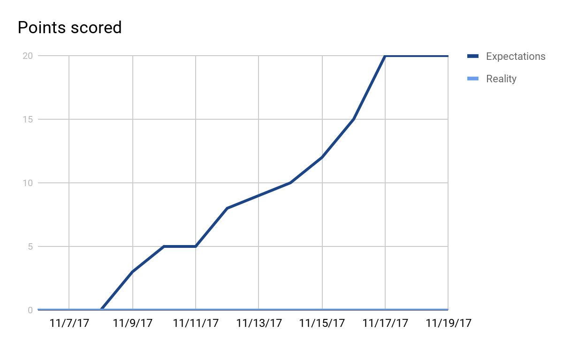

**Initial Scrum Board**

<http://scrumblr.ca/Flsh>

**Scrum Times**

Tues: 3:30pm

Weds: 3:30pm

Thurs: 4:40-5pm