The Overview of IVI OSes

Feng Jin

Exported on Jul 11, 2019

Table of Contents

1 /\*<![CDATA[\*/ div.rbtoc1562823363117 {padding: 0px;} div.rbtoc1562823363117 ul {list-style: disc;margin-left: 0px;} div.rbtoc1562823363117 li {margin-left: 0px;padding-left: 0px;} /\*]]>\*/ 3

2 Introduction 5

2.1 Smartphone OS 5

2.2 Automotive OS 6

2.2.1 Overview 6

2.2.2 Market Share 8

3 GENIVI 11

3.1 Overview 11

3.2 Timeline 11

3.3 Internals 11

3.3.1 Actitecture 11

3.3.2 Modules 11

3.3.3 Documentation 11

3.4 Conclusion 11

4 AGL 12

4.1 Overview 12

4.2 Timeline 12

4.3 Internals 13

4.3.1 Architecture 13

4.3.2 Source code 15

4.3.3 Documentation 15

4.4 Demo 15

4.5 Conclusion 18

5 Android 19

5.1 Overview 19

5.2 Generic Android 20

5.3 Android Automotive 21

5.3.1 Overview 21

5.3.2 Internals 22

5.3.3 Demo 32

5.3.4 Conclusion 32

6 Conclusion 34

7 Abbreviation 35

8 References 36

# /\*<![CDATA[\*/ div.rbtoc1562823363117 {padding: 0px;} div.rbtoc1562823363117 ul {list-style: disc;margin-left: 0px;} div.rbtoc1562823363117 li {margin-left: 0px;padding-left: 0px;} /\*]]>\*/

* [1 Version 2 Introduction 2.1 Smartphone OS 2.2 Automotive OS 2.2.1 Overview 2.2.2 Market Share 3 GENIVI 3.1 Overview 3.2 Timeline 3.3 Internals 3.3.1 Actitecture 3.3.2 Modules 3.3.3 Documentation 3.4 Conclusion 4 AGL 4.1 Overview 4.2 Timeline 4.3 Internals 4.3.1 Architecture 4.3.2 Source code 4.3.3 Documentation 4.4 Demo 4.5 Conclusion 5 Android 5.1 Overview 5.2 Generic Android 5.3 Android Automotive 5.3.1 Overview  5.3.2 Internals 5.3.2.1 Architecture 5.3.2.2 5.3.2.3 Audio 5.3.2.4 Camera HAL 5.3.2.5 IVI Connectivity 5.3.2.6 Vehicle Property 5.3.2.7 Power Management 5.3.2.8 Flash Wear Management 5.3.2.9 OTA 5.3.3 Demo 5.3.4 Conclusion 6 Conclusion 7 Abbreviation 8 References Version](#scroll-bookmark-2)
* [Introduction](#scroll-bookmark-3)
  + [Smartphone OS](#scroll-bookmark-4)
  + [Automotive OS](#scroll-bookmark-5)
    - [Overview](#scroll-bookmark-6)
    - [Market Share](#scroll-bookmark-7)
* [GENIVI](#scroll-bookmark-8)
  + [Overview](#scroll-bookmark-9)
  + [Timeline](#scroll-bookmark-10)
  + [Internals](#scroll-bookmark-11)
    - [Actitecture](#scroll-bookmark-12)
    - [Modules](#scroll-bookmark-13)
    - [Documentation](#scroll-bookmark-14)
  + [Conclusion](#scroll-bookmark-15)
* [AGL](#scroll-bookmark-16)
  + [Overview](#scroll-bookmark-17)
  + [Timeline](#scroll-bookmark-18)
  + [Internals](#scroll-bookmark-19)
    - [Architecture](#scroll-bookmark-20)
    - [Source code](#scroll-bookmark-21)
    - [Documentation](#scroll-bookmark-22)
  + [Demo](#scroll-bookmark-23)
  + [Conclusion](#scroll-bookmark-24)
* [Android](#scroll-bookmark-25)
  + [Overview](#scroll-bookmark-26)
  + [Generic Android](#scroll-bookmark-27)
  + [Android Automotive](#scroll-bookmark-28)
    - [Overview](#scroll-bookmark-29)
    - [Internals](#scroll-bookmark-30)
      * [Architecture](#scroll-bookmark-31)
      * [Audio](#scroll-bookmark-32)
      * [Camera HAL](#scroll-bookmark-33)
      * [IVI Connectivity](#scroll-bookmark-34)
      * [Vehicle Property](#scroll-bookmark-35)
      * [Power Management](#scroll-bookmark-36)
      * [Flash Wear Management](#scroll-bookmark-37)
      * [OTA](#scroll-bookmark-38)
    - [Demo](#scroll-bookmark-39)
    - [Conclusion](#scroll-bookmark-40)
* [Conclusion](#scroll-bookmark-41)
* [Abbreviation](#scroll-bookmark-42)
* [References](#scroll-bookmark-43)

Version

|  |  |  |  |
| --- | --- | --- | --- |
| Version | Date | Author | Changes |
| 1.0 | 2019-2-25 | Jin Feng | Initial, please note we use confluence page for easily expressing, sharing, and controlling accessing |

# Introduction

Hardware components in the car have become more software-driven, and many automakers are openly repositioning themselves as software-based and services-based companies, by providing capabilities such as smartphone-centric applications, consumer-centric infotainment operating systems, and virtual personal assistants (VPAs) in the car.

This article focuses on operating systems used by infotainment modules in the car. The RTOSes used by the other ECUs will be mentioned but are not the focus for this document.

Operating System

## Smartphone OS

Some hints can be obtained from evolution of smartphone OS.

**Yesterday**

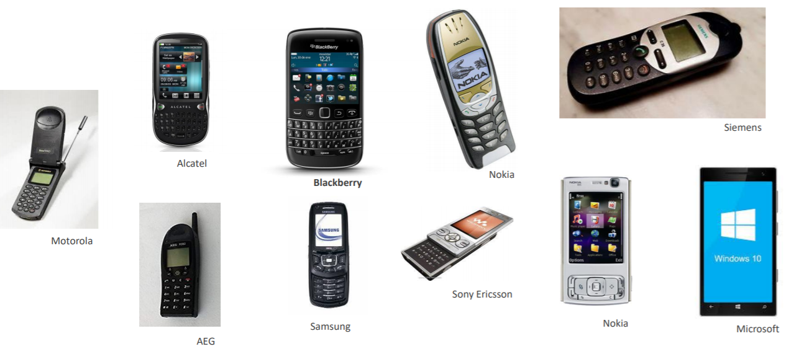

**Today**

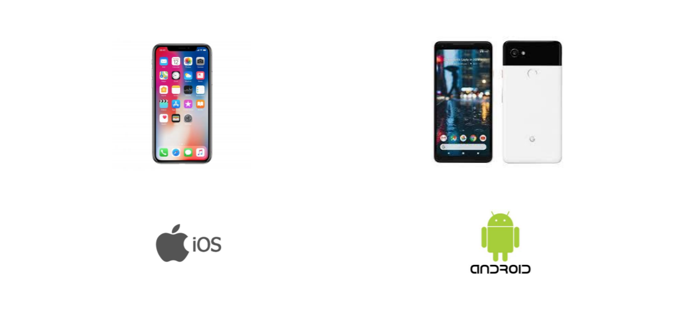

## Automotive OS

### Overview

|  |  |  |  |  |  |
| --- | --- | --- | --- | --- | --- |
| OS | | Vendor | Since | License | Notes |
| Windows | | Microsoft | 1996 | Proprietary | * No update since WinCE 7.0 * Limited support from SoC vendors |
| QNX | | BlackBerry | 1980 | Proprietary | * First choice for instrument clusters * Supporting Android APPs is in plan * License/Royalty Fee |
| Linux | AliOS(YunOS) | Alibaba | 2015 | ? | * Only Banma is using it now. * The HUs with Banma system are installed IVI in Roewe, MG, Maxus, Dongfeng-citroen, Dongfeng-peugeot, Ford. The quantity is 0.5M+ * High integration, Customization, Specialization * Uncertainty, Adaption, Maturity are risks |
| OEMs OS(Linux) | OEMs | 1991? | Open Source | * Mainly used in IC, Tbox, IVI, and autonomous self-driving * fragmentation * Development, integration, customization, Stability/Performance, maintain, and upgrading |
| GENIVI (Linux) | Linux Foundation | 2009 | Open Source | * Bring your own platform |
| AGL (Linux) | Linux Foundation | 2014 | Open Source | * Code first |
| Generic Android | Google | 2007 | Open Source | * Mainly on IVI, Native car makers, Aftermarket Installation * Will Merged into Android Automotive * Customization, extension, upgrading |
| Android Automotive | Google | 2018 | Open Source | * Google’s involvement, International Car Makers |

**AGL vs GENIVI**

<https://blog.csdn.net/xjhhjx/article/details/75201167>

<https://events.static.linuxfound.org/sites/events/files/slides/contributing-to-agl-and-gdp-leon-anavi_0.pdf>

<http://events17.linuxfoundation.org/sites/events/files/slides/Open%20Source%20secure%20software%20updates%20for%20Linux-based%20IVI%20systems.pdf>

[https://lwn.net/Articles/671153](https://lwn.net/Articles/671153/)

<https://opensource.com/life/16/8/agl-provides-common-open-code-base>

<https://blog.csdn.net/xjhhjx/article/details/75201167>

* We are different, but we are not enemies
* AGL is "Code First"
  + Building a complete distro, middleware, app framework
  + OMEs and suppliers use the same software base as starting point for production programs
  + We are organized and run like a standard open source project
* GENIVI is "Bring Your Own Platform"
  + Multiple suppliers can be compliant to GENIVI Specfication
  + Different starting points
  + More options in the marketplace, but less interoperabliility and resue
* AGL and GENIVI are collaborating on software components where appropriate
* AGL is addressing all functions in the vehicle, not just IVI

### Market Share

* This statistic (from IHS) shows the projected market share held by the current three largest automotive infotainment operating system (OS) producers between 2014 and 2022. Microsoft is expected to fall out of competition in the sector by 2022, while the rise of Linux will see them usurp QNX as the largest company in this industry by 2022.  
  <https://www.statista.com/statistics/680077/car-infotainment-os-market-share/>  
  <https://www.d1ev.com/news/jishu/66938>  
  Does not include China market?  
  Trend is more important.

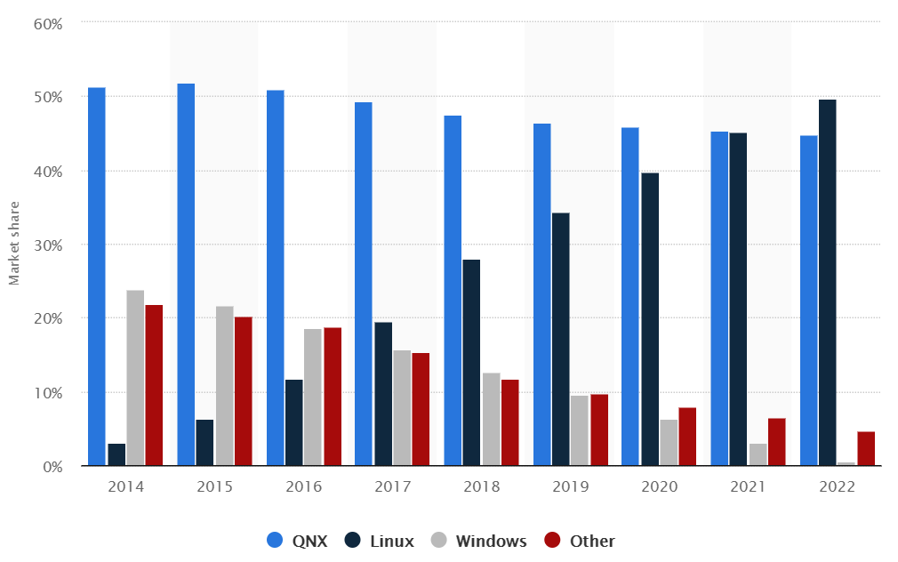

Market share for car infotainment operating system providers from 2014 to 2022

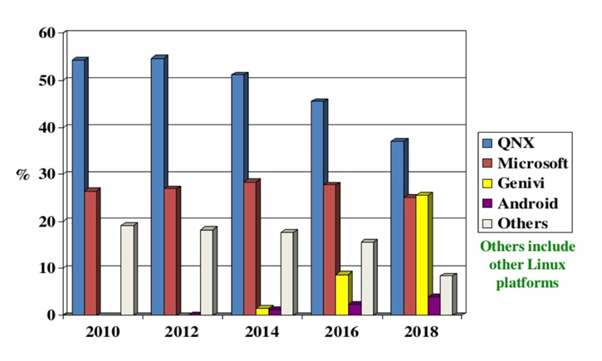

* IHS Markit Analysis  
  <https://ihsmarkit.com/research-analysis/android-automotive-takes-center-stage-as-2nd-largest-automaker.html>  
  + IHS previously forecasted that approximately 11 million vehicles globally would have Android Automotive by 2024.
  + IHS expects Generic Android to remain the dominate player in the infotainment space over the same time, with Android Automotive comprising only 16 percent of total Android volumes in the 2024 sales year.
* The Android  global market share will up to 50%  
  <https://mp.weixin.qq.com/s/lsXZDeqNEnmiQshCfFUcOg>

# GENIVI

## Overview

<https://www.genivi.org/about-genivi>

## Timeline

<https://www.genivi.org/press-release-archive>

## Internals

### Actitecture

<https://www.genivi.org/sites/default/files/resource_documents/GENIVI_Reference_Architecture_29Oct2015.pdf>

### Modules

<https://at.projects.genivi.org/wiki/display/PROJ/Projects+Home>

### Documentation

<https://www.genivi.org/resource-documents>

## Conclusion

* Some components developed by GENIVI are reusable

# AGL

## Overview

<https://www.automotivelinux.org/about>

<https://www.automotivelinux.org/wp-content/uploads/sites/4/2018/06/agl_software_defined_car_jun18.pdf>

## Timeline

<https://www.automotivelinux.org/news/announcements>

<https://en.wikipedia.org/wiki/Moblin>

<https://en.wikipedia.org/wiki/MeeGo>

<https://en.wikipedia.org/wiki/Moblin>

<https://en.wikipedia.org/wiki/Automotive_Grade_Linux>

* 2005.??.??  
  **Maemo**is a [software platform](https://en.wikipedia.org/wiki/Software_platform) developed by [Nokia](https://en.wikipedia.org/wiki/Nokia) for [smartphones](https://en.wikipedia.org/wiki/Smartphone) and [Internet tablets](https://en.wikipedia.org/wiki/Internet_tablet). The platform comprises both the Maemo operating system and [SDK](https://en.wikipedia.org/wiki/Software_development_kit)  
  The first device shipped with was Nokia 770
* 2007.07.??  
  [Intel](https://en.wikipedia.org/wiki/Intel) launched the [Moblin.org](http://moblin.org/) site in July 2007 and significantly updated the site in April 2008 with the launch of the Intel Atom processor family at the [Intel Developer Forum](https://en.wikipedia.org/wiki/Intel_Developer_Forum) in Shanghai. A custom [software development kit](https://en.wikipedia.org/wiki/Software_development_kit) (SDK) is available on the site. The **Moblin** 2 OS was specifically designed to run on an Intel Atom processor in a netbook.
* 2010.02.??
* **MeeGo** T01 was first announced at [Mobile World Congress](https://en.wikipedia.org/wiki/Mobile_World_Congress) in February 2010 by [Intel](https://en.wikipedia.org/wiki/Intel) and [Nokia](https://en.wikipedia.org/wiki/Nokia) in a joint press conference. The stated aim is to merge the efforts of Intel's [Moblin](https://en.wikipedia.org/wiki/Moblin) and Nokia's [Maemo](https://en.wikipedia.org/wiki/Maemo) former projects into one new common project that would drive a broad third party application ecosystem
* 2011.??.??:    
  The **Tizen** project was formed by the [Linux Foundation](https://en.wikipedia.org/wiki/Linux_Foundation) in 2011 as a successor to [MeeGo](https://en.wikipedia.org/wiki/MeeGo), another Linux-based mobile operating system, with its main backer [Intel](https://en.wikipedia.org/wiki/Intel) joining [Samsung Electronics](https://en.wikipedia.org/wiki/Samsung_Electronics), as well as [Access Co.](https://en.wikipedia.org/wiki/Access_Co.), [NEC Casio](https://en.wikipedia.org/wiki/NEC_Casio_Mobile_Communications), [NTT DoCoMo](https://en.wikipedia.org/wiki/NTT_DoCoMo), [Panasonic Mobile](https://en.wikipedia.org/wiki/Panasonic#Panasonic_Mobile_Communications), [SK Telecom](https://en.wikipedia.org/wiki/SK_Telecom), [Telefónica](https://en.wikipedia.org/wiki/Telef%C3%B3nica), and [Vodafone](https://en.wikipedia.org/wiki/Vodafone) as commercial partners
* 2014.06.30  
   On June 30, 2014, **AGL** announced their first release, which was based on [Tizen](https://en.wikipedia.org/wiki/Tizen) and was primarily for demo applications.
* 2017.05.31  
  On May 31, 2017, AGL announced that the 2018 Toyota Camry will be the first Toyota vehicle on the market with the AGL-based system in the United States.
* 2018.11.09  
  SAN FRANCISCO, CA, November 9, 2018 – [Automotive Grade Linux](https://automotive.linuxfoundation.org/) (AGL), a collaborative cross-industry effort developing an open platform for the connected car, today announced that it has been named a[CES® 2019 Innovation Awards Honoree](https://www.ces.tech/Events-Programs/Innovation-Awards.aspx) for its [Unified Code Base (UCB)](https://www.automotivelinux.org/software/unified-code-base) platform
* 2019.??.??  
  Linux foundation previews new speech recognition APIs with Amazon Alexa at [CES 2019](https://www.ces.tech/), along with infotainment and instrument cluster demonstrations using the award-winning AGL Unified Code Base (UCB).  
  [Toyota’s AGL-based infotainment system](https://www.automotivelinux.org/announcements/2017/05/30/automotive-grade-linux-platform-debuts-on-the-2018-toyota-camry) is now in Toyota and Lexus vehicles globally and will be on display in the AGL booth in a 2019 Toyota RAV4.

## Internals

* Based on the Yocto Project and OpenEmbedded
* Tizen is fully open source, and is very actively developed and supported, with hundreds of engineers working on it. It offers HTML5, which is a fantastic development platform, very cutting edge. We think that HTML5 and Javascript will eventually surpass Android. The Tizen IVI variant is also very solid.

### Architecture

<https://www.automotivelinux.org/wp-content/uploads/sites/4/2018/06/agl_software_defined_car_jun18.pdf>

<https://www.automotivelinux.org/>

<https://gerrit.automotivelinux.org/gerrit/#/admin/projects/>

<https://wiki.automotivelinux.org/>

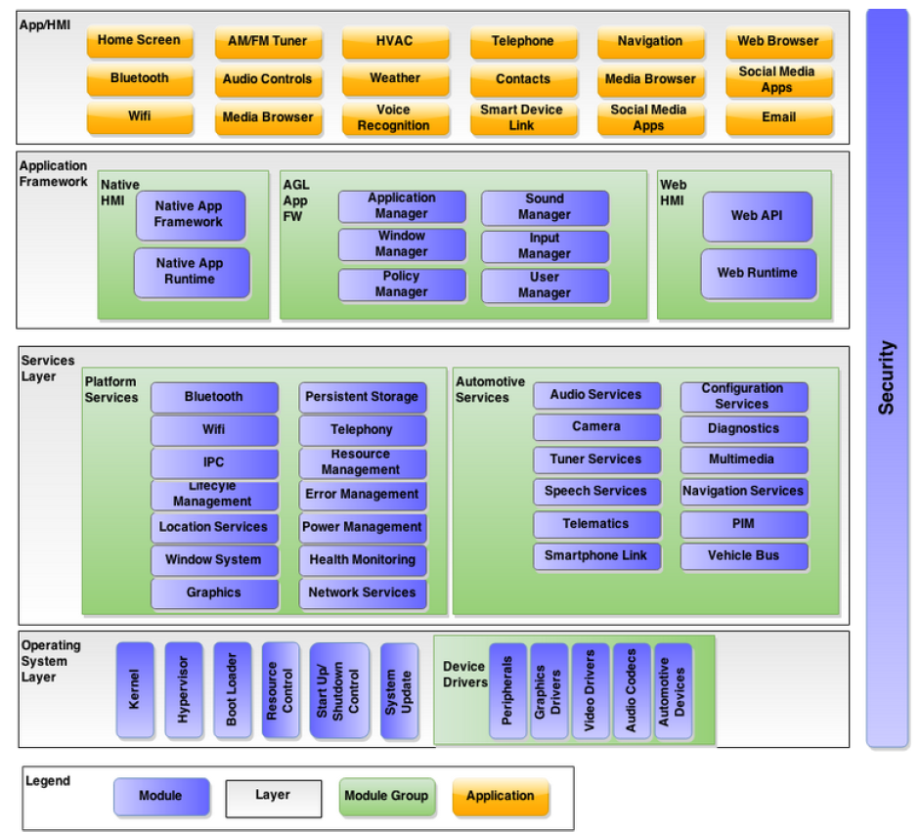

**Figure** AGL Architecture Block Diagram

### Source code

<https://www.automotivelinux.org/software>

<https://wiki.automotivelinux.org/agl-distro/release-notes#funky_flounder>

### Documentation

<http://docs.automotivelinux.org/>

## Demo

[http://linuxgizmos.com/linux-based-agl-ivi-stack-to-debut-on-2018-toyota-camry](http://linuxgizmos.com/linux-based-agl-ivi-stack-to-debut-on-2018-toyota-camry/)

<https://www.toyota.com/camry/photo-gallery/interior>

<https://www.pcworld.com/article/3066913/linux/automotive-grade-linux-an-open-source-platform-for-the-entire-car-industry.html>

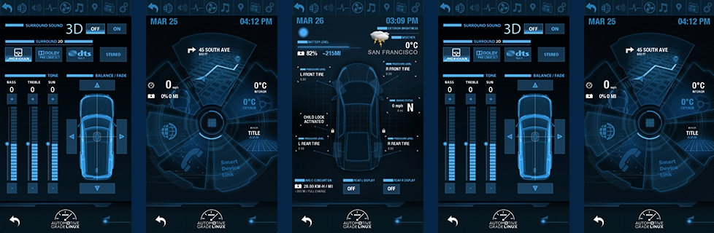

**Figure** Automotive Grade Linux will power everything from the entertainment console to self-driving car features.

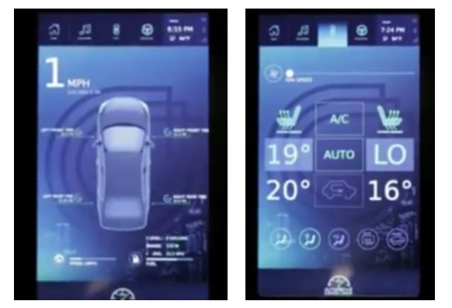

**Figure** Two UCB 3.0 interface screens from AGL’s CES 2017 demo

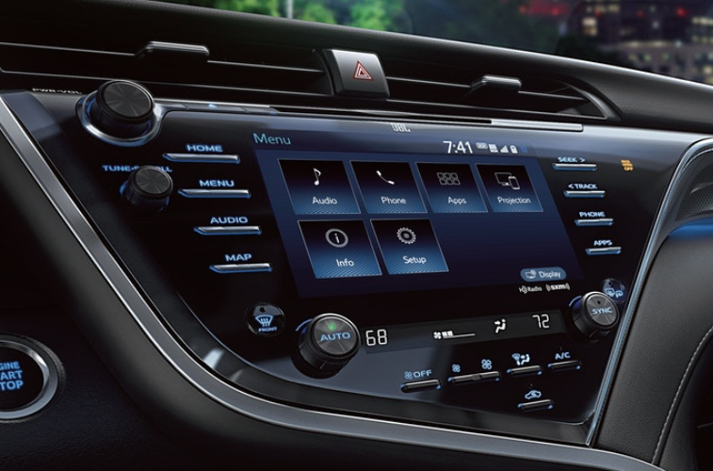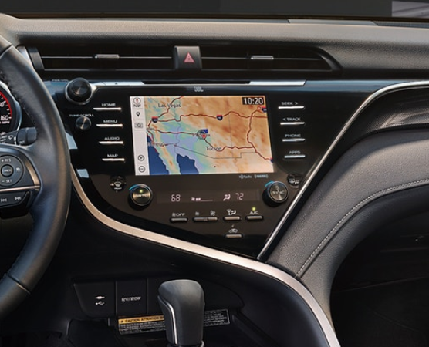

**Figure** Camry interior

## Conclusion

* Most members are Japanese companies
* AGL is farsighted and has a great aim. AGL is the only organization planning to address all software in the vehicle: infotainment, instrument cluster, heads-up-display (HUD), telematics/ connected car, advanced driver assistance systems (ADAS), functional safety and autonomous driving.

# Android

## Overview

In regards to cars, Google has a two-prong approach with Android Auto and [Android Automotive](https://9to5google.com/2018/05/07/google-android-auto-new-features-designs-volvo/). The former is an infotainment system that features Assistant and Google Maps, while the latter involves Android running on cars.

Here we will use "Android" to refer to "Generic Android" and "Android Automotive" except for some contexts where they are differentiated with full name.

谷歌的最终目标，是把Android打造成交钥匙解决方案，以及对Android汽车应用的所有支持，让用户拥有数以千计的应用程序，并在这些本地系统上无缝运行。

基于Android原生汽车系统，谷歌将开始把ADAS和谷歌地图连接起来，并支持多种不同的屏幕和仪表中控集群支持。这将是一个相当大的飞跃。

谷歌的目标很明确：为汽车制造商和最终用户提供一种更安全和无缝的方式访问他们想要的内容。此外，基于4G/5G车联网技术，谷歌将同时进行一次大的UI更新。

此外，谷歌还希望把过去复杂的车载操作系统简单化。按照计划，谷歌将在2019年推出一些简化的系统，适应不同的屏幕形状和大小，以及不同的输入方式（比如触摸版本、语音版本等）**。**

Timeline

* 2008.09.23  
  Android 1.0
* 2010.05.20  
  Android Froyo (2.2-2.2.3)
* 2010.12.05  
  Android Gingerbread (2.3-2.37)
* 2010.??.??   
  SAIC Inkanet     
* 2014.??.??

Google I/O         _scroll_external/attachments/image2019-2-24_12-1-0-b814e04a20c657c9879b6f32cb57425056ac0c99581e3bfb8d1b9fd48f1f2db2.png

* ????.??.??

Honda’s model with Android Jellybean and Hyundai with Android Gingerbread without involving google

* 2016,08.22

Android Nougat (7.0-7.1.2)

* 2016.??.??  
  In I/O mobile developer’s conference 2016, both the cars of Volvo and Audi on display were functioning on Android Nougat
* 2017.08.21  
  Android Oreo (8.0-8.1)  which was built particularly keeping in mind the automotive features
* 2017.12.??  
  谷歌在2017年12月份发布的一个早期版本“车辆地图服务”，将传感器数据融合到他们的地图当中。目前，谷歌正在将该服务提供给采用谷歌车载嵌入式操作系统的汽车制造商。
* 2018.08.06 Android Pie (9.0)
* 2018.??.??  
  Green Car(HEV/BEV/FCEV) and startups (NIO/WELT  MEISTER) choose Android to speed up development  
  而中国造车新势力车和家的理想制造ONE在去年的发布会上也宣布其首款量产车中控系统搭载的是Android Automotive（不过从车和家的招聘信息来看，系统是基于Android O开发，这是谷歌在2017年最新发布的Android 8.0的正式版）和Linux双系统+高通骁龙820A芯片，这款车将于今年正式量产上市。
* 2018.??.??Google has dubbed this factory-installed onboard system "**Android Automotive**", striking its first agreements with Volvo and Audi. Volvo's Android-powered XC40 was on show at this year's Google I/O developer conference, running the latest Android P update, but it won't hit showroom floors until 2020.  
  <https://www.avhub.com.au/news/incar/what-is-android-automotive-490778>
* 2020.??.??  
  2018年Google宣布已经与沃尔沃、奥迪、雷诺-日产达成协议，将在2020年开始陆续推出这些嵌入式操作系统，在过去的一年里，我们已经看到了它们的一些身影  
  2018年沃尔沃官方也已经宣布，他们即将推出的新款电动汽车Polestar 2将是第一款搭载该系统的汽车，不过他们称其为谷歌Android HMI。目前由于量产时间被推迟至2020年，因此它可能是第一个发布的产品，但也可能不是第一个上市的产品。Volvo XC40
* 2021.??.??  
  从2021年开始，雷诺-日产-三菱将在旗下数百万辆新车上搭载Android Automotive. Google is now working with Renault, Nissan, and Mitsubishi to bring Android Automotive into 2021 vehicles.

## Generic Android

The generic android is normal android developed for smartphones and tablets. Currently the factory-installed or aftermarket android HUs are Tire1s or OEMs customized Android based on the Normal Android versions. They are not the official ones and not authorized by Google.

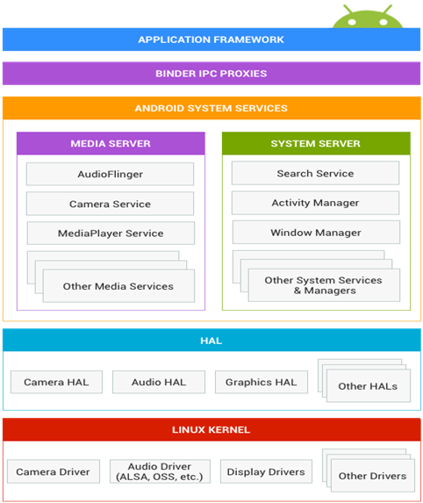

**Figure** The typical three layers of Generic Android ( BSP, Framework, and Application)

We will not cover generic Android here, since

* It is for smartphones and tablets
* The customized specific generic android versions for car will be merged into Android automotive eventually

## Android Automotive

### Overview

<https://d23rjziej2pu9i.cloudfront.net/wp-content/uploads/2018/08/29115649/EB-Next-Generation-of-IVI-Systems-Android-Automotive.pdf>

<https://source.android.google.cn/devices/automotive>

Android Automotive was a joint effort by Google and partners like Audi and Volvo to launch in the market, an advanced [Android OS for car Infotainment](https://www.embitel.com/blog/embedded-blog/design-strategies-develop-in-vehicle-infotainment-system). Android Automotive (internal code name) based on Android P.

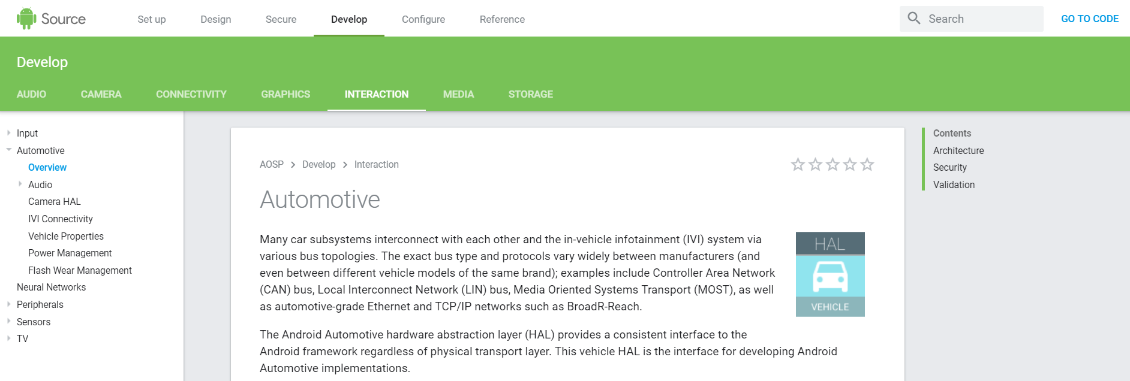

**Figure** Android Automotive has been already in mainline source code

### Internals

#### Architecture

<https://source.android.google.cn/devices/automotive>

Many car subsystems interconnect with each other and the in-vehicle infotainment (IVI) system via various bus topologies. The exact bus type and protocols vary widely between manufacturers (and even between different vehicle models of the same brand); examples include Controller Area Network (CAN) bus, Local Interconnect Network (LIN) bus, Media Oriented Systems Transport (MOST), as well as automotive-grade Ethernet and TCP/IP networks such as BroadR-Reach.

The Android Automotive hardware abstraction layer (HAL) provides a consistent interface to the Android framework regardless of physical transport layer. This vehicle HAL is the interface for developing Android Automotive implementations.

System integrators can implement a vehicle HAL module by connecting function-specific platform HAL interfaces (e.g. HVAC) with technology-specific network interfaces (e.g. CAN bus). Typical implementations may include a dedicated Microcontroller Unit (MCU) running a proprietary real-time operating system (RTOS) for CAN bus access or similar, which may be connected via a serial link to the CPU running Android Automotive. Instead of a dedicated MCU, it may also be possible to implement the bus access as a virtualized CPU. It is up to each partner to choose the architecture suitable for the hardware as long as the implementation fulfills the interface requirements for the vehicle HAL.

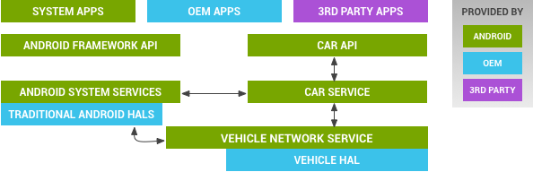

Figure 1 Android vehicle HAL architecture

**Figure** Vehicle HAL and Android automotive architecture

#### Audio

<https://source.android.google.cn/devices/automotive/audio>

Android is responsible for infotainment sounds (i.e. media, navigation, and communications) but is not directly responsible for chimes and warnings that have strict availability and timing requirements. External sources are represented by applications, which are responsible for audio focus. However, you cannot rely on focus for sound selection and mixing. Android 9 includes the some changes to automotive-related audio support:

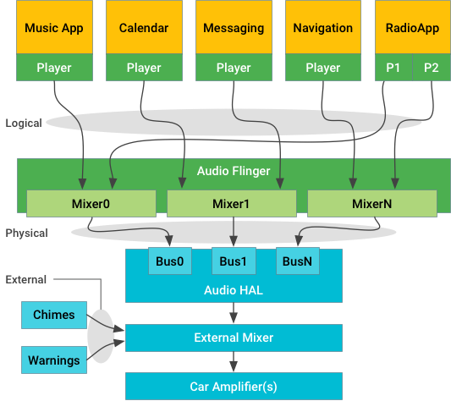

**Figure** Stream-centric architecture diagram

#### Camera HAL

<https://source.android.google.cn/devices/automotive/camera-hal>

Android 8.0 includes an automotive HIDL Hardware Abstraction Layer (HAL) that provides for imagery capture and display very early in the Android boot process and continues functioning for the life of the system. The HAL includes the exterior view system (EVS) stack and is typically used to support rear-view camera and surround view displays in vehicles with Android-based In-Vehicle Infotainment (IVI) systems. EVS also enables advanced features to be implemented in user applications.

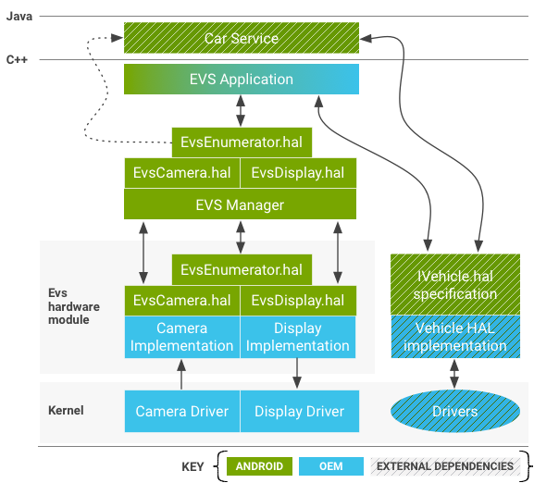

Figure 2 EVS System components diagram.

**Figure** EVS System components overview.

#### IVI Connectivity

Android 8.0 creates a more seamless Bluetooth user experience when connecting devices to the in-vehicle infotainment system (IVI). The IVI listens for events, such as unlocking a car door or starting the engine, and automatically scans for in-range Bluetooth devices. It will also simultaneously connect to separate devices so users can make hands-free calls on any device.

<https://source.android.google.cn/devices/automotive/ivi_connectivity>

#### Vehicle Property

<https://source.android.google.cn/devices/automotive/properties>

The vehicle HAL interface defines the properties OEMs can implement and contains property metadata (for example, whether the property is an int and which change modes are allowed). The vehicle HAL interface is based on accessing (read, write, subscribe) a property, which is an abstraction for a specific function.

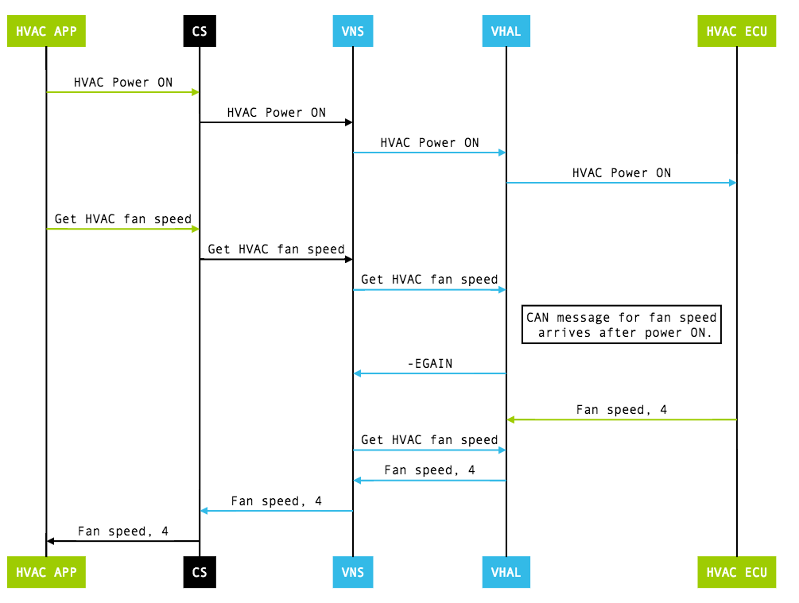

Figure 3 Vehicle HAL get HVAC example

**Figure** Get HVAC temperature (CS = CarService, VNS = VehicleNetworkService, VHAL = Vehicle HAL)

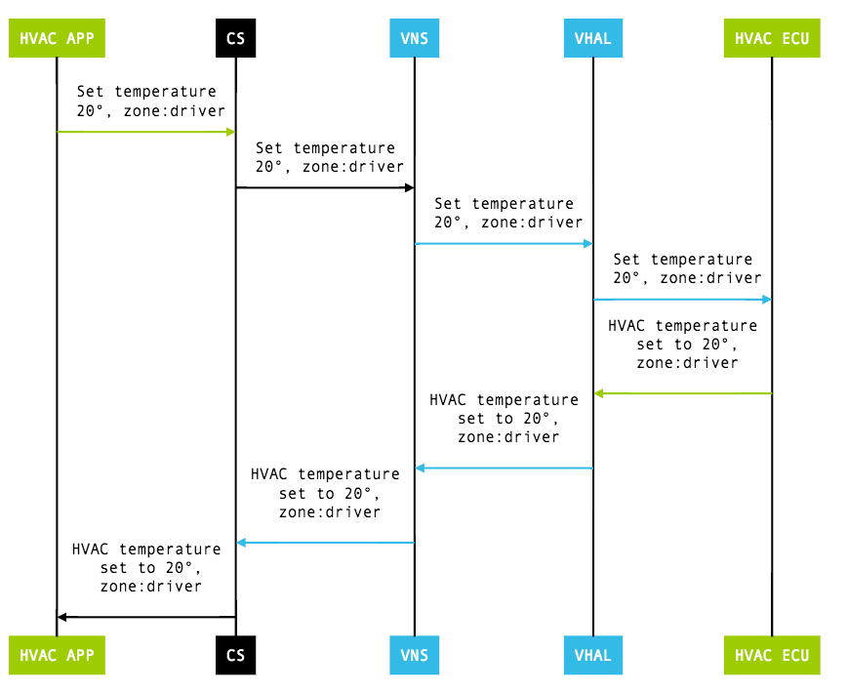

Figure 4 Vehicle HAL set HVAC example

**Figure** Set HVAC temperature (CS = CarService, VNS = VehicleNetworkService, VHAL = Vehicle HAL)

#### Power Management

<https://source.android.google.cn/devices/automotive/power>

Android 9 introduces a new state – *deep sleep* – into the power management state machine. To implement this state, Android 9 provides a new power management service and interface: CarPowerManagementService and CarPowerManager.

State transitions are triggered by the Vehicle MCU (VMCU). To communicate with the VMCU, integrators must implement several components. Integrators are responsible for integrating with the VHAL and the kernel implementation. Integrators are also responsible for disabling wake sources and ensuring that shutdowns are not postponed indefinitely.

Android 9 uses a *state machine* to represent the power state of the AP. This state machine provides these five states, as illustrated below:

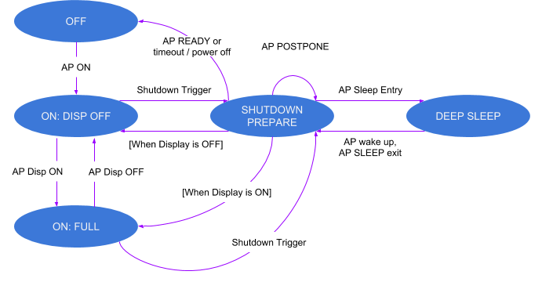

**Figure**Car power state machine

#### Flash Wear Management

<https://source.android.google.cn/devices/tech/perf/flash-wear>

Android Automotive internal storage uses an Embedded MultiMediaCard (eMMC) with thousands of erase/write cycles; if the eMMC fails, the system can become unusable. As vehicles have long lifespans (typically 10+ years), the eMMC must be extremely reliable. This page describes eMMC behavior and how OEMs can lower the risk of a failing eMMC (and thus avoid failed Android Automotive systems).

#### OTA

<https://source.android.google.cn/devices/tech/ota/>

<https://source.android.google.cn/devices/architecture/hidl-cpp>

<https://source.android.google.cn/devices/architecture>

Android 8.0 re-architected the Android OS framework (in a project known as *Treble*) to make it easier, faster, and less costly for manufacturers to update devices to a new version of Android. In this new architecture, the HAL interface definition language (HIDL, pronounced "hide-l") specifies the interface between a HAL and its users, enabling the Android framework to be replaced without rebuilding the HALs.

HIDL separates the vendor implementation (device-specific, lower-level software written by silicon manufacturers) from the Android OS framework via a new vendor interface. Vendors or SOC makers build HALs once and place them in a /vendor partition on the device; the framework, in its own partition, can then be replaced with an [over-the-air (OTA) update](https://source.android.google.cn/devices/tech/ota/) without recompiling the HALs.

The difference between the legacy Android architecture and the current, HIDL-based architecture is in the use of the vendor interface:

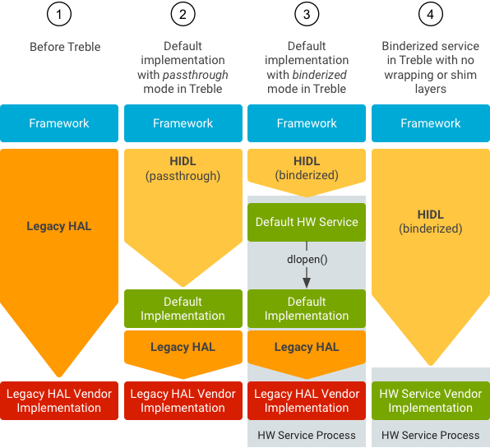

**Figure**Development progression for legacy HALs.

In Android 7.x and earlier, no formal vendor interface exists, so device makers must update large portions of the Android code to move a device to a newer version of Android:

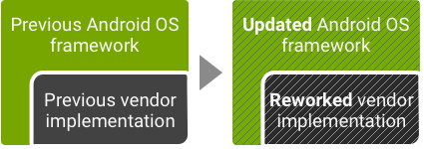

**Figure** Legacy Android update environment

In Android 8.0 and higher, a new stable vendor interface provides access to the hardware-specific parts of Android, so device makers can deliver new Android releases simply by updating the Android OS framework—without additional work required from the silicon manufacturers:

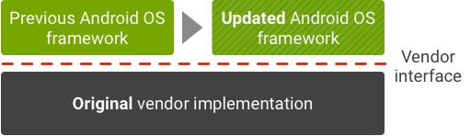

**Figure** Current Android update environment

All new devices launching with Android 8.0 and higher can take advantage of the new architecture. To ensure forward compatibility of vendor implementations, the vendor interface is validated by the[Vendor Test Suite (VTS)](https://source.android.google.cn/devices/tech/vts/index.html), which is analogous to the [Compatibility Test Suite (CTS)](https://source.android.google.cn/compatibility/cts/). You can use VTS to automate HAL and OS kernel testing in both legacy and current Android architectures.

### Demo

* 2017 Google I/O  
  Audi Q8 Concept  
  <https://audi-encounter.com/en/android-automotive>  
  Volvo V90 running Android Automovie  
  <https://arstechnica.com/cars/2017/05/android-automotive-hands-on-google-is-finally-ready-to-talk-about-its-car-os>
* 2018 Google I/O  
  A play store in your car  
  <https://www.androidpolice.com/2018/05/14/google-full-speed-ahead-android-automotive-not-much-android-auto>

### Conclusion

* Pros
  + Google‘s strong wish of Android Car, like Android Phone/Tablet/TV/Wear. It helps Google create a profile in mobility domain in Automotive market
  + Android has always been a people’s favorite operating system because of its user friendly UI and featured Play Store for downloading thousands of free popular apps.
  + The automakers can leverage Google’s extensive expertise of Android and brand influence by partnering with them for new innovations
  + Speed up the development time and releasing their product with latest version of the Operating system (2Y –> 6M) ??
  + The third party plug-in into the existing OS can be done, if the UI is approved for its safety
  + Involving google into automotive, ensures that the car manufacturer will now produce cars with a much newer version of Android.
  + Google has also provisioned the OEMs to add their own apps and rebrand the interface according to their needs.
  + The Android Automotive comes with a feature of Google app like Google Maps and can also support third-party app like Spotify.
  + ……
* Cons
  + Google will charge its partners $2.50 to $40 more per device, depending on its features, and depending on the country, to use Android in Europe  
    <https://www.thurrott.com/mobile/android/189150/report-reveals-new-android-licensing-fees-in-europe>
  + AGL is a formidable rival
  + AliOS has a head start in China, in the past tow years Banma system based on AliOS was factory installed in  Roewe, MG, Maxus, Dongfeng-citroen, Dongfeng-peugeot, Ford
  + China specific local services, internet policies, lows, and restrictions.
  + Android has a problem in that a lot of car manufacturers are not willing to give up the control of the display to Google or Apple. They want to keep that relationship with the consumer and maintain their branding, which is something that AGL and Tizen IVI are better designed to support
  + As cars become mini-data centers or edge compute nodes in their own right, as well as personalized hubs serving consumers outside the home, Linux could well become the primary OS of the in-vehicle computer.
  + ......

# Conclusion

* The price of multiple automotive OSes is too high. One or two OSes will take advantages eventually.
* Android Joined Auto OS Battle. Generic Android, Android Auto, and Android Automotive will coexist for several years
* Android Automotive is promising in IVI
* Linux (AGL) is promising in IC/Tbox/V2X and autonomous driving

# Abbreviation

|  |  |  |
| --- | --- | --- |
| Abbreviation | Full Name | Explanation |
| IVI | In-Vehicle Infotainment |  |
| HEV | Hybrid electric vehicle | <https://chejiahao.autohome.com.cn/info/2627894/> |
| PHEV | Plug-in hybrid electric vehicle | <https://chejiahao.autohome.com.cn/info/2627894/> |
| REEV | Range extended electric vehicle | <https://chejiahao.autohome.com.cn/info/2627894/> |
| BEV | Battery electric vehicle | <https://chejiahao.autohome.com.cn/info/2627894/> |
| FCEV | Fuel cell electric vehicle | <https://chejiahao.autohome.com.cn/info/2627894/> |
| UCB | Unified Code Base | The AGL Unified Code Base (UCB) is a Linux distribution built from the ground up through a joint effort by automakers and suppliers to deliver a modern in-vehicle infotainment and connected car experience for consumers. |
| HUD | Head-up display | <https://en.wikipedia.org/wiki/Head-up_display> |
| AGL | Automotive Grade Linux | <https://en.wikipedia.org/wiki/Automotive_Grade_Linux> |

# References

1. <https://d23rjziej2pu9i.cloudfront.net/wp-content/uploads/2018/08/29115649/EB-Next-Generation-of-IVI-Systems-Android-Automotive.pdf>
2. <https://mp.weixin.qq.com/s/ZcYC40nk2C73y3olDu2ClA>
3. <https://mp.weixin.qq.com/s/PcCaaSjtSZsZFzjoQJg1kg>
4. <https://ihsmarkit.com/research-analysis/android-automotive-takes-center-stage-as-2nd-largest-automaker.html>
5. [https://www.androidpolice.com/2018/05/14/google-full-speed-ahead-android-automotive-not-much-android-auto](https://www.androidpolice.com/2018/05/14/google-full-speed-ahead-android-automotive-not-much-android-auto/)
6. <https://www.embitel.com/blog/embedded-blog/no-android-auto-is-not-an-infotainment-os-make-way-for-android-automotive>
7. <https://www.embitel.com/blog/embedded-blog/design-strategies-develop-in-vehicle-infotainment-system>
8. <https://audi-encounter.com/en/android-automotive>
9. <https://www.avhub.com.au/news/incar/what-is-android-automotive-490778>
10. <https://9to5google.com/2018/05/07/google-android-auto-new-features-designs-volvo/>
11. <https://www.iyiou.com/p/77149.html>
12. <https://www.d1ev.com/kol/69956>
13. <https://source.android.google.cn/devices/automotive>
14. [https://ausdroid.net/2018/05/12/automotive-android-2018-going](https://ausdroid.net/2018/05/12/automotive-android-2018-going/)
15. <https://www.ubergizmo.com/2019/01/volvo-polestar-2-first-run-android-automotive/>
16. <https://www.deathmetalmods.de/android-automotive-erobert-google-nach-dem-smartphone-auch-das-auto/>
17. <https://ihsmarkit.com/research-analysis/details-of-android-automotive-revealed-as-the-os-nears-launch.html>
18. <https://www.theverge.com/2014/1/6/5279116/google-open-automotive-alliance-android-car-announcement>
19. <http://tech.huanqiu.com/diginews/2017-05/10709596.html?agt=62>
20. <https://arstechnica.com/cars/2017/05/android-automotive-hands-on-google-is-finally-ready-to-talk-about-its-car-os/>
21. <https://supplierinsight.ihsmarkit.com/shop/product/5002862/automotive-software-platforms>
22. <http://www.eepw.com.cn/article/201810/393612.htm>
23. <http://baijiahao.baidu.com/s?id=1604342027239301103&wfr=spider&for=pc>
24. <https://www.d1ev.com/news/jishu/66938>
25. <http://www.elecfans.com/qichedianzi/645660.html>
26. <http://baijiahao.baidu.com/s?id=1604931692832125204&wfr=spider&for=pc>
27. <https://baijiahao.baidu.com/s?id=1616294622272256576&wfr=spider&for=pc>
28. <https://www.sohu.com/a/228233750_291577>
29. <https://www.statista.com/statistics/680077/car-infotainment-os-market-share/>
30. <https://en.wikipedia.org/wiki/Automotive_Grade_Linux>
31. <https://www.automotivelinux.org/about>
32. <https://www.sohu.com/a/141305303_760583>
33. <https://gerrit.automotivelinux.org/gerrit/#/admin/projects/>
34. <https://wiki.automotivelinux.org/>
35. <https://www.linux.com/news/automotive-grade-linux-released-interview-dan-cauchy>
36. <https://events.static.linuxfound.org/sites/events/files/slides/contributing-to-agl-and-gdp-leon-anavi_0.pdf>
37. <https://www.automotivelinux.org/>
38. <https://www.genivi.org/>
39. <https://www.genivi.org/about-genivi>