Final Year Project

Software Requirement Specification

FYP Team
Mujtaba Ali 22F-3650
Muhammad Omair 22F-3651
Sarmad Mehmood 22F-3695

Supervised by
Dr. Adeel Ashraf Cheema

Co-Supervised by
Mr. Mughees Ismail

Department of Computer Science
National University of Computer and Emerging Science
Chiniot, Pakistan
2025

Anti-Plagiarism Declaration

This is to declare that the above publication produced under the:
Title: ________________________________
is the sole contribution of the author(s) and no part hereof has been reproduced on as its basis (cut and paste) which can be considered as Plagiarism. All referenced parts have been used to argue the idea and have been cited properly. I/We will be responsible and liable for any consequence if violation of this declaration is determined.
Date: ______________
Student 1
Name: _____________________
Signature: ___________________

Student 2
Name: _____________________
Signature: ___________________

Student 3
Name: _____________________
Signature: ___________________
Table of Contents
1. Introduction 1
2. Vision Document 1
2.1. Problem Statement: 1
2.2. Business Opportunities 2
2.3. Objectives 2
2.4. Scope 2
2.5. Constraints 2
2.6. Stakeholder and User Description 3
2.6.1. Market Demographics 3
2.6.2. User Environment 3
2.6.3. Stakeholder Profiles 3
2.6.3.1. Supervisor Team 3
2.6.3.2. Development Team 4
2.6.3.3. End Users 4
2.6.3.4. External Data Providers 4
2.6.4. Stakeholder Summary 5
3. System Requirements Specification 5
3.1. System Features 5
3.2. Functional Requirements 6
3.2.1 Authentication 6
3.2.2 User Profiles 6
3.2.3 Portfolio Management 6
3.2.4 Recommendation Engine 6
3.2.5 AI Chatbot Advisor 7
3.2.6 Educational Module 7
3.2.7 Data Scraper 7
3.2.8 Dashboard 7
3.2.9 Notifications & Alerts 7
3.3. Non-Functional Requirements 7
3.3.1 Performance 7
3.3.2 Usability 7
3.3.3 Availability 8
3.3.4 Maintainability 8
3.3.5 Security 8
3.3.6 Compatibility 8
Use Case Diagram 9
High Level Use Case 9
User Authentication 9
Portfolio Management 9
View Analytics and Dashboard 10
Interact with Chatbot Advisor 10
Learn Stocks 10
Receive Notifications & Alerts 10
Generate Recommendations 11
Perform Price Prediction 11
Perform Sentiment Analysis 11
Scrape Market Data 11
Expanded Use Case: 12
User Authentication 12
Portfolio Management 12
View Dashboard and Analytics 13
Interact with Chatbot Advisor 13
Learn Stocks 14
Receive Notifications & Alerts 14
Generate Recommendations 15
Perform Price Prediction 15
Perform Sentiment Analysis 16
Scrape Market Data 16
System Sequence Diagram 18
Interact with Chatbot Advisor 18
Dashboard and Analytics 19
Data Scrapping 20
Education Module 21
Notifications and Alerts 22
Portfolio Management 23
Price Prediction 24
Recommendation Engine 25
Sentiment Analysis 26
User Authentication 27
Sequence Diagram 28
AI Chatbot Interaction 28
Dashboard and Analytics 29
Education Module 30
Notifications and Alerts 31
Portfolio Management 32
Recommendation Engine 33
User Authentication 34
Activity Diagram 35
Portfolio Management 35
Generate Recommendation: 36
Interact with Chatbot Advisor 37
Learn Stocks: 38
Receive notifications and alerts 39
User authentication 40
View Dashboard And Analytics 41
Data Flow Diagram 42
Level 0 42
Level1 43
Domain Model 44
Json Tree 46

1. Introduction
StockSense is an AI-driven investment management platform designed to support Pakistani retail investors by combining real-time portfolio tracking, predictive analytics, sentiment analysis, interactive advisory, and comprehensive financial education. The purpose of this SRS is to document functional and non-functional requirements, system features, use cases, architecture, data model, and evaluation plan required to implement StockSense.

2. Vision Document

2.1. Problem Statement:
Category | Description
THE PROBLEM | Individual investors in Pakistan struggle to manage and optimize their stock portfolios due to the absence of proper all-in-one tools, forcing them to rely on manual and inefficient methods. They seek AI-based insights, yet most platforms lack personalized predictions, sentiment analysis, and reliable market data. The scarcity of educational resources further limits their understanding of financial concepts, leading to low confidence and poor investment decisions. Moreover, most investments in Pakistan are handled through brokers, and due to limited investor awareness, scams and misinformation are common. Investors need to understand how the stock market works to make informed decisions and avoid exploitation.
AFFECTS | It weakens Pakistan’s economy by discouraging small investors and new entrants, while also reducing trust in financial institutions and slowing personal and national economic growth.
IMPACT | Many people lose money due to uninformed investment decisions, harming Pakistan’s economy and increasing inequality. Capital that could drive productive investments is wasted, causing instability and reducing financial awareness. This limits fair opportunities and weakens overall economic growth in the country.
SOLUTION | A comprehensive system will be developed to document investment needs and promote informed decision-making. It will offer a cross-platform app that tracks portfolios, predicts stock trends, and provides educational content. The app will operate in a hypothetical environment — users will not make real investments but can simulate owning specific stocks and track their performance. The system will deliver personalized recommendations, real-time alerts, and AI-driven insights while ensuring data privacy. Through interactive learning, simulated portfolio management, and visualized market data, it will empower investors with financial literacy, promote ethical investing, and foster a transparent, knowledge-driven market culture in Pakistan.

2.2. Business Opportunities
Pakistan’s stock market participation is low due to limited investor awareness and lack of smart financial tools. With rising smartphone use and interest in digital finance, StockSense offers an AI-powered platform combining market predictions, real-time analytics, sentiment tracking, and education. It empowers investors to make informed, ethical, and data-driven decisions, boosting confidence and financial literacy while supporting national economic growth.

2.3. Objectives
Following are the objectives
- To develop a cross-platform investment management application that allows users to simulate and track their stock portfolios in real time through an interactive and user-friendly interface.
- To build a ML Recommendation Engine that analyzes market patterns and investor preferences to generate intelligent, data-driven buy, hold, or sell suggestions supported by predictive and sentiment-based analytics.
- To provide an AI chatbot advisor that delivers personalized investment guidance and answers user queries interactively.
- To design an educational learning module with micro-courses, quizzes, and progress tracking to build users’ financial knowledge and confidence.
- To promote financial literacy and transparency by empowering Pakistani investors to make data-informed, responsible decisions in a simulated yet realistic environment.

2.4. Scope
StockSense is a cross-platform (mobile and web) application that serves as a virtual investment assistant and learning tool for retail investors in Pakistan. The system integrates scraped market data, predictive analytics, and machine learning–based sentiment monitoring to guide investment decisions. A dedicated data scraper module continuously collects both historical and real-time stock data from relevant market sources, enabling accurate trend analysis and up-to-date portfolio tracking. Users can create virtual portfolios, simulate trades, and monitor their stock performance through interactive dashboards and analytical charts. The platform also includes an AI chatbot for conversational guidance and an educational module for learning key investment concepts. All recommendations and forecasts are generated from machine learning models trained on past data and enhanced by market sentiment insights; however, the system does not handle or process real financial transactions—it operates purely as a simulation and educational environment. This ensures user safety while enabling realistic financial training, strategic decision-making, and knowledge development in a risk-free setting.

2.5. Constraints
- Data Dependency: Relies on data collected through the in-house scraper for both past and current stock information.
- Scraper Limitation: Dependent on target website availability and structure for data accuracy.
- Model Accuracy: Predictions are based on historical data and may vary with sudden market changes.
- No Real Transactions: Operates only in a simulated environment without handling real investments.
- Resource Limitation: Restricted by available hardware, time, and computational capacity.
- Internet Requirement: Needs stable connectivity for real-time data scraping and updates.

2.6. Stakeholder and User Description

2.6.1. Market Demographics
The primary market consists of individual retail investors in Pakistan who are interested in learning about the stock market and improving their investment decision-making. These users often face difficulties accessing reliable information, understanding stock data, and interpreting market movements. StockSense targets beginner to intermediate investors who want to track virtual portfolios, gain data-driven recommendations, and learn financial concepts through interactive education. The value proposition lies in providing a unified platform that combines real-time data analysis, portfolio tracking, sentiment-driven insights, and learning resources to promote financial literacy and responsible investing in Pakistan’s growing digital finance ecosystem.

2.6.2. User Environment
Users access StockSense through a cross-platform interface available on both mobile (Android , IOS) and web browsers (Chrome, Firefox, Edge). The system is optimized for smooth use on mid-range devices and standard internet connections. Data scraping, prediction, and sentiment analysis are processed on the backend servers to minimize client load. The authentication process supports standard user registration and OAuth login (e.g., Google). Since the system is educational and simulation-based, users interact with virtual portfolios and do not perform real investments. The platform delivers visual dashboards, AI chatbot interactions, alerts, and learning modules, ensuring an engaging and informative experience for each investor.

2.6.3. Stakeholder Profiles

2.6.3.1. Supervisor Team
Attribute | Description
Representatives | Supervisor, Co-Supervisor
Description | Provide academic and technical guidance throughout project development.
Type | Technical/Academic Stakeholders
Responsibility | Ensure project quality, scope alignment, technical feasibility, and documentation standards.
Success Criteria | The system fulfills proposed objectives with stable functionality and complete documentation.
Involvement | Requirement reviews; progress check-ins; final evaluation.
Comments/Issues | Ensure scope realism and emphasize integration of AI and ML, data scraping, and educational features.

2.6.3.2. Development Team
Attribute | Description
Representatives | FYP student developers (StockSense Team)
Description | Design, build, and integrate all components of the StockSense system.
Type | Technical Stakeholders
Responsibility | Develop data scraper, machine learning modules, API services, web/mobile frontends, chatbot, and educational modules.
Success Criteria | Fully functional simulation environment, reliable predictions, and usable learning experience.
Involvement | Entire development lifecycle: research, implementation, testing, integration, and documentation.
Comments/Issues | Ensure data accuracy in scraping, maintain model explainability, and optimize system responsiveness.

2.6.3.3. End Users
Attribute | Description
Representatives | Individual investors, learners, and financial enthusiasts in Pakistan
Description | Users who want to practice investment management, view insights, and learn financial concepts without real monetary risk.
Type | External Stakeholders (Primary Users)
Responsibility | Create virtual portfolios, monitor simulated stock performance, receive recommendations, and complete educational modules.
Success Criteria | Improved understanding of financial concepts, enhanced confidence in investment decision-making.
Involvement | Regular use of portfolio dashboard, chatbot queries, and educational modules.
Comments/Issues | Prefer simple, visual insights with transparent explanations of AI-generated recommendations.

2.6.3.4. External Data Providers
Attribute | Description
Representatives | Publicly available stock market data sources and financial news sites
Description | Provide raw data used by the scraper for price tracking and sentiment analysis.
Type | External Technical Stakeholders
Responsibility | Ensure data availability and reliability for continuous system updates.
Success Criteria | Ensure data availability and reliability for continuous system updates.
Involvement | Continuous, automated data retrieval via scraper.
Comments/Issues | Data format or access changes may affect scraper performance.

2.6.4. Stakeholder Summary

Name | Description | Responsibility
Supervisor Team | Academic supervisors guiding the development and evaluation of StockSense. | Provide direction, monitor progress, ensure quality, and approve deliverables.
Development Team | Student team designing, developing, integrating, and testing StockSense. | Implement scraping, ML, chatbot, and education modules with documentation.
End Users | Individual users simulating investments and learning financial concepts. | Use a system for portfolio tracking, insights, and financial literacy improvement.
External Data Providers | Market data and news sources for scraper input. | Provide accurate, timely data for analysis and predictions.

3. System Requirements Specification

3.1. System Features
Project offers a range of critical features, including:
- Dashboard: Providing an overview of user portfolios, stock performance trends, and market sentiment distribution.
- Portfolio Management: Allowing users to add their preferences and desired stocks.
- Recommendation Engine: Generating intelligent, data-driven buy, hold, or sell suggestions using price prediction on past data and sentiment analysis on financial news.
- AI Chatbot Advisor: Assisting users through conversational guidance, investment explanations, and portfolio insights.
- Educational Module: Delivering courses and quizzes to enhance financial literacy and track learning progress.
- Data Scraper: Collecting both historical and real-time stock data from public sources to support predictions and analytics.
- Visualization & Analytics: Displaying interactive charts, performance graphs, and sentiment indicators for better decision-making.
- Notifications & Alerts: Notifying users of major stock movements, portfolio changes, and learning progress updates.
- User Profiles: Maintaining personalized user data, virtual portfolios, learning progress, and chatbot interaction history.
- Secure Login/Sign-up: Allowing users to register and log in through a secure authentication system (Email or OAuth).

3.2. Functional Requirements
The system must fulfil specific functional requirements, including:

3.2.1 Authentication
- The system shall support secure user registration and login.
- The system shall support OAuth sign-up/login (e.g., Google).

3.2.2 User Profiles
- The system shall maintain per-user profiles containing personal details, preferences , and learning progress.

3.2.3 Portfolio Management
- The system shall allow users to add preferences.
- The system shall enable users to add or remove stocks from their portfolio.
- The system shall display simulated profit/loss and historical stock performance.

3.2.4 Recommendation Engine
- The system shall generate buy, hold, or sell recommendations.
- The system shall analyze historical data for price predictions.
- The system shall process financial news and sentiment data to adjust recommendations.
- The system shall display confidence levels for each recommendation.

3.2.5 AI Chatbot Advisor
- The system shall allow users to interact with a chatbot for investment guidance.
- The system shall provide explanations for stock insights and learning resources.
- The system shall support both general and portfolio-specific queries.

3.2.6 Educational Module
- The system shall provide users with courses and quizzes on financial concepts.
- The system shall track user progress and learning achievements.

3.2.7 Data Scraper
- The system shall scrape historical and real-time stock market data from public sources.
- The system shall automatically refresh data at regular intervals.
- The system shall validate and store the collected data for use in analysis and recommendations.

3.2.8 Dashboard
- The system shall display a summary of portfolio performance, stock trends, sentiment analysis results and buy/hold/sell decisions.
- The system shall visualize data through line charts, bar charts, and performance summaries.

3.2.9 Notifications & Alerts
- The system shall notify users of major changes in stock prices or sentiment.
- The system shall alert users about portfolio updates and recommendation changes.

3.3. Non-Functional Requirements

3.3.1 Performance
- The system shall display dashboard insights and portfolio updates within 2 seconds under normal load.
- The scraper shall update market data at least every 10 minutes during trading hours.

3.3.2 Usability
- The system shall provide an intuitive, user-friendly interface accessible with minimal training.

3.3.3 Availability
- The system shall achieve 99% uptime for user-facing services.

3.3.4 Maintainability
- The system shall follow a modular codebase structure.

3.3.5 Security
- The system shall encrypt sensitive data (e.g., credentials, portfolios).
- The system shall use secure authentication protocols and prevent unauthorized access.

3.3.6 Compatibility
- The system shall function correctly across commonly used desktop and mobile web browsers and adapt to typical screen sizes.

Use Case Diagram
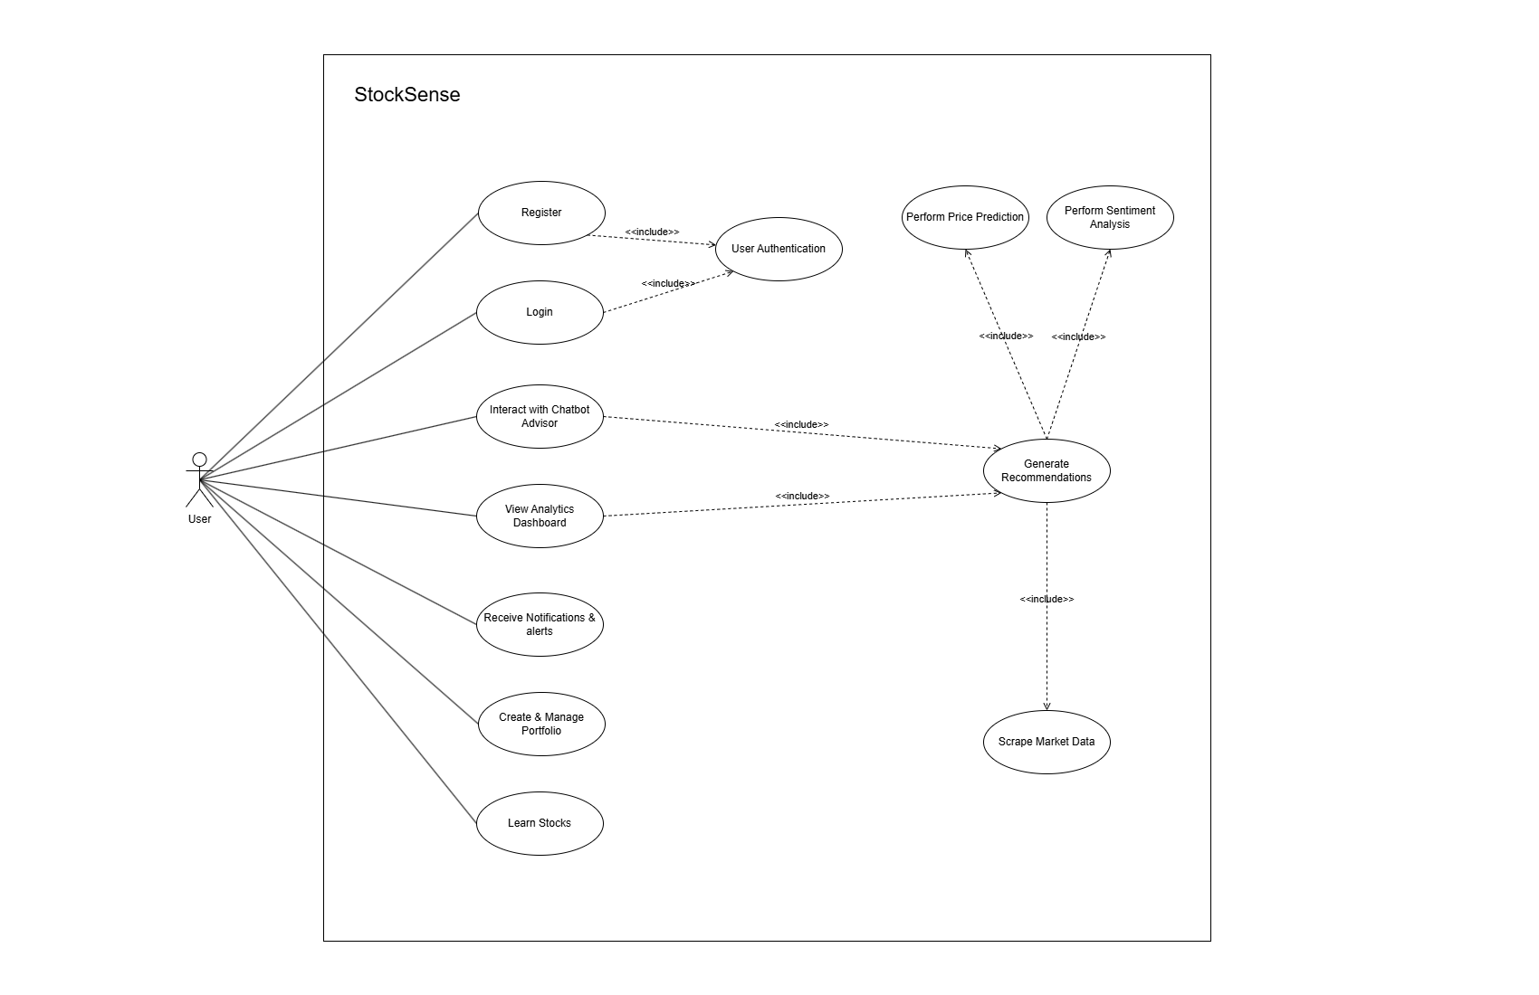

High Level Use Case

User Authentication
Attribute | Detail
Use Case ID | UC-01
Use Case Name | User Authentication
Actor(s) | User
Type | Primary
Description | Allows users to securely register and log in through email or OAuth (Google) to access the StockSense platform.

Portfolio Management
Attribute | Detail
Use Case ID | UC-02
Use Case Name | Portfolio Management
Actor(s) | User
Type | Primary
Description | Users can add preferences and add or remove stocks.

View Analytics and Dashboard
Attribute | Detail
Use Case ID | UC-03
Use Case Name | View Analytics and Dashboard
Actor(s) | User
Type | Primary
Description | Displays portfolio performance, market trends, sentiment insights through visual analytics and charts and buy/hold/sell decisions.

Interact with Chatbot Advisor
Attribute | Detail
Use Case ID | UC-04
Use Case Name | Interact with Chatbot Advisor
Actor(s) | User
Type | Primary
Description | Provides users with personalized investment advice, stock insights, and learning assistance through an AI chatbot.

Learn Stocks
Attribute | Detail
Use Case ID | UC-05
Use Case Name | Learn Stocks
Actor(s) | User
Type | Primary
Description | Allows users to learn financial concepts through courses and quizzes, with progress tracking.

Receive Notifications & Alerts
Attribute | Detail
Use Case ID | UC-06
Use Case Name | Receive Notifications & Alerts
Actor(s) | User
Type | Primary
Description | Notifies users about major stock movements, recommendations and learning progress.

Generate Recommendations
Attribute | Detail
Use Case ID | UC-07
Use Case Name | Generate Recommendations
Actor(s) | System (invoked via Chatbot/Dashboard)
Type | Secondary
Description | The system’s ML model analyzes stock data and sentiment to generate personalized buy, hold, or sell recommendations.

Perform Price Prediction
Attribute | Detail
Use Case ID | UC-08
Use Case Name | Perform Price Prediction
Actor(s) | System
Type | Secondary
Description | Predicts stock price trends based on historical data and model training.

Perform Sentiment Analysis
Attribute | Detail
Use Case ID | UC-09
Use Case Name | Perform Sentiment Analysis
Actor(s) | System
Type | Secondary
Description | Processes financial news and social data to determine market sentiment and its effect on recommendations.

Scrape Market Data
Attribute | Detail
Use Case ID | UC-10
Use Case Name | Scrape Market Data
Actor(s) | System
Type | Secondary
Description | Continuously collects, validates, and updates real-time and historical stock market data for analysis and visualization.

Expanded Use Case:

User Authentication
Use Case ID | UC-01
Use Case Name | User Authentication
Actor | User
Type | Primary
Description | Allows users to securely register and log in through email or OAuth (Google) to access the StockSense platform.
Trigger | The user navigates to the StockSense login page and selects “Login” or “Sign in with Google.”
Pre-condition | - Users must have a valid email or OAuth account.  - Internet connection must be available.
Post-condition | The user is authenticated and redirected to the dashboard.
Normal Flow | - The user opens the StockSense app or website.  - The system displays the login page with registration and OAuth options.  - The user selects “Login” or “Sign in with Google.”  - System requests credentials or redirects to OAuth provider.  - Credentials are verified by StockSense or OAuth service.  - The system creates or updates the user profile.  - The user is redirected to the dashboard with an active session.
Alternative Flow | - Invalid credentials  - User cancels OAuth authorization
Exception | Authentication server unavailable
Priority | High

Portfolio Management
Use Case ID | UC-02
Use Case Name | Portfolio Management
Actor | User
Type | Primary
Description | Enables users to add preferences and add or remove stocks for performance tracking.
Trigger | The user navigates to the Portfolio section from the dashboard.
Pre-condition | Users must be authenticated and logged in.
Post-condition | Portfolio data is saved or updated in the system.
Normal Flow | - The user goes to the portfolio page.  - The system displays the portfolio of the user.  - The user adds preferences and adds desired stocks.  - The user saves the portfolio.  - The system stores portfolio data.  - The user is redirected to the dashboard.
Alternative Flow | - Missing required fields
Exception | Network failure during save
Priority | High

View Dashboard and Analytics
Use Case ID | UC-03
Use Case Name | View Dashboard and Analytics
Actor | User
Type | Primary
Description | Displays user’s portfolio overview, performance insights, and sentiment analysis via charts and visualizations.
Trigger | The user logs in or selects “Dashboard” from navigation.
Pre-condition | Users must be logged in.
Post-condition | Dashboard data (portfolio, sentiment, predictions) is rendered.
Normal Flow | - The system calculates simulated profit/loss.  - The user navigates to the dashboard.  - The system fetches stock data and analytics.  - Dashboard displays performance graphs, market sentiment, and recommendations.
Alternative Flow | The user has not added any stocks yet.
Exception | Backend service unavailable
Priority | High

Interact with Chatbot Advisor
Use Case ID | UC-04
Use Case Name | Interact with Chatbot Advisor
Actor | User
Type | Primary
Description | Users interact with an AI chatbot for investment guidance, portfolio advice, and learning assistance.
Trigger | The user opens a chatbot window from the dashboard.
Pre-condition | Users must be logged in.
Post-condition | The user receives context-based responses and guidance.
Normal Flow | - The user opens the chatbot interface.  - User types a query (e.g., “Should I buy ABC stock?”).  - The system processes the query through the NLP and recommendation module.  - Chatbot displays the AI-generated response with reasoning or resources.  - Users may ask follow-up questions or close the chat.
Alternative Flow | Query not recognized
Exception | Chatbot service unavailable
Priority | High

Learn Stocks
Use Case ID | UC-05
Use Case Name | Learn Stocks
Actor | User
Type | Primary
Description | Provides courses and quizzes to teach investment and finance fundamentals with progress tracking.
Trigger | The user selects “Learn” from the main menu.
Pre-condition | Users must be logged in.
Post-condition | User progress and quiz scores are stored.
Normal Flow | - The user opens a learning module.  - The system displays available courses and quizzes.  - The user selects a course.  - The system loads content and tracks progress.  - Upon completion, quiz results and progress are saved.
Alternative Flow | The user skips the education part.
Exception | Network disruption
Priority | High

Receive Notifications & Alerts
Use Case ID | UC-06
Use Case Name | Receive Notifications & Alerts
Actor | User
Type | Primary
Description | Notifies users about significant stock price movements, sentiment changes, and learning milestones.
Trigger | A monitored event occurs (price change, new recommendation, or quiz completion).
Pre-condition | The user has enabled notifications.
Post-condition | Users receive timely alerts via app or email.
Normal Flow | - The system monitors stock and sentiment data.  - A trigger event is detected (e.g., stock price rises 10%).  - The system generates notification content.  - Notification is sent to the user via app/email.
Alternative Flow | Notification delivery fails
Exception | Notification service down
Priority | Medium

Generate Recommendations
Use Case ID | UC-07
Use Case Name | Generate Recommendations
Actor | System (invoked by user actions)
Type | Secondary
Description | Analyzes stock trends and sentiment to produce personalized buy, hold, or sell recommendations.
Trigger | The user views the dashboard or asks the chatbot for advice.
Pre-condition | Data scraper and ML model are up-to-date.
Post-condition | Recommendations are displayed with confidence levels.
Normal Flow | - The system retrieves recent stock and sentiment data.  - ML model analyzes price patterns and news sentiment.  - Model generates buy/hold/sell recommendation.  - Recommendation with confidence score is shown to the user on the dashboard.
Alternative Flow | Missing sentiment data
Exception | ML model unavailable
Priority | High

Perform Price Prediction
Use Case ID | UC-08
Use Case Name | Perform Price Prediction
Actor | System
Type | Secondary
Description | Predicts stock price trends using historical data and trained ML models.
Trigger | Scheduled task.
Pre-condition | Historical data must exist in the database.
Post-condition | Predicted data stored and used in recommendations.
Normal Flow | - The system loads historical price data and current market data.  - ML algorithm processes.  - The model predicts short-term price trends.  - Predicted data is stored and sent to visualization modules.
Alternative Flow | Missing data
Exception | ML model unavailable
Priority | High

Perform Sentiment Analysis
Use Case ID | UC-09
Use Case Name | Perform Sentiment Analysis
Actor | System
Type | Secondary
Description | Analyzes financial news and social data to compute sentiment indicators for stock recommendations.
Trigger | New articles or social posts detected by scrapers.
Pre-condition | Data scraper functioning properly.
Post-condition | Sentiment scores saved in the database.
Normal Flow | - Scraper collects recent financial articles and social posts.  - The NLP module processes text data.  - The system classifies sentiment as positive, neutral, or negative.  - Aggregated sentiment score stored for each stock.
Alternative Flow | No new data available
Exception | NLP service failure
Priority | High

Scrape Market Data
Use Case ID | UC-10
Use Case Name | Scrape Market Data
Actor | System
Type | Secondary
Description | Collects and updates real-time and historical market data to power analytics, predictions, and dashboards.
Trigger | Scheduled task.
Pre-condition | Target data sources are accessible.
Post-condition | Data stored, validated, and made available for analytics.
Normal Flow | - System initiates scraper process.  - Scraper fetches current stock data and historical data.  - Data is cleaned and validated.  - Updated data stored in database.  - The system refreshes the recommendation module.
Alternative Flow | Partial data fetched
Exception | Source website structure changed
Priority | High

System Sequence Diagram

Interact with Chatbot Advisor
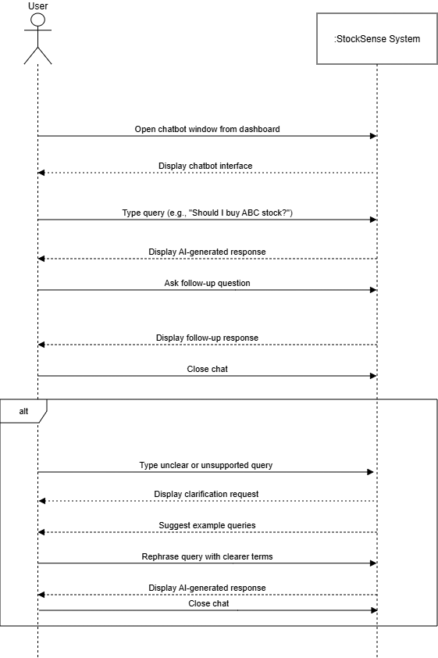

Dashboard and Analytics
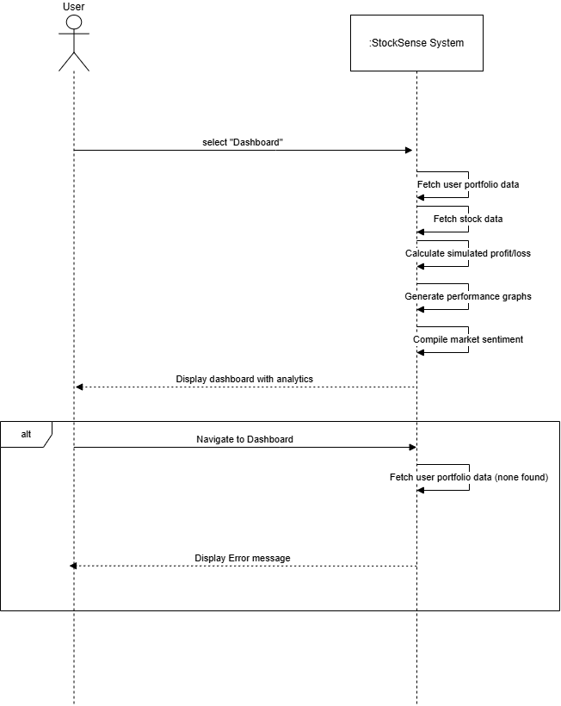

Data Scrapping
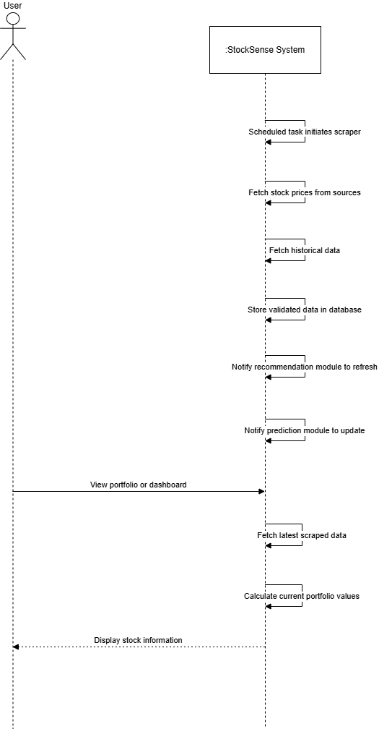

Education Module
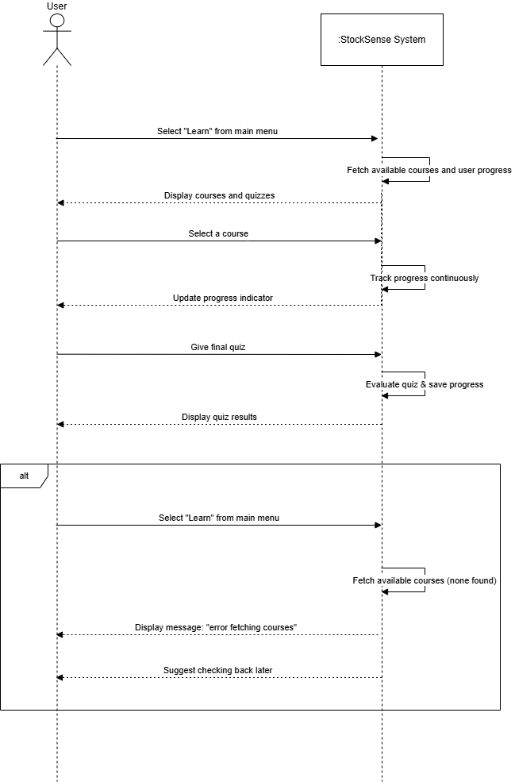

Notifications and Alerts
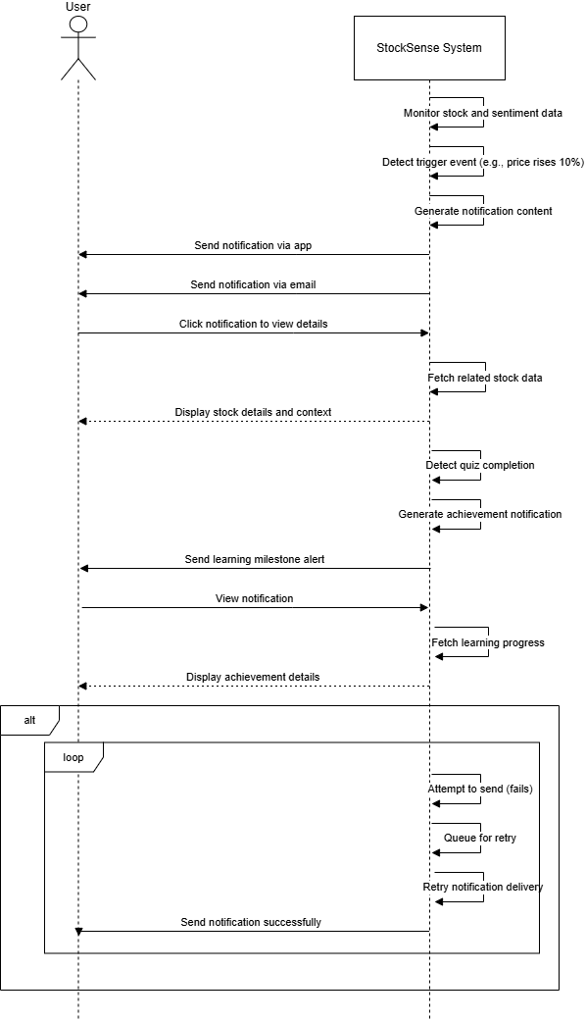

Portfolio Management
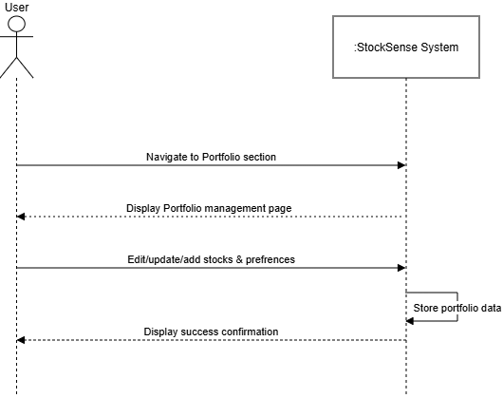

Price Prediction
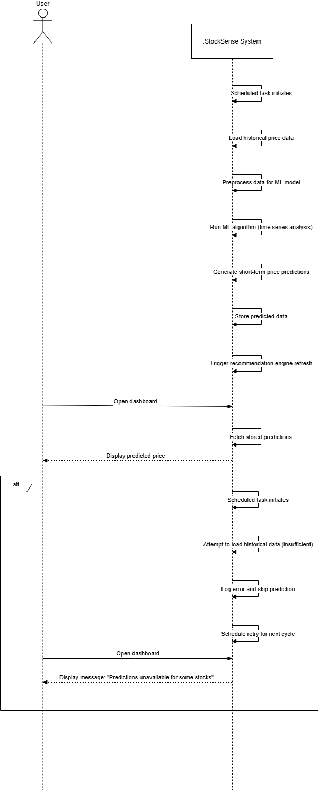

Recommendation Engine
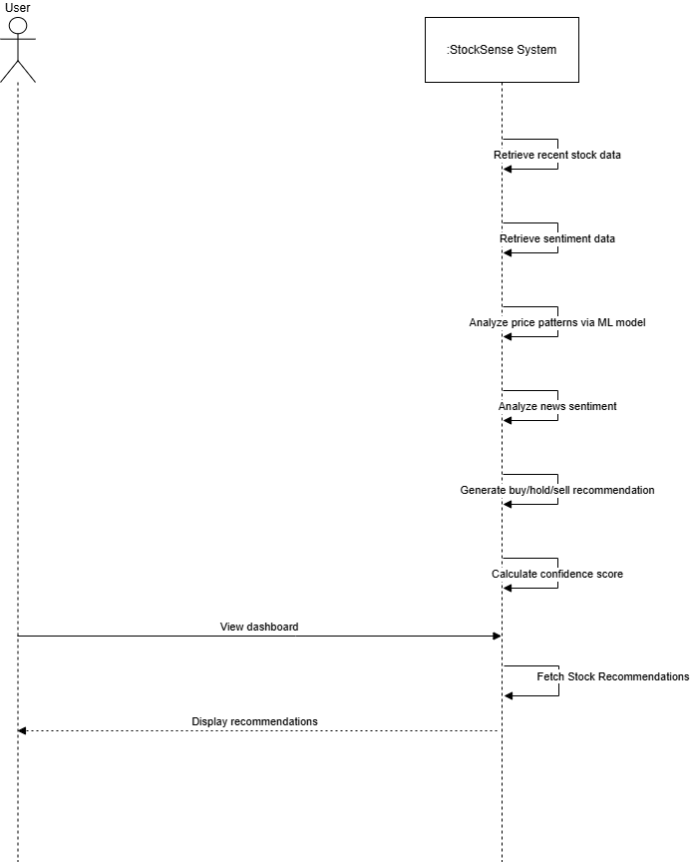

Sentiment Analysis
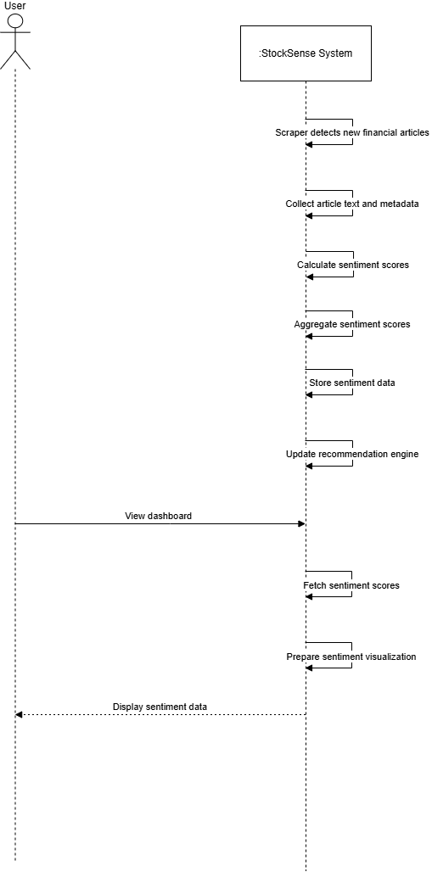

User Authentication
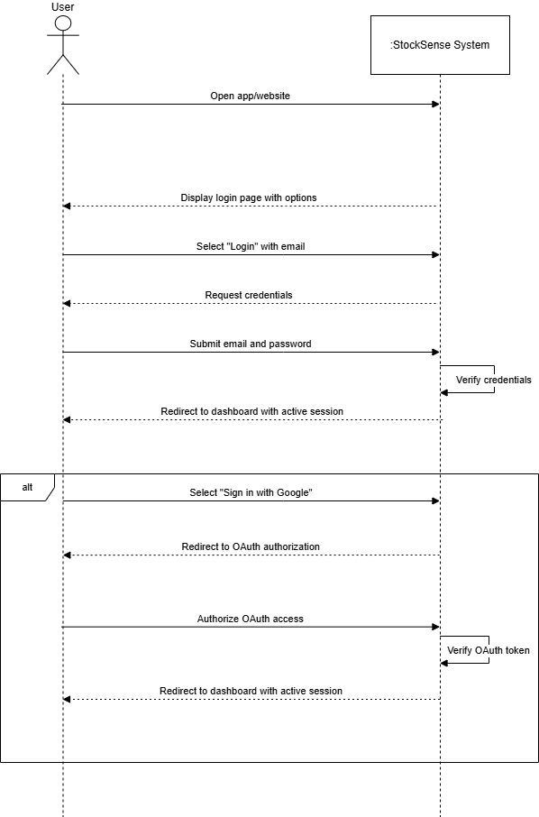

Sequence Diagram

AI Chatbot Interaction
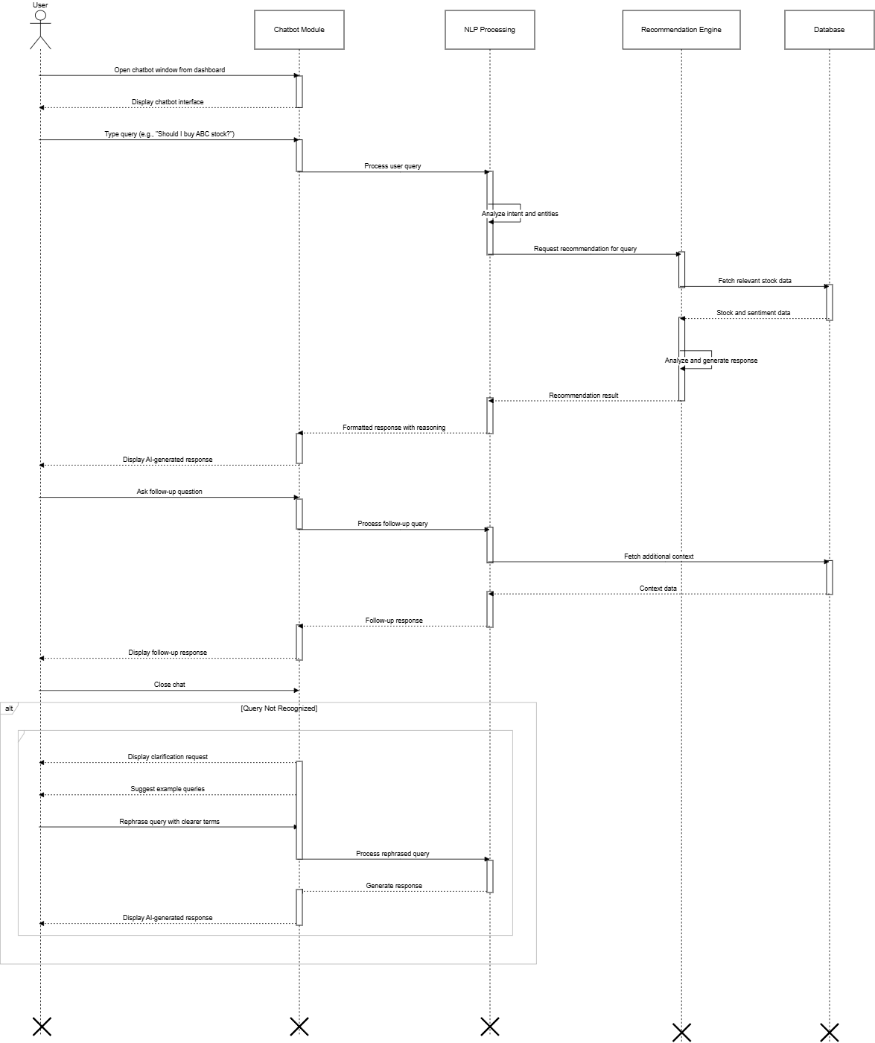

Dashboard and Analytics
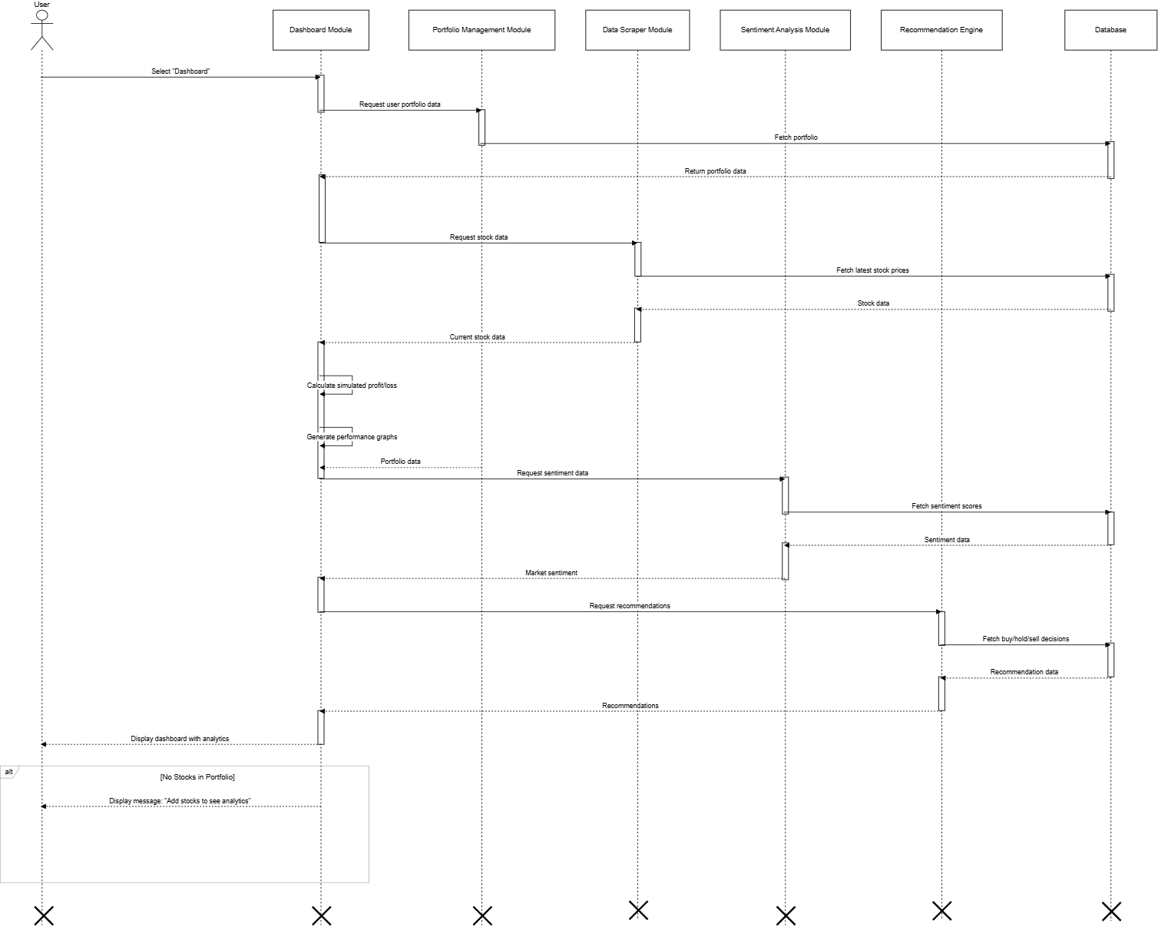

Education Module
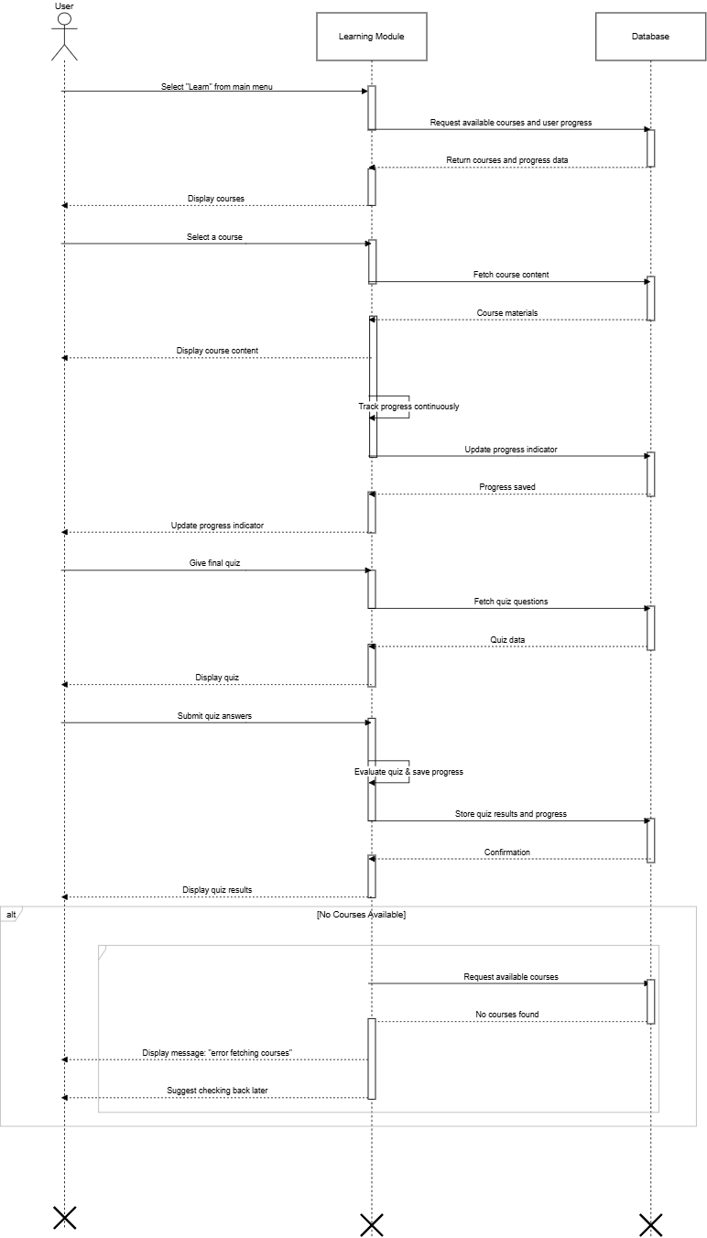

Notifications and Alerts
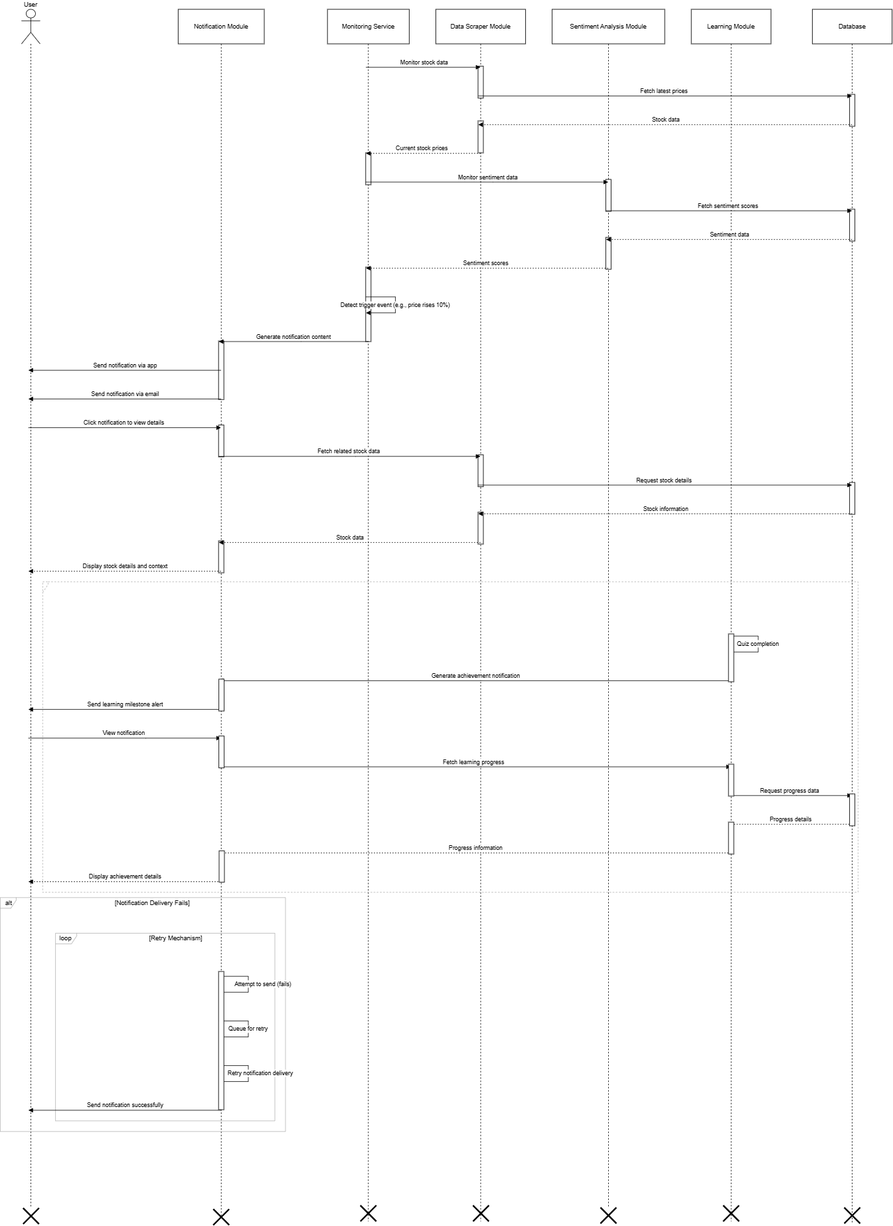

Portfolio Management
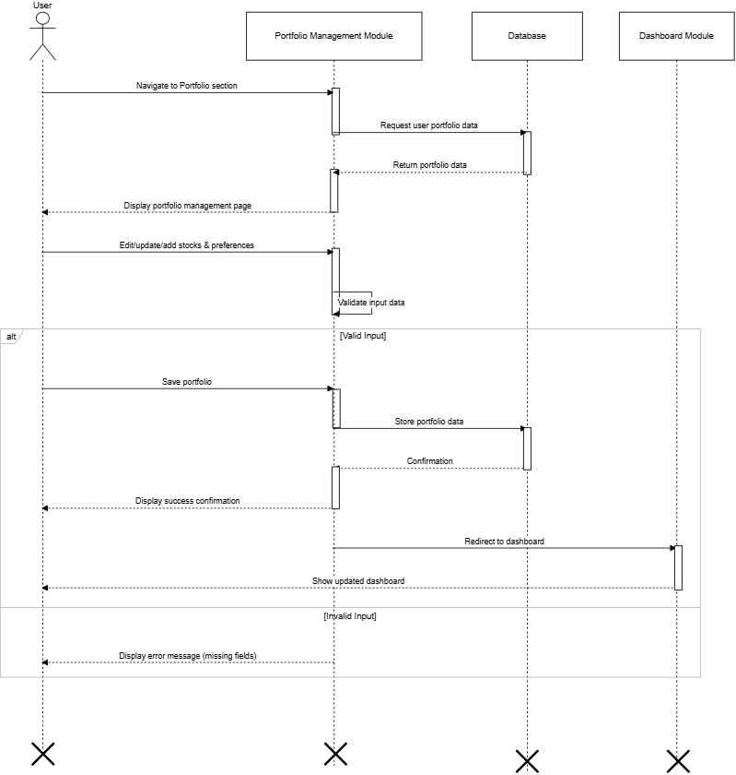

Recommendation Engine
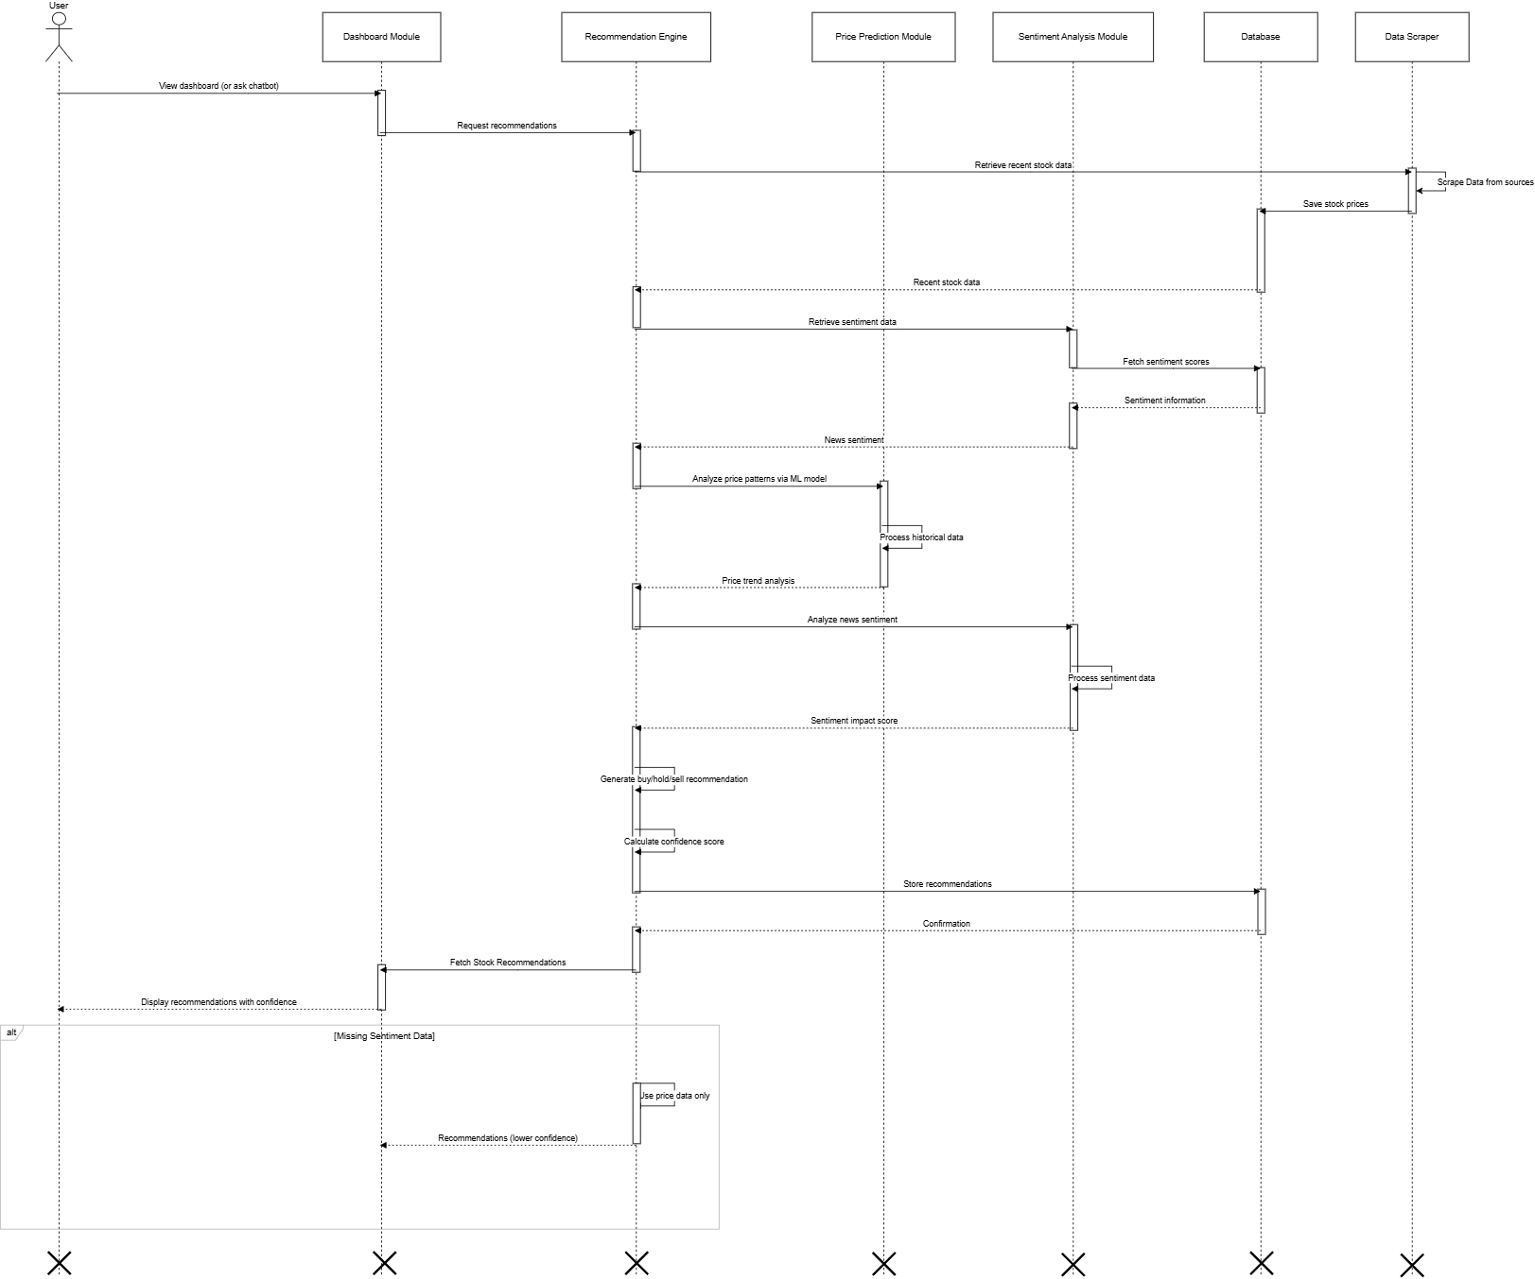

User Authentication
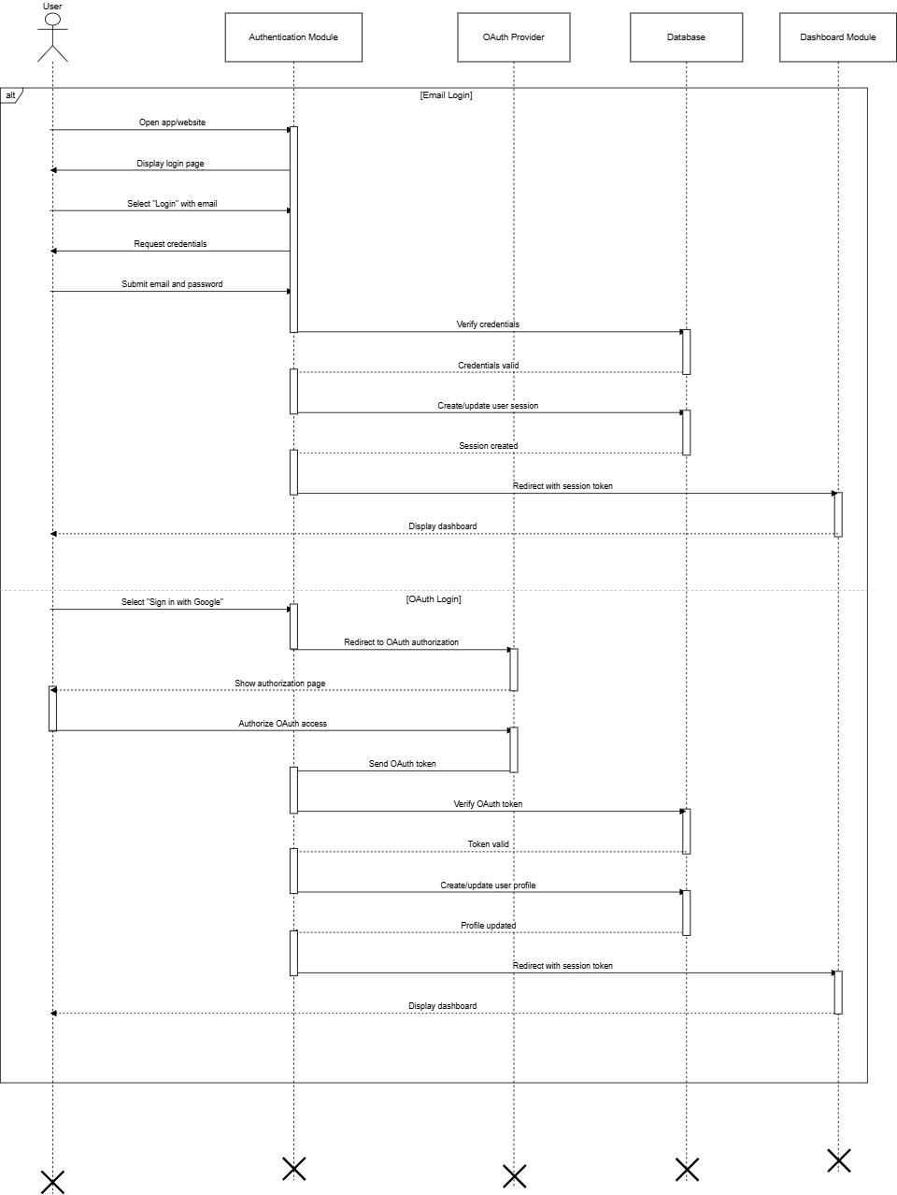

Activity Diagram

Portfolio Management
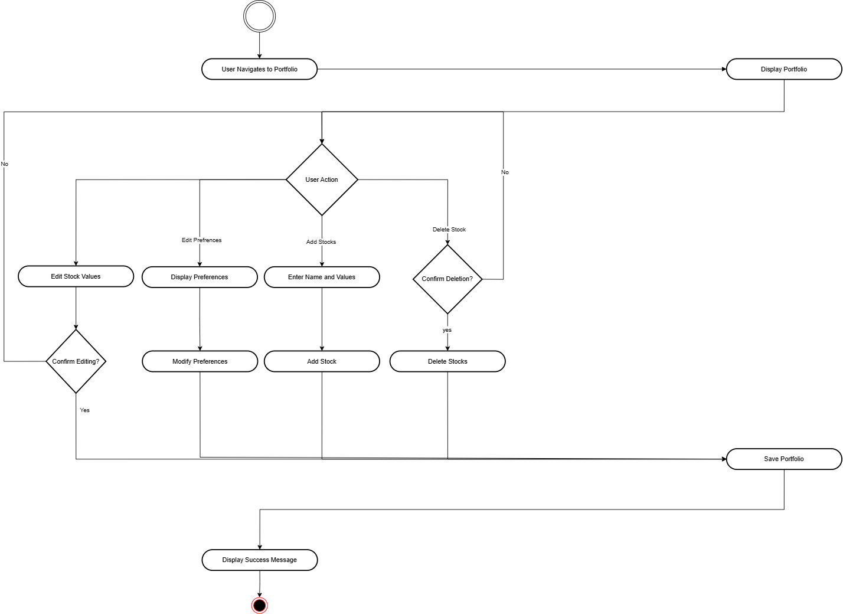

Generate Recommendation:
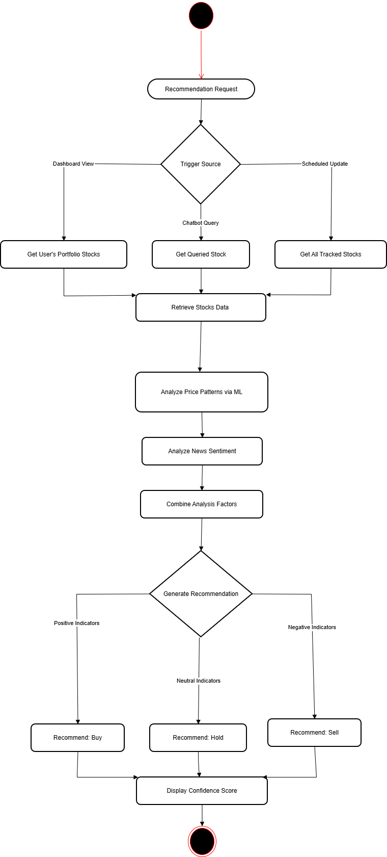

Interact with Chatbot Advisor
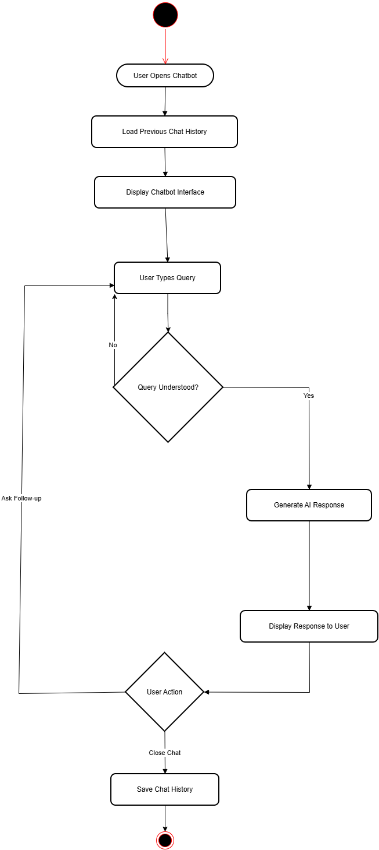

Learn Stocks:
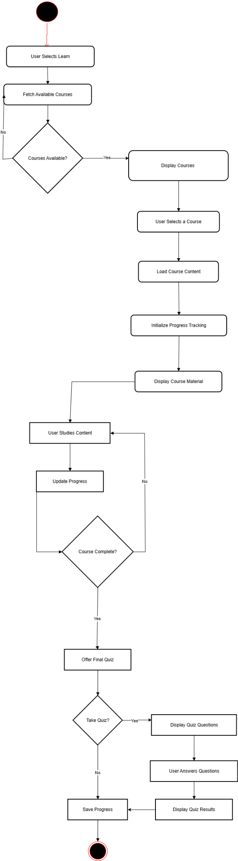

Receive notifications and alerts
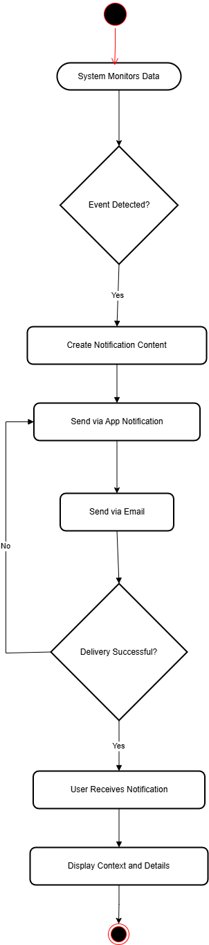

User authentication
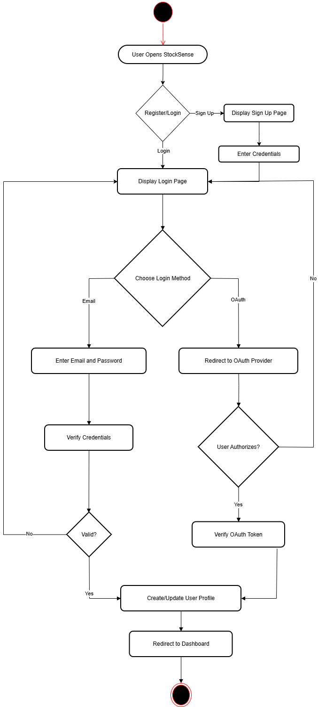

View Dashboard And Analytics
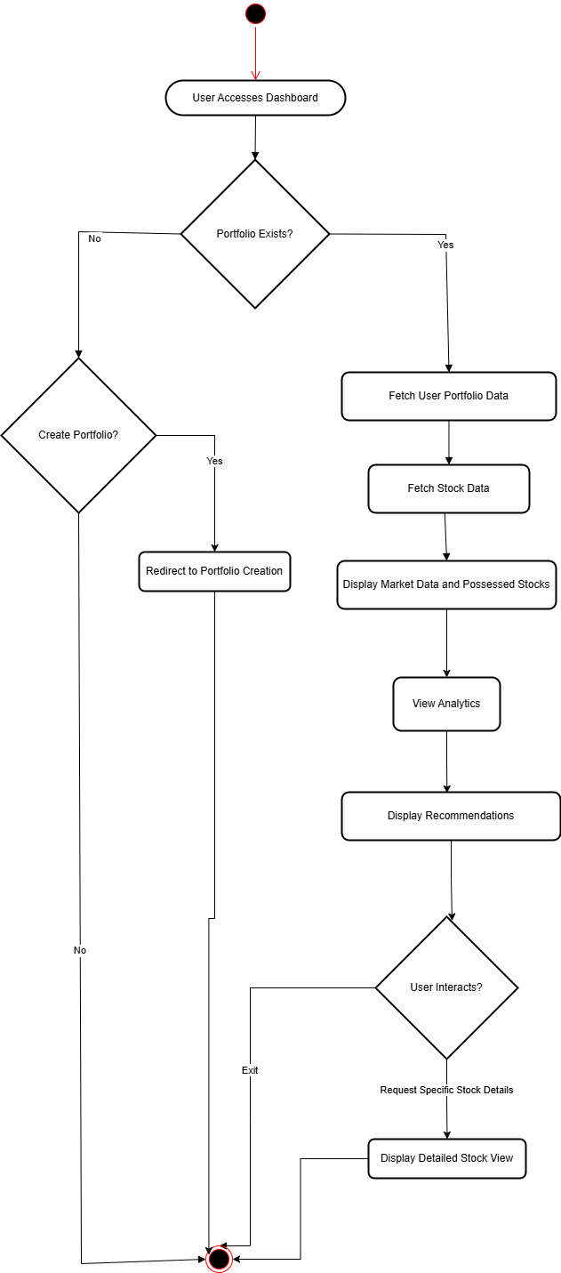

Data Flow Diagram

Level 0
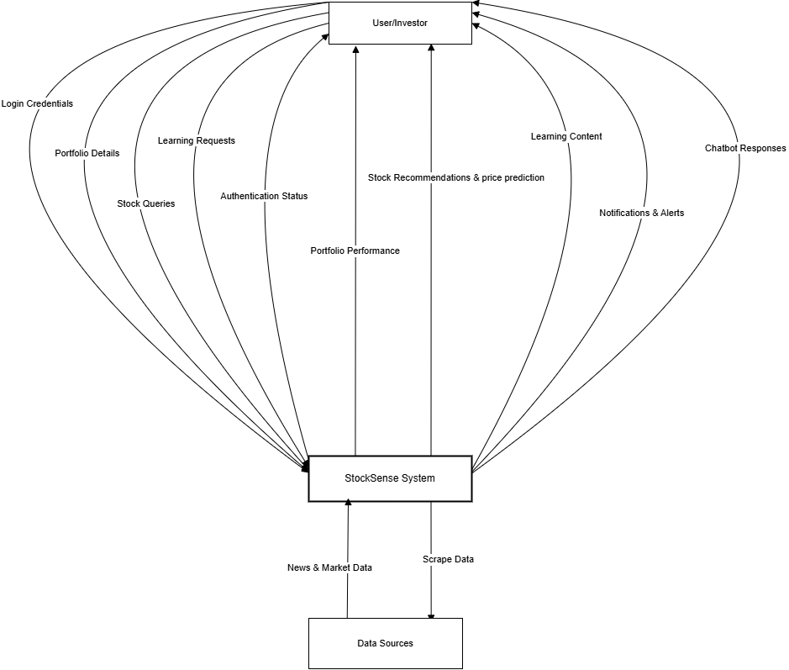

Level1
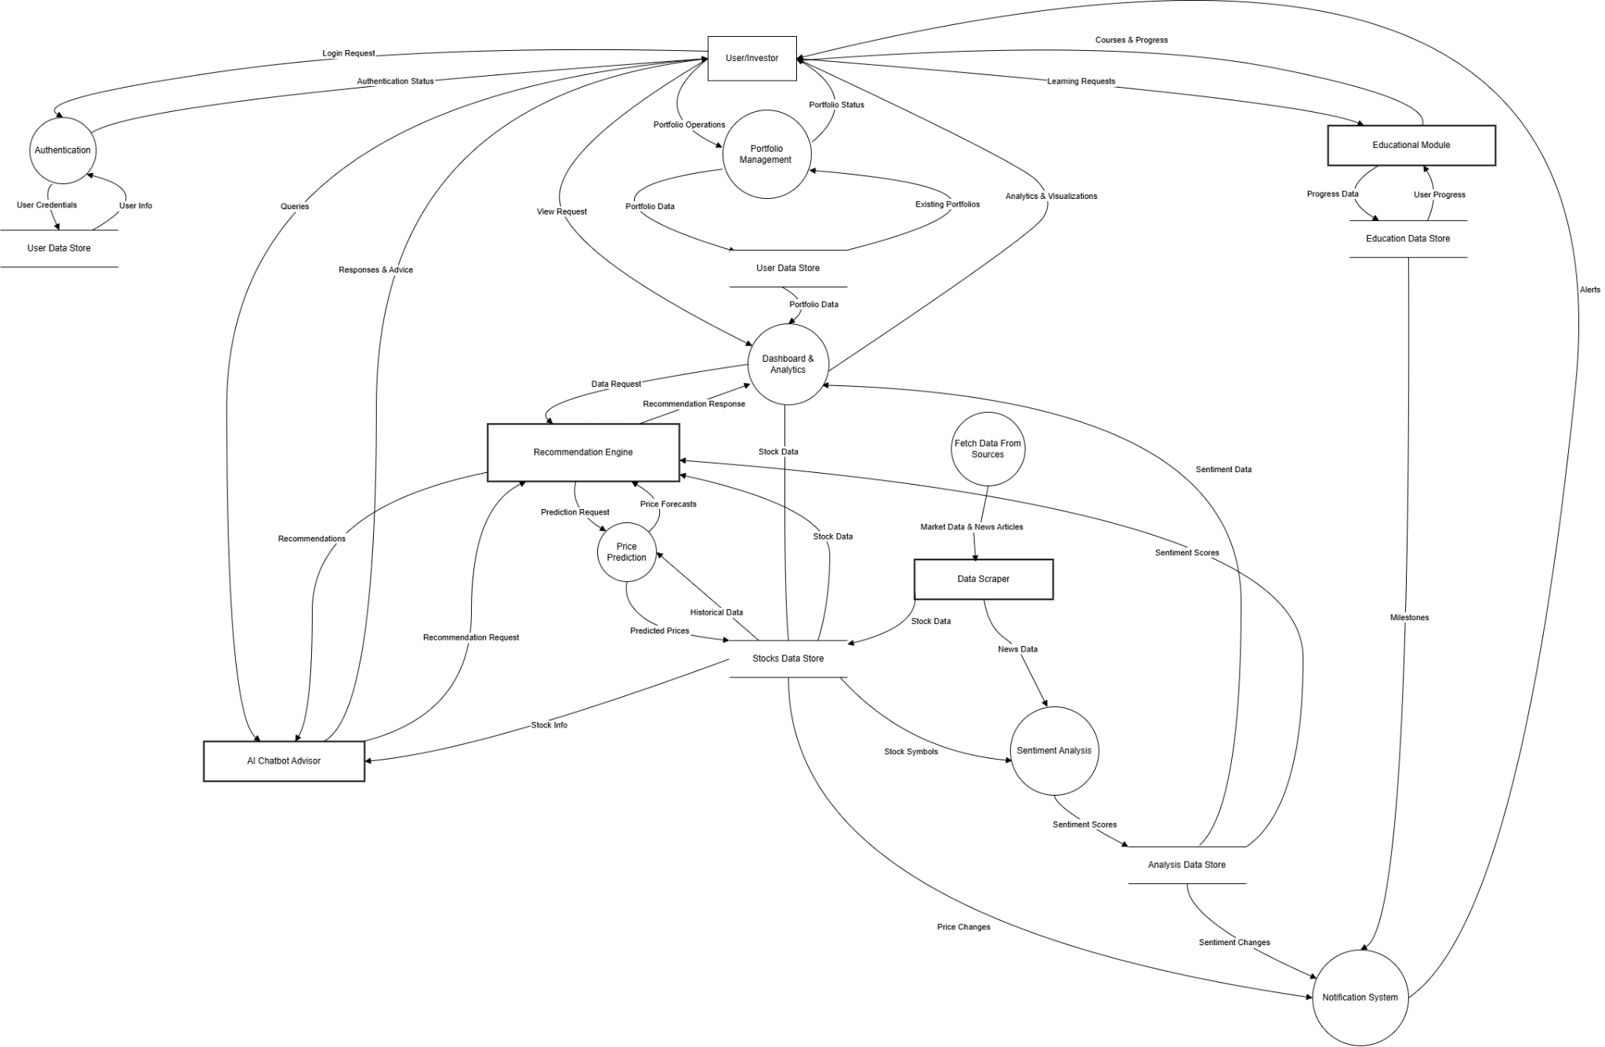

Domain Model
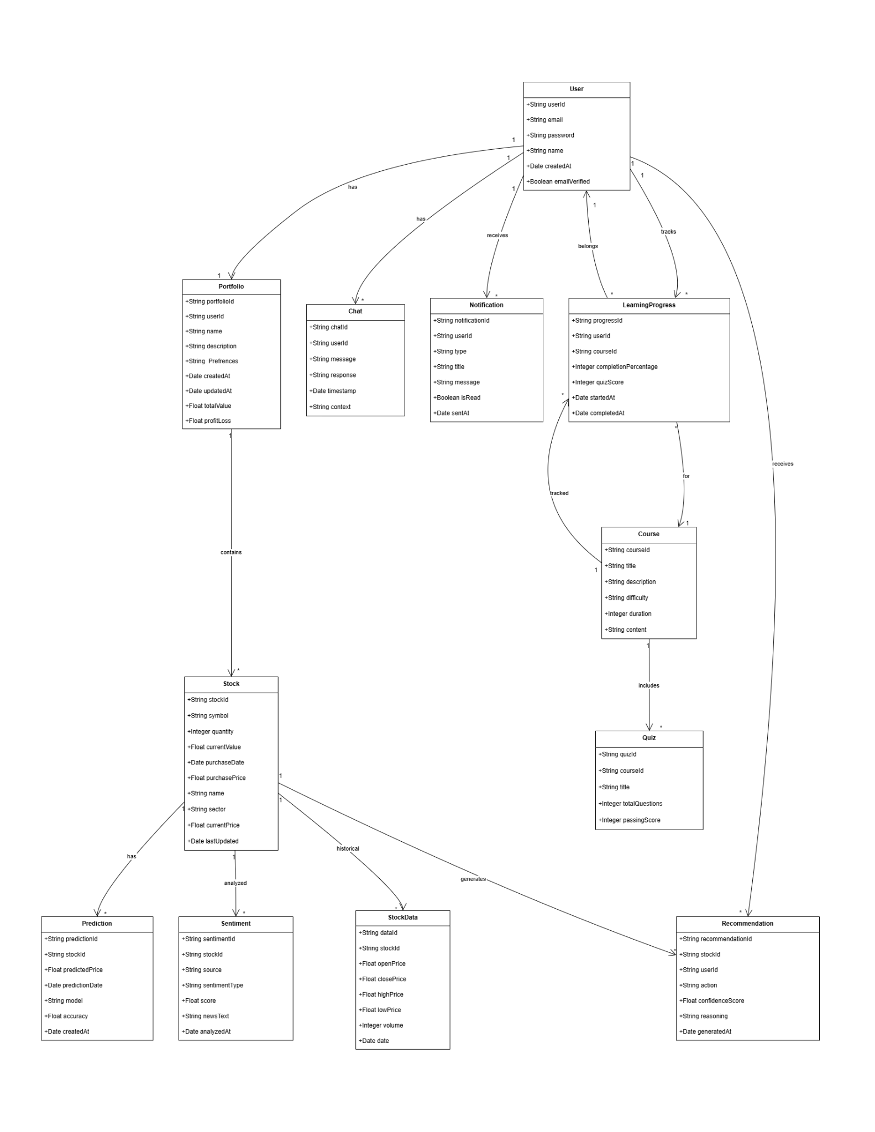

Json Tree
