Chapter 6 (8th Edition): 6.1, 6.3, 6.5, 6.6, 6.10, 6.11, 6.17, 6.22, 6.23, 6.25, 6.36, 6.37

Jeremy Ling & Emmanuel Mejia

April 16, 2018

# loading libraries  
library(car)  
library(gplots)

## Warning: package 'gplots' was built under R version 3.4.4

##   
## Attaching package: 'gplots'

## The following object is masked from 'package:stats':  
##   
## lowess

## 6.1

# creating data table  
factorA = rep(c("-","+","-","+","-","+","-","+"), times = 3)  
factorB = rep(c("-","-","+","+","-","-","+","+"), times = 3)  
factorC = rep(c("-","-","-","-","+","+","+","+"), times = 3)  
Rep = rep(c("I", "II", "III"), each = 8)  
yield = c(22,32,35,55,44,40,60,39,31,43,34,47,45,37,50,41,25,29,50,46,38,36,54,47)  
  
cutting.speed.long = data.frame(factorA, factorB, factorC, Rep, yield)  
  
# defining coded  
coded=function(x) #a function to code variable x  
{  
 ifelse(x=="+", 1, -1)  
}  
  
# linear regression  
cutting.speed.lm=lm(yield ~ coded(factorA) * coded(factorB) * coded(factorC), cutting.speed.long)  
summary(cutting.speed.lm)

##   
## Call:  
## lm(formula = yield ~ coded(factorA) * coded(factorB) * coded(factorC),   
## data = cutting.speed.long)  
##   
## Residuals:  
## Min 1Q Median 3Q Max   
## -5.667 -3.500 -1.167 3.167 10.333   
##   
## Coefficients:  
## Estimate Std. Error t value  
## (Intercept) 40.8333 1.1211 36.421  
## coded(factorA) 0.1667 1.1211 0.149  
## coded(factorB) 5.6667 1.1211 5.054  
## coded(factorC) 3.4167 1.1211 3.048  
## coded(factorA):coded(factorB) -0.8333 1.1211 -0.743  
## coded(factorA):coded(factorC) -4.4167 1.1211 -3.939  
## coded(factorB):coded(factorC) -1.4167 1.1211 -1.264  
## coded(factorA):coded(factorB):coded(factorC) -1.0833 1.1211 -0.966  
## Pr(>|t|)   
## (Intercept) < 2e-16 ***  
## coded(factorA) 0.883680   
## coded(factorB) 0.000117 ***  
## coded(factorC) 0.007679 **   
## coded(factorA):coded(factorB) 0.468078   
## coded(factorA):coded(factorC) 0.001172 **   
## coded(factorB):coded(factorC) 0.224475   
## coded(factorA):coded(factorB):coded(factorC) 0.348282   
## ---  
## Signif. codes: 0 '***' 0.001 '**' 0.01 '*' 0.05 '.' 0.1 ' ' 1  
##   
## Residual standard error: 5.492 on 16 degrees of freedom  
## Multiple R-squared: 0.7696, Adjusted R-squared: 0.6689   
## F-statistic: 7.637 on 7 and 16 DF, p-value: 0.0003977

# interaction plot  
with(cutting.speed.long, interaction.plot(factorA, factorC, yield))

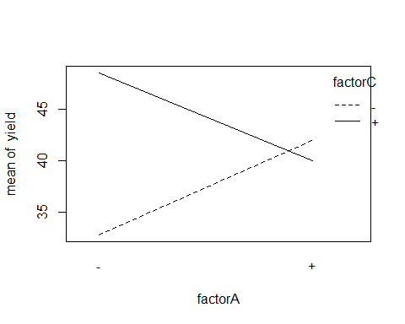

The effects of tool geometry and cutting angle are statistically significant. While cutting speed alone isn’t statistically significant, its interaction with cutting angle is. Therefore cutting speed should remain in the model.

# ANOVA test  
cutting.speed.aov=aov(yield ~ factorA * factorB * factorC, cutting.speed.long)  
summary(cutting.speed.aov)

## Df Sum Sq Mean Sq F value Pr(>F)   
## factorA 1 0.7 0.7 0.022 0.883680   
## factorB 1 770.7 770.7 25.547 0.000117 ***  
## factorC 1 280.2 280.2 9.287 0.007679 **   
## factorA:factorB 1 16.7 16.7 0.552 0.468078   
## factorA:factorC 1 468.2 468.2 15.519 0.001172 **   
## factorB:factorC 1 48.2 48.2 1.597 0.224475   
## factorA:factorB:factorC 1 28.2 28.2 0.934 0.348282   
## Residuals 16 482.7 30.2   
## ---  
## Signif. codes: 0 '***' 0.001 '**' 0.01 '*' 0.05 '.' 0.1 ' ' 1

mse=summary(cutting.speed.aov)[[1]][8,3]  
mse

## [1] 30.16667

The variables that we find statistically significant also match our results from estimating factor effects in part a.

$$y=β_{0}+β_{1}X_{1}+β_{2}+X_{2}+β_{3}+X_{3}+β_{1,3}X_{1}X_{3}$$

res=cutting.speed.long$yield-fitted(cutting.speed.lm)  
qqPlot(res)

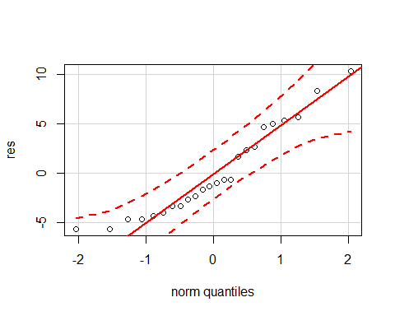

plot(fitted(cutting.speed.lm), res)

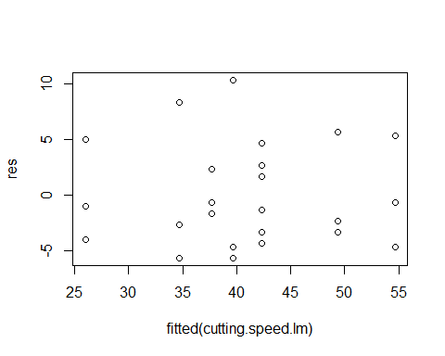

We take a look at our normality plot and can state that normality is good. We take a look at our residual plot and see no patterns, our model is good.

Because the coefficient for factorB is positive, cutting angle should be high. In addition, the interaction plot reveals that lower cutting speed and higher life of a machine tool also produce a higher yield.

## 6.3

#checking Standard error=sqrt(mse/N)  
n=3;a=b=c=2;N=a*b*c*n  
alpha=0.05  
sqrt(mse/N)

## [1] 1.121135

#consturct CI for regression coefficient (example, for coded(A))  
se=sqrt(mse/N)  
df=a*b*c*(n-1)  
hat.beta1=cutting.speed.lm$coefficients[2]  
CI.beta=hat.beta1+c(-1,1)*qt(alpha/2,df,lower.tail = F)*se  
CI.beta

## [1] -2.210034 2.543367

2*CI.beta #CI for main effect A

## [1] -4.420068 5.086735

Standard Error is 1.12 and the confidence interval for the factor effects are (-4.42, 5.0867).

## 6.5

# creating data table  
A <- rep(c("-","+","-","+"), times = 4)  
B <- rep(c("-","-","+","+"), times = 4)  
Rep <- rep(c("I","II","III","IV"), each = 4)  
Vibes <- c(18.2, 27.2, 15.9, 41.0, 18.9, 24.0, 14.5, 43.9, 12.9, 22.4, 15.1, 36.3, 14.4, 22.5, 14.2, 39.9)  
router.long <- data.frame(A, B, Rep, Vibes)  
  
# defining coded  
coded=function(x) #a function to code variable x  
{  
 ifelse(x=="+", 1, -1)  
}  
  
# linear regression  
router.lm=lm(Vibes ~ coded(A) * coded(B), router.long)  
summary(router.lm)

##   
## Call:  
## lm(formula = Vibes ~ coded(A) * coded(B), data = router.long)  
##   
## Residuals:  
## Min 1Q Median 3Q Max   
## -3.975 -1.550 -0.200 1.256 3.625   
##   
## Coefficients:  
## Estimate Std. Error t value Pr(>|t|)   
## (Intercept) 23.8312 0.6112 38.991 5.22e-14 ***  
## coded(A) 8.3187 0.6112 13.611 1.17e-08 ***  
## coded(B) 3.7687 0.6112 6.166 4.83e-05 ***  
## coded(A):coded(B) 4.3562 0.6112 7.127 1.20e-05 ***  
## ---  
## Signif. codes: 0 '***' 0.001 '**' 0.01 '*' 0.05 '.' 0.1 ' ' 1  
##   
## Residual standard error: 2.445 on 12 degrees of freedom  
## Multiple R-squared: 0.9581, Adjusted R-squared: 0.9476   
## F-statistic: 91.36 on 3 and 12 DF, p-value: 1.569e-08

Our linear regression reveals that both treatments are statistically significant, with both variables positively correlated with vibration levels. In addition, there is evidence of interaction between the two.

router.aov = aov(Vibes ~ coded(A) * coded(B), router.long)  
qqnorm(router.aov, full=T)

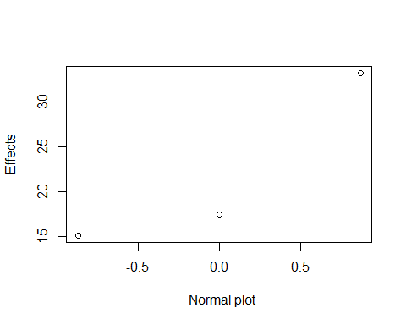

# interaction plot  
with(router.long, interaction.plot(A, B, Vibes))

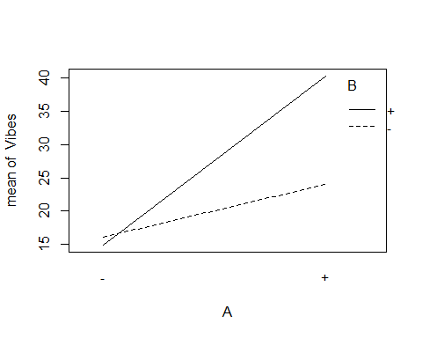

This plot reaffirms the notion that there is an interaction effect present between both variables. We’d recommend a $\frac{1}{16}$ in. bit size and 40rpm speed to minimize vibrations in this operation.

## 6.6

# defining coded  
coded=function(x) #a function to code variable x  
{  
 ifelse(x=="+", 1,   
 ifelse(x == "0", 0, -1))  
}  
  
# creating data table  
factorA <- c(coded(cutting.speed.long$factorA[1:8]), 0, 0, 0, 0)  
factorB <- c(coded(cutting.speed.long$factorB[1:8]), 0, 0, 0, 0)  
factorC <- c(coded(cutting.speed.long$factorC[1:8]), 0, 0, 0, 0)  
yield <- c(cutting.speed.long[1:8, "yield"], 36, 40, 43, 45)  
  
cutting.speed.small <- data.frame(cbind(factorA, factorB, factorC, yield))  
  
# linear regression  
cutting.speed.lm2=lm(yield ~ factorA * factorB * factorC + I(factorA^2) + I(factorB^2) + I(factorC^2), cutting.speed.small)  
  
# interaction plot  
with(cutting.speed.small, interaction.plot(factorA, factorC, yield))

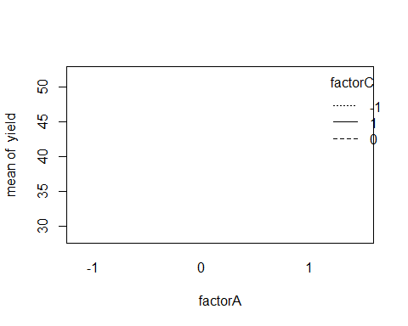

summary(cutting.speed.lm2)

##   
## Call:  
## lm(formula = yield ~ factorA * factorB * factorC + I(factorA^2) +   
## I(factorB^2) + I(factorC^2), data = cutting.speed.small)  
##   
## Residuals:  
## 1 2 3 4 5 6   
## 0.000e+00 -1.665e-16 -4.122e-16 -4.967e-17 -3.542e-16 -5.968e-18   
## 7 8 9 10 11 12   
## 2.390e-16 -9.551e-17 -5.000e+00 -1.000e+00 2.000e+00 4.000e+00   
##   
## Coefficients: (2 not defined because of singularities)  
## Estimate Std. Error t value Pr(>|t|)   
## (Intercept) 41.000 1.958 20.941 0.000238 ***  
## factorA 0.625 1.384 0.451 0.682306   
## factorB 6.375 1.384 4.605 0.019259 *   
## factorC 4.875 1.384 3.521 0.038881 *   
## I(factorA^2) -0.125 2.398 -0.052 0.961703   
## I(factorB^2) NA NA NA NA   
## I(factorC^2) NA NA NA NA   
## factorA:factorB -0.875 1.384 -0.632 0.572249   
## factorA:factorC -6.875 1.384 -4.966 0.015684 *   
## factorB:factorC -2.625 1.384 -1.896 0.154227   
## factorA:factorB:factorC -3.375 1.384 -2.438 0.092681 .   
## ---  
## Signif. codes: 0 '***' 0.001 '**' 0.01 '*' 0.05 '.' 0.1 ' ' 1  
##   
## Residual standard error: 3.916 on 3 degrees of freedom  
## Multiple R-squared: 0.958, Adjusted R-squared: 0.846   
## F-statistic: 8.551 on 8 and 3 DF, p-value: 0.05236

Our linear model reveals that our largest factor effects are exactly thhe same as those found in Problem 6.1.

# center vs. factorial averages  
yc_bar <- mean(cutting.speed.small$yield[9:12])  
test <- mean(cutting.speed.small$yield[1:8])  
  
# ANOVA test  
cutting.speed.aov2 <- aov(yield ~ factorA * factorB * factorC + I(factorA^2) + I(factorB^2) + I(factorC^2), cutting.speed.small)  
summary(cutting.speed.aov2)

## Df Sum Sq Mean Sq F value Pr(>F)   
## factorA 1 3.1 3.1 0.204 0.6823   
## factorB 1 325.1 325.1 21.204 0.0193 *  
## factorC 1 190.1 190.1 12.399 0.0389 *  
## I(factorA^2) 1 0.0 0.0 0.003 0.9617   
## factorA:factorB 1 6.1 6.1 0.399 0.5722   
## factorA:factorC 1 378.1 378.1 24.660 0.0157 *  
## factorB:factorC 1 55.1 55.1 3.595 0.1542   
## factorA:factorB:factorC 1 91.1 91.1 5.943 0.0927 .  
## Residuals 3 46.0 15.3   
## ---  
## Signif. codes: 0 '***' 0.001 '**' 0.01 '*' 0.05 '.' 0.1 ' ' 1

The ANOVA test reveals that there is no statistically significant reason to suspect that there is any quadratic curvature in our model.

Because we know that quadratic curvature should not be introduced to our model, our appropriate model is the same as in Problem 6.1.

$$y=β_{0}+β_{1}X_{1}+β_{2}+X_{2}+β_{3}+X_{3}+β_{1,3}X_{1}X_{3}$$

res=cutting.speed.small$yield-fitted(cutting.speed.lm2)  
qqPlot(res)

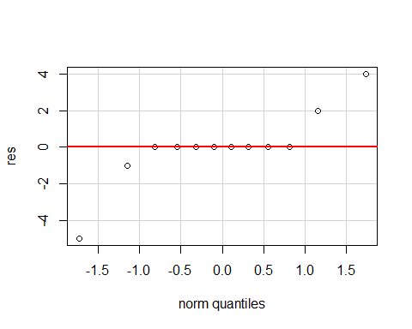

plot(fitted(cutting.speed.lm2), res)

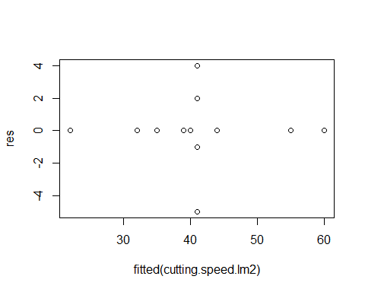

There are patterns present, but this is due to the introduction of our 4 observations.

Exactly like in Problem 6.1, a high cutting angle, low cutting speed, and high life of a machine tool will produce a higher yield.

## 6.10

# creating data table  
type <- rep(c("Glass", "Plastic"), each = 4)  
worker <- rep(c("1", "2"), each = 8)  
pulse <- c(39, 45, 58, 35, 44, 35, 42, 21, 20, 13, 16, 11, 13, 10, 16, 15)  
bottle.long <- data.frame(type, worker, pulse)  
  
# interaction plot  
with(bottle.long, interaction.plot(type, worker, pulse))

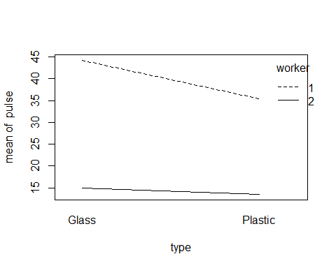

# defining coded  
coded=function(x) #a function to code variable x  
{  
 ifelse(x=="Glass" | x=="1", 1, -1)  
}  
  
# linear regression  
bottle.lm=lm(pulse ~ coded(type) * coded(worker), bottle.long)  
summary(bottle.lm)

##   
## Call:  
## lm(formula = pulse ~ coded(type) * coded(worker), data = bottle.long)  
##   
## Residuals:  
## Min 1Q Median 3Q Max   
## -14.500 -3.625 0.125 3.125 13.750   
##   
## Coefficients:  
## Estimate Std. Error t value Pr(>|t|)   
## (Intercept) 27.062 1.902 14.227 7.11e-09 ***  
## coded(type) 2.563 1.902 1.347 0.203   
## coded(worker) 12.812 1.902 6.736 2.09e-05 ***  
## coded(type):coded(worker) 1.812 1.902 0.953 0.359   
## ---  
## Signif. codes: 0 '***' 0.001 '**' 0.01 '*' 0.05 '.' 0.1 ' ' 1  
##   
## Residual standard error: 7.609 on 12 degrees of freedom  
## Multiple R-squared: 0.8003, Adjusted R-squared: 0.7504   
## F-statistic: 16.03 on 3 and 12 DF, p-value: 0.0001693

# ANOVA test  
bottle.aov=aov(pulse ~ type * worker, bottle.long)  
summary(bottle.aov)

## Df Sum Sq Mean Sq F value Pr(>F)   
## type 1 105.1 105.1 1.815 0.203   
## worker 1 2626.6 2626.6 45.367 2.09e-05 ***  
## type:worker 1 52.6 52.6 0.908 0.359   
## Residuals 12 694.7 57.9   
## ---  
## Signif. codes: 0 '***' 0.001 '**' 0.01 '*' 0.05 '.' 0.1 ' ' 1

mse=summary(bottle.aov)[[1]][4,3]  
mse

## [1] 57.89583

# checking model adequacy  
res=bottle.long$pulse-fitted(bottle.lm)  
qqPlot(res)

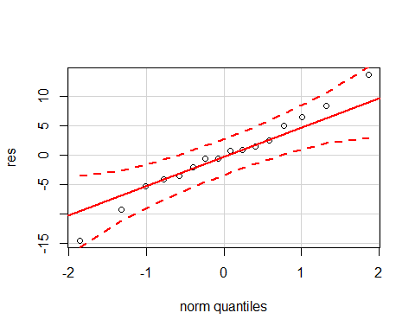

plot(fitted(bottle.lm), res)

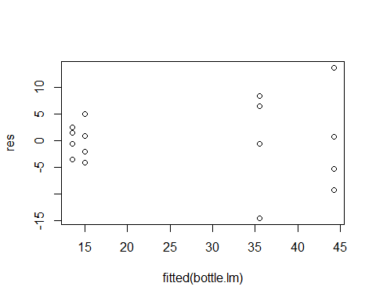

When estimating factor effects, we don’t suspect any interaction effects between bottle type and worker. Both our linear model and ANOVA test suggest that worker is statistically significant in predicting heart rate when performing the task, and reaffirm the conclusion we made in our interaction plot. When checking model adequacy, our qqplot reveals that our data is normally distributed, while the variances of residuals in our residual plot don’t seem homogenous. As a result, the model may not be adequate.

## 6.11

#checking Standard error=sqrt(mse/N)  
n=4;a=b=2;N=a*b*n  
alpha=0.05  
sqrt(mse/N)

## [1] 1.902233

#consturct CI for regression coefficient (example, for coded(A))  
se=sqrt(mse/N)  
df=a*b*(n-1)  
  
hat.beta1=bottle.lm$coefficients[2]  
CI.beta=hat.beta1+c(-1,1)*qt(alpha/2,df,lower.tail = F)*se  
CI.beta

## [1] -1.582109 6.707109

2*CI.beta #CI for main effect A

## [1] -3.164218 13.414218

hat.beta1=bottle.lm$coefficients[3]  
CI.beta=hat.beta1+c(-1,1)*qt(alpha/2,df,lower.tail = F)*se  
CI.beta

## [1] 8.667891 16.957109

2*CI.beta #CI for main effect B

## [1] 17.33578 33.91422

hat.beta1=bottle.lm$coefficients[4]  
CI.beta=hat.beta1+c(-1,1)*qt(alpha/2,df,lower.tail = F)*se  
CI.beta

## [1] -2.332109 5.957109

2*CI.beta #CI for main effect AB

## [1] -4.664218 11.914218

Confidence interval for main effect A is (-3.16, 13.4), for main effect B is (17.33, 33.91), and for interaction effect AB is (-4.66, 11.9). The only confidence interval the doesn’t contain 0 is the one associated with ‘worker’. The results agree with those receive from the ANOVA test we ran earlier.

## 6.17

letter = c("A","B","C","D","AB","AC","AD","BC","BD","CD","ABC","ABD","ACD","BCD","ABCD")  
number = c(76.95,-67.52,-7.84,-18.73,-51.32,11.69,9.78,20.79,14.74,1.27,-2.82,-6.50,10.20,-7.98,-6.25)  
experiment = data.frame(letter, number)  
  
experiment.aov = aov(number ~ coded(letter), experiment)  
  
  
plot = qqnorm(abs(number))

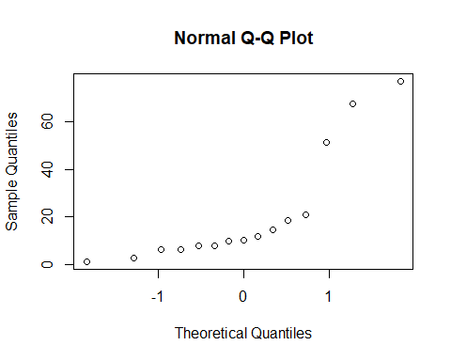

## click at the "outlier" points and then click "Finish" button  
  
  
lister = sort(abs(number))  
  
qqnorm(lister)  
abline(h = 76.95, col = "red")  
abline(h = 67.52, col = "purple")  
abline(h = 51.32, col = "blue")

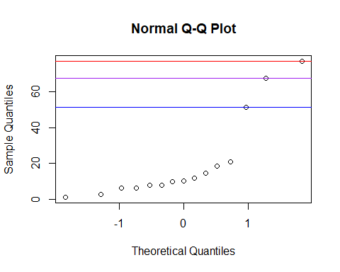

#factor A, B, and AB

$$\overset{^}{y}=β_{0}+75.95x_{a}+67.52x_{b}+51.32x_{ab}$$

## 6.22

Standard.Order = c(8,10,12,9,7,15,2,6,16,13,5,14,1,3,4,11)  
Run.Order = c(1,2,3,4,5,6,7,8,9,10,11,12,13,14,15,16)  
A = Laser.Power = c(1,1,1,-1,-1,-1,1,1,1,-1,-1,1,-1,-1,1,-1)  
B = Pulse.Freq = c(1,-1,1,-1,1,1,-1,-1,1,-1,-1,-1,-1,1,1,1)  
C = Cell.Size = c(1,-1,-1,-1,1,1,-1,1,1,1,1,1,-1,-1,-1,-1)  
D = Writing.Speed = c(-1,1,1,1,-1,1,-1,-1,1,1,-1,1,-1,-1,-1,1)  
UEC = c(0.8,0.81,0.79,0.6,0.65,0.55,0.98,0.67,0.69,0.56,0.63,0.65,0.75,0.72,0.98,0.63)  
error = data.frame(Standard.Order,Run.Order,A,B,C,D,UEC)

error.lm = lm(UEC ~A*B*C*D, error)  
qqnorm(aov(UEC ~ A * B * C * D, error), label=T, full=T)

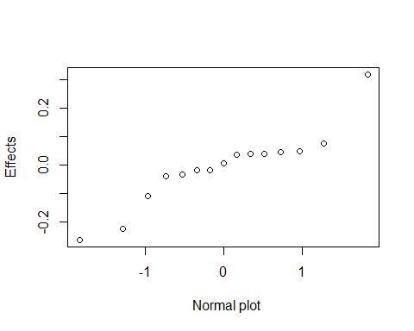

coef=error.lm$coefficients[-1]  
variables=names(coef)  
plot=qqnorm(coef)  
variables[identify(plot)]

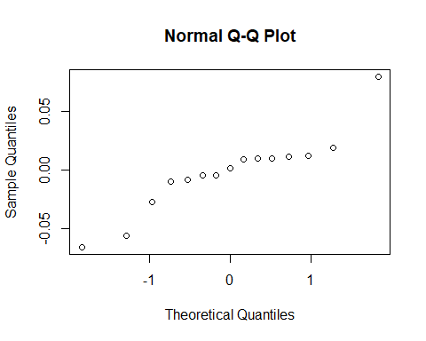

## character(0)

##new model  
error.aov = aov(UEC ~ A+C+D, error)  
summary(error.aov)

## Df Sum Sq Mean Sq F value Pr(>F)   
## A 1 0.10240 0.10240 40.52 3.58e-05 ***  
## C 1 0.07022 0.07022 27.79 0.000197 ***  
## D 1 0.05063 0.05063 20.03 0.000758 ***  
## Residuals 12 0.03033 0.00253   
## ---  
## Signif. codes: 0 '***' 0.001 '**' 0.01 '*' 0.05 '.' 0.1 ' ' 1

With the help of the normal probability plot we are able to identify that “A”, “C”, “D” are important. After choosing my factors, I plug them into a ANOVA and discover that all factors are significantly different.

error.lm2 = lm(UEC~ A*C*D, error)  
res=error$UEC-fitted(error.lm2)  
library(car)  
qqPlot(res)

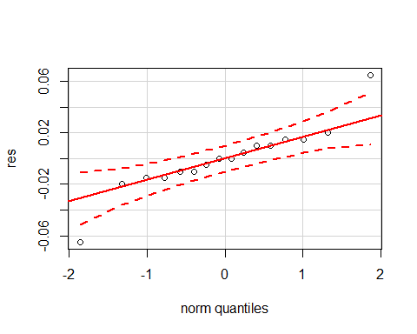

plot(fitted(error.lm2), res)

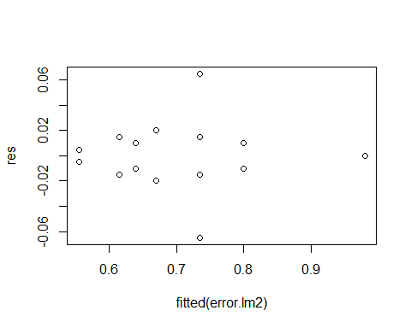

After studying the normality and residuals we can state that normality is good and residuals are patternless and random. We may conclude that model is good.

## 6.23

# creating data table  
A = Laser.Power = c(1,1,1,-1,-1,-1,1,1,1,-1,-1,1,-1,-1,1,-1,0,0,0,0)  
B = Pulse.Freq = c(1,-1,1,-1,1,1,-1,-1,1,-1,-1,-1,-1,1,1,1,0,0,0,0)  
C = Cell.Size = c(1,-1,-1,-1,1,1,-1,1,1,1,1,1,-1,-1,-1,-1,0,0,0,0)  
D = Writing.Speed = c(-1,1,1,1,-1,1,-1,-1,1,1,-1,1,-1,-1,-1,1,0,0,0,0)  
UEC = c(0.8,0.81,0.79,0.6,0.65,0.55,0.98,0.67,0.69,0.56,0.63,0.65,0.75,0.72,0.98,0.63,0.98,0.95,0.93,0.96)  
error2 = data.frame(A,B,C,D,UEC)  
  
#linear regression  
error.lm21 <- lm(UEC ~ A * B * C * D + I(A^2) + I(B^2) + I(C^2) + I(D^2), error2)  
summary(error.lm21)

##   
## Call:  
## lm(formula = UEC ~ A * B * C * D + I(A^2) + I(B^2) + I(C^2) +   
## I(D^2), data = error2)  
##   
## Residuals:  
## 1 2 3 4 5 6   
## 1.518e-18 -1.024e-18 1.520e-18 -1.039e-19 -2.227e-19 6.996e-19   
## 7 8 9 10 11 12   
## 1.821e-18 -1.493e-18 -1.747e-18 -1.020e-19 1.567e-19 1.472e-18   
## 13 14 15 16 17 18   
## -3.361e-19 3.145e-19 -1.456e-18 -3.714e-19 2.500e-02 -5.000e-03   
## 19 20   
## -2.500e-02 5.000e-03   
##   
## Coefficients: (3 not defined because of singularities)  
## Estimate Std. Error t value Pr(>|t|)   
## (Intercept) 0.955000 0.010408 91.753 2.85e-06 ***  
## A 0.080000 0.005204 15.372 0.000598 ***  
## B 0.010000 0.005204 1.922 0.150410   
## C -0.066250 0.005204 -12.730 0.001046 **   
## D -0.056250 0.005204 -10.809 0.001694 **   
## I(A^2) -0.238750 0.011637 -20.517 0.000253 ***  
## I(B^2) NA NA NA NA   
## I(C^2) NA NA NA NA   
## I(D^2) NA NA NA NA   
## A:B 0.008750 0.005204 1.681 0.191287   
## A:C -0.027500 0.005204 -5.284 0.013219 *   
## B:C 0.012500 0.005204 2.402 0.095709 .   
## A:D -0.005000 0.005204 -0.961 0.407544   
## B:D -0.005000 0.005204 -0.961 0.407544   
## C:D 0.018750 0.005204 3.603 0.036687 *   
## A:B:C 0.011250 0.005204 2.162 0.119381   
## A:B:D -0.008750 0.005204 -1.681 0.191287   
## A:C:D 0.010000 0.005204 1.922 0.150410   
## B:C:D -0.010000 0.005204 -1.922 0.150410   
## A:B:C:D 0.001250 0.005204 0.240 0.825659   
## ---  
## Signif. codes: 0 '***' 0.001 '**' 0.01 '*' 0.05 '.' 0.1 ' ' 1  
##   
## Residual standard error: 0.02082 on 3 degrees of freedom  
## Multiple R-squared: 0.997, Adjusted R-squared: 0.9812   
## F-statistic: 62.88 on 16 and 3 DF, p-value: 0.00285

# ANOVA test  
error.aov21 <- aov(UEC ~ A * B * C * D + I(A^2) + I(B^2) + I(C^2) + I(D^2), error2)  
summary(error.aov21)

## Df Sum Sq Mean Sq F value Pr(>F)   
## A 1 0.10240 0.10240 236.308 0.000598 ***  
## B 1 0.00160 0.00160 3.692 0.150410   
## C 1 0.07023 0.07023 162.058 0.001046 **   
## D 1 0.05062 0.05062 116.827 0.001694 **   
## I(A^2) 1 0.18240 0.18240 420.935 0.000253 ***  
## A:B 1 0.00123 0.00123 2.827 0.191287   
## A:C 1 0.01210 0.01210 27.923 0.013219 *   
## B:C 1 0.00250 0.00250 5.769 0.095709 .   
## A:D 1 0.00040 0.00040 0.923 0.407544   
## B:D 1 0.00040 0.00040 0.923 0.407544   
## C:D 1 0.00563 0.00563 12.981 0.036687 *   
## A:B:C 1 0.00202 0.00202 4.673 0.119381   
## A:B:D 1 0.00122 0.00122 2.827 0.191287   
## A:C:D 1 0.00160 0.00160 3.692 0.150410   
## B:C:D 1 0.00160 0.00160 3.692 0.150410   
## A:B:C:D 1 0.00003 0.00003 0.058 0.825659   
## Residuals 3 0.00130 0.00043   
## ---  
## Signif. codes: 0 '***' 0.001 '**' 0.01 '*' 0.05 '.' 0.1 ' ' 1

# rebuild model  
error.lm22 <- lm(UEC ~ A*C + C*D + I(A^2) + I(B^2) + I(C^2) + I(D^2), error2)  
summary(error.lm22)

##   
## Call:  
## lm(formula = UEC ~ A * C + C * D + I(A^2) + I(B^2) + I(C^2) +   
## I(D^2), data = error2)  
##   
## Residuals:  
## Min 1Q Median 3Q Max   
## -0.07000 -0.01125 0.00000 0.01500 0.06000   
##   
## Coefficients: (3 not defined because of singularities)  
## Estimate Std. Error t value Pr(>|t|)   
## (Intercept) 0.955000 0.016350 58.411 < 2e-16 ***  
## A 0.080000 0.008175 9.786 2.31e-07 ***  
## C -0.066250 0.008175 -8.104 1.94e-06 ***  
## D -0.056250 0.008175 -6.881 1.12e-05 ***  
## I(A^2) -0.238750 0.018279 -13.061 7.52e-09 ***  
## I(B^2) NA NA NA NA   
## I(C^2) NA NA NA NA   
## I(D^2) NA NA NA NA   
## A:C -0.027500 0.008175 -3.364 0.00508 **   
## C:D 0.018750 0.008175 2.294 0.03912 *   
## ---  
## Signif. codes: 0 '***' 0.001 '**' 0.01 '*' 0.05 '.' 0.1 ' ' 1  
##   
## Residual standard error: 0.0327 on 13 degrees of freedom  
## Multiple R-squared: 0.9682, Adjusted R-squared: 0.9535   
## F-statistic: 65.99 on 6 and 13 DF, p-value: 5.544e-09

error.aov22 <- aov(UEC ~A*C + C*D + I(A^2) + I(B^2) + I(C^2) + I(D^2), error2)  
summary(error.aov22)

## Df Sum Sq Mean Sq F value Pr(>F)   
## A 1 0.10240 0.10240 95.770 2.31e-07 ***  
## C 1 0.07023 0.07023 65.678 1.94e-06 ***  
## D 1 0.05062 0.05062 47.347 1.12e-05 ***  
## I(A^2) 1 0.18241 0.18241 170.595 7.52e-09 ***  
## A:C 1 0.01210 0.01210 11.317 0.00508 **   
## C:D 1 0.00563 0.00563 5.261 0.03912 *   
## Residuals 13 0.01390 0.00107   
## ---  
## Signif. codes: 0 '***' 0.001 '**' 0.01 '*' 0.05 '.' 0.1 ' ' 1

# interaction plot  
with(error2, interaction.plot(A, C, UEC))

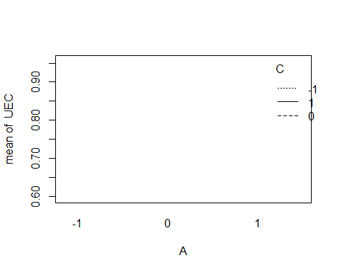

with(error2, interaction.plot(C, D, UEC))

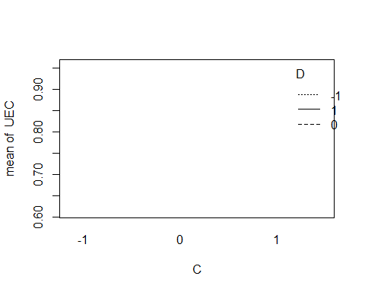

# checking model adequacy  
res=error2$UEC-fitted(error.lm22)  
qqPlot(res)

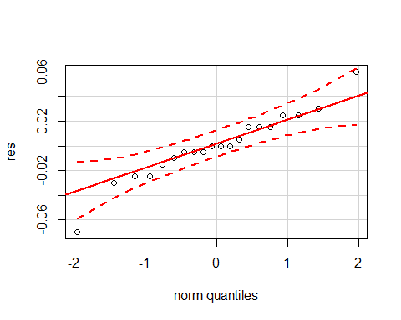

plot(fitted(error.lm22), res)

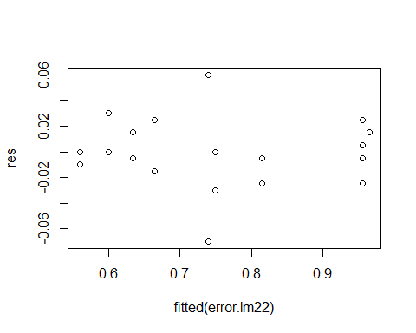

After testing for where or not our model should account for curvature, we do indeed find that squared terms are statistically significant in helping predict UEC, and should be included in the model. We’d recommend excluding laser pulse frequency from the model. Also, laswer power at 13W, matrix cell size at .07in., and writing speed at 10 in./sec is recommended to achieve the highest mean UEC.

## 6.25

Run.Number = c(1:16)  
Run.Label = c("(1)","a,","b","ab","C","ac","bc","abc","d","ad","bd","abd","cd","acd","bcd","abcd")  
# creating data table  
A <- rep(c("-", "+"), times = 8)  
B <- rep(c("-", "+"), each = 2, times = 4)  
C <- rep(c("-", "+"), each = 4, times = 2)  
D <- rep(c("-", "+"), each = 8)  
Filtration.Rate = c(45,71,48,65,68,60,80,65,43,100,45,104,75,86,70,96)  
chem.long <- data.frame(Run.Number,A, B, C, D,Filtration.Rate)  
  
# defining coded  
coded=function(x) #a function to code variable x  
{  
 ifelse(x=="+", 1, -1)  
}  
  
chem.lm = lm(Filtration.Rate ~ coded(A)*coded(B)+coded(A)*coded(C)+coded(A)*coded(D)+coded(B)*coded(C)+coded(B)*coded(D)+coded(C)*coded(D), chem.long)  
summary(chem.lm)

##   
## Call:  
## lm(formula = Filtration.Rate ~ coded(A) * coded(B) + coded(A) *   
## coded(C) + coded(A) * coded(D) + coded(B) * coded(C) + coded(B) *   
## coded(D) + coded(C) * coded(D), data = chem.long)  
##   
## Residuals:  
## 1 2 3 4 5 6 7 8 9   
## -0.1875 2.8125 1.8125 -4.4375 -3.9375 1.3125 2.3125 0.3125 -1.6875   
## 10 11 12 13 14 15 16   
## -0.9375 0.0625 2.5625 5.8125 -3.1875 -4.1875 1.5625   
##   
## Coefficients:  
## Estimate Std. Error t value Pr(>|t|)   
## (Intercept) 70.0625 1.2640 55.430 3.61e-08 ***  
## coded(A) 10.8125 1.2640 8.554 0.000360 ***  
## coded(B) 1.5625 1.2640 1.236 0.271297   
## coded(C) 4.9375 1.2640 3.906 0.011337 *   
## coded(D) 7.3125 1.2640 5.785 0.002172 **   
## coded(A):coded(B) 0.0625 1.2640 0.049 0.962478   
## coded(A):coded(C) -9.0625 1.2640 -7.170 0.000821 ***  
## coded(A):coded(D) 8.3125 1.2640 6.576 0.001220 **   
## coded(B):coded(C) 1.1875 1.2640 0.939 0.390613   
## coded(B):coded(D) -0.1875 1.2640 -0.148 0.887871   
## coded(C):coded(D) -0.5625 1.2640 -0.445 0.674909   
## ---  
## Signif. codes: 0 '***' 0.001 '**' 0.01 '*' 0.05 '.' 0.1 ' ' 1  
##   
## Residual standard error: 5.056 on 5 degrees of freedom  
## Multiple R-squared: 0.9777, Adjusted R-squared: 0.9331   
## F-statistic: 21.92 on 10 and 5 DF, p-value: 0.001634

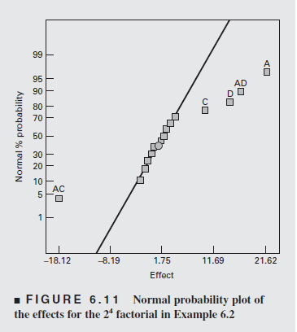

Probability plot for Example 6.2

Looking at our p-values from our linear model. We see that A, C, D, AC, and AD are all significanlty different and important. Take a look at our plot we notice the exact same results. There is no difference in our linear model and probability plot results.

## 6.36

# creating data table  
A <- rep(c("-", "+"), times = 8)  
B <- rep(c("-", "+"), each = 2, times = 4)  
C <- rep(c("-", "+"), each = 4, times = 2)  
D <- rep(c("-", "+"), each = 8)  
Resistivity <- c(1.92, 11.28, 1.09, 5.75, 2.13, 9.53, 1.03, 5.35, 1.60, 11.73, 1.16, 4.68, 2.16, 9.11, 1.07, 5.30)  
wafer.long <- data.frame(Resistivity, A, B, C, D)  
  
# defining coded  
coded=function(x) #a function to code variable x  
{  
 ifelse(x=="+", 1, -1)  
}  
  
# linear regression  
wafer.lm <- lm(Resistivity ~ coded(A) * coded(B) * coded(C) + coded(A) * coded(B) * coded(D) + coded(A) * coded(C) * coded(D) + coded(B) * coded(C) * coded(D), wafer.long)  
summary(wafer.lm)

##   
## Call:  
## lm(formula = Resistivity ~ coded(A) * coded(B) * coded(C) + coded(A) *   
## coded(B) * coded(D) + coded(A) * coded(C) * coded(D) + coded(B) *   
## coded(C) * coded(D), data = wafer.long)  
##   
## Residuals:  
## 1 2 3 4 5 6 7 8 9   
## 0.1419 -0.1419 -0.1419 0.1419 -0.1419 0.1419 0.1419 -0.1419 -0.1419   
## 10 11 12 13 14 15 16   
## 0.1419 0.1419 -0.1419 0.1419 -0.1419 -0.1419 0.1419   
##   
## Coefficients:  
## Estimate Std. Error t value Pr(>|t|)   
## (Intercept) 4.68062 0.14188 32.991 0.0193 *  
## coded(A) 3.16062 0.14188 22.278 0.0286 *  
## coded(B) -1.50187 0.14188 -10.586 0.0600 .  
## coded(C) -0.22062 0.14188 -1.555 0.3638   
## coded(D) -0.07937 0.14188 -0.559 0.6753   
## coded(A):coded(B) -1.06937 0.14188 -7.537 0.0840 .  
## coded(A):coded(C) -0.29812 0.14188 -2.101 0.2828   
## coded(B):coded(C) 0.22937 0.14188 1.617 0.3526   
## coded(A):coded(D) -0.05687 0.14188 -0.401 0.7573   
## coded(B):coded(D) -0.04688 0.14188 -0.330 0.7969   
## coded(C):coded(D) 0.02937 0.14188 0.207 0.8700   
## coded(A):coded(B):coded(C) 0.34437 0.14188 2.427 0.2488   
## coded(A):coded(B):coded(D) -0.09688 0.14188 -0.683 0.6186   
## coded(A):coded(C):coded(D) -0.01063 0.14188 -0.075 0.9524   
## coded(B):coded(C):coded(D) 0.09438 0.14188 0.665 0.6263   
## ---  
## Signif. codes: 0 '***' 0.001 '**' 0.01 '*' 0.05 '.' 0.1 ' ' 1  
##   
## Residual standard error: 0.5675 on 1 degrees of freedom  
## Multiple R-squared: 0.9985, Adjusted R-squared: 0.978   
## F-statistic: 48.72 on 14 and 1 DF, p-value: 0.1119

qqnorm(aov((Resistivity) ~ coded(A) * coded(B) * coded(C) + coded(A) * coded(B) * coded(D) + coded(A) * coded(C) * coded(D) + coded(B) * coded(C) * coded(D), wafer.long), label=T, full=T)

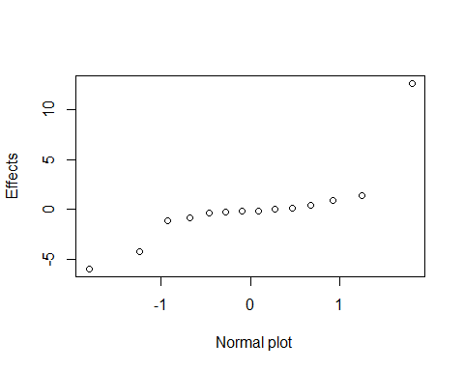

coef=wafer.lm$coefficients[-1]  
variables=names(coef)  
plot=qqnorm(coef)  
variables[identify(plot)]

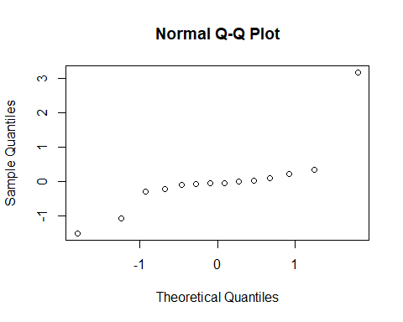

## character(0)

After plotting our ANOVA in a probability model we see that factor A, B, and interaction factor A*B are important. We create a linear model with these results. We look at our results for our model and see all p-values are small and all factors are significantly different in our model.

wafer.lm2 <- lm((Resistivity) ~ coded(A) + coded(B) + coded(A) * coded(B), wafer.long)  
res=wafer.long$Resistivity-fitted(wafer.lm2)  
qqPlot(res)

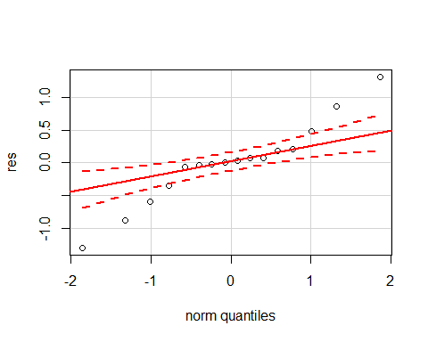

plot(fitted(wafer.lm), res)

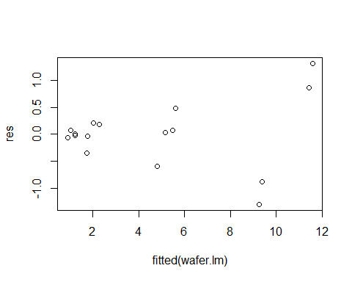

After reviewing normality and residual plot we see that our normality plot is slightly off. As for our residual plot we notice there is some pattern going on. From the normality statement we can state that our model is not good.

wafer.lm3 <- lm(log(Resistivity) ~ coded(A) * coded(B) * coded(C) + coded(A) * coded(B) * coded(D) + coded(A) * coded(C) * coded(D) + coded(B) * coded(C) * coded(D), wafer.long)  
  
qqnorm(aov(log(Resistivity) ~ coded(A) * coded(B) * coded(C) + coded(A) * coded(B) * coded(D) + coded(A) * coded(C) * coded(D) + coded(B) * coded(C) * coded(D), wafer.long), label=T, full=T)

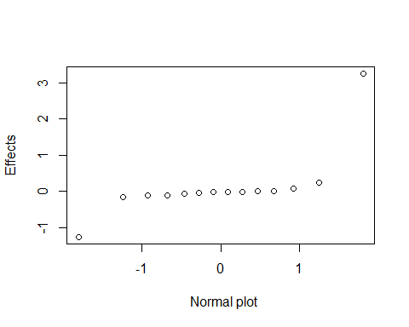

coef=wafer.lm3$coefficients[-1]  
variables=names(coef)  
plot=qqnorm(coef)  
variables[identify(plot)]

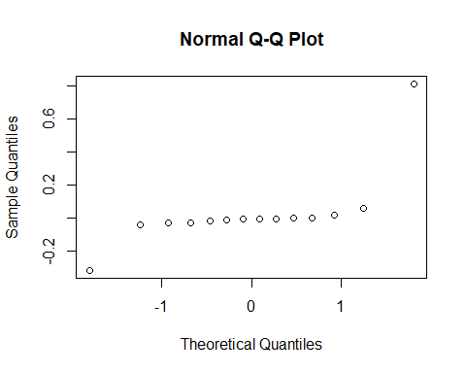

## character(0)

##A and B  
##  
wafer.lm4 = lm(Resistivity ~ coded(A) + coded(B), wafer.long)  
res=wafer.long$Resistivity-fitted(wafer.lm4)  
qqPlot(res)

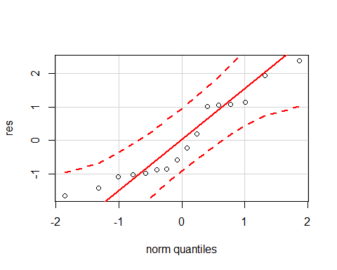

plot(fitted(wafer.lm4), res)

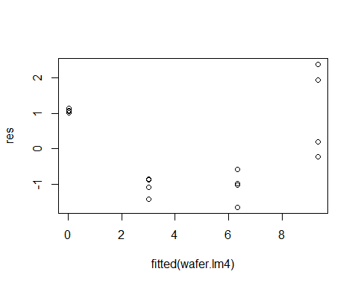

Based on the suggestion of the exercise. We do see an improvement in our model when it comes to checking our normality and residuals. Our model is good.

wafer.lm4 = lm(Resistivity ~ coded(A) + coded(B), wafer.long); summary(wafer.lm4)

##   
## Call:  
## lm(formula = Resistivity ~ coded(A) + coded(B), data = wafer.long)  
##   
## Residuals:  
## Min 1Q Median 3Q Max   
## -1.6594 -1.0019 -0.4113 1.0569 2.3869   
##   
## Coefficients:  
## Estimate Std. Error t value Pr(>|t|)   
## (Intercept) 4.6806 0.3401 13.764 3.97e-09 ***  
## coded(A) 3.1606 0.3401 9.294 4.18e-07 ***  
## coded(B) -1.5019 0.3401 -4.416 0.000696 ***  
## ---  
## Signif. codes: 0 '***' 0.001 '**' 0.01 '*' 0.05 '.' 0.1 ' ' 1  
##   
## Residual standard error: 1.36 on 13 degrees of freedom  
## Multiple R-squared: 0.8906, Adjusted R-squared: 0.8738   
## F-statistic: 52.94 on 2 and 13 DF, p-value: 5.655e-07

After performing part (c) and checking model adequacy we can state that a model with factor A and factor B is a good model.

## 6.37

# creating data table  
A <- c(rep(c(-1, 1), times = 8), 0, 0, 0, 0)  
B <- c(rep(c(-1, 1), each = 2, times = 4), 0, 0, 0, 0)  
C <- c(rep(c(-1, 1), each = 4, times = 2), 0, 0, 0, 0)  
D <- c(rep(c(-1, 1), each = 8), 0, 0, 0, 0)  
Resistivity <- c(1.92, 11.28, 1.09, 5.75, 2.13, 9.53, 1.03, 5.35, 1.60, 11.73, 1.16, 4.68, 2.16, 9.11, 1.07, 5.30, 8.15, 7.63, 8.95, 6.48)  
wafer.long2 <- data.frame(Resistivity, A, B, C, D)  
  
# center vs. factorial averages  
yc_bar <- mean(wafer.long2$Resistivity[1:16])  
test <- mean(wafer.long2$Resistivity[17:20])  
  
# linear regression  
wafer.lm21 <- lm(Resistivity ~ A * B * C * D + I(A^2) + I(B^2) + I(C^2) + I(D^2), wafer.long2)  
summary(wafer.lm21)

##   
## Call:  
## lm(formula = Resistivity ~ A * B * C * D + I(A^2) + I(B^2) +   
## I(C^2) + I(D^2), data = wafer.long2)  
##   
## Residuals:  
## 1 2 3 4 5 6   
## -5.551e-17 3.733e-18 -4.009e-17 -6.194e-19 -9.918e-18 -7.483e-18   
## 7 8 9 10 11 12   
## 3.342e-17 -1.128e-18 4.386e-17 -3.649e-17 -5.293e-18 1.096e-17   
## 13 14 15 16 17 18   
## -2.311e-17 2.824e-17 -6.202e-18 -4.708e-17 3.475e-01 -1.725e-01   
## 19 20   
## 1.147e+00 -1.322e+00   
##   
## Coefficients: (3 not defined because of singularities)  
## Estimate Std. Error t value Pr(>|t|)   
## (Intercept) 7.80250 0.51771 15.071 0.000634 ***  
## A 3.16062 0.25885 12.210 0.001183 **   
## B -1.50187 0.25885 -5.802 0.010189 *   
## C -0.22063 0.25885 -0.852 0.456677   
## D -0.07937 0.25885 -0.307 0.779169   
## I(A^2) -3.12187 0.57882 -5.394 0.012490 *   
## I(B^2) NA NA NA NA   
## I(C^2) NA NA NA NA   
## I(D^2) NA NA NA NA   
## A:B -1.06937 0.25885 -4.131 0.025731 *   
## A:C -0.29812 0.25885 -1.152 0.332897   
## B:C 0.22938 0.25885 0.886 0.440821   
## A:D -0.05687 0.25885 -0.220 0.840192   
## B:D -0.04688 0.25885 -0.181 0.867843   
## C:D 0.02937 0.25885 0.113 0.916818   
## A:B:C 0.34437 0.25885 1.330 0.275482   
## A:B:D -0.09688 0.25885 -0.374 0.733109   
## A:C:D -0.01063 0.25885 -0.041 0.969838   
## B:C:D 0.09437 0.25885 0.365 0.739604   
## A:B:C:D 0.14188 0.25885 0.548 0.621781   
## ---  
## Signif. codes: 0 '***' 0.001 '**' 0.01 '*' 0.05 '.' 0.1 ' ' 1  
##   
## Residual standard error: 1.035 on 3 degrees of freedom  
## Multiple R-squared: 0.9874, Adjusted R-squared: 0.9199   
## F-statistic: 14.64 on 16 and 3 DF, p-value: 0.024

# ANOVA test  
wafer.aov21 <- aov(Resistivity ~ A * B * C * D + I(A^2) + I(B^2) + I(C^2) + I(D^2), wafer.long2)  
summary(wafer.aov21)

## Df Sum Sq Mean Sq F value Pr(>F)   
## A 1 159.83 159.83 149.085 0.00118 **  
## B 1 36.09 36.09 33.663 0.01019 *   
## C 1 0.78 0.78 0.726 0.45668   
## D 1 0.10 0.10 0.094 0.77917   
## I(A^2) 1 31.19 31.19 29.090 0.01249 *   
## A:B 1 18.30 18.30 17.067 0.02573 *   
## A:C 1 1.42 1.42 1.326 0.33290   
## B:C 1 0.84 0.84 0.785 0.44082   
## A:D 1 0.05 0.05 0.048 0.84019   
## B:D 1 0.04 0.04 0.033 0.86784   
## C:D 1 0.01 0.01 0.013 0.91682   
## A:B:C 1 1.90 1.90 1.770 0.27548   
## A:B:D 1 0.15 0.15 0.140 0.73311   
## A:C:D 1 0.00 0.00 0.002 0.96984   
## B:C:D 1 0.14 0.14 0.133 0.73960   
## A:B:C:D 1 0.32 0.32 0.300 0.62178   
## Residuals 3 3.22 1.07   
## ---  
## Signif. codes: 0 '***' 0.001 '**' 0.01 '*' 0.05 '.' 0.1 ' ' 1

# checking model adequacy  
res=wafer.long2$Resistivity-fitted(wafer.lm21)  
qqPlot(res)

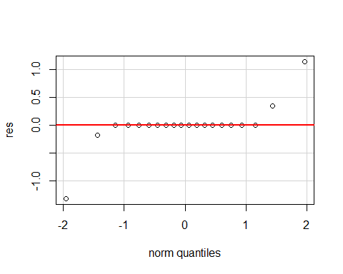

plot(fitted(wafer.lm21), res)

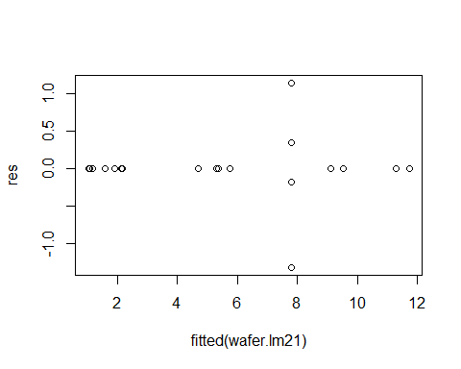

# Rebuild model  
wafer.lm22 <- lm(Resistivity ~ A * B + I(A^2) + I(B^2), wafer.long2)  
summary(wafer.lm22)

##   
## Call:  
## lm(formula = Resistivity ~ A * B + I(A^2) + I(B^2), data = wafer.long2)  
##   
## Residuals:  
## Min 1Q Median 3Q Max   
## -1.32250 -0.21750 0.01625 0.24250 1.31750   
##   
## Coefficients: (1 not defined because of singularities)  
## Estimate Std. Error t value Pr(>|t|)   
## (Intercept) 7.8025 0.3867 20.175 2.78e-12 ***  
## A 3.1606 0.1934 16.345 5.74e-11 ***  
## B -1.5019 0.1934 -7.767 1.24e-06 ***  
## I(A^2) -3.1219 0.4324 -7.220 2.97e-06 ***  
## I(B^2) NA NA NA NA   
## A:B -1.0694 0.1934 -5.530 5.77e-05 ***  
## ---  
## Signif. codes: 0 '***' 0.001 '**' 0.01 '*' 0.05 '.' 0.1 ' ' 1  
##   
## Residual standard error: 0.7735 on 15 degrees of freedom  
## Multiple R-squared: 0.9647, Adjusted R-squared: 0.9553   
## F-statistic: 102.5 on 4 and 15 DF, p-value: 1.052e-10

wafer.aov22 <- aov(Resistivity ~ A * B + I(A^2) + I(B^2), wafer.long2)  
summary(wafer.aov22)

## Df Sum Sq Mean Sq F value Pr(>F)   
## A 1 159.83 159.83 267.14 5.74e-11 ***  
## B 1 36.09 36.09 60.32 1.24e-06 ***  
## I(A^2) 1 31.19 31.19 52.13 2.97e-06 ***  
## A:B 1 18.30 18.30 30.58 5.77e-05 ***  
## Residuals 15 8.97 0.60   
## ---  
## Signif. codes: 0 '***' 0.001 '**' 0.01 '*' 0.05 '.' 0.1 ' ' 1

# checking model adequacy  
res=wafer.long2$Resistivity-fitted(wafer.lm22)  
qqPlot(res)

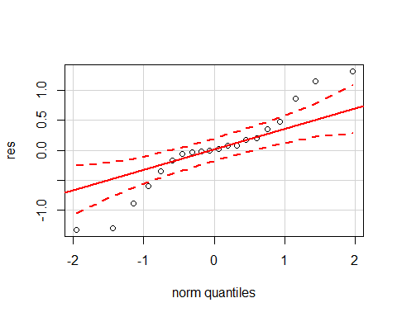

plot(fitted(wafer.lm22), res)

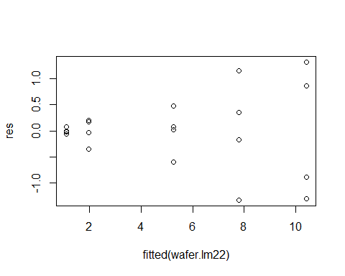

With the introduction of center points to our dataset, we find that therer is statistically significant evidence of curvature in our model. In addition, A, B, and AB are also statistically significant to our model.