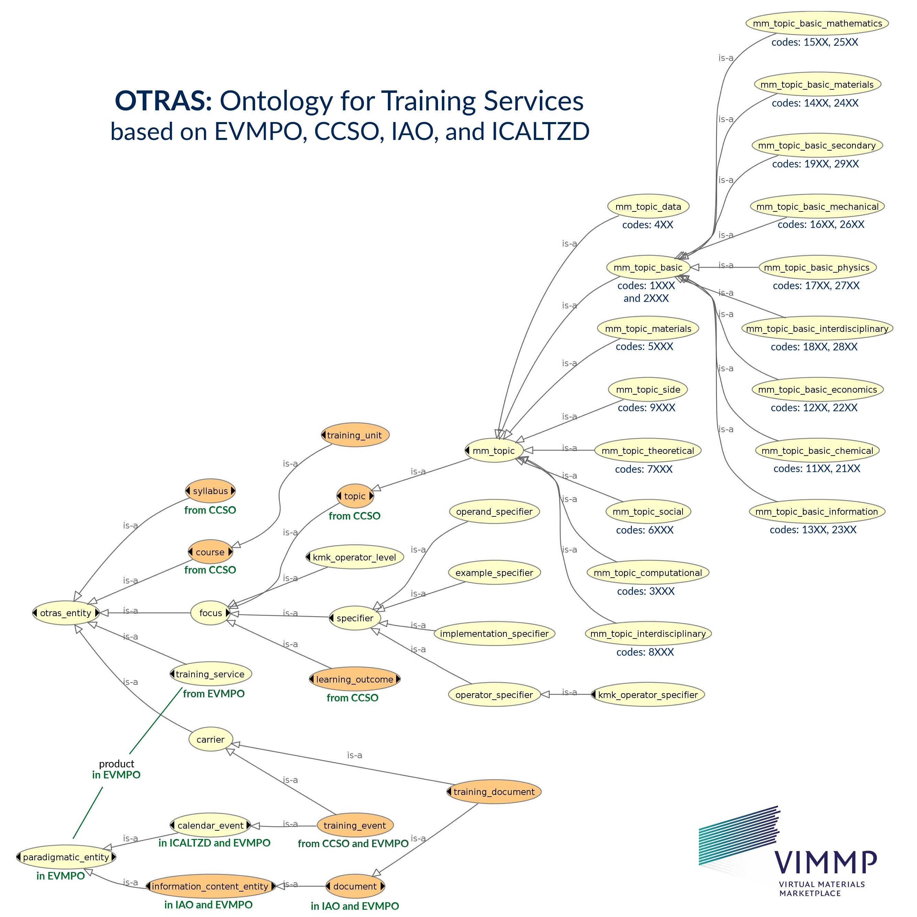

Remark: For information beyond subclass relations, refer to the TTL specification of OTRAS.

Referenced external resources and semantic assets

- CCSO: Curriculum Course Syllabus Ontology, version 0.7, by Evangelos Katis.
- EVMPO: European Virtual Marketplace Ontology, internal draft document.
- IAO: Information Artifact Ontology, by Albert Goldfain, Barry Smith, et al.
- ICALTZD: Ontology for iCalendars with time-zone datatypes, version 1.6, World Wide Web Consortium (W3C).
- KMK Operator Catalogue: Agreement of the German Federal Conference of State Cultural Ministries (KMK) for English-language learning-outcome operator designations in the natural sciences (Physics, Biology, Chemistry), version 265.

Normal form of a learning-outcome specification to be used with OTRAS

A normal form of stating a desired learning outcome can be given as follows:

“After successfully completing X₁, participants can X₂ with respect to X₃ by doing X₄; for example, X₅.” (Note: X₄ and X₅ are not required, and X₁ is not a specifier of the outcome.)

Therein, X₁ is the course or training unit for which a learning outcome is stated. The entities X₂, X₃, X₄, and X₅ are the specifiers of the learning outcome:

- X₂ specifies the operator of the learning outcome (class operator_specifier); a catalogue of operators⁴ with three-digit operator codes is included.
- X₃ specifies the operand of the learning outcome (class operand_specifier); the operand can, and usually will, be related to one or multiple topics for which the present ontology uses the class topic, equivalent to CCSO:Topic. Within materials modelling, a taxonomy of topics (class mm_topic) with four-digit topic codes will be developed; in the present draft, a generic structure is already included.
- X₄ specifies the implementation (class implementation_specifier), describing the way in which the competency is carried out in practice (e.g., “by writing a C++ code” or “by carrying out an appropriate series of DPD simulations”); this is optional, and no catalogue will be developed.
- X₅ specifies an example (class example_specifier), explaining how the competency might be applied in a particular special case (e.g., “if asked to develop a molecular model for caffeine, the participant might suggest a rigid coarse grained model consisting of six Mie interaction sites”). This sort of specifier is also optional, it is technically only an explanation of the learning outcome.

The difference between X₄ and X₅ is that the implementation is a general statement on the acquired competency, whereas the example can be any arbitrary illustration of it.

Operator catalogue for competency specification^{4, 5}

From the KMK catalogue:⁴

- 1XX – Operators to be predominantly used for basic-level competencies: Generic basic-level operator (code 100), “to name/label” (code 120), “to outline/present” (code 130), “to list/give” (code 140), “to write a lab report/data log” (code 150), “to sketch” (code 160), “to draw” (code 170).

- 2XX – Operators to be predominantly used for intermediate-level competencies: Generic intermediate-level operator (code 200), “to compare” (code 215), “to deduce” (code 220), “to estimate” (code 225), “to analyse and identify” (code 230), “to apply” (code 235), “to calculate” (code 240), “to describe” (code 245), “to find” (code 250), “to explain” (code 255), “to describe and explain” (code 260), “to formulate” (code 265), “to derive” (code 270), “to sort/group/classify” (code 275), “to test/verify” (code 280), “to investigate/examine” (code 285), “to generalize” (code 290), “to summarize” (code 295).

- 3XX – Operators to be predominantly used for advanced-level competencies: Generic advanced-level operator (code 300), “to propose a hypothesis” (code 320), “to evaluate” (code 330), “to justify/give reasons” (code 340), “to comment on/assess” (code 350), “to prove” (code 360), “to discuss” (code 370), “to interpret” (code 380), “to plan” (code 390).

Additional operators:

- 4XX – Operators to be predominantly used for expert-level competencies: Generic advanced-level operator (code 400), “to review/evaluate critically” (code 420), “to advise/manage” (code 425), “to characterize experimentally” (code 430), “to document” (code 435), “to carry out professional work” (code 440), “to correspond” (code 445), “to teach” (code 450), “to plan/project/propose” (code 455), “to conduct an exam/assessment” (code 460), “to systematize” (code 465), “to expand/extend/generalize” (code 470), “to simplify/reduce” (code 475), “to innovate/develop” (code 480).

Taxonomy of the topics covered by training in materials modelling

The aim here is, by the point at which the VIMMP Marketplace starts to operate, to include two fully elaborated hierarchy levels as classes, and any further categorization that may be helpful below these two levels implemented in terms of individuals. Parallel to the taxonomy, there are four-digit codes characterizing the respective individuals.

At the first hierarchy level, the fields covered by materials modelling training are subdivided as follows (confer the TTL file for further information):

- Class mm_topic_basic (codes 1XXX and 2XXX): Basic prerequisites for materials modelling, including contents from undergraduate or secondary education.
- Class mm_topic_computational (codes 3XXX): Computational and numerical aspects of materials modelling.
- Class mm_topic_data (codes 4XXX): Data science and technology aspects.
- Class mm_topic_materials (codes 5XXX): Topics related to materials, including but not limited to fluids, and their properties.
- Class mm_topic_social (codes 6XXX): Social, economic, and community aspects of materials modelling.
- Class mm_topic_theoretical (codes 7XXX): Non-computational theoretical aspects of materials modelling.
- Class mm_topic_interdisciplinary (codes 8XXX): Topics that are best described as belonging to multiple categories at the first hierarchy level.
- Class mm_topic_side (codes 9XXX): Topics from other disciplines that can be included as relevant side interests in materials modelling curriculum design.

Confer https://vkreations.github.io/CCSO/ for further information.
Confer http://www.obofoundry.org/ontology/iao.html for further information.
Source: https://www.w3.org/2002/12/cal/icaltzd.
Developed for the use at German Schools outside Germany; source: https://www.kmk.org/fileadmin/Dateien/pdf/Bildung/Auslandsschulwesen/Kerncurriculum/Auslandsschulwesen-Operatoren-Naturwissenschaften-englisch-03-2014.pdf.
Refer to the ontology TTL file or the KMK document for a definition (i.e., a more detailed description) of these operators; e.g., the operator which is expressed by “explain” is defined by giving a detailed account of causes and relationships, whereas the operator expressed by “describe and explain” has a definition that includes giving examples. These definitions, which are not always self-evident from the employed expressions, are a part of the present semantic asset on the basis of the KMK document.

