Purpose and status of the European Virtual Marketplace Ontology (EVMPO)

The ontology work of the VIMMP and MarketPlace consortia aim to be not only transparent and open, but also to become maximally interoperable by using shared ontologies. The European Virtual Marketplace Ontology forms the basis of this and is connected to the European Materials and Modelling Ontology (EMMO) as an upper ontology.

Structure of the European Virtual Marketplace Ontology

EVMPO provides a structure for the marketplace-level ontologies by formulating fundamental paradigmatic categories which correspond to irreducible terms that are constitutive to the virtual-marketplace paradigm. Consistency with EVMPO, and by implication with EMMO, is a requirement for components of the European Virtual Marketplace Framework.

Terms which are not closely related to the virtual marketplace paradigm itself, but will presumably occur somewhere in the related semantic web (elements from the periodic table, academic qualification of experts, etc.), are non-paradigmatic. For this purpose, the EVMPO introduces one fundamental non-paradigmatic category: “annotation”.

This structure facilitates that VIMMP, MarketPlace, and others can agree on the definition of

- paradigmatic entities,
- annotations which are either directly or indirectly related to paradigmatic entities,

while any platform retains the option to extend its own semantic base as required. At any time, any work beyond the agreed joint semantic basis remains possible for any side. To remain compatible with the joint European Virtual Marketplace Framework, however, all such additional works need to avoid logical contradictions with the EVMPO and the EMMO.

List and definition of the fundamental categories

Paradigmatic categories:

- assessment, i.e., proposition on accuracy, performance, or trust in something/someone
- calendar_event; by definition, evmpo:calendar_event is equivalent to ical:Vevent from the W3C iCalendar ontology with Time Zones as Datatypes (ICALTZD)
- communication, i.e., message or action that is communicated by a stakeholder
- information_content_entity; by definition, evmpo:information_content_entity is equivalent to iao:information_content_entity from the Information Artifact Ontology
- infrastructure, i.e., virtual-marketplace infrastructure including DB, hardware, software
- interpreter; by definition, evmpo:role is equivalent to emmo-semiotics:interpreter
- material; by definition, evmpo:material is equivalent to emmo-usercase:material
- model; by definition, evmpo:model is equivalent to emmo-models:model
- process; i.e., temporal evolution of one or multiple entities
- product, i.e., any good or service, marketed off-site or on the virtual marketplace
- property; by definition, evmpo:property is equivalent to emmo-properties:property
- simulation, i.e., a simulation workflow

Non-paradigmatic category:

  - annotation, i.e., non-paradigmatic aspect associated with an entity covered by EVMPO

Selected EVMPO classes displayed jointly with related EMMO classes

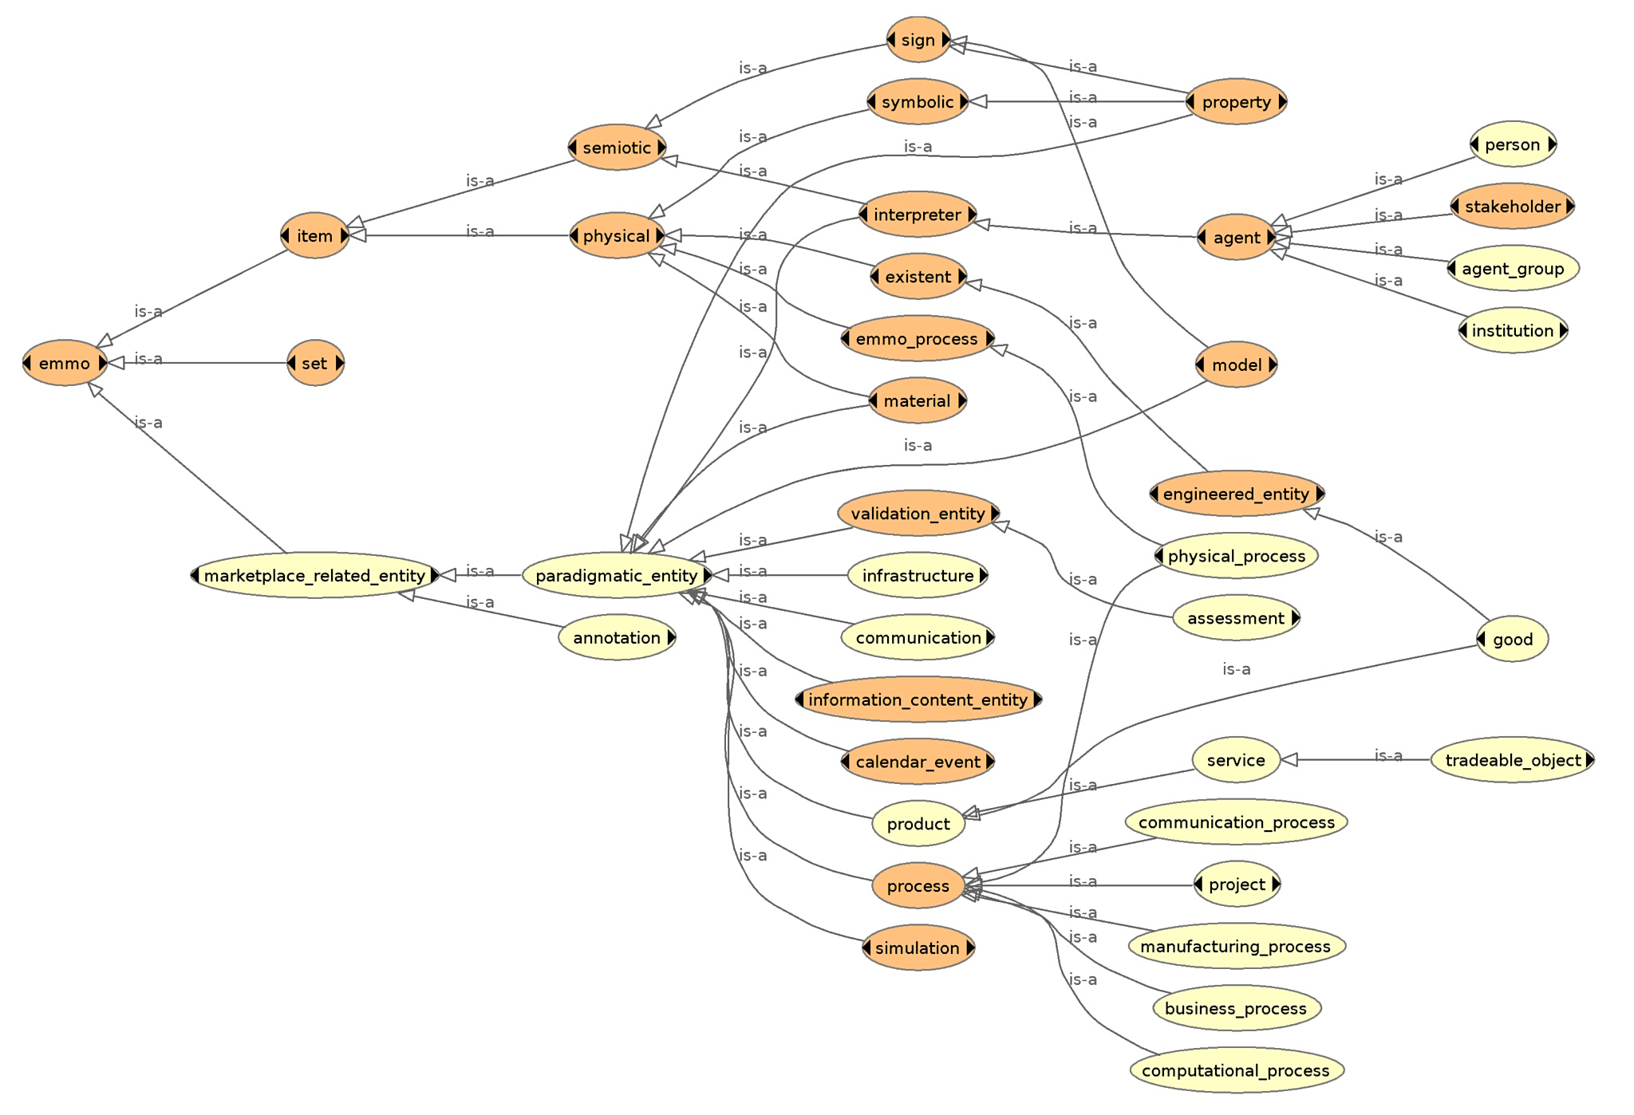

The subclass “stakeholder” refers to an individual/institution/group that acts on a virtual marketplace.
The subclass “physical_process” is stated to be a subclass of emmo-process:process.
The subclass “tradeable_object” specifically refers to a service offered on a virtual marketplace.

