**EPT简介**

* EPT is a feature that can be used to support the virtualization of physical memory.
* EPT是Intel VT-x对嵌套页表的支持，类似于操作系统页表（控制进程的虚拟地址到物理地址映射），EPT控制的是GPA到HPA的翻译。
* 类同于OS的页表GPT，EPT是多级的，提供R-W-X页控制，支持2M大页。（注意GPT不开PAE是不支持X位的设置的）
* OS的总页表指针被放在CR3中，同样的EPT的总页表指针被放在VMCS.EPTP里面
* 当发生GPT 的#PF ，CPU会调用中断表中的general protection exception handler(for R-W-X violation) or page fault handler(for non-present page access)。同样EPT在发生#NPF时，会首先发生#VMEXIT，然后调用nested page fault handler（统一的）
* 在AMD-V里，EPT类似于Rapid Virtualization Indexing（RVI）

**1、EPT原理**

Guest can have full control over Intel®64 page tables / events

– CR3, CR0, CR4 paging bits, INVLPG, page fault

VMM controls Extended Page Tables

CPU uses both tables

EPT (optionally) activated on VM entry

– When EPT active, EPT base pointer (loaded on VM entry from VMCS) points to extended page tables

– EPT deactivated on VM exit

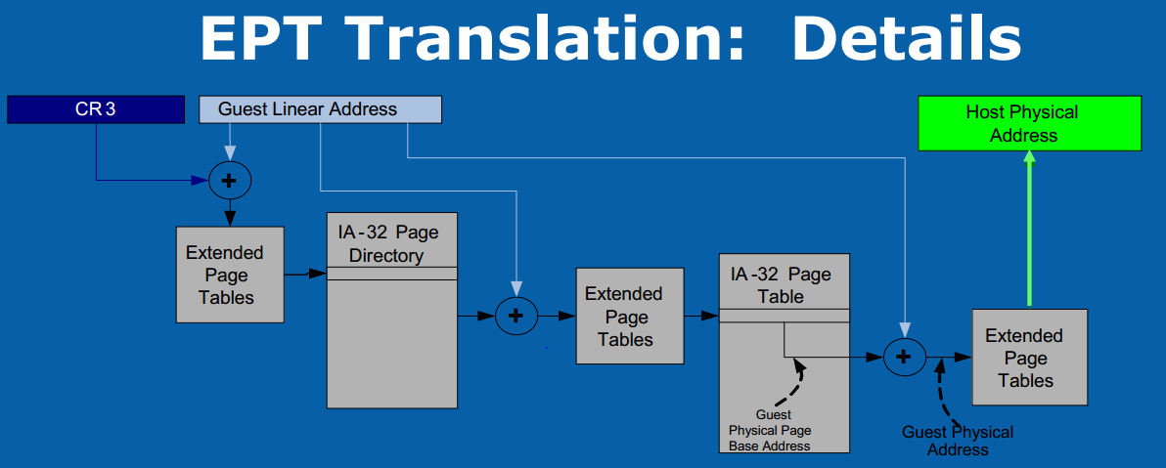

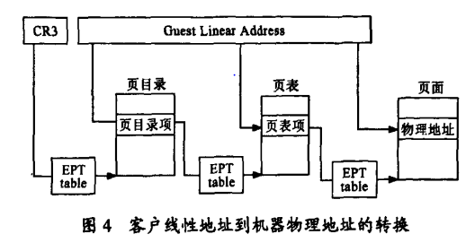

All guest-physical addresses go through extended page tables

– Includes address in CR3, address in PDE, address in PTE, etc.

Example given is for basic 32-bit paging

– Also applies to other paging modes (e.g., PAE and Intel® 64)

At leaf, Intel®64 page faults recognized before EPT violations.

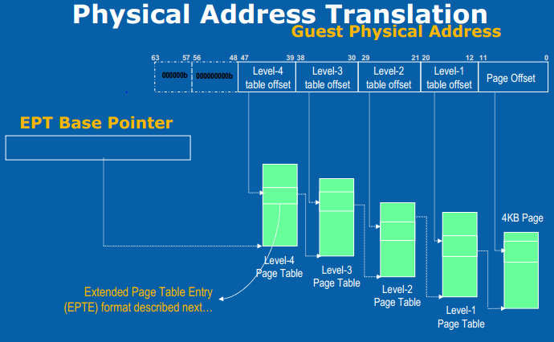

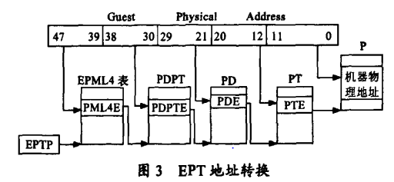

EPTP结构

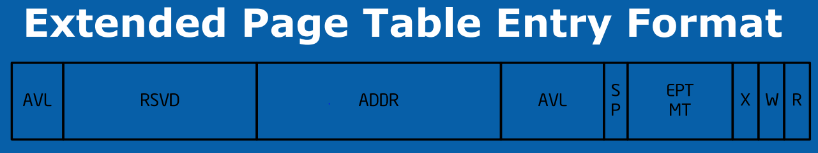

ADDR: Physical address of next table (if not super page and not EPTE) or of page frame (if super page or terminal entry)

SP: Super-page bit: if set, walk stops at a large page

Permission bits: read (R), write (W), execute (X)

EPT MT: Memory-typing controls

AVL: Software-available bit

EPT-based translations used (and cached) only when guest is running

EPT-based translations may be invalidated only when VMM is running

EPT-based translations are architecturally tagged with EPT Base Pointer:

– Tag based only on EPT base pointer

– Tag not based on guest CR3; guest CR loads still flush guest translations

**2、EPT的使用**

打开EPT功能后，虚拟机可以选择使用EPT，也可以选择不使用。默认情况是使用EPT，如果不使用EPT需要在虚拟机配置里添加hap=0

**3、EPT代码分析**

* 以xen的启动到domain0的创建整个流程为例，主要分析有关ept的机制。

经过xen的引导启动操作之后，跳转到第一个C函数__start_xen()完成后续的启动操作。__start_xen 会先建立va🡪pa映射表，然后设置xen地址空间，利用paging_init()建立M2P页表。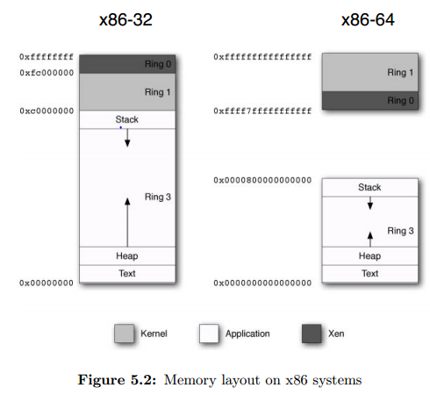

__start_xen调用do_presmp_initcalls();通过遍历__initcall_start至__presmp_initcall_end之间所有的函数，在设置其他vcpu之前对CPU进行初始化设置，包括do_presmp_initcalls(hvm_enable)调用hvm_enable ，这个函数会调用start_vmx();start_vmx()会调用vmx_cpu_up，利用vmx_init_vmcs_config()初始化vmcs结构。





vmx_init_vmcs_config中：

通过adjust_vmx_controls初始化_vmx_cpu_based_exec_control。主要是通过adjust_vmx_controls这个函数获取系统设置。

min = (CPU_BASED_HLT_EXITING|CPU_BASED_VIRTUAL_INTR_PENDING

|CPU_BASED_INVLPG_EXITING|CPU_BASED_CR3_LOAD_EXITING |CPU_BASED_CR3_STORE_EXITING |CPU_BASED_MONITOR_EXITING ………..）

opt = (CPU_BASED_ACTIVATE_MSR_BITMAP |CPU_BASED_TPR_SHADOW

|CPU_BASED_MONITOR_TRAP_FLAG|

CPU_BASED_ACTIVATE_SECONDARY_CONTROLS);

_vmx_cpu_based_exec_control = adjust_vmx_controls(

"CPU-Based Exec Control", min, opt,

MSR_IA32_VMX_PROCBASED_CTLS, &mismatch);

static u32 adjust_vmx_controls(

const char *name, u32 ctl_min, u32 ctl_opt, u32 msr, bool_t *mismatch)

{

u32 vmx_msr_low, vmx_msr_high, ctl = ctl_min | ctl_opt;

rdmsr(msr, vmx_msr_low, vmx_msr_high);

ctl &= vmx_msr_high; /* bit == 0 in high word ==> must be zero */

ctl |= vmx_msr_low; /* bit == 1 in low word ==> must be one */

if ( ctl_min & ~ctl )

{

*mismatch = 1;

printk("VMX: CPU%d has insufficient %s (%08x; requires %08x)\n",

smp_processor_id(), name, ctl, ctl_min);

}

return ctl;

}

/* The IA32_VMX_EPT_VPID_CAP MSR exists only when EPT or VPID available */

if ( _vmx_secondary_exec_control & (SECONDARY_EXEC_ENABLE_EPT |

SECONDARY_EXEC_ENABLE_VPID) )

{

rdmsrl(MSR_IA32_VMX_EPT_VPID_CAP, _vmx_ept_vpid_cap);

/*

* Additional sanity checking before using EPT:

* 1) the CPU we are running on must support EPT WB, as we will set

* ept paging structures memory type to WB;

* 2) the CPU must support the EPT page-walk length of 4 according to

* Intel SDM 25.2.2.

* 3) the CPU must support INVEPT all context invalidation, because we

* will use it as final resort if other types are not supported.

*

* Or we just don't use EPT.

*/

if ( !(_vmx_ept_vpid_cap & VMX_EPT_MEMORY_TYPE_WB) ||

!(_vmx_ept_vpid_cap & VMX_EPT_WALK_LENGTH_4_SUPPORTED) ||

!(_vmx_ept_vpid_cap & VMX_EPT_INVEPT_ALL_CONTEXT) )

_vmx_secondary_exec_control &= ~SECONDARY_EXEC_ENABLE_EPT;

/*

* the CPU must support INVVPID all context invalidation, because we

* will use it as final resort if other types are not supported.

*

* Or we just don't use VPID.

*/

if ( !(_vmx_ept_vpid_cap & VMX_VPID_INVVPID_ALL_CONTEXT) )

_vmx_secondary_exec_control &= ~SECONDARY_EXEC_ENABLE_VPID;

}

vmx_init_vmcs_config()初始化vmcs结构结束后，会执行vmxon进入vmx模式。

__vmxon(virt_to_maddr(this_cpu(vmxon_region)))

进入VMX模式后，接着执行：

if ( cpu_has_vmx_ept )

ept_sync_all();

//ept_sync_all()主要是调用__invept(int type, u64 eptp, u64 gpa)设置所有缓存映射无效，因为刚开启VMX模式。

到此，vmx_cpu_up结束，start_vmx 结束，do_presmp_initcalls(hvm_enable)结束。

__start_xen继续执行。do_presmp_initcalls进行一系列初始化后，执行创建domaon0操作如下：

/* Create initial domain 0. */

dom0 = domain_create(0, DOMCRF_s3_integrity, 0);

这里dom0能够感知虚拟化环境，能够利用P2M页表（P2M页表映射一个虚拟机，而M2P页表由xen创建，由xen维护，映射整个物理内存地址）操作直接寻址机器物理地址，或是执行hypercall与设备交互，属于PV型domain，不执行HVM创建，不创建shadow页表或ept页表。

注：start_xen 执行完domain_create创建dom0之后，调用construct_dom0函数利用一些预先存放的模块进一步初始化dom0。

/*

* We're going to setup domain0 using the module(s) that we stashed safely

* above our heap. The second module, if present, is an initrd ramdisk.

*/

if ( construct_dom0(dom0, mod, modules_headroom,

(initrdidx > 0) && (initrdidx < mbi->mods_count)

? mod + initrdidx : NULL,

bootstrap_map, cmdline) != 0)

panic("Could not set up DOM0 guest OS\n");

construct_dom0调用alloc_vcpu：

for ( i = 1; i < opt_dom0_max_vcpus; i++ )

{

cpu = cpumask_cycle(cpu, cpupool0->cpu_valid);

(void)alloc_vcpu(d, i, cpu);

}

alloc_vcpu首先利用 sched_init_vcpu(v, cpu_id)对vcpu时间调度参数进行设置，把vcpu排入调度队列，然后利用vcpu_initialise(v) 初始化v，利用

if ( is_hvm_domain(d) )

{

rc = hvm_vcpu_initialise(v);

goto done;

}

判断是不是hvm，如果不是则利用

v->arch.schedule_tail = continue_nonidle_domain;

v->arch.ctxt_switch_from = paravirt_ctxt_switch_from;

v->arch.ctxt_switch_to = paravirt_ctxt_switch_to;

进行调度，如果是则利用hvm_vcpu_initialise(v)🡪 vm_funcs.vcpu_initialise(v))进行设置，利用以下转换：

.vcpu_initialise = vmx_vcpu_initialise,

在vmx_vcpu_initialise中设置v->arch.schedule_tail = vmx_do_resume;

（schedule_tail可以理解为调度结尾所做的工作，这样每次调度一个vcpu时结尾就会调用vmx_do_resume。

如void continue_running(struct vcpu *same)

{

schedule_tail(same);

BUG();

}）//直接执行schedule_tail函数，跳过vcpu切换

在vmx_do_resume 中利用reset_stack_and_jump(***vmx_asm_do_vmentry***);

就可以VMEntry进入VMX Non-root模式运行。

每个VCPU都对应一个VMCS结构，所以vmxon、vmxentry、vmxexit、vmxoff不会引起vcpu切换。（A VMM could use a different VMCS for each virtual machine that it supports. For a virtual machine with multiple logical processors (virtual processors), the VMM could use a different VMCS for each virtual processor.）

VMExit

利用vmx_vcpu_initialise调用vmx_create_vmcs，vmx_create_vmcs调用construct_vmcs，construct_vmcs中执行__vmwrite(**HOST_RIP**, (unsigned long)vmx_asm_vmexit_handler);将**HOST_RIP所在地址指向**vmx_asm_vmexit_handler，其中HOST_RIP = 0x00006c16,这样VMExit发生时硬件可以直接转换到vmx_asm_vmexit_handler分析处理, vmx_asm_vmexit_handler处理后会调用vmx_vmexit_handler。

* 当我们在dom0中利用xl create命令创建HVM domain时，会依次执行以下操作：



在xl.c的main函数中执行cmdtable_lookup(cmd) ，根据以下映射，因为是create命令，所以会接着执行main_create函数。

struct cmd_spec cmd_table[] = {

{ "create",

&main_create, 1, 1,

"Create a domain from config file <filename>",

"<ConfigFile> [options] [vars]",

"-h Print this help.\n"

"-p Leave the domain paused after it is created.\n"

"-c Connect to the console after the domain is created.\n"

"-f FILE, --defconfig=FILE\n Use the given configuration file.\n"

"-q, --quiet Quiet.\n"

"-n, --dryrun Dry run - prints the resulting configuration\n"

" (deprecated in favour of global -N option).\n"

"-d Enable debug messages.\n"

"-e Do not wait in the background for the death of the domain.\n"

"-V, --vncviewer Connect to the VNC display after the domain is created.\n"

"-A, --vncviewer-autopass\n"

" Pass VNC password to viewer via stdin."

}

main_create🡪create_domain🡪libxl_domain_create_new🡪do_domain_create🡪initiate_domain_create🡪libxl__domain_make🡪xc_domain_create

通过xc_domain_create()创建控制结构体变量domctl；通过do_domctl()生成超级调用请求；传递请求到OS内核：do_xen_hypercall()do_privcmd通过ioctl来完成由3环到1环的转变，并完成超级调用。如下：

int xc_domain_create(xc_interface *xch,

uint32_t ssidref,

xen_domain_handle_t handle,

uint32_t flags,

uint32_t *pdomid)

{

int err;

DECLARE_DOMCTL;

domctl.cmd = XEN_DOMCTL_createdomain;

domctl.domain = (domid_t)*pdomid;

domctl.u.createdomain.ssidref = ssidref;（SSIDrefs：configure security，系统相关http://old-list-archives.xenproject.org/archives/html/xense-devel/2006-01/msg00002.html）

domctl.u.createdomain.flags = flags;

memcpy(domctl.u.createdomain.handle, handle, sizeof(xen_domain_handle_t));

if ( (err = do_domctl(xch, &domctl)) != 0 )

return err;

*pdomid = (uint16_t)domctl.domain;

return 0;

}

在do_domctl函数中，根据传入参数，相应的会调用domain_create如下。

case XEN_DOMCTL_createdomain:

d = domain_create(dom, domcr_flags, op->u.createdomain.ssidref);

其中domcr_flags参数会指示创建的为HVM虚拟机，接着domain_create 🡪arch_ domain_create，在arch_ domain_create中：

首先paging_domain_init 🡪hap_domain_init(d);初始化hap（硬件辅助页表，即ept）空闲页表。

void hap_domain_init(struct domain *d)

{

INIT_PAGE_LIST_HEAD(&d->arch.paging.hap.freelist);

}

然后hvm_domain_initialise🡪 paging_enable 🡪hap_enable分配页面供hap所用。

domain_pause(d);

/* Allow p2m and log-dirty code to borrow our memory */

d->arch.paging.alloc_page = hap_alloc_p2m_page;

d->arch.paging.free_page = hap_free_p2m_page;

if ( mode & PG_translate )

/* Allocate a new p2m table for a domain.

函数中p2m->phys_table = pagetable_from_mfn(page_to_mfn(p2m_top));

为p2m->phys_table赋值，并利用各种ept页表操作函数完成ept页表创建

arch_domain_create🡪p2m_init🡪p2m_initialise🡪ept_p2m_init设置成ept操作函数*/

rv = p2m_alloc_table(p2m_get_hostp2m(d));

/* Now let other users see the new mode */

d->arch.paging.mode = mode | PG_HAP_enable;

最后，利用rc = hvm_funcs.domain_initialise(d); 确定eptp。

在vmx.c中：.domain_initialise = vmx_domain_initialise,

static int vmx_domain_initialise (struct domain *d)

{ int rc;

/* Set the memory type used when accessing EPT paging structures. */

d->arch.hvm_domain.vmx.ept_control.ept_mt = EPT_DEFAULT_MT;

/* set EPT page-walk length, now it's actual walk length - 1, i.e. 3 */

d->arch.hvm_domain.vmx.ept_control.ept_wl = 3;

d->arch.hvm_domain.vmx.ept_control.asr =

pagetable_get_pfn(p2m_get_pagetable(p2m_get_hostp2m(d)));

/* #define p2m_get_pagetable(p2m) ((p2m)->phys_table) */和上面形成对应。asr即为ept页表最顶层的一页，EPML4表。

if ( !zalloc_cpumask_var(&d->arch.hvm_domain.vmx.ept_synced) )

return -ENOMEM;

if ( (rc = vmx_alloc_vlapic_mapping(d)) != 0 )

{ free_cpumask_var(d->arch.hvm_domain.vmx.ept_synced);

return rc;

} return 0;}

参考ept_control定义可知union结构ept_mt，ept_wl，asr均已赋值，rsvd默认为6。eptp即已经赋值。

union {

struct {

u64 ept_mt :3,

ept_wl :3,

rsvd :6,

asr :52;

};

u64 eptp;

} ept_control;

EPTP切换：vmx_vcpu_initialise 🡪vmx_create_vmcs🡪construct_vmcs.

construct_vmcs中执行：

if ( paging_mode_hap(d) )

__vmwrite(EPT_POINTER, d->arch.hvm_domain.vmx.ept_control.eptp);

其中EPT_POINTER = 0x0000201a,一个eptp对应一个domain，这样每次初始化vcpu时就会设置EPTP值，指向EPT页表。



construct_vmcs之后会调用paging_update_paging_modes(v); 相应的更新Host页表和HOST_CR3。在VMX模式中，VMCS调度运行相当于一般系统中进程的调度运行，每个VMCS结构对应各自的HOST_CR3、GUEST_CR3。

/* will update HOST & GUEST_CR3 as reqd */

/* Update all the things that are derived from the guest's CR0/CR3/CR4.

* Called to initialize paging structures if the paging mode

* has changed, and when bringing up a VCPU for the first time. */

static inline void paging_update_paging_modes(struct vcpu *v)

{

paging_get_hostmode(v)->update_paging_modes(v);

}

hap_paging_real_mode{

.update_paging_modes = hap_update_paging_modes,

}

hap_update_paging_modes中：

if ( pagetable_is_null(v->arch.monitor_table) )

{

mfn_t mmfn = hap_make_monitor_table(v);

v->arch.monitor_table = pagetable_from_mfn(mmfn);

make_cr3(v, mfn_x(mmfn));

hvm_update_host_cr3(v);

}

static inline void

hvm_update_host_cr3(struct vcpu *v)

{

hvm_funcs.update_host_cr3(v);

}

vmx_function_table中：

.update_host_cr3 = vmx_update_host_cr3,

static void vmx_update_host_cr3(struct vcpu *v)

{

vmx_vmcs_enter(v);

__vmwrite(HOST_CR3, v->arch.cr3);

vmx_vmcs_exit(v);

}

arch_vcpu几个页表对比：

struct arch_vcpu{

pagetable_t guest_table; /* (MFN) guest notion of cr3 */

/* guest_table holds a ref to the page, and also a type-count unless

* shadow refcounts are in use */

pagetable_t shadow_table[4]; /* (MFN) shadow(s) of guest */

pagetable_t monitor_table; /* (MFN) hypervisor PT (for HVM) */

unsigned long cr3; /* (MA) value to install in HW CR3 */

}

**4、EPT转换错误处理**

EPT在发生#NPF时，会首先发生#VMEXIT（前文介绍过VMEXIT设置）。调用vmx_vmexit_handler处理。

* case EXIT_REASON_EPT_VIOLATION:

ept_handle_violation🡪 hvm_hap_nested_page_fault

1. nestedhvm_enabled(v->domain)（是否开启嵌套虚拟化并处理）
2. p2m_mem_access_check （处理against access错误）

/* Check access permissions first, then handle faults */

/* If the access is against the permissions, then send to mem_event */

/* First, handle rx2rw conversion automatically */

/* Otherwise, check if there is a memory event listener, and send the message along */

如果有的话：/* Pause the current VCPU */

/* Send request to mem event */

/* VCPU may be paused, return */

注：xen提供接口int xc_hvm_set_mem_access(

xc_interface *xch, domid_t dom, hvmmem_access_t mem_access, uint64_t first_pfn, uint64_t nr)来设置页的访问权限。

1. /** If this GFN is emulated MMIO or marked as read-only, pass the fault

to the mmio handler.*/

1. /* Check if the page has been paged out */
2. /* Mem sharing: unshare the page and try again */
3. /* Spurious fault? PoD and log-dirty also take this path. */
4. /* Shouldn't happen: Maybe the guest was writing to a r/o grant mapping? */

hvm_hap_nested_page_fault处理完后打印有关错误。

* case EXIT_REASON_INVEPT:

hvm_inject_hw_exception(TRAP_invalid_op, HVM_DELIVER_NO_ERROR_CODE);

hvm_inject_trap🡪inject_trap🡪 vmx_inject_trap（向虚拟机注入异常，如下）

* case TRAP_page_fault
* case TRAP_debug:
* case TRAP_int3:

**5、EPT函数调用关系**

__start_xen（setup.c）调用domain_create，domain_create（Domain.c）调用arch_domain_create（xen-4.3.0/xen/arch/x86/domain.c），arch_domain_create调用paging_domain_init（xen-4.3.0\xen\arch\x86\mm\paging.c），paging_domain_init调用p2m_init（xen-4.3.0\xen\arch\x86\mm\paging.c），p2m_init调用p2m_init_hostp2m（xen-4.3.0\xen\arch\x86\mm\p2m.c），p2m_init_hostp2m调用p2m_init_one（xen-4.3.0\xen\arch\x86\mm\p2m.c），p2m_init_one调用p2m_initialise（xen-4.3.0\xen\arch\x86\mm\p2m.c）

p2m_initialise会判断hap是否开启且CPU是否支持vmx

if ( hap_enabled(d) && cpu_has_vmx )

ret = ept_p2m_init(p2m);

else

p2m_pt_init(p2m);

开启则调用ept_p2m_init，否则调用p2m_pt_init

调用关系如下图

